Name : HARSHRAJSINH ZALA

REG NO : 22BCE2238

Q8 :

Code

<!DOCTYPE html>

<html lang="en">

<head>

<meta charset="UTF-8">

<meta name="viewport" content="width=device-width, initial-scale=1.0">

<title>HTML Basics</title>

<link rel="stylesheet" href="q1.css">

</head>

<body>

<table>

<tr><th>Faculty</th><th>Course</th></tr>

<tr><td>Satish</td><td>WEbdev</td></tr>

<tr><td>Ilanthenral</td><td>DAA</td></tr>

<tr><td>Shelja</td><td>Micro</td></tr>

<tr><td>Anand M</td><td>TOC</td></tr>

</table>

</body>

</html>

CSS :

table,tr,th,td{

border: 2px solid black;

border-collapse: collapse;

padding: 5px;

font-size: x-large;

}

tr:hover{

background-color: rgb(216, 194, 165);

}

tr:nth-child(odd){

background-color: rgb(59, 166, 182);

}

th{

background-color: rgb(78, 78, 164);

}

OUTPUT :   
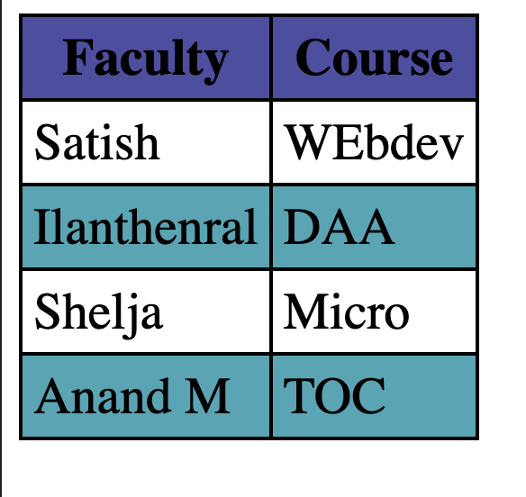

Q9

Code:

<!DOCTYPE html>

<html lang="en">

<head>

<meta charset="UTF-8">

<meta name="viewport" content="width=device-width, initial-scale=1.0">

<title>HTML Basics</title>

<link rel="stylesheet" href="q1.css">

</head>

<body>

<table>

<tr><th>Faculty</th><th>Course</th></tr>

<tr><td>Satish</td><td>WEbdev</td></tr>

<tr><td>Ilanthenral</td><td>DAA</td></tr>

<tr><td>Shelja</td><td>Micro</td></tr>

<tr><td>Anand M</td><td>TOC</td></tr>

</table>

</body>

</html>

CSS :   
table,tr,th,td{

border: 2px solid black;

border-collapse: collapse;

padding: 5px;

font-size: x-large;

}

tr:hover{

background-color: rgb(216, 194, 165);

}

tr:nth-child(odd){

background-color: rgb(59, 166, 182);

}

th{

background-color: rgb(78, 78, 164);

}

OUTPUT :

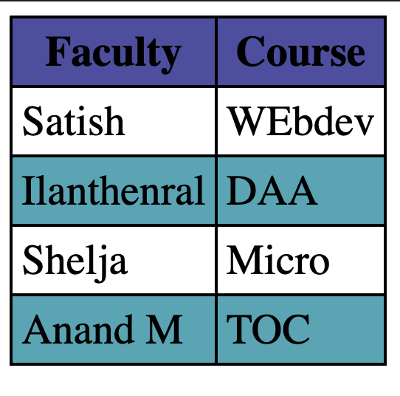

Q10   
CODE :

<!DOCTYPE html>

<html lang="en">

<head>

<meta charset="UTF-8">

<meta http-equiv="X-UA-Compatible" content="IE=edge">

<meta name="viewport" content="width=device-width, initial-scale=1.0">

<title>CSS Table Style</title>

<link rel="stylesheet" href="q4.css">

</head>

<body>

<table>

<tr><th>Name</th><th>Age</th><th>DOB</th><th>Work</th><th>number</th></tr>

<tr><td>Row</td><td>col2</td><td>col3</td><td>col4</td><td>col5</td></tr>

<tr><td>Row</td><td>col2</td><td>col3</td><td>col4</td><td>col5</td></tr>

<tr><td>Row</td><td>col2</td><td>col3</td><td>col4</td><td>col5</td></tr>

<tr><td>Row</td><td>col2</td><td>col3</td><td>col4</td><td>col5</td></tr>

<tr><td>Row</td><td>col2</td><td>col3</td><td>col4</td><td>col5</td></tr>

<tr><td>Row</td><td>col2</td><td>col3</td><td>col4</td><td>col5</td></tr>

<tr><td>Row</td><td>col2</td><td>col3</td><td>col4</td><td>col5</td></tr>

<tr><td>Row</td><td>col2</td><td>col3</td><td>col4</td><td>col5</td></tr>

<tr><td>Row</td><td>col2</td><td>col3</td><td>col4</td><td>col5</td></tr>

</table>

</div>

</body>

</html>

CSS :   
td:nth-child(1){

background-color:black;

color:white;

font-weight: bold;

}

th

{

background-color: black;

color:white;

}

tr:nth-child(odd)

{

background-color:darkgray

}

OUTPUT :   
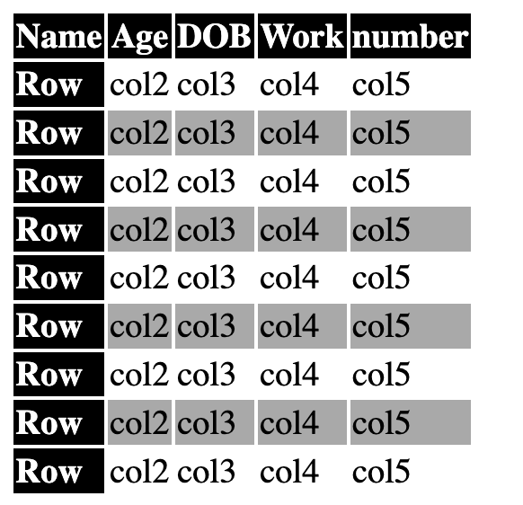

Q11 :

CODE

<!DOCTYPE html>

<html lang="en">

<head>

<meta charset="UTF-8">

<meta http-equiv="X-UA-Compatible" content="IE=edge">

<meta name="viewport" content="width=device-width, initial-scale=1.0">

<title>CSS Table Style</title>

<link rel="stylesheet" href="q4.css">

</head>

<body>

<table>

<tr><th>Name</th><th>Age</th><th>DOB</th><th>Work</th><th>number</th></tr>

<tr><td>Row</td><td>col2</td><td>col3</td><td>col4</td><td>col5</td></tr>

<tr><td>Row</td><td>col2</td><td>col3</td><td>col4</td><td>col5</td></tr>

<tr><td>Row</td><td>col2</td><td>col3</td><td>col4</td><td>col5</td></tr>

<tr><td>Row</td><td>col2</td><td>col3</td><td>col4</td><td>col5</td></tr>

<tr><td>Row</td><td>col2</td><td>col3</td><td>col4</td><td>col5</td></tr>

<tr><td>Row</td><td>col2</td><td>col3</td><td>col4</td><td>col5</td></tr>

<tr><td>Row</td><td>col2</td><td>col3</td><td>col4</td><td>col5</td></tr>

<tr><td>Row</td><td>col2</td><td>col3</td><td>col4</td><td>col5</td></tr>

<tr><td>Row</td><td>col2</td><td>col3</td><td>col4</td><td>col5</td></tr>

</table>

</div>

</body>

</html>

CSS :

td:nth-child(even)

{

background-color: rgb(219, 154, 154);

}

td:nth-child(odd)

{

background-color:rgb(140, 168, 159);

}

th

{

background-color: rgb(127, 150, 37);

color:white;

font-style: italic;

text-align: center;

padding: 4px;

}

table

{

font-size: larger;

text-align: center;

padding: 3px;

}

td,tr{

padding: 4px;

}

OUTPUT :   
