Name : HARSHRAJSINH ZALA

REG NO : 22BCE2238

Q1. Usage of abbr

CODE:

<!DOCTYPE html>

<html lang="en">

<head>

<meta charset="UTF-8">

<meta name="viewport" content="width=device-width, initial-scale=1.0">

<title>Usage of abbr</title>

</head>

<body>

<p>

Tomorrow I'll be heading to the Kennedy Space Center to learn about the

National Aeronautics and Space Administration (NASA). Touring through the

rockets used in

<abbr title="National Aeronautics and Space Administration">NASA</abbr>

will be such fun!

</p>

</body>

</html>

Output:

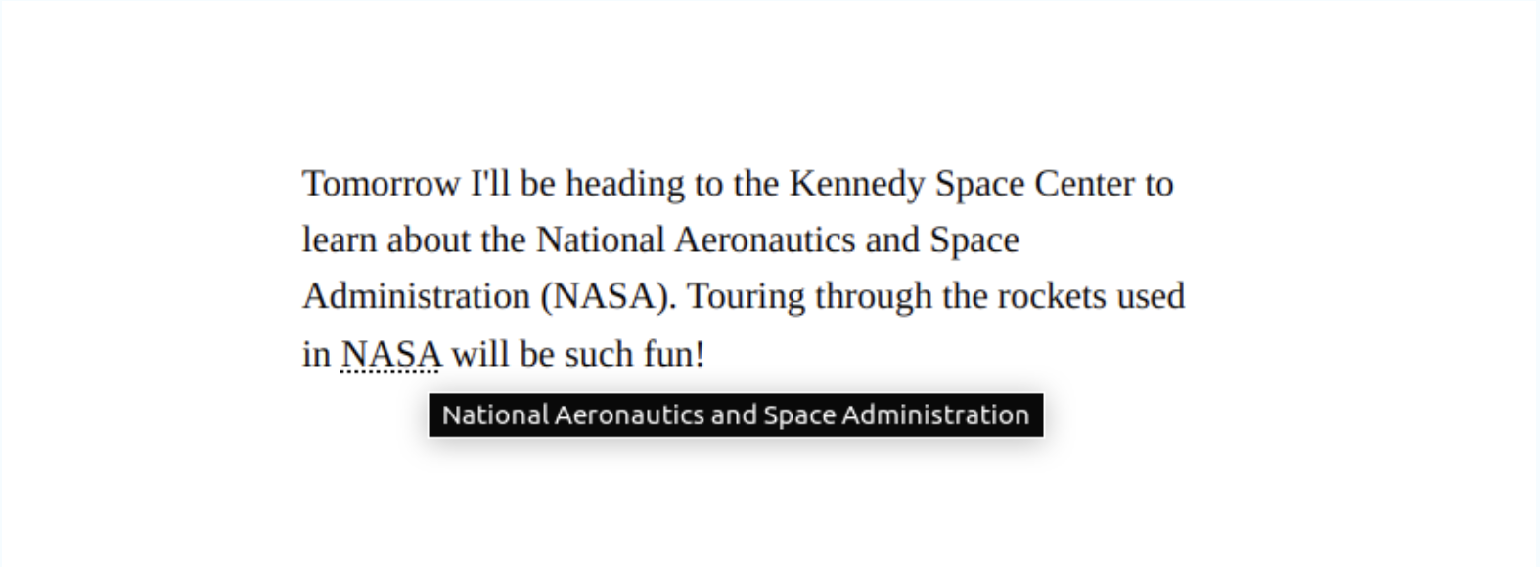

Q2 : USAGE OF ADDRESS

CODE :

<!DOCTYPE html>

<html lang="en">

<head>

<meta charset="UTF-8">

<meta name="viewport" content="width=device-width, initial-scale=1.0">

<title>HTML tutorial</title>

</head>

<body>

Hello Welcome to my Webpage <br>

<address>

Harshrajsinh Zala <br>

VIT University <br>

Vellore <br>

India <br>

</address>

Thanks for Visiting my Page

</body>

</html>

OUTPUT :   
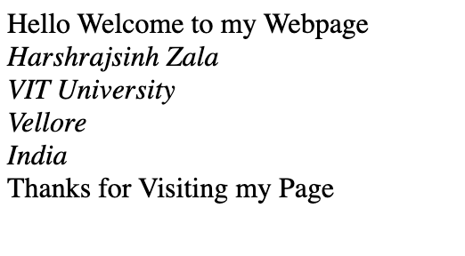

Q3 : USAGE OF CAPTION

CODE:  
<!DOCTYPE html>

<html lang="en">

<head>

<meta charset="UTF-8">

<meta name="viewport" content="width=device-width, initial-scale=1.0">

<title>Table</title>

</head>

<body>

<h1>Course Details</h1>

<label for="sem">Select Semester: </label>

<select name="sem" id="sem">

<option value="sem1">Winter-Sem 2024</option>

<option value="sem2">Fall-Sem 2023</option>

</select><br>

<br>

<table border="1">

<caption>THIS IS THE CAPTION</caption>

<thead>

<tr><th colspan="10">Regular Courses</th></tr>

<tr>

<th>Serial No.</th>

<th>Course Code</th>

<th>Title</th>

<th>Type</th>

<th>Slot</th>

<th>Class Number</th>

</tr>

</thead>

<tbody>

<tr>

<td>1</td>

<td>CSE3002</td>

<td>Internet and Web Programming</td>

<td>ETH</td>

<td>A1</td>

<td>VL20223509867</td>

</tr>

<tr>

<td>2</td>

<td>CSE3002</td>

<td>Internet and Web Programming</td>

<td>ETH</td>

<td>A2</td>

<td>VL20223508768</td>

</tr>

<tr>

<td>3</td>

<td>CSE3002</td>

<td>Internet and Web Programming</td>

<td>ELA</td>

<td>L9+L10</td>

<td>VL20223509345</td>

</tr>

<tr>

<td>4</td>

<td>CSE3002</td>

<td>Internet and Web Programming</td>

<td>ELA</td>

<td>L52+L53</td>

<td>VL20223507689</td>

</tr>

<tr>

<td>5</td>

<td>CSE3002</td>

<td>Internet and Web Programming</td>

<td>ELA</td>

<td>L14+L15</td>

<td>VL20223509665</td>

</tr>

</tbody>

</table>

</body>

</html>

OUTPUT:

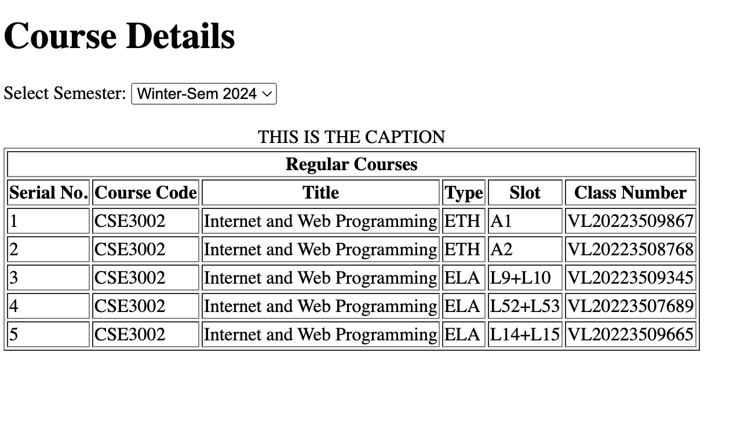

Q4 : USAGE OF CODE

CODE:

<!DOCTYPE html>

<html>

<body>

<pre>

<code>

#include&lt;stdio.h&gt;

int main() {

printf("Hello My name is Harshraj");

}

</code>

</pre>

</body>

</html>

Output:

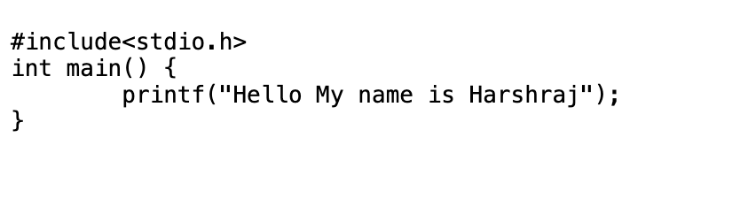

Q5: Usage of COLGROUP

CODE :

<!DOCTYPE html>

<html lang="en">

<head>

<meta charset="UTF-8">

<meta name="viewport" content="width=device-width, initial-scale=1.0">

<title>HTML tutorial</title>

<style>

table, th, td {

border: 1px solid black;

width: 200px;

}

</style>

</head>

<body>

Hello Welcome to my Webpage

<table>

<colgroup>

<col style="background-color: aqua;">

<col span="1" style="background-color:bisque">

<col span="1" style="background-color:gold">

</colgroup>

<caption>Marks of Students</caption>

<tr><td>Harsh</td><td>50</td><td>Java</td></tr>

<tr><td>Rohan</td><td>48</td><td>Maths</td></tr>

<tr><td>Yash</td><td>45</td><td>Physics</td></tr>

</table>

</body>

</html>

OUTPUT:   
  
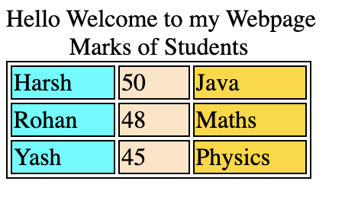

Q6 : DATALIST TAG  
code:

<!DOCTYPE html>

<html lang="en">

<head>

<meta charset="UTF-8">

<meta name="viewport" content="width=device-width, initial-scale=1.0">

<title>HTML tutorial</title>

</head>

<body>

<form>

Select your Subject

<input list="subjects" name="subject" id="subject">

<datalist id="subjects">

<option value="Java">Java</option>

<option value="DSD">DSD</option>

<option value="PNC">PNC</option>

<option value="DBMS">DBMS</option>

</datalist>

<input type="submit">

</form>

</body>

</html>

OUTPUT :



Q7: DL TAG

CODE:

<!DOCTYPE html>

<html lang="en">

<head>

<meta charset="UTF-8">

<meta name="viewport" content="width=device-width, initial-scale=1.0">

<title>DL tag</title>

</head>

<body>

<dl>

<dd>ROM</dd>

<dt>Read Only Memory</dt>

<dd>RAM</dd>

<dt>Random Access Memory</dt>

</dl>

</body>

</html>

OUTPUT:

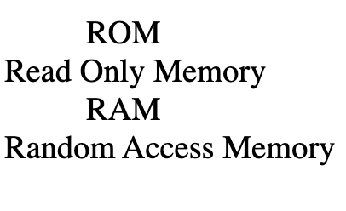

Q8: DEL TAG

CODE:

<!DOCTYPE html>

<html lang="en">

<head>

<meta charset="UTF-8">

<meta name="viewport" content="width=device-width, initial-scale=1.0">

<title>DEL TAG</title>

</head>

<body>

I am currently learning<del>Java</del> WEB DEV

</body>

</html>

OUTPUT:



Q9 : DETAILS TAG

CODE :

<!DOCTYPE html>

<html lang="en">

<head>

<meta charset="UTF-8">

<meta name="viewport" content="width=device-width, initial-scale=1.0">

<title>HTML tutorial</title>

</head>

<body>

<h1>Welcome to my Page</h1>

<details>

<summary>Central Processing Unit</summary>

<p>This is called the brain of the computer , without this a computer cannot be imagined</p>

</details>

</body>

</html>

OUTPUT:   
  


Q10: FIELDSET TAG

CODE:

<!DOCTYPE html>

<html lang="en">

<head>

<meta charset="UTF-8">

<meta name="viewport" content="width=device-width, initial-scale=1.0">

<title>HTML tutorial</title>

</head>

<style>

#t1{

width:300px;

}

</style>

<body>

<h1>Welcome to my Webpage</h1>

<form>

<fieldset id="t1">

<legend>WEBDEV class form</legend>

<label for="username">Enter your Username</label>

<input type="text"> <br>

<label for="password">Enter your Password</label>

<input type="password">

</fieldset>

</form>

</body>

</html>

OUTPUT:   
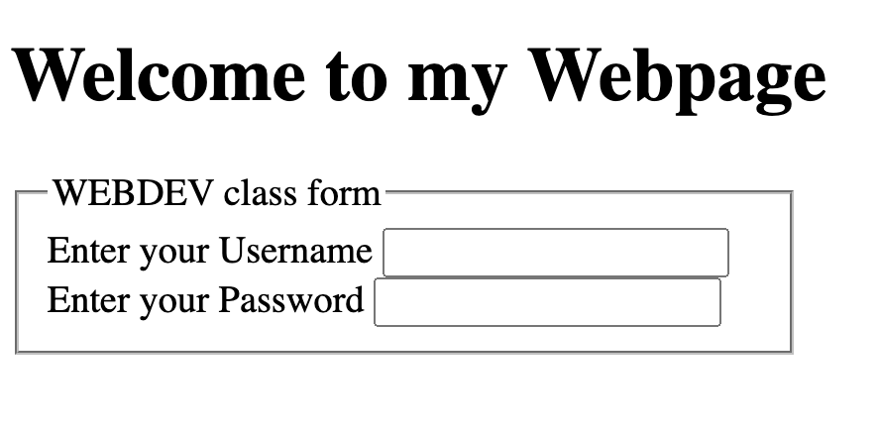

Q11 :

Code:

<!DOCTYPE html>

<html lang="en">

<head>

<meta charset="UTF-8">

<meta name="viewport" content="width=device-width, initial-scale=1.0">

<title>HTML tutorial</title>

</head>

<style>

#t1{

width:300px;

background-color: aqua;

}

</style>

<body>

<h1>Welcome to my Webpage</h1>

<figure>

<img src="images/blue.png" alt="blue button image">

<figcaption>Fig: Blue button</figcaption>

</figure>

</body>

</html>

OUTPUT:  
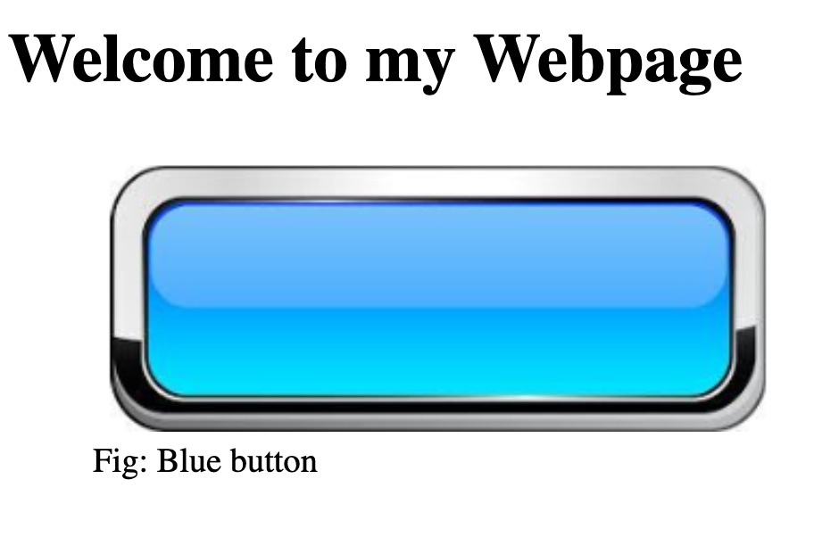

Q12:

Code :

<!DOCTYPE html>

<html lang="en">

<head>

<meta charset="UTF-8">

<meta name="viewport" content="width=device-width, initial-scale=1.0">

<title>HTML tutorial</title>

</head>

<style>

#t1{

width:300px;

background-color: aquamarine;

}

</style>

<body>

<hgroup>

<h2>Web development</h2>

<p>You need to learn html ,css, javascript , React and nodejs for becoming full stack developer</p>

</hgroup>

</body>

</html>

Output :

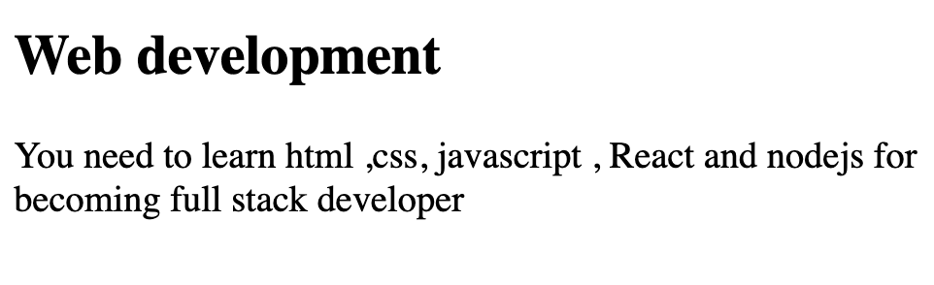

Q13 : MENU TAG

CODE:

<!DOCTYPE html>

<html lang="en">

<head>

<meta charset="UTF-8">

<meta name="viewport" content="width=device-width, initial-scale=1.0">

<title>Alternative to ul tag</title>

</head>

<style>

#t1{

width:300px;

background-color: aqua;

}

</style>

<body>

<h2>Alternative to ul tag is menu tag</h2>

<menu>

<li>item1</li>

<li>item2</li>

<li>item3</li>

</menu>

</body>

</html>

OUTPUT:  
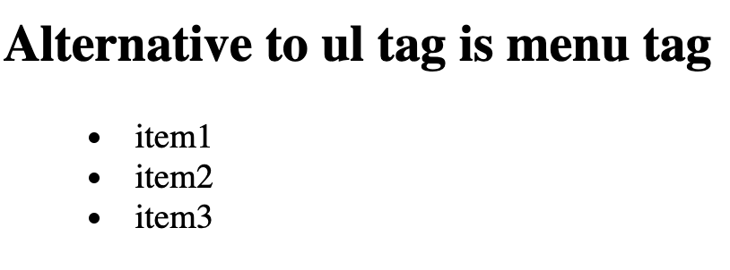

Q14 : METER TAG

Code :

<!DOCTYPE html>

<html lang="en">

<head>

<meta charset="UTF-8">

<meta name="viewport" content="width=device-width, initial-scale=1.0">

<title>HTML tutorial</title>

</head>

<body>

<h1>How Happy You Are</h1>

<label for="Harsh">Harsh</label>

<meter id="s1" value="50" min="0" max="100"></meter>

<label for="yash">Yash</label>

<meter id="s1" value="30" min="0" max="100"></meter>

</body>

</html>

OUTPUT :



Q15 :

CODE :

<!DOCTYPE html>

<html lang="en">

<head>

<meta charset="UTF-8">

<meta name="viewport" content="width=device-width, initial-scale=1.0">

<title>HTML tutorial</title>

</head>

<body>

<label for="countries">Select Your Country</label>

<select name="countries" id="country">

<optgroup label="Asia">

<option value="India" selected>India</option>

<option value="India">Pakistan</option>

<option value="India">Srilanka</option>

</optgroup>

<optgroup label="North America">

<option value="India">US</option>

<option value="India">Canada</option>

<option value="India">Mexico</option>

</optgroup>

</select>

</body>

</html>

OUTPUT :   
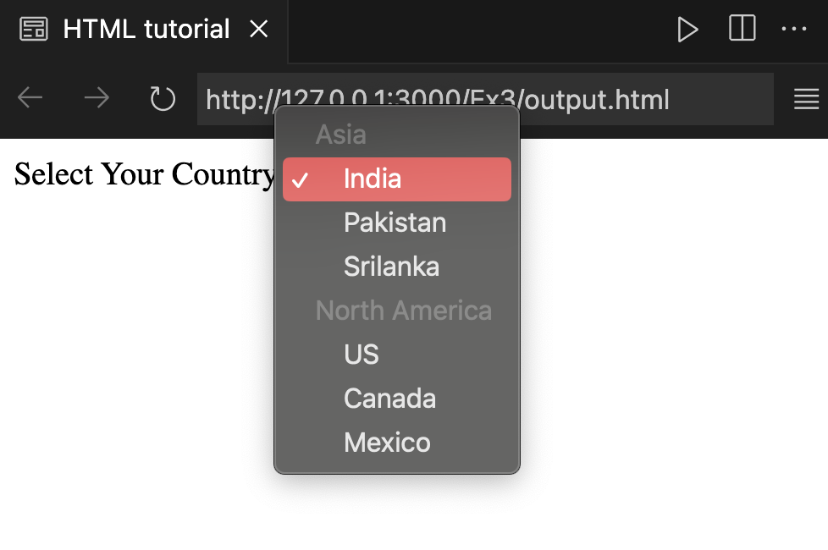

Q16 : NO SCRIPT TAG

CODE :

<!DOCTYPE html>

<html lang="en">

<head>

<meta charset="UTF-8">

<meta name="viewport" content="width=device-width, initial-scale=1.0">

<title>HTML tutorial</title>

</head>

<body>

<script>

function test()

{

document.write("hello world");

}

test();

</script>

<noscript>

Sorry the script is disabled in your system.

</noscript>

</body>

</html>

OUTPUT :

Q17 : Sup and Sub TAG

CODE :

<!DOCTYPE html>

<html lang="en">

<head>

<meta charset="UTF-8">

<meta name="viewport" content="width=device-width, initial-scale=1.0">

<title>SUP AND SUB</title>

</head>

<body>

<h1>See below</h1>

what is X<sup>2</sup> + Y<sub>2</sub>

</body>

</html>

OUTPUT :  
