NAME : HARSHRAJSINH ZALA

REGNO : 22BCE2238

MEDIA QUERIES:

Code:

Html:

<!DOCTYPE html>

<html lang="en">

<head>

<meta charset="UTF-8">

<meta name="viewport" content="width=device-width, initial-scale=1.0">

<title>Document</title>

<link rel="stylesheet" href="style.css">

</head>

<body>

<div class="container">

<div class="item1">1</div>

<div class="item2">2</div>

<div class="item3">3</div>

<div class="item4">4</div>

<div class="item5">5</div>

<div class="item6">6</div>

<div class="item7">7</div>

<div class="item8">8</div>

<div class="item9">9</div>

<div class="item10">10</div>

<div class="item11">11</div>

<div class="item12">12</div>

</div>

</body>

</html>

CSS :   
.container{

display: flex;

flex-wrap: wrap;

}

.container >div{

background-color: #ddd;

height: 200px;

width: 200px;

}

.container>div:nth-child(odd){

background-color: burlywood;

}

@media screen and (max-width:500px) {

.container{

flex-direction: column;

}

.container>div{

width: 96vw;

}

}

/\* @media screen and (max-width:600px) and (max-width:800px){

body{

color: red;

}

} \*/

OUTPUT :

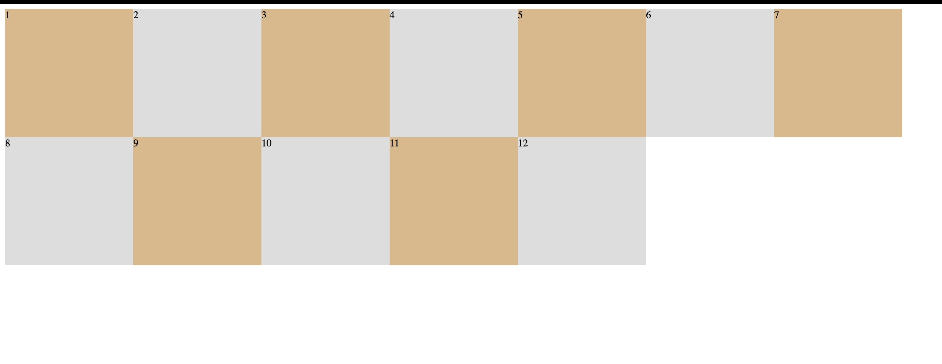

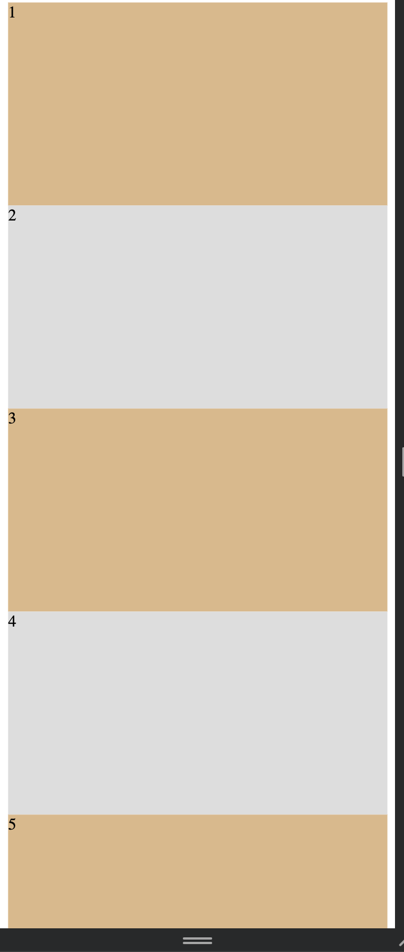

Q2

Code:

HTML :

<!DOCTYPE html>

<html lang="en">

<head>

<meta charset="UTF-8">

<meta name="viewport" content="width=device-width, initial-scale=1.0">

<title>Document</title>

<link rel="stylesheet" href="mystyle.css">

</head>

<body>

<div class="container">

<div class="item1">

<p>Lorem ipsum dolor sit amet consectetur adipisicing elit. Assumenda, blanditiis laudantium. Aspernatur distinctio blanditiis saepe, dicta aut dolorem sed odio sequi, quidem autem dolore debitis fugiat cumque quaerat eum doloribus ex! Repellendus quam alias quidem rerum ipsam aspernatur maxime minus, facere, vel possimus quos! Voluptate error quasi voluptatum laborum voluptatem!</p>

<img src="img.png" alt="asd">

</div>

<div class="item2">

<ul>

<li>Lorem, ipsum dolor sit amet consectetur adipisicing elit. Vero, aperiam?</li>

<li>Lorem ipsum dolor sit amet consectetur adipisicing elit. Distinctio, exercitationem!</li>

<li>Lorem ipsum, dolor sit amet consectetur adipisicing elit. Ullam, ipsam?</li>

<li>Lorem ipsum dolor sit amet consectetur adipisicing elit. Nesciunt, beatae.</li>

<li>Lorem ipsum dolor sit, amet consectetur adipisicing elit. Assumenda, animi.</li>

</ul>

</div>

<div class="item3">

<ul>

<li>Lorem, ipsum dolor sit amet consectetur adipisicing elit. Vero, aperiam?</li>

<li>Lorem ipsum dolor sit amet consectetur adipisicing elit. Distinctio, exercitationem!</li>

<li>Lorem ipsum, dolor sit amet consectetur adipisicing elit. Ullam, ipsam?</li>

<li>Lorem ipsum dolor sit amet consectetur adipisicing elit. Nesciunt, beatae.</li>

<li>Lorem ipsum dolor sit, amet consectetur adipisicing elit. Assumenda, animi.</li>

</ul>

</div>

</div>

</body>

</html>

CSS:

.container {

display: flex;

}

.container>div:nth-child(1) {

flex: 25%;

background-color: aqua;

padding: 30px;

margin: 5px;

}

.container>div:nth-child(2) {

flex: 50%;

background-color: red;

padding: 5px;

color: white;

margin: 5px;

}

.container>div:nth-child(3) {

flex: 20%;

background-color: blanchedalmond;

padding: 5px;

margin: 5px;

}

img {

height: auto;

width: auto;

}

@media screen and (max-width:500px) {

.container {

flex-direction: column;

}

}

@media screen and (min-width:600px) and (max-width:800px) {

.container>div:nth-child(2) {

background-color: burlywood;

}

}

OUTPUT :

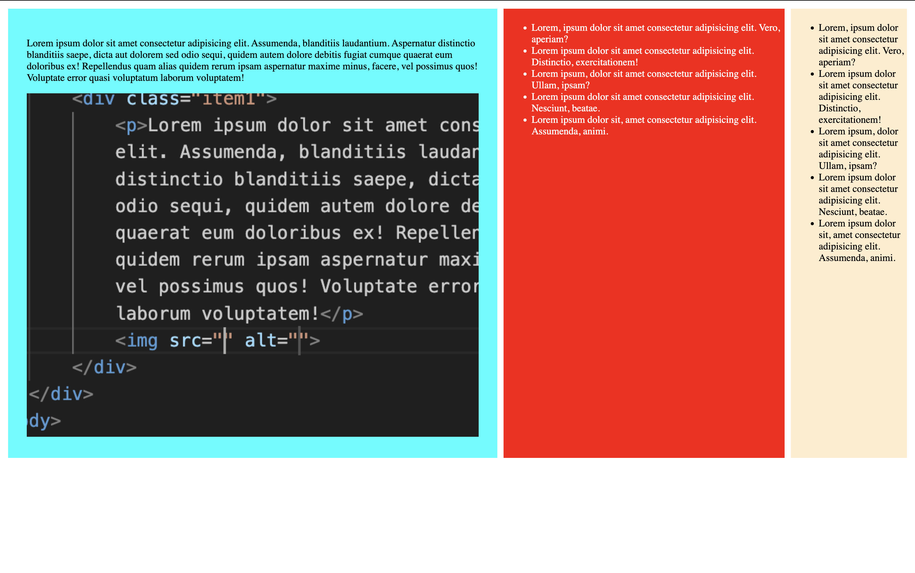

Q3 :

CODE :

HTML :

<!DOCTYPE html>

<html>

<head>

<link rel="stylesheet" href="style.css" />

</head>

<body>

<div class="grid-container">

<div class="item1"></div>

<div class="item2">

<h1>phpMyAdmin</h1>

<div class="nav">

<li><a href="#">Recent</a></li>

<li><a href="#">Favorites</a></li>

</div>

</div>

<div class="item3">3</div>

<div class="item4">4</div>

<div class="item5">5</div>

<div class="item6">6</div>

</div>

</body>

</html>

CSS :

.grid-container {

display: grid;

gap: 10px;

background-color: #2196f3;

padding: 10px;

margin: 5px;

height: 100vh;

}

.grid-container > div {

background-color: rgba(255, 255, 255, 0.8);

text-align: center;

padding: 20px 0;

font-size: 30px;

}

.item1{

grid-column-start: 2;

grid-column-end: 7;

}

.item2{

grid-column-start: 1;

grid-column-end: 1;

grid-row-start: 1;

grid-row-end: 6;

}

.item3{

grid-column-start: 2;

grid-column-end: 5;

grid-row-start: 2;

grid-row-end: 5;

}

.item4{

grid-column-start: 5;

grid-column-end:7;

grid-row-start: 2;

grid-row-end: 5;

}

.item5{

grid-column-start: 2;

grid-column-end: 5;

grid-row-start: 5;

grid-row-end: 6;

}

.item6{

grid-column-start: 5;

grid-column-end: 7;

grid-row-start: 5;

grid-row-end: 6;

}

li{

list-style-type: none;

}

li a{

text-decoration: none;

color: black;

padding: 5px;

margin: 5px;

}

h1{

font-size: smaller;

}

.nav{

display: flex;

padding: 5px;

margin: 5px;

}

OUTPUT :

