Deploying a MERN Application
through Terraform and Ansible on AWS
Application: TravelMemory (React + Express + MongoDB)
Learner: Harshrajsinh Parmar
Assignment: Deploying a MERN Application through Terraform and Ansible
Submitted: 29 October 2026
Repository: https://github.com/harshrajsinhparmar/Terraform_Ansible_Assignment
Region: AWS ap-south-1 (Mumbai)

Contents
1. Objective and summary
2. Architecture
3. Part 1 - Infrastructure with Terraform
4. Part 2 - Configuration and deployment with Ansible
5. Working application
6. Security hardening
7. Challenges and how they were solved
8. Cost and cleanup
9. Requirement checklist

1. Objective and summary
The goal of this assignment is to deploy the TravelMemory MERN application on AWS with the infrastructure created by Terraform and the servers configured by Ansible, with the database kept in a private subnet. Nothing was created by clicking in the AWS console; the console was used only to check what the code had built.
What was delivered:
- Terraform code that builds a VPC with one public and one private subnet, an Internet Gateway, a NAT Gateway, route tables, security groups, an IAM role and two EC2 instances, and outputs the web server's public IP.
- Terraform also generates the Ansible inventory from its own outputs, so the two tools stay in sync and no IP addresses are copied by hand.
- Ansible roles that harden both servers, install and secure MongoDB with authentication, and deploy the Express API and the React production build behind Nginx.
- End-to-end proof: the app loads in the browser at the web server's public IP, a trip added through the React form is stored in MongoDB, and the database cannot be reached from the internet.
Deliverables and where to find them
Deliverable (from the brief) | Location in the repository
Terraform scripts for AWS infrastructure | terraform/ (9 .tf files, inventory template, example tfvars and backend config, state bootstrap script)
Ansible playbooks for configuration and deployment | ansible/site.yml and ansible/roles/{common, hardening, mongodb, webserver}
Detailed report | This document and README.md
Screenshots of the working application | Included in this report (Figures 1 to 64)

Repository: https://github.com/harshrajsinhparmar/Terraform_Ansible_Assignment

2. Architecture
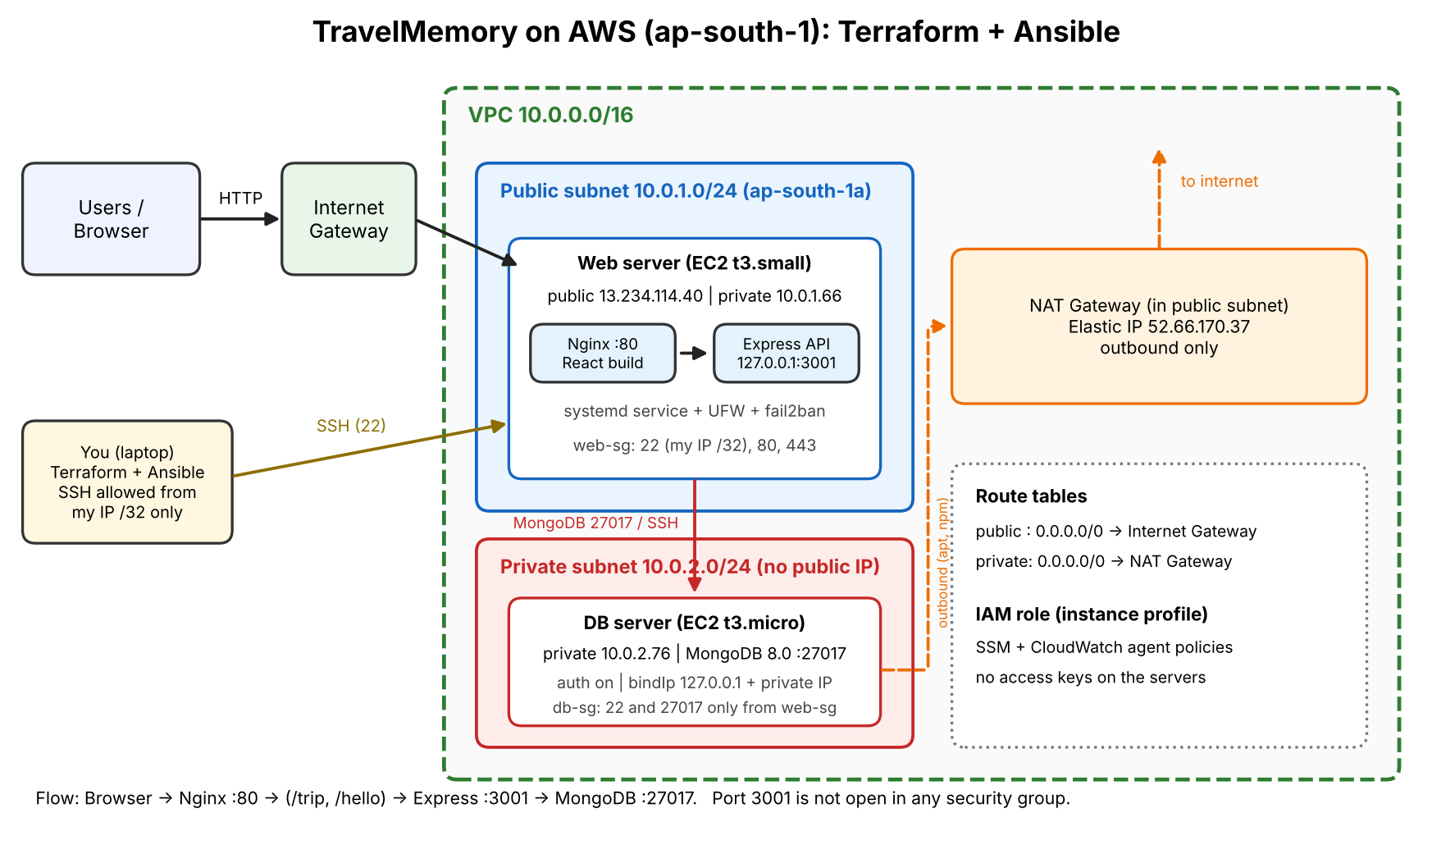
Figure 1: Target architecture: web tier in the public subnet, MongoDB in the private subnet

How the application components interact
- Browser to Nginx. The user opens http://<web_public_ip>/. Nginx on port 80 serves the React production build.
- React to API. The React code calls the backend URL set in frontend/.env. This value is compiled into the JavaScript bundle at build time, so Ansible writes frontend/.env before running npm run build. If it were left at localhost, the browser would try to reach the user's own machine.
- Nginx to Express. Nginx proxies the API routes (/trip and /hello) to Express on 127.0.0.1:3001. Port 3001 is not opened in any security group, so the API is reachable only through Nginx.
- Express to MongoDB. Express reads MONGO_URI from backend/.env (written by Ansible) and connects to MongoDB on the DB server's private IP, port 27017, as an application user that only has readWrite on the travelmemory database.
- Cross-origin check. The Express CORS allow-list (CORS_ORIGIN) contains the public address of the site, so the browser's requests are accepted.
- Network controls. db-sg allows port 27017 only from web-sg. On top of that, UFW on the DB server allows 27017 only from the web server's private IP (10.0.1.66).
- Outbound access for the private subnet. The DB server has no public IP. Its route table sends 0.0.0.0/0 to the NAT Gateway, which is how apt and the MongoDB repository are reached during installation.
- Administration. SSH to the web server is allowed only from my own IP (/32). SSH to the DB server goes through the web server as a jump host.

Tools and versions
Tool | Version | Purpose
Terraform | 1.17.0 (AWS provider 5.100.0, local provider 2.9.1) | Provision VPC, networking, security groups, IAM, EC2
Ansible core | 2.21.5 | Configure servers and deploy the application
AWS CLI | 2.38.6 | Authentication and resource verification
Control machine | Ubuntu 24.04 on WSL2 | Where Terraform and Ansible run
Ubuntu (servers) | 24.04 LTS | OS for both EC2 instances
Node.js | 22 LTS (NodeSource) | Express API and React build
MongoDB | 8.0.34 (mongosh 2.14.0) | Database
Nginx | Ubuntu package | Static hosting and reverse proxy

3. Part 1 - Infrastructure with Terraform

3.1 AWS CLI setup and Terraform initialisation
The control machine is Ubuntu 24.04 running on WSL2. AWS CLI v2, Terraform, Ansible and Git were installed and their versions checked. The AWS CLI was then configured with an IAM user's access key for region ap-south-1, and sts get-caller-identity confirmed the account that Terraform would use.
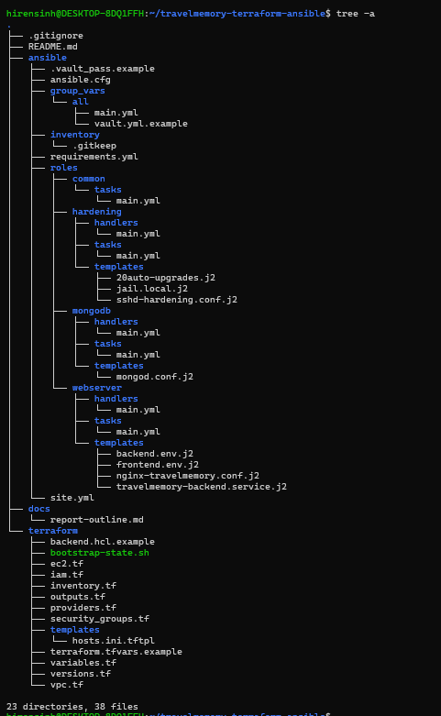
Figure 2: Repository structure (23 directories, 38 files)
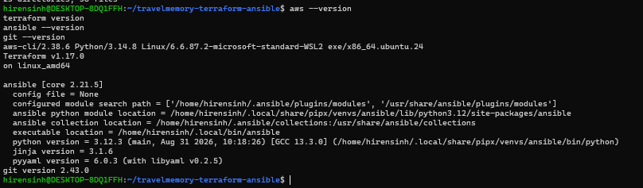
Figure 3: Tool versions on the control machine (AWS CLI, Terraform, Ansible, Git)
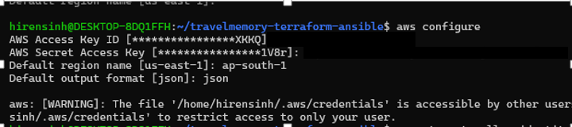
Figure 4: aws configure for region ap-south-1 (secret values hidden)
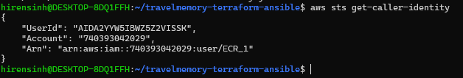
Figure 5: aws sts get-caller-identity confirms the authenticated account
An SSH key pair was created on the laptop. Terraform uploads only the public key to AWS as a key pair; the private key never leaves the laptop and is never committed to Git.
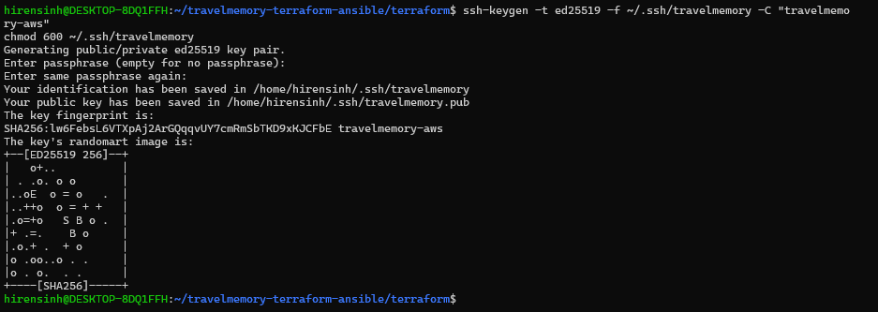
Figure 6: SSH key pair created for the servers
Terraform state is kept remotely in an S3 bucket instead of in the repository. The helper script bootstrap-state.sh creates the bucket once and writes backend.hcl. State locking uses the native S3 lock file (use_lockfile = true), so the state file is never committed to Git.
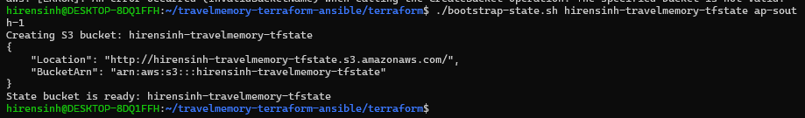
Figure 7: bootstrap-state.sh creates the S3 bucket for Terraform state
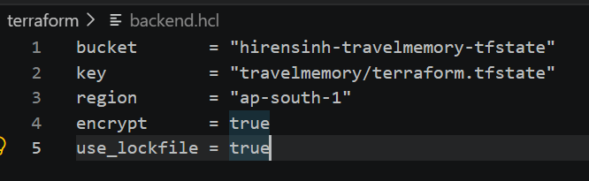
Figure 8: backend.hcl: S3 bucket, key, region, encryption and native locking
terraform.tfvars holds the values that differ per learner: region, project and environment names, the owner tag, the SSH CIDR (my current public IP as a /32), key paths and instance sizes. The web server uses t3.small because the React build needs about 2 GB of memory; the DB server uses t3.micro.
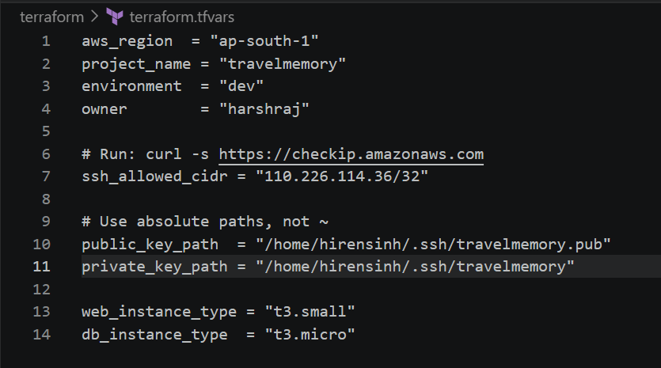
Figure 9: terraform.tfvars: region, tags, SSH CIDR (/32), key paths, instance types
terraform init downloaded the providers and configured the S3 backend. terraform fmt formatted the files and terraform validate reported that the configuration is valid.
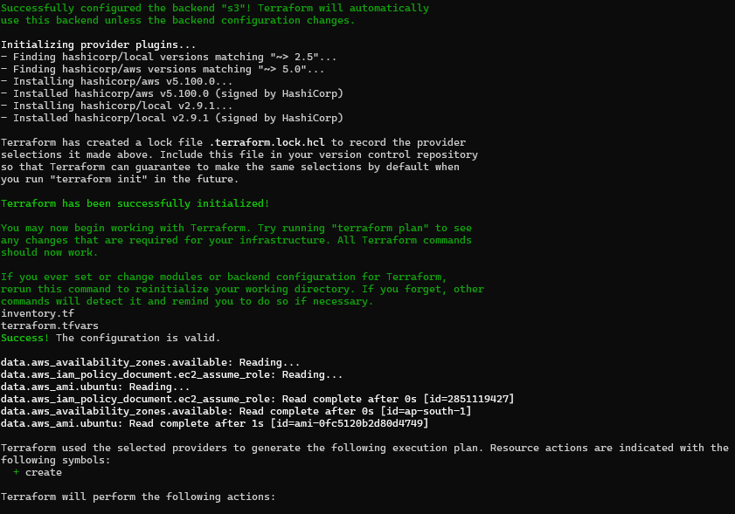
Figure 10: terraform init with the S3 backend, then fmt and validate (configuration is valid)

3.2 Code structure
The Terraform code is split into files by concern, with versions pinned in versions.tf.
File | What it contains
versions.tf | Terraform and provider version pins, S3 backend block
providers.tf | AWS provider with default tags (Project, Environment, Owner, ManagedBy)
variables.tf | Region, names, CIDRs, instance types, key paths, SSH CIDR
vpc.tf | VPC, public and private subnets, Internet Gateway, Elastic IP and NAT Gateway, two route tables, routes and associations
security_groups.tf | web-sg and db-sg, with one resource per rule
iam.tf | EC2 role, SSM and CloudWatch policy attachments, instance profile
ec2.tf | Ubuntu 24.04 AMI lookup, key pair, web and DB instances (IMDSv2 required, encrypted volumes)
inventory.tf and templates/hosts.ini.tftpl | Writes ansible/inventory/hosts.ini from the real instance IPs
outputs.tf | Web public IP, private IPs, NAT IP, VPC ID, SSH commands, app URL
backend.hcl.example, terraform.tfvars.example, bootstrap-state.sh | Safe examples to copy, and the one-time state bucket script

Network. The NAT Gateway sits in the public subnet and the private route table sends internet-bound traffic to it. The public route table sends internet-bound traffic to the Internet Gateway. The route to the NAT is created before the DB server needs it, so package installs work.
SSH only from my IP. The web server's SSH rule uses ssh_allowed_cidr, a single /32 address.
Database only from the web tier. The DB rules reference the web security group instead of a CIDR, so they keep working if IP addresses change. There is no rule that allows 0.0.0.0/0 inbound to the DB server.
Terraform to Ansible hand-off. A local_file resource renders ansible/inventory/hosts.ini from a template, using the real instance IPs and the jump-host setting the DB server needs.

3.3 Plan and apply
terraform plan reported 27 resources to add. The plan was saved to a file (tfplan) and applied exactly as reviewed. The NAT Gateway took the longest, about two minutes. The final output shows the public IP of the web server, as the brief requires.
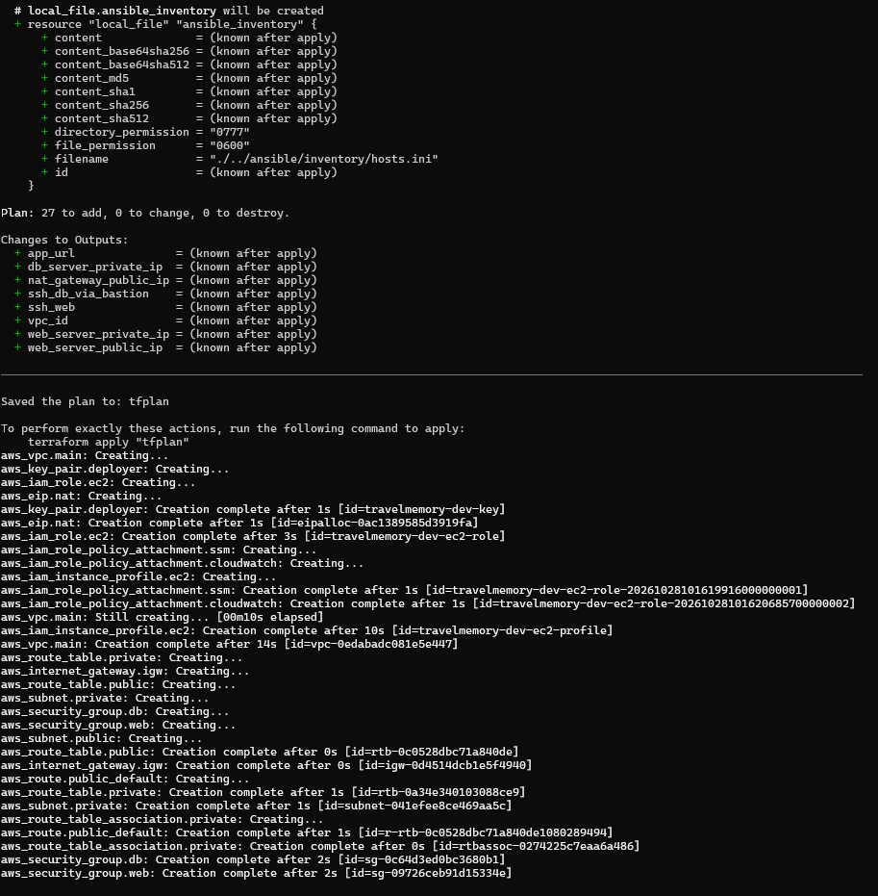
Figure 11: terraform plan: 27 to add, with the outputs listed; plan saved to tfplan
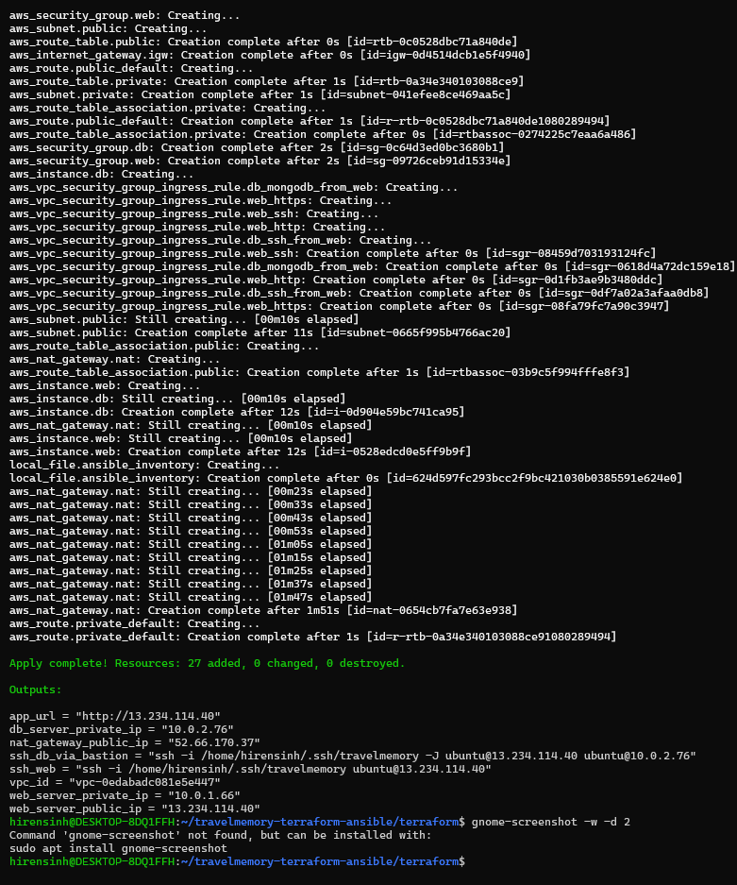
Figure 12: terraform apply complete: 27 added, with the web server public IP output

3.4 Verifying what was created
Each resource was checked in the AWS console. The VPC uses 10.0.0.0/16 with DNS hostnames enabled. The public subnet maps public IPs on launch and the private subnet does not.
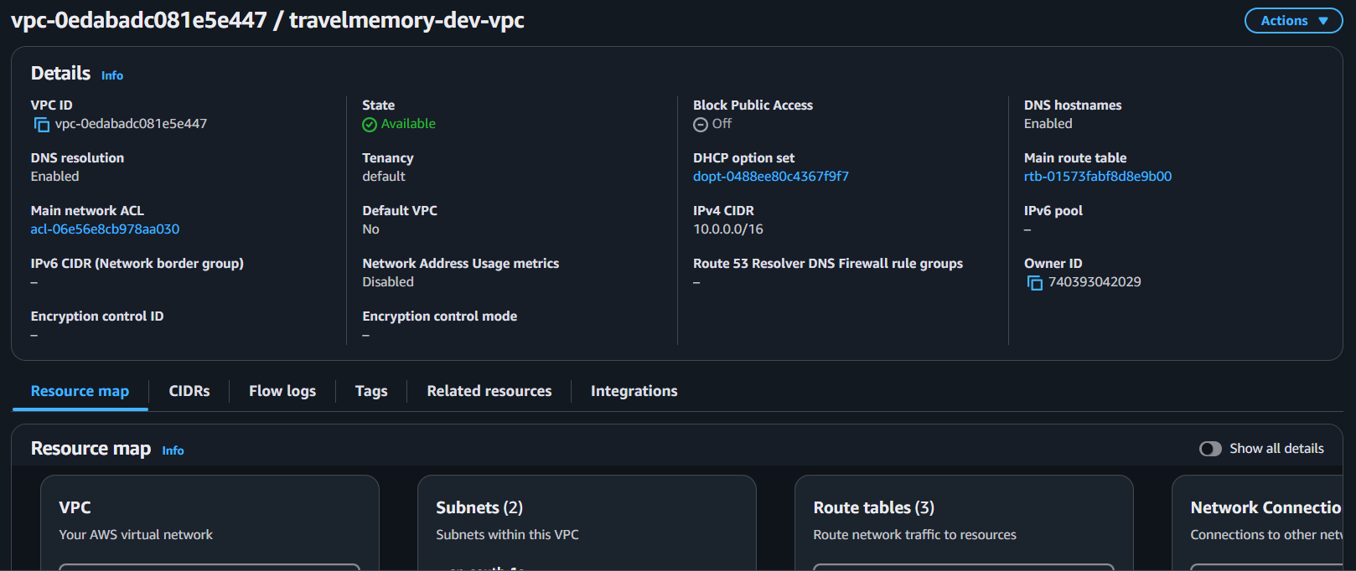
Figure 13: VPC 10.0.0.0/16 with DNS hostnames enabled
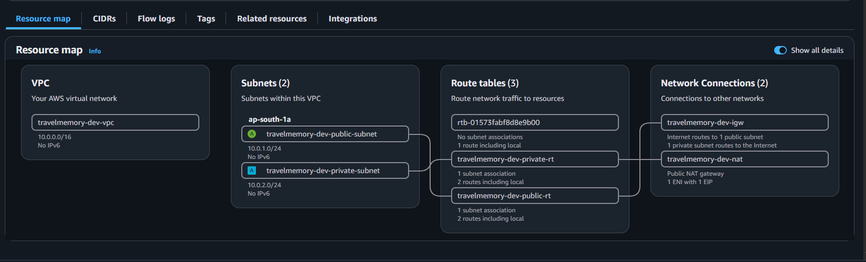
Figure 14: VPC resource map: two subnets, route tables and the connections
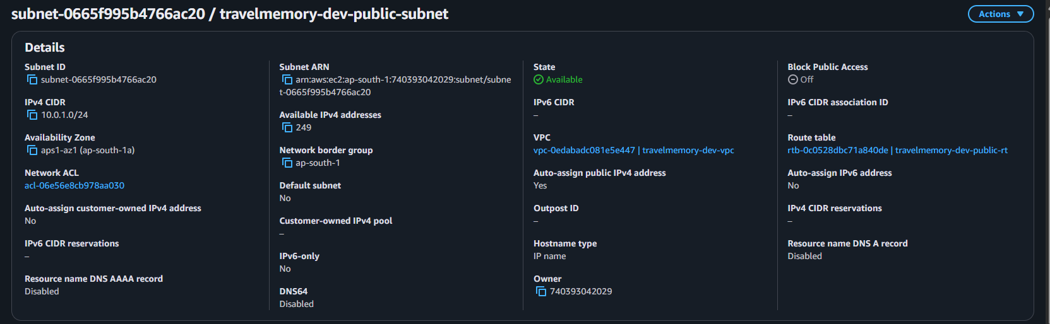
Figure 15: Public subnet 10.0.1.0/24: auto-assigns public IPs
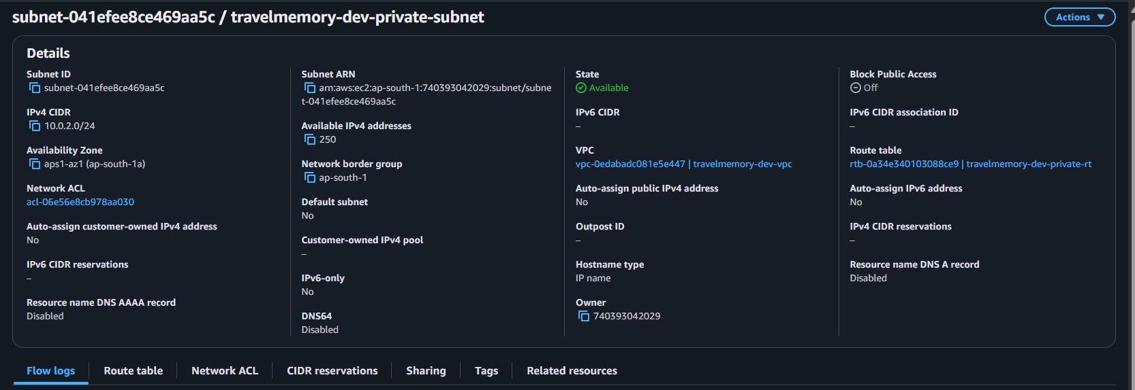
Figure 16: Private subnet 10.0.2.0/24: does not assign public IPs
The Internet Gateway is attached to the VPC. The NAT Gateway sits in the public subnet with an Elastic IP. The public route table points to the Internet Gateway and the private route table points to the NAT Gateway.
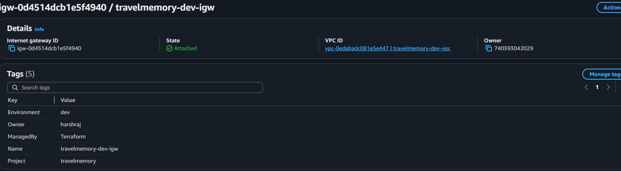
Figure 17: Internet Gateway attached to the VPC
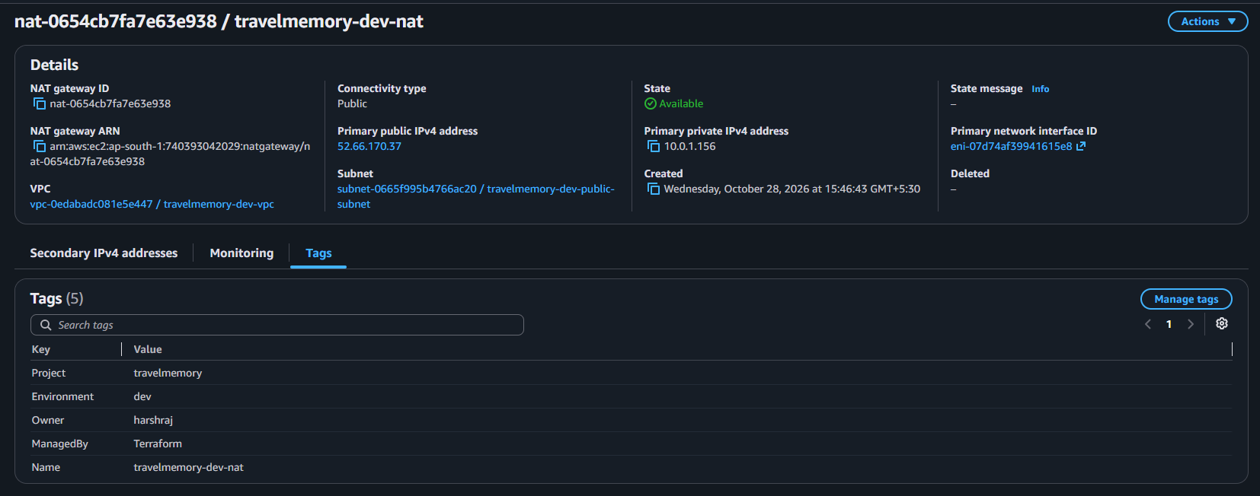
Figure 18: NAT Gateway in the public subnet
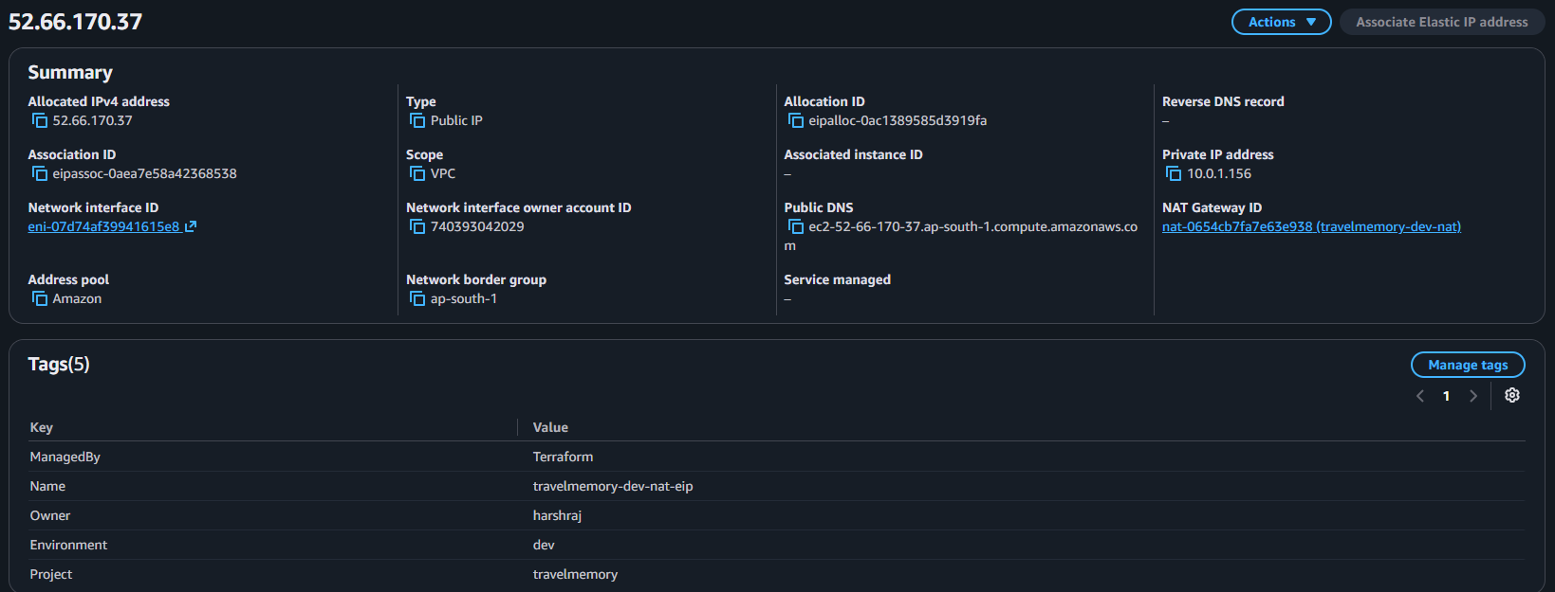
Figure 19: Elastic IP used by the NAT Gateway
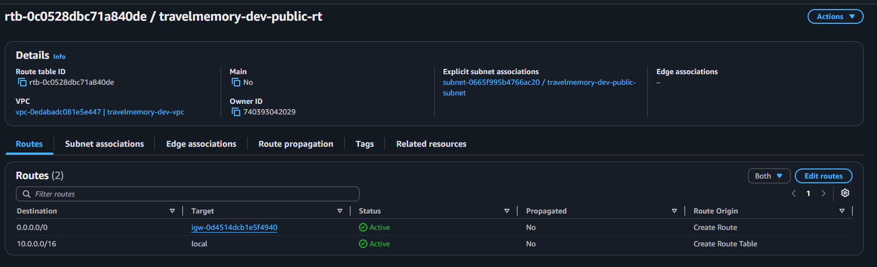
Figure 20: Public route table: 0.0.0.0/0 to the Internet Gateway
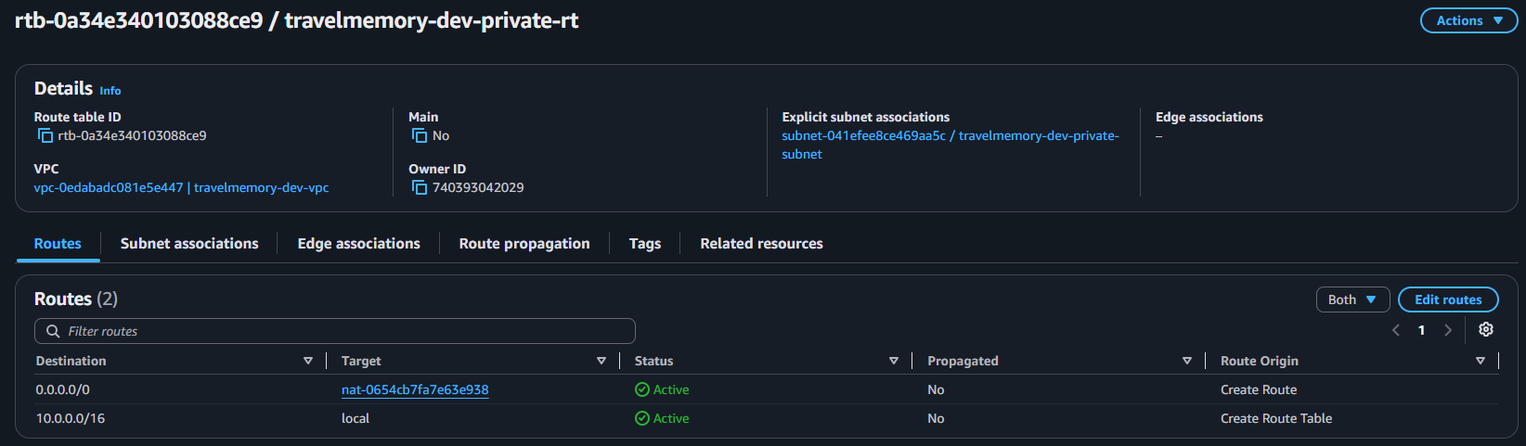
Figure 21: Private route table: 0.0.0.0/0 to the NAT Gateway
The web server has a public IP and the DB server has only a private one. Both use the instance profile and require IMDSv2.
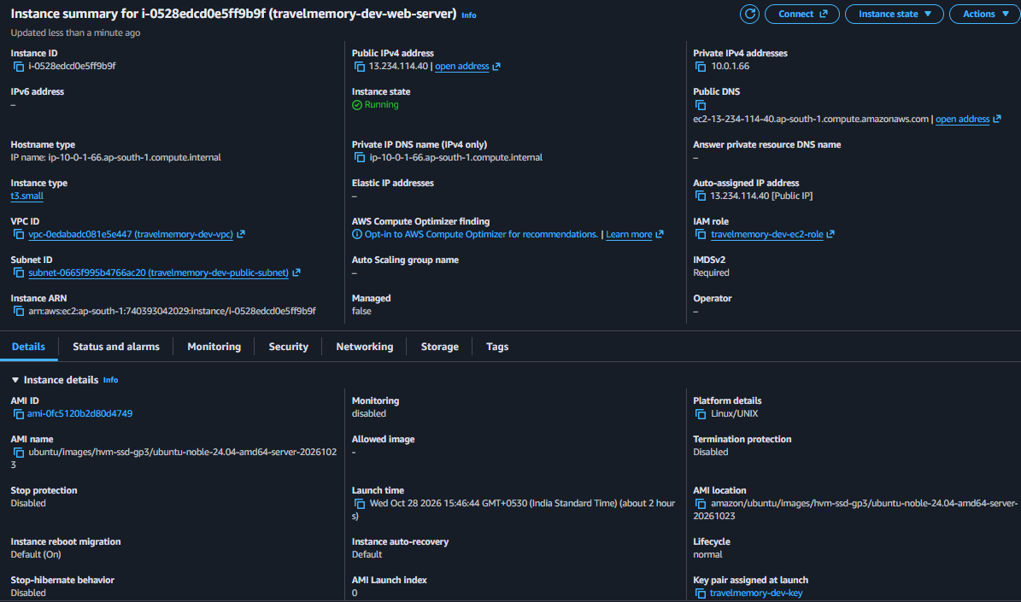
Figure 23: Web server: public IP, in the public subnet, with the instance profile
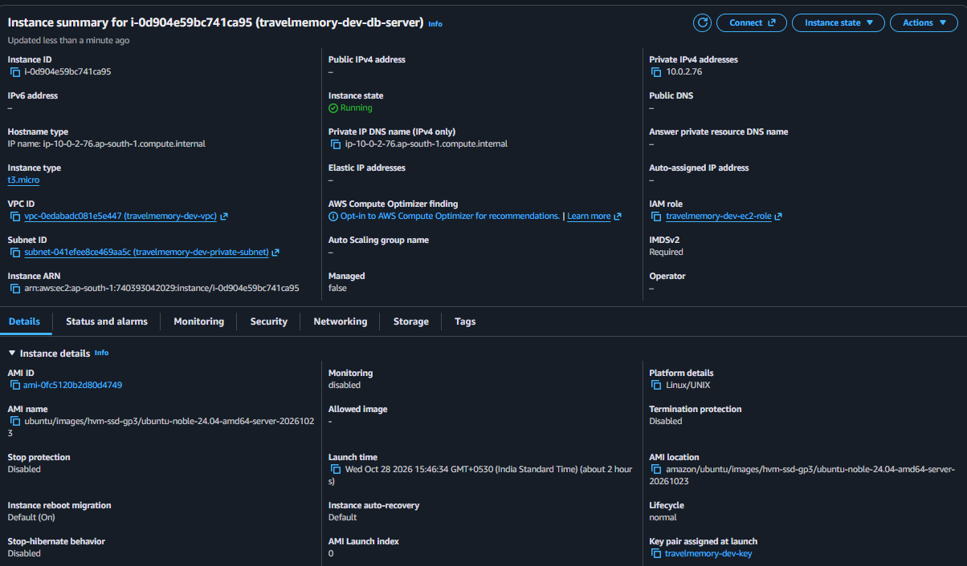
Figure 22: DB server: private IP only, in the private subnet, with the instance profile
Security group rules match the design: SSH to the web server only from my /32, HTTP and HTTPS public, and both SSH and MongoDB on the DB server only from web-sg. The EC2 role has only the SSM and CloudWatch agent managed policies; no access keys are stored on the servers.
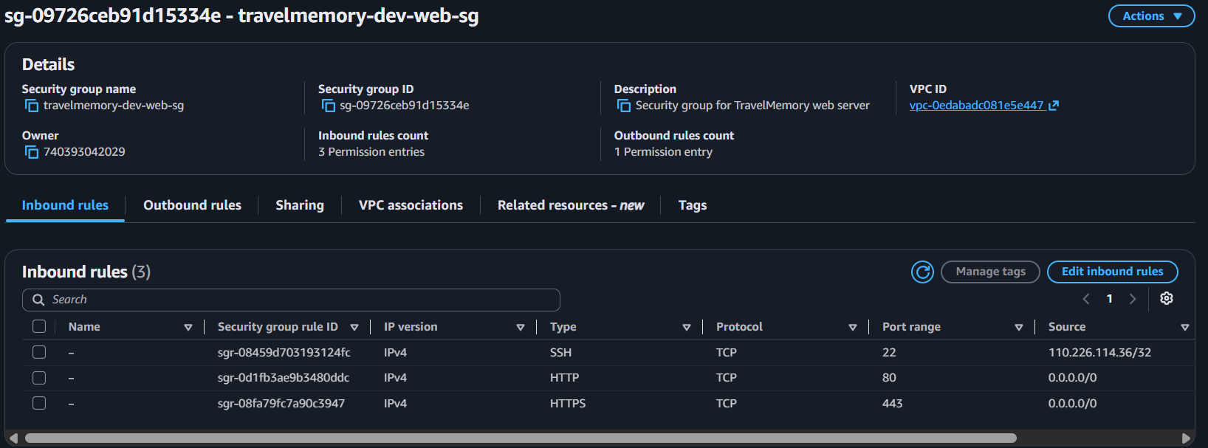
Figure 24: web-sg inbound rules: SSH from my /32 only, HTTP and HTTPS
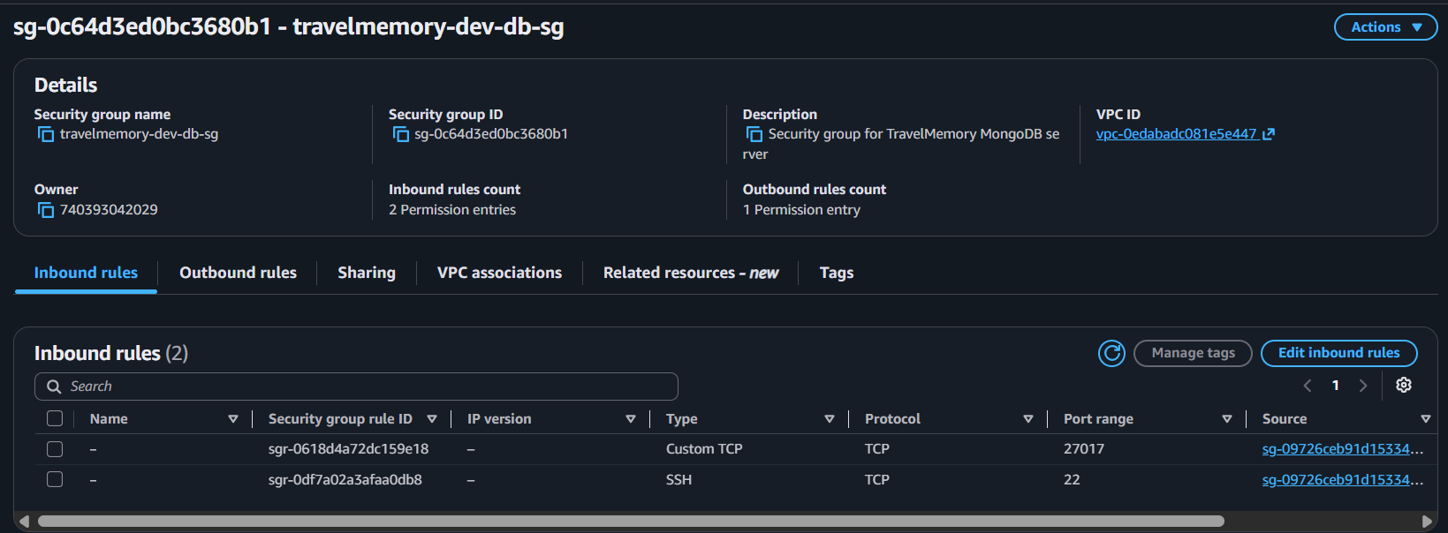
Figure 25: db-sg inbound rules: MongoDB and SSH only from the web security group
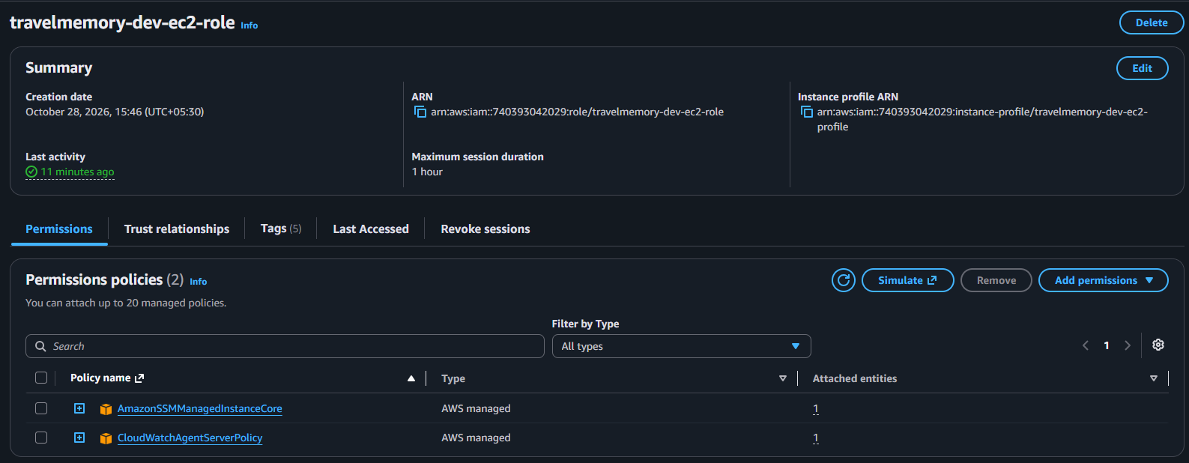
Figure 26: EC2 role with only the SSM and CloudWatch agent managed policies

4. Part 2 - Configuration and deployment with Ansible

4.1 Ansible configuration
ansible.cfg points at the Terraform-generated inventory, sets the remote user to ubuntu, enables SSH pipelining and reads the vault password from a git-ignored .vault_pass file. The inventory has two groups, web and db. The DB server has no public IP, so Ansible reaches it through the web server as a jump host; this is written into the inventory by Terraform. The required collections (community.general and ansible.posix) are listed in requirements.yml.
The MongoDB admin and application passwords live only in group_vars/all/vault.yml, which is encrypted with Ansible Vault. A vault.yml.example file shows the variable names without real values.
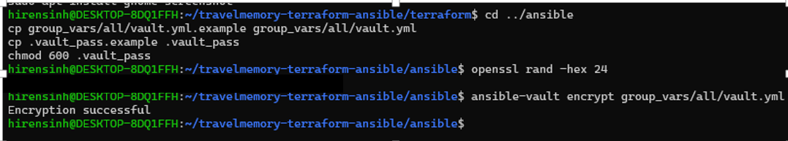
Figure 27: Ansible Vault: vault.yml encrypted, vault password file created
Before writing any task, both hosts were tested with an Ansible ping. Both return SUCCESS, which proves that the key, the SSH rule and the jump host all work.
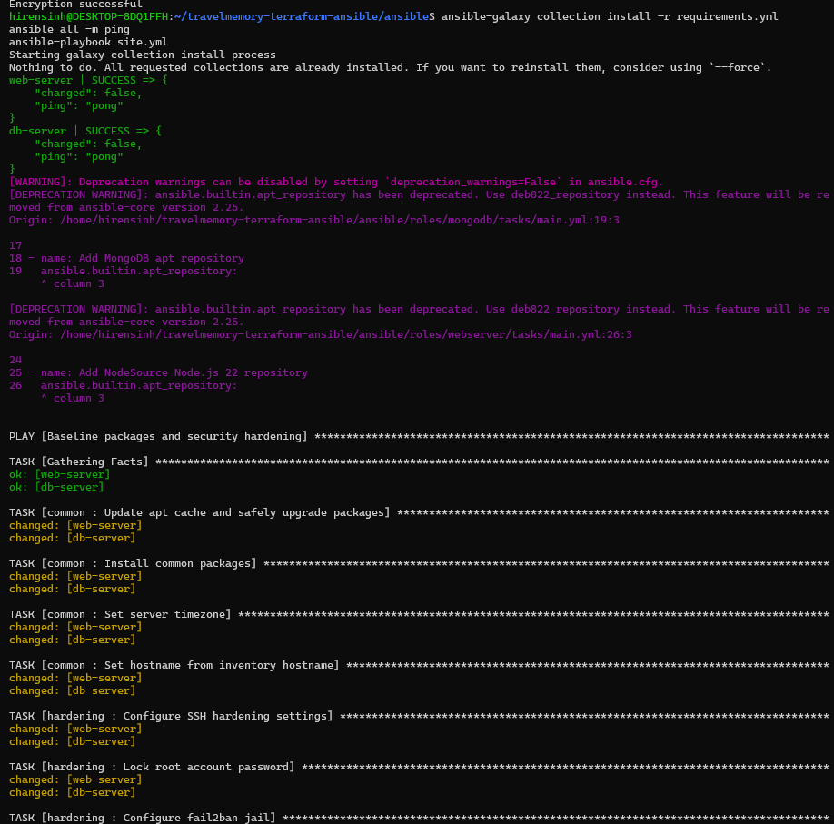
Figure 28: Collections installed and Ansible ping returns SUCCESS for both hosts

4.2 Roles
Role | Hosts | What it does
common | all | apt update and safe upgrade, base packages (git, ufw, fail2ban, acl and others), timezone, hostname
hardening | all | SSH hardening (no root login, no password login), root password locked, UFW default-deny with per-host rules, fail2ban jail, automatic security updates
mongodb | db | MongoDB apt repository, mongod.conf with the private bind address and authorization enabled, systemd override, idempotent creation of the admin user and the application user
webserver | web | Node.js 22 from NodeSource, Nginx, 2 GB swap file, application user, clone TravelMemory, backend and frontend .env files, npm install, React production build, systemd service for the API, Nginx site with reverse proxy

Securing MongoDB. Authorization is enabled in mongod.conf from the first start, and the server listens only on 127.0.0.1 and its private IP, never on 0.0.0.0. The first admin user is created through MongoDB's localhost exception, and the application user is then created with readWrite on the travelmemory database only. The tasks first check whether a user exists, so a second run does not repeat or fail.
Running the API. Express runs as a systemd service (npm start) under a dedicated non-login system user, so it starts on boot, restarts on failure and keeps running after the SSH session closes.
Frontend build. frontend/.env is written before npm run build, because the backend URL is baked into the bundle at build time. The finished build is copied to the Nginx web root.

4.3 Playbook run
ansible-playbook site.yml ran four plays: baseline and hardening on both hosts, MongoDB on the DB server, the web tier on the web server, and a final verification play that calls the health and trip endpoints through Nginx.
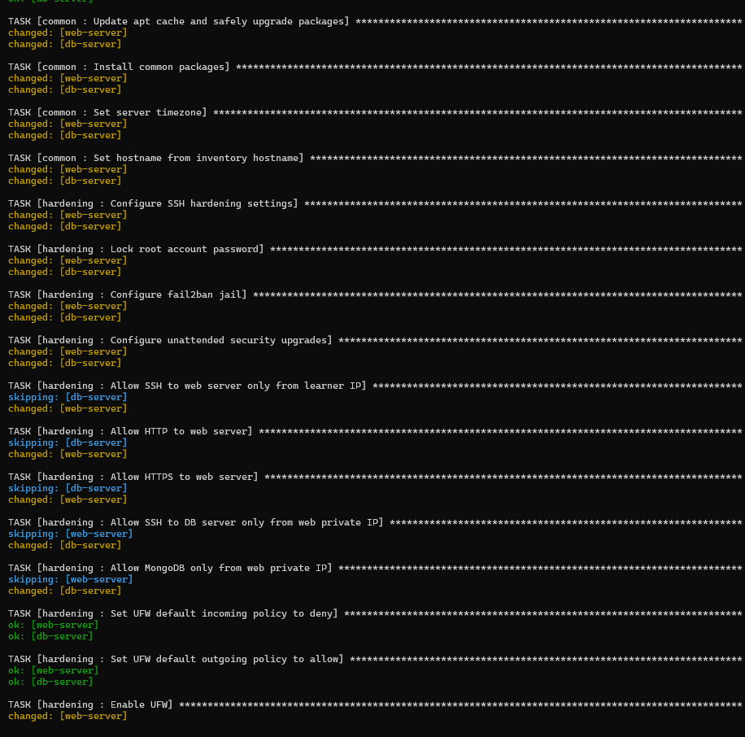
Figure 29: Play 1: baseline packages and security hardening on both servers
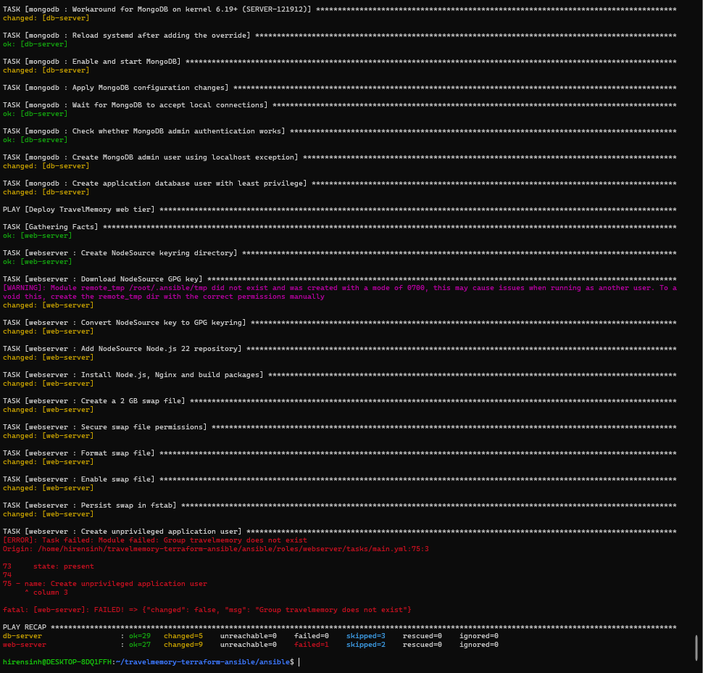
Figure 30: Play 2: MongoDB installed, secured and users created; start of the web play
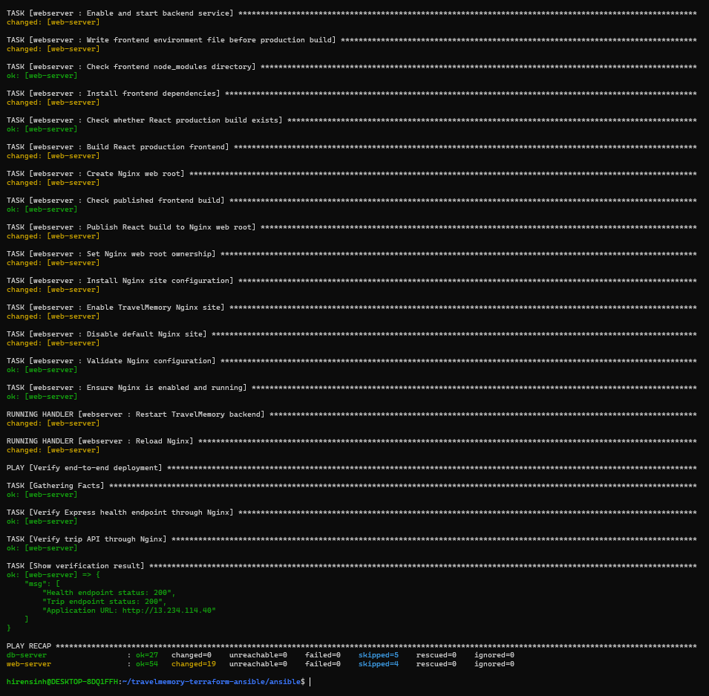
Figure 31: Play 3 and Play 4: web tier deployed and verified; PLAY RECAP with failed=0

4.4 Idempotency
Running the same playbook a second time reports changed=0 on both hosts. The skipped tasks are the ones that only run when something changed (for example, creating the MongoDB admin user and rebuilding the frontend).
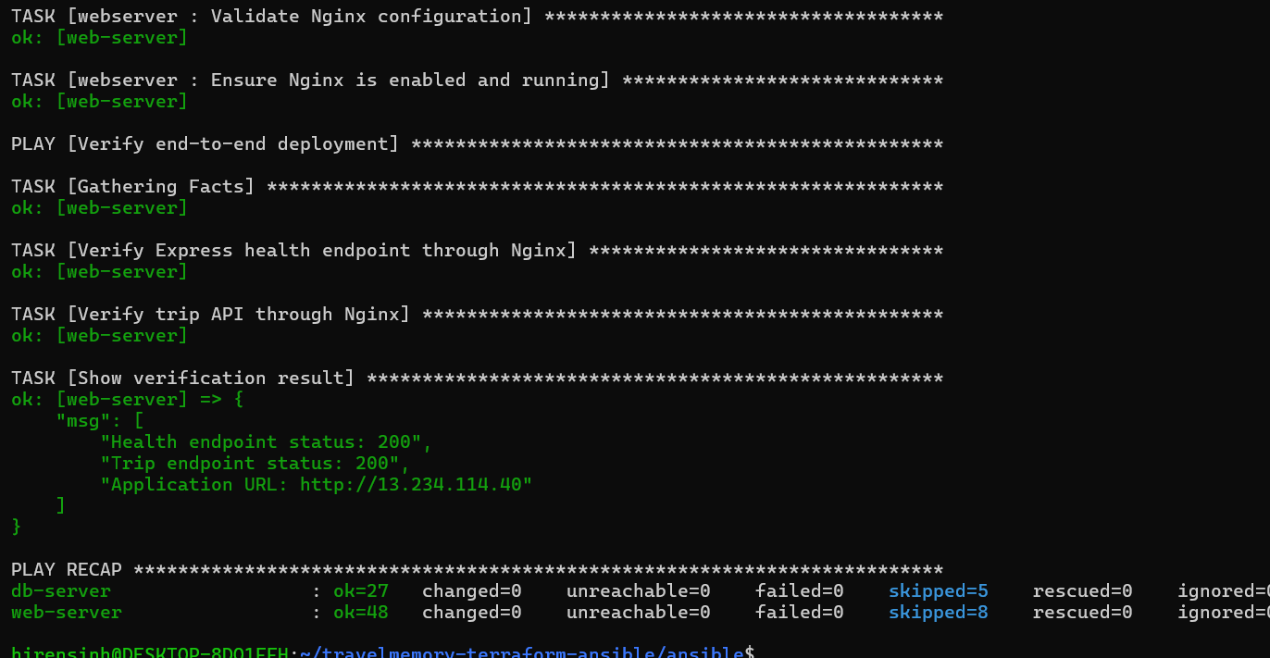
Figure 32: Second run: changed=0 on both hosts (idempotent)

4.5 Verifying the servers
On the DB server, mongod is enabled and active, bound to the localhost and the private IP, with authorization enabled. SSH to this server works only through the web server.
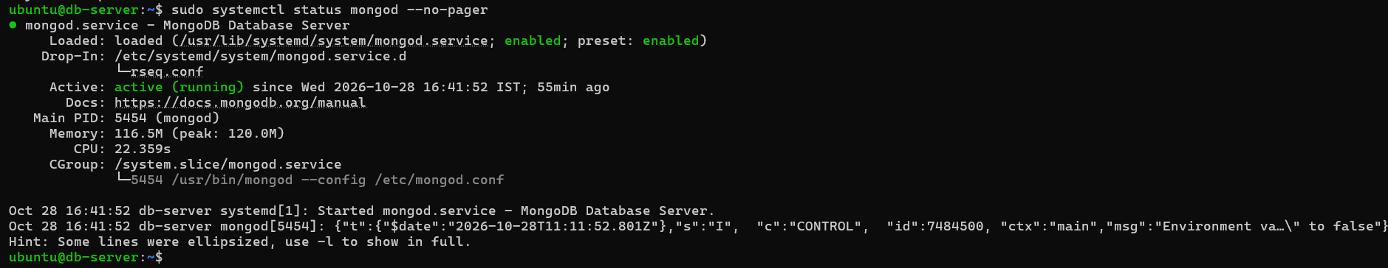
Figure 33: mongod running on the DB server with authorization enabled and the private bind address
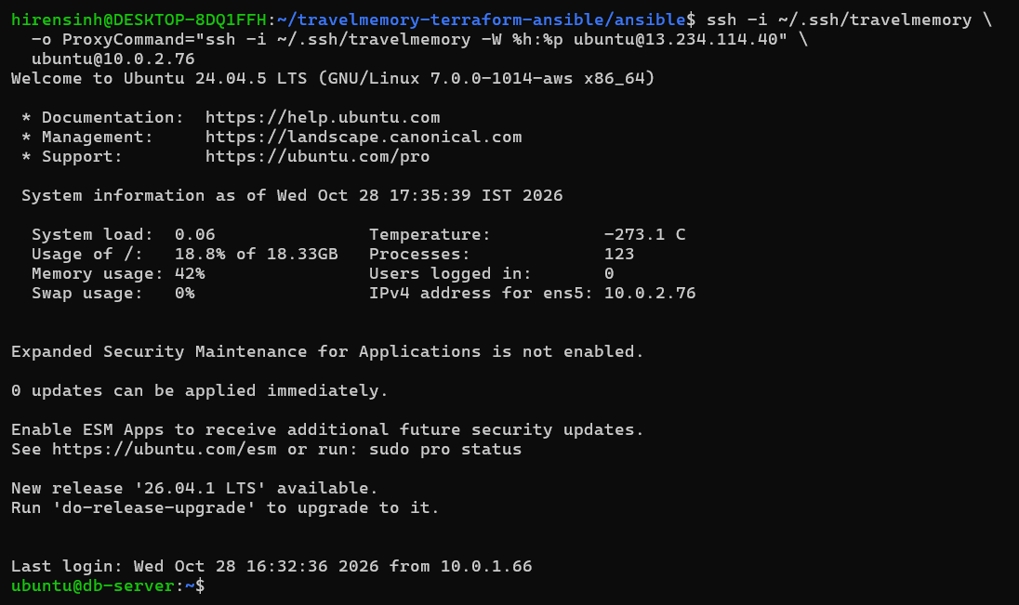
Figure 35: SSH to the DB server through the web server (jump host)
An unauthenticated query is rejected with "command find requires authentication", while the application user can log in and read the data.
Figure 36: Unauthenticated query on MongoDB is refused
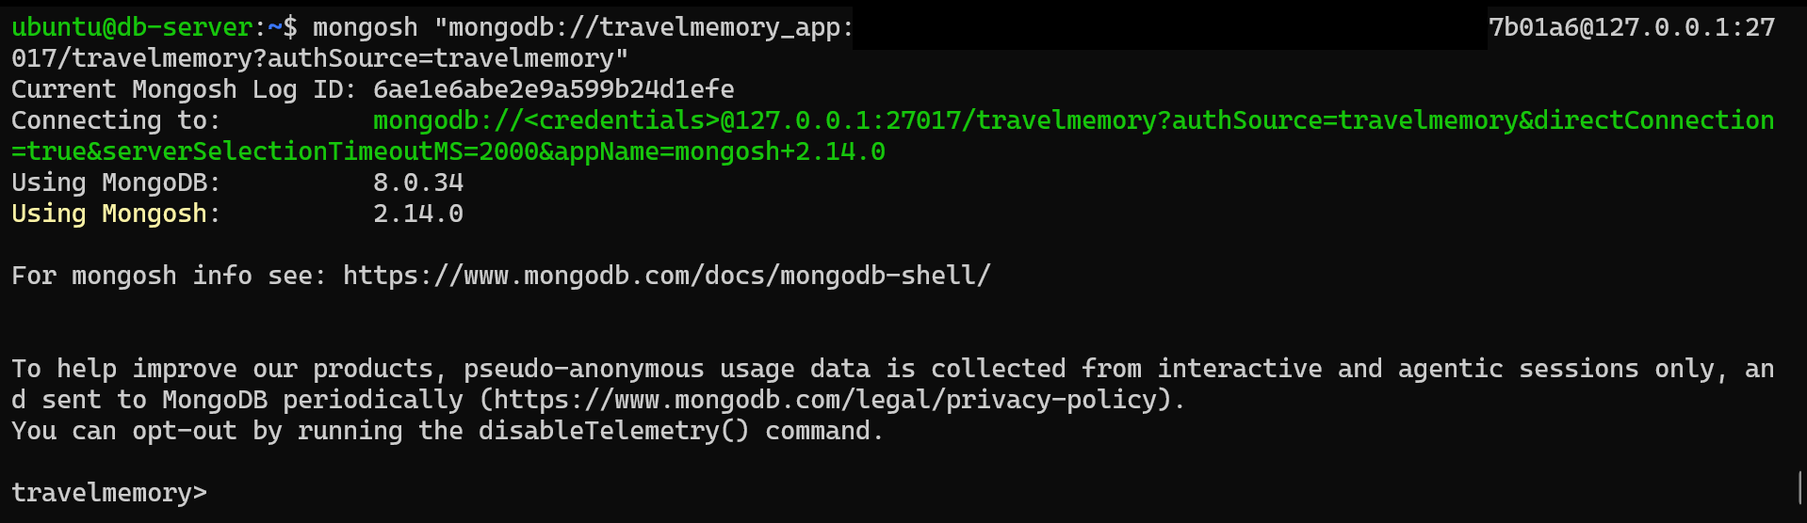
Figure 37: Login to MongoDB as the application user (password hidden)
On the web server, the API runs under systemd and Nginx is active. Both services start automatically on boot.
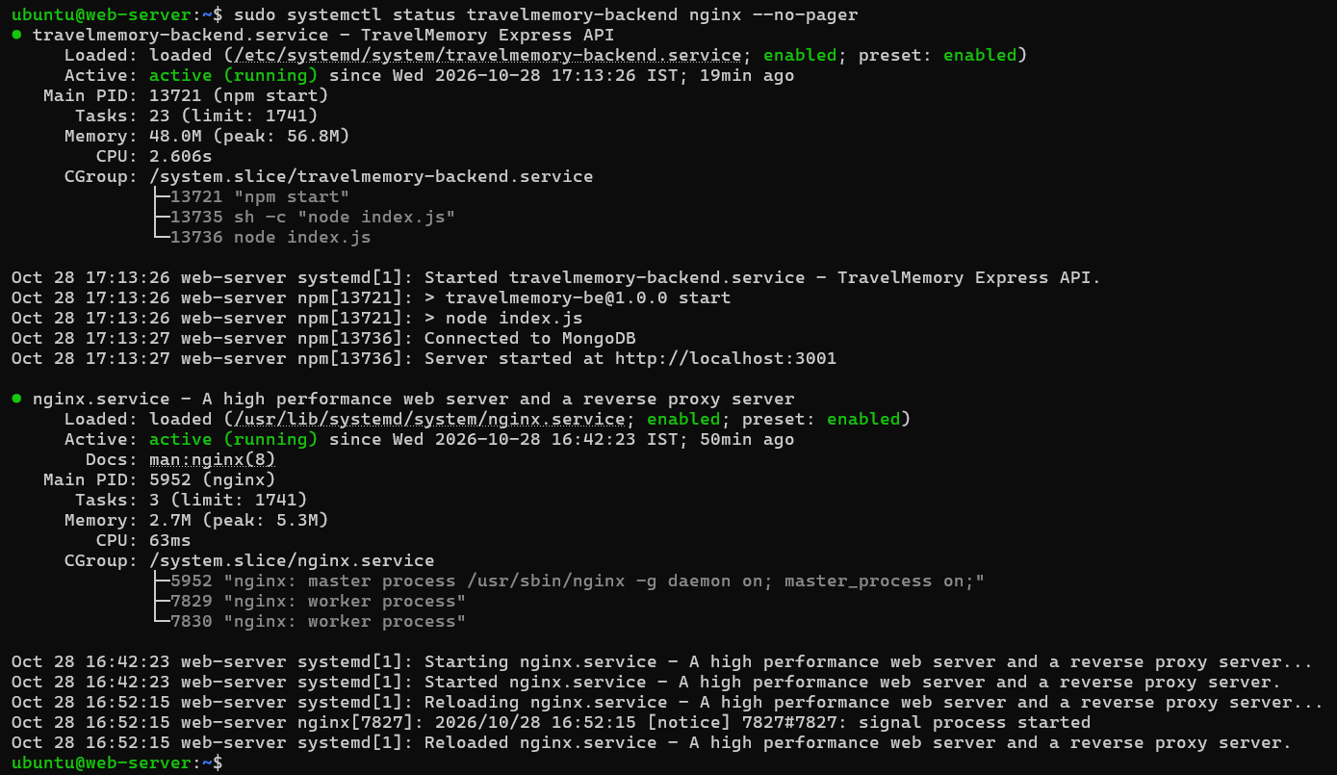
Figure 34: Backend service (npm start under systemd) and Nginx active on the web server

5. Working application
From the laptop, /hello returns the Express health response and /trip returns JSON read from MongoDB, both through Nginx on port 80. A direct request to port 3001 fails because that port is not open.
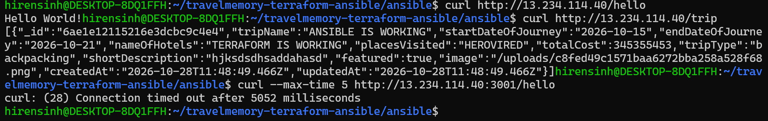
Figure 39: API through Nginx on port 80; direct access to port 3001 times out
The React app is served at the web server's public IP and lists trips from the database.
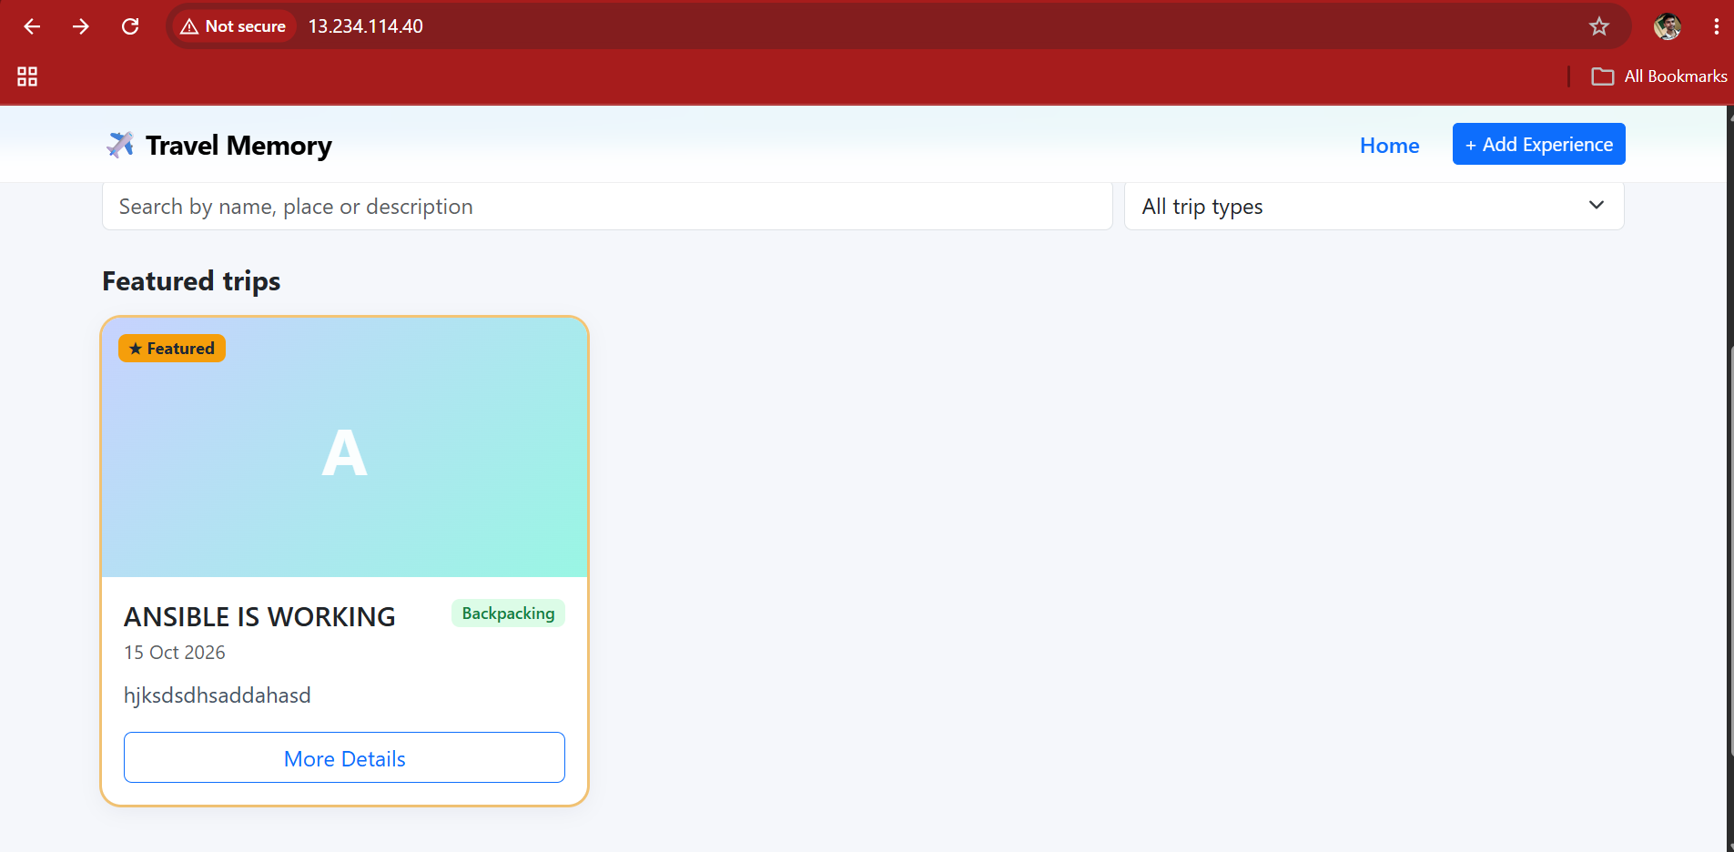
Figure 40: TravelMemory home page at http://13.234.114.40
A new trip ("ANSIBLE IS WORKING") was added through the Add Experience form, which sends a POST /trip from the browser to Express. The app confirms that the trip was saved and shows its details page, loaded by ID from the API.
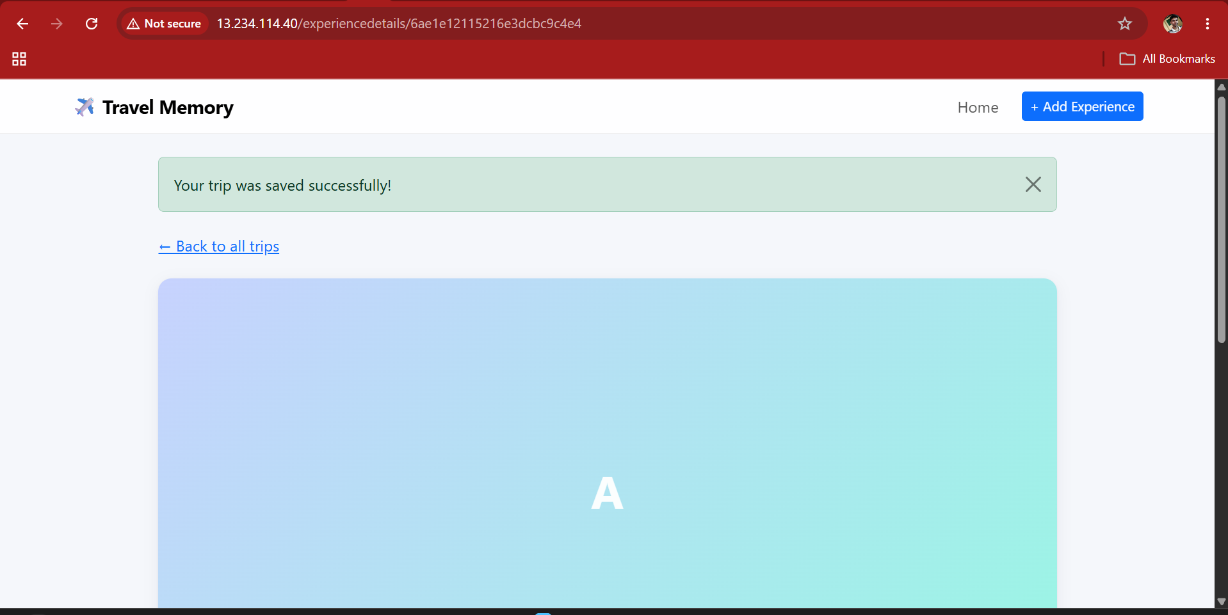
Figure 41: Trip saved successfully through the Add Experience form
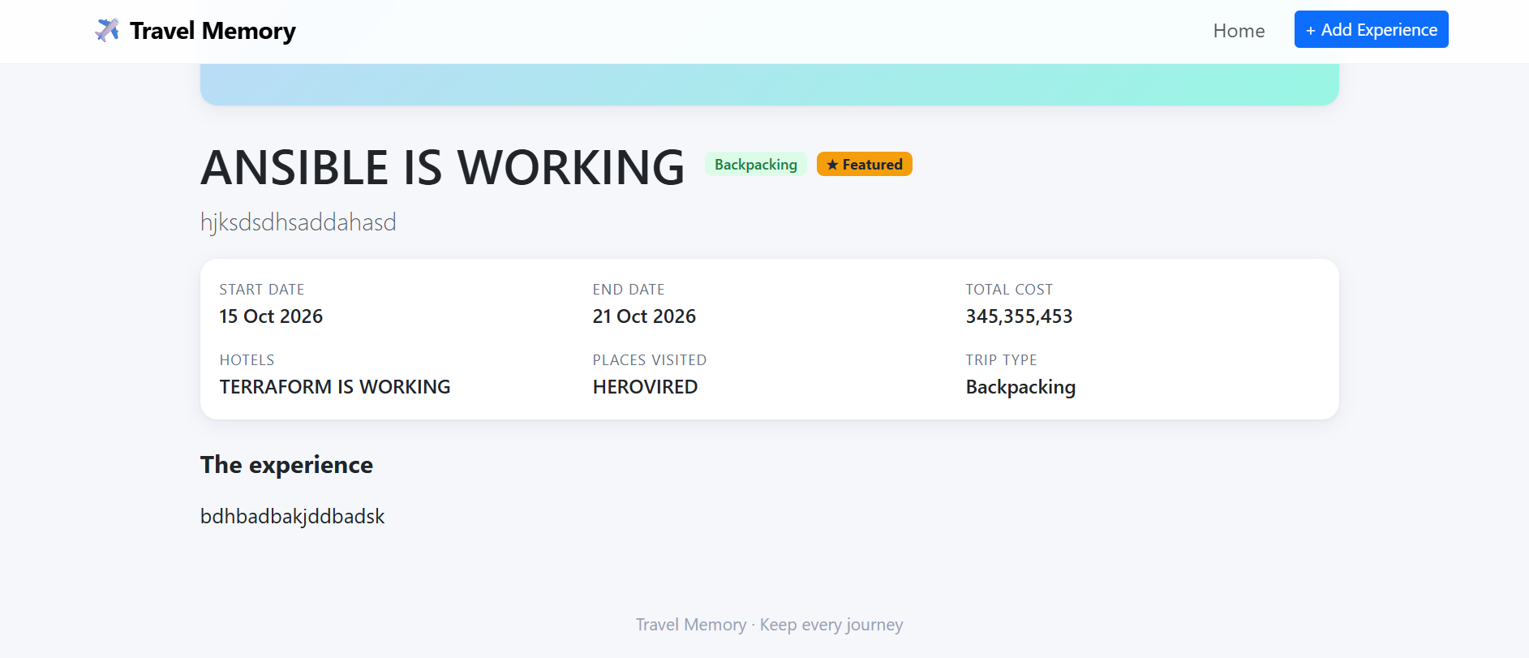
Figure 42: Trip details page loaded from the API
The same trip is stored in MongoDB on the private server. This proves the full path: browser to Nginx to Express to MongoDB.
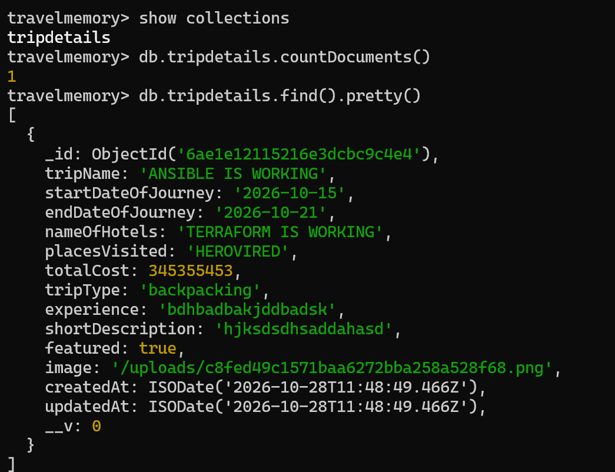
Figure 38: The trip added from the UI is stored in the tripdetails collection

6. Security hardening
Layer | Control | Where
Network | DB in a private subnet with no public IP; outbound only through the NAT Gateway | vpc.tf, ec2.tf
Network | web-sg: SSH from my IP only, 80/443 public. db-sg: 22 and 27017 from web-sg only | security_groups.tf
Host firewall | UFW default deny incoming; web allows 22, 80, 443; DB allows 22 and 27017 only from the web server's private IP | roles/hardening
SSH | Key pair only; root login disabled; password login disabled | roles/hardening
SSH | fail2ban jail for sshd | roles/hardening
Patching | apt safe upgrade on first run, automatic security updates | roles/common, roles/hardening
Instance | IMDSv2 required, encrypted root volumes, IAM role instead of access keys | ec2.tf, iam.tf
Database | Authorization enabled, separate admin and least-privilege app user, bindIp not 0.0.0.0 | roles/mongodb
App | API on localhost behind Nginx, runs as a non-login system user under systemd | roles/webserver
Secrets | Passwords in Ansible Vault, state in S3 not Git, .gitignore for keys, .env, tfvars, vault password | group_vars, .gitignore

Each control was checked from the outside. Root login and password login are both refused:
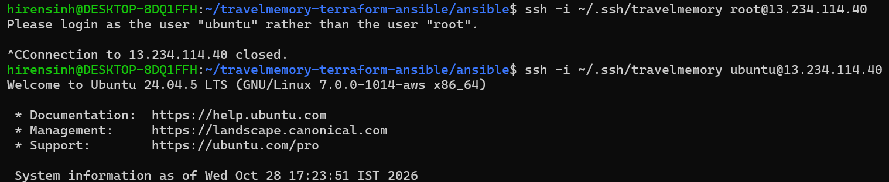
Figure 43: Root login is refused
Figure 44: Password login is refused (public key only)
UFW is active on both servers with default-deny, and fail2ban is running on both:
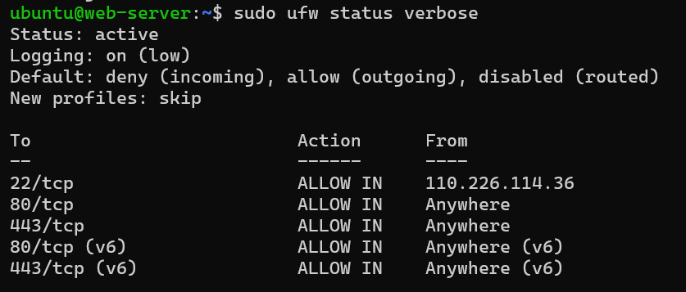
Figure 45: UFW on the web server: 22 (my IP only), 80, 443
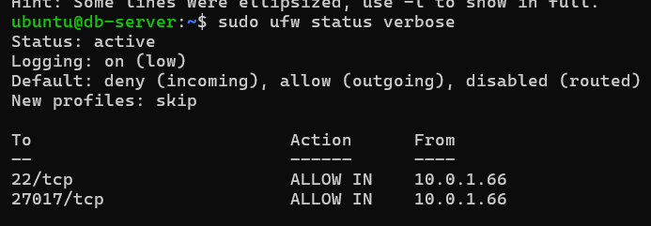
Figure 46: UFW on the DB server: 22 and 27017 only from the web server (10.0.1.66)
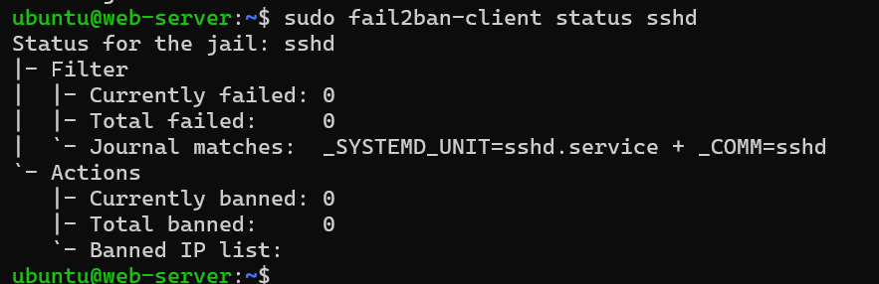
Figure 47: fail2ban sshd jail on the web server
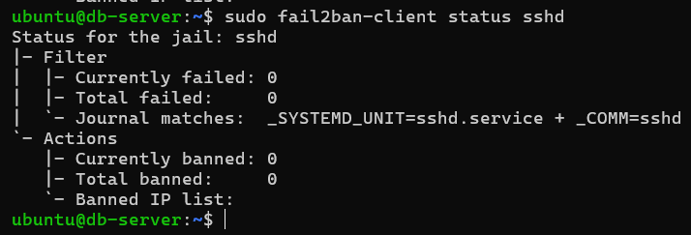
Figure 48: fail2ban sshd jail on the DB server
MongoDB is reachable from the web server but not from the laptop:
Figure 49: MongoDB port reachable from the web server
Figure 50: MongoDB port not reachable from the laptop (timed out)

7. Challenges and how they were solved
Problem | Cause | Fix
Tool downloads failed (Terraform, AWS CLI) | The commands were pasted with the URLs shortened to bare domains, so the downloads returned an error page instead of the files | Used the full vendor URLs (HashiCorp releases and the AWS CLI bundle URL) and checked the file size before unzipping
Playbook stalled at Enable UFW on the DB server | The SSH session through the jump host was interrupted when the firewall was switched on | Checked the UFW rules on the DB server (22 and 27017 allowed from 10.0.1.66, as intended) and re-ran the playbook, which completed
MongoDB did not start (Wait for MongoDB timed out) | The server had been upgraded to kernel 7.0, which this MongoDB build refuses to start on (SERVER-121912) | Added a systemd drop-in for mongod with GLIBC_TUNABLES=glibc.pthread.rseq=1, then reloaded system
Group travelmemory does not exist | The user task referenced a group that had not been created | Added a task that creates the application group before the user
Second run showed changed=1 on the web server | The Nginx web root task was still settling on the first re-run | Re-ran with --diff, saw it was fine, and the next run reported changed=0 on both hosts
"CORS: origin ... is not allowed" when adding a trip | The backend only allows origins listed in CORS_ORIGIN, which defaults to localhost | Added CORS_ORIGIN=http://<web_public_ip> to the backend .env template; the service restarts through a handler

Evidence for these fixes:
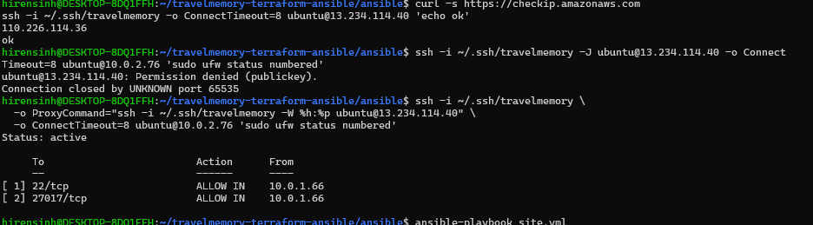
Figure 51: UFW rules on the DB server checked through the jump host
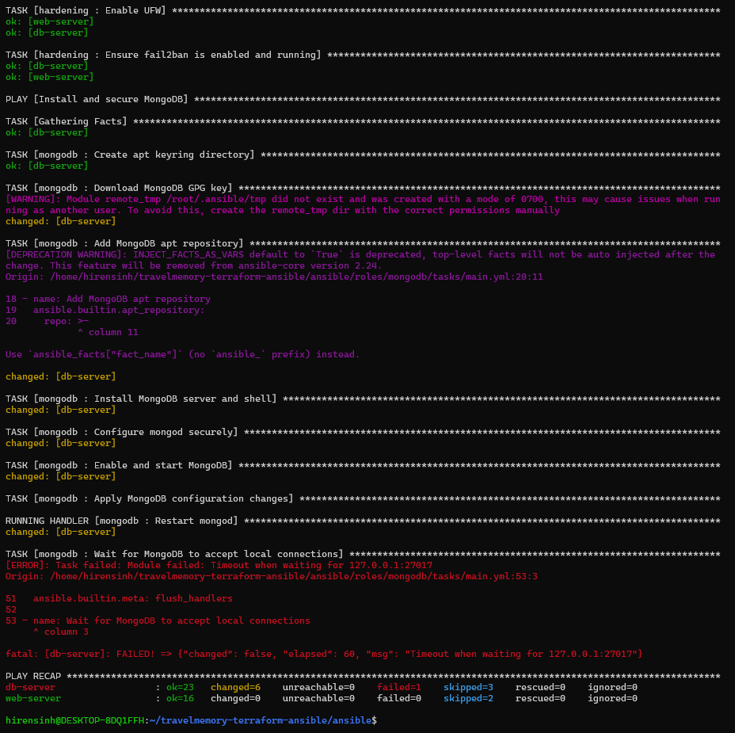
Figure 52: Challenge: Wait for MongoDB timed out
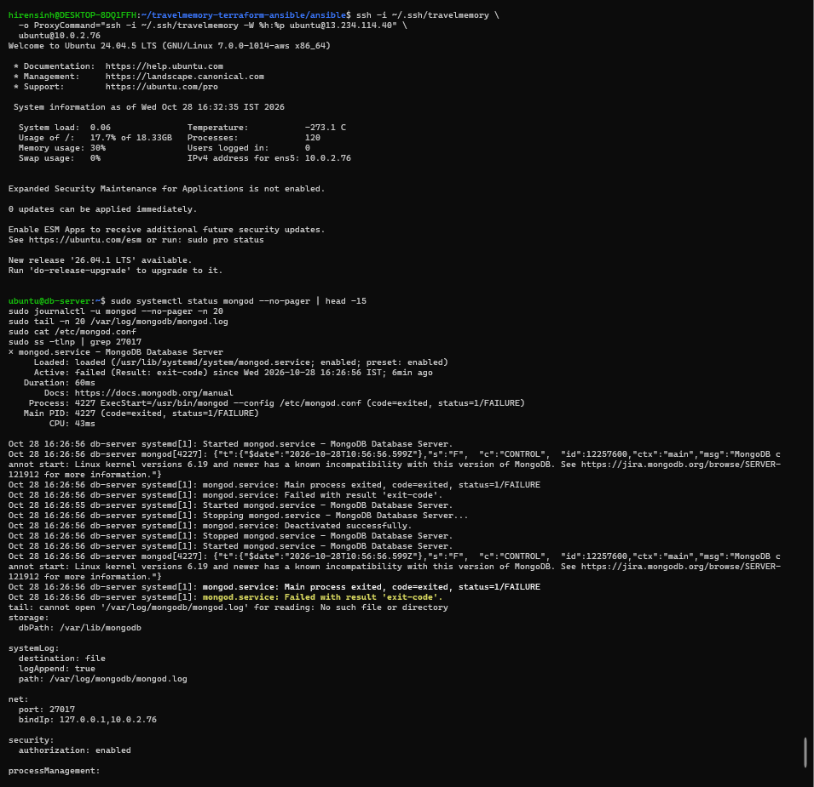
Figure 53: journalctl shows mongod refusing to start on kernel 7.0
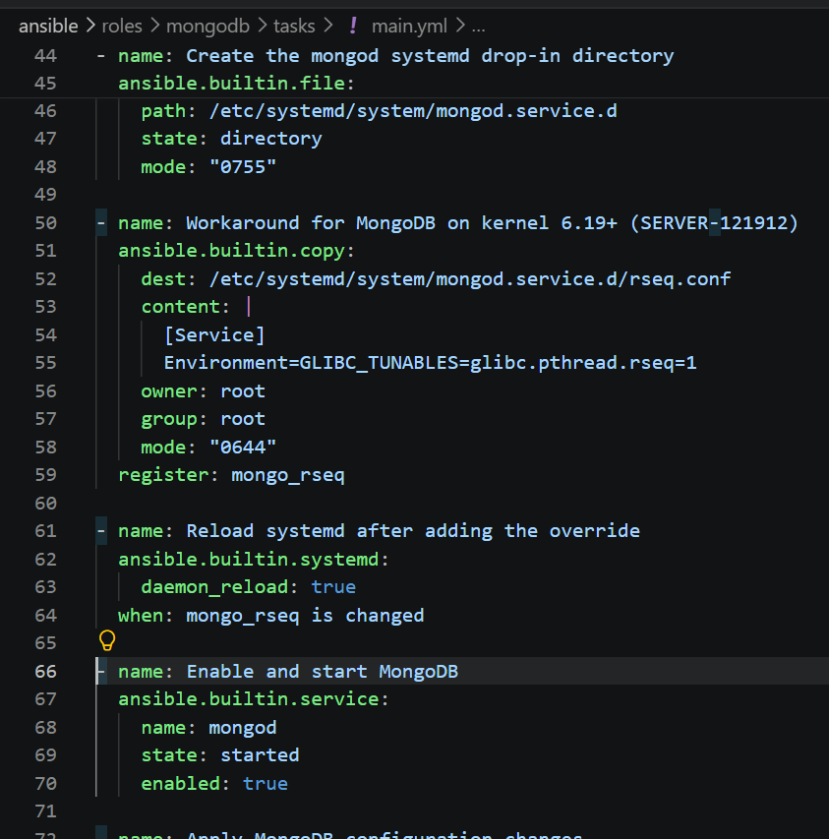
Figure 54: Fix: systemd drop-in with GLIBC_TUNABLES for mongod
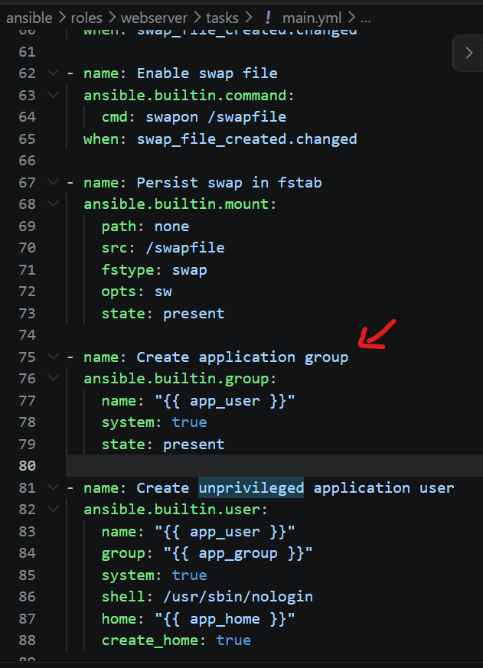
Figure 55: Fix: create the application group before the user
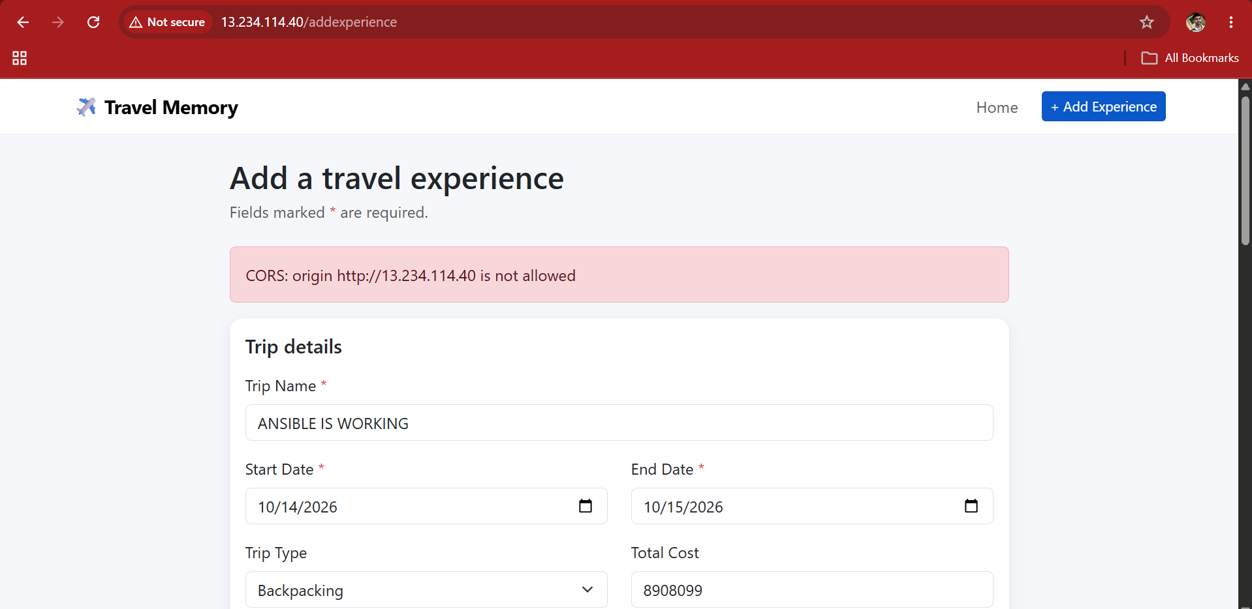
Figure 56: Challenge: CORS error when adding a trip
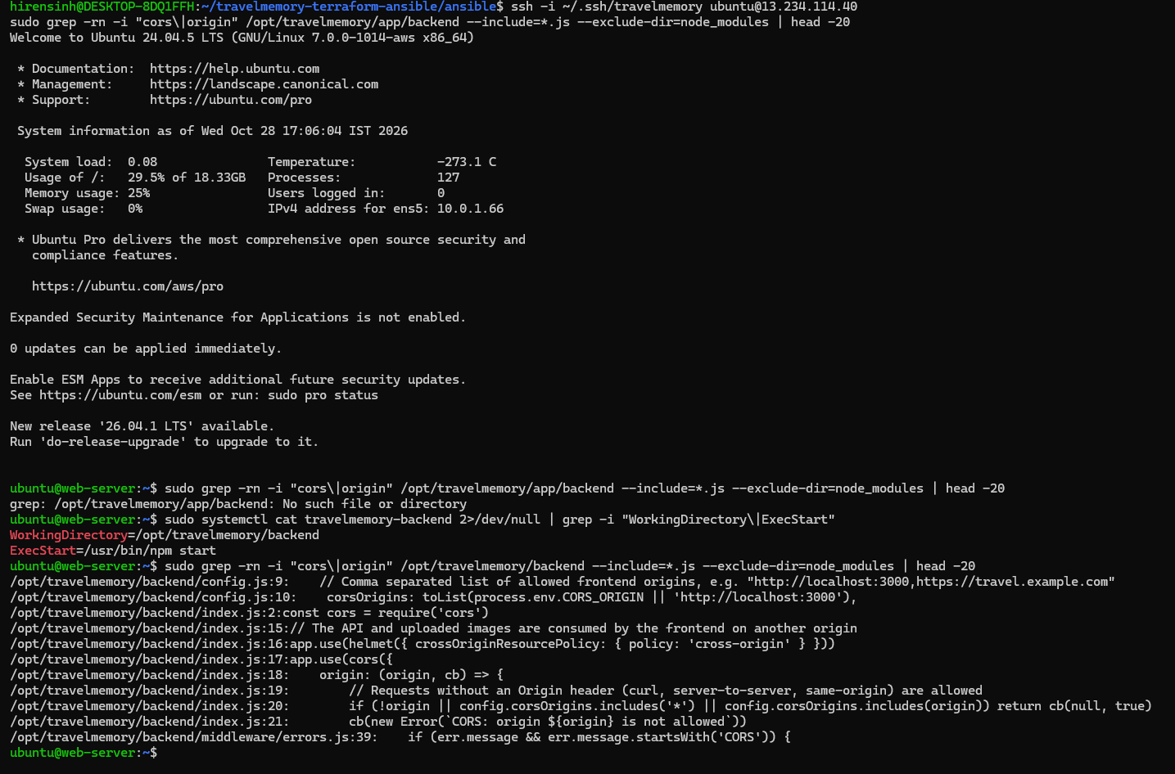
Figure 57: Finding the CORS_ORIGIN setting in the backend code
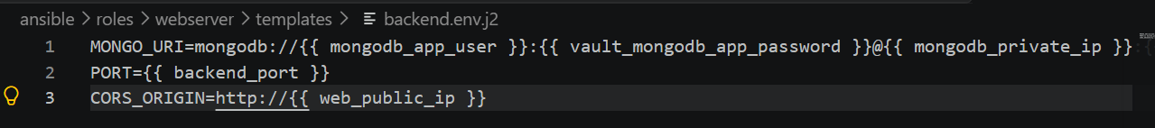
Figure 58: Fix: CORS_ORIGIN added to the backend .env template
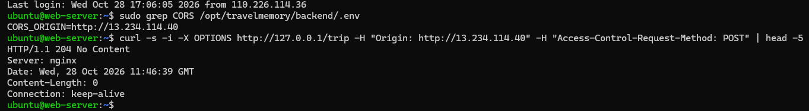
Figure 59: Preflight check after the fix: 204 No Content
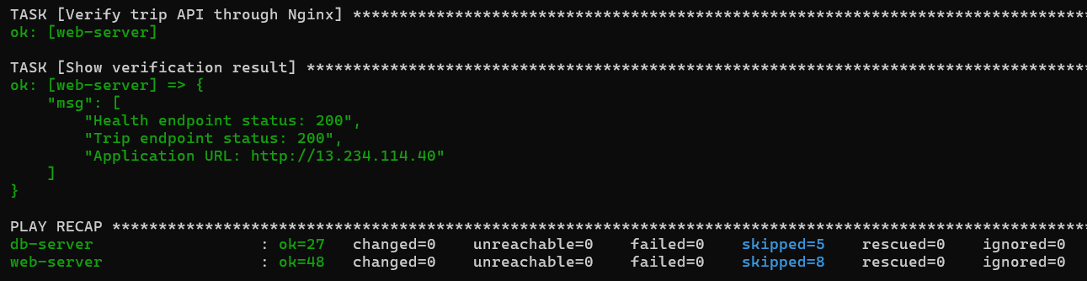
Figure 60: Final run after the CORS fix: changed=0 on both hosts

8. Cost and cleanup
The NAT Gateway is billed for every hour it exists, even with no traffic, and public IPv4 addresses are also charged hourly. After capturing the evidence, everything was removed with terraform destroy, which reported 27 resources destroyed. An AWS CLI check then confirmed that no NAT Gateway, Elastic IP or running instance was left.
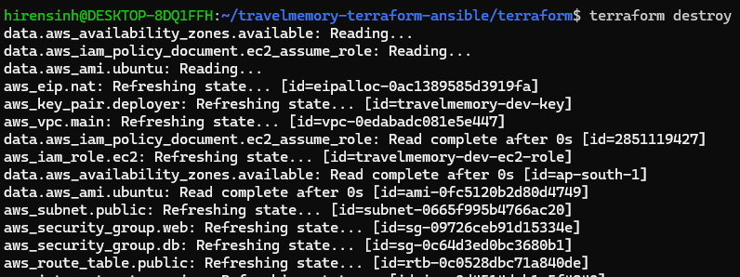
Figure 61: terraform destroy started
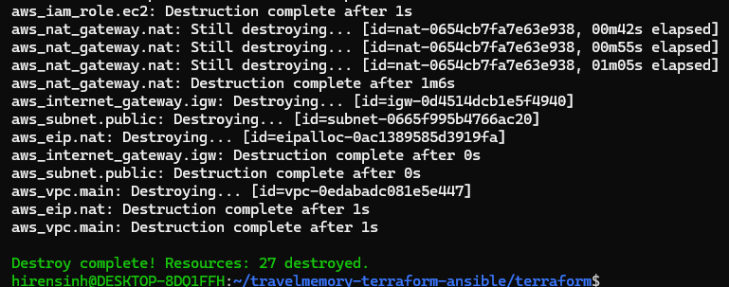
Figure 62: terraform destroy complete: 27 destroyed
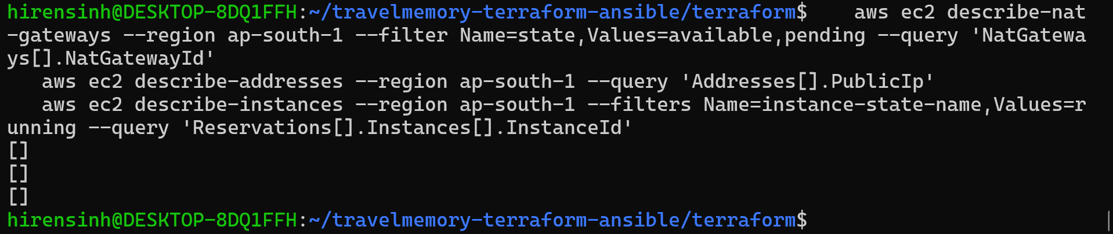
Figure 63: AWS CLI check: no NAT Gateway, Elastic IP or running instance left
Finally, the code (without state files, keys, .env files, the vault password or tfvars) was pushed to GitHub:
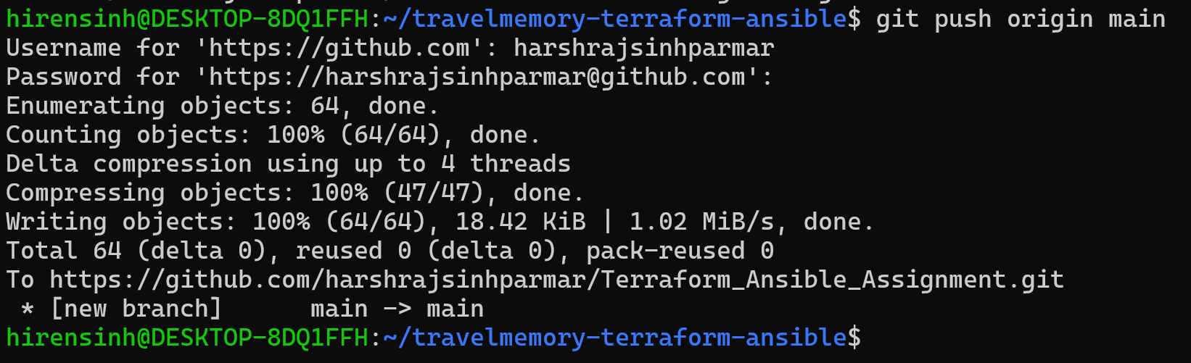
Figure 64: Code pushed to GitHub
Repository: https://github.com/harshrajsinhparmar/Terraform_Ansible_Assignment

9. Requirement checklist
Requirement from the brief | Status | Evidence
Configure AWS CLI and authenticate | Done | Fig. 4, Fig. 5
Initialise a Terraform project targeting AWS | Done | Fig. 10
VPC with one public and one private subnet | Done | Fig. 13, Fig. 14, Fig. 15, Fig. 16
Internet Gateway and NAT Gateway | Done | Fig. 17, Fig. 18, Fig. 19
Route tables for both subnets | Done | Fig. 20, Fig. 21
Web EC2 in public subnet, DB EC2 in private subnet | Done | Fig. 23, Fig. 22
SSH to both; public instance only from my IP | Done | Fig. 24, Fig. 35
Security groups for web and DB servers | Done | Fig. 24, Fig. 25
IAM role for EC2 with required permissions | Done | Fig. 26
Output the public IP of the web server | Done | Fig. 12
Configure Ansible to reach the EC2 instances | Done | Fig. 28
Install Node.js and npm on the web server | Done | Fig. 31, Fig. 34
Clone the MERN repo and install dependencies | Done | Fig. 31
Install and configure MongoDB with Ansible | Done | Fig. 30, Fig. 33
Secure MongoDB, create users and database | Done | Fig. 36, Fig. 37, Fig. 38
Configure environment variables and start Node.js | Done | Fig. 58, Fig. 34
React frontend communicates with Express backend | Done | Fig. 39, Fig. 40, Fig. 41, Fig. 38
Firewalls and security groups hardened | Done | Fig. 24, Fig. 45, Fig. 46
SSH key pairs, root login disabled | Done | Fig. 43, Fig. 44
Idempotent playbooks (re-run shows no changes) | Done | Fig. 32, Fig. 60
Report on implementation and component interaction | Done | Sections 2 to 8
Screenshots of the working application | Done | Fig. 40, Fig. 41, Fig. 42
Cleanup: terraform destroy | Done | Fig. 62, Fig. 63

