**STACKZY**

*Unique Selling Point:*

* Our solution is a web application ( Maximum users who use StackOverflow use it through a PC ).
* Our proposed solution identifies relevant questions to a query using text similarity.
* It will identify top k ( k given by user ) answers using sentimental analysis and semantic search.
* User can filter questions and answers on the basis of reputation.
* Posts can be ordered by date, reputation of user and trending.
* Search box will have prediction on related search strings on basis of text similarity and trending.
* Minimal and aesthetic UI elements.
* Customer Master Records for personalized results.

*Business Impact:*

* Problems which developers face during development life cycle will be solved faster thus faster product development and more projects can be undertaken by the company.
* Personalized follow up suggestions and can bring awareness to developers thus building their development acumen and grooming them to untouched verticals
* On future prospects, if we bring extensions of this app to IDEs, coding will be much easier as they can get solutions to their problems inplace.

*Solution Architecture:*

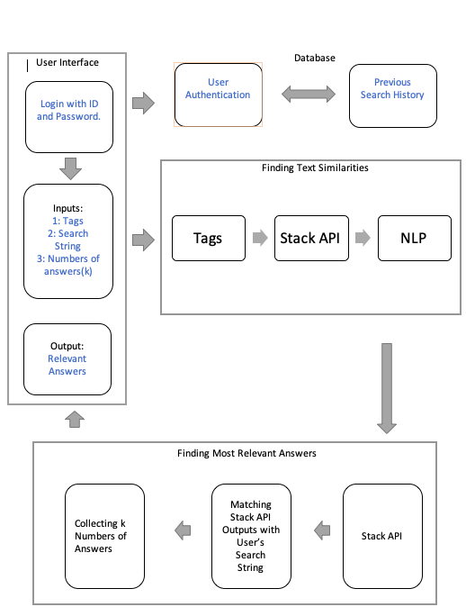

*Scope of Work:*

* React.js frontend webapp
* Backend flask app
* Postgresql Database
* Watson assistant
* Watson NLU
* Watson voice to text
* Python – numpy, pandas, sklearn, tflow, keras, pytorch