OBJECT-ORIENTED PROGRAMMING USING C++ LAB
CIS-257

Faculty name Student name: Roll No.:
Semester: 3rd
Group: I7



Maharaja Agrasen Institute of Technology, PSP Area,
Sector – 22, Rohini, New Delhi – 110085

MAHARAJAAGRASENINSTITUTEOFTECHNOLOGY

VISION

To nurture young minds in a learning environment of high academic value and imbibe spiritual and ethical values with technological and management competence.

MISSION

The Institute shall endeavor to incorporate the following basic missions in the teaching methodology:
Engineering Hardware – Software Symbiosis

Practical exercises in all Engineering and Management disciplines shall be carried out by Hardware equipment as well as the related software enabling deeper understanding of basic concepts and encouraging inquisitive nature.
Life – Long Learning

The Institute strives to match technological advancements and encourage students to keep updating their knowledge for enhancing their skills and inculcating their habit of continuous learning.
Liberalization and Globalization

The Institute endeavors to enhance technical and management skills of students so that they are intellectually capable and competent professionals with Industrial Aptitude to face the challenges of globalization.
Diversification

The Engineering, Technology and Management disciplines have diverse fields of studies with different attributes. The aim is to create a synergy of the above attributes by encouraging analytical thinking.
Digitization of Learning Processes

The Institute provides seamless opportunities for innovative learning in all Engineering and Management disciplines through digitization of learning processes using analysis, synthesis, simulation, graphics, tutorials and related tools to create a platform for multi- disciplinary approach.
Entrepreneurship

The Institute strives to develop potential Engineers and Managers by enhancing their skills and research capabilities so that they become successfully entrepreneurs and responsible citizens.

Department of Information Technology

VISION

To establish a center of excellence promoting Information Technology related education and research thus producing technocrats and entrepreneurs with ethical values.

MISSION

To provide an open, diverse and collaborative environment to achieve global technological excellence producing world-class engineers to solve real-world problems fulfilling the needs of the society.

Computer Networks Lab CO’s and its mapping with PO’s and PSO’s

Program Specific Outcomes (PSOs)
PSO1: Proficient at discerning suitable data structures and algorithms for designing, executing, and validating efficient solutions for research-oriented challenges.
PSO 2: Attaining excellence in programming, technical projects and handling technical challenges.
PSO 3: Acquiring adequate knowledge in Information Technology for a successful professional life, entrepreneurship and higher education.

Program Outcomes (POs)
Engineering Graduates will be able to:
- Engineering knowledge: Apply the knowledge of mathematics, science, engineering fundamentals, and an engineering specialization to the solution of complex engineering problems.
- Problem analysis: Identify, formulate, review research literature, and analyze complex engineering problems reaching substantiated conclusions using first principles of mathematics, natural sciences, and engineering sciences.
- Design/development of solutions: Design solutions for complex engineering problems and design system components or processes that meet the specified needs with appropriate consideration for the public health and safety, and the cultural, societal, and environmental considerations.
- Conduct investigations of complex problems: Use research-based knowledge and research methods including design of experiments, analysis and interpretation of data, and synthesis of the information to provide valid conclusions.
- Modern tool usage: Create, select, and apply appropriate techniques, resources, and modern engineering and IT tools including prediction and modeling to complex engineering activities with an understanding of the limitations.
- The engineer and society: Apply reasoning informed by the contextual knowledge to assess societal, health, safety, legal and cultural issues and the consequent responsibilities relevant to the professional engineering practice.
- Environment and sustainability: Understand the impact of the professional engineering solutions in societal and environmental contexts, and demonstrate the knowledge of, and need for sustainable development.
- Ethics: Apply ethical principles and commit to professional ethics and responsibilities and norms of the engineering practice.
- Individual and team work: Function effectively as an individual, and as a member or leader in diverse teams, and in multidisciplinary settings.
- Communication: Communicate effectively on complex engineering activities with the engineering community and with society at large, such as, being able to comprehend and write effective reports and design documentation, make effective presentations, and give and receive clear instructions.
- Project management and finance: Demonstrate knowledge and understanding of the engineering and management principles and apply these to one’s own work, as a member and leader in a team, to manage projects and in multidisciplinary environments.
- Life-long learning: Recognize the need for, and have the preparation and ability to engage in independent and life-long learning in the broadest context of technological change
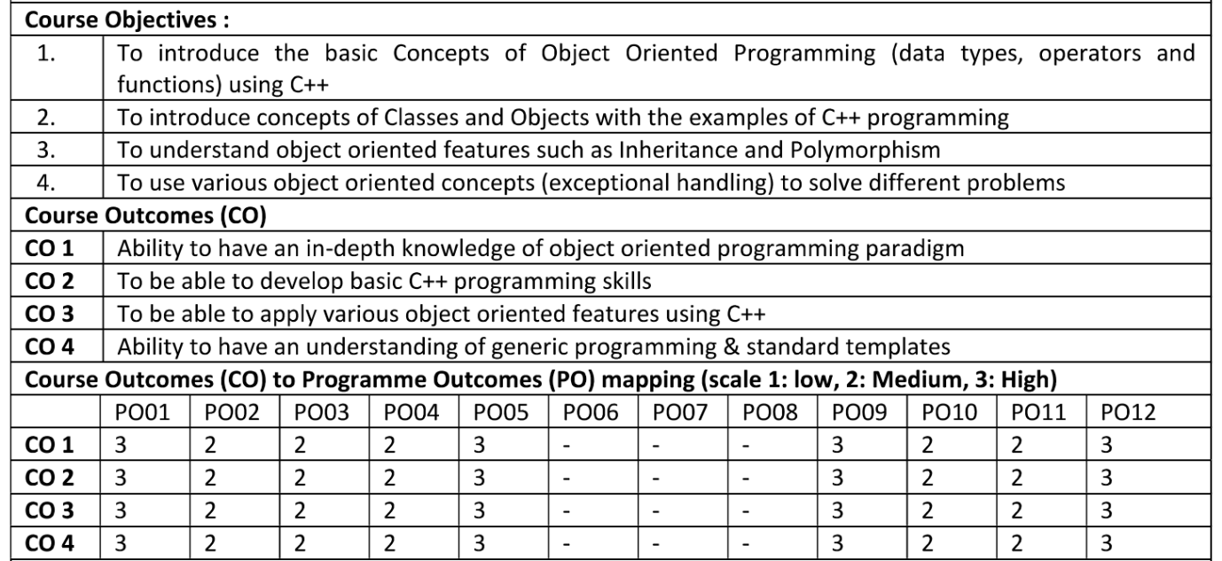

Rubrics Evaluation

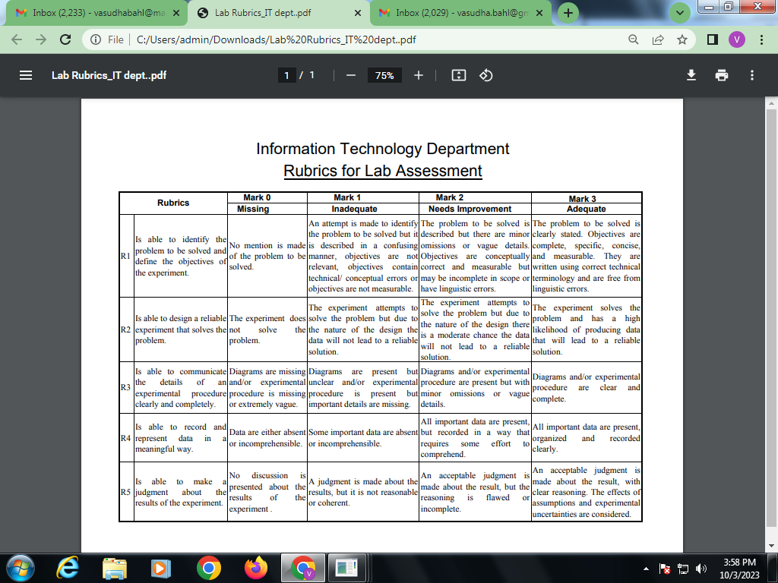

- Index for the Lab File is as follows:

DATA STRUCTURES LAB

PRACTICAL RECORD

PAPER CODE :

Name of the student :

University Roll No. :

Branch :

Section/ Group :

PRACTICAL DETAILS

- Experiments according to the list provided by GGSIPU

Experiment No. | Date | Experiment Name | Marks (0-3) |  |  |  |  | Total Marks (15) | Signature
 |  |  | R1 | R2 | R3 | R4 | R5
1.
2.

3.
4.
5.
6.
7.
8.
9.
10.

- Experiments Additional the list provided by GGSIPU

Experiment No. | Date | Experiment Name | Marks(0-3) |  |  |  |  | Total Marks(15) | Signature
 |  |  | R1 | R2 | R3 | R4 | R5
1.
2.

3.
4.
5.

