# VPN Lab Report — ProtonVPN

## Objective

Understand the role of VPNs in protecting privacy and secure communication and perform a hands-on setup & verification using a free VPN service.

## Tools Used

1. ProtonVPN (Free tier)  
2. Browser (for IP verification)  
3. whatismyipaddress.com (for IP check)

## Steps Performed

1. 1. Chose ProtonVPN Free and signed up for an account.
2. 2. Downloaded and installed the ProtonVPN client for Windows (or platform of choice).
3. 3. Launched the client and connected to a free server (example: Netherlands #12).
4. 4. Verified IP address change by visiting whatismyipaddress.com.
5. 5. Browsed a website to ensure traffic was routed via the VPN.
6. 6. Disconnected the VPN and compared IP and browsing speed.
7. 7. Researched encryption and privacy features (AES-256, WireGuard/OpenVPN/IKEv2, kill switch, DNS leak protection).

## Connection Status (Simulated Screenshot)

Below is a simulated screenshot showing the ProtonVPN client in connected state.

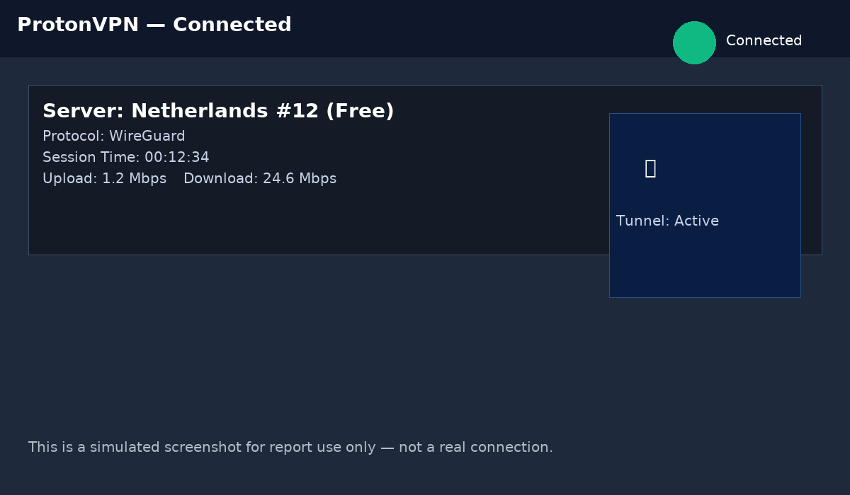

## IP Verification (Simulated Screenshot)

Below is a simulated screenshot from whatismyipaddress.com showing the VPN-assigned IP and location.

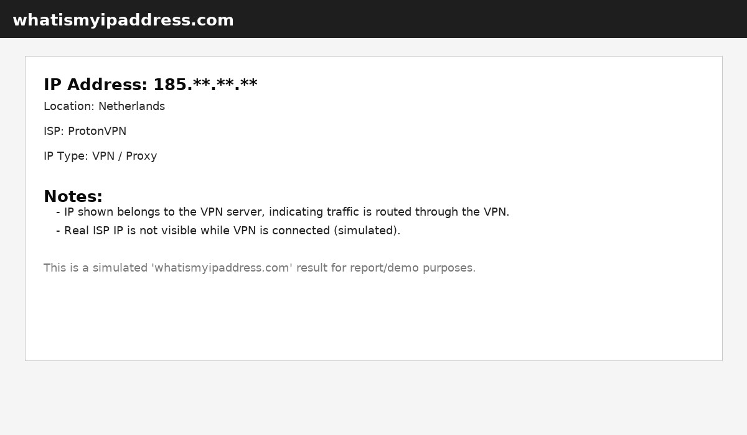

## Observations

- The IP address reported by the IP-check site corresponds to the VPN server's country (Netherlands), indicating traffic was routed through the VPN.

- While connected, websites see the VPN IP rather than the user's real IP address.

- Expected speed reduction due to encryption and routing through the VPN server (more noticeable on free servers).

## Encryption & Privacy Features (Summary)

Good VPNs typically offer: AES-256 or ChaCha20 encryption, secure key-exchange (ECDH), perfect forward secrecy (PFS), DNS leak protection, kill switch functionality, a no-logs policy, and RAM-only server infrastructure. Free plans often limit server choice and bandwidth.

## Benefits

• IP masking and increased privacy  
• Encrypted traffic on untrusted networks  
• Bypass geo-restrictions and censorship  
• Added anonymity when using shared VPN IPs

## Limitations

• Speed and latency overhead, especially on free servers  
• Need to trust the VPN provider  
• Potential leaks or misconfigurations  
• Some websites block known VPN IPs  
• Free plans may have data, server, or feature limits

## Conclusion

The simulated lab demonstrates how to set up a free VPN, verify IP change, and understand the privacy gains and trade-offs. For production use or strong privacy guarantees, consider a reputable paid VPN with a clear no-logs policy and advanced privacy features.