Bucket Created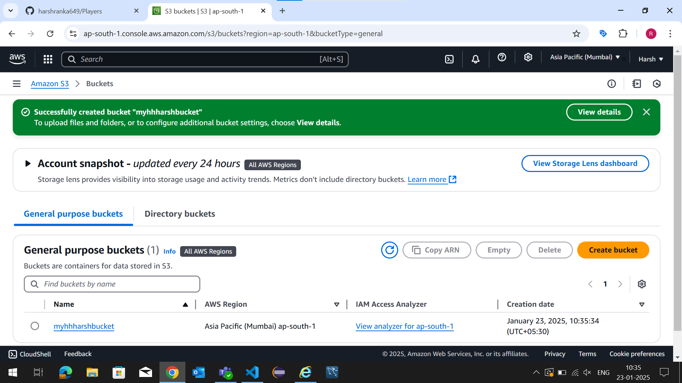File Uploaded but time was not assigned hence it did not open.

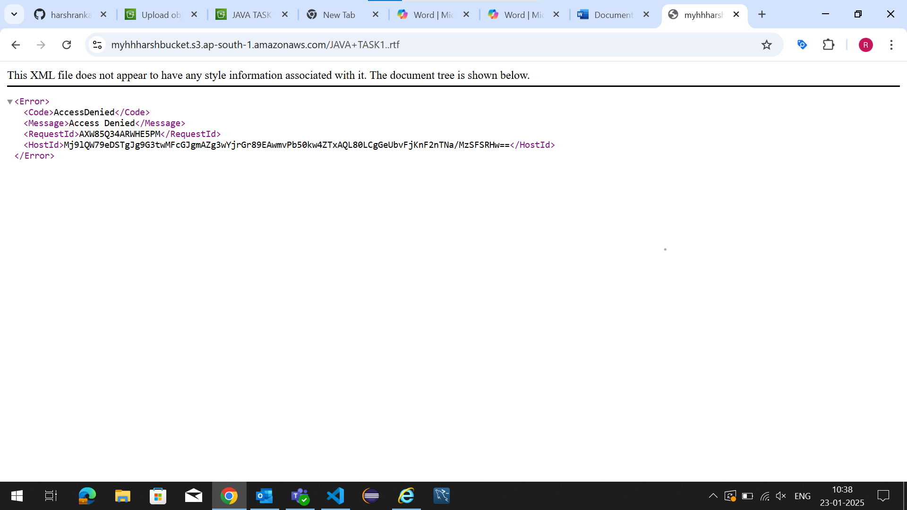

Since it was a notepad file after assigning time and everything while opening the predesigned url the notepad file got downloaded. 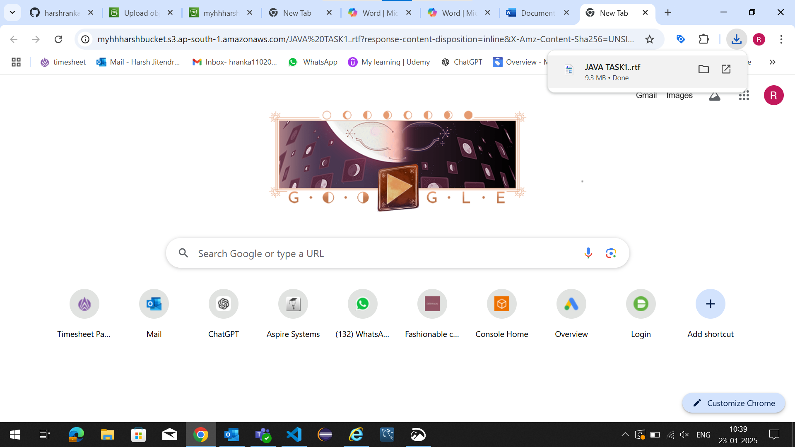

Life cycle rules are set 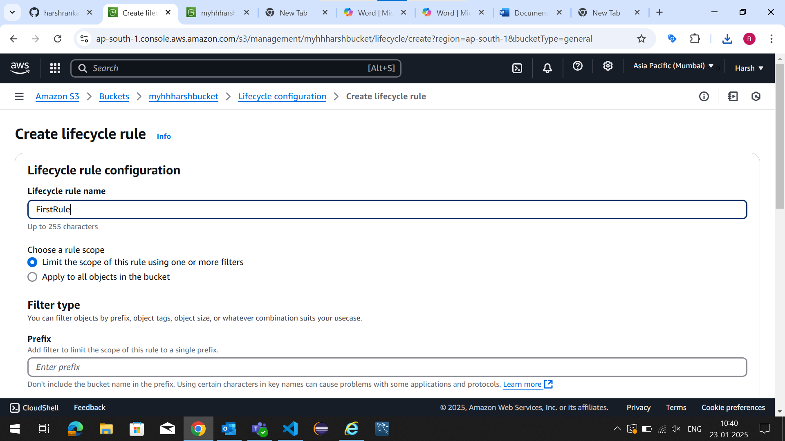

Transition and Expiration Actions.