# **Assignment 1**

* **Install and Import Pandas Library.**
* **Use Pandas for the following tasks:**
* **Create a Data Frame (choose data of your choice).**
* **Read and Write to CSV file.**
* **Read and write to Excel file.**
* **Rename columns in a Data Frame.**
* **Select a single column from the Data frame and print it.**

**Solution:**

import pandas as pd

# Create a DataFrame

data = {'Name': ['John', 'Alice', 'Bob', 'Emily'],

'Age': [25, 30, 35, 40],

'City': ['New York', 'Paris', 'London', 'Sydney']}

df = pd.DataFrame(data)

print(df)

# Write the DataFrame to a CSV file

df.to_csv('example.csv', index=False)

df_csv = pd.read_csv('example.csv')

df.to_excel('example.xlsx', index=False)

df_excel = pd.read_excel('example.xlsx')

df.rename(columns={'Name': 'First Name', 'City': 'Location'}, inplace=True)

print(df['Age'])

**OUTPUT:**

Name Age City

0 John 25 New York

1 Alice 30 Paris

2 Bob 35 London

3 Emily 40 Sydney

0 25

1 30

2 35

3 40

Name: Age, dtype: int64

# **Assignment 2**

* **Install and Import Numpy Library.**
* **Use Numpy for the following tasks:**
* **Create an empty and a full array of size 3x3.**
* **Generate an array of 25 random numbers sampled from a standard normal distribution.**
* **Find Dot product of two arrays.**
* **Sort the below array along the row, along the column and as a whole.**
* **[3, 7, 1] [10, 3, 2] [5, 6, 7]**
* **Make a list of 3 numpy arrays and find the mean of all the numpy arrays and output them as a list.**
* **Make a numpy array containing the string 'PHP C# Python C Java C++' as the only element, then split it on the basis of spaces.**

**Solution:**

import numpy as np

num = np.empty((3,3))

print(num)

num2 = np.zeros((3,3))

print(num2)

import numpy as np

random_array = np.random.normal(0.0, 1.0, 25)

print("1D Array with random values : \n", random_array)

import numpy as np

arr1 = np.matrix('[1, 2, 3; 4, 5, 6; 7, 8, 9]')

arr2 = np.matrix('[1, 2, 3; 4, 5, 6; 7, 8, 9]')

arr = arr1.dot(arr2)

print(arr)

a = np.array([[3, 7, 1], [10, 3,2],[5, 6, 7]])

b = np.sort(a, axis = 0)

b

b = np.sort(a, axis = -1)

b

b = np.sort(a, axis = None)

b

import numpy as np

Input = [np.array([1, 2, 3]),

         np.array([4, 5, 6]),

         np.array([7, 8, 9])]

b = []

for i in range(len(Input)):

   b.append(np.mean(Input[i]))

print(b)

print(np.char.split('PHP c# Python C++ Java HTML CSS Javascript Ruby Chiken'))

**OUTPUT:**

[[0.00e+000 0.00e+000 0.00e+000]

[0.00e+000 0.00e+000 4.33e-321]

[0.00e+000 0.00e+000 0.00e+000]]

[[0. 0. 0.]

[0. 0. 0.]

[0. 0. 0.]]

1D Array with random values :

[-0.088618 -0.49471685 0.12885889 -1.19017752 1.17082229 -0.38684108

1.25185868 -1.15853162 -1.42604111 1.27803133 0.55996665 -0.32010013

-0.14863046 0.71897288 1.17108734 0.13672456 0.37114933 1.16026666

0.17955642 0.07249019 0.47964567 -0.43793002 0.44137223 -0.11774771

1.06238952]

[[ 30 36 42]

[ 66 81 96]

[102 126 150]]

[2.0, 5.0, 8.0]

['PHP', 'c#', 'Python', 'C++', 'Java', 'HTML', 'CSS', 'Javascript', 'Ruby', 'Chiken']

# 

# **Assignment 3**

**Install and Import Matplotlib Library.**

**Use Matplotlib library and the csv file provided to generate plots with the given instruction below:**

1. **Read Total profit of all months and show it using a line plot. Total profit data provided for each month. Generated line plot must include the following properties:**
   1. **X label name = Month Number**
   2. **Y label name = Total profit**
2. **Get total profit of all months and show line plot with the following Style properties. Total profit data provided for each month (same as 1st question). Generated line plot must include following Style properties:**
   1. **Line Style dotted and Line-color should be red**
   2. **Show legend at the lower right location.**
   3. **X label name = Month Number**
   4. **Y label name = Sold units number**
   5. **Add a circle marker.**
   6. **Line marker color as read**
   7. **Line width should be 3**
3. **Display the number of units sold per month for each product using multiline plots. (i.e., Separate Plotline for each product)**
4. **Read toothpaste sales data of each month and show it using a scatter plot. Also, add a grid in the plot, gridline style should be “–“.**
5. **Read face cream and facewash product sales data and show it using the bar chart. The bar chart should display the number of units sold per month for each product. Add a separate bar for each product in the same chart.**

**Solution:**

import pandas as pd

import matplotlib.pyplot as plt

df = pd.read_csv("Downloads\\cs313_assignmnet_3.csv")

profitList = df ['total_profit'].tolist()

monthList  = df ['month_number'].tolist()

plt.plot(monthList, profitList, label = 'Month-wise Profit data of last year')

plt.xlabel('Month number')

plt.ylabel('Profit in dollar')

plt.xticks(monthList)

plt.title('Company profit per month')

plt.yticks([100000, 200000, 300000, 400000, 500000])

plt.show()

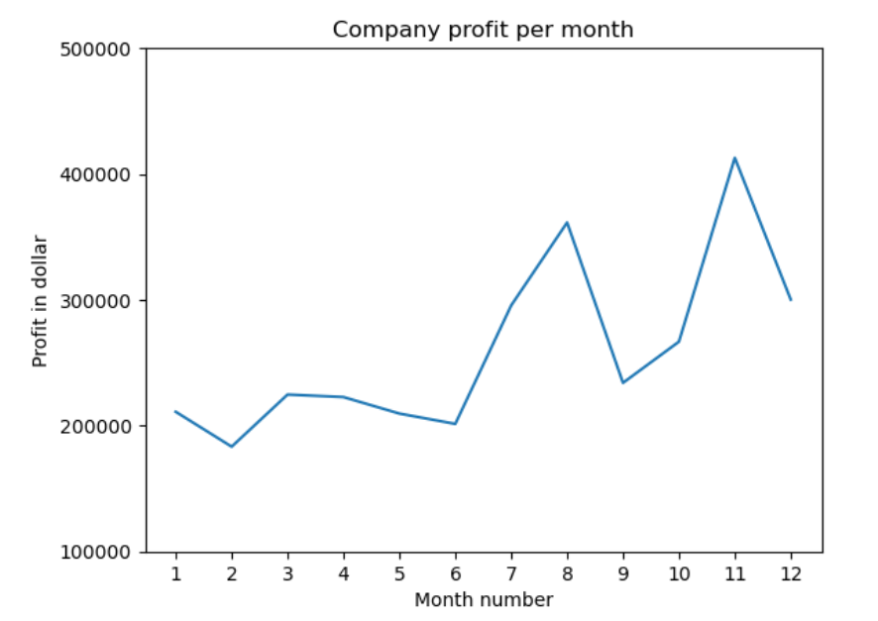

plt.plot(monthList, profitList, label = 'Profit data of last year',

      color='r', marker='o', markerfacecolor='k',

      linestyle='--', linewidth=3)

plt.xlabel('Month Number')

plt.ylabel('Profit in dollar')

plt.legend(loc='lower right')

plt.title('Company Sales data of last year')

plt.xticks(monthList)

plt.yticks([100000, 200000, 300000, 400000, 500000])

plt.show()

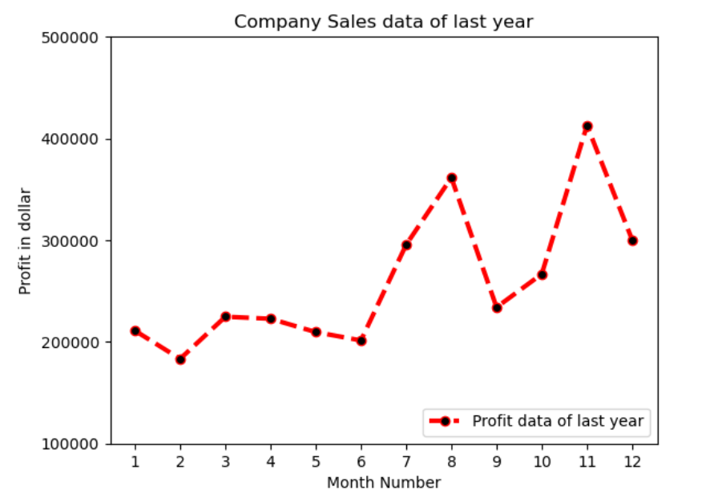

faceCremSalesData   = df ['facecream'].tolist()

faceWashSalesData   = df ['facewash'].tolist()

toothPasteSalesData = df ['toothpaste'].tolist()

bathingsoapSalesData   = df ['bathingsoap'].tolist()

shampooSalesData   = df ['shampoo'].tolist()

moisturizerSalesData = df ['moisturizer'].tolist()

plt.plot(monthList, faceCremSalesData,   label = 'Face cream Sales Data', marker='o', linewidth=3)

plt.plot(monthList, faceWashSalesData,   label = 'Face Wash Sales Data',  marker='o', linewidth=3)

plt.plot(monthList, toothPasteSalesData, label = 'ToothPaste Sales Data', marker='o', linewidth=3)

plt.plot(monthList, bathingsoapSalesData, label = 'ToothPaste Sales Data', marker='o', linewidth=3)

plt.plot(monthList, shampooSalesData, label = 'ToothPaste Sales Data', marker='o', linewidth=3)

plt.plot(monthList, moisturizerSalesData, label = 'ToothPaste Sales Data', marker='o', linewidth=3)

plt.xlabel('Month Number')

plt.ylabel('Sales units in number')

plt.legend(loc='upper left')

plt.xticks(monthList)

plt.yticks([1000, 2000, 4000, 6000, 8000, 10000, 12000, 15000, 18000])

plt.title('Sales data')

plt.show()

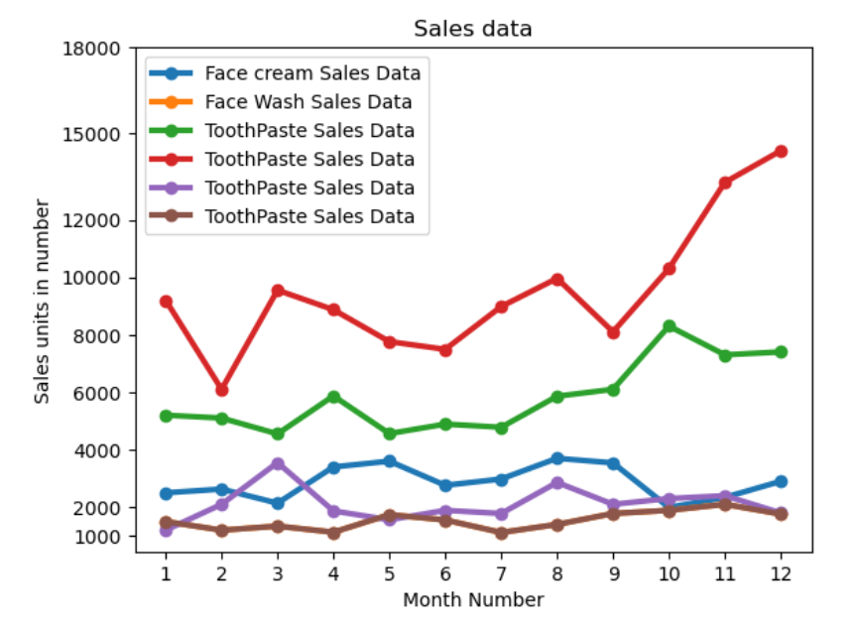

plt.scatter(monthList, toothPasteSalesData, label = 'Tooth paste Sales data')

plt.xlabel('Month Number')

plt.ylabel('Number of units Sold')

plt.legend(loc='upper left')

plt.title(' Tooth paste Sales data')

plt.xticks(monthList)

plt.grid(True, linewidth= 1, linestyle="--")

plt.show()

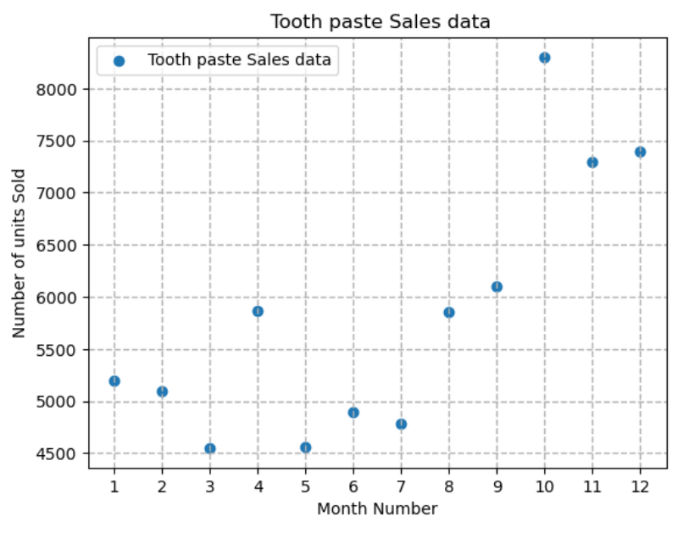

plt.bar([a-0.25 for a in monthList], faceCremSalesData, width= 0.25, label = 'Face Cream sales data', align='edge')

plt.bar([a+0.25 for a in monthList], faceWashSalesData, width= -0.25, label = 'Face Wash sales data', align='edge')

plt.xlabel('Month Number')

plt.ylabel('Sales units in number')

plt.legend(loc='upper left')

plt.title(' Sales data')

plt.xticks(monthList)

plt.grid(True, linewidth= 1, linestyle="--")

plt.title('Facewash and facecream sales data')

plt.show()

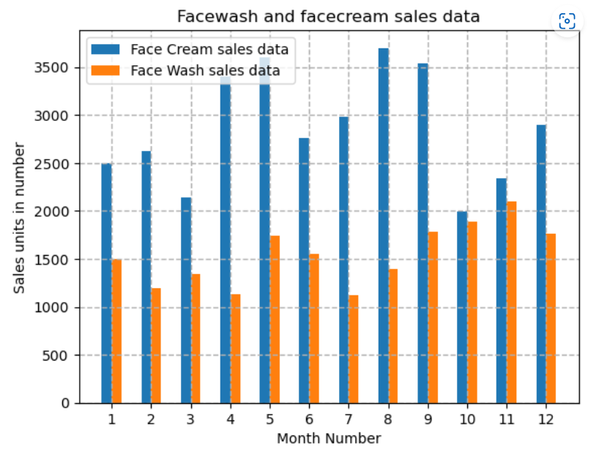

# **Assignment 4**

* Perform Exploratory Data Analysis (EDA) for Iris Species Dataset provided as csv file (you can also download it from: https://www.kaggle.com/datasets/uciml/iris ). Your EDA should include the following operations:

1. Show size of the dataset.
2. Show datatype for each column.
3. Show distribution of data (use describe() function).
4. Check if there are any null values.
5. Check for duplicates.
6. Check the number of instances for each species of flower.
7. Compare sepal length and sepal width.
8. Compare petal length and petal width.
9. Use pairplot to show all comparisons.
10. Use histograms to compare sepal length, sepal width, petal length and petal width across the species.
11. Use boxplot to show distribution of data across the species.
12. Use violinplot to show distribution of data across the species.

**Solution:**

# In[1]:

import pandas as pd

df = pd.read_csv("iris_csv.csv")

df.head()

# In[2]:

df.shape

Output: (150, 5)

# In[3]:

df.info()

Output: <class 'pandas.core.frame.DataFrame'>

RangeIndex: 150 entries, 0 to 149

Data columns (total 5 columns):

# Column Non-Null Count Dtype

--- ------ -------------- -----

0 sepal-length 150 non-null float64

1 sepal-width 150 non-null float64

2 petal-length 150 non-null float64

3 petal-width 150 non-null float64

4 Class 150 non-null object

dtypes: float64(4), object(1)

memory usage: 6.0+ KB

# In[4]:

df.describe()

Output:

|  | **sepal-length** | **sepal-width** | **petal-length** | **petal-width** |
| --- | --- | --- | --- | --- |
| **count** | 150.000000 | 150.000000 | 150.000000 | 150.000000 |
| **mean** | 5.843333 | 3.054000 | 3.758667 | 1.198667 |
| **std** | 0.828066 | 0.433594 | 1.764420 | 0.763161 |
| **min** | 4.300000 | 2.000000 | 1.000000 | 0.100000 |
| **25%** | 5.100000 | 2.800000 | 1.600000 | 0.300000 |
| **50%** | 5.800000 | 3.000000 | 4.350000 | 1.300000 |
| **75%** | 6.400000 | 3.300000 | 5.100000 | 1.800000 |
| **max** | 7.900000 | 4.400000 | 6.900000 | 2.500000 |

# In[5]:

df.isnull().sum()

Output: sepal-length 0

sepal-width 0

petal-length 0

petal-width 0

Class 0

dtype: int64

# In[6]:

data = df.drop_duplicates(subset ="Class",)

data

Output:

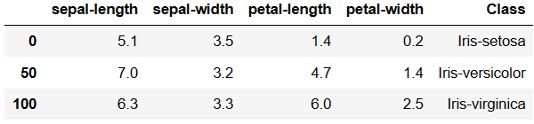

# In[7]:

df.value_counts("Class")

# In[8]:

import seaborn as sns

import matplotlib.pyplot as plt

sns.scatterplot(x='sepal-length', y='sepal-width', hue='Class', data=df, )

plt.legend(bbox_to_anchor=(1, 1), loc=2)

plt.title('Comparing')

plt.show()

Output:

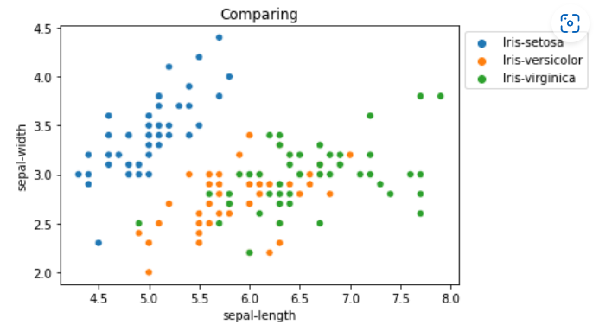

# In[9]:

import seaborn as sns

import matplotlib.pyplot as plt

sns.scatterplot(x='petal-length', y='petal-width',

                hue='Class', data=df, )

plt.legend(bbox_to_anchor=(1, 1), loc=2)

plt.title('Comparing')

plt.show()

Output:

# In[10]:

import seaborn as sns

import matplotlib.pyplot as plt

sns.pairplot(df.drop(['sepal-length'], axis = 1),

             hue='Class', height=2)

Output:

# In[11]:

import seaborn as sns

import matplotlib.pyplot as plt

fig, axes = plt.subplots(2, 2, figsize=(10,10))

axes[0,0].set_title("Sepal Length")

axes[0,0].hist(df['sepal-length'], bins=7)

axes[0,1].set_title("Sepal Width")

axes[0,1].hist(df['sepal-width'], bins=5);

axes[1,0].set_title("Petal Length")

axes[1,0].hist(df['petal-length'], bins=6);

axes[1,1].set_title("Petal Width")

axes[1,1].hist(df['petal-width'], bins=6);

Output:

# In[12]:

import seaborn as sns

import matplotlib.pyplot as plt

def graph(y):

    sns.boxplot(x="Class", y=y, data=df)

plt.figure(figsize=(10,10))

plt.subplot(221)

graph('sepal-length')

plt.subplot(222)

graph('sepal-width')

plt.subplot(223)

graph('petal-length')

plt.subplot(224)

graph('petal-width')

plt.show()

Output:

# In[13]:

import seaborn as sns

from matplotlib import pyplot

import seaborn

fig, ax = pyplot.subplots(figsize =(9, 7))

sns.violinplot( ax = ax, x = df["Class"], y = df["sepal-length"] )

# In[14]:

fig, ax = pyplot.subplots(figsize =(9, 7))

sns.violinplot( ax = ax, x = df["Class"], y = df["sepal-width"] )

Ouput:

# **Assignment 5**

**Write a python program to apply Decision Tree Classifier algorithm on the following datasets using Scikit-learn. (Find the datasets attached along with this assignment).**

**Solution :**

import numpy as np

import pandas as pd

from sklearn.metrics import confusion_matrix

from sklearn.model_selection import train_test_split

from sklearn.tree import DecisionTreeClassifier

from sklearn.metrics import accuracy_score

from sklearn.metrics import classification_report

def importdata():

    balance_data = pd.read_csv(

        'https://archive.ics.uci.edu/ml/machine-learning-' +

        'databases/balance-scale/balance-scale.data',

        sep=',', header=None)

    print("Dataset Length: ", len(balance_data))

    print("Dataset Shape: ", balance_data.shape)

    print("Dataset: ", balance_data.head())

    return balance_data

def splitdataset(balance_data):

    X = balance_data.values[:, 1:5]

    Y = balance_data.values[:, 0]

    X_train, X_test, y_train, y_test = train_test_split(

        X, Y, test_size=0.3, random_state=100)

    return X, Y, X_train, X_test, y_train, y_test

def train_using_gini(X_train, X_test, y_train):

    clf_gini = DecisionTreeClassifier(criterion="gini",random_state=100, max_depth=3, min_samples_leaf=5)

    clf_gini.fit(X_train, y_train)

    return clf_gini

def tarin_using_entropy(X_train, X_test, y_train):

    clf_entropy = DecisionTreeClassifier(

        criterion="entropy", random_state=100,

        max_depth=3, min_samples_leaf=5)

    clf_entropy.fit(X_train, y_train)

    return clf_entropy

def prediction(X_test, clf_object):

    y_pred = clf_object.predict(X_test)

    print("Predicted values:")

    print(y_pred)

    return y_pred

def cal_accuracy(y_test, y_pred):

    print("Confusion Matrix: ",

          confusion_matrix(y_test, y_pred))

    print("Accuracy : ",

          accuracy_score(y_test, y_pred)*100)

    print("Report : ",

          classification_report(y_test, y_pred))

def main():

    data = importdata()

    X, Y, X_train, X_test, y_train, y_test = splitdataset(data)

    clf_gini = train_using_gini(X_train, X_test, y_train)

    clf_entropy = tarin_using_entropy(X_train, X_test, y_train)

    print("Results Using Gini Index:")

    y_pred_gini = prediction(X_test, clf_gini)

    cal_accuracy(y_test, y_pred_gini)

    print("Results Using Entropy:")

    y_pred_entropy = prediction(X_test, clf_entropy)

    cal_accuracy(y_test, y_pred_entropy)

main()

**output:**

Dataset Length: 625

Dataset Shape: (625, 5)

Dataset: 0 1 2 3 4

0 B 1 1 1 1

1 R 1 1 1 2

2 R 1 1 1 3

3 R 1 1 1 4

4 R 1 1 1 5

Results Using Gini Index:

Predicted values:

['R' 'L' 'R' 'R' 'R' 'L' 'R' 'L' 'L' 'L' 'R' 'L' 'L' 'L' 'R' 'L' 'R' 'L'

'L' 'R' 'L' 'R' 'L' 'L' 'R' 'L' 'L' 'L' 'R' 'L' 'L' 'L' 'R' 'L' 'L' 'L'

'L' 'R' 'L' 'L' 'R' 'L' 'R' 'L' 'R' 'R' 'L' 'L' 'R' 'L' 'R' 'R' 'L' 'R'

'R' 'L' 'R' 'R' 'L' 'L' 'R' 'R' 'L' 'L' 'L' 'L' 'L' 'R' 'R' 'L' 'L' 'R'

'R' 'L' 'R' 'L' 'R' 'R' 'R' 'L' 'R' 'L' 'L' 'L' 'L' 'R' 'R' 'L' 'R' 'L'

'R' 'R' 'L' 'L' 'L' 'R' 'R' 'L' 'L' 'L' 'R' 'L' 'R' 'R' 'R' 'R' 'R' 'R'

'R' 'L' 'R' 'L' 'R' 'R' 'L' 'R' 'R' 'R' 'R' 'R' 'L' 'R' 'L' 'L' 'L' 'L'

'L' 'L' 'L' 'R' 'R' 'R' 'R' 'L' 'R' 'R' 'R' 'L' 'L' 'R' 'L' 'R' 'L' 'R'

'L' 'L' 'R' 'L' 'L' 'R' 'L' 'R' 'L' 'R' 'R' 'R' 'L' 'R' 'R' 'R' 'R' 'R'

'L' 'L' 'R' 'R' 'R' 'R' 'L' 'R' 'R' 'R' 'L' 'R' 'L' 'L' 'L' 'L' 'R' 'R'

'L' 'R' 'R' 'L' 'L' 'R' 'R' 'R']

Confusion Matrix: [[ 0 6 7]

[ 0 67 18]

[ 0 19 71]]

Accuracy : 73.40425531914893

Report : precision recall f1-score support

B 0.00 0.00 0.00 13

L 0.73 0.79 0.76 85

R 0.74 0.79 0.76 90

accuracy 0.73 188

macro avg 0.49 0.53 0.51 188

weighted avg 0.68 0.73 0.71 188

Results Using Entropy:

Predicted values:

['R' 'L' 'R' 'L' 'R' 'L' 'R' 'L' 'R' 'R' 'R' 'R' 'L' 'L' 'R' 'L' 'R' 'L'

'L' 'R' 'L' 'R' 'L' 'L' 'R' 'L' 'R' 'L' 'R' 'L' 'R' 'L' 'R' 'L' 'L' 'L'

'L' 'L' 'R' 'L' 'R' 'L' 'R' 'L' 'R' 'R' 'L' 'L' 'R' 'L' 'L' 'R' 'L' 'L'

'R' 'L' 'R' 'R' 'L' 'R' 'R' 'R' 'L' 'L' 'R' 'L' 'L' 'R' 'L' 'L' 'L' 'R'

'R' 'L' 'R' 'L' 'R' 'R' 'R' 'L' 'R' 'L' 'L' 'L' 'L' 'R' 'R' 'L' 'R' 'L'

'R' 'R' 'L' 'L' 'L' 'R' 'R' 'L' 'L' 'L' 'R' 'L' 'L' 'R' 'R' 'R' 'R' 'R'

'R' 'L' 'R' 'L' 'R' 'R' 'L' 'R' 'R' 'L' 'R' 'R' 'L' 'R' 'R' 'R' 'L' 'L'

'L' 'L' 'L' 'R' 'R' 'R' 'R' 'L' 'R' 'R' 'R' 'L' 'L' 'R' 'L' 'R' 'L' 'R'

'L' 'R' 'R' 'L' 'L' 'R' 'L' 'R' 'R' 'R' 'R' 'R' 'L' 'R' 'R' 'R' 'R' 'R'

'R' 'L' 'R' 'L' 'R' 'R' 'L' 'R' 'L' 'R' 'L' 'R' 'L' 'L' 'L' 'L' 'L' 'R'

'R' 'R' 'L' 'L' 'L' 'R' 'R' 'R']

Confusion Matrix: [[ 0 6 7]

[ 0 63 22]

[ 0 20 70]]

Accuracy : 70.74468085106383

Report : precision recall f1-score support

B 0.00 0.00 0.00 13

L 0.71 0.74 0.72 85

R 0.71 0.78 0.74 90

accuracy 0.71 188

macro avg 0.47 0.51 0.49 188

weighted avg 0.66 0.71 0.68 188

# **Assignment 6**

**Write a python program to apply KNN (Classification + Regression) algorithm on the given datasets using Scikit-learn and also plot accuracy and mean error vs k value for both.(Find the datasets attached along with this assignment).**

**Solution:**

import numpy as np

import matplotlib.pyplot as plt

from sklearn.datasets import load_iris, load_boston

from sklearn.model_selection import train_test_split

from sklearn.neighbors import KNeighborsClassifier, KNeighborsRegressor

from sklearn.metrics import accuracy_score, mean_squared_error

iris = load_iris()

X_train, X_test, y_train, y_test = train_test_split(

    iris.data, iris.target, test_size=0.3, random_state=42)

knn_clf = KNeighborsClassifier(n_neighbors=3)

knn_clf.fit(X_train, y_train)

y_pred = knn_clf.predict(X_test)

accuracy = accuracy_score(y_test, y_pred)

print("Accuracy for K=3 in iris dataset is: ", accuracy)

k_range = range(1, 31)

accuracy_scores = []

for k in k_range:

    knn_clf = KNeighborsClassifier(n_neighbors=k)

    knn_clf.fit(X_train, y_train)

    y_pred = knn_clf.predict(X_test)

    accuracy_scores.append(accuracy_score(y_test, y_pred))

plt.plot(k_range, accuracy_scores)

plt.xlabel('K value')

plt.ylabel('Accuracy')

plt.title('Accuracy vs K value for iris dataset')

plt.show()

boston = load_boston()

X_train, X_test, y_train, y_test = train_test_split(

    boston.data, boston.target, test_size=0.3, random_state=42)

knn_reg = KNeighborsRegressor(n_neighbors=3)

knn_reg.fit(X_train, y_train)

y_pred = knn_reg.predict(X_test)

mse = mean_squared_error(y_test, y_pred)

print("Mean squared error for K=3 in boston dataset is: ", mse)

mse_scores = []

for k in k_range:

    knn_reg = KNeighborsRegressor(n_neighbors=k)

    knn_reg.fit(X_train, y_train)

    y_pred = knn_reg.predict(X_test)

    mse_scores.append(mean_squared_error(y_test, y_pred))

plt.plot(k_range, mse_scores)

plt.xlabel('K value')

plt.ylabel('Mean Squared Error')

plt.title('MSE vs K value for boston dataset')

plt.show()

OUTPUT:-

Accuracy for K=3 in iris dataset is: 1.0

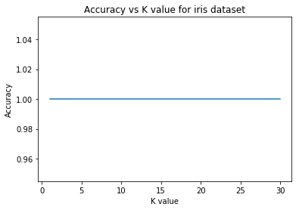

Mean squared error for K=3 in boston dataset is: 28.149334795321632

# **Assignment 7**

**Write a python program to apply Perceptron, SVM, Logistic Regression algorithm on the given datsets using Scikit-learn and also plot accuracy and show the precision, recall, f1-score, support table. (Find the datasets attached along with this assignment).**

**Solution:**

from sklearn import datasets

from sklearn.linear_model import Perceptron, LogisticRegression

from sklearn.svm import SVC

from sklearn.metrics import accuracy_score, classification_report

from sklearn.model_selection import train_test_split

import matplotlib.pyplot as plt

import numpy as np

iris = datasets.load_iris()

X = iris.data[:, :2]

y = iris.target

X_train, X_test, y_train, y_test = train_test_split(

    X, y, test_size=0.3, random_state=42)

models = [

    ('Perceptron', Perceptron(random_state=42)),

    ('SVM', SVC(random_state=42)),

    ('Logistic Regression', LogisticRegression(random_state=42))

]

for name, model in models:

    model.fit(X_train, y_train)

    y_pred = model.predict(X_test)

    accuracy = accuracy_score(y_test, y_pred)

    report = classification_report(y_test, y_pred)

    print(f"{name} accuracy: {accuracy}")

    print(f"{name} classification report:\n{report}"

    plt.figure()

    plt.scatter(X[:, 0], X[:, 1], c=y, cmap=plt.cm.Set1, edgecolor='k')

    plt.xlabel('Sepal length')

    plt.ylabel('Sepal width')

    plt.title(name)

    xx, yy=np.meshgrid(np.arange(X[:, 0].min() - 1, X[:, 0].max() + 1, 0.1),

                         np.arange(X[:, 1].min() - 1, X[:, 1].max() + 1, 0.1))

    Z=model.predict(np.c_[xx.ravel(), yy.ravel()])

    Z=Z.reshape(xx.shape)

    plt.contourf(xx, yy, Z, cmap=plt.cm.Set1, alpha=0.8)

    plt.show()

**OUTPUT:**

Perceptron accuracy: 0.7111111111111111

Perceptron classification report:

precision recall f1-score support

0 1.00 1.00 1.00 19

1 0.50 1.00 0.67 13

2 0.00 0.00 0.00 13

micro avg 0.71 0.71 0.71 45

macro avg 0.50 0.67 0.56 45

weighted avg 0.57 0.71 0.61 45

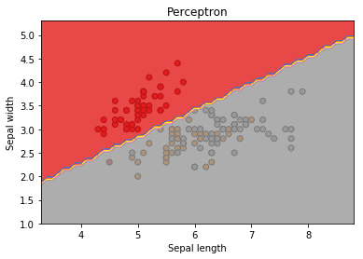

SVM accuracy: 0.8

SVM classification report:

precision recall f1-score support

0 1.00 1.00 1.00 19

1 0.70 0.54 0.61 13

2 0.62 0.77 0.69 13

micro avg 0.80 0.80 0.80 45

macro avg 0.78 0.77 0.77 45

weighted avg 0.81 0.80 0.80 45