Which open-data surrogates reproduce expert biodiversity assessment? A pre-registered multi-catchment validation in northern Australia
Running title: Validating open-data biodiversity surrogates
Authors: Harsh Rastogi
Affiliations: Charles Darwin University, Casuarina, Northern Territory, Australia
Corresponding author: Harsh Rastogi, Charles Darwin University, Casuarina, Northern Territory, Australia. Email: harsh.rastogi@students.cdu.edu.au
ORCID: Harsh Rastogi, https://orcid.org/0009-0004-9452-0206

Abstract
Aim. Conservation planning in data-poor regions substitutes open-access surrogates for direct biodiversity data, yet whether they reproduce expert judgement is seldom tested — and rarely against the analytical choices (unit, weighting, scale) that can determine the answer. We ask which surrogate best reproduces independent expert assessment, whether combining surrogates helps or transfers to unsurveyed landscapes, and how robust the answers are.
Location. Northern Territory, Australia (six expert-assessed areas).
Methods. Using expert assessments for six areas — five on an identical ordinal biodiversity-risk scale (BIORISK, 1–5), one (Greater Weddell) on a related scheme analysed separately — we validated five open-access surrogates (land-system rarity, vegetation-type (NVIS) rarity, vegetation cover (DEA Fractional Cover), convertibility, protection) at the native expert-polygon unit. Pre-registered, it used two co-primary estimands (per-unit, per-area), a spatial block bootstrap with random-effects meta-analysis, a circularity control for the leading surrogate, and a joint model evaluated out-of-sample (spatial-block cross-validation; leave-one-catchment-out transfer).
Results. Land-system rarity did not reproduce expert value per unit (ρ = 0.085, 95% CI −0.003 to 0.172). Vegetation-type (NVIS) rarity showed the strongest per-unit agreement (ρ = 0.244, 0.149–0.334), retaining an independent association after controlling for land-system rarity and convertibility (partial ρ = 0.200, 0.079–0.314). Convertibility was the only surrogate positive under both estimands; cover and protection carried no value signal. Which surrogate worked was estimand-dependent — land-system rarity only per area, NVIS only per unit. A joint model reached only modest out-of-sample agreement (ρ ≈ 0.22–0.27) and, though it transferred positively to every held-out catchment, did not significantly beat the best single surrogate (incremental ρ = 0.074, −0.109 to 0.226).
Main conclusions. Open-data surrogates are weak first-pass screens, not biodiversity-value maps. At the expert-unit level a vegetation-type surrogate modestly outperforms the widely-used landform-rarity surrogate, but the best surrogate depends on analysis unit, weighting and scale — a caution for much surrogate-based planning.
Keywords: biodiversity surrogates; conservation planning; expert assessment; modifiable areal unit problem; northern Australia; open data; spatial cross-validation; validation

1. Introduction
Spatial estimates of where biodiversity value is concentrated underpin systematic conservation planning (Margules & Pressey, 2000), but across much of the world's land surface — including most of northern Australia — the species inventories, fine-scale vegetation mapping and expert assessment that such estimates ideally draw on do not exist at the resolution planning requires. The pragmatic response has been to build priority layers from whatever open, wall-to-wall spatial data are available — land-system and landform maps, vegetation classifications, land-use and tenure layers, remote sensing — as surrogates for the biodiversity information that direct survey would provide (Rodrigues & Brooks, 2007).
Two assumptions underlie this practice, and both are rarely tested. The first is that a chosen surrogate actually reproduces the biodiversity priorities that expert assessment would assign. The second, more subtle, is that the answer to the first does not depend on arbitrary analytical choices — the spatial unit of analysis, whether units are weighted by area, and the grain at which the comparison is made (the modifiable areal unit problem; Openshaw, 1984; Jelinski & Wu, 1996). Independent expert benchmarks are, by definition, scarce in the places surrogates are used, so validations are few; and where they exist they typically report a single correlation at a single unit and scale, leaving the robustness of the conclusion unexamined.
Here we test both assumptions directly. Northern Australia offers an unusual opportunity: the Northern Territory Government's Mapping the Future program has produced independent, field-based expert biodiversity assessments for several catchments — five on a common ordinal risk scale — embedded in a landscape where open-data surrogates are widely proposed for development screening. Using six such assessments, we ask a deliberately practical and testable question:
In a data-poor jurisdiction, how well — and via which surrogate — can open-access spatial data reproduce independent expert biodiversity assessment; does combining surrogates help or transfer to unsurveyed landscapes; and are these answers robust to the analysis unit, weighting and spatial scale?
We pre-registered the analysis, adopted two co-primary estimands so that unit/weighting sensitivity is reported rather than hidden, used spatial inference appropriate to strongly autocorrelated expert polygons, and evaluated the multivariate combination out-of-sample and under landscape transfer. The result is both an empirical answer for northern Australia and a transferable, honest template for validating biodiversity surrogates elsewhere.

2. Materials and Methods
The full pre-registration, code and per-number provenance are archived (Data and code availability); we summarise the confirmed design here.

2.1 Study area and expert benchmarks
The benchmarks are expert biodiversity assessments produced under the Mapping the Future program for six Northern Territory areas (referred to as catchments for brevity): the central Roper River catchment, Larrimah, Wadeye, Gunn Point, the NTP 3910 Deep Well area, and the Greater Weddell subregion (Figure 1; Northern Territory Government, 2020, 2021a, 2021b, 2021c, 2024b, 2025). Five of these (Roper, Larrimah, Wadeye, Gunn Point, Deep Well) carry an identical ordinal biodiversity risk classification (BIORISK: 1 = nil/highly modified; 2 = low; 3 = mitigable; 4 = moderate/sensitive-or-significant; 5 = high), assigned to expert-delineated polygons from field vegetation and fauna survey, and form the primary pool (Table 1). The sixth, Greater Weddell, uses a distinct "biodiversity values" scheme and is reported separately as a robustness check, never pooled.
The analysis unit is the native expert polygon — the polygon at which the expert assigned a BIORISK class — which preserves the benchmark at its own spatial support and avoids the change-of-support distortions that arise when expert judgement is re-aggregated to an imposed grid.
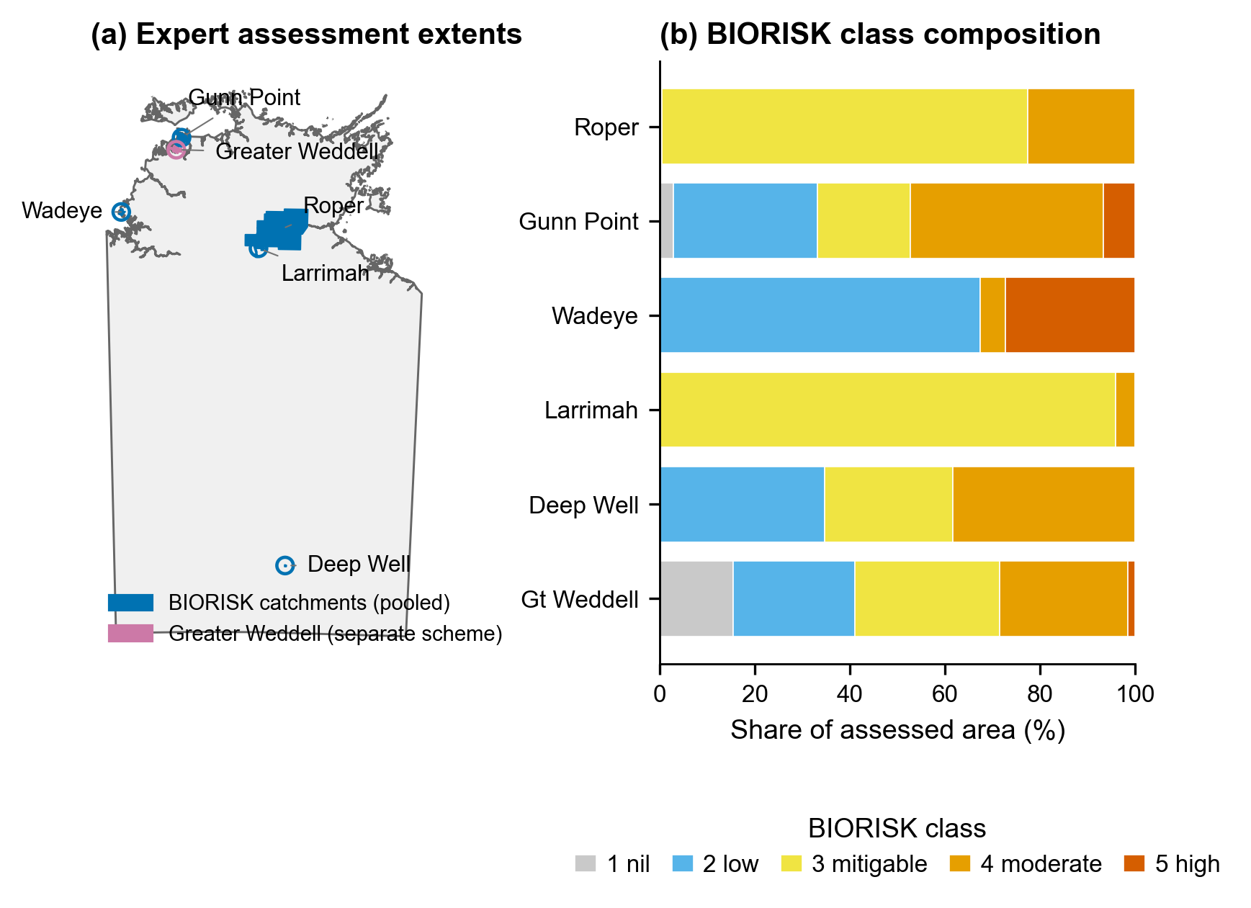
Figure 1. Study area: the six Mapping the Future expert biodiversity assessments within the Northern Territory, with their extents and BIORISK class composition.

2.2 Open-data surrogates
Each polygon was attributed five open-access surrogates (all reprojected to GDA94 / Australian Albers, EPSG:3577; Table 1):
- Land-system rarity (sig_landsys): the incumbent significance surrogate — the log-inverse of the Territory-wide area of each land system (NT Land Systems, 1:250,000/1:1,000,000; Northern Territory Government, n.d.), rescaled to [0,1] and area-weighted per unit.
- Vegetation-type rarity (sig_nvis_mvg): the direct vegetation analogue — the log-inverse Territory-wide area of each National Vegetation Information System v7 Major Vegetation Group (NVIS; Department of Climate Change, Energy, the Environment and Water, 2024; 100 m; 22 native classes; non-vegetation classes treated as no-data).
- Vegetation cover (cond_dea): a condition/intactness proxy — 100 minus the median bare-soil fraction from Digital Earth Australia Fractional Cover Percentiles (Landsat, 30 m, 2020; Geoscience Australia, [year]).
- Agricultural convertibility (convertibility): an area-weighted score derived from the Northern Territory Land Use Mapping (ALUM primary classes; Northern Territory Government, 2024a); water treated as no-data.
- Formal protection (protection): the fraction of the unit within the Collaborative Australian Protected Areas Database (CAPAD; Department of Climate Change, Energy, the Environment and Water, 2022).
sig_landsys, sig_nvis_mvg, cond_dea are candidate biodiversity-value surrogates; convertibility and protection are included as reference predictors.

2.3 Analysis unit and co-primary estimands (pre-registered)
Because a surrogate can agree with expert judgement per delineated unit yet not per unit area (small high-value polygons carry equal weight in the former, negligible weight in the latter), we pre-registered two co-primary estimands: E-UNIT (each expert polygon weighted equally) and E-AREA (polygons weighted by area). Both are always reported; a surrogate is judged validated only if positive under both, null if null under both, and estimand-dependent otherwise. Neither is treated as a significance gate when they disagree; their divergence is itself a result.

2.4 Statistical inference
Agreement was measured by Spearman rank correlation between each surrogate and the expert BIORISK class assigned to each polygon, weighting polygons either equally (E-UNIT) or by area (E-AREA). Because expert polygons are strongly spatially autocorrelated — so their count far exceeds the number of independent observations (Clifford et al., 1989; Legendre, 1993) — we used a spatial block bootstrap: polygons were assigned to contiguous 10 km tiles (with 5 km and 20 km sensitivity), and tiles were resampled with replacement (2,000 iterations) so that whole neighbourhoods move together. Per-catchment Fisher-z variances from the bootstrap fed a DerSimonian–Laird random-effects meta-analysis (DerSimonian & Laird, 1986). The Deep Well area yields only two 10 km blocks and was not estimable in the block bootstrap, so the pooled meta rests on four catchments (and, for protection, on the two in which protected areas overlapped the benchmark).
The leading candidate surrogate was subjected to a circularity control, because expert classes 4–5 are partly defined by significant vegetation and the vegetation surrogate could re-read that criterion: (a) a partial rank correlation controlling for land-system rarity and convertibility, and (b) restriction to the mitigable-versus-moderate (class 3-vs-4) contrast.
Finally, a joint multivariate model (a linear combiner of the surrogates) was evaluated out-of-sample to test whether combining adds predictive value beyond the best single surrogate, using (i) spatial-block cross-validation (Roberts et al., 2017; holding out whole catchment × 10 km tiles) and (ii) leave-one-catchment-out (LOCO) transfer (training on four catchments and predicting the fifth). No catchment identifiers entered the transfer model, so it reflects application to an unsurveyed area. Out-of-sample skill was Spearman(predicted, observed) on held-out data; incremental value (joint minus best single) carried a block-bootstrap confidence interval; the train–test gap indexed overfitting. All analyses used fixed seeds and are reproducible from the archived scripts.

3. Results

3.1 The incumbent land-system-rarity surrogate does not reproduce expert value
At the per-expert-unit estimand, land-system rarity showed no meaningful agreement with expert BIORISK (pooled ρ = 0.085, 95% CI −0.003 to 0.172; Table 2, Figure 2), and this was stable across tile sizes (ρ = 0.071–0.085 at 5–20 km). It was positive under area-weighting (ρ = 0.280, 0.161–0.390), but this apparent signal was substantially leverage-driven: dropping the largest 5% of polygons by area roughly halved it in most catchments (Roper 0.24→0.13; Gunn Point 0.31→0.16; Larrimah 0.52→0.10; the exception was Wadeye, which fell only from 0.40 to 0.33). Land-system rarity is therefore, at best, an area-scaled correlate rather than a per-unit predictor of expert biodiversity value.
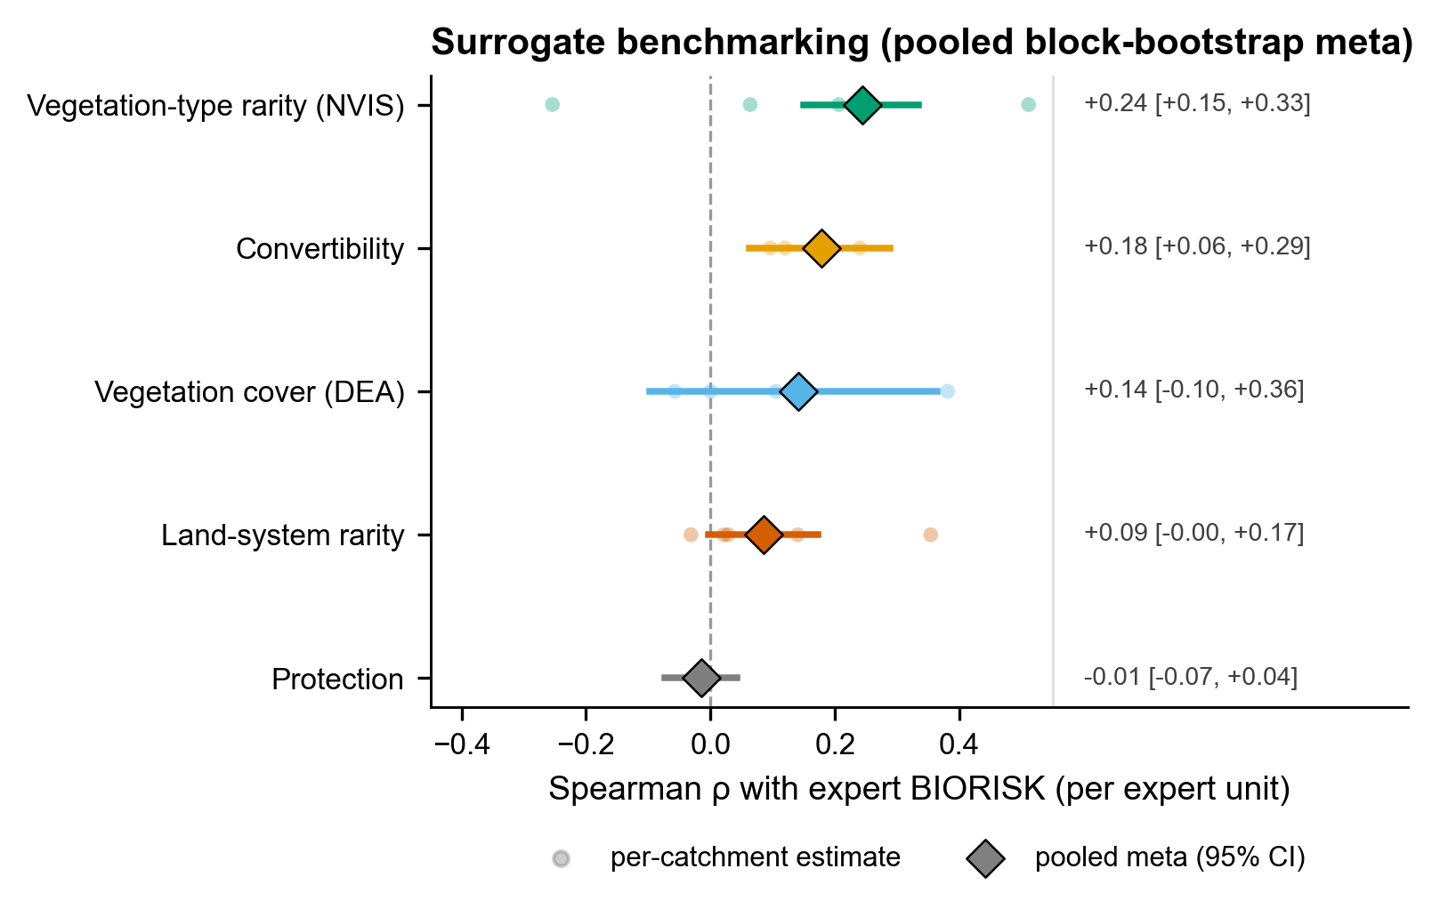
Figure 2. Surrogate benchmarking. Per-catchment and pooled (random-effects meta) Spearman agreement of each surrogate with expert BIORISK at the per-expert-unit estimand, with spatial block-bootstrap 95% intervals. Vegetation-type rarity is highest; land-system rarity overlaps zero.

3.2 Vegetation-type (NVIS) rarity is a modest but genuine improvement
Vegetation-type rarity showed the strongest per-unit agreement of any candidate surrogate (pooled ρ = 0.244, 0.149–0.334; positive in four of five catchments), robust to tile size (0.244–0.270). Critically, it survived the circularity control (Figure 3): after partialling out land-system rarity and convertibility it retained an independent association (partial ρ = 0.200, 0.079–0.314, p = 0.001; positive in every estimable catchment though heterogeneous in magnitude, I² ≈ 70%), and it discriminated BIORISK within the pure class-3-vs-4 contrast (e.g. Roper 0.15; Gunn Point 0.42). Its advantage over land-system rarity is thus not a definitional artefact. However, its agreement was estimand-dependent: under area-weighting it was heterogeneous and indistinguishable from zero (ρ = 0.348, −0.29 to 0.77; I² = 91%) — the mirror image of land-system rarity, which was positive only under area-weighting.
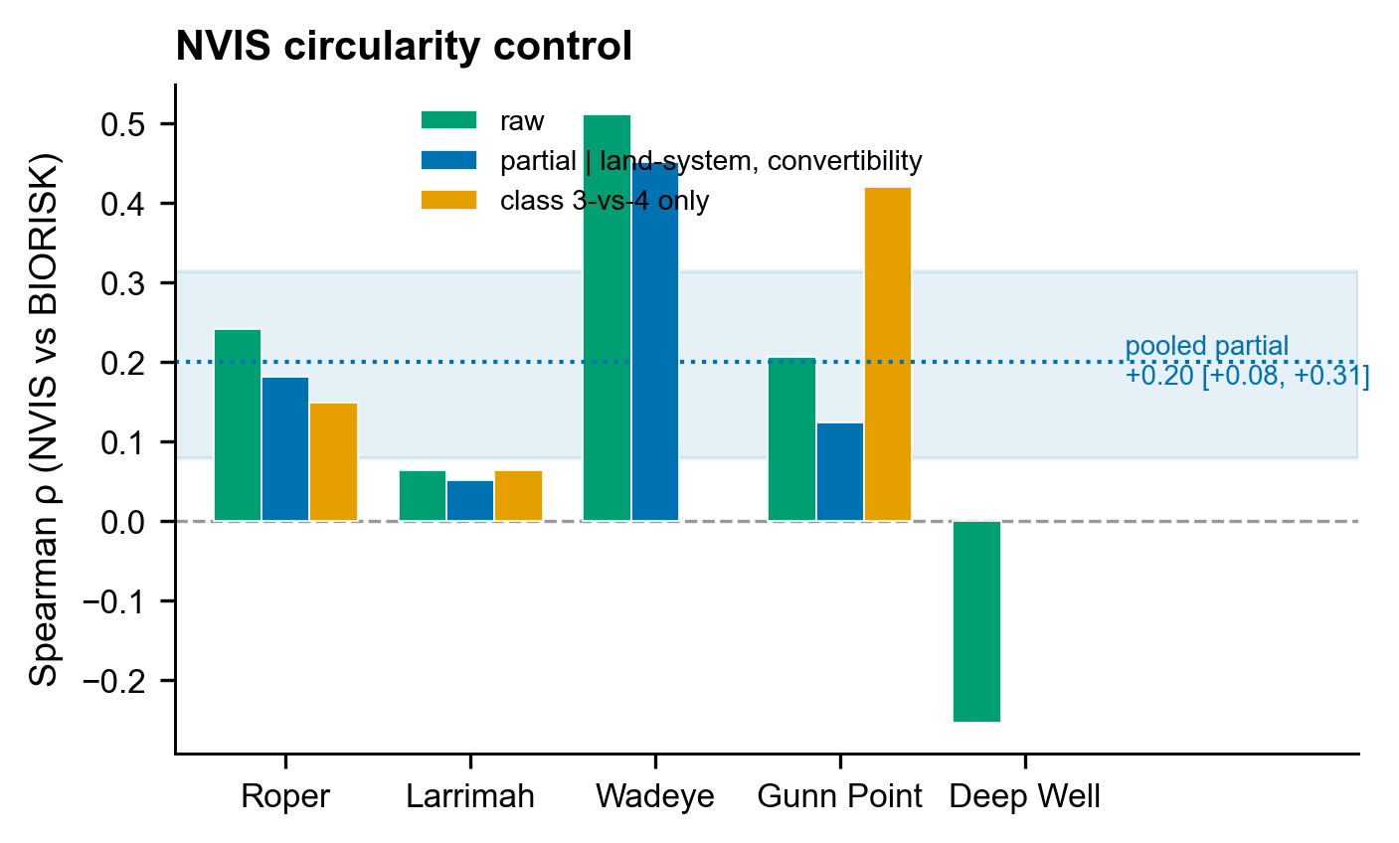
Figure 3. NVIS circularity control. Per-catchment raw agreement, partial agreement controlling for land-system rarity and convertibility, and agreement restricted to the class-3-vs-4 contrast; the independent signal is retained.

3.3 Convertibility is the most robust reference predictor; cover and protection carry no signal
Agricultural convertibility was the only surrogate positive under both estimands (E-UNIT ρ = 0.178, 0.063–0.288; E-AREA ρ = 0.174, 0.041–0.301), consistent with land availability tracking much of the apparent surrogate–expert agreement. Remotely-sensed vegetation cover did not reproduce expert value (E-UNIT ρ = 0.141, −0.098 to 0.364; highly heterogeneous, I² = 83%; strongly positive only in Roper), and formal protection carried no value signal (ρ ≈ 0, as expected given the benchmark contains no protection information; protection was estimable in only the two catchments where protected areas overlapped the benchmark).

3.4 Conclusions depend on unit, weighting and scale
The three candidate significance/condition surrogates changed rank and even sign between the two co-primary estimands (Figure 4): NVIS rarity was best per-unit but null per-area; land-system rarity was null per-unit but positive (leverage-driven) per-area; vegetation cover was null under both. Point estimates were stable across 5–20 km blocks, but the honest replication scale is small — Gunn Point's ~23,000 expert polygons correspond to only 15 independent 10 km blocks, Wadeye to 6 — so per-catchment inference is weak and the multi-catchment meta is the appropriate level.
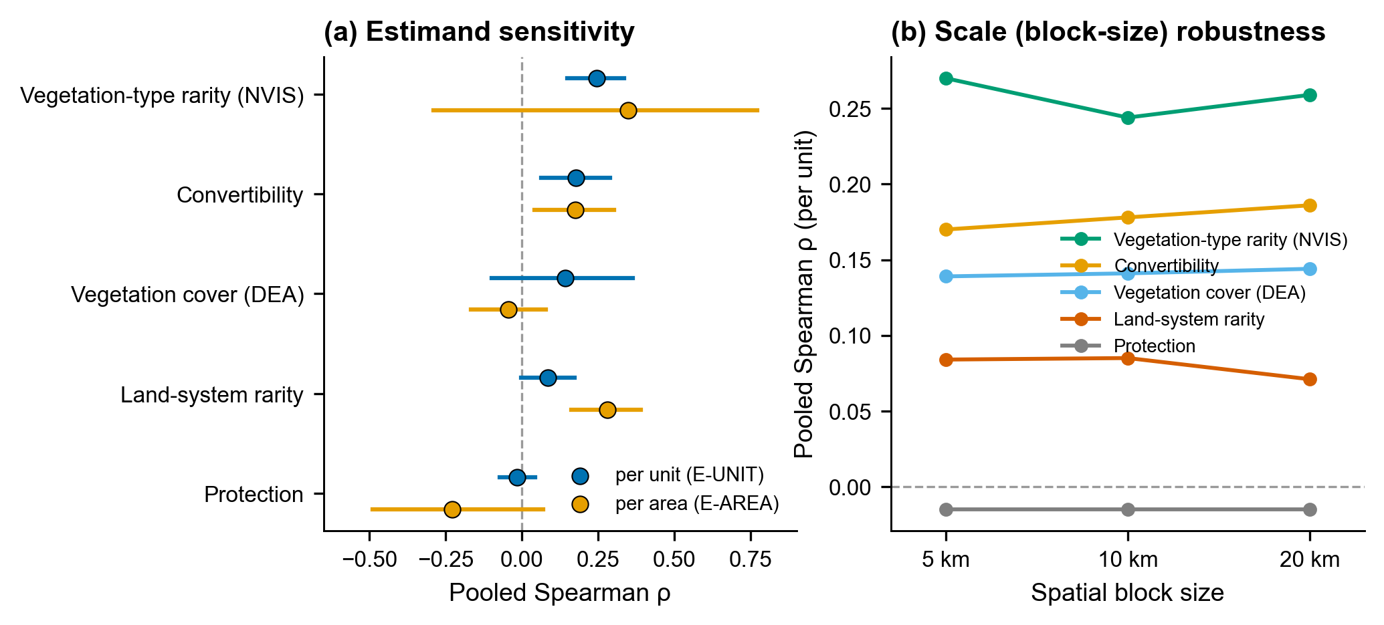
Figure 4. Estimand and scale sensitivity. (a) Pooled agreement under the two co-primary estimands (per-unit vs per-area) for each surrogate, showing rank/sign changes; (b) robustness of the per-unit estimates to block size (5, 10, 20 km).

3.5 Combining surrogates: modest transfer, no confirmed gain over the best single surrogate
Out-of-sample (spatial-block cross-validation, E-UNIT), the joint model was a valid but weak screen (ρ = 0.218, 0.08–0.33; Table 3, Figure 5), exceeding the best single surrogate (NVIS: ρ = 0.127, 0.05–0.26) in point estimate only; the incremental value of combining was not distinguishable from zero (Δρ = 0.074, −0.109 to 0.226). Adding vegetation cover reduced skill. Overfitting was modest (train–test gap ≈ 0.08). Under leave-one-catchment-out transfer the joint model predicted every held-out landscape positively (mean ρ = 0.271; range 0.14–0.54) and slightly more consistently than NVIS alone (mean 0.207, which failed on Deep Well). The strongest out-of-sample agreement we obtained between open-data surrogates and expert assessment was therefore modest (ρ ≈ 0.22–0.27), and combining did not demonstrably improve on a single well-chosen surrogate.
The Greater Weddell area (separate scheme; not pooled) was consistent with the pooled pattern: NVIS rarity showed the strongest agreement (ρ = 0.23), convertibility next (0.19), land-system rarity none (−0.10), vegetation cover none (−0.03).
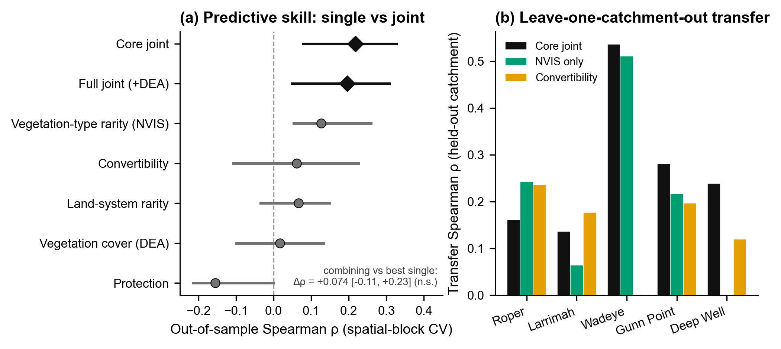
Figure 5. Joint model and transfer. Out-of-sample (spatial-block CV) agreement of single vs joint models, and leave-one-catchment-out transfer skill per held-out catchment; combining does not significantly exceed the best single surrogate.

4. Discussion
Across six independent expert assessments, open-access spatial surrogates reproduced expert biodiversity judgement only weakly, and which surrogate did best depended on how the question was posed. Three findings are robust. First, the land-system/landform-rarity surrogate — among the most widely used low-cost biodiversity proxies — did not reproduce expert value at the level of expert-delineated units; its area-weighted signal was driven by a few large polygons. Second, a vegetation-type-rarity surrogate (NVIS) did modestly better and, unlike the incumbent, carried an association that persisted after controlling for land-system rarity and convertibility and that discriminated expert classes even within the mitigable-versus-moderate contrast — so its advantage is not merely a restatement of the incumbent surrogates or of land availability, though the control is indirect (Section 4.1). Third, agricultural convertibility remained the most consistent correlate, suggesting that part of any surrogate's apparent success may reflect where land is available as much as where biodiversity is.
Two cautions follow. The first is methodological: conclusions were estimand- and scale-dependent (Openshaw, 1984; Jelinski & Wu, 1996). A surrogate that appears predictive when landscape area is the currency can be uninformative when each expert unit is the currency, and vice versa. Because small, high-value units (riparian zones, groundwater-dependent and significant-vegetation patches) are often precisely those a screen must not miss, the per-unit estimand is the more conservative and, we argue, the more appropriate default for biodiversity screening — but reporting both is essential, and single-estimand validations should be read with this in mind. The second is practical: the agreement achieved was weak (ρ ≈ 0.2–0.3), and combining surrogates did not reliably improve it. Open-data surrogate layers are defensible as first-pass screening tools with mapped uncertainty; they are not biodiversity-value maps and should not be presented as such.
That said, the news is not wholly negative. A better-grounded, still-cheap surrogate (vegetation-type rarity) outperformed the incumbent and transferred positively to every held-out landscape, indicating that surrogate choice matters and that open data can support cautious cross-landscape screening where no survey exists.

4.1 Limitations
Our inference is bounded in three ways. (i) Effective replication is small: although the expert benchmarks contain tens of thousands of polygons, strong spatial autocorrelation reduces these to a few independent blocks per catchment and to five BIORISK catchments overall (four in the pooled meta), so effect sizes are estimated with wide uncertainty and between-catchment heterogeneity is poorly resolved. Larrimah is individually uninformative (19 polygons, two classes), and Deep Well — with only two 10 km blocks — is not estimable in the block bootstrap and drops out of the pooled meta entirely; the pooled estimates therefore rest on four catchments (two for protection). This exclusion is driven by block count, not by result, and applies uniformly to all surrogates; we note nonetheless that Deep Well (six polygons) is the one catchment in which the NVIS estimate is negative and the land-system estimate positive, so its removal modestly favours the NVIS–land-system contrast — a contrast that, however, is anchored by the two large catchments (Roper, Gunn Point) in which NVIS also leads. (ii) Single jurisdiction: all benchmarks are from one program in the Northern Territory; external validity to other regions, biomes and assessment protocols is untested. (iii) Surrogate and benchmark constraints: the vegetation surrogate is thematically coarse (major groups); the cover surrogate is a single year; the circularity control, lacking a direct significant-vegetation covariate, used related predictors as proxies. None of these bounds the direction of the conclusions, but each bounds their strength.

4.2 Future work
The improvement path is clear and was deliberately not pursued here to keep claims within the confirmed evidence: finer vegetation subgroups, modelled threatened-species habitat from occurrence data, and multi-year condition composites are natural next candidate surrogates; and replication in a second jurisdiction would test the one assumption this study cannot — geographic generality.

5. Conclusion
Open-access spatial surrogates reproduce independent expert biodiversity assessment only weakly in data-poor northern Australia, and the conclusion one draws depends on the spatial unit, weighting and scale of analysis. At the level of expert-delineated units, a vegetation-type-rarity surrogate modestly and genuinely outperforms the widely used land-system-rarity surrogate and survives circularity controls, but no surrogate — alone or combined, and under either weighting — rises above the level of a weak first-pass screen. Transparent, pre-registered, multi-benchmark validation with explicit estimands is what makes these limits visible, and we recommend it as standard before open-data surrogates are used to guide conservation decisions.

Tables
Table 1. Expert benchmarks and open-data surrogates.
Expert benchmark (BIORISK) | Approx. area (km²) | Expert polygons | Classes present
Roper | 17,254 | 6,342 | 1,3,4,5
Gunn Point | 713 | 23,315 | 1–5
Larrimah | 486 | 19 | 3,4
Wadeye | 178 | 412 | 2,4,5
Deep Well (NTP 3910) | 22 | 6 | 2,3,4
Greater Weddell (separate scheme) | 394 | 20,481 | 1–5

Surrogate | Source | Native resolution | Definition
Land-system rarity | NT Land Systems | 1:250k / 1:1M | log-inverse NT-wide land-system area
Vegetation-type rarity | NVIS v7 MVG | 100 m | log-inverse NT-wide MVG area (native classes)
Vegetation cover | DEA Fractional Cover | 30 m | 100 − median bare-soil % (2020)
Convertibility | NT Land Use (ALUM) | polygon | area-weighted ALUM-class score
Protection | CAPAD (terrestrial) | polygon | fraction protected

Table 2. Pooled hardened agreement (spatial block bootstrap, DerSimonian–Laird meta over the estimable BIORISK catchments — four; Deep Well, with two 10 km blocks, was not estimable, and protection was estimable in two), both co-primary estimands. ρ = Spearman; 95% CI from the block bootstrap.
Surrogate | E-UNIT ρ [95% CI] | E-AREA ρ [95% CI] | Co-primary verdict
Vegetation-type (NVIS) rarity | 0.244 [0.149, 0.334] | 0.348 [−0.29, 0.77] | estimand-dependent (per-unit only)
Land-system rarity | 0.085 [−0.003, 0.172] | 0.280 [0.161, 0.390] | per-unit null; area leverage-driven
Convertibility | 0.178 [0.063, 0.288] | 0.174 [0.041, 0.301] | validated (both)
Vegetation cover (DEA) | 0.141 [−0.098, 0.364] | −0.044 [−0.166, 0.079] | not validated
Protection | −0.015 [−0.073, 0.043] | −0.228 [−0.489, 0.070] | not validated
NVIS partial (| land-system, convertibility) | 0.200 [0.079, 0.314] | — | independent signal retained

Table 3. Joint multivariate model, out-of-sample (spatial-block cross-validation, E-UNIT) and leave-one-catchment-out transfer.
Model | Block-CV ρ [95% CI] | Train ρ | LOCO transfer (mean; range)
Core joint (land-system + NVIS + convertibility + protection) | 0.218 [0.08, 0.33] | 0.30 | 0.271 (0.14–0.54)
Full joint (+ vegetation cover) | 0.196 [0.05, 0.31] | 0.28 | —
NVIS only (best single) | 0.127 [0.05, 0.26] | 0.22 | 0.207 (0.00–0.51)
Convertibility only | 0.061 [−0.11, 0.23] | 0.20 | 0.182
Incremental value (core joint − best single) | Δρ = 0.074 [−0.109, 0.226] | — | inconclusive

Acknowledgements
[To be completed.]

Author Contributions
[Author contributions, following the CRediT taxonomy, to be completed once the author list is finalised.]

Funding
[To be completed.]

Conflict of Interest
[To be completed.]

Ethics Statement
Not applicable. This study used pre-existing, publicly available government biodiversity assessments and open spatial datasets, and involved no new collection of data from human participants or animals.

Data Availability
The expert biodiversity benchmarks and all open-data surrogate layers analysed in this study are open Northern Territory and Australian Government datasets (see Table 1 and References); their sources and licences are documented in the project repository. The derived, harmonised analysis data are archived at [repository/DOI to be completed].

Code Availability
The full pre-registration, analysis scripts (harmonisation, block-bootstrap meta-analysis, circularity control, and the joint model with spatial cross-validation), and a per-number provenance log regenerate every reported value from the archived inputs; random seeds are fixed. Code is available at [repository URL/DOI to be completed].

References
Clifford, P., Richardson, S. & Hémon, D. (1989) Assessing the significance of the correlation between two spatial processes. Biometrics, 45, 123–134. https://doi.org/10.2307/2532039
Department of Climate Change, Energy, the Environment and Water (2022) Collaborative Australian Protected Areas Database (CAPAD) 2022 – Terrestrial [dataset]. Australian Government, Canberra. https://www.dcceew.gov.au/environment/land/nrs/science/capad/2022
Department of Climate Change, Energy, the Environment and Water (2024) National Vegetation Information System (NVIS), Version 7.0 [dataset]. Australian Government, Canberra. https://www.dcceew.gov.au/environment/environment-information-australia/national-vegetation-information-system
DerSimonian, R. & Laird, N. (1986) Meta-analysis in clinical trials. Controlled Clinical Trials, 7, 177–188. https://doi.org/10.1016/0197-2456(86)90046-2
Geoscience Australia ([year — to be confirmed]) DEA Fractional Cover Percentiles (Landsat), Version 4.0.0 [dataset]. Commonwealth of Australia (Geoscience Australia). https://doi.org/10.26186/150570
Jelinski, D.E. & Wu, J. (1996) The modifiable areal unit problem and implications for landscape ecology. Landscape Ecology, 11, 129–140. https://doi.org/10.1007/BF02447512
Legendre, P. (1993) Spatial autocorrelation: trouble or new paradigm? Ecology, 74, 1659–1673. https://doi.org/10.2307/1939924
Margules, C.R. & Pressey, R.L. (2000) Systematic conservation planning. Nature, 405, 243–253. https://doi.org/10.1038/35012251
Northern Territory Government (n.d.) Northern Territory land systems (compilation of north_250 and south_1M) [dataset]. Northern Territory Government, Darwin. https://data.nt.gov.au/dataset/northern-territory-land-systems-compilation-of-north-250-and-south-1m
Northern Territory Government (2020) Risk to biodiversity in the Gunn Point area, 2020 [dataset]. Northern Territory Government, Darwin. https://data.nt.gov.au/dataset/risk-to-biodiversity-in-the-gunn-point-area-2020
Northern Territory Government (2021a) Biodiversity assessment study of NTP 3910 in the Deep Well area, 2021 [dataset]. Northern Territory Government, Darwin. https://data.nt.gov.au/dataset/biodiversity-assessment-of-ntp-3910-in-the-deep-well-area-2021
Northern Territory Government (2021b) Risk to biodiversity in the Wadeye area, 2021 [dataset]. Northern Territory Government, Darwin. https://data.nt.gov.au/dataset/risk-to-biodiversity-in-the-wadeye-area-2021
Northern Territory Government (2021c) Risk to biodiversity of the Larrimah area, 2021 [dataset]. Northern Territory Government, Darwin. https://data.nt.gov.au/dataset/risk-to-biodiversity-of-the-larrimah-area-2021
Northern Territory Government (2024a) Land use mapping project of the Northern Territory, 2016–2024 (LUMP) [dataset]. Northern Territory Government, Darwin. https://data.nt.gov.au/dataset/land-use-mapping-project-of-the-northern-territory-2016-current-lump
Northern Territory Government (2024b) Risk to biodiversity of the central Roper River catchment, 2024 [dataset]. Northern Territory Government, Darwin. https://data.nt.gov.au/dataset/risk-to-biodiversity-of-the-central-roper-river-catchment-2024
Northern Territory Government (2025) Biodiversity assessment of the Greater Weddell subregion [dataset]. Northern Territory Government, Darwin. https://data.nt.gov.au/dataset/biovalue_greater_weddell
Openshaw, S. (1984) The Modifiable Areal Unit Problem. Concepts and Techniques in Modern Geography 38. Geo Books, Norwich. ISBN 0-86094-134-5. http://qmrg.org.uk/files/2008/11/38-maup-openshaw.pdf
Roberts, D.R., Bahn, V., Ciuti, S., Boyce, M.S., Elith, J., Guillera-Arroita, G., Hauenstein, S., Lahoz-Monfort, J.J., Schröder, B., Thuiller, W., Warton, D.I., Wintle, B.A., Hartig, F. & Dormann, C.F. (2017) Cross-validation strategies for data with temporal, spatial, hierarchical, or phylogenetic structure. Ecography, 40, 913–929. https://doi.org/10.1111/ecog.02881
Rodrigues, A.S.L. & Brooks, T.M. (2007) Shortcuts for biodiversity conservation planning: the effectiveness of surrogates. Annual Review of Ecology, Evolution, and Systematics, 38, 713–737. https://doi.org/10.1146/annurev.ecolsys.38.091206.095737

Biosketch
[Biosketch (approximately 30–100 words) to be completed once authorship is finalised.]

Supporting Information
[Supporting Information to be listed here with captions, or state "None".]

