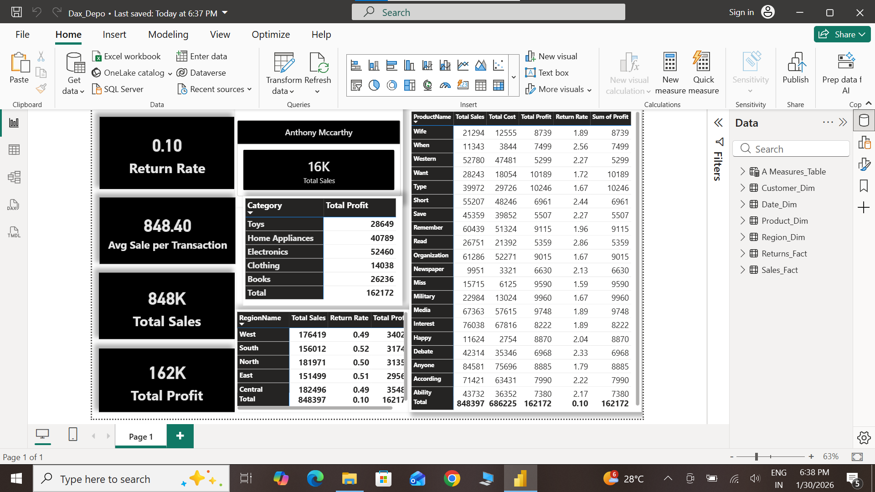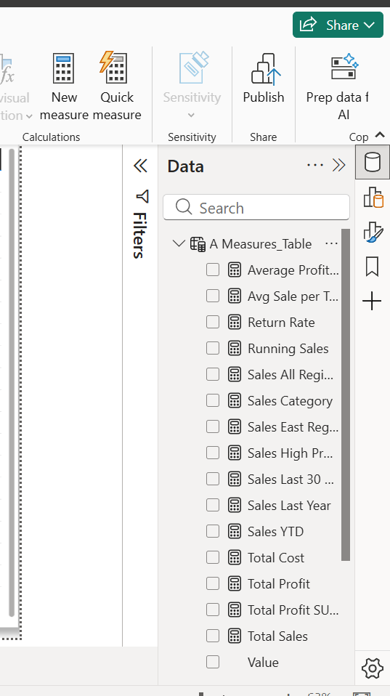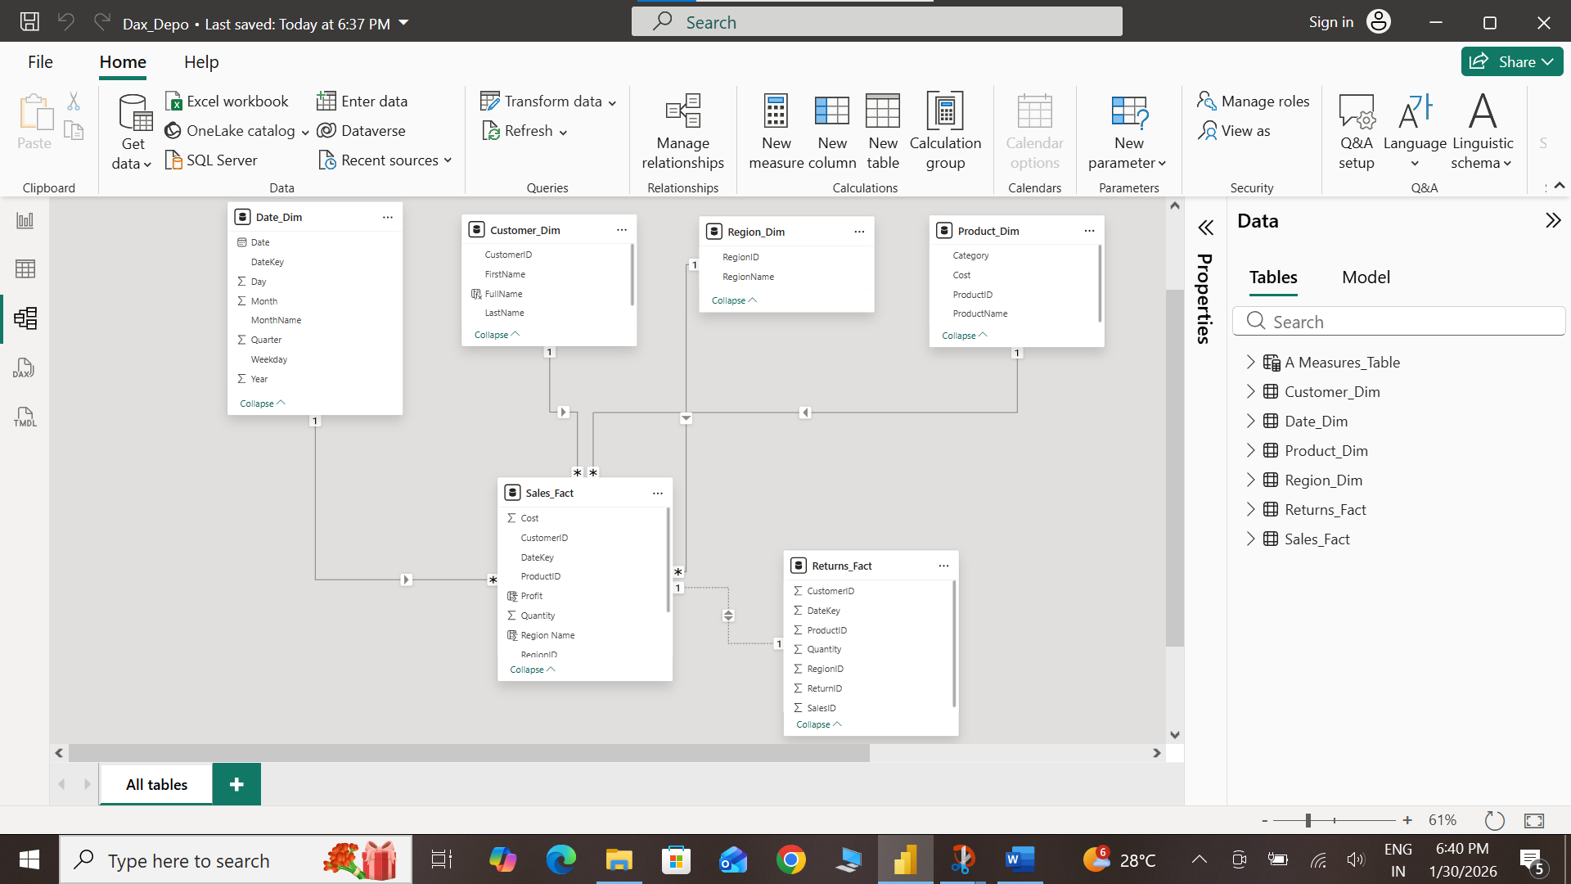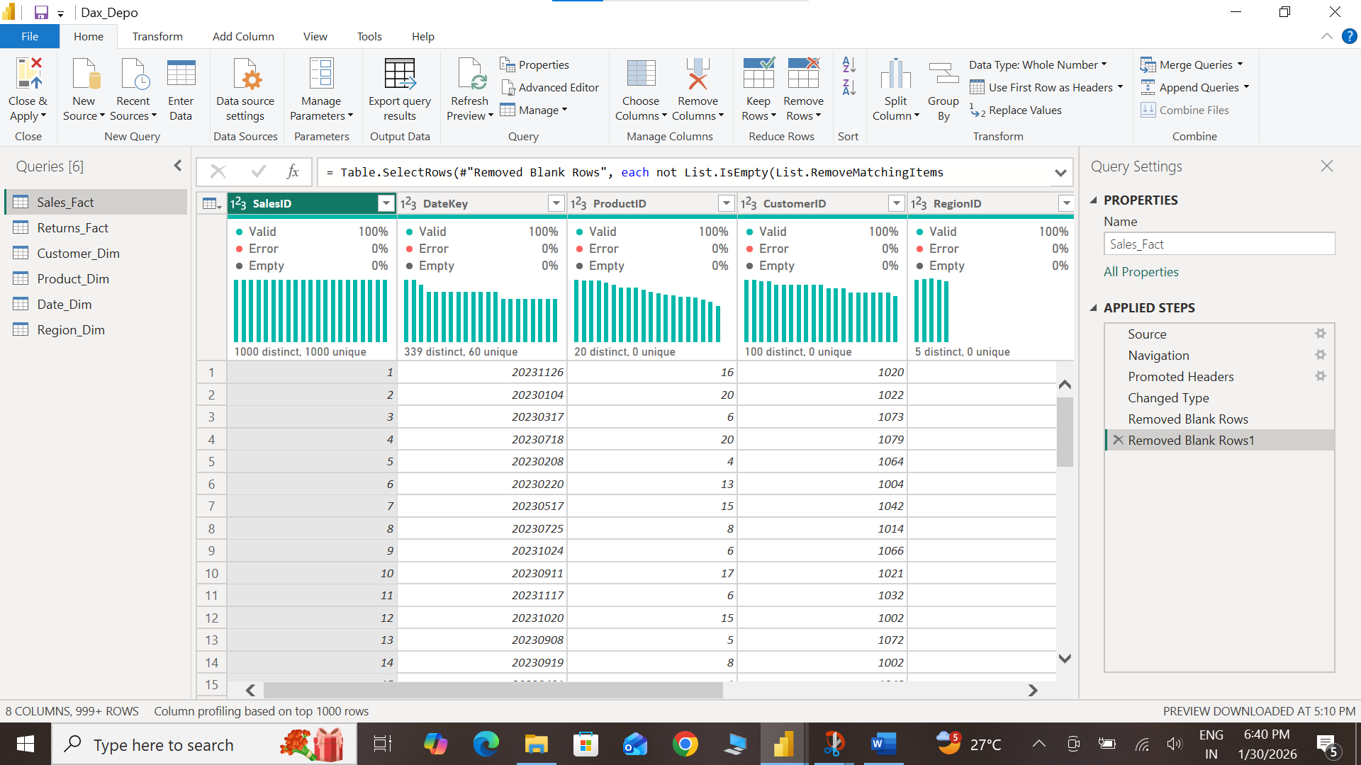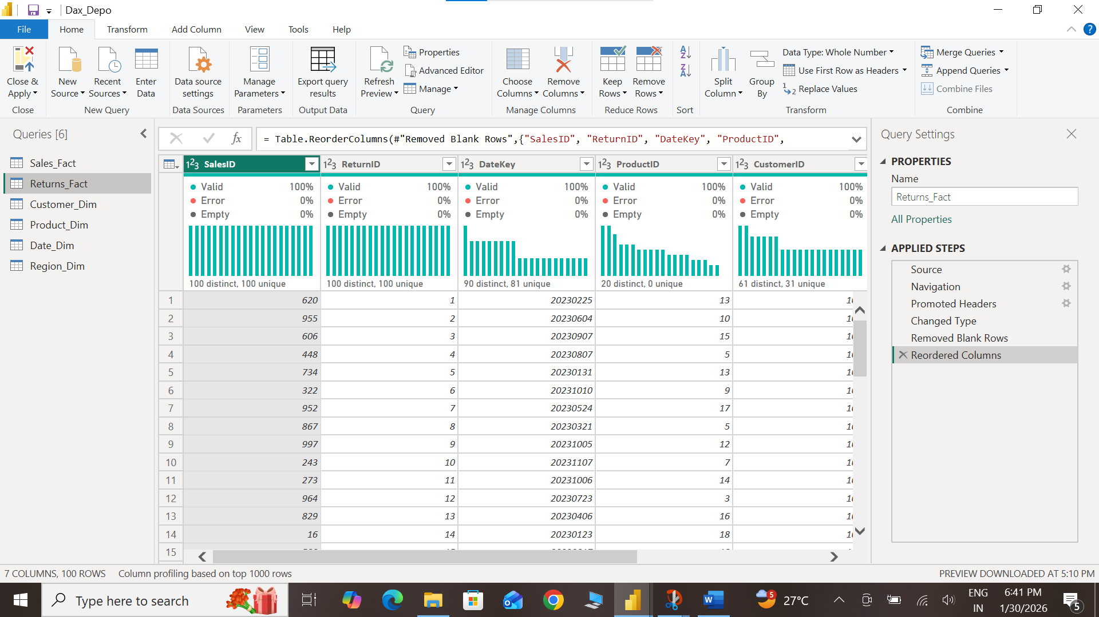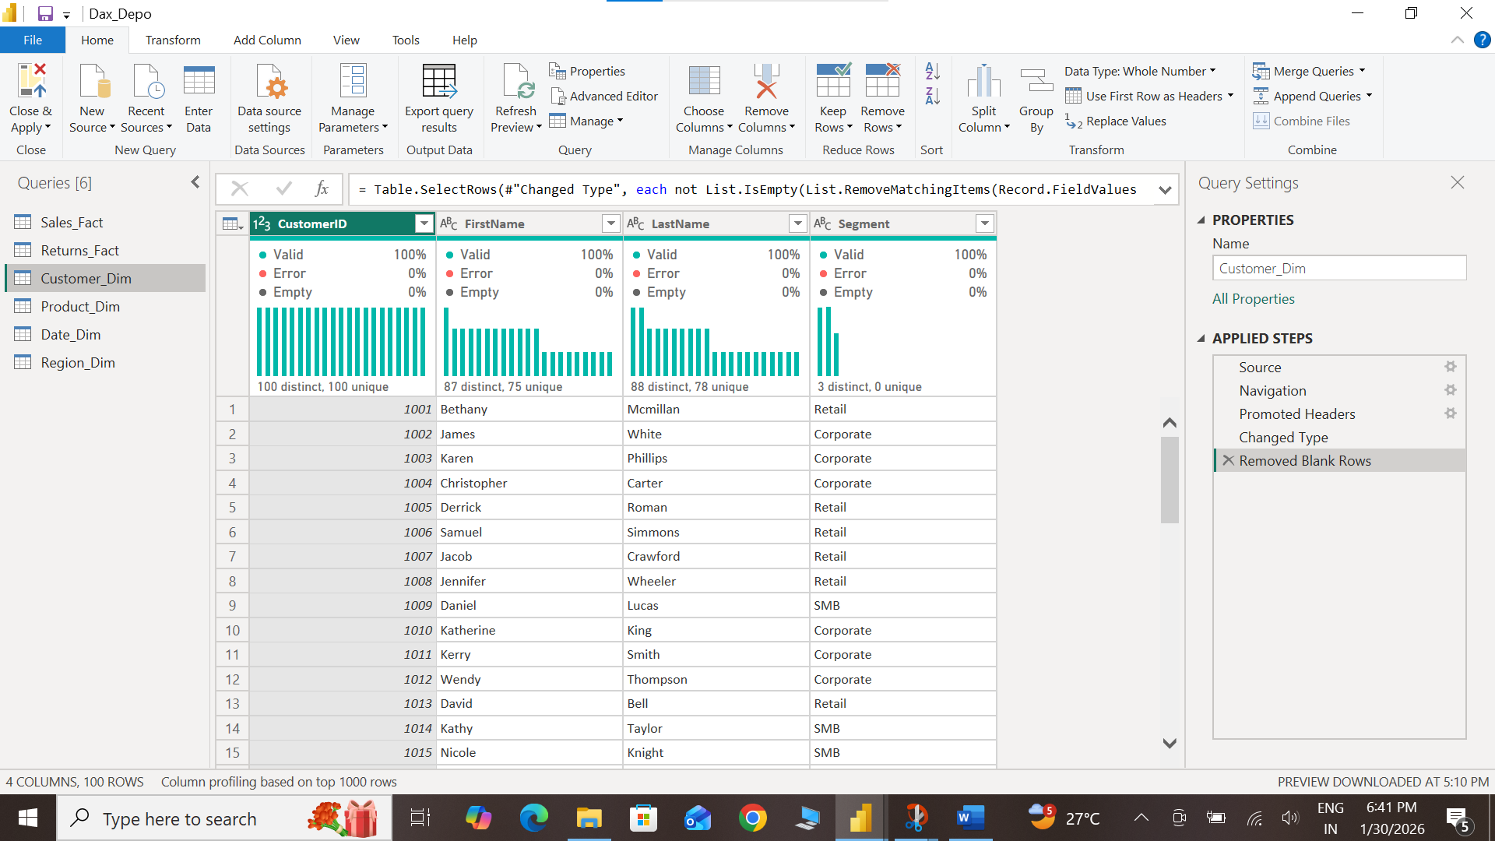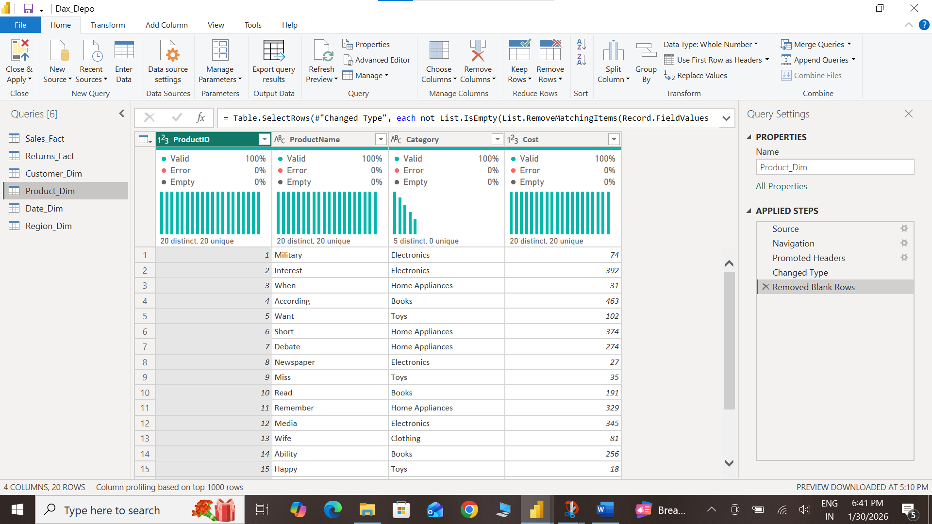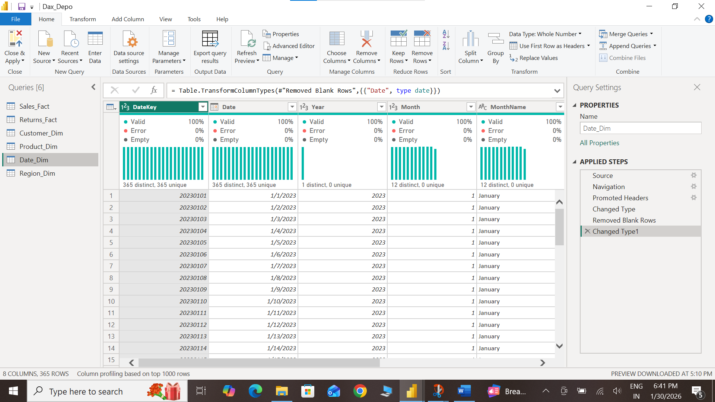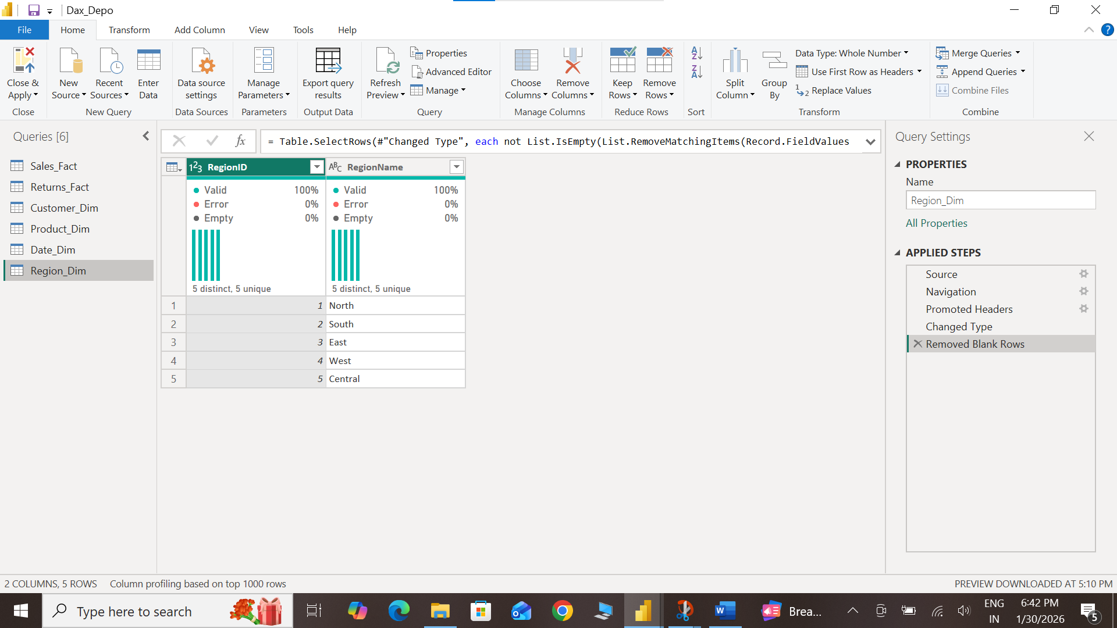

Insights :-
• The business has good total sales of 848K, showing strong performance.
• The company earned 162K profit, so overall business is profitable.
• The return rate is very low (10%), which means customers are mostly satisfied.
• Average sale per transaction is 848, showing customers spend a good amount per order.
• Electronics category gives the highest profit among all categories.
• Home Appliances also perform very well in terms of profit.
• Books category has the lowest profit, so it needs improvement.
• North and West regions have the highest sales, making them top-performing regions.
• East region has the lowest sales, so more marketing is needed there.
• Overall, the business performance is stable, positive, and growing.

