X-ray Diffraction Data Acquisition and Processing Report
Prepared by: Group 9 (Pranav K, Mohnit Akula, Ashish Saharia, Vinit Yaduvanshi, Punit)
Date: September 26, 2025

Aim
The aim of this experiment is to acquire and analyze diffraction data from both powder and thin film samples using X-ray diffraction (XRD). The objective is to understand how X-rays interact with crystalline materials, to generate diffraction patterns, and to prepare the acquired data in formats suitable for further analysis. The experiment also emphasizes the importance of meticulous sample preparation, robust data acquisition, and systematic post-processing steps such as background removal and smoothing, which ensure accurate phase identification and material characterization.

Introduction
X-ray diffraction (XRD) is a cornerstone technique of modern crystallography, enabling the exploration of atomic arrangements within solids. When X-rays encounter a crystalline lattice, they diffract in accordance with Bragg’s Law:
nλ = 2d sinθ
where n is the diffraction order, λ is the X-ray wavelength, d is the interplanar spacing, and θ is the angle of incidence. The diffraction pattern thus encodes fundamental information on crystal structure, phase composition, lattice strain, and texture.
Powder diffraction, owing to the random orientation of crystallites, produces a comprehensive set of diffraction peaks. Thin-film diffraction, by contrast, requires grazing-incidence geometries to mitigate substrate effects and to accentuate surface-sensitive reflections. The present study details the procedures for preparing powder and thin-film specimens, acquiring high-quality diffraction data, and processing this data for subsequent quantitative and qualitative analysis.

Sample Preparation and Data Acquisition

A. Powder Sample
The following steps were employed to prepare and measure powder samples:
• Grinding and Size Reduction – Bulk material was pulverized with an agate mortar and pestle to below 10 µm, ensuring random crystallite orientation.
• Homogenization – The powder was thoroughly mixed to eliminate preferential phases or orientations.
• Mounting – The homogenized powder was packed into a PANalytical flat-plate holder, leveled with a glass slide.
• Compaction – The surface was lightly pressed to minimize porosity and background scatter.
• Instrument Loading – The sample was aligned on the goniometer stage of the PANalytical diffractometer.
• Data Acquisition – X’Pert Data Collector software was configured for a 10°–80° 2θ scan range with 0.02° step size, recording counts per second versus angle.

B. Thin Film Sample
Thin film preparation and measurement required specialized handling:
• Cleaning – The substrate was meticulously cleaned of dust and contaminants.
• Mounting – The specimen was fixed in a PANalytical thin-film holder.
• Alignment – Grazing-incidence XRD (GIXRD) geometry was applied, typically at 0.5°–2° incidence, to emphasize film reflections.
• Data Acquisition – Narrower 2θ scans were conducted with sensitivity optimized for thin-film crystallinity, texture, and orientation.

Data Export and Report Generation
The raw diffraction patterns were processed using PANalytical HighScore software:.
• CSV Export – Intensity versus 2θ data were exported via File → Export → ASCII (CSV).
• File Management – Separate, clearly labeled directories were maintained for powder and thin film datasets.
• External Tools – CSV data were imported into suitable format for peak analysis, replotting, and annotation.
• Report Composition – Final reports integrated raw and processed plots, annotated peaks, and candidate phase identification using the ICDD database.

Background Removal and Smoothing
Accurate diffraction analysis required the careful elimination of spurious background signals and random noise:
- • Background Subtraction – Automatic or polynomial baseline fitting was employed, removing non-crystalline contributions.
- • Smoothing – A Savitzky–Golay filter was applied to reduce stochastic noise without altering intrinsic peak features.
- • Verification – Post-smoothing checks confirmed preservation of peak positions, intensities, and widths.
- • Export – Cleaned datasets were re-exported for advanced analysis, including Rietveld refinement and crystallite size estimation.
- • Final Graphs – Publication-quality plots of Bragg peaks were generated for inclusion in this report.

Conclusion
This experiment has demonstrated the methodological rigor required for reliable XRD analysis. Proper sample preparation, precise alignment, and optimized data collection protocols were shown to be indispensable for both powder and thin-film specimens. Post-acquisition treatments—background subtraction and smoothing—were essential to enhancing peak fidelity, enabling robust phase identification and structural characterization. The procedures outlined herein embody best practices in crystallographic experimentation and constitute a foundation for advanced materials research.

Images for reference

Data acquisition

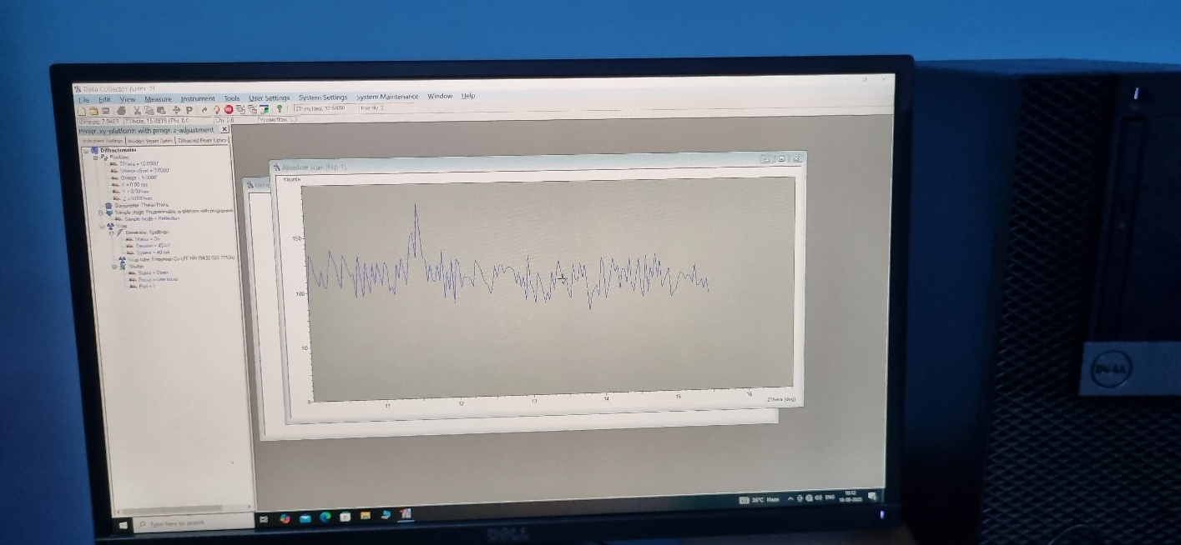

Apparatus
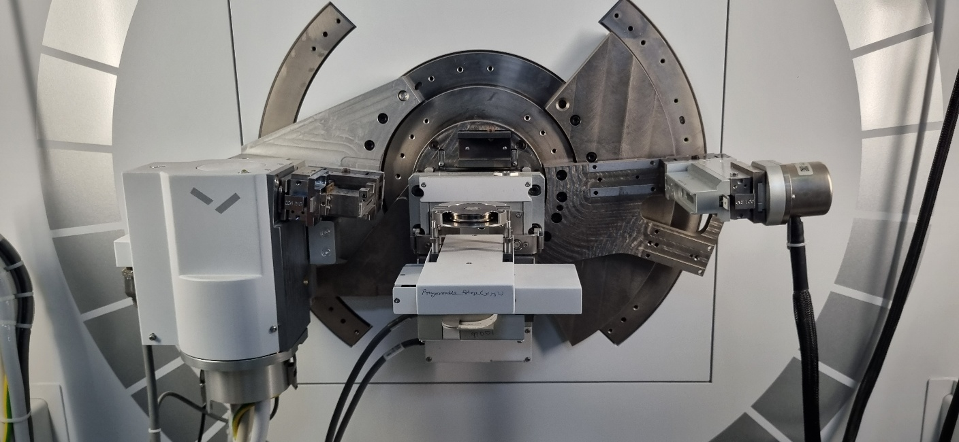

Powder Sample Preparation
