non-invasive liver cancer detection using Deep learning

Harshal Sonkusale Hitanshu Dadhich Nayan Dhurve

[21070735@ycce.in](mailto:21070735@ycce.in) [21071258@ycce.in](mailto:21071258@ycce.in) [21070814@ycce.in](mailto:21070814@ycce.in)

Yash Naktode Chiranjit Roy

[21070073@ycce.in](mailto:21070073@ycce.in) [21070070@ycce.in](mailto:21070070@ycce.in)

Department of Information Technology, Yeshwantrao Chavan College of Engineering, Nagpur, 441110

Abstract:

Non-invasive deep learning-based system for liver cancer detection is a promising area of research which has the potential to transform liver cancer diagnosis. Such a system can detect liver cancer early and provide significant cost savings. Additionally, the system has the potential to improve the survival rate of liver cancer patients, personalize treatment plans, monitor the response of patients to treatment, and reduce the need for invasive procedures.

This project aims to make a non-invasive deep learning-based system for detecting liver cancer using CT scan images. We have collected data from CT scan images with and without liver cancer and currently, we have developed our models of deep learning algorithms to detect liver cancer lesions on CT scan images. The work is still in its early stages, but the results we got at the initial stage are very promising. We used three deep learning models CNN, ResNet, and MobileNetV1. The CNN model showed the highest accuracy in detecting liver cancer lesions, with an accuracy of 91.67% followed by the MobileNetV1 model achieving an accuracy of 87.50% which are much better compared to the ResNet model which achieved an accuracy of 60.87%.

We believe that our work has the potential to make a significant impact in the fight against liver cancer by developing an accurate and efficient non-invasive system based on deep learning to detect liver cancer with it, we can help detect liver cancer earlier, improve patient survival, and reduce healthcare costs.

Keywords: Non-Invasive, Liver cancer detection, cost saving, Deep learning, CT scan images, CNN model, Resnet model, MobileNetV1 model.

1. Introduction

Liver cancer is a serious disease that is the third leading cause of cancer-related death worldwide. It has also been estimated that more than 900,000 new cases of liver cancer will be diagnosed and 830,000 more people will die from liver cancer by 2024. The prognosis for liver cancer is poor, even in patients with severe disease has life expectancy of 5 years. However, early detection and diagnosis of liver cancer can significantly improve patient outcomes. Conventional methods of detecting liver cancer, such as physical examination, testing and imaging, are invasive and expensive. A biopsy involves taking a sample of liver tissue for testing purposes, which can be painful and dangerous. Imaging tests, such as CT (computed tomography) and MRI (magnetic resonance imaging), are expensive and time-consuming. Deep learning (DL) could revolutionize liver cancer diagnosis by providing non-invasive and accurate methods. Deep Learning algorithms (DL) can be trained to detect liver cancer from medical images such as CT scans and MRI scans. Once these models of Deep Learning are trained, they can be used to detect and classify liver cancer in new patients. In this research paper, we propose a 5-step deep learning-based method for liver cancer detection. Deep learning algorithms are well suited for image recognition tasks.

2. Method Preview

2.1. Image acquisition

Patients with chronic liver disease often have complications due to liver failure. The diagnosis and medical examination of such chronic diseases should account for the high fraction of liver fibrosis as a sufficient predictor of HCC LI-RADS [2,3] and the Barcelona Staging System [3,6] is well known as an indicator of the liver cancer stage. However, for multiple diagnoses such as cirrhosis and benign, hepatocellular and cholangiocarcinoma, we need intelligent computer-aided diagnostic systems.

Liver biopsy is a test for the degree of fibrosis and is still considered the gold standard for stag production. However, it is an embodied process that can have consequences; such as 30 to 40% pain in most cases. To minimize the potential use of such painful physical examinations, non-invasive methods such as US, MRI, and CT are used to reliably screen patients at risk followed by the use of ventilation to reduce early detection of death can be done. We discuss these methods and protocols used, on how to conduct detailed analysis.

2.1.1. Ultrasonography (US)

The first commonly used imaging modality for the abdomen is US parenchymal organs, these are non-invasive, extensively available and inexpensive. However, because of the variable diagnostic sensitivity of hepatic fibrosis, and those with positive experience and qualified staff. Use of powerful sound waves to do so viewed from inside the body. A transducer is placed to concentrate a permeable substance containing gel in the skin for sound waves. This is allowed because of the real-time characteristics of active scanning [4].

2.1.2. Computed Tomography (CT)

CT uses X-rays to acquire images using sequential or spiral methods. CT is preferred for evaluating hepatic features because of spiral and second scanning. Axial reconstruction with images is the best spacing resulting in a decrease in the average lesion volume. Similarly, it can monitor liver enlargement in arterial portal delayed modes. Moreover, registration events due to inhalation are less frequent than during a single breath. Finally, spiral CT scans provide three-dimensional imaging information. Usually, a CT scan of the abdomen is performed after the assessment of variable tissue contrast agents with volume, size, and reconstruction time. Sometimes a series of scans are also done for further investigation.

2.1.3. Magnetic Resonance Imaging (MRI)

MRI is used for detailed body image analysis. It has some advantages over CT such as non-ionizing, high contrast, radiation, and wide-field imaging capabilities. MRI uses magnetic waves to align the photons of interest with the field. Thus the radio-frequency current pulses were accurate with a magnetic field and were used to analyze tissue particles. MRI of the abdomen can often be performed with contrast-enhanced axial spin-echo T1-weighted and fast spin-echo T2-weighted imaging. T2-weighted imaging is commonly preferred for abdominal examination [2,3,4].

In this project, we used CT scans to detect and classify liver cancer. We trained a deep-learning model on a dataset of 33 cancer images, 34 non-cancerous images and a training set of 117 images.

2.2. Image Processing

Medical images from CT scans are mostly structural images that may contain artifacts, blurs, and environmental device noise due to unintentional human interference da because These factors can affect image quality and diagnostic accuracy when processed and analysed with state-of-the-art systems are also available [3,4,5]. Nonlinear bilateral mean filters are widely used for noise removal [4,5]. But multivariate multidimensional wavelet-based methods have also been proposed to reduce motion artefacts and noise [5,6] Deep learning has also been widely used to discover and remove various distorted images. Several techniques such as artifact removal, registration, noise removal, blurring and segmentation are used for this purpose. We use Segmentation, based on a deep learning model which has revolutionized image classification by providing more accurate and efficient solutions. This example systematically implements the method of visualization, where multiple filter layers are used to the input image to extract high-quality features deep learning-based models can achieve accuracy as available today in a variety of image classification tasks on even more challenging datasets.

2.3. Deep Learning Models

Deep learning models are a type of machine learning model that uses artificial neural networks with many hidden layers to learn from data. Deep learning models help in identifying complex patterns and relationships in data that are difficult for traditional machine learning models to learn. Deep learning models are used in various areas such as image classification, speech recognition, object recognition, and natural language processing. Convolutional Neural Networks (CNNs) are well-suited for tasks such as image classification and object recognition. CNNs work by extracting features from images by applying a series of convolutional and pooling layers.

There are many models of Convolutional Neural Networks (CNNs). We are using CNN, ResNet and MobileNet which are forms of convolutional neural networks, but they have some key important differences.

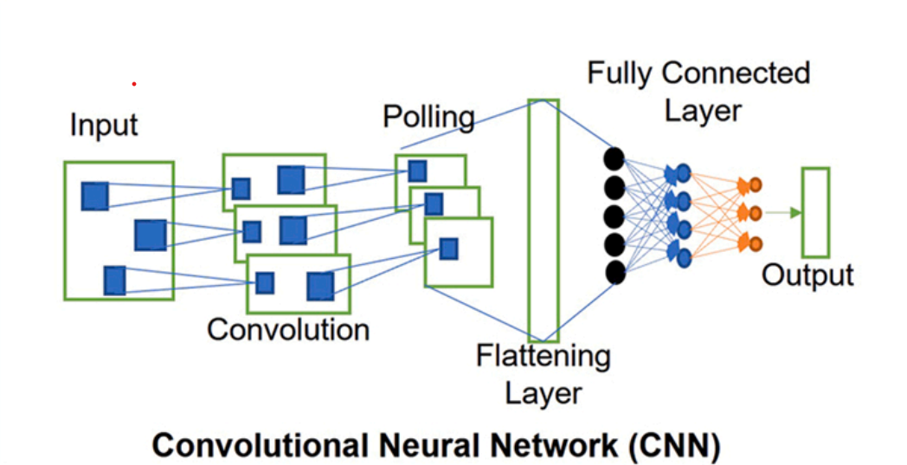

CNNs are a type of deep learning model well suited for image classification and object recognition tasks. CNNs work by extracting features from the images by applying a series of layers. Here is the detailed explanation of CNNs step-by-step

* Image input: The CNN is provided with an input image, such as a CT scan image of the liver.
* Convolutional layers: Convolutional layers apply a series of filters to the input image to identify specific features. Each filter consists of a small matrix of weights applied to a subset of the input image. The output of each convolutional layer is a feature map, which is a map of the activation values ​​of each filter at each location in the input image.
* Pooling layers: Feature maps of convolutional layers produced by downsampling (reducing the number of pixels in an image which indirectly reduces file size) pooling layers. This is done by taking the average or maximum value of a subset of the feature map and assigning it to the corresponding output pixel. Pooling layers help reduce noise and improve the computational efficiency of the model.
* Fully connected layers: Fully connected layers produce the final result by combining features extracted from previous layers, such as class labels or probability distributions among different class labels

CNN (Convolutional Neural Network) is a type of deep learning model which is well-suited for image recognition and classification. This Model has been used in our project Non-Invasive Liver Cancer Detection which is achieving an accuracy of 91.67%.

ResNets is a new CNN introduced by ResNets in 2015 that addresses the problem of vanishing gradients, which complicates the training of deep CNN models. ResNets uses residual connectivity, which skips a few layers in the network and directly connects the input layer to the output layer, which allows it to learn from its mistakes and improve its performance. This Model has been used in our project Non-Invasive Liver Cancer Detection which is achieving an accuracy of 60.87%.

MobileNet is a small deep-learning system designed to run on mobile devices. This model uses depth-separating diffractions to reduce the number of parameters and calculations required. This model has shown comparable accuracy to other CNN models but with a much smaller footprint. This Model has been used in our project Non-Invasive Liver Cancer Detection which is achieving an accuracy of 87.50% followed by CNN.

Overall, we got that the CNN model has the highest accuracy which is followed by the MobileNetV1 model which is much better in comparison to the ResNet model.

2.4. Attribute Analysis

2.4.1. Features

The development of Computer-Aided Diagnosis (CAD) systems requires deep learning algorithms to be trained with discriminating features so that the system can detect any anomalies in its optimal performance because the extraction of these features is classified in method appropriate over morphological and structural properties [4].

2.4.1.1. Morphological Features

Table 1 shows the various common examples in practice for morphological feature extraction. The following examples are described as follows.

Statistical-based models, the statistical methods are mainly divided into primary and secondary components. The first-order feature provides us with statistical properties associated with the grey-level distribution and an image, ignoring pixel proximity or spatial properties. These parameters include mean, slope, kurtosis peak, variance, skewness, standard deviation, etc. [4]. Alternatively, secondary features depend on co-occurrence properties in neighbouring pixels. These features specify some spectral properties related to the image properties, such as grey-level co-occurrence matrix (GLCM) and geometric property-based texture features, etc.

Similarly, few studies have examined texture features based on geometric properties that provide information about the material profile and body structure. Typically, benign tumors have a smooth profile, while malignant lesions tend to have irregular shapes. Thus, spatial features such as solidity, compactness, ROI area, radial length, roundness, rectangularity, etc. Which provides valuable specific information for lesion classification.

Processing-based models are rotated with a mask image of various sizes to quantify textural information [4]. The first obtain such a feature by graphically rotating a mask of size 5 x 5. Since then, the Laws’ features have been used in various fields to find value-added features. The Frequency-Based Models, several transformation models based on frequency-domain features have been proposed [5-7] these are shown to be more efficient than spatial-based features.

|  |  |
| --- | --- |
| Table 1 | |
| Method | Extracted Features |
| Statistical Based Models | |
| Gray-level Co-occurrence Matrix (GLCM), Gray-level Difference Matrix (GLDM) | Correlation information, Inverse difference moment, Angular second moment Sum of the square, Gradient, Sum of variance, Sum of average, Sum of entropy, Contrast, Difference entropy, etc. |
| Gray-level Run Length Matrix (GLRLM) | Gray-level (GL) run length, GL run number, Run emphasis, GL nonuniformity, etc. |
| First Order Statistics (FOS) | Mean, Peak, Slope, Variance, Standard deviation, Kurtosis, Skewness etc. |
| Geometric features | Coarseness, Eccentricity, Periodicity, Roughness, Regional area, Compactness, Margin, Circularity, Rectangularity, Periphery, Border, Width, Depth etc. |
| Processing based Models | |
| Laws’ Mask Analysis | Laws’ mask of length range, edges, corners, texture, shapes, etc |
| Frequency-based Models | |
| Transform domain | Wavelet transform, Fourier power spectrum, Gabor wavelet transform, Contourlet transform, Shearlet transform, Ranklet transform etc. |

2.4.1.2. Hierarchical Feature

Recent studies [4] have used DNN (Deep neural network) models for logical feature extraction. NNS (Neural Network search) uses a back-propagation method to optimize the best combination of spatial features for a desired number of results. Based on the loss function defined in the back-propagation, these weights are optimized to minimize the errors through multiple runs. Since the results we obtained are of the best quality, no further selection is required. However, such algorithms require large data inputs to optimize the performance and avoid overfitting.

2.4.1.3. Feature Selection Based on Algorithms

A selection procedure is performed to select inputs that have a strong statistical relationship with the output. Studies [4-6] have used some methods such as iterative elimination, statistical testing, genetic algorithms, etc.

​​Statistical testing is used to select features based on internal relationships with input and between each output variable. These tests are considered valid keeping in mind some prior assumptions about the data distribution. Furthermore, features are also selected based on the mean of freedom and minimum variance.

Recursive feature elimination (RFE) [4] selects a subset of features based on model performance. Some simple items are removed by repeated runs of the model and analysis of cross-validation scores. Because of its iterative process, RFE requires high computational costs for large numbers of data sets. Therefore, highly correlated features should have to be eliminated before using the RFE method for feature selection.

Genetic algorithms [4] are another method of selecting crossovers and mutations to find the best chromosome. A particular segment is counted as a chromosome, whereas each gene has specific information such as a combination of selection segments according to the required trait locus to select individual genes based on an extreme criterion of fitness to the test survival. Multiple cross-overs are performed to recombine the best chromosomes and mutations for new arrangements from different genomes. In addition, some other methods, such as grasshopper or swarm particle optimization have also been used for optimal feature selection [4,5,6].

2.4.2. Feature Extraction and Selection

Feature extraction and selection are the most important part of the training of the models. Here we are using Laws’ Mask Analysis which is a processing base model that extracts the edges, corners, shapes, texture, etc from the images as the features during training. These extracted features are the selected features on which checking of these features will happen when the actual input Ct scan image has been provided to the model. These selected features by the models will help to determine whether the input image has cancer or not.

3. System architecture

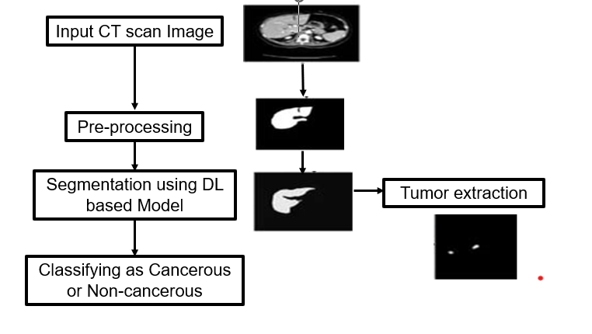

* Image input: The system takes a CT scan image of the liver as input.
* Pre-processing: The system pre-processes the image to improve its quality and facilitate the deep learning model. This includes steps such as contrast enhancement, noise reduction, and normalization.
* Segmentation using deep learning model: The system uses a deep learning model to segment the liver and gall bladder. Deep learning models help in identifying complex patterns in data, making them ideally suited for tasks such as image segmentation.
* Tumor removal: The system removes the tumor from the liver to remove all voxels that are not part of the tumor.
* Classifying: The system classifies tumor as Cancerous or Non-cancerous.

4. Models: Accuracies Graph

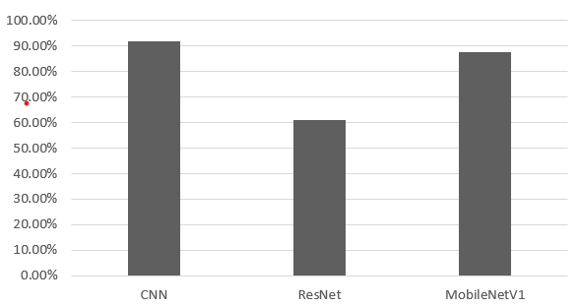

This figure shows an overview of the accuracies of three different models we used: CNN, ResNet and MobileNetV1. The graph shows that CNN has the highest accuracy followed by MobileNetV1.

5. Future work

Future work on non-invasive deep learning-based systems for liver cancer detection could focus on the following areas.

* Improved accuracy and strength.
* Expansion of power.
* Development of user-friendly interface.
* Dealing with social and moral concepts.
* Fusion of CT scan and MRI scan images.

Overall, the future of non-invasive deep learning-based systems for detecting liver cancer is promising. This project has the potential to transform the diagnosis and treatment of liver cancer.

6. Result

Non-invasive deep learning-based systems for liver cancer detection may revolutionize liver cancer diagnosis by reducing the need for invasive testing. Such programs can detect liver cancer at an early stage reducing the death rate, improving patient situation and potential benefits for its patients. Diagnostic features of liver cancer that are not implants can also provide significant cost savings. Work to develop a non-invasive device-based system for the detection of liver cancer has yielded very promising results. The models have demonstrated high accuracy in the detection of liver cancer lesions, with an accuracy of 91.67% on the CNN model, followed by 87.50% on MobileNetV1 which are much better compared to the ResNet model achieving an accuracy of 60.87% on the dataset, as well as feasibility in distinguishing between non-cancerous and cancerous lesions. By providing a detailed analysis of tumor burden and morphology, this system can help physicians accurately diagnose a patient’s cancer.

7. Reference

1] Piyush Kumar Shukla, Mohammad Zakaria, Vessam Atef Hatamleh, Hussam Taraji, and Basant Tiwari, “AI-Driven Novel Approach to Liver Cancer Diagnosis & Prognosis Using Cascaded Fully Convolutional Neural Networks”, Journal of Healthcare Engineering Vol.23, pp 7-14, Sep 2022.

2] Anita Bakrania, Narotam Joshi, Xun Zhao, Gang Zheng, Mamata Bhat,” Artificial intelligence in liver cancer: decoding the impact of machine learning models on clinical diagnosis of primary liver cancer and liver cancer of metastasis”, Journal of Pharmacological Research, pp 12-20, Feb 2023.

3] Esam Othmen, Muhammad Mahmood, Habib Dhari, Meena Ibrahim, Awais Mahmood, and Hatem Abdulkader,” Automated detection of liver cancer using pre-trained hybrid models”, National Institutes of Health July 2022.

4] Ryan Azam Khan, Yigang Luo, and Fang Xiang Wu,” Machine Learning Based Liver Disease Evaluation: A Systematic Review”, Journal of Neurocomputing Volume 468 11 January 2022.

5]Heng Zhang, Cawen Luo, Ren Deng, Shenglin Li, Shukai Duan,” Deep learning-based CT imaging for detection of liver tumors”, National Library of Medicine article May 2022.

6] Abhishek Midya, Jayasree Chakraborty, Rami Srouji, Raja R.Narayan, Thomas Boerner, Jian Zheng, Linda M. Pak, John M. Creasy, Luz A. Escobar, Michael I. D'Angelica “Computerized Diagnosis of Liver Tumors From CT Scans Using a Deep Neural Network Approach”, IEEE Journal of Biomedical and Health Informatics Volume: 27, Issue: 5, May 2023.

7] Venkateswarlu Gavini, G.R. Jothi Lakshmi ,"Liver Tumor Grade Detection using CNN Based LSTM Model with Corelated Feature Set from CT Images", Published in 2022 International Conference on Automation 07 February 2023.

8] Amritha M, Manimegalai P, "Liver Tumor Segmentation and Classification Using Deep Learning" Published in 2023 Fifth International Conference on Electrical, Computer and Communication Technologies (ICECCT), pp 638-650, 21 July 2023.

9]Chao-Lun Kuo, Shyi-Chyi Cheng, Chih-Lang Lin, Kuei-Fang Hsiao, Shang-Hung Lee, "Texture-based treatment prediction by automatic liver tumor segmentation on computed tomography", Published in 2017 International Conference on Computer, Information and Telecommunication Systems (CITS), pp 406-423,14 September 2017.

10] Aparna P R, Libish T M, "Automatic segmentation and classification of the liver tumor using deep learning algorithms", Published in 2023 3rd International Conference on Advances in Computing, Communication, Embedded and Secure Systems (ACCESS), pp 146-151, 07 August 2023.

11]Hameedur Rahman, Tanvir Fatima Naik Bukht, Azhar Imran, Junaid Tariq, Shanshan Tu, Abdulkareem Alzahrani, “A deep learning approach for liver and tumor segmentation in CT images using ResUNet”, Publish in Bioengineering 2022 and article of Artificial intelligence in Advanced Medical Imaging 5th Aug 2022.

12]Xin Dong, Yizhao Zhou, Lantian Wang, Jingfeng Peng, Yanbo Lao, Yiqun Fan, “Liver Cancer Detection Using Hybridized Fully Convolutional Neural Network Based on Deep Learning Framework”, IEEE (Access), pp 99, July 2022

13]Josephine Yu Yan Yap, Laura Shih Hui Goh, Ashley Jun Wei Lim, Samuel S. Chong, Lee Jin Lim, Caroline G. Lee, “Machine learning identifies a signature of Nine exosomal RNAs that predicts hepatocellular carcinoma”, Journal of Cancers 2023 Vol. 15, 24th July 2023.