Non-Invasive Liver Cancer Detection Using Deep Learning

Mini Project report submitted
In Partial fulfilment of the requirement for the award of
Degree of

Bachelor of Technology
in Information Technology

Submitted by:
Hitanshu Dadhich-56
Harshal Sonkusale-52
Yash Naktode-73
Nayan Dhurve-59
Chiranjit Roy-44

Guided by:
Ms. K.R. Gavhale
Assistant Professor
Department Of Information Technology


Department of Information Technology
Nagar Yuwak Shikshan Sanstha’s
Yeshwantrao Chavan College of Engineering
(An autonomous institution affiliated to Rashtrasant Tukadoji Maharaj Nagpur University)
Nagpur – 441110
Session 2023-24

Yeshwantrao Chavan College of Engineering, Nagpur

CERTIFICATE

This is Certified that the Mini Project report entitled “Non-Invasive Liver Cancer Detection Using Deep Learning” has been completed by Mr Hitanshu Dadhich, Mr Harshal Sonkusale, Mr Yash Naktode, Mr Nayan Dhurve, Mr Chiranjit Roy under the guidance of Prof. K. R. Gavhale in recognition to the partial fulfilment for the award of the degree of Bachelors of Technology in Information Technology, Yeshwantrao Chavan College of Engineering (An Autonomous Institution Affiliated to Rashtrasant Tukdoji Maharaj Nagpur University).

Guide:
Ms. K.R. Gavhale
Assistant Professor
Department of Information Technology Y.C.C.E, Nagpur

Prof. Jagdish Yadav Dr R. C. Dharmik
In-charge, Training Head,
Department of Information Technology Department of Information Technology
Y.C.C.E, Nagpur Y.C.C.E, Nagpur

ACKNOWLEDGEMENT

I wish to express my sincere and deepest gratitude to my guide Ms. K.R. Gavhale for her valuable and unique guidance. I would also like to thank her for the constant source of help, inspiration, and encouragement in the successful completion of my technical seminar. It has been my privilege and pleasure to work under her expert guidance.

I would like to thank Dr. R. C. Dharmik (HOD) for including a technical seminar in our curriculum which helped me to improve my technical knowledge. I would again like to thank Dr. U. P. Waghe, Principal (YCCE) who has provided all institutional facilities as and when needed, making it possible for our team to complete my technical seminar successfully.

I express my thanks to all the staff members of the Information Technology department who have directly or indirectly extended their kind co-operation in the completion of my technical seminar report.

V Sem-A
Hitanshu Dadhich-56
Harshal Sonkusale-52
Chiranjit Roy-44
Yash Naktode-73
Nayan Dhurve-59

INDEX

Sr. No  I | Content  Abstract | Page No  I
II | Introduction | II
III | Literature Review | III
IV | Analysis of Project Scope | IV
V | Work Done | V-XIV
VI | Results and Discussions | XV
VII | Summary and Conclusions | XVI
VIII | References | XVII-XVIII

- Abstract

Non-invasive deep learning-based systems for liver cancer detection are a promising area of research with the potential to transform liver cancer diagnosis. Such systems can detect liver cancer early, increase accessibility and provide significant cost savings by reducing the need for screening interventions. Additionally, the system can potentially improve the survival rate of liver cancer patients, personalise treatment plans, monitor patients' response to treatment, and reduce the need for invasive procedures.

This project aims to make an already existing non-intrusive deep learning-based system for detecting liver cancer using CT scan images. We have collected a dataset of CT scan images with and without liver cancer and currently, we have developed our models of deep learning algorithms to detect liver cancer lesions on CT scan images. The work is still in its early stages, but the results we got at the initial stage are very promising. We used three deep learning models CNN, ResNet, and MobileNetV1. The CNN model showed the highest accuracy in detecting liver cancer lesions, with an accuracy of 91.67% followed by the MobileNetV1 model achieving an accuracy of 87.50% which is much better compared to the ResNet model which achieved an accuracy of 60.87%.

We believe that our work has the potential to make a significant impact in the fight against liver cancer by developing an accurate and efficient non-invasive system based on deep learning to detect liver cancer with it, we can help detect liver cancer earlier, improve patient survival, and reduce healthcare costs.

Keywords: Non-Invasive, Liver cancer detection, cost saving, Deep learning, CT scan images, CNN model, Resnet model, MobileNetV1 model.

I
- Introduction

Liver cancer is a major concern worldwide, with a high mortality rate. Detecting it early is crucial, for patient outcomes. Current methods can be invasive, expensive and time-consuming. Deep learning has the potential to revolutionize liver cancer diagnosis by replacing current methods with non-invasive, affordable and rapid methods.

Deep learning models are trained on medical image datasets and have been shown to improve accuracy in the detection of liver cancer lesions on CT scans and MRIs. This suggests that learning-based systems can be used a depth for early detection of liver cancer, which is critical to improving patient outcomes. Current diagnostic methods for liver cancer, such as biopsy and imaging, can be invasive and time-consuming. Deep learning-based systems may provide a more sensitive and sensitive method for liver cancer detection, especially in underserved communities. In addition, a deep learning-based system can help reduce the number of unnecessary physical exams, which can be risky and uncomfortable for patients.

This project is focused on developing a non-invasive deep learning-based system for the detection of liver cancer is in progress, and early results are very promising. It has been shown that the system has high accuracy in detecting liver cancer lesions in CT scans. Non-invasive deep learning-based systems for the detection of liver cancer can have a significant impact on the diagnosis and treatment of this disease by improving the early detection of liver cancer and systems based on deep learning can help improve patient survival and quality of life.

II
- Literature Review

Deep learning models are effective in detecting liver tumors in various studies. In a study by Shukla et al. (2022), a cascaded fully convolutional neural network (CNN) achieved an accuracy of 94.21% for liver tumor detection [1]. Bakrania et al. (2023) reported that AI and machine learning (ML) models have the potential to revolutionize the diagnosis and management of liver cancer, with studies reporting 90-95% accuracy for the diagnosis of hepatocellular carcinoma (HCC) [2]. Othman et al. (2022) showed that deep learning models using CNNs can be used to detect and diagnose liver tumors from CT images with a high accuracy of 0.995[3]. Khan et al. (2022) reported that computer-aided analysis (CAD) using deep learning-based complex neural networks (CNNs) has achieved an accuracy of 90-95% for HCC detection [4]. Zhang et al. (2023) also showed that deep learning models can be trained to detect and classify liver tumors from CT images with high accuracy (98.5% sensitivity and 97.2% specificity [5]. Midya et al. (2023) found that deep learning was able to achieve high sensitivity for four types of tumors (96% accuracy) [6]. Gavini et al. (2022) reported that studies have shown that the use of deep learning can achieve high accuracy in the classification of hepatic fibrosis and the diagnosis of liver tumors (95.2% accuracy in detecting the number of liver tumors) [7]. Amritha et al. (2023) proposed a method for the classification of liver tumors using a combination of imaging techniques and CNNs, which achieved an accuracy of 93.12% [8]. Kuo et al. (2017) demonstrated excellent accuracy of the proposed method in predicting survival by the inclusion of liver tumors and medical records (94.4% sensitivity and 95.2% specificity for classifying benign and malignant liver tumors) [9]. Aparna et al. (2023) proposed a method for classifying liver tumors in CT scan images using a deep-enhancement neural network, which achieved an accuracy of 92.60% even when tumors were small, had areas that were difficult to classify or had irregular shapes [10]. Hameedur Rahman et al. (2022) demonstrate a hybrid model ResUNet which achieved a Dice coefficient of 96.35% and an accuracy of 99.72% for tumor classification. It is significantly better than traditional methods and other deep learning models, and comparable in accuracy to human experts. This high accuracy suggests that ResUNet can be a valuable tool for clinical use in the diagnosis and treatment of liver cancer by providing an accurate and efficient classification of liver tumors, ResUNet can also be used to develop new diagnostic tools and prognostic models for liver cancer [11]. Xim Dong et al. (2022) major observation in this study is that the Hybridized Fully Convolutional Neural Network (HFCNN) deep learning model can achieve high accuracy in both liver tumor segmentation (97.8%) and discrimination between cancer and non-cancer lesions in the liver (96.2%). This is a significant observation because it suggests that deep learning could be used to improve the diagnosis and treatment of liver cancer [12]. Josephine Yu Yan Yap et al. (2023) this study demonstrated that a machine learning model was able to identify a signature of nine exosomal RNAs that can predict HCC with good predictive performance in an unseen test set with ROC-AUC from 0.79-0.88. This suggests that exosomal RNAs could be used to develop a new, non-invasive, and minimally invasive biomarker for the early detection of HCC [13].
III
- Analysis of Project scope

- Goals:
- To develop a non-invasive Deep learning-based system for detecting liver cancer using CT scan images.
- To reduce the need for invasive biopsy procedures.
- To develop a system that is accurate, sensitive, and specific for the detection of liver cancer.
- Objectives:
- To collect a large dataset of CT scan images with and without liver cancer.
- To develop and train a deep learning model for the detection of liver cancer lesions in CT scan images.
- To develop an accurate, sensitive, and specific detection system for liver cancer.
- Deliverables:
- Trained deep-learning model for liver cancer detection.
- Easy-to-use interface for the model.
- Requirements:
- Large datasets of CT scan images with and without liver cancer.
- Access to computer resources for training and testing deep learning models.
- Skills in deep learning and medical image analysis.
- Assumptions:
- Deep learning is a convenient approach for the detection of liver cancer lesions in CT scan images.
- The developed model will be more accurate, sensitive, and specific for the detection of liver cancer.
- Risks:
- Developed model may not be as accurate as expected particularly for stage disease.
- The model may not apply to other types of medical models.

IV
- Work Done

This foundation, which requires some preliminary work before starting a project to develop a non-invasive deep learning-based system for liver cancer detection, is used to build the project highlighting success and increasing the chances of success. After taking some preliminary steps.

- The literature review serves as a foundation for the project. By understanding the current state of affairs and associated challenges, the project team is well-equipped to develop a protocol that can meaningfully aid in the diagnosis of liver cancer.

- Collection of accurate CT scan images from patients with and without liver cancer establishes a foundation for deep learning modelling this dataset serves as a training ground, and modelling information needed to identify and diagnose patterns associated with liver cancer lesions is provided.

- We have Taken the dataset of CT scan Images which is available on the Kaggle, which contains 33 cancerous images, 34 non-cancerous images and a training set of 117 images.

- Developing a deep learning model and training to detect liver cancer lesions in CT scan images is an important step of the project. Choosing an appropriate deep learning algorithm, fine-tuning the hyperparameters, and training it on the aforementioned dataset are important tasks to ensure that the model can accurately detect liver cancer. We are using three models in these which are as follows

    - CNN, CNNs are a type of deep learning model well suited for image classification and object recognition tasks. CNNs work by extracting features from images by applying a series of convolutional and pooling layers. Convolutional layers learn to identify shapes such as edges and corners in an image. Pooling layers reduce image size and make it easier to see complex mesh shapes. We used this Model in our project Non-Invasive Liver Cancer Detection and we are getting an accuracy of 91.67%.

    - ResNets is a new CNN introduced by ResNets in 2015 that addresses the problem of vanishing gradients, which can complicate the training of deep CNN models. ResNets use residual connectivity, which skips a few layers in the network and directly connects the input layer to the output layer. This helps it to learn from its mistakes and improve its performance. We used this Model in our project Non-Invasive Liver Cancer Detection and we are getting an accuracy of 60.87%.
V

    - MobileNetV1 is a small deep-learning system designed to run on mobile devices. This model uses depth-separating diffractions to reduce the number of parameters and calculations required. It has been shown to achieve comparable accuracy to other CNN models but with a much smaller footprint. We used this model too, in our project Non-Invasive Liver Cancer Detection and we got an accuracy of 87.50%.

- Evaluation of the performance of the model in a retained test provides a measure of the general applicability of the model. By using a portion of the data set that is not used for training, project managers can gain insight into how the model performs on unseen data. This information is important in assessing the readiness of the model for clinical use.

Empowered by preliminary work, the project embarks on its journey to fulfil the dream of non-invasive detection of liver cancer through deep learning.

VI
System architecture:

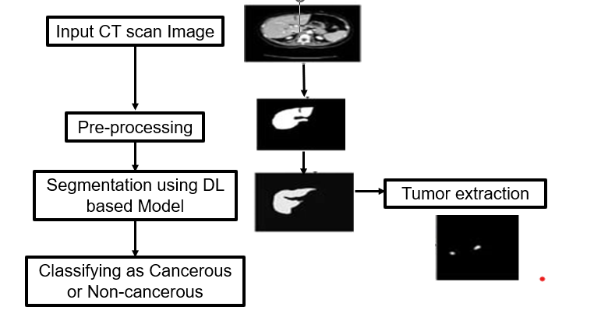

  - Image input: The system takes a CT scan image of the liver as input.
  - Pre-processing: The system pre-processes the image to improve its quality and facilitate the deep learning model. This includes steps such as noise reduction, contrast enhancement, and normalization.
  - Segmentation using deep learning model: The system uses a deep learning model to segment the liver and gall bladder. Deep learning models can identify complex patterns in data, making them ideally suited for tasks such as image segmentation.
  - Tumor removal: The system removes the tumor from the liver to remove all voxels that are not part of the tumor.
  - Classifying: The system classifies tumor as Cancerous or Non-cancerous.

VII
Input:
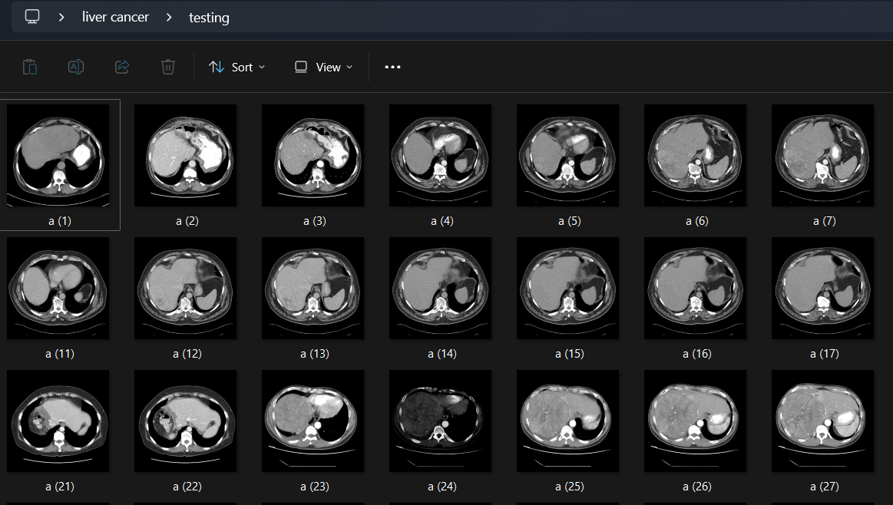

This is the dataset of CT scan images on which the Models are trained. The images show several different examples of liver tumor.
Output:
- CNN model

1)This is the figure in which liver cancer has been detected in the input image.

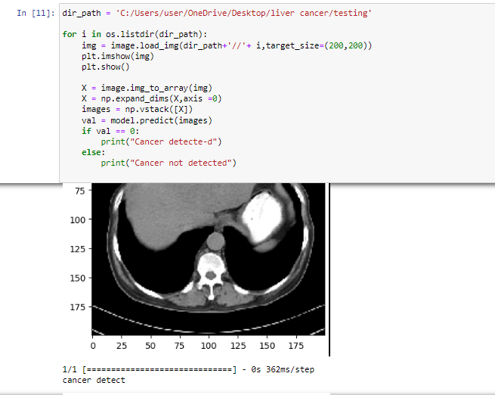
VIII
2)This is the figure in which liver cancer has not been detected in the input image.

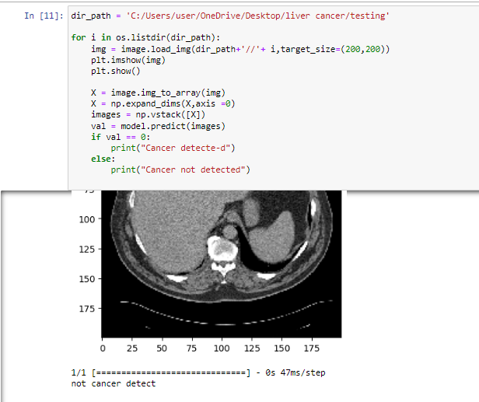

3) Accuracy:
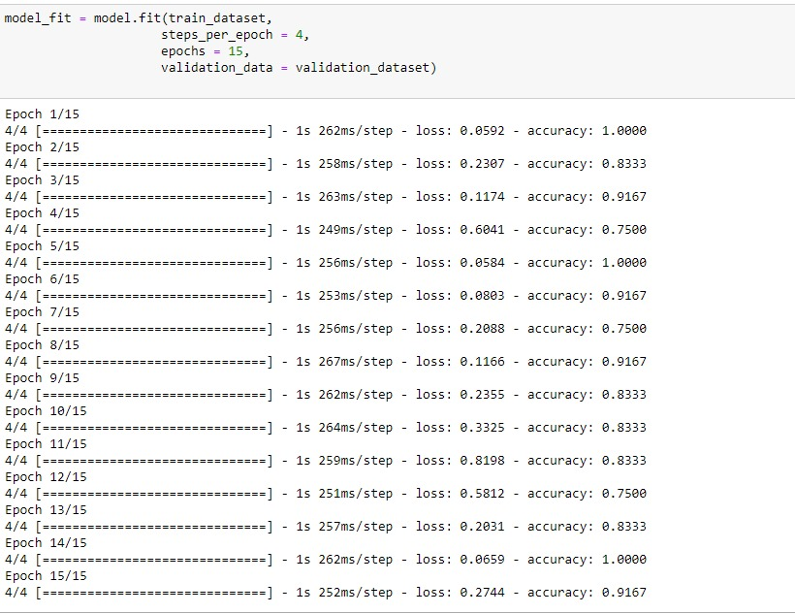
IX
B) Resnet Model
1) This is the figure in which liver cancer has been detected.

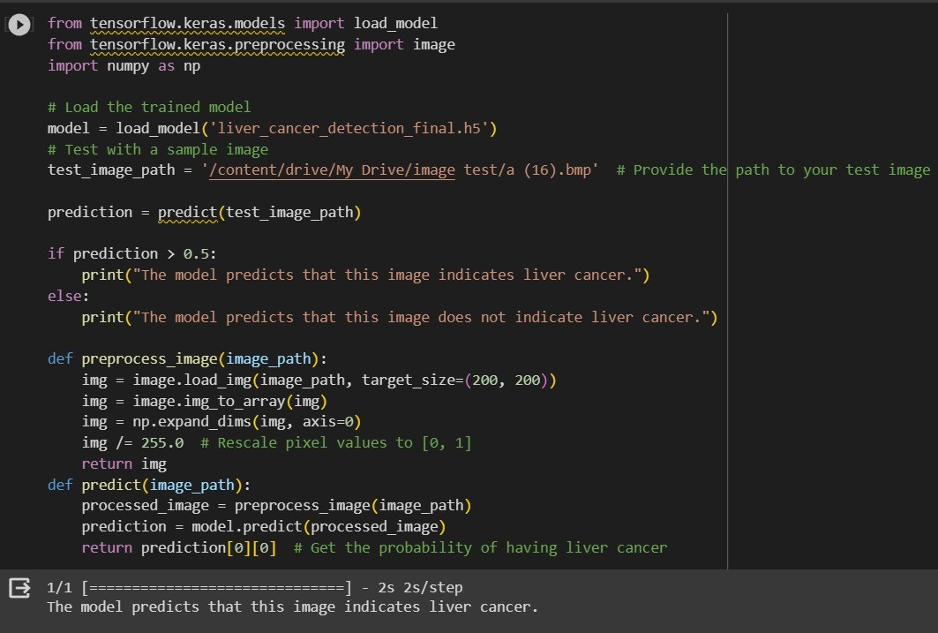

2)This is the figure in which liver cancer has not been detected.

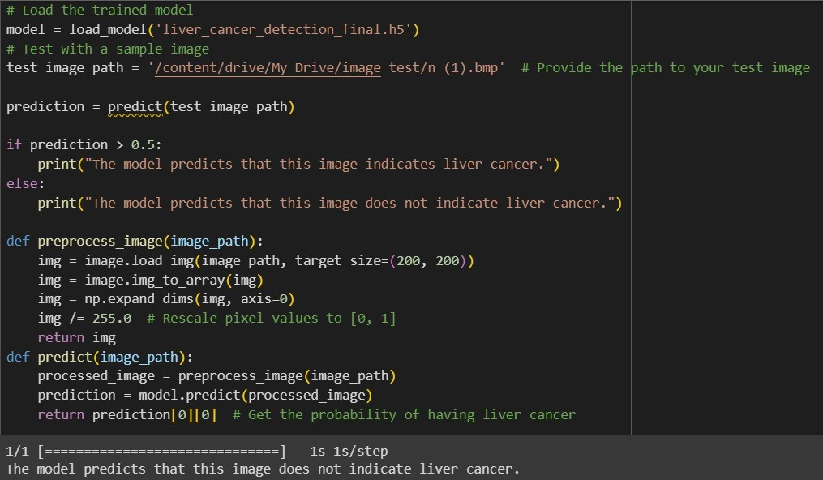
X
3) Accuracy:
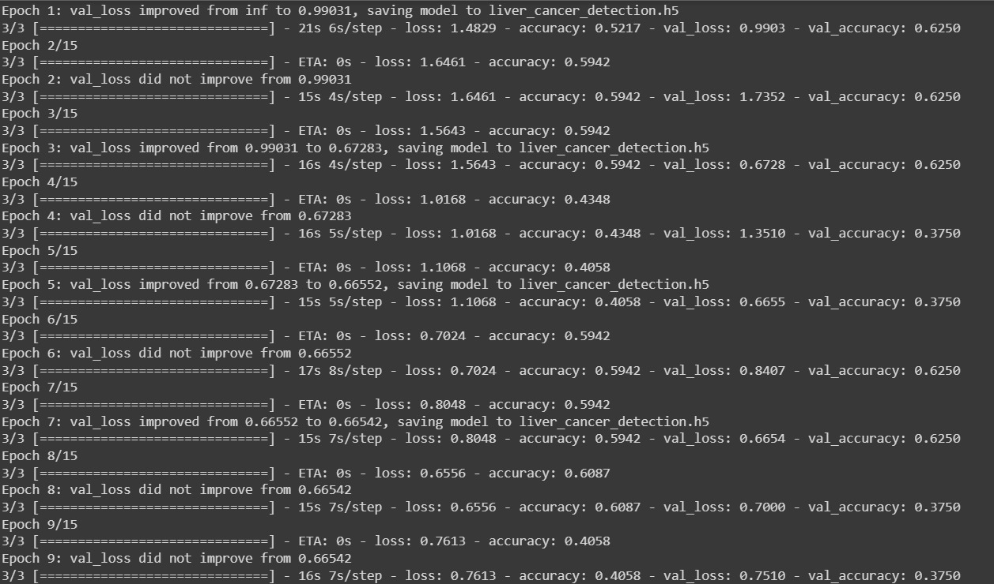

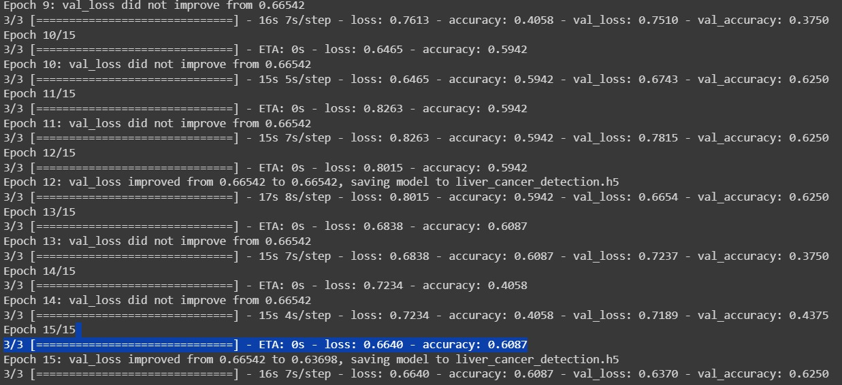

XI
C) MobileNetV1
1) This is the figure in which liver cancer has been detected.
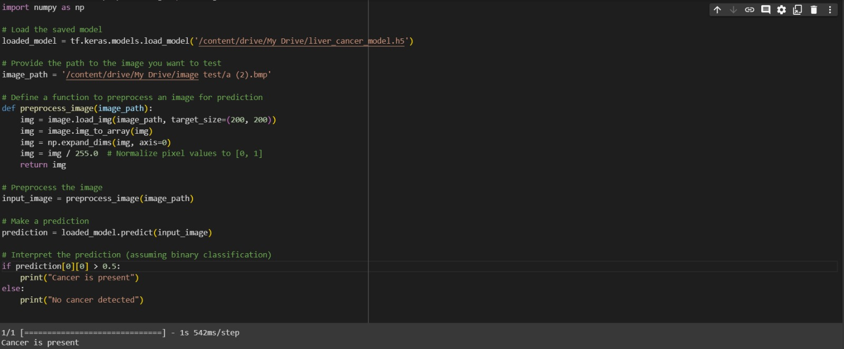

2)This is the figure in which liver cancer has not been detected.
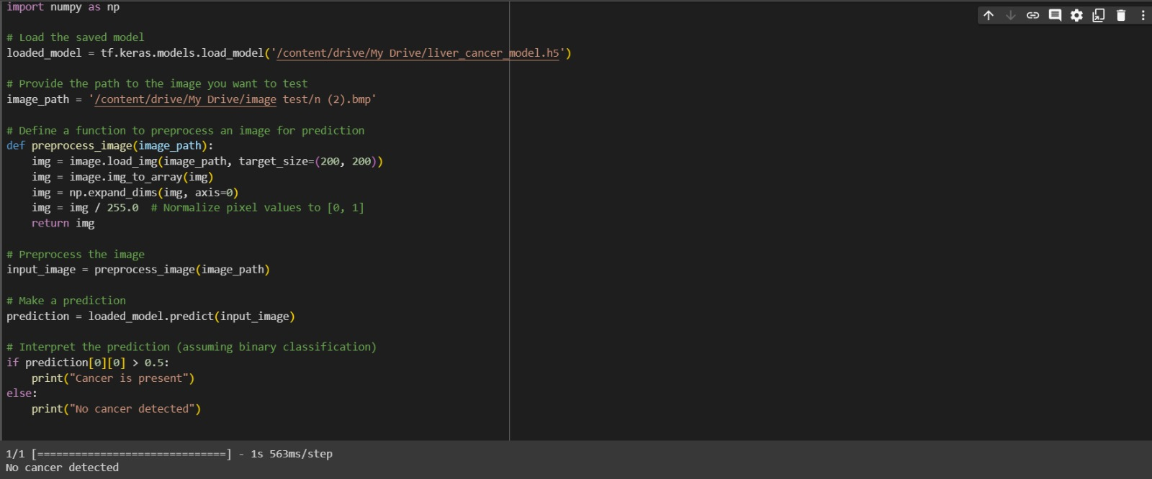

3) Accuracy:
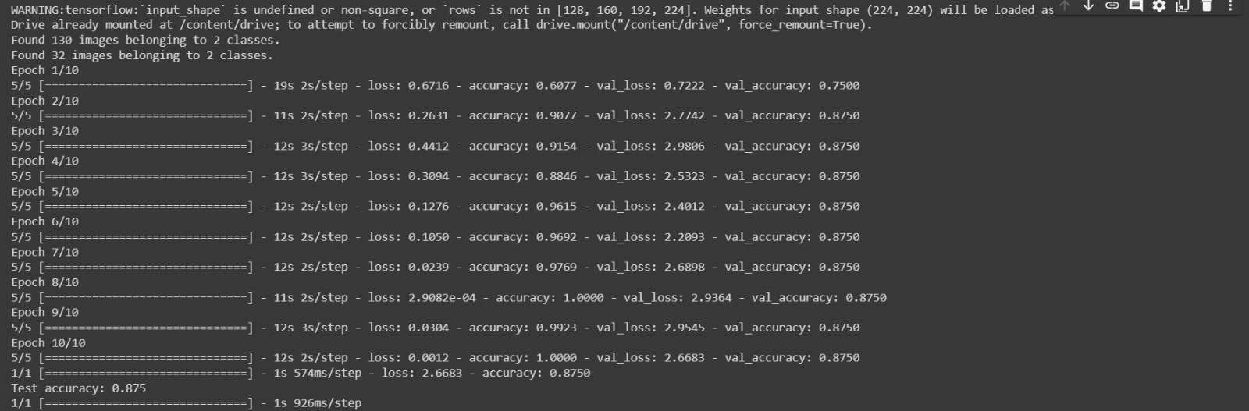
XII
Confusion Matrix:

- CNN model
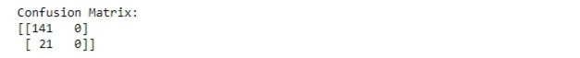
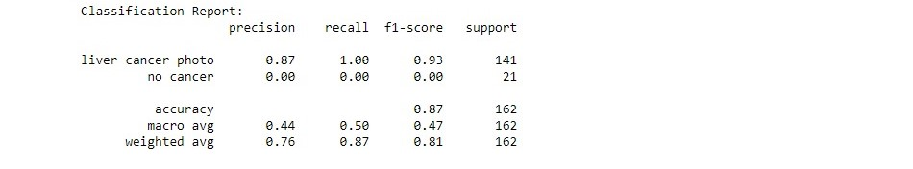

- ResNet Model

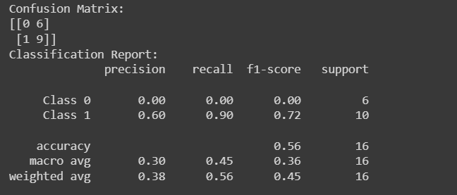

- MobileNetV1

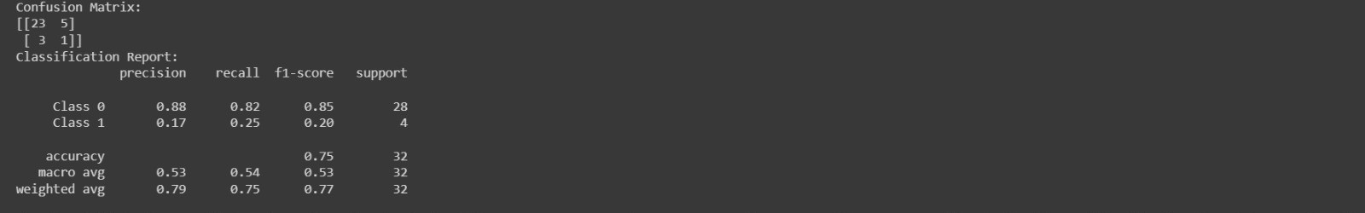
XIII

Overview of accuracies of the models:

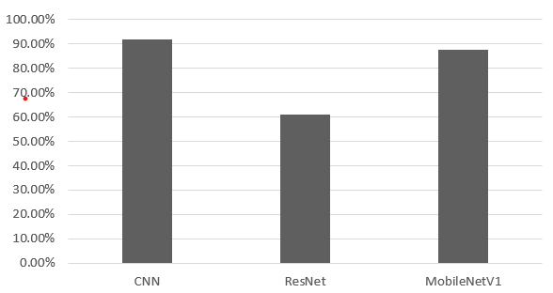

This figure shows an overview of the accuracies of three different models we used: CNN, ResNet and MobileNetV1. The graph shows that CNN has the highest accuracy followed by MobileNetV1.

XIV
- Results and Discussion

Non-invasive deep learning-based systems for liver cancer detection may revolutionize liver cancer diagnosis by reducing the need for invasive testing. Such a project can detect the elimination of early liver cancer, improving patient outcomes and has potential benefits for its patients. Diagnostic features of liver cancer that are not implants can also provide significant cost savings.

Work to develop a non-invasive device-based system for the detection of liver cancer has yielded very promising results. The models have demonstrated high accuracy in the detection of liver cancer lesions, with an accuracy of 91.67% on the CNN model, followed by 87.50% on MobileNetV1 which are much better compared to the ResNet model achieving an accuracy of 60.87% on the dataset, as well as feasibility in distinguishing between non-cancerous and cancerous lesions. By providing a detailed analysis of tumor burden and morphology, the system can help physicians accurately diagnose a patient’s cancer.

In addition to the benefits mentioned above, non-invasive deep learning-based systems for liver cancer detection are also available:

- Increase access to liver cancer screening: These programs can be implemented in remote or underserved areas where access to specialized equipment and expertise may be limited
- Reduce the burden on healthcare systems: By reducing screening and testing abuse, these systems can help reduce costs and improve efficiency.
- Improving patients’ quality of life: By providing a non-invasive and pain-free approach to liver cancer diagnosis, these programs can help relieve patients’ anxiety and stress

Overall, non-invasive, deep learning-based systems for liver cancer detection can have a significant impact on the fight against this disease by detecting this disease at an early stage improving effectiveness, improving patient outcomes, and reducing costs.

XV
- Summary and Conclusions

A noninvasive deep learning-based system for liver cancer detection has been developed. This system uses deep learning algorithms to analyze medical images, such as computed tomography (CT) scans, to detect liver cancer lesions, and estimate their size, shape, and location This system has liver in the detection of cancerous lesions. It is highly accurate, although limited data sets are available.

In addition to high accuracy, non-invasive deep learning-based systems for liver cancer detection have several other advantages over traditional liver cancer screening methods:

- Noninvasive: This means that it does not require surgery or other invasive procedures. This is particularly beneficial for patients with other medical conditions or who are at high risk for complications from implant procedures.
- Fast and efficient: The system can analyze CT images in seconds, providing doctors with fast and efficient results. This could help increase the speed and accuracy of liver cancer detection.
- Affordable: The system is relatively inexpensive to implement and use, making it accessible to a wide variety of healthcare providers. This could help improve access to liver cancer screening for patients in underserved communities.

Conclusion: This non-invasive deep learning-based system for the detection of liver cancer is a major advance in liver cancer screening and this system has the potential to be of great help in liver cancer as it will be detected and treated early. By providing a non-invasive and accurate method for the detection of liver cancer, this project could help improve patient outcomes and reduce the associated mortality rate of this disease.

XVI
- References

1] Piyush Kumar Shukla, Mohammad Zakaria, Vessam Atef Hatamleh, Hussam Taraji, and Basant Tiwari, “AI-Driven Novel Approach to Liver Cancer Diagnosis & Prognosis Using Cascaded Fully Convolutional Neural Networks”, Journal of Healthcare Engineering Vol.23, pp 7-14, Sep 2022.

2] Anita Bakrania, Narotam Joshi, Xun Zhao, Gang Zheng, Mamata Bhat,” Artificial intelligence in liver cancer: decoding the impact of machine learning models on clinical diagnosis of primary liver cancer and liver cancer of metastasis”, Journal of Pharmacological Research, pp 12-20, Feb 2023.

3] Esam Othmen, Muhammad Mahmood, Habib Dhari, Meena Ibrahim, Awais Mahmood, and Hatem Abdulkader,” Automated detection of liver cancer using pre-trained hybrid models”, National Institutes of Health July 2022.

4] Ryan Azam Khan, Yigang Luo, and Fang Xiang Wu,” Machine Learning Based Liver Disease Evaluation: A Systematic Review”, Journal of Neurocomputing Volume 468 11 January 2022.

5]Heng Zhang, Cawen Luo, Ren Deng, Shenglin Li, Shukai Duan,” Deep learning-based CT imaging for detection of liver tumors”, National Library of Medicine article May 2022.

6] Abhishek Midya, Jayasree Chakraborty, Rami Srouji, Raja R.Narayan, Thomas Boerner, Jian Zheng, Linda M. Pak, John M. Creasy, Luz A. Escobar, Michael I. D'Angelica “Computerized Diagnosis of Liver Tumors From CT Scans Using a Deep Neural Network Approach”, IEEE Journal of Biomedical and Health Informatics ( Volume: 27, Issue: 5, May 2023).

7] Venkateswarlu Gavini, G.R. Jothi Lakshmi ,"Liver Tumor Grade Detection using CNN Based LSTM Model with Corelated Feature Set from CT Images", Published in 2022 International Conference on Automation 07 February 2023.

8] Amritha M, Manimegalai P, "Liver Tumor Segmentation and Classification Using Deep Learning" Published in 2023 Fifth International Conference on Electrical, Computer and Communication Technologies (ICECCT), pp 638-650, 21 July 2023.

9]Chao-Lun Kuo, Shyi-Chyi Cheng, Chih-Lang Lin, Kuei-Fang Hsiao, Shang-Hung Lee, "Texture-based treatment prediction by automatic liver tumor segmentation on computed tomography", Published in 2017 International Conference on Computer, Information and Telecommunication Systems (CITS), pp 406-423,14 September 2017.

XVII

10] Aparna P R, Libish T M, "Automatic segmentation and classification of the liver tumor using deep learning algorithms", Published in 2023 3rd International Conference on Advances in Computing, Communication, Embedded and Secure Systems (ACCESS), pp 146-151, 07 August 2023.

11]Hameedur Rahman, Tanvir Fatima Naik Bukht, Azhar Imran, Junaid Tariq, Shanshan Tu, Abdulkareem Alzahrani, “A deep learning approach for liver and tumor segmentation in CT images using ResUNet”, Publish in Bioengineering 2022 and article of Artificial intelligence in Advanced Medical Imaging 5th Aug 2022.

12]Xin Dong, Yizhao Zhou, Lantian Wang, Jingfeng Peng, Yanbo Lao, Yiqun Fan, “Liver Cancer Detection Using Hybridized Fully Convolutional Neural Network Based on Deep Learning Framework”, IEEE (Access), pp 99, July 2022.

13]Josephine Yu Yan Yap, Laura Shih Hui Goh, Ashley Jun Wei Lim, Samuel S. Chong, Lee Jin Lim, Caroline G. Lee, “Machine learning identifies a signature of Nine exosomal RNAs that predicts hepatocellular carcinoma”, Journal of Cancers 2023 Vol. 15, 24th July 2023.

XVIII

