## This Document

In this document I will explain some terms that will hopefully help in building the functionality we need for the Add / Pickup / Service Equipment task #1113.

The document will give the situations that we want to cover. **These situations will be our test cases.** For some of these situations we have completed the items, but we should also verify them. If the test case does not pass, let’s indicate this and add it to the task list.

In some of the situations we have not accomplished the item and we need it to be a task. We will indicate these by marking them in bold and labeling them **Action Item**.

## Explanation of Some Terms

I want to explain some terms because they can sometimes be used interchangeably.

**Quote:** Request on the cost to do a job. **For Example:** We would like to have 2 Standard Restrooms delivered on Dec. 20, 2019 with 2X a week service. How much will it cost?

**Order:** Customers acceptance of the Quote.

**Job:** The actions and products that fulfill the Order. **For Example:** Delivery of 2 Standard Restrooms (action), the 2 Standard Restrooms (products) and servicing of those restrooms weekly (action).

**Products:** The way we use this term is that is could be a tangible item (Standard Restrooms) and it could also be an intangible item (Delivery or Pick Up or Weekly Service).

**Equipment:** A tangible item (Standard Restroom) on the job or something (Delivery Truck) to help fulfill the Order. We usually don’t list Delivery Trucks in our Products List because we usually don’t have them listed on the Order. I just bring it up since they can also be called Equipment. Most of the times when we refer to equipment we are referring to Restrooms and Sinks.

**Service:** Doing something to a tangible item. **For Example:** Weekly Service - cleaning a restroom once a week.

Sometimes the Orders and Jobs terms will be used interchangeably and sometimes the Products/Equipment terms will also be used interchangeably. Hopefully if this happens, the context that the terms are used will make it understandable what is meant.

**Add:** Delivering Product/Equipment to a new job or increasing the amount of Product/Equipment to an existing job.

**Pickup:** Removing/subtracting some or all Products/Equipment from a job.

# Testing the Process of Creating a Quote, Converting it to an Order (start of the job) and Initial Invoice.

### Quote/Order - Tax on Products Marked Taxed at 100% (Looks Good)

Customer: AAA RMSD Antonio

Order/Job #3970

Delivered on 12/23/2019

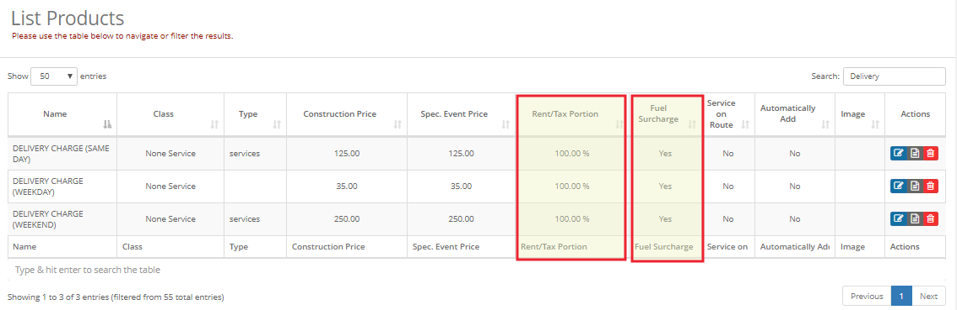

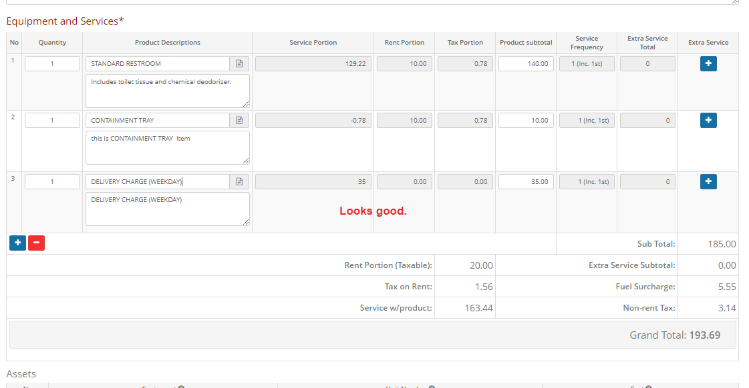



### Generate Order (Good)

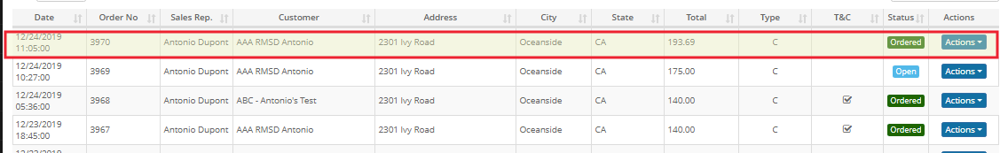

### Dispatch and Delivery Order (Turns into a Job) - Good

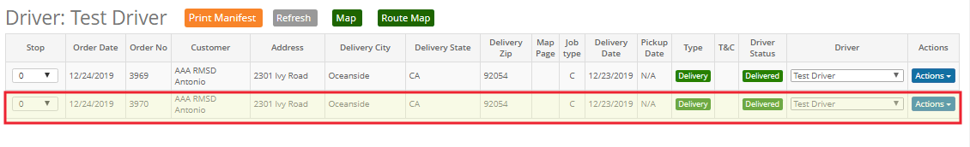

### After a Product Is Delivered An Invoice Should be Created all the Items on the Order and with Billing Dates.

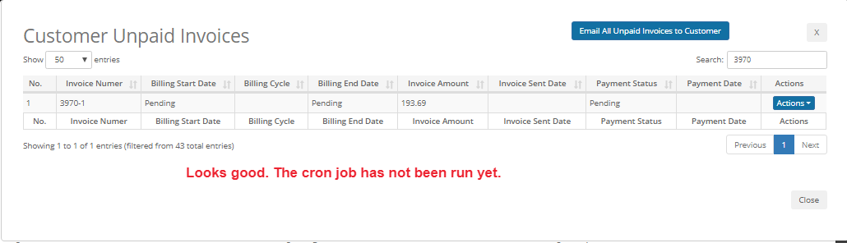

### After Running the Cron Job

[root@cart ~]# /usr/bin/php /var/www/html/cart.myothercup.com/www/test5/index.php cronjob daily

Action Item: I ran the Cron job after delivering the Order/Job, but the Billing Start Date, Billing Cycle and Billing End Date did not populate.

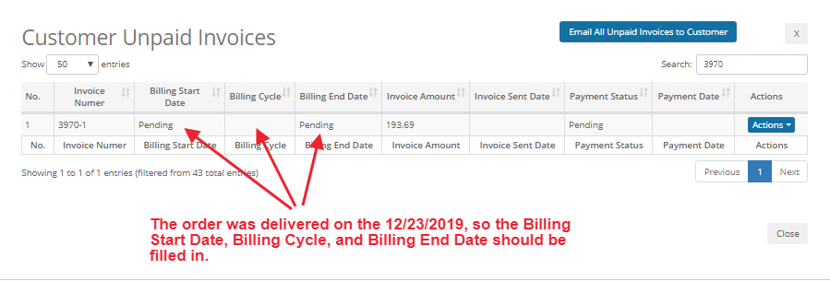

Billing Cycle is set to 28 Days

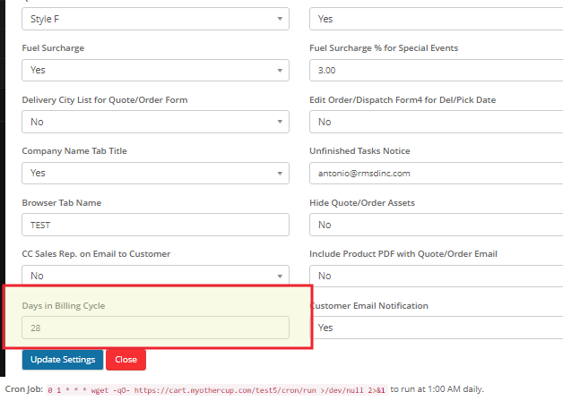

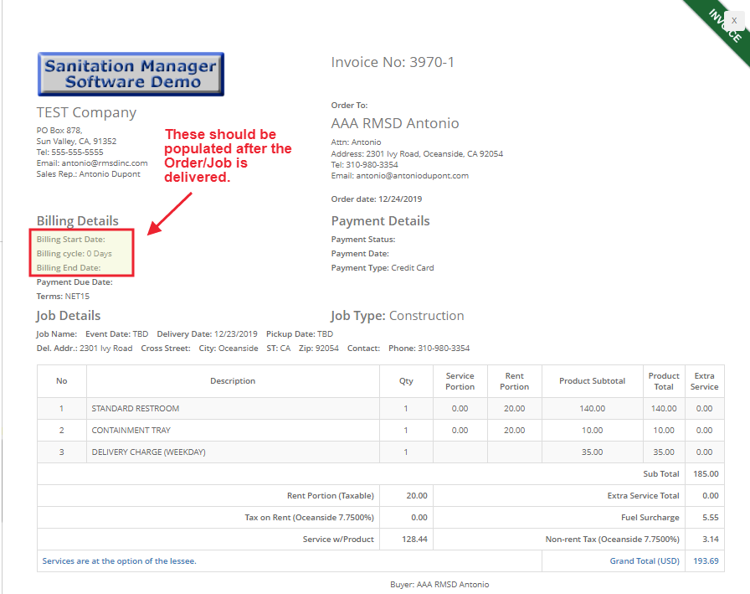

### Action Item: Invoice Default Payment Terms, what’s in the Customer’s Profile Should Match What’s on the Invoice. (See the next two screenshots)

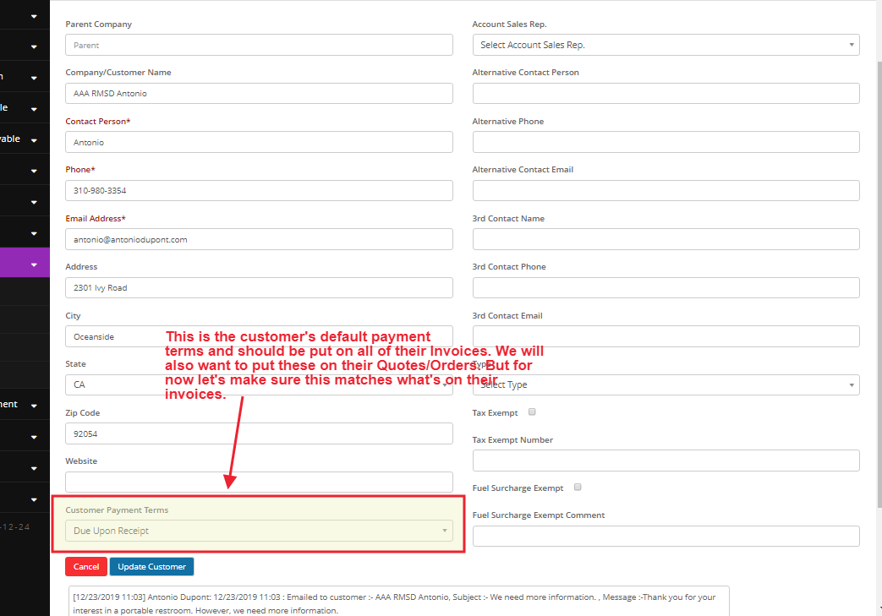

Action Item: the Invoice should not have a Payment Type filled in since no payment has been made against this invoice. (See below)

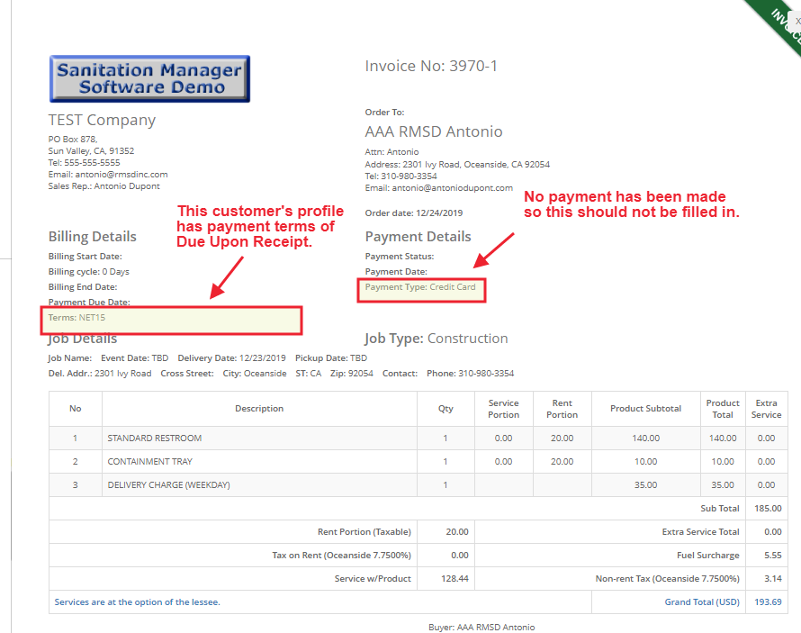

### Stop Dec. 24, 2019