Introduction to AI Agents

1.1 What Are AI Agents
AI agents are software systems capable of perceiving their environment, making decisions using reasoning or learned knowledge, and taking actions to achieve specific goals.
In modern artificial intelligence systems, agents often combine large language models (LLMs), tools, memory systems, and planning modules to autonomously solve complex problems.
Key characteristics of AI agents include:
• Goal-oriented behavior
• Ability to perceive and interpret inputs
• Reasoning and decision-making capabilities
• Ability to take actions through tools or APIs
• Learning or adaptation over time
Examples of AI agents include:
• Autonomous research assistants
• Coding agents
• Customer support agents
• Data analysis agents
• Robotic process automation agents

1.2 Evolution of LLM Agents
AI agents evolved significantly with the development of large language models.
Early AI Systems:
Traditional rule-based systems relied on predefined rules and deterministic logic.
Machine Learning Agents:
Agents began using statistical models to predict actions based on data.
LLM-Based Agents:
Modern agents use large language models to perform reasoning, planning, and natural language interaction.
Tool-Augmented Agents:
LLMs gained the ability to call external tools such as search engines, APIs, or databases.
Multi-Agent Systems:
Multiple agents collaborate together to solve tasks using orchestration frameworks like LangGraph, CrewAI, and AutoGen.
This evolution transformed LLMs from simple chatbots into autonomous problem-solving systems.

1.3 Autonomous vs Semi-Autonomous Agents
AI agents differ based on how much human involvement is required.
Semi-Autonomous Agents:
These agents require human approval or supervision before executing critical actions.
Examples:
• AI copilots
• Chat assistants
• Decision support systems
Autonomous Agents:
These agents independently plan and execute tasks without human intervention.
Examples:
• Autonomous research agents
• AI coding systems
• automated trading systems
Fully autonomous systems require strong guardrails and monitoring mechanisms to ensure safety and reliability.

1.4 Components of an AI Agent
An AI agent consists of several core components working together.
1. LLM Core
Provides reasoning, language understanding, and decision making.
2. Planning Module
Breaks complex goals into smaller tasks.
3. Memory System
Stores context, conversation history, and knowledge.
4. Tools and APIs
Allow the agent to interact with external systems.
5. Execution Engine
Runs actions and returns results to the reasoning module.
These components together enable agents to perform complex multi-step tasks.

1.5 Agent Capabilities
Modern AI agents possess several advanced capabilities.
Reasoning
Agents can analyze problems and determine appropriate actions.
Planning
Agents can break large tasks into smaller steps.
Tool Usage
Agents can call APIs, run code, search the web, and query databases.
Learning
Agents can store knowledge and improve future performance.
Collaboration
Agents can communicate and coordinate with other agents in multi-agent systems.
These capabilities allow AI agents to function as autonomous digital workers.

1.6 LLM-Powered Agent Architecture
LLM-powered agent architecture integrates language models with external systems.
Typical architecture layers include:
User Interface Layer
Handles interaction with users.
Agent Controller
Coordinates reasoning, planning, and execution.
LLM Reasoning Engine
Generates decisions, plans, and responses.
Tool Layer
Provides external capabilities like APIs and databases.
Memory Layer
Stores long-term knowledge and session context.
Environment Layer
Represents the external systems or tasks the agent interacts with.
This architecture enables agents to solve real-world tasks beyond simple conversation.

Figure: Autonomous vs Semi-Autonomous Agents
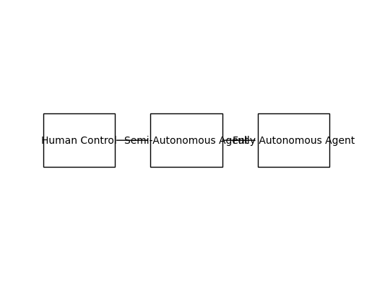

Figure: Components of an AI Agent
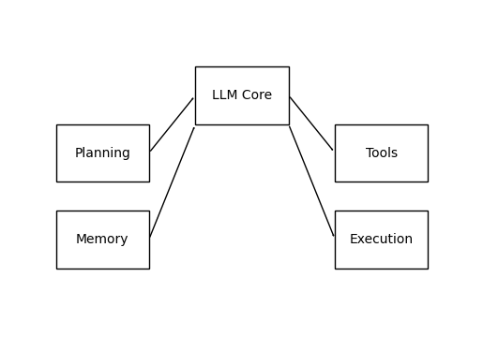

Figure: LLM-Powered Agent Architecture
