JAVA MINI PROJECT
STUDENT EXPENSE TRACKER SYSTEM

Submitted By: Harsh Savadiya
Student ID: 25CS094
Branch: Computer Science & Engineering
Project Subject: Java Programming
Submitted for academic evaluation

1. Program Title
Student Expense Tracker System using Java

2. Problem Statement
Students often spend money on food, travel, stationery and other daily needs, but may not maintain a clear record of their spending. The objective of this project is to develop a menu-driven Java application that allows a student to add expense records, view all recorded expenses and calculate total spending. The program stores expense records during execution using an ArrayList.

3. Objectives
- To record expenses with a category and amount.
- To display all expense records in a readable format.
- To calculate the total amount spent.
- To practise Java classes, objects, encapsulation, methods, loops and ArrayList.
- To validate user input and handle invalid menu choices.

4. Concepts Used
- Class and Object: Expense and StudentExpenseTracker classes.
- Encapsulation: Private data members with public getter methods.
- Constructor: Initializes each Expense object.
- ArrayList: Stores multiple expense objects dynamically.
- Methods: Separate methods perform add, display and total calculations.
- Loop and Switch: The menu repeats until the user selects Exit.
- Scanner: Accepts input from the keyboard.

5. Complete Java Source Code
Save the following code in a file named StudentExpenseTracker.java. Compile it using javac StudentExpenseTracker.java and run it using java StudentExpenseTracker.
import java.util.ArrayList;
import java.util.Scanner;
// Represents one expense record.
class Expense {
private String category;
private double amount;
public Expense(String category, double amount) {
this.category = category;
this.amount = amount;
}
public String getCategory() {
return category;
}
public double getAmount() {
return amount;
}
public void display(int number) {
System.out.printf("%d. %-12s : Rs. %.2f%n",
number, category, amount);
}
}
// Main class of the Student Expense Tracker application.
public class StudentExpenseTracker {
private static final ArrayList<Expense> expenses = new ArrayList<>();
private static final Scanner input = new Scanner(System.in);
private static void addExpense() {
System.out.print("Enter expense category: ");
String category = input.nextLine().trim();
if (category.isEmpty()) {
System.out.println("Category cannot be empty.");
return;
}
System.out.print("Enter amount: ");
if (!input.hasNextDouble()) {
System.out.println("Please enter a valid numeric amount.");
input.nextLine();
return;
}
double amount = input.nextDouble();
input.nextLine(); // Consume the newline.
if (amount <= 0) {
System.out.println("Amount must be greater than zero.");
return;
}
expenses.add(new Expense(category, amount));
System.out.println("Expense added successfully!");
}
private static void viewExpenses() {
if (expenses.isEmpty()) {
System.out.println("No expenses recorded yet.");
return;
}
System.out.println("---------- EXPENSE HISTORY ----------");
for (int i = 0; i < expenses.size(); i++) {
expenses.get(i).display(i + 1);
}
System.out.println("-------------------------------------");
}
private static void viewTotal() {
double total = 0;
for (Expense expense : expenses) {
total += expense.getAmount();
}
System.out.printf("Total spending: Rs. %.2f%n", total);
}
public static void main(String[] args) {
int choice;
System.out.println("==============================================");
System.out.println(" STUDENT EXPENSE TRACKER SYSTEM");
System.out.println("==============================================");
do {
System.out.println("\n1. Add Expense");
System.out.println("2. View All Expenses");
System.out.println("3. View Total Spending");
System.out.println("4. Exit");
System.out.print("Enter your choice: ");
while (!input.hasNextInt()) {
System.out.println("Please enter a number from 1 to 4.");
input.nextLine();
System.out.print("Enter your choice: ");
}
choice = input.nextInt();
input.nextLine();
switch (choice) {
case 1:
addExpense();
break;
case 2:
viewExpenses();
break;
case 3:
viewTotal();
break;
case 4:
System.out.println("Thank you for using Student Expense Tracker!");
break;
default:
System.out.println("Invalid choice. Please try again.");
}
} while (choice != 4);
input.close();
}
}

6. Execution Output Screenshot
The following terminal-style output demonstrates adding two expenses, viewing the expense history, calculating the total spending and exiting the application.
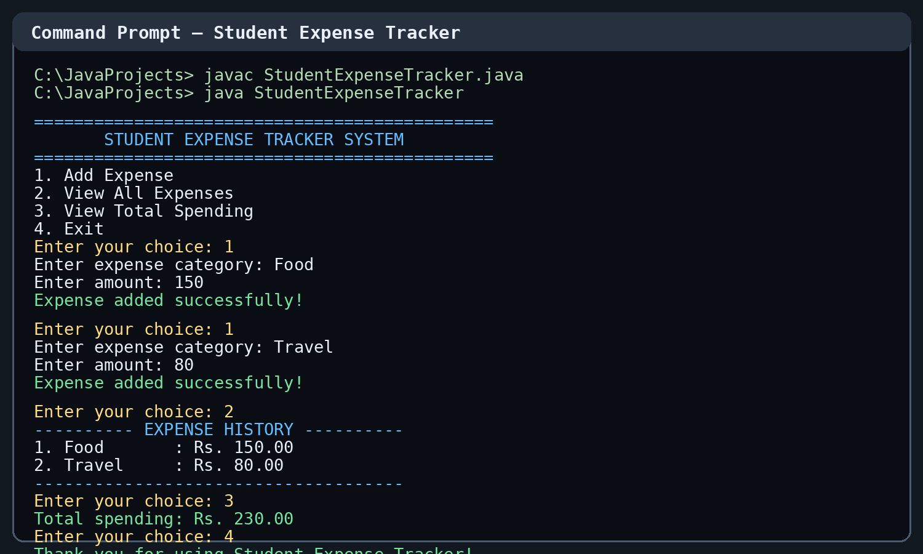
Figure 1: Sample execution output of Student Expense Tracker.

7. Sample Output Summary
- Food expense added: Rs. 150.00
- Travel expense added: Rs. 80.00
- Total spending displayed: Rs. 230.00
- Application exits when option 4 is selected.

8. Conclusion
The Student Expense Tracker System successfully records and displays expense details and calculates total spending. This project demonstrates the practical use of core Java programming concepts and provides a simple foundation for a larger personal-finance application. The records are stored in memory and are cleared when the program is closed.

9. GitHub Repository
Source code repository:
https://github.com/harshsavadiya07/java-practical-.git

