CHARUSAT — CEUE203-OOP
PRACTICAL 10.

 | Practical
P10.1 | Thread-pool runner: with a fixed pool of 3 (ExecutorService), submit about 10 Runnable  tasks that print their id and sleep briefly; shut down and await completion, observing the  few threads being reused..
Code | import java.util.concurrent.*;  public class ThreadPoolRunner {  public static void main(String[] args)  throws InterruptedException {  ExecutorService pool = Executors.newFixedThreadPool(3);  for (int i = 1; i <= 10; i++) {  final int id = i;  pool.submit(() -> {  System.out.println(  "Task " + id + " running on "  + Thread.currentThread().getName()  );  try {  Thread.sleep(300);  } catch (InterruptedException e) {  Thread.currentThread().interrupt();  }  });  }  pool.shutdown();  if (!pool.awaitTermination(1, TimeUnit.MINUTES)) {  pool.shutdownNow();  }  System.out.println("All tasks completed");  }  }
Output | 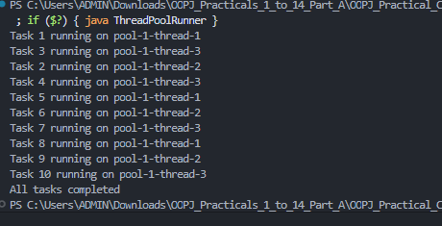

 | Practical
P10.2 | Producer–consumer: one thread adds numbers to a small shared buffer and another  removes them, coordinated with wait()/notify(); produce and consume a fixed number of  items in order with none lost..
Code | import java.util.*;  class Buffer {  private final Queue<Integer> q = new ArrayDeque<>();  private final int capacity = 3;  synchronized void put(int n) throws InterruptedException {  while (q.size() == capacity) {  wait();  }  q.add(n);  System.out.println("Produced: " + n);  notifyAll();  }  synchronized int take() throws InterruptedException {  while (q.isEmpty()) {  wait();  }  int n = q.remove();  System.out.println("Consumed: " + n);  notifyAll();  return n;  }  }  public class ProducerConsumer {  public static void main(String[] args)  throws InterruptedException {  Buffer b = new Buffer();  Thread producer = new Thread(() -> {  try {  for (int i = 1; i <= 10; i++) {  b.put(i);  }  } catch (InterruptedException e) {  Thread.currentThread().interrupt();  }  });  Thread consumer = new Thread(() -> {  try {  for (int i = 1; i <= 10; i++) {  b.take();  }  } catch (InterruptedException e) {  Thread.currentThread().interrupt();  }  });  producer.start();  consumer.start();  producer.join();  consumer.join();  }  }
Output | 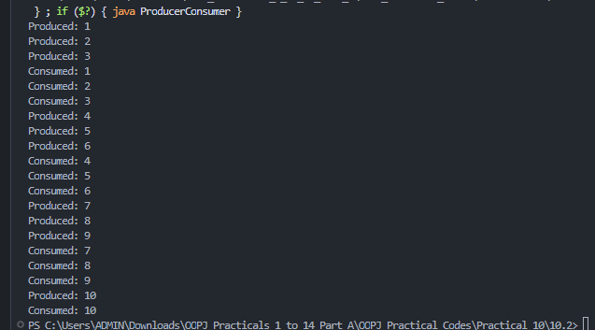

 | Practical
P10.3 | Reproduce a deadlock between two threads that lock  two objects in opposite order, then remove it with a consistent lock order. Choose the  scenario yourself.
Code | public class DeadlockAndFix {  private static final Object A = new Object();  private static final Object B = new Object();  static void safeTransfer(String name, Object first, Object second) {  synchronized (first) {  synchronized (second) {  System.out.println(name + " completed safely");  }  }  }  public static void main(String[] args)  throws InterruptedException {  Thread t1 = new Thread(() ->  safeTransfer("A to B", A, B)  );  Thread t2 = new Thread(() ->  safeTransfer("B to A", A, B)  );  t1.start();  t2.start();  t1.join();  t2.join();  System.out.println(  "Consistent lock order prevents deadlock."  );  }  }
Output | 

