CHARUSAT — CEUE203-OOP
PRACTICAL 12.

 | Practical
P12.1 | Word frequency: split a paragraph into words, count each in a HashMap, and print the  words sorted by frequency (highest first) using a Comparator..
Code | import java.util.*;  public class WordFrequency {  public static void main(String[] args) {  String text = "Java is easy and Java is powerful. Java supports object oriented programming.";  Map<String, Integer> count = new HashMap<>();  for (String word : text.toLowerCase()  .replaceAll("[^a-z ]", " ")  .trim()  .split("\\s+")) {  count.merge(word, 1, Integer::sum);  }  List<Map.Entry<String, Integer>> entries =  new ArrayList<>(count.entrySet());  entries.sort(  Map.Entry.<String, Integer>comparingByValue()  .reversed()  .thenComparing(Map.Entry.comparingByKey())  );  for (var e : entries) {  System.out.println(e.getKey() + " : " + e.getValue());  }  }  }
Output | 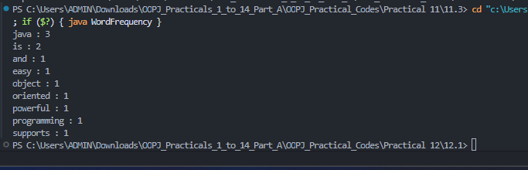

 | Practical
P12.2 | Unique visitors: from a list of login names with repeats, use a HashSet to count unique  users and a LinkedHashSet to keep first-seen order; print the unique count and the first  three distinct names.
Code | import java.util.*;  public class UniqueVisitors {  public static void main(String[] args) {  List<String> logins = List.of(  "prince",  "smit",  "ayush",  "prince",  "smit",  "riya",  "ayush"  );  Set<String> unique = new HashSet<>(logins);  Set<String> ordered = new LinkedHashSet<>(logins);  System.out.println("Unique count: " + unique.size());  System.out.println("First three distinct names:");  int n = 0;  for (String name : ordered) {  if (n++ == 3) {  break;  }  System.out.println(name);  }  }  }
Output | 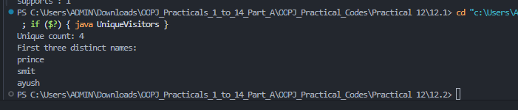

 | Practical
P12.3 | Build a leaderboard from player scores held in a Map  and print the top-N sorted by score (ties broken by name); choose the data and sorting  details.
Code | import java.util.*;  public class Leaderboard {  public static void main(String[] args) {  Map<String, Integer> scores = Map.of(  "Asha", 95,  "Ravi", 88,  "Neel", 95,  "Mira", 76,  "Kiran", 91  );  int topN = 3;  List<Map.Entry<String, Integer>> list =  new ArrayList<>(scores.entrySet());  list.sort(  Map.Entry.<String, Integer>comparingByValue()  .reversed()  .thenComparing(Map.Entry.comparingByKey())  );  System.out.println("Top " + topN + ":");  for (int i = 0; i < Math.min(topN, list.size()); i++) {  System.out.println(  list.get(i).getKey() + " - "  + list.get(i).getValue()  );  }  }  }
Output | 

