CHARUSAT — CEUE203-OOP
PRACTICAL 4.

 | Practical
P4.1 | Password strength (PasswordChecker.java + Driver.java)  (a) In PasswordChecker, check four rules — length ≥ 8, contains an uppercase letter,  contains a digit, contains a special character — using regex (e.g. “.*[A-Z].*”) or  String methods.  (b) Write strength(String pw) that counts how many rules pass and returns “Weak” (0–  1), “Medium” (2–3) or “Strong” (4).  (c) In Driver.main: test several passwords; for each, print which rules passed and the  final label.  Expected output: “abc” → Weak; “Abcd1234!” → Strong.
Code | public class PasswordChecker {  static String strength(String pw) {  int score = 0;  boolean length = pw.length() >= 8;  boolean upper = pw.matches(".*[A-Z].*");  boolean digit = pw.matches(".*[0-9].*");  boolean special = pw.matches(".*[^A-Za-z0-9].*");  System.out.println("Password: " + pw);  System.out.println("Length: " + length  + ", Uppercase: " + upper  + ", Digit: " + digit  + ", Special: " + special);  if (length) {  score++;  }  if (upper) {  score++;  }  if (digit) {  score++;  }  if (special) {  score++;  }  return score <= 1 ? "Weak"  : score <= 3 ? "Medium"  : "Strong";  }  public static void main(String[] args) {  for (String p : new String[]{  "abc",  "abcdef12",  "Abcd1234!",  "HELLO123"  }) {  System.out.println("Strength: " + strength(p) + "\n");  }  }  }
Output | 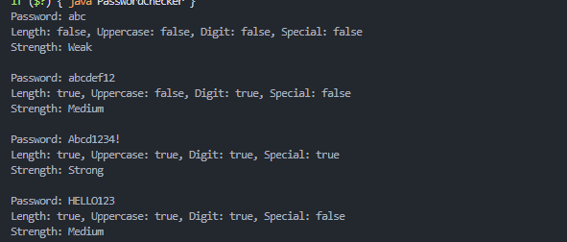

 | Practical
P4.2 | Chat-log filter (ChatFilter.java + Driver.java)  (a) In Driver.main, define a String[] of log lines like “10:05 alice Hello there” (include  one malformed line with fewer than 3 parts).  (b) Read a keyword from the user.  (c) For each line, split into time/user/message with split(“ ”, 3); skip lines that do not  have 3 parts.  (d) If the message contains the keyword (case-insensitive), increment a counter and  append “time user: message” to a StringBuilder.  (e) Print “Matches: N” and the built report.  Expected output: keyword “hello” over 3 lines (1 malformed) → “Matches: 1” and  the matching line.
Code | import java.util.Scanner;  public class ChatFilter {  public static void main(String[] args) {  String[] logs = {  "10:05 alice Hello there",  "10:06 bob Good morning",  "broken line",  "10:07 cara HELLO everyone"  };  try (Scanner sc = new Scanner(System.in)) {  System.out.print("Keyword: ");  String key = sc.nextLine().toLowerCase();  int matches = 0;  StringBuilder report = new StringBuilder();  for (String line : logs) {  String[] p = line.split(" ", 3);  if (p.length < 3) {  continue;  }  if (p[2].toLowerCase().contains(key)) {  matches++;  report.append(p[0])  .append(" ")  .append(p[1])  .append(": ")  .append(p[2])  .append('\n');  }  }  System.out.println("Matches: " + matches);  System.out.print(report);  }  }  }
Output | 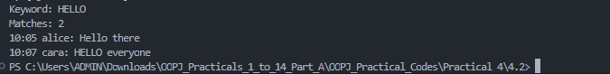

 | Practical
P4.3 | Template filler (TemplateFiller.java +  Driver.java)  (a) In Driver.main, define a template like “Dear {name}, order {id} ships {date}.” and  two parallel arrays: names {“name”, “id”} and values {“Riya”, “A07”} (note {date}  is not supplied).  (b) Compile a Pattern for \{(\w+)\} and get a Matcher on the template.  (c) Walk the matches with a StringBuilder: for each {placeholder}, look up its value in  the names array and replace with the value, or with “[?]” if not found.  (d) Print the filled template.  Expected output: the unsupplied {date} becomes [?].
Code | import java.util.regex.*;  public class TemplateFiller {  public static void main(String[] args) {  String template = "Dear {name}, order {id} ships {date}.";  String[] names = {"name", "id"};  String[] values = {"Riya", "A07"};  Pattern pattern = Pattern.compile("\\{(\\w+)\\}");  Matcher matcher = pattern.matcher(template);  StringBuilder out = new StringBuilder();  int last = 0;  while (matcher.find()) {  out.append(template, last, matcher.start());  String key = matcher.group(1);  String replacement = "[?]";  for (int i = 0; i < names.length; i++) {  if (names[i].equals(key)) {  replacement = values[i];  break;  }  }  out.append(replacement);  last = matcher.end();  }  out.append(template.substring(last));  System.out.println(out);  }  }
Output

