CHARUSAT — CEUE203-OOP
PRACTICAL 7.

 | Practical
P7.1 | Form validator: define @NotBlank and @MaxLength(int) for fields and annotate a  SignupForm. Write a checker that uses reflection to read each field’s annotations and  returns the list of validation errors for a given object.
Code | import java.lang.annotation.*;  import java.lang.reflect.*;  import java.util.*;  @Retention(RetentionPolicy.RUNTIME)  @Target(ElementType.FIELD)  @interface NotBlank {  }  @Retention(RetentionPolicy.RUNTIME)  @Target(ElementType.FIELD)  @interface MaxLength {  int value();  }  class SignupForm {  @NotBlank  @MaxLength(20)  String name;  @NotBlank  @MaxLength(40)  String email;  SignupForm(String n, String e) {  name = n;  email = e;  }  }  public class FormValidator {  static List<String> validate(Object obj) throws IllegalAccessException {  List<String> errors = new ArrayList<>();  for (Field f : obj.getClass().getDeclaredFields()) {  f.setAccessible(true);  Object v = f.get(obj);  if (f.isAnnotationPresent(NotBlank.class)  && (v == null || v.toString().isBlank())) {  errors.add(f.getName() + " must not be blank");  }  MaxLength m = f.getAnnotation(MaxLength.class);  if (m != null && v != null  && v.toString().length() > m.value()) {  errors.add(f.getName() + " exceeds "  + m.value() + " characters");  }  }  return errors;  }  public static void main(String[] args) throws Exception {  SignupForm f = new SignupForm(  "",  "a-very-long-email-address-that-is-too-long@example.com"  );  System.out.println(validate(f));  }  }
Output | 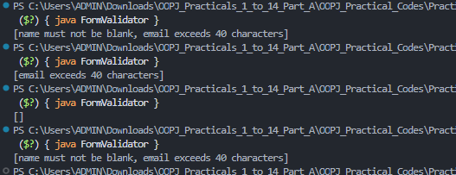

 | Practical
P7.2 | Mini test runner: define a @Run annotation and mark some no-arg methods of a class  with it. Use reflection to find and invoke only the @Run methods and report how many  ran — the idea behind how JUnit finds @Test methods.
Code | import java.lang.annotation.*;  import java.lang.reflect.*;  @Retention(RetentionPolicy.RUNTIME)  @Target(ElementType.METHOD)  @interface Run {  }  class SampleTests {  @Run  void testAddition() {  System.out.println("Addition test passed");  }  @Run  void testText() {  System.out.println("Text test passed");  }  void helper() {  System.out.println("Not run");  }  }  public class MiniTestRunner {  public static void main(String[] args) throws Exception {  Object test = new SampleTests();  int count = 0;  for (Method m : test.getClass().getDeclaredMethods()) {  if (m.isAnnotationPresent(Run.class)  && m.getParameterCount() == 0) {  m.invoke(test);  count++;  }  }  System.out.println("Tests ran: " + count);  }  }
Output | 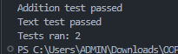

 | Practical
P7.3 | Define a @Column(name) annotation and, by  reflection, populate an object’s fields from a header row and a data row by matching  column names; decide how to handle a missing column.
Code | import java.lang.annotation.*;  import java.lang.reflect.*;  @Retention(RetentionPolicy.RUNTIME)  @Target(ElementType.FIELD)  @interface Column {  String name();  }  class StudentRow {  @Column(name = "student_name")  String name;  @Column(name = "age")  int age;  public String toString() {  return name + " - " + age;  }  }  public class ColumnMapper {  static StudentRow map(String header, String data) throws Exception {  String[] h = header.split(",");  String[] v = data.split(",");  StudentRow obj = new StudentRow();  for (Field f : StudentRow.class.getDeclaredFields()) {  Column c = f.getAnnotation(Column.class);  for (int i = 0; i < h.length && i < v.length; i++) {  if (c.name().equals(h[i].trim())) {  f.setAccessible(true);  if (f.getType() == int.class) {  f.setInt(obj, Integer.parseInt(v[i].trim()));  } else {  f.set(obj, v[i].trim());  }  }  }  }  return obj;  }  public static void main(String[] args) throws Exception {  System.out.println(  map("student_name,age", "Prince,20")  );  }  }
Output | 

