CHARUSAT — CEUE203-OOP
PRACTICAL 8.

 | Practical
P8.1 | Guarded calculator: read two numbers and an operator; throw a custom  DivideByZeroException and catch invalid-number input separately, printing a clear  message each time; loop until a valid calculation succeeds and use finally to log each  attempt.
Code | import java.util.Scanner;  class DivideByZeroException extends Exception {  DivideByZeroException(String m) {  super(m);  }  }  public class GuardedCalculator {  static double calculate(double a, double b, char op)  throws DivideByZeroException {  return switch (op) {  case '+' -> a + b;  case '-' -> a - b;  case '*' -> a * b;  case '/' -> {  if (b == 0) {  throw new DivideByZeroException(  "Cannot divide by zero"  );  }  yield a / b;  }  default -> throw new IllegalArgumentException(  "Unknown operator"  );  };  }  public static void main(String[] args) {  try (Scanner sc = new Scanner(System.in)) {  boolean done = false;  while (!done) {  try {  System.out.print("Enter first number: ");  double a = Double.parseDouble(sc.next());  System.out.print("Operator (+ - * /): ");  char op = sc.next().charAt(0);  System.out.print("Second number: ");  double b = Double.parseDouble(sc.next());  System.out.println(  "Result: " + calculate(a, b, op)  );  done = true;  } catch (NumberFormatException e) {  System.out.println("Invalid number. Try again.");  } catch (DivideByZeroException  | IllegalArgumentException e) {  System.out.println(e.getMessage());  } finally {  System.out.println(  "Calculation attempt completed."  );  }  }  }  }  }
Output | 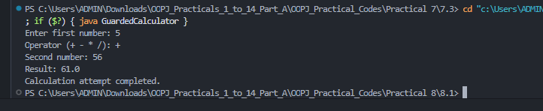

 | Practical
P8.2 | Stock issue: a Warehouse where issue(item, qty) throws a custom checked  OutOfStockException carrying the shortfall, and InvalidQuantityException for qty ≤ 0.  Process a list of requests, catching and reporting each failure without stopping the run.
Code | import java.util.*;  class OutOfStockException extends Exception {  private final int shortfall;  OutOfStockException(int s) {  super("Out of stock by " + s);  shortfall = s;  }  int getShortfall() {  return shortfall;  }  }  class InvalidQuantityException extends Exception {  InvalidQuantityException() {  super("Quantity must be greater than zero");  }  }  class Warehouse {  private final Map<String, Integer> stock = new HashMap<>();  Warehouse() {  stock.put("Pen", 5);  stock.put("Book", 2);  }  void issue(String item, int qty)  throws OutOfStockException, InvalidQuantityException {  if (qty <= 0) {  throw new InvalidQuantityException();  }  int available = stock.getOrDefault(item, 0);  if (qty > available) {  throw new OutOfStockException(qty - available);  }  stock.put(item, available - qty);  System.out.println("Issued " + qty + " " + item);  }  }  public class StockIssue {  public static void main(String[] args) {  Warehouse w = new Warehouse();  Object[][] requests = {  {"Pen", 3},  {"Book", 5},  {"Pen", 0},  {"Pencil", 1},  {"Pen", 2}  };  for (Object[] r : requests) {  try {  w.issue((String) r[0], (int) r[1]);  } catch (OutOfStockException e) {  System.out.println(  e.getMessage()  + " (shortfall=" + e.getShortfall() + ")"  );  } catch (InvalidQuantityException e) {  System.out.println(e.getMessage());  }  }  }  }
Output | 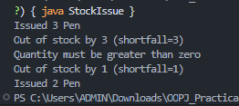

 | Practical
P8.3 | Create an AutoCloseable resource and use try-with-resources to prove it always closes — even when an exception is thrown inside the block— and that the original error is the one reported. Decide what to model as the resource.
Code | class DemoResource implements AutoCloseable {  public void use() {  System.out.println("Using resource");  }  public void close() {  System.out.println("Resource closed");  }  }  public class AutoCloseDemo {  public static void main(String[] args) {  try (DemoResource r = new DemoResource()) {  r.use();  throw new IllegalStateException(  "Original operation failed"  );  } catch (Exception e) {  System.out.println(  "Reported error: " + e.getMessage()  );  }  }  }
Output | 

