CHARUSAT — CEUE203-OOP
PRACTICAL 2 .

 | Practical
P2.1 | Smart thermostat (Thermostat.java, main in this file)  (a) Create class Thermostat with private String location, private int temperature, private  static final int MIN=16 and MAX=30, and private static int activeCount=0.  (b) Constructor(location, startTemp): store location; set temperature to startTemp if it is  within MIN..MAX else 22; increment activeCount.  (c) Constructor(location): chain with this(location, 22).  (d) raise(): if temperature < MAX add 1, else print “Already at maximum (30)”.  (e) lower(): if temperature > MIN subtract 1, else print “Already at minimum (16)”.  (f) Add getTemperature() (no setter) and static getActiveCount().  (g) In main: create two thermostats, call raise() 10 times then lower() 20 times in loops  (printing the temperature each time), then print getActiveCount().  Expected output: temperature rises to 30 then “Already at maximum”, falls to 16  then “Already at minimum”, count 2.
Code | public class Thermostat {  private String location;  private int temperature;  private static final int MIN = 16;  private static final int MAX = 30;  private static int activeCount = 0;  Thermostat(String location, int startTemp) {  this.location = location;  this.temperature = startTemp >= MIN && startTemp <= MAX  ? startTemp : 22;  activeCount++;  }  Thermostat(String location) {  this(location, 22);  }  void raise() {  if (temperature < MAX) {  temperature++;  } else {  System.out.println("Already at maximum (30)");  }  }  void lower() {  if (temperature > MIN) {  temperature--;  } else {  System.out.println("Already at minimum (16)");  }  }  int getTemperature() {  return temperature;  }  static int getActiveCount() {  return activeCount;  }  public static void main(String[] args) {  Thermostat a = new Thermostat("Lab", 25);  Thermostat b = new Thermostat("Office");  for (int i = 0; i < 10; i++) {  a.raise();  System.out.println(a.location + ": " + a.getTemperature());  }  for (int i = 0; i < 20; i++) {  a.lower();  System.out.println(a.location + ": " + a.getTemperature());  }  System.out.println("Active thermostats: " + getActiveCount());  }  }
Output | 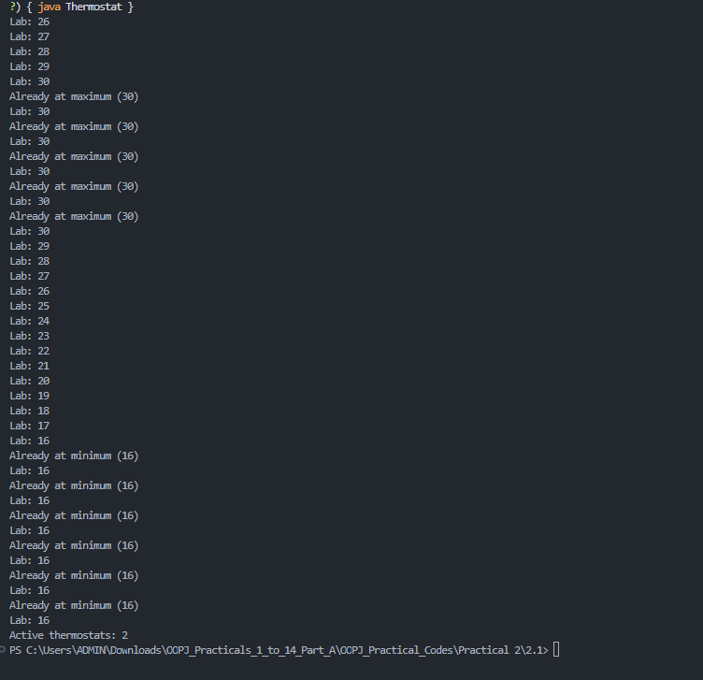

 | Practical
P2.2 | Cinema show (CinemaShow.java, main in this file)  (a) Create class CinemaShow with private String title, private int seatsAvailable, private  final int capacity, and private static int totalBooked=0.  (b) Constructor(title, capacity): set both and seatsAvailable = capacity.  Constructor(title): chain with this(title, 100).  (c) book(int n): if n ≤ seatsAvailable, reduce seatsAvailable by n, add n to totalBooked,  return true; else return false unchanged.  (d) cancel(int n): increase seatsAvailable by n but never above capacity.  (e) Add getSeatsAvailable() and static getTotalBooked().  (f) In main: run a sequence of book and cancel calls, printing the result and seats after  each, then print getTotalBooked().  Expected output: booking more than available prints false and leaves seats  unchanged; totalBooked equals the successful bookings.
Code | public class CinemaShow {  private String title;  private int seatsAvailable;  private final int capacity;  private static int totalBooked = 0;  CinemaShow(String title, int capacity) {  this.title = title;  this.capacity = capacity;  this.seatsAvailable = capacity;  }  CinemaShow(String title) {  this(title, 100);  }  boolean book(int n) {  if (n < 0 || n > seatsAvailable) {  return false;  }  seatsAvailable -= n;  totalBooked += n;  return true;  }  void cancel(int n) {  if (n > 0) {  seatsAvailable = Math.min(capacity, seatsAvailable + n);  }  }  int getSeatsAvailable() {  return seatsAvailable;  }  static int getTotalBooked() {  return totalBooked;  }  public static void main(String[] args) {  CinemaShow show = new CinemaShow("Java Movie", 50);  System.out.println("Book 20: " + show.book(20)  + ", seats: " + show.getSeatsAvailable());  System.out.println("Book 40: " + show.book(40)  + ", seats: " + show.getSeatsAvailable());  System.out.println("Book 10: " + show.book(10)  + ", seats: " + show.getSeatsAvailable());  show.cancel(5);  System.out.println("After cancellation, seats: "  + show.getSeatsAvailable());  System.out.println("Total booked: " + getTotalBooked());  }  }
Output | 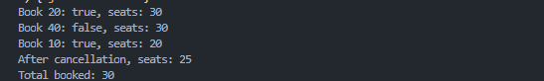

 | Practical
P2.3 | Parking lot (ParkingLot.java)  (a) Create class ParkingLot with private int twoWheelers and fourWheelers, private final  int twoCap and fourCap, and private static long revenue=0.  (b) park(String type): for “two”, if twoWheelers < twoCap increment and add 20 to  revenue; for “four”, if fourWheelers < fourCap increment and add 40; otherwise print  “Full” and reject.  (c) leave(String type): decrement the matching count but never below 0.  (d) In main: simulate a sequence of park/leave events, printing each outcome, then print  final occupancy and revenue.  Expected output: parking into a full section is refused; revenue = 20×(two parked)  + 40×(four parked).
Code | public class ParkingLot {  private int twoWheelers = 0;  private int fourWheelers = 0;  private final int twoCap;  private final int fourCap;  private static long revenue = 0;  ParkingLot(int twoCap, int fourCap) {  this.twoCap = twoCap;  this.fourCap = fourCap;  }  boolean park(String type) {  if (type.equalsIgnoreCase("two") && twoWheelers < twoCap) {  twoWheelers++;  revenue += 20;  return true;  }  if (type.equalsIgnoreCase("four") && fourWheelers < fourCap) {  fourWheelers++;  revenue += 40;  return true;  }  System.out.println("Full or invalid type");  return false;  }  void leave(String type) {  if (type.equalsIgnoreCase("two") && twoWheelers > 0) {  twoWheelers--;  } else if (type.equalsIgnoreCase("four") && fourWheelers > 0) {  fourWheelers--;  }  }  public static void main(String[] args) {  ParkingLot p = new ParkingLot(2, 1);  System.out.println(p.park("two"));  System.out.println(p.park("two"));  System.out.println(p.park("two"));  System.out.println(p.park("four"));  p.leave("two");  System.out.println(p.park("two"));  System.out.println("Two-wheelers: " + p.twoWheelers  + ", Four-wheelers: " + p.fourWheelers);  System.out.println("Revenue: " + revenue);  }  }
Output | 

