Team GR1 Homework # 1

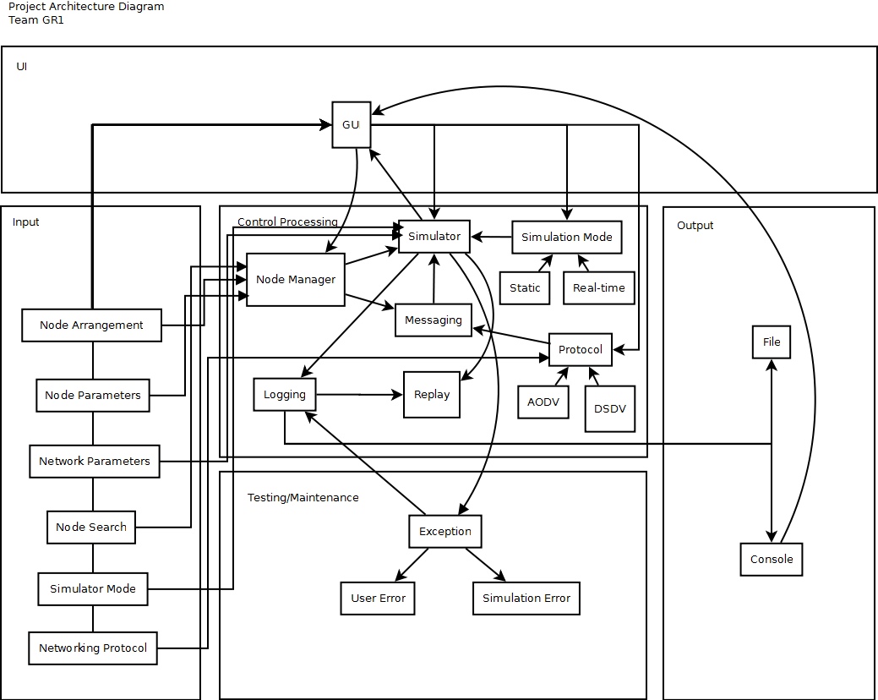
Question 1

The simulator works as follows. The user enters in node and network parameters. The node manager stores information about node arrangement and node parameters. It also handles node search. The user also inputs the simulation mode and the networking protocol.

The simulator obtains the network topology from the node manager. To send messages between nodes, the simulator asks the messaging subsystem to invoke the appropriate
networking protocol. The result of message passing is then sent to the log.

Exceptions encountered by the simulator are also recorded in the log. The log can be written either to a file or to the console. User errors consist of invalid inputs, and simulation errors consist of network topological errors.

The replay subsystem makes use of the log from a previous run and an instance of the simulator.

Question 2

Three Point Estimation

Assumptions: Team GR 1 is using the AODV Simulator for some base estimates for LOC, we found the total 2,700 LOC for the AODV Simulator was small so we will be using this as the LOC minimum in the three point estimation.

The AODV simulator subsystem code was 392 LOC and only implemented the AODV protocol, for our simulator we will have another protocol and an additional replay mode or subsystem, so we are assuming that we will add at least another 300 LOC to add both of these features. The most likely total LOC is estimated to be 3,000. In the worst case scenario we are assuming that the max LOC could be 6000 LOC, or twice as much as the most likely estimate.

If we assume a productivity rate of 620 LOC/person-month, then the number of person-months required for the project is 3450/620 = 5.6 person-months.

Basic COCOMO

Assumptions: Team GR1 is using the assumption that the software project falls under the organic category of the basic COCOMO model due to the size of the team. We are using the estimated project size from the three point estimation as the LOC for the COCOMO equations.

Question 3 :

Three point Estimation Calculation:

Assumptions:
The logging subsystem has 57 LOC in the simulator, which works only for the AODC protocol. for our simulator we will have another protocol and an additional replay mode or subsystem, so we are assuming that we will add at least another 30 LOC to the logging subsystem. In the worst case, we will finish it in about 127 LOC.

If we assume a productivity rate of 620 LOC/person-month, then the number of person-months required for the subsystem is 89/620 = 0.14 person-months.

Basic COCOMO

Assumptions:
We again use the assumption that the software project falls under the organic category of the basic COCOMO model, and we use the estimated project size from the three point estimation as the LOC for the COCOMO equations.

