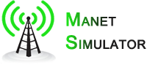 **Users Guide**

**Configuration**

* **Add nodes using drag-and-drop**

C:\Users\Greg\workspace\aodv\images\AddNode.png

To add a Node to the simulation pane simply click and hold on the node icon in the upper left and drag the icon to the intended destination. This can be duplicated as many times as desired.

* **Move nodes on the display (drag-and-drop)**

To Move a node within the simulation pane click and hold on that node (notice the boarder around the icon becomes a thick dark boarder) drag to the desired location and release.

* **Change node location manually**



Nodes can be moved manually by manipulating the X and Y coordinates in the Properties section on the right side of the simulator. Enter your desired coordinates and click the Save button. Please note that it is possible to manipulate the coordinates such that the node is moved completely off the screen. Should this occur you can return it by changing the coordinates back to something that fits on the screen (you may need to search for the node to locate it if it is not visible, see search section).

* **Delete nodes**

C:\Users\Greg\workspace\aodv\images\DeleteNode.pngC:\Users\Greg\workspace\aodv\images\DeleteAllNode.png

Nodes can be deleted individually by selecting the particular node for removal and clicking the Delete Node button C:\Users\Greg\workspace\aodv\images\DeleteNode.png or to facilitate quick reset of the simulation pane you can click the Delete all Nodes buttonC:\Users\Greg\workspace\aodv\images\DeleteAllNode.png which will remove all nodes in the pane at once.

* **Search for a node, and provide its information.**

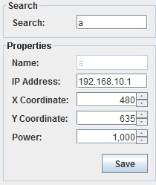

All node information is contained within the Properties section on the right. To search for a node simply enter the node name (an automatically assigned letter) into the search box and hit the Enter key. The results will be displayed under properties and that node will be shown with its power circle in the simulation pane.

* **Automatically set all node parameters**

By default all node parameters are set automatically upon creation. The power level will default to 1000, Name and IP address will be created incrementally, and the location will be set to the coordinates where the node is dropped.

* **Manually set individual node parameters**

After node creation users are able to manipulate node parameters in the properties section, with the exception of the node name (the incrementally generated letter assigned upon creation).

* **Select routing protocol: Ad hoc On-demand Distance Vector (AODV) protocol / Destination Sequenced Distance Vector (DSDV) protocol**

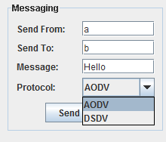

In the Messaging section, on the lower right, simply choose the desired protocol from the drop down menu. This setting can be changed at anytime.

**Execution**

* **Indicate when simulation begins and ends**

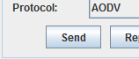 **C:\Users\Greg\workspace\aodv\images\Send.png**

Simulation begins when the required information is entered into the fields in the Messaging section and either the Send button or icon is clicked. The simulation will complete with either a message received, which will be indicated in the left pane at the bottom of the screen, or with a failure which can be determined from the log text viewable in the right pane at the bottom of the screen. During the simulation run the icons will change colors to indicate activity, upon completion they will return to their idle state.

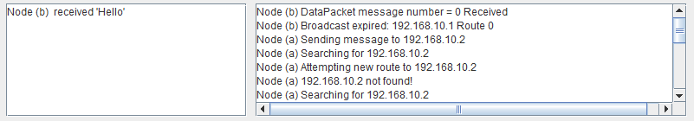

* **Execute simulation runs based on individual node sending to another node**

To send messages from one node to another simply enter the required parameters in the messaging section. Failure to enter valid information will result in a warning and the simulation will not run until the problem is corrected.

* **Execute simulation runs based on multiple nodes sending to other nodes**

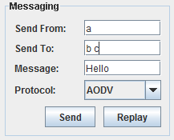

To send messages from one node to multiple others simply enter the required parameters in the messaging section. In the Send To field enter the desired node names separated by either a space or a comma. Failure to enter valid information will result in a warning and the simulation will not run until the problem is corrected.

* **Select network bandwidth**

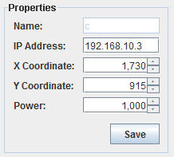

In the properties section the power field can be changed to increase/decrease the power circle around a specific node.

* **Provide textual and graphical/animated representation**

During simulation nodes will indicate activity by the animation of their tower icons:

C:\Users\Greg\workspace\aodv\images\Green\GSendingNode0.pngC:\Users\Greg\workspace\aodv\images\Green\GSendingNode1.pngC:\Users\Greg\workspace\aodv\images\Green\GSendingNode2.pngC:\Users\Greg\workspace\aodv\images\Green\GSendingNode3.png

Additionally the logs will be generated (lower right pane) in real time giving a textual representation of the actions as they occur. Successful message delivery will be indicated in the lower left.

**Analysis / Logs**

* **Logging information on the state of each node**

During simulation detailed logging information can be found in the lower right pane below the simulation pane. The events indicate the specific node and the action for each event. Additional details can be found by browsing to the log folder dir/aodv/logs and opening the specific text file. These files follow the format simlog_date_time.txt

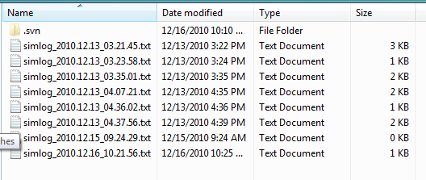

* **Logging information on the environment**

Environment information is available by reviewing the text based log file. This will show a thorough detailed description of how the environment was built.

* **Logging information on the messages**

Detailed information on messages is available in the text based log file. Log events involving messages will begin with ACTION=SendMsgs. Specifics of the message, sender and destination follow.

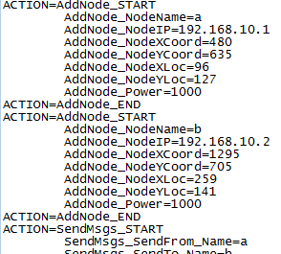

* **Replay executed simulation runs**

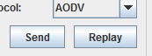 **C:\Users\Greg\workspace\aodv\images\Replay.png**

To replay a previously simulated run users can click on either the Replay button in the Messaging box or the replay icon. Clicking either will prompt the user to select the log file of the simulation they wish to replay. The entire simulation will then rerun from node creation on.