A

REPORT

ON

**GST BILL GENERATOR**

**SUBMITTED BY**

HARSH N. SHAH

UDIT K. PAREKH

**GUIDED BY**

Prof. BHAVESH K. CHHATRALA

Computer Engineering Department

Darshan Institute of Engineering & Technology

For Diploma Studies,

Rajkot.



**2021-22**

**DEPARTMENT OF COMPUTER ENGINEERING**

**DARSHAN INSTITUTE OF ENGINEERING & TECHNOLOGY**

**FOR DIPLOMA STUDIES**

**RAJKOT-MORBI HIGHWAY, RAJKOT (GUJARAT).**

A

REPORT

ON

**GST BILL GENERATOR**

SUBMITTED TO

GUJARAT TECHNOLOGICAL UNIVERSITY, AHMEDABAD.

IN PARTIAL FULFILLMENT OF THE REQUIREMENT FOR THE AWARDS OF

DIPLOMA IN COMPUTER ENGINEERING

SUBMITTED BY

**ENROLLMENT NO**  **NAME OF STUDENT**

1) 196620307059 HARSH N. SHAH

2) 196620307043 UDIT K. PAREKH

**GUIDED BY**

Prof. BHAVESH K. CHHATRALA

Computer Engineering Department

Darshan Institute of Engineering & Technology

For Diploma Studies,

Rajkot.



**2021-22**

**DEPARTMENT OF COMPUTER ENGINEERING**

**DARSHAN INSTITUTE OF ENGINEERING & TECHNOLOGY**

**FOR DIPLOMA STUDIES**

**RAJKOT-MORBI HIGHWAY, RAJKOT (GUJARAT).**



**DARSHAN**

**INSTITUTE OF ENGINEERING & TECHNOLOGY**

**FOR DIPLOMA STUDIES**

**Certificate**

This is to certify that,

**Mr. HARSH N. SHAH** having Enrollment No: **196620307043** has completed **Part-II UDP** Project work for **Semester VI** having title **GST BILL GENERATOR,** in a group of **two** persons under the guidance of the Faculty Guide **Prof. BHAVESH K. CHHATRALA.**

|  |  |
| --- | --- |
| **Guide** | **Head of Department** |
| Prof. BHAVESH K. CHHATRALA  Computer Engg. Dept.  Darshan Institute of Engg. & Tech.  For Diploma Studies,  Rajkot. | Prof. CHINTAN N. KANANI  Computer Engg. Dept.  Darshan Institute of Engg. & Tech.  For Diploma Studies,  Rajkot. |

**2021-22**

**DEPARTMENT OF COMPUTER ENGINEERING**

**DARSHAN INSTITUTE OF ENGINEERING & TECHNOLOGY**

**FOR DIPLOMA STUDIES**

**RAJKOT-MORBI HIGHWAY, RAJKOT (GUJARAT).**



**DARSHAN**

**INSTITUTE OF ENGINEERING & TECHNOLOGY**

**FOR DIPLOMA STUDIES**

**Certificate**

This is to certify that,

**Mr. UDIT K. PAREKH** having Enrollment No: **196620307043** has completed **Part-II UDP** Project work for **Semester VI** having title **GST BILL GENERATOR,** in a group of **two** persons under the guidance of the Faculty Guide **Prof.** **BHAVESH K. CHHATRALA.**

|  |  |
| --- | --- |
| **Guide** | **Head of Department** |
| Prof. BHAVESH K. CHHATRALA  Computer Engg. Dept.  Darshan Institute of Engg. & Tech.  For Diploma Studies,  Rajkot. | Prof. CHINTAN N. KANANI  Computer Engg. Dept.  Darshan Institute of Engg. & Tech.  For Diploma Studies,  Rajkot. |

**2021-22**

**DEPARTMENT OF COMPUTER ENGINEERING**

**DARSHAN INSTITUTE OF ENGINEERING & TECHNOLOGY**

**FOR DIPLOMA STUDIES**

**RAJKOT-MORBI HIGHWAY, RAJKOT (GUJARAT).**



**DARSHAN**

**INSTITUTE OF ENGINEERING & TECHNOLOGY**

**FOR DIPLOMA STUDIES**

**EXAMINER’S CERTIFICATE OF APPROVAL**

This is to certify that draft report entitled **GST BILL GENERATOR** submitted by **HARSH N. SHAH (196620307059) and UDIT K. PAREKH (196620307043)** in partial fulfillment for the award of the diploma in **Computer** **Engineering** of the Gujarat Technological University-Ahmedabad is hereby approved.

Internal Examiners External Examiners

**2021-22**

**DEPARTMENT OF COMPUTER ENGINEERING**

**DARSHAN INSTITUTE OF ENGINEERING & TECHNOLOGY**

**FOR DIPLOMA STUDIES**

**RAJKOT-MORBI HIGHWAY, RAJKOT (GUJARAT).**

**ACKNOWLEDGEMENT**

We would like to express special thanks to our guide Prof. “BHAVESH K. CHHATRALA” and our Head of the Department Prof. “CHINTAN N. KANANI” for their guidance and support to complete our project. They helped us in sorting out errors raised during the project development. They also suggested some changes like adding or removing certain features and making appropriate changes according to the main objective of the project. Last but not least, we would also like to thank our friends who have supported and helped us in our project.

**INDEX**

|  |  |  |  |
| --- | --- | --- | --- |
| **Chapter No.** | **Sub Chapter**  **No.** | **Content** | **Page No.** |
|  |  | **Abstract** |  |
| 1 |  | **Introduction**………………………………………………………... | 1 |
|  | 1.1 | Problem Summary………………………………………………….. | 1 |
| 2 |  | **Planning**……………………………………………………………. | 2 |
|  | 2.1 | Model Description………………………………………………….. | 5 |
|  | 2.2 | Risk Management…………………………………………………... | 5 |
| 3 |  | **Detail Description**…………………………………………………. | 7 |
| 4 |  | **Diagrams**…………………………………………………………… | 9 |
|  | 4.1 | Class Diagram………………………………………………………. | 9 |
|  | 4.2 | Sequence Diagram………………………………………………….. | 10 |
|  | 4.3 | Collaboration Diagram……………………………………………... | 11 |
|  | 4.4 | State Diagram………………………………………………………. | 12 |
|  | 4.5 | Activity Diagram…………………………………………………… | 13 |
|  | 4.6 | Use Case Diagram………………………………………………….. | 14 |
|  | 4.7 | Data Flow Diagram (Level 0)……………………………………… | 15 |
|  |  | Data Flow Diagram (Level 1)……………………………………… | 16 |
| 5 |  | **Data Dictionary**…………………………………………………… | 17 |
|  | 5.1 | E-R Diagram……………………………………………………….. | 19 |
| 6 |  | **Screen Shots**……………………………………………………….. | 20 |
| 7 |  | **Conclusion**…………………………………………………………. | 29 |
| 8 |  | **Future Enhancement**…………………………………………….... | 30 |

**ABSTRACT**

When we want to generate the bill for the purchased products, it takes lots of time to calculate bill amount and there may chances of mistake in calculation. In case of mistake in calculate, it leads to wastage of paper and time. So, we have developed Android Application “**GST Bill Generator**” will generate the bill in PDF format very easily. In application we have to just add customer details first time, add list of products purchased by the customer and it will generate a bill quickly. This application has functionalities to save generated bill for future use, user can view previously purchased product details of the customer etc. So, it saves our precious time and environment.

1. **INTRODUCTION**

**1.1 PROBLEM SUMMARY**

**1.1.1 Problem Identification**

When we want to generate the bill for the purchased products, it takes lots of time to calculate bill amount and there may chances of mistake in calculation. In case of mistake in calculate, it leads to wastage of paper and time. It is also difficult to maintain hard copy of the bills for user/shopkeeper.

**1.1.2 Problem Solution**

The solution for above mentioned problem, we have developed Android Application “**GST Bill Generator**” will generate the bill in PDF format very easily. In application we have to just add customer details first time, add list of products purchased by the customer and it will generate a bill. This application has functionalities to save generated bill for future use, user can view previously purchased product details of the customer etc. So, it saves our precious time, environment and cost effectively.

1. **PLANNING**

**2.1 MODEL DESCRIPTION**

Feasibility study

Requirement analysis and specificationspssssssspespecification

Design

Maintenance

Integration and system testing

Coding and unit testing

**Fig. Iterative Waterfall Model**

* In our project we are using iterative waterfall model.
* It is not possible to strictly follow the classical waterfall model.
* Making necessary changes to the classical waterfall model so that it becomes applicable to practical software development projects.
* The main change to the classical waterfall model is in the form of providing feedback paths from every phase to its preceding phases as shown in figure.
* The feedback paths allow for correction of the errors committed during a phase as and when these are detected in a later phases.
* For example if during testing a design error is identified then the feedback path allows the design to be reworked and the changes to be reflected in the design document.
* There is no feedback path to the feasibility stage. This means that the feasibility study errors cannot be corrected.

**Requirements analysis and specification**

* The aim of the requirements analysis and specification phase is to understand the exact requirements of the customer and to document them properly. This phase consists of two distinct activities, namely
* Requirements gathering and analysis, and
* Requirements specification
* The goal of the requirements gathering activity is to collect all relevant information from the customer regarding the product to be developed. This is done to clearly understand the customer requirements so that incompleteness and inconsistencies are removed.
* The requirements analysis activity is begun by collecting all relevant data regarding the product to be developed from the users of the product and from the customer through interviews and discussions.
* During SRS activity, the user requirements are systematically organized into a Software Requirements Specification (SRS) document.

**Design**

* During the design phase the software architecture is derived from the SRS document. Two distinctly different approaches are available.
* Traditional design consists of two different activities; first a structured analysis of the requirements specification is carried out where the detailed structure of the problem is examined. During structured design, the results of structured analysis are transformed into the software design.

**Coding and unit testing (Implementation)**

* The purpose of the coding and unit testing phase of software development is to translate the software design into source code. Each component of the design is implemented as a program module. The end-product of this phase is a set of program modules that have been individually tested.
* Each module is unit tested for determine the correct working of all the individual modules.

**Integration and system testing**

* Integration of different modules is done once they have been coded and unit tested. During the integration and system testing phase, the modules are integrated in a planned manner.
* Finally, when all the modules have been successfully integrated and tested, system testing is carried out. The goal of system testing is to ensure that the developed system conforms to its requirements laid out in the SRS document. System testing usually consists of three different kinds of testing activities.
* α – testing: It is the system testing performed by the development team.
* β – Testing: It is the system testing performed by a friendly set of customers.
* Acceptance testing: It is the system testing performed by the customer himself after the product delivery to determine whether to accept or reject the delivered product.

**Maintenance**

* Maintenance involves performing any one or more of the following three kinds of activities:
* Correcting errors that were not discovered during the product development phase. This is called corrective maintenance.
* Improving the implementation of the system, and enhancing the functionalities of the system according to the customer’s requirements. This is called perfective maintenance.
* Porting the software to work in a new environment. For example, porting may be required to get the software to work on a new computer platform or with a new operating system. This is called adaptive maintenance.

**2.2 RISK MANAGEMENT**

* The aim of risk management is to reducing the impact of all kind of risks that might affect a project. Risk management consists of three essential activities: risk identification, risk assessment, and risk containment.

**Risk Identification**

* A software project can be affected by a large variety of risks. In order to be able to systematically identify the important risks which might affect a software project, it is necessary to categorize risks into different classes.
* The project manager can then examine which risks from each class are relevant to the project. There are three main categories of risks which can affect a software project:

**Project Risks**

* Project risks concern varies forms of budgetary, schedule, personnel, resource, and customer-related problems. An important project risk is schedule. It is very difficult to monitor and control a software project.
* It is very difficult to control something which cannot be seen.
* The invisibility of the product being developed is an important reason for many software projects failure.
* So in our project we are trying to resolve this kind of project risk which is also known as schedule risk.

**Technical Risks**

* Technical risks concern design, implementation, interfacing, testing, and maintenance problems.
* Technical risks also include ambiguous specification, incomplete specification, changing specification, technical uncertainty. Most technical risks occur due to the team member’s insufficient knowledge about the project.
* So in order to prevent this risk, we have done appropriate project analysis before starting our project.

**Business Risks**

* This type of risks include risks of building an excellent product that no one wants, losing budgetary or personnel commitments, etc.

**Risk Assessment**

* Risk assessment involves identifying risk, analyzing them and then assigns priority to them on the basis of the analysis.
* The objective of risk assessment is to rank the risks in terms of their damage. For risk assessment, first each risk should be rated in two ways:
* The probability of a risk coming true (denoted as r).
* The result of the problems associated with that risk (denoted as s).
* Based on these two factors, the priority of each risk can be computed:

**p = r * s**

Where, p is the priority with which the risk must be handled, r is the probability of the risk becoming true, and so is the result of damage caused due to the risk becoming true. If all identified risks are prioritized, then the most likely and damaging risks can be handled first and reject procedures can be designed for these risks.

**Risk Containment**

* After all the identified risks of a project are assessed, plans must be made to containment the most damaging and the most likely risks.
* Different risks require different containment procedures. In fact, most risks require expertness on the part of the project manager in handling the risk.
* There are three main strategies to plan for risk containment:
* **Avoid the risk:** This may take several forms such as discussing with the customer to change the requirements to reduce the scope of the work.
* **Transfer the risk:** This strategy involves getting the risky component developed by a third party.
* **Risk reduction:** This involves planning ways to containment the damage due to a risk.
* To choose between the different strategies of handling a risk, the project manager must consider the cost of handling the risk and the corresponding reduction in risk.
* For this we may compute the risk leverage of the different risks. Risk leverage is the difference in risk divided by the cost of reducing the risk.

**Risk leverage = (Risk before reducing - Risk after reducing) / cost of reducing**

**3. DETAIL DESCRIPTION**

**Customer:**

The details of customer have been stored in this module. User can insert detail about their customer such as Customer Name, City and Contact Number etc.

* **CustomerID :**ID of customer
* **CustomerName :**Name of customer
* **ContactNumber :**Contact number of customer
* **City :**City of customer
* **CreatedDate :**Date when customer added

**Product:**

In this module, the details of product have been stored. User can view product detail like Product Name, GST Percent, Price etc.

* **ProductID :**ID of product
* **ProductName :**Name of product
* **ProductGSTPercent :**GST percent of product
* **ProductPrice :**Price of product
* **ProductQuantity :**Quantity of product

**Purchase:**

In this module, the details of purchased product have been stored.User can insert and delete purchased product.User can insert product details like Product Name, GST Percent, Purchase Quantity, Total Price etc.

* **PurchaseID :**ID of purchase
* **ProductID :**ID of product
* **CustomerID :**ID of customer
* **PurchasedQuantity :**Quantity of purchase
* **TotalPrice :**Total price of purchase

**Bill:**

In this module, After purchase products by the customer, Bill will be generated and save all details for future use. Bill contains details like Customer Name, Product Name, Product GST Percent, Purchased Quantity, Total Price of Bill etc.

* **BillID :**ID of Bill
* **PurchaseID :**ID of purchase
* **CustomerID :**ID of customer
* **TotalBill :** Total Bill Amount to be pay
* **BillDate :**Date of bill created
* **Ispaid :**Is bill paid or not

**History:**

In this module, the past purchase details of the customers will be stored. User can view & download previously generated bill. Bill contains details like Customer Name, Product Name, Product GST Percent, Purchased Quantity, Total Price of Bill etc.

* **HistoryID :**ID of History
* **CustomerID :**ID of customer
* **PurchaseID :**ID of purchase
* **BillID :**ID of BillGenerate

**4. DIAGRAMS**

**4.1 CLASS DIAGRAM**

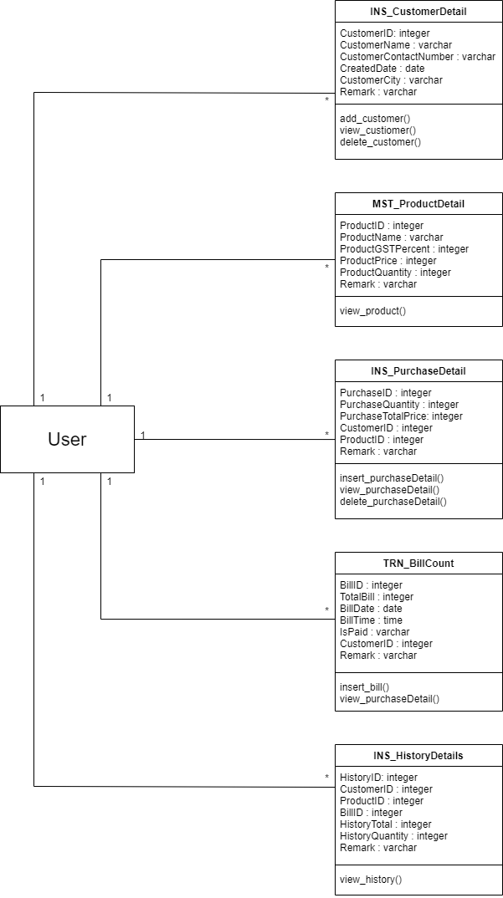

Fig. 4.1 Class Diagram

**4.2 SEQUENCE DIAGRAM**

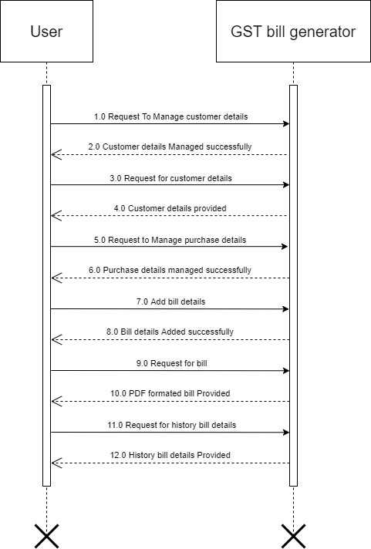

Fig. 4.2 Sequence Diagram

**4.3 COLLABORATION DIAGRAM**

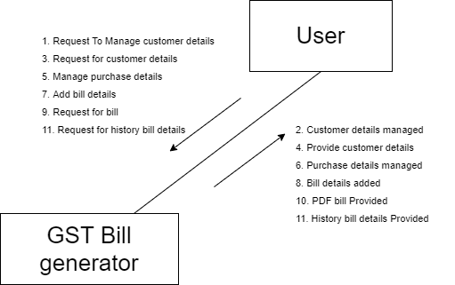

Fig. 4.3 Collaboration Diagram

**4.4 STATE DIAGRAM**

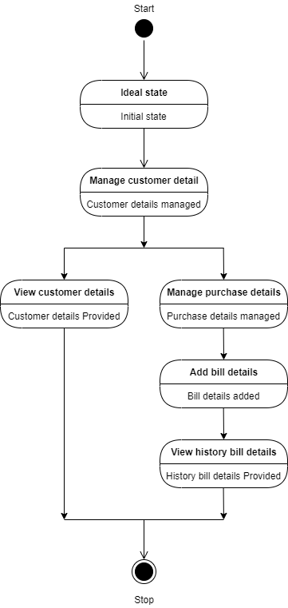

Fig. 4.4 State Diagram

**4.5 ACTIVITY DIAGRAM**

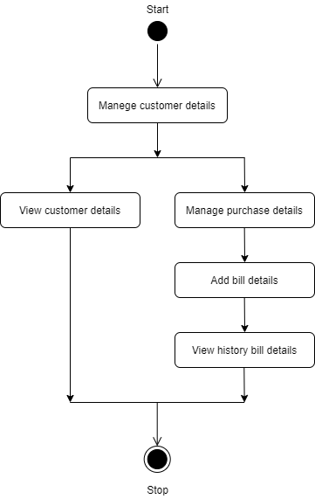

Fig. 4.5 Activity Diagram

**4.6 USE CASE DIAGRAM**

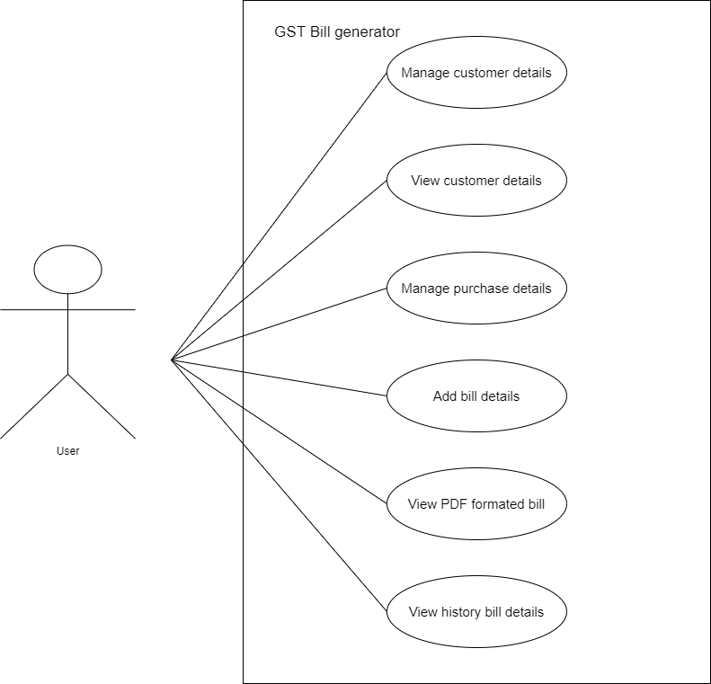

Fig. 4.6 Use Case Diagram

**4.7 DATA FLOW DIAGRAM**

Data Flow Diagram Level 0

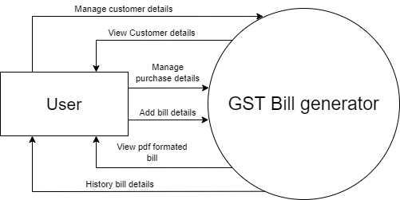

Fig. 4.7.1 Data Flow Diagram (Level 0)

Data Flow Diagram Level 1

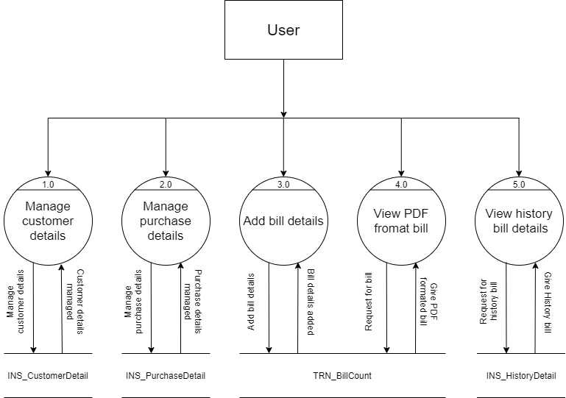

Fig. 4.7.2 Data Flow Diagram (Level 1)

**5. DATA DICTIONARY**

**DATABASE TABLES**

|  |  |  |  |  |
| --- | --- | --- | --- | --- |
| **INS_CustomerDetail** | | | | |
| **Field Name** | **Data Type** | **Size** | **Constraint** | **Reference** |
| CustomerID | integer | 10 | PK | - |
| CustomerName | varchar | 50 | NOT NULL | - |
| ContactNumber | varchar | 20 | NOT NULL | - |
| CreatedDate | datetime | 50 | NOT NULL | - |
| City | varchar | 30 | NOT NULL | - |
| Remark | varchar | 100 | - | - |

|  |  |  |  |  |
| --- | --- | --- | --- | --- |
| **MST_ProductDetail** | | | | |
| **Field Name** | **Data Type** | **Size** | **Constraint** | **Reference** |
| ProductID | integer | 10 | PK | - |
| ProductName | varchar | 50 | NOT NULL | - |
| ProductGSTPercent | integer | 10 | NOT NULL | - |
| ProductPrice | integer | 10 | NOT NULL | - |
| ProductQuantity | integer | 10 | NOT NULL | - |
| Remark | varchar | 100 | - | - |

|  |  |  |  |  |
| --- | --- | --- | --- | --- |
| **INS_HistoryDetail** | | | | |
| **Field Name** | **Data Type** | **Size** | **Constraint** | **Reference** |
| HistoryID | integer | 10 | PK | - |
| CustomerID | integer | 10 | FK | INS_CustomerDetail |
| PurchaseID | integer | 10 | FK | INS_PurchaseDetail |
| BillID | integer | 10 | FK | INS_BillGenerate |
| Remark | varchar | 100 | - | - |

|  |  |  |  |  |
| --- | --- | --- | --- | --- |
| **INS_PurchaseDetail** | | | | |
| **Field Name** | **Data Type** | **Size** | **Constraint** | **Reference** |
| PurchaseID | integer | 10 | PK | - |
| CustomerID | integer | 10 | FK | INS_CustomerDetail |
| ProductID | integer | 10 | FK | MST_ProductDetail |
| PurchasedQuantity | integer | 10 | NOT NULL | - |
| TotalPrice | integer | 10 | NOT NULL | - |
| Remarks | varchar | 100 | - | - |

|  |  |  |  |  |
| --- | --- | --- | --- | --- |
| **TRN_BillGenerate** | | | | |
| **Field Name** | **Data Type** | **Size** | **Constraint** | **Reference** |
| BillID | integer | 10 | PK | - |
| PurchaseID | integer | 10 | FK | INS_PurchaseDetail |
| CustomerID | integer | 10 | FK | INS_CustomerDetail |
| TotalBill | integer | 10 | NOT NULL | - |
| BillDate | datetime | 50 | NOT NULL | - |
| IsPaid | integer | 10 | NOT NULL | - |
| Remarks | varchar | 30 | - | - |

**5.1 E-R DIAGRAM**

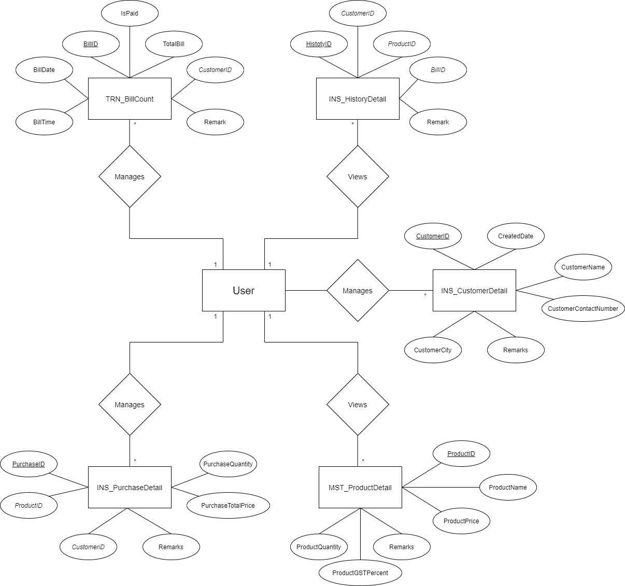

Fig. 5.1 E-R Diagram

**6. SCREEN SHOTS**

**6.1 DASHBOARD**

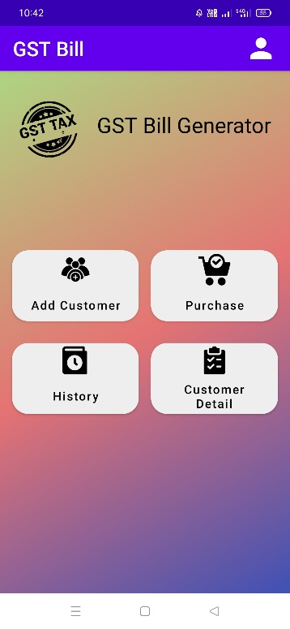

**Fig. 6.1 Dashboard**

* Dashboard of Application is displayed as above.
* User can add customer, purchase details etc. through dashboard.

**6.2 DEVELOPER**

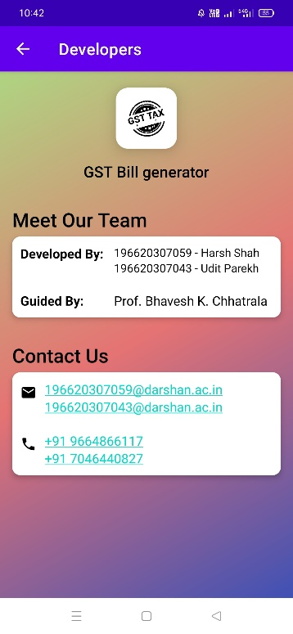

**Fig. 6.2 Developer**

* Details of developers are displayed as above in Application.

**6.3 ADD CUSTOMER**

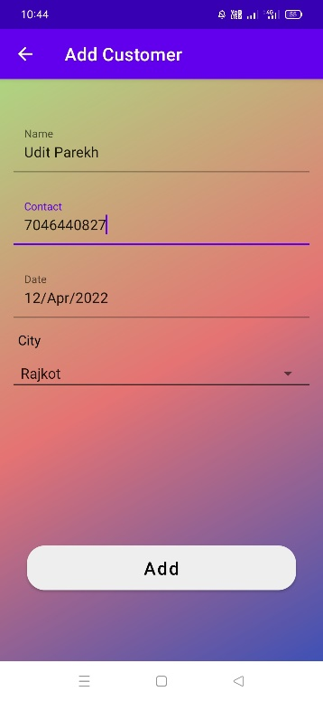

**Fig. 6.3 Add Customer**

* As above user can add customers.
* Here, user just needs to enter customer name, contact number and city name.

**6.4 CUSTOMER DETAILS**

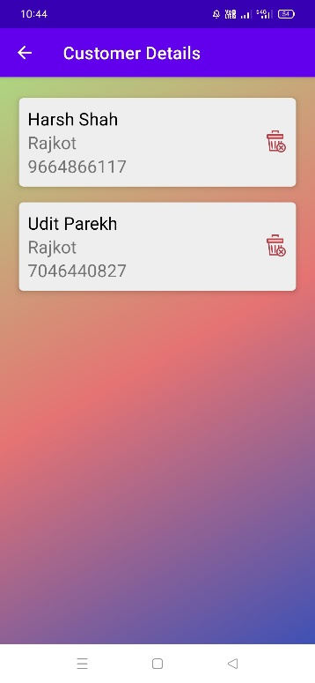

**Fig. 6.4 Customer Details**

* Customer details are displayed as above.
* Here, displayed details such as Customer name, city name and contact number.

**6.5 PURCHASE**

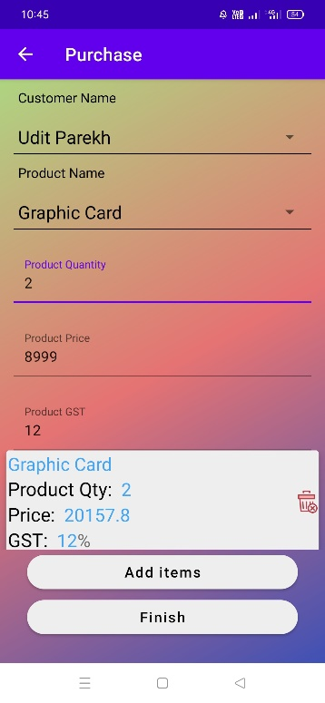

**Fig. 6.5 Purchase**

* User enters purchase details as above.
* Details are such as customer name, product name and quantity.
* Here, Product GST Percent and Product Price will generate automatically.
* User can add one or more than product here.

**6.6 DISPLAY BILL**

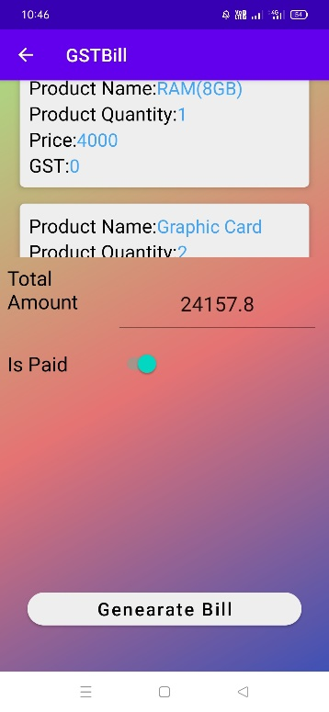

**Fig. 6.6 Display Bill**

* Purchased items are displayed as above.
* Total amount after calculating all price with GST displayed here.

**6.7 BILL GENERATE**

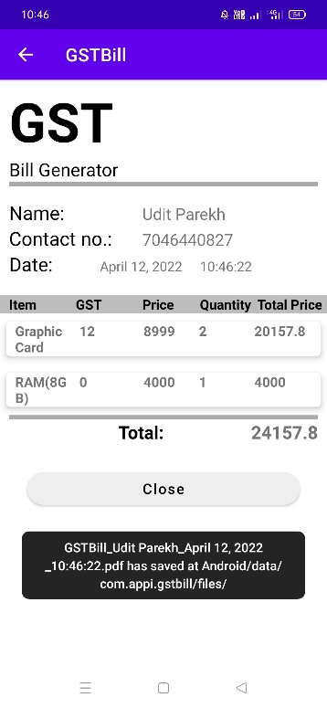

**Fig. 6.7 Bill Generate**

* Bill is displayed as above in Application.

**6.8 HISTORY**

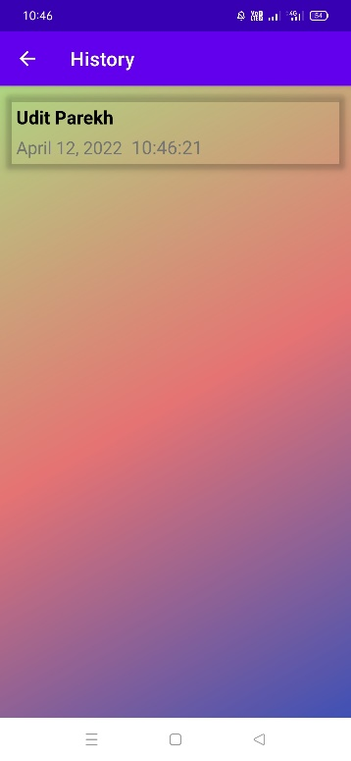

**Fig. 6.8 History**

* The customers list is displayed here as above.
* Here, are customers whose bill is generated.

**6.9 SAVED BILL AS PDF**

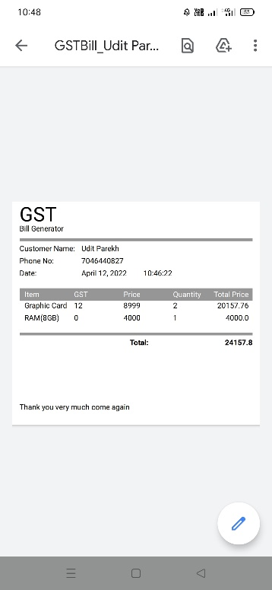

**Fig. 6.9 Saved bill as PDF format**

* Saved bill in PDF format is displayed as above.

**7. CONCLUSION**

Users will able to generate the bill easily by using “GST Bill Generator” Android Application. In application, we have to just add customer details first time, add list of products purchased by the customer and it will generate a bill quickly. This application has functionalities to save generated bill for future use, user can view previously purchased product details of the customer etc. So, it saves our precious time and environment.

**8. FUTURE ENHANCEMENT**

In future, we will add functionality to print bills using the application. In which users can connect their phone to the printer and print bills. We will also add functionality to share bills, user can add or remove default products, etc. Also, we would expand our application to other platforms i.e. iOS.