Experiment No.: 05
Hill Climbing Algorithm for Robot Path Optimization
Aim
To apply the Hill Climbing algorithm for finding an optimized path for a robot from a starting position to a goal position while avoiding obstacles.
Objectives
- To understand the concept of Hill Climbing.
- To calculate the Euclidean distance between the robot and goal.
- To select the best neighboring position iteratively.
- To avoid predefined obstacles.
- To visualize and analyze the obtained robot path.
Software Required : Python , Jupyter Notebook / Google Colab , Python Libraries:

Problem Statement
A mobile robot moves in a two-dimensional grid. The robot starts at (1,1) and has to reach the goal at (8,8).
The robot can move in 8 directions. Some grid positions are occupied by obstacles.
The Hill Climbing algorithm should:
- Check the neighboring positions.
- Ignore positions containing obstacles.
- Calculate the Euclidean distance from each valid position to the goal.
- Select the position having the lowest distance.
- Repeat until the robot reaches the goal or no better neighboring position is available.

Input Data
Start Position: (1,1)
Goal Position: (8,8)
Obstacles:
obstacles = {
(3,5), (4,5), (5,5),
(5,6), (6,6), (7,6),
(2,3), (2,4),
(3,3), (3,4)
}
Cost Function:
where is the goal position.

Theory
Hill Climbing
Hill Climbing is a local search optimization algorithm. It starts with a current solution and repeatedly moves to a neighboring solution that provides a better objective value.
For this experiment:
Lower Euclidean distance to the goal = better solution.
Local Minimum
If none of the neighboring positions has a lower cost than the current position, the robot cannot improve its solution. This condition is called a local minimum.
Obstacle Handling
A position containing an obstacle is considered an invalid position and is not selected by the robot.

Procedure
- Define the starting position and goal position.
- Define the obstacle positions.
- Define the possible robot movements.
- Define the Euclidean distance as the cost function.
- Start the robot from the initial position.
- Generate neighboring positions.
- Remove positions outside the grid.
- Remove positions occupied by obstacles.
- Calculate the cost of each valid neighboring position.
- Select the neighboring position with the lowest cost.
- Move the robot to the selected position.
- Repeat the process until the goal is reached or a local minimum is encountered.
- Plot the robot path and obstacles.
- Analyze the obtained path.
This follows the same Aim → Objectives → Software → Dataset/Input → Theory → Procedure → Observations → Results organization used in your existing manual.

Observations
Robot Path Details
Parameter | Value
Start Position | 1,1
Goal Position | 8,8
Number of Obstacles | 10
Number of Steps | 9
Final Position | 8,8
Goal Reached? | Yes
Iteration-wise Observation
Step | Current Position | Selected Position | Cost | Obstacle Avoided
1 | (1, 1) | (2, 2) | 8.485 | No obstacle encountered
2 | (2, 2) | (3, 2) | 7.81 | Avoided nearby obstacles
3 | (3, 2) | (4, 3) | 6.403 | Avoided obstacle region
4 | (4, 3) | (5, 4) | 5.0 | No obstacle encountered
5 | (5, 4) | (6, 5) | 3.606 | Avoided obstacle region near (5,5)
6 | (6, 5) | (7, 5) | 3.162 | No obstacle encountered
7 | (7, 5) | (8, 6) | 2.0 | Avoided obstacles near (7,6)
8 | (8, 6) | (8, 7) | 1.0 | No obstacle encountered
9 | (8, 7) | (8, 8) | 0.0 | Goal reached

Interpretation
Analyze:
- Whether the robot reached the goal.
The robot successfully reached the goal position (8,8) from the starting position (1,1).
- How the cost changed during each iteration.
The Euclidean distance cost decreased continuously from 8.485 to 0.0, indicating that the robot moved closer to the goal at every step.
- How obstacles affected the path.
The obstacles prevented movement through blocked cells, so the robot selected alternative valid paths while avoiding all obstacles.
- Whether the robot encountered a local minimum.
The robot did not encounter any local minimum because a better neighboring position with lower cost was available in each iteration.
- Whether the obtained path is efficient.
The obtained path was efficient as the robot reached the goal in 9 steps while avoiding obstacles using the Hill Climbing algorithm.

Results
Code :-
import math
import matplotlib.pyplot as plt

grid_size = 8

start = (1, 1)
goal = (8, 8)

obstacles = {
(3,5), (4,5), (5,5),
(5,6), (6,6), (7,6),
(2,3), (2,4),
(3,3), (3,4)
}

def cost(position):
x1, y1 = position
x2, y2 = goal

return math.sqrt(
(x2-x1)**2 +
(y2-y1)**2
)

moves = [
(-1,0),
(1,0),
(0,-1),
(0,1),
(-1,-1),
(-1,1),
(1,-1),
(1,1)
]

def get_neighbors(position):

neighbours = []

x,y = position

for dx,dy in moves:

nx = x + dx
ny = y + dy

if nx < 1 or nx > grid_size:
continue

if ny < 1 or ny > grid_size:
continue

new_position = (nx,ny)

if new_position in obstacles:
continue

neighbours.append(new_position)

return neighbours

def hill_climbing():

current = start

path = [current]

observations = []

step = 1

while current != goal:

neighbours = get_neighbors(current)

if len(neighbours)==0:
print("No valid moves")
break

next_position = min(
neighbours,
key=cost
)

current_cost = cost(current)

next_cost = cost(next_position)

if next_cost >= current_cost:

print("Local minimum reached")

break

observations.append(
[
step,
current,
next_position,
round(next_cost,3)
]
)

current = next_position

path.append(current)

step += 1

return path, observations

path, observations = hill_climbing()

print("\nRobot Path")

for p in path:
print(p)

print("\nIteration Details")

print(
"Step\tCurrent\t\tSelected\tCost"
)

for row in observations:

print(
row[0],
"\t",
row[1],
"\t",
row[2],
"\t",
row[3]
)

print("\nFinal Position:", path[-1])

print(
"Goal Reached:",
path[-1]==goal
)

print(
"Number of Steps:",
len(path)-1
)

plt.figure(figsize=(7,7))

for i in range(1,9):

plt.axhline(i-0.5,color='gray')
plt.axvline(i-0.5,color='gray')

for obs in obstacles:

plt.scatter(
obs[0],
obs[1],
marker="s",
s=500
)

px = [p[0] for p in path]
py = [p[1] for p in path]

plt.plot(
px,
py,
marker="o",
linewidth=2
)

plt.scatter(
start[0],
start[1],
s=300,
marker="o"
)

plt.scatter(
goal[0],
goal[1],
s=300,
marker="*"
)

plt.xlim(0.5,8.5)
plt.ylim(0.5,8.5)

plt.xlabel("X")
plt.ylabel("Y")

plt.title(
"Robot Path using Hill Climbing Algorithm"
)

plt.grid()

plt.show()

Output:-
Robot Path
(1, 1)
(2, 2)
(3, 2)
(4, 3)
(5, 4)
(6, 5)
(7, 5)
(8, 6)
(8, 7)
(8, 8)

Iteration Details
Step Current Selected Cost
1 (1, 1) (2, 2) 8.485
2 (2, 2) (3, 2) 7.81
3 (3, 2) (4, 3) 6.403
4 (4, 3) (5, 4) 5.0
5 (5, 4) (6, 5) 3.606
6 (6, 5) (7, 5) 3.162
7 (7, 5) (8, 6) 2.0
8 (8, 6) (8, 7) 1.0
9 (8, 7) (8, 8) 0.0

Final Position: (8, 8)
Goal Reached: True
Number of Steps: 9
Robot Path Plot
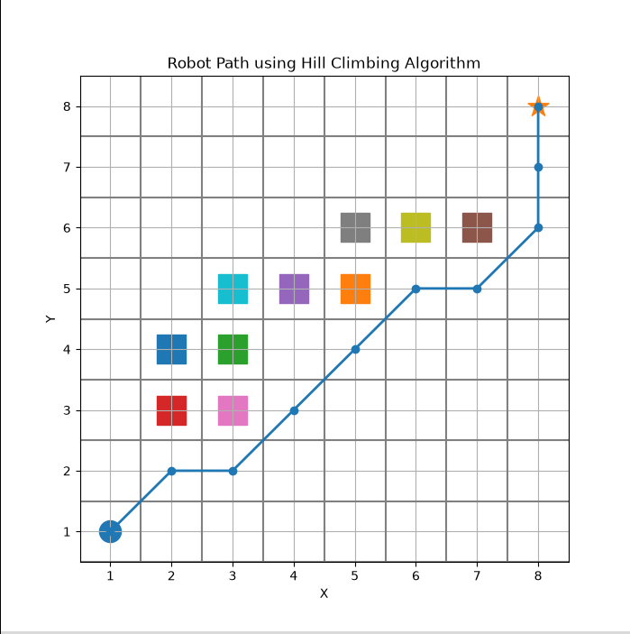

Result Statement
--------

