

II IntroInd Case study

Experiment No.: 01

Title: Introduction to Computer Vision: Case Study

Batch: A2 Roll No.: 16014324028 Experiment No.: 0 1

Aim: Introduction to Computer Vision and Image Processing using OpenCV and Case study

Resources needed:
Python 3.x
- OpenCV Library
- NumPy Library
- Visual Studio Code / Jupyter Notebook

Pre Requisite: Understanding of Computer Vision

Theory: Computer Vision (CV)
Computer Vision is a branch of Artificial Intelligence that enables computers to capture, process, and understand visual information from images and videos. It uses image processing techniques to extract useful features such as objects, shapes, and patterns. Computer Vision is widely used in applications like robotics, autonomous vehicles, medical imaging, and surveillance systems. OpenCV is an open-source library used for implementing Computer Vision and image processing applications.

Grayscale Image
A grayscale image contains only intensity information without color. Each pixel represents brightness values ranging from 0 (black) to 255 (white). Converting an image to grayscale reduces complexity while preserving important details like edges and shapes. It is commonly used for image processing tasks such as edge detection and object recognition.

HSV Color Space
HSV (Hue, Saturation, Value) is a color model that represents images based on human color perception. Hue represents the color, Saturation represents color intensity, and Value represents brightness. HSV is useful in Computer Vision applications because it allows easier color-based object detection and image segmentation compared to traditional RGB color space.



Procedure:

1. Environment &amp; Image Setup: Initialize the required Python environment, import necessary
libraries (cv2, numpy, matplotlib, os), and read the aerial top-view agricultural field image
(img_p106.png) using cv2.imread().
2. Color Space Transformations:
* Convert the default OpenCV BGR image matrix to RGB using cv2.cvtColor(img_bgr,
cv2.COLOR_BGR2RGB) for display compatibility with Matplotlib.
* Convert the BGR image to grayscale using cv2.COLOR_BGR2GRAY to evaluate single-
channel intensity values
3. Channel Splitting &amp; Merging: Separate the original image into individual Blue (B), Green
(G), and Red (R) channels using cv2.split(). Isolate specific channels by zeroing out unused
planes using np.zeros_like() and recombine them with cv2.merge().
4. Region of Interest (ROI) Slicing: Determine central image coordinates and extract a
100x100 pixel Region of Interest (ROI) patch using standard 2D NumPy array slicing.
5. Heatmap &amp; Feature Extraction:
* Apply a standard visual colormap (cv2.COLORMAP_JET) on the grayscale image to
produce a continuous intensity heatmap.
* Divide the image into an 8x10 tile grid and compute the average Excess Green Index (ExG =
2G - R - B) per tile to map relative vegetation vigor across the field.
6. Output Generation: Save processed output matrices and annotated artifacts to disk using
cv2.imwrite().

Results: (Steps with screenshots)

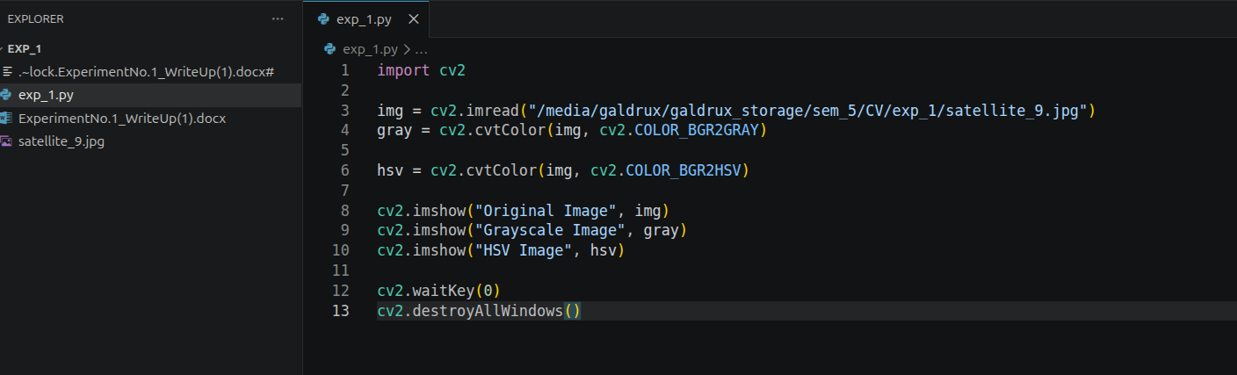

Outcomes:
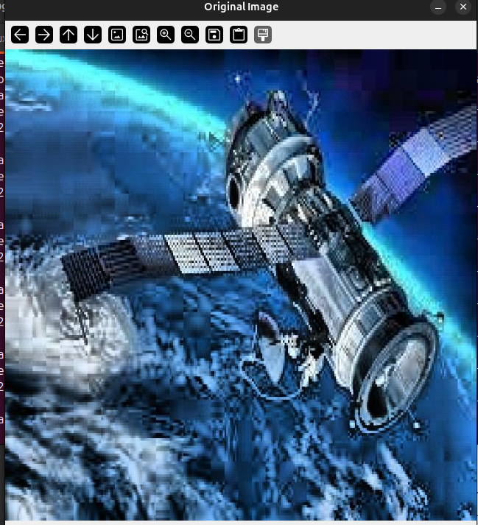
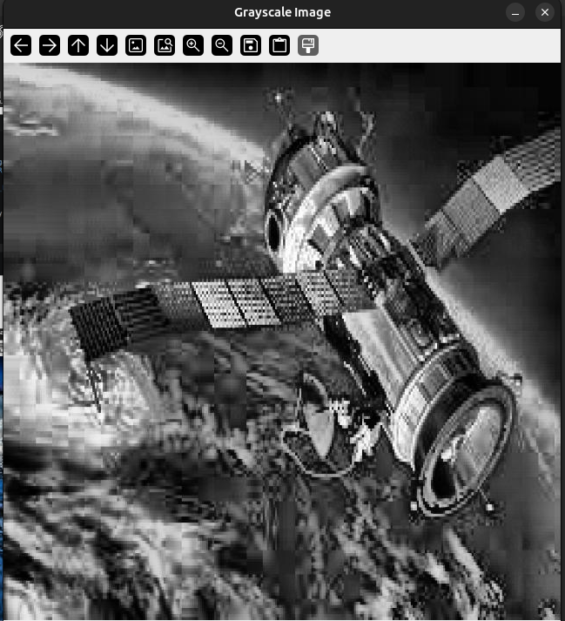

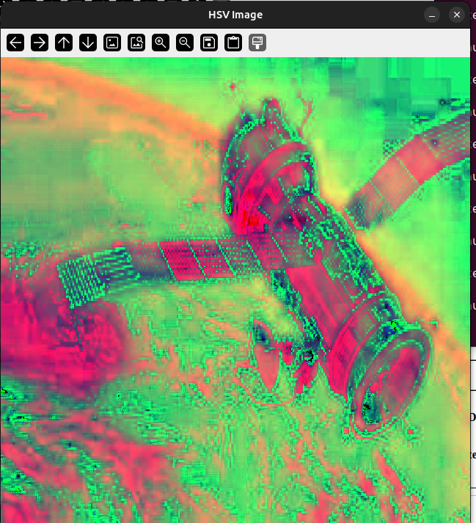

Conclusion: (Conclusion to be based on the objectives and outcomes achieved)

Grade: AA / AB / BB / BC / CC / CD /DD

Signature of faculty in-charge with date

References:
Websites:

