

Experiment No.: 02
Title: Image Acquisition Image Properties & Color Spaces, image filteration

Batch: Roll No.: 16014324028 Experiment No.: 0 2

Aim: To perform Understand how to read, display, and save images also explore image dimensions, channels, and conversion between BGR, RGB, and Grayscale, Filtration algorithm.

Resources needed: Python 3.x ,OpenCV (pip install opencv-python)

Pre Requisite: Students should have prior knowledge of basic concept of Computer Vision, Data sets required and the image processing algorithms

Theory: Image processing and filteration algorithms



Procedure:
- Acquire image
- Load a color image.
- Convert RGB to Gray
- Apply Filtration algorithm
- Display it.

Results: (Code with result Snapshot)

Questions:
1.What is image acquisition in computer vision, and why is it the first step in an image processing pipeline?
Image acquisition is the process of capturing an image using a camera or sensor and converting it into a digital format. It is the first step because all further image processing and analysis depend on the quality of the acquired image.
2.Name two different sources/devices commonly used for image acquisition.
Two common image acquisition devices are:
- Digital cameras
- Webcams
Other sources include mobile cameras, satellite sensors, and medical imaging devices.

3. How does the resolution of a camera affect the quality of image processing?
Higher camera resolution provides more pixels, resulting in better image details and accuracy. Low-resolution images may lose important features and reduce the performance of image processing algorithms.
4.What is the difference between capturing an image using OpenCV vs. loading an existing image file?
(Mention functions like cv2.imread() vs cv2.VideoCapture())
cv2.imread() is used to load an already stored image file from the system.
cv2.VideoCapture() is used to capture real-time images or video frames from a camera or video source.

5.What file formats are typically used for storing images? How do they differ (e.g., JPEG vs PNG)?
Common image formats include JPEG, PNG, BMP, and TIFF.
- JPEG: Uses lossy compression, reduces file size but loses some image quality.
- PNG: Uses lossless compression, maintains image quality and supports transparency.

6. Experimental Analysis
a) In the lab, you applied a Gaussian filter with different kernel sizes. Describe the observed changes in image sharpness and noise removal.
Increasing the Gaussian filter kernel size increases smoothing and removes more noise. However, larger kernels reduce image sharpness and may blur important details.
b) Compare the performance of the Gaussian filter and Median filter for removing salt-and-pepper noise. Which was more effective, and why?
The Median filter is more effective for removing salt-and-pepper noise because it replaces noisy pixels using the median value of neighboring pixels while preserving edges. Gaussian filtering smooths the image but may blur edges and is less effective for impulse noise.

Outcomes:
code:-
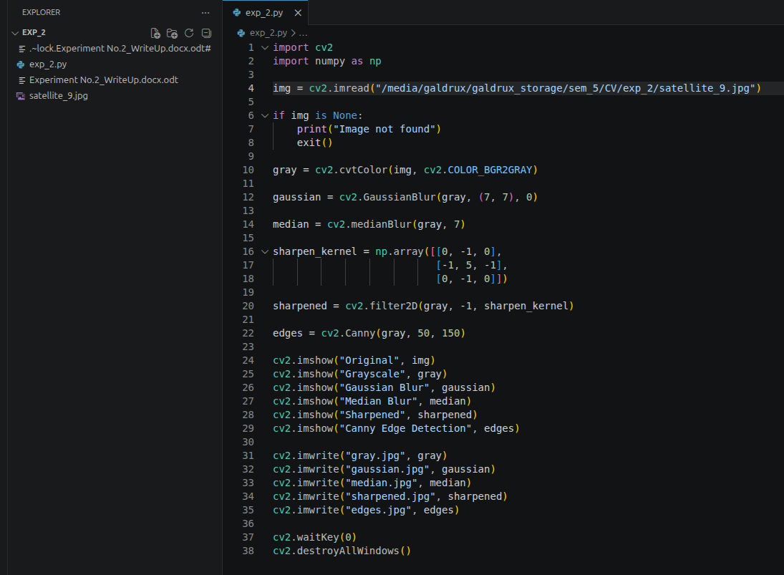
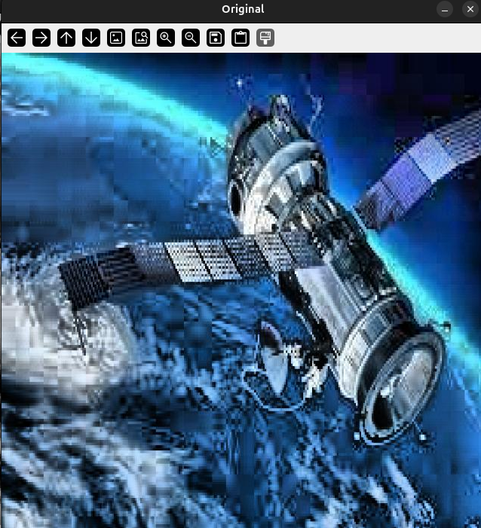
output:-

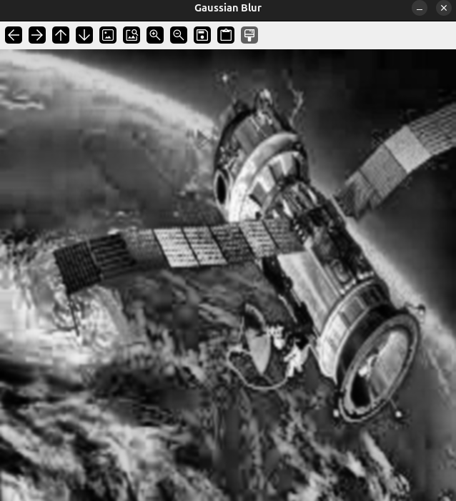

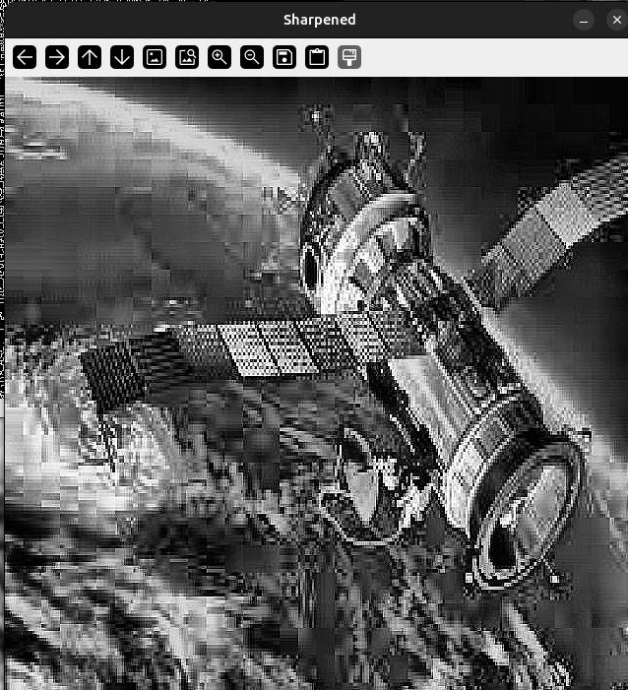

Conclusion: (Conclusion to be based on the objectives and outcomes achieved)

In this experiment, image acquisition and basic image processing techniques were successfully implemented using OpenCV. Different filtering techniques such as Gaussian filter, Median filter, sharpening, and edge detection were studied and applied. The effect of filters on noise removal, image smoothing, and feature enhancement was observed, providing an understanding of their importance in Computer Vision applications

Grade: AA / AB / BB / BC / CC / CD /DD

Signature of faculty in-charge with date

References:
Websites:

