SOFTWARE ENGINEERING
PROJECT REPORT
DISASTER RELIEF & RESCUE
COORDINATION PLATFORM
Comprehensive Consolidated Report
Experiments 1–8
Prepared By
Harsh Shinde
UID: 2024300241
Class: TE-D
Department of Computer Engineering
Bharatiya Vidya Bhavan’s
Sardar Patel Institute of Technology
Munshi Nagar, Andheri (West), Mumbai

Report Structure & Scope
This version is a detailed consolidation of the Disaster Relief & Rescue Coordination Platform work developed for the project. It is structured so that a faculty member can understand the problem, requirements, system design, complete operational workflow, diagrams, planning and risk management without needing the earlier individual submissions.

Source and consistency note
The report preserves the terminology and project scope established in the project study: Citizen/Disaster Victim, Volunteer, Rescue Team, Shelter Manager, Administrator/Disaster Management Authority and NGO/Relief Organization; and the core modules for emergency requests, rescue coordination, volunteers, shelters, relief inventory, resource allocation, notifications and reporting. The eight experiment sections follow the consolidated project workflow already prepared. Where an original individual lab submission was not available as a source, no unsupported numerical experimental result is claimed.

Table of Contents
1. Project Overview and Problem Definition
2. Experiment 1 — Project Identification, Scope and Objectives
3. Experiment 2 — Requirements Engineering and System Specification
4. Experiment 3 — Use Case Modeling
5. Experiment 4 — Class Diagram and Static System Design
6. Experiment 5 — Sequence and Communication Modeling
7. Experiment 6 — Activity Diagram and Data Flow Diagram
8. Experiment 7 — WBS, Scheduling and Project Execution Plan
9. Experiment 8 — RMMM Risk Management
10. End-to-End Working of the Complete System
11. Database / Entity Model
12. System Architecture
13. Testing Strategy and Traceability
14. Final Integration and Conclusion

1. Project Overview and Problem Definition

1.1 Project Background
Disasters create rapidly changing situations in which affected citizens, rescue agencies, volunteers, shelters, NGOs and authorities must coordinate under time pressure. The project addresses the information-coordination problem by providing one centralized platform through which emergency requests can be reported, verified, prioritized, assigned and tracked, while connected shelter and relief-resource operations are maintained in the same system.

1.2 Problem Statement
Information during a disaster can be scattered across phone calls, messaging groups, field reports and independent organizational systems. As a result, authorities may not have a unified view of active incidents, rescue teams may be assigned without current availability information, volunteers may not receive structured tasks, shelter capacity may become outdated, and relief material may be distributed inefficiently.

1.3 Proposed Solution
The proposed platform acts as a centralized coordination layer. It connects emergency reporting with verification, priority management, rescue assignment, volunteer support, shelter management, inventory/resource allocation and notifications. The central operational question is: who needs help, where are they, what help is required, how urgent is it, who can respond, and what resources are available?

1.4 Project Objectives
- Reduce the time between an emergency request and response.
- Provide a common platform for citizens, response teams and relief stakeholders.
- Capture emergency type, description, location, people affected and severity.
- Support verification, prioritization and rescue-team assignment.
- Coordinate volunteers based on skills, availability and location.
- Maintain shelter capacity, occupancy and essential facilities.
- Track relief materials, resource requests and allocations.
- Provide status visibility, alerts, dashboards, reports and historical records.

1.5 Stakeholders and Roles
Actor | Primary responsibility | Key interactions
Citizen / Disaster Victim | Report and track emergencies | Submit request, track status, cancel, find shelters, receive alerts
Volunteer | Provide authorized support | Register skills, accept/decline tasks, update task status
Rescue Team | Perform professional rescue operations | View assignment, acknowledge, update mission, submit report
Shelter Manager | Operate shelter information | Register shelter, capacity/facilities/status, raise resource requests
NGO / Relief Organization | Provide relief materials | Register inventory, coordinate supplies and allocations
Administrator / Authority | Coordinate and control operations | Verify, prioritize, assign, manage resources, publish alerts, view dashboard

2. Experiment 1 — Project Identification, Scope and Objectives

2.1 Aim
To identify a real-world software problem, define the proposed Disaster Relief & Rescue Coordination Platform, establish its stakeholders and boundaries, and convert the problem into a clear software project scope.

2.2 Scope of the System
The core academic scope includes role-based authentication, emergency request creation and tracking, administrative verification and priority management, rescue-team registration/assignment, volunteer task management, shelter capacity management, relief inventory and resource allocation, notifications, map/location display and reporting.

2.3 Core Modules
Module | Purpose | Main users
User & Role Management | Authentication, roles, authorization | All users / Administrator
Emergency Request Management | Capture, validate, verify, prioritize and track incidents | Citizen / Administrator
Rescue Coordination | Assign teams, track mission and record outcomes | Administrator / Rescue Team
Volunteer Management | Match and track support tasks | Volunteer / Administrator
Shelter Management | Maintain shelter capacity and facilities | Shelter Manager / Administrator
Resource & Inventory | Track relief stock, requests and allocations | NGO / Shelter / Administrator
Notification & Reporting | Alerts, status updates and dashboards | All / Administrator

2.4 Project Boundary
The project is an academic prototype/MVP. Large national-scale infrastructure, continuous GPS tracking of every responder, autonomous AI dispatch, drone/satellite/IoT integration, telecom-grade emergency messaging and high-risk identity systems remain future enhancements rather than mandatory first-version functionality.

2.5 Expected Outcome
The outcome is a traceable end-to-end coordination workflow in which a request can move from submission through verification, priority assignment, rescue dispatch, mission updates, rescue reporting and resolution, with connected shelter/resource follow-up when required.

3. Experiment 2 — Requirements Engineering and System Specification

3.1 Aim
To identify functional and non-functional requirements and define how the system should behave for each stakeholder.

3.2 Functional Requirements
- FR-01: Users shall be able to register and authenticate.
- FR-02: The platform shall enforce role-based access control.
- FR-03: Citizens shall be able to submit emergency requests.
- FR-04: Emergency requests shall store type, description, location, affected people, severity/priority and timestamps.
- FR-05: Administrators shall verify, classify and prioritize requests.
- FR-06: Administrators shall assign appropriate available rescue teams.
- FR-07: Rescue teams shall acknowledge assignments and update mission status.
- FR-08: Rescue outcomes shall be recorded through rescue reports.
- FR-09: Volunteers shall maintain skills and availability and receive suitable tasks.
- FR-10: Shelter managers shall maintain shelter capacity, occupancy and facilities.
- FR-11: Shelters/authorized users shall raise resource requirements.
- FR-12: The platform shall maintain relief-material inventory.
- FR-13: Authorized users/organizations shall record resource allocations.
- FR-14: Citizens shall track emergency-request status.
- FR-15: The platform shall generate relevant operational notifications.
- FR-16: Administrators shall view dashboards and reports.
- FR-17: Important operations shall retain timestamps/history.
- FR-18: Invalid, duplicate or cancelled requests shall be handled appropriately.

3.3 Non-Functional Requirements
Requirement | How it applies to DRRCP
Performance | Emergency submission, dashboard reads and common operations should respond quickly under expected load.
Availability | The platform should minimize downtime during active disaster operations.
Reliability | Confirmed emergency and operational records should not be silently lost.
Scalability | The architecture should tolerate sudden increases in requests and users.
Security | Authentication, authorization, secure credential storage and input validation are required.
Privacy | Victim contact/location information should only be exposed where operationally necessary.
Usability | Emergency reporting should use clear language and minimal steps.
Maintainability | Modules should have clear interfaces and separation of responsibilities.
Auditability | Sensitive assignments, status changes and allocations should be traceable.

3.4 Requirement-to-Module Traceability
Requirement group | Primary module | Supporting module
Authentication / roles | User & Role Management | Notification / Audit
Emergency reporting | Emergency Request Management | Notification
Priority / assignment | Rescue Coordination | Emergency Request
Rescue outcome | Rescue Coordination | Reporting
Volunteer tasks | Volunteer Management | Notification
Shelter capacity | Shelter Management | Resource Management
Relief stock | Resource & Inventory | Shelter / NGO
Alerts / dashboard | Notification & Reporting | All operational modules

4. Experiment 3 — Use Case Modeling

4.1 Aim
To model the functional interactions between system actors and the Disaster Relief & Rescue Coordination Platform.
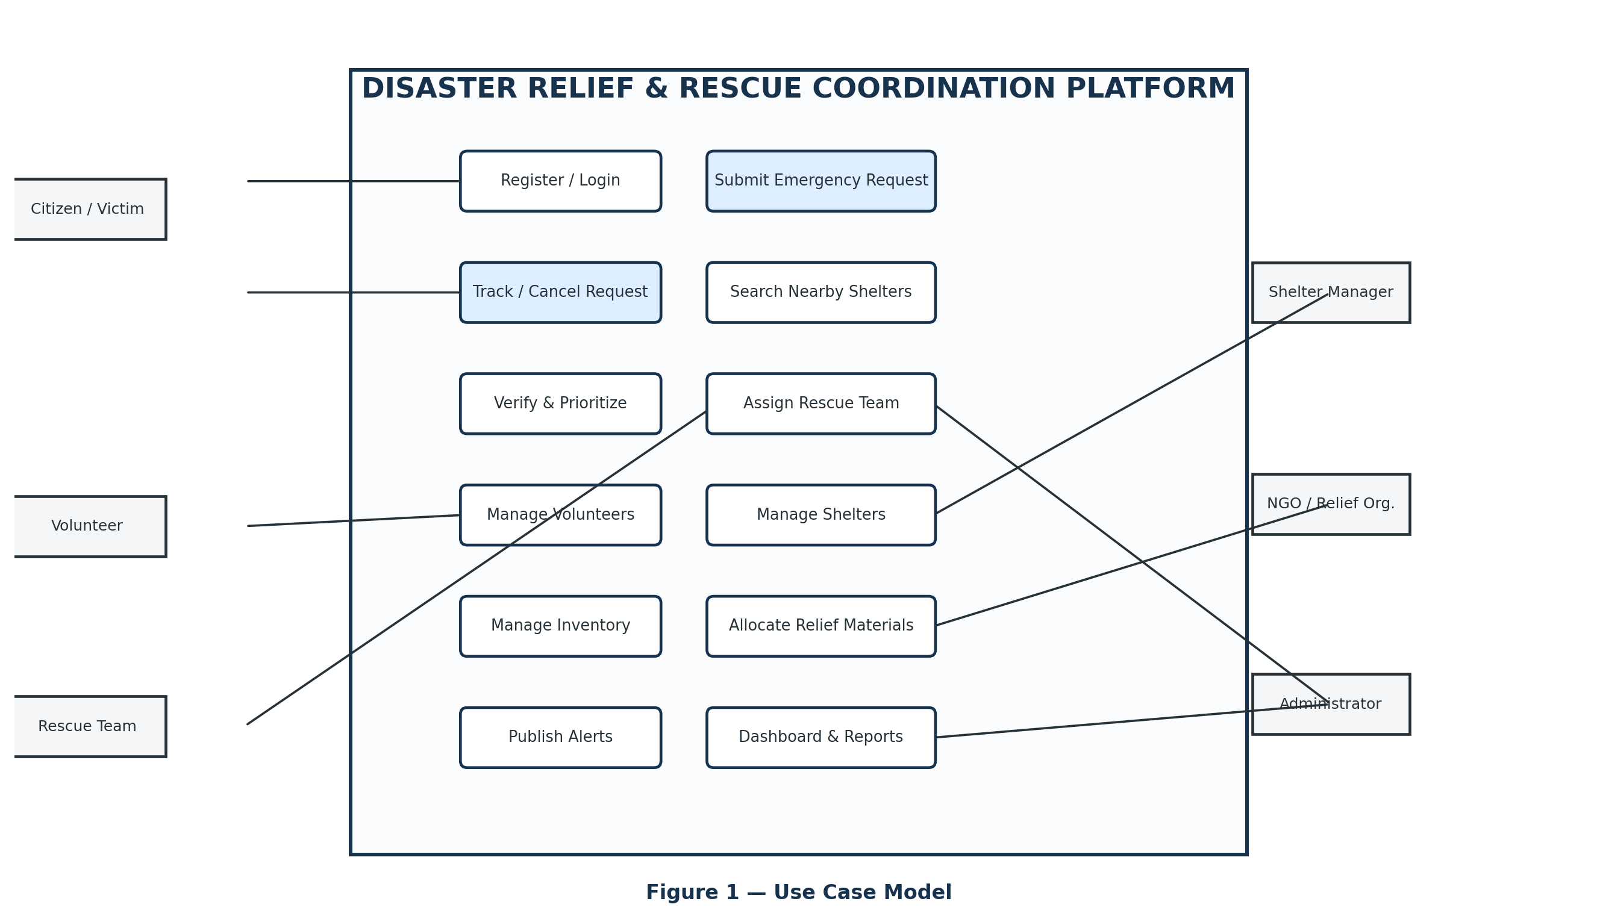
Figure 1 — Clean Use Case Diagram

4.2 Actor Responsibilities
Actor | Use cases represented
Citizen | Register/Login; Submit Emergency Request; Track/Cancel Request; Search Nearby Shelters
Volunteer | Register; Accept/Decline Task; Update Task Status
Rescue Team | View Assigned Incidents; Update Mission Status; Submit Rescue Report
Shelter Manager | Register Shelter; Update Capacity/Facilities/Status; Raise Resource Request
NGO / Relief Organization | Register Inventory; Provide/Allocate Relief Materials
Administrator | Verify Requests; Set Priority; Assign Teams; Manage Volunteers/Shelters/Inventory; Publish Alerts; Dashboard; User Management

4.3 Detailed Use Case — Submit Emergency Request
- Citizen logs into the platform.
- Citizen chooses Submit Emergency Request.
- Citizen enters emergency type, description, location, number of affected people and injury/severity information.
- The system validates mandatory information.
- The citizen confirms the request.
- The platform creates a unique request record and timestamp.
- The request is associated with the active disaster event when applicable.
- The citizen receives confirmation and can track the request status.

4.4 Detailed Use Case — Verify, Prioritize and Assign
- Administrator opens the pending request queue.
- The request details and location are reviewed.
- The administrator verifies the request and checks for invalid/duplicate reports.
- Priority is set or confirmed based on urgency and impact.
- Available rescue teams are reviewed.
- An appropriate team is selected and a RescueAssignment record is created.
- The team receives the incident details and the request/assignment status is updated.
- The citizen is notified of the operational update.

5. Experiment 4 — Class Diagram and Static System Design

5.1 Aim
To model the static structure of the system through classes, attributes, operations and relationships.
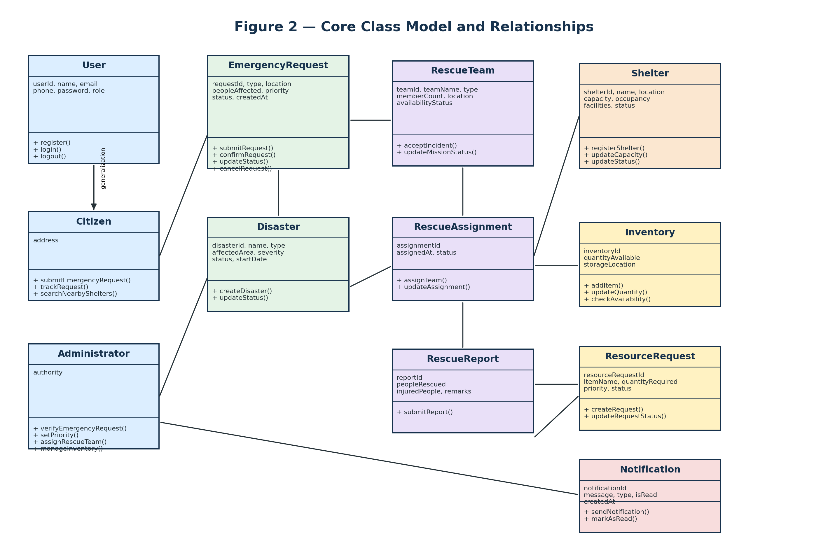
Figure 2 — Clean Class Diagram

5.2 Class Organization
Class group | Classes | Purpose
User hierarchy | User, Citizen, Volunteer, ShelterManager, Administrator, NGO | Common identity plus role-specific responsibilities
Emergency domain | Disaster, EmergencyRequest | Represents disaster events and requests for assistance
Rescue domain | RescueTeam, RescueAssignment, RescueReport | Controls team assignment, mission progress and outcomes
Shelter domain | Shelter, ResourceRequest | Maintains accommodation capacity and resource requirements
Resource domain | ReliefItem, Inventory, ResourceAllocation | Tracks materials, stock and distribution
Communication | Notification | Delivers operational and public updates

5.3 Important Relationships
Relationship | Meaning
User → Citizen/Volunteer/ShelterManager/Administrator/NGO | Inheritance/generalization: role-specific users share common User properties.
Citizen → EmergencyRequest | A citizen can submit multiple emergency requests.
Disaster → EmergencyRequest | A disaster can contain multiple requests.
EmergencyRequest → RescueAssignment | A request can have assignment history.
RescueTeam → RescueAssignment | A team can receive multiple assignments over time.
RescueAssignment → RescueReport | A completed assignment may produce a rescue report.
Shelter → ResourceRequest | A shelter can raise multiple resource requests.
Inventory → ResourceAllocation | Available stock can supply allocations.
User → Notification | Users receive multiple notifications.

5.4 Why this structure matters
The separation between EmergencyRequest, RescueAssignment and RescueReport prevents the request itself from becoming overloaded with operational history. Similarly, separating Shelter, ResourceRequest and Inventory allows the system to represent a shelter need independently from the stock that may later satisfy it.

6. Experiment 5 — Sequence and Communication Modeling

6.1 Aim
To model how objects communicate in time while processing a complete emergency request.
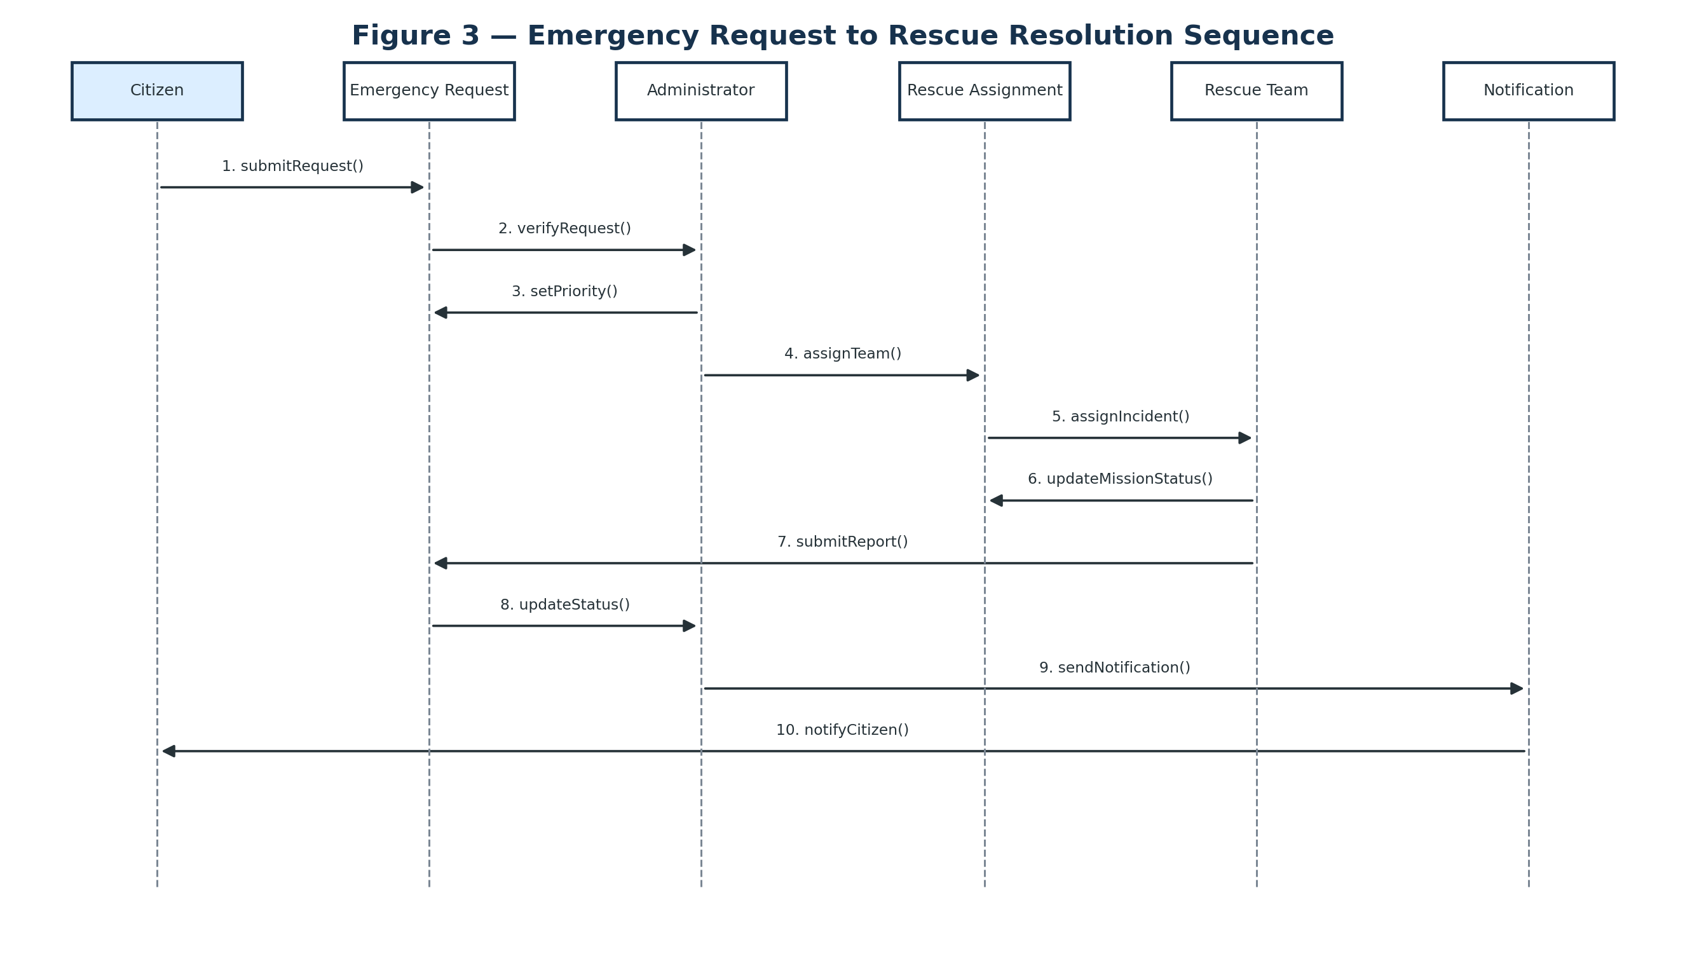
Figure 3 — Clean Sequence Diagram

6.2 Sequence Explanation
Step | Sender → Receiver | Message | Purpose
1 | Citizen → EmergencyRequest | submitRequest() | Create the emergency request.
2 | EmergencyRequest → Administrator | verifyRequest() | Send request for operational verification.
3 | Administrator → EmergencyRequest | setPriority() | Record the operational priority.
4 | Administrator → RescueAssignment | assignTeam() | Create an assignment for a selected team.
5 | RescueAssignment → RescueTeam | assignIncident() | Deliver incident details to the team.
6 | RescueTeam → RescueAssignment | updateMissionStatus() | Update operational progress.
7 | RescueTeam → RescueReport | submitReport() | Record rescue outcome.
8 | RescueReport → EmergencyRequest | updateStatus() | Move the request toward resolution.
9 | EmergencyRequest → Notification | sendNotification() | Create an operational status notification.
10 | Notification → Citizen | notifyCitizen() | Inform the citizen of the outcome/status.

6.3 Communication Diagram
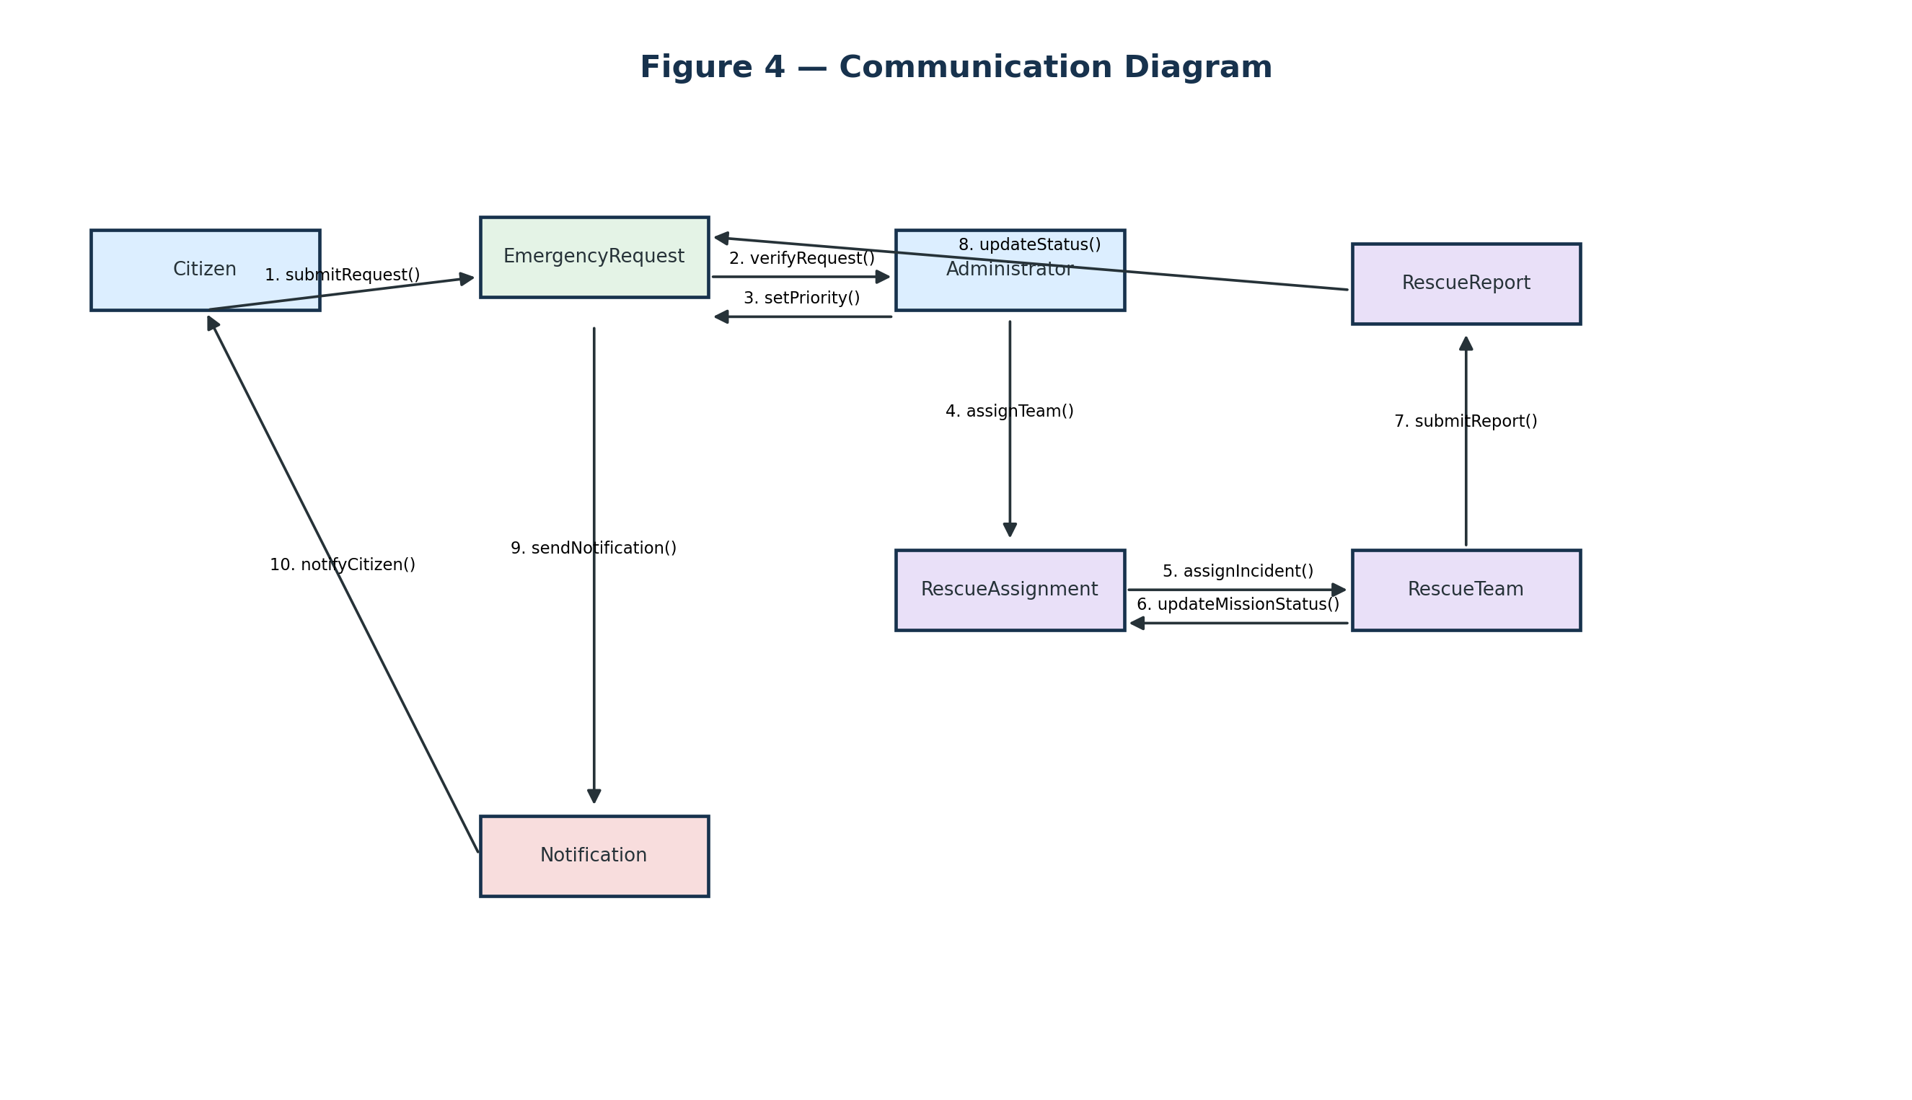
Figure 4 — Clean Communication Diagram
Unlike the sequence diagram, the communication diagram emphasizes the links between objects and uses numbered messages to show the interaction order.

7. Experiment 6 — Activity Diagram and Data Flow Diagram

7.1 Activity Diagram
The activity model represents the complete operational workflow, including validation failures, rejected requests, unavailable rescue teams and unsuccessful rescue attempts.
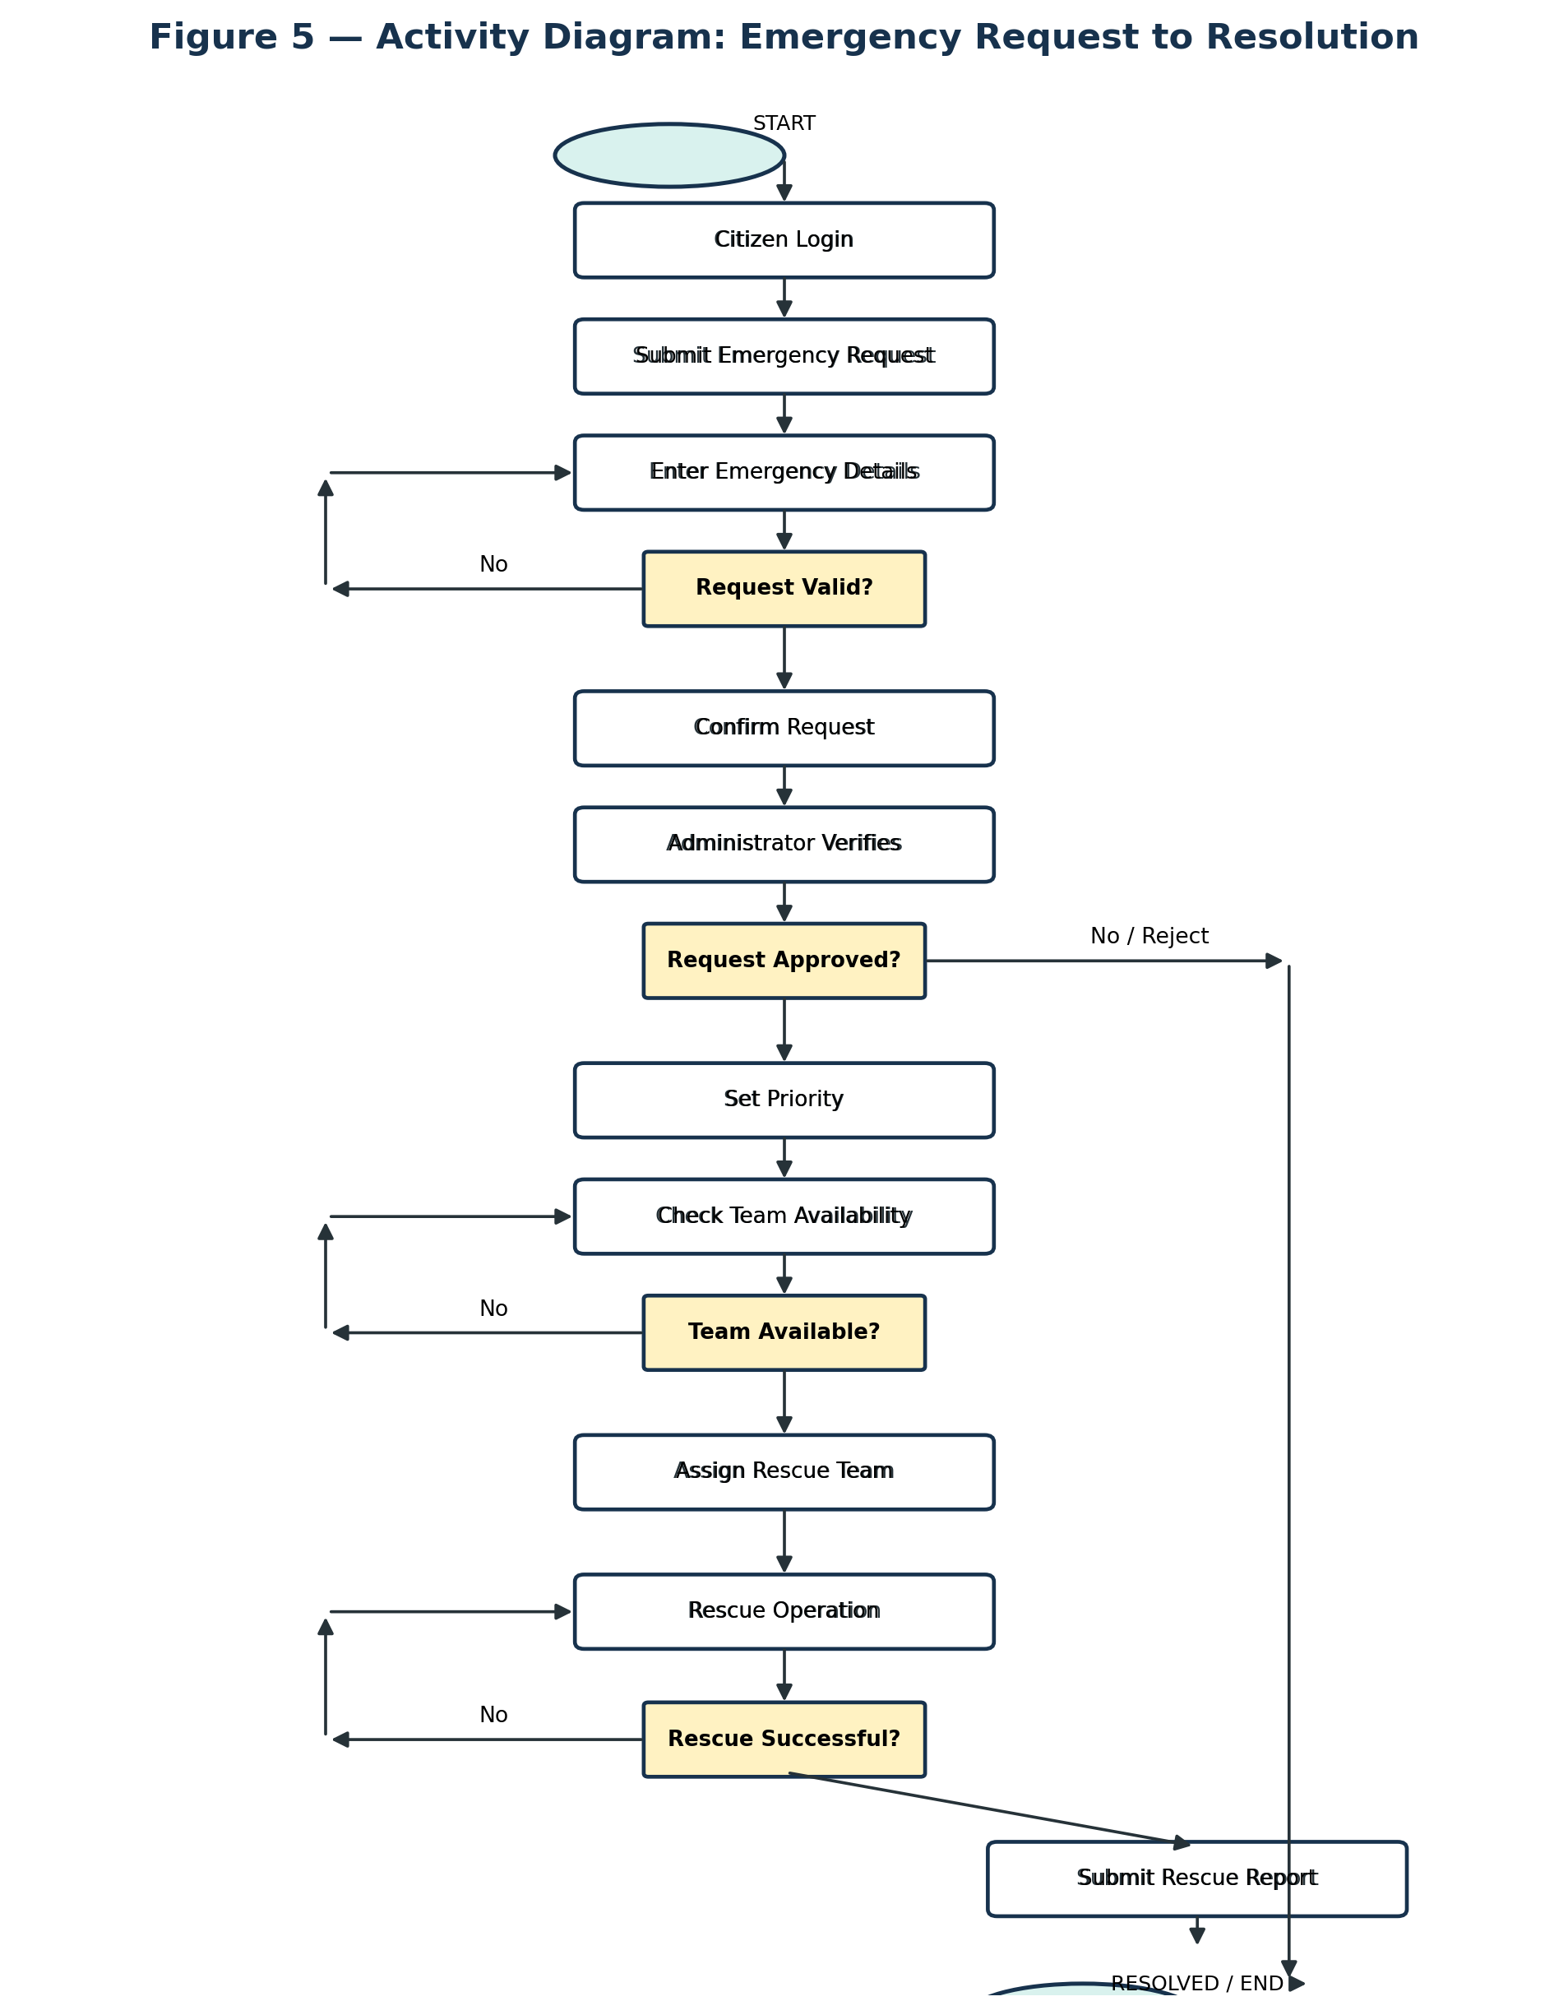
Figure 5 — Clean Activity Diagram

7.2 Decision Logic
Decision | Yes path | No / exception path
Request Valid? | Confirm and create request | Show validation error and re-enter details
Request Approved? | Set priority and continue | Reject and notify citizen
Team Available? | Create assignment | Wait / search for another available team
Rescue Successful? | Submit report and resolve | Request additional support and continue operation

7.3 DFD Level 1
A Data Flow Diagram describes data movement rather than object messages. The main processes transform incoming information and interact with persistent data stores.
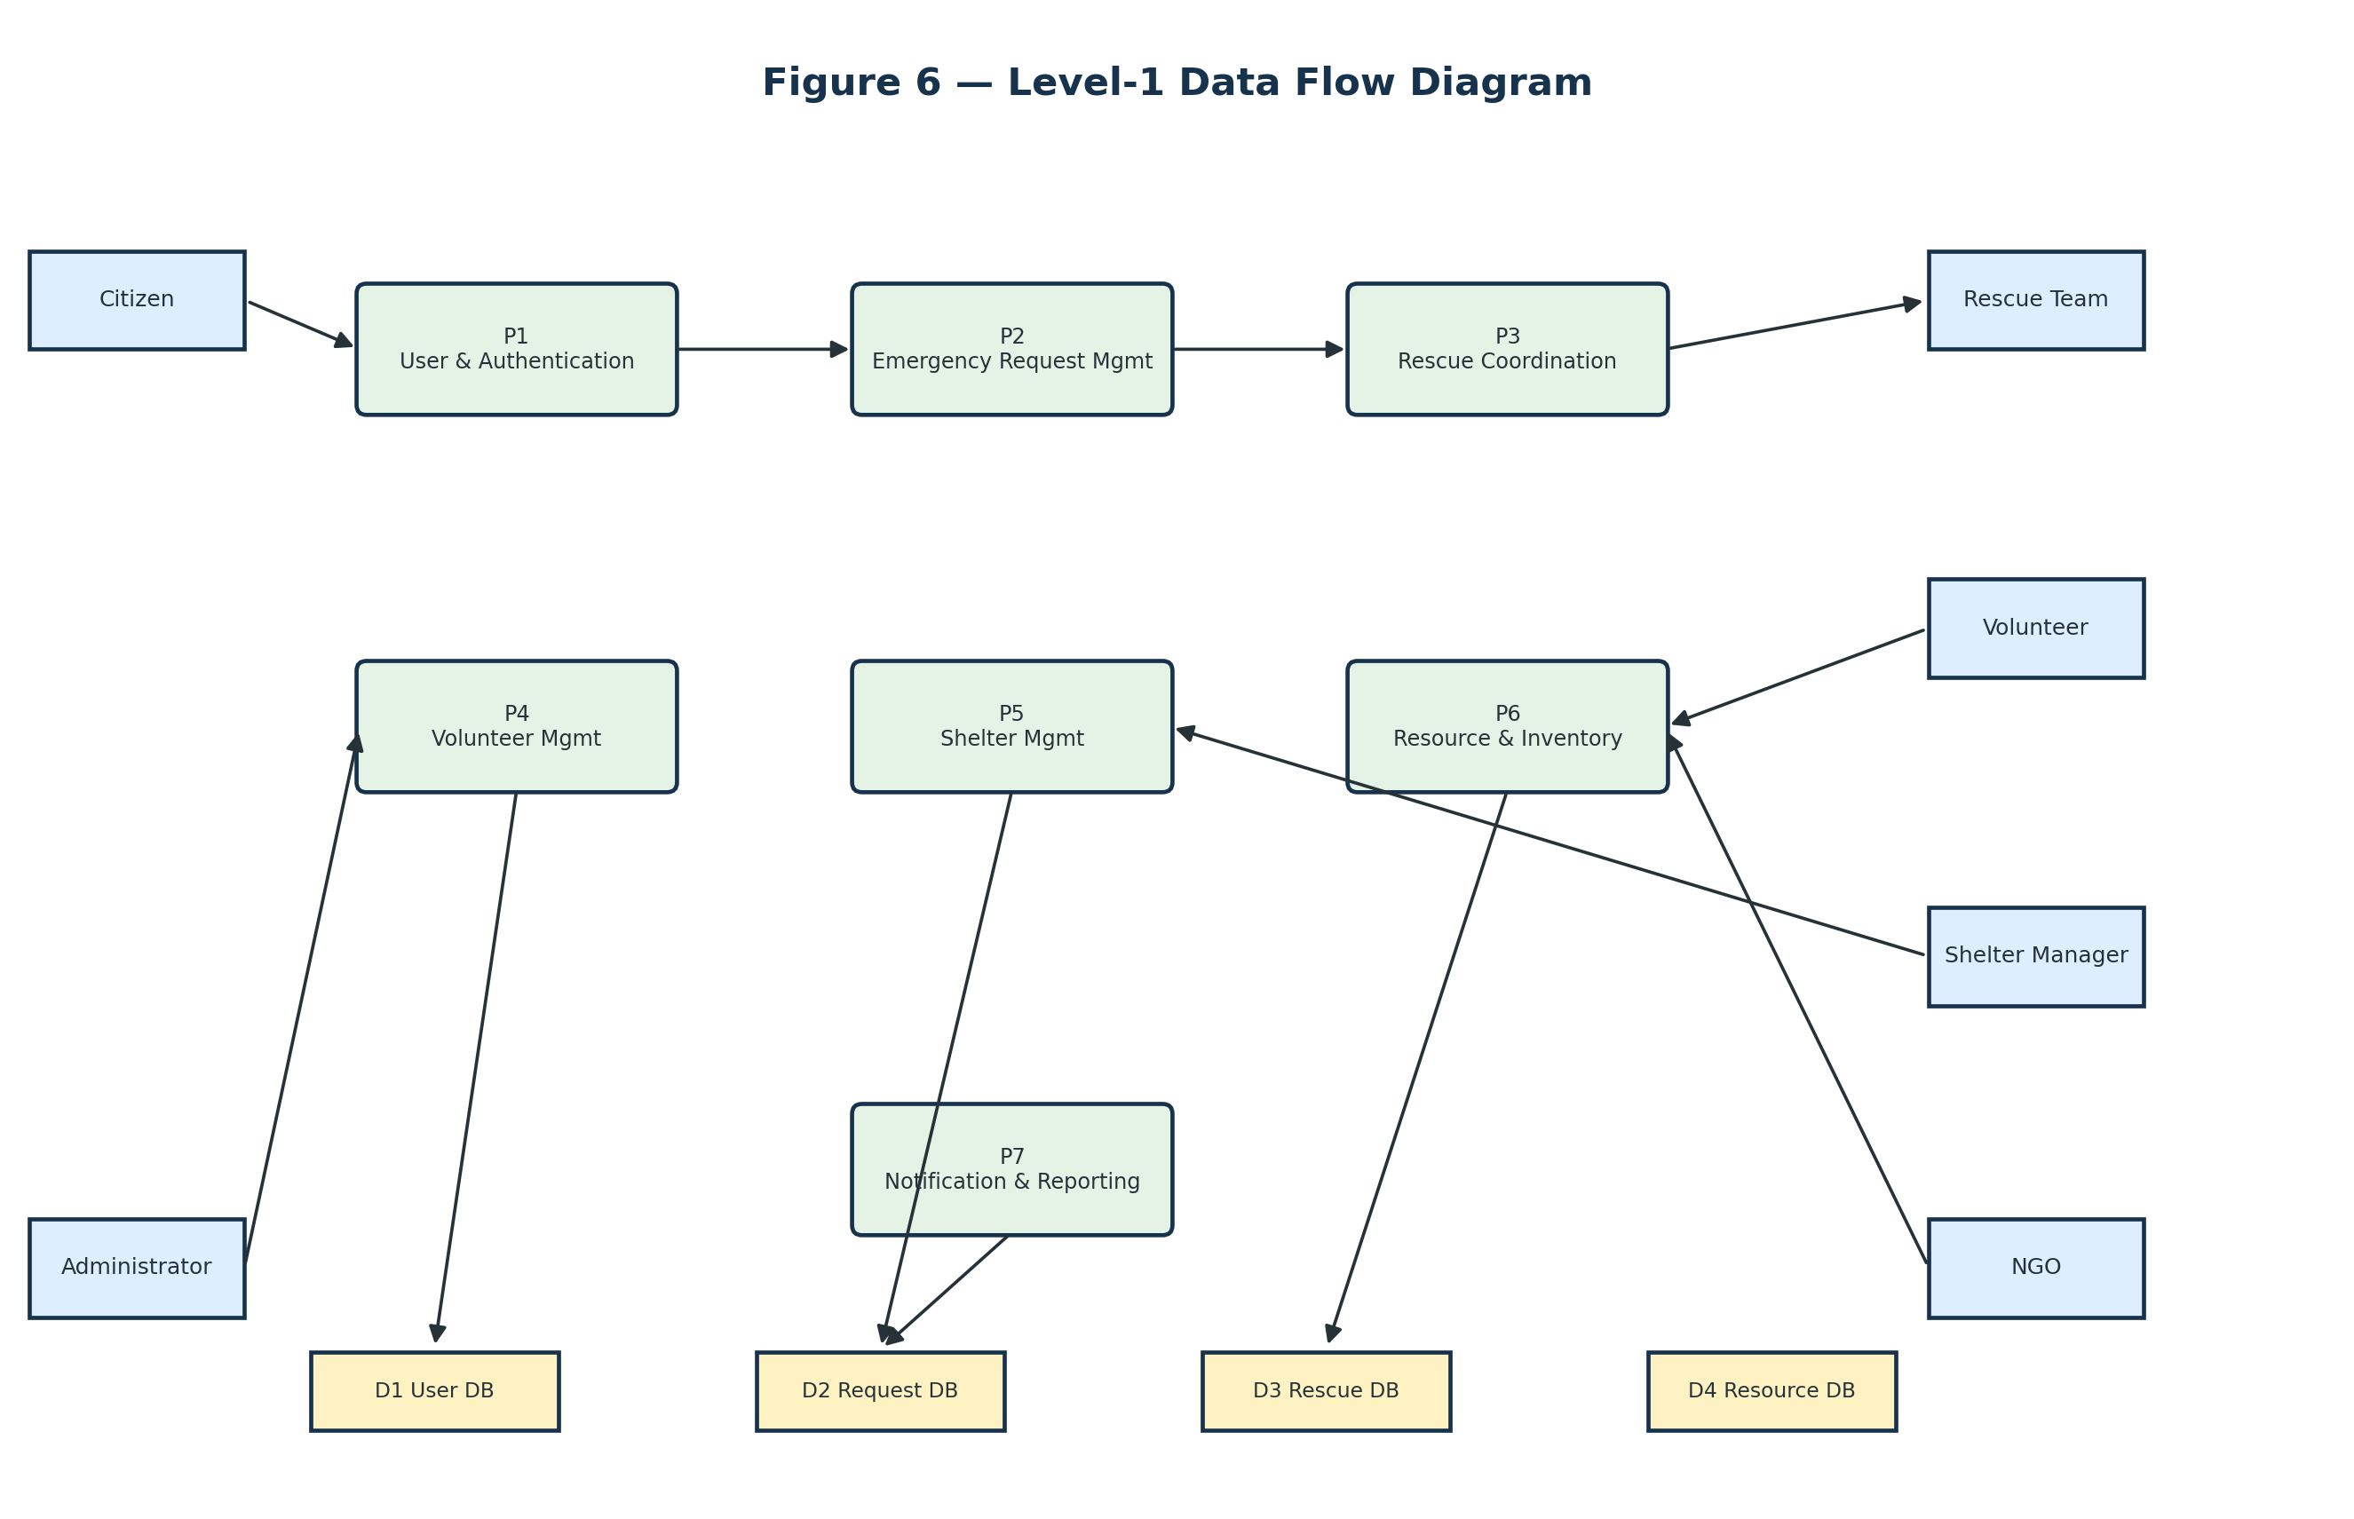
Figure 6 — Clean Level-1 Data Flow Diagram

7.4 DFD Components
Element | Meaning in this project
External entities | Citizen, Administrator, Rescue Team, Volunteer, Shelter Manager and NGO
Processes | User/Auth; Emergency Requests; Rescue Coordination; Volunteer Management; Shelter Management; Resource/Inventory; Notifications/Reporting
Data stores | User DB, Request DB, Rescue DB, Resource DB
Data flows | Registration data, emergency details, assignment data, task updates, shelter/resource information, notifications and reports

8. Experiment 7 — WBS, Scheduling and Project Execution Plan

8.1 Aim
To decompose the project into manageable work packages and map them to a practical schedule and dependencies.
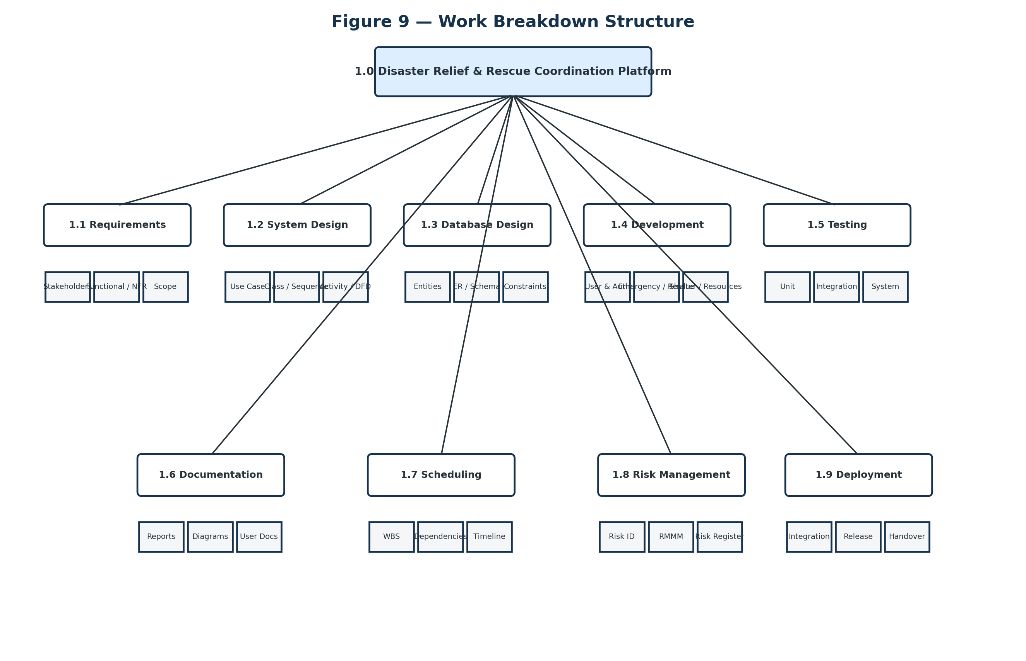
Figure 9 — Clean Work Breakdown Structure

8.2 Schedule
Activity | Duration | Period | Predecessor
Requirements Analysis | 4 days | Week 1 | —
UML & System Design | 5 days | Weeks 1–2 | Requirements
Database Design | 4 days | Week 2 | Requirements
Backend Development | 8 days | Weeks 3–4 | System Design
Frontend Development | 8 days | Weeks 3–4 | System Design
Integration | 3 days | Week 5 | Backend + Frontend
Testing | 4 days | Week 5 | Integration
Bug Fixing | 3 days | Week 6 | Testing
Documentation | 3 days | Week 6 | Testing / Results
Final Deployment | 1 day | Week 6 | Documentation

8.3 Dependency Logic
Requirements must be sufficiently stable before detailed design. Database design depends on the identified entities and requirements. Development follows the design baseline. Integration requires working frontend and backend modules. Testing follows integration; bug fixing is driven by test findings; documentation consolidates the final artifacts and results.

8.4 Work Packages
- Requirements: stakeholders, actors, functional and non-functional requirements.
- Design: Use Case, Class, Sequence, Communication, Activity and DFD.
- Database: entities, relationships, schema and constraints.
- Development: authentication, emergency workflow, rescue, volunteer, shelter and resources.
- Testing: unit, integration, system, security, usability and database checks.
- Documentation: reports, diagrams, test evidence and final demonstration.

9. Experiment 8 — RMMM Risk Management

9.1 Aim
To identify project risks, estimate probability and impact, assign priority, and define mitigation, monitoring and management actions.
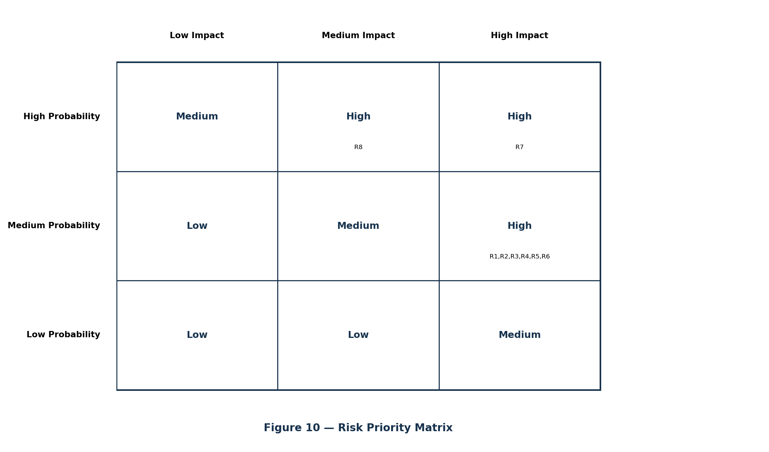
Figure 10 — Risk Priority Matrix

9.2 Project Risk Analysis
ID | Risk | Probability | Impact | Priority
R1 | Database failure / emergency-data loss | Medium | High | High
R2 | Server/platform downtime | Medium | High | High
R3 | Incorrect or incomplete emergency request | Medium | High | High
R4 | Delay in assigning rescue teams/volunteers | Medium | High | High
R5 | Unauthorized access to sensitive information | Medium | High | High
R6 | Incorrect shelter capacity / inventory information | Medium | High | High
R7 | Project schedule delay | High | High | High
R8 | External notification service failure | Medium | Medium | Medium

9.3 Complete RMMM Actions
ID | Mitigation | Monitoring | Management
R1 | Regular backups; maintain backup copies. | DB health, errors and backup status. | Restore latest valid backup; verify records.
R2 | Reliable hosting and backup arrangements. | Availability and response errors. | Switch to backup environment; restore service.
R3 | Mandatory fields, validation and confirmation. | Invalid/duplicate request indicators. | Correct request information and flag duplicates.
R4 | Maintain current team/volunteer availability. | Pending-request age and assignment queue. | Reassign, escalate or locate alternate support.
R5 | Authentication, RBAC and secure password handling. | Access logs and suspicious login patterns. | Block affected access and investigate.
R6 | Authorized updates and validation. | Capacity/stock inconsistencies. | Correct records with responsible manager.
R7 | WBS, realistic deadlines and ownership. | Planned vs actual progress. | Reassign work and revise schedule.
R8 | Reliable service plus alternate communication channel. | Delivery errors and timeouts. | Retry safely or use alternative channel.

9.4 Risk Register
ID | Owner | Initial Status
R1 | Database / Backend Team | Open
R2 | Backend / Infrastructure Team | Open
R3 | Backend / QA Team | Open
R4 | Project / Admin Team | Open
R5 | Security / Backend Team | Open
R6 | Database / Admin Team | Open
R7 | Project Manager | Open
R8 | Backend / Integration Team | Open

10. End-to-End Working of the Complete System

10.1 High-Level Flow
The platform is designed around an incident lifecycle. A citizen creates an emergency request; the platform validates and stores it; the administrator verifies and prioritizes it; an appropriate rescue team is assigned; the team updates its operational status; the completed mission produces a rescue report; the request is resolved; and the citizen receives status information. Connected shelter and resource workflows can continue after rescue when accommodation, food, water, medical support or other relief material is required.
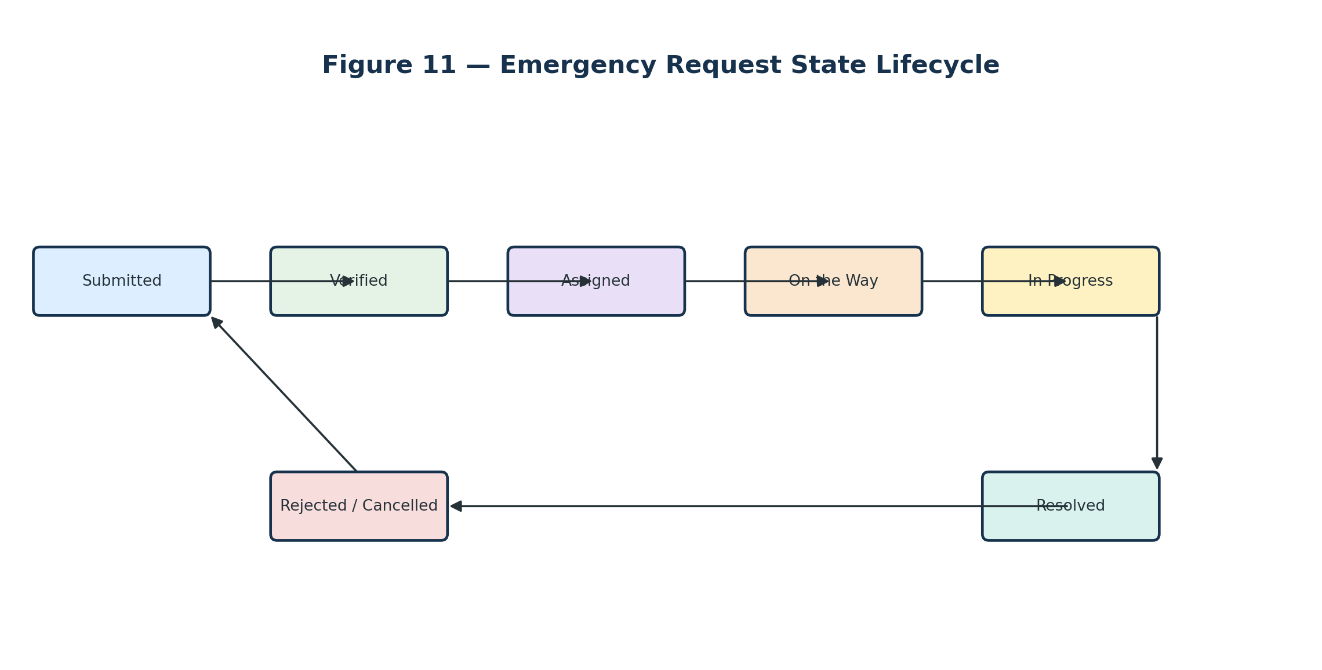
Figure 11 — Emergency Request State Lifecycle

10.2 Step-by-Step Operational Scenario
1. Disaster Activation: The authority creates or activates a disaster event with its name, type, affected area, severity and status.
2. Citizen Reporting: A citizen logs in and submits an emergency request with the emergency type, description, location, affected people and injury/severity information.
3. Validation: The platform checks mandatory information and prevents an incomplete request from entering the operational queue.
4. Request Creation: A unique request record and timestamp are stored. The request starts in a Submitted state.
5. Verification: The administrator reviews the request, validates the information and checks for duplicate/invalid reports.
6. Priority: The administrator sets or confirms the request priority. Critical cases can be handled before lower-urgency cases.
7. Team Selection: The administrator checks rescue-team availability and chooses an appropriate team according to the operational information available.
8. Assignment: A RescueAssignment record links the request to the selected team. The team receives the incident details.
9. Mission Progress: The team acknowledges the assignment and updates its mission status, such as On the Way and In Progress.
10. Rescue Outcome: After the operation, the team submits a RescueReport containing people rescued, injuries and remarks.
11. Resolution: The emergency request is updated to Resolved and the operational history is retained.
12. Notification: A Notification record communicates the relevant status to the citizen.
13. Follow-up Relief: If survivors require accommodation or material support, the shelter/resource modules can create follow-up requests and allocations.

10.3 What Happens When a Rescue Team Is Unavailable?
The activity flow does not assume that a team is always available. The availability decision creates an exception path: the system can keep the request pending while the administrator checks another suitable team or additional support. This prevents the workflow from incorrectly treating an unavailable team as successfully dispatched.

10.4 What Happens When a Rescue Attempt Is Unsuccessful?
The rescue-success decision creates a recovery loop. Additional support can be requested and the rescue operation can continue. The request is not marked resolved until an authorized completion/update action records the outcome.

11. System Architecture
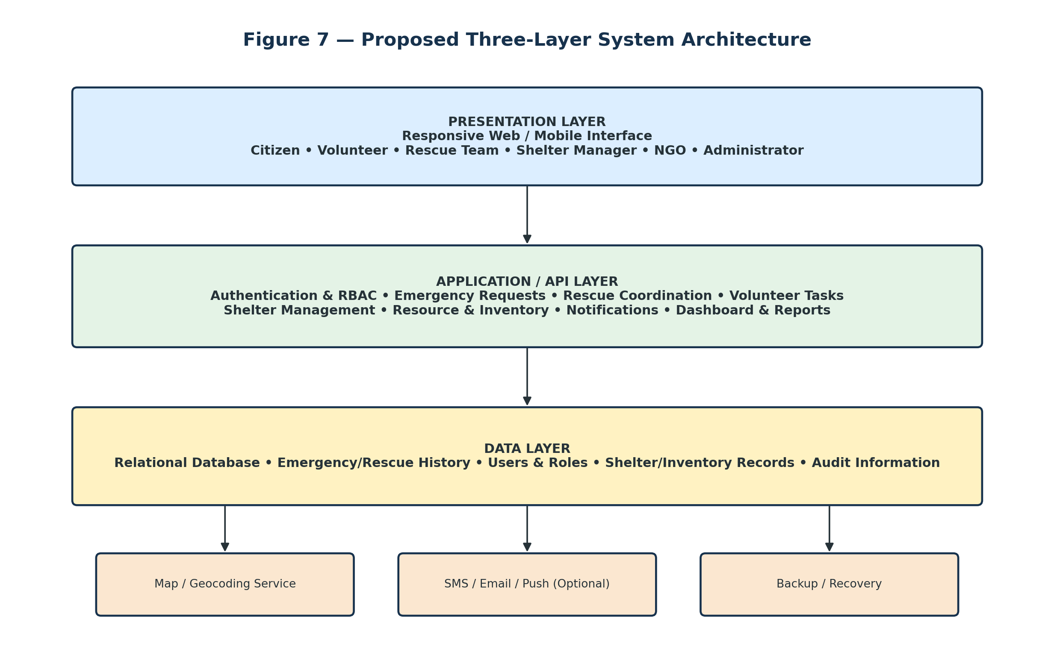
Figure 7 — Three-Layer Architecture

11.1 Presentation Layer
Provides role-specific interfaces for citizens and operational users. A citizen sees emergency submission and tracking functions, while administrators see queues, assignments, dashboards and reports.

11.2 Application / API Layer
Contains the business logic for authentication, authorization, emergency requests, prioritization, rescue assignment, volunteer tasks, shelter management, resources, notifications and reporting.

11.3 Data Layer
Stores transactional and historical information in a relational database. Important records include users, disasters, emergency requests, rescue teams, assignments, reports, volunteers, shelters, resource requests, inventory, allocations and notifications.

11.4 External / Optional Services
Map/geocoding and SMS/email/push services can be integrated as supporting services. Backup and recovery mechanisms protect operational records.

11.5 Role-Based Access Control
Authentication establishes who the user is; authorization determines what the user can do. For example, a citizen can submit a request but should not be able to assign a rescue team, while an administrator has controlled operational permissions.

12. Database and Entity Model
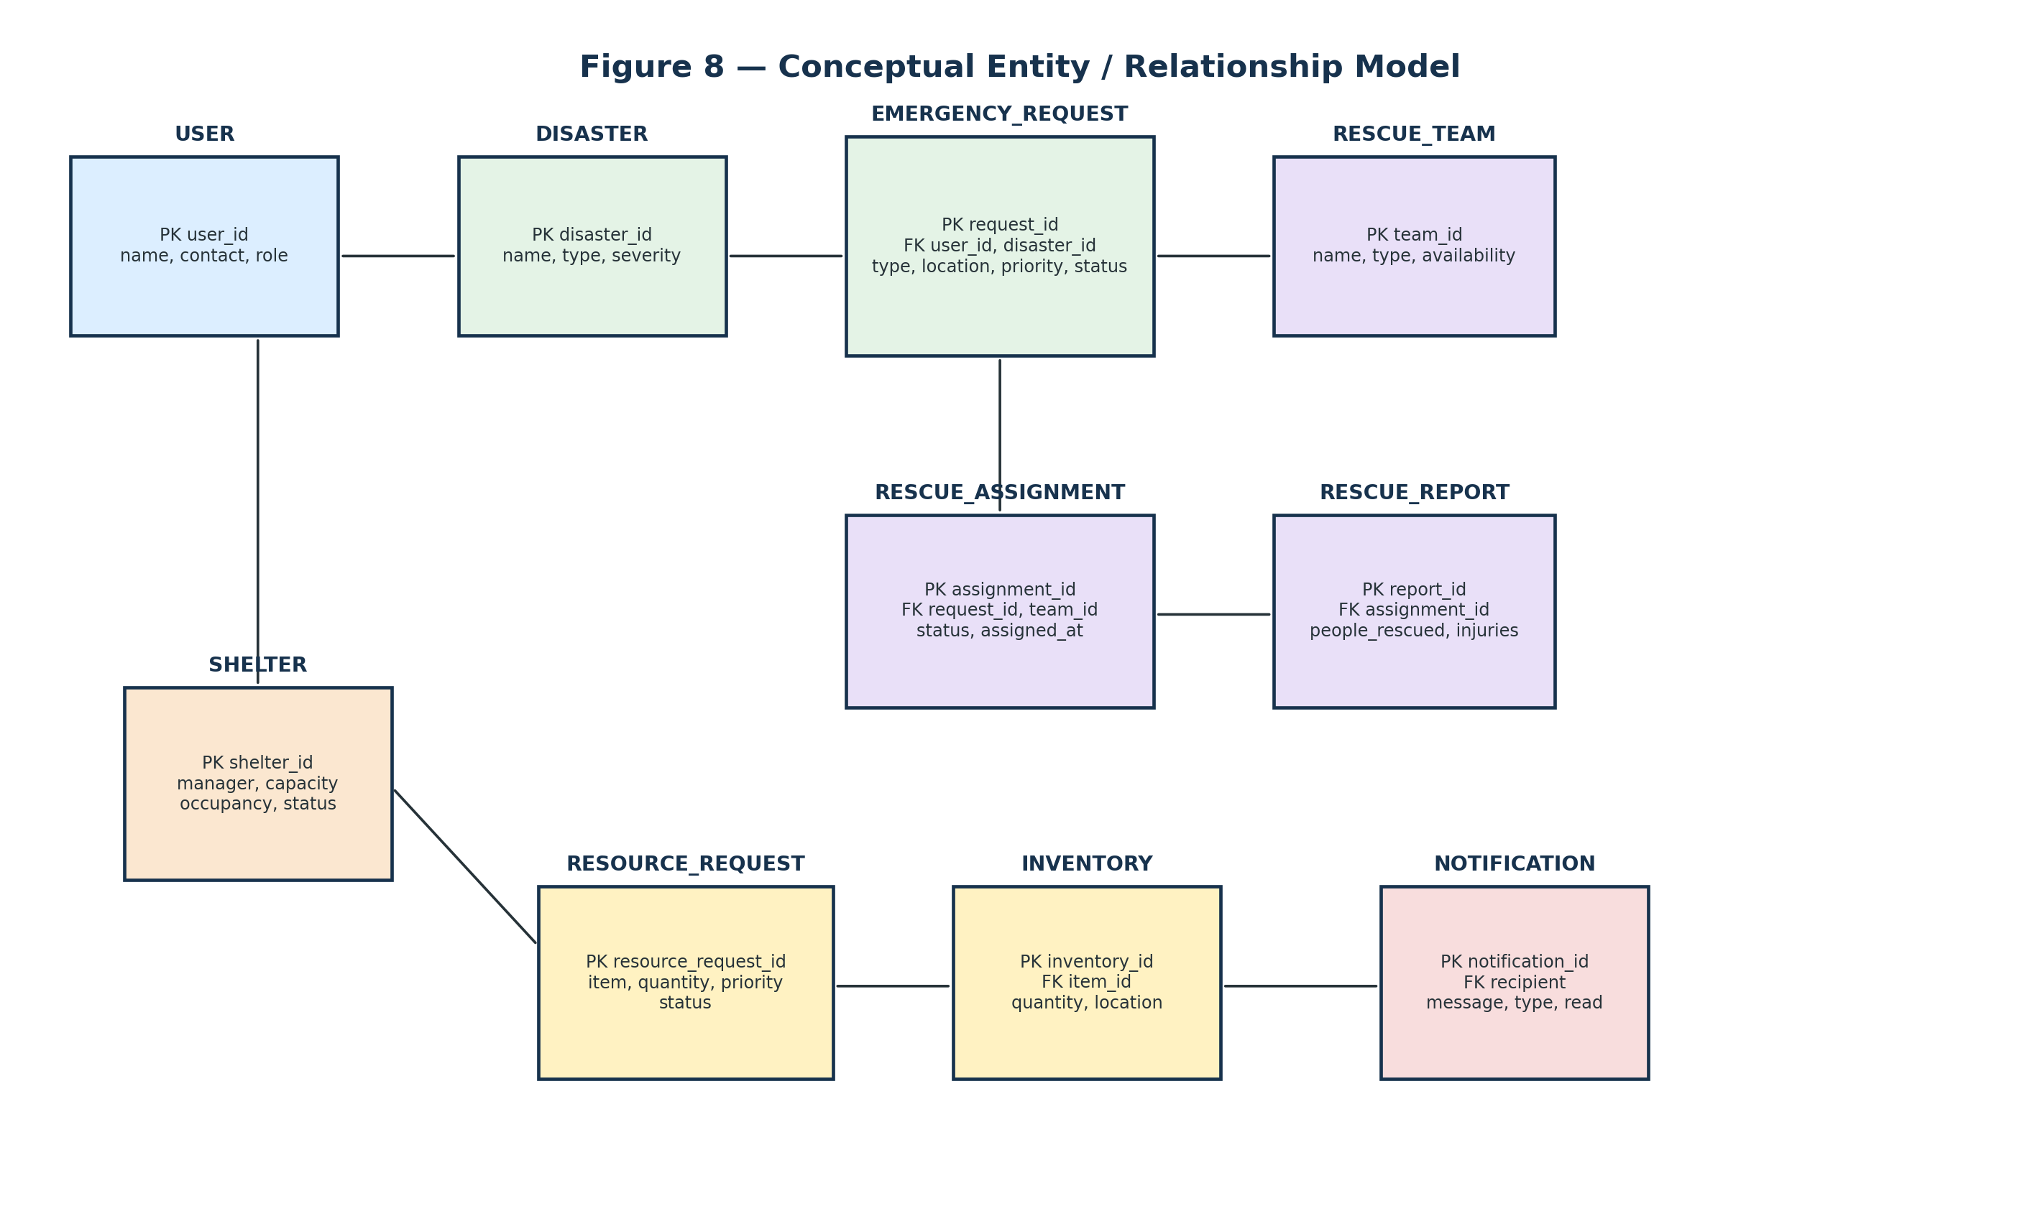
Figure 8 — Conceptual Entity / Relationship Model

12.1 Core Entities
Entity | Important information
USER | user_id, name, contact, role, password/credential information, status/verification
DISASTER | disaster_id, name, type, affected area, severity, start time, status
EMERGENCY_REQUEST | request_id, user, disaster, type, description, location, people affected, priority, status, created_at
RESCUE_TEAM | team_id, name, type, member count, capability, location, availability
RESCUE_ASSIGNMENT | assignment_id, request, team, assigned_by, assigned_at, status, completion time
VOLUNTEER | volunteer/user reference, skills, availability, location, verification
VOLUNTEER_TASK | task_id, volunteer, task type, location, status, assigned_at
SHELTER | shelter_id, manager, name, location, capacity, occupancy, facilities, status
RELIEF_ITEM | item_id, item name, category, unit
INVENTORY | inventory_id, item, location/organization, quantity available, updated_at
RESOURCE_REQUEST | resource_request_id, requester/location, item, quantity, priority, status
RESOURCE_ALLOCATION | allocation_id, request, source, quantity, allocated_by, status
NOTIFICATION | notification_id, recipient, message, type, read status, created_at
RESCUE_REPORT | report_id, assignment, people rescued, injuries, notes, completed_at

12.2 Important Data Rules
- A rescue team marked unavailable should not normally receive a new assignment.
- Available shelter capacity is total capacity minus current occupancy.
- Resource allocation should not exceed confirmed available stock unless an explicit back-order/emergency policy exists.
- Important status changes should be timestamped.
- Duplicate emergency requests should be flagged/linked rather than blindly dispatching multiple teams.
- Operational assignments and allocations should be traceable to authorized users.

13. Testing Strategy and Traceability

13.1 Testing Levels
Testing level | Project examples
Unit Testing | Authentication logic, priority validation, capacity calculations, inventory quantity updates, status transitions
Integration Testing | Emergency request → verification → assignment → notification → rescue report
System Testing | Complete workflows for each role
Security Testing | Unauthorized endpoint access, input validation, role restrictions, sensitive-data exposure
Usability Testing | Citizen can submit a request quickly and understand its status
Performance Testing | Bursts of emergency requests and dashboard reads
Database Testing | Constraints, relationships, transactions and concurrent updates
Acceptance Testing | Realistic disaster scenarios and stakeholder workflows

13.2 Representative Test Cases
Test case | Expected result
Valid emergency request submitted | Unique request created with Submitted status and timestamp
Mandatory location/details omitted | Validation message; request not accepted
Unauthorized citizen attempts team assignment | Access denied
Administrator assigns available team | Assignment created and statuses updated
Administrator selects unavailable team | System blocks/warns according to defined rule
Shelter occupancy updated | Available capacity recalculated
Allocation exceeds inventory | System rejects/warns and stock remains consistent
Rescue completed | Report and request updated; dashboard reflects resolution

13.3 Requirement Traceability
Requirement | Design artifact | Validation evidence
Emergency request creation | Use Case + Class + Sequence + DFD | Valid/invalid request tests
Team assignment | Use Case + Activity + Sequence + Rescue classes | Available/unavailable team tests
Rescue reporting | Class + Sequence + State lifecycle | Completion/report test
Shelter capacity | Class + DFD + ER model | Capacity calculation test
Resource allocation | Class + DFD + ER model | Stock limit test
Notifications | Use Case + Sequence + DFD | Notification delivery/status test
Security/RBAC | Use Case + Architecture | Unauthorized-operation tests

14. Final Integration and Conclusion

14.1 How All Eight Experiments Connect
Stage | Contribution to the final system
Experiment 1 | Established the problem, scope, objectives, actors and system boundary.
Experiment 2 | Converted the problem into functional/non-functional requirements and an operational workflow.
Experiment 3 | Mapped actors to system functions through the Use Case model.
Experiment 4 | Defined the static software structure through classes, attributes, operations and relationships.
Experiment 5 | Explained chronological and object-to-object communication for the emergency workflow.
Experiment 6 | Modeled process flow and data movement through Activity and DFD models.
Experiment 7 | Decomposed the project into work packages and assigned a practical development schedule.
Experiment 8 | Identified project risks and defined mitigation, monitoring and management actions.

14.2 End-to-End Demonstration Story
Consider a flood in which five people are trapped on the second floor of a building and one person is injured. The citizen submits the location, emergency type, number of people and injury information. The platform stores the request and the administrator verifies it and confirms a high priority. The administrator checks the rescue-team availability, selects an available suitable team and creates a rescue assignment. The team receives the incident, acknowledges it, changes its mission state to On the Way and then Rescue in Progress, and performs the rescue. After completion, the team submits the rescue report. The request becomes Resolved, the citizen receives an update and the dashboard reflects the completed operation. If the rescued people require temporary accommodation or relief materials, the shelter and resource modules can be used for follow-up coordination.

14.3 Conclusion
The Disaster Relief & Rescue Coordination Platform is modeled as an integrated coordination and resource-management system rather than only an emergency-reporting website. The project covers requirements engineering, stakeholder analysis, role-based access, emergency workflows, UML modeling, data-flow modeling, database concepts, project planning, testing and risk management. The combined artifacts provide a coherent blueprint for implementation and demonstrate how a Software Engineering project progresses from a real-world problem to requirements, design, planning, verification and risk control.

14.4 Future Enhancements
- AI-assisted emergency prioritization with human review.
- Automatic capability- and distance-based rescue-team recommendations.
- Traffic-aware route optimization.
- IoT sensors for flood, fire, weather and structural conditions.
- Drone and satellite-based situational assessment.
- Predictive relief-resource demand analytics.
- Multilingual emergency assistant/chatbot.
- Offline-first data capture and synchronization.
- Interoperability with hospitals and government systems.
- Advanced missing-person coordination with privacy safeguards.

14.5 Final Deliverables Checklist
- Problem definition and project scope
- Stakeholder and actor analysis
- Functional and non-functional requirements
- Use Case Diagram
- Class Diagram
- Sequence Diagram
- Communication Diagram
- Activity Diagram
- Level-1 DFD
- Conceptual ER/entity model
- System architecture
- WBS and schedule
- RMMM table, risk matrix and risk register
- Testing strategy and representative test cases
- End-to-end demonstration scenario

