A Project Report
on
BUSBAR DIFFERENTIAL & OVERCURRENT
PROTECTION SCHEME USING MICROCONTROLLER

Bachelor of Technology
in
Electrical Engineering

Submitted By:
Harsh Shiroya (23BEE106)
Rudraksh Mishra (23BEE097)



Department of Electrical Engineering
Institute of Technology, Nirma University,
Ahmedabad – 382481

Certificate
This is to certify that the project entitled “Busbar Differential & Overcurrent Protection Scheme Using Microcontroller” has been carried out by Harsh Shiroya (23BEE106) students of the Department of Electrical Engineering, Institute of Technology, Nirma University, under our guidance and supervision.
The work presented in this report is an authentic record of the design, hardware fabrication, and testing carried out by the students, and is found satisfactory in fulfilment of the requirements for the undergraduate project.

Institute – Faculty Mentor

Dr. Shanker D. Godwal
Department of Electrical Engineering
Institute of Technology
Nirma University
Ahmedabad

Acknowledgement
We take this opportunity to express our sincere gratitude to our guides, Prof. Shanker Godwal and Prof. S. C. Vora, Department of Electrical Engineering, Institute of Technology, Nirma University, for their invaluable guidance, constant encouragement, and constructive suggestions throughout the course of this project.
We are also thankful to the laboratory staff, Mr. Sajid Chauhan, Mr. Ghanshyam Purohit, and Mr. Harshad Patel, for their technical assistance during the hardware fabrication and testing phases. Their support in procuring components and troubleshooting the circuit boards was instrumental in the successful completion of this work.
Finally, we would like to thank the Department of Electrical Engineering for providing the necessary laboratory facilities and equipment that made this project possible.

Abstract
Busbars form the nerve centre of any electrical substation, since every incoming and outgoing feeder is connected to them. A fault on a busbar, if not cleared quickly and selectively, can cause widespread disruption, equipment damage, and loss of stability of the entire power system. This project presents the design, hardware development, and testing of a microcontroller-based Busbar Differential and Overcurrent Protection Scheme that replaces conventional electromechanical relaying with a low-cost, flexible, software-driven alternative.
The system compares the currents entering and leaving the protected busbar zone using two current transformers (CTs). The secondary signals are conditioned through precision level-shifting circuits so that the resulting bipolar AC waveform is shifted into the 0–5 V range acceptable to the microcontroller's analog-to-digital converter (ADC). An Arduino Uno continuously samples both currents; if the differential current exceeds a set threshold, or if either current exceeds an overcurrent threshold (depending on the selected mode), the microcontroller drives an opto-isolated gate circuit that turns off an anti-parallel thyristor pair acting as a solid-state circuit breaker, thereby isolating the fault instantaneously.
A distinguishing feature of the design is the use of onboard mode-select switches that allow a single Arduino program to execute differential protection, overcurrent protection, manual reset, and adjustable time-delay functions without having to reflash the microcontroller. The complete hardware — comprising eight functionally distinct sub-circuits — was fabricated on general-purpose boards, individually tested for healthy operating voltages, and integrated into a single working prototype. Results confirm that the scheme trips correctly for internal (in-zone) faults while remaining stable for external (through) faults, validating the fundamental principle of current differential protection using low-cost embedded hardware.

Table of Contents
Certificate 2
Acknowledgement 3
Abstract 4
Table of Contents 5
1. Introduction 7
1.1 Background 7
1.2 Motivation for a Microcontroller-Based Approach 7
1.3 Problem Statement 7
1.4 Objectives 7
2. Theoretical Background 9
2.1 Busbar Protection Philosophy 9
2.2 Principle of Differential Protection 9
2.3 Role of the Microcontroller 9
2.4 Solid-State Circuit Breaking 9
3. System Overview 11
3.1 Master Block Diagram 11
3.2 Functional Flow 11
3.3 Sub-Circuit Summary 12
4. Detailed Circuit Description 13
4.1 Circuit 1 — Anti-Parallel Thyristor Pair 13
About 13
Components Used 13
Healthy Operating Conditions 13
Common Problems & Troubleshooting 13
4.2 Circuit 2 — Thyristor Driver Circuit 14
About 14
Components Used 14
Healthy Operating Conditions 15
Common Problems & Troubleshooting 15
4.3 Circuit 3 — 2.5 V Supply for Switches 15
About 15
Components Used 15
Healthy Operating Conditions 15
Common Problems & Troubleshooting 16
4.4 Circuit 4 — 2.5 V Bias Supply 16
About 16
Components Used 16
Healthy Operating Conditions 16
Common Problems & Troubleshooting 17
4.5 Circuit 5 — +12 / −12 V Bias Supply 17
About 17
Components Used 17
Healthy Operating Conditions 17
Common Problems & Troubleshooting 18
4.6 Circuit 6 & 7 — Level Shifters (CT 1 and CT 2) 18
About 18
Components Used 18
Healthy Operating Conditions 18
Common Problems & Troubleshooting 19
4.8 Circuit 8 — Arduino Uno 19
About 19
Components Used 19
Healthy Operating Conditions 19
Common Problems & Troubleshooting 19
4.9 Mode-Select Switch Summary 20
5. Standard Operating Procedure 21
5.1 Safety Notes 21
6. Testing & Results 22
6.1 Sub-Circuit Verification 22
6.2 Functional Testing 22
6.3 Observations 22
7. Advantages, Limitations & Applications 23
7.1 Advantages 23
7.2 Limitations 23
7.3 Applications & Extensions 23
8. Conclusion 24
References 25

1. Introduction and objectives

1.1 Context
A busbar forms a common electrical connection between supply sources and outgoing circuits. Because several feeders may share the same bus, a fault in the busbar zone can affect substantial portions of a distribution network. Protection is therefore designed to act for faults within the selected zone without unnecessarily interrupting healthy equipment for faults beyond its boundaries.

1.2 Project approach
The project translates the basic functions of current sensing, signal conditioning, fault recognition and tripping into separate circuit boards. Unlike a commercial relay, the arrangement exposes individual sensing and switching stages, making their functions easier to observe during laboratory demonstrations. A switchboard selects protection mode and time delay without requiring a new program for every experiment.

1.3 Objectives
- Explain differential protection using CT measurements at two boundaries of a protected section.
- Interface alternating CT-derived voltages to the Arduino’s unipolar analog inputs.
- Demonstrate selectable differential and definite-time overcurrent functions.
- Control AC load conduction through optically isolated drivers and anti-parallel thyristors.
- Define repeatable checks for supply rails, measurement channels, switch inputs and output operation.

2. Protection principles

2.1 Differential protection
With a consistent current reference convention, Kirchhoff’s current law gives approximately equal incoming and outgoing currents during healthy operation or an external through-fault. An internal fault creates current imbalance. For a two-terminal model the operating quantity is Id = |Iin − Iout|, interpreted using synchronized, polarity-correct measurements. Real busbar schemes include all feeder currents and apply stabilizing methods to accommodate CT errors and saturation.

2.2 Overcurrent protection
An overcurrent element responds when a measured current magnitude exceeds a selected pickup. A definite-time element issues a trip only after the pickup condition has persisted for the configured interval. In this demonstration the switchboard identifies nominal 2 s and 5 s settings; these selections are not an inverse-time relay curve. Current pickup values must be established from the CT scaling and the actual measurement range.

2.3 SCR switching principle
A pair of oppositely oriented SCRs permits controlled conduction on both AC half-cycles. Removing their gate-drive commands prevents subsequent triggering, but an SCR already carrying current normally remains conducting until that current falls below its holding level, generally near an AC natural current zero. Consequently, a LOW Arduino output should not be described as instantly forcing the conducting device open.

3. System architecture
The functional arrangement consists of two CT measurement paths, dedicated low-voltage supplies, an Arduino Uno, optically isolated driver channels, two anti-parallel SCRs and a switchable load/fault arrangement. The original master diagram is reproduced to show the experimental wiring concept.
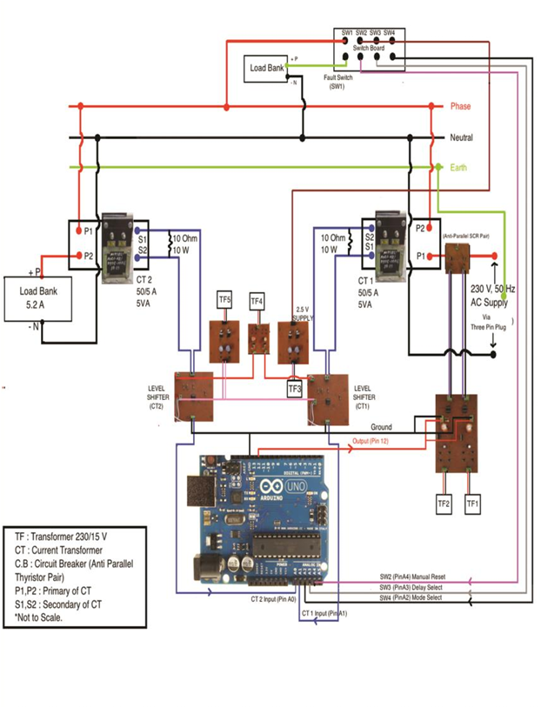
Figure 3.1 Original master arrangement of the protection demonstration

3.1 Signal path
CT1 and CT2 provide secondary current signals. Each burden resistor develops an AC voltage proportional to the corresponding secondary current. An analog level shifter adds a positive reference so both half-cycles can be observed by the Arduino ADC. The controller evaluates its selected detection condition and directs a gate-drive enable signal through pin 12 to the isolated SCR driver circuitry.

3.2 Module overview
Circuit | Function
1 | Anti-parallel SCR power switch
2 | Two optically isolated SCR driver channels
3 | 2.5 V reference for SW2–SW4
4 | Separate 2.5 V references for the level shifters
5 | Bipolar operating supply for analog signal conditioning
6–7 | CT1 and CT2 level shifters
8 | Arduino Uno measurement and decision logic

4. Hardware modules and interfaces
This section describes each board by its electrical role rather than repeating fault-finding instructions after every component list. Component counts follow the supplied project manual; exact resistor values and the analog IC identity are not specified there.

4.1 Anti-parallel SCR switching board
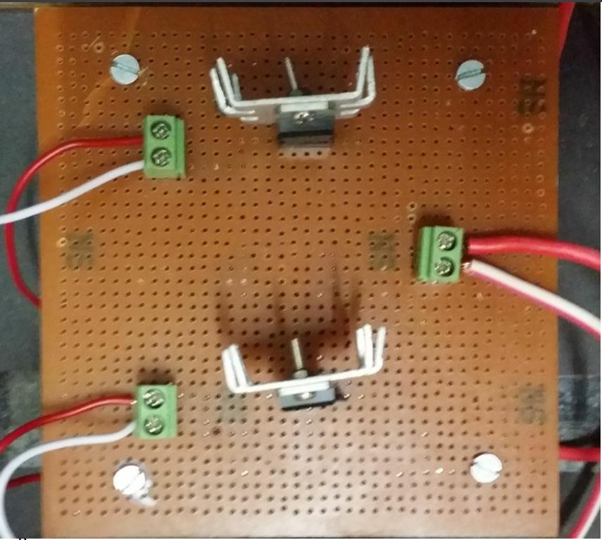
Photograph: Anti-parallel SCR switching board
Two TYN612 thyristors are connected in opposite directions in the supply path to control AC current during the positive and negative half cycles. The gate interface determines whether each device is triggered. The manual lists three connectors and two diodes in addition to the SCRs. The board is a laboratory solid-state switching stage, not a high-voltage industrial circuit breaker.

4.2 Optically isolated gate-driver board
Two TLP250 channels isolate the Arduino command side from the gate-drive side. Independent 230/15 V transformer-derived supplies, rectifiers, filtering and regulators feed the channels. According to the manual, the board includes eight diodes, two 7815 regulators, capacitors, resistors and six connectors. The separate driver references are important because the two SCR cathodes are not at a common potential.

4.3 Switchboard 2.5 V supply
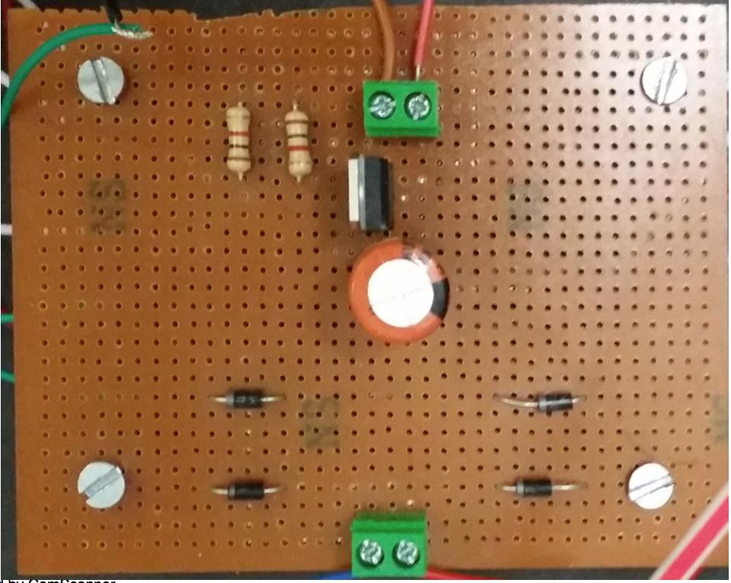
Photograph: Switchboard 2.5 V supply
Circuit 3 uses a 230/15 V supply input, four rectifier diodes, a capacitor, a 7805 regulator and two resistors to provide a nominal 2.5 V control reference. The reference is routed to SW2 (reset), SW3 (delay selection) and SW4 (protection mode); their signals are received at A2, A3 and A4. An OFF switch must leave its Arduino input at a defined logic level, rather than floating.

4.4 Level-shifter 2.5 V bias supply
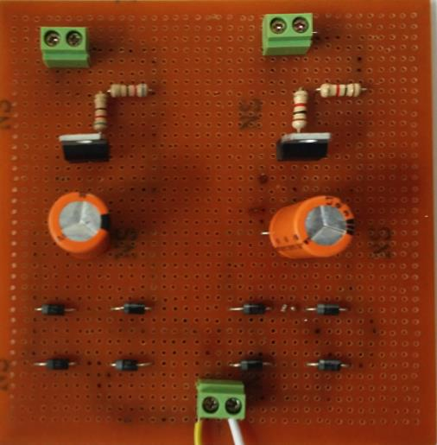
Photograph: Level-shifter 2.5 V bias supply
Circuit 4 is a dedicated source for the measurement offsets. The photographed board carries two channels; the manual specifies eight diodes, two filter capacitors, two 7805 regulators, four resistors and three connectors. One 230/15 V transformer-derived input supplies two nominal 2.5 V outputs, which are routed to the level shifters. This reference shifts the instantaneous AC sensing voltage upward; it is not an additional CT excitation supply.

4.5 Bipolar analog supply
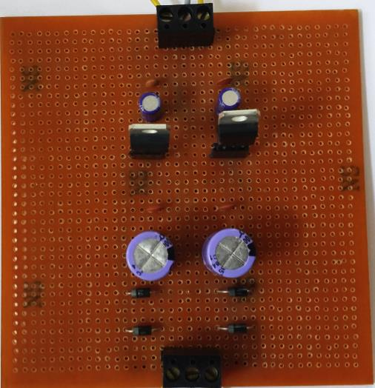
Photograph: Bipolar analog supply
Circuit 5 supplies positive and negative operating rails for the two level-shifter ICs. The manual describes the rails as +12 V and −12 V, but its parts list names 7815 and 7915 regulators, which normally correspond to ±15 V regulators. The precise assembled voltage should therefore be established by checking the installed regulator markings and measured outputs rather than assuming both statements are simultaneously correct.

4.6 Level shifters for CT1 and CT2
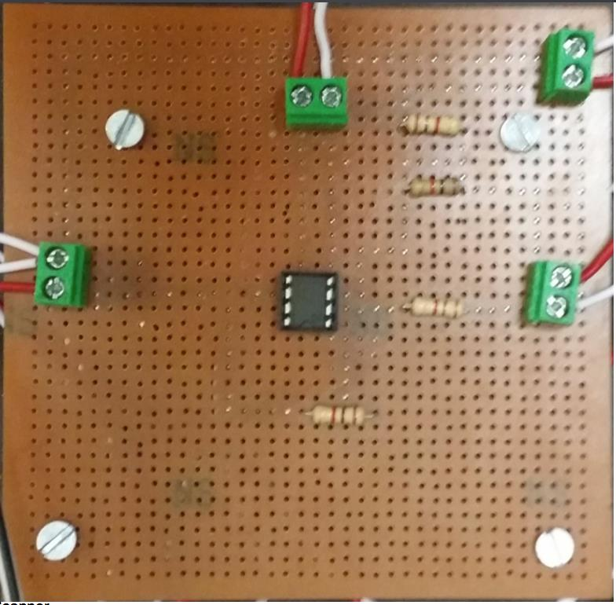
Photograph: Level shifters for CT1 and CT2
Circuits 6 and 7 each contain an analog IC, four resistors and four connectors. Connector 1 receives voltage developed across the stated 10 Ω, 10 W CT sensing resistor; connector 2 receives the bipolar supply; connector 3 receives the nominal 2.5 V bias; and connector 4 provides the conditioned output to A0 or A1. Ideally VADC(t) = Vsense(t) + 2.5 V, assuming the circuit has the required unity gain and polarity. The actual bias and gain require calibration.

4.7 Arduino Uno controller
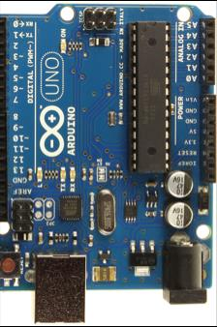
Photograph: Arduino Uno controller
The Arduino provides analog conversion, switch interpretation, programmed detection and the output control signal. A0/A1 read the level-shifter outputs, A2/A3/A4 are used for SW2/SW3/SW4, and pin 12 interfaces to the driver board. The original manual refers to a faculty-provided firmware program, which is not reproduced in that source; software behavior should therefore be described using the code actually loaded and tested.

5. Controller logic and operating modes
Control | OFF / default | ON / activated
SW1 | Fault bank disconnected | Fault bank connected
SW2 | No reset request | Manual reset request
SW3 | 2 s overcurrent delay | 5 s overcurrent delay
SW4 | Differential mode | Overcurrent mode
The Arduino converts each conditioned analog measurement to a digital sample using its ADC reference. In differential mode it should compare polarity-consistent CT signals, ideally using synchronized samples over an appropriate observation window. In overcurrent mode it should estimate a suitable current magnitude, compare that estimate against a calibrated pickup and run the selected timer only while the pickup persists.
A code example provided separately for this project subtracts 512 from a 10-bit ADC reading and then compares the absolute result with an overcurrent threshold of 700. Since the largest possible absolute result is 512, that particular condition cannot operate. Consequently, the example should not be presented as verified overcurrent firmware without correction and a new test. Reset and startup interlocking also require verification before energizing any load.

6. Assembly, testing and observations

6.1 Commissioning sequence
Begin by inspecting the boards, wiring, connector polarities and CT secondary termination with the power isolated. Confirm the intended supply voltages using suitably rated instruments, then check the level-shifter offsets and output ranges with safely simulated inputs. Validate Arduino switch recognition and trip-output logic using an isolated low-voltage test circuit before connecting the AC switching assembly. The mains-connected demonstration must be operated only under qualified laboratory supervision with appropriate isolation and protective equipment.

6.2 Verification matrix
Test case | Expected behavior | Evidence to record
Healthy load | CT measurements agree within tolerance; trip remains inactive | CT readings, ADC values, output state
Internal-zone fault simulation | Differential measurement rises; selected differential function commands a trip | Current waveforms, pickup, trip time
External through-current | Correctly referenced currents remain balanced | Current comparison, stability result
Overcurrent test | Above-pickup current persists for selected delay before trip | Pickup setting, timer trace, actual trip time
Manual reset | Output remains latched until a permitted deliberate reset | Reset sequence, interlock result

6.3 Interpretation of available evidence
The supplied report and user manual describe the intended test cases and connector-level checks, but they do not provide traceable numerical measurement tables or time-stamped waveforms. The entries above are therefore test criteria, not newly claimed experimental results. Actual readings should be inserted from laboratory records before final submission. In particular, a statement that tripping occurred within a fraction of a cycle cannot be substantiated without a measured fault-to-interruption trace.

7. Applications and design considerations
The arrangement is useful for teaching CT-based sensing, analog conditioning, basic differential logic, definite-time overcurrent operation, optically isolated control and the behavior of thyristors on AC. Its modular layout also makes it convenient to examine how an error in a supply or reference channel affects downstream measurement.
For practical utility or substation protection, substantially more engineering would be needed: calibrated multi-feeder current measurements, CT saturation restraint, filtering, dependable fail-safe trip logic, self-diagnostics, supply supervision, tested insulation and EMC performance, and coordination with qualified circuit breakers. Those requirements are beyond the scope of this educational demonstration.

8. Conclusion
This project brings together current transformers, burden resistors, analog level shifting, an Arduino Uno and optically isolated thyristor gate drivers in one modular busbar-protection teaching arrangement. The two selectable functions illustrate distinct decision principles: internal-zone current imbalance for differential protection and magnitude with timing for overcurrent protection. The design also shows why analog references, controller logic and power-switching behavior must be considered together. A final quantitative performance conclusion should be based on calibrated fault-current measurements, recorded trip times and evidence that the loaded firmware matches the reported operating characteristics.

References
- Project user manual, “Busbar Differential & Overcurrent Protection Scheme,” supplied with the laboratory apparatus.
- Arduino Uno / ATmega328P technical documentation and ADC reference material.
- Manufacturer component documentation for TYN612, TLP250, 7805, 7815 and 7915 devices.
- Undergraduate power-system protection coursework: differential zones, CT applications and time-overcurrent coordination.

