A PROJECT REPORT
on

FASTEST FINGERS FIRST CIRCUIT USING NE555 TIMER IC
Bachelor of Technology in Electrical Engineering
Submitted by
Harsh Maheshbhai Shiroya (23BEE106)
Department of Electrical Engineering
Institute of Technology, Nirma University
Ahmedabad, Gujarat
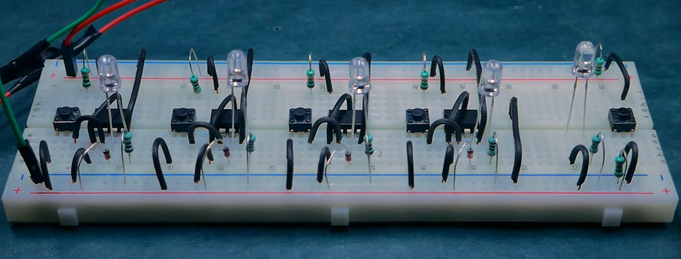
Figure 1. Breadboard-based Fastest Fingers First prototype (provided project photograph).

Abstract
This report examines a hardware-based Fastest Fingers First (FFF) response indicator constructed with NE555 timer ICs, contestant push-buttons, light-emitting diodes and associated discrete components. The circuit is intended to determine which participant acts first, preserve a visible indication and allow a fresh round through a common reset control. Its electrical operation is discussed from the supplied circuit drawing and breadboard photograph, with particular attention to the individual 555 stages, shared control rails and output indicators. The available drawing depicts three NE555 devices rather than a single timer; accordingly, this report treats them as separate player channels. The report explains the intended sequence of operation and recommends practical checks for first-press priority and lockout, while distinguishing these intended functions from performance data that were not supplied.
Keywords: Fastest Fingers First, NE555, quiz indicator, latching, reset, breadboard, priority selection.

Contents
1. Introduction
2. Operating principles
3. Circuit architecture and diagram
4. Components and hardware assembly
5. Working sequence
6. Verification methodology
7. Applications and design considerations
8. Conclusion
References

1. Introduction
Fastest Fingers First systems are used when several participants may respond within a very short interval. A useful electronic system must accept separate player inputs, indicate an accepted response and prevent later presses from obscuring the result. A reset mechanism then makes the circuit ready for the next question.
The supplied project photograph shows a breadboard assembly with multiple push-buttons, LEDs and jumper wires. The associated circuit diagram is titled “Fastest Finger First Circuit for Quizzes” and depicts three NE555 IC stages connected to common positive, reset, status and negative rails. Together, these materials provide the basis for describing the system without assuming additional hidden circuitry.

1.1 Objectives
• Investigate how a 555 timer circuit can respond to a push-button input.
• Explain the common reset arrangement and individual visual indicators.
• Document the connection scheme shown in the provided drawing.
• Set out a reproducible functional test for correct first-response behaviour.

2. Operating Principles

2.1 NE555 functional blocks
An NE555 includes two threshold comparators, an internal set–reset latch, a discharge transistor and an output stage. Pin 2 (TRIG) responds when its voltage falls below approximately one-third of the supply, while pin 6 (THRES) can reset the internal state when it exceeds approximately two-thirds of the supply. Pin 4 is the active-low reset input; pin 3 provides the output signal. Pin 8 connects to the positive supply and pin 1 to the negative rail.

2.2 Latching versus timed output
A conventional monostable uses an external timing resistor and capacitor and has nominal pulse duration T ≈ 1.1RC. The supplied circuit drawing, however, does not clearly display a monostable timing capacitor network for each player channel. It is therefore not justified to assign a particular pulse duration or to describe all stages as verified monostables. The illustrated wiring should instead be analyzed as a timer-based button response and state-indication arrangement until the physical pin connections have been verified.

2.3 First-press selection
In an FFF system, the earliest valid button press should establish the winning state. A common lockout connection must stop the remaining channels from registering after this selection. The schematic labels a shared “STATUS RAIL” and “RESET RAIL”; their precise interaction with each timer is the central feature to verify on the assembled prototype. Nearly simultaneous presses can require additional arbitration or debouncing to produce repeatable results.

3. Circuit Architecture and Diagram
Figure 2 reproduces the user-provided circuit drawing as a reference to the proposed layout. It contains three timer IC symbols and three corresponding contestant switches, with a separate reset switch and a status LED. The photograph includes additional visible LEDs and switches; therefore, the drawing and prototype photograph should not be treated as a completely reconciled, connection-by-connection record.
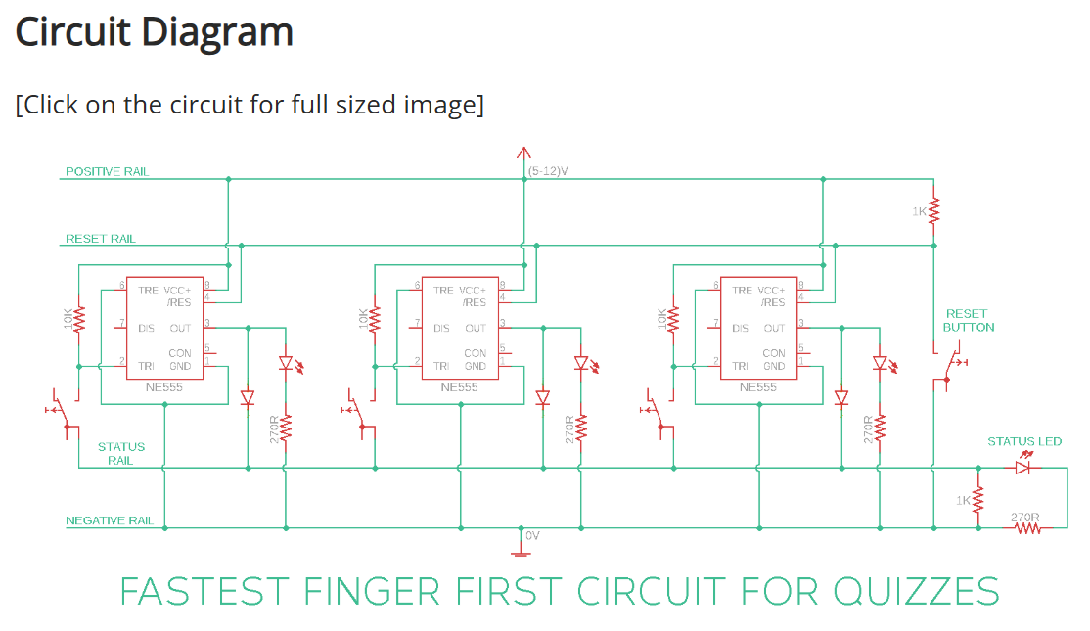
Figure 2. Supplied Fastest Fingers First schematic. This is a reference image, not a newly electrically validated schematic.

3.1 Functional sections
Section | Role
Positive / negative rails | Provide the operating supply and return.
Contestant inputs | Generate a response signal from player push-buttons.
NE555 stages | Process the trigger and retain or present a channel state.
Indicator branches | Display the relevant channel output by LEDs and resistors.
Common reset | Restore the initial condition for the next round.
Status output | Gives a general visual indication of circuit state.

4. Components and Hardware Assembly
The circuit drawing explicitly identifies three NE555 devices, several resistors, diodes, LEDs and push-buttons. The photograph confirms a breadboard realization and multiple wiring links, but not all values or conductor paths can be established solely from a top-side image.
Item | Description / use
NE555 timer ICs | Three symbols in the provided circuit diagram; timer/latch function.
Push-buttons | Individual player inputs plus reset input.
LEDs | Per-channel response indication and status indication.
Resistors | Pull-up / bias and LED-current-limiting functions; diagram includes 10 kΩ, 1 kΩ and 270 Ω labels.
Diodes | Steer or isolate signals between outputs and indicator paths.
Breadboard / jumper leads | Allows circuit assembly and changes without permanent soldering.
DC supply | Schematic specifies a 5–12 V positive rail; actual applied voltage should be measured.

4.1 Circuit construction
The build places the push-buttons across the breadboard center channel and positions indicator LEDs near the associated player sections. Discrete resistors and jumper links connect the inputs to the timer stages and shared supply rails. During inspection, each NE555 pin number should be checked against the actual IC orientation, especially pins 1, 2, 3, 4, 6 and 8.

5. Working Sequence
1. Apply the specified DC supply and establish a defined initial state using the reset control.
2. One contestant presses the corresponding input button.
3. The associated NE555 stage detects the trigger and changes its output/state.
4. The connected LED branch presents the response through its current-limiting resistor.
5. The intended common lockout prevents later inputs from replacing the first registered player.
6. The quiz operator presses reset to clear the state and begin a new round.
The steps above describe the desired behaviour of the project. The provided materials do not establish the switching-time performance, tie-breaking behaviour or a quantitative lockout delay; these should be documented only after testing.

6. Verification Methodology
The following test plan can be used to record actual evidence for the project. It is not presented as a claim that measurements have already been performed.
Test | Method | Expected observation
Power-on | Apply rated DC supply after wiring check | No unintended winner indication.
Single input | Press each player button individually | Corresponding indicator responds.
Successive inputs | Press one button, then another before reset | Only first selection remains active if lockout works.
Reset | Operate common reset button | Selection clears and next round becomes available.
Near-simultaneous presses | Repeat closely spaced inputs | Record winner selection and any ambiguous trials.
Supply robustness | Verify operation across chosen safe DC input range | Record changes in LED brightness or response.
Recommended results log: trial number, supply voltage, button pressed first, second button, observed winner, reset outcome and any unexpected behaviour. Quantitative claims about response speed require an oscilloscope or comparable timing instrument.

7. Applications and Design Considerations
A compact FFF indicator can be used for classroom quiz rounds, electronics exhibitions and demonstrations of discrete-state control. The architecture also provides a useful study example for switch debouncing, shared resets and latching circuits. Future revisions could add defined arbitration circuitry, a dedicated audible indicator, a regulated supply and a soldered PCB with labeled connectors.
Because the drawing and photograph do not fully agree on the channel count and visible component population, the definitive schematic should be redrawn from the final built wiring before presenting it as a certified circuit design.

8. Conclusion
The Fastest Fingers First project illustrates how NE555-based control stages and simple indicators can form an interactive quiz response circuit. The provided circuit drawing shows three individual timer channels connected to shared operating and reset rails, while the breadboard photograph documents a physical implementation. This report consolidates the available design information and describes the intended first-response, display and reset operation. Formal claims of successful lockout, accuracy or fastest-response timing should be made after recording representative test outcomes.

References
[1] Texas Instruments, “NE555 Precision Timers,” device datasheet (for timer pin functions and thresholds).
[2] Supplied project circuit diagram, “Fastest Finger First Circuit for Quizzes” (user-provided figure).
[3] Supplied breadboard photograph of the Fastest Fingers First circuit (user-provided figure).
[4] Original project manuscript, “Design and Implementation of a Fastest Fingers First (FFF) Quiz Buzzer Circuit Using the NE555 Timer IC,” supplied for revision.

