**CS 663 – Assignment 1 – Part 3**

**(a)**

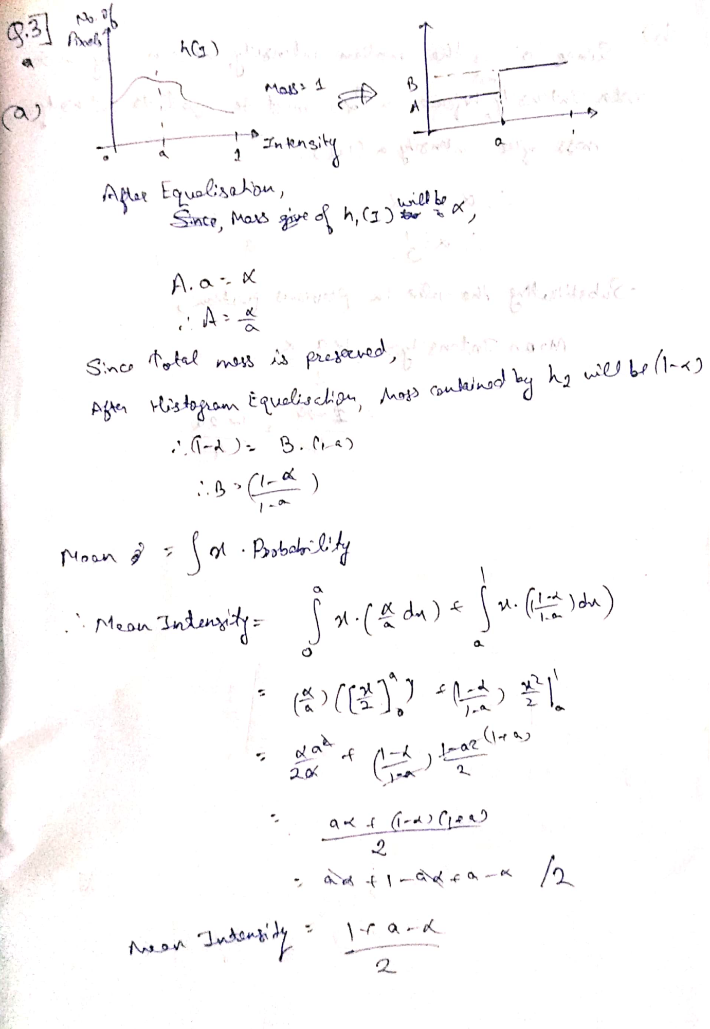

Mean Intensity = (1 + a – α) / 2

**(b)**

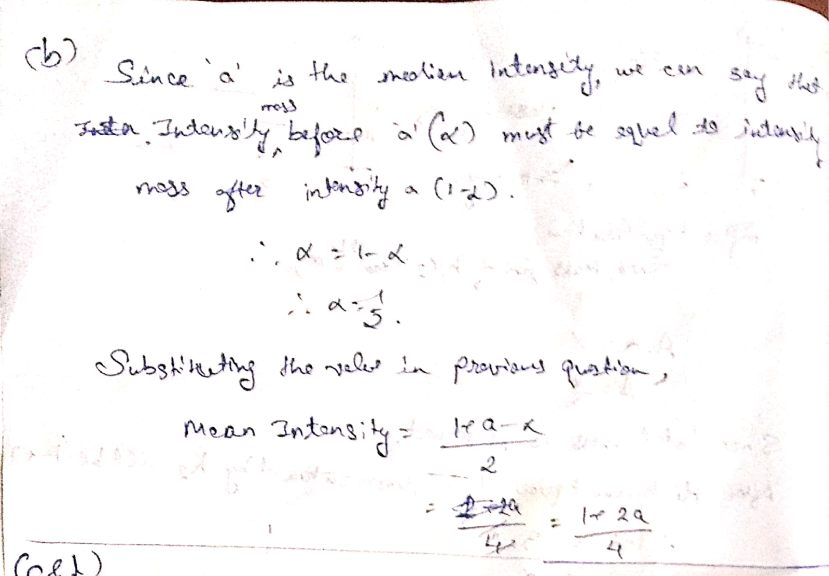

α = 1/2

Mean Intensity = (1 + 2a) / 4

(c)

In images like black and white patterns, normal HE will tend to dissolve the pattern by processing blacks and whites together. But median HE will process them separately so it will preserve the pattern.

So here median HE will perform better

(d)

|  |  |  |
| --- | --- | --- |
| Original | Normal HE | Median HE |
|  |  |  |