**CS 663 – Assignment 2 – Part 3**

Edge-preserving Smoothing using Patch-Based Filtering.

Window Size = 25x25

Patch Size = 9x9

Image1 (barbara) is subsampled by factor of 2. Other two are used on original size.

Spatial Mask is chosen as a gaussian with standard deviaiton 10, so that pixels far away from centre get less weight. The mask is shown below:

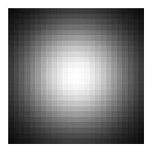

**Barbara**

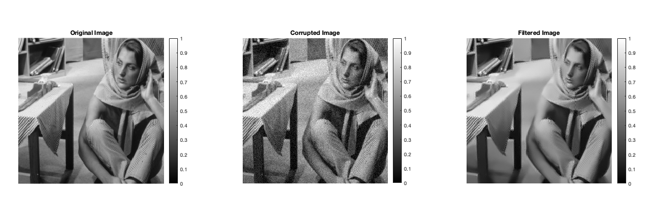

|  |  |
| --- | --- |
| **Sigma** | **RSMD** |
| σ* = 0.52 | 0.028950027854691 |
| 0.9σ* = 0.47 | 0.029624223234140 |
| 1.1σ* = 0.57 | 0.029597998872607 |

**Grass**

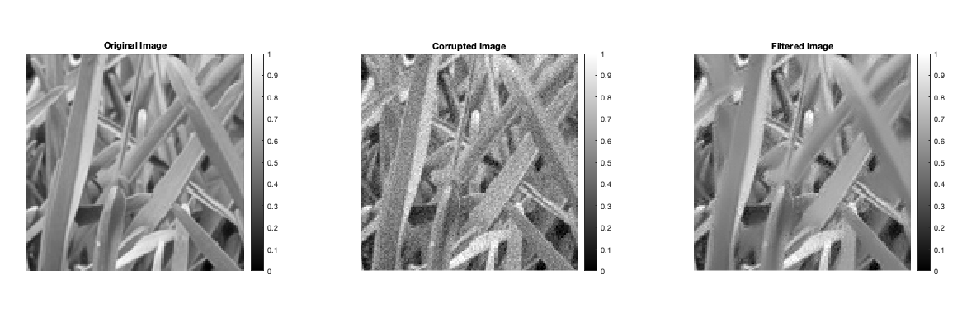

|  |  |
| --- | --- |
| **Sigma** | **RSMD** |
| σ* = 0.51 | 0.033901917573931 |
| 0.9σ* = 0.46 | 0.034915103450025 |
| 1.1σ* = 0.56 | 0.035025065661233 |

**HoneyComb**

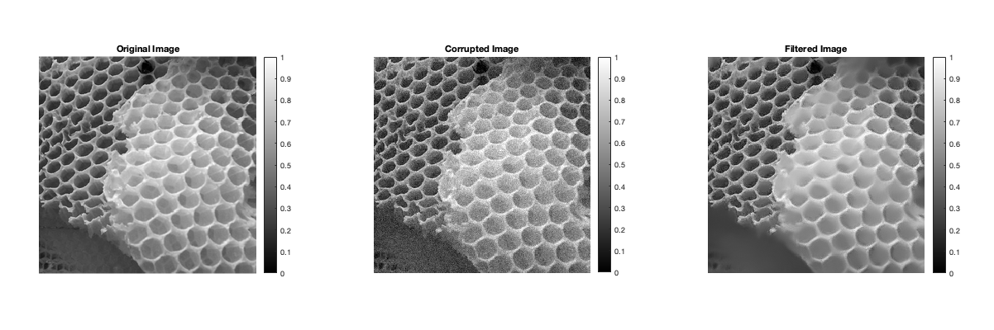

|  |  |
| --- | --- |
| **Sigma** | **RSMD** |
| σ* = 0.53 | 0.033273926310577 |
| 0.9σ* = 0.48 | 0.034031471497020 |
| 1.1σ* = 0.58 | 0.033870070871155 |