import pandas as pd
import numpy as np
import seaborn as sns
import matplotlib.pyplot as plt
%matplotlib inline
from sklearn.linear_model import LinearRegression
from sklearn.model_selection import train_test_split
from sklearn.linear_model import LogisticRegression
df=pd.read_csv("sales.csv")
df
Unnamed: 0 TV Radio Newspaper Sales
0 1 230.1 37.8 69.2 22.1
1 2 44.5 39.3 45.1 10.4
2 3 17.2 45.9 69.3 9.3
3 4 151.5 41.3 58.5 18.5
4 5 180.8 10.8 58.4 12.9
.. ... ... ... ... ...
195 196 38.2 3.7 13.8 7.6
196 197 94.2 4.9 8.1 9.7
197 198 177.0 9.3 6.4 12.8
198 199 283.6 42.0 66.2 25.5
199 200 232.1 8.6 8.7 13.4
[200 rows x 5 columns]
df.head()
Unnamed: 0 TV Radio Newspaper Sales
0 1 230.1 37.8 69.2 22.1
1 2 44.5 39.3 45.1 10.4
2 3 17.2 45.9 69.3 9.3
3 4 151.5 41.3 58.5 18.5
4 5 180.8 10.8 58.4 12.9
df.tail()
Unnamed: 0 TV Radio Newspaper Sales
195 196 38.2 3.7 13.8 7.6
196 197 94.2 4.9 8.1 9.7
197 198 177.0 9.3 6.4 12.8
198 199 283.6 42.0 66.2 25.5
199 200 232.1 8.6 8.7 13.4
df.dtypes
Unnamed: 0 int64
TV float64
Radio float64
Newspaper float64
Sales float64
dtype: object
df.shape
(200, 5)
df.info()
<class 'pandas.core.frame.DataFrame'>
RangeIndex: 200 entries, 0 to 199
Data columns (total 5 columns):
# Column Non-Null Count Dtype
--- ------ -------------- -----
0 Unnamed: 0 200 non-null int64
1 TV 200 non-null float64
2 Radio 200 non-null float64
3 Newspaper 200 non-null float64
4 Sales 200 non-null float64
dtypes: float64(4), int64(1)
memory usage: 7.9 KB
dup=df.duplicated().sum()
dup
0
df.columns
Index(['Unnamed: 0', 'TV', 'Radio', 'Newspaper', 'Sales'], dtype='object')
df.describe()
Unnamed: 0 TV Radio Newspaper Sales
count 200.000000 200.000000 200.000000 200.000000 200.000000
mean 100.500000 147.042500 23.264000 30.554000 14.022500
std 57.879185 85.854236 14.846809 21.778621 5.217457
min 1.000000 0.700000 0.000000 0.300000 1.600000
25% 50.750000 74.375000 9.975000 12.750000 10.375000
50% 100.500000 149.750000 22.900000 25.750000 12.900000
75% 150.250000 218.825000 36.525000 45.100000 17.400000
max 200.000000 296.400000 49.600000 114.000000 27.000000
sns.pairplot(df,kind="reg")
plt.show()
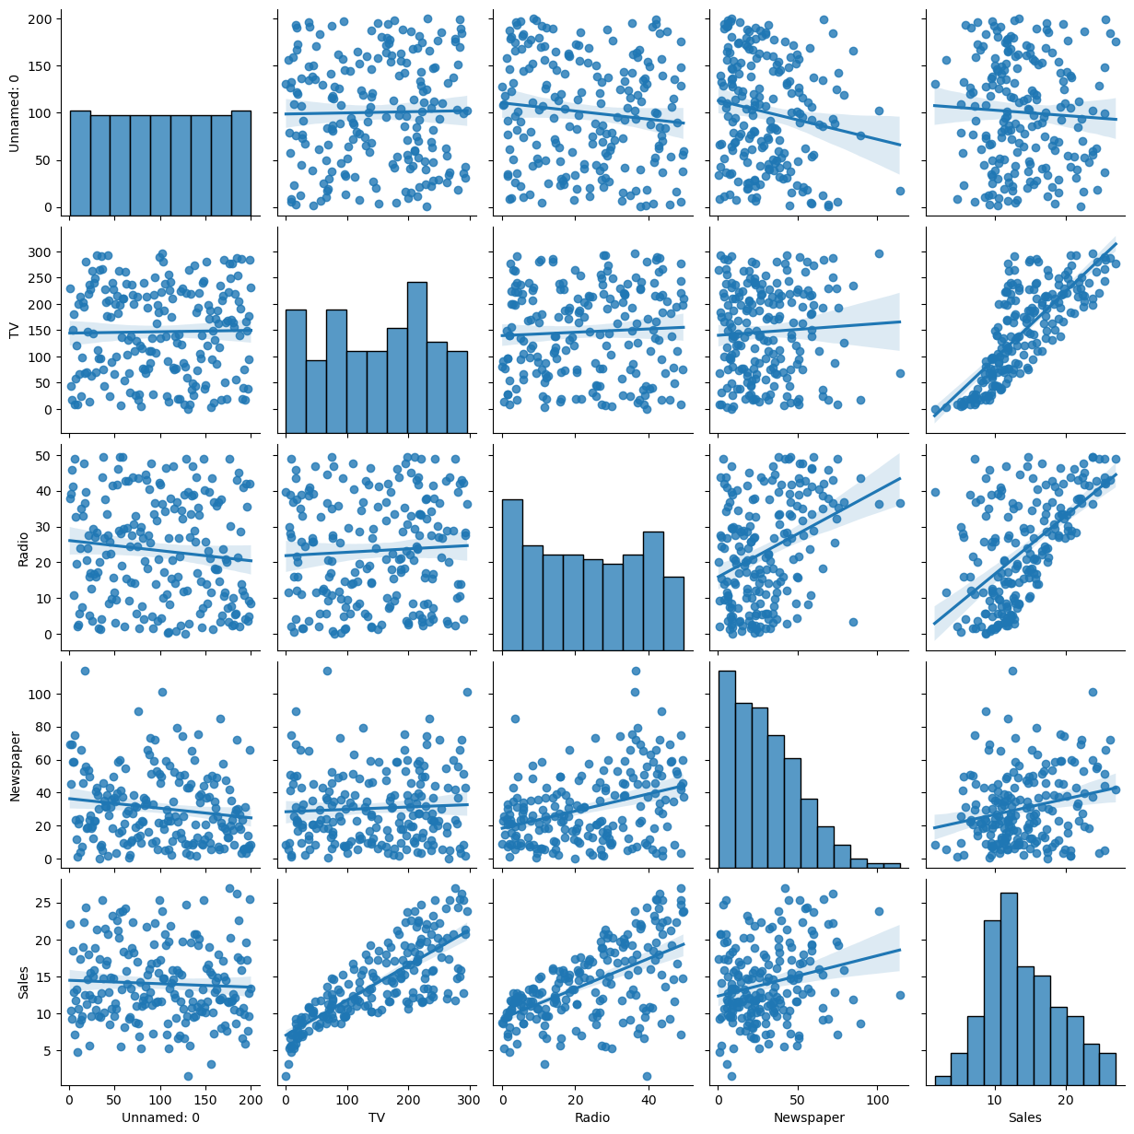
sns.scatterplot(x=df["TV"],y=df["Sales"])
plt.show()
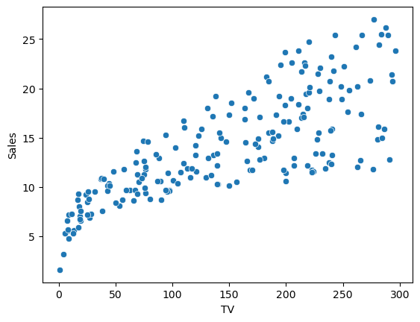
sns.scatterplot(x=df["Newspaper"],y=df["Sales"],color='g')
plt.show()
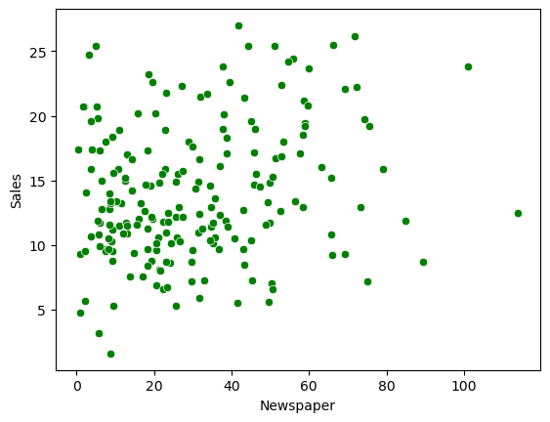
df["Sales"].plot.hist(bins=10,xlabel="Sales")
plt.show()
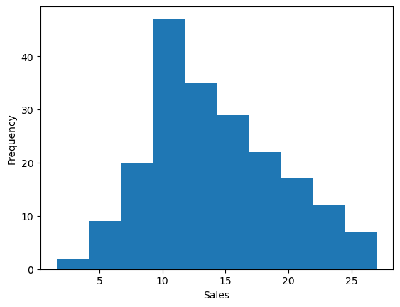
df["Radio"].plot.hist(bins=10,color="g",xlabel="Radio")
plt.show()
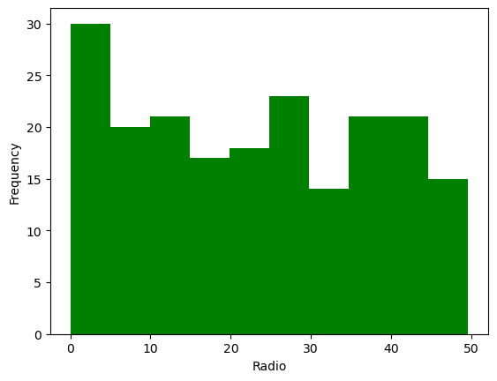
df["Newspaper"].plot.hist(bins=10,color="g",xlabel="Newspaper")
plt.show()
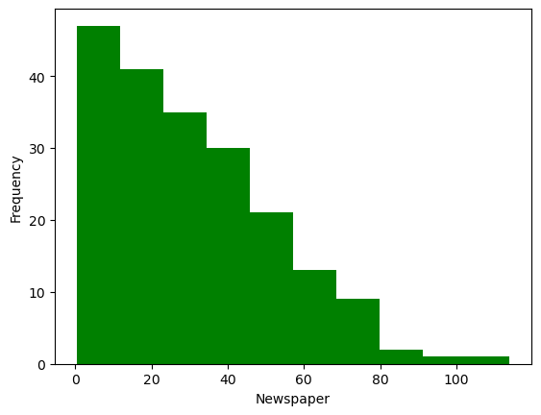
sns.set(style="whitegrid")
features= ["TV","Radio","Newspaper","Sales"]
for x in features:
plt.figure(figsize = (8,4))
plt.title(f'Distribution of {x}')
sns.histplot(df[x], kde=True, bins= 20, color = "blue")
plt.xlabel(x)
plt.ylabel("frequency")
plt.show()
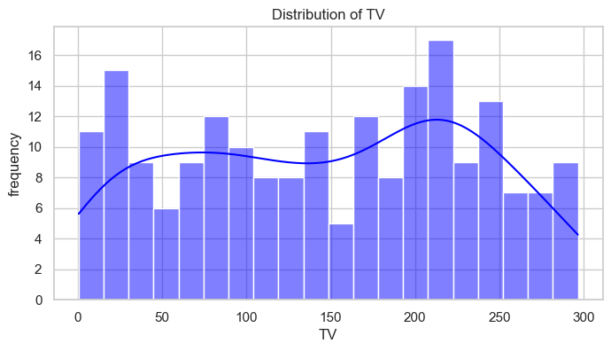
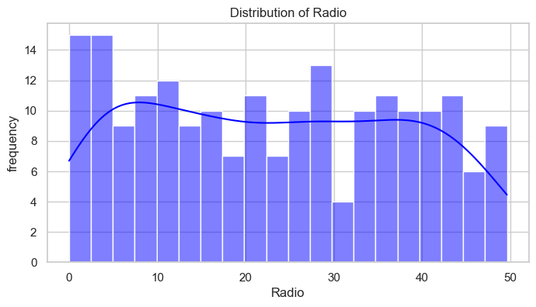
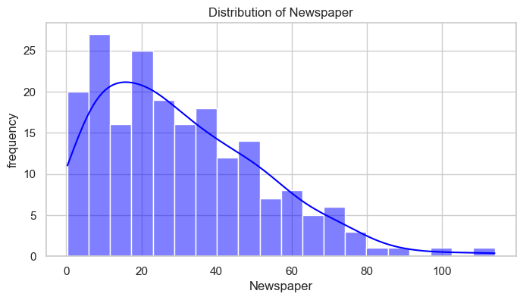
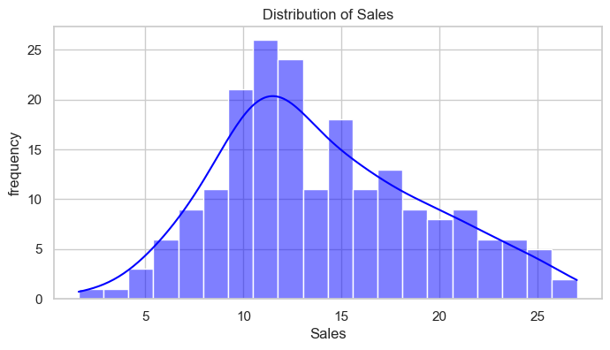
c_m = df.corr()
plt.figure(figsize = (10,6))
sns.heatmap(c_m, annot = True ,cmap = 'coolwarm' ,fmt ='.2f')
plt.title("Correlation Martix")
plt.show()
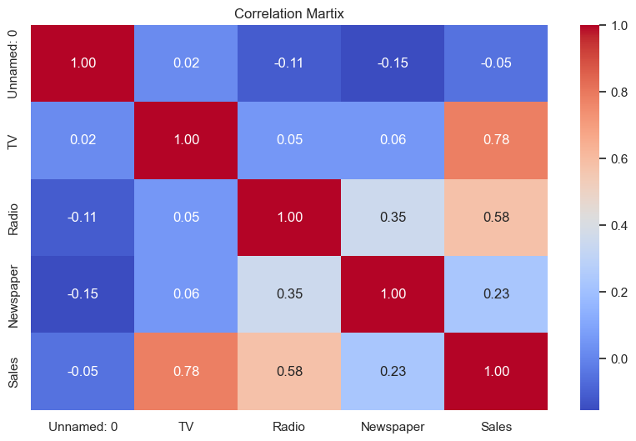
df['Total spent'] = df['TV'] + df['Newspaper'] + df['Radio']
df
Unnamed: 0 TV Radio Newspaper Sales Total spent
0 1 230.1 37.8 69.2 22.1 337.1
1 2 44.5 39.3 45.1 10.4 128.9
2 3 17.2 45.9 69.3 9.3 132.4
3 4 151.5 41.3 58.5 18.5 251.3
4 5 180.8 10.8 58.4 12.9 250.0
.. ... ... ... ... ... ...
195 196 38.2 3.7 13.8 7.6 55.7
196 197 94.2 4.9 8.1 9.7 107.2
197 198 177.0 9.3 6.4 12.8 192.7
198 199 283.6 42.0 66.2 25.5 391.8
199 200 232.1 8.6 8.7 13.4 249.4
[200 rows x 6 columns]
pairplot_data = df[["Sales","Total spent"]]
sns.set(style = 'whitegrid')
sns.pairplot(pairplot_data,height = 4)
plt.show()
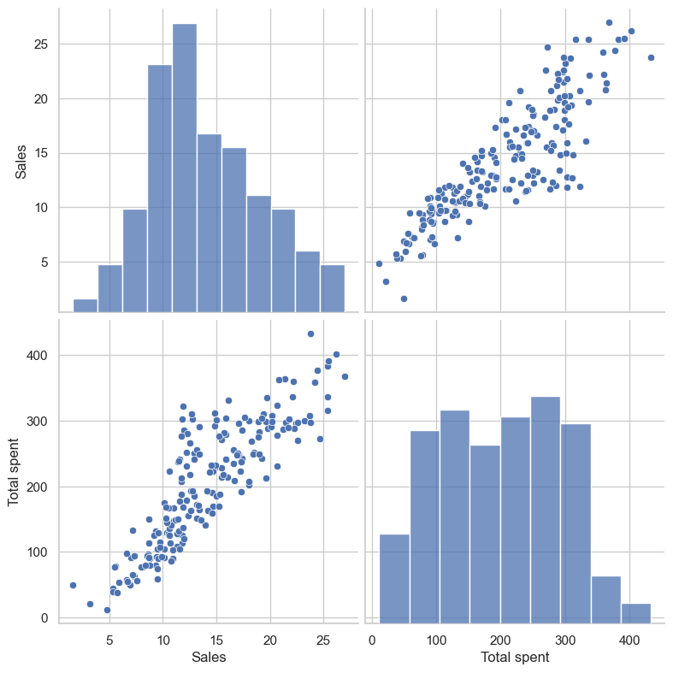
x=df.drop(columns = 'Sales')
x
Unnamed: 0 TV Radio Newspaper Total spent
0 1 230.1 37.8 69.2 337.1
1 2 44.5 39.3 45.1 128.9
2 3 17.2 45.9 69.3 132.4
3 4 151.5 41.3 58.5 251.3
4 5 180.8 10.8 58.4 250.0
.. ... ... ... ... ...
195 196 38.2 3.7 13.8 55.7
196 197 94.2 4.9 8.1 107.2
197 198 177.0 9.3 6.4 192.7
198 199 283.6 42.0 66.2 391.8
199 200 232.1 8.6 8.7 249.4
[200 rows x 5 columns]
y=df['Sales']
y
0 22.1
1 10.4
2 9.3
3 18.5
4 12.9
...
195 7.6
196 9.7
197 12.8
198 25.5
199 13.4
Name: Sales, Length: 200, dtype: float64
x_train,x_test,y_train,y_test = train_test_split(x,y,test_size = 0.3,random_state = 3)
model=LinearRegression()
model.fit(x_train,y_train)
LinearRegression()
prediction = model.predict(x_test)
prediction
array([16.17534904, 9.56375591, 19.74193762, 12.92612872, 7.82334672,
10.38267715, 23.6571004 , 8.98957556, 17.58530374, 13.60765852,
12.49252241, 14.6261671 , 15.27472426, 13.01083066, 12.51108721,
12.08562514, 16.1901009 , 17.3868432 , 17.13506412, 21.65577869,
18.13759983, 8.94362376, 10.71491002, 11.94123015, 6.93235654,
13.73896088, 22.20072734, 13.51873317, 22.53882293, 11.87037526,
17.01026976, 21.46769336, 10.79107195, 7.78191969, 10.14808103,
8.53770328, 12.90466755, 10.75149525, 12.13600412, 9.89325673,
15.52839572, 13.06934618, 5.90581927, 20.51508522, 22.43741466,
24.4563312 , 14.40363967, 10.98858335, 16.27610986, 18.19560275,
11.36555873, 14.7248132 , 16.94652365, 9.02139638, 19.51529967,
10.93959132, 22.66535067, 21.11049966, 15.77468857, 14.93574682])
model.intercept_
3.4175655796755464
model.coef_
array([ 0.00101876, -0.01359129, 0.13172862, -0.06166565, 0.05647168])
model.score(x_test,y_test)
0.8748762638758796

