BUSINESS STRATEGY & INVESTMENT REPORT
AI Emotional Companion App
India · Student Wellbeing / Companion AI Category
Prepared for: Founder / Cap Table Review
Prepared by: AI Co-Founder & Growth Strategy Advisory
Source: Customer & MVP Blueprint (informal validation only)
Date: August 2026
CONFIDENTIAL — FOR INTERNAL FOUNDER & ADVISOR USE ONLY

Table of Contents
01 Executive Summary
02 Startup Snapshot & Extracted Assumptions
03 Business Reality Check
04 Business Model Canvas
05 Revenue & Pricing Strategy
06 Go-To-Market Strategy
07 Customer Acquisition Strategy
08 First 100 Users Plan
09 Competitive Position & Moat
10 Reverse SWOT Analysis
11 Investor One-Liner & 30-Second Pitch
12 Investment Scorecard
13 Visual Dashboard
14 Founder Action Sheet — Top 10 Actions
15 Sustainability Verdict

01 · Executive Summary

Startup Snapshot
- AI emotional companion app for Indian college students (18–24), targeting loneliness and the lack of a judgment-free outlet at night.
- Category is large and fast-growing in India (~40% CAGR cited in source material), but this specific idea is unvalidated beyond informal founder conversations.
- No waitlist, no prototype, no usage data exists yet — this report treats the venture as pre-build.
- Planned MVP: a single, well-tuned Hinglish chat companion with short-term memory and a warm onboarding flow — deliberately minimal.
- Explicitly excluded from MVP: voice, avatars, multiple personas, romantic/relationship modes, notifications, and payments.
- Distribution plan leans entirely on organic creator/Reels content — an unowned, rented channel.
- Pricing is a freemium hypothesis (₹49–149/month) for memory, voice, and personalization — not yet tested with real users.
- The three highest-severity risks are all structural: regulatory/minor-safety exposure, emotional-dependency liability, and a total absence of demand data.
- Blueprint's own scoring already flags MVP Readiness as the weakest dimension (35/100) against a stronger Problem Severity score (74/100).

Bottom line: the problem is real and the market is large, but this is currently a validated problem in search of a validated business — not yet a business.

Extracted Assumptions (from the Blueprint)
Dimension | Stated Assumption | Validation Status
Customer | 18–24 college students/early jobseekers, Tier-1/2 India, hostel/PG, heavy phone users | Informal interviews only
MVP | Single-persona Hinglish chat, session memory, warm onboarding — nothing else | Not built
Value Proposition | Judgment-free, culturally relevant, private companion vs. generic English-only AI tools | Unverified against competitors
Pricing | Freemium; paid tier ₹49–149/month for memory, voice, personalization | Explicit hypothesis, no WTP data
Revenue Model | No ARPU, conversion rate, or CAC/LTV modeled in source material | Not modeled
GTM | Organic distribution via student-community creators and Instagram Reels | Assumed, unvalidated
Every dimension above is a hypothesis, not a fact. Section 03 stress-tests each one.

03 · Business Reality Check

Who Pays?
Uncertain. The hypothesis is that a minority of free-tier users (informally modeled around 10% in this report's dashboard, not sourced from the Blueprint) convert to a ₹49–149/month plan for cross-session memory, voice, and deeper personalization. No pricing test, conjoint study, or pre-order has been run.

Why Do They Pay?
The proposed hook is continuity and depth — the app 'remembering' the user and personalizing further. This is a real upgrade lever in companion-AI products generally, but it is weakened here because the MVP's free tier already delivers the core emotional-relief experience (unlimited basic chat). If the free product fully solves the stated pain point, the paid tier is a nice-to-have, not a need-to-have, until proven otherwise.

How Will They Discover The Product?
Entirely through organic, creator-led short-form content (Instagram Reels) and word-of-mouth in hostel/college networks. This is a low-cost channel to start but a fragile one: no owned audience, no paid-acquisition fallback, and platform-algorithm dependency.

Biggest Growth Risks
- Zero demand signal today — no interviews, no waitlist, no tester data (Blueprint's own admission).
- Distribution is 100% rented (creators, Instagram) with no owned channel or community asset being built in parallel.
- Age-gating an 18–24 product away from the <18 audience that most actively drives loneliness-content virality may cap organic reach.
- Mental-health-adjacent products face outsized negative-press risk; a single bad story can end a creator-led growth loop.

Biggest Monetization Risks
- Free tier cannibalizes the paid hook — the core pain is resolved without paying.
- India student ARPU is structurally low; recurring subscriptions for a chatbot are unproven at scale in this market.
- Character.AI and Replika offer free or near-free alternatives with far larger models, more features, and existing brand trust.
- No retention data exists yet to justify building payment infrastructure at all.

Weak Assumptions to Validate Before Building
# | Assumption | Why It's Risky
1 | Students will pay a recurring subscription for a companion chatbot | Not proven anywhere in the Indian market at meaningful scale
2 | Creator marketing converts to installs and retained users | Views/likes are not demand; no funnel data collected
3 | Hinglish + cultural tuning is enough differentiation | Character.AI already supports custom personas and multilingual chat
4 | Emotional dependency can be managed responsibly | This is a liability and trust risk, not just a UX detail
5 | 25% D1 retention / 40% D3 return is achievable pre-PMF | Ambitious bar for an untested single-persona MVP

04 · Business Model Canvas
Block | Detail
Customer Segments | - College students & early jobseekers, 18–24  - Tier-1 & Tier-2 India (Delhi NCR, Bengaluru, Pune, Hyderabad, Lucknow, Jaipur)  - Living away from family (hostel/PG)
Value Propositions | - Judgment-free, always-available companionship  - Culturally relevant, Hinglish-capable — unlike English-only incumbents  - Private, discreet, framed as 'journaling with a personality'
Channels | - Instagram Reels via student-community creators  - Word-of-mouth in hostel/college peer groups  - Landing-page waitlist (planned, not yet live)
Customer Relationships | - Automated 1:1 chat companion  - Non-manipulative, opt-in check-ins (planned, not built)  - No community/peer layer in MVP
Revenue Streams | - Free: unlimited basic text chat  - Paid: ₹49–149/month for memory, voice, personalization (hypothesis)
Key Resources | - Third-party LLM API (no in-house model)  - Prompt design / conversational tuning for Hinglish tone  - Crisis-detection & safety policy (not yet built)
Key Activities | - Conversation design & safety-flow scripting  - Creator relationship management  - Retention measurement & iteration
Key Partners | - LLM API provider  - Student-community creators / micro-influencers  - Legal/safety consultant for age-gating & privacy
Cost Structure | - LLM API usage (variable, scales with engagement)  - Creator fees / gifting  - Legal & safety review  - No infra for voice/avatars yet (deliberately excluded)

05 · Revenue & Pricing Strategy

Current State
Pricing is explicitly labeled a hypothesis in the source material: freemium access with a ₹49–149/month paid tier unlocking cross-session memory, voice, and deeper personalization. No willingness-to-pay interviews, no pricing test, and no payment infrastructure exist yet — correctly deferred per the MVP plan.

Recommended Approach
- Do not build payments until Week 4 Go/No-Go retention metrics are met (Section 08 of the Blueprint).
- Validate willingness-to-pay qualitatively first: ask directly in the 15–20 structured interviews what users would pay for continuity/memory, before committing to a number.
- Test price sensitivity with a fake-door paywall (show the ₹49 / ₹99 / ₹149 tiers on the waitlist page) to gauge click-through intent — zero engineering cost.
- Consider anchoring the paid tier around a single, sharply-felt benefit (e.g., 'it remembers what you told it last week') rather than a bundle, to make the upgrade decision legible.
- Model unit economics early: at ₹99/month and a plausible 3–8% free-to-paid conversion, back-calculate the free-user base needed to cover LLM API costs before assuming profitability.

Revenue Risk Flags
Risk | Why It Matters
Free tier meets the core need | Weakens the primary reason to ever upgrade
Low India ARPU norms | ₹49–149 is low in absolute terms; needs volume to matter
No proven retention | Building billing before D1/D3 retention is proven is premature spend

06 · Go-To-Market Strategy

Sequencing (from the Blueprint's 30-Day Plan)
Week | Focus | Deliverables
1 | Validate before building | 15–20 structured interviews; landing page + waitlist live
2 | Design the core loop | Script first-conversation flow; define age-gating & safety policy
3 | Build minimal MVP | Single-persona chat with memory + Hinglish tone, via LLM API
4 | Test & decide | 10–20 testers; measure retention/session metrics; Go/No-Go

Strategic Additions
- Treat the waitlist as the real GTM asset, not a formality — track conversion from creator content to waitlist signup as the first hard demand number.
- Pick 2–3 creators for a genuine test cohort before 'mapping 5–10' broadly; validate message-market fit on content before scaling spend/effort.
- Build the crisis-detection/redirect-to-help flow before any public-facing content goes live — this is both a safety and a brand-trust requirement, not a later feature.
- Instrument analytics (retention, session length, return rate) from the first tester, not after Week 3 — the Go/No-Go call in Week 4 is only as good as the data behind it.

07 · Customer Acquisition Strategy

Primary Channel: Creator-Led Organic
The plan correctly avoids paid acquisition at this stage — CAC cannot be justified before retention and conversion are proven. The acquisition strategy should be treated as a research tool first, growth engine second.
Tactic | Purpose | Cost
Structured 1:1 interviews (15–20) | Validate pain point language & willingness to try | Founder time only
Landing page + waitlist | Quantify real intent beyond conversation | Low — no-code tools
2–3 seed creator posts | Test message-market fit on relatable framing | Low — gifting/micro-fee
Manual concierge onboarding (5–10 people) | Observe real reactions to the first-chat script, no code | Founder time only

What To Avoid Early
- Paid social/performance ads — no proven funnel to spend against yet.
- Broad creator campaigns before 2–3 test posts validate the hook and framing.
- Push-notification re-engagement loops — explicitly excluded from MVP, and risky from a dependency-ethics standpoint.

08 · First 100 Users Plan
Source | Target # | Method | What It Proves
Founder network interviews | 15–20 | Manual outreach in hostel/college WhatsApp groups | Problem resonance, language, objections
Landing page waitlist | 50+ | Shared via student communities + one micro-creator | Real intent beyond conversation
Manual concierge testers | 10–20 | Scripted first-chat, no code, direct feedback | Whether the core experience feels 'safe/warm'
Seed creator posts (2–3) | Remaining to 100 | Track installs/replies, not just views | Whether creator content actually converts
Success bar per the Blueprint: Day-1 retention ≥25%; average session ≥5 min; ≥40% of testers return within 72 hrs unprompted; ≥7 of 10 testers report the experience felt 'safe/warm'.

09 · Competitive Position & Moat

Honest Moat Assessment
Moat Type | Strength | Notes
Technology / model | Weak | LLM API wrapper — no proprietary model or fine-tune yet
Data / memory | None yet | Zero usage data; memory feature not yet built
Language / culture | Moderate | Hinglish + local context is a real but replicable edge
Brand / trust | None yet | Unvalidated; safety record not yet established
Distribution | Weak | Rented creator reach, not an owned audience
Community / network effects | None | Not designed into the MVP

Competitive Landscape
- Replika — global incumbent, well-funded, English-first, established (if controversial) brand in companion AI.
- Character.AI — large user base, custom personas, multilingual capability, free-to-use, strong existing distribution.
- Local journaling/venting apps — lower-fidelity substitutes already in use by the target persona.
The realistic differentiation window is cultural fluency (Hinglish, Indian student context) and a narrower, safer scope — not technology. That window is closable: nothing stops a funded incumbent from shipping an Indian-context persona. The moat, if any, will have to come from trust, safety record, and community — none of which exist yet.

10 · Reverse SWOT Analysis
A reverse SWOT stress-tests the venture by starting from what could break it, not what could make it succeed.
Quadrant | Reframed Question | Answer
Strengths → Risk | Could this strength become a liability? | Emotional intimacy is the core value — and the core mental-health/dependency risk. The same feature that drives retention drives regulatory and press exposure.
Weaknesses → Exploit | Could a competitor exploit this weakness fastest? | Zero distribution moat means Character.AI or a funded local player could out-market this venture within weeks of seeing traction.
Opportunities → Trap | Could the 'opportunity' be a trap? | The ~40% category CAGR could attract well-capitalized entrants faster than it grows the addressable market for a pre-seed, single-founder-style build.
Threats → Opportunity | Could a threat be reframed as an advantage? | Stigma around therapy and generic English AI tools is a real gap — but only if safety and trust are demonstrably better, not just claimed.

11 · Investor One-Liner & 30-Second Founder Pitch

Investor One-Liner
A culturally-native AI companion helping Indian students talk through loneliness at 1am — currently pre-validation, seeking a demand-signal sprint before a seed conversation.

30-Second Founder Pitch
Indian students living away from home hit their loneliest moments late at night, with no judgment-free outlet — existing AI companions are English-first and culturally foreign. We're building a Hinglish-speaking AI companion designed specifically for that moment, starting with the simplest possible chat experience. We haven't built it yet — we're spending the next two weeks running structured interviews and a waitlist to prove real demand before writing a line of product code, and we'll only raise once we have retention data to back the story up.
This framing is intentionally investor-honest: it leads with the validation gap rather than hiding it, which is more credible to an experienced early-stage investor than an inflated traction claim.

12 · Investment Scorecard
Scored 0–100. These scores reflect current, pre-validation reality — not the venture's ceiling if the Week 1–2 validation plan succeeds.
Business Viability |  | 40 | Real problem, large market — but no proven revenue hook
Revenue Potential |  | 35 | Freemium hook undercut by a fully-capable free tier
GTM Strength |  | 30 | Entirely organic, unowned, untested channel
Competitive Strength |  | 25 | No technical or distribution moat vs. funded incumbents
Investor Readiness |  | 20 | Zero demand data, no safety/legal framework yet

Reasoning Summary
- Business Viability (40): The problem is well-documented and the market is genuinely large, but the business model has not been stress-tested — this is a viability ceiling, not a floor.
- Revenue Potential (35): Freemium works when the free tier creates the itch the paid tier scratches; here the free tier may fully satisfy the emotional need, which is the single biggest threat to monetization.
- GTM Strength (30): Creator-led organic is a reasonable zero-budget starting channel, but it is not a strategy on its own — there is no plan yet for what happens after the first 2–3 creator posts.
- Competitive Strength (25): Cultural/language fit is a real but thin edge against Character.AI and Replika, both of which have far greater resources to close that gap quickly.
- Investor Readiness (20): No interviews, no waitlist, no safety policy, and no team/traction detail provided — this is pre-seed-of-pre-seed, appropriately scored low.

13 · Visual Dashboard
A single-page infographic view of the business model, revenue streams, GTM flow, first-100-users plan, competitive moat, key risks, scorecard, and final verdict. An interactive HTML version accompanies this report.
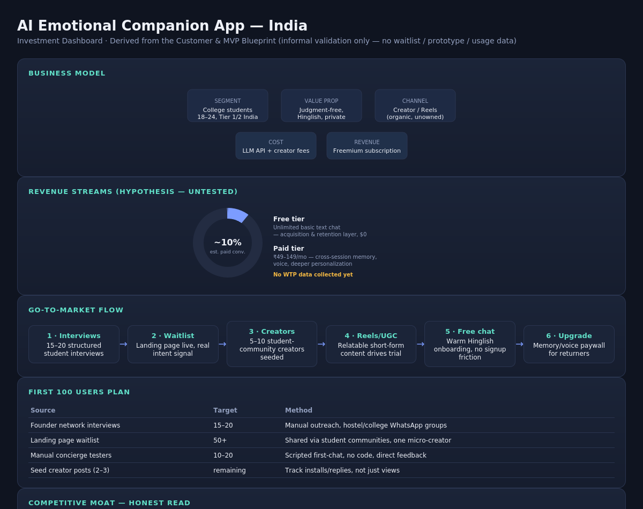

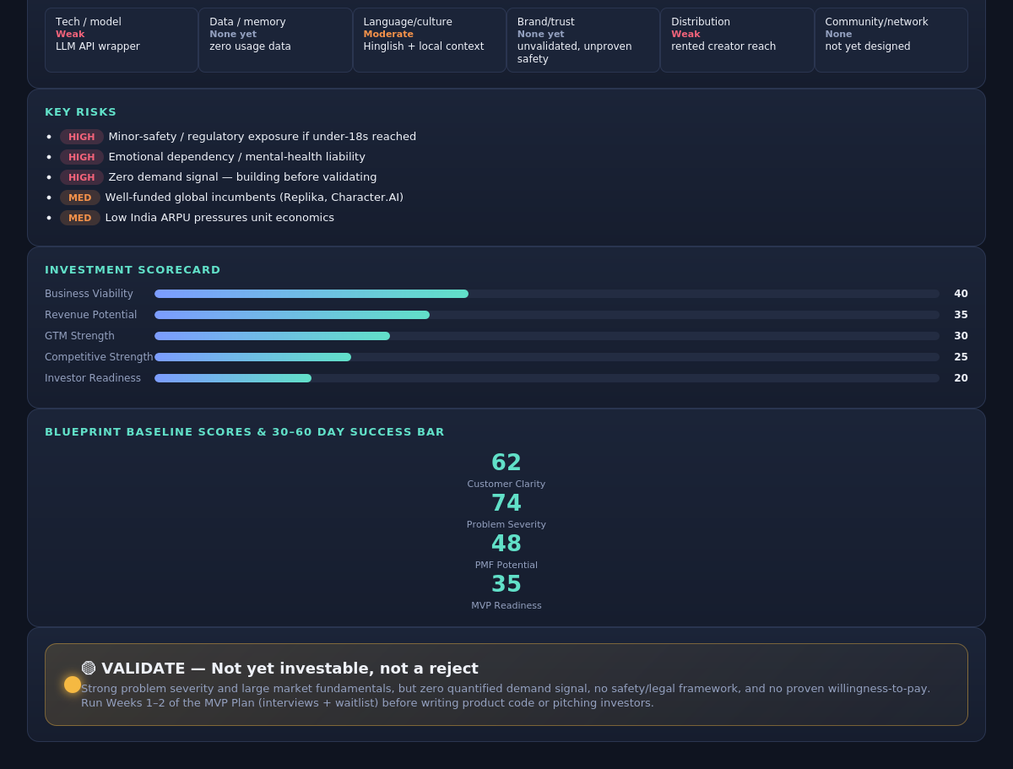

14 · Founder Action Sheet — Top 10 Actions
- Run 15–20 structured customer interviews this week; capture verbatim quotes on language, triggers, and objections.
- Launch a landing page with a waitlist to generate a real, quantified intent signal — not just conversation.
- Draft an age-gating & data-privacy policy and get a legal consult before any public-facing content goes live.
- Script and manually test the first-conversation experience with 5 people — no code required.
- Identify and lock in an LLM API partner rather than building a model in-house.
- Map and approach 2–3 student-community creators for an initial test cohort before scaling to 5–10.
- Define the crisis-detection / redirect-to-help flow before any chat goes live — this is a safety prerequisite, not a feature.
- Set the MVP success metrics (Section 08) and instrument tracking from day one, not after building.
- Hold the line on scope: no voice, avatars, or payments until the core loop proves retention.
- Revisit Go/No-Go at the end of Week 4 using waitlist + tester data — not founder intuition.

15 · Sustainability Verdict
🟡 VALIDATE
This is a promising-but-unvalidated business, not yet a sustainable one: the problem is real and the market is large, but there is no quantified demand signal, no proven willingness-to-pay, and no safety framework for a product carrying real emotional-dependency and minor-safety risk. It can become sustainable only if the free tier is deliberately shaped to leave room for a paid hook, if 2–3 creator tests prove distribution beyond hope, and if the Week 1–2 validation sprint — interviews and a waitlist — produces real numbers before any further product investment is made.

