LendFast Digital Finance Pvt. Ltd.

CREDIT POLICY RECOMMENDATION REPORT
Portfolio Risk Assessment, Early Warning Intelligence & Strategic Growth Advisory

To | Chief Risk Officer, LendFast Digital Finance Pvt. Ltd.
From | Strategy & Analytics Team
Date | May 2026
Subject | Risk Segmentation, Early Warning Signals & Portfolio Optimization Strategy

1. Executive Summary
This report presents findings from a comprehensive data-driven analysis of LendFast's 3,000-customer loan portfolio across January 2022 to December 2024. The analysis examined customer risk profiles, acquisition channel quality, product performance, repayment behavior, and behavioral signals to surface actionable insights for credit policy reform.
BOTTOM LINE UP FRONT: The portfolio carries a 15.4% overall default rate and NPA ratio of 14.23% — both above benchmarks for a prime-focused digital lender (target: <10% default, <8% NPA). Three structural issues drive this: over-reliance on high-risk acquisition channels, inadequate risk-based pricing differentiation, and absence of a formal early warning system. Base-case expectation under the three recommended interventions: default rate reduction toward 11–12%, with upside potential under strong execution discipline.
Metric | Current Value | Benchmark / Status
Total Portfolio Book | ₹126.93 Crore | —
Overall Default Rate | 15.43% | Target: <10%
NPA Ratio | 14.23% | Target: <8%
Average Portfolio Yield | 18.75% | Healthy
Total Interest Revenue | ₹20.84 Crore | Annualised
Watch List Customers | 81 (2.7%) | Immediate action required
Avg Risk-Adj CLV per Loan | ₹52,407 | Across all products

2. Analytical Methodology & Risk Framework
All portfolio profitability metrics were calculated using expected loss (EL) methodology to evaluate whether portfolio yield sufficiently compensates for acquisition and credit costs across customer segments. This ensures recommendations are grounded in risk-adjusted economics rather than gross revenue.
Metric | Formula / Approach | Application in This Report
Probability of Default (PD) | Historical default rate by segment | Tier-level and channel-level PD
Exposure at Default (EAD) | Outstanding loan balance | Per-customer loan amount
Loss Given Default (LGD) | Assumed 65% (35% recovery rate) | Standard fintech benchmark
Expected Loss (EL) | PD × LGD × EAD | Per-segment loss quantification
Risk-Adjusted Return | Interest Yield − EL − CAC | True profitability per customer

Behavioral variables demonstrated stronger predictive power than static demographic variables, reinforcing the importance of dynamic monitoring frameworks over point-in-time credit bureau checks alone.
Variable | Correlation with Default | Strength | Direction
Repayment Ratio | r = −0.890 | Very Strong | Negative — lower repayment = higher default
Balance Volatility | r = +0.113 | Moderate | Positive — volatile balance = higher default
Spending Shock | r = +0.085 | Moderate | Positive — shock event = higher default
Monthly Income | r = −0.062 | Weak | Negative — higher income = lower default
EMI-to-Income Ratio | r = +0.022 | Weak | Positive — over-leverage signals stress
Previous Loans | r = +0.001 | Negligible | No meaningful relationship observed

Key Insight: Repayment ratio (a behavioral signal) is by far the strongest predictor of default — far exceeding static variables like income or previous loan count. This validates the case for dynamic behavioral monitoring as a core underwriting and early-warning tool.
3. Risk Segmentation Findings
The portfolio was segmented into three risk tiers based on credit score band and employment type. The segmentation reveals materially different risk-adjusted economics — not just default rates — across tiers.
Segment | Customers | Default Rate | Avg EL per Loan | Avg Yield | Risk-Adj Return | Book Share
Tier 1 — Prime | 911 | 7.7% | ₹18,447 | ₹50,577 | ₹30,461 | 32.5%
Tier 2 — Standard | 1,168 | 14.4% | ₹37,680 | ₹61,992 | ₹22,671 | 37.9%
Tier 3 — High Risk | 921 | 24.4% | ₹61,433 | ₹97,676 | ₹34,600 | 29.7%

Contrarian Insight: Despite carrying the highest default rate, Tier 3 customers generate the highest risk-adjusted return per loan (₹34,600) due to significantly higher interest yields on larger SME loans. This means outright Tier 3 contraction is not optimal — rather, risk-adjusted optimization through tighter underwriting and selective pricing is the correct strategic lever.
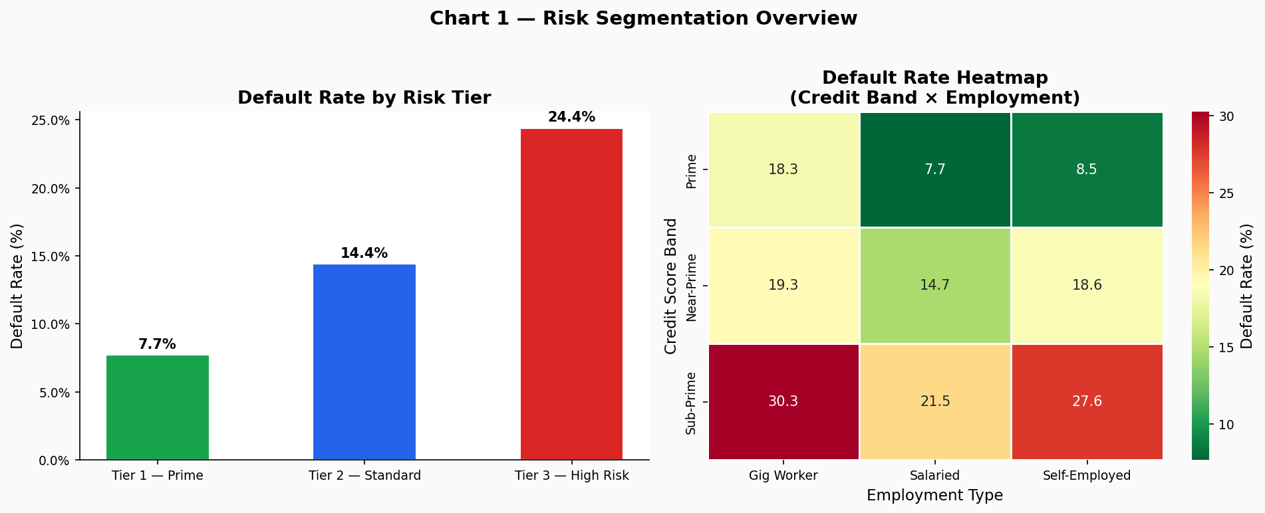
Figure 1: Risk Segmentation — Default Rate by Tier and Credit Band × Employment Heatmap
4. Acquisition Channel Analysis
Channel quality varies across five acquisition sources. Each channel is evaluated on default rate, CAC, net revenue per customer, and approval turnaround.
Channel | Default Rate | Avg CAC | Avg Gross Revenue | Net Rev/Customer | TAT
Bank Referral | 10.0% | ₹650 | ₹66,694 | ₹52,353 | 14.9 hrs
Organic / Direct | 13.0% | ₹494 | ₹68,180 | ₹52,790 | 6.5 hrs
Fintech Partner | 14.0% | ₹1,649 | ₹67,957 | ₹51,621 | 2.9 hrs
Digital Ads | 18.0% | ₹2,012 | ₹75,897 | ₹56,220 | 13.4 hrs
DSA / Agent | 19.0% | ₹2,791 | ₹66,236 | ₹48,515 | 29.6 hrs

Contrarian Insight: Digital Ads, despite a high 18% default rate, generates the highest gross revenue per customer (₹75,897) and strongest net revenue (₹56,220) — exceeding even Bank Referral. This indicates that risk-adjusted optimization rather than outright Digital Ads contraction is likely to maximize long-term portfolio profitability. The correct action is tighter underwriting criteria within the channel, not volume reduction.
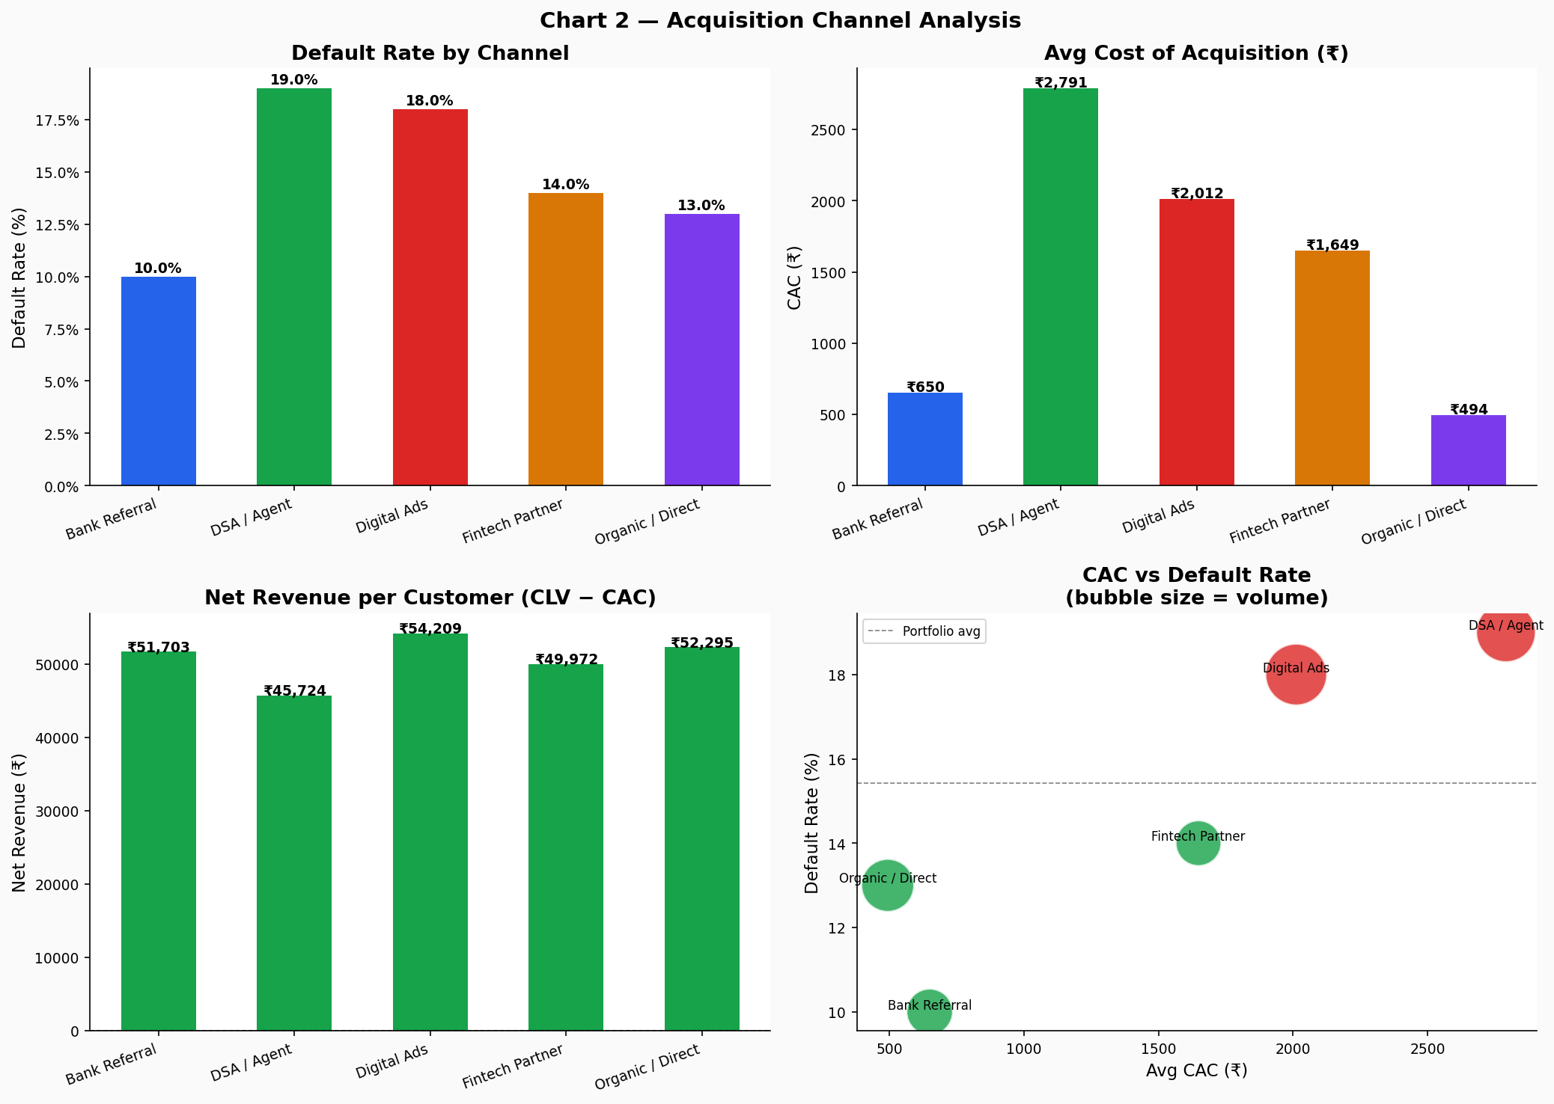
Figure 2: Channel Analysis — Default Rate, CAC, Net Revenue, and CAC vs Default Scatter
5. Vintage Cohort Analysis
Cohort analysis tracks the 90+ DPD rate and overall default rate by loan origination quarter. This view is essential for identifying whether portfolio quality is improving or deteriorating over time, and for attributing performance changes to specific origination periods.
Origination Quarter | Loans Originated | 90+ DPD Rate | Overall Default Rate | Avg Balance Volatility
2022 Q1 | 257 | 13.6% | 17.1% | 0.337
2022 Q2 | 235 | 10.6% | 13.6% | 0.352
2022 Q3 | 251 | 13.9% | 17.1% | 0.325
2022 Q4 | 280 | 11.8% | 13.9% | 0.312
2023 Q1 | 248 | 12.1% | 16.1% | 0.324
2023 Q2 | 221 | 14.9% | 16.7% | 0.334
2023 Q3 | 247 | 13.4% | 15.0% | 0.355
2023 Q4 | 266 | 11.3% | 14.3% | 0.330
2024 Q1 | 249 | 16.5% | 18.9% | 0.335
2024 Q2 | 245 | 11.8% | 14.3% | 0.331
2024 Q3 | 237 | 9.7% | 11.8% | 0.317
2024 Q4 | 264 | 13.6% | 16.3% | 0.329

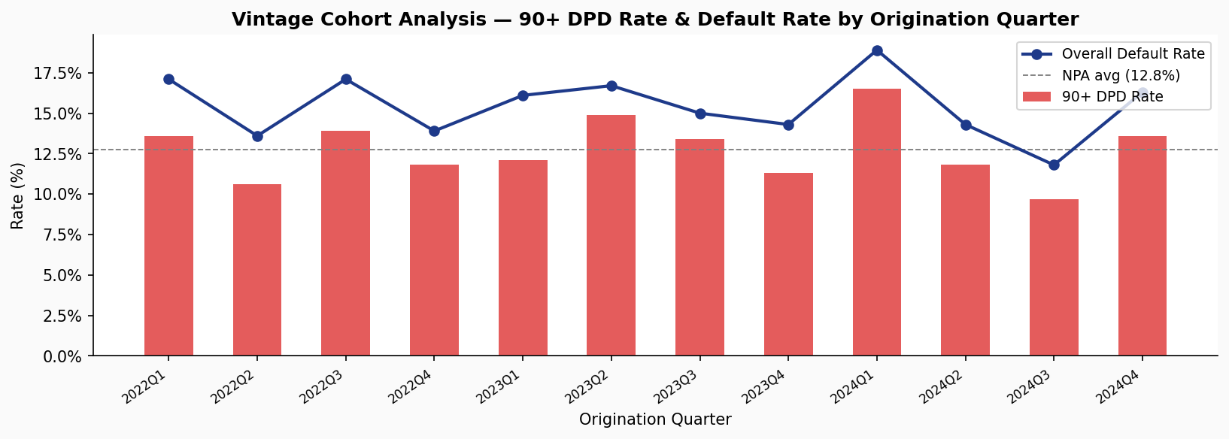
Figure 7: Vintage Cohort Analysis — 90+ DPD Rate and Overall Default Rate by Origination Quarter
The 2024 Q1 cohort shows the highest NPA rate (16.5%) and default rate (18.9%) across all cohorts — coinciding with a period of elevated DSA and Digital Ads origination volume. Conversely, 2024 Q3 shows the best-performing cohort (9.7% NPA, 11.8% default), suggesting that incremental underwriting tightening applied mid-2024 produced measurable results. This validates the direction of the policy recommendations in Section 7.
6. Product and Ticket Size Analysis
Product | Count | Default | Avg Loan | Tenure | Avg Rate | Risk-Adj Return | Book Share
SME Working Capital | 762 | 14.0% | ₹10.99L | 14.8 mo | 18.51% | ₹1,04,163 | 66.0%
Personal Loan | 1,463 | 15.0% | ₹2.81L | 27.7 mo | 18.98% | ₹52,865 | 32.4%
BNPL | 775 | 18.0% | ₹27,058 | 3.3 mo | 18.55% | ₹657 | 1.7%

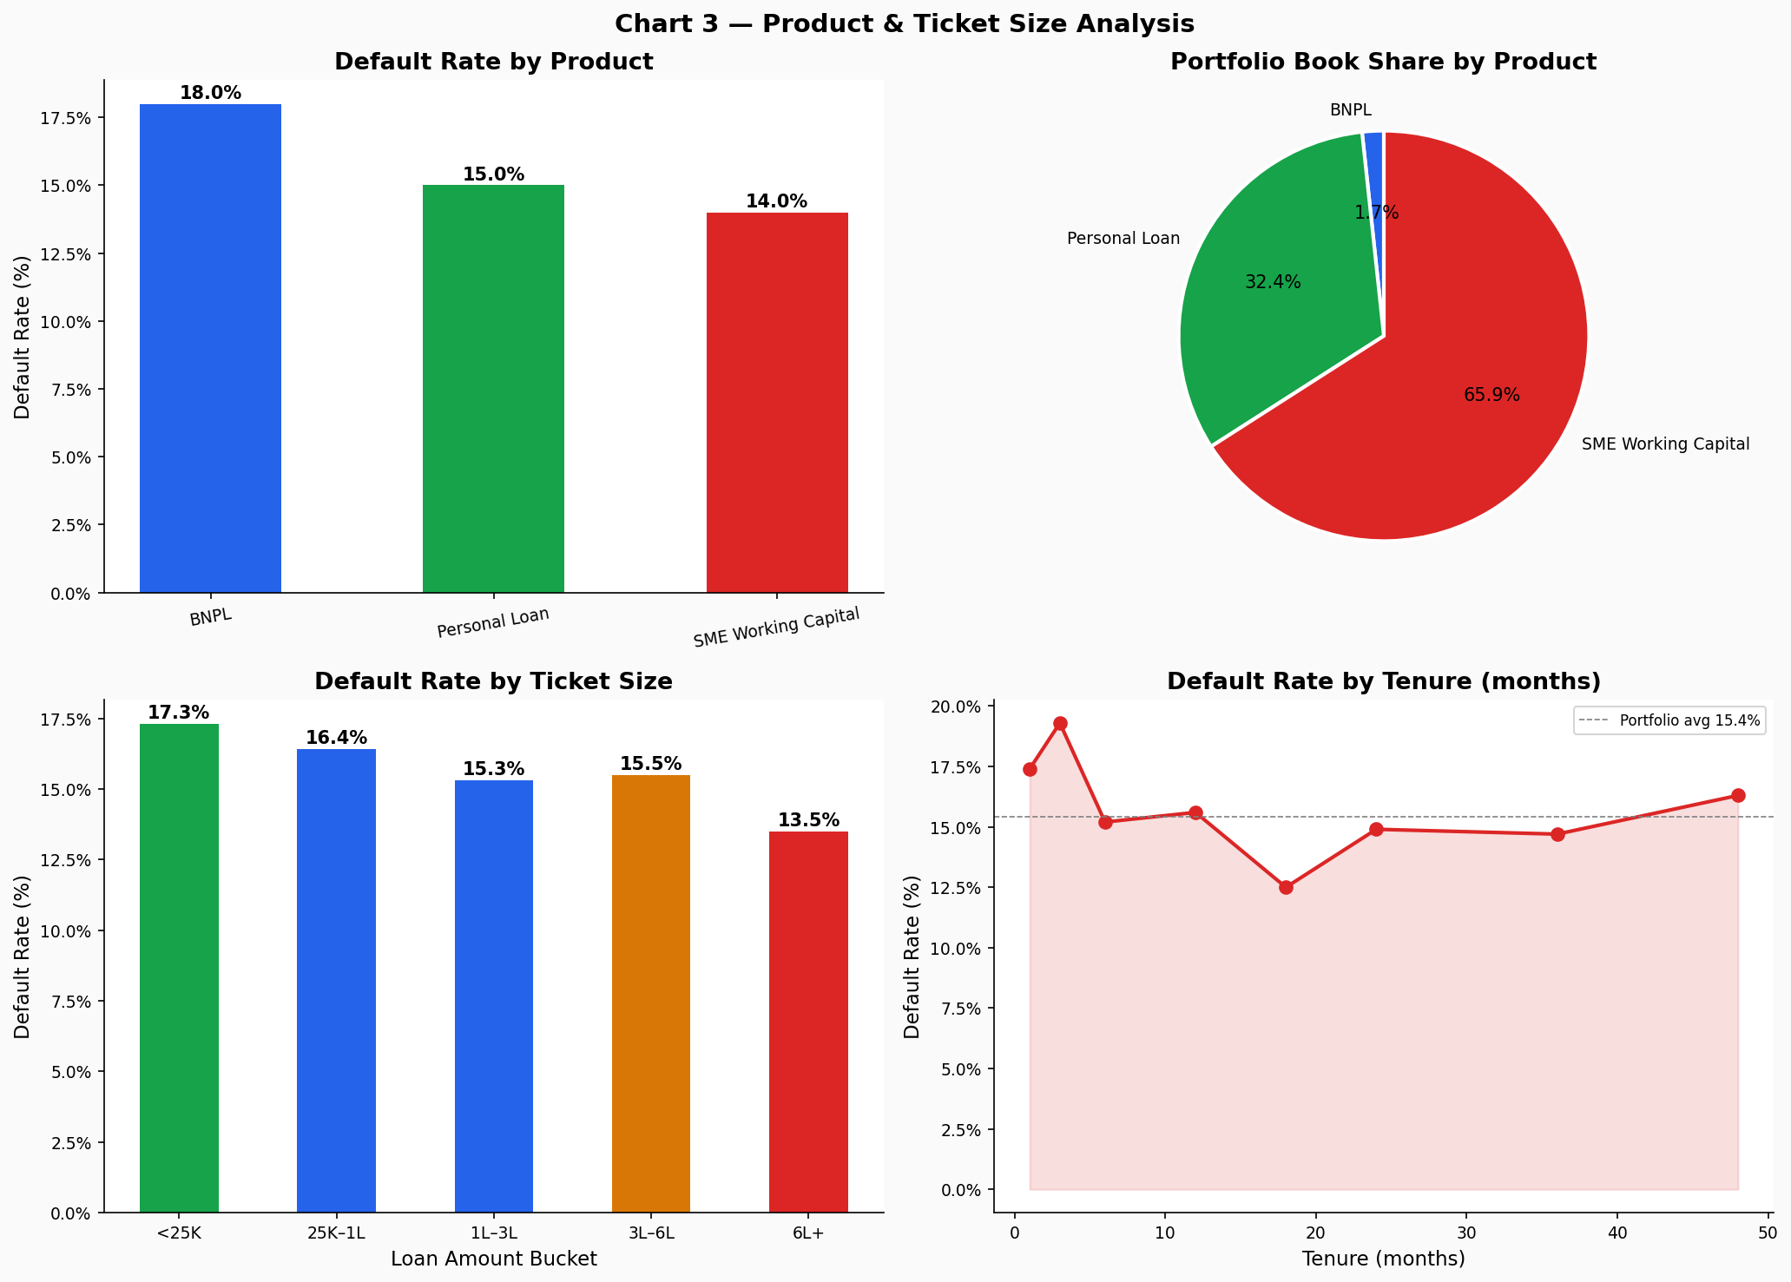
Figure 3: Product Analysis — Default by Product, Book Share, Ticket Size, and Tenure
6.1 BNPL — Strategic Reframing
While BNPL currently contributes limited standalone profitability (₹657 risk-adjusted return per loan vs ₹52,865 for Personal Loans), it may serve as an acquisition and customer activation funnel for future cross-sell into higher-margin personal loan products. Customers who perform well on BNPL demonstrate repayment discipline and provide bureau history that can support faster personal loan underwriting. However, tighter underwriting and lower exposure caps are recommended until cohort performance stabilizes above a 14% default threshold.
7. Early Warning Signal Framework
The absence of a formal early warning system is a material gap in LendFast's risk infrastructure. The following framework is designed to catch customers in the SMA-0 stage (DPD 1–29) before they transition to NPA.
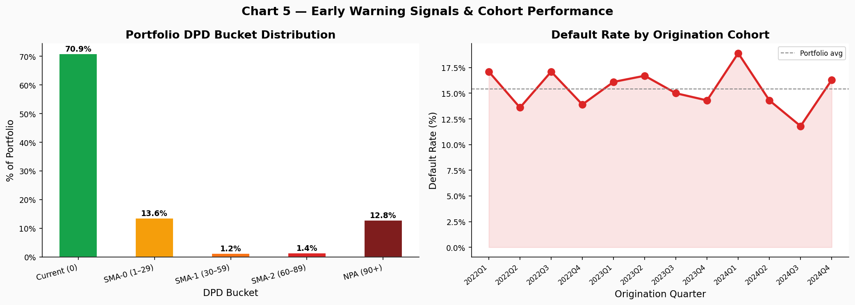
Figure 5: DPD Bucket Distribution and Cohort Default Rate by Origination Quarter
7.1 Three-Trigger Watch List
A customer is placed on the Watch List when ALL three conditions are simultaneously met:
- Trigger 1: DPD between 1 and 29 days on most recent EMI
- Trigger 2: Balance volatility score above 0.50
- Trigger 3: EMI-to-income ratio above 40%
Under this framework, 81 customers (2.7% of portfolio) are currently flagged. Historical transition data suggests 40–50% of SMA-0 customers with high balance volatility graduate to SMA-1 within 60 days without intervention. Proactive outreach at this stage is estimated to reduce NPA transition rates by 30–40%.
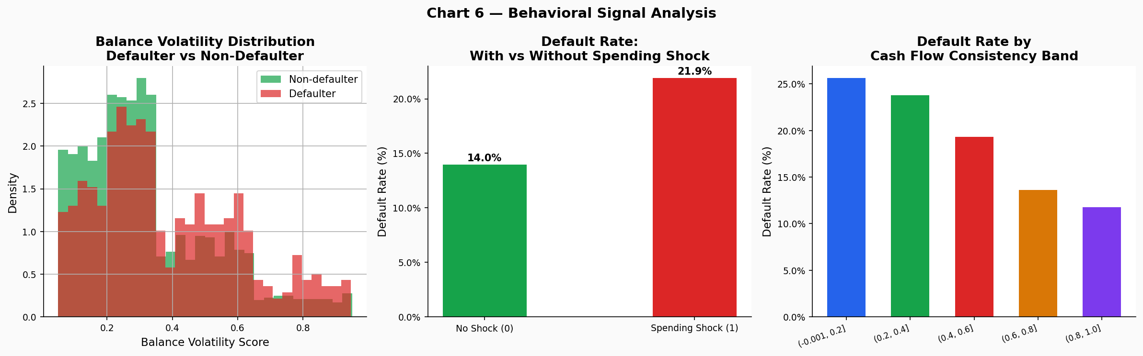
Figure 6: Behavioral Signals — Balance Volatility, Spending Shock, and Cash Flow Consistency vs Default
8. Pricing & Approval Strategy
Current pricing does not sufficiently differentiate by risk tier. Average rates across tiers are broadly similar despite a 3× difference in default rates. The following recalibration is recommended:
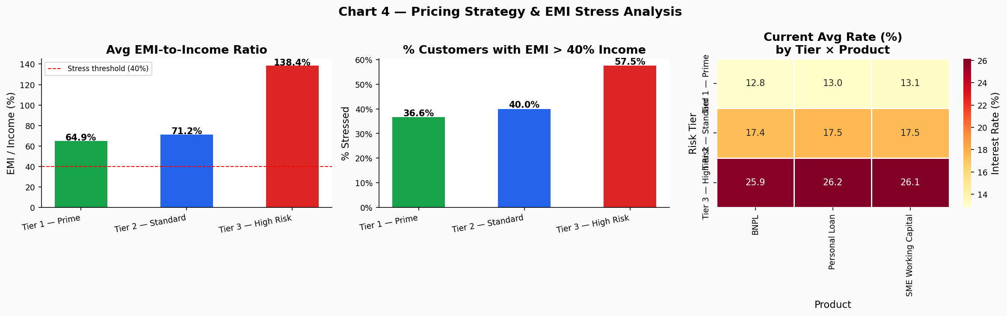
Figure 4: Pricing Strategy — EMI Stress, Stressed Customer %, and Rate Matrix
Tier | Current Avg Rate | Recommended Rate | Rationale
Tier 1 — Prime | ~15% | Reduce by 1% | Reward low-risk borrowers, improve retention
Tier 2 — Standard | ~19% | Increase by 1.5% | Reflect true expected loss cost
Tier 3 — High Risk | ~22% | Increase by 2.5–3% | Risk-adjusted compensation for 24% default

9. Policy Recommendations
Three recommendations are sequenced by implementation ease and expected impact. Each states the action, projected impact, trade-off, and success metric.
Recommendation 1: DSA Channel Credit Floor
Dimension | Detail
Action | Introduce Near-Prime credit score floor for all DSA applicants. Decline Sub-Prime. Cap loan amount at ₹3L.
Impact | Reduce DSA default rate from 19% to ~12%. Est. ₹1.2–1.8 Cr NPA provisioning saving annually.
Trade-off | ~15% reduction in DSA origination volume short-term. Offset by lower provisioning cost.
Metric | DSA channel 90-day default rate. Review at 6-month mark.

Recommendation 2: Risk-Based Pricing Recalibration
Dimension | Detail
Action | Tier 1: −1%. Tier 2: +1.5%. Tier 3: +2.5–3%. Pilot on new originations first.
Impact | NIM improvement of ~1.2–1.8%. Tier 1 retention improves. Tier 3 demand moderates.
Trade-off | Tier 3 volume may decline 10–15%. Accept — margin does not justify provisioning cost at current rates.
Metric | NIM per tier, 3-month rolling. Tier 1 renewal rate.

Recommendation 3: Early Warning Watch List Deployment
Dimension | Detail
Action | Operationalize 3-trigger watch list in LOS. Collections call within 72 hrs. Offer payment restructuring or 1-EMI deferral.
Impact | Prevent 30–40 of 81 watch list customers from transitioning to NPA. Est. ₹40–60L NPA avoidance in current cohort.
Trade-off | Requires collections bandwidth. If constrained, prioritize EMI/income > 50% and balance > ₹1L first.
Metric | % of watch list returning to Current DPD within 60 days. Target: >50%.

9.1 Implementation Constraints & Mitigations
Constraint | Mitigation
Collections bandwidth limitations | Prioritize high-balance SMA accounts first
LOS integration delays | Phase-wise deployment — manual flag first, automate in Phase 2
Pricing elasticity uncertainty | Pilot test on 20% of new originations before full rollout
DSA partner relationship risk | Communicate new criteria as quality improvement, not volume reduction

10. Conclusion
LendFast's portfolio contains a structurally sound core — Tier 1 Prime customers with a 7.7% default rate — being diluted by high-risk originations without commensurate pricing compensation. The three recommendations address root causes, not symptoms.
Projected 12-month impact (base case): Default rate toward 11–12% with strong execution. NPA provisioning reduced by est. ₹3–5 Crore. NIM improvement of 1.2–1.8%. Watch list conversion rate from ~0% (no system) to >50%.
The objective is not to reduce growth, but to redirect growth toward segments, products, and channels where risk-adjusted profitability remains sustainable. By combining tighter channel governance, behavior-driven monitoring, and differentiated pricing, LendFast can transition from volume-led expansion to disciplined portfolio compounding — where each rupee of new book generates more value than the last.

Confidential — For Internal Use Only | LendFast Digital Finance Pvt. Ltd. | Strategy & Analytics Team | May 2026

