House Price Prediction using Data Analytics with AI
Project Report

Submitted by: Harsh Sinha
Haldia Institute of Technology
IBM SkillsBuild Data Analytics with AI Internship 2026
AICTE | BharatCares

1. Introduction
Buying or selling a house is one of the biggest financial decisions most people make, and the price depends on many factors at once. This project uses data analytics and machine learning to estimate the price of a house from its basic details such as city, area, number of rooms, age and location quality. The final model is wrapped in a small web application so anyone can try it without writing code.

2. Objectives
To clean and explore a housing dataset, find which factors affect price the most, train and compare several regression models, pick the best one, and deploy it as a simple web app with a Flask backend.

3. Dataset
The dataset has 1500 records with the columns city, area_sqft, bedrooms, bathrooms, age_years, location_score, parking and price (target). It is generated by data/generate_data.py with realistic price patterns and a few deliberately missing values, so the same code also works on a real dataset with the same columns. The data was split into 1200 training rows and 300 test rows.

4. Tools and technologies
Python, Pandas and NumPy for data handling, Matplotlib for charts, Scikit-learn for modelling, Joblib for saving the model, Flask for the backend, HTML/CSS/JavaScript for the frontend, and Jupyter Notebook for the analysis. AI-assisted coding tools were used to speed up development and debugging.

5. Methodology
Data cleaning: duplicate rows were dropped, missing numeric values were filled with the median and missing city values with the most common city. Exploration: price distribution, average price by city and a correlation heatmap were studied. Preprocessing: numeric columns were standardised and the city column was one-hot encoded inside a single Scikit-learn pipeline, so the same steps run during prediction. Modelling: Linear Regression, Ridge, Lasso, Random Forest and Gradient Boosting were trained and compared using R2, MAE, RMSE and 5-fold cross-validation.

6. Exploratory data analysis
The charts below summarise the main patterns in the data. Prices are right-skewed, differ a lot between cities, and are strongly related to area and location score.
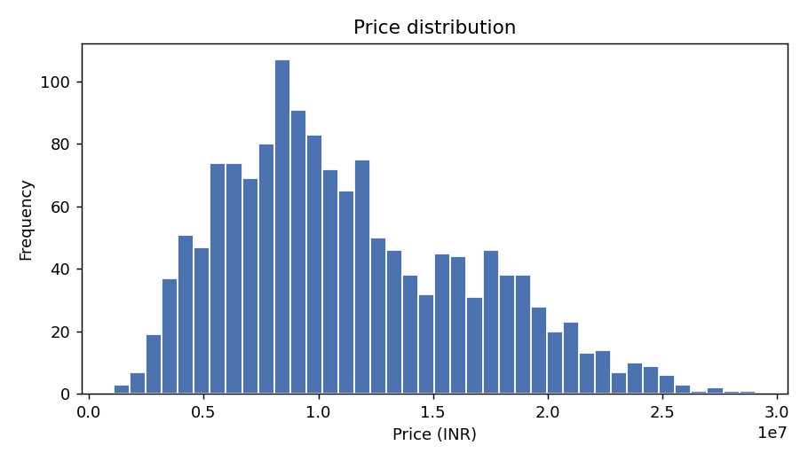
Figure 1: Price distribution
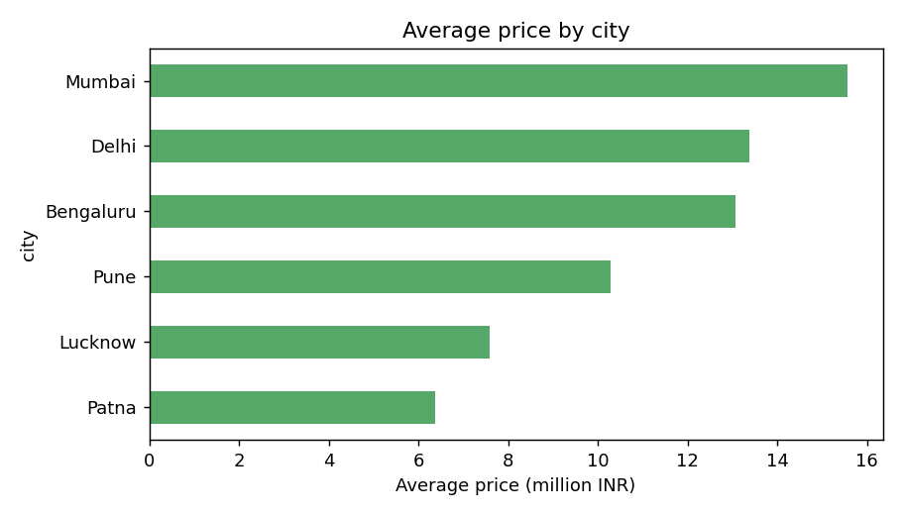
Figure 2: Average price by city
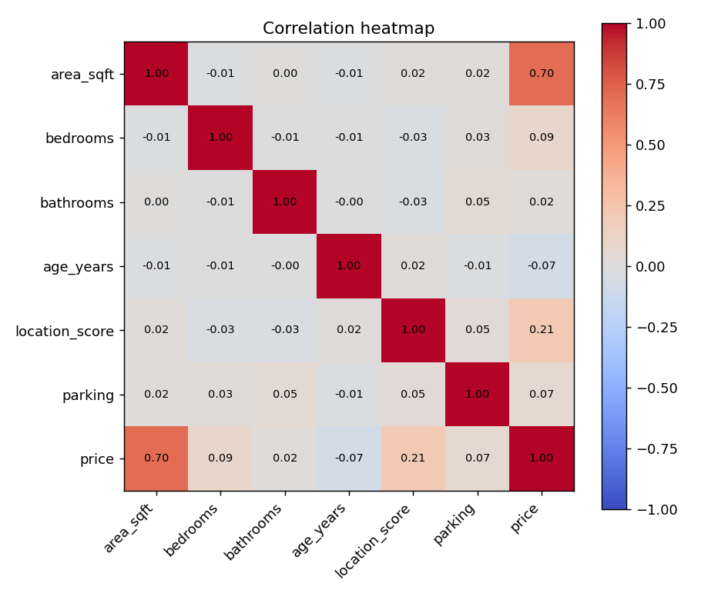
Figure 3: Correlation heatmap

7. Results
Gradient Boosting gave the best cross-validated score and was selected as the final model. On the unseen test set it reached an R2 of 0.9814, a mean absolute error of about Rs 551,906 and an RMSE of about Rs 715,974. The most influential features were area_sqft, city, location_score.
Model | R2 (test) | CV R2 | MAE | RMSE
Gradient Boosting | 0.9814 | 0.961 | 551,906 | 715,974
Random Forest | 0.9735 | 0.9506 | 630,541 | 854,639
Linear Regression | 0.9429 | 0.9224 | 961,331 | 1,254,247
Lasso | 0.9429 | 0.9224 | 961,331 | 1,254,247
Ridge | 0.9429 | 0.9224 | 961,734 | 1,254,078

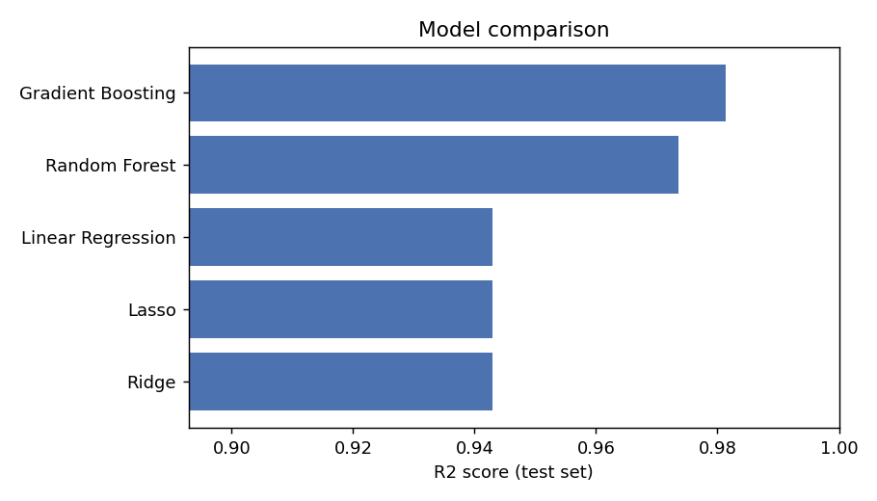
Figure 4: Model comparison (R2 on test data)
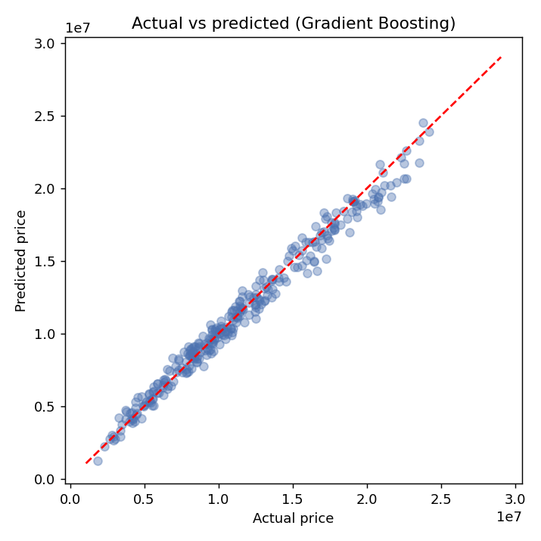
Figure 5: Actual vs predicted price
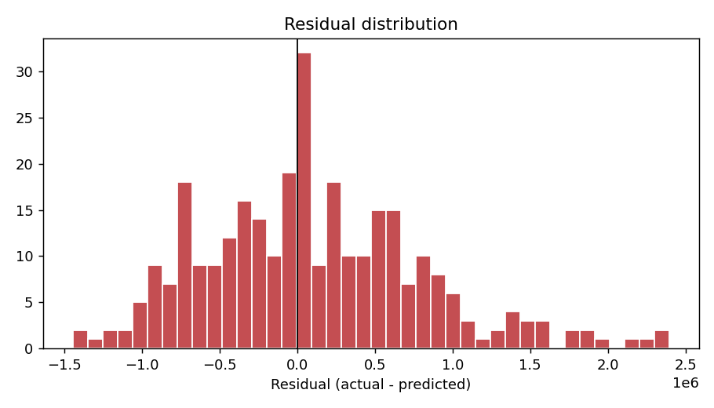
Figure 6: Residual distribution
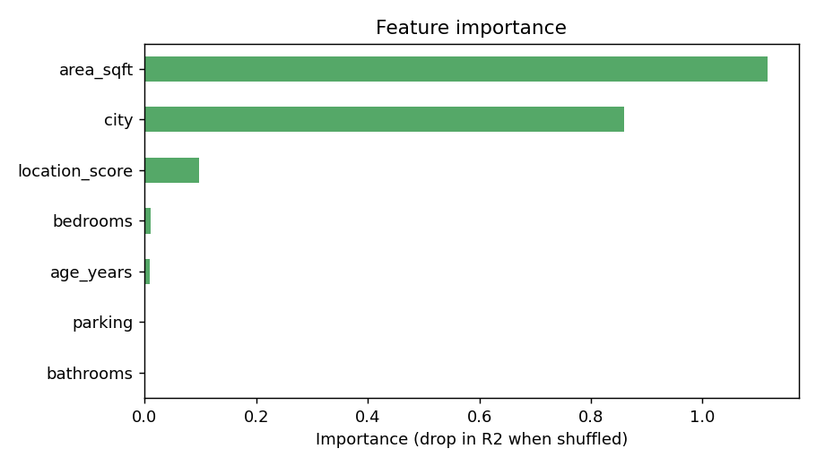
Figure 7: Feature importance

8. Web application
The trained pipeline is loaded by a Flask app (backend/app.py). The /predict endpoint validates the input, runs the model and returns the estimated price as JSON. The frontend is a single HTML page with a form where the user picks a city, enters the property details and sees the price.

9. Conclusion
The project shows the full workflow of a small analytics problem: cleaning, exploring, modelling, comparing and deploying. The model predicts prices well on this dataset. Because the data is synthetic, the scores will be lower on real market data, where more factors such as locality, builder and market trends matter.

10. Future scope
Use a real-world dataset, add more features such as locality and furnishing, tune hyperparameters with GridSearchCV, and deploy the app on a cloud platform.

