Arrays, String, Pointers & Reference

INDEX

Table of Contents

Arrays in C++ 2

Array Declaration & Initialization 2

2D Array Declaration & Initialization 2

3D Array Declaration & Initialization 4

Memory Layout 5

Array Traversal in C++ 6

Access elements in a 2D array 9

Passing 2D arrays as arguments in C++ 10

Strings in C++ 13

C-style (character arrays and literals) 13

String Class in C++ STL 14

String manipulations 15

Pointers & References in C++ 20

Pointers vs References 20

Pointers 21

Drawbacks of Pointers 21

Use case 21

Reference 25

Use case 25

Pointers vs Array 26

Types of Function Call (References v/s Pointers) 28

Call-by-Value 28

Call-by-Reference with Pointer Arguments 29

Call-by-Reference with Reference Arguments 30

Array Name as Pointers 31

Pointers and String literals 32

String Literals as Pointers 32

Modifiable Strings 32

C++ string Class 33

Pointers to pointers 34

Void Pointers 35

NULL Pointer 36

Issue with NULL Pointer 37

# Arrays in C++

Array is a collection of similar types of data elements, stored at continuous memory locations. It is a built-in data type. We cannot change the size and type of arrays after its declaration.

## Array Declaration & Initialization

## 2D Array Declaration & Initialization

A 2D array defined as follows can be viewed as a table of three rows and four columns. There are various ways in which a 2D Array can be initialized.

Each set of inner braces represents one row



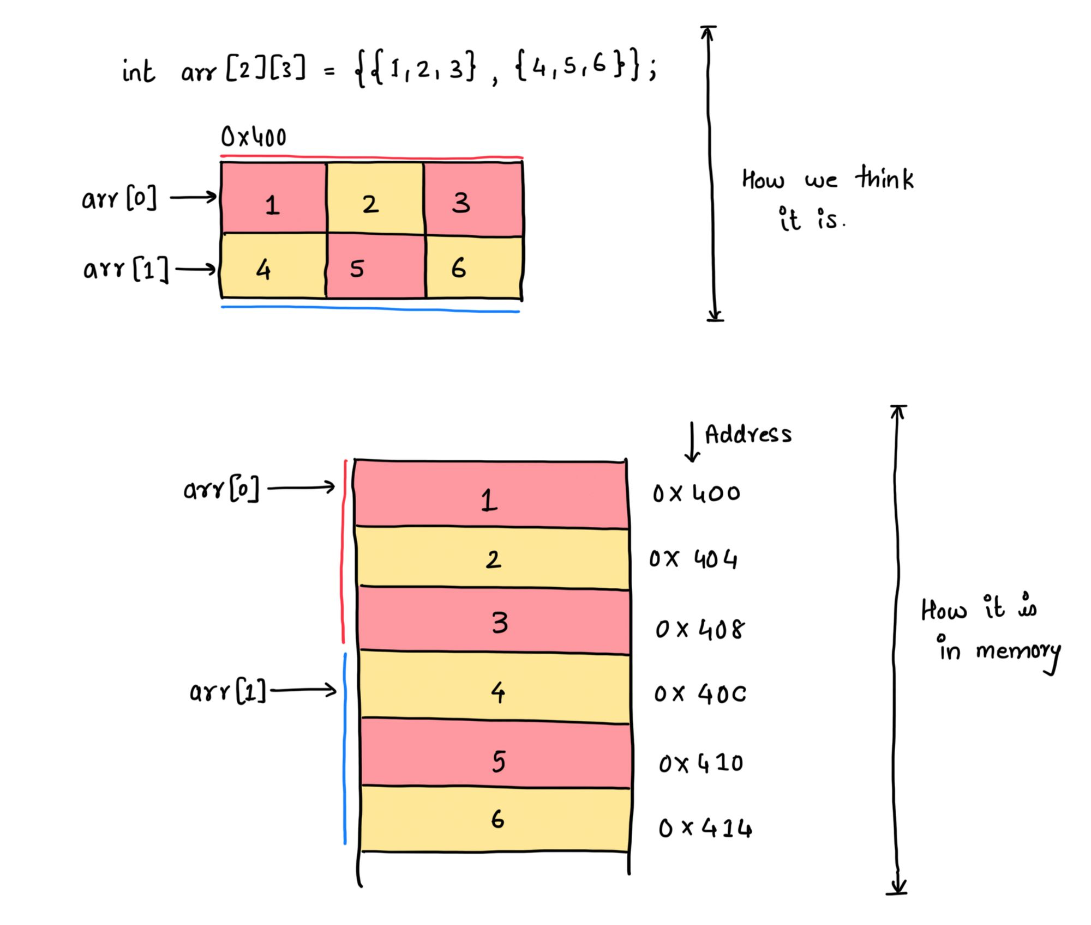

## 3D Array Declaration & Initialization

## Memory Layout

A contiguous memory space is allocated for array elements and can be accessed via an array index.

## Array Traversal in C++

There are three ways to traverse the elements of an array in C++:

1. Using for loop

1. Using for_each loop **(C++11 and later)**

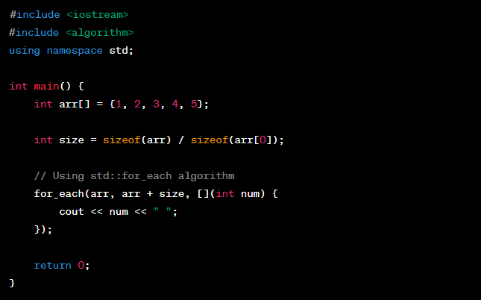

TODO: Difference between for_each and range-based loop because everywhere both have same example.

1. using range-based for loop

**int var** will hold each element of the array arr in each iteration.

Works same as above. Here, the **auto** keyword is used for type inference. It allows the compiler to automatically deduce the appropriate data type for the loop variable var based on the type of the elements in the array.

**const auto &** syntax is used to capture each element by reference for efficiency and to indicate that the loop won't modify the elements.

Using const auto &var reference, var will directly access the read only memory for each element of the array in each iteration but won't modify the elements.

Using auto &var reference, var will directly access the memory for each element of the array in each iteration and do post-increments.

OP



## Access elements in a 2D array

**Common way to access elements in a 2D array : *(arr + x * m + y)**,is used to access the value at the address corresponding to the element arr[x][y] in a 2D array represented as a contiguous block of memory.

Here's a breakdown of how the formula works:

* arr is the base address of the 2D array.
* x represents the row index.
* m is the number of columns in each row.
* y represents the column index.

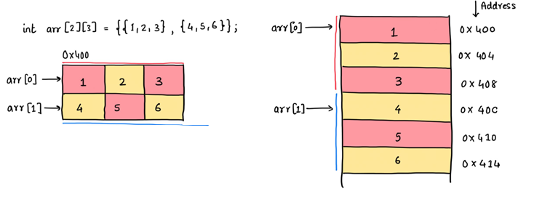

## Passing 2D arrays as arguments in C++

Specify the size of columns of 2D array

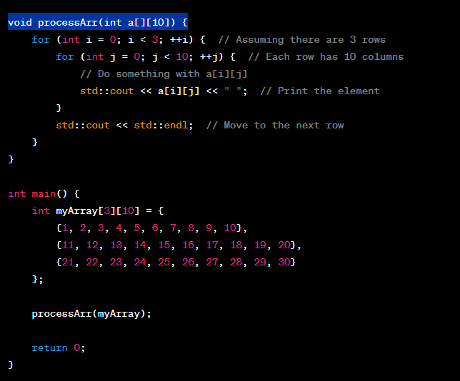

OP



Pass array containing pointers

OP



Pass a pointer to a pointer

OP



# Strings in C++

There are mainly 2 ways of handling strings in C++.

1. **C-style** strings or character arrays.
2. string template class

## C-style (character arrays and literals)

## String Class in C++ STL

### String manipulations

**Remember**

An **iterator** is an object (like a pointer) that points to an element inside the container. Containers are

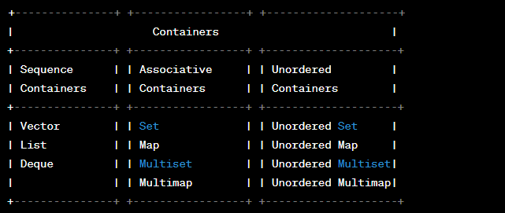

Each container class in the C++ Standard Library provides its own specific type of iterator. Few Examples:

|  |  |
| --- | --- |
| **vector<int>::iterator** | **list<double>::iterator** |
| **set<std::string>::iterator** | **map<int, std::string>::iterator** |

Available functions in the std::string class which can be used for string manipulations.

**String Iteration**

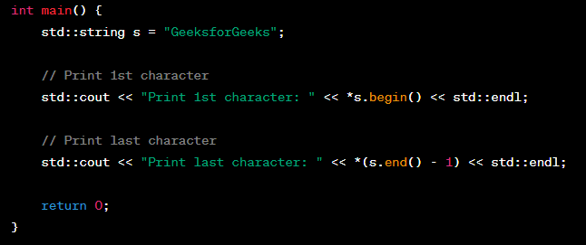

OP

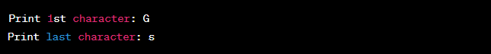

**String Length and Capacity**

Size: size refers to the number of characters in the string.

Capacity:

* The capacity of a container refers to the amount of memory that has been allocated for it, which determines how many elements it can hold efficiently.
* Capacity refers to the number of characters that the **string can hold without needing to reallocate memory**.
* When appending characters to a string, if the size exceeds the capacity, the string might need to be reallocated to accommodate the new characters.

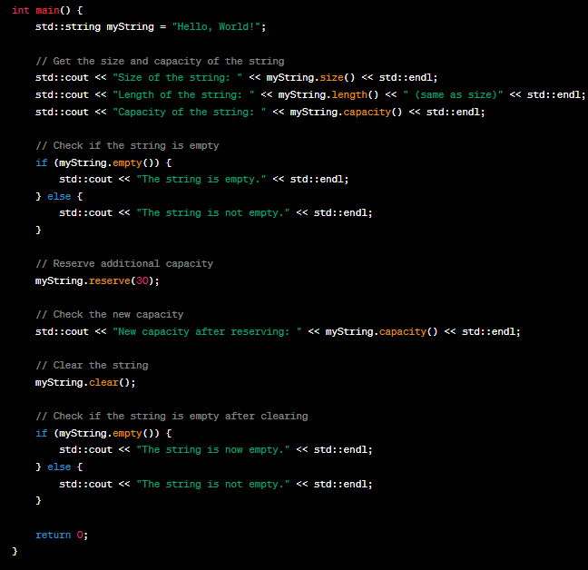

OP

**String Concatenation and Append**

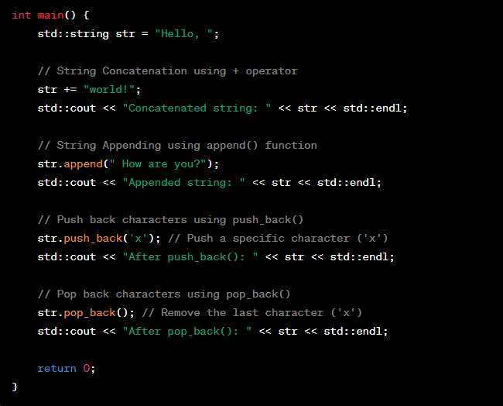

OP

**insert**: It used to insert characters or a substring into a string at a specified position.

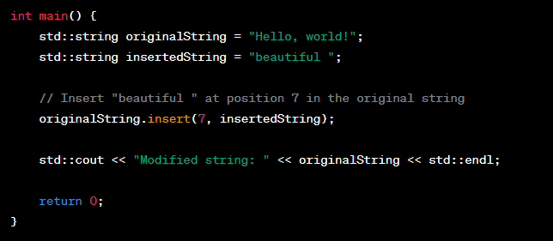

OP

**find and rfind**:

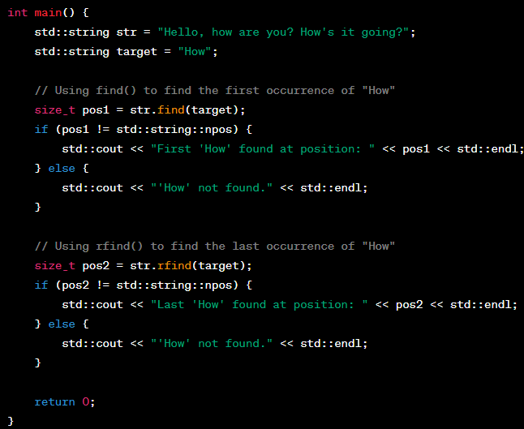

OP



**substr**:

OP



**find_first_of and find_last_of:**

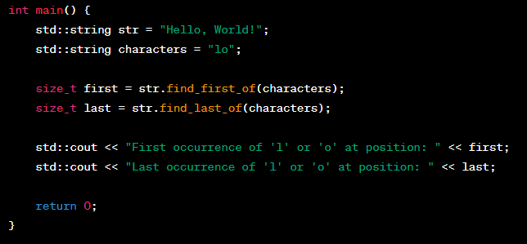

OP

**compare**:

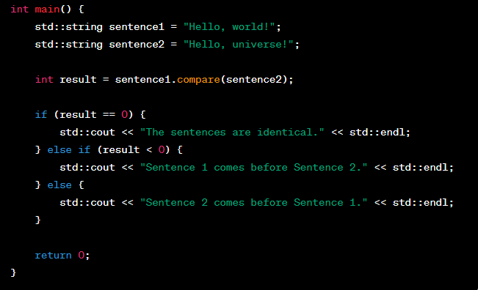

OP



TODO: Confusion with find_first_of and find_last_of – if it searches first char in the string then why it takes string as argument. It should take one char only.

# Pointers & References in C++

## Pointers vs References

|  |  |
| --- | --- |
| **Pointers** | **Reference** |
| Pointer is a variable that **holds the memory address** of another variable. | A reference is an alias for an existing variable. It's essentially **another name** for the same memory location. |
| Pointers **can be reassigned** to point to different memory locations. | References must be initialized when declared, and they **cannot be reassigned** to refer to a different variable. |
| They can be **declared without initialization** and may contain garbage values. | They cannot be declared without initialization. |
| Pointer arithmetic is possible, allowing you to navigate through memory based on the size of the data type. | There is no pointer arithmetic with references. |
| Pointers can be made to **point to nullptr** to indicate they are not currently pointing to any valid memory location. | References **cannot be null or uninitialized**. They must always refer to a valid variable. |
| Pointers can be used for implementing data structures like linked lists, trees, and more. | References are useful when you want to avoid copying data. |

Pointers: Pointers is a variable that holds the memory address of another variable.

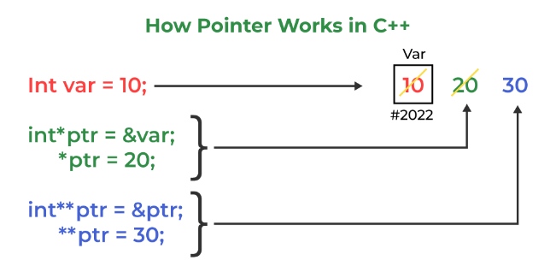

### Drawbacks of Pointers

* Segmentation fault can occur due to uninitialized pointer.
* If we forgot to deallocate a memory, then it will lead to a memory leak.

Use case:

* **Dynamic Memory Allocation**: This is useful when you need memory whose size is determined at runtime.

* **Passing Parameters by Reference**: It allow the function to modify the original variable.

* **Pointers to Functions**: Pointers can be used to pass data structures or large objects efficiently to functions without making copies.

* **Array Manipulation**

OP



* **Working with Hardware**

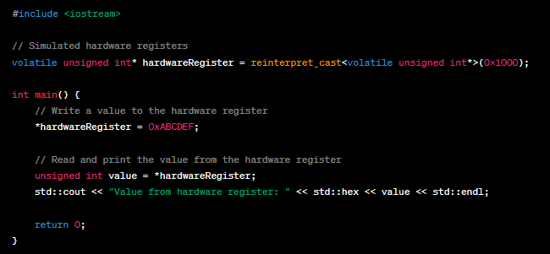

OP



* **Working with Dynamic Data Structures**: Pointers are essential when creating dynamic data structures like linked lists, trees, and graphs.

* **Passing and Returning Multiple Values**

OP



* **Pointer Arithmetic**: Pointers allow you to perform arithmetic operations on memory addresses, which can be useful for traversing arrays or linked data structures.
  + incremented ( ++ )
  + decremented ( -- )
  + an integer may be added to a pointer ( + or += )
  + an integer may be subtracted from a pointer ( - or -= )
  + difference between two pointers (p1-p2)

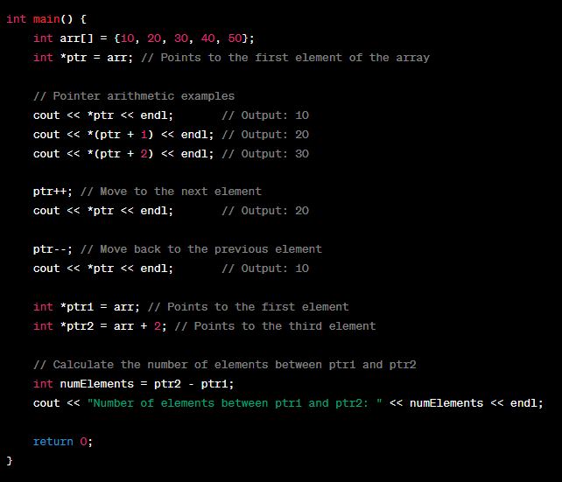

OP

Reference: References serve a different purpose than pointers. They **provide a convenient and safer way to work with values by creating an alias** for an existing variable.

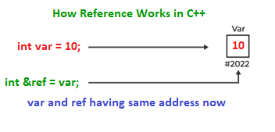

Use case:

* **Function Parameter Passing**: References allow you to pass variables to functions by reference, enabling the function to modify the original variable's value.

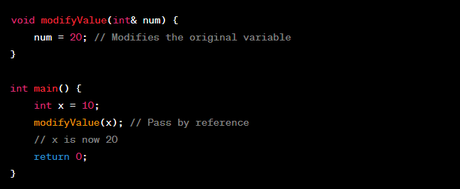

* **Avoiding Copying**: Passing large objects or structures by reference avoids copying their contents.

* **Range-Based Loops**: References are often used in range-based loops to directly access and modify elements in containers.

* **Returning Multiple Values**: Functions can return multiple values through references, providing a convenient way to communicate results.

## Pointers vs Array

**Remember**

**Why can't I increment an array?** It's because array is treated as a constant pointer. There is a reason for it. Array variable is supposed to point to the first element of the array or first memory instance of the block of the contiguous memory locations in which it is stored. So, if we will have the liberty to change(increment or decrement ) the array pointer, it won't point to the first memory location of the block. Thus, it will lose its purpose.

We should write an expression after * otherwise it will invoke error. This expression will invoke error: **++ptr\***, **ptr*++** and **ptr++* (**for both array pointer or simple pointer).

**++ and * has same precedence so it will execute according to associativity which is Right to Left.**



**Possible increment or decrement operation on Array**

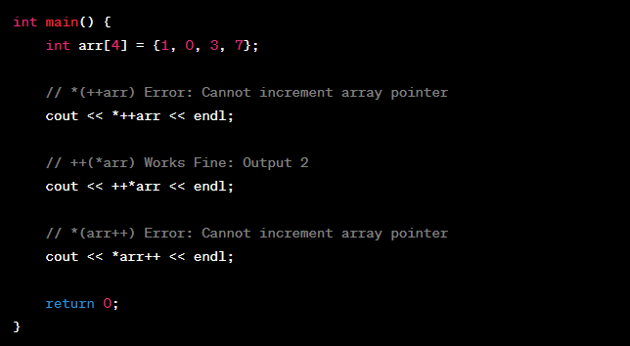

OP

**Possible increment or decrement operation on Pointers**

OP

**Remember**

**What is l-value and r-value?**

* The term l-value and r-value are named because of their appearance in the expression.
* L-value appeared on the left side of the assignment operator. Basically, in general case variable is considered as L-value in which we are going to assign some values.
* R-value appeared on the right side of the assignment operator.
* **Example**: In this expression “x = 15”, x is considered as l-value and 15 is as r-value.

## Types of Function Call (References v/s Pointers)

### Call-by-Value

### Call-by-Reference with Pointer Arguments

### Call-by-Reference with Reference Arguments

TODO: Const & R Value References

## Array Name as Pointers

An array name contains the address of first element of the array which acts like constant pointer. if we have an array named val then val and &val[0] can be used interchangeably.

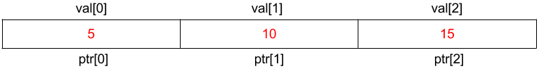

OP



## Pointers and String literals

### String Literals as Pointers

if you declare a pointer as **char* str = "Hello";** without the const qualifier, you might assume that it should be writable. However, this is a **common misconception** when dealing with string literals in C++.

Even though you declare the pointer without const, the actual string literal "Hello" remains in read-only memory.



To avoid confusion and potential issues, it's a good practice to declare the pointer to a string literal as **const char* str = "Hello";** or use a **modifiable character array** or the **std::string class** for manipulation.



|  |  |  |  |  |  |
| --- | --- | --- | --- | --- | --- |
| str[0] | str[1] | str[2] | str[3] | str[4] | str[5] |
| |  |  |  |  |  |  | | --- | --- | --- | --- | --- | --- | | ‘H’ | ‘e’ | ‘l’ | ‘l’ | ‘o’ | ‘\0’ | | | | | | |
| 1800 | 1801 | 1802 | 1803 | 1804 | 1805 |

### Modifiable Strings

If you want to create a modifiable string, you need to allocate memory for it explicitly and then copy the content of the string literal into that memory.



### C++ string Class

it's often recommended to use the std::string class for string manipulation, as it provides a more convenient and safer way to work with strings. It manages memory automatically and allows easy string manipulation without the concerns of memory management and null-termination.

OP



## Pointers to pointers

**Pointers to pointers** are a concept in C++ where you use a pointer to store the memory address of another pointer.

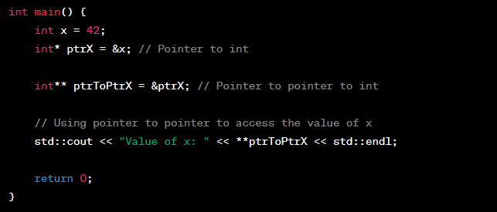

OP



## Void Pointers

**void\*** is a special type of pointer in C++ that **doesn't have a specific data type associated with it**. It can **point to memory locations of any type**. This flexibility comes with some challenges, as you need to be careful when using void pointers to ensure proper type casting when dereferencing or performing pointer arithmetic. Here's an example to illustrate void pointers:

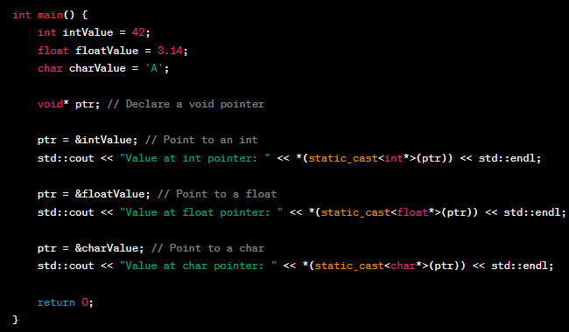

OP

## NULL Pointer

A NULL pointer, often represented as **nullptr**, is a pointer that **doesn't point to any valid memory address**. Dereferencing a NULL pointer usually leads to **undefined behaviour, crashes, or memory access violations**.

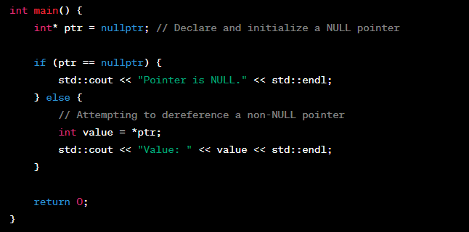

OP



As a side note, **nullptr is** **convertible to bool**.

### Issue with NULL Pointer

In C++, NULL is a macro defined to have 0 value, it may mean **int as well as int\*** causing ambiguity.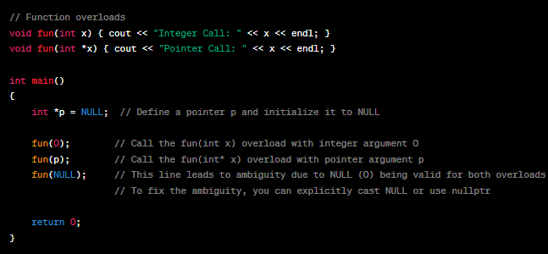

OP

To fix this,



or

