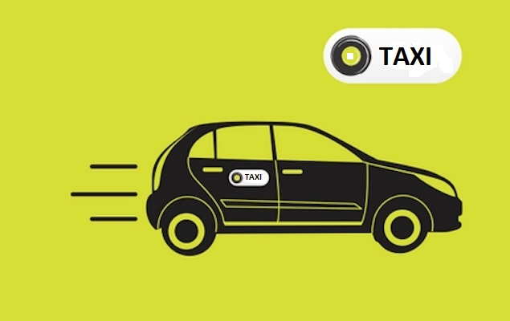

HARSH SRIVASTAVA – 117CS0755

MANISH KUMAR SHAH – 117CS0754

JULI KUMARI – 117CS0753

**TAXI DATABASE MANAGEMNET SYSTEM**

**PROBLEM STATEMENT**

There is nothing more convenient than getting the right thing at the right moment. And isn’t it all for which we all work hard and try to acquire all kind of resources so that we can get whenever whatever we want. With the growing complexities in metro cities, frequent commutation from one place to another has become a challenge. Be it a daily job or an occasional emergency, your own car may not always be the best option to serve all these purposes. And that is where the role of professional taxi services comes in.

The platform shall offer an administration interface where the taxi company can manage the content, and access all bookings and customer information. More and more Taxi companies are looking for integrated taxi booking systems as it makes life much easier for (1) The traveller - this is highly important and in today's internet age people should be able to book taxis online without having to pick up the phone and (2) the taxi company as all their bookings are now managed via an automated system which means they have an electronic record of upcoming and old bookings

 The individual who want to hire/rent a car must first contact the cab hiring company for the desire vehicle. This can be done online. At this point, this person has to supply some information such as: dates of rental, and type of car. Most companies throughout the industry make a profit based of the type of cars. The hiring cabs are categorized into economy, compact, compact premium; premium and luxury & customers are free to choose any car of their choice based on their purse and availability of such car at the time of reservation.

 This project intends to introduce more user friendly in the various activities such as record updating, maintenance, and searching. The objective and scope of our project Taxi Management System is to record the details various activities of user. It will simplify the task and reduce the paper work. To produce a web-based system that allow customer to register and reserve cab online

A Taxi Management System has to keep information about their customers. They must offer the customers their choice in car. Also based on availability the car must be booked for the corresponding customer with highest rated driver. A good management system takes good care of their drivers and their cars. The complete profile of Drivers and Cars must be stored in the database. Finally a reasonable fair should be charged and accounted. It is important to store details like method of payment, receipt no, distance travelled etc..

Following could be some of the possible info that could be collected:

1. CUSTOMER: Address, ID, Phone No.
2. DRIVER: ID, Car Name, Source, Destination, Contact
3. CAR : Name, Type, Cost per hour

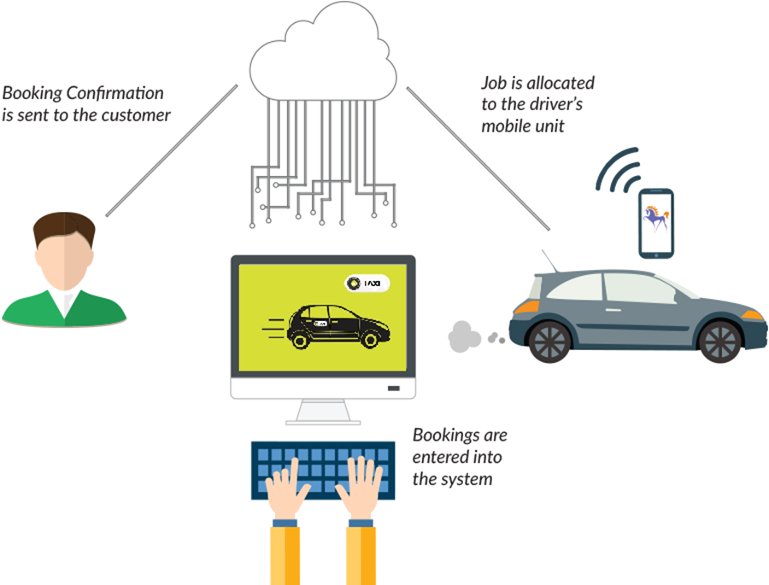

**LOGICAL SCHEMA**

**ER DIAGRAM** 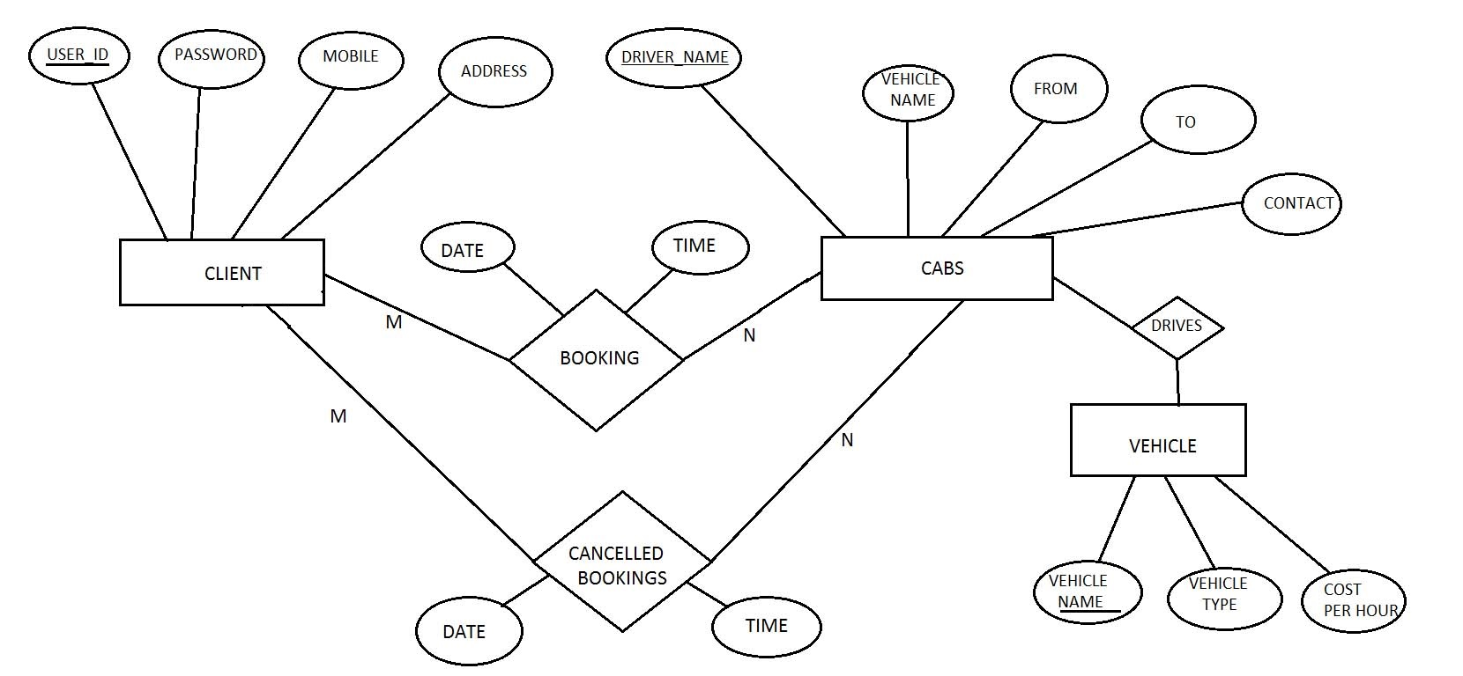

**ADMIN**

**USER ID (PRIMARY KEY)**

**PASSWORD**

**CLIENT**

**USERID (PRIMARY KEY)**

**PASSWORD**

**MOBILE**

**ADDRESS**

**CABS**

**DRIVER NAME (PRIMARY KEY)**

**VEHICLE NAME**

**PICK-FROM**

**DROP TO**

**CONTACT NO.**

**BOOKING**

**DRIVER NAME (PK & FOREIGN KEY FROM CAB)**

**CUSTOMER**

**DATE**

**TIME**

**VEHICLE**

**VEHICLE NAME (PRIMARY KEY)**

**VEHICLE TYPE**

**COST PER HOUR**

**CANCELLED BOOKING**

**DRIVER NAME (PK & FOREIGN KEY FROM CAB)**

**DATE**

**TIME**

**DATA**

**RELATIONAL TABLES**

**SAMPLE TABLES FORMED**

|  |  |
| --- | --- |
| USER ID | PASSWORD |
| Harshsri2208 | Iamharsh |
| Manish | Manish234 |
| Juli | Juli456 |

ADMIN TABLE

|  |  |  |  |
| --- | --- | --- | --- |
| USER ID | PASSWORD | MOBILE | ADDRESS |
| rohan198 | 12345 | 9647121231 | nit Rourkela |
| ramesh46 | 00000 | 9478789865 | nit Rourkela |
| ram94 | iamram4 | 9514367898 | sector 2 |
| sashi888 | lordofrings | 9336478781 | station |
| modi55 | namoagain | 9147852568 | market |

CLIENT TABLE

|  |  |  |  |  |
| --- | --- | --- | --- | --- |
| DRIVER NAME | VEHICLE NAME | PICKS FROM | DROPS TO | CONTACT |
| rahul | alto | station | nit | 9334378789 |
| gopal | i10 | nit | station | 9878787686 |
| ramesh | alto | market | station | 9888887878 |
| vipul | alto | market | station | 9876768521 |
| vikas | santro | nit | sector2 | 9878787811 |
| ganesh | wagonr | sector2 | nit | 9568428742 |
| narendra | i10 | nit | Market | 8989898787 |

CABS TABLE

|  |  |  |
| --- | --- | --- |
| VEHICLE NAME | VEHICLE TYPE | COST PER HOUR |
| alto | hunchback | 10 |
| i10 | sedan | 20 |
| santro | hunchback | 10 |
| wagonr | hunchback | 10 |

VEHICLE TABLE

|  |  |  |  |
| --- | --- | --- | --- |
| DRIVER NAME | DATE | TIME | CUSTOMER |
| rahul | 19/01/2019 | 6 am | rohan198 |
| rahul | 18/01/2019 | 5 am | ramesh46 |
| ropal | 27/04/2019 | 8 am | sashi888 |
| narendra | 27/04/2019 | 8 am | modi55 |

BOOKING TABLE

|  |  |  |  |
| --- | --- | --- | --- |
| DRIVER NAME | DATE | TIME | CUSTOMER |
| gopal | 25/04/2019 | 8 am | rohan198 |
| vipul | 26/04/2019 | 9 pm | rohan198 |
| rahul | 26/04/2019 | 10 am | ram94 |

CANCELLED BOOKINGS TABLE

**CREATE TABLE AND INSERT SQL**

CLEAR SCREEN;

DROP TABLE ADMIN;

DROP TABLE CLIENT;

DROP TABLE CABS;

DROP TABLE BOOKING;

DROP TABLE CANCELLED_BOOKINGS;

DROP TABLE VEHICLE;

CREATE TABLE ADMIN

(

User_id varchar2(20),

Password varchar2(20),

Constraint adpk primary key (user_id)

);

CREATE TABLE CLIENT

(

User_id varchar2(20),

Password varcahr2(20),

Mobile number,

Address varchar2(50),

Constraint clpk primary key (user_id)

);

TABLE CABS

CREATE TABLE CABS

(

Driver_name varchar2(20),

Vehicle_name varchar2(20),

Pick_from varchar2(20),

Drop_to varchar2(20),

Contact number,

Constraint cabpk primary key (driver_name)

);

TABLE VEHICLE

CREATE TABLE VEHICLE

(

Vehicle_name varchar2(20),

Vehicle_type varchar2(20),

Cost number,

Constraint vepk primary key (vehicle_name)

);

TABLE BOOKING

CREATE TABLE BOOKING

(

Driver_name varchar2(20),

Jdate varchar2(20),

Time varchar2(20),

Customer varchar2(20),

Constraint bookpk primary key (driver_name,customer),

Constraint fk1 foreign key (driver_name) references cabs (driver_name) on delete cascade,

Constraint fk2 foreign key (customer) references client (user_id) on delete cascade

);

TABLE CANCELLED_BOOKINGS

CREATE TABLE CANCELLED_BOOKINGS

(

Driver_name varchar2(20),

Jdate varchar2(20),

Time varchar2(20),

Customer varchar2(20),

Constraint cbookpk primary key (driver_name,customer),

Constraint fk3 foreign key (driver_name) references cabs (driver_name) on delete cascade,

Constraint fk4 foreign key (customer) references cabs (user_id) on delete cascade

);

NORMALIZATION OF TABLES

ADMIN TABLE

|  |  |
| --- | --- |
| USER ID | PASSWORD |
| Harshsri2208 | Iamharsh |
| Manish | Manish234 |
| Juli | Juli456 |

Here functional dependencies are :

* User_id 🡪 password
* Here user_id is the candidate key or the primary key
* For first normal form the table is already in first normal form
* For second normal form there are no fds of the form

A 🡪 B , such that it is a partial dependency hence the table is in second normal form

* For third normal form there are fds of the form

A 🡪 B , such that A is a super key or B is a candidate key

* For BCNF the fds are of the form A🡪B such that A is a super key hence it is BCNF.

CABS TABLE

Initially the cabs tables had seven attributes :

|  |  |  |  |  |  |  |
| --- | --- | --- | --- | --- | --- | --- |
| DRIVER_NAME | VEHICLE_NAME | VEHICLE_TYPE | COST | PICK FROM | DROP TO | CONTACT |

Here the functional dependencies are :

* Driver_name 🡪vehicle_name,vehicle_type,cost,pick_from,drop_to,contact
* Contact 🡪 driver_name, vehcile_name,vehicle_type, cost, pick_from, drop_to
* Vehicle_name 🡪 vehicle_type, cost
* For the second normal form there are no depencies of the type A 🡪 B such that A is a proper subset of the candidate key (partial dependency) hence the table is in second normal form
* For the third normal form we get a dependency Vehicle_name🡪vehicle_type, cost which is a transitive dependency such that we get an indirect dependency from the candidate keys driver_name and contact to vehicle_type and cost. Hence we create a separate table Vehicle (vehicle_name,vehicle_type, cost) such that vehicle_name is the candidate key. Hence both the table are now in third normal form.
* All the fds are of the form A🡪 B such that A is a super key hence the tables are in BCNF.

CLIENT TABLE

|  |  |  |  |
| --- | --- | --- | --- |
| USER ID | PASSWORD | MOBILE | ADDRESS |
| rohan198 | 12345 | 9647121231 | nit Rourkela |
| ramesh46 | 00000 | 9478789865 | nit Rourkela |

* Here we functional dependencies:
* User_id 🡪 password, mobile , address
* Mobile 🡪 user_id , password, address ( assuming that every client can have only one mobile number)
* Hence user_id and mobile are candidate keys
* The fds are of the A🡪B such that A is a super key hence the table is in BCNF.

BOOKING TABLE

|  |  |  |  |
| --- | --- | --- | --- |
| DRIVER NAME | DATE | TIME | CUSTOMER |
| rahul | 19/01/2019 | 6 am | rohan198 |
| rahul | 18/01/2019 | 5 am | ramesh46 |

* The fd is
* {driver_name,customer} 🡪date, time
* So {driver_name,customer} is the candidate key or super key
* Hence the fds are of the form A 🡪 B such that A is a super key
* Therefore the table is in BCNF
* Similarly the cancelled bookings table is in BCNF.

**CAPTIONS FROM THE DEMO APPLICATION**

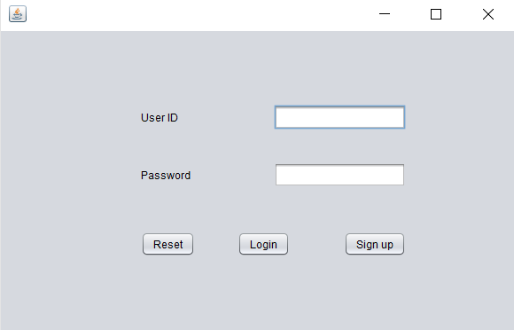

**Welcome screen**

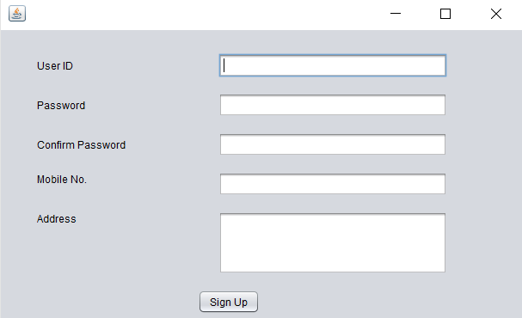

**Sign up**

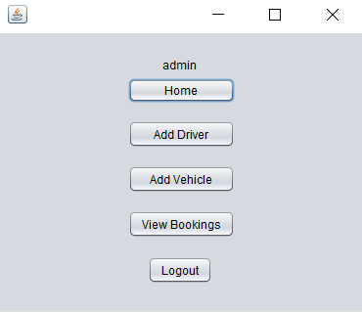

**Admin homescreen**

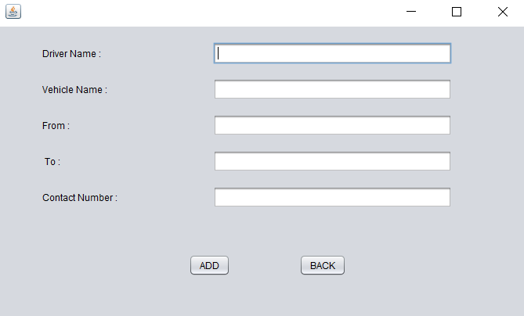

**Admin adding driver/cab**

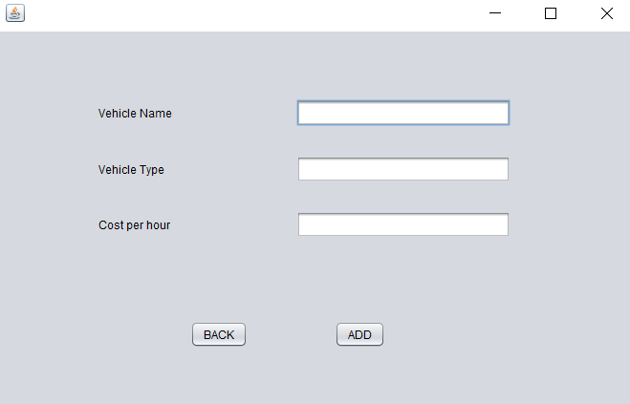

**Admin adding vehicle**

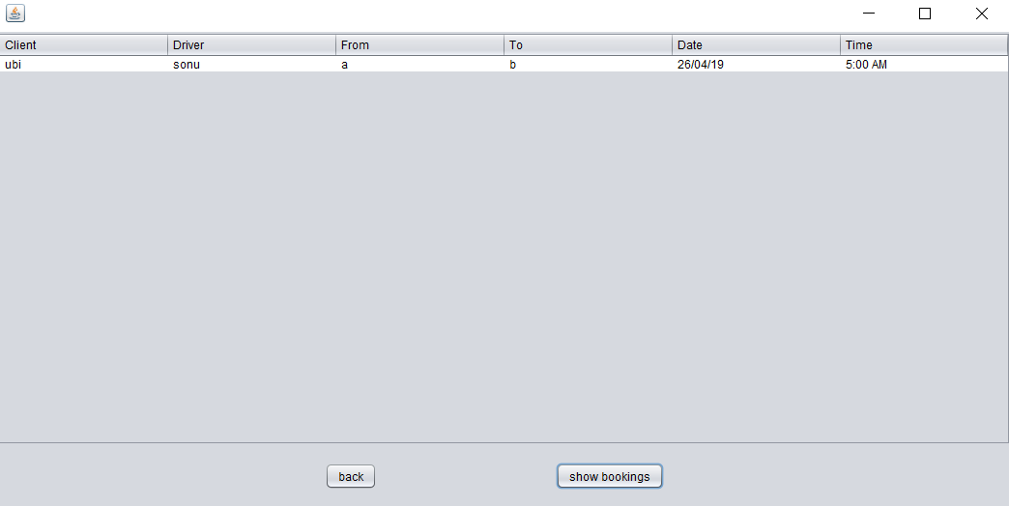

**Admin checking bookings**

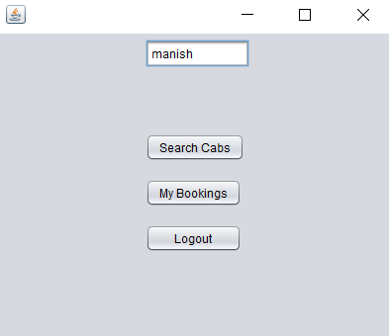

**Customer home page**

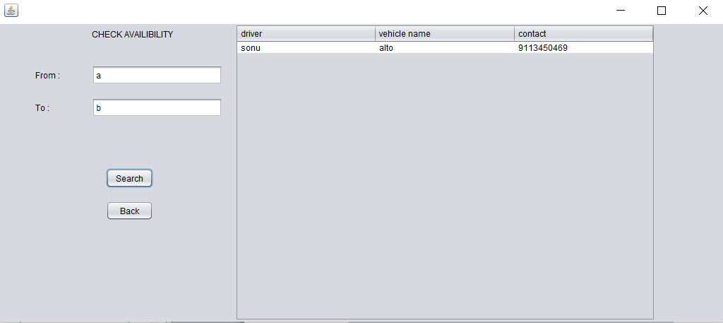

**Customer searching cabs**

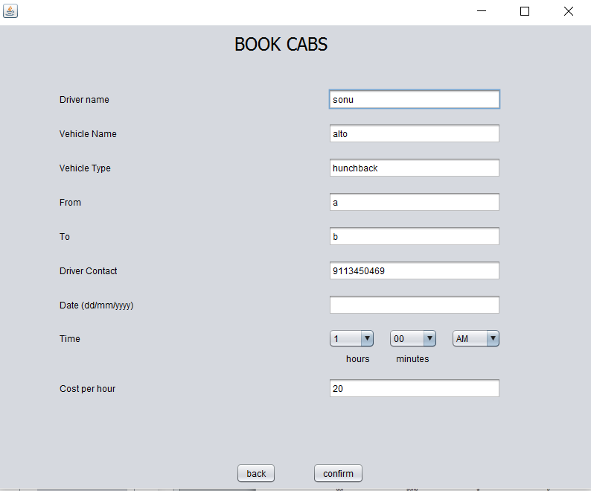

**Customer confirming booking**

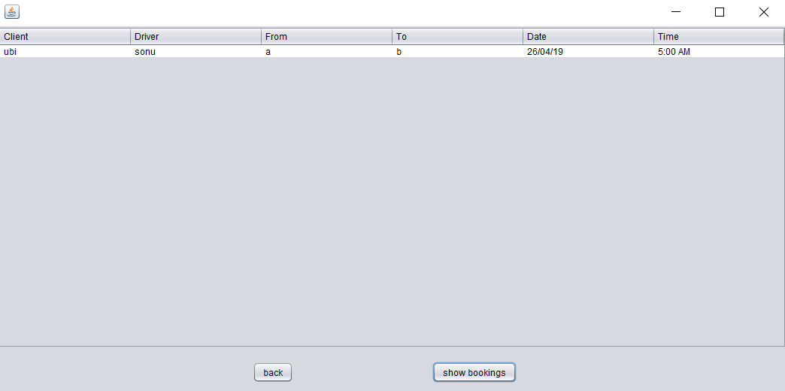

**Customer checking booking**