Assignment 1: Create an infographic illustrating the Test-Driven Development (TDD) process. Highlight steps like writing tests before code, benefits such as bug reduction, and how it fosters software reliability.

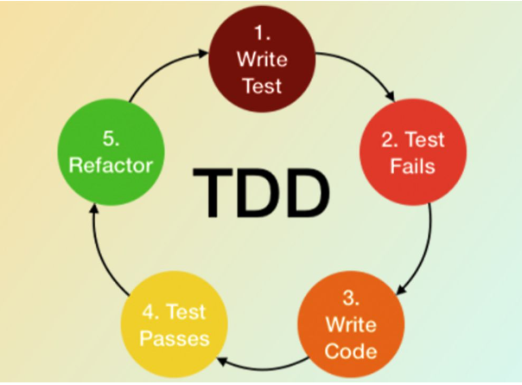

In Test Driven Development(TDD) approach, we focus on writing test case first before writing actual code.

It is helpful to ensure written code meets the customer requirements.

**Flow of TDD-**

First we will write the test case even before writing the code to reduce debug time and make the software fast.

Firstly we will write the code ,then initially test case will fail because we have develop the test case even before the development.

Development team will then modify the code to pass the test cases.

In the typical approach-

We first write the code and then it will go for the testing with test cases. Developers will perform unit testing after developing the code. And if the code does not work then the developer has to modify the whole code again.

In TDD Approach-

We first write the test cases for a given software and then write the code around it.

Eg. Class CalculationTest{

void Test(){

Calculation Calc=new Calculation();

assertEquals(3,Calc.add(1,2));//this method is comparing the value of add(1,2)

//method with 3 as a result

}

}

Class Calculation{

Public int add(int a, int b)

{  
 return a+b;

}

}