**Assignment 2:** Produce a comparative infographic of TDD, BDD, and FDD methodologies. Illustrate their unique approaches, benefits, and suitability for different software development contexts. Use visuals to enhance understanding.

**Test Driven Development-**

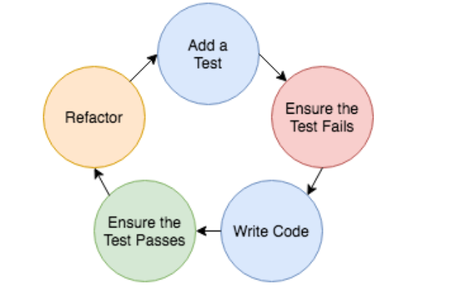

In Test Driven Development(TDD) approach, we focus on writing test case first before writing actual code.

It is helpful to ensure written code meets the customer requirements.

**Flow of TDD-**

First we will write the test case even before writing the code to reduce debug time and make the software fast.

Firstly we will write the code ,then initially test case will fail because we have develop the test case even before the development.

Development team will then modify the code to pass the test cases.

In the typical approach-

We first write the code and then it will go for the testing with test cases. Developers will perform unit testing after developing the code. And if the code does not work then the developer has to modify the whole code again.

In TDD Approach-

We first write the test cases for a given software and then write the code around it.

**Behaviour Driven Development (BDD)-**

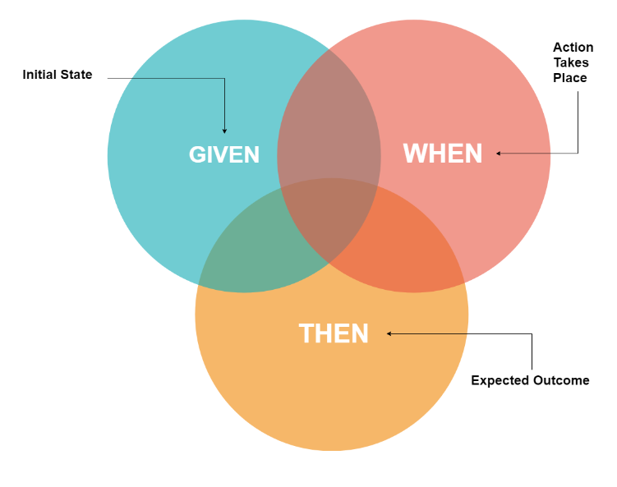

It establishes a communication between developer , business analyst and testing team.

It uses a common Gherkin language in BDD for writing the scenario.

Example of Gherkin language

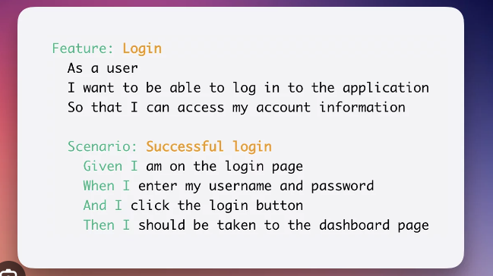

**Feature Driven Development(FDD)-**

Focuses on developing working software with features that satisfy client needs.

Software is developed feature by feature.

**FDD flow chart:-**

develop over all model

|

build the feature list (login,product, booking, cancel,refund,reward)

|

|

plan the feature plan for booking feature

|

design the feature design the booking feature

|

build by feature build the booking feature

