**Assignment 2:** Develop a case study analyzing the implementation of SDLC phases in a real-world engineering project. Evaluate how Requirement Gathering, Design, Implementation, Testing, Deployment, and Maintenance contribute to project outcomes.

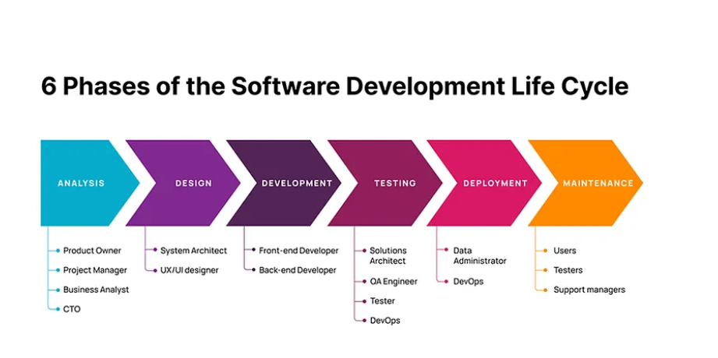

Example:

**Online shopping application**

**Planning:**

Plan the features of the shopping app

**Requirement analysis:**

Make the requirements functional and non functional and analyse them. For example:

The application should have login feature, product filtering feature, add to cart feature, payment feature, customer review and feedbacks features etc.

**Design:**

In this stage we do the designing of all requirements for coding.

**Coding:**

Final coding and development starts here. In this stage , the developer will also perform unit testing.

**Testing:**

Testing is done with different test cases to see wheather the project is meeting the

customer requirements. All features should work properly and if everything is working properly then it goes for deployment.

Different testing involves -

Functional testing

System testing

Integration testing

**Deployment:**

Software is released to user.

**Maintenance:**

Final maintenance is done after the deployment of the software . After service is provided here like updating the software time to time according to the market.