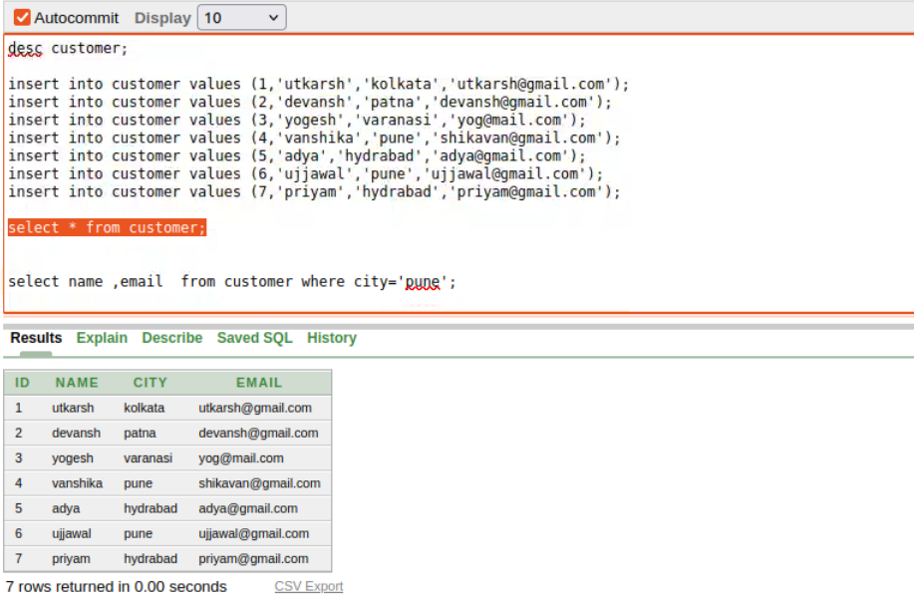

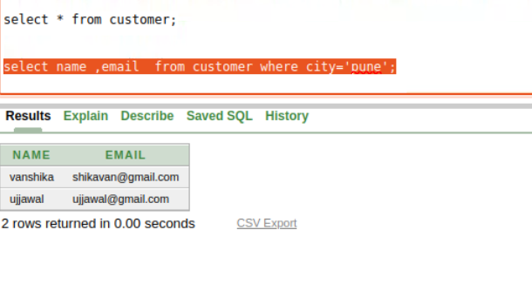

Assignment 1: Write a SELECT query to retrieve all columns from a 'customers' table, and modify it to return only the customer name and email address for customers in a specific city.

select * from customers

select name , email from (select * from customers where address='lucknow')

******************************************************************************************************************************************

Assignment 2 : Craft a query using an INNER JOIN to combine 'orders' and 'customers' tables for customers in a specified region, and a LEFT JOIN to display all customers including those without orders.

//innerjoin

select o.order_id,o.total_amount,c.customer_id,c.name,c.email,c.phone,c.address

from orders o

inner join

customers c on o.customer_id=c.customer_id

where c.address='lucknow'

//left join

select o.order_id,o.total_amount,c.customer_id,c.name,c.email,c.phone,c.address

from orders o

left join

customers c on o.customer_id=c.customer_id

where c.address='lucknow'

************************************************************************************************************************************

Assignment 3: Write SQL statements to CREATE a new database and tables that reflect the library schema you designed earlier. Use ALTER statements to modify the table structures and DROP statements to remove a redundant table.

CREATE TABLE members (

member_id NUMBER(10) PRIMARY KEY,

name VARCHAR2(30) NOT NULL,

contact VARCHAR2(11) NOT NULL UNIQUE,

book_id NUMBER(10), -- Define the book_id column

FOREIGN KEY (book_id) REFERENCES books(book_id)

);

CREATE TABLE books (

book_id NUMBER(10) PRIMARY KEY,

title VARCHAR2(30) NOT NULL,

isbn VARCHAR2(10) UNIQUE NOT NULL,

publication_year NUMBER(10) CHECK (publication_year > 1450),

author_id NUMBER(10) NOT NULL

);

ALTER TABLE books ADD (genre VARCHAR2(20));