**Assignment [Module (HTML) -1]**

1. **Are the HTML tags and elements the same thing?**

* No, HTML tags and elements are not same thing.
* HTML tags are the starting and ending parts of an HTML element. They begin with “<” symbol and end with “>” symbol. Ex. - <h1> </h1> = this is h1 tag.
* HTML elements are come inside the tags. It is content. HTML elements specifies the general content. Ex. - <b>This is elements</b>

1. **What are tags and attributes in HTML?**

* HTML tags are the starting and ending parts of an HTML element. HTML tag use in build Table, List, Paragraph, etc. Ex. - <h1>, <p>, <b>, <i>, <a>, etc.
* HTML elements are come inside the tags HTML attributes are used to describe the characteristic of an HTML element in detail. Whatever written within a HTML tag are HTML elements. Attributes provide additional information about elements. Attributes usually come in name/value pairs like: name="value"

Ex. - <p style=”colour:red;”> This is a red paragraph.</p>

1. **What are void elements in HTML?**

* Void elements are elements that don’t need a closing tag, also referred as self-closing tags. Ex - [<br>](https://www.geeksforgeeks.org/html-brgt-tag/), [<hr>](https://www.geeksforgeeks.org/html-hr-tag/), [<img>](https://www.geeksforgeeks.org/html-img-tag/), [<input>](https://www.geeksforgeeks.org/html-input-tag/), [<link>](https://www.geeksforgeeks.org/html-link-tag/), etc.

1. **What are HTML Entities?**

* In HTML some characters are reserved, so we can’t write them directly. For that we have to use the special characters which called HTML Entities. Ex. - Display a less than sign (<) we must write: &lt; or &#60;

1. **What are different types of lists in HTML?**

* There are main 3 types of list
  + Unordered list
  + Ordered list
  + Description list
* **Unordered list** : An unordered list starts with the <ul> tag. Each list item starts with the <li> tag. The list items will be marked with bullets (small black circles) by default.

Ex. - <ul>  
  <li>Apple</li>  
  <li>Mango</li>  
  <li>Orange</li>  
 </ul>

* Apple
* Mango
* Orange
* **Ordered list** : An ordered list starts with the <ol> tag. Each list item starts with the <li> tag. The list items will be marked with numbers by default.

Ex. - <ol>  
  <li>Apple</li>  
  <li>Mango</li>  
  <li>Orange</li>  
 </ol>

1. Apple
2. Mango
3. Orange

* **Description list** : HTML Description list is also a list style which is supported by HTML. <dl> tag defines the start of the list.

<dt> tag defines a term.

<dd> tag defines the term definition (description).

Ex. - <dl>

<dt>Red</dt>

   <dd>- It is Red color.</dd>

   <dt>Orange</dt>

<dd>- It is Orange color.</dd>

</dl>

Red

-It is Red color.

Orange

-It is Orange color.

1. **What is the ‘class’ attribute in HTML?**

* The HTML class attribute is used to specify a single or multiple class names for an HTML element. You can use this class in CSS with a specific class, write a period (.) character, followed by the name of the class for selecting elements.

Ex. - <!DOCTYPE html>

<html>

<head>

<style>

.country {

background-color: black;

color: white;

padding: 8px;

}

</style>

</head>

<body>

<h1 class="country">CHINA</h1>

<p>China has the largest population in the world.</p>

<h1 class="country">INDIA</h1>

<p>India has the second largest population in the world.</p>

</body>

</html>

1. **What is the difference between the ‘id’ attribute and the ‘class’ attribute of HTML elements?**

* A Class name can be used by multiple HTML elements, while an ID name must only be used by one HTML element within the page.
* **‘id’ attribute** : The HTML id attribute is used to specify a unique id for an HTML element. The id attribute specifies a unique id for an HTML element. The value of the id attribute must be unique within the HTML document. write a hash character (#), followed by an id name.

Ex. - <!DOCTYPE html>  
<html>  
<head>  
<style>  
#heading {  
  background-color: blue;  
  color: black;  
  padding: 40px;  
  text-align: center;  
}  
</style>  
</head>  
<body>  
<h1 id="heading">Heading</h1>  
</body>  
</html>

* **‘class’ attribute** : A class name can be used by multiple HTML elements

Ex. - <!DOCTYPE html>

<html>

<head>

<style>

.country {

background-color: black;

color: white;

padding: 8px;

}

</style>

</head>

<body>

<h1 class="country">CHINA</h1>

<p>China has the largest population in the world.</p>

<h1 class="country">INDIA</h1>

<p>India has the second largest population in the world.</p>

</body>

</html>

1. **What are the various formatting tags in HTML?**

* There are 9 type of formatting tags in HTML

<b> - Bold text

<strong> - Important text

<i> - Italic text

<em> - Emphasized text

<mark> - Marked text

<small> - Smaller text

<ins> - Inserted text

<sub> - Subscript text

<sup> - Superscript text

1. **How is Cell Padding different from Cell Spacing?**

* Cell padding refers to the amount of space between the cell's content and its borders. It is the space inside a cell that separates the cell's content from its borders.
* Cell spacing refers to the amount of space between cells. It is the space between two adjacent cells in a table. You can set the spacing for each side of a cell individually, or you can set it for all sides at once.

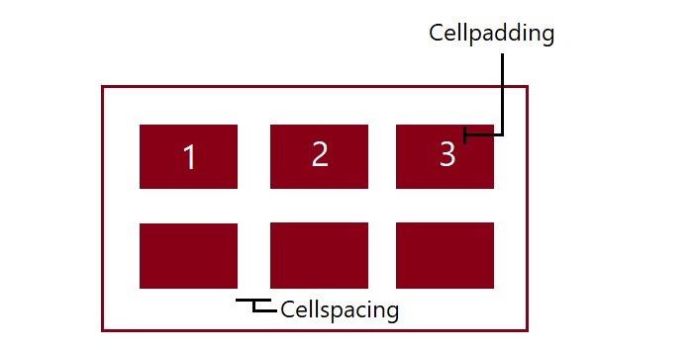

1. **How can we club two or more rows or columns into a single row or column in an HTML table?**

* We use the colspan and rowspan attribute, to merge cells in HTML.
* The rowspan attribute is for the number of rows a cell should merge.
* The colspan attribute is for the number of columns a cell should merge. The attribute should be placed inside the <td> tag.

Ex. - <table border="1">

<tr align="center">

<td>col-1</td>

<td>col-2</td>

<td>col-3</td>

</tr>

<tr>

<td rowspan="2"> Row-1 cell-1</td>

<td> Row-1 cell-2</td>

<td> Row-1 cell-3</td>

</tr>

<tr>

<td> Row-2 cell-2</td>

<td> Row-2 cell-3</td>

</tr>

<tr>

<td colspan="3"> Row- cell-1</td>

</tr>

</table>

|  |  |  |
| --- | --- | --- |
| col-1 | col-2 | col-3 |
| Row-1 cell-1 | Row-1 cell-2 | Row-1 cell-3 |
| Row-2 cell-2 | Row-2 cell-3 |
| Row- cell-1 | | |

1. **What is the difference between a block-level element and an inline element?**

* **Block-level element** : A block-level element always starts on a new line and it occupies the whole horizontal space of its parent element. Ex. - <p>, <h1>, <h2>, <h3>, <h4>, <h5>, <h6>, <ul>, <ol>, <pre>, etc.
* **Inline element** : An inline element does not start on a new line. An inline element only takes up as much width as necessary. Ex. - <span>, <a>, <strong>, <img> etc.

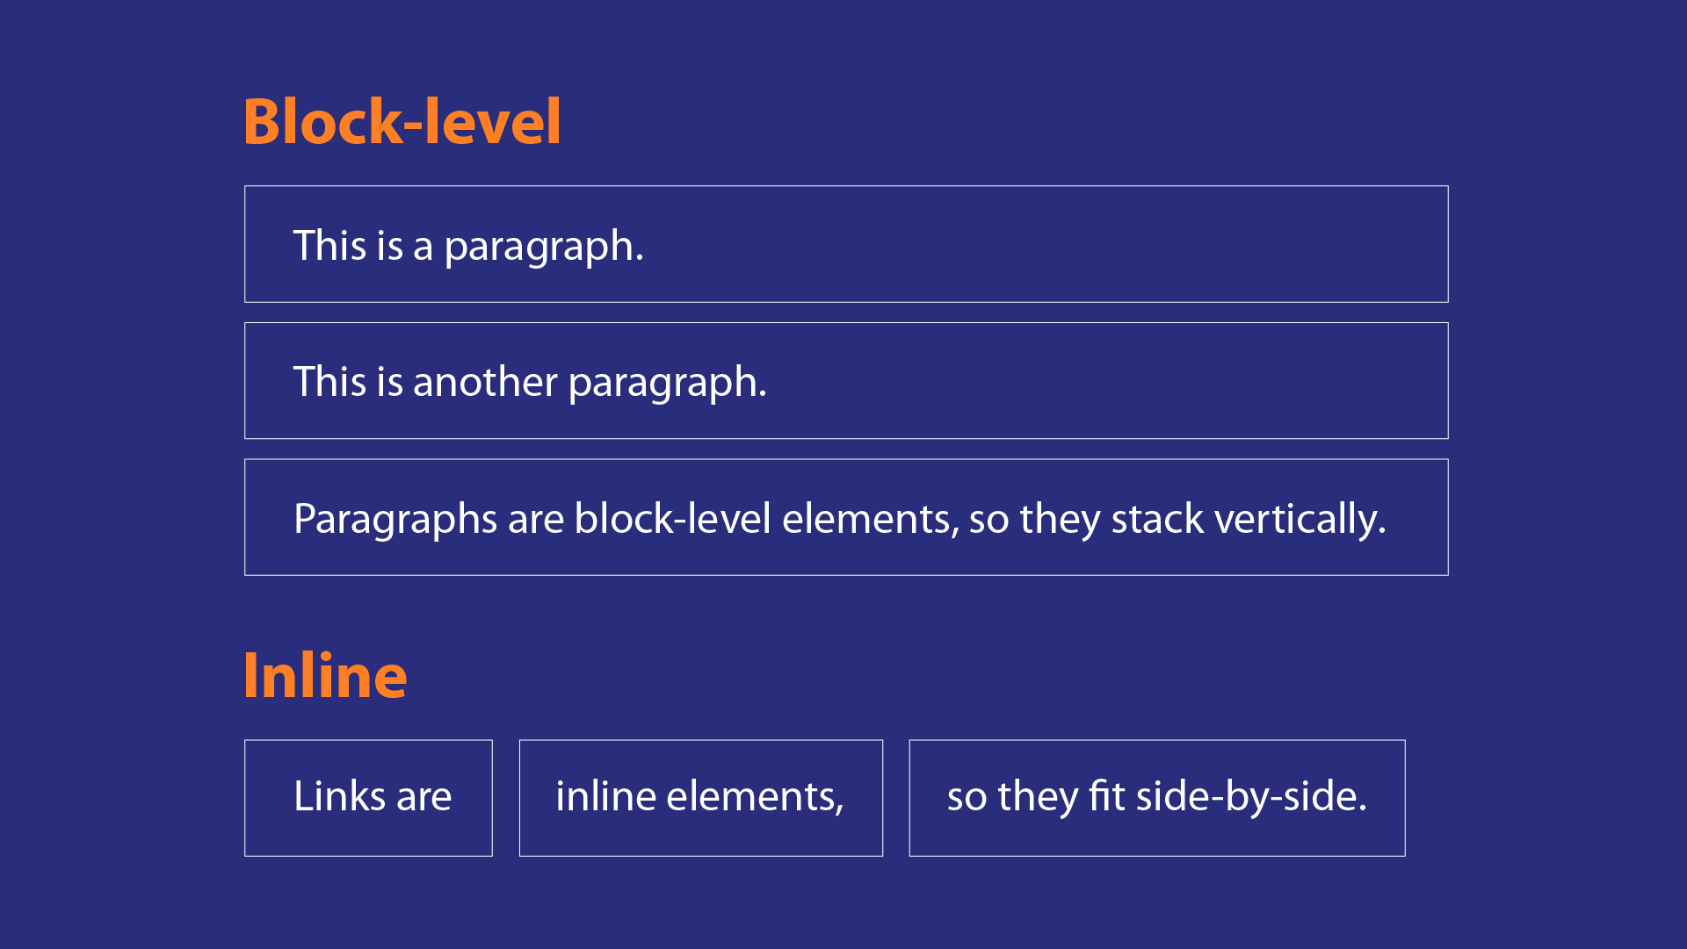

1. **How to create a Hyperlink in HTML?**

* To create a Hyperlink in an HTML page, use the <a> and </a> tags, which are the tags used to define the links. Add the URL for the link in the <a href=” ”> </a>

Ex. - <a href=" [https://www.amazon.in/">amazon</a](https://www.amazon.in/%22%3eamazon%3c/a)>

1. **What is the use of an iframe tag?**

* Iframe tag is also called as an Inline frame. HTML iframe embeds another document within the current HTML document in the rectangular region. iframe is used to embed another document within the current HTML document.

Ex. – <!DOCTYPE html>

<html>

<head>

<title>HTML iframe Tag</title>

</head>

<body style="text-align: center">

<h1>GeeksforGeeks</h1>

<h2>HTML iframe Tag</h2>

<iframe src=<https://ide.geeksforgeeks.org/index.php> height="200" width="400">

</iframe>

</body>

</html>

1. **What is the use of a span tag? Explain with example?**

* The tag is an inline container used to mark up a part of a text, or a part of a document. The <span> tag is much like the <div> element, but <div> is a block-level element and <span> is an inline element.

Ex. - <p>i have <span style="color:black">black</span> bike.</p>

<!DOCTYPE html**>**

**<html>**

**<head>**

**<title>**Span Tag**</title>**

**</head>**

**<body>**

**<h2>**Example of span tag**</h2>**

**<p>**I have choosen only

**<span** style="color: red;"**>**red**</span>**,

**<span** style="color: blue;"**>**blue**</span>**, and

**<span** style="color: green;"**>**green**</span>** colors for my painting.

**</p>**

**</body>**

**</html>**

I have choosen only red, blue and green colors for my painting.

1. **How to insert a picture into a background image of a web page?**

* In simple way to add background image is using the background image attribute inside the <body> tag.

Ex. –

<!**DOCTYPE** html>

<**html**>

<**head**>

<**style**>

body {

  background-image: url(https://www.google.com/url?sa=i&url=https%3A%2F%2Funsplash.com%2Fs%2Fphotos%2Fbackground-image&psig=AOvVaw2ldnD14xd3AU8w9kNJqV1J&ust=1692945936449000&source=images&cd=vfe&opi=89978449&ved=0CBAQjRxqFwoTCJjgjpvZ9IADFQAAAAAdAAAAABAE);

}

</**style**>

</**head**>

<**body**>

    <**p**>Document Body</**p**>

</**body**>

</**html**>

1. **How are active links different from normal links?**

* When we don’t have a mouse cursor over the link is considered a normal link or unvisited link and its color is blue with underline. Whereas, others recognize active links when the link has the focus. The default color for normal and active links is blue. Some browsers recognize an active link when the mouse cursor is placed over that link; Others recognize active links when the link has the focus.

1. **What are the different tags to separate sections of text?**

* **<hr> tag**- it is used to seprate the two line of text by providing horizontal line between them.
* **<br> tag** – Usually <br> tag is used to separate the line of text. It breaks the current line and conveys the flow to the next line.
* **<p> tag** – This contains the text in the form of a new paragraph.
* **<blockquote> tag** – It is used to define a large quoted section.

1. **What is difference between HTML and XHTML?**

* Both languages are used to build web and Android applications. However both languages are the two sides of the same coin, but there are some major differences between the two.
* **HTML** :
* HTML stands for Hypertext Markup Language.
* HTML is not a case-sensitive language.
* Some HTML elements may function properly without a closing tag.
* It can have a filename extension of.html or .htm.
* **XHTML** :
* XHTML stands for Extensible Hypertext Markup Language. It is an extension of HTML and is stricter and more structured compared to HTML.
* XHTML is a case-sensitive language.
* All the XHTML elements must be closed. Even the empty elements also require a closing tag.
* Its filename extension can be .xhtml, .xht, or .xml.

1. **What are logical and physical tags in HTML?**

* In HTML the formatting tags are divided into two categories:
* **Physical tag**:
* These tags are used to provide the visual appearance to the text.
* Ex. - <b>, <big>, <i>, <small>, <sup>, <sub>, etc.
* **Logical tag**:
* These tags are used to add some logical or semantic value to the text.
* Ex. - <address>, <code>, <q>, <strong>, etc.