Megamenu change list
Screenshot 1 · What We Build, services panel
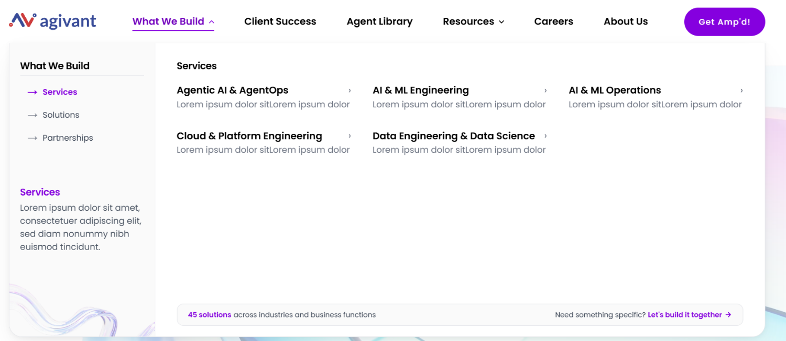
1. Pillar name, third item
NOW AI & ML Operations
CHANGE TO [MLOps & Scalable ML Platforms]
2. Pillar name, fifth item
NOW Data Engineering & Data Science
CHANGE TO [Data Engineering & Advanced Analytics]
3. Order of the five pillars
NOW Agentic AI, AI & ML Engineering, AI & ML Operations, Cloud & Platform, Data Engineering
CHANGE TO [Cloud & Platform Engineering, Data Engineering & Advanced Analytics, AI & ML Engineering, MLOps & Scalable ML Platforms, Agentic AI & AgentOps]
4. Descriptor line under each pillar
NOW Lorem ipsum dolor sitLorem ipsum dolor · all five
01 Cloud & Platform Engineering
[The infrastructure data, models and agents all run on]
02 Data Engineering & Advanced Analytics
[Clean, reliable data and analytics teams can act on]
03 AI & ML Engineering
[Models and RAG systems tuned to the domain, from spec to production]
04 MLOps & Scalable ML Platforms
[The release path that takes a model from notebook to production]
05 Agentic AI & AgentOps
[Agents that run the work and answer for every action]
5. Left card body
NOW Lorem ipsum dolor sit amet, consectetuer adipiscing elit, sed diam nonummy nibh euismod tincidunt.
CHANGE TO [Agivant engineers every layer of the AI stack, so isolated AI wins become an enterprise-wide advantage.]

Remove this content entirely-
Screenshot 2 · What We Build, solutions panel
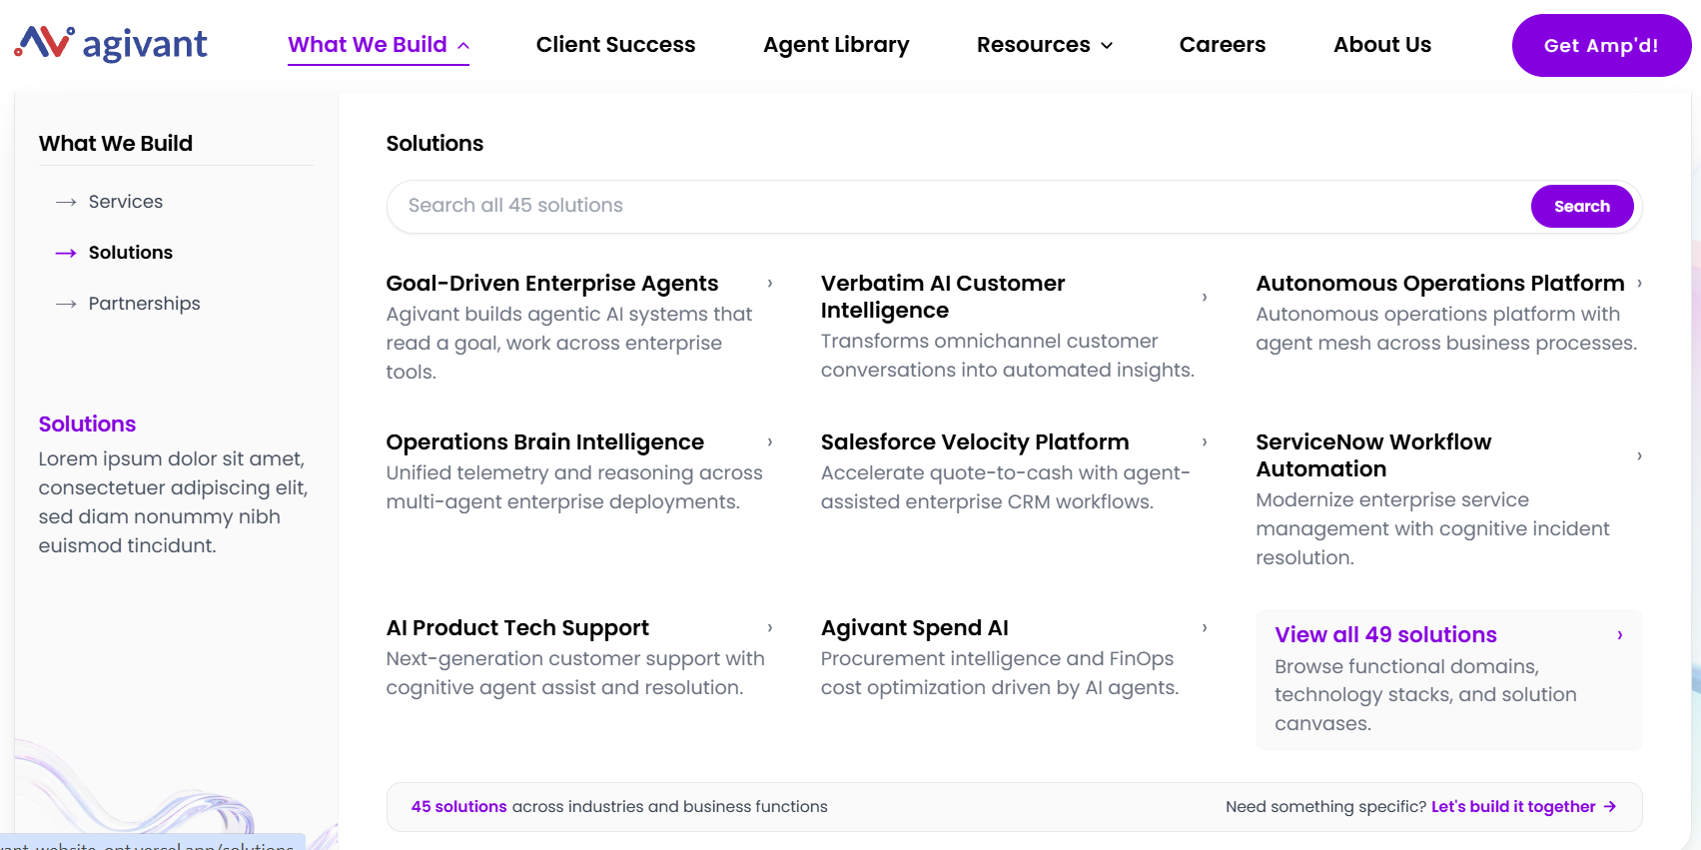
1. Search field placeholder
NOW Search all 45 solutions
CHANGE TO [Search solutions by industry or domains]
2. View all tile
NOW View all 49 solutions / Browse functional domains, technology stacks, and solution canvases.
CHANGE TO [Explore all key solutions/ 30 to 70% shorter cycle times, with first results in days and weeks]
3. Tile name and subtitle, tile 1
NOW Goal-Driven Enterprise Agents / Agivant builds agentic AI systems that read a goal, work across enterprise tools.
CHANGE TO [Agentic AI for autonomous operations / Goal-driven agents working the tools that hold the task]
4. Tile name and subtitle, tile 2
NOW Verbatim AI Customer Intelligence / Transforms omnichannel customer conversations into automated insights.
CHANGE TO [Agentic Mesh Deployment / One agent network holding context across the enterprise]
5. Tile 3
NOW Autonomous Operations Platform / Autonomous operations platform with agent mesh across business processes.
CHANGE TO [Agentic Silicon Lifecycle Platform / Design verification and yield correlation under one policy layer]
6. Tile name and subtitle, tile 4
NOW Operations Brain Intelligence / Unified telemetry and reasoning across multi-agent enterprise deployments.
CHANGE TO [Autonomous Operations Brain / Incidents explained, then resolved inside the shift they open in]
Operations Brain Intelligence is a second name for the same solution. The content document calls it Autonomous Operations Brain.
7. Tile name and subtitle, tile 5
NOW Salesforce Velocity Platform / Accelerate quote-to-cash with agent-assisted enterprise CRM workflows.
CHANGE TO [Agentic Salesforce Velocity Platform / Coordinated agent teams working inside Salesforce]
8. Tile subtitle, tile 6
NOW ServiceNow Workflow Automation / Modernize enterprise service management with cognitive incident resolution.
CHANGE TO [Workflow automation / Launch confidence, predicted weeks ahead of the date]
9. Tile subtitle, tile 7
NOW AI Product Tech Support / Next-generation customer support with cognitive agent assist and resolution.
CHANGE TO [AI product tech support / AI products kept accurate and affordable in production]
10. Tile subtitle, tile 8
NOW Agivant Spend AI / Procurement intelligence and FinOps cost optimization driven by AI agents.
CHANGE TO [Agivant Spend AI / Idle licenses reclaimed, demand forecast ahead of renewal]
11. Left card body
NOW Lorem ipsum dolor sit amet, consectetuer adipiscing elit, sed diam nonummy nibh euismod tincidunt.
CHANGE TO [Agentic AI solutions engineered for real business value, already running in production.]

Screenshot 3 · What We Build, partnerships panel
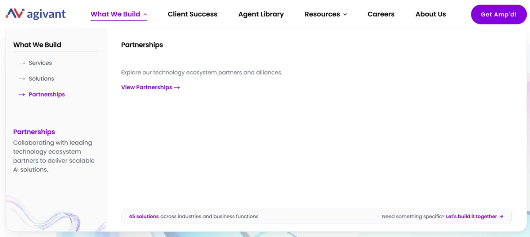

1. Panel standfirst
Remove Explore our technology ecosystem partners and alliances.
2. Panel body
Remove View Partnerships → as the only content in the panel
CHANGE TO -
L3 menu
Gemini Enterprise
[Agents built on Google’s Agent Development Kit]
Databricks
[Bronze Partner, building agents on the Lakehouse]
AWS
[Well-Architected practice for every migration]
Azure
[Optimization practice, built on Agivant’s own AOAF]
Salesforce
[Agent teams working inside Data Cloud and Agentforce]
Glean
[Work AI collaboration, built on domain accelerators]
ServiceNow
[AI-first migration and automation practice]
NVIDIA
[GPU-native AI practice on the full CUDA stack]
Shopify
[Agentic commerce on the Shopify platform]
TigerGraph [Named Global Engineering Center partner]
4. Left card body
NOW Collaborating with leading technology ecosystem partners to deliver scalable AI solutions.
CHANGE TO [Agivant is trusted by global partners across the cloud, data, AI and workflow platforms enterprises depend on.]
6. Left card heading
NOW Partnerships
CHANGE TO [Ecosystem partnerships]

Screenshot 4 · Resources panel
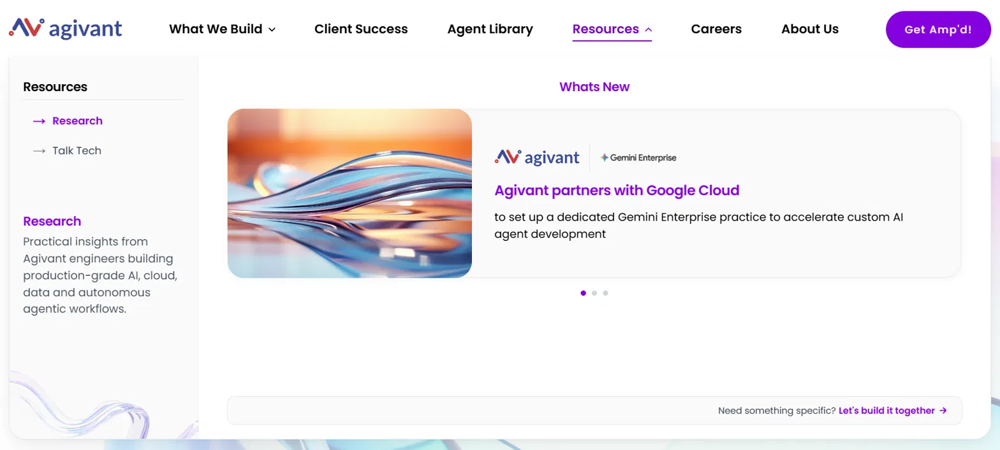
1. Carousel heading
NOW Whats New
CHANGE TO [What’s new]
2. Press release card 1, Gemini Enterprise
NOW Agivant partners with Google Cloud / to set up a dedicated Gemini Enterprise practice to accelerate custom AI agent development
CHANGE TO [Agivant partners with Google Cloud on a dedicated Gemini Enterprise practice / A dedicated practice built to accelerate custom AI agent development on Google Cloud.]
3. Press release card 2, Databricks
NOW Agivant Partners With Databricks To Help Enterprises Turn Enterprise Data Into Trusted Context For AI
CHANGE TO [Agivant partners with Databricks to turn enterprise data into trusted context for AI / Agentic AI, data engineering and enterprise AI solutions built on the Databricks Data + AI Platform.]
4. Press release card 3, Glean
NOW Agivant Technologies Announces Collaboration with Glean to Advance Enterprise Work AI and Agentic AI Transformation / Agivant Technologies announces collaboration with Glean to advance enterprise Work AI and agentic AI transformation.
CHANGE TO [Agivant announces a collaboration with Glean to advance enterprise Work AI / A collaboration to put enterprise knowledge in reach of agents that can act on it.]
6. Research left card
NOW Practical insights from Agivant engineers building production-grade AI, cloud, data and autonomous agentic workflows.
CHANGE TO [Field notes and decision frameworks from the engineers putting AI into production.]

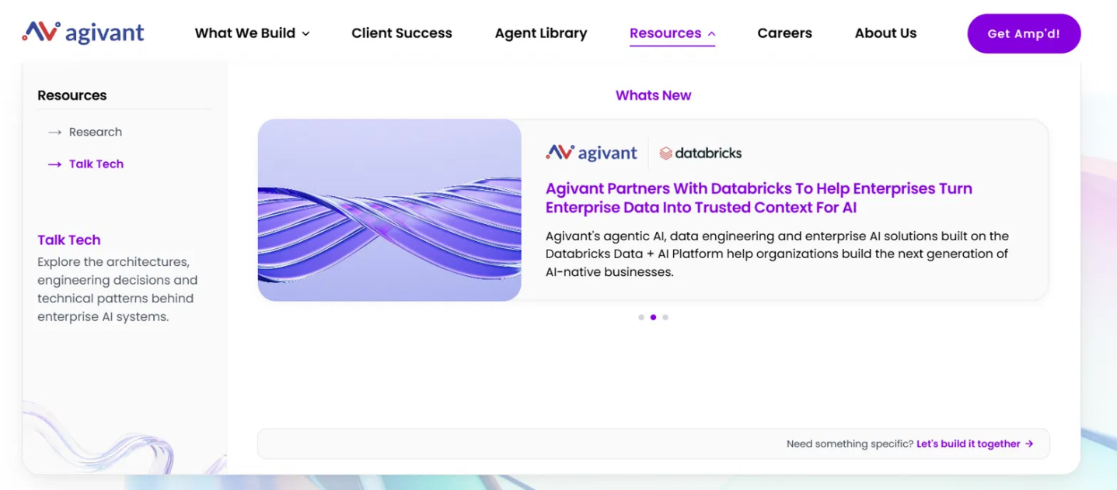
8. Talk Tech left card
NOW Explore the architectures, engineering decisions and technical patterns behind enterprise AI systems.
CHANGE TO [The agentic AI era, explained by the engineers building it.]
9. Utility bar on this panel
Remove the solutions count sits in the left slot

Applies to every panel
1. Utility bar, left slot
NOW 45 solutions across industries and business functions
CHANGE TO [Solutions engineered across industries and business functions]
2. Utility bar, right slot
NOW Need something specific? Let’s build it together
KEEP no change
3. Every solution count, in any slot
NOW remove entirely, no replacement

