A
PROJECT BASED LEARNING
ON
“Student and Admission Management — University ERP”
FOR PARTIAL FULFILLMENT
OF THE REQUIREMENTS FOR THE
DATABASE MANAGEMENT SYSTEM
OF T.Y. B. TECH
By
[[TO BE PROVIDED: student 1 name; use official roster]] | [[TO BE PROVIDED: roll no. 1; use official record]]
[[TO BE PROVIDED: student 2 name; use official roster]] | [[TO BE PROVIDED: roll no. 2; use official record]]
[[TO BE PROVIDED: student 3 name; use official roster]] | [[TO BE PROVIDED: roll no. 3; use official record]]
GUIDE
[[TO BE PROVIDED: guide name; confirm with department]]

DEPARTMENT OF
ELECTRONICS AND TELECOMMUNICATION ENGINEERING
PUNE INSTITUTE OF COMPUTER TECHNOLOGY
PUNE – 43
ACADEMIC YEAR: 2026-2027
Department of Electronics and Telecommunication Engineering
Pune Institute of Computer Technology, Pune – 43
CERTIFICATE
This is to certify that the Mini Project Report entitled
Student and Admission Management — University ERP
has been successfully completed by
[[TO BE PROVIDED: student 1 name; use official roster]] | [[TO BE PROVIDED: exam no. 1; use official record]]
[[TO BE PROVIDED: student 2 name; use official roster]] | [[TO BE PROVIDED: exam no. 2; use official record]]
[[TO BE PROVIDED: student 3 name; use official roster]] | [[TO BE PROVIDED: exam no. 3; use official record]]
Is Bonafide work carried out by them under the supervision of [[TO BE PROVIDED: Name of the Project Guide; confirm from guide allocation]] and it is approved for the partial fulfillment of the requirements for the Database Management Systems Course of TY BTech, E&TCE, PICT, Pune.
[[TO BE PROVIDED: Name of the Project Guide; department to confirm]]  Project Guide | Dr. S. V. Gaikwad  HOD, E&TC Dept. of E&TC
Place: Pune
Date : [[TO BE PROVIDED: actual approval date; signatories must supply after review]]
ACKNOWLEDGEMENT
This report acknowledges the supplied PICT templates for its institutional structure and the referenced source repository for the implementation artifacts examined. SQL definitions and design descriptions are attributed to the pinned source snapshot; original repository screenshots and historical logs are not presented as newly executed evidence.
[[TO BE PROVIDED: verified names and contributions of guide, faculty, staff and colleagues to acknowledge; report authors must obtain confirmation from those involved before submission]]
[[TO BE PROVIDED: student 1 name; use official roster and confirm team size]]
[[TO BE PROVIDED: student 2 name; use official roster and confirm team size]]
[[TO BE PROVIDED: student 3 name; use official roster and confirm team size]]
ABSTRACT
This report documents the Student and Admission Management module of a university ERP using the PICT DBMS report structure for academic year 2026-2027. The module is traced from its React interface and Express routes through services and repositories to the actual relational schema and SQL programmability. Its scope, actors, business rules, data flows, keys, constraints and functional dependencies are analyzed without asserting blanket third-normal-form compliance. Exact relevant SQL definitions and invocation templates are included. Static review distinguishes implemented behavior from gaps, policy assumptions and proposed enhancements. Repository-wide backend and frontend type checks and builds passed; the backend test command found no test files. Live database, API, browser and deployment execution were not verified. Positive, negative, boundary, transaction and authorization cases therefore retain explicit evidence placeholders. The resulting editable draft supports implementation review and viva preparation, while student identities, institutional approval and executed test evidence remain to be supplied by the team.
[[TO BE PROVIDED: student 1 name; confirm from official roster]]
[[TO BE PROVIDED: student 2 name; confirm from official roster]]
[[TO BE PROVIDED: student 3 name; confirm from official roster]]

List of figures:
Figure 2.1 Common stack used by this module 5
Figure 2.2 Student and Admission Management — Level 1 DFD 6
Figure 2.3 sp_approve_admission — transaction/workflow supplement 8
Figure 2.4 Module 1 — relational ER sheet 1/3 9
Figure 2.5 Module 1 — relational ER sheet 2/3 10
Figure 2.6 Module 1 — relational ER sheet 3/3 11

List of tables:
Table 1.1 Source-backed requirements and evidence boundaries 2
Table 2.1 Module processes and integration stores 7
Table 2.2 Shared / cross-module key contracts (not duplicated ownership) 12
Table 2.3 students — full column dictionary 13
Table 2.4 addresses — full column dictionary 17
Table 2.5 guardians — full column dictionary 19
Table 2.6 admissions — full column dictionary 21
Table 2.7 student_documents — full column dictionary 25
Table 2.8 student_status_history — full column dictionary 28
Table 2.9 Relation-level candidate keys and normalization assessment 30
Table 2.10 Student and Admission Management — exact API route/role register 46
Table 3.1 M1-01 — Approve one valid application 56
Table 3.2 M1-02 — Reject and repeat review 57
Table 3.3 M1-03 — Negative date and phone 57
Table 3.4 M1-04 — Email/batch/rollback edges 58
Table 3.5 M1-05 — Public tracking and own profile scope 59
Table 3.6 M1-06 — First-login direct API bypass 59
Table 3.7 M1-07 — Concurrent approval and status history 60
Table 3.8 EXEC-01 — npm run typecheck in backend 61
Table 3.9 EXEC-02 — npm run build in backend 61
Table 3.10 EXEC-03 — npm run typecheck in frontend 62
Table 3.11 EXEC-04 — npm run build in frontend 62
Table 3.12 EXEC-05 — npm test in backend 63

Abbreviations (if any)
ERP — Enterprise Resource Planning
DBMS / RDBMS — Database Management System / Relational DBMS
ER / DFD — Entity–Relationship / Data Flow Diagram
PK / FK / UQ — Primary key / foreign key / UNIQUE constraint
FD / 1NF / 2NF / 3NF — Functional dependency / first, second and third normal forms
API / RBAC / JWT — Application Programming Interface / role-based access control / JSON Web Token
SPA / UDF / SQL — Single-page application / user-defined function / Structured Query Language
SGPA / CGPA — Semester / cumulative grade-point average
PF / LOP / YTD — Provident fund / loss of pay / year to date

Symbols / special words
X → Y — Functional dependency: equal X values imply equal Y values under the stated business assumptions.
1 / 0..1 / 0..N — Exactly one / optional one / zero or many; figure [P; C] gives parents per child and children per parent.
NULL — Missing/unknown or not applicable SQL value; it is not equal to zero or an empty string.
Σ and percentage — Sum across the stated grain; percentage numerator and denominator must be specified.
IN / OUT / @variable — Stored routine parameter modes and MySQL session variables; examples require selected synthetic fixture values.
Implemented / partial / planned / unverified — Defined in source / incomplete or inconsistent / proposed only / no execution evidence.
Evidence placeholder — The exact [[TO BE PROVIDED: ...]] markers are unresolved team inputs, not successful results.

Index
CHAPTER 1: MODULE OVERVIEW & REQUIREMENTS 1
1.1 Introduction & Motivation 1
1.2 Objectives 1
1.3 Scope, Actors & Boundaries 1
1.4 Functional & Non-Functional Requirements 2
1.5 Business Rules & Implementation Status 3
CHAPTER 2: MODULE DESIGN & IMPLEMENTATION 5
2.1 Module Architecture & Technology 5
2.2 Module Data Flow Diagram (Level 1 / Level 2 DFD) 6
2.2.1 Sub-System Processes, Data Stores & External Movement 7
2.3 Module ER Diagram, Sub-Schema & Data Dictionary 9
2.3.1 Normalization Analysis & Justified Exceptions 29
2.4 Advanced SQL Implementation 32
2.4.1 Stored Procedures (SQL Code & Execution Proofs) 32
2.4.2 Database Triggers (SQL Code & Execution Proofs) 39
2.4.3 User-Defined Functions (UDFs) (SQL Code & Execution Proofs) 43
2.5 Complex Analytical Queries & Views 43
2.6 Backend Routes, Services, Repository & Frontend Trace 46
2.7 Validation, Errors, Transactions & Limitations 54
CHAPTER 3: TESTING, CONCLUSION & REFERENCES 56
3.1 Module Test Plan & Preconditions 56
3.2 Positive, Negative, Edge, Authorization & Transaction Cases 56
3.2.1 Executed Repository-Wide Build Checks (not module correctness) 61
3.2.2 Required Evidence & Screenshot Checklist 63
3.3 Conclusion, Limitations & Future Enhancements 64
3.4 References 64

CHAPTER 1: MODULE OVERVIEW & REQUIREMENTS

1.1 Introduction & Motivation
An admission application, an authenticated account and an enrolled student are different lifecycle records. Linking them once prevents downstream modules from inventing separate student identities and makes status changes traceable.
This self-contained module report concerns Student and Admission Management within the seven-module University ERP. It is based on commit b3b56e06cfa8df6ef3765380d0a14ba75b05dc22 and supplied PICT 2026-2027 templates, not on unverified menu labels or borrowed report identities. [T01, T02, T03, R00, R11]

1.2 Objectives
1. Maintain one student_id reused by academic, attendance, examination, finance and hostel records.
2. Convert an eligible application into linked users, students and guardians records in the stored procedure transaction.
3. Validate admission/profile inputs and preserve status history without treating repository demo students as the report authors.

1.3 Scope, Actors & Boundaries
Public admission submission and tracking; staff review and conversion to an account/student; student profile, address, guardian and document-metadata maintenance; student status history. Document metadata is implemented, but a binary document-upload/storage pipeline and external admission email delivery are not established by the inspected code.
Actors: Applicant; STUDENT; ADMIN; FACULTY and other staff where the exact route permits reading. Admissions review and student-changing operations have narrower role gates than public application/tracking. The route register is the authority, not the menu.
Shared identity/academic masters, authentication, audit and notifications are summarized only where needed. The report does not duplicate the entire master; it provides the module's full schema, relevant programmable SQL, implementation trace and module-specific tests. Cross-cutting AI/mock/risk remains adjunct scope rather than a new core module.

1.4 Functional & Non-Functional Requirements
Table 1.1 Source-backed requirements and evidence boundaries
Requirement ID | Requirement / implementation | Evidence / status
M1-REQ-01 | The public application schema validates names, email, phone, date of birth, gender, program/category/year and guardian fields; application numbers are generated in the service. Admission email is UNIQUE in the fresh schema. | Implemented, static
M1-REQ-02 | sp_approve_admission accepts five IN and two OUT parameters, locks the application and active program/year batch, accepts only pending-review states, and creates a first-login account with a temporary hash supplied by the API. | Implemented, static
M1-REQ-03 | Approval links program, department and batch, creates a guardian record with relation FATHER, updates the application and writes audit/notification records. The fixed guardian relation is an implementation assumption, not a verified description of every applicant. | Implemented, static
M1-REQ-04 | Student insert/update triggers check date and phone conditions; the status-change trigger writes student_status_history. A status row alone is not proof of API-wide account deactivation. | Implemented, static
M1-REQ-05 | The SPA redirects a first-login student to password change, but protected server routes do not globally enforce completion. Document metadata creation is not proof that files are stored or scanned. | Partial / needs repair
M1-REQ-06 | Uniqueness, concurrent approval/roll-number allocation, rollback and the public tracking privacy contract have not been exercised against a live database. | Unverified
M1-NFR-01 | Authenticated/role-scoped server access, parameter binding and validation at the actual implementation points. | Source-defined, not a comprehensive security pass.
M1-NFR-02 | Atomic business changes where procedures define transaction handling; audit/notification service writes may be separate. | Source-defined; rollback/concurrency not executed.
M1-NFR-03 | [[TO BE PROVIDED: approved performance, availability, backup and browser targets for this module; team/test lead must provide requirements and measured evidence]] | No invented response-time, user-capacity or recovery claim.

1.5 Business Rules & Implementation Status
Implemented, static — The public application schema validates names, email, phone, date of birth, gender, program/category/year and guardian fields; application numbers are generated in the service. Admission email is UNIQUE in the fresh schema.
Implemented, static — sp_approve_admission accepts five IN and two OUT parameters, locks the application and active program/year batch, accepts only pending-review states, and creates a first-login account with a temporary hash supplied by the API.
Implemented, static — Approval links program, department and batch, creates a guardian record with relation FATHER, updates the application and writes audit/notification records. The fixed guardian relation is an implementation assumption, not a verified description of every applicant.
Implemented, static — Student insert/update triggers check date and phone conditions; the status-change trigger writes student_status_history. A status row alone is not proof of API-wide account deactivation.
Partial / needs repair — The SPA redirects a first-login student to password change, but protected server routes do not globally enforce completion. Document metadata creation is not proof that files are stored or scanned.
Unverified — Uniqueness, concurrent approval/roll-number allocation, rollback and the public tracking privacy contract have not been exercised against a live database.
Implemented means a definition or code path was found. Partial means a source-defined limitation/inconsistency exists. Planned enhancements are proposals only. Unverified means no live result was obtained. Four repository-wide compiler/build checks passed, but no module-specific SQL/API/E2E suite is claimed to have passed.

CHAPTER 2: MODULE DESIGN & IMPLEMENTATION

2.1 Module Architecture & Technology
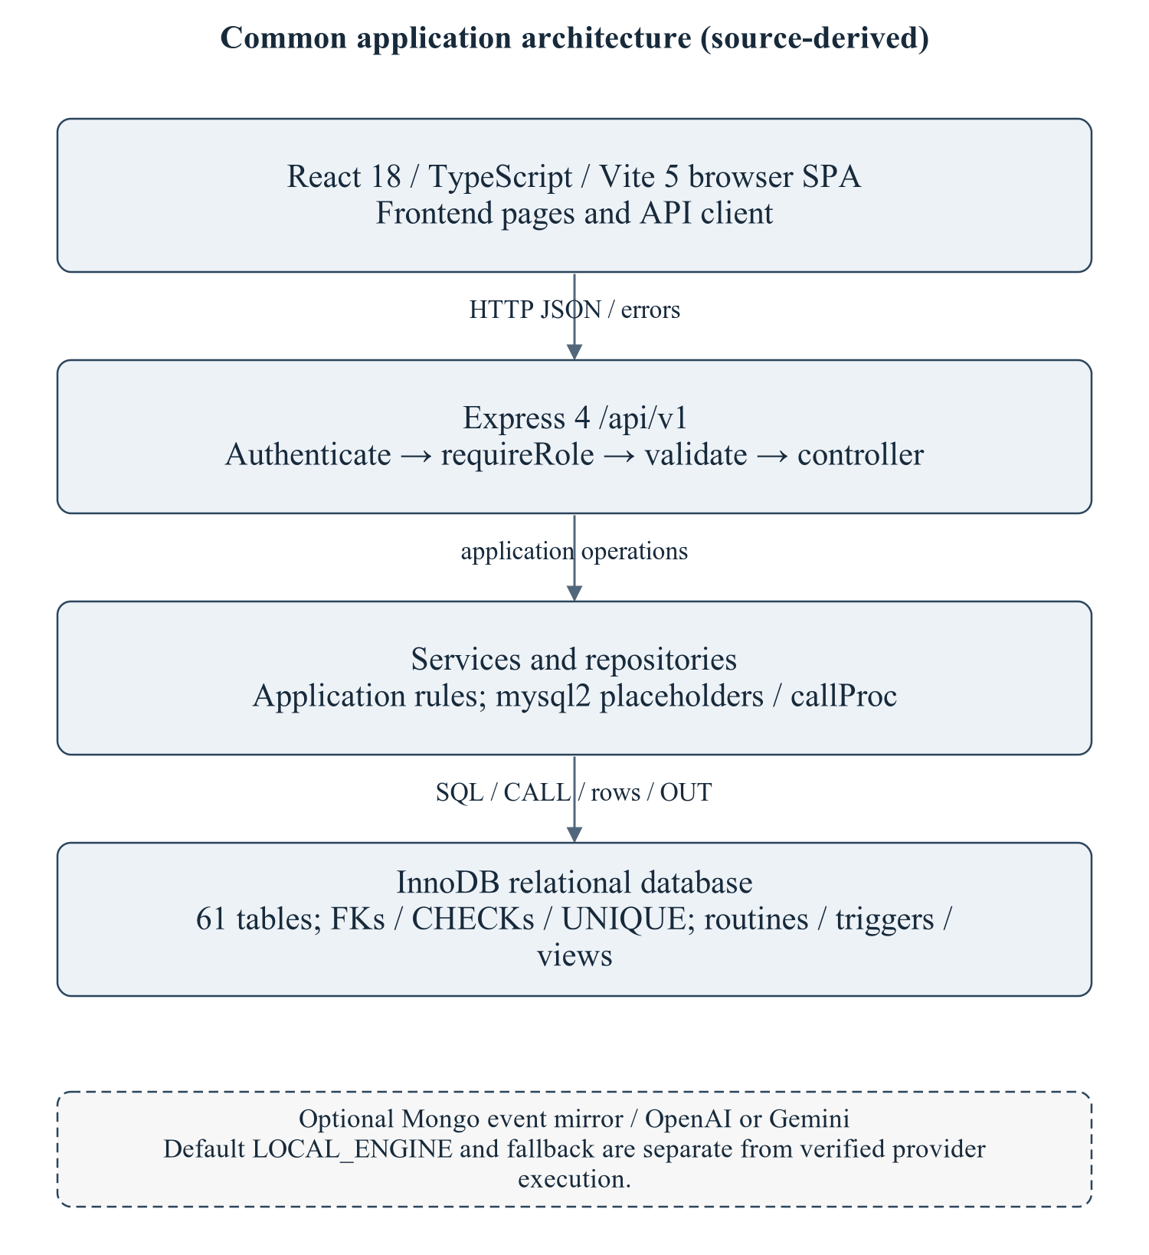
Figure 2.1 Common stack used by this module
The architecture is summarized to locate the module's routes/services/repository and SQL; it is not a copy of the master's enterprise narrative. Optional provider execution is not established.
Editable drawing source: diagrams/01_common_architecture.svg, .dot and .mmd. Edit SVG text/shapes in a vector editor, or regenerate from DOT/Mermaid; retain FK IDs and source names. These figures were created from static source, not captured from a running ERP.
React18/TypeScript/Vite5 client → Express4 /api/v1/students → module controller/service/repository → mysql2/InnoDB. Node>=18 is specified by backend package metadata; audit checks used Node20.20.2. MySQL8-style SQL and Compose MariaDB11.8 are separate unverified runtime targets. Hardware/IDE/browser performance requirements await MI15/MI16. [R09, R23]

2.2 Module Data Flow Diagram (Level 1 / Level 2 DFD)
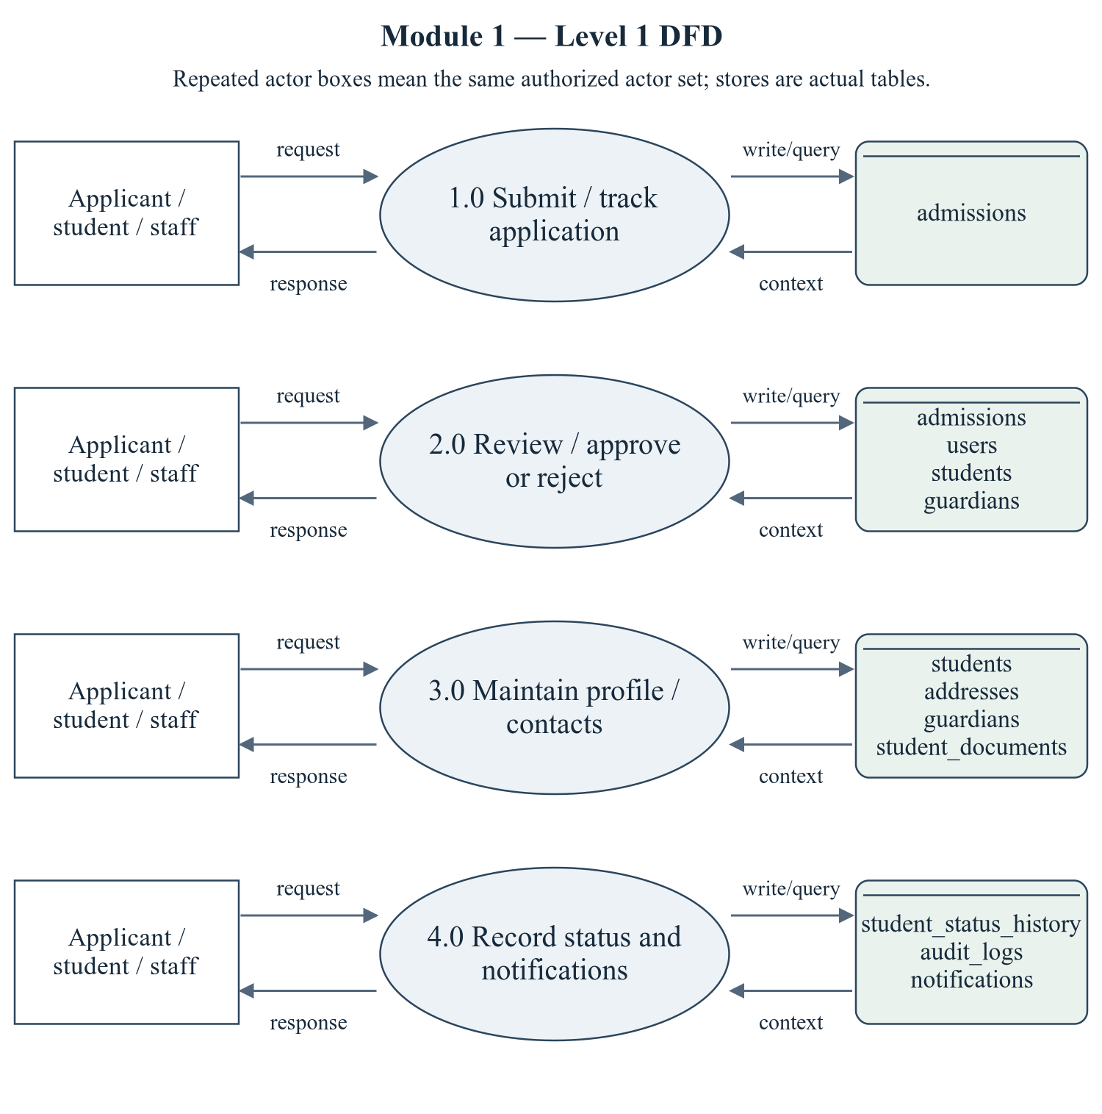
Figure 2.2 Student and Admission Management — Level 1 DFD
Repeated actor boxes mean the same external entity set. Each D label names real stores, not a fabricated table; role and row scope remain as specified in the route/ownership discussion.
Editable drawing source: diagrams/05_module_01_dfd_level1.svg, .dot and .mmd. Edit SVG text/shapes in a vector editor, or regenerate from DOT/Mermaid; retain FK IDs and source names. These figures were created from static source, not captured from a running ERP.

2.2.1 Sub-System Processes, Data Stores & External Movement
Table 2.1 Module processes and integration stores
Process | Actual persisted stores | Data movement
1.0 Submit / track application | admissions | Actor request/decision → module process; data query/write ↔ actual stores; response/report → actor.
2.0 Review / approve or reject | admissions, users, students, guardians | Actor request/decision → module process; data query/write ↔ actual stores; response/report → actor.
3.0 Maintain profile / contacts | students, addresses, guardians, student_documents | Actor request/decision → module process; data query/write ↔ actual stores; response/report → actor.
4.0 Record status and notifications | student_status_history, audit_logs, notifications | Actor request/decision → module process; data query/write ↔ actual stores; response/report → actor.

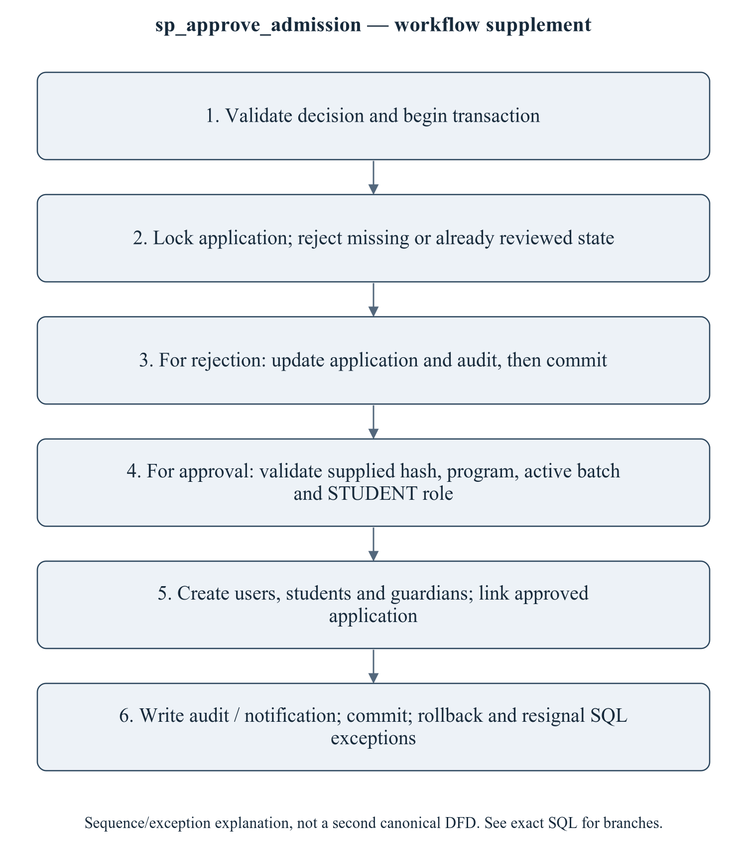
Figure 2.3 sp_approve_admission — transaction/workflow supplement
This is a procedure sequence/exception explanation, not a second canonical DFD. A second approval must not create another identity. Batch/year and email uniqueness failures should leave no partial account. Existing API/SQL test fixtures need the current password-hash argument; no temporary password is printed in this package.
Editable drawing source: diagrams/06_module_01_procedure_workflow.svg, .dot and .mmd. Edit SVG text/shapes in a vector editor, or regenerate from DOT/Mermaid; retain FK IDs and source names. These figures were created from static source, not captured from a running ERP.

2.3 Module ER Diagram, Sub-Schema & Data Dictionary
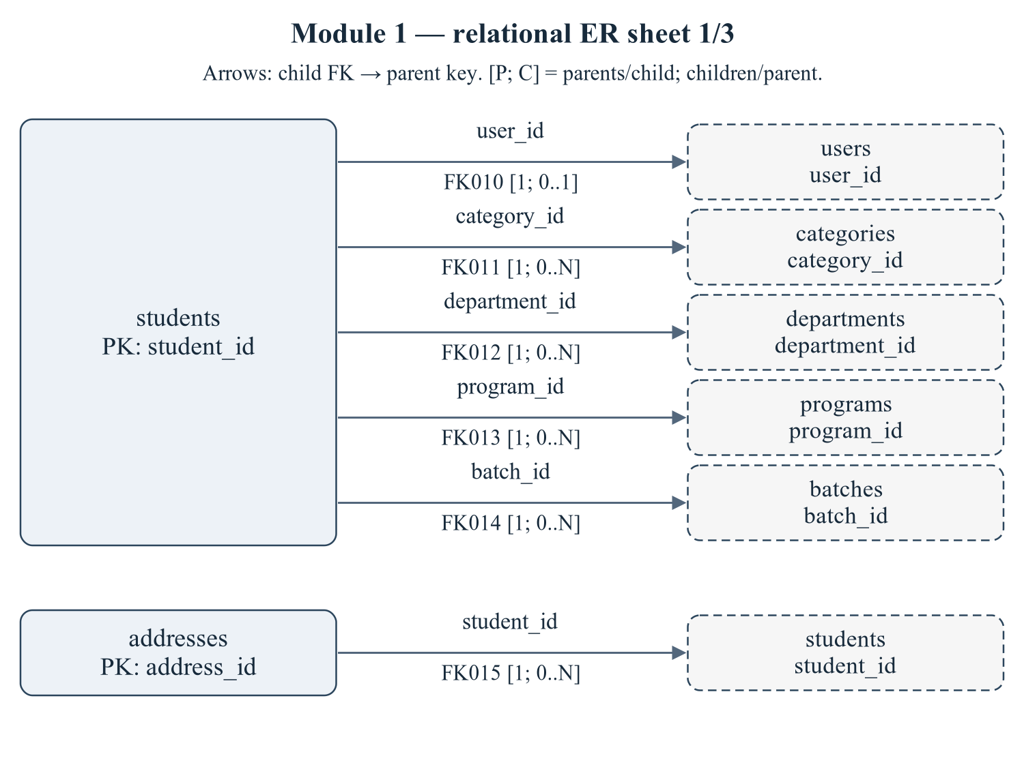
Figure 2.4 Module 1 — relational ER sheet 1/3
The child relations students, addresses refer to actual target keys. Arrows are FK→parent; [P; C] gives parents per child and children per parent. IDs reconcile with the full dictionary and workbook. Dashed parent repetition does not transfer ownership.
Editable drawing source: diagrams/03_er_panel_01_part_01.svg, .dot and .mmd. Edit SVG text/shapes in a vector editor, or regenerate from DOT/Mermaid; retain FK IDs and source names. These figures were created from static source, not captured from a running ERP.
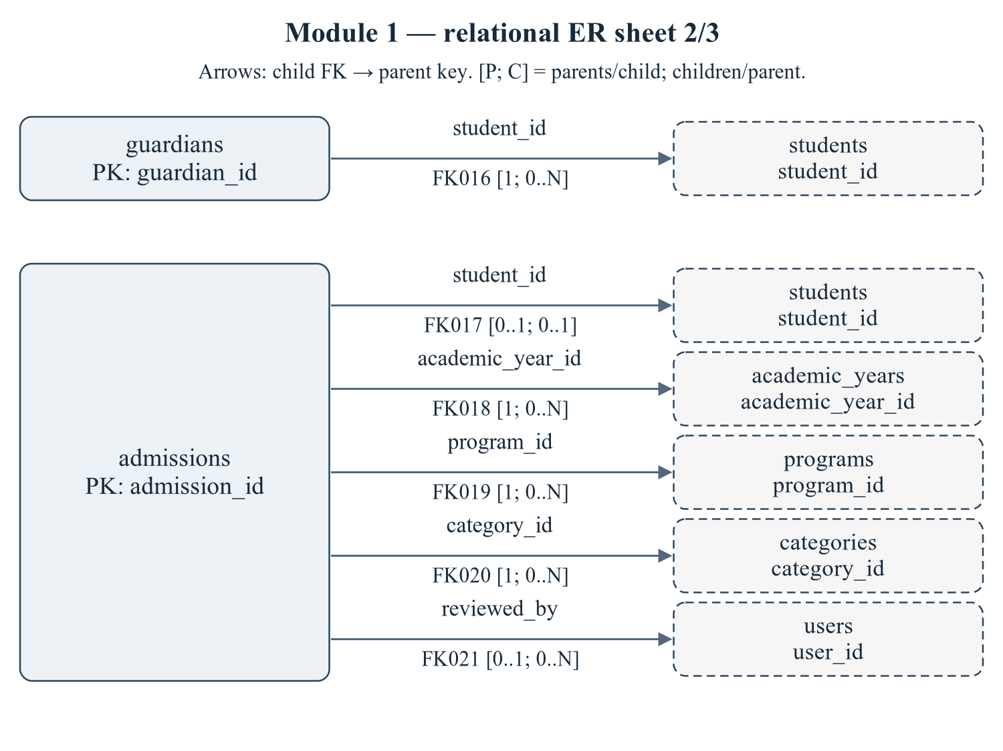
Figure 2.5 Module 1 — relational ER sheet 2/3
The child relations guardians, admissions refer to actual target keys. Arrows are FK→parent; [P; C] gives parents per child and children per parent. IDs reconcile with the full dictionary and workbook. Dashed parent repetition does not transfer ownership.
Editable drawing source: diagrams/03_er_panel_01_part_02.svg, .dot and .mmd. Edit SVG text/shapes in a vector editor, or regenerate from DOT/Mermaid; retain FK IDs and source names. These figures were created from static source, not captured from a running ERP.
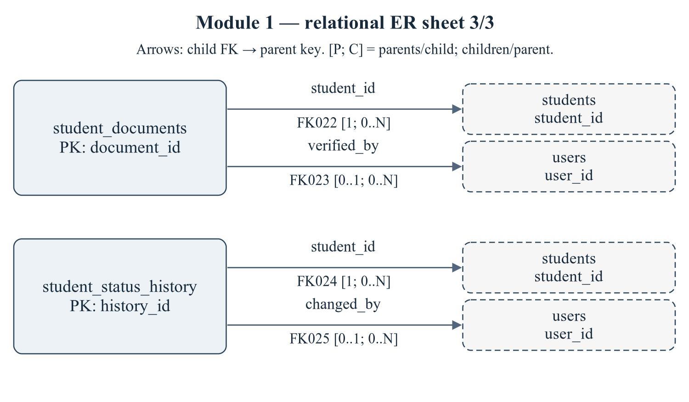
Figure 2.6 Module 1 — relational ER sheet 3/3
The child relations student_documents, student_status_history refer to actual target keys. Arrows are FK→parent; [P; C] gives parents per child and children per parent. IDs reconcile with the full dictionary and workbook. Dashed parent repetition does not transfer ownership.
Editable drawing source: diagrams/03_er_panel_01_part_03.svg, .dot and .mmd. Edit SVG text/shapes in a vector editor, or regenerate from DOT/Mermaid; retain FK IDs and source names. These figures were created from static source, not captured from a running ERP.
Relational notation below lists actual attributes. The full dictionary supplies types/nullability/defaults/constraints; PK/FK notation does not invent undeclared relationships.
students( student_id, user_id, roll_number, registration_number, first_name, middle_name, last_name, email, phone, date_of_birth, gender, blood_group, nationality, category_id, department_id, program_id, batch_id, admission_year, admission_date, current_semester_no, status, photo_url, emergency_contact, created_at, updated_at). PK={student_id}; FK IDs={FK010,FK011,FK012,FK013,FK014}.
addresses( address_id, student_id, address_type, line1, line2, city, district, state, pincode, country, is_primary, created_at, updated_at). PK={address_id}; FK IDs={FK015}.
guardians( guardian_id, student_id, name, relation, phone, email, occupation, annual_income, is_primary, created_at, updated_at). PK={guardian_id}; FK IDs={FK016}.
admissions( admission_id, application_no, student_id, academic_year_id, program_id, category_id, first_name, last_name, email, phone, date_of_birth, gender, guardian_name, guardian_phone, previous_school, qualification, marks_10, marks_12, entrance_score, address_line1, city, state, pincode, application_date, status, reviewed_by, reviewed_at, remarks, created_at, updated_at). PK={admission_id}; FK IDs={FK017,FK018,FK019,FK020,FK021}.
student_documents( document_id, student_id, doc_type, file_name, file_path, mime_type, size_bytes, is_verified, verified_by, verified_at, uploaded_at). PK={document_id}; FK IDs={FK022,FK023}.
student_status_history( history_id, student_id, old_status, new_status, reason, changed_by, changed_at). PK={history_id}; FK IDs={FK024,FK025}.
Table 2.2 Shared / cross-module key contracts (not duplicated ownership)
Parent table / key | Module relationship | Declared action / FK ID
academic_years, PK academic_year_id | admissions.academic_year_id → academic_year_id | FK018: ON DELETE RESTRICT
batches, PK batch_id | students.batch_id → batch_id | FK014: ON DELETE RESTRICT
categories, PK category_id | students.category_id → category_id; admissions.category_id → category_id | FK011: ON DELETE RESTRICT; FK020: ON DELETE RESTRICT
departments, PK department_id | students.department_id → department_id | FK012: ON DELETE RESTRICT
programs, PK program_id | students.program_id → program_id; admissions.program_id → program_id | FK013: ON DELETE RESTRICT; FK019: ON DELETE RESTRICT
users, PK user_id | students.user_id → user_id; admissions.reviewed_by → user_id; student_documents.verified_by → user_id; student_status_history.changed_by → user_id | FK010: ON DELETE CASCADE; FK021: ON DELETE SET NULL; FK023: ON DELETE SET NULL; FK025: ON DELETE SET NULL

The table dictionaries in this module cover its persisted schema in full. External parents above retain their original ownership; their complete 677-column enterprise dictionary is supplied in the master report and inventory workbook. Shared contracts are repeated here so this module can be read independently without pretending to own another module's tables.
students — G1: single student master for the whole ERP.
Definition: database/02_tables.sql:28–79. Owner: Student and Admission Management.
Table 2.3 students — full column dictionary
Column and exact SQL type | Null / default / generation | Keys and purpose
student_id  INT UNSIGNED | NOT NULL  DEFAULT: No explicit DEFAULT  AUTO_INCREMENT | PK  Primary row identifier.
user_id  INT UNSIGNED | NOT NULL  DEFAULT: No explicit DEFAULT | UQ uq_students_user (user_id); FK010 → users.user_id  Login account (role = STUDENT)
roll_number  VARCHAR(20) | NOT NULL  DEFAULT: No explicit DEFAULT | UQ uq_students_roll (roll_number)  University roll number, UNIQUE
registration_number  VARCHAR(30) | NOT NULL  DEFAULT: No explicit DEFAULT | UQ uq_students_regno (registration_number)  Admission registration number, UNIQUE
first_name  VARCHAR(80) | NOT NULL  DEFAULT: No explicit DEFAULT | Given name.
middle_name  VARCHAR(80) | NULL permitted  DEFAULT: No explicit DEFAULT | Optional middle name.
last_name  VARCHAR(80) | NOT NULL  DEFAULT: No explicit DEFAULT | Family name.
email  VARCHAR(150) | NOT NULL  DEFAULT: No explicit DEFAULT | UQ uq_students_email (email)  Stored email address; privacy-sensitive data.
phone  VARCHAR(20) | NULL permitted  DEFAULT: No explicit DEFAULT | Stored contact phone.
date_of_birth  DATE | NOT NULL  DEFAULT: No explicit DEFAULT | Birth date used by validation.
gender  ENUM('MALE','FEMALE','OTHER') | NOT NULL  DEFAULT: No explicit DEFAULT | Gender value.
blood_group  ENUM('A+','A-','B+','B-','AB+','AB-','O+','O-') | NULL permitted  DEFAULT: No explicit DEFAULT | Blood group value.
nationality  VARCHAR(50) | NOT NULL  DEFAULT: 'Indian' | Nationality value.
category_id  TINYINT UNSIGNED | NOT NULL  DEFAULT: No explicit DEFAULT | FK011 → categories.category_id  References categories.category_id.
department_id  INT UNSIGNED | NOT NULL  DEFAULT: No explicit DEFAULT | FK012 → departments.department_id  References departments.department_id.
program_id  SMALLINT UNSIGNED | NOT NULL  DEFAULT: No explicit DEFAULT | FK013 → programs.program_id  References programs.program_id.
batch_id  SMALLINT UNSIGNED | NOT NULL  DEFAULT: No explicit DEFAULT | FK014 → batches.batch_id  References batches.batch_id.
admission_year  SMALLINT UNSIGNED | NOT NULL  DEFAULT: No explicit DEFAULT | Admission year value.
admission_date  DATE | NULL permitted  DEFAULT: No explicit DEFAULT | Admission date date/time, as typed.
current_semester_no  TINYINT UNSIGNED | NOT NULL  DEFAULT: 1 | Current semester no value.
status  ENUM('ACTIVE','INACTIVE','GRADUATED','SUSPENDED','ALUMNI') | NOT NULL  DEFAULT: 'ACTIVE' | Lifecycle state; exact permitted values are in the declared ENUM.
photo_url  VARCHAR(255) | NULL permitted  DEFAULT: No explicit DEFAULT | Stored photo URL metadata; no photo/privacy access verification.
emergency_contact  VARCHAR(20) | NULL permitted  DEFAULT: No explicit DEFAULT | Emergency contact value.
created_at  TIMESTAMP | NOT NULL  DEFAULT: CURRENT_TIMESTAMP | Row creation timestamp.
updated_at  TIMESTAMP; ON UPDATE CURRENT_TIMESTAMP | NOT NULL  DEFAULT: CURRENT_TIMESTAMP | Last row-update timestamp.

PRIMARY KEY: student_id
UNIQUE constraints: UNIQUE KEY `uq_students_roll` (`roll_number`); UNIQUE KEY `uq_students_regno` (`registration_number`); UNIQUE KEY `uq_students_email` (`email`); UNIQUE KEY `uq_students_user` (`user_id`)
CHECK constraints: CONSTRAINT `chk_students_semester` CHECK (`current_semester_no` BETWEEN 1 AND 12)
Secondary indexes: KEY `idx_students_program` (`program_id`); KEY `idx_students_department`(`department_id`); KEY `idx_students_batch` (`batch_id`); KEY `idx_students_status` (`status`); KEY `idx_students_name` (`last_name`, `first_name`); KEY `idx_students_category` (`category_id`); KEY `idx_students_status_program` (`status`, `program_id`, `current_semester_no`)
FK010 fk_students_user: CONSTRAINT `fk_students_user` FOREIGN KEY (`user_id`)
REFERENCES `users` (`user_id`) ON DELETE CASCADE. Parent/child multiplicities 1 / 0..1. Omitted referential actions use restrictive defaults, not an invented cascade.
FK011 fk_students_category: CONSTRAINT `fk_students_category` FOREIGN KEY (`category_id`)
REFERENCES `categories` (`category_id`) ON DELETE RESTRICT. Parent/child multiplicities 1 / 0..N. Omitted referential actions use restrictive defaults, not an invented cascade.
FK012 fk_students_department: CONSTRAINT `fk_students_department` FOREIGN KEY (`department_id`)
REFERENCES `departments` (`department_id`) ON DELETE RESTRICT. Parent/child multiplicities 1 / 0..N. Omitted referential actions use restrictive defaults, not an invented cascade.
FK013 fk_students_program: CONSTRAINT `fk_students_program` FOREIGN KEY (`program_id`)
REFERENCES `programs` (`program_id`) ON DELETE RESTRICT. Parent/child multiplicities 1 / 0..N. Omitted referential actions use restrictive defaults, not an invented cascade.
FK014 fk_students_batch: CONSTRAINT `fk_students_batch` FOREIGN KEY (`batch_id`)
REFERENCES `batches` (`batch_id`) ON DELETE RESTRICT. Parent/child multiplicities 1 / 0..N. Omitted referential actions use restrictive defaults, not an invented cascade.
Normalization / dependency note: Intended batch_id -> program_id and program_id -> department_id repeat cohort/program facts in the row. Independent FKs do not enforce their agreement. Treat this as a conditional transitive-dependency/consistency risk, not a blanket 3NF certification. user_id/email duplication across identity/profile stores is an update anomaly, not automatically a within-relation 3NF violation because user_id is itself UNIQUE NOT NULL.
addresses — G1: student addresses (permanent / correspondence / hostel).
Definition: database/02_tables.sql:84–104. Owner: Student and Admission Management.
Table 2.4 addresses — full column dictionary
Column and exact SQL type | Null / default / generation | Keys and purpose
address_id  INT UNSIGNED | NOT NULL  DEFAULT: No explicit DEFAULT  AUTO_INCREMENT | PK  Primary row identifier.
student_id  INT UNSIGNED | NOT NULL  DEFAULT: No explicit DEFAULT | UQ uq_addresses_student_type (student_id,address_type); FK015 → students.student_id  References students.student_id.
address_type  ENUM('PERMANENT','CORRESPONDENCE','HOSTEL') | NOT NULL  DEFAULT: 'PERMANENT' | UQ uq_addresses_student_type (student_id,address_type)  Address type value.
line1  VARCHAR(160) | NOT NULL  DEFAULT: No explicit DEFAULT | Line1 value.
line2  VARCHAR(160) | NULL permitted  DEFAULT: No explicit DEFAULT | Line2 value.
city  VARCHAR(80) | NOT NULL  DEFAULT: No explicit DEFAULT | City value.
district  VARCHAR(80) | NULL permitted  DEFAULT: No explicit DEFAULT | District value.
state  VARCHAR(80) | NOT NULL  DEFAULT: No explicit DEFAULT | State value.
pincode  VARCHAR(10) | NOT NULL  DEFAULT: No explicit DEFAULT | Pincode value.
country  VARCHAR(60) | NOT NULL  DEFAULT: 'India' | Country value.
is_primary  TINYINT(1) | NOT NULL  DEFAULT: 0 | Primary-record/assignment flag.
created_at  TIMESTAMP | NOT NULL  DEFAULT: CURRENT_TIMESTAMP | Row creation timestamp.
updated_at  TIMESTAMP; ON UPDATE CURRENT_TIMESTAMP | NOT NULL  DEFAULT: CURRENT_TIMESTAMP | Last row-update timestamp.

PRIMARY KEY: address_id
UNIQUE constraints: UNIQUE KEY `uq_addresses_student_type` (`student_id`, `address_type`)
CHECK constraints: CONSTRAINT `chk_addresses_pincode` CHECK (CHAR_LENGTH(`pincode`) BETWEEN 4 AND 10)
Secondary indexes: KEY `idx_addresses_city` (`city`)
FK015 fk_addresses_student: CONSTRAINT `fk_addresses_student` FOREIGN KEY (`student_id`)
REFERENCES `students` (`student_id`) ON DELETE CASCADE. Parent/child multiplicities 1 / 0..N. Omitted referential actions use restrictive defaults, not an invented cascade.
Normalization / dependency note: PK determines the remaining stored attributes. Non-null declared UNIQUE tuples are additional candidate-key evidence. No further non-key determinant was established from DDL alone; 3NF is conditional on the stated business FDs being complete, not certified solely by having a surrogate key.
guardians — G1: guardian / parent information.
Definition: database/02_tables.sql:109–127. Owner: Student and Admission Management.
Table 2.5 guardians — full column dictionary
Column and exact SQL type | Null / default / generation | Keys and purpose
guardian_id  INT UNSIGNED | NOT NULL  DEFAULT: No explicit DEFAULT  AUTO_INCREMENT | PK  Primary row identifier.
student_id  INT UNSIGNED | NOT NULL  DEFAULT: No explicit DEFAULT | UQ uq_guardians_student_relation (student_id,relation); FK016 → students.student_id  References students.student_id.
name  VARCHAR(120) | NOT NULL  DEFAULT: No explicit DEFAULT | Stored display/name attribute.
relation  ENUM('FATHER','MOTHER','GUARDIAN','SPOUSE','SIBLING') | NOT NULL  DEFAULT: 'FATHER' | UQ uq_guardians_student_relation (student_id,relation)  Relation value.
phone  VARCHAR(20) | NOT NULL  DEFAULT: No explicit DEFAULT | Stored contact phone.
email  VARCHAR(150) | NULL permitted  DEFAULT: No explicit DEFAULT | Stored email address; privacy-sensitive data.
occupation  VARCHAR(80) | NULL permitted  DEFAULT: No explicit DEFAULT | Occupation value.
annual_income  DECIMAL(12,2) | NOT NULL  DEFAULT: 0.00 | Declared guardian income; values excluded.
is_primary  TINYINT(1) | NOT NULL  DEFAULT: 0 | Primary-record/assignment flag.
created_at  TIMESTAMP | NOT NULL  DEFAULT: CURRENT_TIMESTAMP | Row creation timestamp.
updated_at  TIMESTAMP; ON UPDATE CURRENT_TIMESTAMP | NOT NULL  DEFAULT: CURRENT_TIMESTAMP | Last row-update timestamp.

PRIMARY KEY: guardian_id
UNIQUE constraints: UNIQUE KEY `uq_guardians_student_relation` (`student_id`, `relation`)
CHECK constraints: CONSTRAINT `chk_guardians_income` CHECK (`annual_income` >= 0)
Secondary indexes: KEY `idx_guardians_student` (`student_id`)
FK016 fk_guardians_student: CONSTRAINT `fk_guardians_student` FOREIGN KEY (`student_id`)
REFERENCES `students` (`student_id`) ON DELETE CASCADE. Parent/child multiplicities 1 / 0..N. Omitted referential actions use restrictive defaults, not an invented cascade.
Normalization / dependency note: PK determines the remaining stored attributes. Non-null declared UNIQUE tuples are additional candidate-key evidence. No further non-key determinant was established from DDL alone; 3NF is conditional on the stated business FDs being complete, not certified solely by having a surrogate key.
admissions — G1: admission applications and their approval lifecycle.
Definition: database/02_tables.sql:132–182. Owner: Student and Admission Management.
Table 2.6 admissions — full column dictionary
Column and exact SQL type | Null / default / generation | Keys and purpose
admission_id  INT UNSIGNED | NOT NULL  DEFAULT: No explicit DEFAULT  AUTO_INCREMENT | PK  Primary row identifier.
application_no  VARCHAR(30) | NOT NULL  DEFAULT: No explicit DEFAULT | UQ uq_admissions_appno (application_no)  APP-2026-000123
student_id  INT UNSIGNED | NULL permitted  DEFAULT: No explicit DEFAULT | UQ uq_admissions_student (student_id); FK017 → students.student_id  Set when the application is APPROVED
academic_year_id  SMALLINT UNSIGNED | NOT NULL  DEFAULT: No explicit DEFAULT | FK018 → academic_years.academic_year_id  References academic_years.academic_year_id.
program_id  SMALLINT UNSIGNED | NOT NULL  DEFAULT: No explicit DEFAULT | FK019 → programs.program_id  References programs.program_id.
category_id  TINYINT UNSIGNED | NOT NULL  DEFAULT: No explicit DEFAULT | FK020 → categories.category_id  References categories.category_id.
first_name  VARCHAR(80) | NOT NULL  DEFAULT: No explicit DEFAULT | Given name.
last_name  VARCHAR(80) | NOT NULL  DEFAULT: No explicit DEFAULT | Family name.
email  VARCHAR(150) | NOT NULL  DEFAULT: No explicit DEFAULT | UQ uq_admissions_email (email)  Stored email address; privacy-sensitive data.
phone  VARCHAR(20) | NOT NULL  DEFAULT: No explicit DEFAULT | Stored contact phone.
date_of_birth  DATE | NOT NULL  DEFAULT: No explicit DEFAULT | Birth date used by validation.
gender  ENUM('MALE','FEMALE','OTHER') | NOT NULL  DEFAULT: No explicit DEFAULT | Gender value.
guardian_name  VARCHAR(120) | NOT NULL  DEFAULT: No explicit DEFAULT | Guardian name value.
guardian_phone  VARCHAR(20) | NOT NULL  DEFAULT: No explicit DEFAULT | Guardian phone value.
previous_school  VARCHAR(160) | NULL permitted  DEFAULT: No explicit DEFAULT | Previous school value.
qualification  VARCHAR(80) | NOT NULL  DEFAULT: 'HSC' | Qualification value.
marks_10  DECIMAL(5,2) | NOT NULL  DEFAULT: 0.00 | Marks 10 value.
marks_12  DECIMAL(5,2) | NOT NULL  DEFAULT: 0.00 | Marks 12 value.
entrance_score  DECIMAL(6,2) | NULL permitted  DEFAULT: No explicit DEFAULT | Entrance score value.
address_line1  VARCHAR(160) | NULL permitted  DEFAULT: No explicit DEFAULT | Address line1 value.
city  VARCHAR(80) | NULL permitted  DEFAULT: No explicit DEFAULT | City value.
state  VARCHAR(80) | NULL permitted  DEFAULT: No explicit DEFAULT | State value.
pincode  VARCHAR(10) | NULL permitted  DEFAULT: No explicit DEFAULT | Pincode value.
application_date  DATE | NOT NULL  DEFAULT: (CURRENT_DATE) | Application date date/time, as typed.
status  ENUM('APPLIED','UNDER_REVIEW','APPROVED','REJECTED','WAITLISTED') | NOT NULL  DEFAULT: 'APPLIED' | Lifecycle state; exact permitted values are in the declared ENUM.
reviewed_by  INT UNSIGNED | NULL permitted  DEFAULT: No explicit DEFAULT | FK021 → users.user_id  References users.user_id.
reviewed_at  DATETIME | NULL permitted  DEFAULT: No explicit DEFAULT | Reviewed at date/time, as typed.
remarks  VARCHAR(500) | NULL permitted  DEFAULT: No explicit DEFAULT | Operation or record remarks.
created_at  TIMESTAMP | NOT NULL  DEFAULT: CURRENT_TIMESTAMP | Row creation timestamp.
updated_at  TIMESTAMP; ON UPDATE CURRENT_TIMESTAMP | NOT NULL  DEFAULT: CURRENT_TIMESTAMP | Last row-update timestamp.

PRIMARY KEY: admission_id
UNIQUE constraints: UNIQUE KEY `uq_admissions_appno` (`application_no`); UNIQUE KEY `uq_admissions_student` (`student_id`); UNIQUE KEY `uq_admissions_email` (`email`)
CHECK constraints: CONSTRAINT `chk_admissions_marks10` CHECK (`marks_10` BETWEEN 0 AND 100); CONSTRAINT `chk_admissions_marks12` CHECK (`marks_12` BETWEEN 0 AND 100)
Secondary indexes: KEY `idx_admissions_status` (`status`); KEY `idx_admissions_program` (`program_id`)
FK017 fk_admissions_student: CONSTRAINT `fk_admissions_student` FOREIGN KEY (`student_id`)
REFERENCES `students` (`student_id`) ON DELETE SET NULL. Parent/child multiplicities 0..1 / 0..1. Omitted referential actions use restrictive defaults, not an invented cascade.
FK018 fk_admissions_year: CONSTRAINT `fk_admissions_year` FOREIGN KEY (`academic_year_id`)
REFERENCES `academic_years` (`academic_year_id`) ON DELETE RESTRICT. Parent/child multiplicities 1 / 0..N. Omitted referential actions use restrictive defaults, not an invented cascade.
FK019 fk_admissions_program: CONSTRAINT `fk_admissions_program` FOREIGN KEY (`program_id`)
REFERENCES `programs` (`program_id`) ON DELETE RESTRICT. Parent/child multiplicities 1 / 0..N. Omitted referential actions use restrictive defaults, not an invented cascade.
FK020 fk_admissions_category: CONSTRAINT `fk_admissions_category` FOREIGN KEY (`category_id`)
REFERENCES `categories` (`category_id`) ON DELETE RESTRICT. Parent/child multiplicities 1 / 0..N. Omitted referential actions use restrictive defaults, not an invented cascade.
FK021 fk_admissions_reviewer: CONSTRAINT `fk_admissions_reviewer` FOREIGN KEY (`reviewed_by`)
REFERENCES `users` (`user_id`) ON DELETE SET NULL. Parent/child multiplicities 0..1 / 0..N. Omitted referential actions use restrictive defaults, not an invented cascade.
Normalization / dependency note: program_id and academic_year_id determine lookup context; copied applicant/contact/guardian values are application snapshots, not a replacement for users/students. student_id is nullable UNIQUE, so multiple NULL applications do not create a candidate key.
student_documents — G1: metadata of documents uploaded against a student.
Definition: database/02_tables.sql:187–207. Owner: Student and Admission Management.
Table 2.7 student_documents — full column dictionary
Column and exact SQL type | Null / default / generation | Keys and purpose
document_id  INT UNSIGNED | NOT NULL  DEFAULT: No explicit DEFAULT  AUTO_INCREMENT | PK  Primary row identifier.
student_id  INT UNSIGNED | NOT NULL  DEFAULT: No explicit DEFAULT | FK022 → students.student_id  References students.student_id.
doc_type  ENUM('PHOTO','AADHAR','PAN','BIRTH_CERTIFICATE','MARKSHEET_10','MARKSHEET_12',  'TRANSFER_CERTIFICATE','CASTE_CERTIFICATE','INCOME_CERTIFICATE','OTHER') | NOT NULL  DEFAULT: No explicit DEFAULT | Doc type value.
file_name  VARCHAR(255) | NOT NULL  DEFAULT: No explicit DEFAULT | File name value.
file_path  VARCHAR(255) | NOT NULL  DEFAULT: No explicit DEFAULT | Stored document location metadata, not proof of binary upload.
mime_type  VARCHAR(100) | NOT NULL  DEFAULT: 'application/octet-stream' | Mime type value.
size_bytes  INT UNSIGNED | NOT NULL  DEFAULT: 0 | Size bytes value.
is_verified  TINYINT(1) | NOT NULL  DEFAULT: 0 | Verified flag.
verified_by  INT UNSIGNED | NULL permitted  DEFAULT: No explicit DEFAULT | FK023 → users.user_id  References users.user_id.
verified_at  DATETIME | NULL permitted  DEFAULT: No explicit DEFAULT | Verified at date/time, as typed.
uploaded_at  TIMESTAMP | NOT NULL  DEFAULT: CURRENT_TIMESTAMP | Uploaded at date/time, as typed.

PRIMARY KEY: document_id
UNIQUE constraints: None declared.
CHECK constraints: None declared.
Secondary indexes: KEY `idx_documents_student` (`student_id`); KEY `idx_documents_type` (`doc_type`)
FK022 fk_documents_student: CONSTRAINT `fk_documents_student` FOREIGN KEY (`student_id`)
REFERENCES `students` (`student_id`) ON DELETE CASCADE. Parent/child multiplicities 1 / 0..N. Omitted referential actions use restrictive defaults, not an invented cascade.
FK023 fk_documents_verifier: CONSTRAINT `fk_documents_verifier` FOREIGN KEY (`verified_by`)
REFERENCES `users` (`user_id`) ON DELETE SET NULL. Parent/child multiplicities 0..1 / 0..N. Omitted referential actions use restrictive defaults, not an invented cascade.
Normalization / dependency note: PK determines the remaining stored attributes. Non-null declared UNIQUE tuples are additional candidate-key evidence. No further non-key determinant was established from DDL alone; 3NF is conditional on the stated business FDs being complete, not certified solely by having a surrogate key.
student_status_history — G1: history of student status transitions (written by trigger).
Definition: database/02_tables.sql:212–225. Owner: Student and Admission Management.
Table 2.8 student_status_history — full column dictionary
Column and exact SQL type | Null / default / generation | Keys and purpose
history_id  INT UNSIGNED | NOT NULL  DEFAULT: No explicit DEFAULT  AUTO_INCREMENT | PK  Primary row identifier.
student_id  INT UNSIGNED | NOT NULL  DEFAULT: No explicit DEFAULT | FK024 → students.student_id  References students.student_id.
old_status  VARCHAR(30) | NULL permitted  DEFAULT: No explicit DEFAULT | Old status value.
new_status  VARCHAR(30) | NOT NULL  DEFAULT: No explicit DEFAULT | New status value.
reason  VARCHAR(255) | NULL permitted  DEFAULT: No explicit DEFAULT | Reason value.
changed_by  INT UNSIGNED | NULL permitted  DEFAULT: No explicit DEFAULT | FK025 → users.user_id  References users.user_id.
changed_at  TIMESTAMP | NOT NULL  DEFAULT: CURRENT_TIMESTAMP | Changed at date/time, as typed.

PRIMARY KEY: history_id
UNIQUE constraints: None declared.
CHECK constraints: None declared.
Secondary indexes: KEY `idx_status_history_student` (`student_id`)
FK024 fk_status_history_student: CONSTRAINT `fk_status_history_student` FOREIGN KEY (`student_id`)
REFERENCES `students` (`student_id`) ON DELETE CASCADE. Parent/child multiplicities 1 / 0..N. Omitted referential actions use restrictive defaults, not an invented cascade.
FK025 fk_status_history_user: CONSTRAINT `fk_status_history_user` FOREIGN KEY (`changed_by`)
REFERENCES `users` (`user_id`) ON DELETE SET NULL. Parent/child multiplicities 0..1 / 0..N. Omitted referential actions use restrictive defaults, not an invented cascade.
Normalization / dependency note: PK determines the remaining stored attributes. Non-null declared UNIQUE tuples are additional candidate-key evidence. No further non-key determinant was established from DDL alone; 3NF is conditional on the stated business FDs being complete, not certified solely by having a surrogate key.

2.3.1 Normalization Analysis & Justified Exceptions
3NF is a property of a relation under a complete functional-dependency set, not a consequence of naming an integer primary key. The DDL supplies PKs, non-null UNIQUE candidates, types and referential constraints; domain FDs and historical snapshot intent require the business owner. Nullable UNIQUE tuples are not automatically candidate keys: multiple NULL-bearing values may be permitted. CHECK accepts TRUE/UNKNOWN and enforced support depends on the actual server version (MySQL 8.0.16+ for enforced CHECK). [D01, D03, R01, R02, R03]
1NF is provisionally interpreted at the declared SQL-type level: one row value per attribute. JSON/text document fields are treated as opaque values, not silently decomposed into invented child tables. 2NF requires dependence on the whole of every candidate key. 3NF additionally rejects non-key determinants unless the dependent attribute is prime or the determinant is a superkey. Cross-table contact duplication and maintained cross-row counters are discussed separately from formal within-row FD violations.
Table 2.9 Relation-level candidate keys and normalization assessment
Relation | Proven key candidates | FD / exception / evidence assessment
students | (student_id); (roll_number); (registration_number); (email); (user_id) | Intended batch_id -> program_id and program_id -> department_id repeat cohort/program facts in the row. Independent FKs do not enforce their agreement. Treat this as a conditional transitive-dependency/consistency risk, not a blanket 3NF certification. user_id/email duplication across identity/profile stores is an update anomaly, not automatically a within-relation 3NF violation because user_id is itself UNIQUE NOT NULL.
addresses | (address_id); (student_id,address_type) | PK determines the remaining stored attributes. Non-null declared UNIQUE tuples are additional candidate-key evidence. No further non-key determinant was established from DDL alone; 3NF is conditional on the stated business FDs being complete, not certified solely by having a surrogate key.
guardians | (guardian_id); (student_id,relation) | PK determines the remaining stored attributes. Non-null declared UNIQUE tuples are additional candidate-key evidence. No further non-key determinant was established from DDL alone; 3NF is conditional on the stated business FDs being complete, not certified solely by having a surrogate key.
admissions | (admission_id); (application_no); (email) | program_id and academic_year_id determine lookup context; copied applicant/contact/guardian values are application snapshots, not a replacement for users/students. student_id is nullable UNIQUE, so multiple NULL applications do not create a candidate key.
student_documents | (document_id) | PK determines the remaining stored attributes. Non-null declared UNIQUE tuples are additional candidate-key evidence. No further non-key determinant was established from DDL alone; 3NF is conditional on the stated business FDs being complete, not certified solely by having a surrogate key.
student_status_history | (history_id) | PK determines the remaining stored attributes. Non-null declared UNIQUE tuples are additional candidate-key evidence. No further non-key determinant was established from DDL alone; 3NF is conditional on the stated business FDs being complete, not certified solely by having a surrogate key.

Module-specific proposal — not implemented DDL: if each student must use the department of the referenced current program, the intended FD program_id → department_id makes the duplicated students.department_id transitively dependent on the student key. Deriving the department through programs would remove that redundancy. The programs PK makes the lookup unique, but reconstruction is equivalent to existing rows only after program/department agreement is verified. If the student department is an intentional admission-time snapshot, retain and label that temporal meaning instead of silently deleting it. The independent FK declarations alone do not establish equality.
This module-specific analysis is a design assessment, not implemented replacement DDL or an executed migration. Confirm domain dependencies and historical semantics, then verify key preservation, join equivalence and affected API/trigger behavior before changing the schema. Current definitions and actual evidence gaps remain authoritative.

2.4 Advanced SQL Implementation

2.4.1 Stored Procedures (SQL Code & Execution Proofs)

sp_approve_admission
Purpose / expected behavior: Approve/reject one reviewable application. Approval locks context and creates a first-login user, student and guardian, links the application and writes audit/notification. Requires a supplied temporary hash; no secret value is included here.
Source: database/05_procedures.sql:985–1146. Definition found in the pinned snapshot; live existence and execution are unverified. Exact source comments may be stale; only inventoried definitions establish object names.
IN p_admission_id: INT UNSIGNED
IN p_reviewed_by: INT UNSIGNED
IN p_approve: TINYINT
IN p_remarks: VARCHAR(500)
IN p_password_hash: VARCHAR(255)
OUT p_student_id: INT UNSIGNED
OUT p_message: VARCHAR(255)
Outputs: p_student_id INT UNSIGNED, p_message VARCHAR(255)
Read/write dependencies: admissions, audit_logs, batches, guardians, programs, roles, students, users, v_admission_state, v_admission_year, v_app, v_batch, v_cat, v_dept, v_dob, v_email, v_first, v_gender, v_gphone, v_guardian, v_last, v_phone, v_prog, v_program_code, v_program_tag, v_regno, v_role, v_roll, v_seq, v_user, v_year
Routine calls: sp_push_notification
Transaction boundary: Explicit START TRANSACTION / COMMIT and SQLEXCEPTION handling in the definition.
Invocation template (not executed): bind every @ input to a mutually consistent synthetic fixture selected from the declared tables and run only on an authorized disposable schema. Numeric literals below are planned test inputs, not observed results. Internal COMMIT means wrapping a CALL in an outer ROLLBACK is not a safe fixture-cleanup strategy.
CALL sp_approve_admission(@p_admission_id, @p_reviewed_by, @p_approve, @p_remarks, @p_password_hash, @p_student_id, @p_message);
SELECT @p_student_id AS p_student_id, @p_message AS p_message;

Actual result: [[TO BE PROVIDED: run this test and record the actual result]]
Status: [[TO BE PROVIDED: run this test and record the actual result]]
Required evidence: [[TO BE PROVIDED: execute sp_approve_admission or its triggering DML using the corresponding module test case; owner must attach sanitized inputs, OUT/SELECT/error output, before/after effects and timestamp]]
Exact SQL definition (unchanged from source):
CREATE PROCEDURE `sp_approve_admission`(
IN p_admission_id INT UNSIGNED,
IN p_reviewed_by INT UNSIGNED,
IN p_approve TINYINT,
IN p_remarks VARCHAR(500),
IN p_password_hash VARCHAR(255),
OUT p_student_id INT UNSIGNED,
OUT p_message VARCHAR(255)
)
BEGIN
DECLARE v_app VARCHAR(30) DEFAULT NULL;
DECLARE v_first VARCHAR(80) DEFAULT NULL;
DECLARE v_last VARCHAR(80) DEFAULT NULL;
DECLARE v_email VARCHAR(150) DEFAULT NULL;
DECLARE v_phone VARCHAR(20) DEFAULT NULL;
DECLARE v_dob DATE DEFAULT NULL;
DECLARE v_gender VARCHAR(10) DEFAULT NULL;
DECLARE v_prog SMALLINT UNSIGNED DEFAULT NULL;
DECLARE v_cat TINYINT UNSIGNED DEFAULT NULL;
DECLARE v_year SMALLINT UNSIGNED DEFAULT NULL;
DECLARE v_guardian VARCHAR(120) DEFAULT NULL;
DECLARE v_gphone VARCHAR(20) DEFAULT NULL;
DECLARE v_admission_state VARCHAR(20) DEFAULT NULL;
DECLARE v_dept INT UNSIGNED DEFAULT NULL;
DECLARE v_batch SMALLINT UNSIGNED DEFAULT NULL;
DECLARE v_admission_year SMALLINT UNSIGNED DEFAULT NULL;
DECLARE v_role TINYINT UNSIGNED DEFAULT NULL;
DECLARE v_user INT UNSIGNED DEFAULT NULL;
DECLARE v_roll VARCHAR(20) DEFAULT NULL;
DECLARE v_regno VARCHAR(30) DEFAULT NULL;
DECLARE v_program_code VARCHAR(20) DEFAULT NULL;
DECLARE v_program_tag VARCHAR(20) DEFAULT NULL;
DECLARE v_seq INT DEFAULT NULL;

DECLARE EXIT HANDLER FOR SQLEXCEPTION
BEGIN
ROLLBACK;
RESIGNAL;
END;

SET p_student_id = NULL;
SET p_message = NULL;

IF p_approve NOT IN (0, 1) THEN
SIGNAL SQLSTATE '45000' SET MESSAGE_TEXT = 'Invalid admission decision.';
END IF;

START TRANSACTION;

SELECT `application_no`, `first_name`, `last_name`, `email`, `phone`, `date_of_birth`,
`gender`, `program_id`, `category_id`, `academic_year_id`, `guardian_name`,
`guardian_phone`, `status`, `student_id`
INTO v_app, v_first, v_last, v_email, v_phone, v_dob, v_gender, v_prog, v_cat,
v_year, v_guardian, v_gphone, v_admission_state, p_student_id
FROM `admissions`
WHERE `admission_id` = p_admission_id
FOR UPDATE;

IF v_app IS NULL THEN
SIGNAL SQLSTATE '45000' SET MESSAGE_TEXT = 'Admission application not found.';
END IF;

IF v_admission_state NOT IN ('APPLIED', 'UNDER_REVIEW', 'WAITLISTED') THEN
SIGNAL SQLSTATE '45000' SET MESSAGE_TEXT = 'This application has already been reviewed.';
END IF;

IF p_approve = 0 THEN
UPDATE `admissions`
SET `status` = 'REJECTED', `reviewed_by` = p_reviewed_by,
`reviewed_at` = NOW(), `remarks` = p_remarks
WHERE `admission_id` = p_admission_id;

INSERT INTO `audit_logs` (`user_id`, `action`, `entity`, `entity_id`, `description`)
VALUES (p_reviewed_by, 'REJECT', 'admissions', p_admission_id,
CONCAT('Admission ', v_app, ' rejected'));

SET p_message = 'Application rejected.';
COMMIT;
ELSE
IF p_student_id IS NOT NULL THEN
SIGNAL SQLSTATE '45000'
SET MESSAGE_TEXT = 'This application has already been converted into a student.';
END IF;
IF p_password_hash IS NULL OR CHAR_LENGTH(p_password_hash) < 20 THEN
SIGNAL SQLSTATE '45000' SET MESSAGE_TEXT = 'A valid temporary password hash is required.';
END IF;

SELECT `department_id`, `program_code`
INTO v_dept, v_program_code
FROM `programs`
WHERE `program_id` = v_prog;

IF v_dept IS NULL OR v_program_code IS NULL THEN
SIGNAL SQLSTATE '45000' SET MESSAGE_TEXT = 'The selected program is no longer available.';
END IF;

SELECT `batch_id`, `start_year`
INTO v_batch, v_admission_year
FROM `batches`
WHERE `program_id` = v_prog AND `academic_year_id` = v_year AND `status` = 'ACTIVE'
ORDER BY `batch_id` ASC
LIMIT 1
FOR UPDATE;

IF v_batch IS NULL OR v_admission_year IS NULL THEN
SIGNAL SQLSTATE '45000'
SET MESSAGE_TEXT = 'No batch exists for this program and academic year.';
END IF;

SELECT `role_id` INTO v_role FROM `roles` WHERE `role_code` = 'STUDENT' LIMIT 1;
IF v_role IS NULL THEN
SIGNAL SQLSTATE '45000' SET MESSAGE_TEXT = 'The student role is not configured.';
END IF;

IF EXISTS (SELECT 1 FROM `users` WHERE `email` = v_email) THEN
SIGNAL SQLSTATE '45000' SET MESSAGE_TEXT = 'A user with this email already exists.';
END IF;

INSERT INTO `users`
(`role_id`, `email`, `password_hash`, `phone`, `is_active`, `is_first_login`)
VALUES (v_role, LOWER(TRIM(v_email)), p_password_hash, v_phone, 1, 1);
SET v_user = LAST_INSERT_ID();

SELECT COALESCE(MAX(CAST(RIGHT(`roll_number`, 4) AS UNSIGNED)), 1000) + 1
INTO v_seq
FROM `students`
WHERE `admission_year` = v_admission_year AND `program_id` = v_prog;

SET v_program_tag = REPLACE(REPLACE(v_program_code, 'BTECH-', ''), 'MTECH-', 'M');
SET v_roll = CONCAT(v_admission_year, v_program_tag, LPAD(v_seq, 4, '0'));
SET v_regno = CONCAT('PICT/', v_admission_year, '/', v_program_tag, '/', LPAD(v_seq, 4, '0'));

INSERT INTO `students`
(`user_id`, `roll_number`, `registration_number`, `first_name`, `last_name`, `email`,
`phone`, `date_of_birth`, `gender`, `category_id`, `department_id`, `program_id`,
`batch_id`, `admission_year`, `admission_date`, `current_semester_no`, `status`)
VALUES
(v_user, v_roll, v_regno, v_first, v_last, LOWER(TRIM(v_email)), v_phone, v_dob, v_gender,
v_cat, v_dept, v_prog, v_batch, v_admission_year, CURDATE(), 1, 'ACTIVE');

SET p_student_id = LAST_INSERT_ID();

INSERT INTO `guardians` (`student_id`, `name`, `relation`, `phone`, `is_primary`)
VALUES (p_student_id, v_guardian, 'FATHER', v_gphone, 1);

UPDATE `admissions`
SET `status` = 'APPROVED', `student_id` = p_student_id, `reviewed_by` = p_reviewed_by,
`reviewed_at` = NOW(), `remarks` = IFNULL(p_remarks, 'Approved')
WHERE `admission_id` = p_admission_id;

INSERT INTO `audit_logs` (`user_id`, `action`, `entity`, `entity_id`, `description`)
VALUES (p_reviewed_by, 'APPROVE', 'admissions', p_admission_id,
CONCAT('Admission approved - student ', v_roll, ' created'));

CALL sp_push_notification(v_user, 'Admission approved',
CONCAT('Your application has been approved. Your roll number is ', v_roll, '.'),
'ADMISSION', 'SUCCESS', 'student', p_student_id, '/profile');

SET p_message = CONCAT('Admission approved. Student ', v_roll, ' created.');
COMMIT;
END IF;
END$$

2.4.2 Database Triggers (SQL Code & Execution Proofs)

trg_students_bi_validate
Purpose / expected behavior: Validate a newly inserted student date of birth and phone under the exact IF conditions; raise SQLSTATE 45000 for rejected data.
Source: database/06_triggers.sql:29–38. Definition found in the pinned snapshot; live existence and execution are unverified. Exact source comments may be stale; only inventoried definitions establish object names.
Event / inputs / output: BEFORE INSERT ON `students` FOR EACH ROW; OLD/NEW are event-appropriate row images; no explicit arguments or scalar return. Side effects are described above.
Read/write dependencies: students
Routine calls: No other stored routine call extracted.
Invocation template (not executed): bind every @ input to a mutually consistent synthetic fixture selected from the declared tables and run only on an authorized disposable schema. Numeric literals below are planned test inputs, not observed results. Internal COMMIT means wrapping a CALL in an outer ROLLBACK is not a safe fixture-cleanup strategy.
CALL sp_approve_admission(@p_admission_id, @p_reviewed_by, 1, NULL, @p_password_hash, @p_student_id, @p_message);

Actual result: [[TO BE PROVIDED: run this test and record the actual result]]
Status: [[TO BE PROVIDED: run this test and record the actual result]]
Required evidence: [[TO BE PROVIDED: execute trg_students_bi_validate or its triggering DML using the corresponding module test case; owner must attach sanitized inputs, OUT/SELECT/error output, before/after effects and timestamp]]
Exact SQL definition (unchanged from source):
CREATE TRIGGER `trg_students_bi_validate`
BEFORE INSERT ON `students` FOR EACH ROW
BEGIN
IF NEW.`date_of_birth` >= CURDATE() THEN
SIGNAL SQLSTATE '45000' SET MESSAGE_TEXT = 'Date of birth must be in the past.';
END IF;
IF NEW.`email` NOT LIKE '%@%' THEN
SIGNAL SQLSTATE '45000' SET MESSAGE_TEXT = 'Student email address is not valid.';
END IF;
END$$

trg_students_bu_validate
Purpose / expected behavior: Validate changed student dates/contact data before update; the exact conditional comparisons in the definition determine the checked changes.
Source: database/06_triggers.sql:41–47. Definition found in the pinned snapshot; live existence and execution are unverified. Exact source comments may be stale; only inventoried definitions establish object names.
Event / inputs / output: BEFORE UPDATE ON `students` FOR EACH ROW; OLD/NEW are event-appropriate row images; no explicit arguments or scalar return. Side effects are described above.
Read/write dependencies: students
Routine calls: No other stored routine call extracted.
Invocation template (not executed): bind every @ input to a mutually consistent synthetic fixture selected from the declared tables and run only on an authorized disposable schema. Numeric literals below are planned test inputs, not observed results. Internal COMMIT means wrapping a CALL in an outer ROLLBACK is not a safe fixture-cleanup strategy.
UPDATE students SET date_of_birth = CURDATE() WHERE student_id = @fixture_student_id;

Actual result: [[TO BE PROVIDED: run this test and record the actual result]]
Status: [[TO BE PROVIDED: run this test and record the actual result]]
Required evidence: [[TO BE PROVIDED: execute trg_students_bu_validate or its triggering DML using the corresponding module test case; owner must attach sanitized inputs, OUT/SELECT/error output, before/after effects and timestamp]]
Exact SQL definition (unchanged from source):
CREATE TRIGGER `trg_students_bu_validate`
BEFORE UPDATE ON `students` FOR EACH ROW
BEGIN
IF NEW.`date_of_birth` >= CURDATE() THEN
SIGNAL SQLSTATE '45000' SET MESSAGE_TEXT = 'Date of birth must be in the past.';
END IF;
END$$

trg_students_au_status_history
Purpose / expected behavior: When status changes, append old/new status and contextual metadata to student_status_history. It does not cover every profile-field update.
Source: database/06_triggers.sql:50–58. Definition found in the pinned snapshot; live existence and execution are unverified. Exact source comments may be stale; only inventoried definitions establish object names.
Event / inputs / output: AFTER UPDATE ON `students` FOR EACH ROW; OLD/NEW are event-appropriate row images; no explicit arguments or scalar return. Side effects are described above.
Read/write dependencies: student_status_history, students
Routine calls: No other stored routine call extracted.
Invocation template (not executed): bind every @ input to a mutually consistent synthetic fixture selected from the declared tables and run only on an authorized disposable schema. Numeric literals below are planned test inputs, not observed results. Internal COMMIT means wrapping a CALL in an outer ROLLBACK is not a safe fixture-cleanup strategy.
UPDATE students SET status = 'SUSPENDED' WHERE student_id = @fixture_student_id;

Actual result: [[TO BE PROVIDED: run this test and record the actual result]]
Status: [[TO BE PROVIDED: run this test and record the actual result]]
Required evidence: [[TO BE PROVIDED: execute trg_students_au_status_history or its triggering DML using the corresponding module test case; owner must attach sanitized inputs, OUT/SELECT/error output, before/after effects and timestamp]]
Exact SQL definition (unchanged from source):
CREATE TRIGGER `trg_students_au_status_history`
AFTER UPDATE ON `students` FOR EACH ROW
BEGIN
IF OLD.`status` <> NEW.`status` THEN
INSERT INTO `student_status_history` (`student_id`, `old_status`, `new_status`, `reason`)
VALUES (NEW.`student_id`, OLD.`status`, NEW.`status`,
CONCAT('Status changed from ', OLD.`status`, ' to ', NEW.`status`));
END IF;
END$$

trg_admissions_bi_validate
Purpose / expected behavior: Reject invalid application date-of-birth/phone conditions before insertion, independently of API schema checks.
Source: database/06_triggers.sql:61–71. Definition found in the pinned snapshot; live existence and execution are unverified. Exact source comments may be stale; only inventoried definitions establish object names.
Event / inputs / output: BEFORE INSERT ON `admissions` FOR EACH ROW; OLD/NEW are event-appropriate row images; no explicit arguments or scalar return. Side effects are described above.
Read/write dependencies: admissions
Routine calls: No other stored routine call extracted.
Invocation template (not executed): bind every @ input to a mutually consistent synthetic fixture selected from the declared tables and run only on an authorized disposable schema. Numeric literals below are planned test inputs, not observed results. Internal COMMIT means wrapping a CALL in an outer ROLLBACK is not a safe fixture-cleanup strategy.
-- Invoke through POST /api/v1/students/admissions/apply with a complete synthetic application payload (M1-03); the route/service supplies INSERT admissions.

Actual result: [[TO BE PROVIDED: run this test and record the actual result]]
Status: [[TO BE PROVIDED: run this test and record the actual result]]
Required evidence: [[TO BE PROVIDED: execute trg_admissions_bi_validate or its triggering DML using the corresponding module test case; owner must attach sanitized inputs, OUT/SELECT/error output, before/after effects and timestamp]]
Exact SQL definition (unchanged from source):
CREATE TRIGGER `trg_admissions_bi_validate`
BEFORE INSERT ON `admissions` FOR EACH ROW
BEGIN
IF NEW.`date_of_birth` >= CURDATE() THEN
SIGNAL SQLSTATE '45000' SET MESSAGE_TEXT = 'Applicant date of birth must be in the past.';
END IF;
IF NEW.`marks_12` < 35.00 THEN
SIGNAL SQLSTATE '45000'
SET MESSAGE_TEXT = 'Applicant does not meet the minimum qualifying marks (35%).';
END IF;
END$$

2.4.3 User-Defined Functions (UDFs) (SQL Code & Execution Proofs)
No implementation was found in the inspected repository. Confirm whether this feature is required and implement it if necessary.
No module-owned UDF is defined; shared/referenced attendance, finance or result UDFs are identified at their consumers. This statement does not mean the whole ERP lacks functions.

2.5 Complex Analytical Queries & Views

v_student_full_profile
Purpose / expected behavior: Join student, identity and academic/category/batch masters into a profile projection. It is not a table and not evidence of current live records.
Source: database/08_views.sql:19–36. Definition found in the pinned snapshot; live existence and execution are unverified. Exact source comments may be stale; only inventoried definitions establish object names.
Inputs / output: No parameters; SELECT returns columns: student_id, roll_number, registration_number, user_id, full_name, first_name, last_name, email, phone, date_of_birth, gender, blood_group, status, photo_url, current_semester_no, admission_year, admission_date, department_id, department_code, department_name, program_id, program_code, program_name, program_level, batch_id, batch_code, batch_start_year, batch_end_year, category_id, category_code, category_name, login_active, last_login_at, age. WHERE/JOIN predicates are query inputs, not stored view parameters.
Read/write dependencies: batches, categories, departments, programs, students, users
Routine calls: No other stored routine call extracted.
Invocation template (not executed): bind every @ input to a mutually consistent synthetic fixture selected from the declared tables and run only on an authorized disposable schema. Numeric literals below are planned test inputs, not observed results. Internal COMMIT means wrapping a CALL in an outer ROLLBACK is not a safe fixture-cleanup strategy.
SELECT * FROM v_student_full_profile LIMIT 10;

Actual result: [[TO BE PROVIDED: run this test and record the actual result]]
Status: [[TO BE PROVIDED: run this test and record the actual result]]
Required evidence: [[TO BE PROVIDED: execute v_student_full_profile or its triggering DML using the corresponding module test case; owner must attach sanitized inputs, OUT/SELECT/error output, before/after effects and timestamp]]
Exact SQL definition (unchanged from source):
CREATE OR REPLACE VIEW `v_student_full_profile` AS
SELECT s.`student_id`, s.`roll_number`, s.`registration_number`, s.`user_id`,
CONCAT(s.`first_name`, ' ', IFNULL(CONCAT(s.`middle_name`, ' '), ''), s.`last_name`) AS `full_name`,
s.`first_name`, s.`last_name`, s.`email`, s.`phone`, s.`date_of_birth`, s.`gender`,
s.`blood_group`, s.`status`, s.`photo_url`, s.`current_semester_no`, s.`admission_year`,
s.`admission_date`,
d.`department_id`, d.`department_code`, d.`name` AS `department_name`,
p.`program_id`, p.`program_code`, p.`name` AS `program_name`, p.`level` AS `program_level`,
b.`batch_id`, b.`batch_code`, b.`start_year` AS `batch_start_year`, b.`end_year` AS `batch_end_year`,
c.`category_id`, c.`category_code`, c.`name` AS `category_name`,
u.`is_active` AS `login_active`, u.`last_login_at`,
TIMESTAMPDIFF(YEAR, s.`date_of_birth`, CURDATE()) AS `age`
FROM `students` s
JOIN `departments` d ON d.`department_id` = s.`department_id`
JOIN `programs` p ON p.`program_id` = s.`program_id`
JOIN `batches` b ON b.`batch_id` = s.`batch_id`
JOIN `categories` c ON c.`category_id` = s.`category_id`
JOIN `users` u ON u.`user_id` = s.`user_id`;

Q15 identifies possible duplicate students by name/date of birth. Q43 aggregates the admission funnel with ROLLUP; its source comment about CUBE/GROUPING SETS is not an implemented MySQL feature and is not a basis for a capability claim. [R08]

Q15 — Data-quality check — possible duplicate students (same name + DOB)
Source: database/09_queries.sql:351. Purpose is the query projection/aggregation below; no output rows have been generated. Expected column structure follows aliases in the exact statement.
SELECT s.first_name,
s.last_name,
s.date_of_birth,
COUNT(*) AS records,
GROUP_CONCAT(s.roll_number ORDER BY s.roll_number SEPARATOR ', ') AS roll_numbers
FROM students s
GROUP BY s.first_name, s.last_name, s.date_of_birth
HAVING COUNT(*) > 1
ORDER BY records DESC;

Actual result: [[TO BE PROVIDED: run this test and record the actual result]]
Status: [[TO BE PROVIDED: run this test and record the actual result]]

Q43 — Admission funnel — applications by status and category
Source: database/09_queries.sql:1119. Purpose is the query projection/aggregation below; no output rows have been generated. Expected column structure follows aliases in the exact statement.
SELECT * FROM (
SELECT IFNULL(c.name, '— ALL CATEGORIES —') AS category,
IFNULL(a.status, '— TOTAL —') AS admission_status,
COUNT(*) AS applications,
ROUND(AVG(a.entrance_score), 1) AS avg_entrance_score
FROM admissions a
LEFT JOIN categories c ON c.category_id = a.category_id
GROUP BY c.name, a.status WITH ROLLUP
) rollup
ORDER BY category, admission_status;

Actual result: [[TO BE PROVIDED: run this test and record the actual result]]
Status: [[TO BE PROVIDED: run this test and record the actual result]]

2.6 Backend Routes, Services, Repository & Frontend Trace
Table 2.10 Student and Admission Management — exact API route/role register
Method and route | Role gate / handler | Validation and source
GET /api/v1/students | ADMIN, FACULTY, EXAM_CELL, ACCOUNTANT, HOSTEL_ADMIN, HR  Handler: list | No route-local Zod validation; service/DB checks may apply  backend/src/routes/student.routes.ts:112
GET /api/v1/students/stats | ADMIN, FACULTY, EXAM_CELL  Handler: stats | No route-local Zod validation; service/DB checks may apply  backend/src/routes/student.routes.ts:113
GET /api/v1/students/my/documents | STUDENT  Handler: documents | No route-local Zod validation; service/DB checks may apply  backend/src/routes/student.routes.ts:114
GET /api/v1/students/my/addresses | STUDENT  Handler: addresses | No route-local Zod validation; service/DB checks may apply  backend/src/routes/student.routes.ts:115
GET /api/v1/students/admissions/options | Public  Handler: admissionOptions | No route-local Zod validation; service/DB checks may apply  backend/src/routes/student.routes.ts:120
POST /api/v1/students/admissions/apply | Public  Handler: apply | Zod validate(...) in route  backend/src/routes/student.routes.ts:121
GET /api/v1/students/admissions/stats | ADMIN  Handler: admissionStats | No route-local Zod validation; service/DB checks may apply  backend/src/routes/student.routes.ts:122
GET /api/v1/students/admissions | ADMIN  Handler: admissions | No route-local Zod validation; service/DB checks may apply  backend/src/routes/student.routes.ts:123
GET /api/v1/students/admissions/:id | ADMIN  Handler: admission | No route-local Zod validation; service/DB checks may apply  backend/src/routes/student.routes.ts:124
POST /api/v1/students/admissions/:id/review | ADMIN  Handler: reviewAdmission | Zod validate(...) in route  backend/src/routes/student.routes.ts:125
GET /api/v1/students/:id | Authenticated; row scope must be inspected  Handler: detail | No route-local Zod validation; service/DB checks may apply  backend/src/routes/student.routes.ts:132
POST /api/v1/students | ADMIN  Handler: create | Zod validate(...) in route  backend/src/routes/student.routes.ts:133
PUT /api/v1/students/:id | ADMIN  Handler: update | Zod validate(...) in route  backend/src/routes/student.routes.ts:134
DELETE /api/v1/students/:id | ADMIN  Handler: remove | No route-local Zod validation; service/DB checks may apply  backend/src/routes/student.routes.ts:135
PATCH /api/v1/students/:id/status | ADMIN  Handler: changeStatus | Zod validate(...) in route  backend/src/routes/student.routes.ts:136
PATCH /api/v1/students/:id/account-status | ADMIN  Handler: setAccountStatus | Zod validate(...) in route  backend/src/routes/student.routes.ts:140
GET /api/v1/students/:id/addresses | Authenticated; row scope must be inspected  Handler: addresses | No route-local Zod validation; service/DB checks may apply  backend/src/routes/student.routes.ts:144
PUT /api/v1/students/:id/addresses | ADMIN  Handler: saveAddress | No route-local Zod validation; service/DB checks may apply  backend/src/routes/student.routes.ts:145
GET /api/v1/students/:id/guardians | Authenticated; row scope must be inspected  Handler: guardians | No route-local Zod validation; service/DB checks may apply  backend/src/routes/student.routes.ts:146
PUT /api/v1/students/:id/guardians | ADMIN  Handler: saveGuardian | No route-local Zod validation; service/DB checks may apply  backend/src/routes/student.routes.ts:147
GET /api/v1/students/:id/documents | Authenticated; row scope must be inspected  Handler: documents | No route-local Zod validation; service/DB checks may apply  backend/src/routes/student.routes.ts:148
POST /api/v1/students/:id/documents | ADMIN  Handler: addDocument | No route-local Zod validation; service/DB checks may apply  backend/src/routes/student.routes.ts:149

backend/src/controllers/student.controller.ts: Exports: list, detail, stats, create, update, remove, changeStatus, setAccountStatus, addresses, saveAddress, guardians, saveGuardian, documents, addDocument, admissionOptions, admissions, admissionStats, admission, apply, reviewAdmission. SQL references: .
backend/src/repositories/student.repository.ts: Exports: buildStudentWhere, listStudents, findStudent, findStudentByUserId, findStudentByRoll, insertStudent, updateStudent, setStudentAccountActive, deleteStudent, nextRollNumber, batchForProgram, addresses, upsertAddress, guardians, upsertGuardian, documents, addDocument, statusHistory, listAdmissions, findAdmission, admissionOptions, insertAdmission, admissionStats, studentStats, countBy, withConnection. SQL references: academic_years, addresses, admissions, batches, categories, enrollments, guardians, programs, student_documents, student_status_history, students, users, fn_calculate_student_cgpa, fn_student_backlog_count, fn_student_outstanding_dues, v_student_full_profile.
backend/src/services/student.service.ts: Exports: list, detail, stats, create, update, remove, changeStatus, setAccountStatus, addresses, saveAddress, guardians, saveGuardian, documents, addDocument, listAdmissions, admissionStats, findAdmission, admissionOptions, apply, reviewAdmission. SQL references: academic_years, admissions, batches, categories, faculty, programs, students, users, sp_approve_admission.
Frontend source pages: frontend/src/pages/students/AdmissionApplyPage.tsx; frontend/src/pages/students/AdmissionsPage.tsx; frontend/src/pages/students/EnrollmentsPage.tsx; frontend/src/pages/students/StudentDetailPage.tsx; frontend/src/pages/students/StudentsPage.tsx.
Controller → service → repository separation is present in source. mysql2 query/execute helpers bind values; callProc reads OUT parameters on one acquired connection. Some services write audit/notifications after the database operation on a separate pooled request, so a procedure transaction does not make every service side effect atomic. [R11, R09, R19]
Validation/error contract: route-local Zod schemas operate on request bodies where listed; the report does not infer validation for routes without validate(...). Services raise AppError for selected missing records/invalid inputs; DB FK/UNIQUE/CHECK/SIGNAL errors pass through the shared handler. HTTP statuses and payloads need API execution evidence, not invented response screenshots. [R10]
Exact route validation expressions (TypeScript/Zod, not SQL; no execution claim):
backend/src/routes/student.routes.ts:21 —
z.object({ id: z.coerce.number().int().positive() })

backend/src/routes/student.routes.ts:121 — router.post '/admissions/apply'
admissionApplySchema = z.object({
programId: z.coerce.number().int().positive(),
categoryId: z.coerce.number().int().positive(),
firstName: z.string().trim().min(1).max(80),
lastName: z.string().trim().min(1).max(80),
email: z.string().trim().email().max(150).toLowerCase(),
phone: z.string().trim().min(6).max(20),
dateOfBirth: dateOnly,
gender: z.enum(['MALE', 'FEMALE', 'OTHER']),
guardianName: z.string().trim().min(1).max(120),
guardianPhone: z.string().trim().min(6).max(20),
previousSchool: optionalText(160),
qualification: optionalText(80),
marks10: z.coerce.number().min(0).max(100),
marks12: z.coerce.number().min(35, '12th marks must be at least 35%').max(100),
entranceScore: z.coerce.number().min(0).max(200).optional(),
addressLine1: optionalText(160),
city: optionalText(80),
state: optionalText(80),
pincode: optionalText(10),
})

backend/src/routes/student.routes.ts:125 — router.post '/admissions/:id/review'
z.object({
approve: z.boolean(),
remarks: z.string().trim().max(500).optional(),
})

backend/src/routes/student.routes.ts:133 — router.post '/'
studentCreateSchema = z.object({
programId: z.coerce.number().int().positive(),
departmentId: z.coerce.number().int().positive(),
categoryId: z.coerce.number().int().positive(),
batchId: z.preprocess((value) => value === null || value === '' ? undefined : value,
z.coerce.number().int().positive().optional()),
firstName: z.string().trim().min(1, 'First name is required').max(80),
middleName: optionalText(80),
lastName: z.string().trim().min(1, 'Last name is required').max(80),
email: z.string().trim().email('Enter a valid email address').max(150).toLowerCase(),
phone: z.preprocess((value) => typeof value === 'string' && value.trim() === '' ? undefined : value,
z.string().trim().min(6).max(20).optional()),
dateOfBirth: dateOnly,
gender: z.enum(['MALE', 'FEMALE', 'OTHER']),
bloodGroup: z.enum(['A+', 'A-', 'B+', 'B-', 'AB+', 'AB-', 'O+', 'O-']).optional(),
admissionYear: z.coerce.number().int().min(1990).max(2100),
admissionDate: dateOnly.optional(),
currentSemesterNo: z.coerce.number().int().min(1).max(12).optional(),
emergencyContact: optionalText(20),
rollNumber: optionalText(20),
registrationNumber: optionalText(30),
status: studentStatus.optional(),
password: z.string().min(10).max(72).optional(),
address: z.object({
addressType: z.enum(['PERMANENT', 'CORRESPONDENCE', 'HOSTEL']).optional(),
line1: z.string().trim().min(1).max(160),
city: z.string().trim().min(1).max(80),
state: z.string().trim().min(1).max(80),
pincode: z.string().trim().min(4).max(10),
line2: optionalText(160),
country: optionalText(60),
}).optional(),
guardian: z.object({
name: z.string().trim().min(1).max(120),
relation: z.enum(['FATHER', 'MOTHER', 'GUARDIAN', 'SPOUSE', 'SIBLING']).optional(),
phone: z.string().trim().min(6).max(20),
email: z.string().trim().email().max(150).optional(),
occupation: optionalText(80),
annualIncome: z.coerce.number().min(0).optional(),
}).optional(),
})

backend/src/routes/student.routes.ts:134 — router.put '/:id'
studentPatchSchema = z.object({
firstName: z.string().trim().min(1).max(80).optional(),
middleName: optionalText(80),
lastName: z.string().trim().min(1).max(80).optional(),
email: z.string().trim().email().max(150).toLowerCase().optional(),
phone: z.preprocess((value) => typeof value === 'string' && value.trim() === '' ? undefined : value,
z.string().trim().min(6).max(20).nullable().optional()),
dateOfBirth: dateOnly.optional(),
gender: z.enum(['MALE', 'FEMALE', 'OTHER']).optional(),
bloodGroup: z.enum(['A+', 'A-', 'B+', 'B-', 'AB+', 'AB-', 'O+', 'O-']).nullable().optional(),
categoryId: z.coerce.number().int().positive().optional(),
departmentId: z.coerce.number().int().positive().optional(),
programId: z.coerce.number().int().positive().optional(),
batchId: z.coerce.number().int().positive().optional(),
admissionYear: z.coerce.number().int().min(1990).max(2100).optional(),
admissionDate: dateOnly.nullable().optional(),
currentSemesterNo: z.coerce.number().int().min(1).max(12).optional(),
rollNumber: z.string().trim().min(1).max(20).optional(),
registrationNumber: z.string().trim().min(1).max(30).optional(),
status: studentStatus.optional(),
emergencyContact: optionalText(20),
}).refine((body) => Object.keys(body).length > 0, 'Provide at least one field to update')

backend/src/routes/student.routes.ts:136 — router.patch '/:id/status'
z.object({
status: studentStatus,
reason: z.string().trim().min(1, 'Give a reason for the status change').max(500),
})

backend/src/routes/student.routes.ts:140 — router.patch '/:id/account-status'
z.object({
active: z.boolean(),
})

2.7 Validation, Errors, Transactions & Limitations
A second approval must not create another identity. Batch/year and email uniqueness failures should leave no partial account. Existing API/SQL test fixtures need the current password-hash argument; no temporary password is printed in this package.
F09 [High] First-login server enforcement gap: Frontend password-change redirect exists, but authentication middleware does not deny other protected API calls for first-login users. Source: backend/src/middleware/auth.ts; frontend/src/App.tsx. Action/proposal: Add a server-side first-login allowlist for me/change-password/logout and test direct API access.
F16 [High] Database test drift / verdict capture: SQL admission approval fixture uses an old signature. runFile discards SELECT result sets; SQL assertion failures are not reliably converted to failing process status. Source: tests/db/test_rules.sql; backend/src/scripts/runDbTests.ts; backend/src/scripts/sqlRunner.ts. Action/proposal: Fix current signature, capture assertion rows and fail the runner when any assertion fails.
F17 [Medium] API smoke authorization expectation drift: The student /students expectation must be reconciled with current route authorization before claiming a passing suite. Source: tests/api/smoke.sh; backend/src/routes/student.routes.ts. Action/proposal: Review expected policy, update the test where approved and retain raw HTTP evidence.
F20 [Medium] Container initialization is a different path: Compose mounts numeric SQL files in filename order; the supported TS runner loads functions/views before seeds/procedures/triggers. Compatibility/order cannot be assumed equivalent. Source: docker-compose.yml; backend/src/scripts/sqlRunner.ts. Action/proposal: Verify a clean disposable container boot or replace with an explicit dependency-aware initializer.
F21 [High] Runtime institution/year defaults do not match report context: 03_constraints.sql includes a different long institute name and CURRENT_ACADEMIC_YEAR=2025-26. Report identity/year comes from supplied PICT templates (2026-2027), not this seed setting. Source: database/03_constraints.sql. Action/proposal: Have the team approve/reset institutional settings and active year flags; do not silently rewrite repository evidence.
F22 [Medium] Documentation TLS drift: README says pool TLS/CA settings are absent, but the application pool now reads DB_SSL_CA with certificate validation. The SQL runner does not mirror that option. Source: README.md; backend/src/config/env.ts; backend/src/config/database.ts; backend/src/scripts/sqlRunner.ts. Action/proposal: Treat current code as primary; align documentation and test both connection paths without disclosing CA/credentials.
F26 [Medium] Analytics source-quality exceptions: Q02 compares offering state to ACTIVE, Q44 compares enrollment state to ACTIVE: validate against actual ENUMs. Q14 capacity can fan out; Q23 compares dates directly to timestamps; Q35 claims dues blocking; Q37 includes future dues in 0-30. Q43 comment overclaims CUBE/GROUPING SETS. Source: database/09_queries.sql. Action/proposal: Treat all 45 examples as source artifacts requiring semantic/runtime review; do not report invented outputs or capabilities.
F27 [Medium] Broadcast read-state is shared: A NULL-user notification is a single broadcast row; mark-read updates that shared row, rather than a per-recipient receipt table. Source: backend/src/repositories/notification.repository.ts; database/01_schema.sql. Action/proposal: Define broadcast read semantics; add per-recipient receipt state only as a proposed future design.
F28 [Medium] Build is not functional validation: Four typecheck/build commands pass. Vitest exits 1 because no test files are found; no live DB/API/E2E or deployment execution was performed. Source: audit/evidence/backend_typecheck.log; audit/evidence/backend_build.log; audit/evidence/frontend_typecheck.log; audit/evidence/frontend_build.log; audit/evidence/backend_vitest.log. Action/proposal: Supply independent, sanitized SQL/API evidence before calling the ERP tested or deployed successfully.
These are static source findings and acceptance risks, not assertions that a live exploit, SQL error or failing business test was observed.

CHAPTER 3: TESTING, CONCLUSION & REFERENCES

3.1 Module Test Plan & Preconditions
Only EXEC-01..EXEC-05 below were executed in this audit. All other cases have the exact requested unresolved Actual result and Status marker. Synthetic counts, percentages and marks in Expected/Input cells are planned oracle fixtures, not captured ERP records.
Run mutating tests only on a disposable authorized database/API. Select mutually compatible fixture IDs through joins (student → enrollment → offering → session/exam/bill/allocation), never assume seed IDs equal 1 or reuse real student records. Capture server/version/sql_mode/timezone, SQL/request, actor role, before/after rows, OUT values, error/status and cleanup. Do not publish passwords, hashes, bearer/refresh tokens, connection strings, real email/phone/bank records or environment values.
Procedures with internal COMMIT/ROLLBACK cannot safely be isolated merely by an outer transaction; use dedicated fixtures/schema rebuild/restore. For concurrency use two independent connections and retain ordering. For every negative case verify unchanged related rows as well as the error. Fix the stale admission signature and make the SQL harness expose/assert FAIL rows before treating db:test exit status as evidence. [R20, R21, R22, D04]
Module integration prerequisites: load the dependency-aware 01→02→03→07→08→04→05→06 source order on a disposable DB, verify declared cross-module FK parents, choose compatible synthetic actor/student/faculty/semester records and retain before-state data. Do not copy seed personal records or demo credentials into screenshots.

3.2 Positive, Negative, Edge, Authorization & Transaction Cases
Table 3.1 M1-01 — Approve one valid application
Test field | Required record
Test ID / module | M1-01 / Student and Admission Management
Objective | Approve one valid application
Preconditions | Disposable DB; reviewable application; active matching program/year batch; reviewer user; fresh email; API-created temporary hash.
Input / action | Call current seven-parameter sp_approve_admission for approval; record OUT values and related row counts.
Expected result | Exactly one linked account/student/guardian and APPROVED application, audit/notification; no plaintext secret in evidence.
Actual result | [[TO BE PROVIDED: run this test and record the actual result]]
Status | [[TO BE PROVIDED: run this test and record the actual result]]
Evidence | [[TO BE PROVIDED: attach sanitized SQL/API transcript or screenshot for M1-01; module/test owner should capture fixture identifiers, command/request, before/after/error and execution timestamp from an authorized disposable environment]]

Table 3.2 M1-02 — Reject and repeat review
Test field | Required record
Test ID / module | M1-02 / Student and Admission Management
Objective | Reject and repeat review
Preconditions | Two separate reviewable fixtures; first rejection committed.
Input / action | Reject with p_approve=0, then attempt a second decision on the same application.
Expected result | Initial rejection creates no student; subsequent review signals already reviewed with no duplicate identity.
Actual result | [[TO BE PROVIDED: run this test and record the actual result]]
Status | [[TO BE PROVIDED: run this test and record the actual result]]
Evidence | [[TO BE PROVIDED: attach sanitized SQL/API transcript or screenshot for M1-02; module/test owner should capture fixture identifiers, command/request, before/after/error and execution timestamp from an authorized disposable environment]]

Table 3.3 M1-03 — Negative date and phone
Test field | Required record
Test ID / module | M1-03 / Student and Admission Management
Objective | Negative date and phone
Preconditions | Valid synthetic applicant/student fixtures; transactions for direct DML.
Input / action | Supply date_of_birth=CURDATE() and a phone outside accepted length through API and direct INSERT/UPDATE.
Expected result | API schema or trigger rejects according to its actual predicates; no partial application/student.
Actual result | [[TO BE PROVIDED: run this test and record the actual result]]
Status | [[TO BE PROVIDED: run this test and record the actual result]]
Evidence | [[TO BE PROVIDED: attach sanitized SQL/API transcript or screenshot for M1-03; module/test owner should capture fixture identifiers, command/request, before/after/error and execution timestamp from an authorized disposable environment]]

Table 3.4 M1-04 — Email/batch/rollback edges
Test field | Required record
Test ID / module | M1-04 / Student and Admission Management
Objective | Email/batch/rollback edges
Preconditions | One existing email and one application whose program/year has no active batch.
Input / action | Attempt approval against each fixture, capture users/students/guardians before/after.
Expected result | Duplicate email or missing batch aborts conversion; no orphan account; original application remains reviewable.
Actual result | [[TO BE PROVIDED: run this test and record the actual result]]
Status | [[TO BE PROVIDED: run this test and record the actual result]]
Evidence | [[TO BE PROVIDED: attach sanitized SQL/API transcript or screenshot for M1-04; module/test owner should capture fixture identifiers, command/request, before/after/error and execution timestamp from an authorized disposable environment]]

Table 3.5 M1-05 — Public tracking and own profile scope
Test field | Required record
Test ID / module | M1-05 / Student and Admission Management
Objective | Public tracking and own profile scope
Preconditions | Two synthetic applicants/students, no real records.
Input / action | Track using valid/invalid application identifiers; request another student profile with a student token.
Expected result | Record actual public fields and access response; desired privacy policy must be approved, and unauthorized profile data must not be returned.
Actual result | [[TO BE PROVIDED: run this test and record the actual result]]
Status | [[TO BE PROVIDED: run this test and record the actual result]]
Evidence | [[TO BE PROVIDED: attach sanitized SQL/API transcript or screenshot for M1-05; module/test owner should capture fixture identifiers, command/request, before/after/error and execution timestamp from an authorized disposable environment]]

Table 3.6 M1-06 — First-login direct API bypass
Test field | Required record
Test ID / module | M1-06 / Student and Admission Management
Objective | First-login direct API bypass
Preconditions | Newly approved student is_first_login=1; authenticated token.
Input / action | Call protected non-password API before password change, then change password and repeat.
Expected result | Policy target: only allowed first-login operations before change; current server gap is expected to be exposed, not marked as a passing implementation.
Actual result | [[TO BE PROVIDED: run this test and record the actual result]]
Status | [[TO BE PROVIDED: run this test and record the actual result]]
Evidence | [[TO BE PROVIDED: attach sanitized SQL/API transcript or screenshot for M1-06; module/test owner should capture fixture identifiers, command/request, before/after/error and execution timestamp from an authorized disposable environment]]

Table 3.7 M1-07 — Concurrent approval and status history
Test field | Required record
Test ID / module | M1-07 / Student and Admission Management
Objective | Concurrent approval and status history
Preconditions | Same pending application plus two DB sessions; separate valid student for status update.
Input / action | Race two approvals; then change ACTIVE to SUSPENDED and inspect history/account behavior.
Expected result | At most one identity conversion; status history records actual transition; do not assume account deactivation without evidence.
Actual result | [[TO BE PROVIDED: run this test and record the actual result]]
Status | [[TO BE PROVIDED: run this test and record the actual result]]
Evidence | [[TO BE PROVIDED: attach sanitized SQL/API transcript or screenshot for M1-07; module/test owner should capture fixture identifiers, command/request, before/after/error and execution timestamp from an authorized disposable environment]]

3.2.1 Executed Repository-Wide Build Checks (not module correctness)
Table 3.8 EXEC-01 — npm run typecheck in backend
Test field | Required record
Test ID / module | EXEC-01 / Enterprise
Objective | npm run typecheck in backend
Preconditions | Pinned clean repository; npm ci --ignore-scripts --no-audit --no-fund completed; Node 20.20.2, npm 10.8.2, TypeScript 5.9.3. No DB/API required.
Input / action | cwd=backend; npm run typecheck
Expected result | TypeScript compiler exits 0.
Actual result | Exit 0; tsc --noEmit completed.
Execution date / exit | 2026-10-19 / 0
Status | PASS (compiler only)
Evidence | evidence/backend_typecheck.log

Table 3.9 EXEC-02 — npm run build in backend
Test field | Required record
Test ID / module | EXEC-02 / Enterprise
Objective | npm run build in backend
Preconditions | Pinned clean repository; npm ci --ignore-scripts --no-audit --no-fund completed; Node 20.20.2, npm 10.8.2, TypeScript 5.9.3. No DB/API required.
Input / action | cwd=backend; npm run build
Expected result | Production TypeScript compilation exits 0.
Actual result | Exit 0; tsc -p tsconfig.json completed.
Execution date / exit | 2026-10-19 / 0
Status | PASS (build only)
Evidence | evidence/backend_build.log

Table 3.10 EXEC-03 — npm run typecheck in frontend
Test field | Required record
Test ID / module | EXEC-03 / Enterprise
Objective | npm run typecheck in frontend
Preconditions | Pinned clean repository; npm ci --ignore-scripts --no-audit --no-fund completed; Node 20.20.2, npm 10.8.2, TypeScript 5.9.3. No DB/API required.
Input / action | cwd=frontend; npm run typecheck
Expected result | TypeScript compiler exits 0.
Actual result | Exit 0; tsc --noEmit completed.
Execution date / exit | 2026-10-19 / 0
Status | PASS (compiler only)
Evidence | evidence/frontend_typecheck.log

Table 3.11 EXEC-04 — npm run build in frontend
Test field | Required record
Test ID / module | EXEC-04 / Enterprise
Objective | npm run build in frontend
Preconditions | Pinned clean repository; npm ci --ignore-scripts --no-audit --no-fund completed; Node 20.20.2, npm 10.8.2, TypeScript 5.9.3. No DB/API required.
Input / action | cwd=frontend; npm run build
Expected result | Vite production bundling exits 0.
Actual result | Exit 0; production assets generated. Not a browser/E2E test.
Execution date / exit | 2026-10-19 / 0
Status | PASS (build only)
Evidence | evidence/frontend_build.log

Table 3.12 EXEC-05 — npm test in backend
Test field | Required record
Test ID / module | EXEC-05 / Enterprise
Objective | npm test in backend
Preconditions | Pinned clean repository; npm ci --ignore-scripts --no-audit --no-fund completed; Node 20.20.2, npm 10.8.2, TypeScript 5.9.3. No DB/API required.
Input / action | cwd=backend; npm test
Expected result | Discover and execute repository unit tests.
Actual result | Exit 1; No test files found. No business-rule assertions ran.
Execution date / exit | 2026-10-19 / 1
Status | NOT PASSED — NO TEST FILES
Evidence | evidence/backend_vitest.log

3.2.2 Required Evidence & Screenshot Checklist
SS-M1-A: Student and Admission Management: Main workflow success with linked DB evidence [[TO BE PROVIDED: capture this live test screenshot; module owner must attach timestamp, route, synthetic fixture/test ID and matching sanitized SQL/API evidence]]
SS-M1-B: Student and Admission Management: Validation/authorization rejection [[TO BE PROVIDED: capture this live test screenshot; module owner must attach timestamp, route, synthetic fixture/test ID and matching sanitized SQL/API evidence]]
SS-M1-C: Student and Admission Management: SQL routine/trigger effect and rollback evidence [[TO BE PROVIDED: capture this live test screenshot; module owner must attach timestamp, route, synthetic fixture/test ID and matching sanitized SQL/API evidence]]
Existing Group2 repository screenshots are fixture-backed React illustrations produced using intercepted synthetic API responses; they are not new captures or live DB/API proof and are not used as passing evidence. Attach output for each routine invocation and triggering DML, including rejects and rollback, before replacing any placeholder. [R26]

3.3 Conclusion, Limitations & Future Enhancements
The module has identifiable schema, API/service/repository and frontend implementation, with actual SQL objects documented above. Its static dependencies and local compiler/build checks are established; live database behavior, API authorization, atomicity, runtime analytics and institutional policy compliance remain unverified. A second approval must not create another identity. Batch/year and email uniqueness failures should leave no partial account. Existing API/SQL test fixtures need the current password-hash argument; no temporary password is printed in this package.
Proposed improvements — not implemented claims: Enforce first-login password change on the server; make guardian relation applicant supplied; implement private binary document storage and scanning; harden tracking disclosure; add atomic concurrency tests and an approved email workflow.
Submission blockers: confirm authors/guide/signatories and title, fix or explicitly accept source gaps, execute every module case plus relevant INT tests, attach sanitized output and refresh the final TNR/TOC print layout. This certificate remains an unsigned template, not institutional approval.

3.4 References
Primary references are commit-pinned repository files; supplied templates govern format. Official documentation explains DBMS/framework semantics, not evidence that this ERP executed successfully. External documentation consulted 2026-10-19.
[T01] Supplied PICT cover, certificate and acknowledgement template.
templates/1_1firstthreepages_report_2026-27.pdf
[T02] Supplied PICT Roman-indexed front-matter template.
templates/1_2romanindexedpages_2026-27.pdf
[T03] Supplied PICT DBMS report structure and formatting instructions.
templates/Dbms Project Template 2026-27.pdf
[R00] Repository snapshot, commit b3b56e06cfa8df6ef3765380d0a14ba75b05dc22.
https://github.com/harshtakalkar037-boop/DBMS-PROJECT/tree/b3b56e06cfa8df6ef3765380d0a14ba75b05dc22
[R01] Shared-master schema.
https://github.com/harshtakalkar037-boop/DBMS-PROJECT/blob/b3b56e06cfa8df6ef3765380d0a14ba75b05dc22/database/01_schema.sql
[R02] Module and adjunct table definitions.
https://github.com/harshtakalkar037-boop/DBMS-PROJECT/blob/b3b56e06cfa8df6ef3765380d0a14ba75b05dc22/database/02_tables.sql
[R03] Deferred constraints, indexes, default settings and grade policy.
https://github.com/harshtakalkar037-boop/DBMS-PROJECT/blob/b3b56e06cfa8df6ef3765380d0a14ba75b05dc22/database/03_constraints.sql
[R04] All 17 stored procedure definitions.
https://github.com/harshtakalkar037-boop/DBMS-PROJECT/blob/b3b56e06cfa8df6ef3765380d0a14ba75b05dc22/database/05_procedures.sql
[R05] All 28 trigger definitions and final occupancy reconciliation.
https://github.com/harshtakalkar037-boop/DBMS-PROJECT/blob/b3b56e06cfa8df6ef3765380d0a14ba75b05dc22/database/06_triggers.sql
[R06] All 13 user-defined function definitions.
https://github.com/harshtakalkar037-boop/DBMS-PROJECT/blob/b3b56e06cfa8df6ef3765380d0a14ba75b05dc22/database/07_functions.sql
[R07] All 20 view definitions.
https://github.com/harshtakalkar037-boop/DBMS-PROJECT/blob/b3b56e06cfa8df6ef3765380d0a14ba75b05dc22/database/08_views.sql
[R08] 45 analytical query examples (not application endpoint SQL).
https://github.com/harshtakalkar037-boop/DBMS-PROJECT/blob/b3b56e06cfa8df6ef3765380d0a14ba75b05dc22/database/09_queries.sql
[R09] API initialization, environment keys and shared DB helpers.
https://github.com/harshtakalkar037-boop/DBMS-PROJECT/blob/b3b56e06cfa8df6ef3765380d0a14ba75b05dc22/backend/src/app.ts
https://github.com/harshtakalkar037-boop/DBMS-PROJECT/blob/b3b56e06cfa8df6ef3765380d0a14ba75b05dc22/backend/src/config/env.ts
https://github.com/harshtakalkar037-boop/DBMS-PROJECT/blob/b3b56e06cfa8df6ef3765380d0a14ba75b05dc22/backend/src/config/database.ts
https://github.com/harshtakalkar037-boop/DBMS-PROJECT/blob/b3b56e06cfa8df6ef3765380d0a14ba75b05dc22/backend/src/config/mongo.ts
[R10] Authentication, RBAC, validation and error handling.
https://github.com/harshtakalkar037-boop/DBMS-PROJECT/blob/b3b56e06cfa8df6ef3765380d0a14ba75b05dc22/backend/src/middleware/auth.ts
https://github.com/harshtakalkar037-boop/DBMS-PROJECT/blob/b3b56e06cfa8df6ef3765380d0a14ba75b05dc22/backend/src/middleware/validate.ts
https://github.com/harshtakalkar037-boop/DBMS-PROJECT/blob/b3b56e06cfa8df6ef3765380d0a14ba75b05dc22/backend/src/middleware/errorHandler.ts
https://github.com/harshtakalkar037-boop/DBMS-PROJECT/blob/b3b56e06cfa8df6ef3765380d0a14ba75b05dc22/backend/src/services/auth.service.ts
https://github.com/harshtakalkar037-boop/DBMS-PROJECT/blob/b3b56e06cfa8df6ef3765380d0a14ba75b05dc22/backend/src/repositories/auth.repository.ts
https://github.com/harshtakalkar037-boop/DBMS-PROJECT/blob/b3b56e06cfa8df6ef3765380d0a14ba75b05dc22/backend/src/routes/auth.routes.ts
[R11] Student and Admission Management implementation chain.
https://github.com/harshtakalkar037-boop/DBMS-PROJECT/blob/b3b56e06cfa8df6ef3765380d0a14ba75b05dc22/backend/src/routes/student.routes.ts
https://github.com/harshtakalkar037-boop/DBMS-PROJECT/blob/b3b56e06cfa8df6ef3765380d0a14ba75b05dc22/backend/src/controllers/student.controller.ts
https://github.com/harshtakalkar037-boop/DBMS-PROJECT/blob/b3b56e06cfa8df6ef3765380d0a14ba75b05dc22/backend/src/services/student.service.ts
https://github.com/harshtakalkar037-boop/DBMS-PROJECT/blob/b3b56e06cfa8df6ef3765380d0a14ba75b05dc22/backend/src/repositories/student.repository.ts
[R18] Cross-cutting AI, risk, mock, dashboard, reports, search, audit, settings and notifications.
https://github.com/harshtakalkar037-boop/DBMS-PROJECT/blob/b3b56e06cfa8df6ef3765380d0a14ba75b05dc22/backend/src/services/ai.service.ts
https://github.com/harshtakalkar037-boop/DBMS-PROJECT/blob/b3b56e06cfa8df6ef3765380d0a14ba75b05dc22/backend/src/services/mockexam.service.ts
https://github.com/harshtakalkar037-boop/DBMS-PROJECT/blob/b3b56e06cfa8df6ef3765380d0a14ba75b05dc22/backend/src/repositories/ai.repository.ts
https://github.com/harshtakalkar037-boop/DBMS-PROJECT/blob/b3b56e06cfa8df6ef3765380d0a14ba75b05dc22/backend/src/repositories/mockexam.repository.ts
https://github.com/harshtakalkar037-boop/DBMS-PROJECT/blob/b3b56e06cfa8df6ef3765380d0a14ba75b05dc22/backend/src/repositories/reports.repository.ts
https://github.com/harshtakalkar037-boop/DBMS-PROJECT/blob/b3b56e06cfa8df6ef3765380d0a14ba75b05dc22/backend/src/repositories/dashboard.repository.ts
https://github.com/harshtakalkar037-boop/DBMS-PROJECT/blob/b3b56e06cfa8df6ef3765380d0a14ba75b05dc22/backend/src/repositories/search.repository.ts
https://github.com/harshtakalkar037-boop/DBMS-PROJECT/blob/b3b56e06cfa8df6ef3765380d0a14ba75b05dc22/backend/src/repositories/notification.repository.ts
https://github.com/harshtakalkar037-boop/DBMS-PROJECT/blob/b3b56e06cfa8df6ef3765380d0a14ba75b05dc22/backend/src/repositories/settings.repository.ts
https://github.com/harshtakalkar037-boop/DBMS-PROJECT/blob/b3b56e06cfa8df6ef3765380d0a14ba75b05dc22/backend/src/repositories/audit.repository.ts
https://github.com/harshtakalkar037-boop/DBMS-PROJECT/blob/b3b56e06cfa8df6ef3765380d0a14ba75b05dc22/backend/src/routes/ai.routes.ts
https://github.com/harshtakalkar037-boop/DBMS-PROJECT/blob/b3b56e06cfa8df6ef3765380d0a14ba75b05dc22/backend/src/routes/mock.routes.ts
https://github.com/harshtakalkar037-boop/DBMS-PROJECT/blob/b3b56e06cfa8df6ef3765380d0a14ba75b05dc22/backend/src/routes/report.routes.ts
https://github.com/harshtakalkar037-boop/DBMS-PROJECT/blob/b3b56e06cfa8df6ef3765380d0a14ba75b05dc22/backend/src/routes/misc.routes.ts
[R19] Frontend routing, HTTP/session client and source pages.
https://github.com/harshtakalkar037-boop/DBMS-PROJECT/blob/b3b56e06cfa8df6ef3765380d0a14ba75b05dc22/frontend/src/App.tsx
https://github.com/harshtakalkar037-boop/DBMS-PROJECT/blob/b3b56e06cfa8df6ef3765380d0a14ba75b05dc22/frontend/src/lib/api.ts
https://github.com/harshtakalkar037-boop/DBMS-PROJECT/blob/b3b56e06cfa8df6ef3765380d0a14ba75b05dc22/frontend/src/lib/auth.tsx
[R20] Dependency-aware DB initialization and verification scripts.
https://github.com/harshtakalkar037-boop/DBMS-PROJECT/blob/b3b56e06cfa8df6ef3765380d0a14ba75b05dc22/backend/src/scripts/sqlRunner.ts
https://github.com/harshtakalkar037-boop/DBMS-PROJECT/blob/b3b56e06cfa8df6ef3765380d0a14ba75b05dc22/backend/src/scripts/resetDb.ts
https://github.com/harshtakalkar037-boop/DBMS-PROJECT/blob/b3b56e06cfa8df6ef3765380d0a14ba75b05dc22/backend/src/scripts/seed.ts
https://github.com/harshtakalkar037-boop/DBMS-PROJECT/blob/b3b56e06cfa8df6ef3765380d0a14ba75b05dc22/backend/src/scripts/verifyDb.ts
https://github.com/harshtakalkar037-boop/DBMS-PROJECT/blob/b3b56e06cfa8df6ef3765380d0a14ba75b05dc22/backend/src/scripts/runDbTests.ts
https://github.com/harshtakalkar037-boop/DBMS-PROJECT/blob/b3b56e06cfa8df6ef3765380d0a14ba75b05dc22/backend/src/scripts/doctor.ts
[R21] SQL business-rule test source (not executed here).
https://github.com/harshtakalkar037-boop/DBMS-PROJECT/blob/b3b56e06cfa8df6ef3765380d0a14ba75b05dc22/tests/db/test_rules.sql
[R22] API smoke/workflow test sources (not executed here).
https://github.com/harshtakalkar037-boop/DBMS-PROJECT/blob/b3b56e06cfa8df6ef3765380d0a14ba75b05dc22/tests/api/smoke.sh
https://github.com/harshtakalkar037-boop/DBMS-PROJECT/blob/b3b56e06cfa8df6ef3765380d0a14ba75b05dc22/tests/api/workflow.py
[R23] Dependency and deployment configuration.
https://github.com/harshtakalkar037-boop/DBMS-PROJECT/blob/b3b56e06cfa8df6ef3765380d0a14ba75b05dc22/backend/package.json
https://github.com/harshtakalkar037-boop/DBMS-PROJECT/blob/b3b56e06cfa8df6ef3765380d0a14ba75b05dc22/frontend/package.json
https://github.com/harshtakalkar037-boop/DBMS-PROJECT/blob/b3b56e06cfa8df6ef3765380d0a14ba75b05dc22/backend/Dockerfile
https://github.com/harshtakalkar037-boop/DBMS-PROJECT/blob/b3b56e06cfa8df6ef3765380d0a14ba75b05dc22/frontend/Dockerfile
https://github.com/harshtakalkar037-boop/DBMS-PROJECT/blob/b3b56e06cfa8df6ef3765380d0a14ba75b05dc22/docker-compose.yml
https://github.com/harshtakalkar037-boop/DBMS-PROJECT/blob/b3b56e06cfa8df6ef3765380d0a14ba75b05dc22/frontend/vite.config.ts
https://github.com/harshtakalkar037-boop/DBMS-PROJECT/blob/b3b56e06cfa8df6ef3765380d0a14ba75b05dc22/frontend/vercel.json
[R24] Seed/load artifacts and upgrades, inspected without republishing row data.
https://github.com/harshtakalkar037-boop/DBMS-PROJECT/blob/b3b56e06cfa8df6ef3765380d0a14ba75b05dc22/database/04_seed.sql
https://github.com/harshtakalkar037-boop/DBMS-PROJECT/blob/b3b56e06cfa8df6ef3765380d0a14ba75b05dc22/database/migrations/2026-10-10_unique_admission_email.sql
https://github.com/harshtakalkar037-boop/DBMS-PROJECT/blob/b3b56e06cfa8df6ef3765380d0a14ba75b05dc22/database/migrations/2026-10-10_approve_admission_credentials.sql
[R26] Provenance of six existing fixture-backed screenshots.
https://github.com/harshtakalkar037-boop/DBMS-PROJECT/blob/b3b56e06cfa8df6ef3765380d0a14ba75b05dc22/docs/reports/group2/capture_screenshots.cjs
[R27] Checks actually executed for this package on 2026-10-19.
evidence/backend_typecheck.log
evidence/backend_build.log
evidence/frontend_typecheck.log
evidence/frontend_build.log
evidence/backend_vitest.log
[D01] MySQL 8.0 Reference Manual: CHECK constraints.
https://dev.mysql.com/doc/refman/8.0/en/create-table-check-constraints.html
[D02] MySQL 8.0 Reference Manual: trigger syntax and OLD/NEW semantics.
https://dev.mysql.com/doc/refman/8.0/en/trigger-syntax.html
[D03] MySQL 8.0 Reference Manual: CREATE INDEX / UNIQUE behavior.
https://dev.mysql.com/doc/refman/8.0/en/create-index.html
[D04] MySQL 8.0 Reference Manual: START TRANSACTION / COMMIT / ROLLBACK.
https://dev.mysql.com/doc/refman/8.0/en/commit.html
[D05] mysql2 documentation: prepared statements and parameter serialization.
https://sidorares.github.io/node-mysql2/docs/documentation/prepared-statements
[D06] React official documentation: components and state.
https://react.dev/learn
[D07] Express official version 4 API documentation.
https://expressjs.com/en/4x/api/
[D08] TypeScript official compiler CLI documentation.
https://www.typescriptlang.org/docs/handbook/compiler-options.html
[D09] Vite version 5 documentation: production build.
https://v5.vite.dev/guide/build.html

