A
PROJECT BASED LEARNING
ON
“Attendance Management — University ERP”
FOR PARTIAL FULFILLMENT
OF THE REQUIREMENTS FOR THE
DATABASE MANAGEMENT SYSTEM
OF T.Y. B. TECH
By
[[TO BE PROVIDED: student 1 name; use official roster]] | [[TO BE PROVIDED: roll no. 1; use official record]]
[[TO BE PROVIDED: student 2 name; use official roster]] | [[TO BE PROVIDED: roll no. 2; use official record]]
[[TO BE PROVIDED: student 3 name; use official roster]] | [[TO BE PROVIDED: roll no. 3; use official record]]
GUIDE
[[TO BE PROVIDED: guide name; confirm with department]]

DEPARTMENT OF
ELECTRONICS AND TELECOMMUNICATION ENGINEERING
PUNE INSTITUTE OF COMPUTER TECHNOLOGY
PUNE – 43
ACADEMIC YEAR: 2026-2027
Department of Electronics and Telecommunication Engineering
Pune Institute of Computer Technology, Pune – 43
CERTIFICATE
This is to certify that the Mini Project Report entitled
Attendance Management — University ERP
has been successfully completed by
[[TO BE PROVIDED: student 1 name; use official roster]] | [[TO BE PROVIDED: exam no. 1; use official record]]
[[TO BE PROVIDED: student 2 name; use official roster]] | [[TO BE PROVIDED: exam no. 2; use official record]]
[[TO BE PROVIDED: student 3 name; use official roster]] | [[TO BE PROVIDED: exam no. 3; use official record]]
Is Bonafide work carried out by them under the supervision of [[TO BE PROVIDED: Name of the Project Guide; confirm from guide allocation]] and it is approved for the partial fulfillment of the requirements for the Database Management Systems Course of TY BTech, E&TCE, PICT, Pune.
[[TO BE PROVIDED: Name of the Project Guide; department to confirm]]  Project Guide | Dr. S. V. Gaikwad  HOD, E&TC Dept. of E&TC
Place: Pune
Date : [[TO BE PROVIDED: actual approval date; signatories must supply after review]]
ACKNOWLEDGEMENT
This report acknowledges the supplied PICT templates for its institutional structure and the referenced source repository for the implementation artifacts examined. SQL definitions and design descriptions are attributed to the pinned source snapshot; original repository screenshots and historical logs are not presented as newly executed evidence.
[[TO BE PROVIDED: verified names and contributions of guide, faculty, staff and colleagues to acknowledge; report authors must obtain confirmation from those involved before submission]]
[[TO BE PROVIDED: student 1 name; use official roster and confirm team size]]
[[TO BE PROVIDED: student 2 name; use official roster and confirm team size]]
[[TO BE PROVIDED: student 3 name; use official roster and confirm team size]]
ABSTRACT
This report documents the Attendance Management module of a university ERP using the PICT DBMS report structure for academic year 2026-2027. The module is traced from its React interface and Express routes through services and repositories to the actual relational schema and SQL programmability. Its scope, actors, business rules, data flows, keys, constraints and functional dependencies are analyzed without asserting blanket third-normal-form compliance. Exact relevant SQL definitions and invocation templates are included. Static review distinguishes implemented behavior from gaps, policy assumptions and proposed enhancements. Repository-wide backend and frontend type checks and builds passed; the backend test command found no test files. Live database, API, browser and deployment execution were not verified. Positive, negative, boundary, transaction and authorization cases therefore retain explicit evidence placeholders. The resulting editable draft supports implementation review and viva preparation, while student identities, institutional approval and executed test evidence remain to be supplied by the team.
[[TO BE PROVIDED: student 1 name; confirm from official roster]]
[[TO BE PROVIDED: student 2 name; confirm from official roster]]
[[TO BE PROVIDED: student 3 name; confirm from official roster]]

List of figures:
Figure 2.1 Common stack used by this module 5
Figure 2.2 Attendance Management — Level 1 DFD 6
Figure 2.3 sp_mark_attendance_bulk — transaction/workflow supplement 8
Figure 2.4 Module 3 — relational ER sheet 1/1 9

List of tables:
Table 1.1 Source-backed requirements and evidence boundaries 2
Table 2.1 Module processes and integration stores 7
Table 2.2 Shared / cross-module key contracts (not duplicated ownership) 9
Table 2.3 attendance — full column dictionary 10
Table 2.4 class_sessions — full column dictionary 13
Table 2.5 Relation-level candidate keys and normalization assessment 16
Table 2.6 Attendance Management — exact API route/role register 31
Table 3.1 M3-01 — Session roster and valid individual mark 37
Table 3.2 M3-02 — Bulk upsert and invalid-row rollback 38
Table 3.3 M3-03 — Session / enrollment consistency negative 38
Table 3.4 M3-04 — EXCUSED and zero-denominator oracle 39
Table 3.5 M3-05 — Session-date versus marked-date month 40
Table 3.6 M3-06 — Role and teaching ownership 40
Table 3.7 M3-07 — Threshold warning and exam integration 41
Table 3.8 EXEC-01 — npm run typecheck in backend 41
Table 3.9 EXEC-02 — npm run build in backend 42
Table 3.10 EXEC-03 — npm run typecheck in frontend 43
Table 3.11 EXEC-04 — npm run build in frontend 43
Table 3.12 EXEC-05 — npm test in backend 44

Abbreviations (if any)
ERP — Enterprise Resource Planning
DBMS / RDBMS — Database Management System / Relational DBMS
ER / DFD — Entity–Relationship / Data Flow Diagram
PK / FK / UQ — Primary key / foreign key / UNIQUE constraint
FD / 1NF / 2NF / 3NF — Functional dependency / first, second and third normal forms
API / RBAC / JWT — Application Programming Interface / role-based access control / JSON Web Token
SPA / UDF / SQL — Single-page application / user-defined function / Structured Query Language
SGPA / CGPA — Semester / cumulative grade-point average
PF / LOP / YTD — Provident fund / loss of pay / year to date

Symbols / special words
X → Y — Functional dependency: equal X values imply equal Y values under the stated business assumptions.
1 / 0..1 / 0..N — Exactly one / optional one / zero or many; figure [P; C] gives parents per child and children per parent.
NULL — Missing/unknown or not applicable SQL value; it is not equal to zero or an empty string.
Σ and percentage — Sum across the stated grain; percentage numerator and denominator must be specified.
IN / OUT / @variable — Stored routine parameter modes and MySQL session variables; examples require selected synthetic fixture values.
Implemented / partial / planned / unverified — Defined in source / incomplete or inconsistent / proposed only / no execution evidence.
Evidence placeholder — The exact [[TO BE PROVIDED: ...]] markers are unresolved team inputs, not successful results.

Index
CHAPTER 1: MODULE OVERVIEW & REQUIREMENTS 1
1.1 Introduction & Motivation 1
1.2 Objectives 1
1.3 Scope, Actors & Boundaries 1
1.4 Functional & Non-Functional Requirements 2
1.5 Business Rules & Implementation Status 3
CHAPTER 2: MODULE DESIGN & IMPLEMENTATION 5
2.1 Module Architecture & Technology 5
2.2 Module Data Flow Diagram (Level 1 / Level 2 DFD) 6
2.2.1 Sub-System Processes, Data Stores & External Movement 7
2.3 Module ER Diagram, Sub-Schema & Data Dictionary 9
2.3.1 Shared class_sessions contract (full relevant dictionary) 13
2.3.2 Normalization Analysis & Justified Exceptions 15
2.4 Advanced SQL Implementation 16
2.4.1 Stored Procedures (SQL Code & Execution Proofs) 16
2.4.2 Database Triggers (SQL Code & Execution Proofs) 20
2.4.3 User-Defined Functions (UDFs) (SQL Code & Execution Proofs) 21
2.5 Complex Analytical Queries & Views 24
2.6 Backend Routes, Services, Repository & Frontend Trace 31
2.7 Validation, Errors, Transactions & Limitations 35
CHAPTER 3: TESTING, CONCLUSION & REFERENCES 37
3.1 Module Test Plan & Preconditions 37
3.2 Positive, Negative, Edge, Authorization & Transaction Cases 37
3.2.1 Executed Repository-Wide Build Checks (not module correctness) 41
3.2.2 Required Evidence & Screenshot Checklist 44
3.3 Conclusion, Limitations & Future Enhancements 45
3.4 References 45

CHAPTER 1: MODULE OVERVIEW & REQUIREMENTS

1.1 Introduction & Motivation
Attendance needs a dated class session, an eligible enrolled student and a reproducible percentage policy. Keeping marks at session/student grain gives examination eligibility a traceable source rather than a manually entered aggregate.
This self-contained module report concerns Attendance Management within the seven-module University ERP. It is based on commit b3b56e06cfa8df6ef3765380d0a14ba75b05dc22 and supplied PICT 2026-2027 templates, not on unverified menu labels or borrowed report identities. [T01, T02, T03, R00, R13]

1.2 Objectives
1. Record one attendance row per session and student with valid status and marking actor.
2. Provide consistent subject/semester summaries for learners and examination registration.
3. Make bulk marking atomic in the procedure and expose missing authorization/percentage-policy evidence honestly.

1.3 Scope, Actors & Boundaries
Session creation/listing and roster retrieval; individual and bulk marking; own/offering/monthly/overall reports; low-attendance lists and in-app warnings. class_sessions is a shared G2/G3 dependency; attendance is the only table in the G3-owned schema block.
Actors: FACULTY and ADMIN for marking; STUDENT for own summaries; additional staff readers only where allowed. Faculty role authorization exists, but an inspected service/controller ownership check tying the caller to the session/offering was not found.
Shared identity/academic masters, authentication, audit and notifications are summarized only where needed. The report does not duplicate the entire master; it provides the module's full schema, relevant programmable SQL, implementation trace and module-specific tests. Cross-cutting AI/mock/risk remains adjunct scope rather than a new core module.

1.4 Functional & Non-Functional Requirements
Table 1.1 Source-backed requirements and evidence boundaries
Requirement ID | Requirement / implementation | Evidence / status
M3-REQ-01 | The UNIQUE(session_id, student_id) key fixes the register grain. Insert triggers require enrollment and consistency between the session and supplied offering/semester. | Implemented, static
M3-REQ-02 | PRESENT and LATE count as attended in the two attendance functions. EXCUSED is excluded from their denominator; the functions return 100 when there are no counted records. | Implemented, static
M3-REQ-03 | The API accepts a studentIds array plus one shared status. sp_mark_attendance_bulk receives a comma-separated TEXT list and one status, parses tokens, upserts rows and writes an audit in a transaction. An empty token stops parsing; p_marked counts processed tokens, not distinct affected rows. | Implemented, static
M3-REQ-04 | v_student_attendance_summary calls the UDF but displays raw COUNT rows; overall and monthly calculations do not have identical EXCUSED/no-data semantics. Monthly periods derive from marked_at rather than class_sessions.session_date. | Partial / policy mismatch
M3-REQ-05 | A role check is not a teaching-ownership check. Re-marking through ON DUPLICATE KEY UPDATE does not invoke a BEFORE INSERT trigger for the update branch. | Partial / security
M3-REQ-06 | Bulk rollback, repeat submission, zero-record interpretation, month boundaries and cross-faculty access have not been tested live. | Unverified
M3-NFR-01 | Authenticated/role-scoped server access, parameter binding and validation at the actual implementation points. | Source-defined, not a comprehensive security pass.
M3-NFR-02 | Atomic business changes where procedures define transaction handling; audit/notification service writes may be separate. | Source-defined; rollback/concurrency not executed.
M3-NFR-03 | [[TO BE PROVIDED: approved performance, availability, backup and browser targets for this module; team/test lead must provide requirements and measured evidence]] | No invented response-time, user-capacity or recovery claim.

1.5 Business Rules & Implementation Status
Implemented, static — The UNIQUE(session_id, student_id) key fixes the register grain. Insert triggers require enrollment and consistency between the session and supplied offering/semester.
Implemented, static — PRESENT and LATE count as attended in the two attendance functions. EXCUSED is excluded from their denominator; the functions return 100 when there are no counted records.
Implemented, static — The API accepts a studentIds array plus one shared status. sp_mark_attendance_bulk receives a comma-separated TEXT list and one status, parses tokens, upserts rows and writes an audit in a transaction. An empty token stops parsing; p_marked counts processed tokens, not distinct affected rows.
Partial / policy mismatch — v_student_attendance_summary calls the UDF but displays raw COUNT rows; overall and monthly calculations do not have identical EXCUSED/no-data semantics. Monthly periods derive from marked_at rather than class_sessions.session_date.
Partial / security — A role check is not a teaching-ownership check. Re-marking through ON DUPLICATE KEY UPDATE does not invoke a BEFORE INSERT trigger for the update branch.
Unverified — Bulk rollback, repeat submission, zero-record interpretation, month boundaries and cross-faculty access have not been tested live.
Implemented means a definition or code path was found. Partial means a source-defined limitation/inconsistency exists. Planned enhancements are proposals only. Unverified means no live result was obtained. Four repository-wide compiler/build checks passed, but no module-specific SQL/API/E2E suite is claimed to have passed.

CHAPTER 2: MODULE DESIGN & IMPLEMENTATION

2.1 Module Architecture & Technology
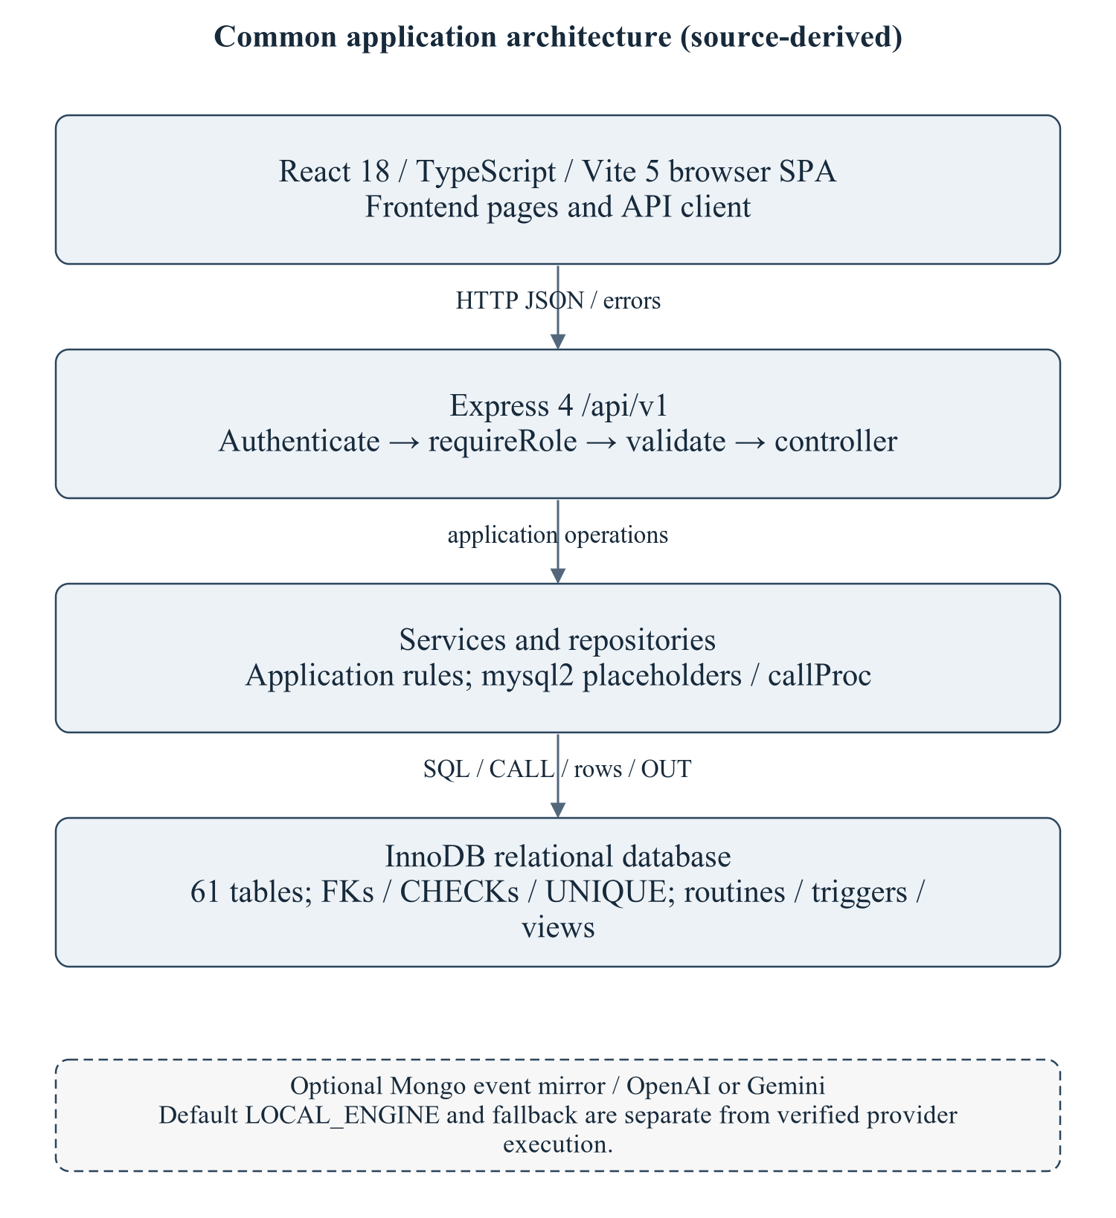
Figure 2.1 Common stack used by this module
The architecture is summarized to locate the module's routes/services/repository and SQL; it is not a copy of the master's enterprise narrative. Optional provider execution is not established.
Editable drawing source: diagrams/01_common_architecture.svg, .dot and .mmd. Edit SVG text/shapes in a vector editor, or regenerate from DOT/Mermaid; retain FK IDs and source names. These figures were created from static source, not captured from a running ERP.
React18/TypeScript/Vite5 client → Express4 /api/v1/attendance → module controller/service/repository → mysql2/InnoDB. Node>=18 is specified by backend package metadata; audit checks used Node20.20.2. MySQL8-style SQL and Compose MariaDB11.8 are separate unverified runtime targets. Hardware/IDE/browser performance requirements await MI15/MI16. [R09, R23]

2.2 Module Data Flow Diagram (Level 1 / Level 2 DFD)
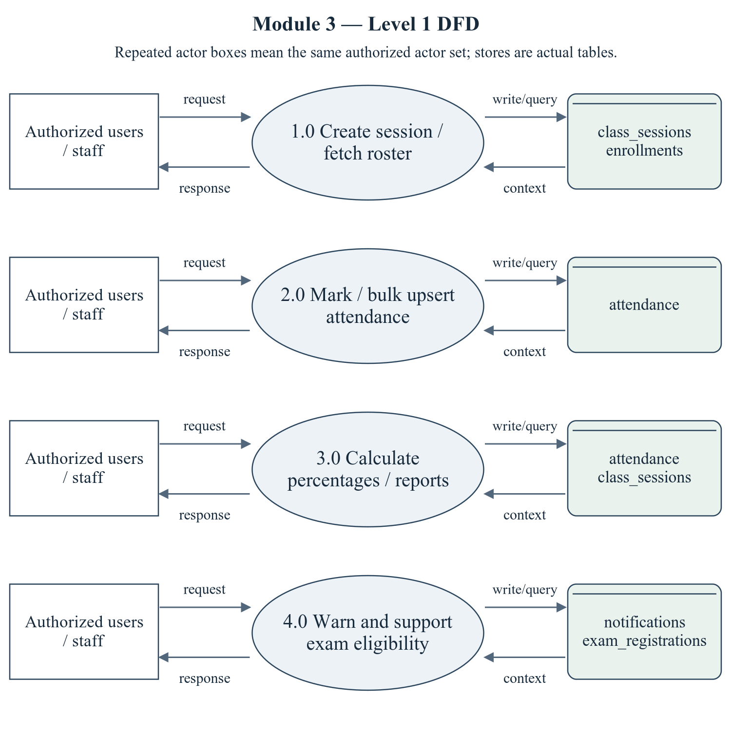
Figure 2.2 Attendance Management — Level 1 DFD
Repeated actor boxes mean the same external entity set. Each D label names real stores, not a fabricated table; role and row scope remain as specified in the route/ownership discussion.
Editable drawing source: diagrams/05_module_03_dfd_level1.svg, .dot and .mmd. Edit SVG text/shapes in a vector editor, or regenerate from DOT/Mermaid; retain FK IDs and source names. These figures were created from static source, not captured from a running ERP.

2.2.1 Sub-System Processes, Data Stores & External Movement
Table 2.1 Module processes and integration stores
Process | Actual persisted stores | Data movement
1.0 Create session / fetch roster | class_sessions, enrollments | Actor request/decision → module process; data query/write ↔ actual stores; response/report → actor.
2.0 Mark / bulk upsert attendance | attendance | Actor request/decision → module process; data query/write ↔ actual stores; response/report → actor.
3.0 Calculate percentages / reports | attendance, class_sessions | Actor request/decision → module process; data query/write ↔ actual stores; response/report → actor.
4.0 Warn and support exam eligibility | notifications, exam_registrations | Actor request/decision → module process; data query/write ↔ actual stores; response/report → actor.

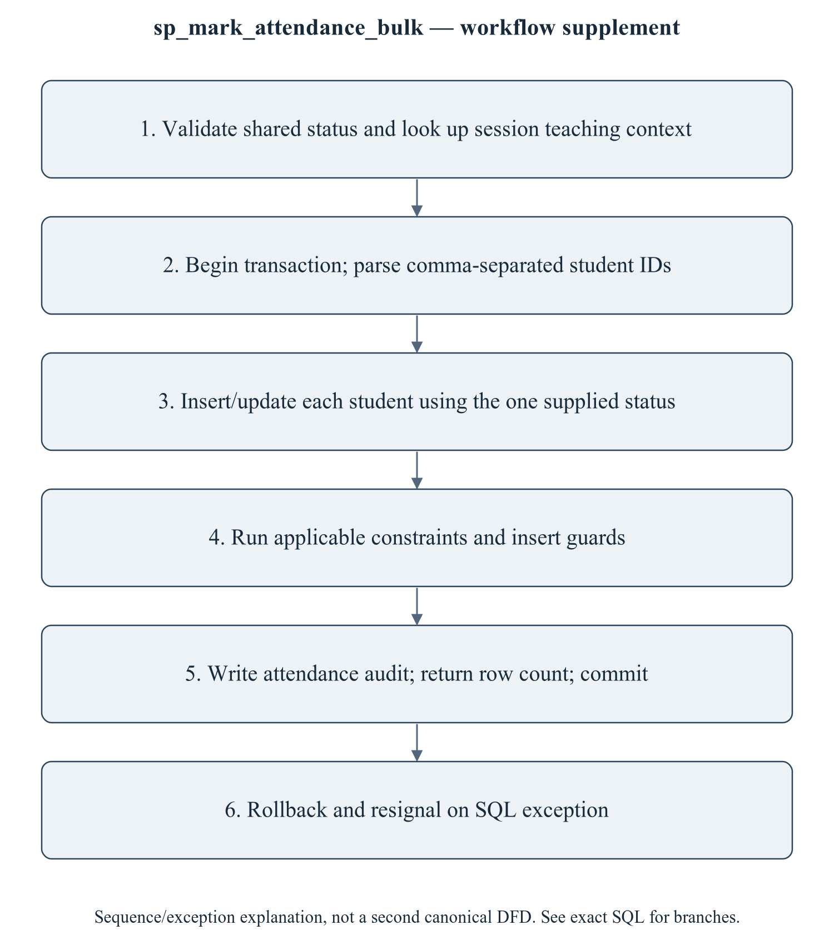
Figure 2.3 sp_mark_attendance_bulk — transaction/workflow supplement
This is a procedure sequence/exception explanation, not a second canonical DFD. An exam uses an exam-specific threshold in its procedure but the global setting in its insert trigger. Attendance reporting must therefore distinguish data capture, percentage formula and eligibility policy instead of claiming a single universal 75% implementation.
Editable drawing source: diagrams/06_module_03_procedure_workflow.svg, .dot and .mmd. Edit SVG text/shapes in a vector editor, or regenerate from DOT/Mermaid; retain FK IDs and source names. These figures were created from static source, not captured from a running ERP.

2.3 Module ER Diagram, Sub-Schema & Data Dictionary
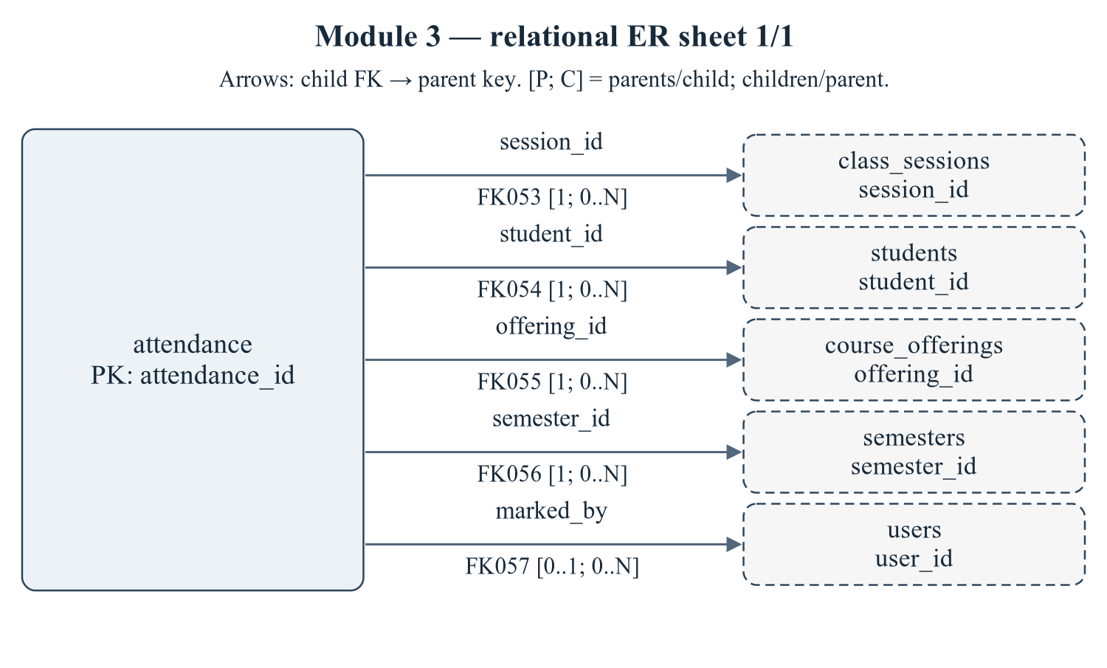
Figure 2.4 Module 3 — relational ER sheet 1/1
The child relations attendance refer to actual target keys. Arrows are FK→parent; [P; C] gives parents per child and children per parent. IDs reconcile with the full dictionary and workbook. Dashed parent repetition does not transfer ownership.
Editable drawing source: diagrams/03_er_panel_03_part_01.svg, .dot and .mmd. Edit SVG text/shapes in a vector editor, or regenerate from DOT/Mermaid; retain FK IDs and source names. These figures were created from static source, not captured from a running ERP.
Relational notation below lists actual attributes. The full dictionary supplies types/nullability/defaults/constraints; PK/FK notation does not invent undeclared relationships.
attendance( attendance_id, session_id, student_id, offering_id, semester_id, status, remarks, marked_by, marked_at). PK={attendance_id}; FK IDs={FK053,FK054,FK055,FK056,FK057}.
Table 2.2 Shared / cross-module key contracts (not duplicated ownership)
Parent table / key | Module relationship | Declared action / FK ID
class_sessions, PK session_id | attendance.session_id → session_id | FK053: ON DELETE CASCADE
course_offerings, PK offering_id | attendance.offering_id → offering_id | FK055: ON DELETE CASCADE
semesters, PK semester_id | attendance.semester_id → semester_id | FK056: ON DELETE CASCADE
students, PK student_id | attendance.student_id → student_id | FK054: ON DELETE CASCADE
users, PK user_id | attendance.marked_by → user_id | FK057: ON DELETE SET NULL

The table dictionaries in this module cover its persisted schema in full. External parents above retain their original ownership; their complete 677-column enterprise dictionary is supplied in the master report and inventory workbook. Shared contracts are repeated here so this module can be read independently without pretending to own another module's tables.
attendance — Session/student attendance rows used for reports and examination attendance checks.
Definition: database/02_tables.sql:445–470. Owner: Attendance Management.
Table 2.3 attendance — full column dictionary
Column and exact SQL type | Null / default / generation | Keys and purpose
attendance_id  INT UNSIGNED | NOT NULL  DEFAULT: No explicit DEFAULT  AUTO_INCREMENT | PK  Primary row identifier.
session_id  INT UNSIGNED | NOT NULL  DEFAULT: No explicit DEFAULT | UQ uq_attendance_session_student (session_id,student_id); FK053 → class_sessions.session_id  References class_sessions.session_id.
student_id  INT UNSIGNED | NOT NULL  DEFAULT: No explicit DEFAULT | UQ uq_attendance_session_student (session_id,student_id); FK054 → students.student_id  References students.student_id.
offering_id  INT UNSIGNED | NOT NULL  DEFAULT: No explicit DEFAULT | FK055 → course_offerings.offering_id  Denormalised for fast % computation (indexed)
semester_id  SMALLINT UNSIGNED | NOT NULL  DEFAULT: No explicit DEFAULT | FK056 → semesters.semester_id  References semesters.semester_id.
status  ENUM('PRESENT','ABSENT','LATE','EXCUSED') | NOT NULL  DEFAULT: 'PRESENT' | Lifecycle state; exact permitted values are in the declared ENUM.
remarks  VARCHAR(255) | NULL permitted  DEFAULT: No explicit DEFAULT | Operation or record remarks.
marked_by  INT UNSIGNED | NULL permitted  DEFAULT: No explicit DEFAULT | FK057 → users.user_id  References users.user_id.
marked_at  TIMESTAMP | NOT NULL  DEFAULT: CURRENT_TIMESTAMP | Marked at date/time, as typed.

PRIMARY KEY: attendance_id
UNIQUE constraints: UNIQUE KEY `uq_attendance_session_student` (`session_id`, `student_id`)
CHECK constraints: None declared.
Secondary indexes: KEY `idx_attendance_student_offering` (`student_id`, `offering_id`, `status`); KEY `idx_attendance_offering_date` (`offering_id`, `status`); KEY `idx_attendance_semester` (`semester_id`); KEY `idx_attendance_student_status` (`student_id`, `status`); KEY `idx_attendance_offering_student` (`offering_id`, `student_id`); KEY `idx_attendance_semester_student` (`semester_id`, `student_id`)
FK053 fk_attendance_session: CONSTRAINT `fk_attendance_session` FOREIGN KEY (`session_id`)
REFERENCES `class_sessions` (`session_id`) ON DELETE CASCADE. Parent/child multiplicities 1 / 0..N. Omitted referential actions use restrictive defaults, not an invented cascade.
FK054 fk_attendance_student: CONSTRAINT `fk_attendance_student` FOREIGN KEY (`student_id`)
REFERENCES `students` (`student_id`) ON DELETE CASCADE. Parent/child multiplicities 1 / 0..N. Omitted referential actions use restrictive defaults, not an invented cascade.
FK055 fk_attendance_offering: CONSTRAINT `fk_attendance_offering` FOREIGN KEY (`offering_id`)
REFERENCES `course_offerings` (`offering_id`) ON DELETE CASCADE. Parent/child multiplicities 1 / 0..N. Omitted referential actions use restrictive defaults, not an invented cascade.
FK056 fk_attendance_semester: CONSTRAINT `fk_attendance_semester` FOREIGN KEY (`semester_id`)
REFERENCES `semesters` (`semester_id`) ON DELETE CASCADE. Parent/child multiplicities 1 / 0..N. Omitted referential actions use restrictive defaults, not an invented cascade.
FK057 fk_attendance_user: CONSTRAINT `fk_attendance_user` FOREIGN KEY (`marked_by`)
REFERENCES `users` (`user_id`) ON DELETE SET NULL. Parent/child multiplicities 0..1 / 0..N. Omitted referential actions use restrictive defaults, not an invented cascade.
Normalization / dependency note: The non-null UNIQUE(session_id,student_id) is an alternate candidate key. Domain session_id -> offering_id,semester_id creates a partial dependency of non-prime context attributes on part of that key: an intended 2NF/3NF exception. The insert guard reduces but does not prove update-path consistency.

2.3.1 Shared class_sessions contract (full relevant dictionary)
class_sessions — G2/G3: a single lecture. Attendance rows hang off this.
Definition: database/02_tables.sql:414–435. Owner: Academic and Course Management.
Table 2.4 class_sessions — full column dictionary
Column and exact SQL type | Null / default / generation | Keys and purpose
session_id  INT UNSIGNED | NOT NULL  DEFAULT: No explicit DEFAULT  AUTO_INCREMENT | PK  Primary row identifier.
offering_id  INT UNSIGNED | NOT NULL  DEFAULT: No explicit DEFAULT | UQ uq_sessions_offering_date_no (offering_id,session_date,session_no); FK050 → course_offerings.offering_id  References course_offerings.offering_id.
faculty_id  INT UNSIGNED | NOT NULL  DEFAULT: No explicit DEFAULT | FK052 → faculty.faculty_id  FK -> faculty.faculty_id (added in 03)
semester_id  SMALLINT UNSIGNED | NOT NULL  DEFAULT: No explicit DEFAULT | FK051 → semesters.semester_id  References semesters.semester_id.
session_date  DATE | NOT NULL  DEFAULT: No explicit DEFAULT | UQ uq_sessions_offering_date_no (offering_id,session_date,session_no)  Session date date/time, as typed.
session_no  TINYINT UNSIGNED | NOT NULL  DEFAULT: 1 | UQ uq_sessions_offering_date_no (offering_id,session_date,session_no)  Session no value.
topic  VARCHAR(255) | NULL permitted  DEFAULT: No explicit DEFAULT | Topic value.
room_number  VARCHAR(20) | NULL permitted  DEFAULT: No explicit DEFAULT | Room number value.
start_time  TIME | NULL permitted  DEFAULT: No explicit DEFAULT | Start time value.
end_time  TIME | NULL permitted  DEFAULT: No explicit DEFAULT | End time value.
status  ENUM('SCHEDULED','COMPLETED','CANCELLED') | NOT NULL  DEFAULT: 'COMPLETED' | Lifecycle state; exact permitted values are in the declared ENUM.
created_at  TIMESTAMP | NOT NULL  DEFAULT: CURRENT_TIMESTAMP | Row creation timestamp.

PRIMARY KEY: session_id
UNIQUE constraints: UNIQUE KEY `uq_sessions_offering_date_no` (`offering_id`, `session_date`, `session_no`)
CHECK constraints: None declared.
Secondary indexes: KEY `idx_sessions_faculty` (`faculty_id`, `session_date`); KEY `idx_sessions_date` (`session_date`)
FK050 fk_sessions_offering: CONSTRAINT `fk_sessions_offering` FOREIGN KEY (`offering_id`)
REFERENCES `course_offerings` (`offering_id`) ON DELETE CASCADE. Parent/child multiplicities 1 / 0..N. Omitted referential actions use restrictive defaults, not an invented cascade.
FK051 fk_sessions_semester: CONSTRAINT `fk_sessions_semester` FOREIGN KEY (`semester_id`)
REFERENCES `semesters` (`semester_id`) ON DELETE CASCADE. Parent/child multiplicities 1 / 0..N. Omitted referential actions use restrictive defaults, not an invented cascade.
FK052 fk_sessions_faculty: CONSTRAINT `fk_sessions_faculty`
FOREIGN KEY (`faculty_id`) REFERENCES `faculty` (`faculty_id`) ON DELETE CASCADE. Parent/child multiplicities 1 / 0..N. Omitted referential actions use restrictive defaults, not an invented cascade.
Normalization / dependency note: offering_id -> semester_id in the academic domain means the copied semester_id is derived context. Session identity/timing and attendance-grain keys should be separated from duplicated teaching context.
This table remains physically grouped with Academic/G2 and is repeated here because attendance creates/consumes dated class sessions. It is counted once in the enterprise total.

2.3.2 Normalization Analysis & Justified Exceptions
3NF is a property of a relation under a complete functional-dependency set, not a consequence of naming an integer primary key. The DDL supplies PKs, non-null UNIQUE candidates, types and referential constraints; domain FDs and historical snapshot intent require the business owner. Nullable UNIQUE tuples are not automatically candidate keys: multiple NULL-bearing values may be permitted. CHECK accepts TRUE/UNKNOWN and enforced support depends on the actual server version (MySQL 8.0.16+ for enforced CHECK). [D01, D03, R01, R02, R03]
1NF is provisionally interpreted at the declared SQL-type level: one row value per attribute. JSON/text document fields are treated as opaque values, not silently decomposed into invented child tables. 2NF requires dependence on the whole of every candidate key. 3NF additionally rejects non-key determinants unless the dependent attribute is prime or the determinant is a superkey. Cross-table contact duplication and maintained cross-row counters are discussed separately from formal within-row FD violations.
Table 2.5 Relation-level candidate keys and normalization assessment
Relation | Proven key candidates | FD / exception / evidence assessment
attendance | (attendance_id); (session_id,student_id) | The non-null UNIQUE(session_id,student_id) is an alternate candidate key. Domain session_id -> offering_id,semester_id creates a partial dependency of non-prime context attributes on part of that key: an intended 2NF/3NF exception. The insert guard reduces but does not prove update-path consistency.

Worked decomposition proposal — not implemented DDL: for attendance, the alternate key (session_id,student_id) and intended FD session_id → offering_id,semester_id mean duplicated context depends on only part of the key. Keeping attendance event attributes at session/student grain and deriving context through class_sessions removes that partial dependency. Joining on session_id is lossless under the stated FD; the session PK preserves lookup uniqueness. Existing schema, APIs, indexes and both insert/update validation paths would need coordinated migration and tests.
This module-specific analysis is a design assessment, not implemented replacement DDL or an executed migration. Confirm domain dependencies and historical semantics, then verify key preservation, join equivalence and affected API/trigger behavior before changing the schema. Current definitions and actual evidence gaps remain authoritative.

2.4 Advanced SQL Implementation

2.4.1 Stored Procedures (SQL Code & Execution Proofs)

sp_mark_attendance_bulk
Purpose / expected behavior: Parse comma-separated student IDs from TEXT and upsert one shared status for a session; p_marked counts processed tokens, including repeats, and an empty token stops the loop. Write an audit in a transaction. API array input is serialized with join(",").
Source: database/05_procedures.sql:172–234. Definition found in the pinned snapshot; live existence and execution are unverified. Exact source comments may be stale; only inventoried definitions establish object names.
IN p_session_id: INT UNSIGNED
IN p_student_ids: TEXT
IN p_status: VARCHAR(10)
IN p_marked_by: INT UNSIGNED
OUT p_marked: INT
OUT p_message: VARCHAR(255)
Outputs: p_marked INT, p_message VARCHAR(255)
Read/write dependencies: attendance, audit_logs, class_sessions, v_count, v_done, v_list, v_offering_id, v_pos, v_semester_id, v_token
Routine calls: No other stored routine call extracted.
Transaction boundary: Explicit START TRANSACTION / COMMIT and SQLEXCEPTION handling in the definition.
Invocation template (not executed): bind every @ input to a mutually consistent synthetic fixture selected from the declared tables and run only on an authorized disposable schema. Numeric literals below are planned test inputs, not observed results. Internal COMMIT means wrapping a CALL in an outer ROLLBACK is not a safe fixture-cleanup strategy.
CALL sp_mark_attendance_bulk(@p_session_id, @p_student_ids, @p_status, @p_marked_by, @p_marked, @p_message);
SELECT @p_marked AS p_marked, @p_message AS p_message;

Actual result: [[TO BE PROVIDED: run this test and record the actual result]]
Status: [[TO BE PROVIDED: run this test and record the actual result]]
Required evidence: [[TO BE PROVIDED: execute sp_mark_attendance_bulk or its triggering DML using the corresponding module test case; owner must attach sanitized inputs, OUT/SELECT/error output, before/after effects and timestamp]]
Exact SQL definition (unchanged from source):
CREATE PROCEDURE `sp_mark_attendance_bulk`(
IN p_session_id INT UNSIGNED,
IN p_student_ids TEXT, -- e.g. '1,2,3,4'
IN p_status VARCHAR(10), -- PRESENT | ABSENT | LATE | EXCUSED
IN p_marked_by INT UNSIGNED,
OUT p_marked INT,
OUT p_message VARCHAR(255)
)
BEGIN
DECLARE v_offering_id INT UNSIGNED;
DECLARE v_semester_id SMALLINT UNSIGNED;
DECLARE v_list TEXT;
DECLARE v_token VARCHAR(20);
DECLARE v_pos INT;
DECLARE v_done TINYINT DEFAULT 0;
DECLARE v_count INT DEFAULT 0;

DECLARE EXIT HANDLER FOR SQLEXCEPTION
BEGIN
ROLLBACK;
RESIGNAL; -- keep the original error visible to the caller
END;

IF p_status NOT IN ('PRESENT', 'ABSENT', 'LATE', 'EXCUSED') THEN
SIGNAL SQLSTATE '45000' SET MESSAGE_TEXT = 'Invalid attendance status.';
END IF;

SELECT `offering_id`, `semester_id` INTO v_offering_id, v_semester_id
FROM `class_sessions` WHERE `session_id` = p_session_id;

IF v_offering_id IS NULL THEN
SIGNAL SQLSTATE '45000' SET MESSAGE_TEXT = 'Class session not found.';
END IF;

START TRANSACTION;

SET v_list = CONCAT(p_student_ids, ',');
WHILE LENGTH(v_list) > 0 AND v_done = 0 DO
SET v_pos = LOCATE(',', v_list);
SET v_token = TRIM(SUBSTRING(v_list, 1, v_pos - 1));
SET v_list = SUBSTRING(v_list, v_pos + 1);
IF v_token = '' THEN
SET v_done = 1;
ELSE
INSERT INTO `attendance`
(`session_id`, `student_id`, `offering_id`, `semester_id`, `status`, `marked_by`)
VALUES
(p_session_id, CAST(v_token AS UNSIGNED), v_offering_id, v_semester_id, p_status, p_marked_by)
ON DUPLICATE KEY UPDATE
`status` = p_status, `marked_by` = p_marked_by, `marked_at` = CURRENT_TIMESTAMP;
SET v_count = v_count + 1;
END IF;
END WHILE;

SET p_marked = v_count;

INSERT INTO `audit_logs` (`user_id`, `action`, `entity`, `entity_id`, `description`)
VALUES (p_marked_by, 'ATTENDANCE_UPDATE', 'attendance', p_session_id,
CONCAT('Bulk attendance: ', v_count, ' students marked ', p_status));

SET p_message = CONCAT(v_count, ' attendance records saved.');
COMMIT;
END$$

2.4.2 Database Triggers (SQL Code & Execution Proofs)

trg_attendance_bi_guard
Purpose / expected behavior: Require enrollment and matching session/offering/semester context for attendance INSERT. It does not establish caller ownership or protect every update branch.
Source: database/06_triggers.sql:204–229. Definition found in the pinned snapshot; live existence and execution are unverified. Exact source comments may be stale; only inventoried definitions establish object names.
Event / inputs / output: BEFORE INSERT ON `attendance` FOR EACH ROW; OLD/NEW are event-appropriate row images; no explicit arguments or scalar return. Side effects are described above.
Read/write dependencies: attendance, class_sessions, enrollments, v_enrolled, v_session_date
Routine calls: No other stored routine call extracted.
Invocation template (not executed): bind every @ input to a mutually consistent synthetic fixture selected from the declared tables and run only on an authorized disposable schema. Numeric literals below are planned test inputs, not observed results. Internal COMMIT means wrapping a CALL in an outer ROLLBACK is not a safe fixture-cleanup strategy.
INSERT INTO attendance (session_id, student_id, offering_id, semester_id, status, marked_by) VALUES (@fixture_session_id, @fixture_student_id, @fixture_offering_id, @fixture_semester_id, 'PRESENT', @actor_user_id);

Actual result: [[TO BE PROVIDED: run this test and record the actual result]]
Status: [[TO BE PROVIDED: run this test and record the actual result]]
Required evidence: [[TO BE PROVIDED: execute trg_attendance_bi_guard or its triggering DML using the corresponding module test case; owner must attach sanitized inputs, OUT/SELECT/error output, before/after effects and timestamp]]
Exact SQL definition (unchanged from source):
CREATE TRIGGER `trg_attendance_bi_guard`
BEFORE INSERT ON `attendance` FOR EACH ROW
BEGIN
DECLARE v_enrolled INT DEFAULT 0;
DECLARE v_session_date DATE;

SELECT `session_date` INTO v_session_date
FROM `class_sessions` WHERE `session_id` = NEW.`session_id`;

IF v_session_date IS NULL THEN
SIGNAL SQLSTATE '45000' SET MESSAGE_TEXT = 'Class session does not exist.';
END IF;
IF v_session_date > CURDATE() THEN
SIGNAL SQLSTATE '45000'
SET MESSAGE_TEXT = 'Attendance cannot be marked for a future dated session.';
END IF;

SELECT COUNT(*) INTO v_enrolled
FROM `enrollments` e
WHERE e.`student_id` = NEW.`student_id` AND e.`offering_id` = NEW.`offering_id`;

IF v_enrolled = 0 THEN
SIGNAL SQLSTATE '45000'
SET MESSAGE_TEXT = 'This student is not enrolled in the course of this session.';
END IF;
END$$

2.4.3 User-Defined Functions (UDFs) (SQL Code & Execution Proofs)

fn_calculate_attendance_percentage
Purpose / expected behavior: Return PRESENT/LATE divided by counted non-EXCUSED attendance rows for a student/offering, rounded to two decimals; return 100 when the denominator is zero.
Source: database/07_functions.sql:42–63. Definition found in the pinned snapshot; live existence and execution are unverified. Exact source comments may be stale; only inventoried definitions establish object names.
IN p_student_id: INT UNSIGNED
IN p_offering_id: INT UNSIGNED
Output: decimal(5,2) scalar return value.
Read/write dependencies: attendance, v_present, v_total
Routine calls: No other stored routine call extracted.
Invocation template (not executed): bind every @ input to a mutually consistent synthetic fixture selected from the declared tables and run only on an authorized disposable schema. Numeric literals below are planned test inputs, not observed results. Internal COMMIT means wrapping a CALL in an outer ROLLBACK is not a safe fixture-cleanup strategy.
SELECT fn_calculate_attendance_percentage(@p_student_id, @p_offering_id) AS computed_value;

Actual result: [[TO BE PROVIDED: run this test and record the actual result]]
Status: [[TO BE PROVIDED: run this test and record the actual result]]
Required evidence: [[TO BE PROVIDED: execute fn_calculate_attendance_percentage or its triggering DML using the corresponding module test case; owner must attach sanitized inputs, OUT/SELECT/error output, before/after effects and timestamp]]
Exact SQL definition (unchanged from source):
CREATE FUNCTION `fn_calculate_attendance_percentage`(
p_student_id INT UNSIGNED,
p_offering_id INT UNSIGNED
) RETURNS decimal(5,2)
READS SQL DATA
BEGIN
DECLARE v_total INT DEFAULT 0;
DECLARE v_present INT DEFAULT 0;

SELECT COUNT(*),
SUM(CASE WHEN a.`status` IN ('PRESENT','LATE') THEN 1 ELSE 0 END)
INTO v_total, v_present
FROM `attendance` a
WHERE a.`student_id` = p_student_id
AND a.`offering_id` = p_offering_id
AND a.`status` <> 'EXCUSED';

IF v_total = 0 THEN
RETURN 100.00;
END IF;
RETURN ROUND((v_present / v_total) * 100, 2);
END$$

fn_calculate_semester_attendance
Purpose / expected behavior: Return the same PRESENT/LATE and EXCUSED-excluding percentage for one student/semester, with 100 for zero counted rows.
Source: database/07_functions.sql:72–91. Definition found in the pinned snapshot; live existence and execution are unverified. Exact source comments may be stale; only inventoried definitions establish object names.
IN p_student_id: INT UNSIGNED
IN p_semester_id: SMALLINT UNSIGNED
Output: decimal(5,2) scalar return value.
Read/write dependencies: attendance, v_present, v_total
Routine calls: No other stored routine call extracted.
Invocation template (not executed): bind every @ input to a mutually consistent synthetic fixture selected from the declared tables and run only on an authorized disposable schema. Numeric literals below are planned test inputs, not observed results. Internal COMMIT means wrapping a CALL in an outer ROLLBACK is not a safe fixture-cleanup strategy.
SELECT fn_calculate_semester_attendance(@p_student_id, @p_semester_id) AS computed_value;

Actual result: [[TO BE PROVIDED: run this test and record the actual result]]
Status: [[TO BE PROVIDED: run this test and record the actual result]]
Required evidence: [[TO BE PROVIDED: execute fn_calculate_semester_attendance or its triggering DML using the corresponding module test case; owner must attach sanitized inputs, OUT/SELECT/error output, before/after effects and timestamp]]
Exact SQL definition (unchanged from source):
CREATE FUNCTION `fn_calculate_semester_attendance`(
p_student_id INT UNSIGNED,
p_semester_id SMALLINT UNSIGNED
) RETURNS decimal(5,2)
READS SQL DATA
BEGIN
DECLARE v_total INT DEFAULT 0;
DECLARE v_present INT DEFAULT 0;

SELECT COUNT(*),
SUM(CASE WHEN a.`status` IN ('PRESENT','LATE') THEN 1 ELSE 0 END)
INTO v_total, v_present
FROM `attendance` a
WHERE a.`student_id` = p_student_id
AND a.`semester_id` = p_semester_id
AND a.`status` <> 'EXCUSED';

IF v_total = 0 THEN RETURN 100.00; END IF;
RETURN ROUND((v_present / v_total) * 100, 2);
END$$

2.5 Complex Analytical Queries & Views

v_student_attendance_summary
Purpose / expected behavior: Provide student/offering attendance counts and the attendance UDF result/status. Raw row counts include records excluded from the UDF denominator.
Source: database/08_views.sql:68–94. Definition found in the pinned snapshot; live existence and execution are unverified. Exact source comments may be stale; only inventoried definitions establish object names.
Inputs / output: No parameters; SELECT returns columns: student_id, roll_number, full_name, offering_id, semester_id, semester_name, subject_id, subject_code, subject_name, credits, total_classes, attended_classes, absent_classes, attendance_percentage, attendance_status. WHERE/JOIN predicates are query inputs, not stored view parameters.
Read/write dependencies: attendance, course_offerings, semesters, students, subjects
Routine calls: No other stored routine call extracted.
Invocation template (not executed): bind every @ input to a mutually consistent synthetic fixture selected from the declared tables and run only on an authorized disposable schema. Numeric literals below are planned test inputs, not observed results. Internal COMMIT means wrapping a CALL in an outer ROLLBACK is not a safe fixture-cleanup strategy.
SELECT * FROM v_student_attendance_summary LIMIT 10;

Actual result: [[TO BE PROVIDED: run this test and record the actual result]]
Status: [[TO BE PROVIDED: run this test and record the actual result]]
Required evidence: [[TO BE PROVIDED: execute v_student_attendance_summary or its triggering DML using the corresponding module test case; owner must attach sanitized inputs, OUT/SELECT/error output, before/after effects and timestamp]]
Exact SQL definition (unchanged from source):
CREATE OR REPLACE VIEW `v_student_attendance_summary` AS
SELECT a.`student_id`,
s.`roll_number`,
CONCAT(s.`first_name`, ' ', s.`last_name`) AS `full_name`,
a.`offering_id`,
co.`semester_id`,
sem.`name` AS `semester_name`,
sub.`subject_id`, sub.`subject_code`, sub.`name` AS `subject_name`, sub.`credits`,
COUNT(*) AS `total_classes`,
SUM(CASE WHEN a.`status` IN ('PRESENT','LATE') THEN 1 ELSE 0 END) AS `attended_classes`,
SUM(CASE WHEN a.`status` = 'ABSENT' THEN 1 ELSE 0 END) AS `absent_classes`,
ROUND(SUM(CASE WHEN a.`status` IN ('PRESENT','LATE') THEN 1 ELSE 0 END) * 100.0
/ NULLIF(COUNT(*), 0), 2) AS `attendance_percentage`,
CASE
WHEN SUM(CASE WHEN a.`status` IN ('PRESENT','LATE') THEN 1 ELSE 0 END) * 100.0
/ NULLIF(COUNT(*),0) >= 85 THEN 'SAFE'
WHEN SUM(CASE WHEN a.`status` IN ('PRESENT','LATE') THEN 1 ELSE 0 END) * 100.0
/ NULLIF(COUNT(*),0) >= 75 THEN 'WARNING'
ELSE 'CRITICAL'
END AS `attendance_status`
FROM `attendance` a
JOIN `students` s ON s.`student_id` = a.`student_id`
JOIN `course_offerings` co ON co.`offering_id`= a.`offering_id`
JOIN `subjects` sub ON sub.`subject_id`= co.`subject_id`
JOIN `semesters` sem ON sem.`semester_id` = co.`semester_id`
GROUP BY a.`student_id`, s.`roll_number`, s.`first_name`, s.`last_name`, a.`offering_id`,
co.`semester_id`, sem.`name`, sub.`subject_id`, sub.`subject_code`, sub.`name`, sub.`credits`;

v_student_attendance_overall
Purpose / expected behavior: Aggregate student attendance overall using its own formula/current-semester context. Its no-data and EXCUSED behavior is not identical to every UDF/view.
Source: database/08_views.sql:99–120. Definition found in the pinned snapshot; live existence and execution are unverified. Exact source comments may be stale; only inventoried definitions establish object names.
Inputs / output: No parameters; SELECT returns columns: student_id, roll_number, full_name, department_id, program_id, batch_id, current_semester_no, total_classes, attended_classes, overall_percentage, current_semester_percentage, attendance_status. WHERE/JOIN predicates are query inputs, not stored view parameters.
Read/write dependencies: attendance, semesters, students
Routine calls: fn_calculate_semester_attendance
Invocation template (not executed): bind every @ input to a mutually consistent synthetic fixture selected from the declared tables and run only on an authorized disposable schema. Numeric literals below are planned test inputs, not observed results. Internal COMMIT means wrapping a CALL in an outer ROLLBACK is not a safe fixture-cleanup strategy.
SELECT * FROM v_student_attendance_overall LIMIT 10;

Actual result: [[TO BE PROVIDED: run this test and record the actual result]]
Status: [[TO BE PROVIDED: run this test and record the actual result]]
Required evidence: [[TO BE PROVIDED: execute v_student_attendance_overall or its triggering DML using the corresponding module test case; owner must attach sanitized inputs, OUT/SELECT/error output, before/after effects and timestamp]]
Exact SQL definition (unchanged from source):
CREATE OR REPLACE VIEW `v_student_attendance_overall` AS
SELECT s.`student_id`, s.`roll_number`,
CONCAT(s.`first_name`, ' ', s.`last_name`) AS `full_name`,
s.`department_id`, s.`program_id`, s.`batch_id`, s.`current_semester_no`,
COUNT(a.`attendance_id`) AS `total_classes`,
SUM(CASE WHEN a.`status` IN ('PRESENT','LATE') THEN 1 ELSE 0 END) AS `attended_classes`,
ROUND(SUM(CASE WHEN a.`status` IN ('PRESENT','LATE') THEN 1 ELSE 0 END) * 100.0
/ NULLIF(COUNT(a.`attendance_id`),0), 2) AS `overall_percentage`,
fn_calculate_semester_attendance(s.`student_id`,
(SELECT sm.`semester_id` FROM `semesters` sm WHERE sm.`is_current` = 1 LIMIT 1)
) AS `current_semester_percentage`,
CASE
WHEN SUM(CASE WHEN a.`status` IN ('PRESENT','LATE') THEN 1 ELSE 0 END) * 100.0
/ NULLIF(COUNT(a.`attendance_id`),0) >= 85 THEN 'SAFE'
WHEN SUM(CASE WHEN a.`status` IN ('PRESENT','LATE') THEN 1 ELSE 0 END) * 100.0
/ NULLIF(COUNT(a.`attendance_id`),0) >= 75 THEN 'WARNING'
ELSE 'CRITICAL'
END AS `attendance_status`
FROM `students` s
LEFT JOIN `attendance` a ON a.`student_id` = s.`student_id`
GROUP BY s.`student_id`, s.`roll_number`, s.`first_name`, s.`last_name`,
s.`department_id`, s.`program_id`, s.`batch_id`, s.`current_semester_no`;

v_monthly_attendance
Purpose / expected behavior: Aggregate by marked_at year/month and count attendance statuses with its implemented percentage. It does not group by the actual session_date.
Source: database/08_views.sql:499–507. Definition found in the pinned snapshot; live existence and execution are unverified. Exact source comments may be stale; only inventoried definitions establish object names.
Inputs / output: No parameters; SELECT returns columns: student_id, year, month, month_name, total_classes, attended, percentage. WHERE/JOIN predicates are query inputs, not stored view parameters.
Read/write dependencies: attendance
Routine calls: No other stored routine call extracted.
Invocation template (not executed): bind every @ input to a mutually consistent synthetic fixture selected from the declared tables and run only on an authorized disposable schema. Numeric literals below are planned test inputs, not observed results. Internal COMMIT means wrapping a CALL in an outer ROLLBACK is not a safe fixture-cleanup strategy.
SELECT * FROM v_monthly_attendance LIMIT 10;

Actual result: [[TO BE PROVIDED: run this test and record the actual result]]
Status: [[TO BE PROVIDED: run this test and record the actual result]]
Required evidence: [[TO BE PROVIDED: execute v_monthly_attendance or its triggering DML using the corresponding module test case; owner must attach sanitized inputs, OUT/SELECT/error output, before/after effects and timestamp]]
Exact SQL definition (unchanged from source):
CREATE OR REPLACE VIEW `v_monthly_attendance` AS
SELECT a.`student_id`, YEAR(a.`marked_at`) AS `year`, MONTH(a.`marked_at`) AS `month`,
MONTHNAME(a.`marked_at`) AS `month_name`,
COUNT(*) AS `total_classes`,
SUM(CASE WHEN a.`status` IN ('PRESENT','LATE') THEN 1 ELSE 0 END) AS `attended`,
ROUND(SUM(CASE WHEN a.`status` IN ('PRESENT','LATE') THEN 1 ELSE 0 END) * 100.0
/ NULLIF(COUNT(*),0), 2) AS `percentage`
FROM `attendance` a
GROUP BY a.`student_id`, YEAR(a.`marked_at`), MONTH(a.`marked_at`), MONTHNAME(a.`marked_at`);

Q32 assigns attendance quartiles using NTILE. Q41 compares monthly session-date attendance with LAG; it counts only PRESENT in the numerator and includes all rows in the denominator, unlike the UDF. No SQL outputs have been generated. [R08]

Q32 — NTILE — split the class into attendance quartiles for mentoring groups
Source: database/09_queries.sql:794. Purpose is the query projection/aggregation below; no output rows have been generated. Expected column structure follows aliases in the exact statement.
SELECT NTILE(4) OVER (ORDER BY x.overall_percentage DESC) AS quartile,
x.roll_number,
x.full_name AS student_name,
x.overall_percentage AS attendance_percentage,
CASE NTILE(4) OVER (ORDER BY x.overall_percentage DESC)
WHEN 1 THEN 'No intervention'
WHEN 2 THEN 'Monitor'
WHEN 3 THEN 'Counselling'
ELSE 'Parent meeting' END AS action
FROM v_student_attendance_overall x
WHERE x.overall_percentage IS NOT NULL
ORDER BY quartile, x.overall_percentage DESC
LIMIT 60;

Actual result: [[TO BE PROVIDED: run this test and record the actual result]]
Status: [[TO BE PROVIDED: run this test and record the actual result]]

Q41 — Attendance trend per student — month over month with LAG
Source: database/09_queries.sql:1076. Purpose is the query projection/aggregation below; no output rows have been generated. Expected column structure follows aliases in the exact statement.
WITH monthly AS (
SELECT a.student_id,
DATE_FORMAT(cs.session_date, '%Y-%m') AS month,
COUNT(*) AS sessions,
ROUND(100.0 * SUM(a.status = 'PRESENT') / COUNT(*), 2) AS attendance_pct
FROM attendance a
JOIN class_sessions cs ON cs.session_id = a.session_id
GROUP BY a.student_id, DATE_FORMAT(cs.session_date, '%Y-%m'))
SELECT s.roll_number,
CONCAT(s.first_name, ' ', s.last_name) AS student_name,
m.month,
m.sessions,
m.attendance_pct,
LAG(m.attendance_pct) OVER (PARTITION BY m.student_id ORDER BY m.month) AS previous_month,
ROUND(m.attendance_pct - LAG(m.attendance_pct) OVER (PARTITION BY m.student_id ORDER BY m.month), 2) AS delta_points,
CASE WHEN m.attendance_pct > LAG(m.attendance_pct) OVER (PARTITION BY m.student_id ORDER BY m.month) THEN 'IMPROVING'
WHEN m.attendance_pct < LAG(m.attendance_pct) OVER (PARTITION BY m.student_id ORDER BY m.month) THEN 'DECLINING'
ELSE 'FLAT' END AS trend
FROM monthly m
JOIN students s ON s.student_id = m.student_id
ORDER BY s.roll_number, m.month DESC
LIMIT 60;

Actual result: [[TO BE PROVIDED: run this test and record the actual result]]
Status: [[TO BE PROVIDED: run this test and record the actual result]]

2.6 Backend Routes, Services, Repository & Frontend Trace
Table 2.6 Attendance Management — exact API route/role register
Method and route | Role gate / handler | Validation and source
GET /api/v1/attendance/sessions | STUDENT, ADMIN, FACULTY  Handler: sessions | No route-local Zod validation; service/DB checks may apply  backend/src/routes/attendance.routes.ts:13
POST /api/v1/attendance/sessions | ADMIN, FACULTY  Handler: createSession | No route-local Zod validation; service/DB checks may apply  backend/src/routes/attendance.routes.ts:14
GET /api/v1/attendance/sessions/:id | ADMIN, FACULTY  Handler: session | No route-local Zod validation; service/DB checks may apply  backend/src/routes/attendance.routes.ts:15
GET /api/v1/attendance/sessions/:id/roster | ADMIN, FACULTY  Handler: roster | No route-local Zod validation; service/DB checks may apply  backend/src/routes/attendance.routes.ts:18
POST /api/v1/attendance/sessions/:id/mark | ADMIN, FACULTY  Handler: mark | Zod validate(...) in route  backend/src/routes/attendance.routes.ts:19
POST /api/v1/attendance/sessions/:id/mark-bulk | ADMIN, FACULTY  Handler: markBulk | Zod validate(...) in route  backend/src/routes/attendance.routes.ts:24
GET /api/v1/attendance/report/offering/:id | EXAM_CELL, ADMIN, FACULTY  Handler: offeringReport | No route-local Zod validation; service/DB checks may apply  backend/src/routes/attendance.routes.ts:29
GET /api/v1/attendance/report/low | EXAM_CELL, ADMIN, FACULTY  Handler: low | No route-local Zod validation; service/DB checks may apply  backend/src/routes/attendance.routes.ts:30
GET /api/v1/attendance/report/stats | EXAM_CELL, ADMIN, FACULTY  Handler: stats | No route-local Zod validation; service/DB checks may apply  backend/src/routes/attendance.routes.ts:31
GET /api/v1/attendance/me | STUDENT  Handler: mySummary | No route-local Zod validation; service/DB checks may apply  backend/src/routes/attendance.routes.ts:34
GET /api/v1/attendance/me/overall | STUDENT  Handler: overall | No route-local Zod validation; service/DB checks may apply  backend/src/routes/attendance.routes.ts:35
GET /api/v1/attendance/me/monthly | STUDENT  Handler: monthly | No route-local Zod validation; service/DB checks may apply  backend/src/routes/attendance.routes.ts:36
GET /api/v1/attendance/student/:id | Authenticated; row scope must be inspected  Handler: mySummary | No route-local Zod validation; service/DB checks may apply  backend/src/routes/attendance.routes.ts:38
GET /api/v1/attendance/student/:id/overall | Authenticated; row scope must be inspected  Handler: overall | No route-local Zod validation; service/DB checks may apply  backend/src/routes/attendance.routes.ts:39
GET /api/v1/attendance/student/:id/monthly | Authenticated; row scope must be inspected  Handler: monthly | No route-local Zod validation; service/DB checks may apply  backend/src/routes/attendance.routes.ts:40
GET /api/v1/attendance/student/:id/history | Authenticated; row scope must be inspected  Handler: history | No route-local Zod validation; service/DB checks may apply  backend/src/routes/attendance.routes.ts:41
POST /api/v1/attendance/warn-low | ADMIN, FACULTY  Handler: warnLow | No route-local Zod validation; service/DB checks may apply  backend/src/routes/attendance.routes.ts:43

backend/src/controllers/attendance.controller.ts: Exports: sessions, session, roster, createSession, mySummary, overall, monthly, history, offeringReport, low, stats, mark, markBulk, warnLow. SQL references: .
backend/src/repositories/attendance.repository.ts: Exports: sessionsRepo, attendanceRepo. SQL references: attendance, class_sessions, course_offerings, departments, enrollments, faculty, programs, semesters, students, subjects, fn_calculate_attendance_percentage, fn_calculate_semester_attendance, v_monthly_attendance, v_student_attendance_overall, v_student_attendance_summary.
backend/src/services/attendance.service.ts: Exports: sessions, threshold, attendance, mark, markBulk, warnLowAttendance. SQL references: notifications, students, sp_mark_attendance_bulk, v_student_attendance_overall.
Frontend source pages: frontend/src/pages/attendance/AttendanceMarkPage.tsx; frontend/src/pages/attendance/AttendanceReportsPage.tsx; frontend/src/pages/attendance/AttendanceSessionsPage.tsx; frontend/src/pages/attendance/MyAttendancePage.tsx.
Controller → service → repository separation is present in source. mysql2 query/execute helpers bind values; callProc reads OUT parameters on one acquired connection. Some services write audit/notifications after the database operation on a separate pooled request, so a procedure transaction does not make every service side effect atomic. [R13, R09, R19]
Validation/error contract: route-local Zod schemas operate on request bodies where listed; the report does not infer validation for routes without validate(...). Services raise AppError for selected missing records/invalid inputs; DB FK/UNIQUE/CHECK/SIGNAL errors pass through the shared handler. HTTP statuses and payloads need API execution evidence, not invented response screenshots. [R10]
Exact route validation expressions (TypeScript/Zod, not SQL; no execution claim):
backend/src/routes/attendance.routes.ts:19 — router.post '/sessions/:id/mark'
z.object({
studentId: z.number().int().positive(),
status: z.enum(['PRESENT', 'ABSENT', 'LATE', 'EXCUSED']),
remarks: z.string().optional(),
})

backend/src/routes/attendance.routes.ts:24 — router.post '/sessions/:id/mark-bulk'
z.object({
studentIds: z.array(z.number().int().positive()).min(1),
status: z.enum(['PRESENT', 'ABSENT', 'LATE', 'EXCUSED']),
})

2.7 Validation, Errors, Transactions & Limitations
An exam uses an exam-specific threshold in its procedure but the global setting in its insert trigger. Attendance reporting must therefore distinguish data capture, percentage formula and eligibility policy instead of claiming a single universal 75% implementation.
F02 [High] Attendance policy divergence: Exam procedure uses per-exam minimum; insert trigger uses global setting. UDF, monthly and overall reports differ on EXCUSED/no-data semantics. Source: database/05_procedures.sql; database/06_triggers.sql; database/07_functions.sql; database/08_views.sql. Action/proposal: Agree one denominator, threshold and no-record contract and test boundaries.
F07 [High] Faculty session ownership missing: Inspected marking controller/service checks roles but not that the faculty owns the session/offering. Source: backend/src/controllers/attendance.controller.ts; backend/src/services/attendance.service.ts. Action/proposal: Enforce teaching ownership (with explicit administrative override) and run negative access tests.
F09 [High] First-login server enforcement gap: Frontend password-change redirect exists, but authentication middleware does not deny other protected API calls for first-login users. Source: backend/src/middleware/auth.ts; frontend/src/App.tsx. Action/proposal: Add a server-side first-login allowlist for me/change-password/logout and test direct API access.
F16 [High] Database test drift / verdict capture: SQL admission approval fixture uses an old signature. runFile discards SELECT result sets; SQL assertion failures are not reliably converted to failing process status. Source: tests/db/test_rules.sql; backend/src/scripts/runDbTests.ts; backend/src/scripts/sqlRunner.ts. Action/proposal: Fix current signature, capture assertion rows and fail the runner when any assertion fails.
F17 [Medium] API smoke authorization expectation drift: The student /students expectation must be reconciled with current route authorization before claiming a passing suite. Source: tests/api/smoke.sh; backend/src/routes/student.routes.ts. Action/proposal: Review expected policy, update the test where approved and retain raw HTTP evidence.
F20 [Medium] Container initialization is a different path: Compose mounts numeric SQL files in filename order; the supported TS runner loads functions/views before seeds/procedures/triggers. Compatibility/order cannot be assumed equivalent. Source: docker-compose.yml; backend/src/scripts/sqlRunner.ts. Action/proposal: Verify a clean disposable container boot or replace with an explicit dependency-aware initializer.
F21 [High] Runtime institution/year defaults do not match report context: 03_constraints.sql includes a different long institute name and CURRENT_ACADEMIC_YEAR=2025-26. Report identity/year comes from supplied PICT templates (2026-2027), not this seed setting. Source: database/03_constraints.sql. Action/proposal: Have the team approve/reset institutional settings and active year flags; do not silently rewrite repository evidence.
F22 [Medium] Documentation TLS drift: README says pool TLS/CA settings are absent, but the application pool now reads DB_SSL_CA with certificate validation. The SQL runner does not mirror that option. Source: README.md; backend/src/config/env.ts; backend/src/config/database.ts; backend/src/scripts/sqlRunner.ts. Action/proposal: Treat current code as primary; align documentation and test both connection paths without disclosing CA/credentials.
F26 [Medium] Analytics source-quality exceptions: Q02 compares offering state to ACTIVE, Q44 compares enrollment state to ACTIVE: validate against actual ENUMs. Q14 capacity can fan out; Q23 compares dates directly to timestamps; Q35 claims dues blocking; Q37 includes future dues in 0-30. Q43 comment overclaims CUBE/GROUPING SETS. Source: database/09_queries.sql. Action/proposal: Treat all 45 examples as source artifacts requiring semantic/runtime review; do not report invented outputs or capabilities.
F27 [Medium] Broadcast read-state is shared: A NULL-user notification is a single broadcast row; mark-read updates that shared row, rather than a per-recipient receipt table. Source: backend/src/repositories/notification.repository.ts; database/01_schema.sql. Action/proposal: Define broadcast read semantics; add per-recipient receipt state only as a proposed future design.
F30 [Medium] Bulk attendance input/count semantics: Procedure parses CSV IDs with one shared status; API serializes an array. Empty token stops the loop and p_marked counts processed tokens including repeats. Source: database/05_procedures.sql; backend/src/services/attendance.service.ts. Action/proposal: Test malformed/duplicate CSV and report token count separately from distinct affected rows.
F28 [Medium] Build is not functional validation: Four typecheck/build commands pass. Vitest exits 1 because no test files are found; no live DB/API/E2E or deployment execution was performed. Source: audit/evidence/backend_typecheck.log; audit/evidence/backend_build.log; audit/evidence/frontend_typecheck.log; audit/evidence/frontend_build.log; audit/evidence/backend_vitest.log. Action/proposal: Supply independent, sanitized SQL/API evidence before calling the ERP tested or deployed successfully.
These are static source findings and acceptance risks, not assertions that a live exploit, SQL error or failing business test was observed.

CHAPTER 3: TESTING, CONCLUSION & REFERENCES

3.1 Module Test Plan & Preconditions
Only EXEC-01..EXEC-05 below were executed in this audit. All other cases have the exact requested unresolved Actual result and Status marker. Synthetic counts, percentages and marks in Expected/Input cells are planned oracle fixtures, not captured ERP records.
Run mutating tests only on a disposable authorized database/API. Select mutually compatible fixture IDs through joins (student → enrollment → offering → session/exam/bill/allocation), never assume seed IDs equal 1 or reuse real student records. Capture server/version/sql_mode/timezone, SQL/request, actor role, before/after rows, OUT values, error/status and cleanup. Do not publish passwords, hashes, bearer/refresh tokens, connection strings, real email/phone/bank records or environment values.
Procedures with internal COMMIT/ROLLBACK cannot safely be isolated merely by an outer transaction; use dedicated fixtures/schema rebuild/restore. For concurrency use two independent connections and retain ordering. For every negative case verify unchanged related rows as well as the error. Fix the stale admission signature and make the SQL harness expose/assert FAIL rows before treating db:test exit status as evidence. [R20, R21, R22, D04]
Module integration prerequisites: load the dependency-aware 01→02→03→07→08→04→05→06 source order on a disposable DB, verify declared cross-module FK parents, choose compatible synthetic actor/student/faculty/semester records and retain before-state data. Do not copy seed personal records or demo credentials into screenshots.

3.2 Positive, Negative, Edge, Authorization & Transaction Cases
Table 3.1 M3-01 — Session roster and valid individual mark
Test field | Required record
Test ID / module | M3-01 / Attendance Management
Objective | Session roster and valid individual mark
Preconditions | Class session tied to an offering/semester and enrolled synthetic student.
Input / action | Create session through allowed role; fetch roster; mark PRESENT once.
Expected result | One session/student attendance row with correct context/marker; roster matches intended enrollment policy.
Actual result | [[TO BE PROVIDED: run this test and record the actual result]]
Status | [[TO BE PROVIDED: run this test and record the actual result]]
Evidence | [[TO BE PROVIDED: attach sanitized SQL/API transcript or screenshot for M3-01; module/test owner should capture fixture identifiers, command/request, before/after/error and execution timestamp from an authorized disposable environment]]

Table 3.2 M3-02 — Bulk upsert and invalid-row rollback
Test field | Required record
Test ID / module | M3-02 / Attendance Management
Objective | Bulk upsert and invalid-row rollback
Preconditions | Valid session; two eligible students; one non-enrolled/invalid-status fixture.
Input / action | Submit API studentIds array with common PRESENT, then a separate common LATE call; resubmit changed status. Call the CSV procedure with a non-enrolled ID, duplicate IDs and an empty token on separate fixtures.
Expected result | Valid rows upsert without duplicate keys; failing DML rolls back the call. Record p_marked token-count behavior and early empty-token termination instead of assuming distinct-row count.
Actual result | [[TO BE PROVIDED: run this test and record the actual result]]
Status | [[TO BE PROVIDED: run this test and record the actual result]]
Evidence | [[TO BE PROVIDED: attach sanitized SQL/API transcript or screenshot for M3-02; module/test owner should capture fixture identifiers, command/request, before/after/error and execution timestamp from an authorized disposable environment]]

Table 3.3 M3-03 — Session / enrollment consistency negative
Test field | Required record
Test ID / module | M3-03 / Attendance Management
Objective | Session / enrollment consistency negative
Preconditions | Valid session plus unrelated offering, semester and non-enrolled student.
Input / action | Direct INSERT mismatched context or non-enrolled student; separately test the upsert UPDATE branch.
Expected result | Insert guard rejects mismatches; update behavior is recorded rather than assumed equally protected.
Actual result | [[TO BE PROVIDED: run this test and record the actual result]]
Status | [[TO BE PROVIDED: run this test and record the actual result]]
Evidence | [[TO BE PROVIDED: attach sanitized SQL/API transcript or screenshot for M3-03; module/test owner should capture fixture identifiers, command/request, before/after/error and execution timestamp from an authorized disposable environment]]

Table 3.4 M3-04 — EXCUSED and zero-denominator oracle
Test field | Required record
Test ID / module | M3-04 / Attendance Management
Objective | EXCUSED and zero-denominator oracle
Preconditions | Synthetic register: PRESENT=1,LATE=1,ABSENT=1,EXCUSED=1; separate zero-record student.
Input / action | Call both attendance UDFs and query summary/overall/monthly views.
Expected result | UDF result 66.67 for the four-row fixture and 100 for zero counted rows; record and explain differing view formulas, not a fabricated common result.
Actual result | [[TO BE PROVIDED: run this test and record the actual result]]
Status | [[TO BE PROVIDED: run this test and record the actual result]]
Evidence | [[TO BE PROVIDED: attach sanitized SQL/API transcript or screenshot for M3-04; module/test owner should capture fixture identifiers, command/request, before/after/error and execution timestamp from an authorized disposable environment]]

Table 3.5 M3-05 — Session-date versus marked-date month
Test field | Required record
Test ID / module | M3-05 / Attendance Management
Objective | Session-date versus marked-date month
Preconditions | A session in one month marked in the following month.
Input / action | Insert valid marks and query v_monthly_attendance versus join to class_sessions.session_date.
Expected result | Current view groups by marked_at month; desired institutional month basis requires approval.
Actual result | [[TO BE PROVIDED: run this test and record the actual result]]
Status | [[TO BE PROVIDED: run this test and record the actual result]]
Evidence | [[TO BE PROVIDED: attach sanitized SQL/API transcript or screenshot for M3-05; module/test owner should capture fixture identifiers, command/request, before/after/error and execution timestamp from an authorized disposable environment]]

Table 3.6 M3-06 — Role and teaching ownership
Test field | Required record
Test ID / module | M3-06 / Attendance Management
Objective | Role and teaching ownership
Preconditions | Two faculty users assigned to distinct offerings plus STUDENT.
Input / action | Try marking another faculty session and marking as STUDENT.
Expected result | Student role denied; policy target is other-faculty denial unless administrative override. Missing ownership guard must be recorded if observed.
Actual result | [[TO BE PROVIDED: run this test and record the actual result]]
Status | [[TO BE PROVIDED: run this test and record the actual result]]
Evidence | [[TO BE PROVIDED: attach sanitized SQL/API transcript or screenshot for M3-06; module/test owner should capture fixture identifiers, command/request, before/after/error and execution timestamp from an authorized disposable environment]]

Table 3.7 M3-07 — Threshold warning and exam integration
Test field | Required record
Test ID / module | M3-07 / Attendance Management
Objective | Threshold warning and exam integration
Preconditions | Attendance just below/equal/above thresholds; exam minimum differs from global setting.
Input / action | Run low-attendance report/warning and attempt registrations for each threshold fixture.
Expected result | Record notifications and distinguish procedure threshold, insert-trigger threshold and reporting policy.
Actual result | [[TO BE PROVIDED: run this test and record the actual result]]
Status | [[TO BE PROVIDED: run this test and record the actual result]]
Evidence | [[TO BE PROVIDED: attach sanitized SQL/API transcript or screenshot for M3-07; module/test owner should capture fixture identifiers, command/request, before/after/error and execution timestamp from an authorized disposable environment]]

3.2.1 Executed Repository-Wide Build Checks (not module correctness)
Table 3.8 EXEC-01 — npm run typecheck in backend
Test field | Required record
Test ID / module | EXEC-01 / Enterprise
Objective | npm run typecheck in backend
Preconditions | Pinned clean repository; npm ci --ignore-scripts --no-audit --no-fund completed; Node 20.20.2, npm 10.8.2, TypeScript 5.9.3. No DB/API required.
Input / action | cwd=backend; npm run typecheck
Expected result | TypeScript compiler exits 0.
Actual result | Exit 0; tsc --noEmit completed.
Execution date / exit | 2026-10-19 / 0
Status | PASS (compiler only)
Evidence | evidence/backend_typecheck.log

Table 3.9 EXEC-02 — npm run build in backend
Test field | Required record
Test ID / module | EXEC-02 / Enterprise
Objective | npm run build in backend
Preconditions | Pinned clean repository; npm ci --ignore-scripts --no-audit --no-fund completed; Node 20.20.2, npm 10.8.2, TypeScript 5.9.3. No DB/API required.
Input / action | cwd=backend; npm run build
Expected result | Production TypeScript compilation exits 0.
Actual result | Exit 0; tsc -p tsconfig.json completed.
Execution date / exit | 2026-10-19 / 0
Status | PASS (build only)
Evidence | evidence/backend_build.log

Table 3.10 EXEC-03 — npm run typecheck in frontend
Test field | Required record
Test ID / module | EXEC-03 / Enterprise
Objective | npm run typecheck in frontend
Preconditions | Pinned clean repository; npm ci --ignore-scripts --no-audit --no-fund completed; Node 20.20.2, npm 10.8.2, TypeScript 5.9.3. No DB/API required.
Input / action | cwd=frontend; npm run typecheck
Expected result | TypeScript compiler exits 0.
Actual result | Exit 0; tsc --noEmit completed.
Execution date / exit | 2026-10-19 / 0
Status | PASS (compiler only)
Evidence | evidence/frontend_typecheck.log

Table 3.11 EXEC-04 — npm run build in frontend
Test field | Required record
Test ID / module | EXEC-04 / Enterprise
Objective | npm run build in frontend
Preconditions | Pinned clean repository; npm ci --ignore-scripts --no-audit --no-fund completed; Node 20.20.2, npm 10.8.2, TypeScript 5.9.3. No DB/API required.
Input / action | cwd=frontend; npm run build
Expected result | Vite production bundling exits 0.
Actual result | Exit 0; production assets generated. Not a browser/E2E test.
Execution date / exit | 2026-10-19 / 0
Status | PASS (build only)
Evidence | evidence/frontend_build.log

Table 3.12 EXEC-05 — npm test in backend
Test field | Required record
Test ID / module | EXEC-05 / Enterprise
Objective | npm test in backend
Preconditions | Pinned clean repository; npm ci --ignore-scripts --no-audit --no-fund completed; Node 20.20.2, npm 10.8.2, TypeScript 5.9.3. No DB/API required.
Input / action | cwd=backend; npm test
Expected result | Discover and execute repository unit tests.
Actual result | Exit 1; No test files found. No business-rule assertions ran.
Execution date / exit | 2026-10-19 / 1
Status | NOT PASSED — NO TEST FILES
Evidence | evidence/backend_vitest.log

3.2.2 Required Evidence & Screenshot Checklist
SS-M3-A: Attendance Management: Main workflow success with linked DB evidence [[TO BE PROVIDED: capture this live test screenshot; module owner must attach timestamp, route, synthetic fixture/test ID and matching sanitized SQL/API evidence]]
SS-M3-B: Attendance Management: Validation/authorization rejection [[TO BE PROVIDED: capture this live test screenshot; module owner must attach timestamp, route, synthetic fixture/test ID and matching sanitized SQL/API evidence]]
SS-M3-C: Attendance Management: SQL routine/trigger effect and rollback evidence [[TO BE PROVIDED: capture this live test screenshot; module owner must attach timestamp, route, synthetic fixture/test ID and matching sanitized SQL/API evidence]]
Existing Group2 repository screenshots are fixture-backed React illustrations produced using intercepted synthetic API responses; they are not new captures or live DB/API proof and are not used as passing evidence. Attach output for each routine invocation and triggering DML, including rejects and rollback, before replacing any placeholder. [R26]

3.3 Conclusion, Limitations & Future Enhancements
The module has identifiable schema, API/service/repository and frontend implementation, with actual SQL objects documented above. Its static dependencies and local compiler/build checks are established; live database behavior, API authorization, atomicity, runtime analytics and institutional policy compliance remain unverified. An exam uses an exam-specific threshold in its procedure but the global setting in its insert trigger. Attendance reporting must therefore distinguish data capture, percentage formula and eligibility policy instead of claiming a single universal 75% implementation.
Proposed improvements — not implemented claims: Use one percentage/threshold policy, date reports by session date, add session/offering ownership and update-path guards, and define an explicit no-record state rather than silently treating it as perfect attendance.
Submission blockers: confirm authors/guide/signatories and title, fix or explicitly accept source gaps, execute every module case plus relevant INT tests, attach sanitized output and refresh the final TNR/TOC print layout. This certificate remains an unsigned template, not institutional approval.

3.4 References
Primary references are commit-pinned repository files; supplied templates govern format. Official documentation explains DBMS/framework semantics, not evidence that this ERP executed successfully. External documentation consulted 2026-10-19.
[T01] Supplied PICT cover, certificate and acknowledgement template.
templates/1_1firstthreepages_report_2026-27.pdf
[T02] Supplied PICT Roman-indexed front-matter template.
templates/1_2romanindexedpages_2026-27.pdf
[T03] Supplied PICT DBMS report structure and formatting instructions.
templates/Dbms Project Template 2026-27.pdf
[R00] Repository snapshot, commit b3b56e06cfa8df6ef3765380d0a14ba75b05dc22.
https://github.com/harshtakalkar037-boop/DBMS-PROJECT/tree/b3b56e06cfa8df6ef3765380d0a14ba75b05dc22
[R01] Shared-master schema.
https://github.com/harshtakalkar037-boop/DBMS-PROJECT/blob/b3b56e06cfa8df6ef3765380d0a14ba75b05dc22/database/01_schema.sql
[R02] Module and adjunct table definitions.
https://github.com/harshtakalkar037-boop/DBMS-PROJECT/blob/b3b56e06cfa8df6ef3765380d0a14ba75b05dc22/database/02_tables.sql
[R03] Deferred constraints, indexes, default settings and grade policy.
https://github.com/harshtakalkar037-boop/DBMS-PROJECT/blob/b3b56e06cfa8df6ef3765380d0a14ba75b05dc22/database/03_constraints.sql
[R04] All 17 stored procedure definitions.
https://github.com/harshtakalkar037-boop/DBMS-PROJECT/blob/b3b56e06cfa8df6ef3765380d0a14ba75b05dc22/database/05_procedures.sql
[R05] All 28 trigger definitions and final occupancy reconciliation.
https://github.com/harshtakalkar037-boop/DBMS-PROJECT/blob/b3b56e06cfa8df6ef3765380d0a14ba75b05dc22/database/06_triggers.sql
[R06] All 13 user-defined function definitions.
https://github.com/harshtakalkar037-boop/DBMS-PROJECT/blob/b3b56e06cfa8df6ef3765380d0a14ba75b05dc22/database/07_functions.sql
[R07] All 20 view definitions.
https://github.com/harshtakalkar037-boop/DBMS-PROJECT/blob/b3b56e06cfa8df6ef3765380d0a14ba75b05dc22/database/08_views.sql
[R08] 45 analytical query examples (not application endpoint SQL).
https://github.com/harshtakalkar037-boop/DBMS-PROJECT/blob/b3b56e06cfa8df6ef3765380d0a14ba75b05dc22/database/09_queries.sql
[R09] API initialization, environment keys and shared DB helpers.
https://github.com/harshtakalkar037-boop/DBMS-PROJECT/blob/b3b56e06cfa8df6ef3765380d0a14ba75b05dc22/backend/src/app.ts
https://github.com/harshtakalkar037-boop/DBMS-PROJECT/blob/b3b56e06cfa8df6ef3765380d0a14ba75b05dc22/backend/src/config/env.ts
https://github.com/harshtakalkar037-boop/DBMS-PROJECT/blob/b3b56e06cfa8df6ef3765380d0a14ba75b05dc22/backend/src/config/database.ts
https://github.com/harshtakalkar037-boop/DBMS-PROJECT/blob/b3b56e06cfa8df6ef3765380d0a14ba75b05dc22/backend/src/config/mongo.ts
[R10] Authentication, RBAC, validation and error handling.
https://github.com/harshtakalkar037-boop/DBMS-PROJECT/blob/b3b56e06cfa8df6ef3765380d0a14ba75b05dc22/backend/src/middleware/auth.ts
https://github.com/harshtakalkar037-boop/DBMS-PROJECT/blob/b3b56e06cfa8df6ef3765380d0a14ba75b05dc22/backend/src/middleware/validate.ts
https://github.com/harshtakalkar037-boop/DBMS-PROJECT/blob/b3b56e06cfa8df6ef3765380d0a14ba75b05dc22/backend/src/middleware/errorHandler.ts
https://github.com/harshtakalkar037-boop/DBMS-PROJECT/blob/b3b56e06cfa8df6ef3765380d0a14ba75b05dc22/backend/src/services/auth.service.ts
https://github.com/harshtakalkar037-boop/DBMS-PROJECT/blob/b3b56e06cfa8df6ef3765380d0a14ba75b05dc22/backend/src/repositories/auth.repository.ts
https://github.com/harshtakalkar037-boop/DBMS-PROJECT/blob/b3b56e06cfa8df6ef3765380d0a14ba75b05dc22/backend/src/routes/auth.routes.ts
[R13] Attendance Management implementation chain.
https://github.com/harshtakalkar037-boop/DBMS-PROJECT/blob/b3b56e06cfa8df6ef3765380d0a14ba75b05dc22/backend/src/routes/attendance.routes.ts
https://github.com/harshtakalkar037-boop/DBMS-PROJECT/blob/b3b56e06cfa8df6ef3765380d0a14ba75b05dc22/backend/src/controllers/attendance.controller.ts
https://github.com/harshtakalkar037-boop/DBMS-PROJECT/blob/b3b56e06cfa8df6ef3765380d0a14ba75b05dc22/backend/src/services/attendance.service.ts
https://github.com/harshtakalkar037-boop/DBMS-PROJECT/blob/b3b56e06cfa8df6ef3765380d0a14ba75b05dc22/backend/src/repositories/attendance.repository.ts
[R18] Cross-cutting AI, risk, mock, dashboard, reports, search, audit, settings and notifications.
https://github.com/harshtakalkar037-boop/DBMS-PROJECT/blob/b3b56e06cfa8df6ef3765380d0a14ba75b05dc22/backend/src/services/ai.service.ts
https://github.com/harshtakalkar037-boop/DBMS-PROJECT/blob/b3b56e06cfa8df6ef3765380d0a14ba75b05dc22/backend/src/services/mockexam.service.ts
https://github.com/harshtakalkar037-boop/DBMS-PROJECT/blob/b3b56e06cfa8df6ef3765380d0a14ba75b05dc22/backend/src/repositories/ai.repository.ts
https://github.com/harshtakalkar037-boop/DBMS-PROJECT/blob/b3b56e06cfa8df6ef3765380d0a14ba75b05dc22/backend/src/repositories/mockexam.repository.ts
https://github.com/harshtakalkar037-boop/DBMS-PROJECT/blob/b3b56e06cfa8df6ef3765380d0a14ba75b05dc22/backend/src/repositories/reports.repository.ts
https://github.com/harshtakalkar037-boop/DBMS-PROJECT/blob/b3b56e06cfa8df6ef3765380d0a14ba75b05dc22/backend/src/repositories/dashboard.repository.ts
https://github.com/harshtakalkar037-boop/DBMS-PROJECT/blob/b3b56e06cfa8df6ef3765380d0a14ba75b05dc22/backend/src/repositories/search.repository.ts
https://github.com/harshtakalkar037-boop/DBMS-PROJECT/blob/b3b56e06cfa8df6ef3765380d0a14ba75b05dc22/backend/src/repositories/notification.repository.ts
https://github.com/harshtakalkar037-boop/DBMS-PROJECT/blob/b3b56e06cfa8df6ef3765380d0a14ba75b05dc22/backend/src/repositories/settings.repository.ts
https://github.com/harshtakalkar037-boop/DBMS-PROJECT/blob/b3b56e06cfa8df6ef3765380d0a14ba75b05dc22/backend/src/repositories/audit.repository.ts
https://github.com/harshtakalkar037-boop/DBMS-PROJECT/blob/b3b56e06cfa8df6ef3765380d0a14ba75b05dc22/backend/src/routes/ai.routes.ts
https://github.com/harshtakalkar037-boop/DBMS-PROJECT/blob/b3b56e06cfa8df6ef3765380d0a14ba75b05dc22/backend/src/routes/mock.routes.ts
https://github.com/harshtakalkar037-boop/DBMS-PROJECT/blob/b3b56e06cfa8df6ef3765380d0a14ba75b05dc22/backend/src/routes/report.routes.ts
https://github.com/harshtakalkar037-boop/DBMS-PROJECT/blob/b3b56e06cfa8df6ef3765380d0a14ba75b05dc22/backend/src/routes/misc.routes.ts
[R19] Frontend routing, HTTP/session client and source pages.
https://github.com/harshtakalkar037-boop/DBMS-PROJECT/blob/b3b56e06cfa8df6ef3765380d0a14ba75b05dc22/frontend/src/App.tsx
https://github.com/harshtakalkar037-boop/DBMS-PROJECT/blob/b3b56e06cfa8df6ef3765380d0a14ba75b05dc22/frontend/src/lib/api.ts
https://github.com/harshtakalkar037-boop/DBMS-PROJECT/blob/b3b56e06cfa8df6ef3765380d0a14ba75b05dc22/frontend/src/lib/auth.tsx
[R20] Dependency-aware DB initialization and verification scripts.
https://github.com/harshtakalkar037-boop/DBMS-PROJECT/blob/b3b56e06cfa8df6ef3765380d0a14ba75b05dc22/backend/src/scripts/sqlRunner.ts
https://github.com/harshtakalkar037-boop/DBMS-PROJECT/blob/b3b56e06cfa8df6ef3765380d0a14ba75b05dc22/backend/src/scripts/resetDb.ts
https://github.com/harshtakalkar037-boop/DBMS-PROJECT/blob/b3b56e06cfa8df6ef3765380d0a14ba75b05dc22/backend/src/scripts/seed.ts
https://github.com/harshtakalkar037-boop/DBMS-PROJECT/blob/b3b56e06cfa8df6ef3765380d0a14ba75b05dc22/backend/src/scripts/verifyDb.ts
https://github.com/harshtakalkar037-boop/DBMS-PROJECT/blob/b3b56e06cfa8df6ef3765380d0a14ba75b05dc22/backend/src/scripts/runDbTests.ts
https://github.com/harshtakalkar037-boop/DBMS-PROJECT/blob/b3b56e06cfa8df6ef3765380d0a14ba75b05dc22/backend/src/scripts/doctor.ts
[R21] SQL business-rule test source (not executed here).
https://github.com/harshtakalkar037-boop/DBMS-PROJECT/blob/b3b56e06cfa8df6ef3765380d0a14ba75b05dc22/tests/db/test_rules.sql
[R22] API smoke/workflow test sources (not executed here).
https://github.com/harshtakalkar037-boop/DBMS-PROJECT/blob/b3b56e06cfa8df6ef3765380d0a14ba75b05dc22/tests/api/smoke.sh
https://github.com/harshtakalkar037-boop/DBMS-PROJECT/blob/b3b56e06cfa8df6ef3765380d0a14ba75b05dc22/tests/api/workflow.py
[R23] Dependency and deployment configuration.
https://github.com/harshtakalkar037-boop/DBMS-PROJECT/blob/b3b56e06cfa8df6ef3765380d0a14ba75b05dc22/backend/package.json
https://github.com/harshtakalkar037-boop/DBMS-PROJECT/blob/b3b56e06cfa8df6ef3765380d0a14ba75b05dc22/frontend/package.json
https://github.com/harshtakalkar037-boop/DBMS-PROJECT/blob/b3b56e06cfa8df6ef3765380d0a14ba75b05dc22/backend/Dockerfile
https://github.com/harshtakalkar037-boop/DBMS-PROJECT/blob/b3b56e06cfa8df6ef3765380d0a14ba75b05dc22/frontend/Dockerfile
https://github.com/harshtakalkar037-boop/DBMS-PROJECT/blob/b3b56e06cfa8df6ef3765380d0a14ba75b05dc22/docker-compose.yml
https://github.com/harshtakalkar037-boop/DBMS-PROJECT/blob/b3b56e06cfa8df6ef3765380d0a14ba75b05dc22/frontend/vite.config.ts
https://github.com/harshtakalkar037-boop/DBMS-PROJECT/blob/b3b56e06cfa8df6ef3765380d0a14ba75b05dc22/frontend/vercel.json
[R24] Seed/load artifacts and upgrades, inspected without republishing row data.
https://github.com/harshtakalkar037-boop/DBMS-PROJECT/blob/b3b56e06cfa8df6ef3765380d0a14ba75b05dc22/database/04_seed.sql
https://github.com/harshtakalkar037-boop/DBMS-PROJECT/blob/b3b56e06cfa8df6ef3765380d0a14ba75b05dc22/database/migrations/2026-10-10_unique_admission_email.sql
https://github.com/harshtakalkar037-boop/DBMS-PROJECT/blob/b3b56e06cfa8df6ef3765380d0a14ba75b05dc22/database/migrations/2026-10-10_approve_admission_credentials.sql
[R26] Provenance of six existing fixture-backed screenshots.
https://github.com/harshtakalkar037-boop/DBMS-PROJECT/blob/b3b56e06cfa8df6ef3765380d0a14ba75b05dc22/docs/reports/group2/capture_screenshots.cjs
[R27] Checks actually executed for this package on 2026-10-19.
evidence/backend_typecheck.log
evidence/backend_build.log
evidence/frontend_typecheck.log
evidence/frontend_build.log
evidence/backend_vitest.log
[D01] MySQL 8.0 Reference Manual: CHECK constraints.
https://dev.mysql.com/doc/refman/8.0/en/create-table-check-constraints.html
[D02] MySQL 8.0 Reference Manual: trigger syntax and OLD/NEW semantics.
https://dev.mysql.com/doc/refman/8.0/en/trigger-syntax.html
[D03] MySQL 8.0 Reference Manual: CREATE INDEX / UNIQUE behavior.
https://dev.mysql.com/doc/refman/8.0/en/create-index.html
[D04] MySQL 8.0 Reference Manual: START TRANSACTION / COMMIT / ROLLBACK.
https://dev.mysql.com/doc/refman/8.0/en/commit.html
[D05] mysql2 documentation: prepared statements and parameter serialization.
https://sidorares.github.io/node-mysql2/docs/documentation/prepared-statements
[D06] React official documentation: components and state.
https://react.dev/learn
[D07] Express official version 4 API documentation.
https://expressjs.com/en/4x/api/
[D08] TypeScript official compiler CLI documentation.
https://www.typescriptlang.org/docs/handbook/compiler-options.html
[D09] Vite version 5 documentation: production build.
https://v5.vite.dev/guide/build.html

