A
PROJECT BASED LEARNING
ON
“Hostel Management — University ERP”
FOR PARTIAL FULFILLMENT
OF THE REQUIREMENTS FOR THE
DATABASE MANAGEMENT SYSTEM
OF T.Y. B. TECH
By
[[TO BE PROVIDED: student 1 name; use official roster]] | [[TO BE PROVIDED: roll no. 1; use official record]]
[[TO BE PROVIDED: student 2 name; use official roster]] | [[TO BE PROVIDED: roll no. 2; use official record]]
[[TO BE PROVIDED: student 3 name; use official roster]] | [[TO BE PROVIDED: roll no. 3; use official record]]
GUIDE
[[TO BE PROVIDED: guide name; confirm with department]]

DEPARTMENT OF
ELECTRONICS AND TELECOMMUNICATION ENGINEERING
PUNE INSTITUTE OF COMPUTER TECHNOLOGY
PUNE – 43
ACADEMIC YEAR: 2026-2027
Department of Electronics and Telecommunication Engineering
Pune Institute of Computer Technology, Pune – 43
CERTIFICATE
This is to certify that the Mini Project Report entitled
Hostel Management — University ERP
has been successfully completed by
[[TO BE PROVIDED: student 1 name; use official roster]] | [[TO BE PROVIDED: exam no. 1; use official record]]
[[TO BE PROVIDED: student 2 name; use official roster]] | [[TO BE PROVIDED: exam no. 2; use official record]]
[[TO BE PROVIDED: student 3 name; use official roster]] | [[TO BE PROVIDED: exam no. 3; use official record]]
Is Bonafide work carried out by them under the supervision of [[TO BE PROVIDED: Name of the Project Guide; confirm from guide allocation]] and it is approved for the partial fulfillment of the requirements for the Database Management Systems Course of TY BTech, E&TCE, PICT, Pune.
[[TO BE PROVIDED: Name of the Project Guide; department to confirm]]  Project Guide | Dr. S. V. Gaikwad  HOD, E&TC Dept. of E&TC
Place: Pune
Date : [[TO BE PROVIDED: actual approval date; signatories must supply after review]]
ACKNOWLEDGEMENT
This report acknowledges the supplied PICT templates for its institutional structure and the referenced source repository for the implementation artifacts examined. SQL definitions and design descriptions are attributed to the pinned source snapshot; original repository screenshots and historical logs are not presented as newly executed evidence.
[[TO BE PROVIDED: verified names and contributions of guide, faculty, staff and colleagues to acknowledge; report authors must obtain confirmation from those involved before submission]]
[[TO BE PROVIDED: student 1 name; use official roster and confirm team size]]
[[TO BE PROVIDED: student 2 name; use official roster and confirm team size]]
[[TO BE PROVIDED: student 3 name; use official roster and confirm team size]]
ABSTRACT
This report documents the Hostel Management module of a university ERP using the PICT DBMS report structure for academic year 2026-2027. The module is traced from its React interface and Express routes through services and repositories to the actual relational schema and SQL programmability. Its scope, actors, business rules, data flows, keys, constraints and functional dependencies are analyzed without asserting blanket third-normal-form compliance. Exact relevant SQL definitions and invocation templates are included. Static review distinguishes implemented behavior from gaps, policy assumptions and proposed enhancements. Repository-wide backend and frontend type checks and builds passed; the backend test command found no test files. Live database, API, browser and deployment execution were not verified. Positive, negative, boundary, transaction and authorization cases therefore retain explicit evidence placeholders. The resulting editable draft supports implementation review and viva preparation, while student identities, institutional approval and executed test evidence remain to be supplied by the team.
[[TO BE PROVIDED: student 1 name; confirm from official roster]]
[[TO BE PROVIDED: student 2 name; confirm from official roster]]
[[TO BE PROVIDED: student 3 name; confirm from official roster]]

List of figures:
Figure 2.1 Common stack used by this module 4
Figure 2.2 Hostel Management — Level 1 DFD 5
Figure 2.3 sp_allocate_hostel_bed — transaction/workflow supplement 7
Figure 2.4 Module 6 — relational ER sheet 1/4 8
Figure 2.5 Module 6 — relational ER sheet 2/4 9
Figure 2.6 Module 6 — relational ER sheet 3/4 10
Figure 2.7 Module 6 — relational ER sheet 4/4 11

List of tables:
Table 1.1 Source-backed requirements and evidence boundaries 2
Table 2.1 Module processes and integration stores 6
Table 2.2 Shared / cross-module key contracts (not duplicated ownership) 12
Table 2.3 hostels — full column dictionary 13
Table 2.4 hostel_blocks — full column dictionary 15
Table 2.5 rooms — full column dictionary 16
Table 2.6 beds — full column dictionary 18
Table 2.7 hostel_applications — full column dictionary 19
Table 2.8 room_allocations — full column dictionary 22
Table 2.9 room_transfers — full column dictionary 24
Table 2.10 hostel_fees — full column dictionary 26
Table 2.11 Relation-level candidate keys and normalization assessment 28
Table 2.12 Hostel Management — exact API route/role register 55
Table 3.1 M6-01 — Valid application and allocation 62
Table 3.2 M6-02 — Duplicate student/bed/year boundaries 63
Table 3.3 M6-03 — Wrong hierarchy/gender/capacity 64
Table 3.4 M6-04 — Vacate and delete counter lifecycle 64
Table 3.5 M6-05 — Transfer within/cross hostel 65
Table 3.6 M6-06 — Student-ID tampering / history privacy 65
Table 3.7 M6-07 — Concurrency and maintenance reconciliation 66
Table 3.8 EXEC-01 — npm run typecheck in backend 67
Table 3.9 EXEC-02 — npm run build in backend 67
Table 3.10 EXEC-03 — npm run typecheck in frontend 68
Table 3.11 EXEC-04 — npm run build in frontend 68
Table 3.12 EXEC-05 — npm test in backend 69

Abbreviations (if any)
ERP — Enterprise Resource Planning
DBMS / RDBMS — Database Management System / Relational DBMS
ER / DFD — Entity–Relationship / Data Flow Diagram
PK / FK / UQ — Primary key / foreign key / UNIQUE constraint
FD / 1NF / 2NF / 3NF — Functional dependency / first, second and third normal forms
API / RBAC / JWT — Application Programming Interface / role-based access control / JSON Web Token
SPA / UDF / SQL — Single-page application / user-defined function / Structured Query Language
SGPA / CGPA — Semester / cumulative grade-point average
PF / LOP / YTD — Provident fund / loss of pay / year to date

Symbols / special words
X → Y — Functional dependency: equal X values imply equal Y values under the stated business assumptions.
1 / 0..1 / 0..N — Exactly one / optional one / zero or many; figure [P; C] gives parents per child and children per parent.
NULL — Missing/unknown or not applicable SQL value; it is not equal to zero or an empty string.
Σ and percentage — Sum across the stated grain; percentage numerator and denominator must be specified.
IN / OUT / @variable — Stored routine parameter modes and MySQL session variables; examples require selected synthetic fixture values.
Implemented / partial / planned / unverified — Defined in source / incomplete or inconsistent / proposed only / no execution evidence.
Evidence placeholder — The exact [[TO BE PROVIDED: ...]] markers are unresolved team inputs, not successful results.

Index
CHAPTER 1: MODULE OVERVIEW & REQUIREMENTS 1
1.1 Introduction & Motivation 1
1.2 Objectives 1
1.3 Scope, Actors & Boundaries 1
1.4 Functional & Non-Functional Requirements 2
1.5 Business Rules & Implementation Status 3
CHAPTER 2: MODULE DESIGN & IMPLEMENTATION 4
2.1 Module Architecture & Technology 4
2.2 Module Data Flow Diagram (Level 1 / Level 2 DFD) 5
2.2.1 Sub-System Processes, Data Stores & External Movement 6
2.3 Module ER Diagram, Sub-Schema & Data Dictionary 8
2.3.1 Normalization Analysis & Justified Exceptions 28
2.4 Advanced SQL Implementation 31
2.4.1 Stored Procedures (SQL Code & Execution Proofs) 31
2.4.2 Database Triggers (SQL Code & Execution Proofs) 40
2.4.3 User-Defined Functions (UDFs) (SQL Code & Execution Proofs) 49
2.5 Complex Analytical Queries & Views 50
2.6 Backend Routes, Services, Repository & Frontend Trace 55
2.7 Validation, Errors, Transactions & Limitations 59
CHAPTER 3: TESTING, CONCLUSION & REFERENCES 62
3.1 Module Test Plan & Preconditions 62
3.2 Positive, Negative, Edge, Authorization & Transaction Cases 62
3.2.1 Executed Repository-Wide Build Checks (not module correctness) 67
3.2.2 Required Evidence & Screenshot Checklist 69
3.3 Conclusion, Limitations & Future Enhancements 70
3.4 References 70

CHAPTER 1: MODULE OVERVIEW & REQUIREMENTS

1.1 Introduction & Motivation
A hostel seat must be unique for a student and physical bed over the intended period, while moves and vacations must preserve occupancy and history. A database-backed workflow exposes these invariants more reliably than independent room spreadsheets.
This self-contained module report concerns Hostel Management within the seven-module University ERP. It is based on commit b3b56e06cfa8df6ef3765380d0a14ba75b05dc22 and supplied PICT 2026-2027 templates, not on unverified menu labels or borrowed report identities. [T01, T02, T03, R00, R16]

1.2 Objectives
1. Prevent concurrent occupation of the same active bed/year using actual generated-key uniqueness.
2. Preserve allocation/transfer history and trigger-maintained counters.
3. Expose differences between student-year uniqueness, all-year procedure checks and physical capacity semantics.

1.3 Scope, Actors & Boundaries
Hostel/block/room/bed lookups and available-bed reports; applications and review; allocation, vacation and room transfer; allocation-based hostel fee rows and occupancy reporting. Allocation fees are not proven to be automatically settled through the finance payment ledger.
Actors: HOSTEL_ADMIN and ADMIN for allocation decisions; STUDENT for own application/allocation views; faculty wardens are referenced by FK. Role checks do not replace target-student and hostel consistency checks.
Shared identity/academic masters, authentication, audit and notifications are summarized only where needed. The report does not duplicate the entire master; it provides the module's full schema, relevant programmable SQL, implementation trace and module-specific tests. Cross-cutting AI/mock/risk remains adjunct scope rather than a new core module.

1.4 Functional & Non-Functional Requirements
Table 1.1 Source-backed requirements and evidence boundaries
Requirement ID | Requirement / implementation | Evidence / status
M6-REQ-01 | room_allocations.active_bed_year is a generated nullable key with UNIQUE protection for an ACTIVE bed/year. Its NULL behavior permits historical non-active rows. | Implemented, static
M6-REQ-02 | The insert duplicate guard checks an active allocation for the student/year, whereas sp_allocate_hostel_bed rejects an existing active allocation across all years. Bed/status/capacity and gender-related conditions are inspected in the procedure. | Implemented, static
M6-REQ-03 | Allocation insert/update/delete triggers maintain beds, rooms and hostels counters; vacate and transfer procedures write history/audit. The transfer routine changes bed_id/room_id but not hostel_id. | Implemented, static
M6-REQ-04 | No observed application-hostel versus selected-bed-hostel equality guard was found. Independently valid FKs do not prove the bed, room and hostel belong to the same hierarchy. | Partial / cross-reference risk
M6-REQ-05 | Application studentId can override the authenticated student and transfer history accepts a supplied student ID. Final trigger-file reconciliation is not year-scoped and can overwrite reserved/maintenance bed status. | Partial / authorization and reconciliation
M6-REQ-06 | Allocation/transfer concurrency, counter rollback, application ownership and rent amounts have no live execution evidence. | Unverified
M6-NFR-01 | Authenticated/role-scoped server access, parameter binding and validation at the actual implementation points. | Source-defined, not a comprehensive security pass.
M6-NFR-02 | Atomic business changes where procedures define transaction handling; audit/notification service writes may be separate. | Source-defined; rollback/concurrency not executed.
M6-NFR-03 | [[TO BE PROVIDED: approved performance, availability, backup and browser targets for this module; team/test lead must provide requirements and measured evidence]] | No invented response-time, user-capacity or recovery claim.

1.5 Business Rules & Implementation Status
Implemented, static — room_allocations.active_bed_year is a generated nullable key with UNIQUE protection for an ACTIVE bed/year. Its NULL behavior permits historical non-active rows.
Implemented, static — The insert duplicate guard checks an active allocation for the student/year, whereas sp_allocate_hostel_bed rejects an existing active allocation across all years. Bed/status/capacity and gender-related conditions are inspected in the procedure.
Implemented, static — Allocation insert/update/delete triggers maintain beds, rooms and hostels counters; vacate and transfer procedures write history/audit. The transfer routine changes bed_id/room_id but not hostel_id.
Partial / cross-reference risk — No observed application-hostel versus selected-bed-hostel equality guard was found. Independently valid FKs do not prove the bed, room and hostel belong to the same hierarchy.
Partial / authorization and reconciliation — Application studentId can override the authenticated student and transfer history accepts a supplied student ID. Final trigger-file reconciliation is not year-scoped and can overwrite reserved/maintenance bed status.
Unverified — Allocation/transfer concurrency, counter rollback, application ownership and rent amounts have no live execution evidence.
Implemented means a definition or code path was found. Partial means a source-defined limitation/inconsistency exists. Planned enhancements are proposals only. Unverified means no live result was obtained. Four repository-wide compiler/build checks passed, but no module-specific SQL/API/E2E suite is claimed to have passed.

CHAPTER 2: MODULE DESIGN & IMPLEMENTATION

2.1 Module Architecture & Technology
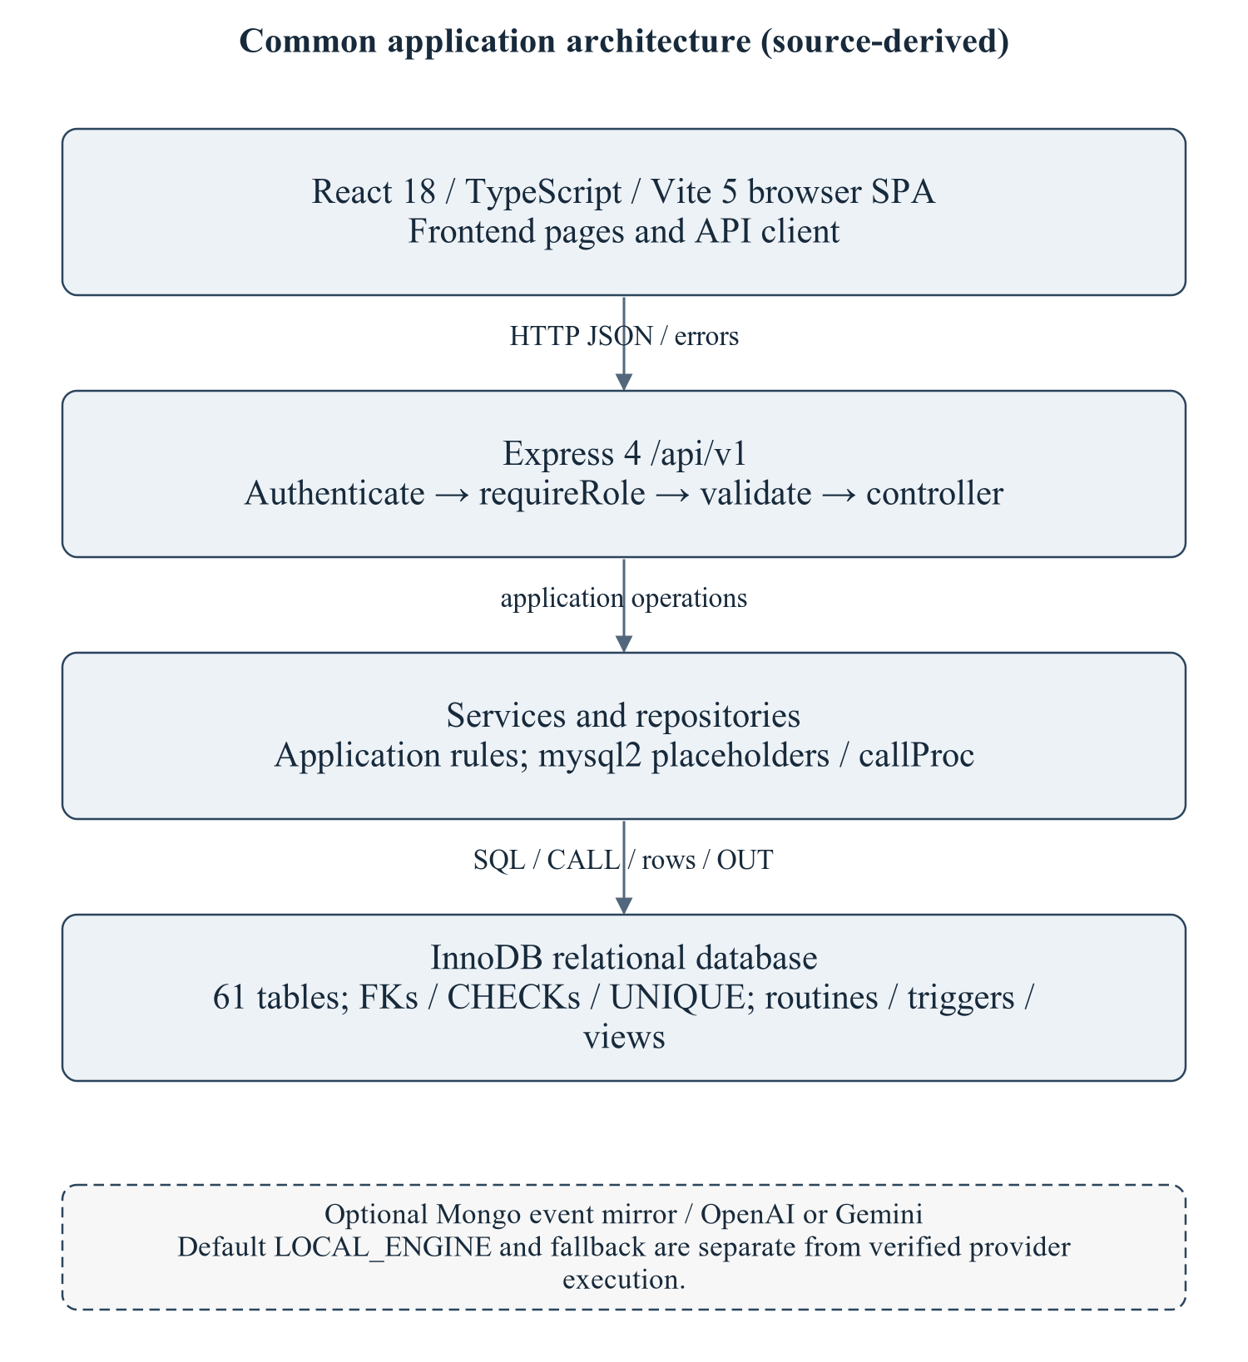
Figure 2.1 Common stack used by this module
The architecture is summarized to locate the module's routes/services/repository and SQL; it is not a copy of the master's enterprise narrative. Optional provider execution is not established.
Editable drawing source: diagrams/01_common_architecture.svg, .dot and .mmd. Edit SVG text/shapes in a vector editor, or regenerate from DOT/Mermaid; retain FK IDs and source names. These figures were created from static source, not captured from a running ERP.
React18/TypeScript/Vite5 client → Express4 /api/v1/hostel → module controller/service/repository → mysql2/InnoDB. Node>=18 is specified by backend package metadata; audit checks used Node20.20.2. MySQL8-style SQL and Compose MariaDB11.8 are separate unverified runtime targets. Hardware/IDE/browser performance requirements await MI15/MI16. [R09, R23]

2.2 Module Data Flow Diagram (Level 1 / Level 2 DFD)
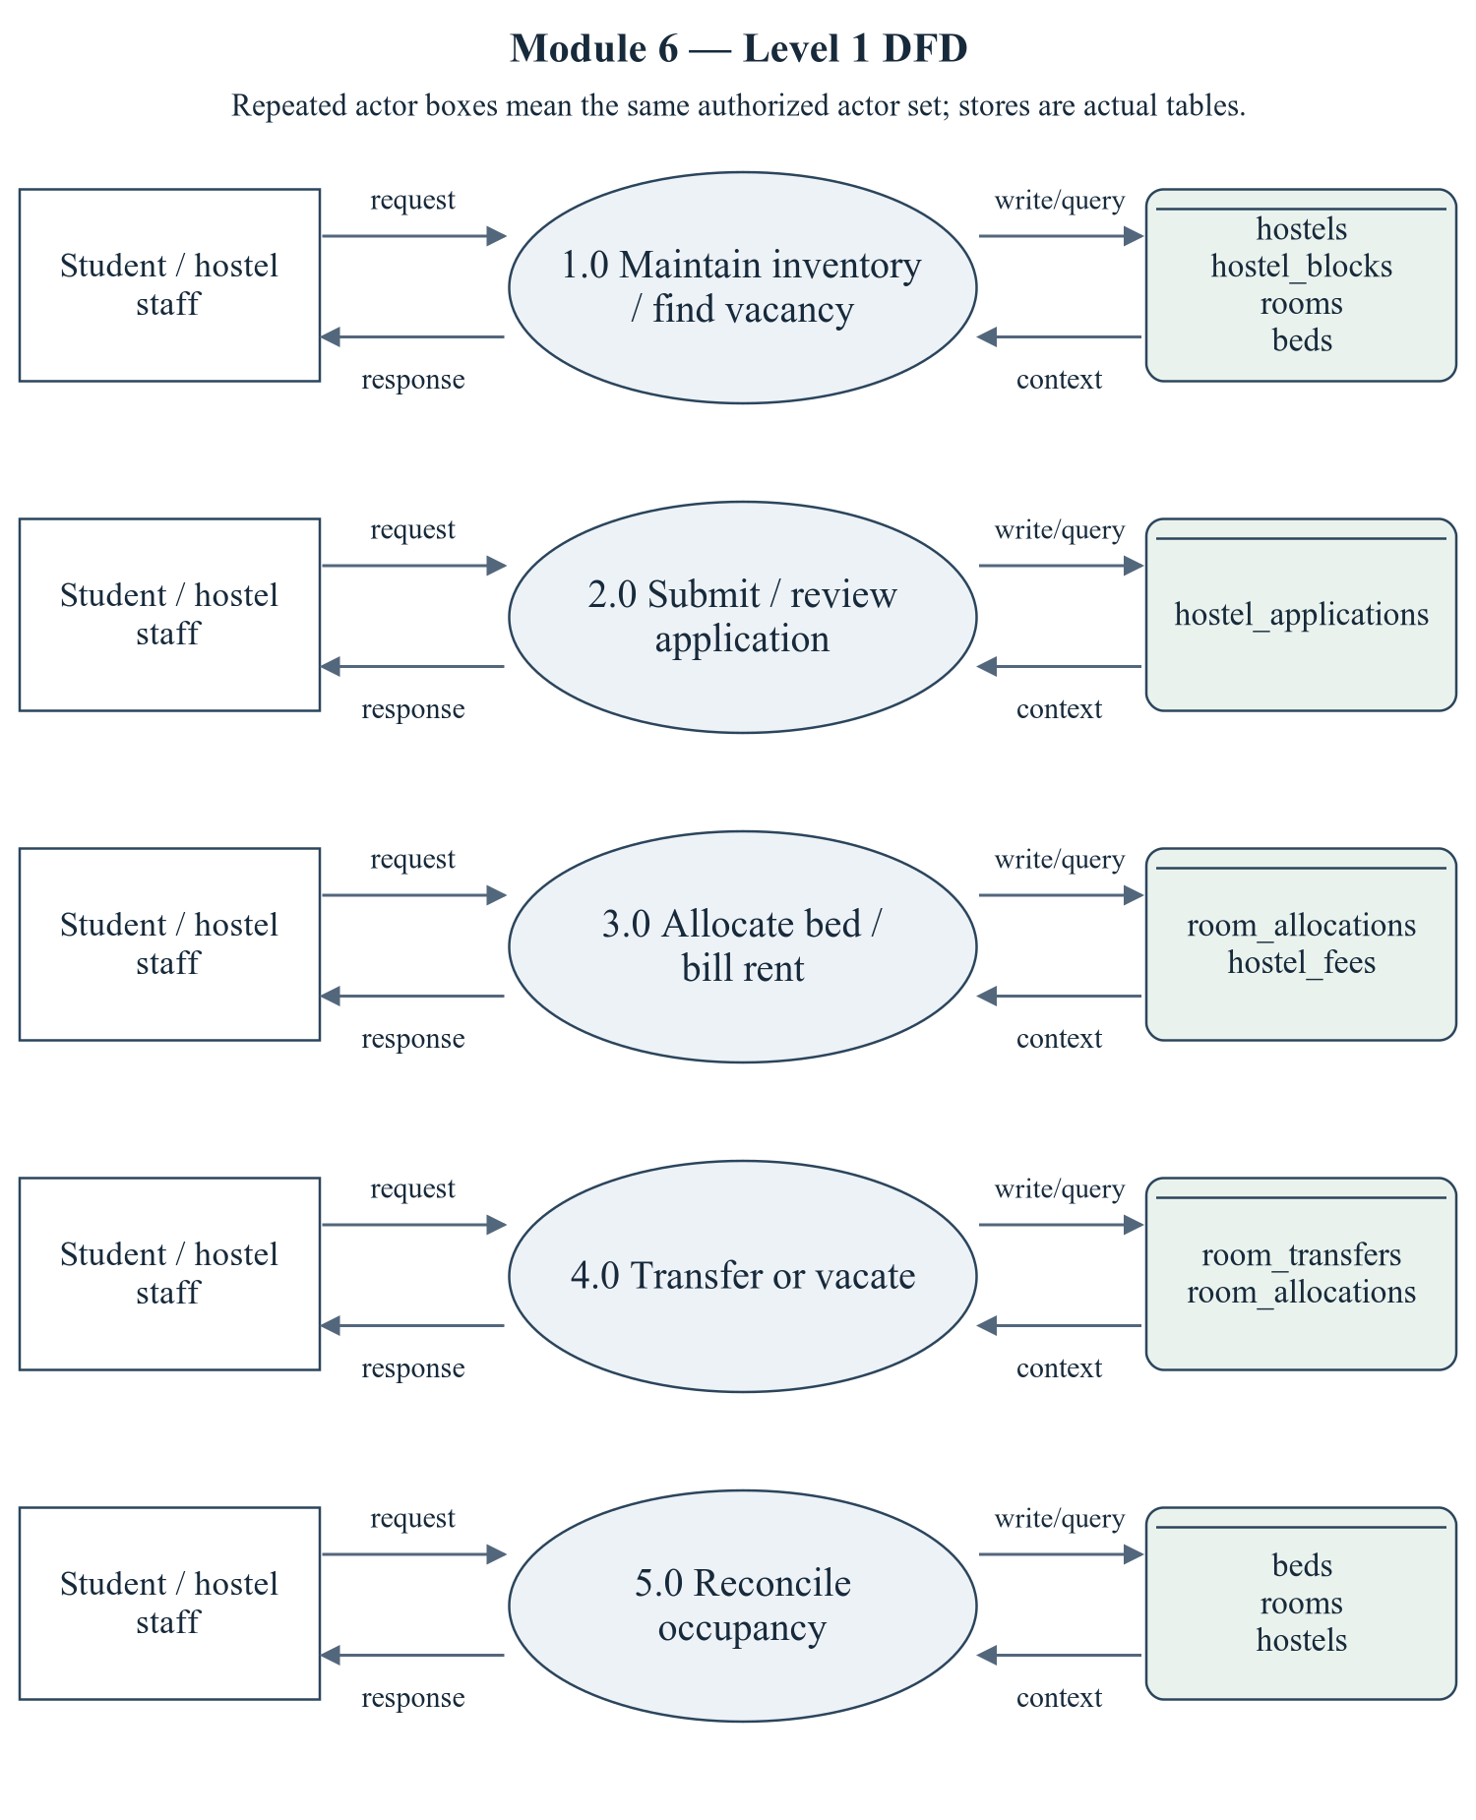
Figure 2.2 Hostel Management — Level 1 DFD
Repeated actor boxes mean the same external entity set. Each D label names real stores, not a fabricated table; role and row scope remain as specified in the route/ownership discussion.
Editable drawing source: diagrams/05_module_06_dfd_level1.svg, .dot and .mmd. Edit SVG text/shapes in a vector editor, or regenerate from DOT/Mermaid; retain FK IDs and source names. These figures were created from static source, not captured from a running ERP.

2.2.1 Sub-System Processes, Data Stores & External Movement
Table 2.1 Module processes and integration stores
Process | Actual persisted stores | Data movement
1.0 Maintain inventory / find vacancy | hostels, hostel_blocks, rooms, beds | Actor request/decision → module process; data query/write ↔ actual stores; response/report → actor.
2.0 Submit / review application | hostel_applications | Actor request/decision → module process; data query/write ↔ actual stores; response/report → actor.
3.0 Allocate bed / bill rent | room_allocations, hostel_fees | Actor request/decision → module process; data query/write ↔ actual stores; response/report → actor.
4.0 Transfer or vacate | room_transfers, room_allocations | Actor request/decision → module process; data query/write ↔ actual stores; response/report → actor.
5.0 Reconcile occupancy | beds, rooms, hostels | Actor request/decision → module process; data query/write ↔ actual stores; response/report → actor.

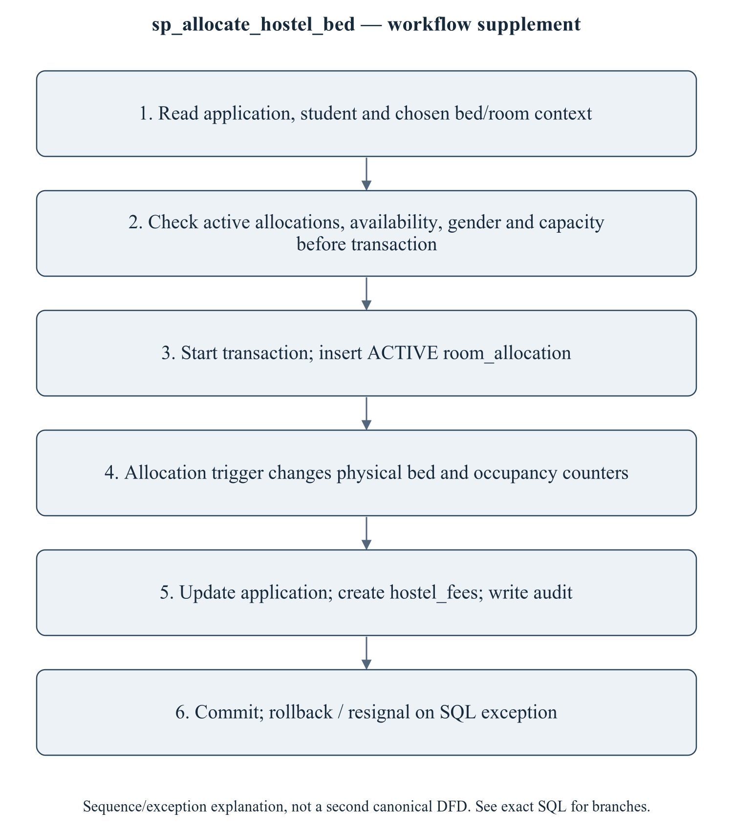
Figure 2.3 sp_allocate_hostel_bed — transaction/workflow supplement
This is a procedure sequence/exception explanation, not a second canonical DFD. Do not claim that capacity checks are serializable: checks precede the transaction. An active-bed/year UNIQUE constraint is narrower than all-time physical-bed exclusivity. Cross-hostel transfer needs an explicit policy and coordinated FK/counter updates.
Editable drawing source: diagrams/06_module_06_procedure_workflow.svg, .dot and .mmd. Edit SVG text/shapes in a vector editor, or regenerate from DOT/Mermaid; retain FK IDs and source names. These figures were created from static source, not captured from a running ERP.

2.3 Module ER Diagram, Sub-Schema & Data Dictionary
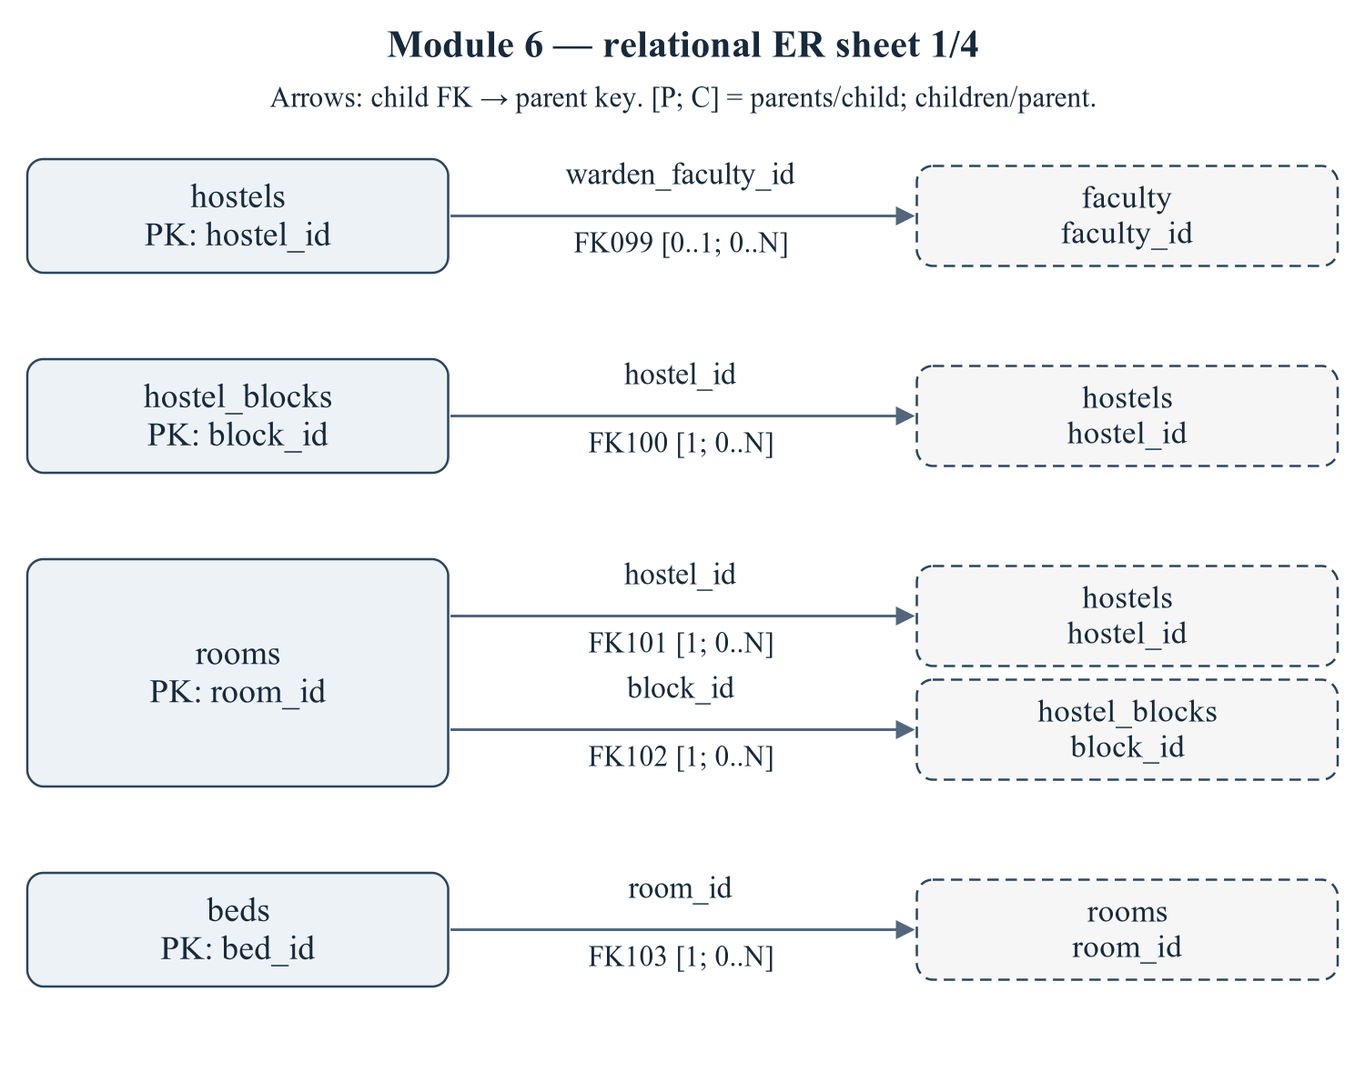
Figure 2.4 Module 6 — relational ER sheet 1/4
The child relations hostels, hostel_blocks, rooms, beds refer to actual target keys. Arrows are FK→parent; [P; C] gives parents per child and children per parent. IDs reconcile with the full dictionary and workbook. Dashed parent repetition does not transfer ownership.
Editable drawing source: diagrams/03_er_panel_06_part_01.svg, .dot and .mmd. Edit SVG text/shapes in a vector editor, or regenerate from DOT/Mermaid; retain FK IDs and source names. These figures were created from static source, not captured from a running ERP.
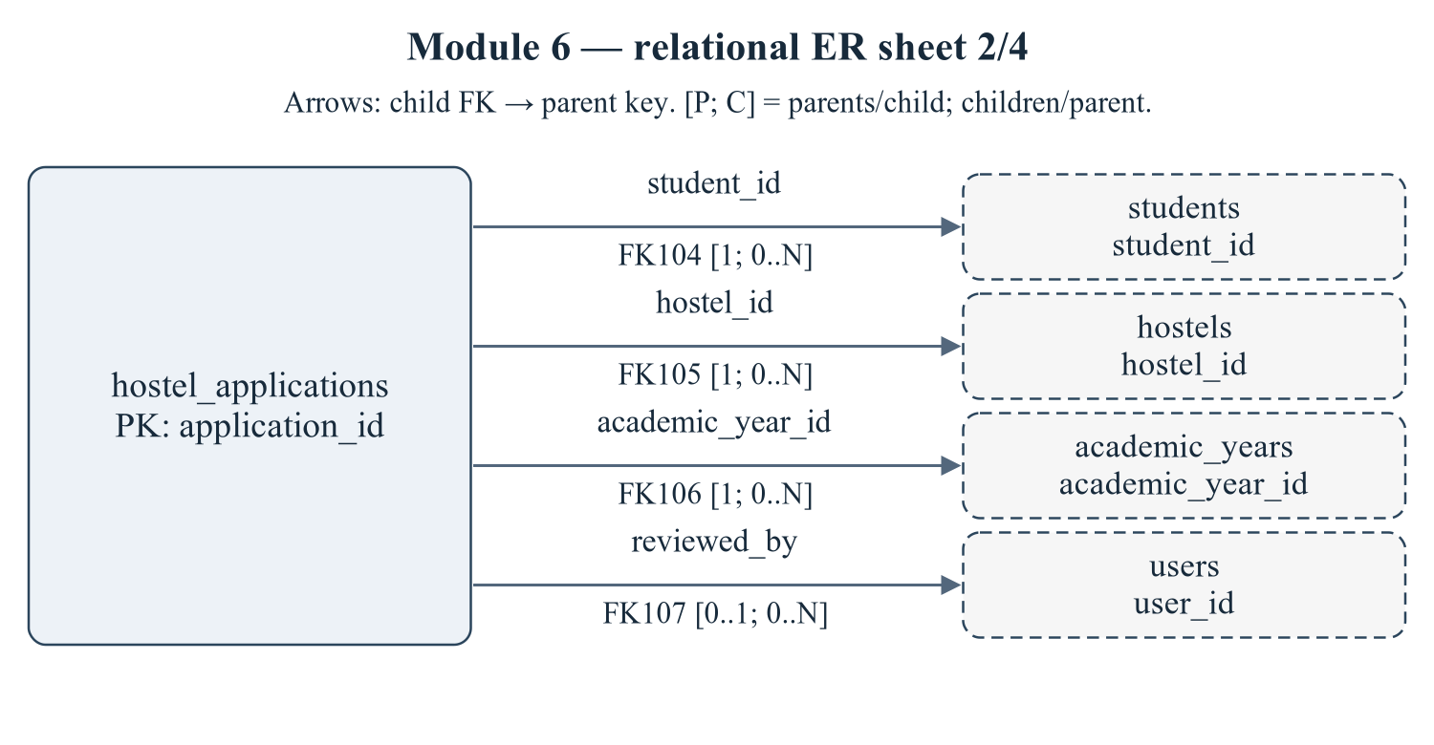
Figure 2.5 Module 6 — relational ER sheet 2/4
The child relations hostel_applications refer to actual target keys. Arrows are FK→parent; [P; C] gives parents per child and children per parent. IDs reconcile with the full dictionary and workbook. Dashed parent repetition does not transfer ownership.
Editable drawing source: diagrams/03_er_panel_06_part_02.svg, .dot and .mmd. Edit SVG text/shapes in a vector editor, or regenerate from DOT/Mermaid; retain FK IDs and source names. These figures were created from static source, not captured from a running ERP.
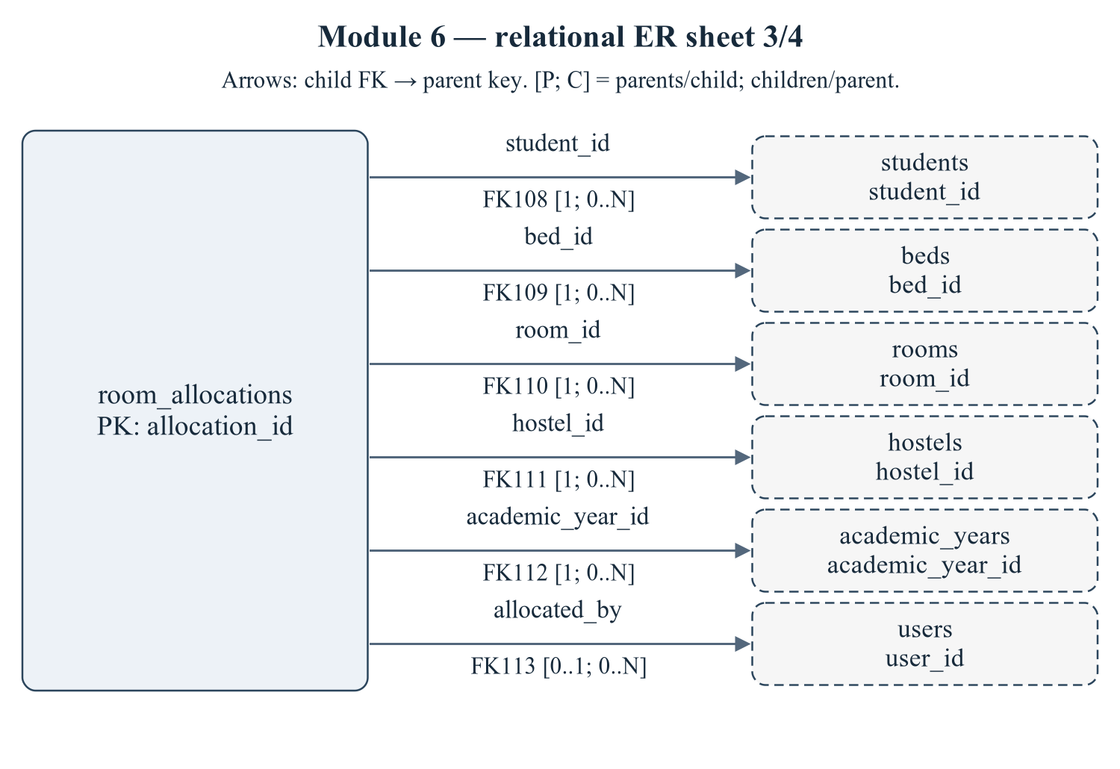
Figure 2.6 Module 6 — relational ER sheet 3/4
The child relations room_allocations refer to actual target keys. Arrows are FK→parent; [P; C] gives parents per child and children per parent. IDs reconcile with the full dictionary and workbook. Dashed parent repetition does not transfer ownership.
Editable drawing source: diagrams/03_er_panel_06_part_03.svg, .dot and .mmd. Edit SVG text/shapes in a vector editor, or regenerate from DOT/Mermaid; retain FK IDs and source names. These figures were created from static source, not captured from a running ERP.
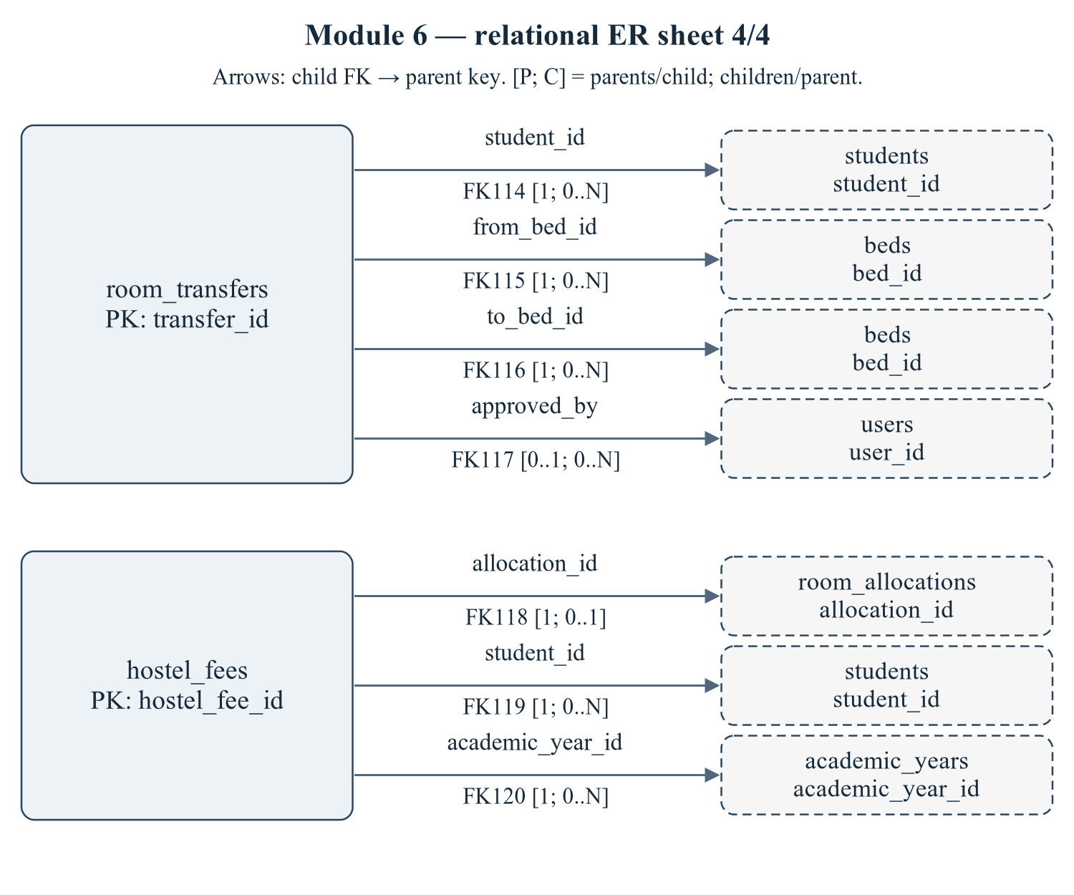
Figure 2.7 Module 6 — relational ER sheet 4/4
The child relations room_transfers, hostel_fees refer to actual target keys. Arrows are FK→parent; [P; C] gives parents per child and children per parent. IDs reconcile with the full dictionary and workbook. Dashed parent repetition does not transfer ownership.
Editable drawing source: diagrams/03_er_panel_06_part_04.svg, .dot and .mmd. Edit SVG text/shapes in a vector editor, or regenerate from DOT/Mermaid; retain FK IDs and source names. These figures were created from static source, not captured from a running ERP.
Relational notation below lists actual attributes. The full dictionary supplies types/nullability/defaults/constraints; PK/FK notation does not invent undeclared relationships.
hostels( hostel_id, hostel_code, name, hostel_type, warden_faculty_id, address, contact_no, total_rooms, total_beds, occupied_beds, rent_per_bed, status, created_at). PK={hostel_id}; FK IDs={FK099}.
hostel_blocks( block_id, hostel_id, block_code, name, floors, status). PK={block_id}; FK IDs={FK100}.
rooms( room_id, hostel_id, block_id, room_number, floor, room_type, capacity, occupied_count, rent_per_bed, status). PK={room_id}; FK IDs={FK101,FK102}.
beds( bed_id, room_id, bed_code, status, remarks). PK={bed_id}; FK IDs={FK103}.
hostel_applications( application_id, application_no, student_id, hostel_id, academic_year_id, room_type_pref, applied_on, status, reviewed_by, reviewed_on, remarks). PK={application_id}; FK IDs={FK104,FK105,FK106,FK107}.
room_allocations( allocation_id, student_id, bed_id, room_id, hostel_id, academic_year_id, allocated_on, allocated_by, vacated_on, rent_amount, status, remarks, active_bed_year). PK={allocation_id}; FK IDs={FK108,FK109,FK110,FK111,FK112,FK113}.
room_transfers( transfer_id, student_id, from_bed_id, to_bed_id, reason, transferred_on, approved_by). PK={transfer_id}; FK IDs={FK114,FK115,FK116,FK117}.
hostel_fees( hostel_fee_id, allocation_id, student_id, academic_year_id, amount, paid_amount, due_date, status, created_at). PK={hostel_fee_id}; FK IDs={FK118,FK119,FK120}.
Table 2.2 Shared / cross-module key contracts (not duplicated ownership)
Parent table / key | Module relationship | Declared action / FK ID
academic_years, PK academic_year_id | hostel_applications.academic_year_id → academic_year_id; room_allocations.academic_year_id → academic_year_id; hostel_fees.academic_year_id → academic_year_id | FK106: ON DELETE CASCADE; FK112: ON DELETE CASCADE; FK120: ON DELETE CASCADE
faculty, PK faculty_id | hostels.warden_faculty_id → faculty_id | FK099: ON DELETE SET NULL
students, PK student_id | hostel_applications.student_id → student_id; room_allocations.student_id → student_id; room_transfers.student_id → student_id; hostel_fees.student_id → student_id | FK104: ON DELETE CASCADE; FK108: ON DELETE CASCADE; FK114: ON DELETE CASCADE; FK119: ON DELETE CASCADE
users, PK user_id | hostel_applications.reviewed_by → user_id; room_allocations.allocated_by → user_id; room_transfers.approved_by → user_id | FK107: ON DELETE SET NULL; FK113: ON DELETE SET NULL; FK117: ON DELETE SET NULL

The table dictionaries in this module cover its persisted schema in full. External parents above retain their original ownership; their complete 677-column enterprise dictionary is supplied in the master report and inventory workbook. Shared contracts are repeated here so this module can be read independently without pretending to own another module's tables.
hostels — G6: hostel master with live occupancy counters.
Definition: database/02_tables.sql:896–914. Owner: Hostel Management.
Table 2.3 hostels — full column dictionary
Column and exact SQL type | Null / default / generation | Keys and purpose
hostel_id  SMALLINT UNSIGNED | NOT NULL  DEFAULT: No explicit DEFAULT  AUTO_INCREMENT | PK  Primary row identifier.
hostel_code  VARCHAR(20) | NOT NULL  DEFAULT: No explicit DEFAULT | UQ uq_hostels_code (hostel_code)  Hostel code identifier/label.
name  VARCHAR(120) | NOT NULL  DEFAULT: No explicit DEFAULT | Stored display/name attribute.
hostel_type  ENUM('BOYS','GIRLS','CO_ED') | NOT NULL  DEFAULT: 'BOYS' | Hostel type value.
warden_faculty_id  INT UNSIGNED | NULL permitted  DEFAULT: No explicit DEFAULT | FK099 → faculty.faculty_id  FK -> faculty.faculty_id (added in 03)
address  VARCHAR(255) | NULL permitted  DEFAULT: No explicit DEFAULT | Address value.
contact_no  VARCHAR(20) | NULL permitted  DEFAULT: No explicit DEFAULT | Contact no value.
total_rooms  SMALLINT UNSIGNED | NOT NULL  DEFAULT: 0 | Maintained by trigger
total_beds  SMALLINT UNSIGNED | NOT NULL  DEFAULT: 0 | Maintained by trigger
occupied_beds  SMALLINT UNSIGNED | NOT NULL  DEFAULT: 0 | Maintained by trigger
rent_per_bed  DECIMAL(10,2) | NOT NULL  DEFAULT: 0.00 | Rent per bed value.
status  ENUM('ACTIVE','MAINTENANCE','CLOSED') | NOT NULL  DEFAULT: 'ACTIVE' | Lifecycle state; exact permitted values are in the declared ENUM.
created_at  TIMESTAMP | NOT NULL  DEFAULT: CURRENT_TIMESTAMP | Row creation timestamp.

PRIMARY KEY: hostel_id
UNIQUE constraints: UNIQUE KEY `uq_hostels_code` (`hostel_code`)
CHECK constraints: CONSTRAINT `chk_hostels_rent` CHECK (`rent_per_bed` >= 0); CONSTRAINT `chk_hostels_occupancy` CHECK (`occupied_beds` <= `total_beds`)
Secondary indexes: None explicitly declared beyond PK/UNIQUE/FK support.
FK099 fk_hostels_warden: CONSTRAINT `fk_hostels_warden`
FOREIGN KEY (`warden_faculty_id`) REFERENCES `faculty` (`faculty_id`) ON DELETE SET NULL. Parent/child multiplicities 0..1 / 0..N. Omitted referential actions use restrictive defaults, not an invented cascade.
Normalization / dependency note: occupied_beds/total_beds and block/room totals are summary values over physical inventory and active allocations. They are intentional aggregates with synchronization risk rather than proof of a normalized independent fact.
hostel_blocks — G6: blocks (wings) inside a hostel.
Definition: database/02_tables.sql:916–927. Owner: Hostel Management.
Table 2.4 hostel_blocks — full column dictionary
Column and exact SQL type | Null / default / generation | Keys and purpose
block_id  SMALLINT UNSIGNED | NOT NULL  DEFAULT: No explicit DEFAULT  AUTO_INCREMENT | PK  Primary row identifier.
hostel_id  SMALLINT UNSIGNED | NOT NULL  DEFAULT: No explicit DEFAULT | UQ uq_hostel_blocks (hostel_id,block_code); FK100 → hostels.hostel_id  References hostels.hostel_id.
block_code  VARCHAR(10) | NOT NULL  DEFAULT: No explicit DEFAULT | UQ uq_hostel_blocks (hostel_id,block_code)  A, B, C
name  VARCHAR(80) | NOT NULL  DEFAULT: No explicit DEFAULT | Stored display/name attribute.
floors  TINYINT UNSIGNED | NOT NULL  DEFAULT: 1 | Floors value.
status  ENUM('ACTIVE','MAINTENANCE','CLOSED') | NOT NULL  DEFAULT: 'ACTIVE' | Lifecycle state; exact permitted values are in the declared ENUM.

PRIMARY KEY: block_id
UNIQUE constraints: UNIQUE KEY `uq_hostel_blocks` (`hostel_id`, `block_code`)
CHECK constraints: None declared.
Secondary indexes: None explicitly declared beyond PK/UNIQUE/FK support.
FK100 fk_blocks_hostel: CONSTRAINT `fk_blocks_hostel` FOREIGN KEY (`hostel_id`)
REFERENCES `hostels` (`hostel_id`) ON DELETE CASCADE. Parent/child multiplicities 1 / 0..N. Omitted referential actions use restrictive defaults, not an invented cascade.
Normalization / dependency note: PK determines the remaining stored attributes. Non-null declared UNIQUE tuples are additional candidate-key evidence. No further non-key determinant was established from DDL alone; 3NF is conditional on the stated business FDs being complete, not certified solely by having a surrogate key.
rooms — Room inventory, nominal capacity and trigger-maintained occupied count.
Definition: database/02_tables.sql:929–951. Owner: Hostel Management.
Table 2.5 rooms — full column dictionary
Column and exact SQL type | Null / default / generation | Keys and purpose
room_id  INT UNSIGNED | NOT NULL  DEFAULT: No explicit DEFAULT  AUTO_INCREMENT | PK  Primary row identifier.
hostel_id  SMALLINT UNSIGNED | NOT NULL  DEFAULT: No explicit DEFAULT | UQ uq_rooms_hostel_number (hostel_id,room_number); FK101 → hostels.hostel_id  References hostels.hostel_id.
block_id  SMALLINT UNSIGNED | NOT NULL  DEFAULT: No explicit DEFAULT | FK102 → hostel_blocks.block_id  References hostel_blocks.block_id.
room_number  VARCHAR(10) | NOT NULL  DEFAULT: No explicit DEFAULT | UQ uq_rooms_hostel_number (hostel_id,room_number)  UNIQUE within hostel
floor  TINYINT UNSIGNED | NOT NULL  DEFAULT: 0 | Floor value.
room_type  ENUM('SINGLE','DOUBLE','TRIPLE','SHARED') | NOT NULL  DEFAULT: 'DOUBLE' | Room type value.
capacity  TINYINT UNSIGNED | NOT NULL  DEFAULT: 2 | Capacity value.
occupied_count  TINYINT UNSIGNED | NOT NULL  DEFAULT: 0 | Maintained by trigger
rent_per_bed  DECIMAL(10,2) | NOT NULL  DEFAULT: 0.00 | Rent per bed value.
status  ENUM('AVAILABLE','FULL','MAINTENANCE','RESERVED') | NOT NULL  DEFAULT: 'AVAILABLE' | Lifecycle state; exact permitted values are in the declared ENUM.

PRIMARY KEY: room_id
UNIQUE constraints: UNIQUE KEY `uq_rooms_hostel_number` (`hostel_id`, `room_number`)
CHECK constraints: CONSTRAINT `chk_rooms_capacity` CHECK (`capacity` BETWEEN 1 AND 6); CONSTRAINT `chk_rooms_occupied` CHECK (`occupied_count` <= `capacity`); CONSTRAINT `chk_rooms_rent` CHECK (`rent_per_bed` >= 0)
Secondary indexes: KEY `idx_rooms_block` (`block_id`); KEY `idx_rooms_status` (`status`)
FK101 fk_rooms_hostel: CONSTRAINT `fk_rooms_hostel` FOREIGN KEY (`hostel_id`)
REFERENCES `hostels` (`hostel_id`) ON DELETE CASCADE. Parent/child multiplicities 1 / 0..N. Omitted referential actions use restrictive defaults, not an invented cascade.
FK102 fk_rooms_block: CONSTRAINT `fk_rooms_block` FOREIGN KEY (`block_id`)
REFERENCES `hostel_blocks` (`block_id`) ON DELETE CASCADE. Parent/child multiplicities 1 / 0..N. Omitted referential actions use restrictive defaults, not an invented cascade.
Normalization / dependency note: room_id -> hostel/block context; block_id -> hostel_id duplicates hierarchy when block is non-NULL. occupied_count and capacity have different meanings: a maintained usage aggregate versus nominal design capacity.
beds — Physical bed inventory associated with a room and operational status.
Definition: database/02_tables.sql:953–965. Owner: Hostel Management.
Table 2.6 beds — full column dictionary
Column and exact SQL type | Null / default / generation | Keys and purpose
bed_id  INT UNSIGNED | NOT NULL  DEFAULT: No explicit DEFAULT  AUTO_INCREMENT | PK  Primary row identifier.
room_id  INT UNSIGNED | NOT NULL  DEFAULT: No explicit DEFAULT | UQ uq_beds_room_code (room_id,bed_code); FK103 → rooms.room_id  References rooms.room_id.
bed_code  VARCHAR(10) | NOT NULL  DEFAULT: No explicit DEFAULT | UQ uq_beds_room_code (room_id,bed_code)  A, B, C or 1, 2
status  ENUM('AVAILABLE','OCCUPIED','RESERVED','MAINTENANCE') | NOT NULL  DEFAULT: 'AVAILABLE' | Lifecycle state; exact permitted values are in the declared ENUM.
remarks  VARCHAR(255) | NULL permitted  DEFAULT: No explicit DEFAULT | Operation or record remarks.

PRIMARY KEY: bed_id
UNIQUE constraints: UNIQUE KEY `uq_beds_room_code` (`room_id`, `bed_code`)
CHECK constraints: None declared.
Secondary indexes: KEY `idx_beds_status` (`status`); KEY `idx_beds_room` (`room_id`); KEY `idx_beds_room_status` (`room_id`, `status`)
FK103 fk_beds_room: CONSTRAINT `fk_beds_room` FOREIGN KEY (`room_id`)
REFERENCES `rooms` (`room_id`) ON DELETE CASCADE. Parent/child multiplicities 1 / 0..N. Omitted referential actions use restrictive defaults, not an invented cascade.
Normalization / dependency note: PK determines the remaining stored attributes. Non-null declared UNIQUE tuples are additional candidate-key evidence. No further non-key determinant was established from DDL alone; 3NF is conditional on the stated business FDs being complete, not certified solely by having a surrogate key.
hostel_applications — G6: hostel seat application workflow.
Definition: database/02_tables.sql:967–991. Owner: Hostel Management.
Table 2.7 hostel_applications — full column dictionary
Column and exact SQL type | Null / default / generation | Keys and purpose
application_id  INT UNSIGNED | NOT NULL  DEFAULT: No explicit DEFAULT  AUTO_INCREMENT | PK  Primary row identifier.
application_no  VARCHAR(30) | NOT NULL  DEFAULT: No explicit DEFAULT | UQ uq_hostel_applications_no (application_no)  Application no value.
student_id  INT UNSIGNED | NOT NULL  DEFAULT: No explicit DEFAULT | UQ uq_hostel_applications_student_year (student_id,academic_year_id); FK104 → students.student_id  References students.student_id.
hostel_id  SMALLINT UNSIGNED | NOT NULL  DEFAULT: No explicit DEFAULT | FK105 → hostels.hostel_id  References hostels.hostel_id.
academic_year_id  SMALLINT UNSIGNED | NOT NULL  DEFAULT: No explicit DEFAULT | UQ uq_hostel_applications_student_year (student_id,academic_year_id); FK106 → academic_years.academic_year_id  References academic_years.academic_year_id.
room_type_pref  ENUM('SINGLE','DOUBLE','TRIPLE','SHARED') | NOT NULL  DEFAULT: 'DOUBLE' | Room type pref value.
applied_on  DATE | NOT NULL  DEFAULT: (CURRENT_DATE) | Applied on date/time, as typed.
status  ENUM('APPLIED','APPROVED','REJECTED','WAITLISTED','CANCELLED') | NOT NULL  DEFAULT: 'APPLIED' | Lifecycle state; exact permitted values are in the declared ENUM.
reviewed_by  INT UNSIGNED | NULL permitted  DEFAULT: No explicit DEFAULT | FK107 → users.user_id  References users.user_id.
reviewed_on  DATETIME | NULL permitted  DEFAULT: No explicit DEFAULT | Reviewed on date/time, as typed.
remarks  VARCHAR(255) | NULL permitted  DEFAULT: No explicit DEFAULT | Operation or record remarks.

PRIMARY KEY: application_id
UNIQUE constraints: UNIQUE KEY `uq_hostel_applications_no` (`application_no`); UNIQUE KEY `uq_hostel_applications_student_year` (`student_id`, `academic_year_id`)
CHECK constraints: None declared.
Secondary indexes: KEY `idx_happlications_hostel` (`hostel_id`)
FK104 fk_ha_student: CONSTRAINT `fk_ha_student` FOREIGN KEY (`student_id`)
REFERENCES `students` (`student_id`) ON DELETE CASCADE. Parent/child multiplicities 1 / 0..N. Omitted referential actions use restrictive defaults, not an invented cascade.
FK105 fk_ha_hostel: CONSTRAINT `fk_ha_hostel` FOREIGN KEY (`hostel_id`)
REFERENCES `hostels` (`hostel_id`) ON DELETE CASCADE. Parent/child multiplicities 1 / 0..N. Omitted referential actions use restrictive defaults, not an invented cascade.
FK106 fk_ha_year: CONSTRAINT `fk_ha_year` FOREIGN KEY (`academic_year_id`)
REFERENCES `academic_years` (`academic_year_id`) ON DELETE CASCADE. Parent/child multiplicities 1 / 0..N. Omitted referential actions use restrictive defaults, not an invented cascade.
FK107 fk_ha_reviewer: CONSTRAINT `fk_ha_reviewer` FOREIGN KEY (`reviewed_by`)
REFERENCES `users` (`user_id`) ON DELETE SET NULL. Parent/child multiplicities 0..1 / 0..N. Omitted referential actions use restrictive defaults, not an invented cascade.
Normalization / dependency note: PK determines the remaining stored attributes. Non-null declared UNIQUE tuples are additional candidate-key evidence. No further non-key determinant was established from DDL alone; 3NF is conditional on the stated business FDs being complete, not certified solely by having a surrogate key.
room_allocations — G6: bed allocation. Triggers maintain bed/room/hostel occupancy.
Definition: database/02_tables.sql:993–1034. Owner: Hostel Management.
Table 2.8 room_allocations — full column dictionary
Column and exact SQL type | Null / default / generation | Keys and purpose
allocation_id  INT UNSIGNED | NOT NULL  DEFAULT: No explicit DEFAULT  AUTO_INCREMENT | PK  Primary row identifier.
student_id  INT UNSIGNED | NOT NULL  DEFAULT: No explicit DEFAULT | FK108 → students.student_id  References students.student_id.
bed_id  INT UNSIGNED | NOT NULL  DEFAULT: No explicit DEFAULT | FK109 → beds.bed_id  References beds.bed_id.
room_id  INT UNSIGNED | NOT NULL  DEFAULT: No explicit DEFAULT | FK110 → rooms.room_id  References rooms.room_id.
hostel_id  SMALLINT UNSIGNED | NOT NULL  DEFAULT: No explicit DEFAULT | FK111 → hostels.hostel_id  References hostels.hostel_id.
academic_year_id  SMALLINT UNSIGNED | NOT NULL  DEFAULT: No explicit DEFAULT | FK112 → academic_years.academic_year_id  References academic_years.academic_year_id.
allocated_on  DATE | NOT NULL  DEFAULT: (CURRENT_DATE) | Allocated on date/time, as typed.
allocated_by  INT UNSIGNED | NULL permitted  DEFAULT: No explicit DEFAULT | FK113 → users.user_id  References users.user_id.
vacated_on  DATE | NULL permitted  DEFAULT: No explicit DEFAULT | Vacated on date/time, as typed.
rent_amount  DECIMAL(10,2) | NOT NULL  DEFAULT: 0.00 | Rent amount value.
status  ENUM('ACTIVE','VACATED','TRANSFERRED') | NOT NULL  DEFAULT: 'ACTIVE' | Lifecycle state; exact permitted values are in the declared ENUM.
remarks  VARCHAR(255) | NULL permitted  DEFAULT: No explicit DEFAULT | Operation or record remarks.
active_bed_year  VARCHAR(32) | NULL permitted  DEFAULT: No explicit DEFAULT  GENERATED AS (IF(`status` = 'ACTIVE',  CONCAT(`bed_id`, '-', `academic_year_id`), NULL)) VIRTUAL | UQ uq_allocations_bed_year (active_bed_year)  Generated active bed/year key; NULL when the allocation is not ACTIVE.

PRIMARY KEY: allocation_id
UNIQUE constraints: UNIQUE KEY `uq_allocations_bed_year` (`active_bed_year`)
CHECK constraints: CONSTRAINT `chk_ra_rent` CHECK (`rent_amount` >= 0)
Secondary indexes: KEY `idx_allocations_student` (`student_id`); KEY `idx_allocations_bed` (`bed_id`, `academic_year_id`); KEY `idx_allocations_hostel` (`hostel_id`); KEY `idx_allocations_status` (`status`); KEY `idx_allocations_hostel_status` (`hostel_id`, `status`)
FK108 fk_ra_student: CONSTRAINT `fk_ra_student` FOREIGN KEY (`student_id`)
REFERENCES `students` (`student_id`) ON DELETE CASCADE. Parent/child multiplicities 1 / 0..N. Omitted referential actions use restrictive defaults, not an invented cascade.
FK109 fk_ra_bed: CONSTRAINT `fk_ra_bed` FOREIGN KEY (`bed_id`)
REFERENCES `beds` (`bed_id`) ON DELETE CASCADE. Parent/child multiplicities 1 / 0..N. Omitted referential actions use restrictive defaults, not an invented cascade.
FK110 fk_ra_room: CONSTRAINT `fk_ra_room` FOREIGN KEY (`room_id`)
REFERENCES `rooms` (`room_id`) ON DELETE CASCADE. Parent/child multiplicities 1 / 0..N. Omitted referential actions use restrictive defaults, not an invented cascade.
FK111 fk_ra_hostel: CONSTRAINT `fk_ra_hostel` FOREIGN KEY (`hostel_id`)
REFERENCES `hostels` (`hostel_id`) ON DELETE CASCADE. Parent/child multiplicities 1 / 0..N. Omitted referential actions use restrictive defaults, not an invented cascade.
FK112 fk_ra_year: CONSTRAINT `fk_ra_year` FOREIGN KEY (`academic_year_id`)
REFERENCES `academic_years` (`academic_year_id`) ON DELETE CASCADE. Parent/child multiplicities 1 / 0..N. Omitted referential actions use restrictive defaults, not an invented cascade.
FK113 fk_ra_allocator: CONSTRAINT `fk_ra_allocator` FOREIGN KEY (`allocated_by`)
REFERENCES `users` (`user_id`) ON DELETE SET NULL. Parent/child multiplicities 0..1 / 0..N. Omitted referential actions use restrictive defaults, not an invented cascade.
Normalization / dependency note: Intended bed_id -> room_id and room_id -> hostel_id repeat location hierarchy. There is no application_id column in room_allocations; the procedure updates the application separately. Location dependencies are transitive unless treated as immutable event-location snapshots. active_bed_year is a nullable generated uniqueness mechanism, not a conventional candidate key.
room_transfers — G6: room transfer history.
Definition: database/02_tables.sql:1036–1055. Owner: Hostel Management.
Table 2.9 room_transfers — full column dictionary
Column and exact SQL type | Null / default / generation | Keys and purpose
transfer_id  INT UNSIGNED | NOT NULL  DEFAULT: No explicit DEFAULT  AUTO_INCREMENT | PK  Primary row identifier.
student_id  INT UNSIGNED | NOT NULL  DEFAULT: No explicit DEFAULT | FK114 → students.student_id  References students.student_id.
from_bed_id  INT UNSIGNED | NOT NULL  DEFAULT: No explicit DEFAULT | FK115 → beds.bed_id  References beds.bed_id.
to_bed_id  INT UNSIGNED | NOT NULL  DEFAULT: No explicit DEFAULT | FK116 → beds.bed_id  References beds.bed_id.
reason  VARCHAR(255) | NOT NULL  DEFAULT: No explicit DEFAULT | Reason value.
transferred_on  DATETIME | NOT NULL  DEFAULT: CURRENT_TIMESTAMP | Transferred on date/time, as typed.
approved_by  INT UNSIGNED | NULL permitted  DEFAULT: No explicit DEFAULT | FK117 → users.user_id  References users.user_id.

PRIMARY KEY: transfer_id
UNIQUE constraints: None declared.
CHECK constraints: CONSTRAINT `chk_rt_beds_differ` CHECK (`from_bed_id` <> `to_bed_id`)
Secondary indexes: KEY `idx_transfers_student` (`student_id`)
FK114 fk_rt_student: CONSTRAINT `fk_rt_student` FOREIGN KEY (`student_id`)
REFERENCES `students` (`student_id`) ON DELETE CASCADE. Parent/child multiplicities 1 / 0..N. Omitted referential actions use restrictive defaults, not an invented cascade.
FK115 fk_rt_from_bed: CONSTRAINT `fk_rt_from_bed` FOREIGN KEY (`from_bed_id`)
REFERENCES `beds` (`bed_id`) ON DELETE CASCADE. Parent/child multiplicities 1 / 0..N. Omitted referential actions use restrictive defaults, not an invented cascade.
FK116 fk_rt_to_bed: CONSTRAINT `fk_rt_to_bed` FOREIGN KEY (`to_bed_id`)
REFERENCES `beds` (`bed_id`) ON DELETE CASCADE. Parent/child multiplicities 1 / 0..N. Omitted referential actions use restrictive defaults, not an invented cascade.
FK117 fk_rt_approver: CONSTRAINT `fk_rt_approver` FOREIGN KEY (`approved_by`)
REFERENCES `users` (`user_id`) ON DELETE SET NULL. Parent/child multiplicities 0..1 / 0..N. Omitted referential actions use restrictive defaults, not an invented cascade.
Normalization / dependency note: student_id identifies the resident; from_bed_id/to_bed_id identify source/target beds and imply physical rooms. No allocation_id column is present in room_transfers. Retain transfer facts as history with time semantics rather than assuming present-day bed hierarchy reproduces a past event.
hostel_fees — G6: hostel rent billed per allocation.
Definition: database/02_tables.sql:1057–1077. Owner: Hostel Management.
Table 2.10 hostel_fees — full column dictionary
Column and exact SQL type | Null / default / generation | Keys and purpose
hostel_fee_id  INT UNSIGNED | NOT NULL  DEFAULT: No explicit DEFAULT  AUTO_INCREMENT | PK  Primary row identifier.
allocation_id  INT UNSIGNED | NOT NULL  DEFAULT: No explicit DEFAULT | UQ uq_hostel_fees_allocation (allocation_id); FK118 → room_allocations.allocation_id  References room_allocations.allocation_id.
student_id  INT UNSIGNED | NOT NULL  DEFAULT: No explicit DEFAULT | FK119 → students.student_id  References students.student_id.
academic_year_id  SMALLINT UNSIGNED | NOT NULL  DEFAULT: No explicit DEFAULT | FK120 → academic_years.academic_year_id  References academic_years.academic_year_id.
amount  DECIMAL(10,2) | NOT NULL  DEFAULT: No explicit DEFAULT | Amount value.
paid_amount  DECIMAL(10,2) | NOT NULL  DEFAULT: 0.00 | Stored total paid amount; reconcile with successful receipts.
due_date  DATE | NOT NULL  DEFAULT: No explicit DEFAULT | Due date date/time, as typed.
status  ENUM('PENDING','PARTIAL','PAID','OVERDUE') | NOT NULL  DEFAULT: 'PENDING' | Lifecycle state; exact permitted values are in the declared ENUM.
created_at  TIMESTAMP | NOT NULL  DEFAULT: CURRENT_TIMESTAMP | Row creation timestamp.

PRIMARY KEY: hostel_fee_id
UNIQUE constraints: UNIQUE KEY `uq_hostel_fees_allocation` (`allocation_id`)
CHECK constraints: CONSTRAINT `chk_hf_amount` CHECK (`amount` >= 0 AND `paid_amount` >= 0)
Secondary indexes: KEY `idx_hostel_fees_student` (`student_id`)
FK118 fk_hf_allocation: CONSTRAINT `fk_hf_allocation` FOREIGN KEY (`allocation_id`)
REFERENCES `room_allocations` (`allocation_id`) ON DELETE CASCADE. Parent/child multiplicities 1 / 0..1. Omitted referential actions use restrictive defaults, not an invented cascade.
FK119 fk_hf_student: CONSTRAINT `fk_hf_student` FOREIGN KEY (`student_id`)
REFERENCES `students` (`student_id`) ON DELETE CASCADE. Parent/child multiplicities 1 / 0..N. Omitted referential actions use restrictive defaults, not an invented cascade.
FK120 fk_hf_year: CONSTRAINT `fk_hf_year` FOREIGN KEY (`academic_year_id`)
REFERENCES `academic_years` (`academic_year_id`) ON DELETE CASCADE. Parent/child multiplicities 1 / 0..N. Omitted referential actions use restrictive defaults, not an invented cascade.
Normalization / dependency note: allocation_id identifies the resident/location/year context, while student/year may be repeated for reporting. Rent/due fields are assessed charge snapshots; no automatic finance-ledger equivalence is established.

2.3.1 Normalization Analysis & Justified Exceptions
3NF is a property of a relation under a complete functional-dependency set, not a consequence of naming an integer primary key. The DDL supplies PKs, non-null UNIQUE candidates, types and referential constraints; domain FDs and historical snapshot intent require the business owner. Nullable UNIQUE tuples are not automatically candidate keys: multiple NULL-bearing values may be permitted. CHECK accepts TRUE/UNKNOWN and enforced support depends on the actual server version (MySQL 8.0.16+ for enforced CHECK). [D01, D03, R01, R02, R03]
1NF is provisionally interpreted at the declared SQL-type level: one row value per attribute. JSON/text document fields are treated as opaque values, not silently decomposed into invented child tables. 2NF requires dependence on the whole of every candidate key. 3NF additionally rejects non-key determinants unless the dependent attribute is prime or the determinant is a superkey. Cross-table contact duplication and maintained cross-row counters are discussed separately from formal within-row FD violations.
Table 2.11 Relation-level candidate keys and normalization assessment
Relation | Proven key candidates | FD / exception / evidence assessment
hostels | (hostel_id); (hostel_code) | occupied_beds/total_beds and block/room totals are summary values over physical inventory and active allocations. They are intentional aggregates with synchronization risk rather than proof of a normalized independent fact.
hostel_blocks | (block_id); (hostel_id,block_code) | PK determines the remaining stored attributes. Non-null declared UNIQUE tuples are additional candidate-key evidence. No further non-key determinant was established from DDL alone; 3NF is conditional on the stated business FDs being complete, not certified solely by having a surrogate key.
rooms | (room_id); (hostel_id,room_number) | room_id -> hostel/block context; block_id -> hostel_id duplicates hierarchy when block is non-NULL. occupied_count and capacity have different meanings: a maintained usage aggregate versus nominal design capacity.
beds | (bed_id); (room_id,bed_code) | PK determines the remaining stored attributes. Non-null declared UNIQUE tuples are additional candidate-key evidence. No further non-key determinant was established from DDL alone; 3NF is conditional on the stated business FDs being complete, not certified solely by having a surrogate key.
hostel_applications | (application_id); (application_no); (student_id,academic_year_id) | PK determines the remaining stored attributes. Non-null declared UNIQUE tuples are additional candidate-key evidence. No further non-key determinant was established from DDL alone; 3NF is conditional on the stated business FDs being complete, not certified solely by having a surrogate key.
room_allocations | (allocation_id) | Intended bed_id -> room_id and room_id -> hostel_id repeat location hierarchy. There is no application_id column in room_allocations; the procedure updates the application separately. Location dependencies are transitive unless treated as immutable event-location snapshots. active_bed_year is a nullable generated uniqueness mechanism, not a conventional candidate key.
room_transfers | (transfer_id) | student_id identifies the resident; from_bed_id/to_bed_id identify source/target beds and imply physical rooms. No allocation_id column is present in room_transfers. Retain transfer facts as history with time semantics rather than assuming present-day bed hierarchy reproduces a past event.
hostel_fees | (hostel_fee_id); (allocation_id) | allocation_id identifies the resident/location/year context, while student/year may be repeated for reporting. Rent/due fields are assessed charge snapshots; no automatic finance-ledger equivalence is established.

Module-specific decomposition proposal — not implemented DDL: the intended current hierarchy is bed_id → room_id → hostel_id. room_allocations stores all three identifiers, so deriving room/hostel through beds and rooms would remove redundant non-key context. The parent PKs make joins unique; equivalence to existing allocations still requires checking that their stored context agrees. If room/hostel attributes are deliberate historical allocation snapshots, preserve and label that temporal grain instead. Generated active_bed_year is an implemented nullable-UNIQUE guard mechanism, not proof that the allocation relation as a whole is in 3NF.
This module-specific analysis is a design assessment, not implemented replacement DDL or an executed migration. Confirm domain dependencies and historical semantics, then verify key preservation, join equivalence and affected API/trigger behavior before changing the schema. Current definitions and actual evidence gaps remain authoritative.

2.4 Advanced SQL Implementation

2.4.1 Stored Procedures (SQL Code & Execution Proofs)

sp_allocate_hostel_bed
Purpose / expected behavior: Check application/student/bed suitability, create an active allocation and hostel-fee record, update application and audit. Several checks precede START TRANSACTION and do not establish concurrency safety.
Source: database/05_procedures.sql:780–869. Definition found in the pinned snapshot; live existence and execution are unverified. Exact source comments may be stale; only inventoried definitions establish object names.
IN p_application_id: INT UNSIGNED
IN p_bed_id: INT UNSIGNED
IN p_allocated_by: INT UNSIGNED
OUT p_allocation_id: INT UNSIGNED
OUT p_message: VARCHAR(255)
Outputs: p_allocation_id INT UNSIGNED, p_message VARCHAR(255)
Read/write dependencies: audit_logs, beds, hostel_applications, hostel_fees, room_allocations, rooms, students, v_active, v_app_state, v_bed_state, v_hostel, v_rent, v_room, v_student, v_year
Routine calls: sp_push_notification
Transaction boundary: Explicit START TRANSACTION / COMMIT and SQLEXCEPTION handling in the definition.
Invocation template (not executed): bind every @ input to a mutually consistent synthetic fixture selected from the declared tables and run only on an authorized disposable schema. Numeric literals below are planned test inputs, not observed results. Internal COMMIT means wrapping a CALL in an outer ROLLBACK is not a safe fixture-cleanup strategy.
CALL sp_allocate_hostel_bed(@p_application_id, @p_bed_id, @p_allocated_by, @p_allocation_id, @p_message);
SELECT @p_allocation_id AS p_allocation_id, @p_message AS p_message;

Actual result: [[TO BE PROVIDED: run this test and record the actual result]]
Status: [[TO BE PROVIDED: run this test and record the actual result]]
Required evidence: [[TO BE PROVIDED: execute sp_allocate_hostel_bed or its triggering DML using the corresponding module test case; owner must attach sanitized inputs, OUT/SELECT/error output, before/after effects and timestamp]]
Exact SQL definition (unchanged from source):
CREATE PROCEDURE `sp_allocate_hostel_bed`(
IN p_application_id INT UNSIGNED,
IN p_bed_id INT UNSIGNED,
IN p_allocated_by INT UNSIGNED,
OUT p_allocation_id INT UNSIGNED,
OUT p_message VARCHAR(255)
)
BEGIN
DECLARE v_student INT UNSIGNED;
DECLARE v_hostel SMALLINT UNSIGNED;
DECLARE v_room INT UNSIGNED;
DECLARE v_year SMALLINT UNSIGNED;
DECLARE v_bed_state VARCHAR(20);
DECLARE v_active INT DEFAULT 0;
DECLARE v_rent DECIMAL(10,2);
DECLARE v_app_state VARCHAR(20);

DECLARE EXIT HANDLER FOR SQLEXCEPTION
BEGIN
ROLLBACK;
RESIGNAL; -- keep the original error visible to the caller
END;

SELECT `student_id`, `hostel_id`, `academic_year_id`, `status`
INTO v_student, v_hostel, v_year, v_app_state
FROM `hostel_applications` WHERE `application_id` = p_application_id;

IF v_student IS NULL THEN
SIGNAL SQLSTATE '45000' SET MESSAGE_TEXT = 'Hostel application not found.';
END IF;
IF v_app_state NOT IN ('APPLIED', 'WAITLISTED', 'APPROVED') THEN
SIGNAL SQLSTATE '45000'
SET MESSAGE_TEXT = 'This application is no longer active.';
END IF;

SELECT `status`, `room_id` INTO v_bed_state, v_room
FROM `beds` WHERE `bed_id` = p_bed_id;

IF v_bed_state IS NULL THEN
SIGNAL SQLSTATE '45000' SET MESSAGE_TEXT = 'Bed not found.';
END IF;
IF v_bed_state <> 'AVAILABLE' THEN
SIGNAL SQLSTATE '45000' SET MESSAGE_TEXT = 'That bed is not available.';
END IF;

SELECT COUNT(*) INTO v_active
FROM `room_allocations`
WHERE `student_id` = v_student AND `status` = 'ACTIVE';

IF v_active > 0 THEN
SIGNAL SQLSTATE '45000'
SET MESSAGE_TEXT = 'This student already has an active bed allocation.';
END IF;

SELECT `rent_per_bed` INTO v_rent FROM `rooms` WHERE `room_id` = v_room;

START TRANSACTION;

INSERT INTO `room_allocations`
(`student_id`, `bed_id`, `room_id`, `hostel_id`, `academic_year_id`,
`allocated_on`, `allocated_by`, `rent_amount`, `status`)
VALUES
(v_student, p_bed_id, v_room, v_hostel, v_year, CURDATE(), p_allocated_by,
v_rent, 'ACTIVE');

SET p_allocation_id = LAST_INSERT_ID();

INSERT INTO `hostel_fees`
(`allocation_id`, `student_id`, `academic_year_id`, `amount`, `due_date`, `status`)
VALUES
(p_allocation_id, v_student, v_year, v_rent * 6,
DATE_ADD(CURDATE(), INTERVAL 30 DAY), 'PENDING');

UPDATE `hostel_applications`
SET `status` = 'APPROVED', `reviewed_by` = p_allocated_by, `reviewed_on` = NOW()
WHERE `application_id` = p_application_id;

INSERT INTO `audit_logs` (`user_id`, `action`, `entity`, `entity_id`, `description`)
VALUES (p_allocated_by, 'HOSTEL_ALLOCATION', 'room_allocations', p_allocation_id,
CONCAT('Bed ', p_bed_id, ' allocated to student ', v_student));

CALL sp_push_notification(
(SELECT `user_id` FROM `students` WHERE `student_id` = v_student),
'Hostel bed allocated',
CONCAT('Bed ', p_bed_id, ' in room ', v_room, ' has been allocated to you.'),
'HOSTEL_ALLOCATION', 'SUCCESS', 'room_allocations', p_allocation_id, '/student/hostel');

SET p_message = CONCAT('Bed allocated (allocation #', p_allocation_id, ').');
COMMIT;
END$$

sp_vacate_hostel_bed
Purpose / expected behavior: Close an active allocation with vacation date/remarks and audit; update triggers release the bed and adjust counters. Missing/already-vacated paths need execution.
Source: database/05_procedures.sql:876–905. Definition found in the pinned snapshot; live existence and execution are unverified. Exact source comments may be stale; only inventoried definitions establish object names.
IN p_allocation_id: INT UNSIGNED
IN p_done_by: INT UNSIGNED
IN p_reason: VARCHAR(255)
OUT p_message: VARCHAR(255)
Outputs: p_message VARCHAR(255)
Read/write dependencies: audit_logs, room_allocations
Routine calls: No other stored routine call extracted.
Transaction boundary: Explicit START TRANSACTION / COMMIT and SQLEXCEPTION handling in the definition.
Invocation template (not executed): bind every @ input to a mutually consistent synthetic fixture selected from the declared tables and run only on an authorized disposable schema. Numeric literals below are planned test inputs, not observed results. Internal COMMIT means wrapping a CALL in an outer ROLLBACK is not a safe fixture-cleanup strategy.
CALL sp_vacate_hostel_bed(@p_allocation_id, @p_done_by, @p_reason, @p_message);
SELECT @p_message AS p_message;

Actual result: [[TO BE PROVIDED: run this test and record the actual result]]
Status: [[TO BE PROVIDED: run this test and record the actual result]]
Required evidence: [[TO BE PROVIDED: execute sp_vacate_hostel_bed or its triggering DML using the corresponding module test case; owner must attach sanitized inputs, OUT/SELECT/error output, before/after effects and timestamp]]
Exact SQL definition (unchanged from source):
CREATE PROCEDURE `sp_vacate_hostel_bed`(
IN p_allocation_id INT UNSIGNED,
IN p_done_by INT UNSIGNED,
IN p_reason VARCHAR(255),
OUT p_message VARCHAR(255)
)
BEGIN
DECLARE EXIT HANDLER FOR SQLEXCEPTION
BEGIN
ROLLBACK;
RESIGNAL; -- keep the original error visible to the caller
END;

START TRANSACTION;

UPDATE `room_allocations`
SET `status` = 'VACATED', `vacated_on` = CURDATE(), `remarks` = p_reason
WHERE `allocation_id` = p_allocation_id AND `status` = 'ACTIVE';

IF ROW_COUNT() = 0 THEN
SIGNAL SQLSTATE '45000' SET MESSAGE_TEXT = 'No active allocation with that id.';
END IF;

INSERT INTO `audit_logs` (`user_id`, `action`, `entity`, `entity_id`, `description`)
VALUES (p_done_by, 'HOSTEL_ALLOCATION', 'room_allocations', p_allocation_id,
CONCAT('Allocation vacated: ', IFNULL(p_reason, '')));

SET p_message = 'Allocation vacated and the bed is available again.';
COMMIT;
END$$

sp_transfer_room
Purpose / expected behavior: Move an allocation to another bed/room, record room_transfers and audit, and rely on allocation-update triggers for occupancy changes. hostel_id is not changed, so cross-hostel moves need a defined guard/fix.
Source: database/05_procedures.sql:912–975. Definition found in the pinned snapshot; live existence and execution are unverified. Exact source comments may be stale; only inventoried definitions establish object names.
IN p_allocation_id: INT UNSIGNED
IN p_to_bed_id: INT UNSIGNED
IN p_reason: VARCHAR(255)
IN p_approved_by: INT UNSIGNED
OUT p_message: VARCHAR(255)
Outputs: p_message VARCHAR(255)
Read/write dependencies: audit_logs, beds, room_allocations, room_transfers, students, v_from, v_hostel, v_room, v_state, v_student
Routine calls: sp_push_notification
Transaction boundary: Explicit START TRANSACTION / COMMIT and SQLEXCEPTION handling in the definition.
Invocation template (not executed): bind every @ input to a mutually consistent synthetic fixture selected from the declared tables and run only on an authorized disposable schema. Numeric literals below are planned test inputs, not observed results. Internal COMMIT means wrapping a CALL in an outer ROLLBACK is not a safe fixture-cleanup strategy.
CALL sp_transfer_room(@p_allocation_id, @p_to_bed_id, @p_reason, @p_approved_by, @p_message);
SELECT @p_message AS p_message;

Actual result: [[TO BE PROVIDED: run this test and record the actual result]]
Status: [[TO BE PROVIDED: run this test and record the actual result]]
Required evidence: [[TO BE PROVIDED: execute sp_transfer_room or its triggering DML using the corresponding module test case; owner must attach sanitized inputs, OUT/SELECT/error output, before/after effects and timestamp]]
Exact SQL definition (unchanged from source):
CREATE PROCEDURE `sp_transfer_room`(
IN p_allocation_id INT UNSIGNED,
IN p_to_bed_id INT UNSIGNED,
IN p_reason VARCHAR(255),
IN p_approved_by INT UNSIGNED,
OUT p_message VARCHAR(255)
)
BEGIN
DECLARE v_student INT UNSIGNED;
DECLARE v_from INT UNSIGNED;
DECLARE v_state VARCHAR(20);
DECLARE v_room INT UNSIGNED;
DECLARE v_hostel SMALLINT UNSIGNED;

DECLARE EXIT HANDLER FOR SQLEXCEPTION
BEGIN
ROLLBACK;
RESIGNAL; -- keep the original error visible to the caller
END;

SELECT `student_id`, `bed_id`, `hostel_id`
INTO v_student, v_from, v_hostel
FROM `room_allocations` WHERE `allocation_id` = p_allocation_id;

IF v_student IS NULL THEN
SIGNAL SQLSTATE '45000' SET MESSAGE_TEXT = 'Allocation not found.';
END IF;
IF v_from = p_to_bed_id THEN
SIGNAL SQLSTATE '45000' SET MESSAGE_TEXT = 'Student already occupies that bed.';
END IF;

SELECT `status`, `room_id` INTO v_state, v_room
FROM `beds` WHERE `bed_id` = p_to_bed_id;

IF v_state IS NULL THEN
SIGNAL SQLSTATE '45000' SET MESSAGE_TEXT = 'Target bed not found.';
END IF;
IF v_state <> 'AVAILABLE' THEN
SIGNAL SQLSTATE '45000' SET MESSAGE_TEXT = 'Target bed is not available.';
END IF;

START TRANSACTION;

UPDATE `room_allocations`
SET `bed_id` = p_to_bed_id, `room_id` = v_room
WHERE `allocation_id` = p_allocation_id;

INSERT INTO `room_transfers`
(`student_id`, `from_bed_id`, `to_bed_id`, `reason`, `transferred_on`, `approved_by`)
VALUES (v_student, v_from, p_to_bed_id, p_reason, NOW(), p_approved_by);

INSERT INTO `audit_logs` (`user_id`, `action`, `entity`, `entity_id`, `description`)
VALUES (p_approved_by, 'HOSTEL_ALLOCATION', 'room_transfers', p_allocation_id,
CONCAT('Room transfer: bed ', v_from, ' -> ', p_to_bed_id));

CALL sp_push_notification(
(SELECT `user_id` FROM `students` WHERE `student_id` = v_student),
'Room transfer approved',
CONCAT('You have been moved to bed ', p_to_bed_id, '.'),
'HOSTEL_ALLOCATION', 'INFO', 'room_transfers', p_allocation_id, '/student/hostel');

SET p_message = 'Room transfer completed.';
COMMIT;
END$$

2.4.2 Database Triggers (SQL Code & Execution Proofs)

trg_allocation_ai
Purpose / expected behavior: For an active inserted allocation, mark the bed occupied, increase room/hostel occupancy and write allocation audit.
Source: database/06_triggers.sql:466–479. Definition found in the pinned snapshot; live existence and execution are unverified. Exact source comments may be stale; only inventoried definitions establish object names.
Event / inputs / output: AFTER INSERT ON `room_allocations` FOR EACH ROW; OLD/NEW are event-appropriate row images; no explicit arguments or scalar return. Side effects are described above.
Read/write dependencies: audit_logs, beds, hostels, room_allocations, rooms
Routine calls: No other stored routine call extracted.
Invocation template (not executed): bind every @ input to a mutually consistent synthetic fixture selected from the declared tables and run only on an authorized disposable schema. Numeric literals below are planned test inputs, not observed results. Internal COMMIT means wrapping a CALL in an outer ROLLBACK is not a safe fixture-cleanup strategy.
CALL sp_allocate_hostel_bed(@p_application_id, @p_bed_id, @p_allocated_by, @p_allocation_id, @p_message);

Actual result: [[TO BE PROVIDED: run this test and record the actual result]]
Status: [[TO BE PROVIDED: run this test and record the actual result]]
Required evidence: [[TO BE PROVIDED: execute trg_allocation_ai or its triggering DML using the corresponding module test case; owner must attach sanitized inputs, OUT/SELECT/error output, before/after effects and timestamp]]
Exact SQL definition (unchanged from source):
CREATE TRIGGER `trg_allocation_ai`
AFTER INSERT ON `room_allocations` FOR EACH ROW
BEGIN
IF NEW.`status` = 'ACTIVE' THEN
UPDATE `beds` SET `status` = 'OCCUPIED' WHERE `bed_id` = NEW.`bed_id`;
UPDATE `rooms` SET `occupied_count` = `occupied_count` + 1 WHERE `room_id` = NEW.`room_id`;
UPDATE `hostels` SET `occupied_beds` = `occupied_beds` + 1 WHERE `hostel_id` = NEW.`hostel_id`;

INSERT INTO `audit_logs` (`user_id`, `action`, `entity`, `entity_id`, `description`)
VALUES (NEW.`allocated_by`, 'HOSTEL_ALLOCATION', 'room_allocations', NEW.`allocation_id`,
CONCAT('TRIGGER: bed ', NEW.`bed_id`, ' occupied, room ',
NEW.`room_id`, ' occupancy incremented'));
END IF;
END$$

trg_allocation_au
Purpose / expected behavior: Handle active/inactive and bed-change transitions, releasing/occupying beds and adjusting relevant room/hostel counters according to the exact branches.
Source: database/06_triggers.sql:483–517. Definition found in the pinned snapshot; live existence and execution are unverified. Exact source comments may be stale; only inventoried definitions establish object names.
Event / inputs / output: AFTER UPDATE ON `room_allocations` FOR EACH ROW; OLD/NEW are event-appropriate row images; no explicit arguments or scalar return. Side effects are described above.
Read/write dependencies: beds, hostels, room_allocations, rooms
Routine calls: No other stored routine call extracted.
Invocation template (not executed): bind every @ input to a mutually consistent synthetic fixture selected from the declared tables and run only on an authorized disposable schema. Numeric literals below are planned test inputs, not observed results. Internal COMMIT means wrapping a CALL in an outer ROLLBACK is not a safe fixture-cleanup strategy.
CALL sp_vacate_hostel_bed(@p_allocation_id, @p_done_by, @p_reason, @p_message);

Actual result: [[TO BE PROVIDED: run this test and record the actual result]]
Status: [[TO BE PROVIDED: run this test and record the actual result]]
Required evidence: [[TO BE PROVIDED: execute trg_allocation_au or its triggering DML using the corresponding module test case; owner must attach sanitized inputs, OUT/SELECT/error output, before/after effects and timestamp]]
Exact SQL definition (unchanged from source):
CREATE TRIGGER `trg_allocation_au`
AFTER UPDATE ON `room_allocations` FOR EACH ROW
BEGIN
-- Bed transfer: free the old bed, occupy the new one.
IF NEW.`bed_id` <> OLD.`bed_id` AND NEW.`status` = 'ACTIVE' THEN
UPDATE `beds` SET `status` = 'AVAILABLE' WHERE `bed_id` = OLD.`bed_id`;
UPDATE `beds` SET `status` = 'OCCUPIED' WHERE `bed_id` = NEW.`bed_id`;

UPDATE `rooms` SET `occupied_count` = GREATEST(0, `occupied_count` - 1)
WHERE `room_id` = OLD.`room_id`;
UPDATE `rooms` SET `occupied_count` = `occupied_count` + 1 WHERE `room_id` = NEW.`room_id`;

IF OLD.`hostel_id` <> NEW.`hostel_id` THEN
UPDATE `hostels` SET `occupied_beds` = GREATEST(0, `occupied_beds` - 1)
WHERE `hostel_id` = OLD.`hostel_id`;
UPDATE `hostels` SET `occupied_beds` = `occupied_beds` + 1 WHERE `hostel_id` = NEW.`hostel_id`;
END IF;
END IF;

-- Vacating: release the bed and decrement every counter.
IF OLD.`status` = 'ACTIVE' AND NEW.`status` IN ('VACATED', 'TRANSFERRED') THEN
UPDATE `beds` SET `status` = 'AVAILABLE' WHERE `bed_id` = NEW.`bed_id`;
UPDATE `rooms` SET `occupied_count` = GREATEST(0, `occupied_count` - 1)
WHERE `room_id` = NEW.`room_id`;
UPDATE `hostels` SET `occupied_beds` = GREATEST(0, `occupied_beds` - 1)
WHERE `hostel_id` = NEW.`hostel_id`;
END IF;

-- Reactivating a vacated allocation (rare, but keeps the counters honest).
IF OLD.`status` IN ('VACATED', 'TRANSFERRED') AND NEW.`status` = 'ACTIVE' THEN
UPDATE `beds` SET `status` = 'OCCUPIED' WHERE `bed_id` = NEW.`bed_id`;
UPDATE `rooms` SET `occupied_count` = `occupied_count` + 1 WHERE `room_id` = NEW.`room_id`;
UPDATE `hostels` SET `occupied_beds` = `occupied_beds` + 1 WHERE `hostel_id` = NEW.`hostel_id`;
END IF;
END$$

trg_allocation_ad
Purpose / expected behavior: If an active allocation is deleted, release bed and decrease room/hostel counters. Cascading FK operations must be tested separately from explicit DELETE trigger behavior.
Source: database/06_triggers.sql:521–531. Definition found in the pinned snapshot; live existence and execution are unverified. Exact source comments may be stale; only inventoried definitions establish object names.
Event / inputs / output: AFTER DELETE ON `room_allocations` FOR EACH ROW; OLD/NEW are event-appropriate row images; no explicit arguments or scalar return. Side effects are described above.
Read/write dependencies: beds, hostels, room_allocations, rooms
Routine calls: No other stored routine call extracted.
Invocation template (not executed): bind every @ input to a mutually consistent synthetic fixture selected from the declared tables and run only on an authorized disposable schema. Numeric literals below are planned test inputs, not observed results. Internal COMMIT means wrapping a CALL in an outer ROLLBACK is not a safe fixture-cleanup strategy.
DELETE FROM room_allocations WHERE allocation_id = @fixture_active_allocation_id;

Actual result: [[TO BE PROVIDED: run this test and record the actual result]]
Status: [[TO BE PROVIDED: run this test and record the actual result]]
Required evidence: [[TO BE PROVIDED: execute trg_allocation_ad or its triggering DML using the corresponding module test case; owner must attach sanitized inputs, OUT/SELECT/error output, before/after effects and timestamp]]
Exact SQL definition (unchanged from source):
CREATE TRIGGER `trg_allocation_ad`
AFTER DELETE ON `room_allocations` FOR EACH ROW
BEGIN
IF OLD.`status` = 'ACTIVE' THEN
UPDATE `beds` SET `status` = 'AVAILABLE' WHERE `bed_id` = OLD.`bed_id`;
UPDATE `rooms` SET `occupied_count` = GREATEST(0, `occupied_count` - 1)
WHERE `room_id` = OLD.`room_id`;
UPDATE `hostels` SET `occupied_beds` = GREATEST(0, `occupied_beds` - 1)
WHERE `hostel_id` = OLD.`hostel_id`;
END IF;
END$$

trg_allocation_bi_duplicate
Purpose / expected behavior: Reject a second ACTIVE allocation for the same student and academic year on INSERT. This is narrower than the allocation procedure all-year check.
Source: database/06_triggers.sql:536–553. Definition found in the pinned snapshot; live existence and execution are unverified. Exact source comments may be stale; only inventoried definitions establish object names.
Event / inputs / output: BEFORE INSERT ON `room_allocations` FOR EACH ROW; OLD/NEW are event-appropriate row images; no explicit arguments or scalar return. Side effects are described above.
Read/write dependencies: room_allocations, v_active
Routine calls: No other stored routine call extracted.
Invocation template (not executed): bind every @ input to a mutually consistent synthetic fixture selected from the declared tables and run only on an authorized disposable schema. Numeric literals below are planned test inputs, not observed results. Internal COMMIT means wrapping a CALL in an outer ROLLBACK is not a safe fixture-cleanup strategy.
CALL sp_allocate_hostel_bed(@p_application_id, @p_bed_id, @p_allocated_by, @p_allocation_id, @p_message);

Actual result: [[TO BE PROVIDED: run this test and record the actual result]]
Status: [[TO BE PROVIDED: run this test and record the actual result]]
Required evidence: [[TO BE PROVIDED: execute trg_allocation_bi_duplicate or its triggering DML using the corresponding module test case; owner must attach sanitized inputs, OUT/SELECT/error output, before/after effects and timestamp]]
Exact SQL definition (unchanged from source):
CREATE TRIGGER `trg_allocation_bi_duplicate`
BEFORE INSERT ON `room_allocations` FOR EACH ROW
BEGIN
DECLARE v_active INT DEFAULT 0;

IF NEW.`status` = 'ACTIVE' THEN
SELECT COUNT(*) INTO v_active
FROM `room_allocations` ra
WHERE ra.`student_id` = NEW.`student_id`
AND ra.`academic_year_id` = NEW.`academic_year_id`
AND ra.`status` = 'ACTIVE';

IF v_active > 0 THEN
SIGNAL SQLSTATE '45000'
SET MESSAGE_TEXT = 'This student already has an active bed allocation for this year.';
END IF;
END IF;
END$$

trg_rooms_bu_capacity
Purpose / expected behavior: Reject an UPDATE in which occupied_count exceeds capacity. It does not create beds or prove counters match the physical inventory.
Source: database/06_triggers.sql:558–573. Definition found in the pinned snapshot; live existence and execution are unverified. Exact source comments may be stale; only inventoried definitions establish object names.
Event / inputs / output: BEFORE UPDATE ON `rooms` FOR EACH ROW; OLD/NEW are event-appropriate row images; no explicit arguments or scalar return. Side effects are described above.
Read/write dependencies: rooms
Routine calls: No other stored routine call extracted.
Invocation template (not executed): bind every @ input to a mutually consistent synthetic fixture selected from the declared tables and run only on an authorized disposable schema. Numeric literals below are planned test inputs, not observed results. Internal COMMIT means wrapping a CALL in an outer ROLLBACK is not a safe fixture-cleanup strategy.
UPDATE rooms SET occupied_count = capacity + 1 WHERE room_id = @fixture_room_id;

Actual result: [[TO BE PROVIDED: run this test and record the actual result]]
Status: [[TO BE PROVIDED: run this test and record the actual result]]
Required evidence: [[TO BE PROVIDED: execute trg_rooms_bu_capacity or its triggering DML using the corresponding module test case; owner must attach sanitized inputs, OUT/SELECT/error output, before/after effects and timestamp]]
Exact SQL definition (unchanged from source):
CREATE TRIGGER `trg_rooms_bu_capacity`
BEFORE UPDATE ON `rooms` FOR EACH ROW
BEGIN
IF NEW.`occupied_count` > NEW.`capacity` THEN
SIGNAL SQLSTATE '45000'
SET MESSAGE_TEXT = 'Room capacity exceeded - there are not enough beds in this room.';
END IF;
IF NEW.`occupied_count` < 0 THEN
SET NEW.`occupied_count` = 0;
END IF;
IF NEW.`occupied_count` >= NEW.`capacity` THEN
SET NEW.`status` = 'FULL';
ELSEIF NEW.`status` = 'FULL' THEN
SET NEW.`status` = 'AVAILABLE';
END IF;
END$$

trg_beds_bu_guard
Purpose / expected behavior: Prevent making an actively allocated bed AVAILABLE under the checked condition. Other bed states and reconciliation paths need testing.
Source: database/06_triggers.sql:578–592. Definition found in the pinned snapshot; live existence and execution are unverified. Exact source comments may be stale; only inventoried definitions establish object names.
Event / inputs / output: BEFORE UPDATE ON `beds` FOR EACH ROW; OLD/NEW are event-appropriate row images; no explicit arguments or scalar return. Side effects are described above.
Read/write dependencies: beds, room_allocations, v_alloc
Routine calls: No other stored routine call extracted.
Invocation template (not executed): bind every @ input to a mutually consistent synthetic fixture selected from the declared tables and run only on an authorized disposable schema. Numeric literals below are planned test inputs, not observed results. Internal COMMIT means wrapping a CALL in an outer ROLLBACK is not a safe fixture-cleanup strategy.
UPDATE beds SET status = 'AVAILABLE' WHERE bed_id = @fixture_actively_allocated_bed_id;

Actual result: [[TO BE PROVIDED: run this test and record the actual result]]
Status: [[TO BE PROVIDED: run this test and record the actual result]]
Required evidence: [[TO BE PROVIDED: execute trg_beds_bu_guard or its triggering DML using the corresponding module test case; owner must attach sanitized inputs, OUT/SELECT/error output, before/after effects and timestamp]]
Exact SQL definition (unchanged from source):
CREATE TRIGGER `trg_beds_bu_guard`
BEFORE UPDATE ON `beds` FOR EACH ROW
BEGIN
DECLARE v_alloc INT DEFAULT 0;

IF OLD.`status` = 'OCCUPIED' AND NEW.`status` = 'AVAILABLE' THEN
SELECT COUNT(*) INTO v_alloc
FROM `room_allocations` ra
WHERE ra.`bed_id` = OLD.`bed_id` AND ra.`status` = 'ACTIVE';
IF v_alloc > 0 THEN
SIGNAL SQLSTATE '45000'
SET MESSAGE_TEXT = 'This bed is currently allocated - vacate the allocation first.';
END IF;
END IF;
END$$

2.4.3 User-Defined Functions (UDFs) (SQL Code & Execution Proofs)

fn_hostel_available_beds
Purpose / expected behavior: Count beds marked AVAILABLE through rooms for the hostel. This status count differs from nominal capacity minus stored occupancy and can be affected by reconciliation.
Source: database/07_functions.sql:279–290. Definition found in the pinned snapshot; live existence and execution are unverified. Exact source comments may be stale; only inventoried definitions establish object names.
IN p_hostel_id: SMALLINT UNSIGNED
Output: int scalar return value.
Read/write dependencies: beds, rooms, v_count
Routine calls: No other stored routine call extracted.
Invocation template (not executed): bind every @ input to a mutually consistent synthetic fixture selected from the declared tables and run only on an authorized disposable schema. Numeric literals below are planned test inputs, not observed results. Internal COMMIT means wrapping a CALL in an outer ROLLBACK is not a safe fixture-cleanup strategy.
SELECT fn_hostel_available_beds(@p_hostel_id) AS computed_value;

Actual result: [[TO BE PROVIDED: run this test and record the actual result]]
Status: [[TO BE PROVIDED: run this test and record the actual result]]
Required evidence: [[TO BE PROVIDED: execute fn_hostel_available_beds or its triggering DML using the corresponding module test case; owner must attach sanitized inputs, OUT/SELECT/error output, before/after effects and timestamp]]
Exact SQL definition (unchanged from source):
CREATE FUNCTION `fn_hostel_available_beds`(p_hostel_id SMALLINT UNSIGNED)
RETURNS int
READS SQL DATA
BEGIN
DECLARE v_count INT DEFAULT 0;
SELECT COUNT(*) INTO v_count
FROM `beds` b
JOIN `rooms` r ON r.`room_id` = b.`room_id`
WHERE r.`hostel_id` = p_hostel_id
AND b.`status` = 'AVAILABLE';
RETURN v_count;
END$$

2.5 Complex Analytical Queries & Views

v_hostel_occupancy
Purpose / expected behavior: Project hostel capacity/stored occupancy, active residents, rooms and warden. Stored counters require reconciliation evidence; a view is not a measured occupancy result.
Source: database/08_views.sql:239–260. Definition found in the pinned snapshot; live existence and execution are unverified. Exact source comments may be stale; only inventoried definitions establish object names.
Inputs / output: No parameters; SELECT returns columns: hostel_id, hostel_code, hostel_name, hostel_type, total_rooms, total_beds, occupied_beds, available_beds, occupancy_percentage, rooms_configured, rooms_full, rooms_available, active_allocations, rent_per_bed, status, warden_name. WHERE/JOIN predicates are query inputs, not stored view parameters.
Read/write dependencies: faculty, hostels, room_allocations, rooms
Routine calls: No other stored routine call extracted.
Invocation template (not executed): bind every @ input to a mutually consistent synthetic fixture selected from the declared tables and run only on an authorized disposable schema. Numeric literals below are planned test inputs, not observed results. Internal COMMIT means wrapping a CALL in an outer ROLLBACK is not a safe fixture-cleanup strategy.
SELECT * FROM v_hostel_occupancy LIMIT 10;

Actual result: [[TO BE PROVIDED: run this test and record the actual result]]
Status: [[TO BE PROVIDED: run this test and record the actual result]]
Required evidence: [[TO BE PROVIDED: execute v_hostel_occupancy or its triggering DML using the corresponding module test case; owner must attach sanitized inputs, OUT/SELECT/error output, before/after effects and timestamp]]
Exact SQL definition (unchanged from source):
CREATE OR REPLACE VIEW `v_hostel_occupancy` AS
SELECT h.`hostel_id`, h.`hostel_code`, h.`name` AS `hostel_name`, h.`hostel_type`,
h.`total_rooms`, h.`total_beds`, h.`occupied_beds`,
h.`total_beds` - h.`occupied_beds` AS `available_beds`,
ROUND(h.`occupied_beds` * 100.0 / NULLIF(h.`total_beds`,0), 2) AS `occupancy_percentage`,
IFNULL(rc.`rooms_configured`, 0) AS `rooms_configured`,
IFNULL(rc.`rooms_full`, 0) AS `rooms_full`,
IFNULL(rc.`rooms_available`, 0) AS `rooms_available`,
IFNULL(ac.`active_allocations`, 0) AS `active_allocations`,
h.`rent_per_bed`, h.`status`,
CONCAT(wf.`first_name`, ' ', wf.`last_name`) AS `warden_name`
FROM `hostels` h
LEFT JOIN (SELECT `hostel_id`, COUNT(*) AS `rooms_configured`,
SUM(`status` = 'FULL') AS `rooms_full`,
SUM(`status` = 'AVAILABLE') AS `rooms_available`
FROM `rooms` GROUP BY `hostel_id`) rc
ON rc.`hostel_id` = h.`hostel_id`
LEFT JOIN (SELECT `hostel_id`, COUNT(*) AS `active_allocations`
FROM `room_allocations` WHERE `status` = 'ACTIVE'
GROUP BY `hostel_id`) ac
ON ac.`hostel_id` = h.`hostel_id`
LEFT JOIN `faculty` wf ON wf.`faculty_id` = h.`warden_faculty_id`;

v_room_vacancy
Purpose / expected behavior: Project room/block/hostel and bed vacancy data, combining inventory and current states. Distinguish nominal capacity from available physical beds.
Source: database/08_views.sql:265–279. Definition found in the pinned snapshot; live existence and execution are unverified. Exact source comments may be stale; only inventoried definitions establish object names.
Inputs / output: No parameters; SELECT returns columns: room_id, room_number, floor, room_type, capacity, occupied_count, vacant_beds, rent_per_bed, status, hostel_id, hostel_code, hostel_name, hostel_type, block_id, block_code, beds_configured, beds_available. WHERE/JOIN predicates are query inputs, not stored view parameters.
Read/write dependencies: beds, hostel_blocks, hostels, rooms
Routine calls: No other stored routine call extracted.
Invocation template (not executed): bind every @ input to a mutually consistent synthetic fixture selected from the declared tables and run only on an authorized disposable schema. Numeric literals below are planned test inputs, not observed results. Internal COMMIT means wrapping a CALL in an outer ROLLBACK is not a safe fixture-cleanup strategy.
SELECT * FROM v_room_vacancy LIMIT 10;

Actual result: [[TO BE PROVIDED: run this test and record the actual result]]
Status: [[TO BE PROVIDED: run this test and record the actual result]]
Required evidence: [[TO BE PROVIDED: execute v_room_vacancy or its triggering DML using the corresponding module test case; owner must attach sanitized inputs, OUT/SELECT/error output, before/after effects and timestamp]]
Exact SQL definition (unchanged from source):
CREATE OR REPLACE VIEW `v_room_vacancy` AS
SELECT r.`room_id`, r.`room_number`, r.`floor`, r.`room_type`, r.`capacity`,
r.`occupied_count`, (r.`capacity` - r.`occupied_count`) AS `vacant_beds`,
r.`rent_per_bed`, r.`status`,
h.`hostel_id`, h.`hostel_code`, h.`name` AS `hostel_name`, h.`hostel_type`,
b.`block_id`, b.`block_code`,
COUNT(bd.`bed_id`) AS `beds_configured`,
SUM(CASE WHEN bd.`status` = 'AVAILABLE' THEN 1 ELSE 0 END) AS `beds_available`
FROM `rooms` r
JOIN `hostels` h ON h.`hostel_id` = r.`hostel_id`
JOIN `hostel_blocks` b ON b.`block_id` = r.`block_id`
LEFT JOIN `beds` bd ON bd.`room_id` = r.`room_id`
GROUP BY r.`room_id`, r.`room_number`, r.`floor`, r.`room_type`, r.`capacity`,
r.`occupied_count`, r.`rent_per_bed`, r.`status`,
h.`hostel_id`, h.`hostel_code`, h.`name`, h.`hostel_type`, b.`block_id`, b.`block_code`;

Q03 LEFT JOINs active residents while preserving day scholars; Q36 presents room vacancy with running occupancy by hostel. Q14 elsewhere in the SQL collection can fan out room capacities after allocation joins and is flagged rather than presented as verified occupancy. [R08]

Q03 — LEFT JOIN with a status predicate in ON (not WHERE) — residents vs
Source: database/09_queries.sql:95. Purpose is the query projection/aggregation below; no output rows have been generated. Expected column structure follows aliases in the exact statement.
SELECT s.roll_number,
CONCAT(s.first_name, ' ', s.last_name) AS student_name,
CASE WHEN ra.allocation_id IS NULL THEN 'DAY SCHOLAR' ELSE 'RESIDENT' END AS residency,
h.name AS hostel,
h.hostel_code,
r.room_number,
bd.bed_code,
ra.allocated_on
FROM students s
LEFT JOIN room_allocations ra
ON ra.student_id = s.student_id
AND ra.status = 'ACTIVE'
LEFT JOIN hostels h ON h.hostel_id = ra.hostel_id
LEFT JOIN rooms r ON r.room_id = ra.room_id
LEFT JOIN beds bd ON bd.bed_id = ra.bed_id
WHERE s.status = 'ACTIVE'
ORDER BY residency, h.hostel_code, r.room_number
LIMIT 60;

Actual result: [[TO BE PROVIDED: run this test and record the actual result]]
Status: [[TO BE PROVIDED: run this test and record the actual result]]

Q36 — Hostel vacancy board with running occupancy per hostel
Source: database/09_queries.sql:912. Purpose is the query projection/aggregation below; no output rows have been generated. Expected column structure follows aliases in the exact statement.
SELECT h.hostel_code,
b.block_code,
r.room_number,
r.room_type,
r.capacity,
r.occupied_count,
r.capacity - r.occupied_count AS free_beds,
SUM(r.occupied_count) OVER (PARTITION BY h.hostel_id
ORDER BY b.block_code, r.room_number
ROWS BETWEEN UNBOUNDED PRECEDING AND CURRENT ROW) AS running_occupancy,
CASE WHEN r.occupied_count = 0 THEN 'VACANT'
WHEN r.occupied_count >= r.capacity THEN 'FULL'
ELSE 'PARTIAL' END AS room_state,
r.status
FROM rooms r
JOIN hostels h ON h.hostel_id = r.hostel_id
LEFT JOIN hostel_blocks b ON b.block_id = r.block_id
ORDER BY h.hostel_code, b.block_code, r.room_number
LIMIT 80;

Actual result: [[TO BE PROVIDED: run this test and record the actual result]]
Status: [[TO BE PROVIDED: run this test and record the actual result]]

2.6 Backend Routes, Services, Repository & Frontend Trace
Table 2.12 Hostel Management — exact API route/role register
Method and route | Role gate / handler | Validation and source
GET /api/v1/hostel/hostels | Authenticated; row scope must be inspected  Handler: hostels | No route-local Zod validation; service/DB checks may apply  backend/src/routes/hostel.routes.ts:13
GET /api/v1/hostel/hostels/:id | Authenticated; row scope must be inspected  Handler: hostel | No route-local Zod validation; service/DB checks may apply  backend/src/routes/hostel.routes.ts:14
GET /api/v1/hostel/occupancy | STUDENT, ADMIN, HOSTEL_ADMIN  Handler: occupancy | No route-local Zod validation; service/DB checks may apply  backend/src/routes/hostel.routes.ts:15
GET /api/v1/hostel/stats | ADMIN, HOSTEL_ADMIN  Handler: stats | No route-local Zod validation; service/DB checks may apply  backend/src/routes/hostel.routes.ts:16
GET /api/v1/hostel/rooms | STUDENT, ADMIN, HOSTEL_ADMIN  Handler: rooms | No route-local Zod validation; service/DB checks may apply  backend/src/routes/hostel.routes.ts:18
GET /api/v1/hostel/rooms/vacancy | ADMIN, HOSTEL_ADMIN  Handler: vacancy | No route-local Zod validation; service/DB checks may apply  backend/src/routes/hostel.routes.ts:19
GET /api/v1/hostel/blocks | ADMIN, HOSTEL_ADMIN  Handler: blocks | No route-local Zod validation; service/DB checks may apply  backend/src/routes/hostel.routes.ts:20
GET /api/v1/hostel/beds | ADMIN, HOSTEL_ADMIN  Handler: beds | No route-local Zod validation; service/DB checks may apply  backend/src/routes/hostel.routes.ts:21
POST /api/v1/hostel/rooms | ADMIN, HOSTEL_ADMIN  Handler: createRoom | No route-local Zod validation; service/DB checks may apply  backend/src/routes/hostel.routes.ts:22
GET /api/v1/hostel/applications | STUDENT, ADMIN, HOSTEL_ADMIN  Handler: applications | No route-local Zod validation; service/DB checks may apply  backend/src/routes/hostel.routes.ts:24
POST /api/v1/hostel/applications | STUDENT, ADMIN, HOSTEL_ADMIN  Handler: apply | Zod validate(...) in route  backend/src/routes/hostel.routes.ts:25
PUT /api/v1/hostel/applications/:id/review | ADMIN, HOSTEL_ADMIN  Handler: reviewApplication | Zod validate(...) in route  backend/src/routes/hostel.routes.ts:31
GET /api/v1/hostel/applications/:id/beds | ADMIN, HOSTEL_ADMIN  Handler: suggestedBeds | No route-local Zod validation; service/DB checks may apply  backend/src/routes/hostel.routes.ts:35
GET /api/v1/hostel/allocations | ADMIN, HOSTEL_ADMIN  Handler: allocations | No route-local Zod validation; service/DB checks may apply  backend/src/routes/hostel.routes.ts:37
GET /api/v1/hostel/allocations/me | STUDENT  Handler: myAllocation | No route-local Zod validation; service/DB checks may apply  backend/src/routes/hostel.routes.ts:38
GET /api/v1/hostel/allocations/history/me | STUDENT  Handler: allocationHistory | No route-local Zod validation; service/DB checks may apply  backend/src/routes/hostel.routes.ts:39
GET /api/v1/hostel/allocations/:id | ADMIN, HOSTEL_ADMIN  Handler: allocation | No route-local Zod validation; service/DB checks may apply  backend/src/routes/hostel.routes.ts:40
GET /api/v1/hostel/allocations/student/:id | Authenticated; row scope must be inspected  Handler: allocationHistory | No route-local Zod validation; service/DB checks may apply  backend/src/routes/hostel.routes.ts:41
POST /api/v1/hostel/allocations | ADMIN, HOSTEL_ADMIN  Handler: allocate | Zod validate(...) in route  backend/src/routes/hostel.routes.ts:42
POST /api/v1/hostel/allocations/:id/transfer | ADMIN, HOSTEL_ADMIN  Handler: transfer | Zod validate(...) in route  backend/src/routes/hostel.routes.ts:46
POST /api/v1/hostel/allocations/:id/vacate | ADMIN, HOSTEL_ADMIN  Handler: vacate | Zod validate(...) in route  backend/src/routes/hostel.routes.ts:50
GET /api/v1/hostel/transfers | STUDENT, ADMIN, HOSTEL_ADMIN  Handler: transfers | No route-local Zod validation; service/DB checks may apply  backend/src/routes/hostel.routes.ts:53
GET /api/v1/hostel/fees | STUDENT, ACCOUNTANT, ADMIN, HOSTEL_ADMIN  Handler: hostelFees | No route-local Zod validation; service/DB checks may apply  backend/src/routes/hostel.routes.ts:55

backend/src/controllers/hostel.controller.ts: Exports: hostels, hostel, occupancy, stats, rooms, vacancy, blocks, beds, createRoom, applications, apply, reviewApplication, suggestedBeds, allocations, allocation, myAllocation, allocationHistory, allocate, transfer, vacate, transfers, hostelFees. SQL references: .
backend/src/repositories/hostel.repository.ts: Exports: hostelsRepo, roomsRepo, applicationsRepo, allocationsRepo, hostelFeesRepo. SQL references: academic_years, beds, faculty, hostel_applications, hostel_blocks, hostel_fees, hostels, programs, room_allocations, room_transfers, rooms, students, fn_hostel_available_beds, v_hostel_occupancy, v_room_vacancy.
backend/src/services/hostel.service.ts: Exports: hostels, rooms, applications, allocations, hostelFees. SQL references: beds, hostel_applications, hostels, room_allocations, rooms, students, sp_allocate_hostel_bed, sp_transfer_room, sp_vacate_hostel_bed.
Frontend source pages: frontend/src/pages/hostel/HostelAllocationsPage.tsx; frontend/src/pages/hostel/HostelApplicationsPage.tsx; frontend/src/pages/hostel/HostelDashboardPage.tsx; frontend/src/pages/hostel/HostelRoomsPage.tsx; frontend/src/pages/hostel/MyHostelPage.tsx.
Controller → service → repository separation is present in source. mysql2 query/execute helpers bind values; callProc reads OUT parameters on one acquired connection. Some services write audit/notifications after the database operation on a separate pooled request, so a procedure transaction does not make every service side effect atomic. [R16, R09, R19]
Validation/error contract: route-local Zod schemas operate on request bodies where listed; the report does not infer validation for routes without validate(...). Services raise AppError for selected missing records/invalid inputs; DB FK/UNIQUE/CHECK/SIGNAL errors pass through the shared handler. HTTP statuses and payloads need API execution evidence, not invented response screenshots. [R10]
Exact route validation expressions (TypeScript/Zod, not SQL; no execution claim):
backend/src/routes/hostel.routes.ts:25 — router.post '/applications'
z.object({
hostelId: z.number().int().positive(),
academicYearId: z.number().int().positive(),
roomTypePref: z.enum(['SINGLE', 'DOUBLE', 'TRIPLE', 'SHARED']).optional(),
studentId: z.number().int().positive().optional(),
})

backend/src/routes/hostel.routes.ts:31 — router.put '/applications/:id/review'
z.object({
status: z.enum(['APPROVED', 'REJECTED', 'WAITLISTED']),
remarks: z.string().optional(),
})

backend/src/routes/hostel.routes.ts:42 — router.post '/allocations'
z.object({
applicationId: z.number().int().positive(),
bedId: z.number().int().positive(),
})

backend/src/routes/hostel.routes.ts:46 — router.post '/allocations/:id/transfer'
z.object({
toBedId: z.number().int().positive(),
reason: z.string().min(3),
})

backend/src/routes/hostel.routes.ts:50 — router.post '/allocations/:id/vacate'
z.object({
reason: z.string().min(3),
})

2.7 Validation, Errors, Transactions & Limitations
Do not claim that capacity checks are serializable: checks precede the transaction. An active-bed/year UNIQUE constraint is narrower than all-time physical-bed exclusivity. Cross-hostel transfer needs an explicit policy and coordinated FK/counter updates.
F05 [High] Hostel target-student authorization: Application body studentId can override current student; history can select a supplied studentId. Source: backend/src/controllers/hostel.controller.ts. Action/proposal: Enforce self-scope server-side for students and test two independent synthetic accounts.
F06 [High] Allocation hierarchy and transfer consistency: No observed application-hostel/selected-bed-hostel equality check; transfer updates room/bed but not hostel_id. Source: database/05_procedures.sql. Action/proposal: Validate the entire hierarchy and define or prohibit cross-hostel moves in one locked transaction.
F09 [High] First-login server enforcement gap: Frontend password-change redirect exists, but authentication middleware does not deny other protected API calls for first-login users. Source: backend/src/middleware/auth.ts; frontend/src/App.tsx. Action/proposal: Add a server-side first-login allowlist for me/change-password/logout and test direct API access.
F14 [High] Hostel prechecks/reconciliation scope: Allocation prechecks precede transaction; final trigger-file reconciliation has no year scope and can overwrite reserved/maintenance bed states. Source: database/05_procedures.sql; database/06_triggers.sql. Action/proposal: Lock inventory and preserve non-occupancy operational states; test multiple years.
F16 [High] Database test drift / verdict capture: SQL admission approval fixture uses an old signature. runFile discards SELECT result sets; SQL assertion failures are not reliably converted to failing process status. Source: tests/db/test_rules.sql; backend/src/scripts/runDbTests.ts; backend/src/scripts/sqlRunner.ts. Action/proposal: Fix current signature, capture assertion rows and fail the runner when any assertion fails.
F17 [Medium] API smoke authorization expectation drift: The student /students expectation must be reconciled with current route authorization before claiming a passing suite. Source: tests/api/smoke.sh; backend/src/routes/student.routes.ts. Action/proposal: Review expected policy, update the test where approved and retain raw HTTP evidence.
F20 [Medium] Container initialization is a different path: Compose mounts numeric SQL files in filename order; the supported TS runner loads functions/views before seeds/procedures/triggers. Compatibility/order cannot be assumed equivalent. Source: docker-compose.yml; backend/src/scripts/sqlRunner.ts. Action/proposal: Verify a clean disposable container boot or replace with an explicit dependency-aware initializer.
F21 [High] Runtime institution/year defaults do not match report context: 03_constraints.sql includes a different long institute name and CURRENT_ACADEMIC_YEAR=2025-26. Report identity/year comes from supplied PICT templates (2026-2027), not this seed setting. Source: database/03_constraints.sql. Action/proposal: Have the team approve/reset institutional settings and active year flags; do not silently rewrite repository evidence.
F22 [Medium] Documentation TLS drift: README says pool TLS/CA settings are absent, but the application pool now reads DB_SSL_CA with certificate validation. The SQL runner does not mirror that option. Source: README.md; backend/src/config/env.ts; backend/src/config/database.ts; backend/src/scripts/sqlRunner.ts. Action/proposal: Treat current code as primary; align documentation and test both connection paths without disclosing CA/credentials.
F26 [Medium] Analytics source-quality exceptions: Q02 compares offering state to ACTIVE, Q44 compares enrollment state to ACTIVE: validate against actual ENUMs. Q14 capacity can fan out; Q23 compares dates directly to timestamps; Q35 claims dues blocking; Q37 includes future dues in 0-30. Q43 comment overclaims CUBE/GROUPING SETS. Source: database/09_queries.sql. Action/proposal: Treat all 45 examples as source artifacts requiring semantic/runtime review; do not report invented outputs or capabilities.
F27 [Medium] Broadcast read-state is shared: A NULL-user notification is a single broadcast row; mark-read updates that shared row, rather than a per-recipient receipt table. Source: backend/src/repositories/notification.repository.ts; database/01_schema.sql. Action/proposal: Define broadcast read semantics; add per-recipient receipt state only as a proposed future design.
F28 [Medium] Build is not functional validation: Four typecheck/build commands pass. Vitest exits 1 because no test files are found; no live DB/API/E2E or deployment execution was performed. Source: audit/evidence/backend_typecheck.log; audit/evidence/backend_build.log; audit/evidence/frontend_typecheck.log; audit/evidence/frontend_build.log; audit/evidence/backend_vitest.log. Action/proposal: Supply independent, sanitized SQL/API evidence before calling the ERP tested or deployed successfully.
These are static source findings and acceptance risks, not assertions that a live exploit, SQL error or failing business test was observed.

CHAPTER 3: TESTING, CONCLUSION & REFERENCES

3.1 Module Test Plan & Preconditions
Only EXEC-01..EXEC-05 below were executed in this audit. All other cases have the exact requested unresolved Actual result and Status marker. Synthetic counts, percentages and marks in Expected/Input cells are planned oracle fixtures, not captured ERP records.
Run mutating tests only on a disposable authorized database/API. Select mutually compatible fixture IDs through joins (student → enrollment → offering → session/exam/bill/allocation), never assume seed IDs equal 1 or reuse real student records. Capture server/version/sql_mode/timezone, SQL/request, actor role, before/after rows, OUT values, error/status and cleanup. Do not publish passwords, hashes, bearer/refresh tokens, connection strings, real email/phone/bank records or environment values.
Procedures with internal COMMIT/ROLLBACK cannot safely be isolated merely by an outer transaction; use dedicated fixtures/schema rebuild/restore. For concurrency use two independent connections and retain ordering. For every negative case verify unchanged related rows as well as the error. Fix the stale admission signature and make the SQL harness expose/assert FAIL rows before treating db:test exit status as evidence. [R20, R21, R22, D04]
Module integration prerequisites: load the dependency-aware 01→02→03→07→08→04→05→06 source order on a disposable DB, verify declared cross-module FK parents, choose compatible synthetic actor/student/faculty/semester records and retain before-state data. Do not copy seed personal records or demo credentials into screenshots.

3.2 Positive, Negative, Edge, Authorization & Transaction Cases
Table 3.1 M6-01 — Valid application and allocation
Test field | Required record
Test ID / module | M6-01 / Hostel Management
Objective | Valid application and allocation
Preconditions | Matching student gender/year/hostel application, AVAILABLE bed/room with capacity, administrator actor.
Input / action | Call sp_allocate_hostel_bed; read application, allocation, hostel_fee, bed, room and hostel.
Expected result | One active allocation and fee row; application state, occupancy and audit agree.
Actual result | [[TO BE PROVIDED: run this test and record the actual result]]
Status | [[TO BE PROVIDED: run this test and record the actual result]]
Evidence | [[TO BE PROVIDED: attach sanitized SQL/API transcript or screenshot for M6-01; module/test owner should capture fixture identifiers, command/request, before/after/error and execution timestamp from an authorized disposable environment]]

Table 3.2 M6-02 — Duplicate student/bed/year boundaries
Test field | Required record
Test ID / module | M6-02 / Hostel Management
Objective | Duplicate student/bed/year boundaries
Preconditions | One active allocation; second bed same year and same physical bed different year fixtures.
Input / action | Attempt duplicate allocation via procedure and direct INSERT for each year combination.
Expected result | Record procedure all-year versus trigger student/year and generated bed/year uniqueness; no claimed all-time exclusivity without evidence.
Actual result | [[TO BE PROVIDED: run this test and record the actual result]]
Status | [[TO BE PROVIDED: run this test and record the actual result]]
Evidence | [[TO BE PROVIDED: attach sanitized SQL/API transcript or screenshot for M6-02; module/test owner should capture fixture identifiers, command/request, before/after/error and execution timestamp from an authorized disposable environment]]

Table 3.3 M6-03 — Wrong hierarchy/gender/capacity
Test field | Required record
Test ID / module | M6-03 / Hostel Management
Objective | Wrong hierarchy/gender/capacity
Preconditions | Application for hostel A; bed in B; full room and unsuitable student fixture.
Input / action | Try each incompatible allocation on separate disposable fixtures.
Expected result | Policy target: all incompatibilities rejected atomically; record current missing application/bed-hostel equality guard if observed.
Actual result | [[TO BE PROVIDED: run this test and record the actual result]]
Status | [[TO BE PROVIDED: run this test and record the actual result]]
Evidence | [[TO BE PROVIDED: attach sanitized SQL/API transcript or screenshot for M6-03; module/test owner should capture fixture identifiers, command/request, before/after/error and execution timestamp from an authorized disposable environment]]

Table 3.4 M6-04 — Vacate and delete counter lifecycle
Test field | Required record
Test ID / module | M6-04 / Hostel Management
Objective | Vacate and delete counter lifecycle
Preconditions | Two separate active allocations with baseline counters.
Input / action | Vacate once and repeat; explicitly delete another active allocation; inspect bed and counters.
Expected result | One release per state transition; no negative/double-decrement; return errors/outcome for repeated vacation.
Actual result | [[TO BE PROVIDED: run this test and record the actual result]]
Status | [[TO BE PROVIDED: run this test and record the actual result]]
Evidence | [[TO BE PROVIDED: attach sanitized SQL/API transcript or screenshot for M6-04; module/test owner should capture fixture identifiers, command/request, before/after/error and execution timestamp from an authorized disposable environment]]

Table 3.5 M6-05 — Transfer within/cross hostel
Test field | Required record
Test ID / module | M6-05 / Hostel Management
Objective | Transfer within/cross hostel
Preconditions | Source active allocation, free target same hostel and free target other hostel.
Input / action | Transfer within hostel then attempt cross-hostel transfer on a fresh fixture.
Expected result | Correct bed/room/history and counters; cross-hostel must be rejected or update entire hierarchy under approved policy. Current unchanged hostel_id is flagged.
Actual result | [[TO BE PROVIDED: run this test and record the actual result]]
Status | [[TO BE PROVIDED: run this test and record the actual result]]
Evidence | [[TO BE PROVIDED: attach sanitized SQL/API transcript or screenshot for M6-05; module/test owner should capture fixture identifiers, command/request, before/after/error and execution timestamp from an authorized disposable environment]]

Table 3.6 M6-06 — Student-ID tampering / history privacy
Test field | Required record
Test ID / module | M6-06 / Hostel Management
Objective | Student-ID tampering / history privacy
Preconditions | Two students with separate applications/allocations and student tokens.
Input / action | Submit application body with other studentId; request another student transfer history.
Expected result | Policy target: ignore/reject unauthorized target IDs; no other-student information or application creation.
Actual result | [[TO BE PROVIDED: run this test and record the actual result]]
Status | [[TO BE PROVIDED: run this test and record the actual result]]
Evidence | [[TO BE PROVIDED: attach sanitized SQL/API transcript or screenshot for M6-06; module/test owner should capture fixture identifiers, command/request, before/after/error and execution timestamp from an authorized disposable environment]]

Table 3.7 M6-07 — Concurrency and maintenance reconciliation
Test field | Required record
Test ID / module | M6-07 / Hostel Management
Objective | Concurrency and maintenance reconciliation
Preconditions | One free bed, two competing valid applications; reserved/maintenance bed fixture and two academic years.
Input / action | Race allocations; run reconciliation only on a disposable copy; compare all states and counters.
Expected result | One valid occupation; no duplicate active physical use under agreed policy; reserved/maintenance status and year semantics must be preserved.
Actual result | [[TO BE PROVIDED: run this test and record the actual result]]
Status | [[TO BE PROVIDED: run this test and record the actual result]]
Evidence | [[TO BE PROVIDED: attach sanitized SQL/API transcript or screenshot for M6-07; module/test owner should capture fixture identifiers, command/request, before/after/error and execution timestamp from an authorized disposable environment]]

3.2.1 Executed Repository-Wide Build Checks (not module correctness)
Table 3.8 EXEC-01 — npm run typecheck in backend
Test field | Required record
Test ID / module | EXEC-01 / Enterprise
Objective | npm run typecheck in backend
Preconditions | Pinned clean repository; npm ci --ignore-scripts --no-audit --no-fund completed; Node 20.20.2, npm 10.8.2, TypeScript 5.9.3. No DB/API required.
Input / action | cwd=backend; npm run typecheck
Expected result | TypeScript compiler exits 0.
Actual result | Exit 0; tsc --noEmit completed.
Execution date / exit | 2026-10-19 / 0
Status | PASS (compiler only)
Evidence | evidence/backend_typecheck.log

Table 3.9 EXEC-02 — npm run build in backend
Test field | Required record
Test ID / module | EXEC-02 / Enterprise
Objective | npm run build in backend
Preconditions | Pinned clean repository; npm ci --ignore-scripts --no-audit --no-fund completed; Node 20.20.2, npm 10.8.2, TypeScript 5.9.3. No DB/API required.
Input / action | cwd=backend; npm run build
Expected result | Production TypeScript compilation exits 0.
Actual result | Exit 0; tsc -p tsconfig.json completed.
Execution date / exit | 2026-10-19 / 0
Status | PASS (build only)
Evidence | evidence/backend_build.log

Table 3.10 EXEC-03 — npm run typecheck in frontend
Test field | Required record
Test ID / module | EXEC-03 / Enterprise
Objective | npm run typecheck in frontend
Preconditions | Pinned clean repository; npm ci --ignore-scripts --no-audit --no-fund completed; Node 20.20.2, npm 10.8.2, TypeScript 5.9.3. No DB/API required.
Input / action | cwd=frontend; npm run typecheck
Expected result | TypeScript compiler exits 0.
Actual result | Exit 0; tsc --noEmit completed.
Execution date / exit | 2026-10-19 / 0
Status | PASS (compiler only)
Evidence | evidence/frontend_typecheck.log

Table 3.11 EXEC-04 — npm run build in frontend
Test field | Required record
Test ID / module | EXEC-04 / Enterprise
Objective | npm run build in frontend
Preconditions | Pinned clean repository; npm ci --ignore-scripts --no-audit --no-fund completed; Node 20.20.2, npm 10.8.2, TypeScript 5.9.3. No DB/API required.
Input / action | cwd=frontend; npm run build
Expected result | Vite production bundling exits 0.
Actual result | Exit 0; production assets generated. Not a browser/E2E test.
Execution date / exit | 2026-10-19 / 0
Status | PASS (build only)
Evidence | evidence/frontend_build.log

Table 3.12 EXEC-05 — npm test in backend
Test field | Required record
Test ID / module | EXEC-05 / Enterprise
Objective | npm test in backend
Preconditions | Pinned clean repository; npm ci --ignore-scripts --no-audit --no-fund completed; Node 20.20.2, npm 10.8.2, TypeScript 5.9.3. No DB/API required.
Input / action | cwd=backend; npm test
Expected result | Discover and execute repository unit tests.
Actual result | Exit 1; No test files found. No business-rule assertions ran.
Execution date / exit | 2026-10-19 / 1
Status | NOT PASSED — NO TEST FILES
Evidence | evidence/backend_vitest.log

3.2.2 Required Evidence & Screenshot Checklist
SS-M6-A: Hostel Management: Main workflow success with linked DB evidence [[TO BE PROVIDED: capture this live test screenshot; module owner must attach timestamp, route, synthetic fixture/test ID and matching sanitized SQL/API evidence]]
SS-M6-B: Hostel Management: Validation/authorization rejection [[TO BE PROVIDED: capture this live test screenshot; module owner must attach timestamp, route, synthetic fixture/test ID and matching sanitized SQL/API evidence]]
SS-M6-C: Hostel Management: SQL routine/trigger effect and rollback evidence [[TO BE PROVIDED: capture this live test screenshot; module owner must attach timestamp, route, synthetic fixture/test ID and matching sanitized SQL/API evidence]]
Existing Group2 repository screenshots are fixture-backed React illustrations produced using intercepted synthetic API responses; they are not new captures or live DB/API proof and are not used as passing evidence. Attach output for each routine invocation and triggering DML, including rejects and rollback, before replacing any placeholder. [R26]

3.3 Conclusion, Limitations & Future Enhancements
The module has identifiable schema, API/service/repository and frontend implementation, with actual SQL objects documented above. Its static dependencies and local compiler/build checks are established; live database behavior, API authorization, atomicity, runtime analytics and institutional policy compliance remain unverified. Do not claim that capacity checks are serializable: checks precede the transaction. An active-bed/year UNIQUE constraint is narrower than all-time physical-bed exclusivity. Cross-hostel transfer needs an explicit policy and coordinated FK/counter updates.
Proposed improvements — not implemented claims: Bind applications/history to the current student; enforce the full bed-room-hostel/application chain; lock allocation inventory; define academic-year versus physical occupancy semantics; preserve maintenance/reservation states during reconciliation; integrate hostel fees explicitly with finance.
Submission blockers: confirm authors/guide/signatories and title, fix or explicitly accept source gaps, execute every module case plus relevant INT tests, attach sanitized output and refresh the final TNR/TOC print layout. This certificate remains an unsigned template, not institutional approval.

3.4 References
Primary references are commit-pinned repository files; supplied templates govern format. Official documentation explains DBMS/framework semantics, not evidence that this ERP executed successfully. External documentation consulted 2026-10-19.
[T01] Supplied PICT cover, certificate and acknowledgement template.
templates/1_1firstthreepages_report_2026-27.pdf
[T02] Supplied PICT Roman-indexed front-matter template.
templates/1_2romanindexedpages_2026-27.pdf
[T03] Supplied PICT DBMS report structure and formatting instructions.
templates/Dbms Project Template 2026-27.pdf
[R00] Repository snapshot, commit b3b56e06cfa8df6ef3765380d0a14ba75b05dc22.
https://github.com/harshtakalkar037-boop/DBMS-PROJECT/tree/b3b56e06cfa8df6ef3765380d0a14ba75b05dc22
[R01] Shared-master schema.
https://github.com/harshtakalkar037-boop/DBMS-PROJECT/blob/b3b56e06cfa8df6ef3765380d0a14ba75b05dc22/database/01_schema.sql
[R02] Module and adjunct table definitions.
https://github.com/harshtakalkar037-boop/DBMS-PROJECT/blob/b3b56e06cfa8df6ef3765380d0a14ba75b05dc22/database/02_tables.sql
[R03] Deferred constraints, indexes, default settings and grade policy.
https://github.com/harshtakalkar037-boop/DBMS-PROJECT/blob/b3b56e06cfa8df6ef3765380d0a14ba75b05dc22/database/03_constraints.sql
[R04] All 17 stored procedure definitions.
https://github.com/harshtakalkar037-boop/DBMS-PROJECT/blob/b3b56e06cfa8df6ef3765380d0a14ba75b05dc22/database/05_procedures.sql
[R05] All 28 trigger definitions and final occupancy reconciliation.
https://github.com/harshtakalkar037-boop/DBMS-PROJECT/blob/b3b56e06cfa8df6ef3765380d0a14ba75b05dc22/database/06_triggers.sql
[R06] All 13 user-defined function definitions.
https://github.com/harshtakalkar037-boop/DBMS-PROJECT/blob/b3b56e06cfa8df6ef3765380d0a14ba75b05dc22/database/07_functions.sql
[R07] All 20 view definitions.
https://github.com/harshtakalkar037-boop/DBMS-PROJECT/blob/b3b56e06cfa8df6ef3765380d0a14ba75b05dc22/database/08_views.sql
[R08] 45 analytical query examples (not application endpoint SQL).
https://github.com/harshtakalkar037-boop/DBMS-PROJECT/blob/b3b56e06cfa8df6ef3765380d0a14ba75b05dc22/database/09_queries.sql
[R09] API initialization, environment keys and shared DB helpers.
https://github.com/harshtakalkar037-boop/DBMS-PROJECT/blob/b3b56e06cfa8df6ef3765380d0a14ba75b05dc22/backend/src/app.ts
https://github.com/harshtakalkar037-boop/DBMS-PROJECT/blob/b3b56e06cfa8df6ef3765380d0a14ba75b05dc22/backend/src/config/env.ts
https://github.com/harshtakalkar037-boop/DBMS-PROJECT/blob/b3b56e06cfa8df6ef3765380d0a14ba75b05dc22/backend/src/config/database.ts
https://github.com/harshtakalkar037-boop/DBMS-PROJECT/blob/b3b56e06cfa8df6ef3765380d0a14ba75b05dc22/backend/src/config/mongo.ts
[R10] Authentication, RBAC, validation and error handling.
https://github.com/harshtakalkar037-boop/DBMS-PROJECT/blob/b3b56e06cfa8df6ef3765380d0a14ba75b05dc22/backend/src/middleware/auth.ts
https://github.com/harshtakalkar037-boop/DBMS-PROJECT/blob/b3b56e06cfa8df6ef3765380d0a14ba75b05dc22/backend/src/middleware/validate.ts
https://github.com/harshtakalkar037-boop/DBMS-PROJECT/blob/b3b56e06cfa8df6ef3765380d0a14ba75b05dc22/backend/src/middleware/errorHandler.ts
https://github.com/harshtakalkar037-boop/DBMS-PROJECT/blob/b3b56e06cfa8df6ef3765380d0a14ba75b05dc22/backend/src/services/auth.service.ts
https://github.com/harshtakalkar037-boop/DBMS-PROJECT/blob/b3b56e06cfa8df6ef3765380d0a14ba75b05dc22/backend/src/repositories/auth.repository.ts
https://github.com/harshtakalkar037-boop/DBMS-PROJECT/blob/b3b56e06cfa8df6ef3765380d0a14ba75b05dc22/backend/src/routes/auth.routes.ts
[R16] Hostel Management implementation chain.
https://github.com/harshtakalkar037-boop/DBMS-PROJECT/blob/b3b56e06cfa8df6ef3765380d0a14ba75b05dc22/backend/src/routes/hostel.routes.ts
https://github.com/harshtakalkar037-boop/DBMS-PROJECT/blob/b3b56e06cfa8df6ef3765380d0a14ba75b05dc22/backend/src/controllers/hostel.controller.ts
https://github.com/harshtakalkar037-boop/DBMS-PROJECT/blob/b3b56e06cfa8df6ef3765380d0a14ba75b05dc22/backend/src/services/hostel.service.ts
https://github.com/harshtakalkar037-boop/DBMS-PROJECT/blob/b3b56e06cfa8df6ef3765380d0a14ba75b05dc22/backend/src/repositories/hostel.repository.ts
[R18] Cross-cutting AI, risk, mock, dashboard, reports, search, audit, settings and notifications.
https://github.com/harshtakalkar037-boop/DBMS-PROJECT/blob/b3b56e06cfa8df6ef3765380d0a14ba75b05dc22/backend/src/services/ai.service.ts
https://github.com/harshtakalkar037-boop/DBMS-PROJECT/blob/b3b56e06cfa8df6ef3765380d0a14ba75b05dc22/backend/src/services/mockexam.service.ts
https://github.com/harshtakalkar037-boop/DBMS-PROJECT/blob/b3b56e06cfa8df6ef3765380d0a14ba75b05dc22/backend/src/repositories/ai.repository.ts
https://github.com/harshtakalkar037-boop/DBMS-PROJECT/blob/b3b56e06cfa8df6ef3765380d0a14ba75b05dc22/backend/src/repositories/mockexam.repository.ts
https://github.com/harshtakalkar037-boop/DBMS-PROJECT/blob/b3b56e06cfa8df6ef3765380d0a14ba75b05dc22/backend/src/repositories/reports.repository.ts
https://github.com/harshtakalkar037-boop/DBMS-PROJECT/blob/b3b56e06cfa8df6ef3765380d0a14ba75b05dc22/backend/src/repositories/dashboard.repository.ts
https://github.com/harshtakalkar037-boop/DBMS-PROJECT/blob/b3b56e06cfa8df6ef3765380d0a14ba75b05dc22/backend/src/repositories/search.repository.ts
https://github.com/harshtakalkar037-boop/DBMS-PROJECT/blob/b3b56e06cfa8df6ef3765380d0a14ba75b05dc22/backend/src/repositories/notification.repository.ts
https://github.com/harshtakalkar037-boop/DBMS-PROJECT/blob/b3b56e06cfa8df6ef3765380d0a14ba75b05dc22/backend/src/repositories/settings.repository.ts
https://github.com/harshtakalkar037-boop/DBMS-PROJECT/blob/b3b56e06cfa8df6ef3765380d0a14ba75b05dc22/backend/src/repositories/audit.repository.ts
https://github.com/harshtakalkar037-boop/DBMS-PROJECT/blob/b3b56e06cfa8df6ef3765380d0a14ba75b05dc22/backend/src/routes/ai.routes.ts
https://github.com/harshtakalkar037-boop/DBMS-PROJECT/blob/b3b56e06cfa8df6ef3765380d0a14ba75b05dc22/backend/src/routes/mock.routes.ts
https://github.com/harshtakalkar037-boop/DBMS-PROJECT/blob/b3b56e06cfa8df6ef3765380d0a14ba75b05dc22/backend/src/routes/report.routes.ts
https://github.com/harshtakalkar037-boop/DBMS-PROJECT/blob/b3b56e06cfa8df6ef3765380d0a14ba75b05dc22/backend/src/routes/misc.routes.ts
[R19] Frontend routing, HTTP/session client and source pages.
https://github.com/harshtakalkar037-boop/DBMS-PROJECT/blob/b3b56e06cfa8df6ef3765380d0a14ba75b05dc22/frontend/src/App.tsx
https://github.com/harshtakalkar037-boop/DBMS-PROJECT/blob/b3b56e06cfa8df6ef3765380d0a14ba75b05dc22/frontend/src/lib/api.ts
https://github.com/harshtakalkar037-boop/DBMS-PROJECT/blob/b3b56e06cfa8df6ef3765380d0a14ba75b05dc22/frontend/src/lib/auth.tsx
[R20] Dependency-aware DB initialization and verification scripts.
https://github.com/harshtakalkar037-boop/DBMS-PROJECT/blob/b3b56e06cfa8df6ef3765380d0a14ba75b05dc22/backend/src/scripts/sqlRunner.ts
https://github.com/harshtakalkar037-boop/DBMS-PROJECT/blob/b3b56e06cfa8df6ef3765380d0a14ba75b05dc22/backend/src/scripts/resetDb.ts
https://github.com/harshtakalkar037-boop/DBMS-PROJECT/blob/b3b56e06cfa8df6ef3765380d0a14ba75b05dc22/backend/src/scripts/seed.ts
https://github.com/harshtakalkar037-boop/DBMS-PROJECT/blob/b3b56e06cfa8df6ef3765380d0a14ba75b05dc22/backend/src/scripts/verifyDb.ts
https://github.com/harshtakalkar037-boop/DBMS-PROJECT/blob/b3b56e06cfa8df6ef3765380d0a14ba75b05dc22/backend/src/scripts/runDbTests.ts
https://github.com/harshtakalkar037-boop/DBMS-PROJECT/blob/b3b56e06cfa8df6ef3765380d0a14ba75b05dc22/backend/src/scripts/doctor.ts
[R21] SQL business-rule test source (not executed here).
https://github.com/harshtakalkar037-boop/DBMS-PROJECT/blob/b3b56e06cfa8df6ef3765380d0a14ba75b05dc22/tests/db/test_rules.sql
[R22] API smoke/workflow test sources (not executed here).
https://github.com/harshtakalkar037-boop/DBMS-PROJECT/blob/b3b56e06cfa8df6ef3765380d0a14ba75b05dc22/tests/api/smoke.sh
https://github.com/harshtakalkar037-boop/DBMS-PROJECT/blob/b3b56e06cfa8df6ef3765380d0a14ba75b05dc22/tests/api/workflow.py
[R23] Dependency and deployment configuration.
https://github.com/harshtakalkar037-boop/DBMS-PROJECT/blob/b3b56e06cfa8df6ef3765380d0a14ba75b05dc22/backend/package.json
https://github.com/harshtakalkar037-boop/DBMS-PROJECT/blob/b3b56e06cfa8df6ef3765380d0a14ba75b05dc22/frontend/package.json
https://github.com/harshtakalkar037-boop/DBMS-PROJECT/blob/b3b56e06cfa8df6ef3765380d0a14ba75b05dc22/backend/Dockerfile
https://github.com/harshtakalkar037-boop/DBMS-PROJECT/blob/b3b56e06cfa8df6ef3765380d0a14ba75b05dc22/frontend/Dockerfile
https://github.com/harshtakalkar037-boop/DBMS-PROJECT/blob/b3b56e06cfa8df6ef3765380d0a14ba75b05dc22/docker-compose.yml
https://github.com/harshtakalkar037-boop/DBMS-PROJECT/blob/b3b56e06cfa8df6ef3765380d0a14ba75b05dc22/frontend/vite.config.ts
https://github.com/harshtakalkar037-boop/DBMS-PROJECT/blob/b3b56e06cfa8df6ef3765380d0a14ba75b05dc22/frontend/vercel.json
[R24] Seed/load artifacts and upgrades, inspected without republishing row data.
https://github.com/harshtakalkar037-boop/DBMS-PROJECT/blob/b3b56e06cfa8df6ef3765380d0a14ba75b05dc22/database/04_seed.sql
https://github.com/harshtakalkar037-boop/DBMS-PROJECT/blob/b3b56e06cfa8df6ef3765380d0a14ba75b05dc22/database/migrations/2026-10-10_unique_admission_email.sql
https://github.com/harshtakalkar037-boop/DBMS-PROJECT/blob/b3b56e06cfa8df6ef3765380d0a14ba75b05dc22/database/migrations/2026-10-10_approve_admission_credentials.sql
[R26] Provenance of six existing fixture-backed screenshots.
https://github.com/harshtakalkar037-boop/DBMS-PROJECT/blob/b3b56e06cfa8df6ef3765380d0a14ba75b05dc22/docs/reports/group2/capture_screenshots.cjs
[R27] Checks actually executed for this package on 2026-10-19.
evidence/backend_typecheck.log
evidence/backend_build.log
evidence/frontend_typecheck.log
evidence/frontend_build.log
evidence/backend_vitest.log
[D01] MySQL 8.0 Reference Manual: CHECK constraints.
https://dev.mysql.com/doc/refman/8.0/en/create-table-check-constraints.html
[D02] MySQL 8.0 Reference Manual: trigger syntax and OLD/NEW semantics.
https://dev.mysql.com/doc/refman/8.0/en/trigger-syntax.html
[D03] MySQL 8.0 Reference Manual: CREATE INDEX / UNIQUE behavior.
https://dev.mysql.com/doc/refman/8.0/en/create-index.html
[D04] MySQL 8.0 Reference Manual: START TRANSACTION / COMMIT / ROLLBACK.
https://dev.mysql.com/doc/refman/8.0/en/commit.html
[D05] mysql2 documentation: prepared statements and parameter serialization.
https://sidorares.github.io/node-mysql2/docs/documentation/prepared-statements
[D06] React official documentation: components and state.
https://react.dev/learn
[D07] Express official version 4 API documentation.
https://expressjs.com/en/4x/api/
[D08] TypeScript official compiler CLI documentation.
https://www.typescriptlang.org/docs/handbook/compiler-options.html
[D09] Vite version 5 documentation: production build.
https://v5.vite.dev/guide/build.html

