A
PROJECT BASED LEARNING
ON
“University Higher Education ERP System”
FOR PARTIAL FULFILLMENT
OF THE REQUIREMENTS FOR THE
DATABASE MANAGEMENT SYSTEM
OF T.Y. B. TECH
By
[[TO BE PROVIDED: student 1 name; use official roster]] | [[TO BE PROVIDED: roll no. 1; use official record]]
[[TO BE PROVIDED: student 2 name; use official roster]] | [[TO BE PROVIDED: roll no. 2; use official record]]
[[TO BE PROVIDED: student 3 name; use official roster]] | [[TO BE PROVIDED: roll no. 3; use official record]]
GUIDE
[[TO BE PROVIDED: guide name; confirm with department]]

DEPARTMENT OF
ELECTRONICS AND TELECOMMUNICATION ENGINEERING
PUNE INSTITUTE OF COMPUTER TECHNOLOGY
PUNE – 43
ACADEMIC YEAR: 2026-2027
Department of Electronics and Telecommunication Engineering
Pune Institute of Computer Technology, Pune – 43
CERTIFICATE
This is to certify that the Mini Project Report entitled
University Higher Education ERP System
has been successfully completed by
[[TO BE PROVIDED: student 1 name; use official roster]] | [[TO BE PROVIDED: exam no. 1; use official record]]
[[TO BE PROVIDED: student 2 name; use official roster]] | [[TO BE PROVIDED: exam no. 2; use official record]]
[[TO BE PROVIDED: student 3 name; use official roster]] | [[TO BE PROVIDED: exam no. 3; use official record]]
Is Bonafide work carried out by them under the supervision of [[TO BE PROVIDED: Name of the Project Guide; confirm from guide allocation]] and it is approved for the partial fulfillment of the requirements for the Database Management Systems Course of TY BTech, E&TCE, PICT, Pune.
[[TO BE PROVIDED: Name of the Project Guide; department to confirm]]  Project Guide | Dr. S. V. Gaikwad  HOD, E&TC Dept. of E&TC
Place: Pune
Date : [[TO BE PROVIDED: actual approval date; signatories must supply after review]]
ACKNOWLEDGEMENT
This report acknowledges the supplied PICT templates for its institutional structure and the referenced source repository for the implementation artifacts examined. SQL definitions and design descriptions are attributed to the pinned source snapshot; original repository screenshots and historical logs are not presented as newly executed evidence.
[[TO BE PROVIDED: verified names and contributions of guide, faculty, staff and colleagues to acknowledge; report authors must obtain confirmation from those involved before submission]]
[[TO BE PROVIDED: student 1 name; use official roster and confirm team size]]
[[TO BE PROVIDED: student 2 name; use official roster and confirm team size]]
[[TO BE PROVIDED: student 3 name; use official roster and confirm team size]]
ABSTRACT
This report documents a university higher-education ERP across seven source-derived modules: student/admission, academics, attendance, examinations/results, fees/payments, hostel, and faculty/HR/payroll. A pinned repository snapshot is traced through database definitions, backend routes/services/repositories, frontend pages, tests and deployment configuration. The source inventory contains 61 tables, 677 columns, 138 foreign keys, 17 procedures, 28 triggers, 13 functions and 20 views. Enterprise and module diagrams, dictionaries and exact SQL definitions are provided with justified normalization analysis rather than an automatic 3NF claim. Backend and frontend type checks and builds passed, but the backend test command found no test files. Live database, API, end-to-end and deployment execution were not verified; expected behavior is separated from actual results. Identified policy, authorization, concurrency and calculation gaps are documented alongside reproducible test plans and clearly proposed improvements. The editable PICT 2026-2027 draft is accompanied by inventories, diagram sources and completion checklists. Team identities, approvals, signatures and execution evidence remain explicit placeholders.
[[TO BE PROVIDED: student 1 name; confirm from official roster]]
[[TO BE PROVIDED: student 2 name; confirm from official roster]]
[[TO BE PROVIDED: student 3 name; confirm from official roster]]

List of figures:
Figure 1.1 Common application architecture 5
Figure 1.2 Enterprise module and shared-data overview 6
Figure 1.3 Shared masters — relational ER sheet 1/3 8
Figure 1.4 Shared masters — relational ER sheet 2/3 9
Figure 1.5 Shared masters — relational ER sheet 3/3 10
Figure 1.6 Module 1 — relational ER sheet 1/3 11
Figure 1.7 Module 1 — relational ER sheet 2/3 12
Figure 1.8 Module 1 — relational ER sheet 3/3 13
Figure 1.9 Module 2 — relational ER sheet 1/5 14
Figure 1.10 Module 2 — relational ER sheet 2/5 15
Figure 1.11 Module 2 — relational ER sheet 3/5 16
Figure 1.12 Module 2 — relational ER sheet 4/5 17
Figure 1.13 Module 2 — relational ER sheet 5/5 18
Figure 1.14 Module 3 — relational ER sheet 1/1 19
Figure 1.15 Module 4 — relational ER sheet 1/4 20
Figure 1.16 Module 4 — relational ER sheet 2/4 21
Figure 1.17 Module 4 — relational ER sheet 3/4 22
Figure 1.18 Module 4 — relational ER sheet 4/4 23
Figure 1.19 Module 5 — relational ER sheet 1/4 24
Figure 1.20 Module 5 — relational ER sheet 2/4 25
Figure 1.21 Module 5 — relational ER sheet 3/4 26
Figure 1.22 Module 5 — relational ER sheet 4/4 27
Figure 1.23 Module 6 — relational ER sheet 1/4 28
Figure 1.24 Module 6 — relational ER sheet 2/4 29
Figure 1.25 Module 6 — relational ER sheet 3/4 30
Figure 1.26 Module 6 — relational ER sheet 4/4 31
Figure 1.27 Module 7 — relational ER sheet 1/2 32
Figure 1.28 Module 7 — relational ER sheet 2/2 33
Figure 1.29 Cross-cutting adjuncts — relational ER sheet 1/2 34
Figure 1.30 Cross-cutting adjuncts — relational ER sheet 2/2 35
Figure 1.31 ERP system context (Level 0 DFD) 36
Figure 2.1 Student and Admission Management — Level 1 DFD 186
Figure 2.2 sp_approve_admission — workflow supplement 187
Figure 2.3 Academic and Course Management — Level 1 DFD 214
Figure 2.4 sp_bulk_enroll_students — workflow supplement 215
Figure 2.5 Attendance Management — Level 1 DFD 241
Figure 2.6 sp_mark_attendance_bulk — workflow supplement 242
Figure 2.7 Examination and Results — Level 1 DFD 264
Figure 2.8 sp_register_student_for_exam — workflow supplement 265
Figure 2.9 Fees and Payments — Level 1 DFD 319
Figure 2.10 sp_process_fee_payment — workflow supplement 320
Figure 2.11 Hostel Management — Level 1 DFD 356
Figure 2.12 sp_allocate_hostel_bed — workflow supplement 357
Figure 2.13 Faculty, HR and Payroll — Level 1 DFD 391
Figure 2.14 sp_generate_monthly_payroll — workflow supplement 392

List of tables:
Table 1.1 Source-derived module boundaries and physical ownership 1
Table 1.2 Audited source inventory and execution boundary 3
Table 1.3 Context boundary and external data movement 37
Table 1.4 Relation-level candidate keys and normalization assessment 43
Table 1.5 Implemented stack, observed audit tools and unresolved deployment requirements 57
Table 1.6 roles — full column dictionary 58
Table 1.7 users — full column dictionary 59
Table 1.8 departments — full column dictionary 62
Table 1.9 categories — full column dictionary 64
Table 1.10 academic_years — full column dictionary 65
Table 1.11 semesters — full column dictionary 66
Table 1.12 programs — full column dictionary 67
Table 1.13 batches — full column dictionary 69
Table 1.14 subjects — full column dictionary 71
Table 1.15 system_settings — full column dictionary 73
Table 1.16 notifications — full column dictionary 74
Table 1.17 audit_logs — full column dictionary 76
Table 1.18 students — full column dictionary 79
Table 1.19 addresses — full column dictionary 83
Table 1.20 guardians — full column dictionary 85
Table 1.21 admissions — full column dictionary 87
Table 1.22 student_documents — full column dictionary 91
Table 1.23 student_status_history — full column dictionary 94
Table 1.24 sections — full column dictionary 95
Table 1.25 program_subjects — full column dictionary 97
Table 1.26 course_offerings — full column dictionary 99
Table 1.27 enrollments — full column dictionary 102
Table 1.28 faculty_subjects — full column dictionary 104
Table 1.29 timetable — full column dictionary 106
Table 1.30 academic_calendar — full column dictionary 109
Table 1.31 class_sessions — full column dictionary 111
Table 1.32 attendance — full column dictionary 113
Table 1.33 grades — full column dictionary 115
Table 1.34 exams — full column dictionary 117
Table 1.35 exam_schedules — full column dictionary 119
Table 1.36 exam_registrations — full column dictionary 121
Table 1.37 marks — full column dictionary 125
Table 1.38 results — full column dictionary 127
Table 1.39 fee_structures — full column dictionary 129
Table 1.40 student_fees — full column dictionary 132
Table 1.41 payments — full column dictionary 136
Table 1.42 scholarships — full column dictionary 138
Table 1.43 student_scholarships — full column dictionary 140
Table 1.44 fines — full column dictionary 142
Table 1.45 refunds — full column dictionary 144
Table 1.46 transactions — full column dictionary 146
Table 1.47 hostels — full column dictionary 148
Table 1.48 hostel_blocks — full column dictionary 150
Table 1.49 rooms — full column dictionary 151
Table 1.50 beds — full column dictionary 153
Table 1.51 hostel_applications — full column dictionary 154
Table 1.52 room_allocations — full column dictionary 156
Table 1.53 room_transfers — full column dictionary 159
Table 1.54 hostel_fees — full column dictionary 161
Table 1.55 designations — full column dictionary 163
Table 1.56 faculty — full column dictionary 164
Table 1.57 faculty_leaves — full column dictionary 167
Table 1.58 leave_balances — full column dictionary 170
Table 1.59 payrolls — full column dictionary 171
Table 1.60 payroll_components — full column dictionary 174
Table 1.61 mcq_questions — full column dictionary 175
Table 1.62 mock_exams — full column dictionary 177
Table 1.63 mock_exam_answers — full column dictionary 179
Table 1.64 ai_conversations — full column dictionary 180
Table 1.65 study_plans — full column dictionary 182
Table 1.66 student_risk_scores — full column dictionary 183
Table 2.1 Student and Admission Management — processes and real stores 188
Table 2.2 Shared / cross-module key contracts (not duplicated ownership) 189
Table 2.3 Student and Admission Management — exact API route/role register 205
Table 2.4 Academic and Course Management — processes and real stores 216
Table 2.5 Shared / cross-module key contracts (not duplicated ownership) 217
Table 2.6 Academic and Course Management — exact API route/role register 233
Table 2.7 Attendance Management — processes and real stores 243
Table 2.8 Shared / cross-module key contracts (not duplicated ownership) 244
Table 2.9 Attendance Management — exact API route/role register 259
Table 2.10 Examination and Results — processes and real stores 266
Table 2.11 Shared / cross-module key contracts (not duplicated ownership) 268
Table 2.12 Examination and Results — exact API route/role register 312
Table 2.13 Fees and Payments — processes and real stores 321
Table 2.14 Shared / cross-module key contracts (not duplicated ownership) 323
Table 2.15 Fees and Payments — exact API route/role register 349
Table 2.16 Hostel Management — processes and real stores 358
Table 2.17 Shared / cross-module key contracts (not duplicated ownership) 360
Table 2.18 Hostel Management — exact API route/role register 385
Table 2.19 Faculty, HR and Payroll — processes and real stores 393
Table 2.20 Shared / cross-module key contracts (not duplicated ownership) 394
Table 2.21 Faculty, HR and Payroll — exact API route/role register 419
Table 2.22 Cross-cutting API routes and policy gates 435
Table 2.23 Complete analytical query catalog (source, not output) 439
Table 3.1 M1-01 — Approve one valid application 446
Table 3.2 M1-02 — Reject and repeat review 447
Table 3.3 M1-03 — Negative date and phone 447
Table 3.4 M1-04 — Email/batch/rollback edges 448
Table 3.5 M1-05 — Public tracking and own profile scope 448
Table 3.6 M1-06 — First-login direct API bypass 449
Table 3.7 M1-07 — Concurrent approval and status history 450
Table 3.8 M2-01 — Single enrollment and duplicate 450
Table 3.9 M2-02 — Capacity and student status boundaries 451
Table 3.10 M2-03 — Bulk cohort idempotency / cleanup 451
Table 3.11 M2-04 — Drop/delete counter semantics 452
Table 3.12 M2-05 — Timetable overlap and endpoints 453
Table 3.13 M2-06 — Calendar and cross-faculty assignment 453
Table 3.14 M2-07 — Concurrent enrollment / direct UPDATE 454
Table 3.15 M3-01 — Session roster and valid individual mark 454
Table 3.16 M3-02 — Bulk upsert and invalid-row rollback 455
Table 3.17 M3-03 — Session / enrollment consistency negative 456
Table 3.18 M3-04 — EXCUSED and zero-denominator oracle 456
Table 3.19 M3-05 — Session-date versus marked-date month 457
Table 3.20 M3-06 — Role and teaching ownership 457
Table 3.21 M3-07 — Threshold warning and exam integration 458
Table 3.22 M4-01 — Registration threshold / exemption 459
Table 3.23 M4-02 — Positive dues eligibility gap 459
Table 3.24 M4-03 — Marks positive/negative/absent 460
Table 3.25 M4-04 — SGPA / CGPA repeat-attempt oracle 461
Table 3.26 M4-05 — Publication and hall-ticket scope 461
Table 3.27 M4-06 — Rank/failure optional filter regression 462
Table 3.28 M4-07 — Mock timer / answer disclosure / atomicity 462
Table 3.29 M5-01 — Generate bills and repeat 463
Table 3.30 M5-02 — Partial/full payment and ledger 464
Table 3.31 M5-03 — Nonpositive and excess payment 464
Table 3.32 M5-04 — Concurrent payments / repeated request 465
Table 3.33 M5-05 — Refund full/partial/repeated 465
Table 3.34 M5-06 — Late fee grace/rate and rerun 466
Table 3.35 M5-07 — Student scope / scholarship / fine accounting 467
Table 3.36 M6-01 — Valid application and allocation 467
Table 3.37 M6-02 — Duplicate student/bed/year boundaries 468
Table 3.38 M6-03 — Wrong hierarchy/gender/capacity 469
Table 3.39 M6-04 — Vacate and delete counter lifecycle 469
Table 3.40 M6-05 — Transfer within/cross hostel 470
Table 3.41 M6-06 — Student-ID tampering / history privacy 470
Table 3.42 M6-07 — Concurrency and maintenance reconciliation 471
Table 3.43 M7-01 — Faculty create and validation 472
Table 3.44 M7-02 — Leave overlap/date/balance 472
Table 3.45 M7-03 — Pending and transition idempotency 473
Table 3.46 M7-04 — Monthly payroll and components 473
Table 3.47 M7-05 — Variable PF / cross-month unpaid leave 474
Table 3.48 M7-06 — Paid-row guard and payslip privacy 475
Table 3.49 M7-07 — YTD/latest-period and cross-role reports 475
Table 3.50 INT-01 — Clean dependency-aware installation 476
Table 3.51 INT-02 — FK target/type and orphan tests 476
Table 3.52 INT-03 — Constraint boundary matrix 477
Table 3.53 INT-04 — Transaction failure injection 478
Table 3.54 INT-05 — Authentication and token lifecycle 478
Table 3.55 INT-06 — Reports/search/notifications privacy 479
Table 3.56 INT-07 — Application/database TLS paths 479
Table 3.57 INT-08 — Compose / hosting / browser verification 480
Table 3.58 INT-09 — Performance and recovery evidence 481
Table 3.59 INT-10 — Current DB/API test harness 481
Table 3.60 EXEC-01 — npm run typecheck in backend 482
Table 3.61 EXEC-02 — npm run build in backend 482
Table 3.62 EXEC-03 — npm run typecheck in frontend 483
Table 3.63 EXEC-04 — npm run build in frontend 483
Table 3.64 EXEC-05 — npm test in backend 484

Abbreviations (if any)
ERP — Enterprise Resource Planning
DBMS / RDBMS — Database Management System / Relational DBMS
ER / DFD — Entity–Relationship / Data Flow Diagram
PK / FK / UQ — Primary key / foreign key / UNIQUE constraint
FD / 1NF / 2NF / 3NF — Functional dependency / first, second and third normal forms
API / RBAC / JWT — Application Programming Interface / role-based access control / JSON Web Token
SPA / UDF / SQL — Single-page application / user-defined function / Structured Query Language
SGPA / CGPA — Semester / cumulative grade-point average
PF / LOP / YTD — Provident fund / loss of pay / year to date

Symbols / special words
X → Y — Functional dependency: equal X values imply equal Y values under the stated business assumptions.
1 / 0..1 / 0..N — Exactly one / optional one / zero or many; figure [P; C] gives parents per child and children per parent.
NULL — Missing/unknown or not applicable SQL value; it is not equal to zero or an empty string.
Σ and percentage — Sum across the stated grain; percentage numerator and denominator must be specified.
IN / OUT / @variable — Stored routine parameter modes and MySQL session variables; examples require selected synthetic fixture values.
Implemented / partial / planned / unverified — Defined in source / incomplete or inconsistent / proposed only / no execution evidence.
Evidence placeholder — The exact [[TO BE PROVIDED: ...]] markers are unresolved team inputs, not successful results.

Index
CHAPTER 1: SYSTEM OVERVIEW & COMMON ARCHITECTURE 1
1.1 Introduction & Overall Project Scope 1
1.2 Overall Enterprise ER Diagram 6
1.3 Master System Context Diagram (Level 0 DFD) 36
1.3.1 Enterprise System Boundary, External Actors & Top-Level Data Flows 37
1.4 Master Database Relational Schema & Normalization (3NF) 37
1.5 Hardware & Software Requirements Specification (DBMS, IDEs, Tech Stack) 57
1.6 Global Data Dictionary & Cross-Module Key Standards 58
CHAPTER 2: MODULE IMPLEMENTATION & PROGRAMMABILITY 185
2.1 Student and Admission Management 185
2.1.1 Module Scope & Business Rules 185
2.1.2 Module Data Flow Diagram (Level 1 / Level 2 DFD) 186
2.1.3 Sub-Schema & Relational Data Dictionary 188
2.1.4 Advanced SQL Implementation 190
2.1.4.1 Stored Procedures (SQL Code & Execution Proofs) 190
2.1.4.2 Database Triggers (SQL Code & Execution Proofs) 197
2.1.4.3 User-Defined Functions (UDFs) (SQL Code & Execution Proofs) 202
2.1.5 Complex Analytical Queries & Views 202
2.1.6 Backend, Frontend, Validation & Transaction Trace 205
2.2 Academic and Course Management 212
2.2.1 Module Scope & Business Rules 212
2.2.2 Module Data Flow Diagram (Level 1 / Level 2 DFD) 214
2.2.3 Sub-Schema & Relational Data Dictionary 216
2.2.4 Advanced SQL Implementation 219
2.2.4.1 Stored Procedures (SQL Code & Execution Proofs) 219
2.2.4.2 Database Triggers (SQL Code & Execution Proofs) 223
2.2.4.3 User-Defined Functions (UDFs) (SQL Code & Execution Proofs) 230
2.2.5 Complex Analytical Queries & Views 230
2.2.6 Backend, Frontend, Validation & Transaction Trace 233
2.3 Attendance Management 239
2.3.1 Module Scope & Business Rules 239
2.3.2 Module Data Flow Diagram (Level 1 / Level 2 DFD) 241
2.3.3 Sub-Schema & Relational Data Dictionary 243
2.3.4 Advanced SQL Implementation 244
2.3.4.1 Stored Procedures (SQL Code & Execution Proofs) 244
2.3.4.2 Database Triggers (SQL Code & Execution Proofs) 248
2.3.4.3 User-Defined Functions (UDFs) (SQL Code & Execution Proofs) 249
2.3.5 Complex Analytical Queries & Views 252
2.3.6 Backend, Frontend, Validation & Transaction Trace 259
2.4 Examination and Results 263
2.4.1 Module Scope & Business Rules 263
2.4.2 Module Data Flow Diagram (Level 1 / Level 2 DFD) 264
2.4.3 Sub-Schema & Relational Data Dictionary 267
2.4.4 Advanced SQL Implementation 269
2.4.4.1 Stored Procedures (SQL Code & Execution Proofs) 269
2.4.4.2 Database Triggers (SQL Code & Execution Proofs) 284
2.4.4.3 User-Defined Functions (UDFs) (SQL Code & Execution Proofs) 292
2.4.5 Complex Analytical Queries & Views 299
2.4.6 Backend, Frontend, Validation & Transaction Trace 312
2.5 Fees and Payments 317
2.5.1 Module Scope & Business Rules 317
2.5.2 Module Data Flow Diagram (Level 1 / Level 2 DFD) 319
2.5.3 Sub-Schema & Relational Data Dictionary 322
2.5.4 Advanced SQL Implementation 324
2.5.4.1 Stored Procedures (SQL Code & Execution Proofs) 324
2.5.4.2 Database Triggers (SQL Code & Execution Proofs) 334
2.5.4.3 User-Defined Functions (UDFs) (SQL Code & Execution Proofs) 340
2.5.5 Complex Analytical Queries & Views 342
2.5.6 Backend, Frontend, Validation & Transaction Trace 349
2.6 Hostel Management 355
2.6.1 Module Scope & Business Rules 355
2.6.2 Module Data Flow Diagram (Level 1 / Level 2 DFD) 356
2.6.3 Sub-Schema & Relational Data Dictionary 359
2.6.4 Advanced SQL Implementation 361
2.6.4.1 Stored Procedures (SQL Code & Execution Proofs) 361
2.6.4.2 Database Triggers (SQL Code & Execution Proofs) 370
2.6.4.3 User-Defined Functions (UDFs) (SQL Code & Execution Proofs) 379
2.6.5 Complex Analytical Queries & Views 380
2.6.6 Backend, Frontend, Validation & Transaction Trace 385
2.7 Faculty, HR and Payroll 389
2.7.1 Module Scope & Business Rules 389
2.7.2 Module Data Flow Diagram (Level 1 / Level 2 DFD) 391
2.7.3 Sub-Schema & Relational Data Dictionary 393
2.7.4 Advanced SQL Implementation 395
2.7.4.1 Stored Procedures (SQL Code & Execution Proofs) 395
2.7.4.2 Database Triggers (SQL Code & Execution Proofs) 403
2.7.4.3 User-Defined Functions (UDFs) (SQL Code & Execution Proofs) 409
2.7.5 Complex Analytical Queries & Views 413
2.7.6 Backend, Frontend, Validation & Transaction Trace 419
2.8 Shared Services & Cross-Cutting Adjuncts 425
CHAPTER 3: SYSTEM INTEGRATION, TESTING & CONCLUSION 445
3.1 Cross-Module Foreign Key Alignment & Master Script Execution 445
3.2 Constraint, Edge-Case & Transaction Validation Testing 446
3.2.1 Static Findings, Inconsistencies & Prioritized Acceptance Risks 485
3.2.2 Required Diagrams, Screenshots & Evidence Handover 490
3.3 Conclusion & Future Enhancements 490
3.4 References 491

CHAPTER 1: SYSTEM OVERVIEW & COMMON ARCHITECTURE

1.1 Introduction & Overall Project Scope
This report documents the pinned University ERP repository for TY B.Tech E&TC DBMS, academic year 2026-2027. The supplied three templates were inspected before source analysis. The snapshot has 260 tracked files; source, SQL definitions, test scripts, frontend pages, configuration and secondary artifacts were inventoried. Repeated seed/demo records were inspected structurally, not published as personal/student evidence. Existing report/guide identities and historic transcripts are not adopted as this team's identities or this audit's test results. [T01, T02, T03, R00, R24, R25]
Provenance: commit b3b56e06cfa8df6ef3765380d0a14ba75b05dc22 (repository commit authored 2026-10-17T20:03:39+05:30; source audit/checks 2026-10-19). Implementation claims mean code/DDL exists in that snapshot unless explicitly labeled executed. A newer remote commit is outside this package. Team-specific approval and official report title remain subject to MI01–MI04.
Table 1.1 Source-derived module boundaries and physical ownership
No. / module | Owned tables | Integration meaning
1 Student and Admission Management | students, addresses, guardians, admissions, student_documents, student_status_history | Public admission submission and tracking; staff review and conversion to an account/student; student profile, address, guardian and document-metadata maintenance; student status history. Document metadata is implemented, but a binary document-upload/storage pipeline and external admission email delivery are not established by the inspected code.
2 Academic and Course Management | sections, program_subjects, course_offerings, enrollments, faculty_subjects, timetable, academic_calendar, class_sessions | Department/program/batch/year/semester lookups, subject CRUD, sections and class teachers, curriculum mappings in SQL, offerings, single and bulk enrollment, timetable CRUD and conflict inspection, academic calendar and faculty-subject assignment. Not every table has a complete standalone CRUD screen.
3 Attendance Management | attendance | Session creation/listing and roster retrieval; individual and bulk marking; own/offering/monthly/overall reports; low-attendance lists and in-app warnings. class_sessions is a shared G2/G3 dependency; attendance is the only table in the G3-owned schema block.
4 Examination and Results | grades, exams, exam_schedules, exam_registrations, marks, results | Grades and exam headers; schedules; registration and hall-ticket data; marks entry and derived grades; semester result processing/publication; analytical results. The bank-backed mock exam engine is an adjunct using three cross-cutting tables, not an eighth core module.
5 Fees and Payments | fee_structures, student_fees, payments, scholarships, student_scholarships, fines, refunds, transactions | Fee structure maintenance; semester bill generation; scholarship awards; fines; manual payment recording and receipt lookup; full-payment status reversal through the existing refund path; collection/defaulter/ledger analytics. No external payment gateway settlement or bank reconciliation service was found.
6 Hostel Management | hostels, hostel_blocks, rooms, beds, hostel_applications, room_allocations, room_transfers, hostel_fees | Hostel/block/room/bed lookups and available-bed reports; applications and review; allocation, vacation and room transfer; allocation-based hostel fee rows and occupancy reporting. Allocation fees are not proven to be automatically settled through the finance payment ledger.
7 Faculty, HR and Payroll | designations, faculty, faculty_leaves, leave_balances, payrolls, payroll_components | Faculty/designation records and directory; leave applications/decisions and balances; payroll generation, components, payslip reads/payment status and workload/payroll analytics. Formulae are educational assumptions, not verified statutory payroll or tax advice.
Shared enterprise (not module 8) | roles, users, departments, categories, academic_years, semesters, programs, batches, subjects, system_settings, notifications, audit_logs | Identity/RBAC, academic masters, settings, notifications and audit.
Cross-cutting adjuncts | mcq_questions, mock_exams, mock_exam_answers, ai_conversations, study_plans, student_risk_scores | Mock, AI, study-plan and risk support; not additional core modules.

Table 1.2 Audited source inventory and execution boundary
Item | Static source count / outcome
Persistent base tables | 61
Columns | 677
Declared foreign keys | 138
Declared UNIQUE constraints | 61
CHECK constraints | 57
Stored procedures | 17
Triggers | 28
User-defined functions | 13
Views | 20
Analytical query examples | 45
Backend/frontend typecheck and build | 4 commands PASS; compiler/bundler evidence only
Backend unit-test command | Exit 1: No test files found
Live DB/API/E2E/deployment | Not executed or independently verified in this audit

Scope excludes claims of external gateway settlement, delivered email, validated LLM/Mongo providers, statutory payroll correctness, measured speed/scalability or successful deployment. Functional pages and advanced SQL exist, but several security, policy and transaction gaps remain. Planned enhancements are explicitly separated from implemented behavior.
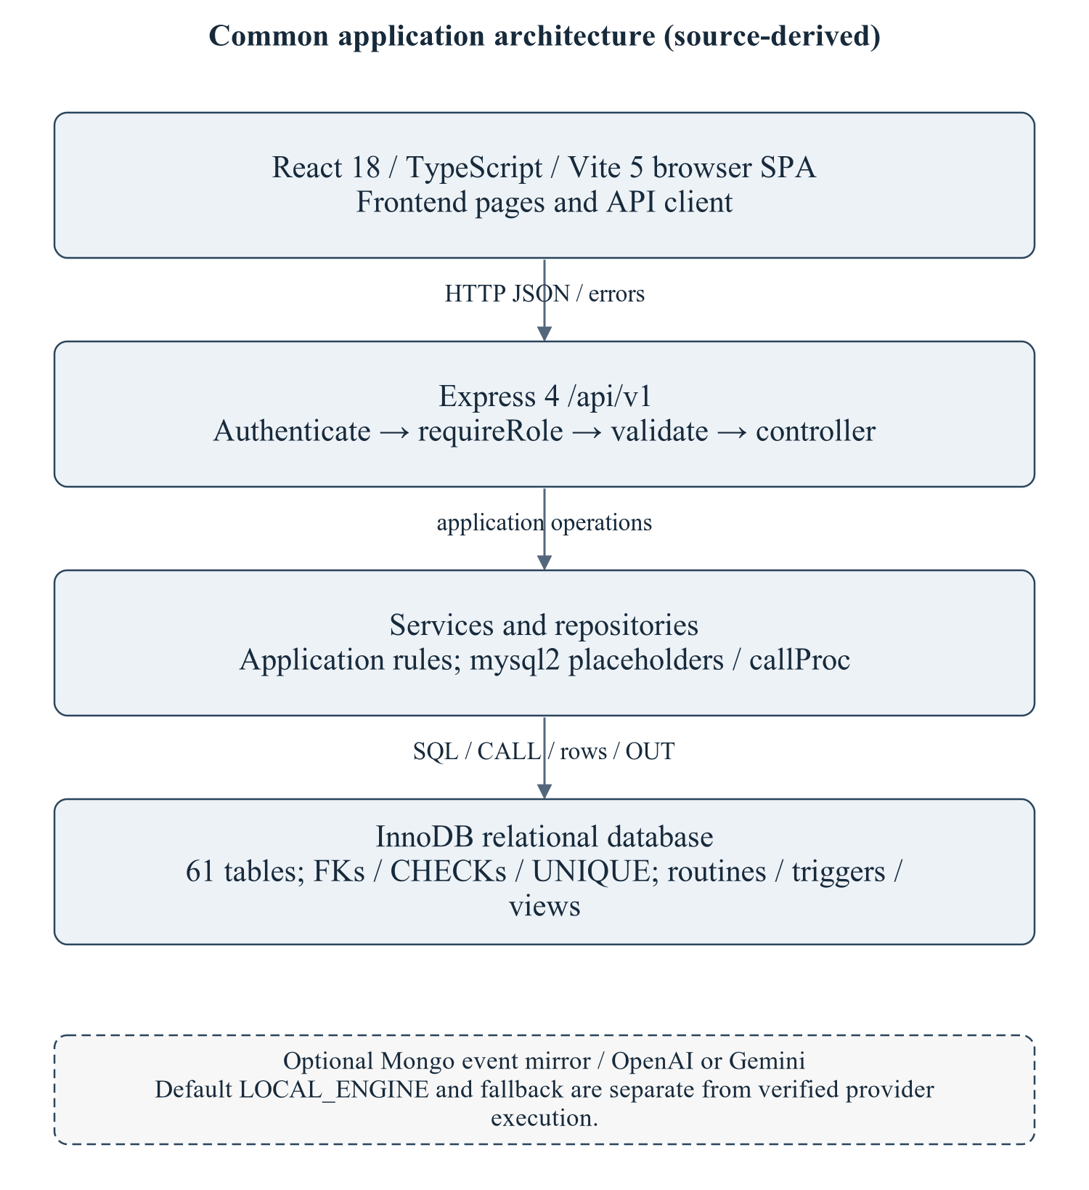
Figure 1.1 Common application architecture
React/Vite pages call relative JSON APIs. Express middleware/controllers dispatch services/repositories, which issue SQL/CALL through mysql2 to InnoDB. Optional integrations are dashed and unverified; a build does not prove these paths executed.
Editable drawing source: diagrams/01_common_architecture.svg, .dot and .mmd. Edit SVG text/shapes in a vector editor, or regenerate from DOT/Mermaid; retain FK IDs and source names. These figures were created from static source, not captured from a running ERP.

1.2 Overall Enterprise ER Diagram
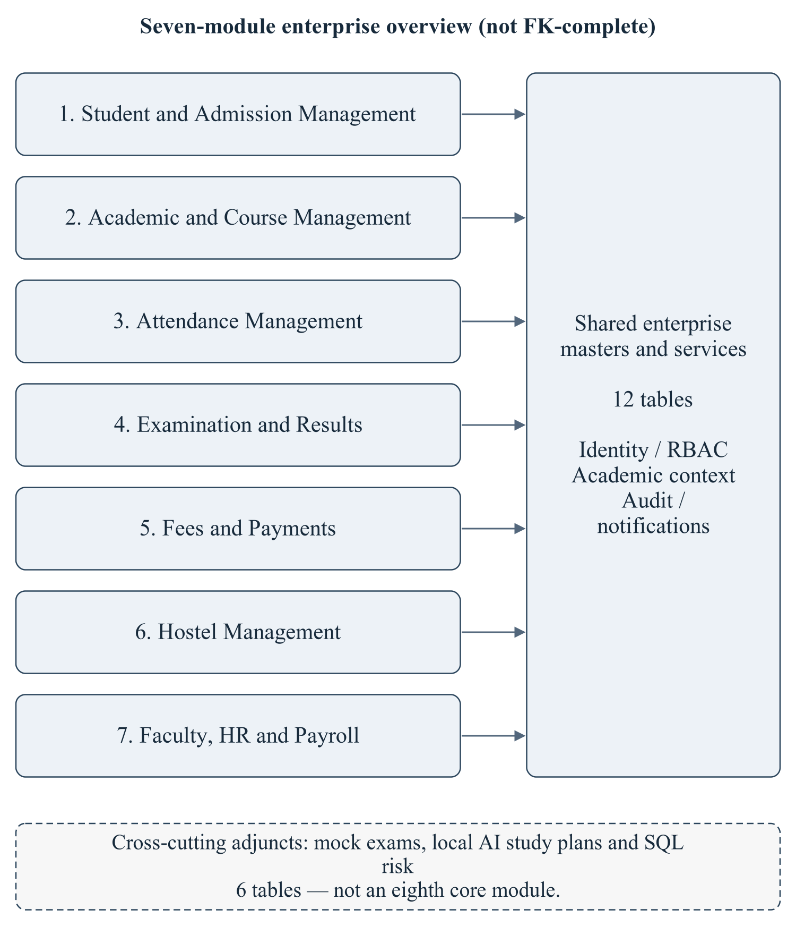
Figure 1.2 Enterprise module and shared-data overview
This overview establishes seven module boundaries and shared/adjunct ownership. It is not an FK-complete drawing; the following readable relational ER sheets collectively contain all 61 tables and all 138 declared FKs exactly once as outgoing child relationships.
Editable drawing source: diagrams/02_enterprise_overview.svg, .dot and .mmd. Edit SVG text/shapes in a vector editor, or regenerate from DOT/Mermaid; retain FK IDs and source names. These figures were created from static source, not captured from a running ERP.
ER convention: each solid child card names the actual relation and PK. Dashed parent cards name existing target relations/keys, even when owned by the same module elsewhere. Arrows point child FK → parent key. [P; C] records parent rows per child (1 or 0..1 from nullability) and children per parent (0..N or 0..1 from declared uniqueness). FK IDs join to the inventory workbook. No minimum-one child is inferred from an FK. Optional uniqueness on NULL-bearing tuples is not overclaimed.
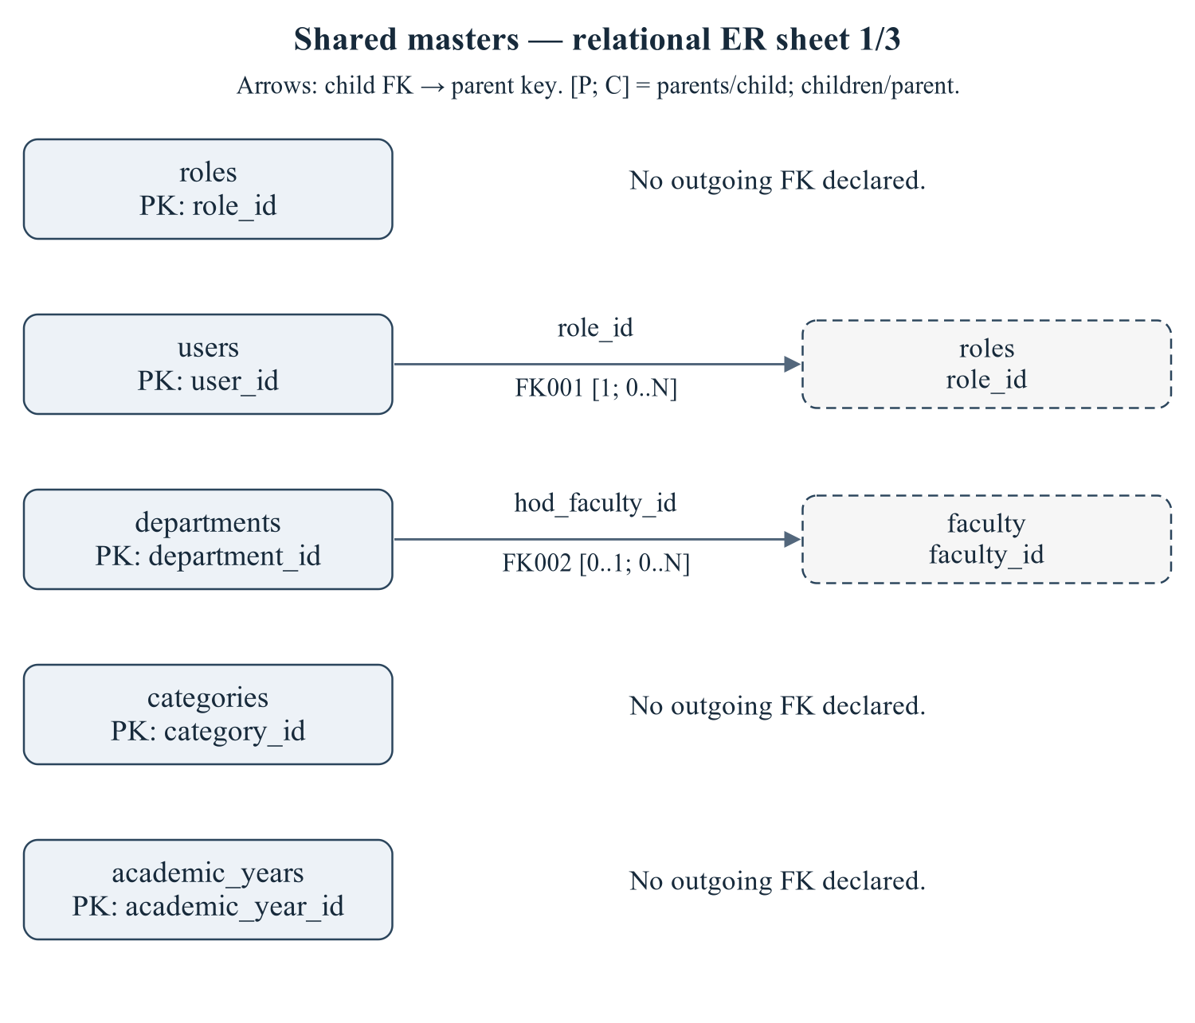
Figure 1.3 Shared masters — relational ER sheet 1/3
Child relations: roles, users, departments, categories, academic_years. Declared relationship IDs: FK001, FK002. Every relationship is sourced from 01/02 schema or the eight deferred FKs in 03_constraints.sql; trigger-only consistency rules are not drawn as invented FKs.
Editable drawing source: diagrams/03_er_panel_00_part_01.svg, .dot and .mmd. Edit SVG text/shapes in a vector editor, or regenerate from DOT/Mermaid; retain FK IDs and source names. These figures were created from static source, not captured from a running ERP.
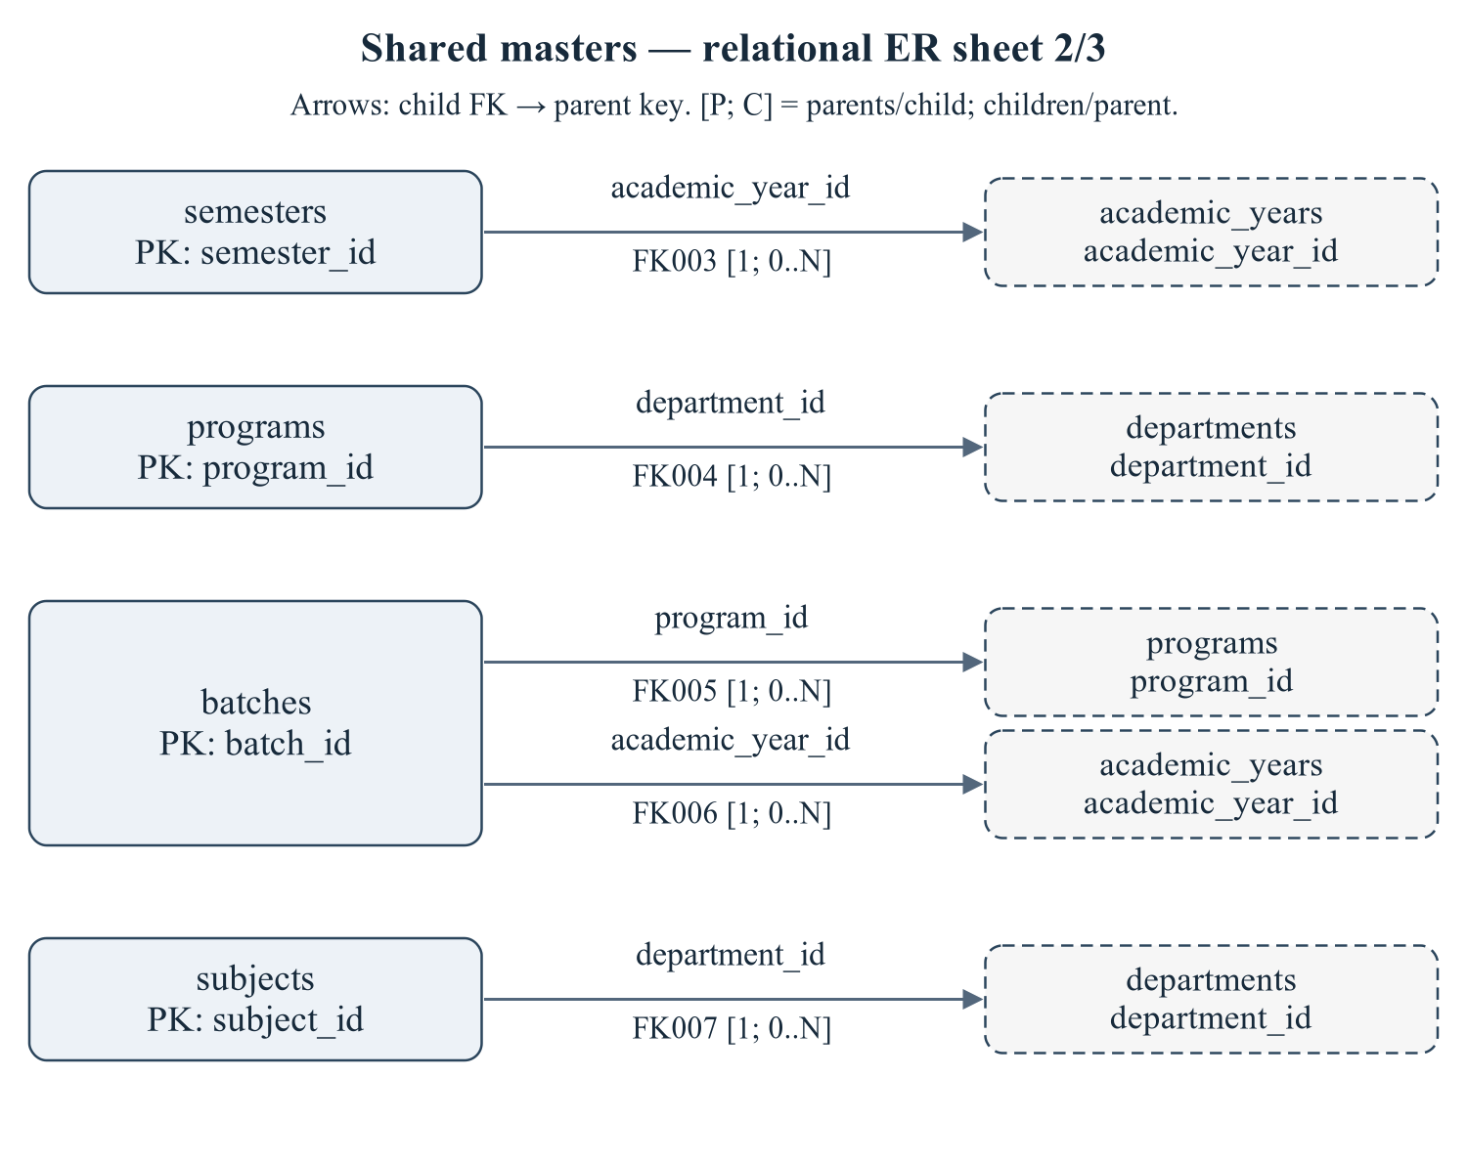
Figure 1.4 Shared masters — relational ER sheet 2/3
Child relations: semesters, programs, batches, subjects. Declared relationship IDs: FK003, FK004, FK005, FK006, FK007. Every relationship is sourced from 01/02 schema or the eight deferred FKs in 03_constraints.sql; trigger-only consistency rules are not drawn as invented FKs.
Editable drawing source: diagrams/03_er_panel_00_part_02.svg, .dot and .mmd. Edit SVG text/shapes in a vector editor, or regenerate from DOT/Mermaid; retain FK IDs and source names. These figures were created from static source, not captured from a running ERP.
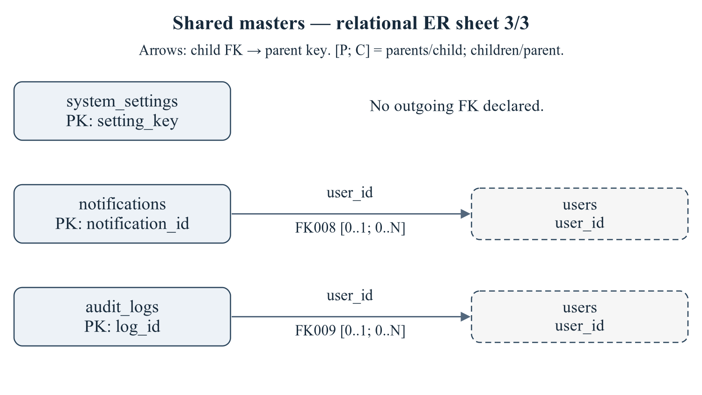
Figure 1.5 Shared masters — relational ER sheet 3/3
Child relations: system_settings, notifications, audit_logs. Declared relationship IDs: FK008, FK009. Every relationship is sourced from 01/02 schema or the eight deferred FKs in 03_constraints.sql; trigger-only consistency rules are not drawn as invented FKs.
Editable drawing source: diagrams/03_er_panel_00_part_03.svg, .dot and .mmd. Edit SVG text/shapes in a vector editor, or regenerate from DOT/Mermaid; retain FK IDs and source names. These figures were created from static source, not captured from a running ERP.
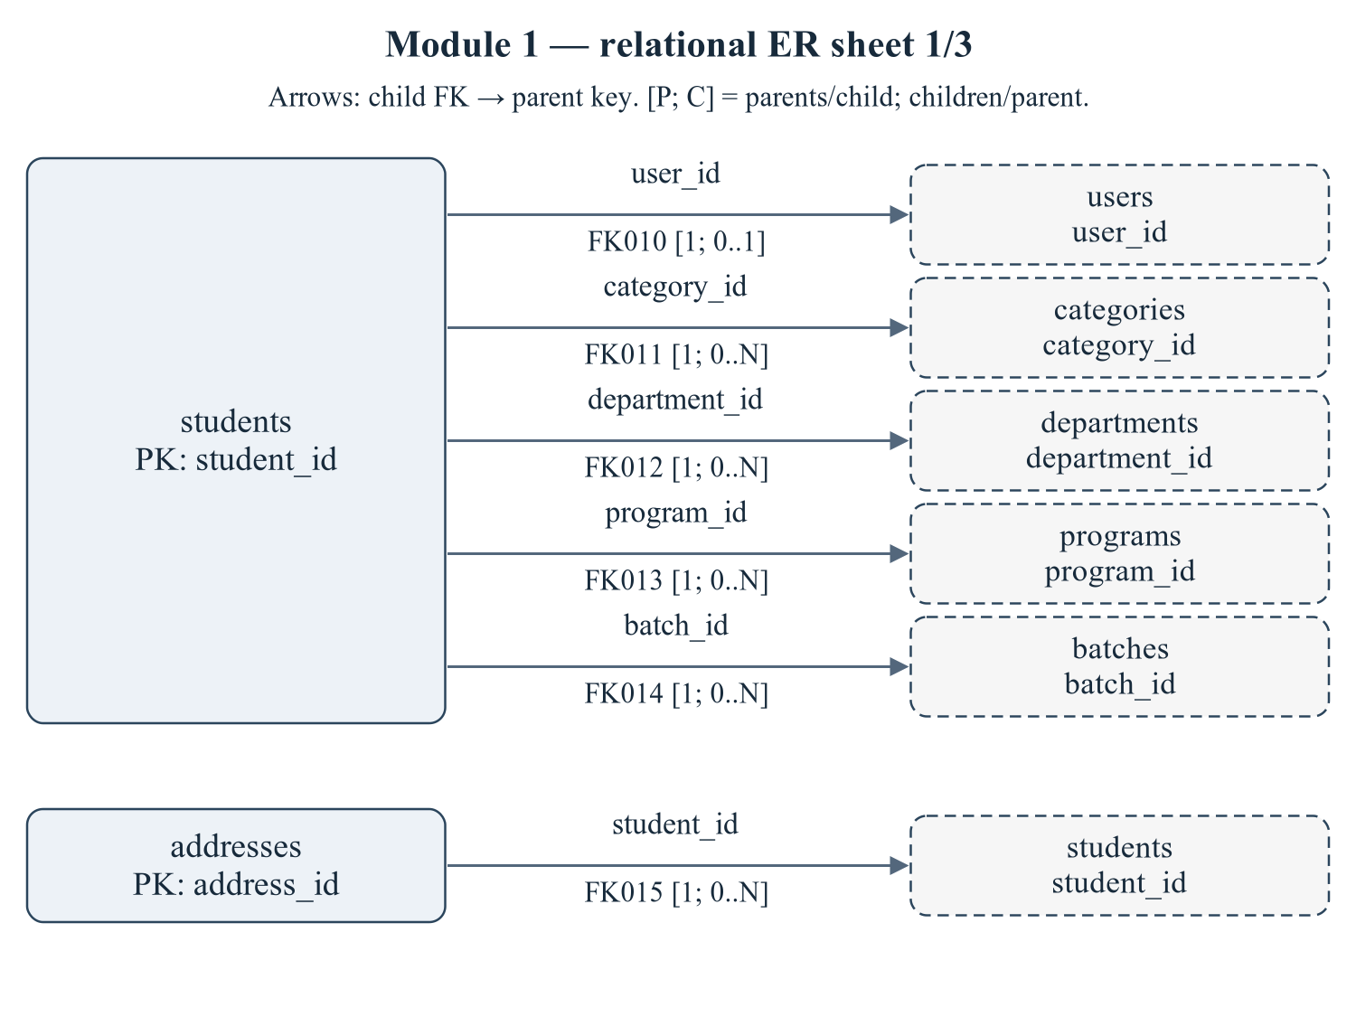
Figure 1.6 Module 1 — relational ER sheet 1/3
Child relations: students, addresses. Declared relationship IDs: FK010, FK011, FK012, FK013, FK014, FK015. Every relationship is sourced from 01/02 schema or the eight deferred FKs in 03_constraints.sql; trigger-only consistency rules are not drawn as invented FKs.
Editable drawing source: diagrams/03_er_panel_01_part_01.svg, .dot and .mmd. Edit SVG text/shapes in a vector editor, or regenerate from DOT/Mermaid; retain FK IDs and source names. These figures were created from static source, not captured from a running ERP.
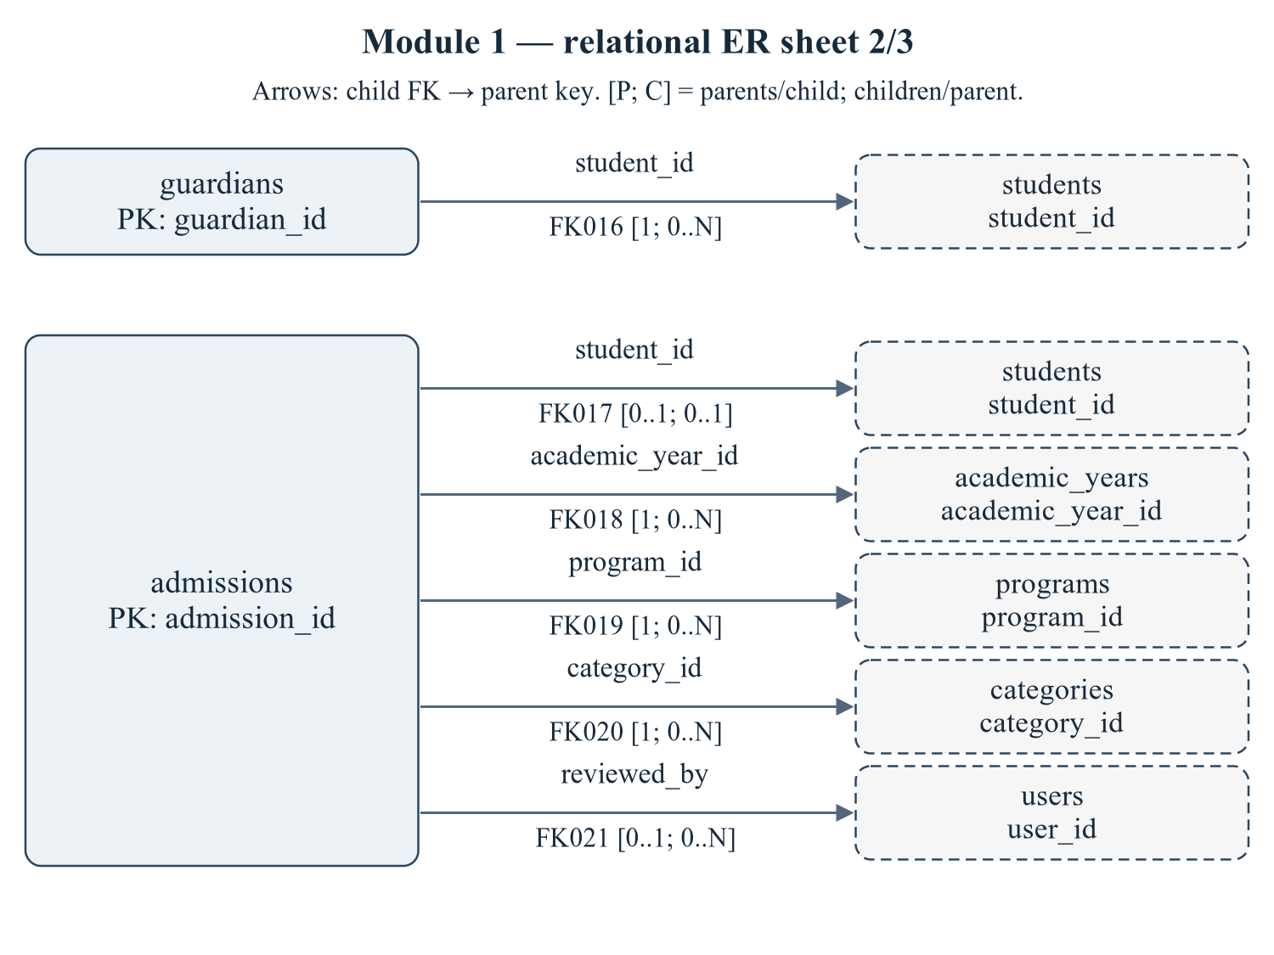
Figure 1.7 Module 1 — relational ER sheet 2/3
Child relations: guardians, admissions. Declared relationship IDs: FK016, FK017, FK018, FK019, FK020, FK021. Every relationship is sourced from 01/02 schema or the eight deferred FKs in 03_constraints.sql; trigger-only consistency rules are not drawn as invented FKs.
Editable drawing source: diagrams/03_er_panel_01_part_02.svg, .dot and .mmd. Edit SVG text/shapes in a vector editor, or regenerate from DOT/Mermaid; retain FK IDs and source names. These figures were created from static source, not captured from a running ERP.
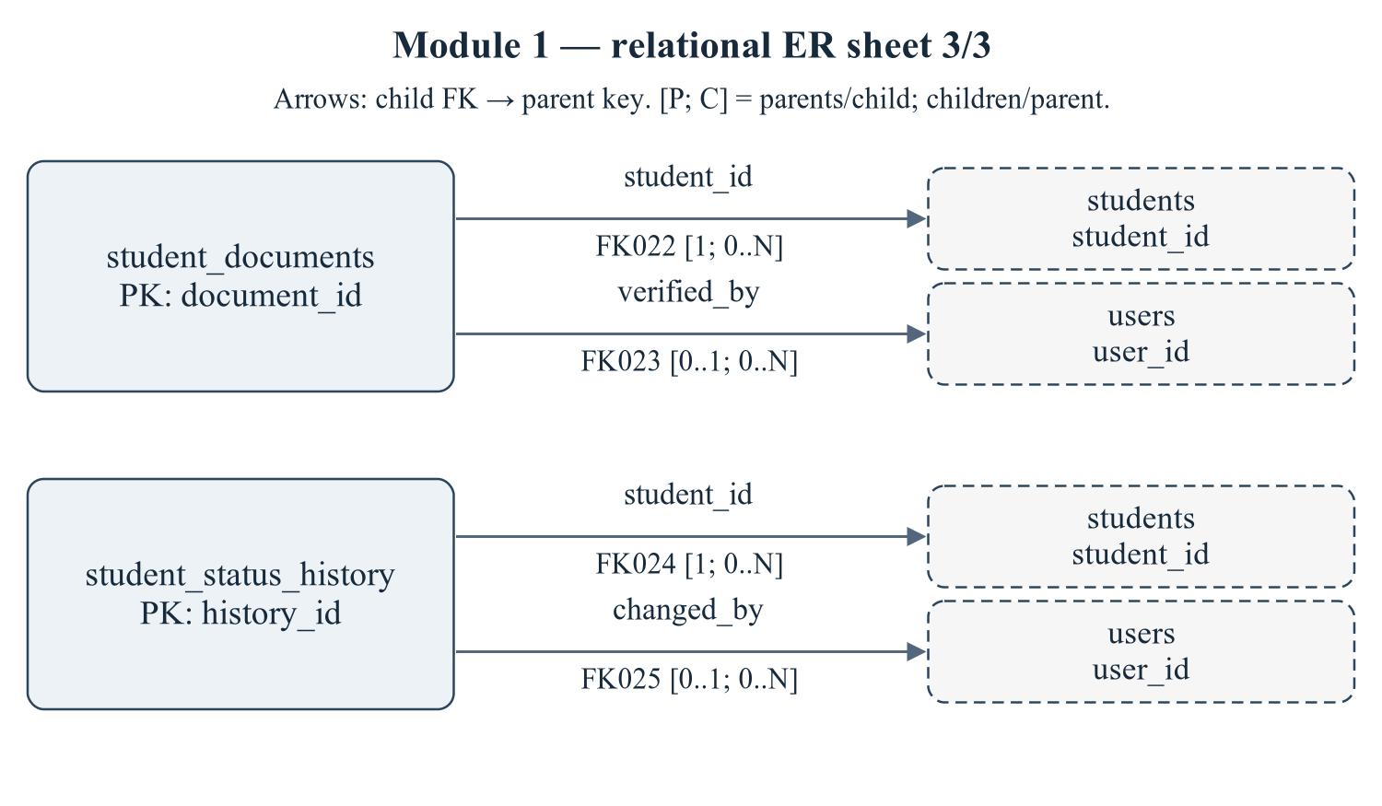
Figure 1.8 Module 1 — relational ER sheet 3/3
Child relations: student_documents, student_status_history. Declared relationship IDs: FK022, FK023, FK024, FK025. Every relationship is sourced from 01/02 schema or the eight deferred FKs in 03_constraints.sql; trigger-only consistency rules are not drawn as invented FKs.
Editable drawing source: diagrams/03_er_panel_01_part_03.svg, .dot and .mmd. Edit SVG text/shapes in a vector editor, or regenerate from DOT/Mermaid; retain FK IDs and source names. These figures were created from static source, not captured from a running ERP.
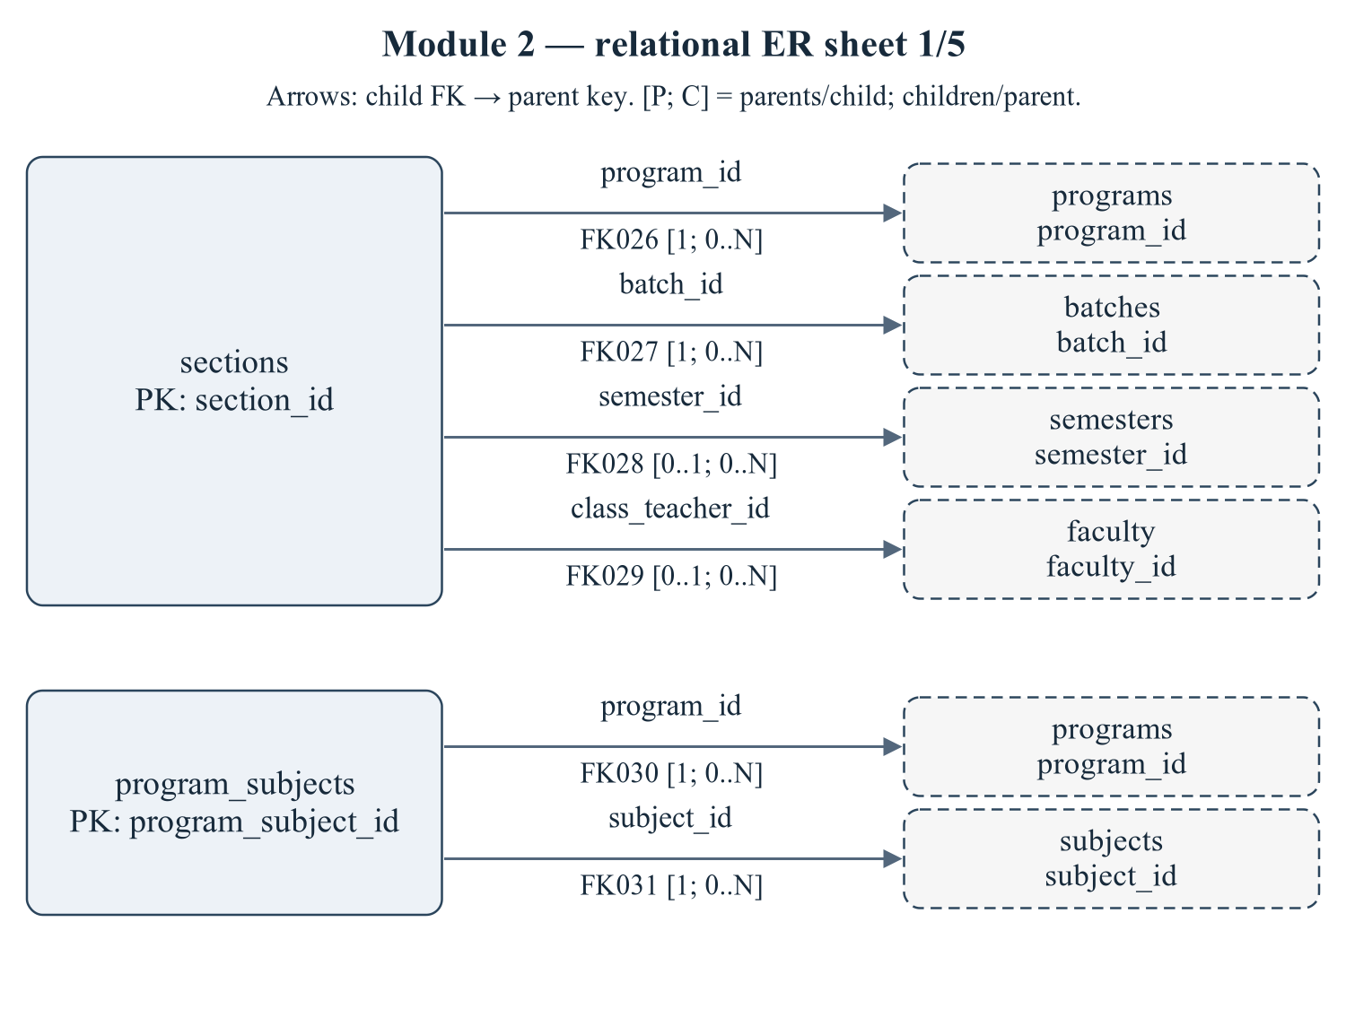
Figure 1.9 Module 2 — relational ER sheet 1/5
Child relations: sections, program_subjects. Declared relationship IDs: FK026, FK027, FK028, FK029, FK030, FK031. Every relationship is sourced from 01/02 schema or the eight deferred FKs in 03_constraints.sql; trigger-only consistency rules are not drawn as invented FKs.
Editable drawing source: diagrams/03_er_panel_02_part_01.svg, .dot and .mmd. Edit SVG text/shapes in a vector editor, or regenerate from DOT/Mermaid; retain FK IDs and source names. These figures were created from static source, not captured from a running ERP.
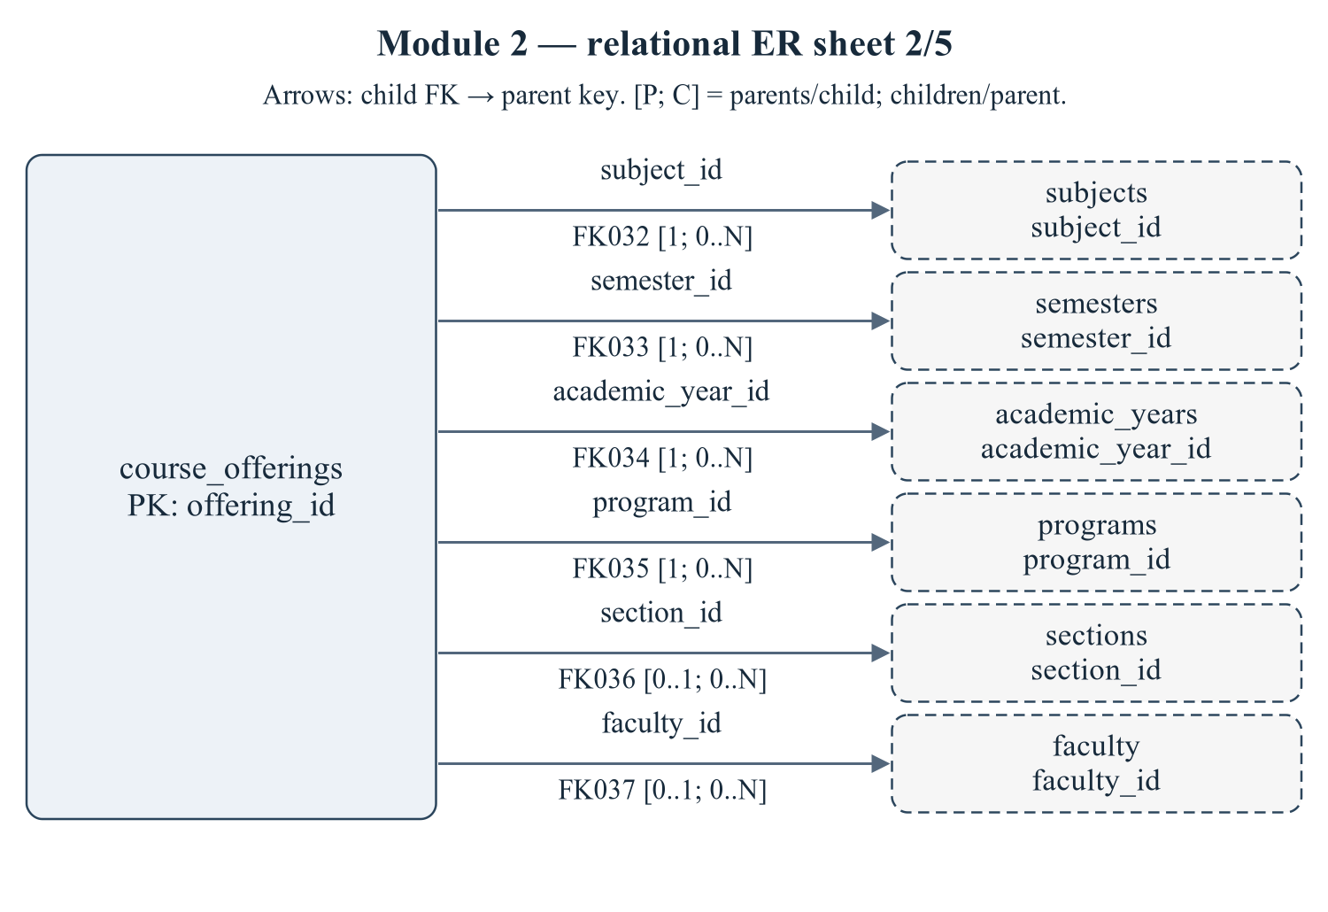
Figure 1.10 Module 2 — relational ER sheet 2/5
Child relations: course_offerings. Declared relationship IDs: FK032, FK033, FK034, FK035, FK036, FK037. Every relationship is sourced from 01/02 schema or the eight deferred FKs in 03_constraints.sql; trigger-only consistency rules are not drawn as invented FKs.
Editable drawing source: diagrams/03_er_panel_02_part_02.svg, .dot and .mmd. Edit SVG text/shapes in a vector editor, or regenerate from DOT/Mermaid; retain FK IDs and source names. These figures were created from static source, not captured from a running ERP.
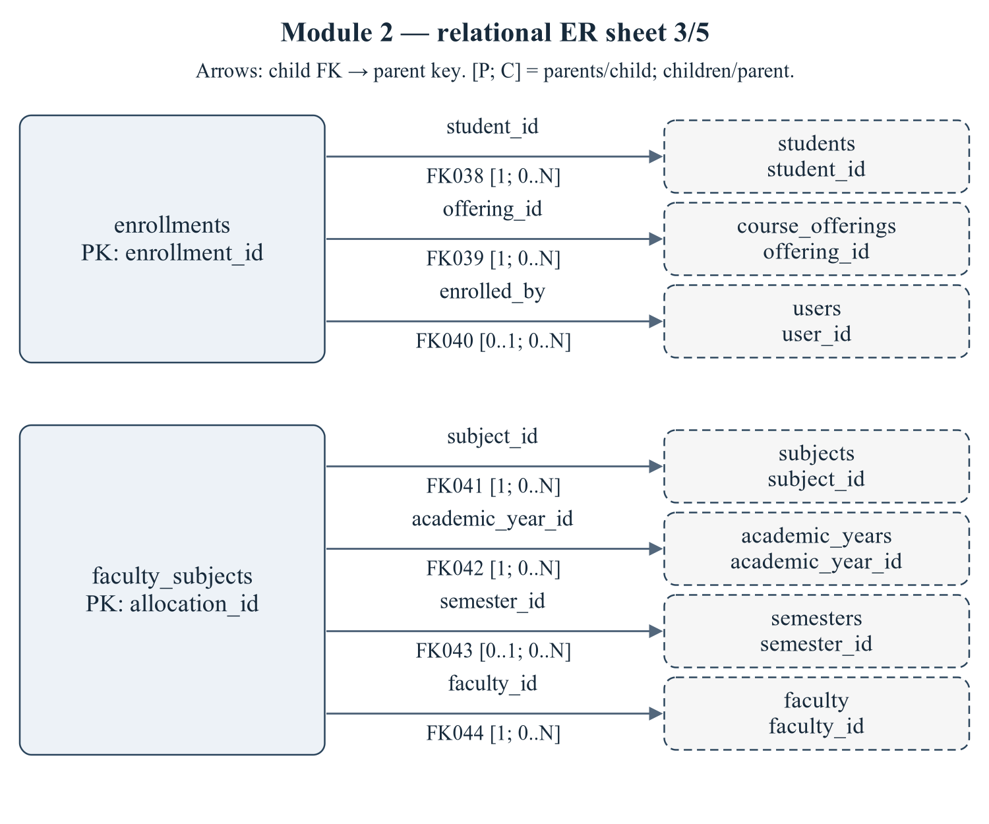
Figure 1.11 Module 2 — relational ER sheet 3/5
Child relations: enrollments, faculty_subjects. Declared relationship IDs: FK038, FK039, FK040, FK041, FK042, FK043, FK044. Every relationship is sourced from 01/02 schema or the eight deferred FKs in 03_constraints.sql; trigger-only consistency rules are not drawn as invented FKs.
Editable drawing source: diagrams/03_er_panel_02_part_03.svg, .dot and .mmd. Edit SVG text/shapes in a vector editor, or regenerate from DOT/Mermaid; retain FK IDs and source names. These figures were created from static source, not captured from a running ERP.
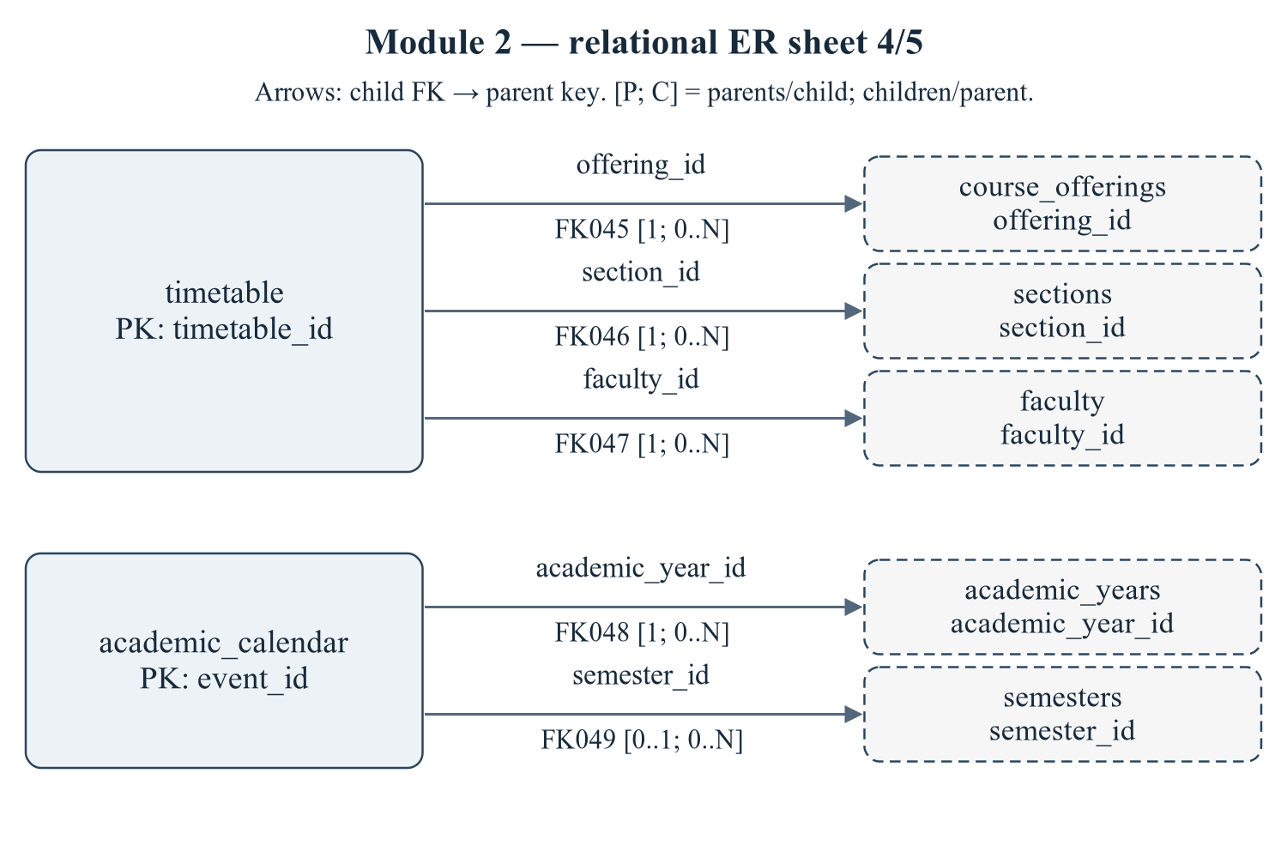
Figure 1.12 Module 2 — relational ER sheet 4/5
Child relations: timetable, academic_calendar. Declared relationship IDs: FK045, FK046, FK047, FK048, FK049. Every relationship is sourced from 01/02 schema or the eight deferred FKs in 03_constraints.sql; trigger-only consistency rules are not drawn as invented FKs.
Editable drawing source: diagrams/03_er_panel_02_part_04.svg, .dot and .mmd. Edit SVG text/shapes in a vector editor, or regenerate from DOT/Mermaid; retain FK IDs and source names. These figures were created from static source, not captured from a running ERP.
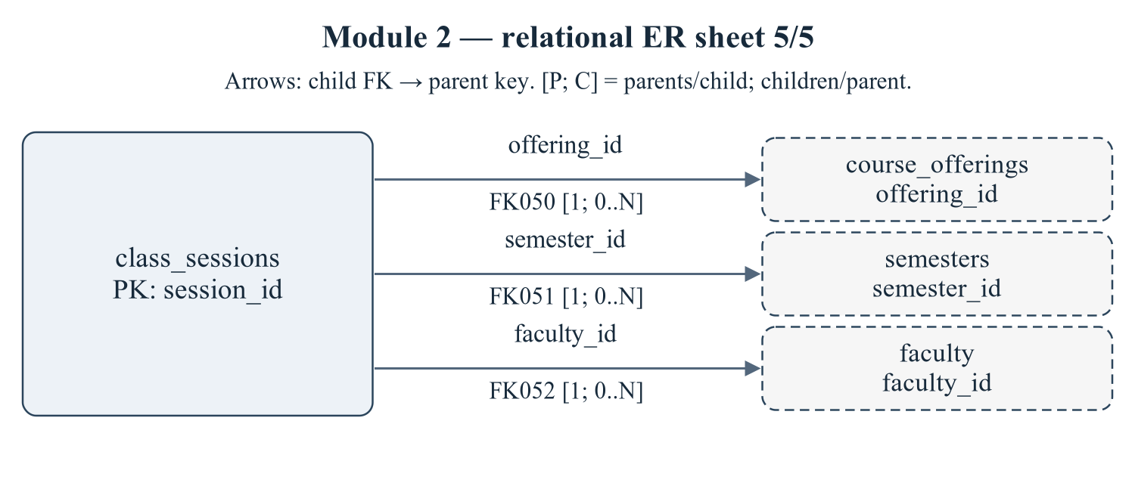
Figure 1.13 Module 2 — relational ER sheet 5/5
Child relations: class_sessions. Declared relationship IDs: FK050, FK051, FK052. Every relationship is sourced from 01/02 schema or the eight deferred FKs in 03_constraints.sql; trigger-only consistency rules are not drawn as invented FKs.
Editable drawing source: diagrams/03_er_panel_02_part_05.svg, .dot and .mmd. Edit SVG text/shapes in a vector editor, or regenerate from DOT/Mermaid; retain FK IDs and source names. These figures were created from static source, not captured from a running ERP.
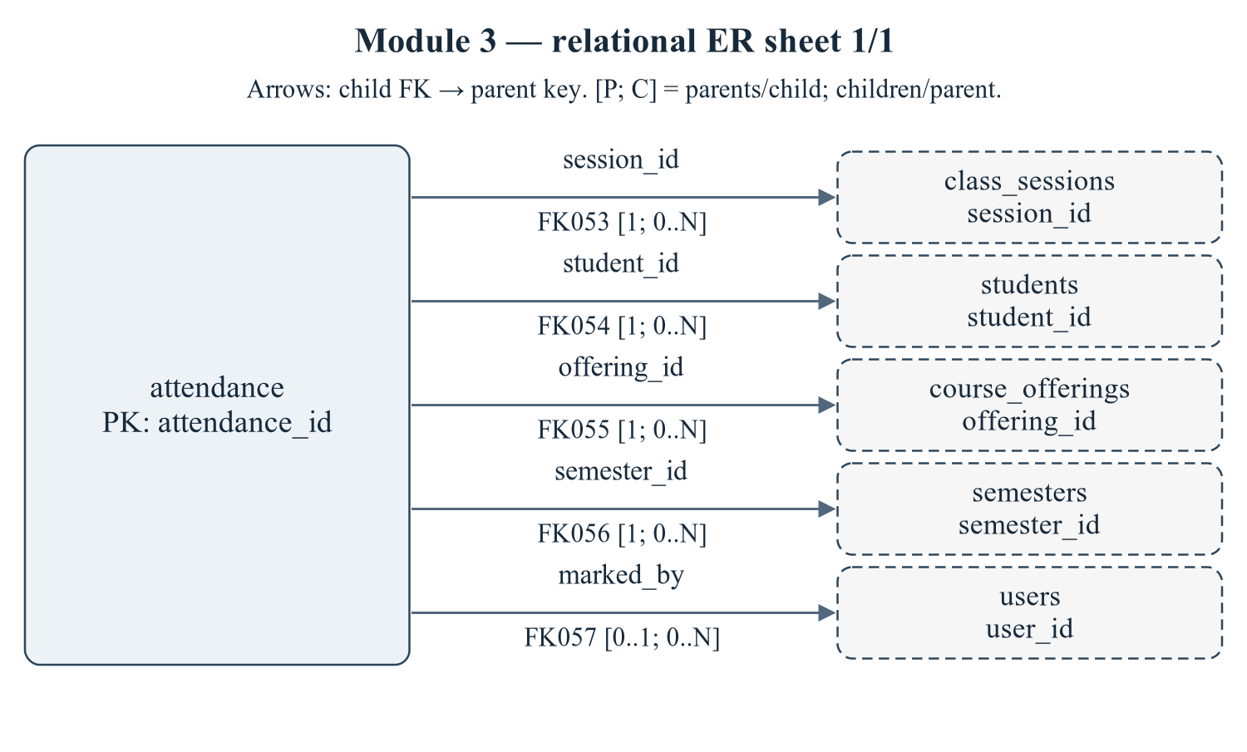
Figure 1.14 Module 3 — relational ER sheet 1/1
Child relations: attendance. Declared relationship IDs: FK053, FK054, FK055, FK056, FK057. Every relationship is sourced from 01/02 schema or the eight deferred FKs in 03_constraints.sql; trigger-only consistency rules are not drawn as invented FKs.
Editable drawing source: diagrams/03_er_panel_03_part_01.svg, .dot and .mmd. Edit SVG text/shapes in a vector editor, or regenerate from DOT/Mermaid; retain FK IDs and source names. These figures were created from static source, not captured from a running ERP.
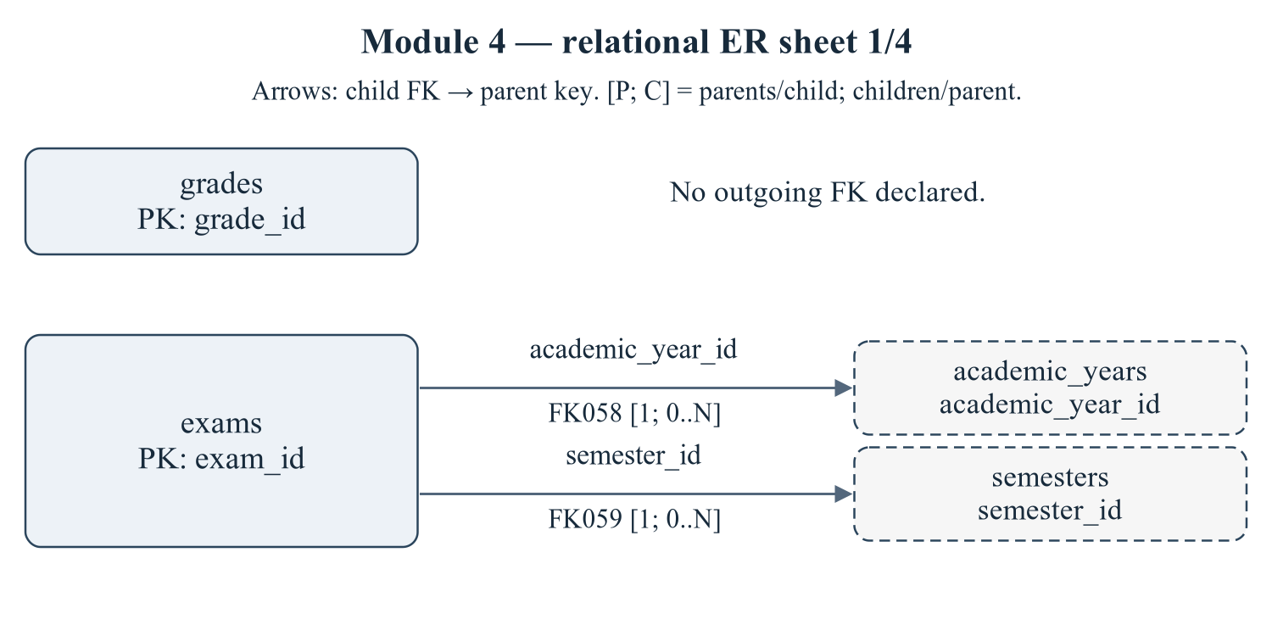
Figure 1.15 Module 4 — relational ER sheet 1/4
Child relations: grades, exams. Declared relationship IDs: FK058, FK059. Every relationship is sourced from 01/02 schema or the eight deferred FKs in 03_constraints.sql; trigger-only consistency rules are not drawn as invented FKs.
Editable drawing source: diagrams/03_er_panel_04_part_01.svg, .dot and .mmd. Edit SVG text/shapes in a vector editor, or regenerate from DOT/Mermaid; retain FK IDs and source names. These figures were created from static source, not captured from a running ERP.
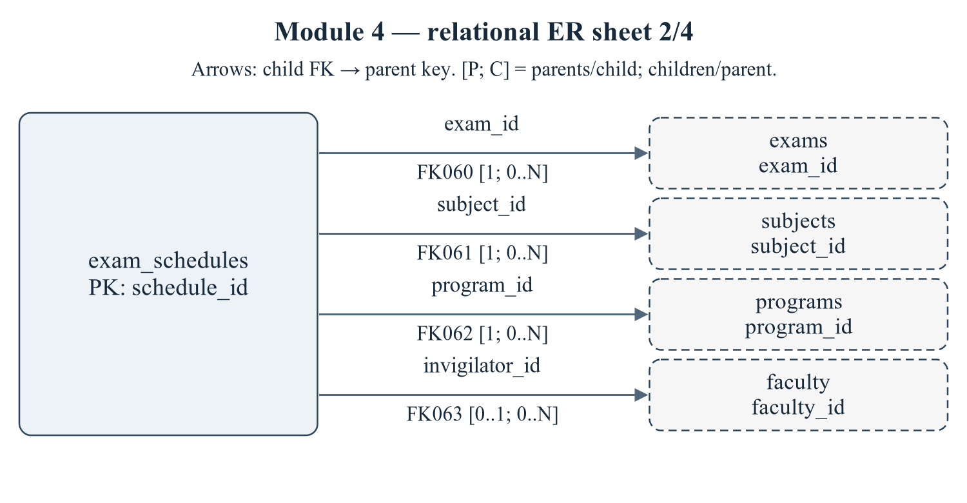
Figure 1.16 Module 4 — relational ER sheet 2/4
Child relations: exam_schedules. Declared relationship IDs: FK060, FK061, FK062, FK063. Every relationship is sourced from 01/02 schema or the eight deferred FKs in 03_constraints.sql; trigger-only consistency rules are not drawn as invented FKs.
Editable drawing source: diagrams/03_er_panel_04_part_02.svg, .dot and .mmd. Edit SVG text/shapes in a vector editor, or regenerate from DOT/Mermaid; retain FK IDs and source names. These figures were created from static source, not captured from a running ERP.
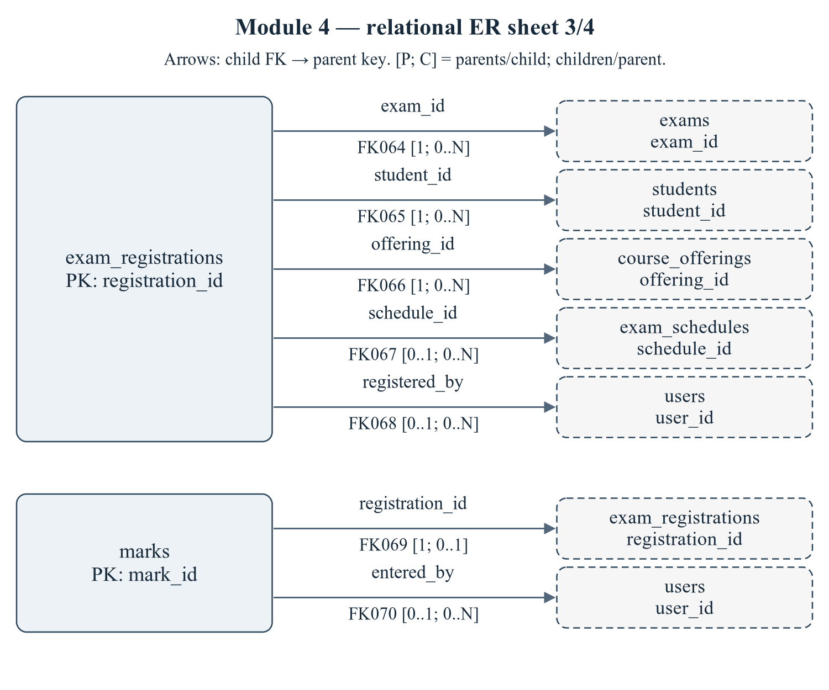
Figure 1.17 Module 4 — relational ER sheet 3/4
Child relations: exam_registrations, marks. Declared relationship IDs: FK064, FK065, FK066, FK067, FK068, FK069, FK070. Every relationship is sourced from 01/02 schema or the eight deferred FKs in 03_constraints.sql; trigger-only consistency rules are not drawn as invented FKs.
Editable drawing source: diagrams/03_er_panel_04_part_03.svg, .dot and .mmd. Edit SVG text/shapes in a vector editor, or regenerate from DOT/Mermaid; retain FK IDs and source names. These figures were created from static source, not captured from a running ERP.
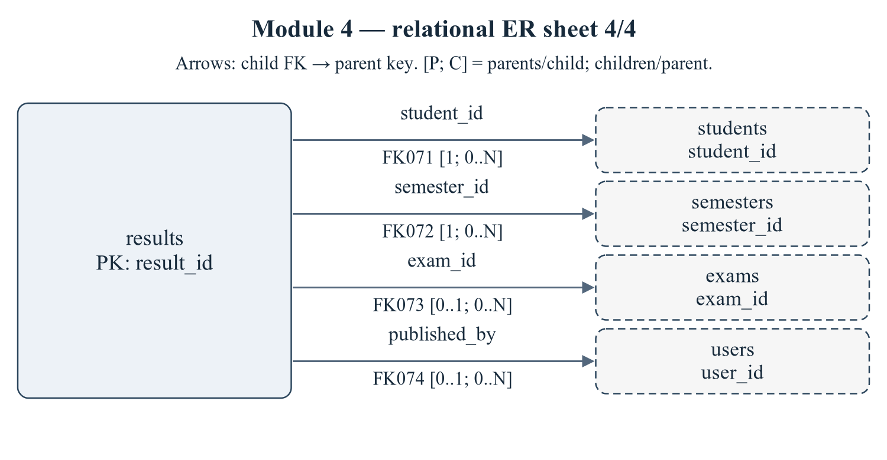
Figure 1.18 Module 4 — relational ER sheet 4/4
Child relations: results. Declared relationship IDs: FK071, FK072, FK073, FK074. Every relationship is sourced from 01/02 schema or the eight deferred FKs in 03_constraints.sql; trigger-only consistency rules are not drawn as invented FKs.
Editable drawing source: diagrams/03_er_panel_04_part_04.svg, .dot and .mmd. Edit SVG text/shapes in a vector editor, or regenerate from DOT/Mermaid; retain FK IDs and source names. These figures were created from static source, not captured from a running ERP.
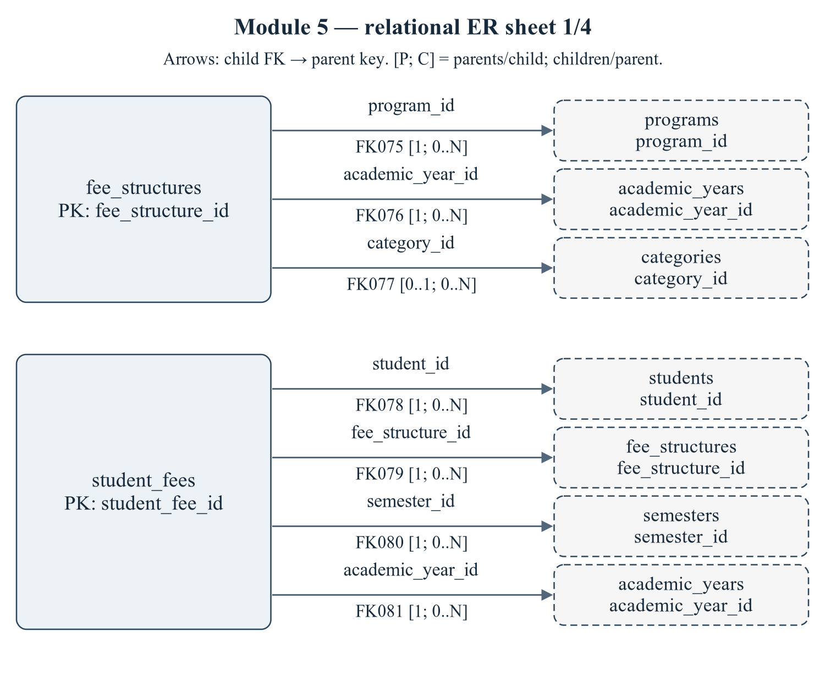
Figure 1.19 Module 5 — relational ER sheet 1/4
Child relations: fee_structures, student_fees. Declared relationship IDs: FK075, FK076, FK077, FK078, FK079, FK080, FK081. Every relationship is sourced from 01/02 schema or the eight deferred FKs in 03_constraints.sql; trigger-only consistency rules are not drawn as invented FKs.
Editable drawing source: diagrams/03_er_panel_05_part_01.svg, .dot and .mmd. Edit SVG text/shapes in a vector editor, or regenerate from DOT/Mermaid; retain FK IDs and source names. These figures were created from static source, not captured from a running ERP.
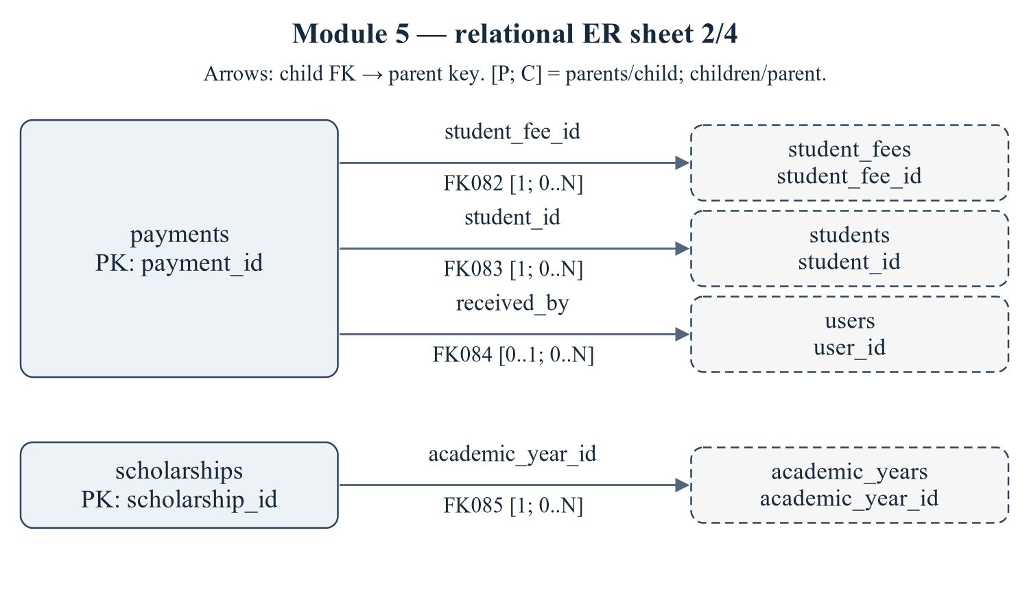
Figure 1.20 Module 5 — relational ER sheet 2/4
Child relations: payments, scholarships. Declared relationship IDs: FK082, FK083, FK084, FK085. Every relationship is sourced from 01/02 schema or the eight deferred FKs in 03_constraints.sql; trigger-only consistency rules are not drawn as invented FKs.
Editable drawing source: diagrams/03_er_panel_05_part_02.svg, .dot and .mmd. Edit SVG text/shapes in a vector editor, or regenerate from DOT/Mermaid; retain FK IDs and source names. These figures were created from static source, not captured from a running ERP.
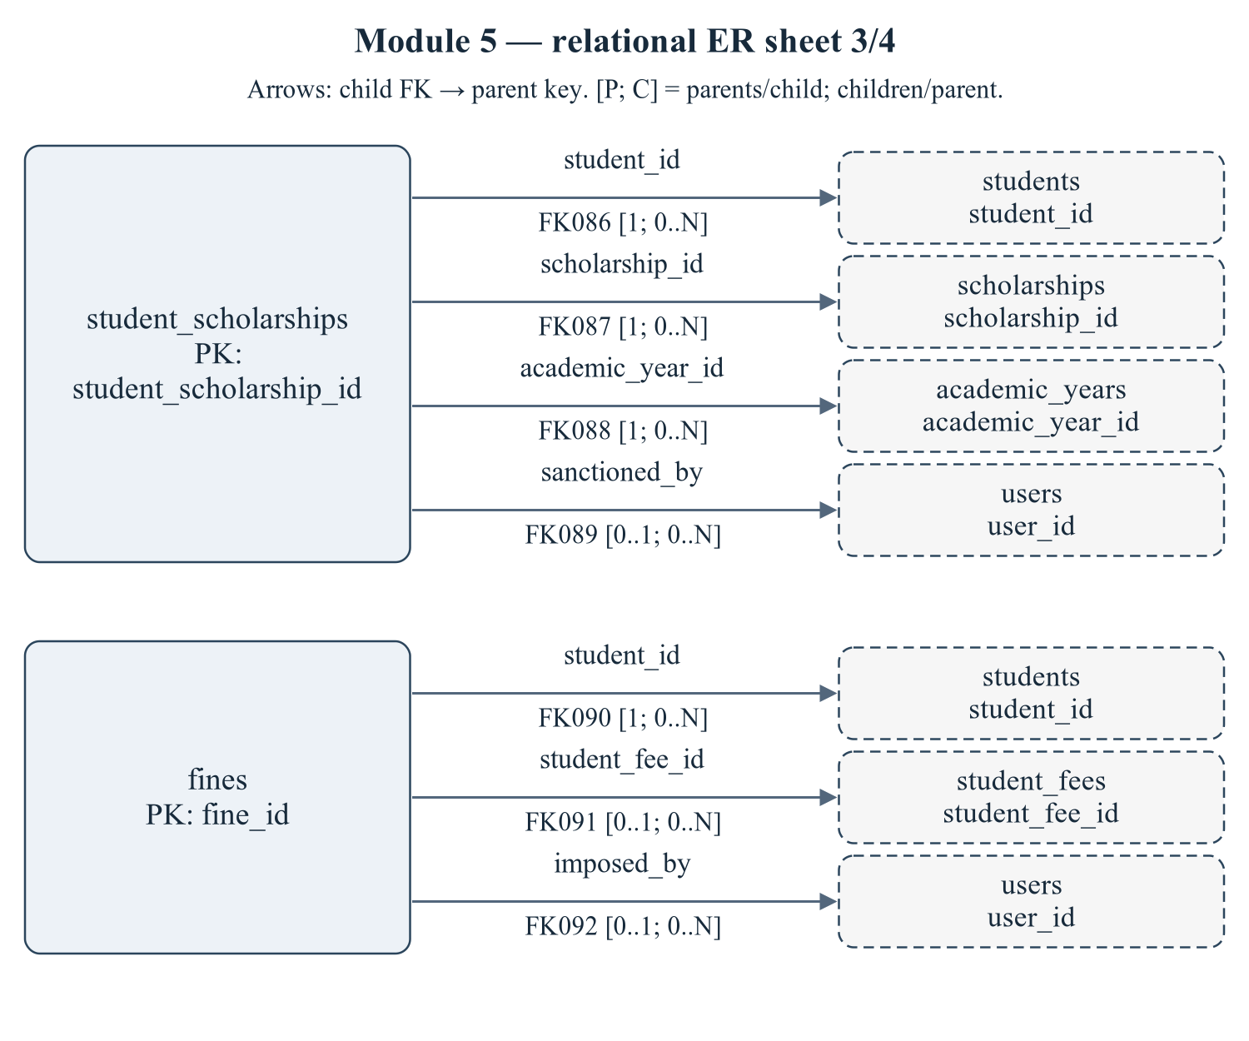
Figure 1.21 Module 5 — relational ER sheet 3/4
Child relations: student_scholarships, fines. Declared relationship IDs: FK086, FK087, FK088, FK089, FK090, FK091, FK092. Every relationship is sourced from 01/02 schema or the eight deferred FKs in 03_constraints.sql; trigger-only consistency rules are not drawn as invented FKs.
Editable drawing source: diagrams/03_er_panel_05_part_03.svg, .dot and .mmd. Edit SVG text/shapes in a vector editor, or regenerate from DOT/Mermaid; retain FK IDs and source names. These figures were created from static source, not captured from a running ERP.
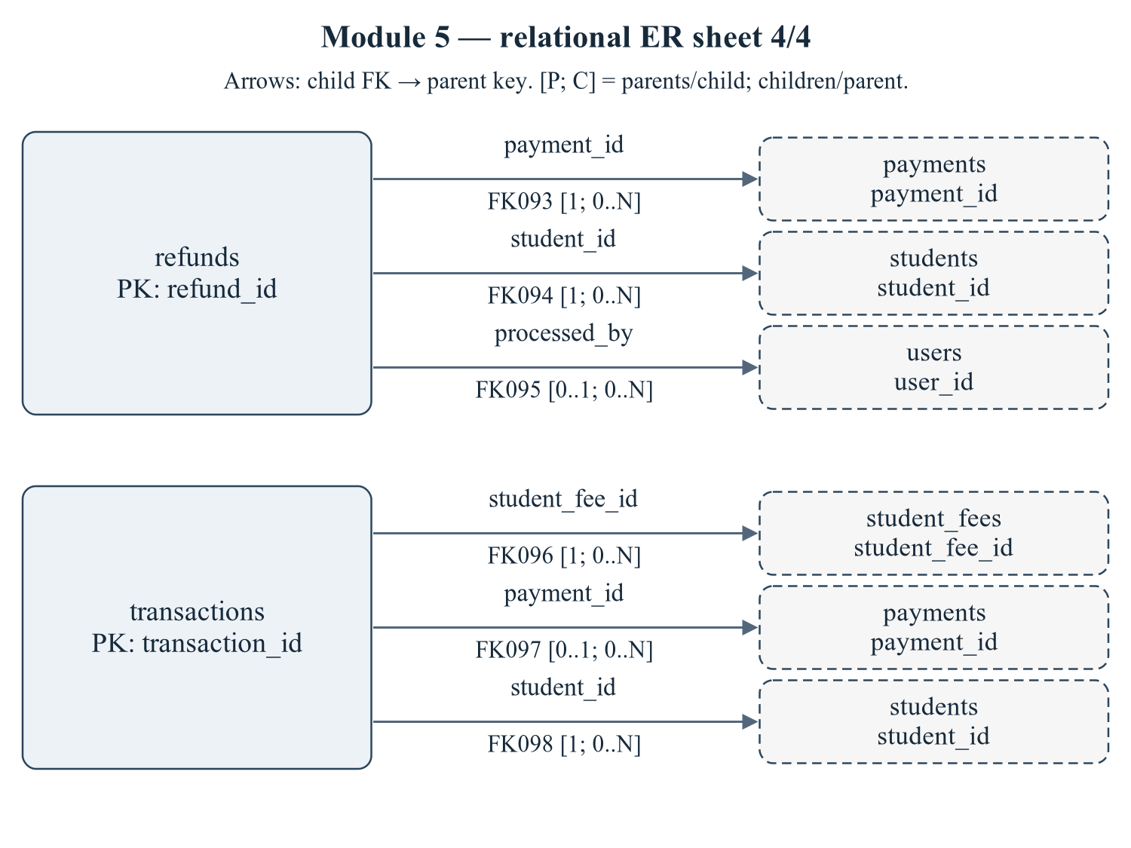
Figure 1.22 Module 5 — relational ER sheet 4/4
Child relations: refunds, transactions. Declared relationship IDs: FK093, FK094, FK095, FK096, FK097, FK098. Every relationship is sourced from 01/02 schema or the eight deferred FKs in 03_constraints.sql; trigger-only consistency rules are not drawn as invented FKs.
Editable drawing source: diagrams/03_er_panel_05_part_04.svg, .dot and .mmd. Edit SVG text/shapes in a vector editor, or regenerate from DOT/Mermaid; retain FK IDs and source names. These figures were created from static source, not captured from a running ERP.
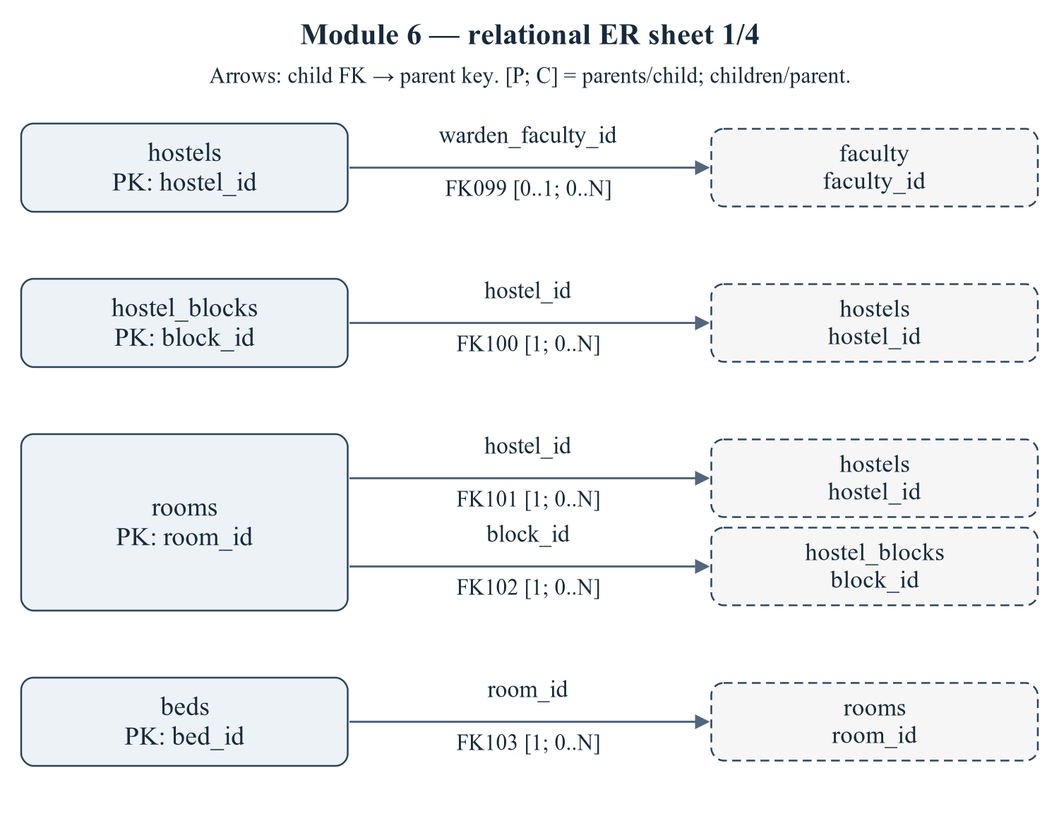
Figure 1.23 Module 6 — relational ER sheet 1/4
Child relations: hostels, hostel_blocks, rooms, beds. Declared relationship IDs: FK099, FK100, FK101, FK102, FK103. Every relationship is sourced from 01/02 schema or the eight deferred FKs in 03_constraints.sql; trigger-only consistency rules are not drawn as invented FKs.
Editable drawing source: diagrams/03_er_panel_06_part_01.svg, .dot and .mmd. Edit SVG text/shapes in a vector editor, or regenerate from DOT/Mermaid; retain FK IDs and source names. These figures were created from static source, not captured from a running ERP.
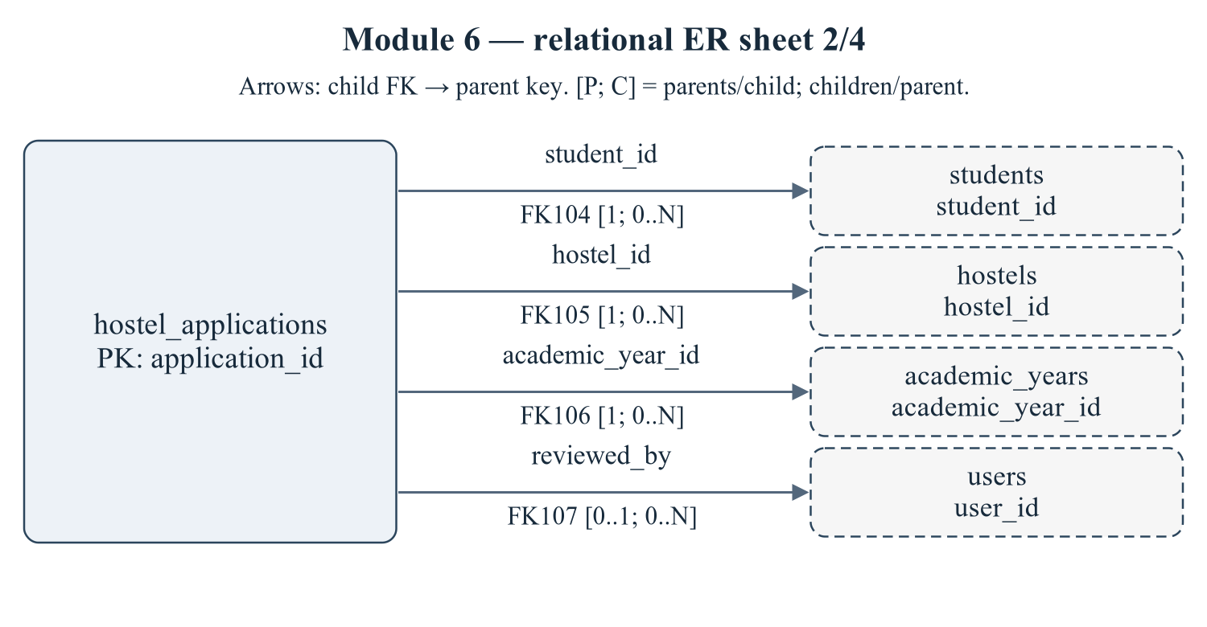
Figure 1.24 Module 6 — relational ER sheet 2/4
Child relations: hostel_applications. Declared relationship IDs: FK104, FK105, FK106, FK107. Every relationship is sourced from 01/02 schema or the eight deferred FKs in 03_constraints.sql; trigger-only consistency rules are not drawn as invented FKs.
Editable drawing source: diagrams/03_er_panel_06_part_02.svg, .dot and .mmd. Edit SVG text/shapes in a vector editor, or regenerate from DOT/Mermaid; retain FK IDs and source names. These figures were created from static source, not captured from a running ERP.
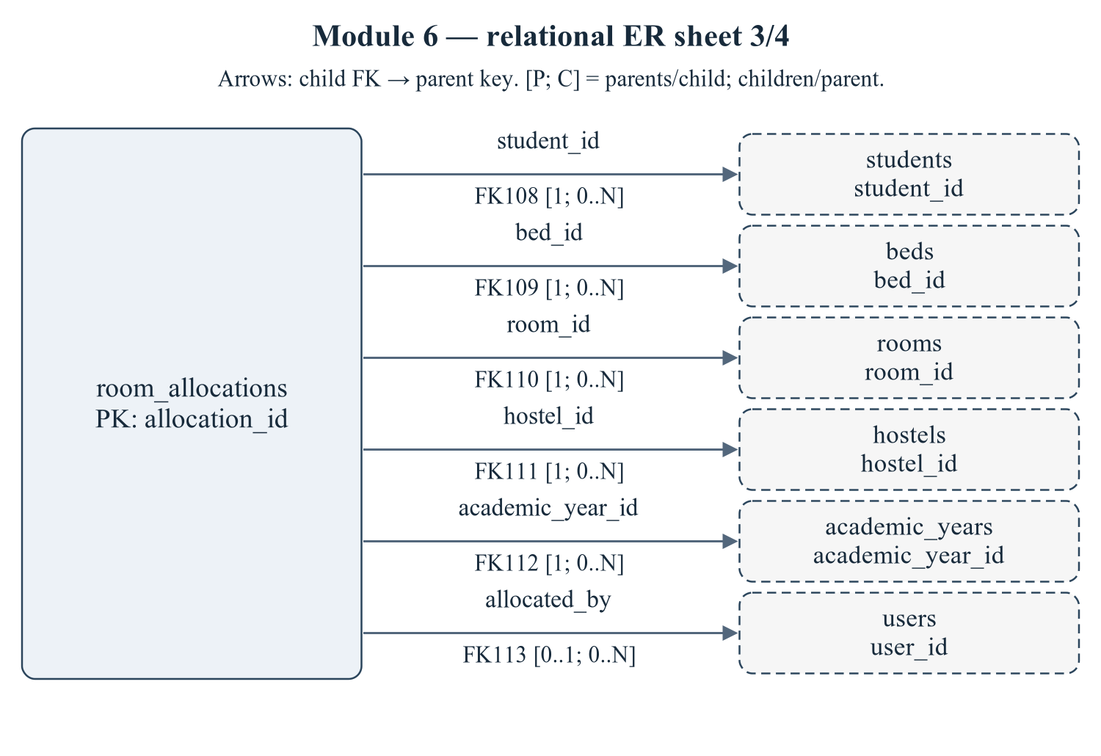
Figure 1.25 Module 6 — relational ER sheet 3/4
Child relations: room_allocations. Declared relationship IDs: FK108, FK109, FK110, FK111, FK112, FK113. Every relationship is sourced from 01/02 schema or the eight deferred FKs in 03_constraints.sql; trigger-only consistency rules are not drawn as invented FKs.
Editable drawing source: diagrams/03_er_panel_06_part_03.svg, .dot and .mmd. Edit SVG text/shapes in a vector editor, or regenerate from DOT/Mermaid; retain FK IDs and source names. These figures were created from static source, not captured from a running ERP.
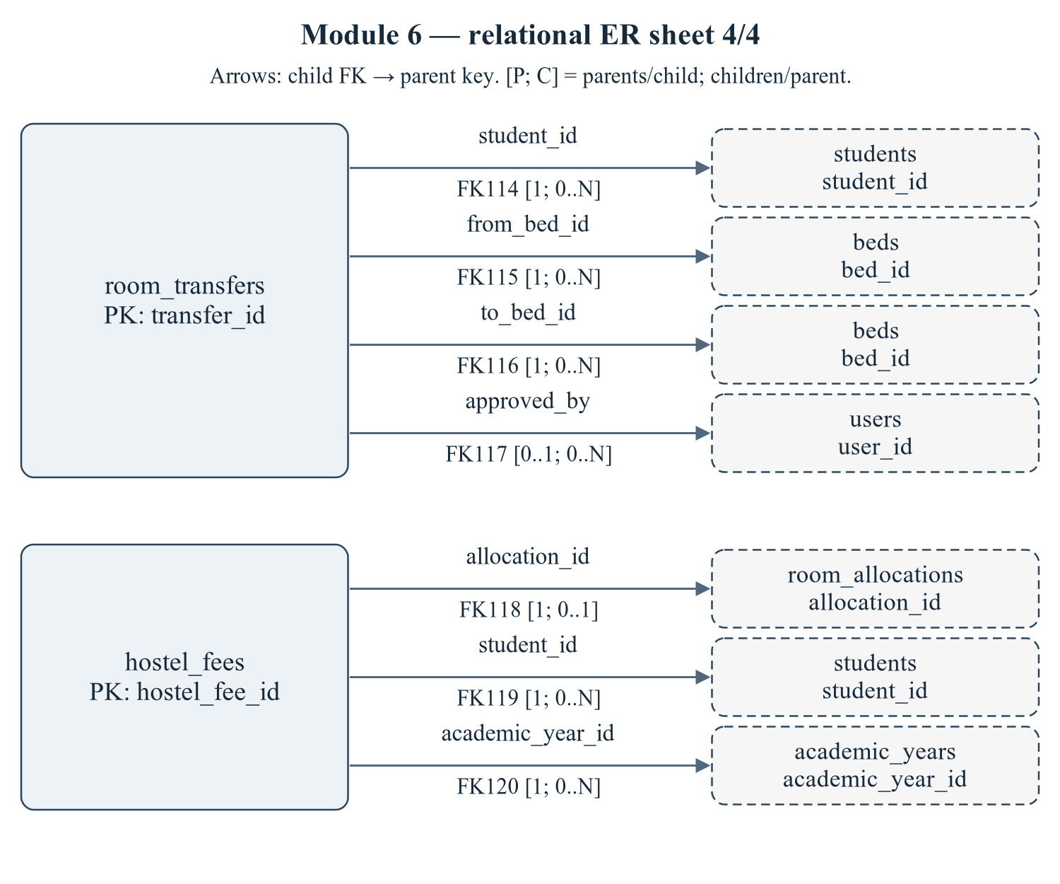
Figure 1.26 Module 6 — relational ER sheet 4/4
Child relations: room_transfers, hostel_fees. Declared relationship IDs: FK114, FK115, FK116, FK117, FK118, FK119, FK120. Every relationship is sourced from 01/02 schema or the eight deferred FKs in 03_constraints.sql; trigger-only consistency rules are not drawn as invented FKs.
Editable drawing source: diagrams/03_er_panel_06_part_04.svg, .dot and .mmd. Edit SVG text/shapes in a vector editor, or regenerate from DOT/Mermaid; retain FK IDs and source names. These figures were created from static source, not captured from a running ERP.
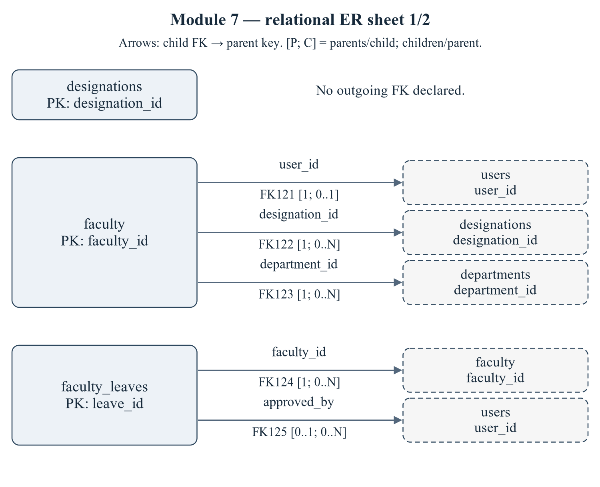
Figure 1.27 Module 7 — relational ER sheet 1/2
Child relations: designations, faculty, faculty_leaves. Declared relationship IDs: FK121, FK122, FK123, FK124, FK125. Every relationship is sourced from 01/02 schema or the eight deferred FKs in 03_constraints.sql; trigger-only consistency rules are not drawn as invented FKs.
Editable drawing source: diagrams/03_er_panel_07_part_01.svg, .dot and .mmd. Edit SVG text/shapes in a vector editor, or regenerate from DOT/Mermaid; retain FK IDs and source names. These figures were created from static source, not captured from a running ERP.
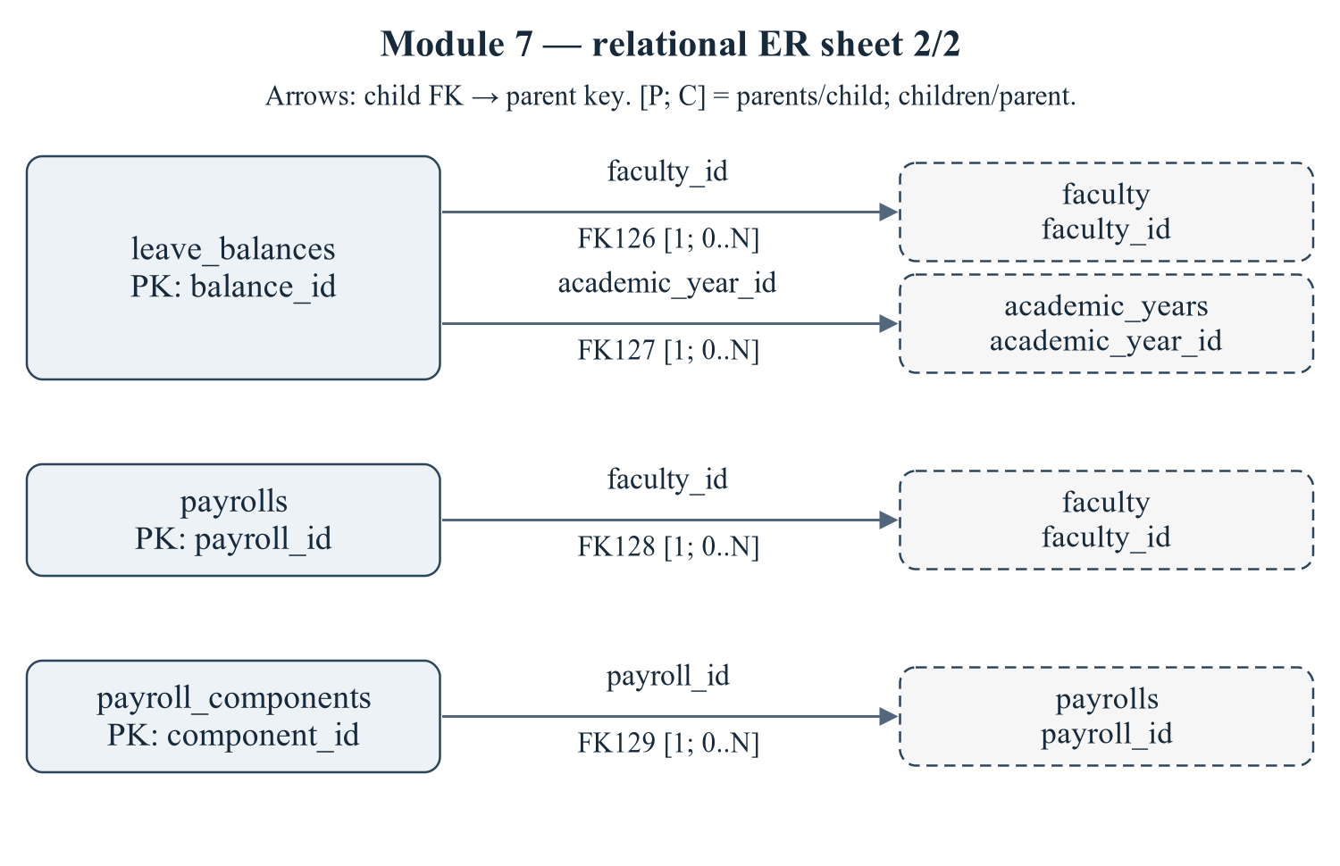
Figure 1.28 Module 7 — relational ER sheet 2/2
Child relations: leave_balances, payrolls, payroll_components. Declared relationship IDs: FK126, FK127, FK128, FK129. Every relationship is sourced from 01/02 schema or the eight deferred FKs in 03_constraints.sql; trigger-only consistency rules are not drawn as invented FKs.
Editable drawing source: diagrams/03_er_panel_07_part_02.svg, .dot and .mmd. Edit SVG text/shapes in a vector editor, or regenerate from DOT/Mermaid; retain FK IDs and source names. These figures were created from static source, not captured from a running ERP.
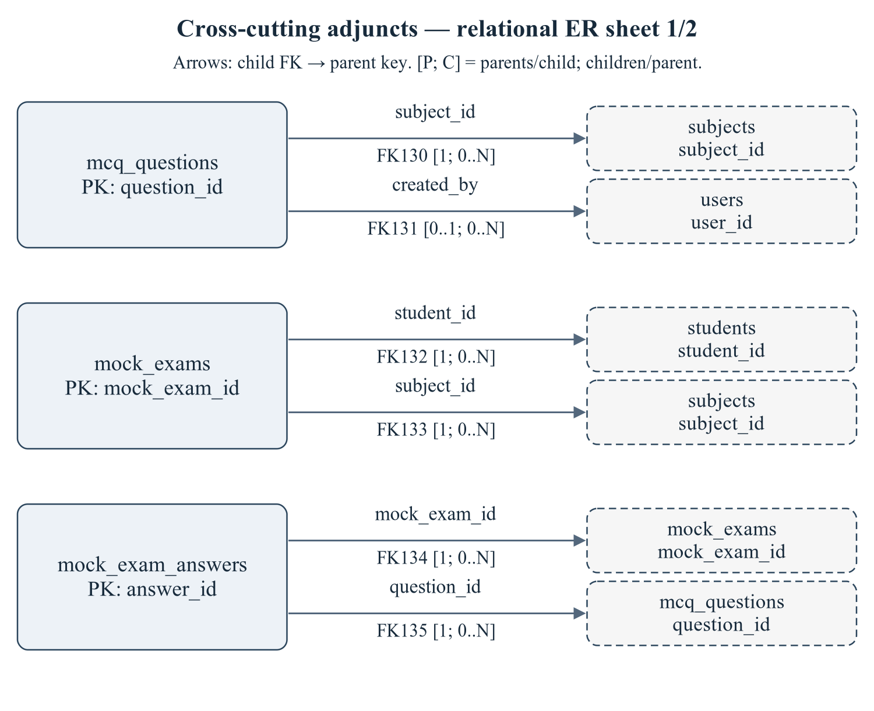
Figure 1.29 Cross-cutting adjuncts — relational ER sheet 1/2
Child relations: mcq_questions, mock_exams, mock_exam_answers. Declared relationship IDs: FK130, FK131, FK132, FK133, FK134, FK135. Every relationship is sourced from 01/02 schema or the eight deferred FKs in 03_constraints.sql; trigger-only consistency rules are not drawn as invented FKs.
Editable drawing source: diagrams/03_er_panel_08_part_01.svg, .dot and .mmd. Edit SVG text/shapes in a vector editor, or regenerate from DOT/Mermaid; retain FK IDs and source names. These figures were created from static source, not captured from a running ERP.
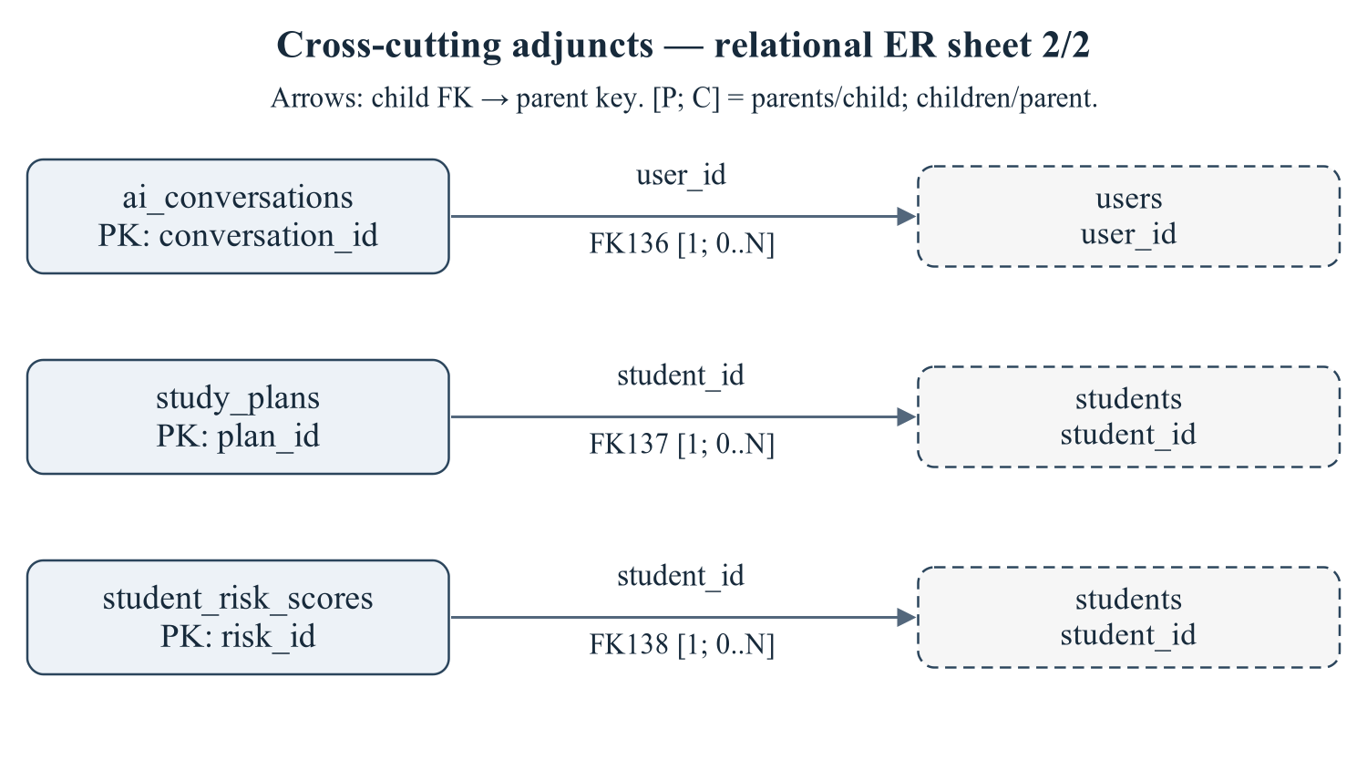
Figure 1.30 Cross-cutting adjuncts — relational ER sheet 2/2
Child relations: ai_conversations, study_plans, student_risk_scores. Declared relationship IDs: FK136, FK137, FK138. Every relationship is sourced from 01/02 schema or the eight deferred FKs in 03_constraints.sql; trigger-only consistency rules are not drawn as invented FKs.
Editable drawing source: diagrams/03_er_panel_08_part_02.svg, .dot and .mmd. Edit SVG text/shapes in a vector editor, or regenerate from DOT/Mermaid; retain FK IDs and source names. These figures were created from static source, not captured from a running ERP.
Complete zoomable/editable ER source: diagrams/00_complete_enterprise_ER.mmd. The multi-sheet presentation deliberately avoids an illegible 61-table single-page portrait image.

1.3 Master System Context Diagram (Level 0 DFD)
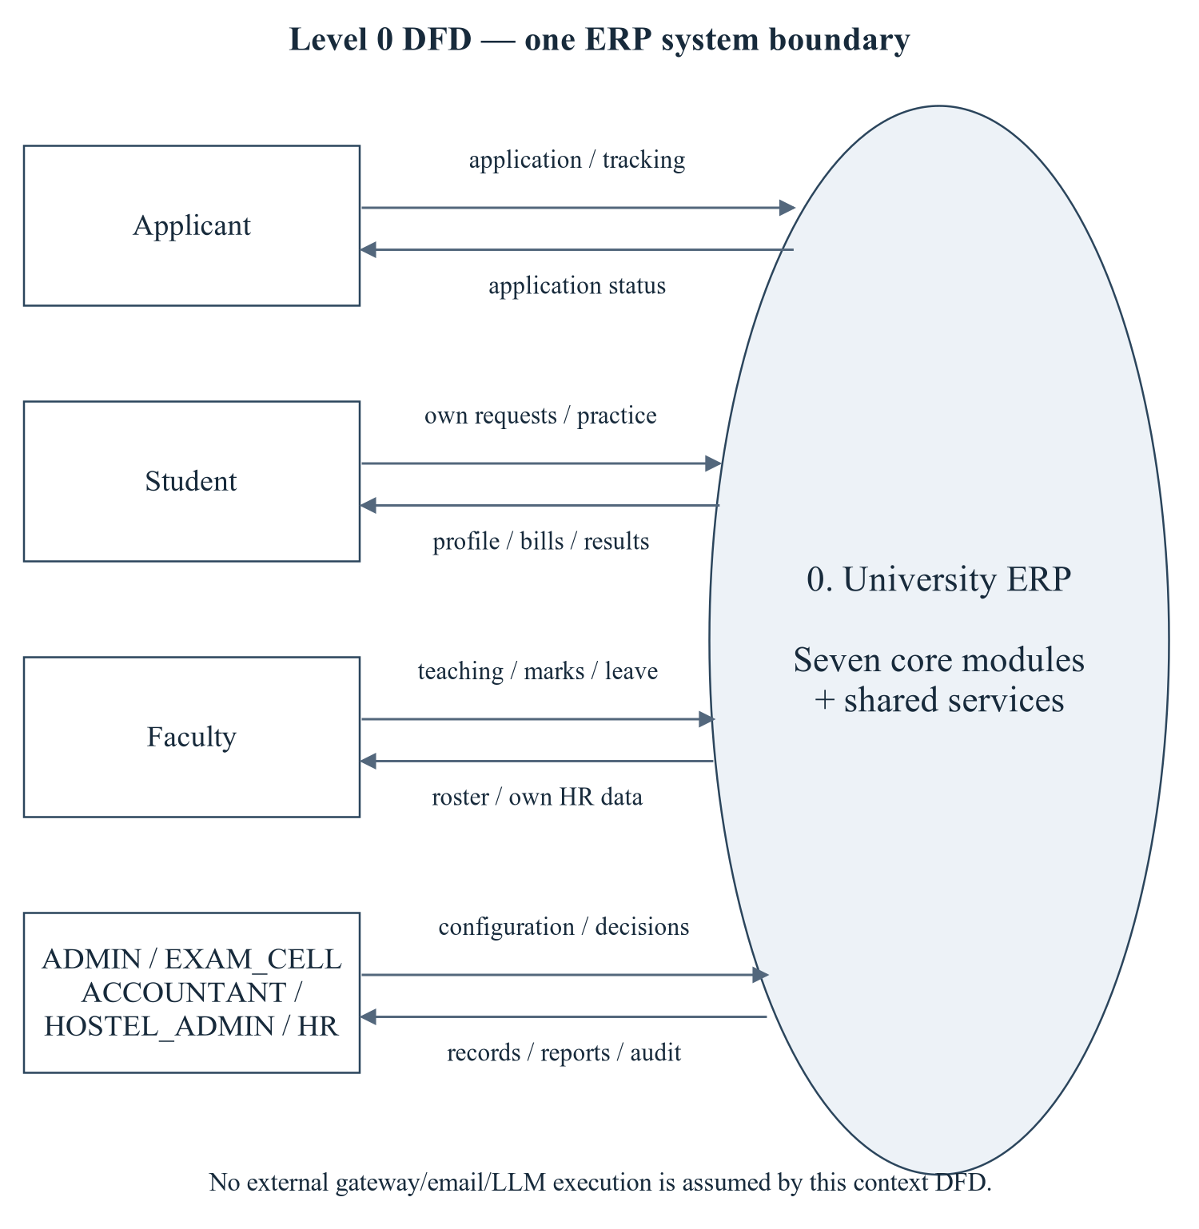
Figure 1.31 ERP system context (Level 0 DFD)
A single ERP process exchanges requests and responses with applicants, students, faculty and authorized office roles. Databases are inside the system boundary and therefore are not external actors in this context diagram.
Editable drawing source: diagrams/04_context_dfd_level0.svg, .dot and .mmd. Edit SVG text/shapes in a vector editor, or regenerate from DOT/Mermaid; retain FK IDs and source names. These figures were created from static source, not captured from a running ERP.

1.3.1 Enterprise System Boundary, External Actors & Top-Level Data Flows
Table 1.3 Context boundary and external data movement
Actor | Inbound data | Outbound data / caveat
Applicant | Application and tracking identifiers | Application status; public tracking privacy must be tested.
STUDENT | Own profile/enrollment/hostel/practice requests | Own academic/attendance/fee/allocation/results/notices subject to actual route scope.
FACULTY | Teaching/attendance/marks and own leave requests | Rosters, workload and own HR data; ownership gaps are identified, not assumed safe.
ADMIN / EXAM_CELL / ACCOUNTANT / HOSTEL_ADMIN / HR | Configuration, decisions, publication, payments, allocation and payroll commands | Operational data/reports/audit subject to approved least-privilege policy.

1.4 Master Database Relational Schema & Normalization (3NF)
Relational notation below lists actual attributes. The full dictionary supplies types/nullability/defaults/constraints; PK/FK notation does not invent undeclared relationships.
roles( role_id, role_code, role_name, description, created_at). PK={role_id}; FK IDs={}.
users( user_id, role_id, email, password_hash, phone, is_active, is_first_login, last_login_at, failed_attempts, locked_until, refresh_token, password_reset_token, created_at, updated_at). PK={user_id}; FK IDs={FK001}.
departments( department_id, department_code, name, short_name, hod_faculty_id, email, phone, established_year, status, created_at, updated_at). PK={department_id}; FK IDs={FK002}.
categories( category_id, category_code, name, description). PK={category_id}; FK IDs={}.
academic_years( academic_year_id, year_label, start_date, end_date, is_current, status). PK={academic_year_id}; FK IDs={}.
semesters( semester_id, academic_year_id, semester_no, name, start_date, end_date, is_current, result_published). PK={semester_id}; FK IDs={FK003}.
programs( program_id, program_code, name, short_name, level, department_id, duration_years, total_semesters, total_credits, intake, status, created_at, updated_at). PK={program_id}; FK IDs={FK004}.
batches( batch_id, batch_code, program_id, academic_year_id, start_year, end_year, current_semester_no, strength, status). PK={batch_id}; FK IDs={FK005,FK006}.
subjects( subject_id, subject_code, name, short_name, credits, subject_type, department_id, lecture_hours, tutorial_hours, practical_hours, is_elective, status, created_at). PK={subject_id}; FK IDs={FK007}.
system_settings( setting_key, setting_value, description, updated_at). PK={setting_key}; FK IDs={}.
notifications( notification_id, user_id, title, message, type, severity, entity, entity_id, link, is_read, read_at, created_at). PK={notification_id}; FK IDs={FK008}.
audit_logs( log_id, user_id, action, entity, entity_id, description, old_value, new_value, ip_address, user_agent, created_at). PK={log_id}; FK IDs={FK009}.
students( student_id, user_id, roll_number, registration_number, first_name, middle_name, last_name, email, phone, date_of_birth, gender, blood_group, nationality, category_id, department_id, program_id, batch_id, admission_year, admission_date, current_semester_no, status, photo_url, emergency_contact, created_at, updated_at). PK={student_id}; FK IDs={FK010,FK011,FK012,FK013,FK014}.
addresses( address_id, student_id, address_type, line1, line2, city, district, state, pincode, country, is_primary, created_at, updated_at). PK={address_id}; FK IDs={FK015}.
guardians( guardian_id, student_id, name, relation, phone, email, occupation, annual_income, is_primary, created_at, updated_at). PK={guardian_id}; FK IDs={FK016}.
admissions( admission_id, application_no, student_id, academic_year_id, program_id, category_id, first_name, last_name, email, phone, date_of_birth, gender, guardian_name, guardian_phone, previous_school, qualification, marks_10, marks_12, entrance_score, address_line1, city, state, pincode, application_date, status, reviewed_by, reviewed_at, remarks, created_at, updated_at). PK={admission_id}; FK IDs={FK017,FK018,FK019,FK020,FK021}.
student_documents( document_id, student_id, doc_type, file_name, file_path, mime_type, size_bytes, is_verified, verified_by, verified_at, uploaded_at). PK={document_id}; FK IDs={FK022,FK023}.
student_status_history( history_id, student_id, old_status, new_status, reason, changed_by, changed_at). PK={history_id}; FK IDs={FK024,FK025}.
sections( section_id, section_code, program_id, batch_id, semester_id, capacity, room_number, class_teacher_id, status). PK={section_id}; FK IDs={FK026,FK027,FK028,FK029}.
program_subjects( program_subject_id, program_id, subject_id, semester_no, is_elective). PK={program_subject_id}; FK IDs={FK030,FK031}.
course_offerings( offering_id, subject_id, semester_id, academic_year_id, program_id, section_id, faculty_id, capacity, enrolled_count, offering_type, status, created_at). PK={offering_id}; FK IDs={FK032,FK033,FK034,FK035,FK036,FK037}.
enrollments( enrollment_id, student_id, offering_id, enrolled_on, enrolled_by, grade, grade_points, status, created_at, updated_at). PK={enrollment_id}; FK IDs={FK038,FK039,FK040}.
faculty_subjects( allocation_id, faculty_id, subject_id, academic_year_id, semester_id, is_primary, assigned_on). PK={allocation_id}; FK IDs={FK041,FK042,FK043,FK044}.
timetable( timetable_id, offering_id, section_id, faculty_id, day_of_week, start_time, end_time, room_number, slot_label, is_active). PK={timetable_id}; FK IDs={FK045,FK046,FK047}.
academic_calendar( event_id, academic_year_id, semester_id, title, description, event_type, event_date, end_date, is_holiday, created_at). PK={event_id}; FK IDs={FK048,FK049}.
class_sessions( session_id, offering_id, faculty_id, semester_id, session_date, session_no, topic, room_number, start_time, end_time, status, created_at). PK={session_id}; FK IDs={FK050,FK051,FK052}.
attendance( attendance_id, session_id, student_id, offering_id, semester_id, status, remarks, marked_by, marked_at). PK={attendance_id}; FK IDs={FK053,FK054,FK055,FK056,FK057}.
grades( grade_id, grade_code, grade_label, min_percentage, max_percentage, grade_points, is_pass). PK={grade_id}; FK IDs={}.
exams( exam_id, exam_code, name, exam_type, academic_year_id, semester_id, start_date, end_date, registration_start, registration_end, result_published, published_on, min_attendance_required, status, created_at). PK={exam_id}; FK IDs={FK058,FK059}.
exam_schedules( schedule_id, exam_id, subject_id, program_id, exam_date, start_time, end_time, room_number, max_marks, min_marks, invigilator_id). PK={schedule_id}; FK IDs={FK060,FK061,FK062,FK063}.
exam_registrations( registration_id, exam_id, student_id, offering_id, schedule_id, registered_on, registered_by, attendance_percentage, is_eligible, eligibility_reason, exemption_granted, exemption_by, exemption_reason, hall_ticket_no, hall_ticket_issued_at, status). PK={registration_id}; FK IDs={FK064,FK065,FK066,FK067,FK068}.
marks( mark_id, registration_id, marks_obtained, max_marks, percentage, grade, grade_points, is_absent, is_pass, entered_by, entered_on, updated_at, remarks). PK={mark_id}; FK IDs={FK069,FK070}.
results( result_id, student_id, semester_id, exam_id, sgpa, cgpa, total_credits, earned_credits, backlog_count, result_status, remarks, published_on, published_by, created_at). PK={result_id}; FK IDs={FK071,FK072,FK073,FK074}.
fee_structures( fee_structure_id, fee_code, program_id, semester_no, academic_year_id, category_id, tuition_fee, hostel_fee, exam_fee, library_fee, lab_fee, development_fee, other_fee, late_fee_per_day, grace_days, due_date, status, created_at). PK={fee_structure_id}; FK IDs={FK075,FK076,FK077}.
student_fees( student_fee_id, student_id, fee_structure_id, semester_id, academic_year_id, total_amount, scholarship_amount, discount_amount, fine_amount, paid_amount, due_amount, status, due_date, paid_on, remarks, created_at, updated_at). PK={student_fee_id}; FK IDs={FK078,FK079,FK080,FK081}.
payments( payment_id, receipt_no, transaction_id, student_fee_id, student_id, amount, payment_mode, payment_date, status, reference_no, received_by, remarks, created_at). PK={payment_id}; FK IDs={FK082,FK083,FK084}.
scholarships( scholarship_id, scholarship_code, name, provider, scholarship_type, amount, is_percentage, criteria, max_beneficiaries, academic_year_id, status). PK={scholarship_id}; FK IDs={FK085}.
student_scholarships( student_scholarship_id, student_id, scholarship_id, academic_year_id, amount, sanctioned_on, sanctioned_by, status, remarks). PK={student_scholarship_id}; FK IDs={FK086,FK087,FK088,FK089}.
fines( fine_id, student_id, student_fee_id, reason, fine_type, amount, imposed_on, imposed_by, status, remarks). PK={fine_id}; FK IDs={FK090,FK091,FK092}.
refunds( refund_id, payment_id, student_id, amount, reason, refund_mode, refund_date, status, processed_by, remarks). PK={refund_id}; FK IDs={FK093,FK094,FK095}.
transactions( transaction_id, student_fee_id, payment_id, student_id, txn_type, amount, balance_after, description, created_at). PK={transaction_id}; FK IDs={FK096,FK097,FK098}.
hostels( hostel_id, hostel_code, name, hostel_type, warden_faculty_id, address, contact_no, total_rooms, total_beds, occupied_beds, rent_per_bed, status, created_at). PK={hostel_id}; FK IDs={FK099}.
hostel_blocks( block_id, hostel_id, block_code, name, floors, status). PK={block_id}; FK IDs={FK100}.
rooms( room_id, hostel_id, block_id, room_number, floor, room_type, capacity, occupied_count, rent_per_bed, status). PK={room_id}; FK IDs={FK101,FK102}.
beds( bed_id, room_id, bed_code, status, remarks). PK={bed_id}; FK IDs={FK103}.
hostel_applications( application_id, application_no, student_id, hostel_id, academic_year_id, room_type_pref, applied_on, status, reviewed_by, reviewed_on, remarks). PK={application_id}; FK IDs={FK104,FK105,FK106,FK107}.
room_allocations( allocation_id, student_id, bed_id, room_id, hostel_id, academic_year_id, allocated_on, allocated_by, vacated_on, rent_amount, status, remarks, active_bed_year). PK={allocation_id}; FK IDs={FK108,FK109,FK110,FK111,FK112,FK113}.
room_transfers( transfer_id, student_id, from_bed_id, to_bed_id, reason, transferred_on, approved_by). PK={transfer_id}; FK IDs={FK114,FK115,FK116,FK117}.
hostel_fees( hostel_fee_id, allocation_id, student_id, academic_year_id, amount, paid_amount, due_date, status, created_at). PK={hostel_fee_id}; FK IDs={FK118,FK119,FK120}.
designations( designation_id, designation_code, title, grade, min_basic_pay, max_basic_pay, teaching_hours_per_week). PK={designation_id}; FK IDs={}.
faculty( faculty_id, user_id, employee_code, first_name, last_name, email, phone, date_of_birth, gender, designation_id, department_id, joining_date, employment_type, qualification, specialization, experience_years, basic_salary, hra, da, ta, special_allowance, pf_percent, bank_account, status, created_at, updated_at). PK={faculty_id}; FK IDs={FK121,FK122,FK123}.
faculty_leaves( leave_id, faculty_id, leave_type, start_date, end_date, days, reason, applied_on, status, approved_by, approved_on, remarks). PK={leave_id}; FK IDs={FK124,FK125}.
leave_balances( balance_id, faculty_id, academic_year_id, leave_type, allotted, used). PK={balance_id}; FK IDs={FK126,FK127}.
payrolls( payroll_id, faculty_id, pay_month, pay_year, basic, hra, da, ta, special_allowance, gross_salary, pf_deduction, professional_tax, income_tax, lop_days, lop_amount, other_deduction, net_salary, working_days, status, generated_on, paid_on, remarks). PK={payroll_id}; FK IDs={FK128}.
payroll_components( component_id, payroll_id, component_type, name, amount). PK={component_id}; FK IDs={FK129}.
mcq_questions( question_id, subject_id, difficulty, question_text, option_a, option_b, option_c, option_d, correct_option, marks, explanation, topic, created_by, status, created_at). PK={question_id}; FK IDs={FK130,FK131}.
mock_exams( mock_exam_id, student_id, subject_id, difficulty, total_questions, duration_minutes, started_at, expires_at, submitted_at, score, max_score, percentage, correct_count, status). PK={mock_exam_id}; FK IDs={FK132,FK133}.
mock_exam_answers( answer_id, mock_exam_id, question_id, selected_option, is_correct, marks_awarded, answered_at). PK={answer_id}; FK IDs={FK134,FK135}.
ai_conversations( conversation_id, user_id, session_id, role, message, source, created_at). PK={conversation_id}; FK IDs={FK136}.
study_plans( plan_id, student_id, generated_on, source, input_snapshot, plan_json, valid_until). PK={plan_id}; FK IDs={FK137}.
student_risk_scores( risk_id, student_id, computed_on, risk_score, risk_level, attendance_pct, avg_marks, cgpa, pending_fees, backlog_count, factors). PK={risk_id}; FK IDs={FK138}.
3NF is a property of a relation under a complete functional-dependency set, not a consequence of naming an integer primary key. The DDL supplies PKs, non-null UNIQUE candidates, types and referential constraints; domain FDs and historical snapshot intent require the business owner. Nullable UNIQUE tuples are not automatically candidate keys: multiple NULL-bearing values may be permitted. CHECK accepts TRUE/UNKNOWN and enforced support depends on the actual server version (MySQL 8.0.16+ for enforced CHECK). [D01, D03, R01, R02, R03]
1NF is provisionally interpreted at the declared SQL-type level: one row value per attribute. JSON/text document fields are treated as opaque values, not silently decomposed into invented child tables. 2NF requires dependence on the whole of every candidate key. 3NF additionally rejects non-key determinants unless the dependent attribute is prime or the determinant is a superkey. Cross-table contact duplication and maintained cross-row counters are discussed separately from formal within-row FD violations.
Table 1.4 Relation-level candidate keys and normalization assessment
Relation | Proven key candidates | FD / exception / evidence assessment
roles | (role_id); (role_code) | PK determines the remaining stored attributes. Non-null declared UNIQUE tuples are additional candidate-key evidence. No further non-key determinant was established from DDL alone; 3NF is conditional on the stated business FDs being complete, not certified solely by having a surrogate key.
users | (user_id); (email) | PK determines the remaining stored attributes. Non-null declared UNIQUE tuples are additional candidate-key evidence. No further non-key determinant was established from DDL alone; 3NF is conditional on the stated business FDs being complete, not certified solely by having a surrogate key.
departments | (department_id); (department_code); (name) | PK determines the remaining stored attributes. Non-null declared UNIQUE tuples are additional candidate-key evidence. No further non-key determinant was established from DDL alone; 3NF is conditional on the stated business FDs being complete, not certified solely by having a surrogate key.
categories | (category_id); (category_code) | PK determines the remaining stored attributes. Non-null declared UNIQUE tuples are additional candidate-key evidence. No further non-key determinant was established from DDL alone; 3NF is conditional on the stated business FDs being complete, not certified solely by having a surrogate key.
academic_years | (academic_year_id); (year_label) | PK determines the remaining stored attributes. Non-null declared UNIQUE tuples are additional candidate-key evidence. No further non-key determinant was established from DDL alone; 3NF is conditional on the stated business FDs being complete, not certified solely by having a surrogate key.
semesters | (semester_id); (academic_year_id,semester_no) | PK determines the remaining stored attributes. Non-null declared UNIQUE tuples are additional candidate-key evidence. No further non-key determinant was established from DDL alone; 3NF is conditional on the stated business FDs being complete, not certified solely by having a surrogate key.
programs | (program_id); (program_code) | PK determines the remaining stored attributes. Non-null declared UNIQUE tuples are additional candidate-key evidence. No further non-key determinant was established from DDL alone; 3NF is conditional on the stated business FDs being complete, not certified solely by having a surrogate key.
batches | (batch_id); (batch_code) | PK determines the remaining stored attributes. Non-null declared UNIQUE tuples are additional candidate-key evidence. No further non-key determinant was established from DDL alone; 3NF is conditional on the stated business FDs being complete, not certified solely by having a surrogate key.
subjects | (subject_id); (subject_code) | PK determines the remaining stored attributes. Non-null declared UNIQUE tuples are additional candidate-key evidence. No further non-key determinant was established from DDL alone; 3NF is conditional on the stated business FDs being complete, not certified solely by having a surrogate key.
system_settings | (setting_key) | PK determines the remaining stored attributes. Non-null declared UNIQUE tuples are additional candidate-key evidence. No further non-key determinant was established from DDL alone; 3NF is conditional on the stated business FDs being complete, not certified solely by having a surrogate key.
notifications | (notification_id) | PK determines the remaining stored attributes. Non-null declared UNIQUE tuples are additional candidate-key evidence. No further non-key determinant was established from DDL alone; 3NF is conditional on the stated business FDs being complete, not certified solely by having a surrogate key.
audit_logs | (log_id) | PK determines the remaining stored attributes. Non-null declared UNIQUE tuples are additional candidate-key evidence. No further non-key determinant was established from DDL alone; 3NF is conditional on the stated business FDs being complete, not certified solely by having a surrogate key.
students | (student_id); (roll_number); (registration_number); (email); (user_id) | Intended batch_id -> program_id and program_id -> department_id repeat cohort/program facts in the row. Independent FKs do not enforce their agreement. Treat this as a conditional transitive-dependency/consistency risk, not a blanket 3NF certification. user_id/email duplication across identity/profile stores is an update anomaly, not automatically a within-relation 3NF violation because user_id is itself UNIQUE NOT NULL.
addresses | (address_id); (student_id,address_type) | PK determines the remaining stored attributes. Non-null declared UNIQUE tuples are additional candidate-key evidence. No further non-key determinant was established from DDL alone; 3NF is conditional on the stated business FDs being complete, not certified solely by having a surrogate key.
guardians | (guardian_id); (student_id,relation) | PK determines the remaining stored attributes. Non-null declared UNIQUE tuples are additional candidate-key evidence. No further non-key determinant was established from DDL alone; 3NF is conditional on the stated business FDs being complete, not certified solely by having a surrogate key.
admissions | (admission_id); (application_no); (email) | program_id and academic_year_id determine lookup context; copied applicant/contact/guardian values are application snapshots, not a replacement for users/students. student_id is nullable UNIQUE, so multiple NULL applications do not create a candidate key.
student_documents | (document_id) | PK determines the remaining stored attributes. Non-null declared UNIQUE tuples are additional candidate-key evidence. No further non-key determinant was established from DDL alone; 3NF is conditional on the stated business FDs being complete, not certified solely by having a surrogate key.
student_status_history | (history_id) | PK determines the remaining stored attributes. Non-null declared UNIQUE tuples are additional candidate-key evidence. No further non-key determinant was established from DDL alone; 3NF is conditional on the stated business FDs being complete, not certified solely by having a surrogate key.
sections | (section_id); (batch_id,section_code) | batch_id -> program_id repeats domain hierarchy inside sections; retain only if an explicitly maintained snapshot/validation contract is approved.
program_subjects | (program_subject_id); (program_id,subject_id,semester_no) | PK determines the remaining stored attributes. Non-null declared UNIQUE tuples are additional candidate-key evidence. No further non-key determinant was established from DDL alone; 3NF is conditional on the stated business FDs being complete, not certified solely by having a surrogate key.
course_offerings | (offering_id) | semester_id -> academic_year_id means the duplicated year can create an intended transitive dependency among stored columns. enrolled_count is a maintained aggregate over enrollments and must be reconciled, not called an atomic enrollment fact.
enrollments | (enrollment_id); (student_id,offering_id) | PK determines the remaining stored attributes. Non-null declared UNIQUE tuples are additional candidate-key evidence. No further non-key determinant was established from DDL alone; 3NF is conditional on the stated business FDs being complete, not certified solely by having a surrogate key.
faculty_subjects | (allocation_id) | PK determines the remaining stored attributes. Non-null declared UNIQUE tuples are additional candidate-key evidence. No further non-key determinant was established from DDL alone; 3NF is conditional on the stated business FDs being complete, not certified solely by having a surrogate key.
timetable | (timetable_id); (section_id,day_of_week,start_time); (faculty_id,day_of_week,start_time); (room_number,day_of_week,start_time) | PK determines the remaining stored attributes. Non-null declared UNIQUE tuples are additional candidate-key evidence. No further non-key determinant was established from DDL alone; 3NF is conditional on the stated business FDs being complete, not certified solely by having a surrogate key.
academic_calendar | (event_id) | PK determines the remaining stored attributes. Non-null declared UNIQUE tuples are additional candidate-key evidence. No further non-key determinant was established from DDL alone; 3NF is conditional on the stated business FDs being complete, not certified solely by having a surrogate key.
class_sessions | (session_id); (offering_id,session_date,session_no) | offering_id -> semester_id in the academic domain means the copied semester_id is derived context. Session identity/timing and attendance-grain keys should be separated from duplicated teaching context.
attendance | (attendance_id); (session_id,student_id) | The non-null UNIQUE(session_id,student_id) is an alternate candidate key. Domain session_id -> offering_id,semester_id creates a partial dependency of non-prime context attributes on part of that key: an intended 2NF/3NF exception. The insert guard reduces but does not prove update-path consistency.
grades | (grade_id); (grade_code); (min_percentage,max_percentage) | PK determines the remaining stored attributes. Non-null declared UNIQUE tuples are additional candidate-key evidence. No further non-key determinant was established from DDL alone; 3NF is conditional on the stated business FDs being complete, not certified solely by having a surrogate key.
exams | (exam_id); (exam_code) | semester_id -> academic_year_id repeats year context. Thresholds/publication flags are examination policy snapshots, not evidence of normalization by themselves.
exam_schedules | (schedule_id); (exam_id,subject_id,program_id); (exam_date,start_time,room_number) | PK determines the remaining stored attributes. Non-null declared UNIQUE tuples are additional candidate-key evidence. No further non-key determinant was established from DDL alone; 3NF is conditional on the stated business FDs being complete, not certified solely by having a surrogate key.
exam_registrations | (registration_id); (exam_id,student_id,offering_id) | exam_id -> semester/year context through exams and offering_id -> teaching context. attendance_percentage, eligibility/reason and hall-ticket data are registration-time snapshots. Define when re-evaluation may overwrite these snapshots.
marks | (mark_id); (registration_id) | registration_id is UNIQUE NOT NULL and determines the registration context; percentage/grade/grade_points/is_pass are deterministic from marks/max/absent and the chosen grading policy. Under a fixed grading policy these non-key dependencies are deliberate derived-value exceptions needing synchronized updates.
results | (result_id); (student_id,semester_id) | UNIQUE(student_id,semester_id) fixes one stored semester result. The year is obtained by joining semesters, not stored as an invented results.academic_year_id. SGPA/CGPA/credits/backlogs are materialized cross-row aggregates; historical policy/versioning is required before deleting these snapshots as redundant.
fee_structures | (fee_structure_id); (fee_code) | The business tuple (program_id,semester_no,academic_year_id,category_id) is UNIQUE but category_id is nullable, so it is not automatically a candidate key. The fee components are stored individually; no total_amount column exists in this table. The generation procedure sums them into student_fees.
student_fees | (student_fee_id); (student_id,fee_structure_id,semester_id) | student_fee_id is the surrogate key and the billing tuple is a non-null UNIQUE. academic_year_id follows semester_id; due_amount is stored and recomputed by a BEFORE UPDATE trigger from bill components/discount/scholarship/paid/fine, not defined as a generated column. Snapshotted charges plus maintained payment totals require reconciliation and a policy for historical fee-template changes.
payments | (payment_id); (receipt_no); (transaction_id) | The NOT NULL student_fee_id identifies a bill which determines student_id, while both are stored. This is an intended domain transitive dependency unless explicitly preserved as an event snapshot; payment amount/date/mode/receipt remain payment facts.
scholarships | (scholarship_id); (scholarship_code) | PK determines the remaining stored attributes. Non-null declared UNIQUE tuples are additional candidate-key evidence. No further non-key determinant was established from DDL alone; 3NF is conditional on the stated business FDs being complete, not certified solely by having a surrogate key.
student_scholarships | (student_scholarship_id); (student_id,scholarship_id,academic_year_id) | PK determines the remaining stored attributes. Non-null declared UNIQUE tuples are additional candidate-key evidence. No further non-key determinant was established from DDL alone; 3NF is conditional on the stated business FDs being complete, not certified solely by having a surrogate key.
fines | (fine_id) | PK determines the remaining stored attributes. Non-null declared UNIQUE tuples are additional candidate-key evidence. No further non-key determinant was established from DDL alone; 3NF is conditional on the stated business FDs being complete, not certified solely by having a surrogate key.
refunds | (refund_id) | PK determines the remaining stored attributes. Non-null declared UNIQUE tuples are additional candidate-key evidence. No further non-key determinant was established from DDL alone; 3NF is conditional on the stated business FDs being complete, not certified solely by having a surrogate key.
transactions | (transaction_id) | Payment/bill/student identifiers and balance_after reproduce linked financial context. A ledger snapshot is justified only with immutability, ordering and reconciliation semantics; 3NF alone does not prove accounting correctness.
hostels | (hostel_id); (hostel_code) | occupied_beds/total_beds and block/room totals are summary values over physical inventory and active allocations. They are intentional aggregates with synchronization risk rather than proof of a normalized independent fact.
hostel_blocks | (block_id); (hostel_id,block_code) | PK determines the remaining stored attributes. Non-null declared UNIQUE tuples are additional candidate-key evidence. No further non-key determinant was established from DDL alone; 3NF is conditional on the stated business FDs being complete, not certified solely by having a surrogate key.
rooms | (room_id); (hostel_id,room_number) | room_id -> hostel/block context; block_id -> hostel_id duplicates hierarchy when block is non-NULL. occupied_count and capacity have different meanings: a maintained usage aggregate versus nominal design capacity.
beds | (bed_id); (room_id,bed_code) | PK determines the remaining stored attributes. Non-null declared UNIQUE tuples are additional candidate-key evidence. No further non-key determinant was established from DDL alone; 3NF is conditional on the stated business FDs being complete, not certified solely by having a surrogate key.
hostel_applications | (application_id); (application_no); (student_id,academic_year_id) | PK determines the remaining stored attributes. Non-null declared UNIQUE tuples are additional candidate-key evidence. No further non-key determinant was established from DDL alone; 3NF is conditional on the stated business FDs being complete, not certified solely by having a surrogate key.
room_allocations | (allocation_id) | Intended bed_id -> room_id and room_id -> hostel_id repeat location hierarchy. There is no application_id column in room_allocations; the procedure updates the application separately. Location dependencies are transitive unless treated as immutable event-location snapshots. active_bed_year is a nullable generated uniqueness mechanism, not a conventional candidate key.
room_transfers | (transfer_id) | student_id identifies the resident; from_bed_id/to_bed_id identify source/target beds and imply physical rooms. No allocation_id column is present in room_transfers. Retain transfer facts as history with time semantics rather than assuming present-day bed hierarchy reproduces a past event.
hostel_fees | (hostel_fee_id); (allocation_id) | allocation_id identifies the resident/location/year context, while student/year may be repeated for reporting. Rent/due fields are assessed charge snapshots; no automatic finance-ledger equivalence is established.
designations | (designation_id); (designation_code) | PK determines the remaining stored attributes. Non-null declared UNIQUE tuples are additional candidate-key evidence. No further non-key determinant was established from DDL alone; 3NF is conditional on the stated business FDs being complete, not certified solely by having a surrogate key.
faculty | (faculty_id); (employee_code); (email); (user_id) | user_id and employee_code are non-null UNIQUE alternate keys; contact duplication across users/faculty is a cross-table synchronization concern. designation_id and stored salary are not proven to have a fixed FD because salary can vary per faculty.
faculty_leaves | (leave_id) | A date range and days may be related, but working-day/half-day rules are not supplied; do not assert a date->days FD without institutional policy. Overlap is a temporal business rule, not solved by 3NF.
leave_balances | (balance_id); (faculty_id,academic_year_id,leave_type) | UNIQUE(faculty_id,academic_year_id,leave_type) is the business ledger key. allotted/used and any generated balance depend on this whole key; pending reservations are calculated separately and need agreed semantics.
payrolls | (payroll_id); (faculty_id,pay_month,pay_year) | UNIQUE(faculty_id,pay_month,pay_year) is a full business key. Gross/net and deduction amounts are formula-derived period snapshots; non-key components determine totals, a deliberate derived-value exception. Policy versioning and paid-record controls matter more than a blanket 3NF label.
payroll_components | (component_id) | Each component_id is an itemized payslip fact; payroll_id plus component type/title is not declared UNIQUE and must not be invented as a candidate key. Component totals need reconciliation with payrolls.
mcq_questions | (question_id) | PK determines the remaining stored attributes. Non-null declared UNIQUE tuples are additional candidate-key evidence. No further non-key determinant was established from DDL alone; 3NF is conditional on the stated business FDs being complete, not certified solely by having a surrogate key.
mock_exams | (mock_exam_id) | Attempt totals/score/percentage/correct_count summarize answer rows and current question marks. They are derived snapshots; question-bank changes can invalidate historical reproducibility without versioning.
mock_exam_answers | (answer_id); (mock_exam_id,question_id) | UNIQUE(mock_exam_id,question_id) fixes one answer per attempt/question. is_correct and marks_awarded are derived from selected_option and question-bank data; preserve a versioned assessment snapshot if the bank can change.
ai_conversations | (conversation_id) | message is a text value and metadata may be structured. role/provider/user/student/session relationships need a documented retention and privacy contract; no nested-document decomposition proof is supplied.
study_plans | (plan_id) | plan_json is a document-valued attribute. Treat it as opaque for this SQL inventory; if individual tasks are required as relational facts, a child-task decomposition would be a proposed redesign, not an implemented table.
student_risk_scores | (risk_id); (student_id,computed_on) | UNIQUE(student_id,computed_on) fixes one student/date risk snapshot; no academic_year_id column is present; score/level/factors are derived analytics. The calculation timestamp and model policy must explain differences from the live view and planner.

Worked decomposition proposal — not implemented DDL: for attendance, the alternate key (session_id,student_id) and intended FD session_id → offering_id,semester_id mean duplicated context depends on only part of the key. Keeping attendance event attributes at session/student grain and deriving context through class_sessions removes that partial dependency. Joining on session_id is lossless under the stated FD; the session PK preserves lookup uniqueness. Existing schema, APIs, indexes and both insert/update validation paths would need coordinated migration and tests.
Other proposals remain separate from current implementation: derive student/cohort/program/department hierarchy where historical snapshots are unnecessary; derive bill balances or maintain them under one fully tested transaction contract; version grading/payroll/risk policies before freezing aggregate snapshots. Generated active_bed_year is a deliberate constraint mechanism. student_fees.due_amount is not generated DDL: it is a stored column recomputed on UPDATE by a trigger. No whole-database 3NF pass is claimed.

1.5 Hardware & Software Requirements Specification (DBMS, IDEs, Tech Stack)
Table 1.5 Implemented stack, observed audit tools and unresolved deployment requirements
Layer | Evidence-backed specification | Verification / requirement boundary
Client | React ^18.3.1; TypeScript; Vite ^5.3.5, with actual dependency locks in repository. | SPA production build and typecheck passed; browser functionality not exercised.
API | Express ^4.19.2, mysql2 ^3.10.2, Zod ^3.23.8, bcryptjs and JWT; backend package Node >=18. | Audit used Node20.20.2/npm10.8.2/TS5.9.3; backend Dockerfile uses Node20.
DBMS | SQL targets MySQL8-style InnoDB/utf8mb4; enforced CHECK requires MySQL8.0.16+. Compose selects MariaDB11.8. | No DB engine was running here; MySQL/MariaDB compatibility and initialization paths are unverified.
Connections / optional services | Application pool has optional DB_SSL_CA certificate validation; SQL runner does not mirror that option. Optional Mongo/LLM code and local fallback exist. | No environment values or provider execution claimed. See F19/F22.
Hardware / OS / storage | [[TO BE PROVIDED: validated target CPU, RAM, storage, OS and dataset size; deployment owner must supply an approved environment specification]] | No measured minimum or supported concurrent-user count is established.
IDE / browser / operations | [[TO BE PROVIDED: team-used IDE/version, supported browser matrix and backup/restore targets; obtain from team environment and test records]] | Do not invent VS Code use, load capacity, response-time, availability or recovery success.

Dependency installation was run with lifecycle scripts disabled and audit/funding output suppressed; it is not a vulnerability audit. Local compiler/bundle success is the only executed application-build evidence. A successful static-site bundle is not equivalent to backend/DB hosting readiness. [R23, R27, D05, D06, D07, D08, D09]

1.6 Global Data Dictionary & Cross-Module Key Standards
Key standards: reuse declared enterprise IDs and exact SQL signedness/width. students.student_id and faculty.faculty_id are module-owned identity keys; users.user_id is authentication identity, not interchangeable with either. subject_id/program_id/semester_id/academic_year_id come from shared masters. Domain labels/rolls/receipts are business identifiers, not substitutes for FK keys. Context duplication (semester/year, bed/room/hostel, bill/student) requires consistency guards beyond independent FKs.
Dictionary convention: every actual column, type, effective PK nullability, explicit default, auto-increment/generated expression and ON UPDATE clause is recorded. No explicit DEFAULT is distinguished from SQL NULL. ENUM members are reproduced, not renamed to generic ACTIVE states. Constraint lists include eight deferred FKs/two CHECKs and indexes from 03_constraints.sql. Purposes describe declared keys/comments/SQL use; no additional institutional policy is inferred.
roles — Master list of system roles (RBAC). Shared by all modules.
Definition: database/01_schema.sql:50–58. Owner: Shared enterprise.
Table 1.6 roles — full column dictionary
Column and exact SQL type | Null / default / generation | Keys and purpose
role_id  TINYINT UNSIGNED | NOT NULL  DEFAULT: No explicit DEFAULT  AUTO_INCREMENT | PK  Primary row identifier.
role_code  VARCHAR(30) | NOT NULL  DEFAULT: No explicit DEFAULT | UQ uq_roles_code (role_code)  ADMIN, FACULTY, STUDENT, ACCOUNTANT, HOSTEL_ADMIN, EXAM_CELL, HR
role_name  VARCHAR(60) | NOT NULL  DEFAULT: No explicit DEFAULT | Role name value.
description  VARCHAR(255) | NULL permitted  DEFAULT: No explicit DEFAULT | Descriptive text.
created_at  TIMESTAMP | NOT NULL  DEFAULT: CURRENT_TIMESTAMP | Row creation timestamp.

PRIMARY KEY: role_id
UNIQUE constraints: UNIQUE KEY `uq_roles_code` (`role_code`)
CHECK constraints: None declared.
Secondary indexes: None explicitly declared beyond PK/UNIQUE/FK support.
Normalization / dependency note: PK determines the remaining stored attributes. Non-null declared UNIQUE tuples are additional candidate-key evidence. No further non-key determinant was established from DDL alone; 3NF is conditional on the stated business FDs being complete, not certified solely by having a surrogate key.
users — Single identity store: admin, faculty, students, staff.
Definition: database/01_schema.sql:63–82. Owner: Shared enterprise.
Table 1.7 users — full column dictionary
Column and exact SQL type | Null / default / generation | Keys and purpose
user_id  INT UNSIGNED | NOT NULL  DEFAULT: No explicit DEFAULT  AUTO_INCREMENT | PK  Primary row identifier.
role_id  TINYINT UNSIGNED | NOT NULL  DEFAULT: No explicit DEFAULT | FK001 → roles.role_id  References roles.role_id.
email  VARCHAR(150) | NOT NULL  DEFAULT: No explicit DEFAULT | UQ uq_users_email (email)  Stored email address; privacy-sensitive data.
password_hash  VARCHAR(255) | NOT NULL  DEFAULT: No explicit DEFAULT | bcrypt(12) hash - never reversible
phone  VARCHAR(20) | NULL permitted  DEFAULT: No explicit DEFAULT | Stored contact phone.
is_active  TINYINT(1) | NOT NULL  DEFAULT: 1 | Enabled/active flag.
is_first_login  TINYINT(1) | NOT NULL  DEFAULT: 1 | First-login password-change state.
last_login_at  DATETIME | NULL permitted  DEFAULT: No explicit DEFAULT | Last login at date/time, as typed.
failed_attempts  TINYINT UNSIGNED | NOT NULL  DEFAULT: 0 | Failed-login counter.
locked_until  DATETIME | NULL permitted  DEFAULT: No explicit DEFAULT | Account lockout end timestamp.
refresh_token  VARCHAR(512) | NULL permitted  DEFAULT: No explicit DEFAULT | Hashed refresh token (rotated on use)
password_reset_token  VARCHAR(255) | NULL permitted  DEFAULT: No explicit DEFAULT | Password-reset token storage; values excluded.
created_at  TIMESTAMP | NOT NULL  DEFAULT: CURRENT_TIMESTAMP | Row creation timestamp.
updated_at  TIMESTAMP; ON UPDATE CURRENT_TIMESTAMP | NOT NULL  DEFAULT: CURRENT_TIMESTAMP | Last row-update timestamp.

PRIMARY KEY: user_id
UNIQUE constraints: UNIQUE KEY `uq_users_email` (`email`)
CHECK constraints: None declared.
Secondary indexes: KEY `idx_users_role` (`role_id`)
FK001 fk_users_role: CONSTRAINT `fk_users_role` FOREIGN KEY (`role_id`) REFERENCES `roles` (`role_id`). Parent/child multiplicities 1 / 0..N. Omitted referential actions use restrictive defaults, not an invented cascade.
Normalization / dependency note: PK determines the remaining stored attributes. Non-null declared UNIQUE tuples are additional candidate-key evidence. No further non-key determinant was established from DDL alone; 3NF is conditional on the stated business FDs being complete, not certified solely by having a surrogate key.
departments — Academic departments. One row per department - shared everywhere.
Definition: database/01_schema.sql:87–102. Owner: Shared enterprise.
Table 1.8 departments — full column dictionary
Column and exact SQL type | Null / default / generation | Keys and purpose
department_id  INT UNSIGNED | NOT NULL  DEFAULT: No explicit DEFAULT  AUTO_INCREMENT | PK  Primary row identifier.
department_code  VARCHAR(20) | NOT NULL  DEFAULT: No explicit DEFAULT | UQ uq_departments_code (department_code)  e.g. CE, ETC, IT
name  VARCHAR(120) | NOT NULL  DEFAULT: No explicit DEFAULT | UQ uq_departments_name (name)  Stored display/name attribute.
short_name  VARCHAR(40) | NULL permitted  DEFAULT: No explicit DEFAULT | Short name value.
hod_faculty_id  INT UNSIGNED | NULL permitted  DEFAULT: No explicit DEFAULT | FK002 → faculty.faculty_id  FK -> faculty(faculty_id), added in 03_constraints.sql
email  VARCHAR(150) | NULL permitted  DEFAULT: No explicit DEFAULT | Stored email address; privacy-sensitive data.
phone  VARCHAR(20) | NULL permitted  DEFAULT: No explicit DEFAULT | Stored contact phone.
established_year  SMALLINT UNSIGNED | NULL permitted  DEFAULT: No explicit DEFAULT | Established year value.
status  ENUM('ACTIVE','INACTIVE') | NOT NULL  DEFAULT: 'ACTIVE' | Lifecycle state; exact permitted values are in the declared ENUM.
created_at  TIMESTAMP | NOT NULL  DEFAULT: CURRENT_TIMESTAMP | Row creation timestamp.
updated_at  TIMESTAMP; ON UPDATE CURRENT_TIMESTAMP | NOT NULL  DEFAULT: CURRENT_TIMESTAMP | Last row-update timestamp.

PRIMARY KEY: department_id
UNIQUE constraints: UNIQUE KEY `uq_departments_code` (`department_code`); UNIQUE KEY `uq_departments_name` (`name`)
CHECK constraints: None declared.
Secondary indexes: None explicitly declared beyond PK/UNIQUE/FK support.
FK002 fk_departments_hod: CONSTRAINT `fk_departments_hod`
FOREIGN KEY (`hod_faculty_id`) REFERENCES `faculty` (`faculty_id`) ON DELETE SET NULL. Parent/child multiplicities 0..1 / 0..N. Omitted referential actions use restrictive defaults, not an invented cascade.
Normalization / dependency note: PK determines the remaining stored attributes. Non-null declared UNIQUE tuples are additional candidate-key evidence. No further non-key determinant was established from DDL alone; 3NF is conditional on the stated business FDs being complete, not certified solely by having a surrogate key.
categories — Reservation / admission categories.
Definition: database/01_schema.sql:107–114. Owner: Shared enterprise.
Table 1.9 categories — full column dictionary
Column and exact SQL type | Null / default / generation | Keys and purpose
category_id  TINYINT UNSIGNED | NOT NULL  DEFAULT: No explicit DEFAULT  AUTO_INCREMENT | PK  Primary row identifier.
category_code  VARCHAR(10) | NOT NULL  DEFAULT: No explicit DEFAULT | UQ uq_categories_code (category_code)  GEN, OBC, SC, ST, EWS, PWD
name  VARCHAR(60) | NOT NULL  DEFAULT: No explicit DEFAULT | Stored display/name attribute.
description  VARCHAR(255) | NULL permitted  DEFAULT: No explicit DEFAULT | Descriptive text.

PRIMARY KEY: category_id
UNIQUE constraints: UNIQUE KEY `uq_categories_code` (`category_code`)
CHECK constraints: None declared.
Secondary indexes: None explicitly declared beyond PK/UNIQUE/FK support.
Normalization / dependency note: PK determines the remaining stored attributes. Non-null declared UNIQUE tuples are additional candidate-key evidence. No further non-key determinant was established from DDL alone; 3NF is conditional on the stated business FDs being complete, not certified solely by having a surrogate key.
academic_years — Academic year master. Single source of truth for all modules.
Definition: database/01_schema.sql:119–129. Owner: Shared enterprise.
Table 1.10 academic_years — full column dictionary
Column and exact SQL type | Null / default / generation | Keys and purpose
academic_year_id  SMALLINT UNSIGNED | NOT NULL  DEFAULT: No explicit DEFAULT  AUTO_INCREMENT | PK  Primary row identifier.
year_label  VARCHAR(20) | NOT NULL  DEFAULT: No explicit DEFAULT | UQ uq_academic_years_label (year_label)  e.g. 2025-26
start_date  DATE | NOT NULL  DEFAULT: No explicit DEFAULT | Start date date/time, as typed.
end_date  DATE | NOT NULL  DEFAULT: No explicit DEFAULT | End date date/time, as typed.
is_current  TINYINT(1) | NOT NULL  DEFAULT: 0 | Current academic-period flag.
status  ENUM('ACTIVE','CLOSED','UPCOMING') | NOT NULL  DEFAULT: 'ACTIVE' | Lifecycle state; exact permitted values are in the declared ENUM.

PRIMARY KEY: academic_year_id
UNIQUE constraints: UNIQUE KEY `uq_academic_years_label` (`year_label`)
CHECK constraints: CONSTRAINT `chk_academic_years_dates` CHECK (`end_date` > `start_date`)
Secondary indexes: None explicitly declared beyond PK/UNIQUE/FK support.
Normalization / dependency note: PK determines the remaining stored attributes. Non-null declared UNIQUE tuples are additional candidate-key evidence. No further non-key determinant was established from DDL alone; 3NF is conditional on the stated business FDs being complete, not certified solely by having a surrogate key.
semesters — Semester master, one row per (academic year, semester number).
Definition: database/01_schema.sql:134–150. Owner: Shared enterprise.
Table 1.11 semesters — full column dictionary
Column and exact SQL type | Null / default / generation | Keys and purpose
semester_id  SMALLINT UNSIGNED | NOT NULL  DEFAULT: No explicit DEFAULT  AUTO_INCREMENT | PK  Primary row identifier.
academic_year_id  SMALLINT UNSIGNED | NOT NULL  DEFAULT: No explicit DEFAULT | UQ uq_semesters_year_no (academic_year_id,semester_no); FK003 → academic_years.academic_year_id  References academic_years.academic_year_id.
semester_no  TINYINT UNSIGNED | NOT NULL  DEFAULT: No explicit DEFAULT | UQ uq_semesters_year_no (academic_year_id,semester_no)  1..8
name  VARCHAR(40) | NOT NULL  DEFAULT: No explicit DEFAULT | e.g. Semester 3
start_date  DATE | NOT NULL  DEFAULT: No explicit DEFAULT | Start date date/time, as typed.
end_date  DATE | NOT NULL  DEFAULT: No explicit DEFAULT | End date date/time, as typed.
is_current  TINYINT(1) | NOT NULL  DEFAULT: 0 | Current academic-period flag.
result_published  TINYINT(1) | NOT NULL  DEFAULT: 0 | Result published value.

PRIMARY KEY: semester_id
UNIQUE constraints: UNIQUE KEY `uq_semesters_year_no` (`academic_year_id`, `semester_no`)
CHECK constraints: CONSTRAINT `chk_semesters_no` CHECK (`semester_no` BETWEEN 1 AND 12); CONSTRAINT `chk_semesters_dates` CHECK (`end_date` > `start_date`)
Secondary indexes: KEY `idx_semesters_current` (`is_current`)
FK003 fk_semesters_year: CONSTRAINT `fk_semesters_year` FOREIGN KEY (`academic_year_id`)
REFERENCES `academic_years` (`academic_year_id`) ON DELETE CASCADE. Parent/child multiplicities 1 / 0..N. Omitted referential actions use restrictive defaults, not an invented cascade.
Normalization / dependency note: PK determines the remaining stored attributes. Non-null declared UNIQUE tuples are additional candidate-key evidence. No further non-key determinant was established from DDL alone; 3NF is conditional on the stated business FDs being complete, not certified solely by having a surrogate key.
programs — Degree / diploma programs offered by the university.
Definition: database/01_schema.sql:155–175. Owner: Shared enterprise.
Table 1.12 programs — full column dictionary
Column and exact SQL type | Null / default / generation | Keys and purpose
program_id  SMALLINT UNSIGNED | NOT NULL  DEFAULT: No explicit DEFAULT  AUTO_INCREMENT | PK  Primary row identifier.
program_code  VARCHAR(20) | NOT NULL  DEFAULT: No explicit DEFAULT | UQ uq_programs_code (program_code)  e.g. BTECH-ETC
name  VARCHAR(150) | NOT NULL  DEFAULT: No explicit DEFAULT | Stored display/name attribute.
short_name  VARCHAR(40) | NULL permitted  DEFAULT: No explicit DEFAULT | Short name value.
level  ENUM('DIPLOMA','UG','PG','PHD') | NOT NULL  DEFAULT: 'UG' | Level value.
department_id  INT UNSIGNED | NOT NULL  DEFAULT: No explicit DEFAULT | FK004 → departments.department_id  References departments.department_id.
duration_years  TINYINT UNSIGNED | NOT NULL  DEFAULT: 4 | Duration years value.
total_semesters  TINYINT UNSIGNED | NOT NULL  DEFAULT: 8 | Total semesters value.
total_credits  SMALLINT UNSIGNED | NOT NULL  DEFAULT: 160 | Total credits value.
intake  SMALLINT UNSIGNED | NOT NULL  DEFAULT: 60 | Intake value.
status  ENUM('ACTIVE','INACTIVE','CLOSED') | NOT NULL  DEFAULT: 'ACTIVE' | Lifecycle state; exact permitted values are in the declared ENUM.
created_at  TIMESTAMP | NOT NULL  DEFAULT: CURRENT_TIMESTAMP | Row creation timestamp.
updated_at  TIMESTAMP; ON UPDATE CURRENT_TIMESTAMP | NOT NULL  DEFAULT: CURRENT_TIMESTAMP | Last row-update timestamp.

PRIMARY KEY: program_id
UNIQUE constraints: UNIQUE KEY `uq_programs_code` (`program_code`)
CHECK constraints: CONSTRAINT `chk_programs_duration` CHECK (`duration_years` BETWEEN 1 AND 8)
Secondary indexes: KEY `idx_programs_department` (`department_id`)
FK004 fk_programs_department: CONSTRAINT `fk_programs_department` FOREIGN KEY (`department_id`)
REFERENCES `departments` (`department_id`) ON DELETE RESTRICT. Parent/child multiplicities 1 / 0..N. Omitted referential actions use restrictive defaults, not an invented cascade.
Normalization / dependency note: PK determines the remaining stored attributes. Non-null declared UNIQUE tuples are additional candidate-key evidence. No further non-key determinant was established from DDL alone; 3NF is conditional on the stated business FDs being complete, not certified solely by having a surrogate key.
batches — Student cohort / batch inside a program.
Definition: database/01_schema.sql:180–198. Owner: Shared enterprise.
Table 1.13 batches — full column dictionary
Column and exact SQL type | Null / default / generation | Keys and purpose
batch_id  SMALLINT UNSIGNED | NOT NULL  DEFAULT: No explicit DEFAULT  AUTO_INCREMENT | PK  Primary row identifier.
batch_code  VARCHAR(20) | NOT NULL  DEFAULT: No explicit DEFAULT | UQ uq_batches_code (batch_code)  e.g. ETC-2024-A
program_id  SMALLINT UNSIGNED | NOT NULL  DEFAULT: No explicit DEFAULT | FK005 → programs.program_id  References programs.program_id.
academic_year_id  SMALLINT UNSIGNED | NOT NULL  DEFAULT: No explicit DEFAULT | FK006 → academic_years.academic_year_id  Year of admission
start_year  SMALLINT UNSIGNED | NOT NULL  DEFAULT: No explicit DEFAULT | Start year value.
end_year  SMALLINT UNSIGNED | NOT NULL  DEFAULT: No explicit DEFAULT | End year value.
current_semester_no  TINYINT UNSIGNED | NOT NULL  DEFAULT: 1 | Current semester no value.
strength  SMALLINT UNSIGNED | NOT NULL  DEFAULT: 0 | Strength value.
status  ENUM('ACTIVE','GRADUATED','INACTIVE') | NOT NULL  DEFAULT: 'ACTIVE' | Lifecycle state; exact permitted values are in the declared ENUM.

PRIMARY KEY: batch_id
UNIQUE constraints: UNIQUE KEY `uq_batches_code` (`batch_code`)
CHECK constraints: CONSTRAINT `chk_batches_years` CHECK (`end_year` > `start_year`)
Secondary indexes: KEY `idx_batches_program` (`program_id`)
FK005 fk_batches_program: CONSTRAINT `fk_batches_program` FOREIGN KEY (`program_id`)
REFERENCES `programs` (`program_id`) ON DELETE CASCADE. Parent/child multiplicities 1 / 0..N. Omitted referential actions use restrictive defaults, not an invented cascade.
FK006 fk_batches_year: CONSTRAINT `fk_batches_year` FOREIGN KEY (`academic_year_id`)
REFERENCES `academic_years` (`academic_year_id`) ON DELETE RESTRICT. Parent/child multiplicities 1 / 0..N. Omitted referential actions use restrictive defaults, not an invented cascade.
Normalization / dependency note: PK determines the remaining stored attributes. Non-null declared UNIQUE tuples are additional candidate-key evidence. No further non-key determinant was established from DDL alone; 3NF is conditional on the stated business FDs being complete, not certified solely by having a surrogate key.
subjects — Subject master. Shared by academic, attendance and exam modules.
Definition: database/01_schema.sql:203–224. Owner: Shared enterprise.
Table 1.14 subjects — full column dictionary
Column and exact SQL type | Null / default / generation | Keys and purpose
subject_id  SMALLINT UNSIGNED | NOT NULL  DEFAULT: No explicit DEFAULT  AUTO_INCREMENT | PK  Primary row identifier.
subject_code  VARCHAR(20) | NOT NULL  DEFAULT: No explicit DEFAULT | UQ uq_subjects_code (subject_code)  e.g. ETC301
name  VARCHAR(150) | NOT NULL  DEFAULT: No explicit DEFAULT | Stored display/name attribute.
short_name  VARCHAR(40) | NULL permitted  DEFAULT: No explicit DEFAULT | Short name value.
credits  TINYINT UNSIGNED | NOT NULL  DEFAULT: 3 | Credits value.
subject_type  ENUM('THEORY','PRACTICAL','ELECTIVE','PROJECT','SEMINAR') | NOT NULL  DEFAULT: 'THEORY' | Subject type value.
department_id  INT UNSIGNED | NOT NULL  DEFAULT: No explicit DEFAULT | FK007 → departments.department_id  References departments.department_id.
lecture_hours  TINYINT UNSIGNED | NOT NULL  DEFAULT: 3 | Lecture hours value.
tutorial_hours  TINYINT UNSIGNED | NOT NULL  DEFAULT: 0 | Tutorial hours value.
practical_hours  TINYINT UNSIGNED | NOT NULL  DEFAULT: 0 | Practical hours value.
is_elective  TINYINT(1) | NOT NULL  DEFAULT: 0 | Elective flag.
status  ENUM('ACTIVE','INACTIVE') | NOT NULL  DEFAULT: 'ACTIVE' | Lifecycle state; exact permitted values are in the declared ENUM.
created_at  TIMESTAMP | NOT NULL  DEFAULT: CURRENT_TIMESTAMP | Row creation timestamp.

PRIMARY KEY: subject_id
UNIQUE constraints: UNIQUE KEY `uq_subjects_code` (`subject_code`)
CHECK constraints: CONSTRAINT `chk_subjects_credits` CHECK (`credits` BETWEEN 1 AND 12)
Secondary indexes: KEY `idx_subjects_department` (`department_id`); KEY `idx_subjects_type` (`subject_type`)
FK007 fk_subjects_department: CONSTRAINT `fk_subjects_department` FOREIGN KEY (`department_id`)
REFERENCES `departments` (`department_id`) ON DELETE RESTRICT. Parent/child multiplicities 1 / 0..N. Omitted referential actions use restrictive defaults, not an invented cascade.
Normalization / dependency note: PK determines the remaining stored attributes. Non-null declared UNIQUE tuples are additional candidate-key evidence. No further non-key determinant was established from DDL alone; 3NF is conditional on the stated business FDs being complete, not certified solely by having a surrogate key.
system_settings — Runtime configuration: attendance threshold, late fee rate etc.
Definition: database/01_schema.sql:229–235. Owner: Shared enterprise.
Table 1.15 system_settings — full column dictionary
Column and exact SQL type | Null / default / generation | Keys and purpose
setting_key  VARCHAR(60) | NOT NULL  DEFAULT: No explicit DEFAULT | PK  Primary key value.
setting_value  VARCHAR(255) | NOT NULL  DEFAULT: No explicit DEFAULT | Setting value value.
description  VARCHAR(255) | NULL permitted  DEFAULT: No explicit DEFAULT | Descriptive text.
updated_at  TIMESTAMP; ON UPDATE CURRENT_TIMESTAMP | NOT NULL  DEFAULT: CURRENT_TIMESTAMP | Last row-update timestamp.

PRIMARY KEY: setting_key
UNIQUE constraints: None declared.
CHECK constraints: None declared.
Secondary indexes: None explicitly declared beyond PK/UNIQUE/FK support.
Normalization / dependency note: PK determines the remaining stored attributes. Non-null declared UNIQUE tuples are additional candidate-key evidence. No further non-key determinant was established from DDL alone; 3NF is conditional on the stated business FDs being complete, not certified solely by having a surrogate key.
notifications — Central notification centre. Written by every module.
Definition: database/01_schema.sql:240–260. Owner: Shared enterprise.
Table 1.16 notifications — full column dictionary
Column and exact SQL type | Null / default / generation | Keys and purpose
notification_id  INT UNSIGNED | NOT NULL  DEFAULT: No explicit DEFAULT  AUTO_INCREMENT | PK  Primary row identifier.
user_id  INT UNSIGNED | NULL permitted  DEFAULT: No explicit DEFAULT | FK008 → users.user_id  NULL => broadcast to all users
title  VARCHAR(160) | NOT NULL  DEFAULT: No explicit DEFAULT | Title value.
message  VARCHAR(500) | NOT NULL  DEFAULT: No explicit DEFAULT | Message value.
type  ENUM('ATTENDANCE_WARNING','EXAM_REGISTRATION','EXAM_SCHEDULE','RESULT_PUBLISHED',  'FEE_DUE','FEE_OVERDUE','HOSTEL_ALLOCATION','LEAVE_APPROVAL','PAYROLL_GENERATED',  'ANNOUNCEMENT','ADMISSION','GENERAL') | NOT NULL  DEFAULT: 'GENERAL' | Type value.
severity  ENUM('INFO','SUCCESS','WARNING','ERROR') | NOT NULL  DEFAULT: 'INFO' | Severity value.
entity  VARCHAR(60) | NULL permitted  DEFAULT: No explicit DEFAULT | e.g. student_fee, exam
entity_id  INT UNSIGNED | NULL permitted  DEFAULT: No explicit DEFAULT | Identifier attribute; no FK is inferred beyond declared constraints.
link  VARCHAR(255) | NULL permitted  DEFAULT: No explicit DEFAULT | Link value.
is_read  TINYINT(1) | NOT NULL  DEFAULT: 0 | Read flag.
read_at  DATETIME | NULL permitted  DEFAULT: No explicit DEFAULT | Read at date/time, as typed.
created_at  TIMESTAMP | NOT NULL  DEFAULT: CURRENT_TIMESTAMP | Row creation timestamp.

PRIMARY KEY: notification_id
UNIQUE constraints: None declared.
CHECK constraints: None declared.
Secondary indexes: KEY `idx_notifications_user_read` (`user_id`, `is_read`, `created_at`); KEY `idx_notifications_type` (`type`); KEY `idx_notifications_created` (`created_at`)
FK008 fk_notifications_user: CONSTRAINT `fk_notifications_user` FOREIGN KEY (`user_id`)
REFERENCES `users` (`user_id`) ON DELETE CASCADE. Parent/child multiplicities 0..1 / 0..N. Omitted referential actions use restrictive defaults, not an invented cascade.
Normalization / dependency note: PK determines the remaining stored attributes. Non-null declared UNIQUE tuples are additional candidate-key evidence. No further non-key determinant was established from DDL alone; 3NF is conditional on the stated business FDs being complete, not certified solely by having a surrogate key.
audit_logs — Audit trail for all important operations across all modules.
Definition: database/01_schema.sql:265–287. Owner: Shared enterprise.
Table 1.17 audit_logs — full column dictionary
Column and exact SQL type | Null / default / generation | Keys and purpose
log_id  BIGINT UNSIGNED | NOT NULL  DEFAULT: No explicit DEFAULT  AUTO_INCREMENT | PK  Primary row identifier.
user_id  INT UNSIGNED | NULL permitted  DEFAULT: No explicit DEFAULT | FK009 → users.user_id  References users.user_id.
action  ENUM('LOGIN','LOGOUT','LOGIN_FAILED','CREATE','UPDATE','DELETE','PAYMENT',  'FEE_CHANGE','MARKS_UPDATE','ATTENDANCE_UPDATE','HOSTEL_ALLOCATION',  'EXAM_REGISTRATION','RESULT_PUBLISHED','LEAVE_ACTION','PAYROLL_RUN',  'APPROVE','REJECT','SYSTEM') | NOT NULL  DEFAULT: No explicit DEFAULT | Action value.
entity  VARCHAR(60) | NOT NULL  DEFAULT: No explicit DEFAULT | Entity value.
entity_id  INT UNSIGNED | NULL permitted  DEFAULT: No explicit DEFAULT | Identifier attribute; no FK is inferred beyond declared constraints.
description  VARCHAR(500) | NULL permitted  DEFAULT: No explicit DEFAULT | Descriptive text.
old_value  JSON | NULL permitted  DEFAULT: No explicit DEFAULT | Old value value.
new_value  JSON | NULL permitted  DEFAULT: No explicit DEFAULT | New value value.
ip_address  VARCHAR(45) | NULL permitted  DEFAULT: No explicit DEFAULT | Ip address value.
user_agent  VARCHAR(255) | NULL permitted  DEFAULT: No explicit DEFAULT | User agent value.
created_at  TIMESTAMP | NOT NULL  DEFAULT: CURRENT_TIMESTAMP | Row creation timestamp.

PRIMARY KEY: log_id
UNIQUE constraints: None declared.
CHECK constraints: None declared.
Secondary indexes: KEY `idx_audit_user` (`user_id`); KEY `idx_audit_entity` (`entity`, `entity_id`); KEY `idx_audit_created` (`created_at`); KEY `idx_audit_action` (`action`)
FK009 fk_audit_user: CONSTRAINT `fk_audit_user` FOREIGN KEY (`user_id`)
REFERENCES `users` (`user_id`) ON DELETE SET NULL. Parent/child multiplicities 0..1 / 0..N. Omitted referential actions use restrictive defaults, not an invented cascade.
Normalization / dependency note: PK determines the remaining stored attributes. Non-null declared UNIQUE tuples are additional candidate-key evidence. No further non-key determinant was established from DDL alone; 3NF is conditional on the stated business FDs being complete, not certified solely by having a surrogate key.
students — G1: single student master for the whole ERP.
Definition: database/02_tables.sql:28–79. Owner: Student and Admission Management.
Table 1.18 students — full column dictionary
Column and exact SQL type | Null / default / generation | Keys and purpose
student_id  INT UNSIGNED | NOT NULL  DEFAULT: No explicit DEFAULT  AUTO_INCREMENT | PK  Primary row identifier.
user_id  INT UNSIGNED | NOT NULL  DEFAULT: No explicit DEFAULT | UQ uq_students_user (user_id); FK010 → users.user_id  Login account (role = STUDENT)
roll_number  VARCHAR(20) | NOT NULL  DEFAULT: No explicit DEFAULT | UQ uq_students_roll (roll_number)  University roll number, UNIQUE
registration_number  VARCHAR(30) | NOT NULL  DEFAULT: No explicit DEFAULT | UQ uq_students_regno (registration_number)  Admission registration number, UNIQUE
first_name  VARCHAR(80) | NOT NULL  DEFAULT: No explicit DEFAULT | Given name.
middle_name  VARCHAR(80) | NULL permitted  DEFAULT: No explicit DEFAULT | Optional middle name.
last_name  VARCHAR(80) | NOT NULL  DEFAULT: No explicit DEFAULT | Family name.
email  VARCHAR(150) | NOT NULL  DEFAULT: No explicit DEFAULT | UQ uq_students_email (email)  Stored email address; privacy-sensitive data.
phone  VARCHAR(20) | NULL permitted  DEFAULT: No explicit DEFAULT | Stored contact phone.
date_of_birth  DATE | NOT NULL  DEFAULT: No explicit DEFAULT | Birth date used by validation.
gender  ENUM('MALE','FEMALE','OTHER') | NOT NULL  DEFAULT: No explicit DEFAULT | Gender value.
blood_group  ENUM('A+','A-','B+','B-','AB+','AB-','O+','O-') | NULL permitted  DEFAULT: No explicit DEFAULT | Blood group value.
nationality  VARCHAR(50) | NOT NULL  DEFAULT: 'Indian' | Nationality value.
category_id  TINYINT UNSIGNED | NOT NULL  DEFAULT: No explicit DEFAULT | FK011 → categories.category_id  References categories.category_id.
department_id  INT UNSIGNED | NOT NULL  DEFAULT: No explicit DEFAULT | FK012 → departments.department_id  References departments.department_id.
program_id  SMALLINT UNSIGNED | NOT NULL  DEFAULT: No explicit DEFAULT | FK013 → programs.program_id  References programs.program_id.
batch_id  SMALLINT UNSIGNED | NOT NULL  DEFAULT: No explicit DEFAULT | FK014 → batches.batch_id  References batches.batch_id.
admission_year  SMALLINT UNSIGNED | NOT NULL  DEFAULT: No explicit DEFAULT | Admission year value.
admission_date  DATE | NULL permitted  DEFAULT: No explicit DEFAULT | Admission date date/time, as typed.
current_semester_no  TINYINT UNSIGNED | NOT NULL  DEFAULT: 1 | Current semester no value.
status  ENUM('ACTIVE','INACTIVE','GRADUATED','SUSPENDED','ALUMNI') | NOT NULL  DEFAULT: 'ACTIVE' | Lifecycle state; exact permitted values are in the declared ENUM.
photo_url  VARCHAR(255) | NULL permitted  DEFAULT: No explicit DEFAULT | Stored photo URL metadata; no photo/privacy access verification.
emergency_contact  VARCHAR(20) | NULL permitted  DEFAULT: No explicit DEFAULT | Emergency contact value.
created_at  TIMESTAMP | NOT NULL  DEFAULT: CURRENT_TIMESTAMP | Row creation timestamp.
updated_at  TIMESTAMP; ON UPDATE CURRENT_TIMESTAMP | NOT NULL  DEFAULT: CURRENT_TIMESTAMP | Last row-update timestamp.

PRIMARY KEY: student_id
UNIQUE constraints: UNIQUE KEY `uq_students_roll` (`roll_number`); UNIQUE KEY `uq_students_regno` (`registration_number`); UNIQUE KEY `uq_students_email` (`email`); UNIQUE KEY `uq_students_user` (`user_id`)
CHECK constraints: CONSTRAINT `chk_students_semester` CHECK (`current_semester_no` BETWEEN 1 AND 12)
Secondary indexes: KEY `idx_students_program` (`program_id`); KEY `idx_students_department`(`department_id`); KEY `idx_students_batch` (`batch_id`); KEY `idx_students_status` (`status`); KEY `idx_students_name` (`last_name`, `first_name`); KEY `idx_students_category` (`category_id`); KEY `idx_students_status_program` (`status`, `program_id`, `current_semester_no`)
FK010 fk_students_user: CONSTRAINT `fk_students_user` FOREIGN KEY (`user_id`)
REFERENCES `users` (`user_id`) ON DELETE CASCADE. Parent/child multiplicities 1 / 0..1. Omitted referential actions use restrictive defaults, not an invented cascade.
FK011 fk_students_category: CONSTRAINT `fk_students_category` FOREIGN KEY (`category_id`)
REFERENCES `categories` (`category_id`) ON DELETE RESTRICT. Parent/child multiplicities 1 / 0..N. Omitted referential actions use restrictive defaults, not an invented cascade.
FK012 fk_students_department: CONSTRAINT `fk_students_department` FOREIGN KEY (`department_id`)
REFERENCES `departments` (`department_id`) ON DELETE RESTRICT. Parent/child multiplicities 1 / 0..N. Omitted referential actions use restrictive defaults, not an invented cascade.
FK013 fk_students_program: CONSTRAINT `fk_students_program` FOREIGN KEY (`program_id`)
REFERENCES `programs` (`program_id`) ON DELETE RESTRICT. Parent/child multiplicities 1 / 0..N. Omitted referential actions use restrictive defaults, not an invented cascade.
FK014 fk_students_batch: CONSTRAINT `fk_students_batch` FOREIGN KEY (`batch_id`)
REFERENCES `batches` (`batch_id`) ON DELETE RESTRICT. Parent/child multiplicities 1 / 0..N. Omitted referential actions use restrictive defaults, not an invented cascade.
Normalization / dependency note: Intended batch_id -> program_id and program_id -> department_id repeat cohort/program facts in the row. Independent FKs do not enforce their agreement. Treat this as a conditional transitive-dependency/consistency risk, not a blanket 3NF certification. user_id/email duplication across identity/profile stores is an update anomaly, not automatically a within-relation 3NF violation because user_id is itself UNIQUE NOT NULL.
addresses — G1: student addresses (permanent / correspondence / hostel).
Definition: database/02_tables.sql:84–104. Owner: Student and Admission Management.
Table 1.19 addresses — full column dictionary
Column and exact SQL type | Null / default / generation | Keys and purpose
address_id  INT UNSIGNED | NOT NULL  DEFAULT: No explicit DEFAULT  AUTO_INCREMENT | PK  Primary row identifier.
student_id  INT UNSIGNED | NOT NULL  DEFAULT: No explicit DEFAULT | UQ uq_addresses_student_type (student_id,address_type); FK015 → students.student_id  References students.student_id.
address_type  ENUM('PERMANENT','CORRESPONDENCE','HOSTEL') | NOT NULL  DEFAULT: 'PERMANENT' | UQ uq_addresses_student_type (student_id,address_type)  Address type value.
line1  VARCHAR(160) | NOT NULL  DEFAULT: No explicit DEFAULT | Line1 value.
line2  VARCHAR(160) | NULL permitted  DEFAULT: No explicit DEFAULT | Line2 value.
city  VARCHAR(80) | NOT NULL  DEFAULT: No explicit DEFAULT | City value.
district  VARCHAR(80) | NULL permitted  DEFAULT: No explicit DEFAULT | District value.
state  VARCHAR(80) | NOT NULL  DEFAULT: No explicit DEFAULT | State value.
pincode  VARCHAR(10) | NOT NULL  DEFAULT: No explicit DEFAULT | Pincode value.
country  VARCHAR(60) | NOT NULL  DEFAULT: 'India' | Country value.
is_primary  TINYINT(1) | NOT NULL  DEFAULT: 0 | Primary-record/assignment flag.
created_at  TIMESTAMP | NOT NULL  DEFAULT: CURRENT_TIMESTAMP | Row creation timestamp.
updated_at  TIMESTAMP; ON UPDATE CURRENT_TIMESTAMP | NOT NULL  DEFAULT: CURRENT_TIMESTAMP | Last row-update timestamp.

PRIMARY KEY: address_id
UNIQUE constraints: UNIQUE KEY `uq_addresses_student_type` (`student_id`, `address_type`)
CHECK constraints: CONSTRAINT `chk_addresses_pincode` CHECK (CHAR_LENGTH(`pincode`) BETWEEN 4 AND 10)
Secondary indexes: KEY `idx_addresses_city` (`city`)
FK015 fk_addresses_student: CONSTRAINT `fk_addresses_student` FOREIGN KEY (`student_id`)
REFERENCES `students` (`student_id`) ON DELETE CASCADE. Parent/child multiplicities 1 / 0..N. Omitted referential actions use restrictive defaults, not an invented cascade.
Normalization / dependency note: PK determines the remaining stored attributes. Non-null declared UNIQUE tuples are additional candidate-key evidence. No further non-key determinant was established from DDL alone; 3NF is conditional on the stated business FDs being complete, not certified solely by having a surrogate key.
guardians — G1: guardian / parent information.
Definition: database/02_tables.sql:109–127. Owner: Student and Admission Management.
Table 1.20 guardians — full column dictionary
Column and exact SQL type | Null / default / generation | Keys and purpose
guardian_id  INT UNSIGNED | NOT NULL  DEFAULT: No explicit DEFAULT  AUTO_INCREMENT | PK  Primary row identifier.
student_id  INT UNSIGNED | NOT NULL  DEFAULT: No explicit DEFAULT | UQ uq_guardians_student_relation (student_id,relation); FK016 → students.student_id  References students.student_id.
name  VARCHAR(120) | NOT NULL  DEFAULT: No explicit DEFAULT | Stored display/name attribute.
relation  ENUM('FATHER','MOTHER','GUARDIAN','SPOUSE','SIBLING') | NOT NULL  DEFAULT: 'FATHER' | UQ uq_guardians_student_relation (student_id,relation)  Relation value.
phone  VARCHAR(20) | NOT NULL  DEFAULT: No explicit DEFAULT | Stored contact phone.
email  VARCHAR(150) | NULL permitted  DEFAULT: No explicit DEFAULT | Stored email address; privacy-sensitive data.
occupation  VARCHAR(80) | NULL permitted  DEFAULT: No explicit DEFAULT | Occupation value.
annual_income  DECIMAL(12,2) | NOT NULL  DEFAULT: 0.00 | Declared guardian income; values excluded.
is_primary  TINYINT(1) | NOT NULL  DEFAULT: 0 | Primary-record/assignment flag.
created_at  TIMESTAMP | NOT NULL  DEFAULT: CURRENT_TIMESTAMP | Row creation timestamp.
updated_at  TIMESTAMP; ON UPDATE CURRENT_TIMESTAMP | NOT NULL  DEFAULT: CURRENT_TIMESTAMP | Last row-update timestamp.

PRIMARY KEY: guardian_id
UNIQUE constraints: UNIQUE KEY `uq_guardians_student_relation` (`student_id`, `relation`)
CHECK constraints: CONSTRAINT `chk_guardians_income` CHECK (`annual_income` >= 0)
Secondary indexes: KEY `idx_guardians_student` (`student_id`)
FK016 fk_guardians_student: CONSTRAINT `fk_guardians_student` FOREIGN KEY (`student_id`)
REFERENCES `students` (`student_id`) ON DELETE CASCADE. Parent/child multiplicities 1 / 0..N. Omitted referential actions use restrictive defaults, not an invented cascade.
Normalization / dependency note: PK determines the remaining stored attributes. Non-null declared UNIQUE tuples are additional candidate-key evidence. No further non-key determinant was established from DDL alone; 3NF is conditional on the stated business FDs being complete, not certified solely by having a surrogate key.
admissions — G1: admission applications and their approval lifecycle.
Definition: database/02_tables.sql:132–182. Owner: Student and Admission Management.
Table 1.21 admissions — full column dictionary
Column and exact SQL type | Null / default / generation | Keys and purpose
admission_id  INT UNSIGNED | NOT NULL  DEFAULT: No explicit DEFAULT  AUTO_INCREMENT | PK  Primary row identifier.
application_no  VARCHAR(30) | NOT NULL  DEFAULT: No explicit DEFAULT | UQ uq_admissions_appno (application_no)  APP-2026-000123
student_id  INT UNSIGNED | NULL permitted  DEFAULT: No explicit DEFAULT | UQ uq_admissions_student (student_id); FK017 → students.student_id  Set when the application is APPROVED
academic_year_id  SMALLINT UNSIGNED | NOT NULL  DEFAULT: No explicit DEFAULT | FK018 → academic_years.academic_year_id  References academic_years.academic_year_id.
program_id  SMALLINT UNSIGNED | NOT NULL  DEFAULT: No explicit DEFAULT | FK019 → programs.program_id  References programs.program_id.
category_id  TINYINT UNSIGNED | NOT NULL  DEFAULT: No explicit DEFAULT | FK020 → categories.category_id  References categories.category_id.
first_name  VARCHAR(80) | NOT NULL  DEFAULT: No explicit DEFAULT | Given name.
last_name  VARCHAR(80) | NOT NULL  DEFAULT: No explicit DEFAULT | Family name.
email  VARCHAR(150) | NOT NULL  DEFAULT: No explicit DEFAULT | UQ uq_admissions_email (email)  Stored email address; privacy-sensitive data.
phone  VARCHAR(20) | NOT NULL  DEFAULT: No explicit DEFAULT | Stored contact phone.
date_of_birth  DATE | NOT NULL  DEFAULT: No explicit DEFAULT | Birth date used by validation.
gender  ENUM('MALE','FEMALE','OTHER') | NOT NULL  DEFAULT: No explicit DEFAULT | Gender value.
guardian_name  VARCHAR(120) | NOT NULL  DEFAULT: No explicit DEFAULT | Guardian name value.
guardian_phone  VARCHAR(20) | NOT NULL  DEFAULT: No explicit DEFAULT | Guardian phone value.
previous_school  VARCHAR(160) | NULL permitted  DEFAULT: No explicit DEFAULT | Previous school value.
qualification  VARCHAR(80) | NOT NULL  DEFAULT: 'HSC' | Qualification value.
marks_10  DECIMAL(5,2) | NOT NULL  DEFAULT: 0.00 | Marks 10 value.
marks_12  DECIMAL(5,2) | NOT NULL  DEFAULT: 0.00 | Marks 12 value.
entrance_score  DECIMAL(6,2) | NULL permitted  DEFAULT: No explicit DEFAULT | Entrance score value.
address_line1  VARCHAR(160) | NULL permitted  DEFAULT: No explicit DEFAULT | Address line1 value.
city  VARCHAR(80) | NULL permitted  DEFAULT: No explicit DEFAULT | City value.
state  VARCHAR(80) | NULL permitted  DEFAULT: No explicit DEFAULT | State value.
pincode  VARCHAR(10) | NULL permitted  DEFAULT: No explicit DEFAULT | Pincode value.
application_date  DATE | NOT NULL  DEFAULT: (CURRENT_DATE) | Application date date/time, as typed.
status  ENUM('APPLIED','UNDER_REVIEW','APPROVED','REJECTED','WAITLISTED') | NOT NULL  DEFAULT: 'APPLIED' | Lifecycle state; exact permitted values are in the declared ENUM.
reviewed_by  INT UNSIGNED | NULL permitted  DEFAULT: No explicit DEFAULT | FK021 → users.user_id  References users.user_id.
reviewed_at  DATETIME | NULL permitted  DEFAULT: No explicit DEFAULT | Reviewed at date/time, as typed.
remarks  VARCHAR(500) | NULL permitted  DEFAULT: No explicit DEFAULT | Operation or record remarks.
created_at  TIMESTAMP | NOT NULL  DEFAULT: CURRENT_TIMESTAMP | Row creation timestamp.
updated_at  TIMESTAMP; ON UPDATE CURRENT_TIMESTAMP | NOT NULL  DEFAULT: CURRENT_TIMESTAMP | Last row-update timestamp.

PRIMARY KEY: admission_id
UNIQUE constraints: UNIQUE KEY `uq_admissions_appno` (`application_no`); UNIQUE KEY `uq_admissions_student` (`student_id`); UNIQUE KEY `uq_admissions_email` (`email`)
CHECK constraints: CONSTRAINT `chk_admissions_marks10` CHECK (`marks_10` BETWEEN 0 AND 100); CONSTRAINT `chk_admissions_marks12` CHECK (`marks_12` BETWEEN 0 AND 100)
Secondary indexes: KEY `idx_admissions_status` (`status`); KEY `idx_admissions_program` (`program_id`)
FK017 fk_admissions_student: CONSTRAINT `fk_admissions_student` FOREIGN KEY (`student_id`)
REFERENCES `students` (`student_id`) ON DELETE SET NULL. Parent/child multiplicities 0..1 / 0..1. Omitted referential actions use restrictive defaults, not an invented cascade.
FK018 fk_admissions_year: CONSTRAINT `fk_admissions_year` FOREIGN KEY (`academic_year_id`)
REFERENCES `academic_years` (`academic_year_id`) ON DELETE RESTRICT. Parent/child multiplicities 1 / 0..N. Omitted referential actions use restrictive defaults, not an invented cascade.
FK019 fk_admissions_program: CONSTRAINT `fk_admissions_program` FOREIGN KEY (`program_id`)
REFERENCES `programs` (`program_id`) ON DELETE RESTRICT. Parent/child multiplicities 1 / 0..N. Omitted referential actions use restrictive defaults, not an invented cascade.
FK020 fk_admissions_category: CONSTRAINT `fk_admissions_category` FOREIGN KEY (`category_id`)
REFERENCES `categories` (`category_id`) ON DELETE RESTRICT. Parent/child multiplicities 1 / 0..N. Omitted referential actions use restrictive defaults, not an invented cascade.
FK021 fk_admissions_reviewer: CONSTRAINT `fk_admissions_reviewer` FOREIGN KEY (`reviewed_by`)
REFERENCES `users` (`user_id`) ON DELETE SET NULL. Parent/child multiplicities 0..1 / 0..N. Omitted referential actions use restrictive defaults, not an invented cascade.
Normalization / dependency note: program_id and academic_year_id determine lookup context; copied applicant/contact/guardian values are application snapshots, not a replacement for users/students. student_id is nullable UNIQUE, so multiple NULL applications do not create a candidate key.
student_documents — G1: metadata of documents uploaded against a student.
Definition: database/02_tables.sql:187–207. Owner: Student and Admission Management.
Table 1.22 student_documents — full column dictionary
Column and exact SQL type | Null / default / generation | Keys and purpose
document_id  INT UNSIGNED | NOT NULL  DEFAULT: No explicit DEFAULT  AUTO_INCREMENT | PK  Primary row identifier.
student_id  INT UNSIGNED | NOT NULL  DEFAULT: No explicit DEFAULT | FK022 → students.student_id  References students.student_id.
doc_type  ENUM('PHOTO','AADHAR','PAN','BIRTH_CERTIFICATE','MARKSHEET_10','MARKSHEET_12',  'TRANSFER_CERTIFICATE','CASTE_CERTIFICATE','INCOME_CERTIFICATE','OTHER') | NOT NULL  DEFAULT: No explicit DEFAULT | Doc type value.
file_name  VARCHAR(255) | NOT NULL  DEFAULT: No explicit DEFAULT | File name value.
file_path  VARCHAR(255) | NOT NULL  DEFAULT: No explicit DEFAULT | Stored document location metadata, not proof of binary upload.
mime_type  VARCHAR(100) | NOT NULL  DEFAULT: 'application/octet-stream' | Mime type value.
size_bytes  INT UNSIGNED | NOT NULL  DEFAULT: 0 | Size bytes value.
is_verified  TINYINT(1) | NOT NULL  DEFAULT: 0 | Verified flag.
verified_by  INT UNSIGNED | NULL permitted  DEFAULT: No explicit DEFAULT | FK023 → users.user_id  References users.user_id.
verified_at  DATETIME | NULL permitted  DEFAULT: No explicit DEFAULT | Verified at date/time, as typed.
uploaded_at  TIMESTAMP | NOT NULL  DEFAULT: CURRENT_TIMESTAMP | Uploaded at date/time, as typed.

PRIMARY KEY: document_id
UNIQUE constraints: None declared.
CHECK constraints: None declared.
Secondary indexes: KEY `idx_documents_student` (`student_id`); KEY `idx_documents_type` (`doc_type`)
FK022 fk_documents_student: CONSTRAINT `fk_documents_student` FOREIGN KEY (`student_id`)
REFERENCES `students` (`student_id`) ON DELETE CASCADE. Parent/child multiplicities 1 / 0..N. Omitted referential actions use restrictive defaults, not an invented cascade.
FK023 fk_documents_verifier: CONSTRAINT `fk_documents_verifier` FOREIGN KEY (`verified_by`)
REFERENCES `users` (`user_id`) ON DELETE SET NULL. Parent/child multiplicities 0..1 / 0..N. Omitted referential actions use restrictive defaults, not an invented cascade.
Normalization / dependency note: PK determines the remaining stored attributes. Non-null declared UNIQUE tuples are additional candidate-key evidence. No further non-key determinant was established from DDL alone; 3NF is conditional on the stated business FDs being complete, not certified solely by having a surrogate key.
student_status_history — G1: history of student status transitions (written by trigger).
Definition: database/02_tables.sql:212–225. Owner: Student and Admission Management.
Table 1.23 student_status_history — full column dictionary
Column and exact SQL type | Null / default / generation | Keys and purpose
history_id  INT UNSIGNED | NOT NULL  DEFAULT: No explicit DEFAULT  AUTO_INCREMENT | PK  Primary row identifier.
student_id  INT UNSIGNED | NOT NULL  DEFAULT: No explicit DEFAULT | FK024 → students.student_id  References students.student_id.
old_status  VARCHAR(30) | NULL permitted  DEFAULT: No explicit DEFAULT | Old status value.
new_status  VARCHAR(30) | NOT NULL  DEFAULT: No explicit DEFAULT | New status value.
reason  VARCHAR(255) | NULL permitted  DEFAULT: No explicit DEFAULT | Reason value.
changed_by  INT UNSIGNED | NULL permitted  DEFAULT: No explicit DEFAULT | FK025 → users.user_id  References users.user_id.
changed_at  TIMESTAMP | NOT NULL  DEFAULT: CURRENT_TIMESTAMP | Changed at date/time, as typed.

PRIMARY KEY: history_id
UNIQUE constraints: None declared.
CHECK constraints: None declared.
Secondary indexes: KEY `idx_status_history_student` (`student_id`)
FK024 fk_status_history_student: CONSTRAINT `fk_status_history_student` FOREIGN KEY (`student_id`)
REFERENCES `students` (`student_id`) ON DELETE CASCADE. Parent/child multiplicities 1 / 0..N. Omitted referential actions use restrictive defaults, not an invented cascade.
FK025 fk_status_history_user: CONSTRAINT `fk_status_history_user` FOREIGN KEY (`changed_by`)
REFERENCES `users` (`user_id`) ON DELETE SET NULL. Parent/child multiplicities 0..1 / 0..N. Omitted referential actions use restrictive defaults, not an invented cascade.
Normalization / dependency note: PK determines the remaining stored attributes. Non-null declared UNIQUE tuples are additional candidate-key evidence. No further non-key determinant was established from DDL alone; 3NF is conditional on the stated business FDs being complete, not certified solely by having a surrogate key.
sections — G2: class sections inside a batch.
Definition: database/02_tables.sql:236–256. Owner: Academic and Course Management.
Table 1.24 sections — full column dictionary
Column and exact SQL type | Null / default / generation | Keys and purpose
section_id  SMALLINT UNSIGNED | NOT NULL  DEFAULT: No explicit DEFAULT  AUTO_INCREMENT | PK  Primary row identifier.
section_code  VARCHAR(10) | NOT NULL  DEFAULT: No explicit DEFAULT | UQ uq_sections_batch_code (batch_id,section_code)  A, B, C
program_id  SMALLINT UNSIGNED | NOT NULL  DEFAULT: No explicit DEFAULT | FK026 → programs.program_id  References programs.program_id.
batch_id  SMALLINT UNSIGNED | NOT NULL  DEFAULT: No explicit DEFAULT | UQ uq_sections_batch_code (batch_id,section_code); FK027 → batches.batch_id  References batches.batch_id.
semester_id  SMALLINT UNSIGNED | NULL permitted  DEFAULT: No explicit DEFAULT | FK028 → semesters.semester_id  References semesters.semester_id.
capacity  SMALLINT UNSIGNED | NOT NULL  DEFAULT: 60 | Capacity value.
room_number  VARCHAR(20) | NULL permitted  DEFAULT: No explicit DEFAULT | Room number value.
class_teacher_id  INT UNSIGNED | NULL permitted  DEFAULT: No explicit DEFAULT | FK029 → faculty.faculty_id  FK -> faculty(faculty_id), added in 03
status  ENUM('ACTIVE','INACTIVE') | NOT NULL  DEFAULT: 'ACTIVE' | Lifecycle state; exact permitted values are in the declared ENUM.

PRIMARY KEY: section_id
UNIQUE constraints: UNIQUE KEY `uq_sections_batch_code` (`batch_id`, `section_code`)
CHECK constraints: CONSTRAINT `chk_sections_capacity` CHECK (`capacity` BETWEEN 1 AND 300)
Secondary indexes: KEY `idx_sections_program` (`program_id`)
FK026 fk_sections_program: CONSTRAINT `fk_sections_program` FOREIGN KEY (`program_id`)
REFERENCES `programs` (`program_id`) ON DELETE CASCADE. Parent/child multiplicities 1 / 0..N. Omitted referential actions use restrictive defaults, not an invented cascade.
FK027 fk_sections_batch: CONSTRAINT `fk_sections_batch` FOREIGN KEY (`batch_id`)
REFERENCES `batches` (`batch_id`) ON DELETE CASCADE. Parent/child multiplicities 1 / 0..N. Omitted referential actions use restrictive defaults, not an invented cascade.
FK028 fk_sections_semester: CONSTRAINT `fk_sections_semester` FOREIGN KEY (`semester_id`)
REFERENCES `semesters` (`semester_id`) ON DELETE SET NULL. Parent/child multiplicities 0..1 / 0..N. Omitted referential actions use restrictive defaults, not an invented cascade.
FK029 fk_sections_class_teacher: CONSTRAINT `fk_sections_class_teacher`
FOREIGN KEY (`class_teacher_id`) REFERENCES `faculty` (`faculty_id`) ON DELETE SET NULL. Parent/child multiplicities 0..1 / 0..N. Omitted referential actions use restrictive defaults, not an invented cascade.
Normalization / dependency note: batch_id -> program_id repeats domain hierarchy inside sections; retain only if an explicitly maintained snapshot/validation contract is approved.
program_subjects — G2: curriculum mapping program -> subject per semester.
Definition: database/02_tables.sql:261–275. Owner: Academic and Course Management.
Table 1.25 program_subjects — full column dictionary
Column and exact SQL type | Null / default / generation | Keys and purpose
program_subject_id  SMALLINT UNSIGNED | NOT NULL  DEFAULT: No explicit DEFAULT  AUTO_INCREMENT | PK  Primary row identifier.
program_id  SMALLINT UNSIGNED | NOT NULL  DEFAULT: No explicit DEFAULT | UQ uq_program_subjects (program_id,subject_id,semester_no); FK030 → programs.program_id  References programs.program_id.
subject_id  SMALLINT UNSIGNED | NOT NULL  DEFAULT: No explicit DEFAULT | UQ uq_program_subjects (program_id,subject_id,semester_no); FK031 → subjects.subject_id  References subjects.subject_id.
semester_no  TINYINT UNSIGNED | NOT NULL  DEFAULT: No explicit DEFAULT | UQ uq_program_subjects (program_id,subject_id,semester_no)  Semester no value.
is_elective  TINYINT(1) | NOT NULL  DEFAULT: 0 | Elective flag.

PRIMARY KEY: program_subject_id
UNIQUE constraints: UNIQUE KEY `uq_program_subjects` (`program_id`, `subject_id`, `semester_no`)
CHECK constraints: CONSTRAINT `chk_ps_semester` CHECK (`semester_no` BETWEEN 1 AND 12)
Secondary indexes: KEY `idx_program_subjects_sem` (`program_id`, `semester_no`)
FK030 fk_ps_program: CONSTRAINT `fk_ps_program` FOREIGN KEY (`program_id`)
REFERENCES `programs` (`program_id`) ON DELETE CASCADE. Parent/child multiplicities 1 / 0..N. Omitted referential actions use restrictive defaults, not an invented cascade.
FK031 fk_ps_subject: CONSTRAINT `fk_ps_subject` FOREIGN KEY (`subject_id`)
REFERENCES `subjects` (`subject_id`) ON DELETE CASCADE. Parent/child multiplicities 1 / 0..N. Omitted referential actions use restrictive defaults, not an invented cascade.
Normalization / dependency note: PK determines the remaining stored attributes. Non-null declared UNIQUE tuples are additional candidate-key evidence. No further non-key determinant was established from DDL alone; 3NF is conditional on the stated business FDs being complete, not certified solely by having a surrogate key.
course_offerings — A subject made available for a semester/program/optional section with assigned faculty and seat counter.
Definition: database/02_tables.sql:280–310. Owner: Academic and Course Management.
Table 1.26 course_offerings — full column dictionary
Column and exact SQL type | Null / default / generation | Keys and purpose
offering_id  INT UNSIGNED | NOT NULL  DEFAULT: No explicit DEFAULT  AUTO_INCREMENT | PK  Primary row identifier.
subject_id  SMALLINT UNSIGNED | NOT NULL  DEFAULT: No explicit DEFAULT | UQ uq_offerings (subject_id,semester_id,program_id,section_id); FK032 → subjects.subject_id  References subjects.subject_id.
semester_id  SMALLINT UNSIGNED | NOT NULL  DEFAULT: No explicit DEFAULT | UQ uq_offerings (subject_id,semester_id,program_id,section_id); FK033 → semesters.semester_id  References semesters.semester_id.
academic_year_id  SMALLINT UNSIGNED | NOT NULL  DEFAULT: No explicit DEFAULT | FK034 → academic_years.academic_year_id  References academic_years.academic_year_id.
program_id  SMALLINT UNSIGNED | NOT NULL  DEFAULT: No explicit DEFAULT | UQ uq_offerings (subject_id,semester_id,program_id,section_id); FK035 → programs.program_id  References programs.program_id.
section_id  SMALLINT UNSIGNED | NULL permitted  DEFAULT: No explicit DEFAULT | UQ uq_offerings (subject_id,semester_id,program_id,section_id); FK036 → sections.section_id  References sections.section_id.
faculty_id  INT UNSIGNED | NULL permitted  DEFAULT: No explicit DEFAULT | FK037 → faculty.faculty_id  FK -> faculty.faculty_id (added in 03)
capacity  SMALLINT UNSIGNED | NOT NULL  DEFAULT: 60 | Capacity value.
enrolled_count  SMALLINT UNSIGNED | NOT NULL  DEFAULT: 0 | Enrolled count value.
offering_type  ENUM('REGULAR','ELECTIVE','BACKLOG','AUDIT') | NOT NULL  DEFAULT: 'REGULAR' | Offering type value.
status  ENUM('OPEN','CLOSED','CANCELLED','COMPLETED') | NOT NULL  DEFAULT: 'OPEN' | Lifecycle state; exact permitted values are in the declared ENUM.
created_at  TIMESTAMP | NOT NULL  DEFAULT: CURRENT_TIMESTAMP | Row creation timestamp.

PRIMARY KEY: offering_id
UNIQUE constraints: UNIQUE KEY `uq_offerings` (`subject_id`, `semester_id`, `program_id`, `section_id`)
CHECK constraints: CONSTRAINT `chk_offerings_capacity` CHECK (`capacity` >= 1); CONSTRAINT `chk_offerings_enrolled` CHECK (`enrolled_count` >= 0)
Secondary indexes: KEY `idx_offerings_faculty` (`faculty_id`); KEY `idx_offerings_semester` (`semester_id`); KEY `idx_offerings_program` (`program_id`); KEY `idx_offerings_year_status` (`academic_year_id`, `status`)
FK032 fk_offerings_subject: CONSTRAINT `fk_offerings_subject` FOREIGN KEY (`subject_id`)
REFERENCES `subjects` (`subject_id`) ON DELETE CASCADE. Parent/child multiplicities 1 / 0..N. Omitted referential actions use restrictive defaults, not an invented cascade.
FK033 fk_offerings_semester: CONSTRAINT `fk_offerings_semester` FOREIGN KEY (`semester_id`)
REFERENCES `semesters` (`semester_id`) ON DELETE CASCADE. Parent/child multiplicities 1 / 0..N. Omitted referential actions use restrictive defaults, not an invented cascade.
FK034 fk_offerings_year: CONSTRAINT `fk_offerings_year` FOREIGN KEY (`academic_year_id`)
REFERENCES `academic_years` (`academic_year_id`) ON DELETE CASCADE. Parent/child multiplicities 1 / 0..N. Omitted referential actions use restrictive defaults, not an invented cascade.
FK035 fk_offerings_program: CONSTRAINT `fk_offerings_program` FOREIGN KEY (`program_id`)
REFERENCES `programs` (`program_id`) ON DELETE CASCADE. Parent/child multiplicities 1 / 0..N. Omitted referential actions use restrictive defaults, not an invented cascade.
FK036 fk_offerings_section: CONSTRAINT `fk_offerings_section` FOREIGN KEY (`section_id`)
REFERENCES `sections` (`section_id`) ON DELETE SET NULL. Parent/child multiplicities 0..1 / 0..N. Omitted referential actions use restrictive defaults, not an invented cascade.
FK037 fk_offerings_faculty: CONSTRAINT `fk_offerings_faculty`
FOREIGN KEY (`faculty_id`) REFERENCES `faculty` (`faculty_id`) ON DELETE SET NULL. Parent/child multiplicities 0..1 / 0..N. Omitted referential actions use restrictive defaults, not an invented cascade.
Normalization / dependency note: semester_id -> academic_year_id means the duplicated year can create an intended transitive dependency among stored columns. enrolled_count is a maintained aggregate over enrollments and must be reconciled, not called an atomic enrollment fact.
enrollments — G2: student enrolled into a course offering (no duplicate enrollment).
Definition: database/02_tables.sql:315–337. Owner: Academic and Course Management.
Table 1.27 enrollments — full column dictionary
Column and exact SQL type | Null / default / generation | Keys and purpose
enrollment_id  INT UNSIGNED | NOT NULL  DEFAULT: No explicit DEFAULT  AUTO_INCREMENT | PK  Primary row identifier.
student_id  INT UNSIGNED | NOT NULL  DEFAULT: No explicit DEFAULT | UQ uq_enrollments_student_offering (student_id,offering_id); FK038 → students.student_id  References students.student_id.
offering_id  INT UNSIGNED | NOT NULL  DEFAULT: No explicit DEFAULT | UQ uq_enrollments_student_offering (student_id,offering_id); FK039 → course_offerings.offering_id  References course_offerings.offering_id.
enrolled_on  DATE | NOT NULL  DEFAULT: (CURRENT_DATE) | Enrolled on date/time, as typed.
enrolled_by  INT UNSIGNED | NULL permitted  DEFAULT: No explicit DEFAULT | FK040 → users.user_id  References users.user_id.
grade  VARCHAR(4) | NULL permitted  DEFAULT: No explicit DEFAULT | Final grade letter for this offering
grade_points  DECIMAL(4,2) | NULL permitted  DEFAULT: No explicit DEFAULT | Stored grade points; derivation depends on the relevant grade/result logic.
status  ENUM('ENROLLED','COMPLETED','DROPPED','FAILED','PASSED') | NOT NULL  DEFAULT: 'ENROLLED' | Lifecycle state; exact permitted values are in the declared ENUM.
created_at  TIMESTAMP | NOT NULL  DEFAULT: CURRENT_TIMESTAMP | Row creation timestamp.
updated_at  TIMESTAMP; ON UPDATE CURRENT_TIMESTAMP | NOT NULL  DEFAULT: CURRENT_TIMESTAMP | Last row-update timestamp.

PRIMARY KEY: enrollment_id
UNIQUE constraints: UNIQUE KEY `uq_enrollments_student_offering` (`student_id`, `offering_id`)
CHECK constraints: CONSTRAINT `chk_enrollments_points` CHECK (`grade_points` IS NULL OR (`grade_points` BETWEEN 0 AND 10))
Secondary indexes: KEY `idx_enrollments_offering` (`offering_id`); KEY `idx_enrollments_status` (`status`); KEY `idx_enrollments_student_status` (`student_id`, `status`)
FK038 fk_enrollments_student: CONSTRAINT `fk_enrollments_student` FOREIGN KEY (`student_id`)
REFERENCES `students` (`student_id`) ON DELETE CASCADE. Parent/child multiplicities 1 / 0..N. Omitted referential actions use restrictive defaults, not an invented cascade.
FK039 fk_enrollments_offering: CONSTRAINT `fk_enrollments_offering` FOREIGN KEY (`offering_id`)
REFERENCES `course_offerings` (`offering_id`) ON DELETE CASCADE. Parent/child multiplicities 1 / 0..N. Omitted referential actions use restrictive defaults, not an invented cascade.
FK040 fk_enrollments_user: CONSTRAINT `fk_enrollments_user` FOREIGN KEY (`enrolled_by`)
REFERENCES `users` (`user_id`) ON DELETE SET NULL. Parent/child multiplicities 0..1 / 0..N. Omitted referential actions use restrictive defaults, not an invented cascade.
Normalization / dependency note: PK determines the remaining stored attributes. Non-null declared UNIQUE tuples are additional candidate-key evidence. No further non-key determinant was established from DDL alone; 3NF is conditional on the stated business FDs being complete, not certified solely by having a surrogate key.
faculty_subjects — G2: which faculty teaches which subject in which year.
Definition: database/02_tables.sql:342–359. Owner: Academic and Course Management.
Table 1.28 faculty_subjects — full column dictionary
Column and exact SQL type | Null / default / generation | Keys and purpose
allocation_id  INT UNSIGNED | NOT NULL  DEFAULT: No explicit DEFAULT  AUTO_INCREMENT | PK  Primary row identifier.
faculty_id  INT UNSIGNED | NOT NULL  DEFAULT: No explicit DEFAULT | UQ uq_faculty_subjects (faculty_id,subject_id,academic_year_id,semester_id); FK044 → faculty.faculty_id  FK -> faculty.faculty_id (added in 03)
subject_id  SMALLINT UNSIGNED | NOT NULL  DEFAULT: No explicit DEFAULT | UQ uq_faculty_subjects (faculty_id,subject_id,academic_year_id,semester_id); FK041 → subjects.subject_id  References subjects.subject_id.
academic_year_id  SMALLINT UNSIGNED | NOT NULL  DEFAULT: No explicit DEFAULT | UQ uq_faculty_subjects (faculty_id,subject_id,academic_year_id,semester_id); FK042 → academic_years.academic_year_id  References academic_years.academic_year_id.
semester_id  SMALLINT UNSIGNED | NULL permitted  DEFAULT: No explicit DEFAULT | UQ uq_faculty_subjects (faculty_id,subject_id,academic_year_id,semester_id); FK043 → semesters.semester_id  References semesters.semester_id.
is_primary  TINYINT(1) | NOT NULL  DEFAULT: 1 | Primary-record/assignment flag.
assigned_on  DATE | NOT NULL  DEFAULT: (CURRENT_DATE) | Assigned on date/time, as typed.

PRIMARY KEY: allocation_id
UNIQUE constraints: UNIQUE KEY `uq_faculty_subjects` (`faculty_id`, `subject_id`, `academic_year_id`, `semester_id`)
CHECK constraints: None declared.
Secondary indexes: KEY `idx_fs_subject` (`subject_id`)
FK041 fk_fs_subject: CONSTRAINT `fk_fs_subject` FOREIGN KEY (`subject_id`)
REFERENCES `subjects` (`subject_id`) ON DELETE CASCADE. Parent/child multiplicities 1 / 0..N. Omitted referential actions use restrictive defaults, not an invented cascade.
FK042 fk_fs_year: CONSTRAINT `fk_fs_year` FOREIGN KEY (`academic_year_id`)
REFERENCES `academic_years` (`academic_year_id`) ON DELETE CASCADE. Parent/child multiplicities 1 / 0..N. Omitted referential actions use restrictive defaults, not an invented cascade.
FK043 fk_fs_semester: CONSTRAINT `fk_fs_semester` FOREIGN KEY (`semester_id`)
REFERENCES `semesters` (`semester_id`) ON DELETE SET NULL. Parent/child multiplicities 0..1 / 0..N. Omitted referential actions use restrictive defaults, not an invented cascade.
FK044 fk_fs_faculty: CONSTRAINT `fk_fs_faculty`
FOREIGN KEY (`faculty_id`) REFERENCES `faculty` (`faculty_id`) ON DELETE CASCADE. Parent/child multiplicities 1 / 0..N. Omitted referential actions use restrictive defaults, not an invented cascade.
Normalization / dependency note: PK determines the remaining stored attributes. Non-null declared UNIQUE tuples are additional candidate-key evidence. No further non-key determinant was established from DDL alone; 3NF is conditional on the stated business FDs being complete, not certified solely by having a surrogate key.
timetable — G2: weekly timetable. Conflicts blocked by UNIQUE keys + trigger.
Definition: database/02_tables.sql:364–385. Owner: Academic and Course Management.
Table 1.29 timetable — full column dictionary
Column and exact SQL type | Null / default / generation | Keys and purpose
timetable_id  SMALLINT UNSIGNED | NOT NULL  DEFAULT: No explicit DEFAULT  AUTO_INCREMENT | PK  Primary row identifier.
offering_id  INT UNSIGNED | NOT NULL  DEFAULT: No explicit DEFAULT | FK045 → course_offerings.offering_id  References course_offerings.offering_id.
section_id  SMALLINT UNSIGNED | NOT NULL  DEFAULT: No explicit DEFAULT | UQ uq_timetable_section_slot (section_id,day_of_week,start_time); FK046 → sections.section_id  References sections.section_id.
faculty_id  INT UNSIGNED | NOT NULL  DEFAULT: No explicit DEFAULT | UQ uq_timetable_faculty_slot (faculty_id,day_of_week,start_time); FK047 → faculty.faculty_id  FK -> faculty.faculty_id (added in 03)
day_of_week  ENUM('MONDAY','TUESDAY','WEDNESDAY','THURSDAY','FRIDAY','SATURDAY','SUNDAY') | NOT NULL  DEFAULT: No explicit DEFAULT | UQ uq_timetable_section_slot (section_id,day_of_week,start_time); UQ uq_timetable_faculty_slot (faculty_id,day_of_week,start_time); UQ uq_timetable_room_slot (room_number,day_of_week,start_time)  Day of week value.
start_time  TIME | NOT NULL  DEFAULT: No explicit DEFAULT | UQ uq_timetable_section_slot (section_id,day_of_week,start_time); UQ uq_timetable_faculty_slot (faculty_id,day_of_week,start_time); UQ uq_timetable_room_slot (room_number,day_of_week,start_time)  Start time value.
end_time  TIME | NOT NULL  DEFAULT: No explicit DEFAULT | End time value.
room_number  VARCHAR(20) | NOT NULL  DEFAULT: No explicit DEFAULT | UQ uq_timetable_room_slot (room_number,day_of_week,start_time)  Room number value.
slot_label  VARCHAR(20) | NULL permitted  DEFAULT: No explicit DEFAULT | e.g. 09:00-10:00
is_active  TINYINT(1) | NOT NULL  DEFAULT: 1 | Enabled/active flag.

PRIMARY KEY: timetable_id
UNIQUE constraints: UNIQUE KEY `uq_timetable_section_slot` (`section_id`, `day_of_week`, `start_time`); UNIQUE KEY `uq_timetable_faculty_slot` (`faculty_id`, `day_of_week`, `start_time`); UNIQUE KEY `uq_timetable_room_slot` (`room_number`, `day_of_week`, `start_time`)
CHECK constraints: CONSTRAINT `chk_timetable_time` CHECK (`end_time` > `start_time`)
Secondary indexes: KEY `idx_timetable_offering` (`offering_id`)
FK045 fk_timetable_offering: CONSTRAINT `fk_timetable_offering` FOREIGN KEY (`offering_id`)
REFERENCES `course_offerings` (`offering_id`) ON DELETE CASCADE. Parent/child multiplicities 1 / 0..N. Omitted referential actions use restrictive defaults, not an invented cascade.
FK046 fk_timetable_section: CONSTRAINT `fk_timetable_section` FOREIGN KEY (`section_id`)
REFERENCES `sections` (`section_id`) ON DELETE CASCADE. Parent/child multiplicities 1 / 0..N. Omitted referential actions use restrictive defaults, not an invented cascade.
FK047 fk_timetable_faculty: CONSTRAINT `fk_timetable_faculty`
FOREIGN KEY (`faculty_id`) REFERENCES `faculty` (`faculty_id`) ON DELETE CASCADE. Parent/child multiplicities 1 / 0..N. Omitted referential actions use restrictive defaults, not an invented cascade.
Normalization / dependency note: PK determines the remaining stored attributes. Non-null declared UNIQUE tuples are additional candidate-key evidence. No further non-key determinant was established from DDL alone; 3NF is conditional on the stated business FDs being complete, not certified solely by having a surrogate key.
academic_calendar — G2: academic calendar shared with exams, finance and students.
Definition: database/02_tables.sql:390–409. Owner: Academic and Course Management.
Table 1.30 academic_calendar — full column dictionary
Column and exact SQL type | Null / default / generation | Keys and purpose
event_id  INT UNSIGNED | NOT NULL  DEFAULT: No explicit DEFAULT  AUTO_INCREMENT | PK  Primary row identifier.
academic_year_id  SMALLINT UNSIGNED | NOT NULL  DEFAULT: No explicit DEFAULT | FK048 → academic_years.academic_year_id  References academic_years.academic_year_id.
semester_id  SMALLINT UNSIGNED | NULL permitted  DEFAULT: No explicit DEFAULT | FK049 → semesters.semester_id  References semesters.semester_id.
title  VARCHAR(150) | NOT NULL  DEFAULT: No explicit DEFAULT | Title value.
description  VARCHAR(500) | NULL permitted  DEFAULT: No explicit DEFAULT | Descriptive text.
event_type  ENUM('EXAM','HOLIDAY','FEST','WORKSHOP','SEMINAR','RESULT','FEE_DUE','OTHER') | NOT NULL  DEFAULT: 'OTHER' | Event type value.
event_date  DATE | NOT NULL  DEFAULT: No explicit DEFAULT | Event date date/time, as typed.
end_date  DATE | NULL permitted  DEFAULT: No explicit DEFAULT | End date date/time, as typed.
is_holiday  TINYINT(1) | NOT NULL  DEFAULT: 0 | Holiday flag.
created_at  TIMESTAMP | NOT NULL  DEFAULT: CURRENT_TIMESTAMP | Row creation timestamp.

PRIMARY KEY: event_id
UNIQUE constraints: None declared.
CHECK constraints: CONSTRAINT `chk_calendar_dates` CHECK (`end_date` IS NULL OR `end_date` >= `event_date`)
Secondary indexes: KEY `idx_calendar_year` (`academic_year_id`); KEY `idx_calendar_date` (`event_date`)
FK048 fk_calendar_year: CONSTRAINT `fk_calendar_year` FOREIGN KEY (`academic_year_id`)
REFERENCES `academic_years` (`academic_year_id`) ON DELETE CASCADE. Parent/child multiplicities 1 / 0..N. Omitted referential actions use restrictive defaults, not an invented cascade.
FK049 fk_calendar_semester: CONSTRAINT `fk_calendar_semester` FOREIGN KEY (`semester_id`)
REFERENCES `semesters` (`semester_id`) ON DELETE SET NULL. Parent/child multiplicities 0..1 / 0..N. Omitted referential actions use restrictive defaults, not an invented cascade.
Normalization / dependency note: PK determines the remaining stored attributes. Non-null declared UNIQUE tuples are additional candidate-key evidence. No further non-key determinant was established from DDL alone; 3NF is conditional on the stated business FDs being complete, not certified solely by having a surrogate key.
class_sessions — G2/G3: a single lecture. Attendance rows hang off this.
Definition: database/02_tables.sql:414–435. Owner: Academic and Course Management.
Table 1.31 class_sessions — full column dictionary
Column and exact SQL type | Null / default / generation | Keys and purpose
session_id  INT UNSIGNED | NOT NULL  DEFAULT: No explicit DEFAULT  AUTO_INCREMENT | PK  Primary row identifier.
offering_id  INT UNSIGNED | NOT NULL  DEFAULT: No explicit DEFAULT | UQ uq_sessions_offering_date_no (offering_id,session_date,session_no); FK050 → course_offerings.offering_id  References course_offerings.offering_id.
faculty_id  INT UNSIGNED | NOT NULL  DEFAULT: No explicit DEFAULT | FK052 → faculty.faculty_id  FK -> faculty.faculty_id (added in 03)
semester_id  SMALLINT UNSIGNED | NOT NULL  DEFAULT: No explicit DEFAULT | FK051 → semesters.semester_id  References semesters.semester_id.
session_date  DATE | NOT NULL  DEFAULT: No explicit DEFAULT | UQ uq_sessions_offering_date_no (offering_id,session_date,session_no)  Session date date/time, as typed.
session_no  TINYINT UNSIGNED | NOT NULL  DEFAULT: 1 | UQ uq_sessions_offering_date_no (offering_id,session_date,session_no)  Session no value.
topic  VARCHAR(255) | NULL permitted  DEFAULT: No explicit DEFAULT | Topic value.
room_number  VARCHAR(20) | NULL permitted  DEFAULT: No explicit DEFAULT | Room number value.
start_time  TIME | NULL permitted  DEFAULT: No explicit DEFAULT | Start time value.
end_time  TIME | NULL permitted  DEFAULT: No explicit DEFAULT | End time value.
status  ENUM('SCHEDULED','COMPLETED','CANCELLED') | NOT NULL  DEFAULT: 'COMPLETED' | Lifecycle state; exact permitted values are in the declared ENUM.
created_at  TIMESTAMP | NOT NULL  DEFAULT: CURRENT_TIMESTAMP | Row creation timestamp.

PRIMARY KEY: session_id
UNIQUE constraints: UNIQUE KEY `uq_sessions_offering_date_no` (`offering_id`, `session_date`, `session_no`)
CHECK constraints: None declared.
Secondary indexes: KEY `idx_sessions_faculty` (`faculty_id`, `session_date`); KEY `idx_sessions_date` (`session_date`)
FK050 fk_sessions_offering: CONSTRAINT `fk_sessions_offering` FOREIGN KEY (`offering_id`)
REFERENCES `course_offerings` (`offering_id`) ON DELETE CASCADE. Parent/child multiplicities 1 / 0..N. Omitted referential actions use restrictive defaults, not an invented cascade.
FK051 fk_sessions_semester: CONSTRAINT `fk_sessions_semester` FOREIGN KEY (`semester_id`)
REFERENCES `semesters` (`semester_id`) ON DELETE CASCADE. Parent/child multiplicities 1 / 0..N. Omitted referential actions use restrictive defaults, not an invented cascade.
FK052 fk_sessions_faculty: CONSTRAINT `fk_sessions_faculty`
FOREIGN KEY (`faculty_id`) REFERENCES `faculty` (`faculty_id`) ON DELETE CASCADE. Parent/child multiplicities 1 / 0..N. Omitted referential actions use restrictive defaults, not an invented cascade.
Normalization / dependency note: offering_id -> semester_id in the academic domain means the copied semester_id is derived context. Session identity/timing and attendance-grain keys should be separated from duplicated teaching context.
attendance — Session/student attendance rows used for reports and examination attendance checks.
Definition: database/02_tables.sql:445–470. Owner: Attendance Management.
Table 1.32 attendance — full column dictionary
Column and exact SQL type | Null / default / generation | Keys and purpose
attendance_id  INT UNSIGNED | NOT NULL  DEFAULT: No explicit DEFAULT  AUTO_INCREMENT | PK  Primary row identifier.
session_id  INT UNSIGNED | NOT NULL  DEFAULT: No explicit DEFAULT | UQ uq_attendance_session_student (session_id,student_id); FK053 → class_sessions.session_id  References class_sessions.session_id.
student_id  INT UNSIGNED | NOT NULL  DEFAULT: No explicit DEFAULT | UQ uq_attendance_session_student (session_id,student_id); FK054 → students.student_id  References students.student_id.
offering_id  INT UNSIGNED | NOT NULL  DEFAULT: No explicit DEFAULT | FK055 → course_offerings.offering_id  Denormalised for fast % computation (indexed)
semester_id  SMALLINT UNSIGNED | NOT NULL  DEFAULT: No explicit DEFAULT | FK056 → semesters.semester_id  References semesters.semester_id.
status  ENUM('PRESENT','ABSENT','LATE','EXCUSED') | NOT NULL  DEFAULT: 'PRESENT' | Lifecycle state; exact permitted values are in the declared ENUM.
remarks  VARCHAR(255) | NULL permitted  DEFAULT: No explicit DEFAULT | Operation or record remarks.
marked_by  INT UNSIGNED | NULL permitted  DEFAULT: No explicit DEFAULT | FK057 → users.user_id  References users.user_id.
marked_at  TIMESTAMP | NOT NULL  DEFAULT: CURRENT_TIMESTAMP | Marked at date/time, as typed.

PRIMARY KEY: attendance_id
UNIQUE constraints: UNIQUE KEY `uq_attendance_session_student` (`session_id`, `student_id`)
CHECK constraints: None declared.
Secondary indexes: KEY `idx_attendance_student_offering` (`student_id`, `offering_id`, `status`); KEY `idx_attendance_offering_date` (`offering_id`, `status`); KEY `idx_attendance_semester` (`semester_id`); KEY `idx_attendance_student_status` (`student_id`, `status`); KEY `idx_attendance_offering_student` (`offering_id`, `student_id`); KEY `idx_attendance_semester_student` (`semester_id`, `student_id`)
FK053 fk_attendance_session: CONSTRAINT `fk_attendance_session` FOREIGN KEY (`session_id`)
REFERENCES `class_sessions` (`session_id`) ON DELETE CASCADE. Parent/child multiplicities 1 / 0..N. Omitted referential actions use restrictive defaults, not an invented cascade.
FK054 fk_attendance_student: CONSTRAINT `fk_attendance_student` FOREIGN KEY (`student_id`)
REFERENCES `students` (`student_id`) ON DELETE CASCADE. Parent/child multiplicities 1 / 0..N. Omitted referential actions use restrictive defaults, not an invented cascade.
FK055 fk_attendance_offering: CONSTRAINT `fk_attendance_offering` FOREIGN KEY (`offering_id`)
REFERENCES `course_offerings` (`offering_id`) ON DELETE CASCADE. Parent/child multiplicities 1 / 0..N. Omitted referential actions use restrictive defaults, not an invented cascade.
FK056 fk_attendance_semester: CONSTRAINT `fk_attendance_semester` FOREIGN KEY (`semester_id`)
REFERENCES `semesters` (`semester_id`) ON DELETE CASCADE. Parent/child multiplicities 1 / 0..N. Omitted referential actions use restrictive defaults, not an invented cascade.
FK057 fk_attendance_user: CONSTRAINT `fk_attendance_user` FOREIGN KEY (`marked_by`)
REFERENCES `users` (`user_id`) ON DELETE SET NULL. Parent/child multiplicities 0..1 / 0..N. Omitted referential actions use restrictive defaults, not an invented cascade.
Normalization / dependency note: The non-null UNIQUE(session_id,student_id) is an alternate candidate key. Domain session_id -> offering_id,semester_id creates a partial dependency of non-prime context attributes on part of that key: an intended 2NF/3NF exception. The insert guard reduces but does not prove update-path consistency.
grades — G4: 10-point grade master used by marks + results.
Definition: database/02_tables.sql:480–493. Owner: Examination and Results.
Table 1.33 grades — full column dictionary
Column and exact SQL type | Null / default / generation | Keys and purpose
grade_id  TINYINT UNSIGNED | NOT NULL  DEFAULT: No explicit DEFAULT  AUTO_INCREMENT | PK  Primary row identifier.
grade_code  VARCHAR(4) | NOT NULL  DEFAULT: No explicit DEFAULT | UQ uq_grades_code (grade_code)  AA, AB, BB, ... FF
grade_label  VARCHAR(20) | NOT NULL  DEFAULT: No explicit DEFAULT | Outstanding / Excellent / Fail
min_percentage  DECIMAL(5,2) | NOT NULL  DEFAULT: No explicit DEFAULT | UQ uq_grades_range (min_percentage,max_percentage)  Min percentage value.
max_percentage  DECIMAL(5,2) | NOT NULL  DEFAULT: No explicit DEFAULT | UQ uq_grades_range (min_percentage,max_percentage)  Max percentage value.
grade_points  DECIMAL(4,2) | NOT NULL  DEFAULT: No explicit DEFAULT | 10.00 for an AA grade needs 4 digits
is_pass  TINYINT(1) | NOT NULL  DEFAULT: 1 | Stored pass flag under source policy.

PRIMARY KEY: grade_id
UNIQUE constraints: UNIQUE KEY `uq_grades_code` (`grade_code`); UNIQUE KEY `uq_grades_range` (`min_percentage`, `max_percentage`)
CHECK constraints: CONSTRAINT `chk_grades_range` CHECK (`max_percentage` > `min_percentage`); CONSTRAINT `chk_grades_points` CHECK (`grade_points` BETWEEN 0 AND 10)
Secondary indexes: None explicitly declared beyond PK/UNIQUE/FK support.
Normalization / dependency note: PK determines the remaining stored attributes. Non-null declared UNIQUE tuples are additional candidate-key evidence. No further non-key determinant was established from DDL alone; 3NF is conditional on the stated business FDs being complete, not certified solely by having a surrogate key.
exams — G4: examination header. Eligibility threshold stored per exam.
Definition: database/02_tables.sql:498–524. Owner: Examination and Results.
Table 1.34 exams — full column dictionary
Column and exact SQL type | Null / default / generation | Keys and purpose
exam_id  SMALLINT UNSIGNED | NOT NULL  DEFAULT: No explicit DEFAULT  AUTO_INCREMENT | PK  Primary row identifier.
exam_code  VARCHAR(20) | NOT NULL  DEFAULT: No explicit DEFAULT | UQ uq_exams_code (exam_code)  ENDSEM-2025-ODD
name  VARCHAR(120) | NOT NULL  DEFAULT: No explicit DEFAULT | Stored display/name attribute.
exam_type  ENUM('INTERNAL','MIDTERM','ENDSEM','PRACTICAL','VIVA','QUIZ','MOCK') | NOT NULL  DEFAULT: 'ENDSEM' | Exam type value.
academic_year_id  SMALLINT UNSIGNED | NOT NULL  DEFAULT: No explicit DEFAULT | FK058 → academic_years.academic_year_id  References academic_years.academic_year_id.
semester_id  SMALLINT UNSIGNED | NOT NULL  DEFAULT: No explicit DEFAULT | FK059 → semesters.semester_id  References semesters.semester_id.
start_date  DATE | NOT NULL  DEFAULT: No explicit DEFAULT | Start date date/time, as typed.
end_date  DATE | NOT NULL  DEFAULT: No explicit DEFAULT | End date date/time, as typed.
registration_start  DATE | NULL permitted  DEFAULT: No explicit DEFAULT | Registration start value.
registration_end  DATE | NULL permitted  DEFAULT: No explicit DEFAULT | Registration end value.
result_published  TINYINT(1) | NOT NULL  DEFAULT: 0 | Result published value.
published_on  DATETIME | NULL permitted  DEFAULT: No explicit DEFAULT | Published on date/time, as typed.
min_attendance_required  DECIMAL(5,2) | NOT NULL  DEFAULT: 75.00 | Business rule: 75%
status  ENUM('DRAFT','SCHEDULED','REGISTRATION_OPEN','ONGOING','COMPLETED','PUBLISHED','CANCELLED') | NOT NULL  DEFAULT: 'DRAFT' | Lifecycle state; exact permitted values are in the declared ENUM.
created_at  TIMESTAMP | NOT NULL  DEFAULT: CURRENT_TIMESTAMP | Row creation timestamp.

PRIMARY KEY: exam_id
UNIQUE constraints: UNIQUE KEY `uq_exams_code` (`exam_code`)
CHECK constraints: CONSTRAINT `chk_exams_dates` CHECK (`end_date` >= `start_date`); CONSTRAINT `chk_exams_min_att` CHECK (`min_attendance_required` BETWEEN 0 AND 100)
Secondary indexes: KEY `idx_exams_semester` (`semester_id`); KEY `idx_exams_status` (`status`)
FK058 fk_exams_year: CONSTRAINT `fk_exams_year` FOREIGN KEY (`academic_year_id`)
REFERENCES `academic_years` (`academic_year_id`) ON DELETE CASCADE. Parent/child multiplicities 1 / 0..N. Omitted referential actions use restrictive defaults, not an invented cascade.
FK059 fk_exams_semester: CONSTRAINT `fk_exams_semester` FOREIGN KEY (`semester_id`)
REFERENCES `semesters` (`semester_id`) ON DELETE CASCADE. Parent/child multiplicities 1 / 0..N. Omitted referential actions use restrictive defaults, not an invented cascade.
Normalization / dependency note: semester_id -> academic_year_id repeats year context. Thresholds/publication flags are examination policy snapshots, not evidence of normalization by themselves.
exam_schedules — G4: date sheet - one row per (exam, subject, program).
Definition: database/02_tables.sql:529–553. Owner: Examination and Results.
Table 1.35 exam_schedules — full column dictionary
Column and exact SQL type | Null / default / generation | Keys and purpose
schedule_id  INT UNSIGNED | NOT NULL  DEFAULT: No explicit DEFAULT  AUTO_INCREMENT | PK  Primary row identifier.
exam_id  SMALLINT UNSIGNED | NOT NULL  DEFAULT: No explicit DEFAULT | UQ uq_exam_schedules (exam_id,subject_id,program_id); FK060 → exams.exam_id  References exams.exam_id.
subject_id  SMALLINT UNSIGNED | NOT NULL  DEFAULT: No explicit DEFAULT | UQ uq_exam_schedules (exam_id,subject_id,program_id); FK061 → subjects.subject_id  References subjects.subject_id.
program_id  SMALLINT UNSIGNED | NOT NULL  DEFAULT: No explicit DEFAULT | UQ uq_exam_schedules (exam_id,subject_id,program_id); FK062 → programs.program_id  References programs.program_id.
exam_date  DATE | NOT NULL  DEFAULT: No explicit DEFAULT | UQ uq_exam_schedules_room (exam_date,start_time,room_number)  Exam date date/time, as typed.
start_time  TIME | NOT NULL  DEFAULT: No explicit DEFAULT | UQ uq_exam_schedules_room (exam_date,start_time,room_number)  Start time value.
end_time  TIME | NOT NULL  DEFAULT: No explicit DEFAULT | End time value.
room_number  VARCHAR(20) | NOT NULL  DEFAULT: No explicit DEFAULT | UQ uq_exam_schedules_room (exam_date,start_time,room_number)  Room number value.
max_marks  SMALLINT UNSIGNED | NOT NULL  DEFAULT: 100 | Max marks value.
min_marks  SMALLINT UNSIGNED | NOT NULL  DEFAULT: 40 | Min marks value.
invigilator_id  INT UNSIGNED | NULL permitted  DEFAULT: No explicit DEFAULT | FK063 → faculty.faculty_id  FK -> faculty.faculty_id (added in 03)

PRIMARY KEY: schedule_id
UNIQUE constraints: UNIQUE KEY `uq_exam_schedules` (`exam_id`, `subject_id`, `program_id`); UNIQUE KEY `uq_exam_schedules_room` (`exam_date`, `start_time`, `room_number`)
CHECK constraints: CONSTRAINT `chk_es_marks` CHECK (`min_marks` < `max_marks` AND `max_marks` <= 200); CONSTRAINT `chk_es_time` CHECK (`end_time` > `start_time`)
Secondary indexes: KEY `idx_exam_schedules_date` (`exam_date`)
FK060 fk_es_exam: CONSTRAINT `fk_es_exam` FOREIGN KEY (`exam_id`)
REFERENCES `exams` (`exam_id`) ON DELETE CASCADE. Parent/child multiplicities 1 / 0..N. Omitted referential actions use restrictive defaults, not an invented cascade.
FK061 fk_es_subject: CONSTRAINT `fk_es_subject` FOREIGN KEY (`subject_id`)
REFERENCES `subjects` (`subject_id`) ON DELETE CASCADE. Parent/child multiplicities 1 / 0..N. Omitted referential actions use restrictive defaults, not an invented cascade.
FK062 fk_es_program: CONSTRAINT `fk_es_program` FOREIGN KEY (`program_id`)
REFERENCES `programs` (`program_id`) ON DELETE CASCADE. Parent/child multiplicities 1 / 0..N. Omitted referential actions use restrictive defaults, not an invented cascade.
FK063 fk_es_invigilator: CONSTRAINT `fk_es_invigilator`
FOREIGN KEY (`invigilator_id`) REFERENCES `faculty` (`faculty_id`) ON DELETE SET NULL. Parent/child multiplicities 0..1 / 0..N. Omitted referential actions use restrictive defaults, not an invented cascade.
Normalization / dependency note: PK determines the remaining stored attributes. Non-null declared UNIQUE tuples are additional candidate-key evidence. No further non-key determinant was established from DDL alone; 3NF is conditional on the stated business FDs being complete, not certified solely by having a surrogate key.
exam_registrations — G4: exam registration. Trigger blocks <75% attendance.
Definition: database/02_tables.sql:558–591. Owner: Examination and Results.
Table 1.36 exam_registrations — full column dictionary
Column and exact SQL type | Null / default / generation | Keys and purpose
registration_id  INT UNSIGNED | NOT NULL  DEFAULT: No explicit DEFAULT  AUTO_INCREMENT | PK  Primary row identifier.
exam_id  SMALLINT UNSIGNED | NOT NULL  DEFAULT: No explicit DEFAULT | UQ uq_exam_reg (exam_id,student_id,offering_id); FK064 → exams.exam_id  References exams.exam_id.
student_id  INT UNSIGNED | NOT NULL  DEFAULT: No explicit DEFAULT | UQ uq_exam_reg (exam_id,student_id,offering_id); FK065 → students.student_id  References students.student_id.
offering_id  INT UNSIGNED | NOT NULL  DEFAULT: No explicit DEFAULT | UQ uq_exam_reg (exam_id,student_id,offering_id); FK066 → course_offerings.offering_id  References course_offerings.offering_id.
schedule_id  INT UNSIGNED | NULL permitted  DEFAULT: No explicit DEFAULT | FK067 → exam_schedules.schedule_id  References exam_schedules.schedule_id.
registered_on  DATETIME | NOT NULL  DEFAULT: CURRENT_TIMESTAMP | Registered on date/time, as typed.
registered_by  INT UNSIGNED | NULL permitted  DEFAULT: No explicit DEFAULT | FK068 → users.user_id  References users.user_id.
attendance_percentage  DECIMAL(5,2) | NULL permitted  DEFAULT: No explicit DEFAULT | Snapshot at registration time
is_eligible  TINYINT(1) | NOT NULL  DEFAULT: 1 | Stored exam-eligibility flag.
eligibility_reason  VARCHAR(255) | NULL permitted  DEFAULT: No explicit DEFAULT | Eligibility reason value.
exemption_granted  TINYINT(1) | NOT NULL  DEFAULT: 0 | Authorised 75% waiver
exemption_by  INT UNSIGNED | NULL permitted  DEFAULT: No explicit DEFAULT | Exemption by value.
exemption_reason  VARCHAR(255) | NULL permitted  DEFAULT: No explicit DEFAULT | Exemption reason value.
hall_ticket_no  VARCHAR(30) | NULL permitted  DEFAULT: No explicit DEFAULT | UQ uq_exam_hall_ticket (hall_ticket_no)  Hall ticket no value.
hall_ticket_issued_at  DATETIME | NULL permitted  DEFAULT: No explicit DEFAULT | Hall ticket issued at date/time, as typed.
status  ENUM('REGISTERED','VERIFIED','REJECTED','CANCELLED','ABSENT','APPEARED') | NOT NULL  DEFAULT: 'REGISTERED' | Lifecycle state; exact permitted values are in the declared ENUM.

PRIMARY KEY: registration_id
UNIQUE constraints: UNIQUE KEY `uq_exam_reg` (`exam_id`, `student_id`, `offering_id`); UNIQUE KEY `uq_exam_hall_ticket` (`hall_ticket_no`)
CHECK constraints: CONSTRAINT `chk_er_attendance` CHECK (`attendance_percentage` IS NULL OR (`attendance_percentage` BETWEEN 0 AND 100)); CONSTRAINT `chk_er_hall_ticket_needs_eligibility`
CHECK (`hall_ticket_no` IS NULL OR `is_eligible` = 1); CONSTRAINT `chk_er_exemption_reason`
CHECK (`exemption_granted` = 0 OR (`exemption_reason` IS NOT NULL AND `exemption_by` IS NOT NULL))
Secondary indexes: KEY `idx_exam_reg_student` (`student_id`); KEY `idx_exam_reg_exam` (`exam_id`)
FK064 fk_er_exam: CONSTRAINT `fk_er_exam` FOREIGN KEY (`exam_id`)
REFERENCES `exams` (`exam_id`) ON DELETE CASCADE. Parent/child multiplicities 1 / 0..N. Omitted referential actions use restrictive defaults, not an invented cascade.
FK065 fk_er_student: CONSTRAINT `fk_er_student` FOREIGN KEY (`student_id`)
REFERENCES `students` (`student_id`) ON DELETE CASCADE. Parent/child multiplicities 1 / 0..N. Omitted referential actions use restrictive defaults, not an invented cascade.
FK066 fk_er_offering: CONSTRAINT `fk_er_offering` FOREIGN KEY (`offering_id`)
REFERENCES `course_offerings` (`offering_id`) ON DELETE CASCADE. Parent/child multiplicities 1 / 0..N. Omitted referential actions use restrictive defaults, not an invented cascade.
FK067 fk_er_schedule: CONSTRAINT `fk_er_schedule` FOREIGN KEY (`schedule_id`)
REFERENCES `exam_schedules` (`schedule_id`) ON DELETE SET NULL. Parent/child multiplicities 0..1 / 0..N. Omitted referential actions use restrictive defaults, not an invented cascade.
FK068 fk_er_registered_by: CONSTRAINT `fk_er_registered_by` FOREIGN KEY (`registered_by`)
REFERENCES `users` (`user_id`) ON DELETE SET NULL. Parent/child multiplicities 0..1 / 0..N. Omitted referential actions use restrictive defaults, not an invented cascade.
Normalization / dependency note: exam_id -> semester/year context through exams and offering_id -> teaching context. attendance_percentage, eligibility/reason and hall-ticket data are registration-time snapshots. Define when re-evaluation may overwrite these snapshots.
marks — G4: marks entry. Grade/grade points derived by trigger.
Definition: database/02_tables.sql:596–618. Owner: Examination and Results.
Table 1.37 marks — full column dictionary
Column and exact SQL type | Null / default / generation | Keys and purpose
mark_id  INT UNSIGNED | NOT NULL  DEFAULT: No explicit DEFAULT  AUTO_INCREMENT | PK  Primary row identifier.
registration_id  INT UNSIGNED | NOT NULL  DEFAULT: No explicit DEFAULT | UQ uq_marks_registration (registration_id); FK069 → exam_registrations.registration_id  References exam_registrations.registration_id.
marks_obtained  DECIMAL(6,2) | NOT NULL  DEFAULT: 0.00 | Marks obtained value.
max_marks  SMALLINT UNSIGNED | NOT NULL  DEFAULT: 100 | Max marks value.
percentage  DECIMAL(5,2) | NULL permitted  DEFAULT: No explicit DEFAULT | Percentage value.
grade  VARCHAR(4) | NULL permitted  DEFAULT: No explicit DEFAULT | Grade value.
grade_points  DECIMAL(4,2) | NULL permitted  DEFAULT: No explicit DEFAULT | Stored grade points; derivation depends on the relevant grade/result logic.
is_absent  TINYINT(1) | NOT NULL  DEFAULT: 0 | Absent flag.
is_pass  TINYINT(1) | NOT NULL  DEFAULT: 1 | Stored pass flag under source policy.
entered_by  INT UNSIGNED | NULL permitted  DEFAULT: No explicit DEFAULT | FK070 → users.user_id  References users.user_id.
entered_on  DATETIME | NOT NULL  DEFAULT: CURRENT_TIMESTAMP | Entered on date/time, as typed.
updated_at  TIMESTAMP; ON UPDATE CURRENT_TIMESTAMP | NOT NULL  DEFAULT: CURRENT_TIMESTAMP | Last row-update timestamp.
remarks  VARCHAR(255) | NULL permitted  DEFAULT: No explicit DEFAULT | Operation or record remarks.

PRIMARY KEY: mark_id
UNIQUE constraints: UNIQUE KEY `uq_marks_registration` (`registration_id`)
CHECK constraints: CONSTRAINT `chk_marks_range` CHECK (`marks_obtained` >= 0 AND `marks_obtained` <= `max_marks`)
Secondary indexes: KEY `idx_marks_grade` (`grade`)
FK069 fk_marks_registration: CONSTRAINT `fk_marks_registration` FOREIGN KEY (`registration_id`)
REFERENCES `exam_registrations` (`registration_id`) ON DELETE CASCADE. Parent/child multiplicities 1 / 0..1. Omitted referential actions use restrictive defaults, not an invented cascade.
FK070 fk_marks_entered_by: CONSTRAINT `fk_marks_entered_by` FOREIGN KEY (`entered_by`)
REFERENCES `users` (`user_id`) ON DELETE SET NULL. Parent/child multiplicities 0..1 / 0..N. Omitted referential actions use restrictive defaults, not an invented cascade.
Normalization / dependency note: registration_id is UNIQUE NOT NULL and determines the registration context; percentage/grade/grade_points/is_pass are deterministic from marks/max/absent and the chosen grading policy. Under a fixed grading policy these non-key dependencies are deliberate derived-value exceptions needing synchronized updates.
results — Stored semester result aggregates; computation and examination publication are separate operations.
Definition: database/02_tables.sql:623–652. Owner: Examination and Results.
Table 1.38 results — full column dictionary
Column and exact SQL type | Null / default / generation | Keys and purpose
result_id  INT UNSIGNED | NOT NULL  DEFAULT: No explicit DEFAULT  AUTO_INCREMENT | PK  Primary row identifier.
student_id  INT UNSIGNED | NOT NULL  DEFAULT: No explicit DEFAULT | UQ uq_results_student_semester (student_id,semester_id); FK071 → students.student_id  References students.student_id.
semester_id  SMALLINT UNSIGNED | NOT NULL  DEFAULT: No explicit DEFAULT | UQ uq_results_student_semester (student_id,semester_id); FK072 → semesters.semester_id  References semesters.semester_id.
exam_id  SMALLINT UNSIGNED | NULL permitted  DEFAULT: No explicit DEFAULT | FK073 → exams.exam_id  References exams.exam_id.
sgpa  DECIMAL(4,2) | NOT NULL  DEFAULT: 0.00 | Stored semester grade-point aggregate.
cgpa  DECIMAL(4,2) | NOT NULL  DEFAULT: 0.00 | Snapshot of fn_calculate_student_cgpa()
total_credits  SMALLINT UNSIGNED | NOT NULL  DEFAULT: 0 | Total credits value.
earned_credits  SMALLINT UNSIGNED | NOT NULL  DEFAULT: 0 | Earned credits value.
backlog_count  TINYINT UNSIGNED | NOT NULL  DEFAULT: 0 | Backlog count value.
result_status  ENUM('PASS','FAIL','PROMOTED','WITHHELD') | NOT NULL  DEFAULT: 'PASS' | Result status value.
remarks  VARCHAR(255) | NULL permitted  DEFAULT: No explicit DEFAULT | Operation or record remarks.
published_on  DATETIME | NULL permitted  DEFAULT: No explicit DEFAULT | Published on date/time, as typed.
published_by  INT UNSIGNED | NULL permitted  DEFAULT: No explicit DEFAULT | FK074 → users.user_id  References users.user_id.
created_at  TIMESTAMP | NOT NULL  DEFAULT: CURRENT_TIMESTAMP | Row creation timestamp.

PRIMARY KEY: result_id
UNIQUE constraints: UNIQUE KEY `uq_results_student_semester` (`student_id`, `semester_id`)
CHECK constraints: CONSTRAINT `chk_results_sgpa` CHECK (`sgpa` BETWEEN 0 AND 10); CONSTRAINT `chk_results_cgpa` CHECK (`cgpa` BETWEEN 0 AND 10)
Secondary indexes: KEY `idx_results_semester` (`semester_id`); KEY `idx_results_sgpa` (`sgpa`); KEY `idx_results_status_sem` (`semester_id`, `result_status`)
FK071 fk_results_student: CONSTRAINT `fk_results_student` FOREIGN KEY (`student_id`)
REFERENCES `students` (`student_id`) ON DELETE CASCADE. Parent/child multiplicities 1 / 0..N. Omitted referential actions use restrictive defaults, not an invented cascade.
FK072 fk_results_semester: CONSTRAINT `fk_results_semester` FOREIGN KEY (`semester_id`)
REFERENCES `semesters` (`semester_id`) ON DELETE CASCADE. Parent/child multiplicities 1 / 0..N. Omitted referential actions use restrictive defaults, not an invented cascade.
FK073 fk_results_exam: CONSTRAINT `fk_results_exam` FOREIGN KEY (`exam_id`)
REFERENCES `exams` (`exam_id`) ON DELETE SET NULL. Parent/child multiplicities 0..1 / 0..N. Omitted referential actions use restrictive defaults, not an invented cascade.
FK074 fk_results_published_by: CONSTRAINT `fk_results_published_by` FOREIGN KEY (`published_by`)
REFERENCES `users` (`user_id`) ON DELETE SET NULL. Parent/child multiplicities 0..1 / 0..N. Omitted referential actions use restrictive defaults, not an invented cascade.
Normalization / dependency note: UNIQUE(student_id,semester_id) fixes one stored semester result. The year is obtained by joining semesters, not stored as an invented results.academic_year_id. SGPA/CGPA/credits/backlogs are materialized cross-row aggregates; historical policy/versioning is required before deleting these snapshots as redundant.
fee_structures — G5: fee template per program/semester/category.
Definition: database/02_tables.sql:663–695. Owner: Fees and Payments.
Table 1.39 fee_structures — full column dictionary
Column and exact SQL type | Null / default / generation | Keys and purpose
fee_structure_id  SMALLINT UNSIGNED | NOT NULL  DEFAULT: No explicit DEFAULT  AUTO_INCREMENT | PK  Primary row identifier.
fee_code  VARCHAR(30) | NOT NULL  DEFAULT: No explicit DEFAULT | UQ uq_fee_structures_code (fee_code)  FS-BTECH-ETC-S3-GEN
program_id  SMALLINT UNSIGNED | NOT NULL  DEFAULT: No explicit DEFAULT | UQ uq_fee_structures_key (program_id,semester_no,academic_year_id,category_id); FK075 → programs.program_id  References programs.program_id.
semester_no  TINYINT UNSIGNED | NOT NULL  DEFAULT: No explicit DEFAULT | UQ uq_fee_structures_key (program_id,semester_no,academic_year_id,category_id)  Semester no value.
academic_year_id  SMALLINT UNSIGNED | NOT NULL  DEFAULT: No explicit DEFAULT | UQ uq_fee_structures_key (program_id,semester_no,academic_year_id,category_id); FK076 → academic_years.academic_year_id  References academic_years.academic_year_id.
category_id  TINYINT UNSIGNED | NULL permitted  DEFAULT: No explicit DEFAULT | UQ uq_fee_structures_key (program_id,semester_no,academic_year_id,category_id); FK077 → categories.category_id  NULL => applies to all categories
tuition_fee  DECIMAL(10,2) | NOT NULL  DEFAULT: 0.00 | Tuition fee value.
hostel_fee  DECIMAL(10,2) | NOT NULL  DEFAULT: 0.00 | Hostel fee value.
exam_fee  DECIMAL(10,2) | NOT NULL  DEFAULT: 0.00 | Exam fee value.
library_fee  DECIMAL(10,2) | NOT NULL  DEFAULT: 0.00 | Library fee value.
lab_fee  DECIMAL(10,2) | NOT NULL  DEFAULT: 0.00 | Lab fee value.
development_fee  DECIMAL(10,2) | NOT NULL  DEFAULT: 0.00 | Development fee value.
other_fee  DECIMAL(10,2) | NOT NULL  DEFAULT: 0.00 | Other fee value.
late_fee_per_day  DECIMAL(8,2) | NOT NULL  DEFAULT: 50.00 | Late fee per day value.
grace_days  SMALLINT UNSIGNED | NOT NULL  DEFAULT: 10 | Grace days value.
due_date  DATE | NOT NULL  DEFAULT: No explicit DEFAULT | Due date date/time, as typed.
status  ENUM('ACTIVE','INACTIVE') | NOT NULL  DEFAULT: 'ACTIVE' | Lifecycle state; exact permitted values are in the declared ENUM.
created_at  TIMESTAMP | NOT NULL  DEFAULT: CURRENT_TIMESTAMP | Row creation timestamp.

PRIMARY KEY: fee_structure_id
UNIQUE constraints: UNIQUE KEY `uq_fee_structures_code` (`fee_code`); UNIQUE KEY `uq_fee_structures_key` (`program_id`, `semester_no`, `academic_year_id`, `category_id`)
CHECK constraints: CONSTRAINT `chk_fee_structures_nonneg` CHECK (`tuition_fee` >= 0 AND `hostel_fee` >= 0
AND `exam_fee` >= 0 AND `library_fee` >= 0 AND `lab_fee` >= 0
AND `development_fee` >= 0 AND `other_fee` >= 0)
Secondary indexes: KEY `idx_fee_structures_program` (`program_id`)
FK075 fk_fee_structures_program: CONSTRAINT `fk_fee_structures_program` FOREIGN KEY (`program_id`)
REFERENCES `programs` (`program_id`) ON DELETE CASCADE. Parent/child multiplicities 1 / 0..N. Omitted referential actions use restrictive defaults, not an invented cascade.
FK076 fk_fee_structures_year: CONSTRAINT `fk_fee_structures_year` FOREIGN KEY (`academic_year_id`)
REFERENCES `academic_years` (`academic_year_id`) ON DELETE CASCADE. Parent/child multiplicities 1 / 0..N. Omitted referential actions use restrictive defaults, not an invented cascade.
FK077 fk_fee_structures_category: CONSTRAINT `fk_fee_structures_category` FOREIGN KEY (`category_id`)
REFERENCES `categories` (`category_id`) ON DELETE SET NULL. Parent/child multiplicities 0..1 / 0..N. Omitted referential actions use restrictive defaults, not an invented cascade.
Normalization / dependency note: The business tuple (program_id,semester_no,academic_year_id,category_id) is UNIQUE but category_id is nullable, so it is not automatically a candidate key. The fee components are stored individually; no total_amount column exists in this table. The generation procedure sums them into student_fees.
student_fees — G5: fee ledger head per student per semester.
Definition: database/02_tables.sql:700–735. Owner: Fees and Payments.
Table 1.40 student_fees — full column dictionary
Column and exact SQL type | Null / default / generation | Keys and purpose
student_fee_id  INT UNSIGNED | NOT NULL  DEFAULT: No explicit DEFAULT  AUTO_INCREMENT | PK  Primary row identifier.
student_id  INT UNSIGNED | NOT NULL  DEFAULT: No explicit DEFAULT | UQ uq_student_fees (student_id,fee_structure_id,semester_id); FK078 → students.student_id  References students.student_id.
fee_structure_id  SMALLINT UNSIGNED | NOT NULL  DEFAULT: No explicit DEFAULT | UQ uq_student_fees (student_id,fee_structure_id,semester_id); FK079 → fee_structures.fee_structure_id  References fee_structures.fee_structure_id.
semester_id  SMALLINT UNSIGNED | NOT NULL  DEFAULT: No explicit DEFAULT | UQ uq_student_fees (student_id,fee_structure_id,semester_id); FK080 → semesters.semester_id  References semesters.semester_id.
academic_year_id  SMALLINT UNSIGNED | NOT NULL  DEFAULT: No explicit DEFAULT | FK081 → academic_years.academic_year_id  References academic_years.academic_year_id.
total_amount  DECIMAL(10,2) | NOT NULL  DEFAULT: 0.00 | Assessed total amount stored on the bill.
scholarship_amount  DECIMAL(10,2) | NOT NULL  DEFAULT: 0.00 | Scholarship amount value.
discount_amount  DECIMAL(10,2) | NOT NULL  DEFAULT: 0.00 | Discount amount value.
fine_amount  DECIMAL(10,2) | NOT NULL  DEFAULT: 0.00 | Fine amount value.
paid_amount  DECIMAL(10,2) | NOT NULL  DEFAULT: 0.00 | Stored total paid amount; reconcile with successful receipts.
due_amount  DECIMAL(10,2) | NOT NULL  DEFAULT: 0.00 | Stored outstanding bill amount; recomputed by the fee BEFORE UPDATE trigger, not a generated column.
status  ENUM('PENDING','PARTIAL','PAID','OVERDUE','REFUNDED') | NOT NULL  DEFAULT: 'PENDING' | Lifecycle state; exact permitted values are in the declared ENUM.
due_date  DATE | NOT NULL  DEFAULT: No explicit DEFAULT | Due date date/time, as typed.
paid_on  DATETIME | NULL permitted  DEFAULT: No explicit DEFAULT | Paid on date/time, as typed.
remarks  VARCHAR(255) | NULL permitted  DEFAULT: No explicit DEFAULT | Operation or record remarks.
created_at  TIMESTAMP | NOT NULL  DEFAULT: CURRENT_TIMESTAMP | Row creation timestamp.
updated_at  TIMESTAMP; ON UPDATE CURRENT_TIMESTAMP | NOT NULL  DEFAULT: CURRENT_TIMESTAMP | Last row-update timestamp.

PRIMARY KEY: student_fee_id
UNIQUE constraints: UNIQUE KEY `uq_student_fees` (`student_id`, `fee_structure_id`, `semester_id`)
CHECK constraints: CONSTRAINT `chk_student_fees_amounts` CHECK (`total_amount` >= 0 AND `paid_amount` >= 0
AND `due_amount` >= 0 AND `fine_amount` >= 0 AND `scholarship_amount` >= 0
AND `discount_amount` >= 0); CONSTRAINT `chk_student_fees_paid_limit` CHECK (`paid_amount` <= `total_amount`)
Secondary indexes: KEY `idx_student_fees_status` (`status`); KEY `idx_student_fees_due` (`due_date`); KEY `idx_student_fees_semester`(`semester_id`); KEY `idx_student_fees_status_sem` (`semester_id`, `status`)
FK078 fk_student_fees_student: CONSTRAINT `fk_student_fees_student` FOREIGN KEY (`student_id`)
REFERENCES `students` (`student_id`) ON DELETE CASCADE. Parent/child multiplicities 1 / 0..N. Omitted referential actions use restrictive defaults, not an invented cascade.
FK079 fk_student_fees_structure: CONSTRAINT `fk_student_fees_structure` FOREIGN KEY (`fee_structure_id`)
REFERENCES `fee_structures` (`fee_structure_id`) ON DELETE RESTRICT. Parent/child multiplicities 1 / 0..N. Omitted referential actions use restrictive defaults, not an invented cascade.
FK080 fk_student_fees_semester: CONSTRAINT `fk_student_fees_semester` FOREIGN KEY (`semester_id`)
REFERENCES `semesters` (`semester_id`) ON DELETE CASCADE. Parent/child multiplicities 1 / 0..N. Omitted referential actions use restrictive defaults, not an invented cascade.
FK081 fk_student_fees_year: CONSTRAINT `fk_student_fees_year` FOREIGN KEY (`academic_year_id`)
REFERENCES `academic_years` (`academic_year_id`) ON DELETE CASCADE. Parent/child multiplicities 1 / 0..N. Omitted referential actions use restrictive defaults, not an invented cascade.
Normalization / dependency note: student_fee_id is the surrogate key and the billing tuple is a non-null UNIQUE. academic_year_id follows semester_id; due_amount is stored and recomputed by a BEFORE UPDATE trigger from bill components/discount/scholarship/paid/fine, not defined as a generated column. Snapshotted charges plus maintained payment totals require reconciliation and a policy for historical fee-template changes.
payments — G5: payment receipt. Trigger updates student_fees status.
Definition: database/02_tables.sql:740–767. Owner: Fees and Payments.
Table 1.41 payments — full column dictionary
Column and exact SQL type | Null / default / generation | Keys and purpose
payment_id  INT UNSIGNED | NOT NULL  DEFAULT: No explicit DEFAULT  AUTO_INCREMENT | PK  Primary row identifier.
receipt_no  VARCHAR(30) | NOT NULL  DEFAULT: No explicit DEFAULT | UQ uq_payments_receipt (receipt_no)  RCP-2026-000001
transaction_id  VARCHAR(60) | NOT NULL  DEFAULT: No explicit DEFAULT | UQ uq_payments_txn (transaction_id)  Gateway / bank reference, UNIQUE
student_fee_id  INT UNSIGNED | NOT NULL  DEFAULT: No explicit DEFAULT | FK082 → student_fees.student_fee_id  References student_fees.student_fee_id.
student_id  INT UNSIGNED | NOT NULL  DEFAULT: No explicit DEFAULT | FK083 → students.student_id  References students.student_id.
amount  DECIMAL(10,2) | NOT NULL  DEFAULT: No explicit DEFAULT | Amount value.
payment_mode  ENUM('CASH','CARD','UPI','NETBANKING','CHEQUE','DD','ONLINE','SCHOLARSHIP') | NOT NULL  DEFAULT: 'ONLINE' | Payment mode value.
payment_date  DATETIME | NOT NULL  DEFAULT: CURRENT_TIMESTAMP | Payment date date/time, as typed.
status  ENUM('SUCCESS','PENDING','FAILED','REFUNDED') | NOT NULL  DEFAULT: 'SUCCESS' | Lifecycle state; exact permitted values are in the declared ENUM.
reference_no  VARCHAR(60) | NULL permitted  DEFAULT: No explicit DEFAULT | Reference no value.
received_by  INT UNSIGNED | NULL permitted  DEFAULT: No explicit DEFAULT | FK084 → users.user_id  References users.user_id.
remarks  VARCHAR(255) | NULL permitted  DEFAULT: No explicit DEFAULT | Operation or record remarks.
created_at  TIMESTAMP | NOT NULL  DEFAULT: CURRENT_TIMESTAMP | Row creation timestamp.

PRIMARY KEY: payment_id
UNIQUE constraints: UNIQUE KEY `uq_payments_receipt` (`receipt_no`); UNIQUE KEY `uq_payments_txn` (`transaction_id`)
CHECK constraints: CONSTRAINT `chk_payments_amount` CHECK (`amount` > 0)
Secondary indexes: KEY `idx_payments_student` (`student_id`); KEY `idx_payments_fee` (`student_fee_id`); KEY `idx_payments_date` (`payment_date`)
FK082 fk_payments_fee: CONSTRAINT `fk_payments_fee` FOREIGN KEY (`student_fee_id`)
REFERENCES `student_fees` (`student_fee_id`) ON DELETE CASCADE. Parent/child multiplicities 1 / 0..N. Omitted referential actions use restrictive defaults, not an invented cascade.
FK083 fk_payments_student: CONSTRAINT `fk_payments_student` FOREIGN KEY (`student_id`)
REFERENCES `students` (`student_id`) ON DELETE CASCADE. Parent/child multiplicities 1 / 0..N. Omitted referential actions use restrictive defaults, not an invented cascade.
FK084 fk_payments_receiver: CONSTRAINT `fk_payments_receiver` FOREIGN KEY (`received_by`)
REFERENCES `users` (`user_id`) ON DELETE SET NULL. Parent/child multiplicities 0..1 / 0..N. Omitted referential actions use restrictive defaults, not an invented cascade.
Normalization / dependency note: The NOT NULL student_fee_id identifies a bill which determines student_id, while both are stored. This is an intended domain transitive dependency unless explicitly preserved as an event snapshot; payment amount/date/mode/receipt remain payment facts.
scholarships — G5: scholarship master.
Definition: database/02_tables.sql:772–789. Owner: Fees and Payments.
Table 1.42 scholarships — full column dictionary
Column and exact SQL type | Null / default / generation | Keys and purpose
scholarship_id  SMALLINT UNSIGNED | NOT NULL  DEFAULT: No explicit DEFAULT  AUTO_INCREMENT | PK  Primary row identifier.
scholarship_code  VARCHAR(20) | NOT NULL  DEFAULT: No explicit DEFAULT | UQ uq_scholarships_code (scholarship_code)  Scholarship code identifier/label.
name  VARCHAR(150) | NOT NULL  DEFAULT: No explicit DEFAULT | Stored display/name attribute.
provider  VARCHAR(120) | NOT NULL  DEFAULT: No explicit DEFAULT | Provider value.
scholarship_type  ENUM('MERIT','NEED','SPORTS','GOVERNMENT','MINORITY','OTHER') | NOT NULL  DEFAULT: 'MERIT' | Scholarship type value.
amount  DECIMAL(10,2) | NOT NULL  DEFAULT: 0.00 | Amount value.
is_percentage  TINYINT(1) | NOT NULL  DEFAULT: 0 | 1 => amount is a % of tuition
criteria  VARCHAR(500) | NULL permitted  DEFAULT: No explicit DEFAULT | Criteria value.
max_beneficiaries  SMALLINT UNSIGNED | NULL permitted  DEFAULT: No explicit DEFAULT | Max beneficiaries value.
academic_year_id  SMALLINT UNSIGNED | NOT NULL  DEFAULT: No explicit DEFAULT | FK085 → academic_years.academic_year_id  References academic_years.academic_year_id.
status  ENUM('ACTIVE','INACTIVE') | NOT NULL  DEFAULT: 'ACTIVE' | Lifecycle state; exact permitted values are in the declared ENUM.

PRIMARY KEY: scholarship_id
UNIQUE constraints: UNIQUE KEY `uq_scholarships_code` (`scholarship_code`)
CHECK constraints: CONSTRAINT `chk_scholarships_amount` CHECK (`amount` >= 0)
Secondary indexes: None explicitly declared beyond PK/UNIQUE/FK support.
FK085 fk_scholarships_year: CONSTRAINT `fk_scholarships_year` FOREIGN KEY (`academic_year_id`)
REFERENCES `academic_years` (`academic_year_id`) ON DELETE CASCADE. Parent/child multiplicities 1 / 0..N. Omitted referential actions use restrictive defaults, not an invented cascade.
Normalization / dependency note: PK determines the remaining stored attributes. Non-null declared UNIQUE tuples are additional candidate-key evidence. No further non-key determinant was established from DDL alone; 3NF is conditional on the stated business FDs being complete, not certified solely by having a surrogate key.
student_scholarships — G5: scholarship awarded to a student for a year.
Definition: database/02_tables.sql:791–813. Owner: Fees and Payments.
Table 1.43 student_scholarships — full column dictionary
Column and exact SQL type | Null / default / generation | Keys and purpose
student_scholarship_id  INT UNSIGNED | NOT NULL  DEFAULT: No explicit DEFAULT  AUTO_INCREMENT | PK  Primary row identifier.
student_id  INT UNSIGNED | NOT NULL  DEFAULT: No explicit DEFAULT | UQ uq_student_scholarships (student_id,scholarship_id,academic_year_id); FK086 → students.student_id  References students.student_id.
scholarship_id  SMALLINT UNSIGNED | NOT NULL  DEFAULT: No explicit DEFAULT | UQ uq_student_scholarships (student_id,scholarship_id,academic_year_id); FK087 → scholarships.scholarship_id  References scholarships.scholarship_id.
academic_year_id  SMALLINT UNSIGNED | NOT NULL  DEFAULT: No explicit DEFAULT | UQ uq_student_scholarships (student_id,scholarship_id,academic_year_id); FK088 → academic_years.academic_year_id  References academic_years.academic_year_id.
amount  DECIMAL(10,2) | NOT NULL  DEFAULT: 0.00 | Amount value.
sanctioned_on  DATE | NOT NULL  DEFAULT: (CURRENT_DATE) | Sanctioned on date/time, as typed.
sanctioned_by  INT UNSIGNED | NULL permitted  DEFAULT: No explicit DEFAULT | FK089 → users.user_id  References users.user_id.
status  ENUM('APPLIED','APPROVED','REJECTED','CREDITED') | NOT NULL  DEFAULT: 'APPROVED' | Lifecycle state; exact permitted values are in the declared ENUM.
remarks  VARCHAR(255) | NULL permitted  DEFAULT: No explicit DEFAULT | Operation or record remarks.

PRIMARY KEY: student_scholarship_id
UNIQUE constraints: UNIQUE KEY `uq_student_scholarships` (`student_id`, `scholarship_id`, `academic_year_id`)
CHECK constraints: CONSTRAINT `chk_ss_amount` CHECK (`amount` >= 0)
Secondary indexes: KEY `idx_ss_student` (`student_id`)
FK086 fk_ss_student: CONSTRAINT `fk_ss_student` FOREIGN KEY (`student_id`)
REFERENCES `students` (`student_id`) ON DELETE CASCADE. Parent/child multiplicities 1 / 0..N. Omitted referential actions use restrictive defaults, not an invented cascade.
FK087 fk_ss_scholarship: CONSTRAINT `fk_ss_scholarship` FOREIGN KEY (`scholarship_id`)
REFERENCES `scholarships` (`scholarship_id`) ON DELETE CASCADE. Parent/child multiplicities 1 / 0..N. Omitted referential actions use restrictive defaults, not an invented cascade.
FK088 fk_ss_year: CONSTRAINT `fk_ss_year` FOREIGN KEY (`academic_year_id`)
REFERENCES `academic_years` (`academic_year_id`) ON DELETE CASCADE. Parent/child multiplicities 1 / 0..N. Omitted referential actions use restrictive defaults, not an invented cascade.
FK089 fk_ss_user: CONSTRAINT `fk_ss_user` FOREIGN KEY (`sanctioned_by`)
REFERENCES `users` (`user_id`) ON DELETE SET NULL. Parent/child multiplicities 0..1 / 0..N. Omitted referential actions use restrictive defaults, not an invented cascade.
Normalization / dependency note: PK determines the remaining stored attributes. Non-null declared UNIQUE tuples are additional candidate-key evidence. No further non-key determinant was established from DDL alone; 3NF is conditional on the stated business FDs being complete, not certified solely by having a surrogate key.
fines — G5: fines raised against students.
Definition: database/02_tables.sql:818–838. Owner: Fees and Payments.
Table 1.44 fines — full column dictionary
Column and exact SQL type | Null / default / generation | Keys and purpose
fine_id  INT UNSIGNED | NOT NULL  DEFAULT: No explicit DEFAULT  AUTO_INCREMENT | PK  Primary row identifier.
student_id  INT UNSIGNED | NOT NULL  DEFAULT: No explicit DEFAULT | FK090 → students.student_id  References students.student_id.
student_fee_id  INT UNSIGNED | NULL permitted  DEFAULT: No explicit DEFAULT | FK091 → student_fees.student_fee_id  References student_fees.student_fee_id.
reason  VARCHAR(255) | NOT NULL  DEFAULT: No explicit DEFAULT | Reason value.
fine_type  ENUM('LATE_FEE','LIBRARY','HOSTEL_DAMAGE','DISCIPLINE','EXAM_MALPRACTICE','OTHER') | NOT NULL  DEFAULT: 'OTHER' | Fine type value.
amount  DECIMAL(10,2) | NOT NULL  DEFAULT: No explicit DEFAULT | Amount value.
imposed_on  DATE | NOT NULL  DEFAULT: (CURRENT_DATE) | Imposed on date/time, as typed.
imposed_by  INT UNSIGNED | NULL permitted  DEFAULT: No explicit DEFAULT | FK092 → users.user_id  References users.user_id.
status  ENUM('PENDING','PAID','WAIVED') | NOT NULL  DEFAULT: 'PENDING' | Lifecycle state; exact permitted values are in the declared ENUM.
remarks  VARCHAR(255) | NULL permitted  DEFAULT: No explicit DEFAULT | Operation or record remarks.

PRIMARY KEY: fine_id
UNIQUE constraints: None declared.
CHECK constraints: CONSTRAINT `chk_fines_amount` CHECK (`amount` > 0)
Secondary indexes: KEY `idx_fines_student` (`student_id`)
FK090 fk_fines_student: CONSTRAINT `fk_fines_student` FOREIGN KEY (`student_id`)
REFERENCES `students` (`student_id`) ON DELETE CASCADE. Parent/child multiplicities 1 / 0..N. Omitted referential actions use restrictive defaults, not an invented cascade.
FK091 fk_fines_fee: CONSTRAINT `fk_fines_fee` FOREIGN KEY (`student_fee_id`)
REFERENCES `student_fees` (`student_fee_id`) ON DELETE SET NULL. Parent/child multiplicities 0..1 / 0..N. Omitted referential actions use restrictive defaults, not an invented cascade.
FK092 fk_fines_user: CONSTRAINT `fk_fines_user` FOREIGN KEY (`imposed_by`)
REFERENCES `users` (`user_id`) ON DELETE SET NULL. Parent/child multiplicities 0..1 / 0..N. Omitted referential actions use restrictive defaults, not an invented cascade.
Normalization / dependency note: PK determines the remaining stored attributes. Non-null declared UNIQUE tuples are additional candidate-key evidence. No further non-key determinant was established from DDL alone; 3NF is conditional on the stated business FDs being complete, not certified solely by having a surrogate key.
refunds — G5: refund processing.
Definition: database/02_tables.sql:843–863. Owner: Fees and Payments.
Table 1.45 refunds — full column dictionary
Column and exact SQL type | Null / default / generation | Keys and purpose
refund_id  INT UNSIGNED | NOT NULL  DEFAULT: No explicit DEFAULT  AUTO_INCREMENT | PK  Primary row identifier.
payment_id  INT UNSIGNED | NOT NULL  DEFAULT: No explicit DEFAULT | FK093 → payments.payment_id  References payments.payment_id.
student_id  INT UNSIGNED | NOT NULL  DEFAULT: No explicit DEFAULT | FK094 → students.student_id  References students.student_id.
amount  DECIMAL(10,2) | NOT NULL  DEFAULT: No explicit DEFAULT | Amount value.
reason  VARCHAR(255) | NOT NULL  DEFAULT: No explicit DEFAULT | Reason value.
refund_mode  ENUM('CASH','UPI','NETBANKING','CHEQUE') | NOT NULL  DEFAULT: 'NETBANKING' | Refund mode value.
refund_date  DATETIME | NOT NULL  DEFAULT: CURRENT_TIMESTAMP | Refund date date/time, as typed.
status  ENUM('INITIATED','PROCESSED','REJECTED') | NOT NULL  DEFAULT: 'INITIATED' | Lifecycle state; exact permitted values are in the declared ENUM.
processed_by  INT UNSIGNED | NULL permitted  DEFAULT: No explicit DEFAULT | FK095 → users.user_id  References users.user_id.
remarks  VARCHAR(255) | NULL permitted  DEFAULT: No explicit DEFAULT | Operation or record remarks.

PRIMARY KEY: refund_id
UNIQUE constraints: None declared.
CHECK constraints: CONSTRAINT `chk_refunds_amount` CHECK (`amount` > 0)
Secondary indexes: KEY `idx_refunds_student` (`student_id`)
FK093 fk_refunds_payment: CONSTRAINT `fk_refunds_payment` FOREIGN KEY (`payment_id`)
REFERENCES `payments` (`payment_id`) ON DELETE CASCADE. Parent/child multiplicities 1 / 0..N. Omitted referential actions use restrictive defaults, not an invented cascade.
FK094 fk_refunds_student: CONSTRAINT `fk_refunds_student` FOREIGN KEY (`student_id`)
REFERENCES `students` (`student_id`) ON DELETE CASCADE. Parent/child multiplicities 1 / 0..N. Omitted referential actions use restrictive defaults, not an invented cascade.
FK095 fk_refunds_user: CONSTRAINT `fk_refunds_user` FOREIGN KEY (`processed_by`)
REFERENCES `users` (`user_id`) ON DELETE SET NULL. Parent/child multiplicities 0..1 / 0..N. Omitted referential actions use restrictive defaults, not an invented cascade.
Normalization / dependency note: PK determines the remaining stored attributes. Non-null declared UNIQUE tuples are additional candidate-key evidence. No further non-key determinant was established from DDL alone; 3NF is conditional on the stated business FDs being complete, not certified solely by having a surrogate key.
transactions — Financial posting rows; current payment/refund paths do not establish complete accounting coverage.
Definition: database/02_tables.sql:868–888. Owner: Fees and Payments.
Table 1.46 transactions — full column dictionary
Column and exact SQL type | Null / default / generation | Keys and purpose
transaction_id  BIGINT UNSIGNED | NOT NULL  DEFAULT: No explicit DEFAULT  AUTO_INCREMENT | PK  Primary row identifier.
student_fee_id  INT UNSIGNED | NOT NULL  DEFAULT: No explicit DEFAULT | FK096 → student_fees.student_fee_id  References student_fees.student_fee_id.
payment_id  INT UNSIGNED | NULL permitted  DEFAULT: No explicit DEFAULT | FK097 → payments.payment_id  References payments.payment_id.
student_id  INT UNSIGNED | NOT NULL  DEFAULT: No explicit DEFAULT | FK098 → students.student_id  References students.student_id.
txn_type  ENUM('DEBIT','CREDIT') | NOT NULL  DEFAULT: No explicit DEFAULT | Txn type value.
amount  DECIMAL(10,2) | NOT NULL  DEFAULT: No explicit DEFAULT | Amount value.
balance_after  DECIMAL(10,2) | NOT NULL  DEFAULT: 0.00 | Stored balance snapshot after a ledger event.
description  VARCHAR(255) | NULL permitted  DEFAULT: No explicit DEFAULT | Descriptive text.
created_at  TIMESTAMP | NOT NULL  DEFAULT: CURRENT_TIMESTAMP | Row creation timestamp.

PRIMARY KEY: transaction_id
UNIQUE constraints: None declared.
CHECK constraints: CONSTRAINT `chk_txn_amount` CHECK (`amount` >= 0)
Secondary indexes: KEY `idx_txn_student` (`student_id`); KEY `idx_txn_fee` (`student_fee_id`)
FK096 fk_txn_fee: CONSTRAINT `fk_txn_fee` FOREIGN KEY (`student_fee_id`)
REFERENCES `student_fees` (`student_fee_id`) ON DELETE CASCADE. Parent/child multiplicities 1 / 0..N. Omitted referential actions use restrictive defaults, not an invented cascade.
FK097 fk_txn_payment: CONSTRAINT `fk_txn_payment` FOREIGN KEY (`payment_id`)
REFERENCES `payments` (`payment_id`) ON DELETE SET NULL. Parent/child multiplicities 0..1 / 0..N. Omitted referential actions use restrictive defaults, not an invented cascade.
FK098 fk_txn_student: CONSTRAINT `fk_txn_student` FOREIGN KEY (`student_id`)
REFERENCES `students` (`student_id`) ON DELETE CASCADE. Parent/child multiplicities 1 / 0..N. Omitted referential actions use restrictive defaults, not an invented cascade.
Normalization / dependency note: Payment/bill/student identifiers and balance_after reproduce linked financial context. A ledger snapshot is justified only with immutability, ordering and reconciliation semantics; 3NF alone does not prove accounting correctness.
hostels — G6: hostel master with live occupancy counters.
Definition: database/02_tables.sql:896–914. Owner: Hostel Management.
Table 1.47 hostels — full column dictionary
Column and exact SQL type | Null / default / generation | Keys and purpose
hostel_id  SMALLINT UNSIGNED | NOT NULL  DEFAULT: No explicit DEFAULT  AUTO_INCREMENT | PK  Primary row identifier.
hostel_code  VARCHAR(20) | NOT NULL  DEFAULT: No explicit DEFAULT | UQ uq_hostels_code (hostel_code)  Hostel code identifier/label.
name  VARCHAR(120) | NOT NULL  DEFAULT: No explicit DEFAULT | Stored display/name attribute.
hostel_type  ENUM('BOYS','GIRLS','CO_ED') | NOT NULL  DEFAULT: 'BOYS' | Hostel type value.
warden_faculty_id  INT UNSIGNED | NULL permitted  DEFAULT: No explicit DEFAULT | FK099 → faculty.faculty_id  FK -> faculty.faculty_id (added in 03)
address  VARCHAR(255) | NULL permitted  DEFAULT: No explicit DEFAULT | Address value.
contact_no  VARCHAR(20) | NULL permitted  DEFAULT: No explicit DEFAULT | Contact no value.
total_rooms  SMALLINT UNSIGNED | NOT NULL  DEFAULT: 0 | Maintained by trigger
total_beds  SMALLINT UNSIGNED | NOT NULL  DEFAULT: 0 | Maintained by trigger
occupied_beds  SMALLINT UNSIGNED | NOT NULL  DEFAULT: 0 | Maintained by trigger
rent_per_bed  DECIMAL(10,2) | NOT NULL  DEFAULT: 0.00 | Rent per bed value.
status  ENUM('ACTIVE','MAINTENANCE','CLOSED') | NOT NULL  DEFAULT: 'ACTIVE' | Lifecycle state; exact permitted values are in the declared ENUM.
created_at  TIMESTAMP | NOT NULL  DEFAULT: CURRENT_TIMESTAMP | Row creation timestamp.

PRIMARY KEY: hostel_id
UNIQUE constraints: UNIQUE KEY `uq_hostels_code` (`hostel_code`)
CHECK constraints: CONSTRAINT `chk_hostels_rent` CHECK (`rent_per_bed` >= 0); CONSTRAINT `chk_hostels_occupancy` CHECK (`occupied_beds` <= `total_beds`)
Secondary indexes: None explicitly declared beyond PK/UNIQUE/FK support.
FK099 fk_hostels_warden: CONSTRAINT `fk_hostels_warden`
FOREIGN KEY (`warden_faculty_id`) REFERENCES `faculty` (`faculty_id`) ON DELETE SET NULL. Parent/child multiplicities 0..1 / 0..N. Omitted referential actions use restrictive defaults, not an invented cascade.
Normalization / dependency note: occupied_beds/total_beds and block/room totals are summary values over physical inventory and active allocations. They are intentional aggregates with synchronization risk rather than proof of a normalized independent fact.
hostel_blocks — G6: blocks (wings) inside a hostel.
Definition: database/02_tables.sql:916–927. Owner: Hostel Management.
Table 1.48 hostel_blocks — full column dictionary
Column and exact SQL type | Null / default / generation | Keys and purpose
block_id  SMALLINT UNSIGNED | NOT NULL  DEFAULT: No explicit DEFAULT  AUTO_INCREMENT | PK  Primary row identifier.
hostel_id  SMALLINT UNSIGNED | NOT NULL  DEFAULT: No explicit DEFAULT | UQ uq_hostel_blocks (hostel_id,block_code); FK100 → hostels.hostel_id  References hostels.hostel_id.
block_code  VARCHAR(10) | NOT NULL  DEFAULT: No explicit DEFAULT | UQ uq_hostel_blocks (hostel_id,block_code)  A, B, C
name  VARCHAR(80) | NOT NULL  DEFAULT: No explicit DEFAULT | Stored display/name attribute.
floors  TINYINT UNSIGNED | NOT NULL  DEFAULT: 1 | Floors value.
status  ENUM('ACTIVE','MAINTENANCE','CLOSED') | NOT NULL  DEFAULT: 'ACTIVE' | Lifecycle state; exact permitted values are in the declared ENUM.

PRIMARY KEY: block_id
UNIQUE constraints: UNIQUE KEY `uq_hostel_blocks` (`hostel_id`, `block_code`)
CHECK constraints: None declared.
Secondary indexes: None explicitly declared beyond PK/UNIQUE/FK support.
FK100 fk_blocks_hostel: CONSTRAINT `fk_blocks_hostel` FOREIGN KEY (`hostel_id`)
REFERENCES `hostels` (`hostel_id`) ON DELETE CASCADE. Parent/child multiplicities 1 / 0..N. Omitted referential actions use restrictive defaults, not an invented cascade.
Normalization / dependency note: PK determines the remaining stored attributes. Non-null declared UNIQUE tuples are additional candidate-key evidence. No further non-key determinant was established from DDL alone; 3NF is conditional on the stated business FDs being complete, not certified solely by having a surrogate key.
rooms — Room inventory, nominal capacity and trigger-maintained occupied count.
Definition: database/02_tables.sql:929–951. Owner: Hostel Management.
Table 1.49 rooms — full column dictionary
Column and exact SQL type | Null / default / generation | Keys and purpose
room_id  INT UNSIGNED | NOT NULL  DEFAULT: No explicit DEFAULT  AUTO_INCREMENT | PK  Primary row identifier.
hostel_id  SMALLINT UNSIGNED | NOT NULL  DEFAULT: No explicit DEFAULT | UQ uq_rooms_hostel_number (hostel_id,room_number); FK101 → hostels.hostel_id  References hostels.hostel_id.
block_id  SMALLINT UNSIGNED | NOT NULL  DEFAULT: No explicit DEFAULT | FK102 → hostel_blocks.block_id  References hostel_blocks.block_id.
room_number  VARCHAR(10) | NOT NULL  DEFAULT: No explicit DEFAULT | UQ uq_rooms_hostel_number (hostel_id,room_number)  UNIQUE within hostel
floor  TINYINT UNSIGNED | NOT NULL  DEFAULT: 0 | Floor value.
room_type  ENUM('SINGLE','DOUBLE','TRIPLE','SHARED') | NOT NULL  DEFAULT: 'DOUBLE' | Room type value.
capacity  TINYINT UNSIGNED | NOT NULL  DEFAULT: 2 | Capacity value.
occupied_count  TINYINT UNSIGNED | NOT NULL  DEFAULT: 0 | Maintained by trigger
rent_per_bed  DECIMAL(10,2) | NOT NULL  DEFAULT: 0.00 | Rent per bed value.
status  ENUM('AVAILABLE','FULL','MAINTENANCE','RESERVED') | NOT NULL  DEFAULT: 'AVAILABLE' | Lifecycle state; exact permitted values are in the declared ENUM.

PRIMARY KEY: room_id
UNIQUE constraints: UNIQUE KEY `uq_rooms_hostel_number` (`hostel_id`, `room_number`)
CHECK constraints: CONSTRAINT `chk_rooms_capacity` CHECK (`capacity` BETWEEN 1 AND 6); CONSTRAINT `chk_rooms_occupied` CHECK (`occupied_count` <= `capacity`); CONSTRAINT `chk_rooms_rent` CHECK (`rent_per_bed` >= 0)
Secondary indexes: KEY `idx_rooms_block` (`block_id`); KEY `idx_rooms_status` (`status`)
FK101 fk_rooms_hostel: CONSTRAINT `fk_rooms_hostel` FOREIGN KEY (`hostel_id`)
REFERENCES `hostels` (`hostel_id`) ON DELETE CASCADE. Parent/child multiplicities 1 / 0..N. Omitted referential actions use restrictive defaults, not an invented cascade.
FK102 fk_rooms_block: CONSTRAINT `fk_rooms_block` FOREIGN KEY (`block_id`)
REFERENCES `hostel_blocks` (`block_id`) ON DELETE CASCADE. Parent/child multiplicities 1 / 0..N. Omitted referential actions use restrictive defaults, not an invented cascade.
Normalization / dependency note: room_id -> hostel/block context; block_id -> hostel_id duplicates hierarchy when block is non-NULL. occupied_count and capacity have different meanings: a maintained usage aggregate versus nominal design capacity.
beds — Physical bed inventory associated with a room and operational status.
Definition: database/02_tables.sql:953–965. Owner: Hostel Management.
Table 1.50 beds — full column dictionary
Column and exact SQL type | Null / default / generation | Keys and purpose
bed_id  INT UNSIGNED | NOT NULL  DEFAULT: No explicit DEFAULT  AUTO_INCREMENT | PK  Primary row identifier.
room_id  INT UNSIGNED | NOT NULL  DEFAULT: No explicit DEFAULT | UQ uq_beds_room_code (room_id,bed_code); FK103 → rooms.room_id  References rooms.room_id.
bed_code  VARCHAR(10) | NOT NULL  DEFAULT: No explicit DEFAULT | UQ uq_beds_room_code (room_id,bed_code)  A, B, C or 1, 2
status  ENUM('AVAILABLE','OCCUPIED','RESERVED','MAINTENANCE') | NOT NULL  DEFAULT: 'AVAILABLE' | Lifecycle state; exact permitted values are in the declared ENUM.
remarks  VARCHAR(255) | NULL permitted  DEFAULT: No explicit DEFAULT | Operation or record remarks.

PRIMARY KEY: bed_id
UNIQUE constraints: UNIQUE KEY `uq_beds_room_code` (`room_id`, `bed_code`)
CHECK constraints: None declared.
Secondary indexes: KEY `idx_beds_status` (`status`); KEY `idx_beds_room` (`room_id`); KEY `idx_beds_room_status` (`room_id`, `status`)
FK103 fk_beds_room: CONSTRAINT `fk_beds_room` FOREIGN KEY (`room_id`)
REFERENCES `rooms` (`room_id`) ON DELETE CASCADE. Parent/child multiplicities 1 / 0..N. Omitted referential actions use restrictive defaults, not an invented cascade.
Normalization / dependency note: PK determines the remaining stored attributes. Non-null declared UNIQUE tuples are additional candidate-key evidence. No further non-key determinant was established from DDL alone; 3NF is conditional on the stated business FDs being complete, not certified solely by having a surrogate key.
hostel_applications — G6: hostel seat application workflow.
Definition: database/02_tables.sql:967–991. Owner: Hostel Management.
Table 1.51 hostel_applications — full column dictionary
Column and exact SQL type | Null / default / generation | Keys and purpose
application_id  INT UNSIGNED | NOT NULL  DEFAULT: No explicit DEFAULT  AUTO_INCREMENT | PK  Primary row identifier.
application_no  VARCHAR(30) | NOT NULL  DEFAULT: No explicit DEFAULT | UQ uq_hostel_applications_no (application_no)  Application no value.
student_id  INT UNSIGNED | NOT NULL  DEFAULT: No explicit DEFAULT | UQ uq_hostel_applications_student_year (student_id,academic_year_id); FK104 → students.student_id  References students.student_id.
hostel_id  SMALLINT UNSIGNED | NOT NULL  DEFAULT: No explicit DEFAULT | FK105 → hostels.hostel_id  References hostels.hostel_id.
academic_year_id  SMALLINT UNSIGNED | NOT NULL  DEFAULT: No explicit DEFAULT | UQ uq_hostel_applications_student_year (student_id,academic_year_id); FK106 → academic_years.academic_year_id  References academic_years.academic_year_id.
room_type_pref  ENUM('SINGLE','DOUBLE','TRIPLE','SHARED') | NOT NULL  DEFAULT: 'DOUBLE' | Room type pref value.
applied_on  DATE | NOT NULL  DEFAULT: (CURRENT_DATE) | Applied on date/time, as typed.
status  ENUM('APPLIED','APPROVED','REJECTED','WAITLISTED','CANCELLED') | NOT NULL  DEFAULT: 'APPLIED' | Lifecycle state; exact permitted values are in the declared ENUM.
reviewed_by  INT UNSIGNED | NULL permitted  DEFAULT: No explicit DEFAULT | FK107 → users.user_id  References users.user_id.
reviewed_on  DATETIME | NULL permitted  DEFAULT: No explicit DEFAULT | Reviewed on date/time, as typed.
remarks  VARCHAR(255) | NULL permitted  DEFAULT: No explicit DEFAULT | Operation or record remarks.

PRIMARY KEY: application_id
UNIQUE constraints: UNIQUE KEY `uq_hostel_applications_no` (`application_no`); UNIQUE KEY `uq_hostel_applications_student_year` (`student_id`, `academic_year_id`)
CHECK constraints: None declared.
Secondary indexes: KEY `idx_happlications_hostel` (`hostel_id`)
FK104 fk_ha_student: CONSTRAINT `fk_ha_student` FOREIGN KEY (`student_id`)
REFERENCES `students` (`student_id`) ON DELETE CASCADE. Parent/child multiplicities 1 / 0..N. Omitted referential actions use restrictive defaults, not an invented cascade.
FK105 fk_ha_hostel: CONSTRAINT `fk_ha_hostel` FOREIGN KEY (`hostel_id`)
REFERENCES `hostels` (`hostel_id`) ON DELETE CASCADE. Parent/child multiplicities 1 / 0..N. Omitted referential actions use restrictive defaults, not an invented cascade.
FK106 fk_ha_year: CONSTRAINT `fk_ha_year` FOREIGN KEY (`academic_year_id`)
REFERENCES `academic_years` (`academic_year_id`) ON DELETE CASCADE. Parent/child multiplicities 1 / 0..N. Omitted referential actions use restrictive defaults, not an invented cascade.
FK107 fk_ha_reviewer: CONSTRAINT `fk_ha_reviewer` FOREIGN KEY (`reviewed_by`)
REFERENCES `users` (`user_id`) ON DELETE SET NULL. Parent/child multiplicities 0..1 / 0..N. Omitted referential actions use restrictive defaults, not an invented cascade.
Normalization / dependency note: PK determines the remaining stored attributes. Non-null declared UNIQUE tuples are additional candidate-key evidence. No further non-key determinant was established from DDL alone; 3NF is conditional on the stated business FDs being complete, not certified solely by having a surrogate key.
room_allocations — G6: bed allocation. Triggers maintain bed/room/hostel occupancy.
Definition: database/02_tables.sql:993–1034. Owner: Hostel Management.
Table 1.52 room_allocations — full column dictionary
Column and exact SQL type | Null / default / generation | Keys and purpose
allocation_id  INT UNSIGNED | NOT NULL  DEFAULT: No explicit DEFAULT  AUTO_INCREMENT | PK  Primary row identifier.
student_id  INT UNSIGNED | NOT NULL  DEFAULT: No explicit DEFAULT | FK108 → students.student_id  References students.student_id.
bed_id  INT UNSIGNED | NOT NULL  DEFAULT: No explicit DEFAULT | FK109 → beds.bed_id  References beds.bed_id.
room_id  INT UNSIGNED | NOT NULL  DEFAULT: No explicit DEFAULT | FK110 → rooms.room_id  References rooms.room_id.
hostel_id  SMALLINT UNSIGNED | NOT NULL  DEFAULT: No explicit DEFAULT | FK111 → hostels.hostel_id  References hostels.hostel_id.
academic_year_id  SMALLINT UNSIGNED | NOT NULL  DEFAULT: No explicit DEFAULT | FK112 → academic_years.academic_year_id  References academic_years.academic_year_id.
allocated_on  DATE | NOT NULL  DEFAULT: (CURRENT_DATE) | Allocated on date/time, as typed.
allocated_by  INT UNSIGNED | NULL permitted  DEFAULT: No explicit DEFAULT | FK113 → users.user_id  References users.user_id.
vacated_on  DATE | NULL permitted  DEFAULT: No explicit DEFAULT | Vacated on date/time, as typed.
rent_amount  DECIMAL(10,2) | NOT NULL  DEFAULT: 0.00 | Rent amount value.
status  ENUM('ACTIVE','VACATED','TRANSFERRED') | NOT NULL  DEFAULT: 'ACTIVE' | Lifecycle state; exact permitted values are in the declared ENUM.
remarks  VARCHAR(255) | NULL permitted  DEFAULT: No explicit DEFAULT | Operation or record remarks.
active_bed_year  VARCHAR(32) | NULL permitted  DEFAULT: No explicit DEFAULT  GENERATED AS (IF(`status` = 'ACTIVE',  CONCAT(`bed_id`, '-', `academic_year_id`), NULL)) VIRTUAL | UQ uq_allocations_bed_year (active_bed_year)  Generated active bed/year key; NULL when the allocation is not ACTIVE.

PRIMARY KEY: allocation_id
UNIQUE constraints: UNIQUE KEY `uq_allocations_bed_year` (`active_bed_year`)
CHECK constraints: CONSTRAINT `chk_ra_rent` CHECK (`rent_amount` >= 0)
Secondary indexes: KEY `idx_allocations_student` (`student_id`); KEY `idx_allocations_bed` (`bed_id`, `academic_year_id`); KEY `idx_allocations_hostel` (`hostel_id`); KEY `idx_allocations_status` (`status`); KEY `idx_allocations_hostel_status` (`hostel_id`, `status`)
FK108 fk_ra_student: CONSTRAINT `fk_ra_student` FOREIGN KEY (`student_id`)
REFERENCES `students` (`student_id`) ON DELETE CASCADE. Parent/child multiplicities 1 / 0..N. Omitted referential actions use restrictive defaults, not an invented cascade.
FK109 fk_ra_bed: CONSTRAINT `fk_ra_bed` FOREIGN KEY (`bed_id`)
REFERENCES `beds` (`bed_id`) ON DELETE CASCADE. Parent/child multiplicities 1 / 0..N. Omitted referential actions use restrictive defaults, not an invented cascade.
FK110 fk_ra_room: CONSTRAINT `fk_ra_room` FOREIGN KEY (`room_id`)
REFERENCES `rooms` (`room_id`) ON DELETE CASCADE. Parent/child multiplicities 1 / 0..N. Omitted referential actions use restrictive defaults, not an invented cascade.
FK111 fk_ra_hostel: CONSTRAINT `fk_ra_hostel` FOREIGN KEY (`hostel_id`)
REFERENCES `hostels` (`hostel_id`) ON DELETE CASCADE. Parent/child multiplicities 1 / 0..N. Omitted referential actions use restrictive defaults, not an invented cascade.
FK112 fk_ra_year: CONSTRAINT `fk_ra_year` FOREIGN KEY (`academic_year_id`)
REFERENCES `academic_years` (`academic_year_id`) ON DELETE CASCADE. Parent/child multiplicities 1 / 0..N. Omitted referential actions use restrictive defaults, not an invented cascade.
FK113 fk_ra_allocator: CONSTRAINT `fk_ra_allocator` FOREIGN KEY (`allocated_by`)
REFERENCES `users` (`user_id`) ON DELETE SET NULL. Parent/child multiplicities 0..1 / 0..N. Omitted referential actions use restrictive defaults, not an invented cascade.
Normalization / dependency note: Intended bed_id -> room_id and room_id -> hostel_id repeat location hierarchy. There is no application_id column in room_allocations; the procedure updates the application separately. Location dependencies are transitive unless treated as immutable event-location snapshots. active_bed_year is a nullable generated uniqueness mechanism, not a conventional candidate key.
room_transfers — G6: room transfer history.
Definition: database/02_tables.sql:1036–1055. Owner: Hostel Management.
Table 1.53 room_transfers — full column dictionary
Column and exact SQL type | Null / default / generation | Keys and purpose
transfer_id  INT UNSIGNED | NOT NULL  DEFAULT: No explicit DEFAULT  AUTO_INCREMENT | PK  Primary row identifier.
student_id  INT UNSIGNED | NOT NULL  DEFAULT: No explicit DEFAULT | FK114 → students.student_id  References students.student_id.
from_bed_id  INT UNSIGNED | NOT NULL  DEFAULT: No explicit DEFAULT | FK115 → beds.bed_id  References beds.bed_id.
to_bed_id  INT UNSIGNED | NOT NULL  DEFAULT: No explicit DEFAULT | FK116 → beds.bed_id  References beds.bed_id.
reason  VARCHAR(255) | NOT NULL  DEFAULT: No explicit DEFAULT | Reason value.
transferred_on  DATETIME | NOT NULL  DEFAULT: CURRENT_TIMESTAMP | Transferred on date/time, as typed.
approved_by  INT UNSIGNED | NULL permitted  DEFAULT: No explicit DEFAULT | FK117 → users.user_id  References users.user_id.

PRIMARY KEY: transfer_id
UNIQUE constraints: None declared.
CHECK constraints: CONSTRAINT `chk_rt_beds_differ` CHECK (`from_bed_id` <> `to_bed_id`)
Secondary indexes: KEY `idx_transfers_student` (`student_id`)
FK114 fk_rt_student: CONSTRAINT `fk_rt_student` FOREIGN KEY (`student_id`)
REFERENCES `students` (`student_id`) ON DELETE CASCADE. Parent/child multiplicities 1 / 0..N. Omitted referential actions use restrictive defaults, not an invented cascade.
FK115 fk_rt_from_bed: CONSTRAINT `fk_rt_from_bed` FOREIGN KEY (`from_bed_id`)
REFERENCES `beds` (`bed_id`) ON DELETE CASCADE. Parent/child multiplicities 1 / 0..N. Omitted referential actions use restrictive defaults, not an invented cascade.
FK116 fk_rt_to_bed: CONSTRAINT `fk_rt_to_bed` FOREIGN KEY (`to_bed_id`)
REFERENCES `beds` (`bed_id`) ON DELETE CASCADE. Parent/child multiplicities 1 / 0..N. Omitted referential actions use restrictive defaults, not an invented cascade.
FK117 fk_rt_approver: CONSTRAINT `fk_rt_approver` FOREIGN KEY (`approved_by`)
REFERENCES `users` (`user_id`) ON DELETE SET NULL. Parent/child multiplicities 0..1 / 0..N. Omitted referential actions use restrictive defaults, not an invented cascade.
Normalization / dependency note: student_id identifies the resident; from_bed_id/to_bed_id identify source/target beds and imply physical rooms. No allocation_id column is present in room_transfers. Retain transfer facts as history with time semantics rather than assuming present-day bed hierarchy reproduces a past event.
hostel_fees — G6: hostel rent billed per allocation.
Definition: database/02_tables.sql:1057–1077. Owner: Hostel Management.
Table 1.54 hostel_fees — full column dictionary
Column and exact SQL type | Null / default / generation | Keys and purpose
hostel_fee_id  INT UNSIGNED | NOT NULL  DEFAULT: No explicit DEFAULT  AUTO_INCREMENT | PK  Primary row identifier.
allocation_id  INT UNSIGNED | NOT NULL  DEFAULT: No explicit DEFAULT | UQ uq_hostel_fees_allocation (allocation_id); FK118 → room_allocations.allocation_id  References room_allocations.allocation_id.
student_id  INT UNSIGNED | NOT NULL  DEFAULT: No explicit DEFAULT | FK119 → students.student_id  References students.student_id.
academic_year_id  SMALLINT UNSIGNED | NOT NULL  DEFAULT: No explicit DEFAULT | FK120 → academic_years.academic_year_id  References academic_years.academic_year_id.
amount  DECIMAL(10,2) | NOT NULL  DEFAULT: No explicit DEFAULT | Amount value.
paid_amount  DECIMAL(10,2) | NOT NULL  DEFAULT: 0.00 | Stored total paid amount; reconcile with successful receipts.
due_date  DATE | NOT NULL  DEFAULT: No explicit DEFAULT | Due date date/time, as typed.
status  ENUM('PENDING','PARTIAL','PAID','OVERDUE') | NOT NULL  DEFAULT: 'PENDING' | Lifecycle state; exact permitted values are in the declared ENUM.
created_at  TIMESTAMP | NOT NULL  DEFAULT: CURRENT_TIMESTAMP | Row creation timestamp.

PRIMARY KEY: hostel_fee_id
UNIQUE constraints: UNIQUE KEY `uq_hostel_fees_allocation` (`allocation_id`)
CHECK constraints: CONSTRAINT `chk_hf_amount` CHECK (`amount` >= 0 AND `paid_amount` >= 0)
Secondary indexes: KEY `idx_hostel_fees_student` (`student_id`)
FK118 fk_hf_allocation: CONSTRAINT `fk_hf_allocation` FOREIGN KEY (`allocation_id`)
REFERENCES `room_allocations` (`allocation_id`) ON DELETE CASCADE. Parent/child multiplicities 1 / 0..1. Omitted referential actions use restrictive defaults, not an invented cascade.
FK119 fk_hf_student: CONSTRAINT `fk_hf_student` FOREIGN KEY (`student_id`)
REFERENCES `students` (`student_id`) ON DELETE CASCADE. Parent/child multiplicities 1 / 0..N. Omitted referential actions use restrictive defaults, not an invented cascade.
FK120 fk_hf_year: CONSTRAINT `fk_hf_year` FOREIGN KEY (`academic_year_id`)
REFERENCES `academic_years` (`academic_year_id`) ON DELETE CASCADE. Parent/child multiplicities 1 / 0..N. Omitted referential actions use restrictive defaults, not an invented cascade.
Normalization / dependency note: allocation_id identifies the resident/location/year context, while student/year may be repeated for reporting. Rent/due fields are assessed charge snapshots; no automatic finance-ledger equivalence is established.
designations — G7: designation master (Professor, Asst. Professor...).
Definition: database/02_tables.sql:1085–1096. Owner: Faculty, HR and Payroll.
Table 1.55 designations — full column dictionary
Column and exact SQL type | Null / default / generation | Keys and purpose
designation_id  SMALLINT UNSIGNED | NOT NULL  DEFAULT: No explicit DEFAULT  AUTO_INCREMENT | PK  Primary row identifier.
designation_code  VARCHAR(20) | NOT NULL  DEFAULT: No explicit DEFAULT | UQ uq_designations_code (designation_code)  PROF, ASP, AP, LECT
title  VARCHAR(80) | NOT NULL  DEFAULT: No explicit DEFAULT | Title value.
grade  VARCHAR(20) | NULL permitted  DEFAULT: No explicit DEFAULT | Grade value.
min_basic_pay  DECIMAL(12,2) | NOT NULL  DEFAULT: 0.00 | Min basic pay value.
max_basic_pay  DECIMAL(12,2) | NOT NULL  DEFAULT: 0.00 | Max basic pay value.
teaching_hours_per_week  TINYINT UNSIGNED | NOT NULL  DEFAULT: 16 | Teaching hours per week value.

PRIMARY KEY: designation_id
UNIQUE constraints: UNIQUE KEY `uq_designations_code` (`designation_code`)
CHECK constraints: CONSTRAINT `chk_designations_pay` CHECK (`max_basic_pay` >= `min_basic_pay`)
Secondary indexes: None explicitly declared beyond PK/UNIQUE/FK support.
Normalization / dependency note: PK determines the remaining stored attributes. Non-null declared UNIQUE tuples are additional candidate-key evidence. No further non-key determinant was established from DDL alone; 3NF is conditional on the stated business FDs being complete, not certified solely by having a surrogate key.
faculty — G7: single faculty master for attendance, exams and payroll.
Definition: database/02_tables.sql:1098–1142. Owner: Faculty, HR and Payroll.
Table 1.56 faculty — full column dictionary
Column and exact SQL type | Null / default / generation | Keys and purpose
faculty_id  INT UNSIGNED | NOT NULL  DEFAULT: No explicit DEFAULT  AUTO_INCREMENT | PK  Primary row identifier.
user_id  INT UNSIGNED | NOT NULL  DEFAULT: No explicit DEFAULT | UQ uq_faculty_user (user_id); FK121 → users.user_id  Login account (role = FACULTY)
employee_code  VARCHAR(20) | NOT NULL  DEFAULT: No explicit DEFAULT | UQ uq_faculty_employee_code (employee_code)  EMP-0001
first_name  VARCHAR(80) | NOT NULL  DEFAULT: No explicit DEFAULT | Given name.
last_name  VARCHAR(80) | NOT NULL  DEFAULT: No explicit DEFAULT | Family name.
email  VARCHAR(150) | NOT NULL  DEFAULT: No explicit DEFAULT | UQ uq_faculty_email (email)  Stored email address; privacy-sensitive data.
phone  VARCHAR(20) | NULL permitted  DEFAULT: No explicit DEFAULT | Stored contact phone.
date_of_birth  DATE | NOT NULL  DEFAULT: No explicit DEFAULT | Birth date used by validation.
gender  ENUM('MALE','FEMALE','OTHER') | NOT NULL  DEFAULT: No explicit DEFAULT | Gender value.
designation_id  SMALLINT UNSIGNED | NOT NULL  DEFAULT: No explicit DEFAULT | FK122 → designations.designation_id  References designations.designation_id.
department_id  INT UNSIGNED | NOT NULL  DEFAULT: No explicit DEFAULT | FK123 → departments.department_id  References departments.department_id.
joining_date  DATE | NOT NULL  DEFAULT: No explicit DEFAULT | Joining date date/time, as typed.
employment_type  ENUM('REGULAR','CONTRACT','VISITING','ADJUNCT') | NOT NULL  DEFAULT: 'REGULAR' | Employment type value.
qualification  VARCHAR(150) | NULL permitted  DEFAULT: No explicit DEFAULT | Qualification value.
specialization  VARCHAR(150) | NULL permitted  DEFAULT: No explicit DEFAULT | Specialization value.
experience_years  TINYINT UNSIGNED | NOT NULL  DEFAULT: 0 | Experience years value.
basic_salary  DECIMAL(12,2) | NOT NULL  DEFAULT: 0.00 | Basic salary value.
hra  DECIMAL(12,2) | NOT NULL  DEFAULT: 0.00 | Hra value.
da  DECIMAL(12,2) | NOT NULL  DEFAULT: 0.00 | Da value.
ta  DECIMAL(12,2) | NOT NULL  DEFAULT: 0.00 | Ta value.
special_allowance  DECIMAL(12,2) | NOT NULL  DEFAULT: 0.00 | Special allowance value.
pf_percent  DECIMAL(5,2) | NOT NULL  DEFAULT: 12.00 | Pf percent value.
bank_account  VARCHAR(30) | NULL permitted  DEFAULT: No explicit DEFAULT | Sensitive payroll bank-account field; values excluded.
status  ENUM('ACTIVE','ON_LEAVE','RESIGNED','RETIRED','SUSPENDED') | NOT NULL  DEFAULT: 'ACTIVE' | Lifecycle state; exact permitted values are in the declared ENUM.
created_at  TIMESTAMP | NOT NULL  DEFAULT: CURRENT_TIMESTAMP | Row creation timestamp.
updated_at  TIMESTAMP; ON UPDATE CURRENT_TIMESTAMP | NOT NULL  DEFAULT: CURRENT_TIMESTAMP | Last row-update timestamp.

PRIMARY KEY: faculty_id
UNIQUE constraints: UNIQUE KEY `uq_faculty_employee_code` (`employee_code`); UNIQUE KEY `uq_faculty_email` (`email`); UNIQUE KEY `uq_faculty_user` (`user_id`)
CHECK constraints: CONSTRAINT `chk_faculty_salary` CHECK (`basic_salary` >= 0 AND `hra` >= 0 AND `da` >= 0
AND `ta` >= 0 AND `special_allowance` >= 0); CONSTRAINT `chk_faculty_pf` CHECK (`pf_percent` BETWEEN 0 AND 25)
Secondary indexes: KEY `idx_faculty_department` (`department_id`); KEY `idx_faculty_designation` (`designation_id`); KEY `idx_faculty_status` (`status`)
FK121 fk_faculty_user: CONSTRAINT `fk_faculty_user` FOREIGN KEY (`user_id`)
REFERENCES `users` (`user_id`) ON DELETE CASCADE. Parent/child multiplicities 1 / 0..1. Omitted referential actions use restrictive defaults, not an invented cascade.
FK122 fk_faculty_designation: CONSTRAINT `fk_faculty_designation` FOREIGN KEY (`designation_id`)
REFERENCES `designations` (`designation_id`) ON DELETE RESTRICT. Parent/child multiplicities 1 / 0..N. Omitted referential actions use restrictive defaults, not an invented cascade.
FK123 fk_faculty_department: CONSTRAINT `fk_faculty_department` FOREIGN KEY (`department_id`)
REFERENCES `departments` (`department_id`) ON DELETE RESTRICT. Parent/child multiplicities 1 / 0..N. Omitted referential actions use restrictive defaults, not an invented cascade.
Normalization / dependency note: user_id and employee_code are non-null UNIQUE alternate keys; contact duplication across users/faculty is a cross-table synchronization concern. designation_id and stored salary are not proven to have a fixed FD because salary can vary per faculty.
faculty_leaves — G7: leave application and approval workflow.
Definition: database/02_tables.sql:1144–1166. Owner: Faculty, HR and Payroll.
Table 1.57 faculty_leaves — full column dictionary
Column and exact SQL type | Null / default / generation | Keys and purpose
leave_id  INT UNSIGNED | NOT NULL  DEFAULT: No explicit DEFAULT  AUTO_INCREMENT | PK  Primary row identifier.
faculty_id  INT UNSIGNED | NOT NULL  DEFAULT: No explicit DEFAULT | FK124 → faculty.faculty_id  References faculty.faculty_id.
leave_type  ENUM('CASUAL','SICK','EARNED','MATERNITY','PATERNITY','UNPAID','ON_DUTY') | NOT NULL  DEFAULT: 'CASUAL' | Leave type value.
start_date  DATE | NOT NULL  DEFAULT: No explicit DEFAULT | Start date date/time, as typed.
end_date  DATE | NOT NULL  DEFAULT: No explicit DEFAULT | End date date/time, as typed.
days  TINYINT UNSIGNED | NOT NULL  DEFAULT: 1 | Days value.
reason  VARCHAR(500) | NOT NULL  DEFAULT: No explicit DEFAULT | Reason value.
applied_on  DATE | NOT NULL  DEFAULT: (CURRENT_DATE) | Applied on date/time, as typed.
status  ENUM('PENDING','APPROVED','REJECTED','CANCELLED') | NOT NULL  DEFAULT: 'PENDING' | Lifecycle state; exact permitted values are in the declared ENUM.
approved_by  INT UNSIGNED | NULL permitted  DEFAULT: No explicit DEFAULT | FK125 → users.user_id  References users.user_id.
approved_on  DATETIME | NULL permitted  DEFAULT: No explicit DEFAULT | Approved on date/time, as typed.
remarks  VARCHAR(255) | NULL permitted  DEFAULT: No explicit DEFAULT | Operation or record remarks.

PRIMARY KEY: leave_id
UNIQUE constraints: None declared.
CHECK constraints: CONSTRAINT `chk_leaves_dates` CHECK (`end_date` >= `start_date`); CONSTRAINT `chk_leaves_days` CHECK (`days` BETWEEN 1 AND 180)
Secondary indexes: KEY `idx_leaves_faculty` (`faculty_id`, `status`); KEY `idx_leaves_dates` (`start_date`, `end_date`)
FK124 fk_leaves_faculty: CONSTRAINT `fk_leaves_faculty` FOREIGN KEY (`faculty_id`)
REFERENCES `faculty` (`faculty_id`) ON DELETE CASCADE. Parent/child multiplicities 1 / 0..N. Omitted referential actions use restrictive defaults, not an invented cascade.
FK125 fk_leaves_approver: CONSTRAINT `fk_leaves_approver` FOREIGN KEY (`approved_by`)
REFERENCES `users` (`user_id`) ON DELETE SET NULL. Parent/child multiplicities 0..1 / 0..N. Omitted referential actions use restrictive defaults, not an invented cascade.
Normalization / dependency note: A date range and days may be related, but working-day/half-day rules are not supplied; do not assert a date->days FD without institutional policy. Overlap is a temporal business rule, not solved by 3NF.
leave_balances — Faculty/year/type leave ledger; approval procedure and cancellation trigger update used amounts.
Definition: database/02_tables.sql:1168–1182. Owner: Faculty, HR and Payroll.
Table 1.58 leave_balances — full column dictionary
Column and exact SQL type | Null / default / generation | Keys and purpose
balance_id  INT UNSIGNED | NOT NULL  DEFAULT: No explicit DEFAULT  AUTO_INCREMENT | PK  Primary row identifier.
faculty_id  INT UNSIGNED | NOT NULL  DEFAULT: No explicit DEFAULT | UQ uq_leave_balances (faculty_id,academic_year_id,leave_type); FK126 → faculty.faculty_id  References faculty.faculty_id.
academic_year_id  SMALLINT UNSIGNED | NOT NULL  DEFAULT: No explicit DEFAULT | UQ uq_leave_balances (faculty_id,academic_year_id,leave_type); FK127 → academic_years.academic_year_id  References academic_years.academic_year_id.
leave_type  ENUM('CASUAL','SICK','EARNED','MATERNITY','PATERNITY','UNPAID','ON_DUTY') | NOT NULL  DEFAULT: No explicit DEFAULT | UQ uq_leave_balances (faculty_id,academic_year_id,leave_type)  Leave type value.
allotted  TINYINT UNSIGNED | NOT NULL  DEFAULT: 0 | Allotted value.
used  TINYINT UNSIGNED | NOT NULL  DEFAULT: 0 | Used value.

PRIMARY KEY: balance_id
UNIQUE constraints: UNIQUE KEY `uq_leave_balances` (`faculty_id`, `academic_year_id`, `leave_type`)
CHECK constraints: CONSTRAINT `chk_lb_used` CHECK (`used` >= 0)
Secondary indexes: None explicitly declared beyond PK/UNIQUE/FK support.
FK126 fk_lb_faculty: CONSTRAINT `fk_lb_faculty` FOREIGN KEY (`faculty_id`)
REFERENCES `faculty` (`faculty_id`) ON DELETE CASCADE. Parent/child multiplicities 1 / 0..N. Omitted referential actions use restrictive defaults, not an invented cascade.
FK127 fk_lb_year: CONSTRAINT `fk_lb_year` FOREIGN KEY (`academic_year_id`)
REFERENCES `academic_years` (`academic_year_id`) ON DELETE CASCADE. Parent/child multiplicities 1 / 0..N. Omitted referential actions use restrictive defaults, not an invented cascade.
Normalization / dependency note: UNIQUE(faculty_id,academic_year_id,leave_type) is the business ledger key. allotted/used and any generated balance depend on this whole key; pending reservations are calculated separately and need agreed semantics.
payrolls — G7: monthly payroll record (payslip).
Definition: database/02_tables.sql:1184–1214. Owner: Faculty, HR and Payroll.
Table 1.59 payrolls — full column dictionary
Column and exact SQL type | Null / default / generation | Keys and purpose
payroll_id  INT UNSIGNED | NOT NULL  DEFAULT: No explicit DEFAULT  AUTO_INCREMENT | PK  Primary row identifier.
faculty_id  INT UNSIGNED | NOT NULL  DEFAULT: No explicit DEFAULT | UQ uq_payrolls_faculty_month (faculty_id,pay_month,pay_year); FK128 → faculty.faculty_id  References faculty.faculty_id.
pay_month  TINYINT UNSIGNED | NOT NULL  DEFAULT: No explicit DEFAULT | UQ uq_payrolls_faculty_month (faculty_id,pay_month,pay_year)  1..12
pay_year  SMALLINT UNSIGNED | NOT NULL  DEFAULT: No explicit DEFAULT | UQ uq_payrolls_faculty_month (faculty_id,pay_month,pay_year)  Pay year value.
basic  DECIMAL(12,2) | NOT NULL  DEFAULT: 0.00 | Basic value.
hra  DECIMAL(12,2) | NOT NULL  DEFAULT: 0.00 | Hra value.
da  DECIMAL(12,2) | NOT NULL  DEFAULT: 0.00 | Da value.
ta  DECIMAL(12,2) | NOT NULL  DEFAULT: 0.00 | Ta value.
special_allowance  DECIMAL(12,2) | NOT NULL  DEFAULT: 0.00 | Special allowance value.
gross_salary  DECIMAL(12,2) | NOT NULL  DEFAULT: 0.00 | Gross salary value.
pf_deduction  DECIMAL(12,2) | NOT NULL  DEFAULT: 0.00 | Pf deduction value.
professional_tax  DECIMAL(12,2) | NOT NULL  DEFAULT: 0.00 | Professional tax value.
income_tax  DECIMAL(12,2) | NOT NULL  DEFAULT: 0.00 | Income tax value.
lop_days  TINYINT UNSIGNED | NOT NULL  DEFAULT: 0 | Loss of pay days
lop_amount  DECIMAL(12,2) | NOT NULL  DEFAULT: 0.00 | Lop amount value.
other_deduction  DECIMAL(12,2) | NOT NULL  DEFAULT: 0.00 | Other deduction value.
net_salary  DECIMAL(12,2) | NOT NULL  DEFAULT: 0.00 | Net salary value.
working_days  TINYINT UNSIGNED | NOT NULL  DEFAULT: 30 | Working days value.
status  ENUM('DRAFT','GENERATED','APPROVED','PAID') | NOT NULL  DEFAULT: 'DRAFT' | Lifecycle state; exact permitted values are in the declared ENUM.
generated_on  DATETIME | NULL permitted  DEFAULT: No explicit DEFAULT | Generated on date/time, as typed.
paid_on  DATE | NULL permitted  DEFAULT: No explicit DEFAULT | Paid on date/time, as typed.
remarks  VARCHAR(255) | NULL permitted  DEFAULT: No explicit DEFAULT | Operation or record remarks.

PRIMARY KEY: payroll_id
UNIQUE constraints: UNIQUE KEY `uq_payrolls_faculty_month` (`faculty_id`, `pay_month`, `pay_year`)
CHECK constraints: CONSTRAINT `chk_payrolls_month` CHECK (`pay_month` BETWEEN 1 AND 12); CONSTRAINT `chk_payrolls_net` CHECK (`net_salary` >= 0)
Secondary indexes: KEY `idx_payrolls_period` (`pay_year`, `pay_month`); KEY `idx_payrolls_faculty_year` (`faculty_id`, `pay_year`)
FK128 fk_payrolls_faculty: CONSTRAINT `fk_payrolls_faculty` FOREIGN KEY (`faculty_id`)
REFERENCES `faculty` (`faculty_id`) ON DELETE CASCADE. Parent/child multiplicities 1 / 0..N. Omitted referential actions use restrictive defaults, not an invented cascade.
Normalization / dependency note: UNIQUE(faculty_id,pay_month,pay_year) is a full business key. Gross/net and deduction amounts are formula-derived period snapshots; non-key components determine totals, a deliberate derived-value exception. Policy versioning and paid-record controls matter more than a blanket 3NF label.
payroll_components — G7: itemised allowances / deductions of a payslip.
Definition: database/02_tables.sql:1216–1227. Owner: Faculty, HR and Payroll.
Table 1.60 payroll_components — full column dictionary
Column and exact SQL type | Null / default / generation | Keys and purpose
component_id  INT UNSIGNED | NOT NULL  DEFAULT: No explicit DEFAULT  AUTO_INCREMENT | PK  Primary row identifier.
payroll_id  INT UNSIGNED | NOT NULL  DEFAULT: No explicit DEFAULT | FK129 → payrolls.payroll_id  References payrolls.payroll_id.
component_type  ENUM('EARNING','DEDUCTION') | NOT NULL  DEFAULT: No explicit DEFAULT | Component type value.
name  VARCHAR(80) | NOT NULL  DEFAULT: No explicit DEFAULT | Stored display/name attribute.
amount  DECIMAL(12,2) | NOT NULL  DEFAULT: 0.00 | Amount value.

PRIMARY KEY: component_id
UNIQUE constraints: None declared.
CHECK constraints: CONSTRAINT `chk_pc_amount` CHECK (`amount` >= 0)
Secondary indexes: KEY `idx_payroll_components` (`payroll_id`)
FK129 fk_pc_payroll: CONSTRAINT `fk_pc_payroll` FOREIGN KEY (`payroll_id`)
REFERENCES `payrolls` (`payroll_id`) ON DELETE CASCADE. Parent/child multiplicities 1 / 0..N. Omitted referential actions use restrictive defaults, not an invented cascade.
Normalization / dependency note: Each component_id is an itemized payslip fact; payroll_id plus component type/title is not declared UNIQUE and must not be invented as a candidate key. Component totals need reconciliation with payrolls.
mcq_questions — Mock exam question bank.
Definition: database/02_tables.sql:1233–1255. Owner: Cross-cutting adjunct.
Table 1.61 mcq_questions — full column dictionary
Column and exact SQL type | Null / default / generation | Keys and purpose
question_id  INT UNSIGNED | NOT NULL  DEFAULT: No explicit DEFAULT  AUTO_INCREMENT | PK  Primary row identifier.
subject_id  SMALLINT UNSIGNED | NOT NULL  DEFAULT: No explicit DEFAULT | FK130 → subjects.subject_id  References subjects.subject_id.
difficulty  ENUM('EASY','MEDIUM','HARD') | NOT NULL  DEFAULT: 'MEDIUM' | Difficulty value.
question_text  VARCHAR(500) | NOT NULL  DEFAULT: No explicit DEFAULT | Question statement.
option_a  VARCHAR(255) | NOT NULL  DEFAULT: No explicit DEFAULT | Option a value.
option_b  VARCHAR(255) | NOT NULL  DEFAULT: No explicit DEFAULT | Option b value.
option_c  VARCHAR(255) | NOT NULL  DEFAULT: No explicit DEFAULT | Option c value.
option_d  VARCHAR(255) | NOT NULL  DEFAULT: No explicit DEFAULT | Option d value.
correct_option  ENUM('A','B','C','D') | NOT NULL  DEFAULT: No explicit DEFAULT | Question-bank answer key; must not be exposed to an unauthorized learner.
marks  TINYINT UNSIGNED | NOT NULL  DEFAULT: 1 | Marks value.
explanation  VARCHAR(500) | NULL permitted  DEFAULT: No explicit DEFAULT | Explanation value.
topic  VARCHAR(100) | NULL permitted  DEFAULT: No explicit DEFAULT | Topic value.
created_by  INT UNSIGNED | NULL permitted  DEFAULT: No explicit DEFAULT | FK131 → users.user_id  References users.user_id.
status  ENUM('ACTIVE','INACTIVE') | NOT NULL  DEFAULT: 'ACTIVE' | Lifecycle state; exact permitted values are in the declared ENUM.
created_at  TIMESTAMP | NOT NULL  DEFAULT: CURRENT_TIMESTAMP | Row creation timestamp.

PRIMARY KEY: question_id
UNIQUE constraints: None declared.
CHECK constraints: None declared.
Secondary indexes: KEY `idx_mcq_subject` (`subject_id`, `difficulty`)
FK130 fk_mcq_subject: CONSTRAINT `fk_mcq_subject` FOREIGN KEY (`subject_id`)
REFERENCES `subjects` (`subject_id`) ON DELETE CASCADE. Parent/child multiplicities 1 / 0..N. Omitted referential actions use restrictive defaults, not an invented cascade.
FK131 fk_mcq_creator: CONSTRAINT `fk_mcq_creator` FOREIGN KEY (`created_by`)
REFERENCES `users` (`user_id`) ON DELETE SET NULL. Parent/child multiplicities 0..1 / 0..N. Omitted referential actions use restrictive defaults, not an invented cascade.
Normalization / dependency note: PK determines the remaining stored attributes. Non-null declared UNIQUE tuples are additional candidate-key evidence. No further non-key determinant was established from DDL alone; 3NF is conditional on the stated business FDs being complete, not certified solely by having a surrogate key.
mock_exams — Practice attempts with stored start/expiry and aggregate result state.
Definition: database/02_tables.sql:1257–1278. Owner: Cross-cutting adjunct.
Table 1.62 mock_exams — full column dictionary
Column and exact SQL type | Null / default / generation | Keys and purpose
mock_exam_id  INT UNSIGNED | NOT NULL  DEFAULT: No explicit DEFAULT  AUTO_INCREMENT | PK  Primary row identifier.
student_id  INT UNSIGNED | NOT NULL  DEFAULT: No explicit DEFAULT | FK132 → students.student_id  References students.student_id.
subject_id  SMALLINT UNSIGNED | NOT NULL  DEFAULT: No explicit DEFAULT | FK133 → subjects.subject_id  References subjects.subject_id.
difficulty  ENUM('EASY','MEDIUM','HARD','MIXED') | NOT NULL  DEFAULT: 'MIXED' | Difficulty value.
total_questions  SMALLINT UNSIGNED | NOT NULL  DEFAULT: 10 | Total questions value.
duration_minutes  SMALLINT UNSIGNED | NOT NULL  DEFAULT: 15 | Duration minutes value.
started_at  DATETIME | NOT NULL  DEFAULT: CURRENT_TIMESTAMP | Started at date/time, as typed.
expires_at  DATETIME | NOT NULL  DEFAULT: No explicit DEFAULT | Expires at date/time, as typed.
submitted_at  DATETIME | NULL permitted  DEFAULT: No explicit DEFAULT | Submitted at date/time, as typed.
score  DECIMAL(6,2) | NOT NULL  DEFAULT: 0.00 | Score value.
max_score  DECIMAL(6,2) | NOT NULL  DEFAULT: 0.00 | Max score value.
percentage  DECIMAL(5,2) | NOT NULL  DEFAULT: 0.00 | Percentage value.
correct_count  SMALLINT UNSIGNED | NOT NULL  DEFAULT: 0 | Correct count value.
status  ENUM('IN_PROGRESS','SUBMITTED','EXPIRED') | NOT NULL  DEFAULT: 'IN_PROGRESS' | Lifecycle state; exact permitted values are in the declared ENUM.

PRIMARY KEY: mock_exam_id
UNIQUE constraints: None declared.
CHECK constraints: None declared.
Secondary indexes: KEY `idx_mock_exams_student` (`student_id`, `started_at`)
FK132 fk_me_student: CONSTRAINT `fk_me_student` FOREIGN KEY (`student_id`)
REFERENCES `students` (`student_id`) ON DELETE CASCADE. Parent/child multiplicities 1 / 0..N. Omitted referential actions use restrictive defaults, not an invented cascade.
FK133 fk_me_subject: CONSTRAINT `fk_me_subject` FOREIGN KEY (`subject_id`)
REFERENCES `subjects` (`subject_id`) ON DELETE CASCADE. Parent/child multiplicities 1 / 0..N. Omitted referential actions use restrictive defaults, not an invented cascade.
Normalization / dependency note: Attempt totals/score/percentage/correct_count summarize answer rows and current question marks. They are derived snapshots; question-bank changes can invalidate historical reproducibility without versioning.
mock_exam_answers — Answers of a mock exam attempt.
Definition: database/02_tables.sql:1280–1294. Owner: Cross-cutting adjunct.
Table 1.63 mock_exam_answers — full column dictionary
Column and exact SQL type | Null / default / generation | Keys and purpose
answer_id  INT UNSIGNED | NOT NULL  DEFAULT: No explicit DEFAULT  AUTO_INCREMENT | PK  Primary row identifier.
mock_exam_id  INT UNSIGNED | NOT NULL  DEFAULT: No explicit DEFAULT | UQ uq_mock_answers (mock_exam_id,question_id); FK134 → mock_exams.mock_exam_id  References mock_exams.mock_exam_id.
question_id  INT UNSIGNED | NOT NULL  DEFAULT: No explicit DEFAULT | UQ uq_mock_answers (mock_exam_id,question_id); FK135 → mcq_questions.question_id  References mcq_questions.question_id.
selected_option  ENUM('A','B','C','D') | NULL permitted  DEFAULT: No explicit DEFAULT | Selected option value.
is_correct  TINYINT(1) | NOT NULL  DEFAULT: 0 | Derived answer-correctness flag.
marks_awarded  DECIMAL(5,2) | NOT NULL  DEFAULT: 0.00 | Awarded score for one mock answer.
answered_at  DATETIME | NULL permitted  DEFAULT: No explicit DEFAULT | Answered at date/time, as typed.

PRIMARY KEY: answer_id
UNIQUE constraints: UNIQUE KEY `uq_mock_answers` (`mock_exam_id`, `question_id`)
CHECK constraints: None declared.
Secondary indexes: None explicitly declared beyond PK/UNIQUE/FK support.
FK134 fk_ma_exam: CONSTRAINT `fk_ma_exam` FOREIGN KEY (`mock_exam_id`)
REFERENCES `mock_exams` (`mock_exam_id`) ON DELETE CASCADE. Parent/child multiplicities 1 / 0..N. Omitted referential actions use restrictive defaults, not an invented cascade.
FK135 fk_ma_question: CONSTRAINT `fk_ma_question` FOREIGN KEY (`question_id`)
REFERENCES `mcq_questions` (`question_id`) ON DELETE CASCADE. Parent/child multiplicities 1 / 0..N. Omitted referential actions use restrictive defaults, not an invented cascade.
Normalization / dependency note: UNIQUE(mock_exam_id,question_id) fixes one answer per attempt/question. is_correct and marks_awarded are derived from selected_option and question-bank data; preserve a versioned assessment snapshot if the bank can change.
ai_conversations — AI study assistant chat history (MySQL mirror of optional Mongo store).
Definition: database/02_tables.sql:1296–1308. Owner: Cross-cutting adjunct.
Table 1.64 ai_conversations — full column dictionary
Column and exact SQL type | Null / default / generation | Keys and purpose
conversation_id  INT UNSIGNED | NOT NULL  DEFAULT: No explicit DEFAULT  AUTO_INCREMENT | PK  Primary row identifier.
user_id  INT UNSIGNED | NOT NULL  DEFAULT: No explicit DEFAULT | FK136 → users.user_id  References users.user_id.
session_id  VARCHAR(64) | NOT NULL  DEFAULT: No explicit DEFAULT | Session identifier; target depends on this table, not always a class-session FK.
role  ENUM('USER','ASSISTANT') | NOT NULL  DEFAULT: No explicit DEFAULT | Conversation/message role, as declared.
message  TEXT | NOT NULL  DEFAULT: No explicit DEFAULT | Message value.
source  ENUM('LOCAL_ENGINE','LLM') | NOT NULL  DEFAULT: 'LOCAL_ENGINE' | Engine/source label recorded by the implementation.
created_at  TIMESTAMP | NOT NULL  DEFAULT: CURRENT_TIMESTAMP | Row creation timestamp.

PRIMARY KEY: conversation_id
UNIQUE constraints: None declared.
CHECK constraints: None declared.
Secondary indexes: KEY `idx_ai_conv_user_session` (`user_id`, `session_id`)
FK136 fk_ai_conv_user: CONSTRAINT `fk_ai_conv_user` FOREIGN KEY (`user_id`)
REFERENCES `users` (`user_id`) ON DELETE CASCADE. Parent/child multiplicities 1 / 0..N. Omitted referential actions use restrictive defaults, not an invented cascade.
Normalization / dependency note: message is a text value and metadata may be structured. role/provider/user/student/session relationships need a documented retention and privacy contract; no nested-document decomposition proof is supplied.
study_plans — Generated study plans (local analytics engine or LLM).
Definition: database/02_tables.sql:1310–1322. Owner: Cross-cutting adjunct.
Table 1.65 study_plans — full column dictionary
Column and exact SQL type | Null / default / generation | Keys and purpose
plan_id  INT UNSIGNED | NOT NULL  DEFAULT: No explicit DEFAULT  AUTO_INCREMENT | PK  Primary row identifier.
student_id  INT UNSIGNED | NOT NULL  DEFAULT: No explicit DEFAULT | FK137 → students.student_id  References students.student_id.
generated_on  DATETIME | NOT NULL  DEFAULT: CURRENT_TIMESTAMP | Generated on date/time, as typed.
source  ENUM('LOCAL_ENGINE','LLM') | NOT NULL  DEFAULT: 'LOCAL_ENGINE' | Engine/source label recorded by the implementation.
input_snapshot  JSON | NULL permitted  DEFAULT: No explicit DEFAULT | attendance %, weak subjects, risk score used
plan_json  JSON | NOT NULL  DEFAULT: No explicit DEFAULT | JSON study-plan document.
valid_until  DATE | NULL permitted  DEFAULT: No explicit DEFAULT | Valid until value.

PRIMARY KEY: plan_id
UNIQUE constraints: None declared.
CHECK constraints: None declared.
Secondary indexes: KEY `idx_study_plans_student` (`student_id`, `generated_on`)
FK137 fk_study_plans_student: CONSTRAINT `fk_study_plans_student` FOREIGN KEY (`student_id`)
REFERENCES `students` (`student_id`) ON DELETE CASCADE. Parent/child multiplicities 1 / 0..N. Omitted referential actions use restrictive defaults, not an invented cascade.
Normalization / dependency note: plan_json is a document-valued attribute. Treat it as opaque for this SQL inventory; if individual tasks are required as relational facts, a child-task decomposition would be a proposed redesign, not an implemented table.
student_risk_scores — Academic risk detection output (analytics engine).
Definition: database/02_tables.sql:1324–1342. Owner: Cross-cutting adjunct.
Table 1.66 student_risk_scores — full column dictionary
Column and exact SQL type | Null / default / generation | Keys and purpose
risk_id  INT UNSIGNED | NOT NULL  DEFAULT: No explicit DEFAULT  AUTO_INCREMENT | PK  Primary row identifier.
student_id  INT UNSIGNED | NOT NULL  DEFAULT: No explicit DEFAULT | UQ uq_risk_student_date (student_id,computed_on); FK138 → students.student_id  References students.student_id.
computed_on  DATE | NOT NULL  DEFAULT: No explicit DEFAULT | UQ uq_risk_student_date (student_id,computed_on)  Risk computation date.
risk_score  DECIMAL(5,2) | NOT NULL  DEFAULT: 0.00 | Stored derived risk score.
risk_level  ENUM('LOW','MEDIUM','HIGH','CRITICAL') | NOT NULL  DEFAULT: 'LOW' | Stored risk classification.
attendance_pct  DECIMAL(5,2) | NULL permitted  DEFAULT: No explicit DEFAULT | Attendance pct value.
avg_marks  DECIMAL(5,2) | NULL permitted  DEFAULT: No explicit DEFAULT | Avg marks value.
cgpa  DECIMAL(4,2) | NULL permitted  DEFAULT: No explicit DEFAULT | Stored cumulative grade-point aggregate.
pending_fees  DECIMAL(10,2) | NULL permitted  DEFAULT: No explicit DEFAULT | Pending fees value.
backlog_count  TINYINT UNSIGNED | NOT NULL  DEFAULT: 0 | Backlog count value.
factors  JSON | NULL permitted  DEFAULT: No explicit DEFAULT | JSON or text risk-factor details as declared.

PRIMARY KEY: risk_id
UNIQUE constraints: UNIQUE KEY `uq_risk_student_date` (`student_id`, `computed_on`)
CHECK constraints: CONSTRAINT `chk_risk_score` CHECK (`risk_score` BETWEEN 0 AND 100)
Secondary indexes: KEY `idx_risk_level` (`risk_level`)
FK138 fk_risk_student: CONSTRAINT `fk_risk_student` FOREIGN KEY (`student_id`)
REFERENCES `students` (`student_id`) ON DELETE CASCADE. Parent/child multiplicities 1 / 0..N. Omitted referential actions use restrictive defaults, not an invented cascade.
Normalization / dependency note: UNIQUE(student_id,computed_on) fixes one student/date risk snapshot; no academic_year_id column is present; score/level/factors are derived analytics. The calculation timestamp and model policy must explain differences from the live view and planner.

CHAPTER 2: MODULE IMPLEMENTATION & PROGRAMMABILITY
Every CREATE definition in 05–08 is reproduced once under its primary module or the cross-cutting section. SQL remains editable text. Invocation templates are not execution proofs; actual result/status are unresolved. Source comments containing stale identifiers or overclaims are retained verbatim inside code but are corrected in the surrounding analysis.

2.1 Student and Admission Management

2.1.1 Module Scope & Business Rules
Public admission submission and tracking; staff review and conversion to an account/student; student profile, address, guardian and document-metadata maintenance; student status history. Document metadata is implemented, but a binary document-upload/storage pipeline and external admission email delivery are not established by the inspected code. [R11, R02]
Actors: Applicant; STUDENT; ADMIN; FACULTY and other staff where the exact route permits reading. Admissions review and student-changing operations have narrower role gates than public application/tracking. The route register is the authority, not the menu.
Motivation: An admission application, an authenticated account and an enrolled student are different lifecycle records. Linking them once prevents downstream modules from inventing separate student identities and makes status changes traceable.
Implemented, static — The public application schema validates names, email, phone, date of birth, gender, program/category/year and guardian fields; application numbers are generated in the service. Admission email is UNIQUE in the fresh schema.
Implemented, static — sp_approve_admission accepts five IN and two OUT parameters, locks the application and active program/year batch, accepts only pending-review states, and creates a first-login account with a temporary hash supplied by the API.
Implemented, static — Approval links program, department and batch, creates a guardian record with relation FATHER, updates the application and writes audit/notification records. The fixed guardian relation is an implementation assumption, not a verified description of every applicant.
Implemented, static — Student insert/update triggers check date and phone conditions; the status-change trigger writes student_status_history. A status row alone is not proof of API-wide account deactivation.
Partial / needs repair — The SPA redirects a first-login student to password change, but protected server routes do not globally enforce completion. Document metadata creation is not proof that files are stored or scanned.
Unverified — Uniqueness, concurrent approval/roll-number allocation, rollback and the public tracking privacy contract have not been exercised against a live database.

2.1.2 Module Data Flow Diagram (Level 1 / Level 2 DFD)
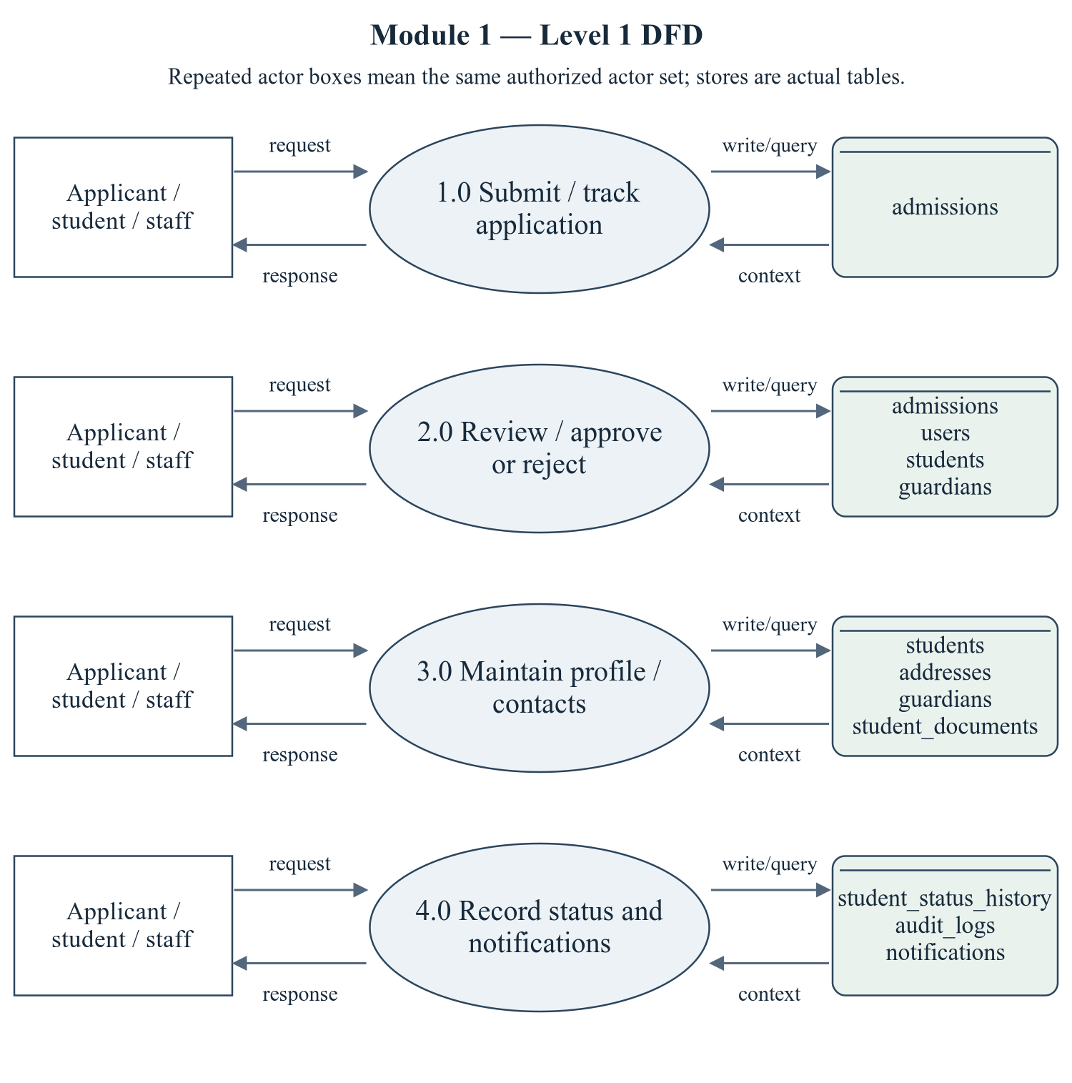
Figure 2.1 Student and Admission Management — Level 1 DFD
The repeated actor boxes denote the same permitted actor set. Ellipses are module processes; D stores list actual persisted tables. Arrows represent request/response and query/write context, not proof of successful operations.
Editable drawing source: diagrams/05_module_01_dfd_level1.svg, .dot and .mmd. Edit SVG text/shapes in a vector editor, or regenerate from DOT/Mermaid; retain FK IDs and source names. These figures were created from static source, not captured from a running ERP.
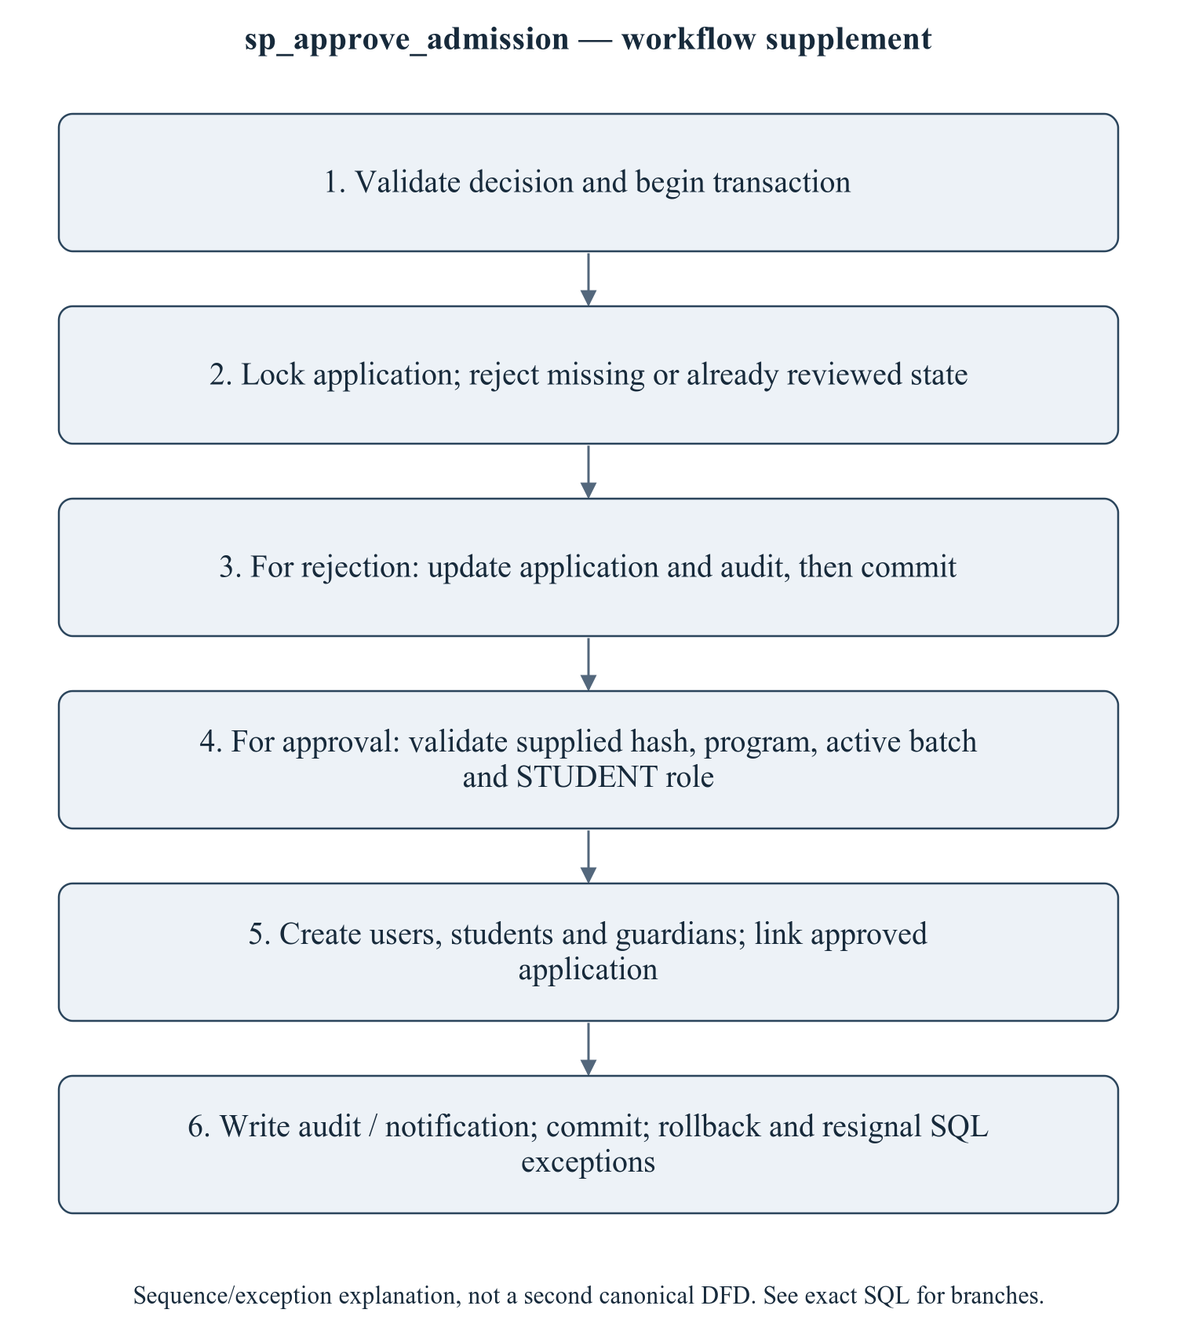
Figure 2.2 sp_approve_admission — workflow supplement
This sequence refines the critical procedure for explanation; it is explicitly a control/transaction workflow supplement, not a mislabeled canonical Level 2 DFD. The Level 1 DFD provides the formal module data-flow view. A second approval must not create another identity. Batch/year and email uniqueness failures should leave no partial account. Existing API/SQL test fixtures need the current password-hash argument; no temporary password is printed in this package.
Editable drawing source: diagrams/06_module_01_procedure_workflow.svg, .dot and .mmd. Edit SVG text/shapes in a vector editor, or regenerate from DOT/Mermaid; retain FK IDs and source names. These figures were created from static source, not captured from a running ERP.

2.1.2.1 Sub-System Processes, Data Stores (Tables), and External Data Movement
Table 2.1 Student and Admission Management — processes and real stores
Process | Actual stores | External movement / integration
1.0 Submit / track application | admissions | Authorized actor request/response; shared master/FK data are internal context, not invented external systems.
2.0 Review / approve or reject | admissions, users, students, guardians | Authorized actor request/response; shared master/FK data are internal context, not invented external systems.
3.0 Maintain profile / contacts | students, addresses, guardians, student_documents | Authorized actor request/response; shared master/FK data are internal context, not invented external systems.
4.0 Record status and notifications | student_status_history, audit_logs, notifications | Authorized actor request/response; shared master/FK data are internal context, not invented external systems.

2.1.3 Sub-Schema & Relational Data Dictionary
Relational notation below lists actual attributes. The full dictionary supplies types/nullability/defaults/constraints; PK/FK notation does not invent undeclared relationships.
students( student_id, user_id, roll_number, registration_number, first_name, middle_name, last_name, email, phone, date_of_birth, gender, blood_group, nationality, category_id, department_id, program_id, batch_id, admission_year, admission_date, current_semester_no, status, photo_url, emergency_contact, created_at, updated_at). PK={student_id}; FK IDs={FK010,FK011,FK012,FK013,FK014}.
addresses( address_id, student_id, address_type, line1, line2, city, district, state, pincode, country, is_primary, created_at, updated_at). PK={address_id}; FK IDs={FK015}.
guardians( guardian_id, student_id, name, relation, phone, email, occupation, annual_income, is_primary, created_at, updated_at). PK={guardian_id}; FK IDs={FK016}.
admissions( admission_id, application_no, student_id, academic_year_id, program_id, category_id, first_name, last_name, email, phone, date_of_birth, gender, guardian_name, guardian_phone, previous_school, qualification, marks_10, marks_12, entrance_score, address_line1, city, state, pincode, application_date, status, reviewed_by, reviewed_at, remarks, created_at, updated_at). PK={admission_id}; FK IDs={FK017,FK018,FK019,FK020,FK021}.
student_documents( document_id, student_id, doc_type, file_name, file_path, mime_type, size_bytes, is_verified, verified_by, verified_at, uploaded_at). PK={document_id}; FK IDs={FK022,FK023}.
student_status_history( history_id, student_id, old_status, new_status, reason, changed_by, changed_at). PK={history_id}; FK IDs={FK024,FK025}.
The complete column/constraint dictionary for these exact relations is in 1.6; it is not copied a second time here. The module report repeats its own complete dictionary for independent use. class_sessions remains a joint G2/G3 contract.
Table 2.2 Shared / cross-module key contracts (not duplicated ownership)
Parent table / key | Module relationship | Declared action / FK ID
academic_years, PK academic_year_id | admissions.academic_year_id → academic_year_id | FK018: ON DELETE RESTRICT
batches, PK batch_id | students.batch_id → batch_id | FK014: ON DELETE RESTRICT
categories, PK category_id | students.category_id → category_id; admissions.category_id → category_id | FK011: ON DELETE RESTRICT; FK020: ON DELETE RESTRICT
departments, PK department_id | students.department_id → department_id | FK012: ON DELETE RESTRICT
programs, PK program_id | students.program_id → program_id; admissions.program_id → program_id | FK013: ON DELETE RESTRICT; FK019: ON DELETE RESTRICT
users, PK user_id | students.user_id → user_id; admissions.reviewed_by → user_id; student_documents.verified_by → user_id; student_status_history.changed_by → user_id | FK010: ON DELETE CASCADE; FK021: ON DELETE SET NULL; FK023: ON DELETE SET NULL; FK025: ON DELETE SET NULL

The table dictionaries in this module cover its persisted schema in full. External parents above retain their original ownership; their complete 677-column enterprise dictionary is supplied in the master report and inventory workbook. Shared contracts are repeated here so this module can be read independently without pretending to own another module's tables.

2.1.4 Advanced SQL Implementation

2.1.4.1 Stored Procedures (SQL Code & Execution Proofs)

sp_approve_admission
Purpose / expected behavior: Approve/reject one reviewable application. Approval locks context and creates a first-login user, student and guardian, links the application and writes audit/notification. Requires a supplied temporary hash; no secret value is included here.
Source: database/05_procedures.sql:985–1146. Definition found in the pinned snapshot; live existence and execution are unverified. Exact source comments may be stale; only inventoried definitions establish object names.
IN p_admission_id: INT UNSIGNED
IN p_reviewed_by: INT UNSIGNED
IN p_approve: TINYINT
IN p_remarks: VARCHAR(500)
IN p_password_hash: VARCHAR(255)
OUT p_student_id: INT UNSIGNED
OUT p_message: VARCHAR(255)
Outputs: p_student_id INT UNSIGNED, p_message VARCHAR(255)
Read/write dependencies: admissions, audit_logs, batches, guardians, programs, roles, students, users, v_admission_state, v_admission_year, v_app, v_batch, v_cat, v_dept, v_dob, v_email, v_first, v_gender, v_gphone, v_guardian, v_last, v_phone, v_prog, v_program_code, v_program_tag, v_regno, v_role, v_roll, v_seq, v_user, v_year
Routine calls: sp_push_notification
Transaction boundary: Explicit START TRANSACTION / COMMIT and SQLEXCEPTION handling in the definition.
Invocation template (not executed): bind every @ input to a mutually consistent synthetic fixture selected from the declared tables and run only on an authorized disposable schema. Numeric literals below are planned test inputs, not observed results. Internal COMMIT means wrapping a CALL in an outer ROLLBACK is not a safe fixture-cleanup strategy.
CALL sp_approve_admission(@p_admission_id, @p_reviewed_by, @p_approve, @p_remarks, @p_password_hash, @p_student_id, @p_message);
SELECT @p_student_id AS p_student_id, @p_message AS p_message;

Actual result: [[TO BE PROVIDED: run this test and record the actual result]]
Status: [[TO BE PROVIDED: run this test and record the actual result]]
Required evidence: [[TO BE PROVIDED: execute sp_approve_admission or its triggering DML using the corresponding module test case; owner must attach sanitized inputs, OUT/SELECT/error output, before/after effects and timestamp]]
Exact SQL definition (unchanged from source):
CREATE PROCEDURE `sp_approve_admission`(
IN p_admission_id INT UNSIGNED,
IN p_reviewed_by INT UNSIGNED,
IN p_approve TINYINT,
IN p_remarks VARCHAR(500),
IN p_password_hash VARCHAR(255),
OUT p_student_id INT UNSIGNED,
OUT p_message VARCHAR(255)
)
BEGIN
DECLARE v_app VARCHAR(30) DEFAULT NULL;
DECLARE v_first VARCHAR(80) DEFAULT NULL;
DECLARE v_last VARCHAR(80) DEFAULT NULL;
DECLARE v_email VARCHAR(150) DEFAULT NULL;
DECLARE v_phone VARCHAR(20) DEFAULT NULL;
DECLARE v_dob DATE DEFAULT NULL;
DECLARE v_gender VARCHAR(10) DEFAULT NULL;
DECLARE v_prog SMALLINT UNSIGNED DEFAULT NULL;
DECLARE v_cat TINYINT UNSIGNED DEFAULT NULL;
DECLARE v_year SMALLINT UNSIGNED DEFAULT NULL;
DECLARE v_guardian VARCHAR(120) DEFAULT NULL;
DECLARE v_gphone VARCHAR(20) DEFAULT NULL;
DECLARE v_admission_state VARCHAR(20) DEFAULT NULL;
DECLARE v_dept INT UNSIGNED DEFAULT NULL;
DECLARE v_batch SMALLINT UNSIGNED DEFAULT NULL;
DECLARE v_admission_year SMALLINT UNSIGNED DEFAULT NULL;
DECLARE v_role TINYINT UNSIGNED DEFAULT NULL;
DECLARE v_user INT UNSIGNED DEFAULT NULL;
DECLARE v_roll VARCHAR(20) DEFAULT NULL;
DECLARE v_regno VARCHAR(30) DEFAULT NULL;
DECLARE v_program_code VARCHAR(20) DEFAULT NULL;
DECLARE v_program_tag VARCHAR(20) DEFAULT NULL;
DECLARE v_seq INT DEFAULT NULL;

DECLARE EXIT HANDLER FOR SQLEXCEPTION
BEGIN
ROLLBACK;
RESIGNAL;
END;

SET p_student_id = NULL;
SET p_message = NULL;

IF p_approve NOT IN (0, 1) THEN
SIGNAL SQLSTATE '45000' SET MESSAGE_TEXT = 'Invalid admission decision.';
END IF;

START TRANSACTION;

SELECT `application_no`, `first_name`, `last_name`, `email`, `phone`, `date_of_birth`,
`gender`, `program_id`, `category_id`, `academic_year_id`, `guardian_name`,
`guardian_phone`, `status`, `student_id`
INTO v_app, v_first, v_last, v_email, v_phone, v_dob, v_gender, v_prog, v_cat,
v_year, v_guardian, v_gphone, v_admission_state, p_student_id
FROM `admissions`
WHERE `admission_id` = p_admission_id
FOR UPDATE;

IF v_app IS NULL THEN
SIGNAL SQLSTATE '45000' SET MESSAGE_TEXT = 'Admission application not found.';
END IF;

IF v_admission_state NOT IN ('APPLIED', 'UNDER_REVIEW', 'WAITLISTED') THEN
SIGNAL SQLSTATE '45000' SET MESSAGE_TEXT = 'This application has already been reviewed.';
END IF;

IF p_approve = 0 THEN
UPDATE `admissions`
SET `status` = 'REJECTED', `reviewed_by` = p_reviewed_by,
`reviewed_at` = NOW(), `remarks` = p_remarks
WHERE `admission_id` = p_admission_id;

INSERT INTO `audit_logs` (`user_id`, `action`, `entity`, `entity_id`, `description`)
VALUES (p_reviewed_by, 'REJECT', 'admissions', p_admission_id,
CONCAT('Admission ', v_app, ' rejected'));

SET p_message = 'Application rejected.';
COMMIT;
ELSE
IF p_student_id IS NOT NULL THEN
SIGNAL SQLSTATE '45000'
SET MESSAGE_TEXT = 'This application has already been converted into a student.';
END IF;
IF p_password_hash IS NULL OR CHAR_LENGTH(p_password_hash) < 20 THEN
SIGNAL SQLSTATE '45000' SET MESSAGE_TEXT = 'A valid temporary password hash is required.';
END IF;

SELECT `department_id`, `program_code`
INTO v_dept, v_program_code
FROM `programs`
WHERE `program_id` = v_prog;

IF v_dept IS NULL OR v_program_code IS NULL THEN
SIGNAL SQLSTATE '45000' SET MESSAGE_TEXT = 'The selected program is no longer available.';
END IF;

SELECT `batch_id`, `start_year`
INTO v_batch, v_admission_year
FROM `batches`
WHERE `program_id` = v_prog AND `academic_year_id` = v_year AND `status` = 'ACTIVE'
ORDER BY `batch_id` ASC
LIMIT 1
FOR UPDATE;

IF v_batch IS NULL OR v_admission_year IS NULL THEN
SIGNAL SQLSTATE '45000'
SET MESSAGE_TEXT = 'No batch exists for this program and academic year.';
END IF;

SELECT `role_id` INTO v_role FROM `roles` WHERE `role_code` = 'STUDENT' LIMIT 1;
IF v_role IS NULL THEN
SIGNAL SQLSTATE '45000' SET MESSAGE_TEXT = 'The student role is not configured.';
END IF;

IF EXISTS (SELECT 1 FROM `users` WHERE `email` = v_email) THEN
SIGNAL SQLSTATE '45000' SET MESSAGE_TEXT = 'A user with this email already exists.';
END IF;

INSERT INTO `users`
(`role_id`, `email`, `password_hash`, `phone`, `is_active`, `is_first_login`)
VALUES (v_role, LOWER(TRIM(v_email)), p_password_hash, v_phone, 1, 1);
SET v_user = LAST_INSERT_ID();

SELECT COALESCE(MAX(CAST(RIGHT(`roll_number`, 4) AS UNSIGNED)), 1000) + 1
INTO v_seq
FROM `students`
WHERE `admission_year` = v_admission_year AND `program_id` = v_prog;

SET v_program_tag = REPLACE(REPLACE(v_program_code, 'BTECH-', ''), 'MTECH-', 'M');
SET v_roll = CONCAT(v_admission_year, v_program_tag, LPAD(v_seq, 4, '0'));
SET v_regno = CONCAT('PICT/', v_admission_year, '/', v_program_tag, '/', LPAD(v_seq, 4, '0'));

INSERT INTO `students`
(`user_id`, `roll_number`, `registration_number`, `first_name`, `last_name`, `email`,
`phone`, `date_of_birth`, `gender`, `category_id`, `department_id`, `program_id`,
`batch_id`, `admission_year`, `admission_date`, `current_semester_no`, `status`)
VALUES
(v_user, v_roll, v_regno, v_first, v_last, LOWER(TRIM(v_email)), v_phone, v_dob, v_gender,
v_cat, v_dept, v_prog, v_batch, v_admission_year, CURDATE(), 1, 'ACTIVE');

SET p_student_id = LAST_INSERT_ID();

INSERT INTO `guardians` (`student_id`, `name`, `relation`, `phone`, `is_primary`)
VALUES (p_student_id, v_guardian, 'FATHER', v_gphone, 1);

UPDATE `admissions`
SET `status` = 'APPROVED', `student_id` = p_student_id, `reviewed_by` = p_reviewed_by,
`reviewed_at` = NOW(), `remarks` = IFNULL(p_remarks, 'Approved')
WHERE `admission_id` = p_admission_id;

INSERT INTO `audit_logs` (`user_id`, `action`, `entity`, `entity_id`, `description`)
VALUES (p_reviewed_by, 'APPROVE', 'admissions', p_admission_id,
CONCAT('Admission approved - student ', v_roll, ' created'));

CALL sp_push_notification(v_user, 'Admission approved',
CONCAT('Your application has been approved. Your roll number is ', v_roll, '.'),
'ADMISSION', 'SUCCESS', 'student', p_student_id, '/profile');

SET p_message = CONCAT('Admission approved. Student ', v_roll, ' created.');
COMMIT;
END IF;
END$$

2.1.4.2 Database Triggers (SQL Code & Execution Proofs)

trg_students_bi_validate
Purpose / expected behavior: Validate a newly inserted student date of birth and phone under the exact IF conditions; raise SQLSTATE 45000 for rejected data.
Source: database/06_triggers.sql:29–38. Definition found in the pinned snapshot; live existence and execution are unverified. Exact source comments may be stale; only inventoried definitions establish object names.
Event / inputs / output: BEFORE INSERT ON `students` FOR EACH ROW; OLD/NEW are event-appropriate row images; no explicit arguments or scalar return. Side effects are described above.
Read/write dependencies: students
Routine calls: No other stored routine call extracted.
Invocation template (not executed): bind every @ input to a mutually consistent synthetic fixture selected from the declared tables and run only on an authorized disposable schema. Numeric literals below are planned test inputs, not observed results. Internal COMMIT means wrapping a CALL in an outer ROLLBACK is not a safe fixture-cleanup strategy.
CALL sp_approve_admission(@p_admission_id, @p_reviewed_by, 1, NULL, @p_password_hash, @p_student_id, @p_message);

Actual result: [[TO BE PROVIDED: run this test and record the actual result]]
Status: [[TO BE PROVIDED: run this test and record the actual result]]
Required evidence: [[TO BE PROVIDED: execute trg_students_bi_validate or its triggering DML using the corresponding module test case; owner must attach sanitized inputs, OUT/SELECT/error output, before/after effects and timestamp]]
Exact SQL definition (unchanged from source):
CREATE TRIGGER `trg_students_bi_validate`
BEFORE INSERT ON `students` FOR EACH ROW
BEGIN
IF NEW.`date_of_birth` >= CURDATE() THEN
SIGNAL SQLSTATE '45000' SET MESSAGE_TEXT = 'Date of birth must be in the past.';
END IF;
IF NEW.`email` NOT LIKE '%@%' THEN
SIGNAL SQLSTATE '45000' SET MESSAGE_TEXT = 'Student email address is not valid.';
END IF;
END$$

trg_students_bu_validate
Purpose / expected behavior: Validate changed student dates/contact data before update; the exact conditional comparisons in the definition determine the checked changes.
Source: database/06_triggers.sql:41–47. Definition found in the pinned snapshot; live existence and execution are unverified. Exact source comments may be stale; only inventoried definitions establish object names.
Event / inputs / output: BEFORE UPDATE ON `students` FOR EACH ROW; OLD/NEW are event-appropriate row images; no explicit arguments or scalar return. Side effects are described above.
Read/write dependencies: students
Routine calls: No other stored routine call extracted.
Invocation template (not executed): bind every @ input to a mutually consistent synthetic fixture selected from the declared tables and run only on an authorized disposable schema. Numeric literals below are planned test inputs, not observed results. Internal COMMIT means wrapping a CALL in an outer ROLLBACK is not a safe fixture-cleanup strategy.
UPDATE students SET date_of_birth = CURDATE() WHERE student_id = @fixture_student_id;

Actual result: [[TO BE PROVIDED: run this test and record the actual result]]
Status: [[TO BE PROVIDED: run this test and record the actual result]]
Required evidence: [[TO BE PROVIDED: execute trg_students_bu_validate or its triggering DML using the corresponding module test case; owner must attach sanitized inputs, OUT/SELECT/error output, before/after effects and timestamp]]
Exact SQL definition (unchanged from source):
CREATE TRIGGER `trg_students_bu_validate`
BEFORE UPDATE ON `students` FOR EACH ROW
BEGIN
IF NEW.`date_of_birth` >= CURDATE() THEN
SIGNAL SQLSTATE '45000' SET MESSAGE_TEXT = 'Date of birth must be in the past.';
END IF;
END$$

trg_students_au_status_history
Purpose / expected behavior: When status changes, append old/new status and contextual metadata to student_status_history. It does not cover every profile-field update.
Source: database/06_triggers.sql:50–58. Definition found in the pinned snapshot; live existence and execution are unverified. Exact source comments may be stale; only inventoried definitions establish object names.
Event / inputs / output: AFTER UPDATE ON `students` FOR EACH ROW; OLD/NEW are event-appropriate row images; no explicit arguments or scalar return. Side effects are described above.
Read/write dependencies: student_status_history, students
Routine calls: No other stored routine call extracted.
Invocation template (not executed): bind every @ input to a mutually consistent synthetic fixture selected from the declared tables and run only on an authorized disposable schema. Numeric literals below are planned test inputs, not observed results. Internal COMMIT means wrapping a CALL in an outer ROLLBACK is not a safe fixture-cleanup strategy.
UPDATE students SET status = 'SUSPENDED' WHERE student_id = @fixture_student_id;

Actual result: [[TO BE PROVIDED: run this test and record the actual result]]
Status: [[TO BE PROVIDED: run this test and record the actual result]]
Required evidence: [[TO BE PROVIDED: execute trg_students_au_status_history or its triggering DML using the corresponding module test case; owner must attach sanitized inputs, OUT/SELECT/error output, before/after effects and timestamp]]
Exact SQL definition (unchanged from source):
CREATE TRIGGER `trg_students_au_status_history`
AFTER UPDATE ON `students` FOR EACH ROW
BEGIN
IF OLD.`status` <> NEW.`status` THEN
INSERT INTO `student_status_history` (`student_id`, `old_status`, `new_status`, `reason`)
VALUES (NEW.`student_id`, OLD.`status`, NEW.`status`,
CONCAT('Status changed from ', OLD.`status`, ' to ', NEW.`status`));
END IF;
END$$

trg_admissions_bi_validate
Purpose / expected behavior: Reject invalid application date-of-birth/phone conditions before insertion, independently of API schema checks.
Source: database/06_triggers.sql:61–71. Definition found in the pinned snapshot; live existence and execution are unverified. Exact source comments may be stale; only inventoried definitions establish object names.
Event / inputs / output: BEFORE INSERT ON `admissions` FOR EACH ROW; OLD/NEW are event-appropriate row images; no explicit arguments or scalar return. Side effects are described above.
Read/write dependencies: admissions
Routine calls: No other stored routine call extracted.
Invocation template (not executed): bind every @ input to a mutually consistent synthetic fixture selected from the declared tables and run only on an authorized disposable schema. Numeric literals below are planned test inputs, not observed results. Internal COMMIT means wrapping a CALL in an outer ROLLBACK is not a safe fixture-cleanup strategy.
-- Invoke through POST /api/v1/students/admissions/apply with a complete synthetic application payload (M1-03); the route/service supplies INSERT admissions.

Actual result: [[TO BE PROVIDED: run this test and record the actual result]]
Status: [[TO BE PROVIDED: run this test and record the actual result]]
Required evidence: [[TO BE PROVIDED: execute trg_admissions_bi_validate or its triggering DML using the corresponding module test case; owner must attach sanitized inputs, OUT/SELECT/error output, before/after effects and timestamp]]
Exact SQL definition (unchanged from source):
CREATE TRIGGER `trg_admissions_bi_validate`
BEFORE INSERT ON `admissions` FOR EACH ROW
BEGIN
IF NEW.`date_of_birth` >= CURDATE() THEN
SIGNAL SQLSTATE '45000' SET MESSAGE_TEXT = 'Applicant date of birth must be in the past.';
END IF;
IF NEW.`marks_12` < 35.00 THEN
SIGNAL SQLSTATE '45000'
SET MESSAGE_TEXT = 'Applicant does not meet the minimum qualifying marks (35%).';
END IF;
END$$

2.1.4.3 User-Defined Functions (UDFs) (SQL Code & Execution Proofs)
No implementation was found in the inspected repository. Confirm whether this feature is required and implement it if necessary.
No module-owned UDF is defined; shared/referenced attendance, finance or result UDFs are identified at their consumers. This statement does not mean the whole ERP lacks functions.

2.1.5 Complex Analytical Queries & Views

v_student_full_profile
Purpose / expected behavior: Join student, identity and academic/category/batch masters into a profile projection. It is not a table and not evidence of current live records.
Source: database/08_views.sql:19–36. Definition found in the pinned snapshot; live existence and execution are unverified. Exact source comments may be stale; only inventoried definitions establish object names.
Inputs / output: No parameters; SELECT returns columns: student_id, roll_number, registration_number, user_id, full_name, first_name, last_name, email, phone, date_of_birth, gender, blood_group, status, photo_url, current_semester_no, admission_year, admission_date, department_id, department_code, department_name, program_id, program_code, program_name, program_level, batch_id, batch_code, batch_start_year, batch_end_year, category_id, category_code, category_name, login_active, last_login_at, age. WHERE/JOIN predicates are query inputs, not stored view parameters.
Read/write dependencies: batches, categories, departments, programs, students, users
Routine calls: No other stored routine call extracted.
Invocation template (not executed): bind every @ input to a mutually consistent synthetic fixture selected from the declared tables and run only on an authorized disposable schema. Numeric literals below are planned test inputs, not observed results. Internal COMMIT means wrapping a CALL in an outer ROLLBACK is not a safe fixture-cleanup strategy.
SELECT * FROM v_student_full_profile LIMIT 10;

Actual result: [[TO BE PROVIDED: run this test and record the actual result]]
Status: [[TO BE PROVIDED: run this test and record the actual result]]
Required evidence: [[TO BE PROVIDED: execute v_student_full_profile or its triggering DML using the corresponding module test case; owner must attach sanitized inputs, OUT/SELECT/error output, before/after effects and timestamp]]
Exact SQL definition (unchanged from source):
CREATE OR REPLACE VIEW `v_student_full_profile` AS
SELECT s.`student_id`, s.`roll_number`, s.`registration_number`, s.`user_id`,
CONCAT(s.`first_name`, ' ', IFNULL(CONCAT(s.`middle_name`, ' '), ''), s.`last_name`) AS `full_name`,
s.`first_name`, s.`last_name`, s.`email`, s.`phone`, s.`date_of_birth`, s.`gender`,
s.`blood_group`, s.`status`, s.`photo_url`, s.`current_semester_no`, s.`admission_year`,
s.`admission_date`,
d.`department_id`, d.`department_code`, d.`name` AS `department_name`,
p.`program_id`, p.`program_code`, p.`name` AS `program_name`, p.`level` AS `program_level`,
b.`batch_id`, b.`batch_code`, b.`start_year` AS `batch_start_year`, b.`end_year` AS `batch_end_year`,
c.`category_id`, c.`category_code`, c.`name` AS `category_name`,
u.`is_active` AS `login_active`, u.`last_login_at`,
TIMESTAMPDIFF(YEAR, s.`date_of_birth`, CURDATE()) AS `age`
FROM `students` s
JOIN `departments` d ON d.`department_id` = s.`department_id`
JOIN `programs` p ON p.`program_id` = s.`program_id`
JOIN `batches` b ON b.`batch_id` = s.`batch_id`
JOIN `categories` c ON c.`category_id` = s.`category_id`
JOIN `users` u ON u.`user_id` = s.`user_id`;

Q15 identifies possible duplicate students by name/date of birth. Q43 aggregates the admission funnel with ROLLUP; its source comment about CUBE/GROUPING SETS is not an implemented MySQL feature and is not a basis for a capability claim. [R08]

Q15 — Data-quality check — possible duplicate students (same name + DOB)
Source: database/09_queries.sql:351. Purpose is the query projection/aggregation below; no output rows have been generated. Expected column structure follows aliases in the exact statement.
SELECT s.first_name,
s.last_name,
s.date_of_birth,
COUNT(*) AS records,
GROUP_CONCAT(s.roll_number ORDER BY s.roll_number SEPARATOR ', ') AS roll_numbers
FROM students s
GROUP BY s.first_name, s.last_name, s.date_of_birth
HAVING COUNT(*) > 1
ORDER BY records DESC;

Actual result: [[TO BE PROVIDED: run this test and record the actual result]]
Status: [[TO BE PROVIDED: run this test and record the actual result]]

Q43 — Admission funnel — applications by status and category
Source: database/09_queries.sql:1119. Purpose is the query projection/aggregation below; no output rows have been generated. Expected column structure follows aliases in the exact statement.
SELECT * FROM (
SELECT IFNULL(c.name, '— ALL CATEGORIES —') AS category,
IFNULL(a.status, '— TOTAL —') AS admission_status,
COUNT(*) AS applications,
ROUND(AVG(a.entrance_score), 1) AS avg_entrance_score
FROM admissions a
LEFT JOIN categories c ON c.category_id = a.category_id
GROUP BY c.name, a.status WITH ROLLUP
) rollup
ORDER BY category, admission_status;

Actual result: [[TO BE PROVIDED: run this test and record the actual result]]
Status: [[TO BE PROVIDED: run this test and record the actual result]]

2.1.6 Backend, Frontend, Validation & Transaction Trace
Table 2.3 Student and Admission Management — exact API route/role register
Method and route | Role gate / handler | Validation and source
GET /api/v1/students | ADMIN, FACULTY, EXAM_CELL, ACCOUNTANT, HOSTEL_ADMIN, HR  Handler: list | No route-local Zod validation; service/DB checks may apply  backend/src/routes/student.routes.ts:112
GET /api/v1/students/stats | ADMIN, FACULTY, EXAM_CELL  Handler: stats | No route-local Zod validation; service/DB checks may apply  backend/src/routes/student.routes.ts:113
GET /api/v1/students/my/documents | STUDENT  Handler: documents | No route-local Zod validation; service/DB checks may apply  backend/src/routes/student.routes.ts:114
GET /api/v1/students/my/addresses | STUDENT  Handler: addresses | No route-local Zod validation; service/DB checks may apply  backend/src/routes/student.routes.ts:115
GET /api/v1/students/admissions/options | Public  Handler: admissionOptions | No route-local Zod validation; service/DB checks may apply  backend/src/routes/student.routes.ts:120
POST /api/v1/students/admissions/apply | Public  Handler: apply | Zod validate(...) in route  backend/src/routes/student.routes.ts:121
GET /api/v1/students/admissions/stats | ADMIN  Handler: admissionStats | No route-local Zod validation; service/DB checks may apply  backend/src/routes/student.routes.ts:122
GET /api/v1/students/admissions | ADMIN  Handler: admissions | No route-local Zod validation; service/DB checks may apply  backend/src/routes/student.routes.ts:123
GET /api/v1/students/admissions/:id | ADMIN  Handler: admission | No route-local Zod validation; service/DB checks may apply  backend/src/routes/student.routes.ts:124
POST /api/v1/students/admissions/:id/review | ADMIN  Handler: reviewAdmission | Zod validate(...) in route  backend/src/routes/student.routes.ts:125
GET /api/v1/students/:id | Authenticated; row scope must be inspected  Handler: detail | No route-local Zod validation; service/DB checks may apply  backend/src/routes/student.routes.ts:132
POST /api/v1/students | ADMIN  Handler: create | Zod validate(...) in route  backend/src/routes/student.routes.ts:133
PUT /api/v1/students/:id | ADMIN  Handler: update | Zod validate(...) in route  backend/src/routes/student.routes.ts:134
DELETE /api/v1/students/:id | ADMIN  Handler: remove | No route-local Zod validation; service/DB checks may apply  backend/src/routes/student.routes.ts:135
PATCH /api/v1/students/:id/status | ADMIN  Handler: changeStatus | Zod validate(...) in route  backend/src/routes/student.routes.ts:136
PATCH /api/v1/students/:id/account-status | ADMIN  Handler: setAccountStatus | Zod validate(...) in route  backend/src/routes/student.routes.ts:140
GET /api/v1/students/:id/addresses | Authenticated; row scope must be inspected  Handler: addresses | No route-local Zod validation; service/DB checks may apply  backend/src/routes/student.routes.ts:144
PUT /api/v1/students/:id/addresses | ADMIN  Handler: saveAddress | No route-local Zod validation; service/DB checks may apply  backend/src/routes/student.routes.ts:145
GET /api/v1/students/:id/guardians | Authenticated; row scope must be inspected  Handler: guardians | No route-local Zod validation; service/DB checks may apply  backend/src/routes/student.routes.ts:146
PUT /api/v1/students/:id/guardians | ADMIN  Handler: saveGuardian | No route-local Zod validation; service/DB checks may apply  backend/src/routes/student.routes.ts:147
GET /api/v1/students/:id/documents | Authenticated; row scope must be inspected  Handler: documents | No route-local Zod validation; service/DB checks may apply  backend/src/routes/student.routes.ts:148
POST /api/v1/students/:id/documents | ADMIN  Handler: addDocument | No route-local Zod validation; service/DB checks may apply  backend/src/routes/student.routes.ts:149

backend/src/controllers/student.controller.ts: Exports: list, detail, stats, create, update, remove, changeStatus, setAccountStatus, addresses, saveAddress, guardians, saveGuardian, documents, addDocument, admissionOptions, admissions, admissionStats, admission, apply, reviewAdmission. SQL references: .
backend/src/repositories/student.repository.ts: Exports: buildStudentWhere, listStudents, findStudent, findStudentByUserId, findStudentByRoll, insertStudent, updateStudent, setStudentAccountActive, deleteStudent, nextRollNumber, batchForProgram, addresses, upsertAddress, guardians, upsertGuardian, documents, addDocument, statusHistory, listAdmissions, findAdmission, admissionOptions, insertAdmission, admissionStats, studentStats, countBy, withConnection. SQL references: academic_years, addresses, admissions, batches, categories, enrollments, guardians, programs, student_documents, student_status_history, students, users, fn_calculate_student_cgpa, fn_student_backlog_count, fn_student_outstanding_dues, v_student_full_profile.
backend/src/services/student.service.ts: Exports: list, detail, stats, create, update, remove, changeStatus, setAccountStatus, addresses, saveAddress, guardians, saveGuardian, documents, addDocument, listAdmissions, admissionStats, findAdmission, admissionOptions, apply, reviewAdmission. SQL references: academic_years, admissions, batches, categories, faculty, programs, students, users, sp_approve_admission.
Frontend source pages: frontend/src/pages/students/AdmissionApplyPage.tsx; frontend/src/pages/students/AdmissionsPage.tsx; frontend/src/pages/students/EnrollmentsPage.tsx; frontend/src/pages/students/StudentDetailPage.tsx; frontend/src/pages/students/StudentsPage.tsx.
Controller → service → repository separation is present in source. mysql2 query/execute helpers bind values; callProc reads OUT parameters on one acquired connection. Some services write audit/notifications after the database operation on a separate pooled request, so a procedure transaction does not make every service side effect atomic. [R11, R09, R19]
Validation/error contract: route-local Zod schemas operate on request bodies where listed; the report does not infer validation for routes without validate(...). Services raise AppError for selected missing records/invalid inputs; DB FK/UNIQUE/CHECK/SIGNAL errors pass through the shared handler. HTTP statuses and payloads need API execution evidence, not invented response screenshots. [R10]
Exact route validation expressions (TypeScript/Zod, not SQL; no execution claim):
backend/src/routes/student.routes.ts:21 —
z.object({ id: z.coerce.number().int().positive() })

backend/src/routes/student.routes.ts:121 — router.post '/admissions/apply'
admissionApplySchema = z.object({
programId: z.coerce.number().int().positive(),
categoryId: z.coerce.number().int().positive(),
firstName: z.string().trim().min(1).max(80),
lastName: z.string().trim().min(1).max(80),
email: z.string().trim().email().max(150).toLowerCase(),
phone: z.string().trim().min(6).max(20),
dateOfBirth: dateOnly,
gender: z.enum(['MALE', 'FEMALE', 'OTHER']),
guardianName: z.string().trim().min(1).max(120),
guardianPhone: z.string().trim().min(6).max(20),
previousSchool: optionalText(160),
qualification: optionalText(80),
marks10: z.coerce.number().min(0).max(100),
marks12: z.coerce.number().min(35, '12th marks must be at least 35%').max(100),
entranceScore: z.coerce.number().min(0).max(200).optional(),
addressLine1: optionalText(160),
city: optionalText(80),
state: optionalText(80),
pincode: optionalText(10),
})

backend/src/routes/student.routes.ts:125 — router.post '/admissions/:id/review'
z.object({
approve: z.boolean(),
remarks: z.string().trim().max(500).optional(),
})

backend/src/routes/student.routes.ts:133 — router.post '/'
studentCreateSchema = z.object({
programId: z.coerce.number().int().positive(),
departmentId: z.coerce.number().int().positive(),
categoryId: z.coerce.number().int().positive(),
batchId: z.preprocess((value) => value === null || value === '' ? undefined : value,
z.coerce.number().int().positive().optional()),
firstName: z.string().trim().min(1, 'First name is required').max(80),
middleName: optionalText(80),
lastName: z.string().trim().min(1, 'Last name is required').max(80),
email: z.string().trim().email('Enter a valid email address').max(150).toLowerCase(),
phone: z.preprocess((value) => typeof value === 'string' && value.trim() === '' ? undefined : value,
z.string().trim().min(6).max(20).optional()),
dateOfBirth: dateOnly,
gender: z.enum(['MALE', 'FEMALE', 'OTHER']),
bloodGroup: z.enum(['A+', 'A-', 'B+', 'B-', 'AB+', 'AB-', 'O+', 'O-']).optional(),
admissionYear: z.coerce.number().int().min(1990).max(2100),
admissionDate: dateOnly.optional(),
currentSemesterNo: z.coerce.number().int().min(1).max(12).optional(),
emergencyContact: optionalText(20),
rollNumber: optionalText(20),
registrationNumber: optionalText(30),
status: studentStatus.optional(),
password: z.string().min(10).max(72).optional(),
address: z.object({
addressType: z.enum(['PERMANENT', 'CORRESPONDENCE', 'HOSTEL']).optional(),
line1: z.string().trim().min(1).max(160),
city: z.string().trim().min(1).max(80),
state: z.string().trim().min(1).max(80),
pincode: z.string().trim().min(4).max(10),
line2: optionalText(160),
country: optionalText(60),
}).optional(),
guardian: z.object({
name: z.string().trim().min(1).max(120),
relation: z.enum(['FATHER', 'MOTHER', 'GUARDIAN', 'SPOUSE', 'SIBLING']).optional(),
phone: z.string().trim().min(6).max(20),
email: z.string().trim().email().max(150).optional(),
occupation: optionalText(80),
annualIncome: z.coerce.number().min(0).optional(),
}).optional(),
})

backend/src/routes/student.routes.ts:134 — router.put '/:id'
studentPatchSchema = z.object({
firstName: z.string().trim().min(1).max(80).optional(),
middleName: optionalText(80),
lastName: z.string().trim().min(1).max(80).optional(),
email: z.string().trim().email().max(150).toLowerCase().optional(),
phone: z.preprocess((value) => typeof value === 'string' && value.trim() === '' ? undefined : value,
z.string().trim().min(6).max(20).nullable().optional()),
dateOfBirth: dateOnly.optional(),
gender: z.enum(['MALE', 'FEMALE', 'OTHER']).optional(),
bloodGroup: z.enum(['A+', 'A-', 'B+', 'B-', 'AB+', 'AB-', 'O+', 'O-']).nullable().optional(),
categoryId: z.coerce.number().int().positive().optional(),
departmentId: z.coerce.number().int().positive().optional(),
programId: z.coerce.number().int().positive().optional(),
batchId: z.coerce.number().int().positive().optional(),
admissionYear: z.coerce.number().int().min(1990).max(2100).optional(),
admissionDate: dateOnly.nullable().optional(),
currentSemesterNo: z.coerce.number().int().min(1).max(12).optional(),
rollNumber: z.string().trim().min(1).max(20).optional(),
registrationNumber: z.string().trim().min(1).max(30).optional(),
status: studentStatus.optional(),
emergencyContact: optionalText(20),
}).refine((body) => Object.keys(body).length > 0, 'Provide at least one field to update')

backend/src/routes/student.routes.ts:136 — router.patch '/:id/status'
z.object({
status: studentStatus,
reason: z.string().trim().min(1, 'Give a reason for the status change').max(500),
})

backend/src/routes/student.routes.ts:140 — router.patch '/:id/account-status'
z.object({
active: z.boolean(),
})

2.2 Academic and Course Management

2.2.1 Module Scope & Business Rules
Department/program/batch/year/semester lookups, subject CRUD, sections and class teachers, curriculum mappings in SQL, offerings, single and bulk enrollment, timetable CRUD and conflict inspection, academic calendar and faculty-subject assignment. Not every table has a complete standalone CRUD screen. [R12, R02]
Actors: ADMIN; FACULTY; STUDENT and authenticated readers according to individual routes. Administrative writes are role-gated; learner self-enrollment and staff bulk enrollment are different paths.
Motivation: Curriculum, a scheduled course offering and an individual enrollment are separate facts. Shared academic masters allow attendance, exams and payroll workload to refer to the same teaching context.
Implemented, static — Enrollment is UNIQUE by student_id/offering_id. The insert guard permits ACTIVE or SUSPENDED students and rejects only CANCELLED offerings; it is not an ACTIVE-only or OPEN-only gate.
Implemented, static — Insert/delete triggers maintain course_offerings.enrolled_count. All enrollment rows contribute; changing an enrollment to DROPPED does not execute the delete trigger.
Implemented, static — sp_bulk_enroll_students stages missing student/offering pairs for all ACTIVE students of the program; p_section_id filters offerings, not student batch/section membership. The temporary table avoids the mutating-table interaction. At-capacity prechecks may reject even a duplicate-only rerun.
Implemented, static — The timetable insert trigger checks overlapping faculty/section/room slots, rejects break intervals and checks applicable theory duration. An insert guard is not an equivalent update guard.
Shared implementation — class_sessions is located in the G2 schema block but is created/consumed by attendance routes. Shared academic masters remain enterprise tables, not additional module-specific copies.
Unverified / partial — Capacity, conflict checks, day/time boundary behavior and concurrent insert races are unexecuted. UI visibility and a successful TypeScript build do not establish scheduling correctness.

2.2.2 Module Data Flow Diagram (Level 1 / Level 2 DFD)
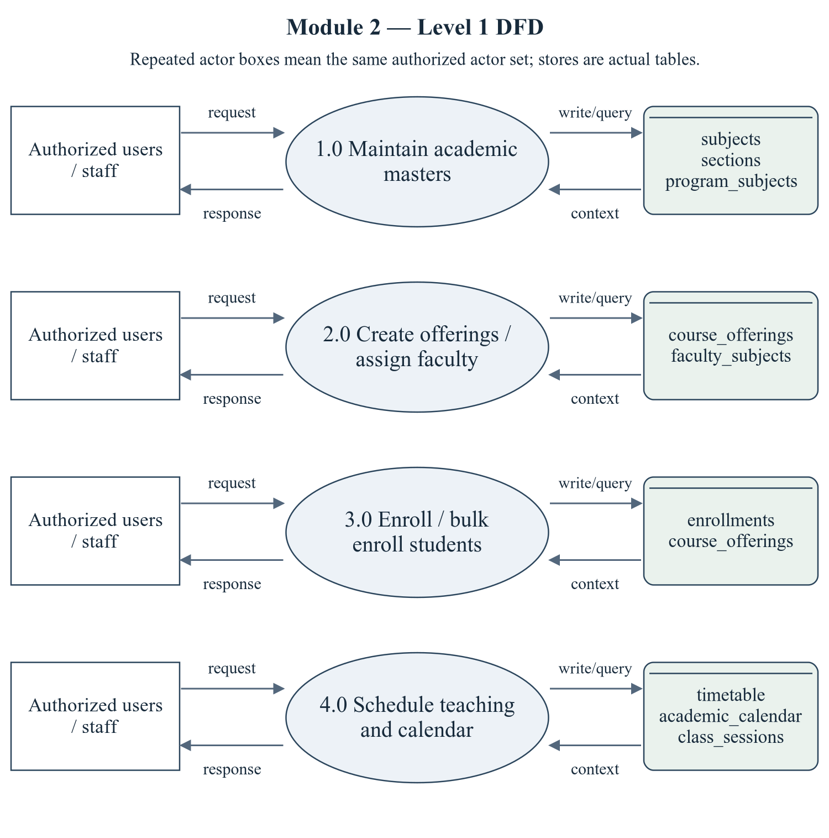
Figure 2.3 Academic and Course Management — Level 1 DFD
The repeated actor boxes denote the same permitted actor set. Ellipses are module processes; D stores list actual persisted tables. Arrows represent request/response and query/write context, not proof of successful operations.
Editable drawing source: diagrams/05_module_02_dfd_level1.svg, .dot and .mmd. Edit SVG text/shapes in a vector editor, or regenerate from DOT/Mermaid; retain FK IDs and source names. These figures were created from static source, not captured from a running ERP.
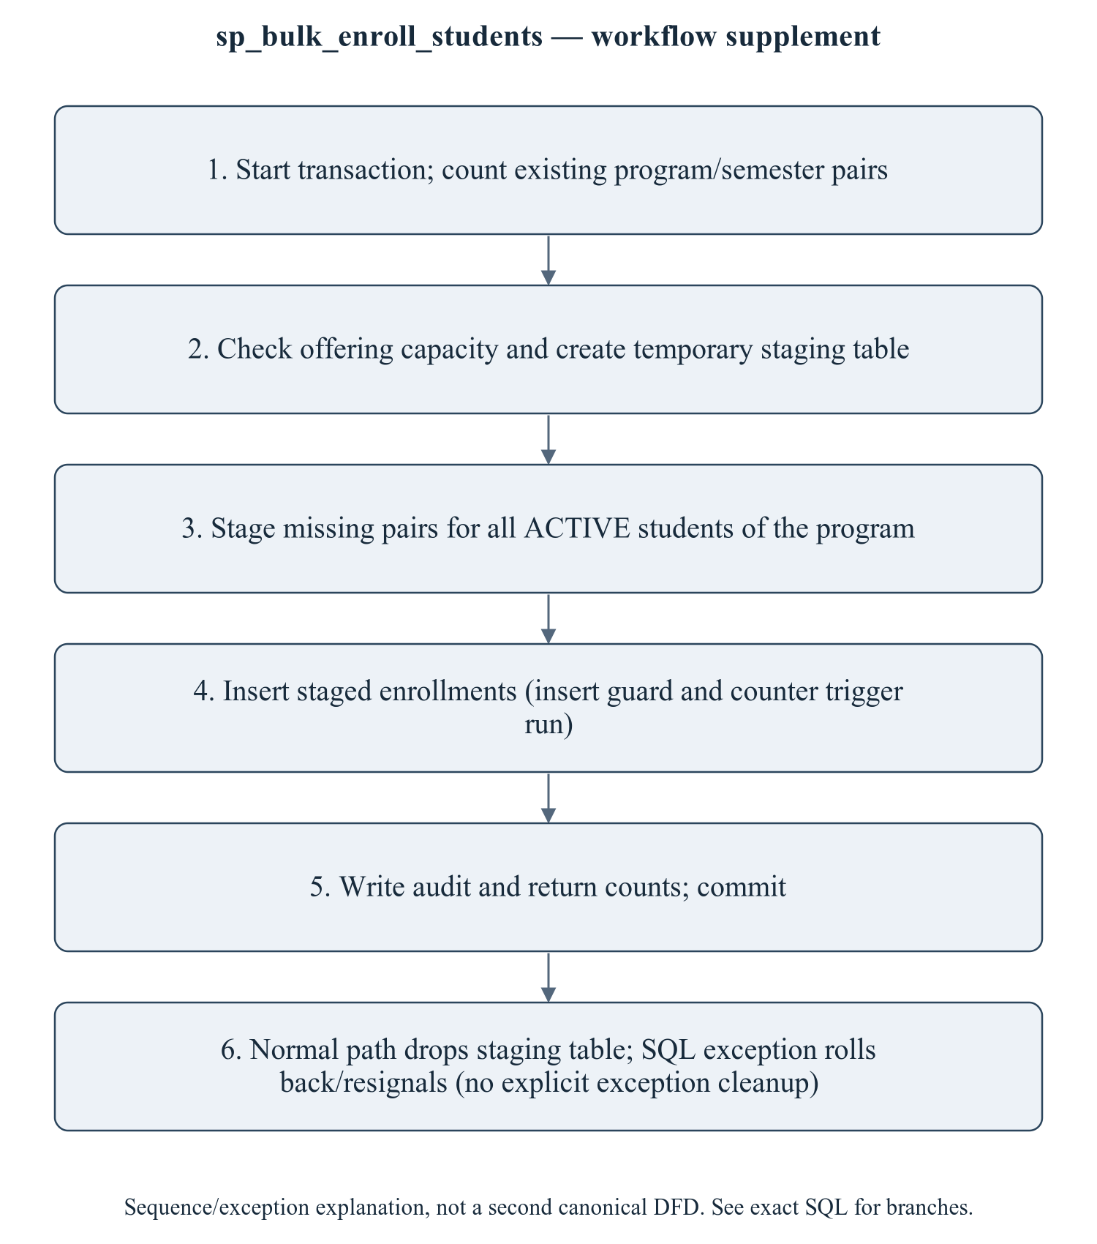
Figure 2.4 sp_bulk_enroll_students — workflow supplement
This sequence refines the critical procedure for explanation; it is explicitly a control/transaction workflow supplement, not a mislabeled canonical Level 2 DFD. The Level 1 DFD provides the formal module data-flow view. Enrollment status semantics and the counter meaning must be agreed before changing rows in place. The trigger guards insertion, while direct SQL UPDATE paths require separate tests. Timetable capacities and policy statements must follow actual code, not old documentation.
Editable drawing source: diagrams/06_module_02_procedure_workflow.svg, .dot and .mmd. Edit SVG text/shapes in a vector editor, or regenerate from DOT/Mermaid; retain FK IDs and source names. These figures were created from static source, not captured from a running ERP.

2.2.2.1 Sub-System Processes, Data Stores (Tables), and External Data Movement
Table 2.4 Academic and Course Management — processes and real stores
Process | Actual stores | External movement / integration
1.0 Maintain academic masters | subjects, sections, program_subjects | Authorized actor request/response; shared master/FK data are internal context, not invented external systems.
2.0 Create offerings / assign faculty | course_offerings, faculty_subjects | Authorized actor request/response; shared master/FK data are internal context, not invented external systems.
3.0 Enroll / bulk enroll students | enrollments, course_offerings | Authorized actor request/response; shared master/FK data are internal context, not invented external systems.
4.0 Schedule teaching and calendar | timetable, academic_calendar, class_sessions | Authorized actor request/response; shared master/FK data are internal context, not invented external systems.

2.2.3 Sub-Schema & Relational Data Dictionary
Relational notation below lists actual attributes. The full dictionary supplies types/nullability/defaults/constraints; PK/FK notation does not invent undeclared relationships.
sections( section_id, section_code, program_id, batch_id, semester_id, capacity, room_number, class_teacher_id, status). PK={section_id}; FK IDs={FK026,FK027,FK028,FK029}.
program_subjects( program_subject_id, program_id, subject_id, semester_no, is_elective). PK={program_subject_id}; FK IDs={FK030,FK031}.
course_offerings( offering_id, subject_id, semester_id, academic_year_id, program_id, section_id, faculty_id, capacity, enrolled_count, offering_type, status, created_at). PK={offering_id}; FK IDs={FK032,FK033,FK034,FK035,FK036,FK037}.
enrollments( enrollment_id, student_id, offering_id, enrolled_on, enrolled_by, grade, grade_points, status, created_at, updated_at). PK={enrollment_id}; FK IDs={FK038,FK039,FK040}.
faculty_subjects( allocation_id, faculty_id, subject_id, academic_year_id, semester_id, is_primary, assigned_on). PK={allocation_id}; FK IDs={FK041,FK042,FK043,FK044}.
timetable( timetable_id, offering_id, section_id, faculty_id, day_of_week, start_time, end_time, room_number, slot_label, is_active). PK={timetable_id}; FK IDs={FK045,FK046,FK047}.
academic_calendar( event_id, academic_year_id, semester_id, title, description, event_type, event_date, end_date, is_holiday, created_at). PK={event_id}; FK IDs={FK048,FK049}.
class_sessions( session_id, offering_id, faculty_id, semester_id, session_date, session_no, topic, room_number, start_time, end_time, status, created_at). PK={session_id}; FK IDs={FK050,FK051,FK052}.
The complete column/constraint dictionary for these exact relations is in 1.6; it is not copied a second time here. The module report repeats its own complete dictionary for independent use. class_sessions remains a joint G2/G3 contract.
Table 2.5 Shared / cross-module key contracts (not duplicated ownership)
Parent table / key | Module relationship | Declared action / FK ID
academic_years, PK academic_year_id | course_offerings.academic_year_id → academic_year_id; faculty_subjects.academic_year_id → academic_year_id; academic_calendar.academic_year_id → academic_year_id | FK034: ON DELETE CASCADE; FK042: ON DELETE CASCADE; FK048: ON DELETE CASCADE
batches, PK batch_id | sections.batch_id → batch_id | FK027: ON DELETE CASCADE
faculty, PK faculty_id | sections.class_teacher_id → faculty_id; course_offerings.faculty_id → faculty_id; faculty_subjects.faculty_id → faculty_id; timetable.faculty_id → faculty_id; class_sessions.faculty_id → faculty_id | FK029: ON DELETE SET NULL; FK037: ON DELETE SET NULL; FK044: ON DELETE CASCADE; FK047: ON DELETE CASCADE; FK052: ON DELETE CASCADE
programs, PK program_id | sections.program_id → program_id; program_subjects.program_id → program_id; course_offerings.program_id → program_id | FK026: ON DELETE CASCADE; FK030: ON DELETE CASCADE; FK035: ON DELETE CASCADE
semesters, PK semester_id | sections.semester_id → semester_id; course_offerings.semester_id → semester_id; faculty_subjects.semester_id → semester_id; academic_calendar.semester_id → semester_id; class_sessions.semester_id → semester_id | FK028: ON DELETE SET NULL; FK033: ON DELETE CASCADE; FK043: ON DELETE SET NULL; FK049: ON DELETE SET NULL; FK051: ON DELETE CASCADE
students, PK student_id | enrollments.student_id → student_id | FK038: ON DELETE CASCADE
subjects, PK subject_id | program_subjects.subject_id → subject_id; course_offerings.subject_id → subject_id; faculty_subjects.subject_id → subject_id | FK031: ON DELETE CASCADE; FK032: ON DELETE CASCADE; FK041: ON DELETE CASCADE
users, PK user_id | enrollments.enrolled_by → user_id | FK040: ON DELETE SET NULL

The table dictionaries in this module cover its persisted schema in full. External parents above retain their original ownership; their complete 677-column enterprise dictionary is supplied in the master report and inventory workbook. Shared contracts are repeated here so this module can be read independently without pretending to own another module's tables.

2.2.4 Advanced SQL Implementation

2.2.4.1 Stored Procedures (SQL Code & Execution Proofs)

sp_bulk_enroll_students
Purpose / expected behavior: Stage missing enrollment pairs for ACTIVE program students and selected semester/optional offering section, insert and recalculate counters, and return enrolled/skipped counts. There is no student batch/section predicate; at-capacity prechecks can reject a rerun before skipping duplicates.
Source: database/05_procedures.sql:71–163. Definition found in the pinned snapshot; live existence and execution are unverified. Exact source comments may be stale; only inventoried definitions establish object names.
IN p_program_id: SMALLINT UNSIGNED
IN p_semester_id: SMALLINT UNSIGNED
IN p_section_id: SMALLINT UNSIGNED
IN p_enrolled_by: INT UNSIGNED
OUT p_enrolled: INT
OUT p_skipped: INT
OUT p_message: VARCHAR(255)
Outputs: p_enrolled INT, p_skipped INT, p_message VARCHAR(255)
Read/write dependencies: audit_logs, course_offerings, enrollments, students, v_capacity_violation
Routine calls: No other stored routine call extracted.
Transaction boundary: Explicit START TRANSACTION / COMMIT and SQLEXCEPTION handling in the definition.
Invocation template (not executed): bind every @ input to a mutually consistent synthetic fixture selected from the declared tables and run only on an authorized disposable schema. Numeric literals below are planned test inputs, not observed results. Internal COMMIT means wrapping a CALL in an outer ROLLBACK is not a safe fixture-cleanup strategy.
CALL sp_bulk_enroll_students(@p_program_id, @p_semester_id, @p_section_id, @p_enrolled_by, @p_enrolled, @p_skipped, @p_message);
SELECT @p_enrolled AS p_enrolled, @p_skipped AS p_skipped, @p_message AS p_message;

Actual result: [[TO BE PROVIDED: run this test and record the actual result]]
Status: [[TO BE PROVIDED: run this test and record the actual result]]
Required evidence: [[TO BE PROVIDED: execute sp_bulk_enroll_students or its triggering DML using the corresponding module test case; owner must attach sanitized inputs, OUT/SELECT/error output, before/after effects and timestamp]]
Exact SQL definition (unchanged from source):
CREATE PROCEDURE `sp_bulk_enroll_students`(
IN p_program_id SMALLINT UNSIGNED,
IN p_semester_id SMALLINT UNSIGNED,
IN p_section_id SMALLINT UNSIGNED,
IN p_enrolled_by INT UNSIGNED,
OUT p_enrolled INT,
OUT p_skipped INT,
OUT p_message VARCHAR(255)
)
BEGIN
DECLARE v_capacity_violation INT DEFAULT 0;
DECLARE EXIT HANDLER FOR SQLEXCEPTION
BEGIN
ROLLBACK;
RESIGNAL; -- keep the original error visible to the caller
END;

START TRANSACTION;

-- How many (student, offering) pairs are still missing?
SELECT COUNT(*) INTO p_skipped
FROM `students` s
JOIN `course_offerings` o
ON o.`program_id` = p_program_id
AND o.`semester_id` = p_semester_id
AND (p_section_id IS NULL OR o.`section_id` = p_section_id)
WHERE s.`program_id` = p_program_id
AND s.`status` = 'ACTIVE'
AND EXISTS (SELECT 1 FROM `enrollments` e
WHERE e.`student_id` = s.`student_id` AND e.`offering_id` = o.`offering_id`);

-- Guard: refuse to over-fill an offering.
SELECT COUNT(*) INTO v_capacity_violation
FROM (
SELECT o.`offering_id`, o.`capacity`,
COUNT(e.`enrollment_id`) AS `already`
FROM `course_offerings` o
LEFT JOIN `enrollments` e ON e.`offering_id` = o.`offering_id`
WHERE o.`program_id` = p_program_id
AND o.`semester_id` = p_semester_id
AND (p_section_id IS NULL OR o.`section_id` = p_section_id)
GROUP BY o.`offering_id`, o.`capacity`
HAVING `already` >= o.`capacity`
) x;

IF v_capacity_violation > 0 THEN
SIGNAL SQLSTATE '45000'
SET MESSAGE_TEXT = 'One or more course offerings have reached their capacity.';
END IF;

-- The pairs are staged in a temporary table first. MySQL error 1442 forbids a
-- trigger from writing to `course_offerings` while the statement that fired it is
-- still reading that table, so the INSERT below must not JOIN course_offerings.
DROP TEMPORARY TABLE IF EXISTS `tmp_enroll_batch`;
CREATE TEMPORARY TABLE `tmp_enroll_batch` (
`student_id` INT UNSIGNED NOT NULL,
`offering_id` INT UNSIGNED NOT NULL,
PRIMARY KEY (`student_id`, `offering_id`)
) ENGINE = Memory;

INSERT INTO `tmp_enroll_batch` (`student_id`, `offering_id`)
SELECT s.`student_id`, o.`offering_id`
FROM `students` s
JOIN `course_offerings` o
ON o.`program_id` = p_program_id
AND o.`semester_id` = p_semester_id
AND (p_section_id IS NULL OR o.`section_id` = p_section_id)
WHERE s.`program_id` = p_program_id
AND s.`status` = 'ACTIVE'
AND NOT EXISTS (SELECT 1 FROM `enrollments` e
WHERE e.`student_id` = s.`student_id` AND e.`offering_id` = o.`offering_id`);

INSERT INTO `enrollments` (`student_id`, `offering_id`, `enrolled_on`, `enrolled_by`, `status`)
SELECT `student_id`, `offering_id`, CURDATE(), p_enrolled_by, 'ENROLLED'
FROM `tmp_enroll_batch`;

SET p_enrolled = ROW_COUNT();
DROP TEMPORARY TABLE IF EXISTS `tmp_enroll_batch`;

-- Keep the denormalised seat counter in sync.
UPDATE `course_offerings` o
SET o.`enrolled_count` = (SELECT COUNT(*) FROM `enrollments` e WHERE e.`offering_id` = o.`offering_id`)
WHERE o.`program_id` = p_program_id
AND o.`semester_id` = p_semester_id
AND (p_section_id IS NULL OR o.`section_id` = p_section_id);

INSERT INTO `audit_logs` (`user_id`, `action`, `entity`, `entity_id`, `description`)
VALUES (p_enrolled_by, 'CREATE', 'enrollments', NULL,
CONCAT('Bulk enrollment: ', p_enrolled, ' new enrollments, ', p_skipped, ' already present'));

SET p_message = CONCAT('Enrolled ', p_enrolled, ' student-subject combinations.');
COMMIT;
END$$

2.2.4.2 Database Triggers (SQL Code & Execution Proofs)

trg_enrollments_bi_guard
Purpose / expected behavior: Check student state, offering existence/state and capacity before enrollment insertion. ACTIVE/SUSPENDED are permitted student states; only CANCELLED offerings are rejected by the state condition.
Source: database/06_triggers.sql:93–128. Definition found in the pinned snapshot; live existence and execution are unverified. Exact source comments may be stale; only inventoried definitions establish object names.
Event / inputs / output: BEFORE INSERT ON `enrollments` FOR EACH ROW; OLD/NEW are event-appropriate row images; no explicit arguments or scalar return. Side effects are described above.
Read/write dependencies: course_offerings, enrollments, students, v_capacity, v_prog, v_seats, v_st_state, v_status
Routine calls: No other stored routine call extracted.
Invocation template (not executed): bind every @ input to a mutually consistent synthetic fixture selected from the declared tables and run only on an authorized disposable schema. Numeric literals below are planned test inputs, not observed results. Internal COMMIT means wrapping a CALL in an outer ROLLBACK is not a safe fixture-cleanup strategy.
INSERT INTO enrollments (student_id, offering_id, enrolled_by) VALUES (@fixture_student_id, @fixture_offering_id, @actor_user_id);

Actual result: [[TO BE PROVIDED: run this test and record the actual result]]
Status: [[TO BE PROVIDED: run this test and record the actual result]]
Required evidence: [[TO BE PROVIDED: execute trg_enrollments_bi_guard or its triggering DML using the corresponding module test case; owner must attach sanitized inputs, OUT/SELECT/error output, before/after effects and timestamp]]
Exact SQL definition (unchanged from source):
CREATE TRIGGER `trg_enrollments_bi_guard`
BEFORE INSERT ON `enrollments` FOR EACH ROW
BEGIN
DECLARE v_status VARCHAR(20);
DECLARE v_capacity SMALLINT UNSIGNED;
DECLARE v_seats INT;
DECLARE v_st_state VARCHAR(20);
DECLARE v_prog SMALLINT UNSIGNED;

SELECT o.`status`, o.`capacity`, o.`program_id`
INTO v_status, v_capacity, v_prog
FROM `course_offerings` o WHERE o.`offering_id` = NEW.`offering_id`;

IF v_status IS NULL THEN
SIGNAL SQLSTATE '45000' SET MESSAGE_TEXT = 'Course offering does not exist.';
END IF;
IF v_status = 'CANCELLED' THEN
SIGNAL SQLSTATE '45000' SET MESSAGE_TEXT = 'This course offering has been cancelled.';
END IF;

SELECT s.`status`, s.`program_id` INTO v_st_state, v_prog
FROM `students` s WHERE s.`student_id` = NEW.`student_id`;

IF v_st_state NOT IN ('ACTIVE', 'SUSPENDED') THEN
SIGNAL SQLSTATE '45000'
SET MESSAGE_TEXT = 'Only ACTIVE students can be enrolled.';
END IF;

SELECT COUNT(*) INTO v_seats
FROM `enrollments` e WHERE e.`offering_id` = NEW.`offering_id`;

IF v_seats >= v_capacity THEN
SIGNAL SQLSTATE '45000'
SET MESSAGE_TEXT = 'This course offering is already full.';
END IF;
END$$

trg_enrollments_ai_count
Purpose / expected behavior: Increment offering.enrolled_count after every inserted enrollment, without filtering enrollment status.
Source: database/06_triggers.sql:131–137. Definition found in the pinned snapshot; live existence and execution are unverified. Exact source comments may be stale; only inventoried definitions establish object names.
Event / inputs / output: AFTER INSERT ON `enrollments` FOR EACH ROW; OLD/NEW are event-appropriate row images; no explicit arguments or scalar return. Side effects are described above.
Read/write dependencies: course_offerings, enrollments
Routine calls: No other stored routine call extracted.
Invocation template (not executed): bind every @ input to a mutually consistent synthetic fixture selected from the declared tables and run only on an authorized disposable schema. Numeric literals below are planned test inputs, not observed results. Internal COMMIT means wrapping a CALL in an outer ROLLBACK is not a safe fixture-cleanup strategy.
INSERT INTO enrollments (student_id, offering_id, enrolled_by) VALUES (@fixture_student_id, @fixture_offering_id, @actor_user_id);

Actual result: [[TO BE PROVIDED: run this test and record the actual result]]
Status: [[TO BE PROVIDED: run this test and record the actual result]]
Required evidence: [[TO BE PROVIDED: execute trg_enrollments_ai_count or its triggering DML using the corresponding module test case; owner must attach sanitized inputs, OUT/SELECT/error output, before/after effects and timestamp]]
Exact SQL definition (unchanged from source):
CREATE TRIGGER `trg_enrollments_ai_count`
AFTER INSERT ON `enrollments` FOR EACH ROW
BEGIN
UPDATE `course_offerings`
SET `enrolled_count` = (SELECT COUNT(*) FROM `enrollments` e WHERE e.`offering_id` = NEW.`offering_id`)
WHERE `offering_id` = NEW.`offering_id`;
END$$

trg_enrollments_ad_count
Purpose / expected behavior: Decrement offering.enrolled_count after an enrollment DELETE, bounded as implemented. A status UPDATE does not invoke this trigger.
Source: database/06_triggers.sql:140–146. Definition found in the pinned snapshot; live existence and execution are unverified. Exact source comments may be stale; only inventoried definitions establish object names.
Event / inputs / output: AFTER DELETE ON `enrollments` FOR EACH ROW; OLD/NEW are event-appropriate row images; no explicit arguments or scalar return. Side effects are described above.
Read/write dependencies: course_offerings, enrollments
Routine calls: No other stored routine call extracted.
Invocation template (not executed): bind every @ input to a mutually consistent synthetic fixture selected from the declared tables and run only on an authorized disposable schema. Numeric literals below are planned test inputs, not observed results. Internal COMMIT means wrapping a CALL in an outer ROLLBACK is not a safe fixture-cleanup strategy.
DELETE FROM enrollments WHERE enrollment_id = @fixture_enrollment_id;

Actual result: [[TO BE PROVIDED: run this test and record the actual result]]
Status: [[TO BE PROVIDED: run this test and record the actual result]]
Required evidence: [[TO BE PROVIDED: execute trg_enrollments_ad_count or its triggering DML using the corresponding module test case; owner must attach sanitized inputs, OUT/SELECT/error output, before/after effects and timestamp]]
Exact SQL definition (unchanged from source):
CREATE TRIGGER `trg_enrollments_ad_count`
AFTER DELETE ON `enrollments` FOR EACH ROW
BEGIN
UPDATE `course_offerings`
SET `enrolled_count` = (SELECT COUNT(*) FROM `enrollments` e WHERE e.`offering_id` = OLD.`offering_id`)
WHERE `offering_id` = OLD.`offering_id`;
END$$

trg_timetable_bi_conflict
Purpose / expected behavior: Reject overlapping faculty/section/room times and implemented break/duration conflicts before timetable INSERT. No corresponding timetable UPDATE trigger is defined.
Source: database/06_triggers.sql:152–197. Definition found in the pinned snapshot; live existence and execution are unverified. Exact source comments may be stale; only inventoried definitions establish object names.
Event / inputs / output: BEFORE INSERT ON `timetable` FOR EACH ROW; OLD/NEW are event-appropriate row images; no explicit arguments or scalar return. Side effects are described above.
Read/write dependencies: course_offerings, subjects, timetable, v_clash, v_subj
Routine calls: No other stored routine call extracted.
Invocation template (not executed): bind every @ input to a mutually consistent synthetic fixture selected from the declared tables and run only on an authorized disposable schema. Numeric literals below are planned test inputs, not observed results. Internal COMMIT means wrapping a CALL in an outer ROLLBACK is not a safe fixture-cleanup strategy.
INSERT INTO timetable (offering_id, section_id, faculty_id, day_of_week, start_time, end_time, room_number) VALUES (@fixture_offering_id, @fixture_section_id, @fixture_faculty_id, 'MONDAY', '09:00:00', '10:00:00', @fixture_room_label);

Actual result: [[TO BE PROVIDED: run this test and record the actual result]]
Status: [[TO BE PROVIDED: run this test and record the actual result]]
Required evidence: [[TO BE PROVIDED: execute trg_timetable_bi_conflict or its triggering DML using the corresponding module test case; owner must attach sanitized inputs, OUT/SELECT/error output, before/after effects and timestamp]]
Exact SQL definition (unchanged from source):
CREATE TRIGGER `trg_timetable_bi_conflict`
BEFORE INSERT ON `timetable` FOR EACH ROW
BEGIN
DECLARE v_clash INT DEFAULT 0;
DECLARE v_subj VARCHAR(150);

IF NEW.`end_time` <= NEW.`start_time` THEN
SIGNAL SQLSTATE '45000' SET MESSAGE_TEXT = 'Slot end time must be after the start time.';
END IF;

SELECT COUNT(*) INTO v_clash
FROM `timetable` t
WHERE t.`faculty_id` = NEW.`faculty_id`
AND t.`day_of_week` = NEW.`day_of_week`
AND t.`start_time` = NEW.`start_time`;
IF v_clash > 0 THEN
SELECT s.`name` INTO v_subj FROM `subjects` s
JOIN `course_offerings` o ON o.`subject_id` = s.`subject_id`
WHERE o.`offering_id` = (SELECT `offering_id` FROM `timetable`
WHERE `faculty_id` = NEW.`faculty_id`
AND `day_of_week` = NEW.`day_of_week`
AND `start_time` = NEW.`start_time` LIMIT 1);
SIGNAL SQLSTATE '45000'
SET MESSAGE_TEXT = 'Timetable conflict: this faculty member already teaches another class in that slot.';
END IF;

SELECT COUNT(*) INTO v_clash
FROM `timetable` t
WHERE t.`room_number` = NEW.`room_number`
AND t.`day_of_week` = NEW.`day_of_week`
AND t.`start_time` = NEW.`start_time`;
IF v_clash > 0 THEN
SIGNAL SQLSTATE '45000'
SET MESSAGE_TEXT = 'Timetable conflict: this room is already booked in that slot.';
END IF;

SELECT COUNT(*) INTO v_clash
FROM `timetable` t
WHERE t.`section_id` = NEW.`section_id`
AND t.`day_of_week` = NEW.`day_of_week`
AND t.`start_time` = NEW.`start_time`;
IF v_clash > 0 THEN
SIGNAL SQLSTATE '45000'
SET MESSAGE_TEXT = 'Timetable conflict: this section already has a class in that slot.';
END IF;
END$$

2.2.4.3 User-Defined Functions (UDFs) (SQL Code & Execution Proofs)
No implementation was found in the inspected repository. Confirm whether this feature is required and implement it if necessary.
No module-owned UDF is defined; shared/referenced attendance, finance or result UDFs are identified at their consumers. This statement does not mean the whole ERP lacks functions.

2.2.5 Complex Analytical Queries & Views
No implementation was found in the inspected repository. Confirm whether this feature is required and implement it if necessary.
No dedicated module-owned CREATE VIEW definition was found. Application analytics use repository SELECT statements and the shared v_faculty_workload view; ownership remains with Faculty/HR.
Q24 recursively generates the semester ladder for a program; Q40 detects timetable clashes with interval self-joins. Both are analytical examples from 09_queries.sql, not stored routines or measured output. [R08]

Q24 — Recursive CTE — semester ladder for a program (1 → total_semesters)
Source: database/09_queries.sql:591. Purpose is the query projection/aggregation below; no output rows have been generated. Expected column structure follows aliases in the exact statement.
WITH RECURSIVE ladder AS (
SELECT 1 AS semester_no, p.total_semesters, p.program_id, p.program_code
FROM programs p
WHERE p.total_semesters > 0
UNION ALL
SELECT l.semester_no + 1, l.total_semesters, l.program_id, l.program_code
FROM ladder l
WHERE l.semester_no < l.total_semesters)
SELECT l.program_code,
l.semester_no,
COUNT(DISTINCT ps.subject_id) AS subjects_in_curriculum,
(SELECT COUNT(*) FROM students s
WHERE s.program_id = l.program_id
AND s.current_semester_no = l.semester_no
AND s.status = 'ACTIVE') AS students_here
FROM ladder l
LEFT JOIN program_subjects ps
ON ps.program_id = l.program_id
AND ps.semester_no = l.semester_no
GROUP BY l.program_id, l.program_code, l.semester_no
ORDER BY l.program_code, l.semester_no;

Actual result: [[TO BE PROVIDED: run this test and record the actual result]]
Status: [[TO BE PROVIDED: run this test and record the actual result]]

Q40 — Timetable clash detection — the query behind the conflict API
Source: database/09_queries.sql:1013. Purpose is the query projection/aggregation below; no output rows have been generated. Expected column structure follows aliases in the exact statement.
SELECT 'FACULTY' AS clash_type,
f.employee_code,
CONCAT(f.first_name, ' ', f.last_name) AS faculty_name,
t1.day_of_week,
t1.start_time,
t1.end_time,
t1.room_number AS room_a,
t2.room_number AS room_b,
s1.subject_code AS subject_a,
s2.subject_code AS subject_b
FROM timetable t1
JOIN timetable t2
ON t1.faculty_id = t2.faculty_id
AND t1.timetable_id < t2.timetable_id
AND t1.day_of_week = t2.day_of_week
AND t1.start_time < t2.end_time
AND t2.start_time < t1.end_time
AND t1.is_active = 1
AND t2.is_active = 1
JOIN faculty f ON f.faculty_id = t1.faculty_id
JOIN course_offerings o1 ON o1.offering_id = t1.offering_id
JOIN subjects s1 ON s1.subject_id = o1.subject_id
JOIN course_offerings o2 ON o2.offering_id = t2.offering_id
JOIN subjects s2 ON s2.subject_id = o2.subject_id

UNION ALL

SELECT 'ROOM',
f.employee_code,
CONCAT(f.first_name, ' ', f.last_name),
t1.day_of_week,
t1.start_time,
t1.end_time,
t1.room_number,
t2.room_number,
s1.subject_code,
s2.subject_code
FROM timetable t1
JOIN timetable t2
ON t1.room_number = t2.room_number
AND t1.timetable_id < t2.timetable_id
AND t1.day_of_week = t2.day_of_week
AND t1.start_time < t2.end_time
AND t2.start_time < t1.end_time
AND t1.is_active = 1
AND t2.is_active = 1
JOIN faculty f ON f.faculty_id = t1.faculty_id
JOIN course_offerings o1 ON o1.offering_id = t1.offering_id
JOIN subjects s1 ON s1.subject_id = o1.subject_id
JOIN course_offerings o2 ON o2.offering_id = t2.offering_id
JOIN subjects s2 ON s2.subject_id = o2.subject_id
ORDER BY clash_type, day_of_week, start_time;

Actual result: [[TO BE PROVIDED: run this test and record the actual result]]
Status: [[TO BE PROVIDED: run this test and record the actual result]]

2.2.6 Backend, Frontend, Validation & Transaction Trace
Table 2.6 Academic and Course Management — exact API route/role register
Method and route | Role gate / handler | Validation and source
GET /api/v1/academics/departments | Authenticated; row scope must be inspected  Handler: departments | No route-local Zod validation; service/DB checks may apply  backend/src/routes/academic.routes.ts:13
GET /api/v1/academics/departments/:id | Authenticated; row scope must be inspected  Handler: department | No route-local Zod validation; service/DB checks may apply  backend/src/routes/academic.routes.ts:14
GET /api/v1/academics/programs | Authenticated; row scope must be inspected  Handler: programs | No route-local Zod validation; service/DB checks may apply  backend/src/routes/academic.routes.ts:15
GET /api/v1/academics/programs/all | Authenticated; row scope must be inspected  Handler: allPrograms | No route-local Zod validation; service/DB checks may apply  backend/src/routes/academic.routes.ts:16
GET /api/v1/academics/categories | Authenticated; row scope must be inspected  Handler: categories | No route-local Zod validation; service/DB checks may apply  backend/src/routes/academic.routes.ts:17
GET /api/v1/academics/batches | Authenticated; row scope must be inspected  Handler: batches | No route-local Zod validation; service/DB checks may apply  backend/src/routes/academic.routes.ts:18
GET /api/v1/academics/years | Authenticated; row scope must be inspected  Handler: academicYears | No route-local Zod validation; service/DB checks may apply  backend/src/routes/academic.routes.ts:19
GET /api/v1/academics/semesters | Authenticated; row scope must be inspected  Handler: semesters | No route-local Zod validation; service/DB checks may apply  backend/src/routes/academic.routes.ts:20
GET /api/v1/academics/semesters/current | Authenticated; row scope must be inspected  Handler: currentSemester | No route-local Zod validation; service/DB checks may apply  backend/src/routes/academic.routes.ts:21
GET /api/v1/academics/sections | Authenticated; row scope must be inspected  Handler: sections | No route-local Zod validation; service/DB checks may apply  backend/src/routes/academic.routes.ts:22
GET /api/v1/academics/subjects | Authenticated; row scope must be inspected  Handler: subjects | No route-local Zod validation; service/DB checks may apply  backend/src/routes/academic.routes.ts:23
GET /api/v1/academics/subjects/:id | Authenticated; row scope must be inspected  Handler: subject | No route-local Zod validation; service/DB checks may apply  backend/src/routes/academic.routes.ts:24
GET /api/v1/academics/offerings | Authenticated; row scope must be inspected  Handler: offerings | No route-local Zod validation; service/DB checks may apply  backend/src/routes/academic.routes.ts:25
GET /api/v1/academics/offerings/:id | Authenticated; row scope must be inspected  Handler: offering | No route-local Zod validation; service/DB checks may apply  backend/src/routes/academic.routes.ts:26
GET /api/v1/academics/enrollments | ADMIN, FACULTY, EXAM_CELL, ACCOUNTANT, HOSTEL_ADMIN, HR  Handler: enrollments | No route-local Zod validation; service/DB checks may apply  backend/src/routes/academic.routes.ts:27
GET /api/v1/academics/faculty-subjects | ADMIN, FACULTY  Handler: facultySubjects | No route-local Zod validation; service/DB checks may apply  backend/src/routes/academic.routes.ts:28
GET /api/v1/academics/timetable/section/:id | Authenticated; row scope must be inspected  Handler: timetableSection | No route-local Zod validation; service/DB checks may apply  backend/src/routes/academic.routes.ts:30
GET /api/v1/academics/timetable/faculty/:id | Authenticated; row scope must be inspected  Handler: timetableFaculty | No route-local Zod validation; service/DB checks may apply  backend/src/routes/academic.routes.ts:31
GET /api/v1/academics/timetable/student/:id | ADMIN, FACULTY, STUDENT  Handler: timetableStudent | No route-local Zod validation; service/DB checks may apply  backend/src/routes/academic.routes.ts:32
GET /api/v1/academics/timetable/conflicts | ADMIN  Handler: timetableConflicts | No route-local Zod validation; service/DB checks may apply  backend/src/routes/academic.routes.ts:33
GET /api/v1/academics/calendar | Authenticated; row scope must be inspected  Handler: calendar | No route-local Zod validation; service/DB checks may apply  backend/src/routes/academic.routes.ts:35
POST /api/v1/academics/subjects | ADMIN  Handler: createSubject | No route-local Zod validation; service/DB checks may apply  backend/src/routes/academic.routes.ts:38
PUT /api/v1/academics/subjects/:id | ADMIN  Handler: updateSubject | No route-local Zod validation; service/DB checks may apply  backend/src/routes/academic.routes.ts:39
POST /api/v1/academics/sections | ADMIN  Handler: createSection | No route-local Zod validation; service/DB checks may apply  backend/src/routes/academic.routes.ts:40
PUT /api/v1/academics/sections/:id/class-teacher | ADMIN  Handler: setClassTeacher | No route-local Zod validation; service/DB checks may apply  backend/src/routes/academic.routes.ts:41
POST /api/v1/academics/offerings | ADMIN  Handler: createOffering | No route-local Zod validation; service/DB checks may apply  backend/src/routes/academic.routes.ts:42
PUT /api/v1/academics/offerings/:id | ADMIN  Handler: updateOffering | No route-local Zod validation; service/DB checks may apply  backend/src/routes/academic.routes.ts:43
POST /api/v1/academics/enrollments | ADMIN  Handler: enroll | No route-local Zod validation; service/DB checks may apply  backend/src/routes/academic.routes.ts:44
POST /api/v1/academics/enrollments/bulk | ADMIN  Handler: bulkEnroll | No route-local Zod validation; service/DB checks may apply  backend/src/routes/academic.routes.ts:45
DELETE /api/v1/academics/enrollments/:id | ADMIN  Handler: dropEnrollment | No route-local Zod validation; service/DB checks may apply  backend/src/routes/academic.routes.ts:46
POST /api/v1/academics/timetable | ADMIN  Handler: createTimetable | No route-local Zod validation; service/DB checks may apply  backend/src/routes/academic.routes.ts:47
DELETE /api/v1/academics/timetable/:id | ADMIN  Handler: deleteTimetable | No route-local Zod validation; service/DB checks may apply  backend/src/routes/academic.routes.ts:48
POST /api/v1/academics/calendar | ADMIN  Handler: createEvent | No route-local Zod validation; service/DB checks may apply  backend/src/routes/academic.routes.ts:49
DELETE /api/v1/academics/calendar/:id | ADMIN  Handler: deleteEvent | No route-local Zod validation; service/DB checks may apply  backend/src/routes/academic.routes.ts:50
POST /api/v1/academics/faculty-subjects | ADMIN  Handler: assignFacultySubject | No route-local Zod validation; service/DB checks may apply  backend/src/routes/academic.routes.ts:51
DELETE /api/v1/academics/faculty-subjects/:id | ADMIN  Handler: removeFacultySubject | No route-local Zod validation; service/DB checks may apply  backend/src/routes/academic.routes.ts:52

backend/src/controllers/academic.controller.ts: Exports: departments, department, programs, allPrograms, categories, subjects, subject, createSubject, updateSubject, batches, academicYears, semesters, currentSemester, sections, createSection, setClassTeacher, offerings, offering, createOffering, updateOffering, enrollments, enroll, dropEnrollment, bulkEnroll, timetableSection, timetableFaculty, timetableStudent, timetableConflicts, createTimetable, deleteTimetable, calendar, createEvent, deleteEvent, facultySubjects, assignFacultySubject, removeFacultySubject. SQL references: .
backend/src/repositories/academic.repository.ts: Exports: departmentsRepo, categoriesRepo, designationsRepo, programsRepo, subjectsRepo, batchesRepo, yearsRepo, sectionsRepo, offeringsRepo, enrollmentsRepo, timetableRepo, calendarRepo, facultySubjectsRepo, curriculumRepo. SQL references: academic_calendar, academic_years, batches, course_offerings, departments, enrollments, faculty, faculty_subjects, program_subjects, programs, sections, semesters, students, subjects, timetable, fn_calculate_attendance_percentage.
backend/src/services/academic.service.ts: Exports: departments, programs, subjects, batches, years, sections, categories, offerings, enrollments, timetable, calendar, curriculum, facultySubjects. SQL references: sp_bulk_enroll_students.
Frontend source pages: frontend/src/pages/academics/AcademicsMastersPage.tsx; frontend/src/pages/academics/CalendarPage.tsx; frontend/src/pages/academics/OfferingsPage.tsx; frontend/src/pages/academics/SubjectsPage.tsx; frontend/src/pages/academics/TimetablePage.tsx.
The enrollment page lives under frontend/src/pages/students/EnrollmentsPage.tsx but consumes academic enrollment routes; menu location does not change module ownership. class_sessions is a shared G2/G3 schema object.
Controller → service → repository separation is present in source. mysql2 query/execute helpers bind values; callProc reads OUT parameters on one acquired connection. Some services write audit/notifications after the database operation on a separate pooled request, so a procedure transaction does not make every service side effect atomic. [R12, R09, R19]
Validation/error contract: route-local Zod schemas operate on request bodies where listed; the report does not infer validation for routes without validate(...). Services raise AppError for selected missing records/invalid inputs; DB FK/UNIQUE/CHECK/SIGNAL errors pass through the shared handler. HTTP statuses and payloads need API execution evidence, not invented response screenshots. [R10]

2.3 Attendance Management

2.3.1 Module Scope & Business Rules
Session creation/listing and roster retrieval; individual and bulk marking; own/offering/monthly/overall reports; low-attendance lists and in-app warnings. class_sessions is a shared G2/G3 dependency; attendance is the only table in the G3-owned schema block. [R13, R02]
Actors: FACULTY and ADMIN for marking; STUDENT for own summaries; additional staff readers only where allowed. Faculty role authorization exists, but an inspected service/controller ownership check tying the caller to the session/offering was not found.
Motivation: Attendance needs a dated class session, an eligible enrolled student and a reproducible percentage policy. Keeping marks at session/student grain gives examination eligibility a traceable source rather than a manually entered aggregate.
Implemented, static — The UNIQUE(session_id, student_id) key fixes the register grain. Insert triggers require enrollment and consistency between the session and supplied offering/semester.
Implemented, static — PRESENT and LATE count as attended in the two attendance functions. EXCUSED is excluded from their denominator; the functions return 100 when there are no counted records.
Implemented, static — The API accepts a studentIds array plus one shared status. sp_mark_attendance_bulk receives a comma-separated TEXT list and one status, parses tokens, upserts rows and writes an audit in a transaction. An empty token stops parsing; p_marked counts processed tokens, not distinct affected rows.
Partial / policy mismatch — v_student_attendance_summary calls the UDF but displays raw COUNT rows; overall and monthly calculations do not have identical EXCUSED/no-data semantics. Monthly periods derive from marked_at rather than class_sessions.session_date.
Partial / security — A role check is not a teaching-ownership check. Re-marking through ON DUPLICATE KEY UPDATE does not invoke a BEFORE INSERT trigger for the update branch.
Unverified — Bulk rollback, repeat submission, zero-record interpretation, month boundaries and cross-faculty access have not been tested live.

2.3.2 Module Data Flow Diagram (Level 1 / Level 2 DFD)
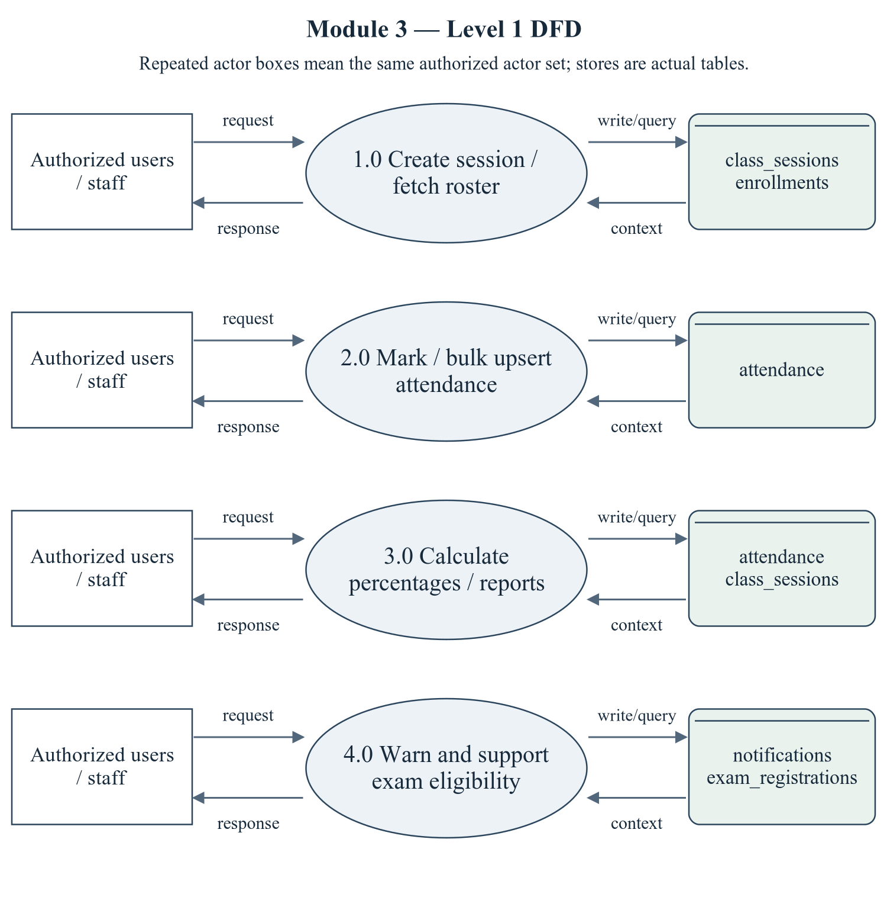
Figure 2.5 Attendance Management — Level 1 DFD
The repeated actor boxes denote the same permitted actor set. Ellipses are module processes; D stores list actual persisted tables. Arrows represent request/response and query/write context, not proof of successful operations.
Editable drawing source: diagrams/05_module_03_dfd_level1.svg, .dot and .mmd. Edit SVG text/shapes in a vector editor, or regenerate from DOT/Mermaid; retain FK IDs and source names. These figures were created from static source, not captured from a running ERP.
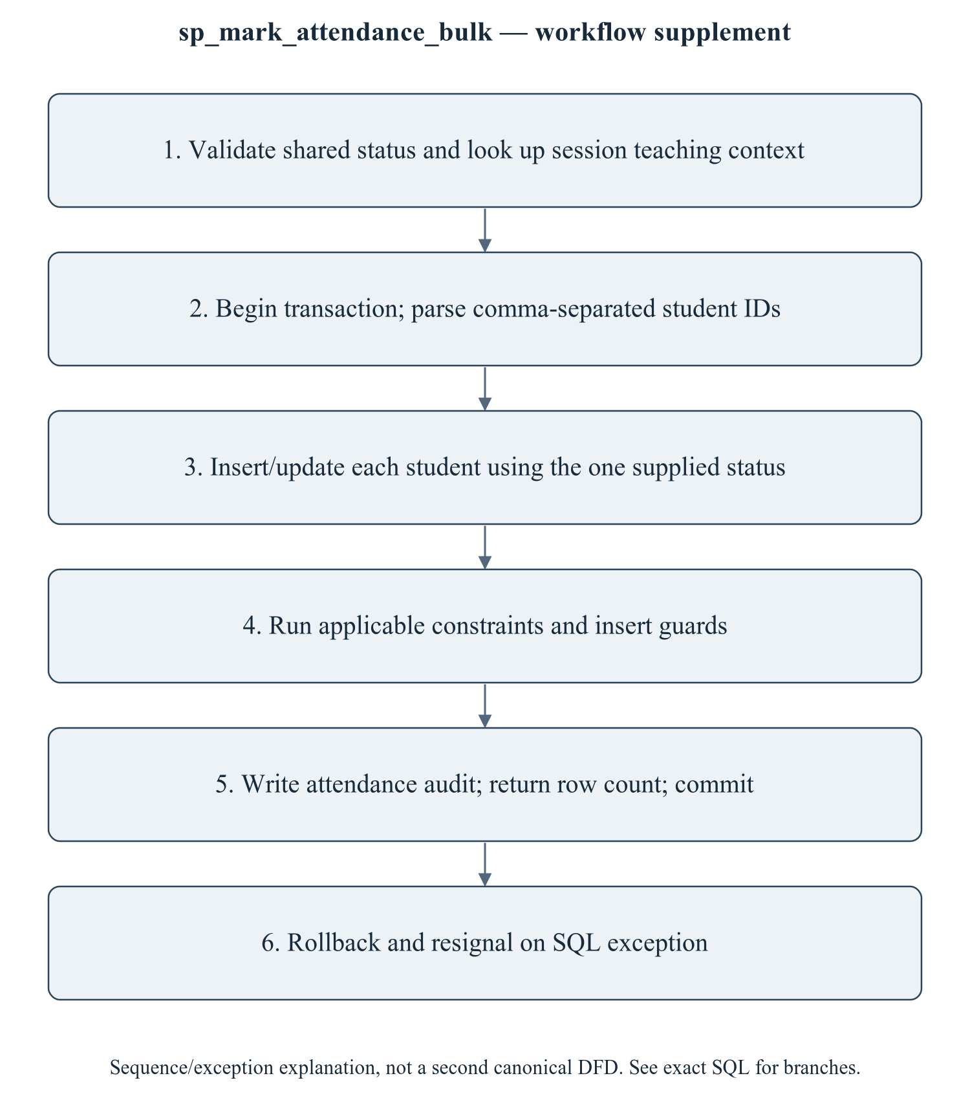
Figure 2.6 sp_mark_attendance_bulk — workflow supplement
This sequence refines the critical procedure for explanation; it is explicitly a control/transaction workflow supplement, not a mislabeled canonical Level 2 DFD. The Level 1 DFD provides the formal module data-flow view. An exam uses an exam-specific threshold in its procedure but the global setting in its insert trigger. Attendance reporting must therefore distinguish data capture, percentage formula and eligibility policy instead of claiming a single universal 75% implementation.
Editable drawing source: diagrams/06_module_03_procedure_workflow.svg, .dot and .mmd. Edit SVG text/shapes in a vector editor, or regenerate from DOT/Mermaid; retain FK IDs and source names. These figures were created from static source, not captured from a running ERP.

2.3.2.1 Sub-System Processes, Data Stores (Tables), and External Data Movement
Table 2.7 Attendance Management — processes and real stores
Process | Actual stores | External movement / integration
1.0 Create session / fetch roster | class_sessions, enrollments | Authorized actor request/response; shared master/FK data are internal context, not invented external systems.
2.0 Mark / bulk upsert attendance | attendance | Authorized actor request/response; shared master/FK data are internal context, not invented external systems.
3.0 Calculate percentages / reports | attendance, class_sessions | Authorized actor request/response; shared master/FK data are internal context, not invented external systems.
4.0 Warn and support exam eligibility | notifications, exam_registrations | Authorized actor request/response; shared master/FK data are internal context, not invented external systems.

2.3.3 Sub-Schema & Relational Data Dictionary
Relational notation below lists actual attributes. The full dictionary supplies types/nullability/defaults/constraints; PK/FK notation does not invent undeclared relationships.
attendance( attendance_id, session_id, student_id, offering_id, semester_id, status, remarks, marked_by, marked_at). PK={attendance_id}; FK IDs={FK053,FK054,FK055,FK056,FK057}.
The complete column/constraint dictionary for these exact relations is in 1.6; it is not copied a second time here. The module report repeats its own complete dictionary for independent use. class_sessions remains a joint G2/G3 contract.
Table 2.8 Shared / cross-module key contracts (not duplicated ownership)
Parent table / key | Module relationship | Declared action / FK ID
class_sessions, PK session_id | attendance.session_id → session_id | FK053: ON DELETE CASCADE
course_offerings, PK offering_id | attendance.offering_id → offering_id | FK055: ON DELETE CASCADE
semesters, PK semester_id | attendance.semester_id → semester_id | FK056: ON DELETE CASCADE
students, PK student_id | attendance.student_id → student_id | FK054: ON DELETE CASCADE
users, PK user_id | attendance.marked_by → user_id | FK057: ON DELETE SET NULL

The table dictionaries in this module cover its persisted schema in full. External parents above retain their original ownership; their complete 677-column enterprise dictionary is supplied in the master report and inventory workbook. Shared contracts are repeated here so this module can be read independently without pretending to own another module's tables.

2.3.4 Advanced SQL Implementation

2.3.4.1 Stored Procedures (SQL Code & Execution Proofs)

sp_mark_attendance_bulk
Purpose / expected behavior: Parse comma-separated student IDs from TEXT and upsert one shared status for a session; p_marked counts processed tokens, including repeats, and an empty token stops the loop. Write an audit in a transaction. API array input is serialized with join(",").
Source: database/05_procedures.sql:172–234. Definition found in the pinned snapshot; live existence and execution are unverified. Exact source comments may be stale; only inventoried definitions establish object names.
IN p_session_id: INT UNSIGNED
IN p_student_ids: TEXT
IN p_status: VARCHAR(10)
IN p_marked_by: INT UNSIGNED
OUT p_marked: INT
OUT p_message: VARCHAR(255)
Outputs: p_marked INT, p_message VARCHAR(255)
Read/write dependencies: attendance, audit_logs, class_sessions, v_count, v_done, v_list, v_offering_id, v_pos, v_semester_id, v_token
Routine calls: No other stored routine call extracted.
Transaction boundary: Explicit START TRANSACTION / COMMIT and SQLEXCEPTION handling in the definition.
Invocation template (not executed): bind every @ input to a mutually consistent synthetic fixture selected from the declared tables and run only on an authorized disposable schema. Numeric literals below are planned test inputs, not observed results. Internal COMMIT means wrapping a CALL in an outer ROLLBACK is not a safe fixture-cleanup strategy.
CALL sp_mark_attendance_bulk(@p_session_id, @p_student_ids, @p_status, @p_marked_by, @p_marked, @p_message);
SELECT @p_marked AS p_marked, @p_message AS p_message;

Actual result: [[TO BE PROVIDED: run this test and record the actual result]]
Status: [[TO BE PROVIDED: run this test and record the actual result]]
Required evidence: [[TO BE PROVIDED: execute sp_mark_attendance_bulk or its triggering DML using the corresponding module test case; owner must attach sanitized inputs, OUT/SELECT/error output, before/after effects and timestamp]]
Exact SQL definition (unchanged from source):
CREATE PROCEDURE `sp_mark_attendance_bulk`(
IN p_session_id INT UNSIGNED,
IN p_student_ids TEXT, -- e.g. '1,2,3,4'
IN p_status VARCHAR(10), -- PRESENT | ABSENT | LATE | EXCUSED
IN p_marked_by INT UNSIGNED,
OUT p_marked INT,
OUT p_message VARCHAR(255)
)
BEGIN
DECLARE v_offering_id INT UNSIGNED;
DECLARE v_semester_id SMALLINT UNSIGNED;
DECLARE v_list TEXT;
DECLARE v_token VARCHAR(20);
DECLARE v_pos INT;
DECLARE v_done TINYINT DEFAULT 0;
DECLARE v_count INT DEFAULT 0;

DECLARE EXIT HANDLER FOR SQLEXCEPTION
BEGIN
ROLLBACK;
RESIGNAL; -- keep the original error visible to the caller
END;

IF p_status NOT IN ('PRESENT', 'ABSENT', 'LATE', 'EXCUSED') THEN
SIGNAL SQLSTATE '45000' SET MESSAGE_TEXT = 'Invalid attendance status.';
END IF;

SELECT `offering_id`, `semester_id` INTO v_offering_id, v_semester_id
FROM `class_sessions` WHERE `session_id` = p_session_id;

IF v_offering_id IS NULL THEN
SIGNAL SQLSTATE '45000' SET MESSAGE_TEXT = 'Class session not found.';
END IF;

START TRANSACTION;

SET v_list = CONCAT(p_student_ids, ',');
WHILE LENGTH(v_list) > 0 AND v_done = 0 DO
SET v_pos = LOCATE(',', v_list);
SET v_token = TRIM(SUBSTRING(v_list, 1, v_pos - 1));
SET v_list = SUBSTRING(v_list, v_pos + 1);
IF v_token = '' THEN
SET v_done = 1;
ELSE
INSERT INTO `attendance`
(`session_id`, `student_id`, `offering_id`, `semester_id`, `status`, `marked_by`)
VALUES
(p_session_id, CAST(v_token AS UNSIGNED), v_offering_id, v_semester_id, p_status, p_marked_by)
ON DUPLICATE KEY UPDATE
`status` = p_status, `marked_by` = p_marked_by, `marked_at` = CURRENT_TIMESTAMP;
SET v_count = v_count + 1;
END IF;
END WHILE;

SET p_marked = v_count;

INSERT INTO `audit_logs` (`user_id`, `action`, `entity`, `entity_id`, `description`)
VALUES (p_marked_by, 'ATTENDANCE_UPDATE', 'attendance', p_session_id,
CONCAT('Bulk attendance: ', v_count, ' students marked ', p_status));

SET p_message = CONCAT(v_count, ' attendance records saved.');
COMMIT;
END$$

2.3.4.2 Database Triggers (SQL Code & Execution Proofs)

trg_attendance_bi_guard
Purpose / expected behavior: Require enrollment and matching session/offering/semester context for attendance INSERT. It does not establish caller ownership or protect every update branch.
Source: database/06_triggers.sql:204–229. Definition found in the pinned snapshot; live existence and execution are unverified. Exact source comments may be stale; only inventoried definitions establish object names.
Event / inputs / output: BEFORE INSERT ON `attendance` FOR EACH ROW; OLD/NEW are event-appropriate row images; no explicit arguments or scalar return. Side effects are described above.
Read/write dependencies: attendance, class_sessions, enrollments, v_enrolled, v_session_date
Routine calls: No other stored routine call extracted.
Invocation template (not executed): bind every @ input to a mutually consistent synthetic fixture selected from the declared tables and run only on an authorized disposable schema. Numeric literals below are planned test inputs, not observed results. Internal COMMIT means wrapping a CALL in an outer ROLLBACK is not a safe fixture-cleanup strategy.
INSERT INTO attendance (session_id, student_id, offering_id, semester_id, status, marked_by) VALUES (@fixture_session_id, @fixture_student_id, @fixture_offering_id, @fixture_semester_id, 'PRESENT', @actor_user_id);

Actual result: [[TO BE PROVIDED: run this test and record the actual result]]
Status: [[TO BE PROVIDED: run this test and record the actual result]]
Required evidence: [[TO BE PROVIDED: execute trg_attendance_bi_guard or its triggering DML using the corresponding module test case; owner must attach sanitized inputs, OUT/SELECT/error output, before/after effects and timestamp]]
Exact SQL definition (unchanged from source):
CREATE TRIGGER `trg_attendance_bi_guard`
BEFORE INSERT ON `attendance` FOR EACH ROW
BEGIN
DECLARE v_enrolled INT DEFAULT 0;
DECLARE v_session_date DATE;

SELECT `session_date` INTO v_session_date
FROM `class_sessions` WHERE `session_id` = NEW.`session_id`;

IF v_session_date IS NULL THEN
SIGNAL SQLSTATE '45000' SET MESSAGE_TEXT = 'Class session does not exist.';
END IF;
IF v_session_date > CURDATE() THEN
SIGNAL SQLSTATE '45000'
SET MESSAGE_TEXT = 'Attendance cannot be marked for a future dated session.';
END IF;

SELECT COUNT(*) INTO v_enrolled
FROM `enrollments` e
WHERE e.`student_id` = NEW.`student_id` AND e.`offering_id` = NEW.`offering_id`;

IF v_enrolled = 0 THEN
SIGNAL SQLSTATE '45000'
SET MESSAGE_TEXT = 'This student is not enrolled in the course of this session.';
END IF;
END$$

2.3.4.3 User-Defined Functions (UDFs) (SQL Code & Execution Proofs)

fn_calculate_attendance_percentage
Purpose / expected behavior: Return PRESENT/LATE divided by counted non-EXCUSED attendance rows for a student/offering, rounded to two decimals; return 100 when the denominator is zero.
Source: database/07_functions.sql:42–63. Definition found in the pinned snapshot; live existence and execution are unverified. Exact source comments may be stale; only inventoried definitions establish object names.
IN p_student_id: INT UNSIGNED
IN p_offering_id: INT UNSIGNED
Output: decimal(5,2) scalar return value.
Read/write dependencies: attendance, v_present, v_total
Routine calls: No other stored routine call extracted.
Invocation template (not executed): bind every @ input to a mutually consistent synthetic fixture selected from the declared tables and run only on an authorized disposable schema. Numeric literals below are planned test inputs, not observed results. Internal COMMIT means wrapping a CALL in an outer ROLLBACK is not a safe fixture-cleanup strategy.
SELECT fn_calculate_attendance_percentage(@p_student_id, @p_offering_id) AS computed_value;

Actual result: [[TO BE PROVIDED: run this test and record the actual result]]
Status: [[TO BE PROVIDED: run this test and record the actual result]]
Required evidence: [[TO BE PROVIDED: execute fn_calculate_attendance_percentage or its triggering DML using the corresponding module test case; owner must attach sanitized inputs, OUT/SELECT/error output, before/after effects and timestamp]]
Exact SQL definition (unchanged from source):
CREATE FUNCTION `fn_calculate_attendance_percentage`(
p_student_id INT UNSIGNED,
p_offering_id INT UNSIGNED
) RETURNS decimal(5,2)
READS SQL DATA
BEGIN
DECLARE v_total INT DEFAULT 0;
DECLARE v_present INT DEFAULT 0;

SELECT COUNT(*),
SUM(CASE WHEN a.`status` IN ('PRESENT','LATE') THEN 1 ELSE 0 END)
INTO v_total, v_present
FROM `attendance` a
WHERE a.`student_id` = p_student_id
AND a.`offering_id` = p_offering_id
AND a.`status` <> 'EXCUSED';

IF v_total = 0 THEN
RETURN 100.00;
END IF;
RETURN ROUND((v_present / v_total) * 100, 2);
END$$

fn_calculate_semester_attendance
Purpose / expected behavior: Return the same PRESENT/LATE and EXCUSED-excluding percentage for one student/semester, with 100 for zero counted rows.
Source: database/07_functions.sql:72–91. Definition found in the pinned snapshot; live existence and execution are unverified. Exact source comments may be stale; only inventoried definitions establish object names.
IN p_student_id: INT UNSIGNED
IN p_semester_id: SMALLINT UNSIGNED
Output: decimal(5,2) scalar return value.
Read/write dependencies: attendance, v_present, v_total
Routine calls: No other stored routine call extracted.
Invocation template (not executed): bind every @ input to a mutually consistent synthetic fixture selected from the declared tables and run only on an authorized disposable schema. Numeric literals below are planned test inputs, not observed results. Internal COMMIT means wrapping a CALL in an outer ROLLBACK is not a safe fixture-cleanup strategy.
SELECT fn_calculate_semester_attendance(@p_student_id, @p_semester_id) AS computed_value;

Actual result: [[TO BE PROVIDED: run this test and record the actual result]]
Status: [[TO BE PROVIDED: run this test and record the actual result]]
Required evidence: [[TO BE PROVIDED: execute fn_calculate_semester_attendance or its triggering DML using the corresponding module test case; owner must attach sanitized inputs, OUT/SELECT/error output, before/after effects and timestamp]]
Exact SQL definition (unchanged from source):
CREATE FUNCTION `fn_calculate_semester_attendance`(
p_student_id INT UNSIGNED,
p_semester_id SMALLINT UNSIGNED
) RETURNS decimal(5,2)
READS SQL DATA
BEGIN
DECLARE v_total INT DEFAULT 0;
DECLARE v_present INT DEFAULT 0;

SELECT COUNT(*),
SUM(CASE WHEN a.`status` IN ('PRESENT','LATE') THEN 1 ELSE 0 END)
INTO v_total, v_present
FROM `attendance` a
WHERE a.`student_id` = p_student_id
AND a.`semester_id` = p_semester_id
AND a.`status` <> 'EXCUSED';

IF v_total = 0 THEN RETURN 100.00; END IF;
RETURN ROUND((v_present / v_total) * 100, 2);
END$$

2.3.5 Complex Analytical Queries & Views

v_student_attendance_summary
Purpose / expected behavior: Provide student/offering attendance counts and the attendance UDF result/status. Raw row counts include records excluded from the UDF denominator.
Source: database/08_views.sql:68–94. Definition found in the pinned snapshot; live existence and execution are unverified. Exact source comments may be stale; only inventoried definitions establish object names.
Inputs / output: No parameters; SELECT returns columns: student_id, roll_number, full_name, offering_id, semester_id, semester_name, subject_id, subject_code, subject_name, credits, total_classes, attended_classes, absent_classes, attendance_percentage, attendance_status. WHERE/JOIN predicates are query inputs, not stored view parameters.
Read/write dependencies: attendance, course_offerings, semesters, students, subjects
Routine calls: No other stored routine call extracted.
Invocation template (not executed): bind every @ input to a mutually consistent synthetic fixture selected from the declared tables and run only on an authorized disposable schema. Numeric literals below are planned test inputs, not observed results. Internal COMMIT means wrapping a CALL in an outer ROLLBACK is not a safe fixture-cleanup strategy.
SELECT * FROM v_student_attendance_summary LIMIT 10;

Actual result: [[TO BE PROVIDED: run this test and record the actual result]]
Status: [[TO BE PROVIDED: run this test and record the actual result]]
Required evidence: [[TO BE PROVIDED: execute v_student_attendance_summary or its triggering DML using the corresponding module test case; owner must attach sanitized inputs, OUT/SELECT/error output, before/after effects and timestamp]]
Exact SQL definition (unchanged from source):
CREATE OR REPLACE VIEW `v_student_attendance_summary` AS
SELECT a.`student_id`,
s.`roll_number`,
CONCAT(s.`first_name`, ' ', s.`last_name`) AS `full_name`,
a.`offering_id`,
co.`semester_id`,
sem.`name` AS `semester_name`,
sub.`subject_id`, sub.`subject_code`, sub.`name` AS `subject_name`, sub.`credits`,
COUNT(*) AS `total_classes`,
SUM(CASE WHEN a.`status` IN ('PRESENT','LATE') THEN 1 ELSE 0 END) AS `attended_classes`,
SUM(CASE WHEN a.`status` = 'ABSENT' THEN 1 ELSE 0 END) AS `absent_classes`,
ROUND(SUM(CASE WHEN a.`status` IN ('PRESENT','LATE') THEN 1 ELSE 0 END) * 100.0
/ NULLIF(COUNT(*), 0), 2) AS `attendance_percentage`,
CASE
WHEN SUM(CASE WHEN a.`status` IN ('PRESENT','LATE') THEN 1 ELSE 0 END) * 100.0
/ NULLIF(COUNT(*),0) >= 85 THEN 'SAFE'
WHEN SUM(CASE WHEN a.`status` IN ('PRESENT','LATE') THEN 1 ELSE 0 END) * 100.0
/ NULLIF(COUNT(*),0) >= 75 THEN 'WARNING'
ELSE 'CRITICAL'
END AS `attendance_status`
FROM `attendance` a
JOIN `students` s ON s.`student_id` = a.`student_id`
JOIN `course_offerings` co ON co.`offering_id`= a.`offering_id`
JOIN `subjects` sub ON sub.`subject_id`= co.`subject_id`
JOIN `semesters` sem ON sem.`semester_id` = co.`semester_id`
GROUP BY a.`student_id`, s.`roll_number`, s.`first_name`, s.`last_name`, a.`offering_id`,
co.`semester_id`, sem.`name`, sub.`subject_id`, sub.`subject_code`, sub.`name`, sub.`credits`;

v_student_attendance_overall
Purpose / expected behavior: Aggregate student attendance overall using its own formula/current-semester context. Its no-data and EXCUSED behavior is not identical to every UDF/view.
Source: database/08_views.sql:99–120. Definition found in the pinned snapshot; live existence and execution are unverified. Exact source comments may be stale; only inventoried definitions establish object names.
Inputs / output: No parameters; SELECT returns columns: student_id, roll_number, full_name, department_id, program_id, batch_id, current_semester_no, total_classes, attended_classes, overall_percentage, current_semester_percentage, attendance_status. WHERE/JOIN predicates are query inputs, not stored view parameters.
Read/write dependencies: attendance, semesters, students
Routine calls: fn_calculate_semester_attendance
Invocation template (not executed): bind every @ input to a mutually consistent synthetic fixture selected from the declared tables and run only on an authorized disposable schema. Numeric literals below are planned test inputs, not observed results. Internal COMMIT means wrapping a CALL in an outer ROLLBACK is not a safe fixture-cleanup strategy.
SELECT * FROM v_student_attendance_overall LIMIT 10;

Actual result: [[TO BE PROVIDED: run this test and record the actual result]]
Status: [[TO BE PROVIDED: run this test and record the actual result]]
Required evidence: [[TO BE PROVIDED: execute v_student_attendance_overall or its triggering DML using the corresponding module test case; owner must attach sanitized inputs, OUT/SELECT/error output, before/after effects and timestamp]]
Exact SQL definition (unchanged from source):
CREATE OR REPLACE VIEW `v_student_attendance_overall` AS
SELECT s.`student_id`, s.`roll_number`,
CONCAT(s.`first_name`, ' ', s.`last_name`) AS `full_name`,
s.`department_id`, s.`program_id`, s.`batch_id`, s.`current_semester_no`,
COUNT(a.`attendance_id`) AS `total_classes`,
SUM(CASE WHEN a.`status` IN ('PRESENT','LATE') THEN 1 ELSE 0 END) AS `attended_classes`,
ROUND(SUM(CASE WHEN a.`status` IN ('PRESENT','LATE') THEN 1 ELSE 0 END) * 100.0
/ NULLIF(COUNT(a.`attendance_id`),0), 2) AS `overall_percentage`,
fn_calculate_semester_attendance(s.`student_id`,
(SELECT sm.`semester_id` FROM `semesters` sm WHERE sm.`is_current` = 1 LIMIT 1)
) AS `current_semester_percentage`,
CASE
WHEN SUM(CASE WHEN a.`status` IN ('PRESENT','LATE') THEN 1 ELSE 0 END) * 100.0
/ NULLIF(COUNT(a.`attendance_id`),0) >= 85 THEN 'SAFE'
WHEN SUM(CASE WHEN a.`status` IN ('PRESENT','LATE') THEN 1 ELSE 0 END) * 100.0
/ NULLIF(COUNT(a.`attendance_id`),0) >= 75 THEN 'WARNING'
ELSE 'CRITICAL'
END AS `attendance_status`
FROM `students` s
LEFT JOIN `attendance` a ON a.`student_id` = s.`student_id`
GROUP BY s.`student_id`, s.`roll_number`, s.`first_name`, s.`last_name`,
s.`department_id`, s.`program_id`, s.`batch_id`, s.`current_semester_no`;

v_monthly_attendance
Purpose / expected behavior: Aggregate by marked_at year/month and count attendance statuses with its implemented percentage. It does not group by the actual session_date.
Source: database/08_views.sql:499–507. Definition found in the pinned snapshot; live existence and execution are unverified. Exact source comments may be stale; only inventoried definitions establish object names.
Inputs / output: No parameters; SELECT returns columns: student_id, year, month, month_name, total_classes, attended, percentage. WHERE/JOIN predicates are query inputs, not stored view parameters.
Read/write dependencies: attendance
Routine calls: No other stored routine call extracted.
Invocation template (not executed): bind every @ input to a mutually consistent synthetic fixture selected from the declared tables and run only on an authorized disposable schema. Numeric literals below are planned test inputs, not observed results. Internal COMMIT means wrapping a CALL in an outer ROLLBACK is not a safe fixture-cleanup strategy.
SELECT * FROM v_monthly_attendance LIMIT 10;

Actual result: [[TO BE PROVIDED: run this test and record the actual result]]
Status: [[TO BE PROVIDED: run this test and record the actual result]]
Required evidence: [[TO BE PROVIDED: execute v_monthly_attendance or its triggering DML using the corresponding module test case; owner must attach sanitized inputs, OUT/SELECT/error output, before/after effects and timestamp]]
Exact SQL definition (unchanged from source):
CREATE OR REPLACE VIEW `v_monthly_attendance` AS
SELECT a.`student_id`, YEAR(a.`marked_at`) AS `year`, MONTH(a.`marked_at`) AS `month`,
MONTHNAME(a.`marked_at`) AS `month_name`,
COUNT(*) AS `total_classes`,
SUM(CASE WHEN a.`status` IN ('PRESENT','LATE') THEN 1 ELSE 0 END) AS `attended`,
ROUND(SUM(CASE WHEN a.`status` IN ('PRESENT','LATE') THEN 1 ELSE 0 END) * 100.0
/ NULLIF(COUNT(*),0), 2) AS `percentage`
FROM `attendance` a
GROUP BY a.`student_id`, YEAR(a.`marked_at`), MONTH(a.`marked_at`), MONTHNAME(a.`marked_at`);

Q32 assigns attendance quartiles using NTILE. Q41 compares monthly session-date attendance with LAG; it counts only PRESENT in the numerator and includes all rows in the denominator, unlike the UDF. No SQL outputs have been generated. [R08]

Q32 — NTILE — split the class into attendance quartiles for mentoring groups
Source: database/09_queries.sql:794. Purpose is the query projection/aggregation below; no output rows have been generated. Expected column structure follows aliases in the exact statement.
SELECT NTILE(4) OVER (ORDER BY x.overall_percentage DESC) AS quartile,
x.roll_number,
x.full_name AS student_name,
x.overall_percentage AS attendance_percentage,
CASE NTILE(4) OVER (ORDER BY x.overall_percentage DESC)
WHEN 1 THEN 'No intervention'
WHEN 2 THEN 'Monitor'
WHEN 3 THEN 'Counselling'
ELSE 'Parent meeting' END AS action
FROM v_student_attendance_overall x
WHERE x.overall_percentage IS NOT NULL
ORDER BY quartile, x.overall_percentage DESC
LIMIT 60;

Actual result: [[TO BE PROVIDED: run this test and record the actual result]]
Status: [[TO BE PROVIDED: run this test and record the actual result]]

Q41 — Attendance trend per student — month over month with LAG
Source: database/09_queries.sql:1076. Purpose is the query projection/aggregation below; no output rows have been generated. Expected column structure follows aliases in the exact statement.
WITH monthly AS (
SELECT a.student_id,
DATE_FORMAT(cs.session_date, '%Y-%m') AS month,
COUNT(*) AS sessions,
ROUND(100.0 * SUM(a.status = 'PRESENT') / COUNT(*), 2) AS attendance_pct
FROM attendance a
JOIN class_sessions cs ON cs.session_id = a.session_id
GROUP BY a.student_id, DATE_FORMAT(cs.session_date, '%Y-%m'))
SELECT s.roll_number,
CONCAT(s.first_name, ' ', s.last_name) AS student_name,
m.month,
m.sessions,
m.attendance_pct,
LAG(m.attendance_pct) OVER (PARTITION BY m.student_id ORDER BY m.month) AS previous_month,
ROUND(m.attendance_pct - LAG(m.attendance_pct) OVER (PARTITION BY m.student_id ORDER BY m.month), 2) AS delta_points,
CASE WHEN m.attendance_pct > LAG(m.attendance_pct) OVER (PARTITION BY m.student_id ORDER BY m.month) THEN 'IMPROVING'
WHEN m.attendance_pct < LAG(m.attendance_pct) OVER (PARTITION BY m.student_id ORDER BY m.month) THEN 'DECLINING'
ELSE 'FLAT' END AS trend
FROM monthly m
JOIN students s ON s.student_id = m.student_id
ORDER BY s.roll_number, m.month DESC
LIMIT 60;

Actual result: [[TO BE PROVIDED: run this test and record the actual result]]
Status: [[TO BE PROVIDED: run this test and record the actual result]]

2.3.6 Backend, Frontend, Validation & Transaction Trace
Table 2.9 Attendance Management — exact API route/role register
Method and route | Role gate / handler | Validation and source
GET /api/v1/attendance/sessions | STUDENT, ADMIN, FACULTY  Handler: sessions | No route-local Zod validation; service/DB checks may apply  backend/src/routes/attendance.routes.ts:13
POST /api/v1/attendance/sessions | ADMIN, FACULTY  Handler: createSession | No route-local Zod validation; service/DB checks may apply  backend/src/routes/attendance.routes.ts:14
GET /api/v1/attendance/sessions/:id | ADMIN, FACULTY  Handler: session | No route-local Zod validation; service/DB checks may apply  backend/src/routes/attendance.routes.ts:15
GET /api/v1/attendance/sessions/:id/roster | ADMIN, FACULTY  Handler: roster | No route-local Zod validation; service/DB checks may apply  backend/src/routes/attendance.routes.ts:18
POST /api/v1/attendance/sessions/:id/mark | ADMIN, FACULTY  Handler: mark | Zod validate(...) in route  backend/src/routes/attendance.routes.ts:19
POST /api/v1/attendance/sessions/:id/mark-bulk | ADMIN, FACULTY  Handler: markBulk | Zod validate(...) in route  backend/src/routes/attendance.routes.ts:24
GET /api/v1/attendance/report/offering/:id | EXAM_CELL, ADMIN, FACULTY  Handler: offeringReport | No route-local Zod validation; service/DB checks may apply  backend/src/routes/attendance.routes.ts:29
GET /api/v1/attendance/report/low | EXAM_CELL, ADMIN, FACULTY  Handler: low | No route-local Zod validation; service/DB checks may apply  backend/src/routes/attendance.routes.ts:30
GET /api/v1/attendance/report/stats | EXAM_CELL, ADMIN, FACULTY  Handler: stats | No route-local Zod validation; service/DB checks may apply  backend/src/routes/attendance.routes.ts:31
GET /api/v1/attendance/me | STUDENT  Handler: mySummary | No route-local Zod validation; service/DB checks may apply  backend/src/routes/attendance.routes.ts:34
GET /api/v1/attendance/me/overall | STUDENT  Handler: overall | No route-local Zod validation; service/DB checks may apply  backend/src/routes/attendance.routes.ts:35
GET /api/v1/attendance/me/monthly | STUDENT  Handler: monthly | No route-local Zod validation; service/DB checks may apply  backend/src/routes/attendance.routes.ts:36
GET /api/v1/attendance/student/:id | Authenticated; row scope must be inspected  Handler: mySummary | No route-local Zod validation; service/DB checks may apply  backend/src/routes/attendance.routes.ts:38
GET /api/v1/attendance/student/:id/overall | Authenticated; row scope must be inspected  Handler: overall | No route-local Zod validation; service/DB checks may apply  backend/src/routes/attendance.routes.ts:39
GET /api/v1/attendance/student/:id/monthly | Authenticated; row scope must be inspected  Handler: monthly | No route-local Zod validation; service/DB checks may apply  backend/src/routes/attendance.routes.ts:40
GET /api/v1/attendance/student/:id/history | Authenticated; row scope must be inspected  Handler: history | No route-local Zod validation; service/DB checks may apply  backend/src/routes/attendance.routes.ts:41
POST /api/v1/attendance/warn-low | ADMIN, FACULTY  Handler: warnLow | No route-local Zod validation; service/DB checks may apply  backend/src/routes/attendance.routes.ts:43

backend/src/controllers/attendance.controller.ts: Exports: sessions, session, roster, createSession, mySummary, overall, monthly, history, offeringReport, low, stats, mark, markBulk, warnLow. SQL references: .
backend/src/repositories/attendance.repository.ts: Exports: sessionsRepo, attendanceRepo. SQL references: attendance, class_sessions, course_offerings, departments, enrollments, faculty, programs, semesters, students, subjects, fn_calculate_attendance_percentage, fn_calculate_semester_attendance, v_monthly_attendance, v_student_attendance_overall, v_student_attendance_summary.
backend/src/services/attendance.service.ts: Exports: sessions, threshold, attendance, mark, markBulk, warnLowAttendance. SQL references: notifications, students, sp_mark_attendance_bulk, v_student_attendance_overall.
Frontend source pages: frontend/src/pages/attendance/AttendanceMarkPage.tsx; frontend/src/pages/attendance/AttendanceReportsPage.tsx; frontend/src/pages/attendance/AttendanceSessionsPage.tsx; frontend/src/pages/attendance/MyAttendancePage.tsx.
Controller → service → repository separation is present in source. mysql2 query/execute helpers bind values; callProc reads OUT parameters on one acquired connection. Some services write audit/notifications after the database operation on a separate pooled request, so a procedure transaction does not make every service side effect atomic. [R13, R09, R19]
Validation/error contract: route-local Zod schemas operate on request bodies where listed; the report does not infer validation for routes without validate(...). Services raise AppError for selected missing records/invalid inputs; DB FK/UNIQUE/CHECK/SIGNAL errors pass through the shared handler. HTTP statuses and payloads need API execution evidence, not invented response screenshots. [R10]
Exact route validation expressions (TypeScript/Zod, not SQL; no execution claim):
backend/src/routes/attendance.routes.ts:19 — router.post '/sessions/:id/mark'
z.object({
studentId: z.number().int().positive(),
status: z.enum(['PRESENT', 'ABSENT', 'LATE', 'EXCUSED']),
remarks: z.string().optional(),
})

backend/src/routes/attendance.routes.ts:24 — router.post '/sessions/:id/mark-bulk'
z.object({
studentIds: z.array(z.number().int().positive()).min(1),
status: z.enum(['PRESENT', 'ABSENT', 'LATE', 'EXCUSED']),
})

2.4 Examination and Results

2.4.1 Module Scope & Business Rules
Grades and exam headers; schedules; registration and hall-ticket data; marks entry and derived grades; semester result processing/publication; analytical results. The bank-backed mock exam engine is an adjunct using three cross-cutting tables, not an eighth core module. [R14, R02]
Actors: EXAM_CELL, ADMIN and FACULTY according to the endpoint; STUDENT for own eligibility, registrations, result views and practice attempts. Server-side row ownership and report publication visibility need route-specific verification.
Motivation: A result must be traceable from examination configuration through eligible registration and marks to a publication decision. Separating these stages supports audit and prevents a displayed average from being treated as an approved academic result.
Implemented, static — sp_register_student_for_exam checks examination context, calculates attendance, uses exams.min_attendance_required and returns a REJECTED outcome with rollback for low attendance. It has no exemption input; exemptions are separate row-update/direct-insert paths.
Partial / policy mismatch — The insert trigger checks enrollment and the global MIN_ATTENDANCE_PERCENTAGE, so it can disagree with an exam-specific threshold. Outstanding dues are computed but are not enforced as a registration rejection.
Implemented, static — Exemption needs reason and authorizer under a CHECK. A hall ticket number requires is_eligible=1. Marks insert/update triggers derive percentage, grade, points and pass state; marks updates are audited.
Partial / calculation semantics — fn_calculate_sgpa does not filter ENDSEM or passed rows despite comments. CGPA includes stored result rows; backlog/earned credits use the best grade per offering, not the latest attempt. Result publication is a separate procedure.
Partial / analytics and mock security — Semester filters in rankings/subject-failure repository methods reference absent view columns. Mock paper projection omits correct answers, but authenticated question-bank read routes return q.* including correct_option.
Unverified — Threshold boundaries, repeat attempts, grading scale, result publication/visibility and mock timer/ownership behavior have not been exercised against a live API/database.

2.4.2 Module Data Flow Diagram (Level 1 / Level 2 DFD)
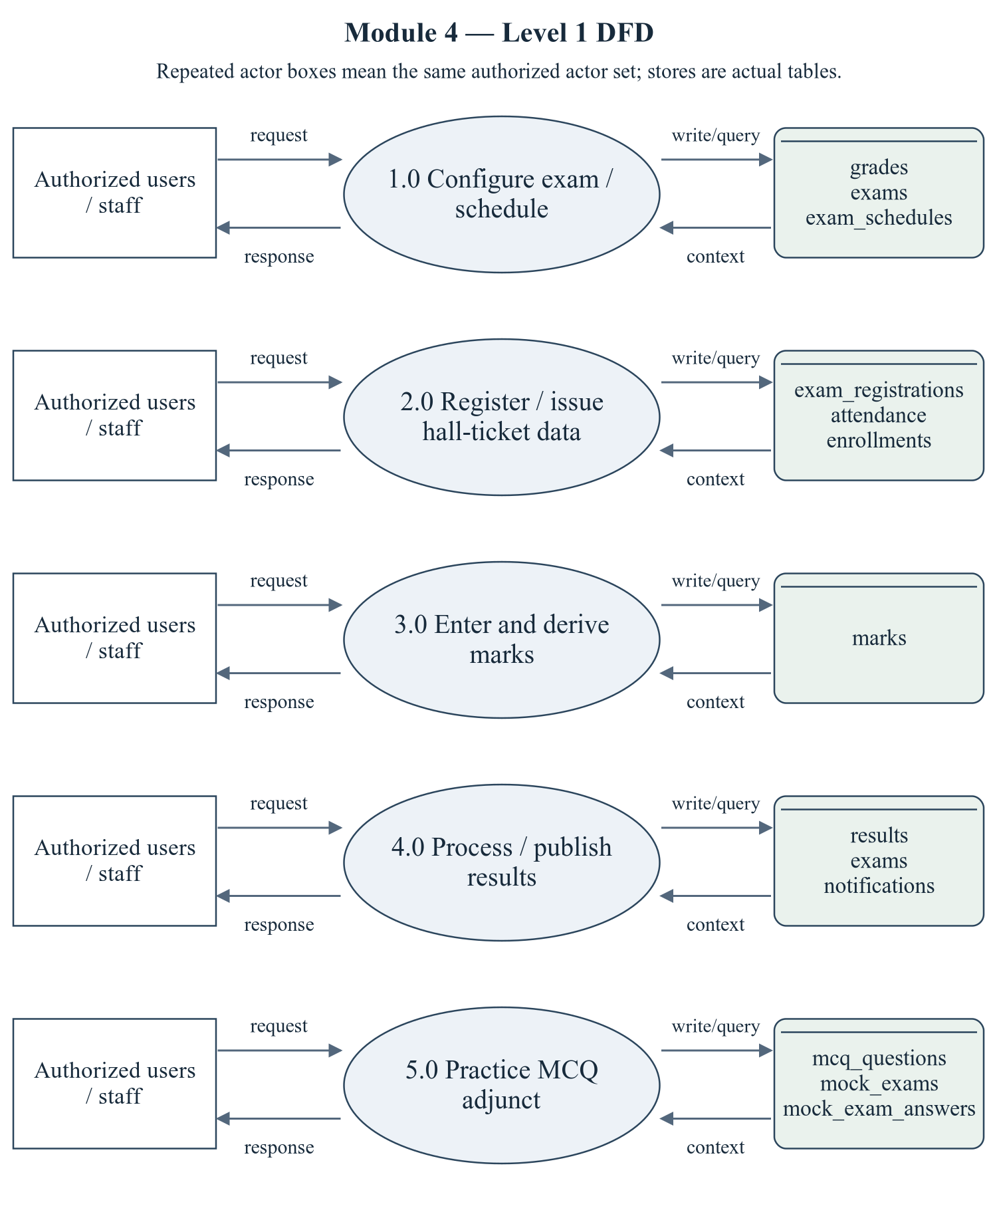
Figure 2.7 Examination and Results — Level 1 DFD
The repeated actor boxes denote the same permitted actor set. Ellipses are module processes; D stores list actual persisted tables. Arrows represent request/response and query/write context, not proof of successful operations.
Editable drawing source: diagrams/05_module_04_dfd_level1.svg, .dot and .mmd. Edit SVG text/shapes in a vector editor, or regenerate from DOT/Mermaid; retain FK IDs and source names. These figures were created from static source, not captured from a running ERP.
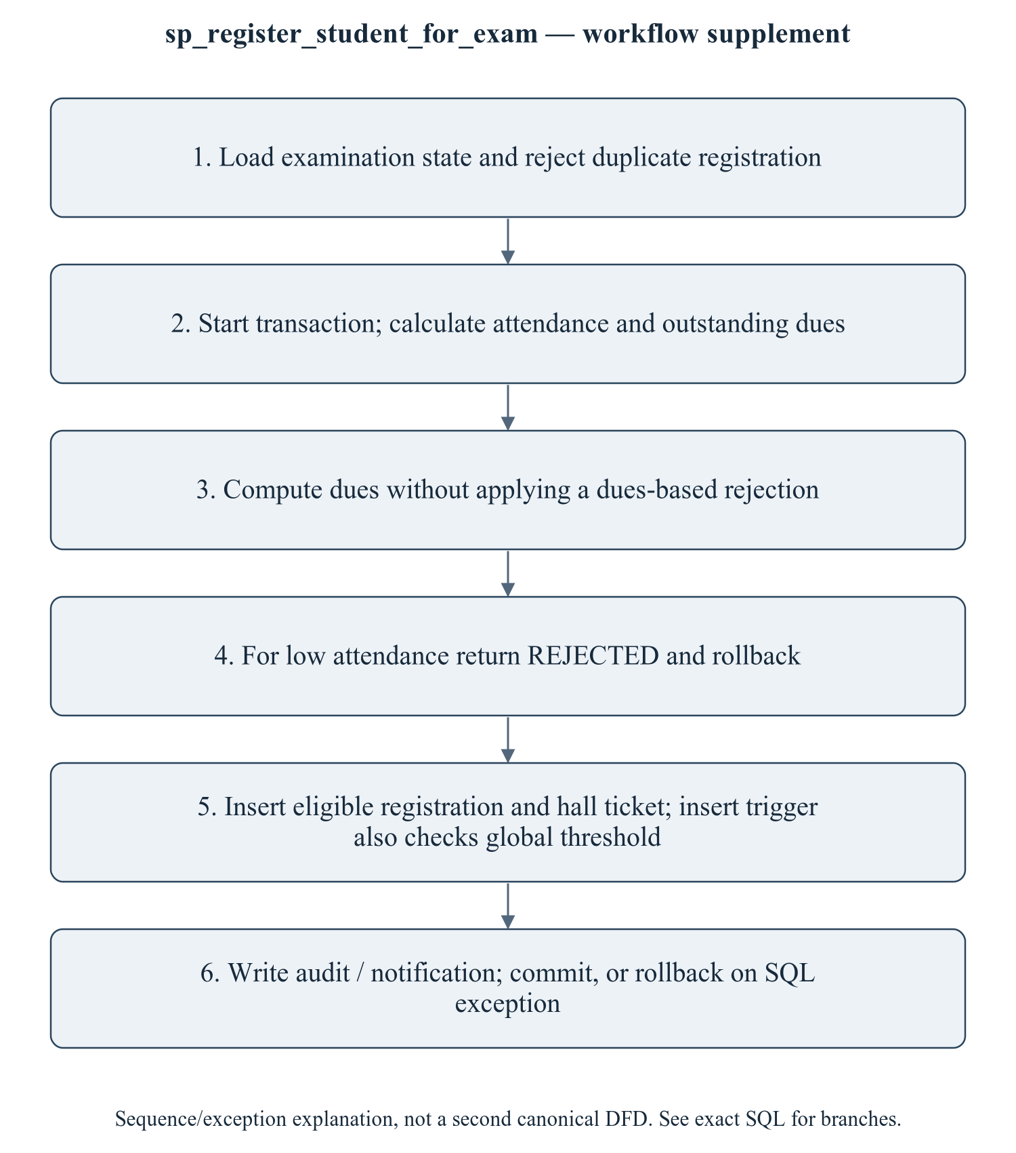
Figure 2.8 sp_register_student_for_exam — workflow supplement
This sequence refines the critical procedure for explanation; it is explicitly a control/transaction workflow supplement, not a mislabeled canonical Level 2 DFD. The Level 1 DFD provides the formal module data-flow view. No report should say fees block hall tickets in the current implementation. Academic formulae are project code, not confirmed university regulations. Mock question/attempt writes are multiple repository operations without an observed encompassing transaction.
Editable drawing source: diagrams/06_module_04_procedure_workflow.svg, .dot and .mmd. Edit SVG text/shapes in a vector editor, or regenerate from DOT/Mermaid; retain FK IDs and source names. These figures were created from static source, not captured from a running ERP.

2.4.2.1 Sub-System Processes, Data Stores (Tables), and External Data Movement
Table 2.10 Examination and Results — processes and real stores
Process | Actual stores | External movement / integration
1.0 Configure exam / schedule | grades, exams, exam_schedules | Authorized actor request/response; shared master/FK data are internal context, not invented external systems.
2.0 Register / issue hall-ticket data | exam_registrations, attendance, enrollments | Authorized actor request/response; shared master/FK data are internal context, not invented external systems.
3.0 Enter and derive marks | marks | Authorized actor request/response; shared master/FK data are internal context, not invented external systems.
4.0 Process / publish results | results, exams, notifications | Authorized actor request/response; shared master/FK data are internal context, not invented external systems.
5.0 Practice MCQ adjunct | mcq_questions, mock_exams, mock_exam_answers | Authorized actor request/response; shared master/FK data are internal context, not invented external systems.

2.4.3 Sub-Schema & Relational Data Dictionary
Relational notation below lists actual attributes. The full dictionary supplies types/nullability/defaults/constraints; PK/FK notation does not invent undeclared relationships.
grades( grade_id, grade_code, grade_label, min_percentage, max_percentage, grade_points, is_pass). PK={grade_id}; FK IDs={}.
exams( exam_id, exam_code, name, exam_type, academic_year_id, semester_id, start_date, end_date, registration_start, registration_end, result_published, published_on, min_attendance_required, status, created_at). PK={exam_id}; FK IDs={FK058,FK059}.
exam_schedules( schedule_id, exam_id, subject_id, program_id, exam_date, start_time, end_time, room_number, max_marks, min_marks, invigilator_id). PK={schedule_id}; FK IDs={FK060,FK061,FK062,FK063}.
exam_registrations( registration_id, exam_id, student_id, offering_id, schedule_id, registered_on, registered_by, attendance_percentage, is_eligible, eligibility_reason, exemption_granted, exemption_by, exemption_reason, hall_ticket_no, hall_ticket_issued_at, status). PK={registration_id}; FK IDs={FK064,FK065,FK066,FK067,FK068}.
marks( mark_id, registration_id, marks_obtained, max_marks, percentage, grade, grade_points, is_absent, is_pass, entered_by, entered_on, updated_at, remarks). PK={mark_id}; FK IDs={FK069,FK070}.
results( result_id, student_id, semester_id, exam_id, sgpa, cgpa, total_credits, earned_credits, backlog_count, result_status, remarks, published_on, published_by, created_at). PK={result_id}; FK IDs={FK071,FK072,FK073,FK074}.
The complete column/constraint dictionary for these exact relations is in 1.6; it is not copied a second time here. The module report repeats its own complete dictionary for independent use. class_sessions remains a joint G2/G3 contract.
Table 2.11 Shared / cross-module key contracts (not duplicated ownership)
Parent table / key | Module relationship | Declared action / FK ID
academic_years, PK academic_year_id | exams.academic_year_id → academic_year_id | FK058: ON DELETE CASCADE
course_offerings, PK offering_id | exam_registrations.offering_id → offering_id | FK066: ON DELETE CASCADE
faculty, PK faculty_id | exam_schedules.invigilator_id → faculty_id | FK063: ON DELETE SET NULL
programs, PK program_id | exam_schedules.program_id → program_id | FK062: ON DELETE CASCADE
semesters, PK semester_id | exams.semester_id → semester_id; results.semester_id → semester_id | FK059: ON DELETE CASCADE; FK072: ON DELETE CASCADE
students, PK student_id | exam_registrations.student_id → student_id; results.student_id → student_id | FK065: ON DELETE CASCADE; FK071: ON DELETE CASCADE
subjects, PK subject_id | exam_schedules.subject_id → subject_id | FK061: ON DELETE CASCADE
users, PK user_id | exam_registrations.registered_by → user_id; marks.entered_by → user_id; results.published_by → user_id | FK068: ON DELETE SET NULL; FK070: ON DELETE SET NULL; FK074: ON DELETE SET NULL

The table dictionaries in this module cover its persisted schema in full. External parents above retain their original ownership; their complete 677-column enterprise dictionary is supplied in the master report and inventory workbook. Shared contracts are repeated here so this module can be read independently without pretending to own another module's tables.

2.4.4 Advanced SQL Implementation

2.4.4.1 Stored Procedures (SQL Code & Execution Proofs)

sp_register_student_for_exam
Purpose / expected behavior: Check examination state/duplicates, calculate attendance and unenforced dues, and insert eligible registration/hall ticket or return REJECTED with rollback. There is no exemption parameter; the trigger supports explicit exemption fields and the API separately updates existing rows.
Source: database/05_procedures.sql:244–326. Definition found in the pinned snapshot; live existence and execution are unverified. Exact source comments may be stale; only inventoried definitions establish object names.
IN p_exam_id: SMALLINT UNSIGNED
IN p_student_id: INT UNSIGNED
IN p_offering_id: INT UNSIGNED
IN p_registered_by: INT UNSIGNED
OUT p_registration_id: INT UNSIGNED
OUT p_status: VARCHAR(20)
OUT p_message: VARCHAR(500)
Outputs: p_registration_id INT UNSIGNED, p_status VARCHAR(20), p_message VARCHAR(500)
Read/write dependencies: audit_logs, exam_registrations, exams, students, v_attendance, v_dues, v_exam_status, v_existing, v_hall_ticket, v_semester_id, v_threshold
Routine calls: fn_calculate_attendance_percentage, fn_student_outstanding_dues, sp_push_notification
Transaction boundary: Explicit START TRANSACTION / COMMIT and SQLEXCEPTION handling in the definition.
Invocation template (not executed): bind every @ input to a mutually consistent synthetic fixture selected from the declared tables and run only on an authorized disposable schema. Numeric literals below are planned test inputs, not observed results. Internal COMMIT means wrapping a CALL in an outer ROLLBACK is not a safe fixture-cleanup strategy.
CALL sp_register_student_for_exam(@p_exam_id, @p_student_id, @p_offering_id, @p_registered_by, @p_registration_id, @p_status, @p_message);
SELECT @p_registration_id AS p_registration_id, @p_status AS p_status, @p_message AS p_message;

Actual result: [[TO BE PROVIDED: run this test and record the actual result]]
Status: [[TO BE PROVIDED: run this test and record the actual result]]
Required evidence: [[TO BE PROVIDED: execute sp_register_student_for_exam or its triggering DML using the corresponding module test case; owner must attach sanitized inputs, OUT/SELECT/error output, before/after effects and timestamp]]
Exact SQL definition (unchanged from source):
CREATE PROCEDURE `sp_register_student_for_exam`(
IN p_exam_id SMALLINT UNSIGNED,
IN p_student_id INT UNSIGNED,
IN p_offering_id INT UNSIGNED,
IN p_registered_by INT UNSIGNED,
OUT p_registration_id INT UNSIGNED,
OUT p_status VARCHAR(20),
OUT p_message VARCHAR(500)
)
BEGIN
DECLARE v_attendance DECIMAL(5,2);
DECLARE v_threshold DECIMAL(5,2);
DECLARE v_semester_id SMALLINT UNSIGNED;
DECLARE v_exam_status VARCHAR(20);
DECLARE v_existing INT DEFAULT 0;
DECLARE v_dues DECIMAL(12,2);
DECLARE v_hall_ticket VARCHAR(30);

DECLARE EXIT HANDLER FOR SQLEXCEPTION
BEGIN
ROLLBACK;
RESIGNAL; -- keep the original error visible to the caller
END;

SELECT `semester_id`, `status`, `min_attendance_required`
INTO v_semester_id, v_exam_status, v_threshold
FROM `exams` WHERE `exam_id` = p_exam_id;

IF v_semester_id IS NULL THEN
SIGNAL SQLSTATE '45000' SET MESSAGE_TEXT = 'Examination not found.';
END IF;
IF v_exam_status NOT IN ('DRAFT', 'SCHEDULED', 'REGISTRATION_OPEN', 'ONGOING') THEN
SIGNAL SQLSTATE '45000' SET MESSAGE_TEXT = 'Registration is closed for this examination.';
END IF;

SELECT COUNT(*) INTO v_existing
FROM `exam_registrations`
WHERE `exam_id` = p_exam_id AND `student_id` = p_student_id AND `offering_id` = p_offering_id;

IF v_existing > 0 THEN
SIGNAL SQLSTATE '45000' SET MESSAGE_TEXT = 'Already registered for this subject.';
END IF;

START TRANSACTION;

SET v_attendance = fn_calculate_attendance_percentage(p_student_id, p_offering_id);
SET v_dues = fn_student_outstanding_dues(p_student_id);

IF v_attendance < v_threshold THEN
SET p_registration_id = NULL;
SET p_status = 'REJECTED';
SET p_message = CONCAT('Not eligible: attendance ', v_attendance,
'% is below the required ', v_threshold,
'%. Contact the examination cell for a condonation.');
ROLLBACK;
ELSE
SET v_hall_ticket = CONCAT('HT-', LPAD(p_exam_id, 2, '0'), '-',
LPAD(p_student_id, 4, '0'), '-',
LPAD(p_offering_id, 4, '0'));

INSERT INTO `exam_registrations`
(`exam_id`, `student_id`, `offering_id`, `registered_by`, `attendance_percentage`,
`is_eligible`, `eligibility_reason`, `hall_ticket_no`, `hall_ticket_issued_at`, `status`)
VALUES
(p_exam_id, p_student_id, p_offering_id, p_registered_by, v_attendance, 1,
CONCAT('Eligible: attendance ', v_attendance, '%'), v_hall_ticket, NOW(), 'REGISTERED');

SET p_registration_id = LAST_INSERT_ID();
SET p_status = 'REGISTERED';
SET p_message = CONCAT('Registered successfully. Hall ticket ', v_hall_ticket, '.');

INSERT INTO `audit_logs` (`user_id`, `action`, `entity`, `entity_id`, `description`)
VALUES (p_registered_by, 'EXAM_REGISTRATION', 'exam_registrations', p_registration_id, p_message);

CALL sp_push_notification(
(SELECT `user_id` FROM `students` WHERE `student_id` = p_student_id),
'Exam registration confirmed',
CONCAT('You are registered. Hall ticket ', v_hall_ticket, '.'),
'EXAM_REGISTRATION', 'SUCCESS', 'exam', p_exam_id, '/student/exams');

COMMIT;
END IF;
END$$

sp_enter_marks
Purpose / expected behavior: Validate registration/marks and scheduled maximum, insert or update marks and audit the operation. Grade fields are derived by triggers; SQL exceptions roll back. Verify maximum-mark and absent-state behavior with fixtures.
Source: database/05_procedures.sql:333–414. Definition found in the pinned snapshot; live existence and execution are unverified. Exact source comments may be stale; only inventoried definitions establish object names.
IN p_registration_id: INT UNSIGNED
IN p_marks_obtained: DECIMAL(6,2)
IN p_is_absent: TINYINT
IN p_entered_by: INT UNSIGNED
OUT p_grade: VARCHAR(4)
OUT p_grade_points: DECIMAL(4,2)
OUT p_message: VARCHAR(255)
Outputs: p_grade VARCHAR(4), p_grade_points DECIMAL(4,2), p_message VARCHAR(255)
Read/write dependencies: audit_logs, course_offerings, exam_registrations, exam_schedules, exams, marks, v_max, v_pct, v_status_old
Routine calls: fn_grade_code, fn_grade_points
Transaction boundary: Explicit START TRANSACTION / COMMIT and SQLEXCEPTION handling in the definition.
Invocation template (not executed): bind every @ input to a mutually consistent synthetic fixture selected from the declared tables and run only on an authorized disposable schema. Numeric literals below are planned test inputs, not observed results. Internal COMMIT means wrapping a CALL in an outer ROLLBACK is not a safe fixture-cleanup strategy.
CALL sp_enter_marks(@p_registration_id, @p_marks_obtained, @p_is_absent, @p_entered_by, @p_grade, @p_grade_points, @p_message);
SELECT @p_grade AS p_grade, @p_grade_points AS p_grade_points, @p_message AS p_message;

Actual result: [[TO BE PROVIDED: run this test and record the actual result]]
Status: [[TO BE PROVIDED: run this test and record the actual result]]
Required evidence: [[TO BE PROVIDED: execute sp_enter_marks or its triggering DML using the corresponding module test case; owner must attach sanitized inputs, OUT/SELECT/error output, before/after effects and timestamp]]
Exact SQL definition (unchanged from source):
CREATE PROCEDURE `sp_enter_marks`(
IN p_registration_id INT UNSIGNED,
IN p_marks_obtained DECIMAL(6,2),
IN p_is_absent TINYINT,
IN p_entered_by INT UNSIGNED,
OUT p_grade VARCHAR(4),
OUT p_grade_points DECIMAL(4,2),
OUT p_message VARCHAR(255)
)
BEGIN
DECLARE v_max SMALLINT UNSIGNED;
DECLARE v_pct DECIMAL(5,2);
DECLARE v_status_old VARCHAR(20);

DECLARE EXIT HANDLER FOR SQLEXCEPTION
BEGIN
ROLLBACK;
RESIGNAL; -- keep the original error visible to the caller
END;

SELECT es.`max_marks`
INTO v_max
FROM `exam_registrations` er
LEFT JOIN `exam_schedules` es
ON es.`exam_id` = er.`exam_id`
AND es.`subject_id` = (SELECT `subject_id` FROM `course_offerings`
WHERE `offering_id` = er.`offering_id`)
WHERE er.`registration_id` = p_registration_id;

IF v_max IS NULL THEN
SELECT e.`max_marks` INTO v_max
FROM `exam_registrations` er
JOIN `exams` x ON x.`exam_id` = er.`exam_id`
LEFT JOIN `exam_schedules` e ON e.`exam_id` = x.`exam_id`
WHERE er.`registration_id` = p_registration_id LIMIT 1;
END IF;
IF v_max IS NULL THEN
SET v_max = 100;
END IF;

IF p_is_absent = 0 AND (p_marks_obtained < 0 OR p_marks_obtained > v_max) THEN
SIGNAL SQLSTATE '45000'
SET MESSAGE_TEXT = 'Marks are outside the permitted range for this paper.';
END IF;

START TRANSACTION;

IF p_is_absent = 1 THEN
SET v_pct = 0.00;
SET p_grade = 'FF';
SET p_grade_points = 0.00;
ELSE
SET v_pct = ROUND(p_marks_obtained * 100.0 / v_max, 2);
SET p_grade = fn_grade_code(v_pct);
SET p_grade_points = fn_grade_points(v_pct);
END IF;

INSERT INTO `marks`
(`registration_id`, `marks_obtained`, `max_marks`, `percentage`, `grade`,
`grade_points`, `is_absent`, `is_pass`, `entered_by`)
VALUES
(p_registration_id, IF(p_is_absent = 1, 0.00, p_marks_obtained), v_max, v_pct,
p_grade, p_grade_points, p_is_absent, IF(p_is_absent = 1, 0, v_pct >= 40), p_entered_by)
ON DUPLICATE KEY UPDATE
`marks_obtained` = IF(p_is_absent = 1, 0.00, p_marks_obtained),
`percentage` = v_pct,
`grade` = p_grade,
`grade_points` = p_grade_points,
`is_absent` = p_is_absent,
`is_pass` = IF(p_is_absent = 1, 0, v_pct >= 40),
`entered_by` = p_entered_by;

UPDATE `exam_registrations` SET `status` = 'APPEARED' WHERE `registration_id` = p_registration_id;

INSERT INTO `audit_logs` (`user_id`, `action`, `entity`, `entity_id`, `description`)
VALUES (p_entered_by, 'MARKS_UPDATE', 'marks', p_registration_id,
CONCAT('Marks entered: ', IF(p_is_absent = 1, 'ABSENT', p_marks_obtained),
' -> grade ', p_grade));

SET p_message = CONCAT('Saved. Grade ', p_grade, ' (', p_grade_points, ' points).');
COMMIT;
END$$

sp_process_semester_results
Purpose / expected behavior: Use a cursor over marks filtered by p_exam_id and offering semester; upsert result SGPA/credits/backlogs, recompute credit-weighted CGPA across results and update enrollment grades/status. It uses inline formulas, not fn_calculate_sgpa, and writes result published_on before the separate exam publication flag.
Source: database/05_procedures.sql:423–520. Definition found in the pinned snapshot; live existence and execution are unverified. Exact source comments may be stale; only inventoried definitions establish object names.
IN p_semester_id: SMALLINT UNSIGNED
IN p_exam_id: SMALLINT UNSIGNED
IN p_published_by: INT UNSIGNED
OUT p_processed: INT
OUT p_message: VARCHAR(255)
Outputs: p_processed INT, p_message VARCHAR(255)
Read/write dependencies: audit_logs, course_offerings, enrollments, exam_registrations, marks, results, subjects, v_backlogs, v_cgpa, v_count, v_credits, v_done, v_earned, v_sgpa, v_student
Routine calls: No other stored routine call extracted.
Transaction boundary: Explicit START TRANSACTION / COMMIT and SQLEXCEPTION handling in the definition.
Invocation template (not executed): bind every @ input to a mutually consistent synthetic fixture selected from the declared tables and run only on an authorized disposable schema. Numeric literals below are planned test inputs, not observed results. Internal COMMIT means wrapping a CALL in an outer ROLLBACK is not a safe fixture-cleanup strategy.
CALL sp_process_semester_results(@p_semester_id, @p_exam_id, @p_published_by, @p_processed, @p_message);
SELECT @p_processed AS p_processed, @p_message AS p_message;

Actual result: [[TO BE PROVIDED: run this test and record the actual result]]
Status: [[TO BE PROVIDED: run this test and record the actual result]]
Required evidence: [[TO BE PROVIDED: execute sp_process_semester_results or its triggering DML using the corresponding module test case; owner must attach sanitized inputs, OUT/SELECT/error output, before/after effects and timestamp]]
Exact SQL definition (unchanged from source):
CREATE PROCEDURE `sp_process_semester_results`(
IN p_semester_id SMALLINT UNSIGNED,
IN p_exam_id SMALLINT UNSIGNED,
IN p_published_by INT UNSIGNED,
OUT p_processed INT,
OUT p_message VARCHAR(255)
)
BEGIN
DECLARE v_student INT UNSIGNED;
DECLARE v_sgpa DECIMAL(4,2);
DECLARE v_cgpa DECIMAL(4,2);
DECLARE v_credits SMALLINT UNSIGNED;
DECLARE v_earned SMALLINT UNSIGNED;
DECLARE v_backlogs TINYINT UNSIGNED;
DECLARE v_done TINYINT DEFAULT 0;
DECLARE v_count INT DEFAULT 0;

DECLARE cur CURSOR FOR
SELECT er.`student_id`,
ROUND(SUM(s.`credits` * m.`grade_points`) / NULLIF(SUM(s.`credits`), 0), 2),
SUM(s.`credits`),
SUM(CASE WHEN m.`grade_points` > 0 THEN s.`credits` ELSE 0 END),
SUM(CASE WHEN m.`grade_points` = 0 THEN 1 ELSE 0 END)
FROM `marks` m
JOIN `exam_registrations` er ON er.`registration_id` = m.`registration_id`
JOIN `course_offerings` co ON co.`offering_id` = er.`offering_id`
JOIN `subjects` s ON s.`subject_id` = co.`subject_id`
WHERE er.`exam_id` = p_exam_id
AND co.`semester_id` = p_semester_id
GROUP BY er.`student_id`;

DECLARE CONTINUE HANDLER FOR NOT FOUND SET v_done = 1;

DECLARE EXIT HANDLER FOR SQLEXCEPTION
BEGIN
ROLLBACK;
RESIGNAL; -- keep the original error visible to the caller
END;

START TRANSACTION;
OPEN cur;
read_loop: LOOP
FETCH cur INTO v_student, v_sgpa, v_credits, v_earned, v_backlogs;
IF v_done = 1 THEN LEAVE read_loop; END IF;

INSERT INTO `results`
(`student_id`, `semester_id`, `exam_id`, `sgpa`, `cgpa`, `total_credits`,
`earned_credits`, `backlog_count`, `result_status`, `published_on`, `published_by`)
VALUES
(v_student, p_semester_id, p_exam_id, v_sgpa, 0.00, v_credits, v_earned, v_backlogs,
CASE WHEN v_backlogs = 0 THEN 'PASS'
WHEN v_backlogs <= 3 THEN 'PROMOTED'
ELSE 'FAIL' END,
NOW(), p_published_by)
ON DUPLICATE KEY UPDATE
`exam_id` = p_exam_id,
`sgpa` = v_sgpa,
`total_credits` = v_credits,
`earned_credits` = v_earned,
`backlog_count` = v_backlogs,
`result_status` = CASE WHEN v_backlogs = 0 THEN 'PASS'
WHEN v_backlogs <= 3 THEN 'PROMOTED'
ELSE 'FAIL' END,
`published_on` = NOW(),
`published_by` = p_published_by;

SET v_count = v_count + 1;
END LOOP;
CLOSE cur;

-- CGPA is the credit weighted average of every published semester result.
UPDATE `results` r
JOIN (
SELECT r2.`student_id`,
ROUND(SUM(r2.`sgpa` * r2.`total_credits`) / NULLIF(SUM(r2.`total_credits`), 0), 2) AS cgpa
FROM `results` r2
GROUP BY r2.`student_id`
) c ON c.`student_id` = r.`student_id`
SET r.`cgpa` = c.cgpa
WHERE r.`semester_id` = p_semester_id;

UPDATE `enrollments` e
JOIN `course_offerings` co ON co.`offering_id` = e.`offering_id`
JOIN `exam_registrations` er ON er.`offering_id` = e.`offering_id` AND er.`student_id` = e.`student_id`
JOIN `marks` m ON m.`registration_id` = er.`registration_id`
SET e.`grade` = m.`grade`, e.`grade_points` = m.`grade_points`,
e.`status` = IF(m.`grade_points` > 0, 'PASSED', 'FAILED')
WHERE co.`semester_id` = p_semester_id AND er.`exam_id` = p_exam_id;

SET p_processed = v_count;

INSERT INTO `audit_logs` (`user_id`, `action`, `entity`, `entity_id`, `description`)
VALUES (p_published_by, 'RESULT_PUBLISHED', 'results', p_semester_id,
CONCAT('Result processed for ', v_count, ' students'));

SET p_message = CONCAT('Processed ', v_count, ' student results.');
COMMIT;
END$$

sp_publish_exam_results
Purpose / expected behavior: Set examination and semester publication state/date and emit student notifications/audit using the supplied actor. Publishing is distinct from generating result rows and is not evidence that every result endpoint hides unpublished rows.
Source: database/05_procedures.sql:527–569. Definition found in the pinned snapshot; live existence and execution are unverified. Exact source comments may be stale; only inventoried definitions establish object names.
IN p_exam_id: SMALLINT UNSIGNED
IN p_published_by: INT UNSIGNED
OUT p_notified: INT
OUT p_message: VARCHAR(255)
Outputs: p_notified INT, p_message VARCHAR(255)
Read/write dependencies: audit_logs, exam_registrations, exams, notifications, semesters, students
Routine calls: No other stored routine call extracted.
Transaction boundary: Explicit START TRANSACTION / COMMIT and SQLEXCEPTION handling in the definition.
Invocation template (not executed): bind every @ input to a mutually consistent synthetic fixture selected from the declared tables and run only on an authorized disposable schema. Numeric literals below are planned test inputs, not observed results. Internal COMMIT means wrapping a CALL in an outer ROLLBACK is not a safe fixture-cleanup strategy.
CALL sp_publish_exam_results(@p_exam_id, @p_published_by, @p_notified, @p_message);
SELECT @p_notified AS p_notified, @p_message AS p_message;

Actual result: [[TO BE PROVIDED: run this test and record the actual result]]
Status: [[TO BE PROVIDED: run this test and record the actual result]]
Required evidence: [[TO BE PROVIDED: execute sp_publish_exam_results or its triggering DML using the corresponding module test case; owner must attach sanitized inputs, OUT/SELECT/error output, before/after effects and timestamp]]
Exact SQL definition (unchanged from source):
CREATE PROCEDURE `sp_publish_exam_results`(
IN p_exam_id SMALLINT UNSIGNED,
IN p_published_by INT UNSIGNED,
OUT p_notified INT,
OUT p_message VARCHAR(255)
)
BEGIN
DECLARE EXIT HANDLER FOR SQLEXCEPTION
BEGIN
ROLLBACK;
RESIGNAL; -- keep the original error visible to the caller
END;

START TRANSACTION;

UPDATE `exams`
SET `result_published` = 1, `published_on` = NOW(), `status` = 'PUBLISHED'
WHERE `exam_id` = p_exam_id;

UPDATE `semesters` s
JOIN `exams` e ON e.`semester_id` = s.`semester_id`
SET s.`result_published` = 1
WHERE e.`exam_id` = p_exam_id;

INSERT INTO `notifications` (`user_id`, `title`, `message`, `type`, `severity`, `entity`, `entity_id`, `link`)
SELECT st.`user_id`, 'Result published',
CONCAT('Your result for ', e.`name`, ' has been published.'),
'RESULT_PUBLISHED', 'SUCCESS', 'exam', p_exam_id, '/student/results'
FROM `exam_registrations` er
JOIN `students` st ON st.`student_id` = er.`student_id`
JOIN `exams` e ON e.`exam_id` = er.`exam_id`
WHERE er.`exam_id` = p_exam_id
GROUP BY st.`user_id`, e.`name`;

SET p_notified = ROW_COUNT();

INSERT INTO `audit_logs` (`user_id`, `action`, `entity`, `entity_id`, `description`)
VALUES (p_published_by, 'RESULT_PUBLISHED', 'exams', p_exam_id,
CONCAT('Results published, ', p_notified, ' students notified'));

SET p_message = CONCAT('Results published. ', p_notified, ' students notified.');
COMMIT;
END$$

2.4.4.2 Database Triggers (SQL Code & Execution Proofs)

trg_exam_reg_bi_eligibility
Purpose / expected behavior: Require enrollment and global-setting attendance eligibility unless exempted; derive eligibility snapshot/reason before INSERT. It does not block outstanding fees.
Source: database/06_triggers.sql:236–277. Definition found in the pinned snapshot; live existence and execution are unverified. Exact source comments may be stale; only inventoried definitions establish object names.
Event / inputs / output: BEFORE INSERT ON `exam_registrations` FOR EACH ROW; OLD/NEW are event-appropriate row images; no explicit arguments or scalar return. Side effects are described above.
Read/write dependencies: enrollments, exam_registrations, system_settings, v_attendance, v_enrolled, v_threshold
Routine calls: fn_calculate_attendance_percentage
Invocation template (not executed): bind every @ input to a mutually consistent synthetic fixture selected from the declared tables and run only on an authorized disposable schema. Numeric literals below are planned test inputs, not observed results. Internal COMMIT means wrapping a CALL in an outer ROLLBACK is not a safe fixture-cleanup strategy.
CALL sp_register_student_for_exam(@p_exam_id, @p_student_id, @p_offering_id, @p_registered_by, @p_registration_id, @p_status, @p_message);

Actual result: [[TO BE PROVIDED: run this test and record the actual result]]
Status: [[TO BE PROVIDED: run this test and record the actual result]]
Required evidence: [[TO BE PROVIDED: execute trg_exam_reg_bi_eligibility or its triggering DML using the corresponding module test case; owner must attach sanitized inputs, OUT/SELECT/error output, before/after effects and timestamp]]
Exact SQL definition (unchanged from source):
CREATE TRIGGER `trg_exam_reg_bi_eligibility`
BEFORE INSERT ON `exam_registrations` FOR EACH ROW
BEGIN
DECLARE v_attendance DECIMAL(5,2);
DECLARE v_threshold DECIMAL(5,2) DEFAULT 75.00;
DECLARE v_enrolled INT DEFAULT 0;

SELECT CAST(`setting_value` AS DECIMAL(5,2)) INTO v_threshold
FROM `system_settings` WHERE `setting_key` = 'MIN_ATTENDANCE_PERCENTAGE';

-- Only students of the offering may register.
SELECT COUNT(*) INTO v_enrolled
FROM `enrollments` e
WHERE e.`student_id` = NEW.`student_id` AND e.`offering_id` = NEW.`offering_id`;
IF v_enrolled = 0 THEN
SIGNAL SQLSTATE '45000'
SET MESSAGE_TEXT = 'This student is not enrolled in the course of this examination.';
END IF;

-- Always recompute attendance from the register - never trust the client.
SET v_attendance = fn_calculate_attendance_percentage(NEW.`student_id`, NEW.`offering_id`);

IF NEW.`attendance_percentage` IS NULL
OR NEW.`attendance_percentage` <> v_attendance THEN
SET NEW.`attendance_percentage` = v_attendance;
END IF;

IF v_attendance < v_threshold AND NEW.`exemption_granted` = 0 THEN
SET NEW.`is_eligible` = 0;
SET NEW.`eligibility_reason` =
CONCAT('Attendance ', v_attendance, '% is below the mandatory ', v_threshold, '%');
SIGNAL SQLSTATE '45000'
SET MESSAGE_TEXT = 'Exam registration refused: attendance is below the required 75%.';
END IF;

IF v_attendance >= v_threshold THEN
SET NEW.`is_eligible` = 1;
IF NEW.`eligibility_reason` IS NULL THEN
SET NEW.`eligibility_reason` = CONCAT('Eligible: attendance ', v_attendance, '%');
END IF;
END IF;
END$$

trg_exam_reg_ai_audit
Purpose / expected behavior: Append registration audit information after INSERT. Compare with procedure audit to avoid assuming exactly one log per business action.
Source: database/06_triggers.sql:281–288. Definition found in the pinned snapshot; live existence and execution are unverified. Exact source comments may be stale; only inventoried definitions establish object names.
Event / inputs / output: AFTER INSERT ON `exam_registrations` FOR EACH ROW; OLD/NEW are event-appropriate row images; no explicit arguments or scalar return. Side effects are described above.
Read/write dependencies: audit_logs, exam_registrations
Routine calls: No other stored routine call extracted.
Invocation template (not executed): bind every @ input to a mutually consistent synthetic fixture selected from the declared tables and run only on an authorized disposable schema. Numeric literals below are planned test inputs, not observed results. Internal COMMIT means wrapping a CALL in an outer ROLLBACK is not a safe fixture-cleanup strategy.
CALL sp_register_student_for_exam(@p_exam_id, @p_student_id, @p_offering_id, @p_registered_by, @p_registration_id, @p_status, @p_message);

Actual result: [[TO BE PROVIDED: run this test and record the actual result]]
Status: [[TO BE PROVIDED: run this test and record the actual result]]
Required evidence: [[TO BE PROVIDED: execute trg_exam_reg_ai_audit or its triggering DML using the corresponding module test case; owner must attach sanitized inputs, OUT/SELECT/error output, before/after effects and timestamp]]
Exact SQL definition (unchanged from source):
CREATE TRIGGER `trg_exam_reg_ai_audit`
AFTER INSERT ON `exam_registrations` FOR EACH ROW
BEGIN
INSERT INTO `audit_logs` (`user_id`, `action`, `entity`, `entity_id`, `description`)
VALUES (NEW.`registered_by`, 'EXAM_REGISTRATION', 'exam_registrations', NEW.`registration_id`,
CONCAT('Registration for exam ', NEW.`exam_id`, ' (attendance ',
IFNULL(NEW.`attendance_percentage`, 0), '%)'));
END$$

trg_marks_bi_derive
Purpose / expected behavior: Validate/derive marks maximum, percentage, grade, grade_points and pass flag on INSERT using registration/schedule context and grade functions.
Source: database/06_triggers.sql:294–328. Definition found in the pinned snapshot; live existence and execution are unverified. Exact source comments may be stale; only inventoried definitions establish object names.
Event / inputs / output: BEFORE INSERT ON `marks` FOR EACH ROW; OLD/NEW are event-appropriate row images; no explicit arguments or scalar return. Side effects are described above.
Read/write dependencies: course_offerings, exam_registrations, exam_schedules, marks, v_max
Routine calls: fn_grade_code, fn_grade_points
Invocation template (not executed): bind every @ input to a mutually consistent synthetic fixture selected from the declared tables and run only on an authorized disposable schema. Numeric literals below are planned test inputs, not observed results. Internal COMMIT means wrapping a CALL in an outer ROLLBACK is not a safe fixture-cleanup strategy.
CALL sp_enter_marks(@p_registration_id, 82.00, 0, @p_entered_by, @p_grade, @p_grade_points, @p_message);

Actual result: [[TO BE PROVIDED: run this test and record the actual result]]
Status: [[TO BE PROVIDED: run this test and record the actual result]]
Required evidence: [[TO BE PROVIDED: execute trg_marks_bi_derive or its triggering DML using the corresponding module test case; owner must attach sanitized inputs, OUT/SELECT/error output, before/after effects and timestamp]]
Exact SQL definition (unchanged from source):
CREATE TRIGGER `trg_marks_bi_derive`
BEFORE INSERT ON `marks` FOR EACH ROW
BEGIN
DECLARE v_max SMALLINT UNSIGNED;

SELECT COALESCE(MAX(es.`max_marks`), 100) INTO v_max
FROM `exam_registrations` er
LEFT JOIN `exam_schedules` es
ON es.`exam_id` = er.`exam_id`
AND es.`subject_id` = (SELECT `subject_id` FROM `course_offerings`
WHERE `offering_id` = er.`offering_id`)
WHERE er.`registration_id` = NEW.`registration_id`;

IF NEW.`max_marks` IS NULL OR NEW.`max_marks` = 0 THEN
SET NEW.`max_marks` = v_max;
END IF;

IF NEW.`marks_obtained` < 0 OR NEW.`marks_obtained` > NEW.`max_marks` THEN
SIGNAL SQLSTATE '45000'
SET MESSAGE_TEXT = 'Marks entered are outside the permitted range for this paper.';
END IF;

IF NEW.`is_absent` = 1 THEN
SET NEW.`marks_obtained` = 0.00;
SET NEW.`percentage` = 0.00;
SET NEW.`grade` = 'FF';
SET NEW.`grade_points` = 0.00;
SET NEW.`is_pass` = 0;
ELSE
SET NEW.`percentage` = ROUND(NEW.`marks_obtained` * 100.0 / NEW.`max_marks`, 2);
SET NEW.`grade` = fn_grade_code(NEW.`percentage`);
SET NEW.`grade_points` = fn_grade_points(NEW.`percentage`);
SET NEW.`is_pass` = IF(NEW.`percentage` >= 40, 1, 0);
END IF;
END$$

trg_marks_bu_derive
Purpose / expected behavior: Re-derive percentage/grade/points/pass fields for an UPDATE under the implemented absent/marks rules.
Source: database/06_triggers.sql:331–351. Definition found in the pinned snapshot; live existence and execution are unverified. Exact source comments may be stale; only inventoried definitions establish object names.
Event / inputs / output: BEFORE UPDATE ON `marks` FOR EACH ROW; OLD/NEW are event-appropriate row images; no explicit arguments or scalar return. Side effects are described above.
Read/write dependencies: marks
Routine calls: fn_grade_code, fn_grade_points
Invocation template (not executed): bind every @ input to a mutually consistent synthetic fixture selected from the declared tables and run only on an authorized disposable schema. Numeric literals below are planned test inputs, not observed results. Internal COMMIT means wrapping a CALL in an outer ROLLBACK is not a safe fixture-cleanup strategy.
UPDATE marks SET marks_obtained = 35.00 WHERE mark_id = @fixture_mark_id;

Actual result: [[TO BE PROVIDED: run this test and record the actual result]]
Status: [[TO BE PROVIDED: run this test and record the actual result]]
Required evidence: [[TO BE PROVIDED: execute trg_marks_bu_derive or its triggering DML using the corresponding module test case; owner must attach sanitized inputs, OUT/SELECT/error output, before/after effects and timestamp]]
Exact SQL definition (unchanged from source):
CREATE TRIGGER `trg_marks_bu_derive`
BEFORE UPDATE ON `marks` FOR EACH ROW
BEGIN
IF NEW.`marks_obtained` < 0 OR NEW.`marks_obtained` > NEW.`max_marks` THEN
SIGNAL SQLSTATE '45000'
SET MESSAGE_TEXT = 'Marks entered are outside the permitted range for this paper.';
END IF;

IF NEW.`is_absent` = 1 THEN
SET NEW.`marks_obtained` = 0.00;
SET NEW.`percentage` = 0.00;
SET NEW.`grade` = 'FF';
SET NEW.`grade_points` = 0.00;
SET NEW.`is_pass` = 0;
ELSE
SET NEW.`percentage` = ROUND(NEW.`marks_obtained` * 100.0 / NEW.`max_marks`, 2);
SET NEW.`grade` = fn_grade_code(NEW.`percentage`);
SET NEW.`grade_points` = fn_grade_points(NEW.`percentage`);
SET NEW.`is_pass` = IF(NEW.`percentage` >= 40, 1, 0);
END IF;
END$$

trg_marks_au_audit
Purpose / expected behavior: Append marks old/new values and actor information for relevant marks updates. This audit is narrower than an immutable whole-system event store.
Source: database/06_triggers.sql:354–364. Definition found in the pinned snapshot; live existence and execution are unverified. Exact source comments may be stale; only inventoried definitions establish object names.
Event / inputs / output: AFTER UPDATE ON `marks` FOR EACH ROW; OLD/NEW are event-appropriate row images; no explicit arguments or scalar return. Side effects are described above.
Read/write dependencies: audit_logs, marks
Routine calls: No other stored routine call extracted.
Invocation template (not executed): bind every @ input to a mutually consistent synthetic fixture selected from the declared tables and run only on an authorized disposable schema. Numeric literals below are planned test inputs, not observed results. Internal COMMIT means wrapping a CALL in an outer ROLLBACK is not a safe fixture-cleanup strategy.
UPDATE marks SET marks_obtained = 35.00 WHERE mark_id = @fixture_mark_id;

Actual result: [[TO BE PROVIDED: run this test and record the actual result]]
Status: [[TO BE PROVIDED: run this test and record the actual result]]
Required evidence: [[TO BE PROVIDED: execute trg_marks_au_audit or its triggering DML using the corresponding module test case; owner must attach sanitized inputs, OUT/SELECT/error output, before/after effects and timestamp]]
Exact SQL definition (unchanged from source):
CREATE TRIGGER `trg_marks_au_audit`
AFTER UPDATE ON `marks` FOR EACH ROW
BEGIN
IF OLD.`marks_obtained` <> NEW.`marks_obtained` OR OLD.`is_absent` <> NEW.`is_absent` THEN
INSERT INTO `audit_logs` (`user_id`, `action`, `entity`, `entity_id`, `old_value`, `new_value`, `description`)
VALUES (NEW.`entered_by`, 'MARKS_UPDATE', 'marks', NEW.`mark_id`,
JSON_OBJECT('marks', OLD.`marks_obtained`, 'grade', OLD.`grade`),
JSON_OBJECT('marks', NEW.`marks_obtained`, 'grade', NEW.`grade`),
CONCAT('Marks changed from ', OLD.`marks_obtained`, ' to ', NEW.`marks_obtained`));
END IF;
END$$

2.4.4.3 User-Defined Functions (UDFs) (SQL Code & Execution Proofs)

fn_grade_points
Purpose / expected behavior: Map the supplied percentage into grades.min_percentage..max_percentage and return grade_points; inspect defined fallback behavior in the exact SQL.
Source: database/07_functions.sql:99–109. Definition found in the pinned snapshot; live existence and execution are unverified. Exact source comments may be stale; only inventoried definitions establish object names.
IN p_percentage: DECIMAL(5,2)
Output: decimal(4,2) scalar return value.
Read/write dependencies: grades, v_points
Routine calls: No other stored routine call extracted.
Invocation template (not executed): bind every @ input to a mutually consistent synthetic fixture selected from the declared tables and run only on an authorized disposable schema. Numeric literals below are planned test inputs, not observed results. Internal COMMIT means wrapping a CALL in an outer ROLLBACK is not a safe fixture-cleanup strategy.
SELECT fn_grade_points(@p_percentage) AS computed_value;

Actual result: [[TO BE PROVIDED: run this test and record the actual result]]
Status: [[TO BE PROVIDED: run this test and record the actual result]]
Required evidence: [[TO BE PROVIDED: execute fn_grade_points or its triggering DML using the corresponding module test case; owner must attach sanitized inputs, OUT/SELECT/error output, before/after effects and timestamp]]
Exact SQL definition (unchanged from source):
CREATE FUNCTION `fn_grade_points`(p_percentage DECIMAL(5,2))
RETURNS decimal(4,2)
READS SQL DATA
BEGIN
DECLARE v_points DECIMAL(4,2) DEFAULT 0.00;
SELECT g.`grade_points` INTO v_points
FROM `grades` g
WHERE p_percentage BETWEEN g.`min_percentage` AND g.`max_percentage`
ORDER BY g.`min_percentage` DESC LIMIT 1;
RETURN IFNULL(v_points, 0.00);
END$$

fn_grade_code
Purpose / expected behavior: Map a percentage into the grade master and return its grade_code, using the fallback in the definition. Grade bands are project seed policy, not confirmed institutional rules.
Source: database/07_functions.sql:117–127. Definition found in the pinned snapshot; live existence and execution are unverified. Exact source comments may be stale; only inventoried definitions establish object names.
IN p_percentage: DECIMAL(5,2)
Output: varchar(4) scalar return value.
Read/write dependencies: grades, v_code
Routine calls: No other stored routine call extracted.
Invocation template (not executed): bind every @ input to a mutually consistent synthetic fixture selected from the declared tables and run only on an authorized disposable schema. Numeric literals below are planned test inputs, not observed results. Internal COMMIT means wrapping a CALL in an outer ROLLBACK is not a safe fixture-cleanup strategy.
SELECT fn_grade_code(@p_percentage) AS computed_value;

Actual result: [[TO BE PROVIDED: run this test and record the actual result]]
Status: [[TO BE PROVIDED: run this test and record the actual result]]
Required evidence: [[TO BE PROVIDED: execute fn_grade_code or its triggering DML using the corresponding module test case; owner must attach sanitized inputs, OUT/SELECT/error output, before/after effects and timestamp]]
Exact SQL definition (unchanged from source):
CREATE FUNCTION `fn_grade_code`(p_percentage DECIMAL(5,2))
RETURNS varchar(4)
READS SQL DATA
BEGIN
DECLARE v_code VARCHAR(4) DEFAULT 'FF';
SELECT g.`grade_code` INTO v_code
FROM `grades` g
WHERE p_percentage BETWEEN g.`min_percentage` AND g.`max_percentage`
ORDER BY g.`min_percentage` DESC LIMIT 1;
RETURN IFNULL(v_code, 'FF');
END$$

fn_calculate_sgpa
Purpose / expected behavior: Credit-weight grade points from joined marks/registrations/offerings for the requested semester. No actual ENDSEM-only or pass-only filter is present despite source comments.
Source: database/07_functions.sql:137–157. Definition found in the pinned snapshot; live existence and execution are unverified. Exact source comments may be stale; only inventoried definitions establish object names.
IN p_student_id: INT UNSIGNED
IN p_semester_id: SMALLINT UNSIGNED
Output: decimal(4,2) scalar return value.
Read/write dependencies: course_offerings, exam_registrations, exams, marks, subjects, v_sgpa
Routine calls: No other stored routine call extracted.
Invocation template (not executed): bind every @ input to a mutually consistent synthetic fixture selected from the declared tables and run only on an authorized disposable schema. Numeric literals below are planned test inputs, not observed results. Internal COMMIT means wrapping a CALL in an outer ROLLBACK is not a safe fixture-cleanup strategy.
SELECT fn_calculate_sgpa(@p_student_id, @p_semester_id) AS computed_value;

Actual result: [[TO BE PROVIDED: run this test and record the actual result]]
Status: [[TO BE PROVIDED: run this test and record the actual result]]
Required evidence: [[TO BE PROVIDED: execute fn_calculate_sgpa or its triggering DML using the corresponding module test case; owner must attach sanitized inputs, OUT/SELECT/error output, before/after effects and timestamp]]
Exact SQL definition (unchanged from source):
CREATE FUNCTION `fn_calculate_sgpa`(
p_student_id INT UNSIGNED,
p_semester_id SMALLINT UNSIGNED
) RETURNS decimal(4,2)
READS SQL DATA
BEGIN
DECLARE v_sgpa DECIMAL(4,2) DEFAULT 0.00;

SELECT ROUND(SUM(s.`credits` * m.`grade_points`) / NULLIF(SUM(s.`credits`),0), 2)
INTO v_sgpa
FROM `marks` m
JOIN `exam_registrations` er ON er.`registration_id` = m.`registration_id`
JOIN `exams` e ON e.`exam_id` = er.`exam_id`
JOIN `course_offerings` co ON co.`offering_id` = er.`offering_id`
JOIN `subjects` s ON s.`subject_id` = co.`subject_id`
WHERE er.`student_id` = p_student_id
AND e.`semester_id` = p_semester_id
AND m.`grade_points` IS NOT NULL;

RETURN IFNULL(v_sgpa, 0.00);
END$$

fn_calculate_student_cgpa
Purpose / expected behavior: Weight stored results by their credits for a student. It includes the selected result rows rather than proving latest-attempt-only or publication-only policy.
Source: database/07_functions.sql:167–180. Definition found in the pinned snapshot; live existence and execution are unverified. Exact source comments may be stale; only inventoried definitions establish object names.
IN p_student_id: INT UNSIGNED
Output: decimal(4,2) scalar return value.
Read/write dependencies: results, v_cgpa
Routine calls: No other stored routine call extracted.
Invocation template (not executed): bind every @ input to a mutually consistent synthetic fixture selected from the declared tables and run only on an authorized disposable schema. Numeric literals below are planned test inputs, not observed results. Internal COMMIT means wrapping a CALL in an outer ROLLBACK is not a safe fixture-cleanup strategy.
SELECT fn_calculate_student_cgpa(@p_student_id) AS computed_value;

Actual result: [[TO BE PROVIDED: run this test and record the actual result]]
Status: [[TO BE PROVIDED: run this test and record the actual result]]
Required evidence: [[TO BE PROVIDED: execute fn_calculate_student_cgpa or its triggering DML using the corresponding module test case; owner must attach sanitized inputs, OUT/SELECT/error output, before/after effects and timestamp]]
Exact SQL definition (unchanged from source):
CREATE FUNCTION `fn_calculate_student_cgpa`(p_student_id INT UNSIGNED)
RETURNS decimal(4,2)
READS SQL DATA
BEGIN
DECLARE v_cgpa DECIMAL(4,2) DEFAULT 0.00;

SELECT ROUND(SUM(r.`sgpa` * r.`total_credits`) / NULLIF(SUM(r.`total_credits`),0), 2)
INTO v_cgpa
FROM `results` r
WHERE r.`student_id` = p_student_id
AND r.`total_credits` > 0;

RETURN IFNULL(v_cgpa, 0.00);
END$$

fn_student_backlog_count
Purpose / expected behavior: Count offerings whose best recorded grade points fail the implemented pass rule. The query uses the best grade per offering rather than the latest attempt.
Source: database/07_functions.sql:350–366. Definition found in the pinned snapshot; live existence and execution are unverified. Exact source comments may be stale; only inventoried definitions establish object names.
IN p_student_id: INT UNSIGNED
Output: int scalar return value.
Read/write dependencies: exam_registrations, marks, v_count
Routine calls: No other stored routine call extracted.
Invocation template (not executed): bind every @ input to a mutually consistent synthetic fixture selected from the declared tables and run only on an authorized disposable schema. Numeric literals below are planned test inputs, not observed results. Internal COMMIT means wrapping a CALL in an outer ROLLBACK is not a safe fixture-cleanup strategy.
SELECT fn_student_backlog_count(@p_student_id) AS computed_value;

Actual result: [[TO BE PROVIDED: run this test and record the actual result]]
Status: [[TO BE PROVIDED: run this test and record the actual result]]
Required evidence: [[TO BE PROVIDED: execute fn_student_backlog_count or its triggering DML using the corresponding module test case; owner must attach sanitized inputs, OUT/SELECT/error output, before/after effects and timestamp]]
Exact SQL definition (unchanged from source):
CREATE FUNCTION `fn_student_backlog_count`(p_student_id INT UNSIGNED)
RETURNS int
READS SQL DATA
BEGIN
DECLARE v_count INT DEFAULT 0;
SELECT COUNT(*) INTO v_count
FROM (
SELECT er.`offering_id`,
MAX(m.`grade_points`) AS best_points
FROM `marks` m
JOIN `exam_registrations` er ON er.`registration_id` = m.`registration_id`
WHERE er.`student_id` = p_student_id
GROUP BY er.`offering_id`
HAVING best_points = 0
) x;
RETURN v_count;
END$$

fn_student_earned_credits
Purpose / expected behavior: Sum offering credits using the best recorded grade per offering and the defined pass condition. Repeat-attempt and offering/subject equivalence need policy confirmation.
Source: database/07_functions.sql:374–391. Definition found in the pinned snapshot; live existence and execution are unverified. Exact source comments may be stale; only inventoried definitions establish object names.
IN p_student_id: INT UNSIGNED
Output: int scalar return value.
Read/write dependencies: course_offerings, exam_registrations, marks, subjects, v_credits
Routine calls: No other stored routine call extracted.
Invocation template (not executed): bind every @ input to a mutually consistent synthetic fixture selected from the declared tables and run only on an authorized disposable schema. Numeric literals below are planned test inputs, not observed results. Internal COMMIT means wrapping a CALL in an outer ROLLBACK is not a safe fixture-cleanup strategy.
SELECT fn_student_earned_credits(@p_student_id) AS computed_value;

Actual result: [[TO BE PROVIDED: run this test and record the actual result]]
Status: [[TO BE PROVIDED: run this test and record the actual result]]
Required evidence: [[TO BE PROVIDED: execute fn_student_earned_credits or its triggering DML using the corresponding module test case; owner must attach sanitized inputs, OUT/SELECT/error output, before/after effects and timestamp]]
Exact SQL definition (unchanged from source):
CREATE FUNCTION `fn_student_earned_credits`(p_student_id INT UNSIGNED)
RETURNS int
READS SQL DATA
BEGIN
DECLARE v_credits INT DEFAULT 0;
SELECT IFNULL(SUM(s.`credits`),0) INTO v_credits
FROM (
SELECT er.`offering_id`, MAX(m.`grade_points`) AS best_points
FROM `marks` m
JOIN `exam_registrations` er ON er.`registration_id` = m.`registration_id`
WHERE er.`student_id` = p_student_id
GROUP BY er.`offering_id`
HAVING best_points > 0
) x
JOIN `course_offerings` co ON co.`offering_id` = x.`offering_id`
JOIN `subjects` s ON s.`subject_id` = co.`subject_id`;
RETURN v_credits;
END$$

2.4.5 Complex Analytical Queries & Views

v_student_academic_summary
Purpose / expected behavior: Provide student academic/result aggregates with program/batch/department context. Read the exact aggregation/publication selection before using it as an official transcript.
Source: database/08_views.sql:41–62. Definition found in the pinned snapshot; live existence and execution are unverified. Exact source comments may be stale; only inventoried definitions establish object names.
Inputs / output: No parameters; SELECT returns columns: student_id, roll_number, full_name, program_id, program_code, program_name, department_id, department_code, batch_id, batch_code, current_semester_no, status, cgpa, earned_credits, backlog_count, enrollment_count, avg_sgpa, current_sgpa. WHERE/JOIN predicates are query inputs, not stored view parameters.
Read/write dependencies: batches, departments, enrollments, programs, results, semesters, students
Routine calls: fn_calculate_student_cgpa, fn_student_backlog_count, fn_student_earned_credits
Invocation template (not executed): bind every @ input to a mutually consistent synthetic fixture selected from the declared tables and run only on an authorized disposable schema. Numeric literals below are planned test inputs, not observed results. Internal COMMIT means wrapping a CALL in an outer ROLLBACK is not a safe fixture-cleanup strategy.
SELECT * FROM v_student_academic_summary LIMIT 10;

Actual result: [[TO BE PROVIDED: run this test and record the actual result]]
Status: [[TO BE PROVIDED: run this test and record the actual result]]
Required evidence: [[TO BE PROVIDED: execute v_student_academic_summary or its triggering DML using the corresponding module test case; owner must attach sanitized inputs, OUT/SELECT/error output, before/after effects and timestamp]]
Exact SQL definition (unchanged from source):
CREATE OR REPLACE VIEW `v_student_academic_summary` AS
SELECT s.`student_id`, s.`roll_number`,
CONCAT(s.`first_name`, ' ', s.`last_name`) AS `full_name`,
s.`program_id`, p.`program_code`, p.`name` AS `program_name`,
s.`department_id`, d.`department_code`,
s.`batch_id`, b.`batch_code`, s.`current_semester_no`, s.`status`,
fn_calculate_student_cgpa(s.`student_id`) AS `cgpa`,
fn_student_earned_credits(s.`student_id`) AS `earned_credits`,
fn_student_backlog_count(s.`student_id`) AS `backlog_count`,
COUNT(DISTINCT e.`enrollment_id`) AS `enrollment_count`,
ROUND(AVG(r.`sgpa`), 2) AS `avg_sgpa`,
MAX(CASE WHEN sem.`is_current` = 1 THEN r.`sgpa` END) AS `current_sgpa`
FROM `students` s
JOIN `programs` p ON p.`program_id` = s.`program_id`
JOIN `departments` d ON d.`department_id`= s.`department_id`
JOIN `batches` b ON b.`batch_id` = s.`batch_id`
LEFT JOIN `enrollments` e ON e.`student_id` = s.`student_id`
LEFT JOIN `results` r ON r.`student_id` = s.`student_id`
LEFT JOIN `semesters` sem ON sem.`semester_id` = r.`semester_id`
GROUP BY s.`student_id`, s.`roll_number`, s.`first_name`, s.`last_name`,
s.`program_id`, p.`program_code`, p.`name`, s.`department_id`, d.`department_code`,
s.`batch_id`, b.`batch_code`, s.`current_semester_no`, s.`status`;

v_exam_result_summary
Purpose / expected behavior: Aggregate registered/appeared/pass/fail and marks per exam with semester/publication context.
Source: database/08_views.sql:284–303. Definition found in the pinned snapshot; live existence and execution are unverified. Exact source comments may be stale; only inventoried definitions establish object names.
Inputs / output: No parameters; SELECT returns columns: exam_id, exam_code, exam_name, exam_type, semester_id, semester_name, exam_status, result_published, registrations, appeared, passed, failed, absent, average_percentage, highest_marks, lowest_marks, pass_percentage. WHERE/JOIN predicates are query inputs, not stored view parameters.
Read/write dependencies: exam_registrations, exams, marks, semesters
Routine calls: No other stored routine call extracted.
Invocation template (not executed): bind every @ input to a mutually consistent synthetic fixture selected from the declared tables and run only on an authorized disposable schema. Numeric literals below are planned test inputs, not observed results. Internal COMMIT means wrapping a CALL in an outer ROLLBACK is not a safe fixture-cleanup strategy.
SELECT * FROM v_exam_result_summary LIMIT 10;

Actual result: [[TO BE PROVIDED: run this test and record the actual result]]
Status: [[TO BE PROVIDED: run this test and record the actual result]]
Required evidence: [[TO BE PROVIDED: execute v_exam_result_summary or its triggering DML using the corresponding module test case; owner must attach sanitized inputs, OUT/SELECT/error output, before/after effects and timestamp]]
Exact SQL definition (unchanged from source):
CREATE OR REPLACE VIEW `v_exam_result_summary` AS
SELECT e.`exam_id`, e.`exam_code`, e.`name` AS `exam_name`, e.`exam_type`,
e.`semester_id`, sem.`name` AS `semester_name`, e.`status` AS `exam_status`,
e.`result_published`,
COUNT(DISTINCT er.`registration_id`) AS `registrations`,
SUM(CASE WHEN er.`status` = 'APPEARED' THEN 1 ELSE 0 END) AS `appeared`,
SUM(CASE WHEN m.`is_pass` = 1 THEN 1 ELSE 0 END) AS `passed`,
SUM(CASE WHEN m.`is_pass` = 0 THEN 1 ELSE 0 END) AS `failed`,
SUM(CASE WHEN m.`is_absent` = 1 THEN 1 ELSE 0 END) AS `absent`,
ROUND(AVG(m.`percentage`), 2) AS `average_percentage`,
MAX(m.`marks_obtained`) AS `highest_marks`,
MIN(m.`marks_obtained`) AS `lowest_marks`,
ROUND(SUM(CASE WHEN m.`is_pass` = 1 THEN 1 ELSE 0 END) * 100.0
/ NULLIF(SUM(CASE WHEN m.`is_pass` IN (0,1) THEN 1 ELSE 0 END),0), 2) AS `pass_percentage`
FROM `exams` e
JOIN `semesters` sem ON sem.`semester_id` = e.`semester_id`
LEFT JOIN `exam_registrations` er ON er.`exam_id` = e.`exam_id`
LEFT JOIN `marks` m ON m.`registration_id` = er.`registration_id`
GROUP BY e.`exam_id`, e.`exam_code`, e.`name`, e.`exam_type`, e.`semester_id`,
sem.`name`, e.`status`, e.`result_published`;

v_subject_failure_rate
Purpose / expected behavior: Aggregate marks attempts and failures by subject/department. Its columns do not include the semester filter used by one repository method.
Source: database/08_views.sql:308–324. Definition found in the pinned snapshot; live existence and execution are unverified. Exact source comments may be stale; only inventoried definitions establish object names.
Inputs / output: No parameters; SELECT returns columns: subject_id, subject_code, subject_name, credits, subject_type, department_id, department_code, attempts, failures, failure_rate, average_percentage, average_grade_points. WHERE/JOIN predicates are query inputs, not stored view parameters.
Read/write dependencies: course_offerings, departments, exam_registrations, marks, subjects
Routine calls: No other stored routine call extracted.
Invocation template (not executed): bind every @ input to a mutually consistent synthetic fixture selected from the declared tables and run only on an authorized disposable schema. Numeric literals below are planned test inputs, not observed results. Internal COMMIT means wrapping a CALL in an outer ROLLBACK is not a safe fixture-cleanup strategy.
SELECT * FROM v_subject_failure_rate LIMIT 10;

Actual result: [[TO BE PROVIDED: run this test and record the actual result]]
Status: [[TO BE PROVIDED: run this test and record the actual result]]
Required evidence: [[TO BE PROVIDED: execute v_subject_failure_rate or its triggering DML using the corresponding module test case; owner must attach sanitized inputs, OUT/SELECT/error output, before/after effects and timestamp]]
Exact SQL definition (unchanged from source):
CREATE OR REPLACE VIEW `v_subject_failure_rate` AS
SELECT sub.`subject_id`, sub.`subject_code`, sub.`name` AS `subject_name`,
sub.`credits`, sub.`subject_type`, sub.`department_id`,
d.`department_code`,
COUNT(m.`mark_id`) AS `attempts`,
SUM(CASE WHEN m.`is_pass` = 0 THEN 1 ELSE 0 END) AS `failures`,
ROUND(SUM(CASE WHEN m.`is_pass` = 0 THEN 1 ELSE 0 END) * 100.0
/ NULLIF(COUNT(m.`mark_id`),0), 2) AS `failure_rate`,
ROUND(AVG(m.`percentage`), 2) AS `average_percentage`,
ROUND(AVG(m.`grade_points`), 2) AS `average_grade_points`
FROM `marks` m
JOIN `exam_registrations` er ON er.`registration_id` = m.`registration_id`
JOIN `course_offerings` co ON co.`offering_id` = er.`offering_id`
JOIN `subjects` sub ON sub.`subject_id` = co.`subject_id`
JOIN `departments` d ON d.`department_id` = sub.`department_id`
GROUP BY sub.`subject_id`, sub.`subject_code`, sub.`name`, sub.`credits`,
sub.`subject_type`, sub.`department_id`, d.`department_code`;

v_exam_eligibility
Purpose / expected behavior: Expose enrollment, attendance, global threshold/exemption-related eligibility context and outstanding dues separately. is_eligible is not a dues gate.
Source: database/08_views.sql:382–405. Definition found in the pinned snapshot; live existence and execution are unverified. Exact source comments may be stale; only inventoried definitions establish object names.
Inputs / output: No parameters; SELECT returns columns: student_id, roll_number, full_name, offering_id, subject_code, subject_name, semester_id, semester_name, attendance_percentage, required_percentage, is_eligible, outstanding_dues. WHERE/JOIN predicates are query inputs, not stored view parameters.
Read/write dependencies: course_offerings, enrollments, semesters, students, subjects, system_settings
Routine calls: fn_calculate_attendance_percentage, fn_student_outstanding_dues
Invocation template (not executed): bind every @ input to a mutually consistent synthetic fixture selected from the declared tables and run only on an authorized disposable schema. Numeric literals below are planned test inputs, not observed results. Internal COMMIT means wrapping a CALL in an outer ROLLBACK is not a safe fixture-cleanup strategy.
SELECT * FROM v_exam_eligibility LIMIT 10;

Actual result: [[TO BE PROVIDED: run this test and record the actual result]]
Status: [[TO BE PROVIDED: run this test and record the actual result]]
Required evidence: [[TO BE PROVIDED: execute v_exam_eligibility or its triggering DML using the corresponding module test case; owner must attach sanitized inputs, OUT/SELECT/error output, before/after effects and timestamp]]
Exact SQL definition (unchanged from source):
CREATE OR REPLACE VIEW `v_exam_eligibility` AS
SELECT s.`student_id`, s.`roll_number`,
CONCAT(s.`first_name`, ' ', s.`last_name`) AS `full_name`,
co.`offering_id`,
sub.`subject_code`, sub.`name` AS `subject_name`,
sem.`semester_id`, sem.`name` AS `semester_name`,
-- Deliberately the SAME function the exam trigger and
-- sp_register_student_for_exam use, so the screen, the API and the
-- database can never disagree about who is eligible.
fn_calculate_attendance_percentage(s.`student_id`, co.`offering_id`) AS `attendance_percentage`,
(SELECT CAST(`setting_value` AS DECIMAL(5,2)) FROM `system_settings`
WHERE `setting_key` = 'MIN_ATTENDANCE_PERCENTAGE') AS `required_percentage`,
CASE
WHEN fn_calculate_attendance_percentage(s.`student_id`, co.`offering_id`)
>= (SELECT CAST(`setting_value` AS DECIMAL(5,2)) FROM `system_settings`
WHERE `setting_key` = 'MIN_ATTENDANCE_PERCENTAGE')
THEN 1 ELSE 0
END AS `is_eligible`,
fn_student_outstanding_dues(s.`student_id`) AS `outstanding_dues`
FROM `enrollments` e
JOIN `students` s ON s.`student_id` = e.`student_id`
JOIN `course_offerings` co ON co.`offering_id` = e.`offering_id`
JOIN `subjects` sub ON sub.`subject_id` = co.`subject_id`
JOIN `semesters` sem ON sem.`semester_id` = co.`semester_id`;

v_student_result_history
Purpose / expected behavior: Join result rows to student, semester and academic-year labels for historical display; confirm publication visibility in each consumer.
Source: database/08_views.sql:410–420. Definition found in the pinned snapshot; live existence and execution are unverified. Exact source comments may be stale; only inventoried definitions establish object names.
Inputs / output: No parameters; SELECT returns columns: result_id, student_id, roll_number, full_name, semester_id, semester_no, semester_name, year_label, sgpa, cgpa, total_credits, earned_credits, backlog_count, result_status, published_on. WHERE/JOIN predicates are query inputs, not stored view parameters.
Read/write dependencies: academic_years, results, semesters, students
Routine calls: No other stored routine call extracted.
Invocation template (not executed): bind every @ input to a mutually consistent synthetic fixture selected from the declared tables and run only on an authorized disposable schema. Numeric literals below are planned test inputs, not observed results. Internal COMMIT means wrapping a CALL in an outer ROLLBACK is not a safe fixture-cleanup strategy.
SELECT * FROM v_student_result_history LIMIT 10;

Actual result: [[TO BE PROVIDED: run this test and record the actual result]]
Status: [[TO BE PROVIDED: run this test and record the actual result]]
Required evidence: [[TO BE PROVIDED: execute v_student_result_history or its triggering DML using the corresponding module test case; owner must attach sanitized inputs, OUT/SELECT/error output, before/after effects and timestamp]]
Exact SQL definition (unchanged from source):
CREATE OR REPLACE VIEW `v_student_result_history` AS
SELECT r.`result_id`, r.`student_id`, s.`roll_number`,
CONCAT(s.`first_name`, ' ', s.`last_name`) AS `full_name`,
r.`semester_id`, sem.`semester_no`, sem.`name` AS `semester_name`,
ay.`year_label`,
r.`sgpa`, r.`cgpa`, r.`total_credits`, r.`earned_credits`,
r.`backlog_count`, r.`result_status`, r.`published_on`
FROM `results` r
JOIN `students` s ON s.`student_id` = r.`student_id`
JOIN `semesters` sem ON sem.`semester_id` = r.`semester_id`
JOIN `academic_years` ay ON ay.`academic_year_id` = sem.`academic_year_id`;

v_student_rankings
Purpose / expected behavior: Use window ranks over the academic summary for class/department/university ordering. The view lacks the semester columns referenced by an optional repository filter.
Source: database/08_views.sql:487–494. Definition found in the pinned snapshot; live existence and execution are unverified. Exact source comments may be stale; only inventoried definitions establish object names.
Inputs / output: No parameters; SELECT returns columns: student_id, roll_number, full_name, department_id, program_id, cgpa, earned_credits, backlog_count, current_semester_no, class_rank, department_rank, university_rank. WHERE/JOIN predicates are query inputs, not stored view parameters.
Read/write dependencies: v_student_academic_summary
Routine calls: No other stored routine call extracted.
Invocation template (not executed): bind every @ input to a mutually consistent synthetic fixture selected from the declared tables and run only on an authorized disposable schema. Numeric literals below are planned test inputs, not observed results. Internal COMMIT means wrapping a CALL in an outer ROLLBACK is not a safe fixture-cleanup strategy.
SELECT * FROM v_student_rankings LIMIT 10;

Actual result: [[TO BE PROVIDED: run this test and record the actual result]]
Status: [[TO BE PROVIDED: run this test and record the actual result]]
Required evidence: [[TO BE PROVIDED: execute v_student_rankings or its triggering DML using the corresponding module test case; owner must attach sanitized inputs, OUT/SELECT/error output, before/after effects and timestamp]]
Exact SQL definition (unchanged from source):
CREATE OR REPLACE VIEW `v_student_rankings` AS
SELECT `student_id`, `roll_number`, `full_name`, `department_id`, `program_id`,
`cgpa`, `earned_credits`, `backlog_count`, `current_semester_no`,
RANK() OVER (PARTITION BY `program_id`, `current_semester_no`
ORDER BY `cgpa` DESC) AS `class_rank`,
DENSE_RANK() OVER (PARTITION BY `department_id` ORDER BY `cgpa` DESC) AS `department_rank`,
ROW_NUMBER() OVER (ORDER BY `cgpa` DESC, `backlog_count` ASC) AS `university_rank`
FROM `v_student_academic_summary`;

v_exam_hall_ticket
Purpose / expected behavior: Join eligible exam registrations, subject/semester/program and schedule information for hall-ticket display. Validate duplicate scheduling and publication/access behavior separately.
Source: database/08_views.sql:525–541. Definition found in the pinned snapshot; live existence and execution are unverified. Exact source comments may be stale; only inventoried definitions establish object names.
Inputs / output: No parameters; SELECT returns columns: registration_id, hall_ticket_no, exam_id, exam_code, exam_name, exam_type, student_id, roll_number, student_name, photo_url, department_id, department_code, program_code, subject_code, subject_name, exam_date, start_time, end_time, room_number, max_marks, status. WHERE/JOIN predicates are query inputs, not stored view parameters.
Read/write dependencies: course_offerings, departments, exam_registrations, exam_schedules, exams, programs, students, subjects
Routine calls: No other stored routine call extracted.
Invocation template (not executed): bind every @ input to a mutually consistent synthetic fixture selected from the declared tables and run only on an authorized disposable schema. Numeric literals below are planned test inputs, not observed results. Internal COMMIT means wrapping a CALL in an outer ROLLBACK is not a safe fixture-cleanup strategy.
SELECT * FROM v_exam_hall_ticket LIMIT 10;

Actual result: [[TO BE PROVIDED: run this test and record the actual result]]
Status: [[TO BE PROVIDED: run this test and record the actual result]]
Required evidence: [[TO BE PROVIDED: execute v_exam_hall_ticket or its triggering DML using the corresponding module test case; owner must attach sanitized inputs, OUT/SELECT/error output, before/after effects and timestamp]]
Exact SQL definition (unchanged from source):
CREATE OR REPLACE VIEW `v_exam_hall_ticket` AS
SELECT er.`registration_id`, er.`hall_ticket_no`, er.`exam_id`, ex.`exam_code`,
ex.`name` AS `exam_name`, ex.`exam_type`,
s.`student_id`, s.`roll_number`,
CONCAT(s.`first_name`, ' ', s.`last_name`) AS `student_name`,
s.`photo_url`, s.`department_id`, d.`department_code`, p.`program_code`,
sub.`subject_code`, sub.`name` AS `subject_name`,
esch.`exam_date`, esch.`start_time`, esch.`end_time`, esch.`room_number`,
esch.`max_marks`, er.`status`
FROM `exam_registrations` er
JOIN `exams` ex ON ex.`exam_id` = er.`exam_id`
JOIN `students` s ON s.`student_id` = er.`student_id`
JOIN `departments` d ON d.`department_id` = s.`department_id`
JOIN `programs` p ON p.`program_id` = s.`program_id`
JOIN `course_offerings` co ON co.`offering_id`= er.`offering_id`
JOIN `subjects` sub ON sub.`subject_id`= co.`subject_id`
LEFT JOIN `exam_schedules` esch ON esch.`schedule_id` = er.`schedule_id`;

Q25 ranks result aggregates using window functions; Q28 returns the top three dense-ranked raw mark scores per subject. Validate which result attempts/publication states and mark scales are intended before treating either as official academic analytics. [R08]

Q25 — CTE + window function — rank students inside their department and
Source: database/09_queries.sql:619. Purpose is the query projection/aggregation below; no output rows have been generated. Expected column structure follows aliases in the exact statement.
WITH latest AS (
SELECT r.student_id,
r.cgpa,
r.sgpa,
s.department_id,
s.program_id,
ROW_NUMBER() OVER (PARTITION BY r.student_id
ORDER BY r.published_on DESC, r.result_id DESC) AS rn
FROM results r
JOIN students s ON s.student_id = r.student_id)
SELECT s.roll_number,
CONCAT(s.first_name, ' ', s.last_name) AS student_name,
d.department_code,
p.program_code,
l.cgpa,
RANK() OVER (PARTITION BY l.department_id ORDER BY l.cgpa DESC) AS dept_rank,
DENSE_RANK() OVER (PARTITION BY l.program_id ORDER BY l.cgpa DESC) AS program_dense_rank,
COUNT(*) OVER (PARTITION BY l.department_id) AS dept_strength,
ROUND(100.0 * RANK() OVER (PARTITION BY l.department_id ORDER BY l.cgpa DESC)
/ COUNT(*) OVER (PARTITION BY l.department_id), 1) AS percentile_from_top
FROM latest l
JOIN students s ON s.student_id = l.student_id
JOIN departments d ON d.department_id = l.department_id
JOIN programs p ON p.program_id = l.program_id
WHERE l.rn = 1
ORDER BY d.department_code, dept_rank
LIMIT 60;

Actual result: [[TO BE PROVIDED: run this test and record the actual result]]
Status: [[TO BE PROVIDED: run this test and record the actual result]]

Q28 — DENSE_RANK + filtered window frame — top 3 scorers per subject
Source: database/09_queries.sql:704. Purpose is the query projection/aggregation below; no output rows have been generated. Expected column structure follows aliases in the exact statement.
WITH scored AS (
SELECT sub.subject_code,
sub.name AS subject_name,
s.roll_number,
CONCAT(s.first_name, ' ', s.last_name) AS student_name,
m.marks_obtained,
DENSE_RANK() OVER (PARTITION BY sub.subject_id
ORDER BY m.marks_obtained DESC) AS subject_rank
FROM marks m
JOIN exam_registrations er ON er.registration_id = m.registration_id
JOIN course_offerings o ON o.offering_id = er.offering_id
JOIN subjects sub ON sub.subject_id = o.subject_id
JOIN students s ON s.student_id = er.student_id
WHERE m.is_absent = 0)
SELECT * FROM scored
WHERE subject_rank <= 3
ORDER BY subject_code, subject_rank
LIMIT 60;

Actual result: [[TO BE PROVIDED: run this test and record the actual result]]
Status: [[TO BE PROVIDED: run this test and record the actual result]]

2.4.6 Backend, Frontend, Validation & Transaction Trace
Table 2.12 Examination and Results — exact API route/role register
Method and route | Role gate / handler | Validation and source
GET /api/v1/exams | STUDENT, ADMIN, EXAM_CELL, FACULTY  Handler: exams | No route-local Zod validation; service/DB checks may apply  backend/src/routes/exam.routes.ts:15
POST /api/v1/exams | ADMIN, EXAM_CELL  Handler: createExam | No route-local Zod validation; service/DB checks may apply  backend/src/routes/exam.routes.ts:16
GET /api/v1/exams/schedules | STUDENT, ADMIN, EXAM_CELL, FACULTY  Handler: schedules | No route-local Zod validation; service/DB checks may apply  backend/src/routes/exam.routes.ts:19
POST /api/v1/exams/schedules | ADMIN, EXAM_CELL  Handler: createSchedule | No route-local Zod validation; service/DB checks may apply  backend/src/routes/exam.routes.ts:20
DELETE /api/v1/exams/schedules/:id | ADMIN, EXAM_CELL  Handler: deleteSchedule | No route-local Zod validation; service/DB checks may apply  backend/src/routes/exam.routes.ts:21
GET /api/v1/exams/registrations | ADMIN, EXAM_CELL, FACULTY  Handler: registrations | No route-local Zod validation; service/DB checks may apply  backend/src/routes/exam.routes.ts:24
GET /api/v1/exams/registrations/stats | ADMIN, EXAM_CELL, FACULTY  Handler: registrationStats | No route-local Zod validation; service/DB checks may apply  backend/src/routes/exam.routes.ts:25
GET /api/v1/exams/registrations/eligibility | ADMIN, EXAM_CELL, FACULTY  Handler: eligibility | No route-local Zod validation; service/DB checks may apply  backend/src/routes/exam.routes.ts:26
POST /api/v1/exams/registrations | Authenticated; row scope must be inspected  Handler: register | Zod validate(...) in route  backend/src/routes/exam.routes.ts:27
POST /api/v1/exams/registrations/:id/exempt | ADMIN, EXAM_CELL  Handler: exempt | Zod validate(...) in route  backend/src/routes/exam.routes.ts:32
GET /api/v1/exams/grades | Authenticated; row scope must be inspected  Handler: grades | No route-local Zod validation; service/DB checks may apply  backend/src/routes/exam.routes.ts:36
GET /api/v1/exams/:id | STUDENT, ADMIN, EXAM_CELL, FACULTY  Handler: exam | No route-local Zod validation; service/DB checks may apply  backend/src/routes/exam.routes.ts:37
PUT /api/v1/exams/:id | ADMIN, EXAM_CELL  Handler: updateExam | No route-local Zod validation; service/DB checks may apply  backend/src/routes/exam.routes.ts:38
GET /api/v1/exams/marks/sheet/:id | ADMIN, EXAM_CELL, FACULTY  Handler: marksSheet | No route-local Zod validation; service/DB checks may apply  backend/src/routes/exam.routes.ts:41
POST /api/v1/exams/marks | FACULTY, ADMIN, EXAM_CELL  Handler: enterMarks | Zod validate(...) in route  backend/src/routes/exam.routes.ts:42
GET /api/v1/exams/results/me | STUDENT  Handler: myResults | No route-local Zod validation; service/DB checks may apply  backend/src/routes/exam.routes.ts:49
GET /api/v1/exams/results/department | ADMIN, EXAM_CELL, FACULTY  Handler: departmentAnalysis | No route-local Zod validation; service/DB checks may apply  backend/src/routes/exam.routes.ts:50
GET /api/v1/exams/results/subjects | ADMIN, EXAM_CELL, FACULTY  Handler: subjectAnalysis | No route-local Zod validation; service/DB checks may apply  backend/src/routes/exam.routes.ts:51
GET /api/v1/exams/results/rankings | ADMIN, EXAM_CELL, FACULTY  Handler: rankings | No route-local Zod validation; service/DB checks may apply  backend/src/routes/exam.routes.ts:52
POST /api/v1/exams/results/process | ADMIN, EXAM_CELL  Handler: processResults | No route-local Zod validation; service/DB checks may apply  backend/src/routes/exam.routes.ts:53
POST /api/v1/exams/results/publish/:id | ADMIN, EXAM_CELL  Handler: publish | No route-local Zod validation; service/DB checks may apply  backend/src/routes/exam.routes.ts:54
GET /api/v1/exams/results/student/:id | Authenticated; row scope must be inspected  Handler: myResults | No route-local Zod validation; service/DB checks may apply  backend/src/routes/exam.routes.ts:55
GET /api/v1/exams/results/marksheet/:id | Authenticated; row scope must be inspected  Handler: markSheet | No route-local Zod validation; service/DB checks may apply  backend/src/routes/exam.routes.ts:56
GET /api/v1/exams/results/summary/:id | Authenticated; row scope must be inspected  Handler: resultSummary | No route-local Zod validation; service/DB checks may apply  backend/src/routes/exam.routes.ts:57
GET /api/v1/exams/hall-ticket/me | STUDENT  Handler: hallTicket | No route-local Zod validation; service/DB checks may apply  backend/src/routes/exam.routes.ts:60
GET /api/v1/exams/hall-ticket/:id | ADMIN, EXAM_CELL, FACULTY  Handler: hallTicket | No route-local Zod validation; service/DB checks may apply  backend/src/routes/exam.routes.ts:61
GET /api/v1/exams/policy/threshold | Authenticated; row scope must be inspected  Handler: threshold | No route-local Zod validation; service/DB checks may apply  backend/src/routes/exam.routes.ts:64
PUT /api/v1/exams/policy/threshold | ADMIN, EXAM_CELL  Handler: setThreshold | Zod validate(...) in route  backend/src/routes/exam.routes.ts:65
POST /api/v1/exams/notify | ADMIN, EXAM_CELL  Handler: broadcast | Zod validate(...) in route  backend/src/routes/exam.routes.ts:68

backend/src/controllers/exam.controller.ts: Exports: exams, exam, createExam, updateExam, schedules, createSchedule, deleteSchedule, registrations, myRegistrations, eligibility, register, exempt, registrationStats, marksSheet, enterMarks, myResults, markSheet, resultSummary, departmentAnalysis, rankings, subjectAnalysis, processResults, publish, hallTicket, grades, threshold, setThreshold, broadcast. SQL references: .
backend/src/repositories/exam.repository.ts: Exports: examsRepo, schedulesRepo, registrationsRepo, resultsRepo, gradesRepo. SQL references: academic_years, course_offerings, departments, exam_registrations, exam_schedules, exams, faculty, grades, marks, programs, results, semesters, students, subjects, v_student_academic_summary, v_student_rankings, v_subject_failure_rate.
backend/src/services/exam.service.ts: Exports: exams, schedules, registrations, marks, results, grades, hallTicket, examPolicy, notifyStudents. SQL references: exam_registrations, students, fn_grade_code, fn_grade_points, sp_enter_marks, sp_process_semester_results, sp_publish_exam_results, sp_register_student_for_exam, v_exam_eligibility, v_exam_hall_ticket, v_student_full_profile.
Frontend source pages: frontend/src/pages/exams/ExamRegistrationsPage.tsx; frontend/src/pages/exams/ExamsPage.tsx; frontend/src/pages/exams/HallTicketPage.tsx; frontend/src/pages/exams/MarksPage.tsx; frontend/src/pages/exams/MockAttemptPage.tsx; frontend/src/pages/exams/MockExamsPage.tsx; frontend/src/pages/exams/ResultsPage.tsx.
MockExamsPage/MockAttemptPage consume /mock-exams adjunct routes. Their source does not prove correct timer, ownership, answer secrecy or grading execution; F08/F25 apply.
Controller → service → repository separation is present in source. mysql2 query/execute helpers bind values; callProc reads OUT parameters on one acquired connection. Some services write audit/notifications after the database operation on a separate pooled request, so a procedure transaction does not make every service side effect atomic. [R14, R09, R19]
Validation/error contract: route-local Zod schemas operate on request bodies where listed; the report does not infer validation for routes without validate(...). Services raise AppError for selected missing records/invalid inputs; DB FK/UNIQUE/CHECK/SIGNAL errors pass through the shared handler. HTTP statuses and payloads need API execution evidence, not invented response screenshots. [R10]
Exact route validation expressions (TypeScript/Zod, not SQL; no execution claim):
backend/src/routes/exam.routes.ts:27 — router.post '/registrations'
z.object({
examId: z.number().int().positive(),
studentId: z.number().int().positive().optional(),
offeringId: z.number().int().positive(),
})

backend/src/routes/exam.routes.ts:32 — router.post '/registrations/:id/exempt'
z.object({
reason: z.string().min(5, 'Record why this exemption was granted'),
})

backend/src/routes/exam.routes.ts:42 — router.post '/marks'
z.object({
registrationId: z.number().int().positive(),
marksObtained: z.number().min(0).nullable().optional(),
isAbsent: z.boolean().optional(),
})

backend/src/routes/exam.routes.ts:65 — router.put '/policy/threshold'
z.object({
value: z.number().min(0).max(100),
})

backend/src/routes/exam.routes.ts:68 — router.post '/notify'
z.object({
title: z.string().min(3), message: z.string().min(3), link: z.string().optional(),
})

2.5 Fees and Payments

2.5.1 Module Scope & Business Rules
Fee structure maintenance; semester bill generation; scholarship awards; fines; manual payment recording and receipt lookup; full-payment status reversal through the existing refund path; collection/defaulter/ledger analytics. No external payment gateway settlement or bank reconciliation service was found. [R15, R02]
Actors: ACCOUNTANT and ADMIN for financial writes; STUDENT for own fees/payments where the controller scopes the request; other staff only through explicitly permitted report routes.
Motivation: A fee template, an assessed student bill, a payment receipt and a financial ledger entry represent different accounting events. Shared student identities and trigger-backed postings reduce manual reconciliation, while refund semantics require particularly careful evidence.
Implemented, static — student_fees.due_amount is an ordinary stored DECIMAL, not a generated column. Its BEFORE UPDATE trigger recomputes GREATEST(0,total_amount-scholarship_amount-discount_amount-paid_amount+fine_amount); insert values are supplied by the writer. Component checks and the billing UNIQUE tuple also apply.
Implemented, static — sp_generate_semester_fees selects a category_id IS NULL program/semester/year template, bills ACTIVE program students not already billed in that semester, then joins year-matched scholarship rows without a sanction-status filter. Multiple scholarship awards and category-specific structures require policy/selection repair. Late fees use the actual UDF.
Implemented, static — sp_process_fee_payment checks the bill and amount, inserts a successful payment and replaces the initial receipt sequence with the actual payment ID. trg_payment_ai increments the bill and posts a CREDIT ledger row.
Partial / transaction risk — Payment due validation precedes START TRANSACTION and permits up to 0.01 above the recorded due; no observed bill row lock serializes competing payments. The initial in-transaction MAX(payment_id)+1 receipt construction also needs a concurrency test.
Partial / refund risk — The service inserts a refunds row and separately changes the original payment to REFUNDED. The update trigger reverses the entire original payment, even if the requested refund amount is smaller. Cumulative/refund-status validation and atomicity are not established.
Unverified — No payment, refund, late fee, scholarship, ledger balance or concurrency outcome is verified live. The notification code reads fee_code although the repository alias is feeCode.

2.5.2 Module Data Flow Diagram (Level 1 / Level 2 DFD)
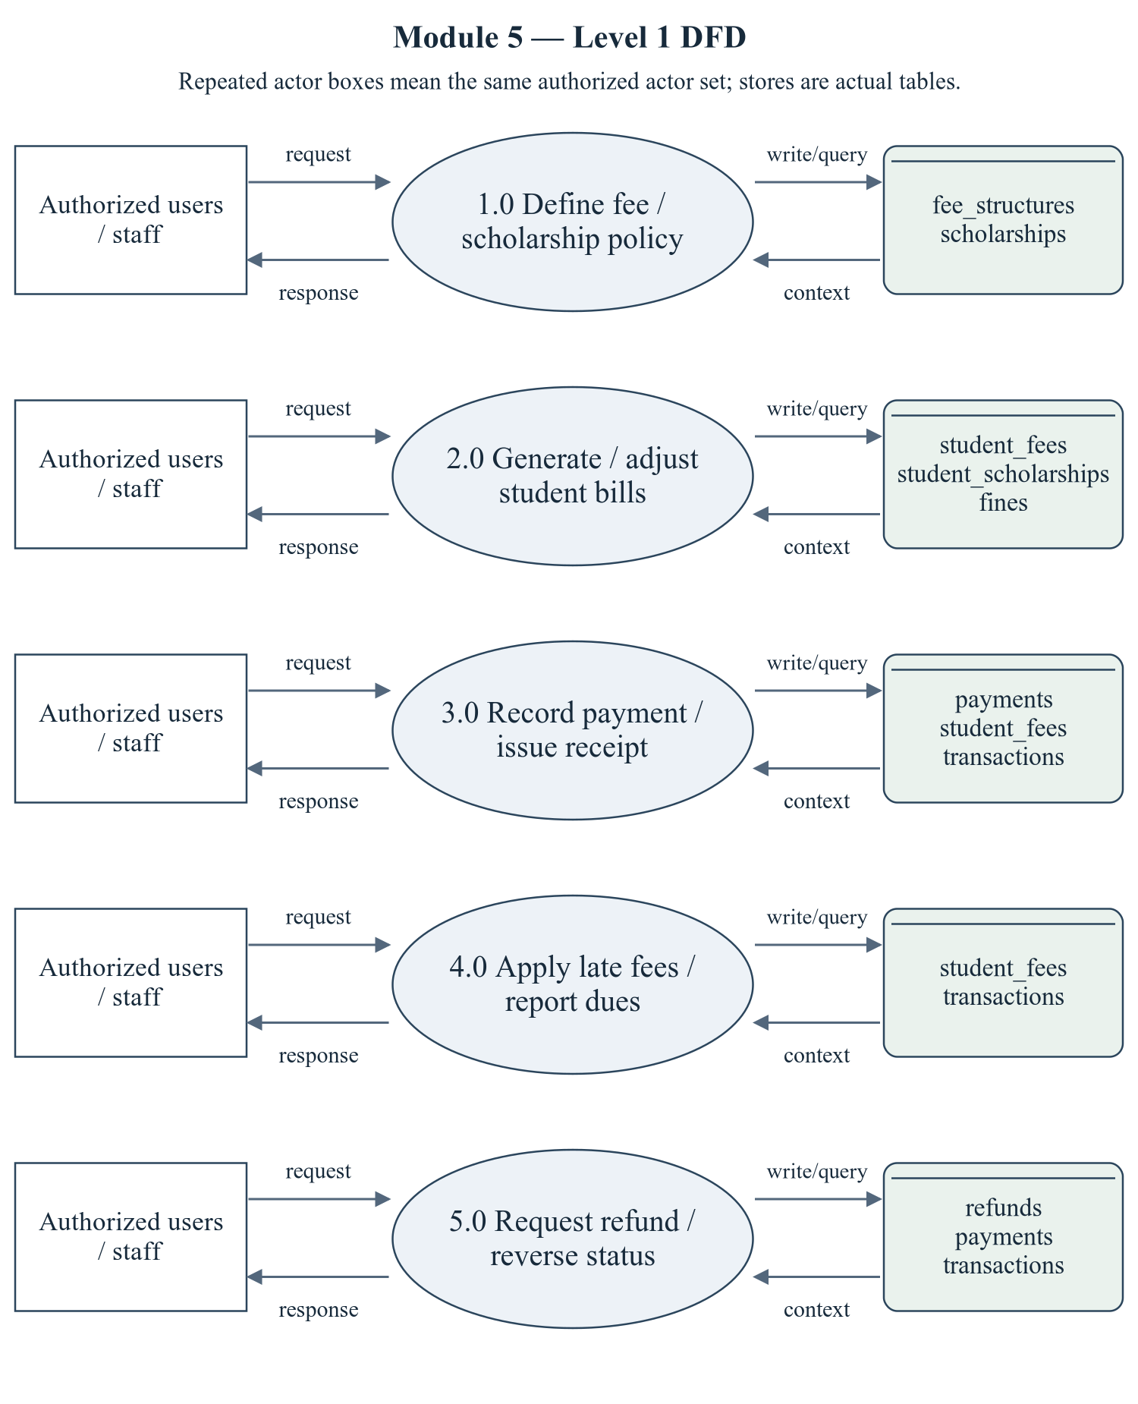
Figure 2.9 Fees and Payments — Level 1 DFD
The repeated actor boxes denote the same permitted actor set. Ellipses are module processes; D stores list actual persisted tables. Arrows represent request/response and query/write context, not proof of successful operations.
Editable drawing source: diagrams/05_module_05_dfd_level1.svg, .dot and .mmd. Edit SVG text/shapes in a vector editor, or regenerate from DOT/Mermaid; retain FK IDs and source names. These figures were created from static source, not captured from a running ERP.
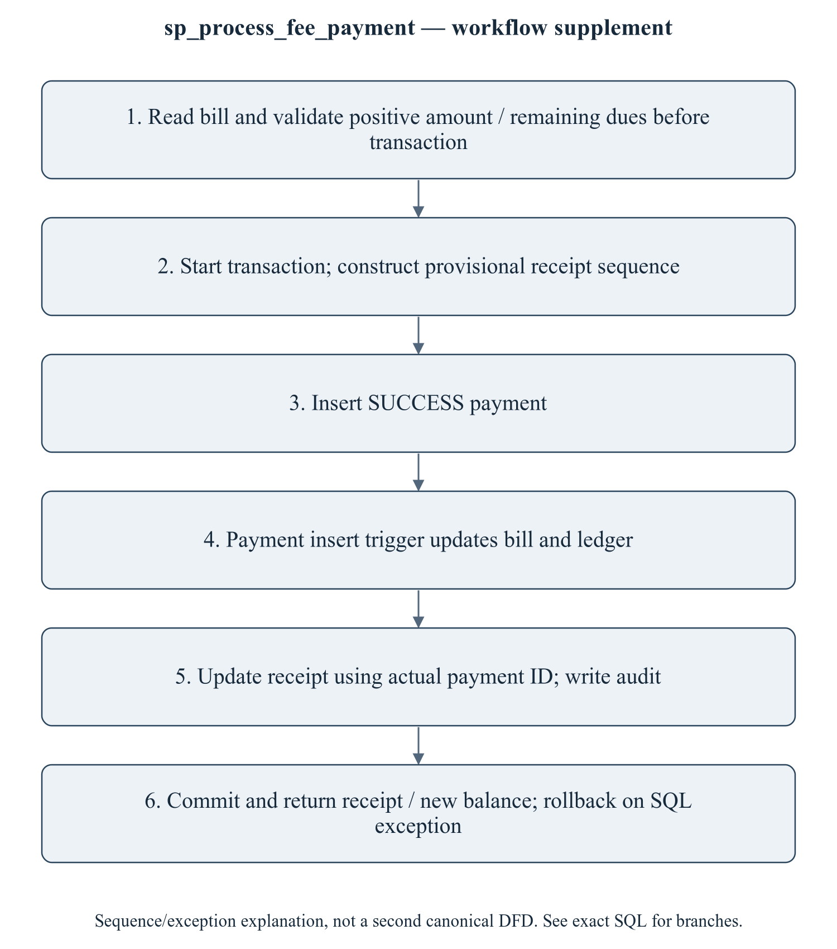
Figure 2.10 sp_process_fee_payment — workflow supplement
This sequence refines the critical procedure for explanation; it is explicitly a control/transaction workflow supplement, not a mislabeled canonical Level 2 DFD. The Level 1 DFD provides the formal module data-flow view. The BEFORE UPDATE trigger floors calculated dues at zero; the CHECK only guards nonnegative stored amounts. Neither proves overpayment or inconsistent direct INSERT is impossible. Manual finance recording is not a payment gateway. Partial refunds must not be described as correct until the full-reversal mismatch is repaired and executed.
Editable drawing source: diagrams/06_module_05_procedure_workflow.svg, .dot and .mmd. Edit SVG text/shapes in a vector editor, or regenerate from DOT/Mermaid; retain FK IDs and source names. These figures were created from static source, not captured from a running ERP.

2.5.2.1 Sub-System Processes, Data Stores (Tables), and External Data Movement
Table 2.13 Fees and Payments — processes and real stores
Process | Actual stores | External movement / integration
1.0 Define fee / scholarship policy | fee_structures, scholarships | Authorized actor request/response; shared master/FK data are internal context, not invented external systems.
2.0 Generate / adjust student bills | student_fees, student_scholarships, fines | Authorized actor request/response; shared master/FK data are internal context, not invented external systems.
3.0 Record payment / issue receipt | payments, student_fees, transactions | Authorized actor request/response; shared master/FK data are internal context, not invented external systems.
4.0 Apply late fees / report dues | student_fees, transactions | Authorized actor request/response; shared master/FK data are internal context, not invented external systems.
5.0 Request refund / reverse status | refunds, payments, transactions | Authorized actor request/response; shared master/FK data are internal context, not invented external systems.

2.5.3 Sub-Schema & Relational Data Dictionary
Relational notation below lists actual attributes. The full dictionary supplies types/nullability/defaults/constraints; PK/FK notation does not invent undeclared relationships.
fee_structures( fee_structure_id, fee_code, program_id, semester_no, academic_year_id, category_id, tuition_fee, hostel_fee, exam_fee, library_fee, lab_fee, development_fee, other_fee, late_fee_per_day, grace_days, due_date, status, created_at). PK={fee_structure_id}; FK IDs={FK075,FK076,FK077}.
student_fees( student_fee_id, student_id, fee_structure_id, semester_id, academic_year_id, total_amount, scholarship_amount, discount_amount, fine_amount, paid_amount, due_amount, status, due_date, paid_on, remarks, created_at, updated_at). PK={student_fee_id}; FK IDs={FK078,FK079,FK080,FK081}.
payments( payment_id, receipt_no, transaction_id, student_fee_id, student_id, amount, payment_mode, payment_date, status, reference_no, received_by, remarks, created_at). PK={payment_id}; FK IDs={FK082,FK083,FK084}.
scholarships( scholarship_id, scholarship_code, name, provider, scholarship_type, amount, is_percentage, criteria, max_beneficiaries, academic_year_id, status). PK={scholarship_id}; FK IDs={FK085}.
student_scholarships( student_scholarship_id, student_id, scholarship_id, academic_year_id, amount, sanctioned_on, sanctioned_by, status, remarks). PK={student_scholarship_id}; FK IDs={FK086,FK087,FK088,FK089}.
fines( fine_id, student_id, student_fee_id, reason, fine_type, amount, imposed_on, imposed_by, status, remarks). PK={fine_id}; FK IDs={FK090,FK091,FK092}.
refunds( refund_id, payment_id, student_id, amount, reason, refund_mode, refund_date, status, processed_by, remarks). PK={refund_id}; FK IDs={FK093,FK094,FK095}.
transactions( transaction_id, student_fee_id, payment_id, student_id, txn_type, amount, balance_after, description, created_at). PK={transaction_id}; FK IDs={FK096,FK097,FK098}.
The complete column/constraint dictionary for these exact relations is in 1.6; it is not copied a second time here. The module report repeats its own complete dictionary for independent use. class_sessions remains a joint G2/G3 contract.
Table 2.14 Shared / cross-module key contracts (not duplicated ownership)
Parent table / key | Module relationship | Declared action / FK ID
academic_years, PK academic_year_id | fee_structures.academic_year_id → academic_year_id; student_fees.academic_year_id → academic_year_id; scholarships.academic_year_id → academic_year_id; student_scholarships.academic_year_id → academic_year_id | FK076: ON DELETE CASCADE; FK081: ON DELETE CASCADE; FK085: ON DELETE CASCADE; FK088: ON DELETE CASCADE
categories, PK category_id | fee_structures.category_id → category_id | FK077: ON DELETE SET NULL
programs, PK program_id | fee_structures.program_id → program_id | FK075: ON DELETE CASCADE
semesters, PK semester_id | student_fees.semester_id → semester_id | FK080: ON DELETE CASCADE
students, PK student_id | student_fees.student_id → student_id; payments.student_id → student_id; student_scholarships.student_id → student_id; fines.student_id → student_id; refunds.student_id → student_id; transactions.student_id → student_id | FK078: ON DELETE CASCADE; FK083: ON DELETE CASCADE; FK086: ON DELETE CASCADE; FK090: ON DELETE CASCADE; FK094: ON DELETE CASCADE; FK098: ON DELETE CASCADE
users, PK user_id | payments.received_by → user_id; student_scholarships.sanctioned_by → user_id; fines.imposed_by → user_id; refunds.processed_by → user_id | FK084: ON DELETE SET NULL; FK089: ON DELETE SET NULL; FK092: ON DELETE SET NULL; FK095: ON DELETE SET NULL

The table dictionaries in this module cover its persisted schema in full. External parents above retain their original ownership; their complete 677-column enterprise dictionary is supplied in the master report and inventory workbook. Shared contracts are repeated here so this module can be read independently without pretending to own another module's tables.

2.5.4 Advanced SQL Implementation

2.5.4.1 Stored Procedures (SQL Code & Execution Proofs)

sp_generate_semester_fees
Purpose / expected behavior: Choose the generic category_id IS NULL structure for program/semester/year, bill ACTIVE students without any bill for that semester, and join year-matched scholarship rows without a sanction-status predicate. Return generated count; category-specific/multiple-award policy needs repair.
Source: database/05_procedures.sql:577–639. Definition found in the pinned snapshot; live existence and execution are unverified. Exact source comments may be stale; only inventoried definitions establish object names.
IN p_program_id: SMALLINT UNSIGNED
IN p_semester_id: SMALLINT UNSIGNED
IN p_semester_no: TINYINT UNSIGNED
IN p_academic_year_id: SMALLINT UNSIGNED
IN p_due_date: DATE
OUT p_generated: INT
OUT p_message: VARCHAR(255)
Outputs: p_generated INT, p_message VARCHAR(255)
Read/write dependencies: fee_structures, student_fees, student_scholarships, students, v_structure, v_total
Routine calls: No other stored routine call extracted.
Transaction boundary: Explicit START TRANSACTION / COMMIT and SQLEXCEPTION handling in the definition.
Invocation template (not executed): bind every @ input to a mutually consistent synthetic fixture selected from the declared tables and run only on an authorized disposable schema. Numeric literals below are planned test inputs, not observed results. Internal COMMIT means wrapping a CALL in an outer ROLLBACK is not a safe fixture-cleanup strategy.
CALL sp_generate_semester_fees(@p_program_id, @p_semester_id, @p_semester_no, @p_academic_year_id, @p_due_date, @p_generated, @p_message);
SELECT @p_generated AS p_generated, @p_message AS p_message;

Actual result: [[TO BE PROVIDED: run this test and record the actual result]]
Status: [[TO BE PROVIDED: run this test and record the actual result]]
Required evidence: [[TO BE PROVIDED: execute sp_generate_semester_fees or its triggering DML using the corresponding module test case; owner must attach sanitized inputs, OUT/SELECT/error output, before/after effects and timestamp]]
Exact SQL definition (unchanged from source):
CREATE PROCEDURE `sp_generate_semester_fees`(
IN p_program_id SMALLINT UNSIGNED,
IN p_semester_id SMALLINT UNSIGNED,
IN p_semester_no TINYINT UNSIGNED,
IN p_academic_year_id SMALLINT UNSIGNED,
IN p_due_date DATE,
OUT p_generated INT,
OUT p_message VARCHAR(255)
)
BEGIN
DECLARE v_structure SMALLINT UNSIGNED;
DECLARE v_total DECIMAL(10,2);

DECLARE EXIT HANDLER FOR SQLEXCEPTION
BEGIN
ROLLBACK;
RESIGNAL; -- keep the original error visible to the caller
END;

SELECT `fee_structure_id`,
(`tuition_fee` + `hostel_fee` + `exam_fee` + `library_fee` + `lab_fee`
+ `development_fee` + `other_fee`)
INTO v_structure, v_total
FROM `fee_structures`
WHERE `program_id` = p_program_id
AND `semester_no` = p_semester_no
AND `academic_year_id` = p_academic_year_id
AND `category_id` IS NULL
LIMIT 1;

IF v_structure IS NULL THEN
SIGNAL SQLSTATE '45000'
SET MESSAGE_TEXT = 'No fee structure defined for this program / semester / year.';
END IF;

START TRANSACTION;

INSERT INTO `student_fees`
(`student_id`, `fee_structure_id`, `semester_id`, `academic_year_id`,
`total_amount`, `due_amount`, `status`, `due_date`)
SELECT s.`student_id`, v_structure, p_semester_id, p_academic_year_id, v_total, v_total,
'PENDING', p_due_date
FROM `students` s
WHERE s.`program_id` = p_program_id
AND s.`status` = 'ACTIVE'
AND NOT EXISTS (SELECT 1 FROM `student_fees` sf
WHERE sf.`student_id` = s.`student_id`
AND sf.`semester_id` = p_semester_id);

SET p_generated = ROW_COUNT();

-- Credit any sanctioned scholarship against the fresh bills.
UPDATE `student_fees` sf
JOIN `student_scholarships` ss
ON ss.`student_id` = sf.`student_id` AND ss.`academic_year_id` = sf.`academic_year_id`
SET sf.`scholarship_amount` = ss.`amount`,
sf.`due_amount` = GREATEST(0, sf.`total_amount` - ss.`amount`)
WHERE sf.`semester_id` = p_semester_id
AND sf.`scholarship_amount` = 0;

SET p_message = CONCAT(p_generated, ' fee bills generated.');
COMMIT;
END$$

sp_process_fee_payment
Purpose / expected behavior: Validate amount/bill, create a successful payment/receipt and invoke insert-trigger bill/ledger effects; return payment ID/receipt/due outcome. Due checks precede the transaction; concurrent requests are unverified.
Source: database/05_procedures.sql:648–740. Definition found in the pinned snapshot; live existence and execution are unverified. Exact source comments may be stale; only inventoried definitions establish object names.
IN p_student_fee_id: INT UNSIGNED
IN p_amount: DECIMAL(10,2)
IN p_payment_mode: VARCHAR(20)
IN p_reference_no: VARCHAR(60)
IN p_received_by: INT UNSIGNED
OUT p_payment_id: INT UNSIGNED
OUT p_receipt_no: VARCHAR(30)
OUT p_message: VARCHAR(255)
Outputs: p_payment_id INT UNSIGNED, p_receipt_no VARCHAR(30), p_message VARCHAR(255)
Read/write dependencies: audit_logs, payments, student_fees, students, v_due, v_dup, v_paid, v_receipt, v_student, v_total, v_txn
Routine calls: sp_push_notification
Transaction boundary: Explicit START TRANSACTION / COMMIT and SQLEXCEPTION handling in the definition.
Invocation template (not executed): bind every @ input to a mutually consistent synthetic fixture selected from the declared tables and run only on an authorized disposable schema. Numeric literals below are planned test inputs, not observed results. Internal COMMIT means wrapping a CALL in an outer ROLLBACK is not a safe fixture-cleanup strategy.
CALL sp_process_fee_payment(@p_student_fee_id, @p_amount, @p_payment_mode, @p_reference_no, @p_received_by, @p_payment_id, @p_receipt_no, @p_message);
SELECT @p_payment_id AS p_payment_id, @p_receipt_no AS p_receipt_no, @p_message AS p_message;

Actual result: [[TO BE PROVIDED: run this test and record the actual result]]
Status: [[TO BE PROVIDED: run this test and record the actual result]]
Required evidence: [[TO BE PROVIDED: execute sp_process_fee_payment or its triggering DML using the corresponding module test case; owner must attach sanitized inputs, OUT/SELECT/error output, before/after effects and timestamp]]
Exact SQL definition (unchanged from source):
CREATE PROCEDURE `sp_process_fee_payment`(
IN p_student_fee_id INT UNSIGNED,
IN p_amount DECIMAL(10,2),
IN p_payment_mode VARCHAR(20),
IN p_reference_no VARCHAR(60),
IN p_received_by INT UNSIGNED,
OUT p_payment_id INT UNSIGNED,
OUT p_receipt_no VARCHAR(30),
OUT p_message VARCHAR(255)
)
BEGIN
DECLARE v_student INT UNSIGNED;
DECLARE v_due DECIMAL(10,2);
DECLARE v_total DECIMAL(10,2);
DECLARE v_paid DECIMAL(10,2);
DECLARE v_txn VARCHAR(60);
DECLARE v_receipt VARCHAR(30);
DECLARE v_dup INT DEFAULT 0;

DECLARE EXIT HANDLER FOR SQLEXCEPTION
BEGIN
ROLLBACK;
RESIGNAL; -- keep the original error visible to the caller
END;

IF p_amount IS NULL OR p_amount <= 0 THEN
SIGNAL SQLSTATE '45000' SET MESSAGE_TEXT = 'Payment amount must be greater than zero.';
END IF;

SELECT `student_id`, `due_amount`, `total_amount`, `paid_amount`
INTO v_student, v_due, v_total, v_paid
FROM `student_fees`
WHERE `student_fee_id` = p_student_fee_id;

IF v_student IS NULL THEN
SIGNAL SQLSTATE '45000' SET MESSAGE_TEXT = 'Fee bill not found.';
END IF;
IF p_amount > v_due + 0.01 THEN
SIGNAL SQLSTATE '45000'
SET MESSAGE_TEXT = 'Payment exceeds the outstanding amount on this bill.';
END IF;
IF p_reference_no IS NOT NULL THEN
SELECT COUNT(*) INTO v_dup FROM `payments` WHERE `transaction_id` = p_reference_no;
IF v_dup > 0 THEN
SIGNAL SQLSTATE '45000' SET MESSAGE_TEXT = 'Duplicate transaction reference.';
END IF;
END IF;

START TRANSACTION;

SET v_txn = CONCAT('TXN', DATE_FORMAT(NOW(), '%Y%m%d%H%i%s'), LPAD(FLOOR(RAND() * 100000), 5, '0'));
IF p_reference_no IS NOT NULL AND p_reference_no <> '' THEN
SET v_txn = p_reference_no;
END IF;

SET v_receipt = CONCAT('RCP-', DATE_FORMAT(NOW(), '%Y'), '-',
LPAD((SELECT IFNULL(MAX(`payment_id`), 0) + 1 FROM `payments`), 6, '0'));

INSERT INTO `payments`
(`receipt_no`, `transaction_id`, `student_fee_id`, `student_id`, `amount`,
`payment_mode`, `payment_date`, `status`, `reference_no`, `received_by`)
VALUES
(v_receipt, v_txn, p_student_fee_id, v_student, p_amount, p_payment_mode,
NOW(), 'SUCCESS', p_reference_no, p_received_by);

SET p_payment_id = LAST_INSERT_ID();
SET p_receipt_no = CONCAT('RCP-', DATE_FORMAT(NOW(), '%Y'), '-', LPAD(p_payment_id, 6, '0'));
UPDATE `payments` SET `receipt_no` = p_receipt_no WHERE `payment_id` = p_payment_id;

-- The AFTER INSERT trigger trg_payment_after_insert keeps student_fees in sync and
-- writes the ledger row; the UPDATE below only normalises the status value.
UPDATE `student_fees`
SET `status` = CASE
WHEN `due_amount` <= 0 THEN 'PAID'
WHEN `paid_amount` > 0 THEN 'PARTIAL'
ELSE `status`
END,
`paid_on` = CASE WHEN `due_amount` <= 0 THEN NOW() ELSE `paid_on` END
WHERE `student_fee_id` = p_student_fee_id;

INSERT INTO `audit_logs` (`user_id`, `action`, `entity`, `entity_id`, `description`)
VALUES (p_received_by, 'PAYMENT', 'payments', p_payment_id,
CONCAT('Receipt ', p_receipt_no, ' for INR ', p_amount, ' via ', p_payment_mode));

CALL sp_push_notification(
(SELECT `user_id` FROM `students` WHERE `student_id` = v_student),
'Payment received',
CONCAT('We received INR ', FORMAT(p_amount, 2), '. Receipt no. ', p_receipt_no, '.'),
'FEE_DUE', 'SUCCESS', 'payment', p_payment_id, '/student/fees');

SET p_message = CONCAT('Payment recorded. Receipt ', p_receipt_no, '.');
COMMIT;
END$$

sp_apply_late_fees
Purpose / expected behavior: Apply calculated late-fee values to qualifying unpaid bills and return affected count. The UDF supplies grace/rate behavior with no cap; rerun/idempotency must be tested.
Source: database/05_procedures.sql:747–771. Definition found in the pinned snapshot; live existence and execution are unverified. Exact source comments may be stale; only inventoried definitions establish object names.
OUT p_updated: INT
OUT p_message: VARCHAR(255)
Outputs: p_updated INT, p_message VARCHAR(255)
Read/write dependencies: fee_structures, student_fees
Routine calls: fn_calculate_late_fee
Transaction boundary: Explicit START TRANSACTION / COMMIT and SQLEXCEPTION handling in the definition.
Invocation template (not executed): bind every @ input to a mutually consistent synthetic fixture selected from the declared tables and run only on an authorized disposable schema. Numeric literals below are planned test inputs, not observed results. Internal COMMIT means wrapping a CALL in an outer ROLLBACK is not a safe fixture-cleanup strategy.
CALL sp_apply_late_fees(@p_updated, @p_message);
SELECT @p_updated AS p_updated, @p_message AS p_message;

Actual result: [[TO BE PROVIDED: run this test and record the actual result]]
Status: [[TO BE PROVIDED: run this test and record the actual result]]
Required evidence: [[TO BE PROVIDED: execute sp_apply_late_fees or its triggering DML using the corresponding module test case; owner must attach sanitized inputs, OUT/SELECT/error output, before/after effects and timestamp]]
Exact SQL definition (unchanged from source):
CREATE PROCEDURE `sp_apply_late_fees`(OUT p_updated INT, OUT p_message VARCHAR(255))
BEGIN
DECLARE EXIT HANDLER FOR SQLEXCEPTION
BEGIN
ROLLBACK;
RESIGNAL; -- keep the original error visible to the caller
END;

START TRANSACTION;

UPDATE `student_fees` sf
JOIN `fee_structures` fs ON fs.`fee_structure_id` = sf.`fee_structure_id`
SET sf.`fine_amount` = fn_calculate_late_fee(sf.`student_fee_id`),
sf.`due_amount` = GREATEST(0, sf.`total_amount` - sf.`scholarship_amount`
- sf.`discount_amount` - sf.`paid_amount`)
+ fn_calculate_late_fee(sf.`student_fee_id`),
sf.`status` = 'OVERDUE'
WHERE sf.`status` IN ('PENDING', 'PARTIAL', 'OVERDUE')
AND sf.`due_amount` > 0
AND CURDATE() > DATE_ADD(sf.`due_date`, INTERVAL fs.`grace_days` DAY);

SET p_updated = ROW_COUNT();
SET p_message = CONCAT('Late fees applied to ', p_updated, ' bills.');
COMMIT;
END$$

2.5.4.2 Database Triggers (SQL Code & Execution Proofs)

trg_student_fees_ai_audit
Purpose / expected behavior: Write bill-generation audit information after a student_fees INSERT.
Source: database/06_triggers.sql:371–380. Definition found in the pinned snapshot; live existence and execution are unverified. Exact source comments may be stale; only inventoried definitions establish object names.
Event / inputs / output: AFTER INSERT ON `student_fees` FOR EACH ROW; OLD/NEW are event-appropriate row images; no explicit arguments or scalar return. Side effects are described above.
Read/write dependencies: audit_logs, student_fees
Routine calls: No other stored routine call extracted.
Invocation template (not executed): bind every @ input to a mutually consistent synthetic fixture selected from the declared tables and run only on an authorized disposable schema. Numeric literals below are planned test inputs, not observed results. Internal COMMIT means wrapping a CALL in an outer ROLLBACK is not a safe fixture-cleanup strategy.
CALL sp_generate_semester_fees(@p_program_id, @p_semester_id, @p_semester_no, @p_academic_year_id, @p_due_date, @p_generated, @p_message);

Actual result: [[TO BE PROVIDED: run this test and record the actual result]]
Status: [[TO BE PROVIDED: run this test and record the actual result]]
Required evidence: [[TO BE PROVIDED: execute trg_student_fees_ai_audit or its triggering DML using the corresponding module test case; owner must attach sanitized inputs, OUT/SELECT/error output, before/after effects and timestamp]]
Exact SQL definition (unchanged from source):
CREATE TRIGGER `trg_student_fees_ai_audit`
AFTER INSERT ON `student_fees` FOR EACH ROW
BEGIN
INSERT INTO `audit_logs` (`action`, `entity`, `entity_id`, `description`, `new_value`)
VALUES ('FEE_CHANGE', 'student_fees', NEW.`student_fee_id`,
CONCAT('Fee bill created for student ', NEW.`student_id`,
' amount ', NEW.`total_amount`),
JSON_OBJECT('total_amount', NEW.`total_amount`, 'due_amount', NEW.`due_amount`,
'status', NEW.`status`, 'due_date', NEW.`due_date`));
END$$

trg_student_fees_bu_audit
Purpose / expected behavior: Write fee-change audit for selected watched bill fields before UPDATE. Not all columns are watched; no blanket full-row-audit claim is made.
Source: database/06_triggers.sql:385–421. Definition found in the pinned snapshot; live existence and execution are unverified. Exact source comments may be stale; only inventoried definitions establish object names.
Event / inputs / output: BEFORE UPDATE ON `student_fees` FOR EACH ROW; OLD/NEW are event-appropriate row images; no explicit arguments or scalar return. Side effects are described above.
Read/write dependencies: audit_logs, student_fees
Routine calls: No other stored routine call extracted.
Invocation template (not executed): bind every @ input to a mutually consistent synthetic fixture selected from the declared tables and run only on an authorized disposable schema. Numeric literals below are planned test inputs, not observed results. Internal COMMIT means wrapping a CALL in an outer ROLLBACK is not a safe fixture-cleanup strategy.
UPDATE student_fees SET fine_amount = fine_amount + 10.00 WHERE student_fee_id = @fixture_student_fee_id;

Actual result: [[TO BE PROVIDED: run this test and record the actual result]]
Status: [[TO BE PROVIDED: run this test and record the actual result]]
Required evidence: [[TO BE PROVIDED: execute trg_student_fees_bu_audit or its triggering DML using the corresponding module test case; owner must attach sanitized inputs, OUT/SELECT/error output, before/after effects and timestamp]]
Exact SQL definition (unchanged from source):
CREATE TRIGGER `trg_student_fees_bu_audit`
BEFORE UPDATE ON `student_fees` FOR EACH ROW
BEGIN
-- Recompute the outstanding balance and the payment status centrally, so that no
-- application code can leave a contradictory (amount, status) pair behind.
SET NEW.`due_amount` = GREATEST(0,
NEW.`total_amount` - NEW.`scholarship_amount` - NEW.`discount_amount`
- NEW.`paid_amount` + NEW.`fine_amount`);

IF NEW.`due_amount` <= 0 THEN
SET NEW.`status` = 'PAID';
SET NEW.`paid_on` = COALESCE(NEW.`paid_on`, NOW());
ELSEIF NEW.`paid_amount` > 0 THEN
SET NEW.`status` = 'PARTIAL';
ELSEIF NEW.`due_date` < CURDATE() THEN
SET NEW.`status` = 'OVERDUE';
ELSE
SET NEW.`status` = 'PENDING';
END IF;

IF OLD.`total_amount` <> NEW.`total_amount`
OR OLD.`scholarship_amount` <> NEW.`scholarship_amount`
OR OLD.`discount_amount` <> NEW.`discount_amount`
OR OLD.`fine_amount` <> NEW.`fine_amount`
OR OLD.`paid_amount` <> NEW.`paid_amount`
OR OLD.`status` <> NEW.`status` THEN
INSERT INTO `audit_logs` (`action`, `entity`, `entity_id`, `old_value`, `new_value`, `description`)
VALUES ('FEE_CHANGE', 'student_fees', NEW.`student_fee_id`,
JSON_OBJECT('total_amount', OLD.`total_amount`, 'paid_amount', OLD.`paid_amount`,
'due_amount', OLD.`due_amount`, 'fine_amount', OLD.`fine_amount`,
'scholarship_amount', OLD.`scholarship_amount`, 'status', OLD.`status`),
JSON_OBJECT('total_amount', NEW.`total_amount`, 'paid_amount', NEW.`paid_amount`,
'due_amount', NEW.`due_amount`, 'fine_amount', NEW.`fine_amount`,
'scholarship_amount', NEW.`scholarship_amount`, 'status', NEW.`status`),
'Fee record modified');
END IF;
END$$

trg_payment_ai
Purpose / expected behavior: For a SUCCESS payment, increment paid_amount, recalculate bill status and insert a CREDIT transactions entry with balance. Failed/non-success inserts do not have the same effects.
Source: database/06_triggers.sql:426–442. Definition found in the pinned snapshot; live existence and execution are unverified. Exact source comments may be stale; only inventoried definitions establish object names.
Event / inputs / output: AFTER INSERT ON `payments` FOR EACH ROW; OLD/NEW are event-appropriate row images; no explicit arguments or scalar return. Side effects are described above.
Read/write dependencies: payments, student_fees, transactions
Routine calls: No other stored routine call extracted.
Invocation template (not executed): bind every @ input to a mutually consistent synthetic fixture selected from the declared tables and run only on an authorized disposable schema. Numeric literals below are planned test inputs, not observed results. Internal COMMIT means wrapping a CALL in an outer ROLLBACK is not a safe fixture-cleanup strategy.
CALL sp_process_fee_payment(@p_student_fee_id, @p_amount, @p_payment_mode, @p_reference_no, @p_received_by, @p_payment_id, @p_receipt_no, @p_message);

Actual result: [[TO BE PROVIDED: run this test and record the actual result]]
Status: [[TO BE PROVIDED: run this test and record the actual result]]
Required evidence: [[TO BE PROVIDED: execute trg_payment_ai or its triggering DML using the corresponding module test case; owner must attach sanitized inputs, OUT/SELECT/error output, before/after effects and timestamp]]
Exact SQL definition (unchanged from source):
CREATE TRIGGER `trg_payment_ai`
AFTER INSERT ON `payments` FOR EACH ROW
BEGIN
IF NEW.`status` = 'SUCCESS' THEN
UPDATE `student_fees`
SET `paid_amount` = `paid_amount` + NEW.`amount`
WHERE `student_fee_id` = NEW.`student_fee_id`;

INSERT INTO `transactions`
(`student_fee_id`, `payment_id`, `student_id`, `txn_type`, `amount`, `balance_after`, `description`)
SELECT sf.`student_fee_id`, NEW.`payment_id`, NEW.`student_id`, 'CREDIT', NEW.`amount`,
GREATEST(0, sf.`total_amount` - sf.`scholarship_amount` - sf.`discount_amount`
- sf.`paid_amount` + sf.`fine_amount`),
CONCAT('Receipt ', NEW.`receipt_no`, ' - ', NEW.`payment_mode`)
FROM `student_fees` sf WHERE sf.`student_fee_id` = NEW.`student_fee_id`;
END IF;
END$$

trg_payment_au
Purpose / expected behavior: On SUCCESS to REFUNDED, reverse the entire original amount on the bill and insert a DEBIT ledger entry. This is not correct partial-refund handling.
Source: database/06_triggers.sql:446–459. Definition found in the pinned snapshot; live existence and execution are unverified. Exact source comments may be stale; only inventoried definitions establish object names.
Event / inputs / output: AFTER UPDATE ON `payments` FOR EACH ROW; OLD/NEW are event-appropriate row images; no explicit arguments or scalar return. Side effects are described above.
Read/write dependencies: payments, student_fees, transactions
Routine calls: No other stored routine call extracted.
Invocation template (not executed): bind every @ input to a mutually consistent synthetic fixture selected from the declared tables and run only on an authorized disposable schema. Numeric literals below are planned test inputs, not observed results. Internal COMMIT means wrapping a CALL in an outer ROLLBACK is not a safe fixture-cleanup strategy.
UPDATE payments SET status = 'REFUNDED' WHERE payment_id = @fixture_success_payment_id;

Actual result: [[TO BE PROVIDED: run this test and record the actual result]]
Status: [[TO BE PROVIDED: run this test and record the actual result]]
Required evidence: [[TO BE PROVIDED: execute trg_payment_au or its triggering DML using the corresponding module test case; owner must attach sanitized inputs, OUT/SELECT/error output, before/after effects and timestamp]]
Exact SQL definition (unchanged from source):
CREATE TRIGGER `trg_payment_au`
AFTER UPDATE ON `payments` FOR EACH ROW
BEGIN
IF OLD.`status` = 'SUCCESS' AND NEW.`status` = 'REFUNDED' THEN
UPDATE `student_fees`
SET `paid_amount` = GREATEST(0, `paid_amount` - NEW.`amount`)
WHERE `student_fee_id` = NEW.`student_fee_id`;

INSERT INTO `transactions`
(`student_fee_id`, `payment_id`, `student_id`, `txn_type`, `amount`, `description`)
VALUES (NEW.`student_fee_id`, NEW.`payment_id`, NEW.`student_id`, 'DEBIT', NEW.`amount`,
CONCAT('Refund against receipt ', NEW.`receipt_no`));
END IF;
END$$

2.5.4.3 User-Defined Functions (UDFs) (SQL Code & Execution Proofs)

fn_calculate_late_fee
Purpose / expected behavior: Calculate bill late fee as positive days beyond due_date + grace_days times the template daily rate, rounded to two decimals; no cap is implemented. Returns a computed value; does not by itself post a ledger transaction.
Source: database/07_functions.sql:191–216. Definition found in the pinned snapshot; live existence and execution are unverified. Exact source comments may be stale; only inventoried definitions establish object names.
IN p_student_fee_id: INT UNSIGNED
Output: decimal(10,2) scalar return value.
Read/write dependencies: fee_structures, student_fees, v_days_late, v_due_date, v_grace_days, v_per_day, v_status
Routine calls: No other stored routine call extracted.
Invocation template (not executed): bind every @ input to a mutually consistent synthetic fixture selected from the declared tables and run only on an authorized disposable schema. Numeric literals below are planned test inputs, not observed results. Internal COMMIT means wrapping a CALL in an outer ROLLBACK is not a safe fixture-cleanup strategy.
SELECT fn_calculate_late_fee(@p_student_fee_id) AS computed_value;

Actual result: [[TO BE PROVIDED: run this test and record the actual result]]
Status: [[TO BE PROVIDED: run this test and record the actual result]]
Required evidence: [[TO BE PROVIDED: execute fn_calculate_late_fee or its triggering DML using the corresponding module test case; owner must attach sanitized inputs, OUT/SELECT/error output, before/after effects and timestamp]]
Exact SQL definition (unchanged from source):
CREATE FUNCTION `fn_calculate_late_fee`(p_student_fee_id INT UNSIGNED)
RETURNS decimal(10,2)
READS SQL DATA
BEGIN
DECLARE v_due_date DATE;
DECLARE v_grace_days INT DEFAULT 0;
DECLARE v_per_day DECIMAL(8,2) DEFAULT 0.00;
DECLARE v_days_late INT DEFAULT 0;
DECLARE v_status VARCHAR(20);

SELECT sf.`due_date`, fs.`grace_days`, fs.`late_fee_per_day`, sf.`status`
INTO v_due_date, v_grace_days, v_per_day, v_status
FROM `student_fees` sf
JOIN `fee_structures` fs ON fs.`fee_structure_id` = sf.`fee_structure_id`
WHERE sf.`student_fee_id` = p_student_fee_id;

IF v_due_date IS NULL OR v_status IN ('PAID','REFUNDED') THEN
RETURN 0.00;
END IF;

SET v_days_late = DATEDIFF(CURDATE(), DATE_ADD(v_due_date, INTERVAL v_grace_days DAY));
IF v_days_late <= 0 THEN
RETURN 0.00;
END IF;
RETURN ROUND(v_days_late * v_per_day, 2);
END$$

fn_student_outstanding_dues
Purpose / expected behavior: Sum due_amount for the student where bill status is PENDING, PARTIAL or OVERDUE, returning zero for an empty aggregate. It is a calculation, not an exam-registration rejection rule.
Source: database/07_functions.sql:261–271. Definition found in the pinned snapshot; live existence and execution are unverified. Exact source comments may be stale; only inventoried definitions establish object names.
IN p_student_id: INT UNSIGNED
Output: decimal(12,2) scalar return value.
Read/write dependencies: student_fees, v_dues
Routine calls: No other stored routine call extracted.
Invocation template (not executed): bind every @ input to a mutually consistent synthetic fixture selected from the declared tables and run only on an authorized disposable schema. Numeric literals below are planned test inputs, not observed results. Internal COMMIT means wrapping a CALL in an outer ROLLBACK is not a safe fixture-cleanup strategy.
SELECT fn_student_outstanding_dues(@p_student_id) AS computed_value;

Actual result: [[TO BE PROVIDED: run this test and record the actual result]]
Status: [[TO BE PROVIDED: run this test and record the actual result]]
Required evidence: [[TO BE PROVIDED: execute fn_student_outstanding_dues or its triggering DML using the corresponding module test case; owner must attach sanitized inputs, OUT/SELECT/error output, before/after effects and timestamp]]
Exact SQL definition (unchanged from source):
CREATE FUNCTION `fn_student_outstanding_dues`(p_student_id INT UNSIGNED)
RETURNS decimal(12,2)
READS SQL DATA
BEGIN
DECLARE v_dues DECIMAL(12,2) DEFAULT 0.00;
SELECT IFNULL(SUM(`due_amount`),0) INTO v_dues
FROM `student_fees`
WHERE `student_id` = p_student_id
AND `status` IN ('PENDING','PARTIAL','OVERDUE');
RETURN v_dues;
END$$

2.5.5 Complex Analytical Queries & Views

v_student_fee_status
Purpose / expected behavior: Aggregate billed, paid, due and overdue student bills with overall fee status and next due date.
Source: database/08_views.sql:125–150. Definition found in the pinned snapshot; live existence and execution are unverified. Exact source comments may be stale; only inventoried definitions establish object names.
Inputs / output: No parameters; SELECT returns columns: student_id, roll_number, full_name, department_id, program_id, batch_id, total_bills, total_billed, total_paid, total_due, total_fine, total_scholarship, paid_bills, pending_bills, partial_bills, overdue_bills, next_due_date, overall_fee_status. WHERE/JOIN predicates are query inputs, not stored view parameters.
Read/write dependencies: student_fees, students
Routine calls: No other stored routine call extracted.
Invocation template (not executed): bind every @ input to a mutually consistent synthetic fixture selected from the declared tables and run only on an authorized disposable schema. Numeric literals below are planned test inputs, not observed results. Internal COMMIT means wrapping a CALL in an outer ROLLBACK is not a safe fixture-cleanup strategy.
SELECT * FROM v_student_fee_status LIMIT 10;

Actual result: [[TO BE PROVIDED: run this test and record the actual result]]
Status: [[TO BE PROVIDED: run this test and record the actual result]]
Required evidence: [[TO BE PROVIDED: execute v_student_fee_status or its triggering DML using the corresponding module test case; owner must attach sanitized inputs, OUT/SELECT/error output, before/after effects and timestamp]]
Exact SQL definition (unchanged from source):
CREATE OR REPLACE VIEW `v_student_fee_status` AS
SELECT s.`student_id`, s.`roll_number`,
CONCAT(s.`first_name`, ' ', s.`last_name`) AS `full_name`,
s.`department_id`, s.`program_id`, s.`batch_id`,
COUNT(sf.`student_fee_id`) AS `total_bills`,
IFNULL(SUM(sf.`total_amount`),0) AS `total_billed`,
IFNULL(SUM(sf.`paid_amount`),0) AS `total_paid`,
IFNULL(SUM(sf.`due_amount`),0) AS `total_due`,
IFNULL(SUM(sf.`fine_amount`),0) AS `total_fine`,
IFNULL(SUM(sf.`scholarship_amount`),0) AS `total_scholarship`,
SUM(CASE WHEN sf.`status` = 'PAID' THEN 1 ELSE 0 END) AS `paid_bills`,
SUM(CASE WHEN sf.`status` = 'PENDING' THEN 1 ELSE 0 END) AS `pending_bills`,
SUM(CASE WHEN sf.`status` = 'PARTIAL' THEN 1 ELSE 0 END) AS `partial_bills`,
SUM(CASE WHEN sf.`status` = 'OVERDUE' THEN 1 ELSE 0 END) AS `overdue_bills`,
MIN(CASE WHEN sf.`due_amount` > 0 THEN sf.`due_date` END) AS `next_due_date`,
CASE
WHEN SUM(sf.`due_amount`) = 0 AND COUNT(sf.`student_fee_id`) > 0 THEN 'CLEARED'
WHEN SUM(CASE WHEN sf.`status` = 'OVERDUE' THEN 1 ELSE 0 END) > 0 THEN 'OVERDUE'
WHEN SUM(sf.`due_amount`) > 0 AND SUM(sf.`paid_amount`) > 0 THEN 'PARTIAL'
WHEN COUNT(sf.`student_fee_id`) = 0 THEN 'NO_BILL'
ELSE 'PENDING'
END AS `overall_fee_status`
FROM `students` s
LEFT JOIN `student_fees` sf ON sf.`student_id` = s.`student_id`
GROUP BY s.`student_id`, s.`roll_number`, s.`first_name`, s.`last_name`,
s.`department_id`, s.`program_id`, s.`batch_id`;

v_fee_collection_summary
Purpose / expected behavior: Aggregate bill/collection amounts by academic program/semester context; it is not a month-by-month payments view.
Source: database/08_views.sql:155–172. Definition found in the pinned snapshot; live existence and execution are unverified. Exact source comments may be stale; only inventoried definitions establish object names.
Inputs / output: No parameters; SELECT returns columns: program_id, program_code, program_name, department_id, department_code, semester_id, semester_name, semester_no, bills_raised, amount_billed, amount_collected, amount_pending, amount_fine, collection_percentage. WHERE/JOIN predicates are query inputs, not stored view parameters.
Read/write dependencies: departments, programs, semesters, student_fees, students
Routine calls: No other stored routine call extracted.
Invocation template (not executed): bind every @ input to a mutually consistent synthetic fixture selected from the declared tables and run only on an authorized disposable schema. Numeric literals below are planned test inputs, not observed results. Internal COMMIT means wrapping a CALL in an outer ROLLBACK is not a safe fixture-cleanup strategy.
SELECT * FROM v_fee_collection_summary LIMIT 10;

Actual result: [[TO BE PROVIDED: run this test and record the actual result]]
Status: [[TO BE PROVIDED: run this test and record the actual result]]
Required evidence: [[TO BE PROVIDED: execute v_fee_collection_summary or its triggering DML using the corresponding module test case; owner must attach sanitized inputs, OUT/SELECT/error output, before/after effects and timestamp]]
Exact SQL definition (unchanged from source):
CREATE OR REPLACE VIEW `v_fee_collection_summary` AS
SELECT p.`program_id`, p.`program_code`, p.`name` AS `program_name`,
d.`department_id`, d.`department_code`,
sem.`semester_id`, sem.`name` AS `semester_name`, sem.`semester_no`,
COUNT(sf.`student_fee_id`) AS `bills_raised`,
IFNULL(SUM(sf.`total_amount`),0) AS `amount_billed`,
IFNULL(SUM(sf.`paid_amount`),0) AS `amount_collected`,
IFNULL(SUM(sf.`due_amount`),0) AS `amount_pending`,
IFNULL(SUM(sf.`fine_amount`),0) AS `amount_fine`,
ROUND(IFNULL(SUM(sf.`paid_amount`),0) * 100.0
/ NULLIF(SUM(sf.`total_amount`),0), 2) AS `collection_percentage`
FROM `student_fees` sf
JOIN `students` s ON s.`student_id` = sf.`student_id`
JOIN `programs` p ON p.`program_id` = s.`program_id`
JOIN `departments` d ON d.`department_id` = s.`department_id`
JOIN `semesters` sem ON sem.`semester_id` = sf.`semester_id`
GROUP BY p.`program_id`, p.`program_code`, p.`name`, d.`department_id`, d.`department_code`,
sem.`semester_id`, sem.`name`, sem.`semester_no`;

v_daily_fee_collection
Purpose / expected behavior: Aggregate successful payments by DATE(payment_date), including payment-mode totals and transaction count.
Source: database/08_views.sql:512–520. Definition found in the pinned snapshot; live existence and execution are unverified. Exact source comments may be stale; only inventoried definitions establish object names.
Inputs / output: No parameters; SELECT returns columns: payment_day, transactions, collected_amount, online_amount, cash_amount. WHERE/JOIN predicates are query inputs, not stored view parameters.
Read/write dependencies: payments
Routine calls: No other stored routine call extracted.
Invocation template (not executed): bind every @ input to a mutually consistent synthetic fixture selected from the declared tables and run only on an authorized disposable schema. Numeric literals below are planned test inputs, not observed results. Internal COMMIT means wrapping a CALL in an outer ROLLBACK is not a safe fixture-cleanup strategy.
SELECT * FROM v_daily_fee_collection LIMIT 10;

Actual result: [[TO BE PROVIDED: run this test and record the actual result]]
Status: [[TO BE PROVIDED: run this test and record the actual result]]
Required evidence: [[TO BE PROVIDED: execute v_daily_fee_collection or its triggering DML using the corresponding module test case; owner must attach sanitized inputs, OUT/SELECT/error output, before/after effects and timestamp]]
Exact SQL definition (unchanged from source):
CREATE OR REPLACE VIEW `v_daily_fee_collection` AS
SELECT DATE(p.`payment_date`) AS `payment_day`,
COUNT(*) AS `transactions`,
SUM(p.`amount`) AS `collected_amount`,
SUM(CASE WHEN p.`payment_mode` = 'ONLINE' THEN p.`amount` ELSE 0 END) AS `online_amount`,
SUM(CASE WHEN p.`payment_mode` = 'CASH' THEN p.`amount` ELSE 0 END) AS `cash_amount`
FROM `payments` p
WHERE p.`status` = 'SUCCESS'
GROUP BY DATE(p.`payment_date`);

Q29 analyzes collections over months. Q37 groups fee aging; negative days (future due dates) fall into its 0-30 bucket, so that bucket is not an exclusively overdue population. [R08]

Q29 — LAG / LEAD — month-on-month fee collection growth
Source: database/09_queries.sql:728. Purpose is the query projection/aggregation below; no output rows have been generated. Expected column structure follows aliases in the exact statement.
WITH monthly AS (
SELECT DATE_FORMAT(p.payment_date, '%Y-%m') AS month,
SUM(p.amount) AS collected,
COUNT(*) AS receipts
FROM payments p
WHERE p.status = 'SUCCESS'
GROUP BY DATE_FORMAT(p.payment_date, '%Y-%m'))
SELECT month,
receipts,
collected,
LAG(collected) OVER (ORDER BY month) AS previous_month,
collected - LAG(collected) OVER (ORDER BY month) AS delta,
ROUND(100.0 * (collected - LAG(collected) OVER (ORDER BY month))
/ NULLIF(LAG(collected) OVER (ORDER BY month), 0), 1) AS growth_percentage,
LEAD(collected) OVER (ORDER BY month) AS next_month
FROM monthly
ORDER BY month;

Actual result: [[TO BE PROVIDED: run this test and record the actual result]]
Status: [[TO BE PROVIDED: run this test and record the actual result]]

Q37 — Fee ageing buckets (0-30 / 31-90 / 91-180 / 180+) per program
Source: database/09_queries.sql:938. Purpose is the query projection/aggregation below; no output rows have been generated. Expected column structure follows aliases in the exact statement.
WITH aged AS (
SELECT s.program_id,
p.program_code,
DATEDIFF(CURDATE(), sf.due_date) AS days,
sf.due_amount
FROM student_fees sf
JOIN students s ON s.student_id = sf.student_id
JOIN programs p ON p.program_id = s.program_id
WHERE sf.status <> 'PAID' AND sf.due_amount > 0)
SELECT program_code,
COUNT(*) AS overdue_bills,
SUM(due_amount) AS total_due,
SUM(CASE WHEN days <= 30 THEN due_amount ELSE 0 END) AS bucket_0_30,
SUM(CASE WHEN days BETWEEN 31 AND 90 THEN due_amount ELSE 0 END) AS bucket_31_90,
SUM(CASE WHEN days BETWEEN 91 AND 180 THEN due_amount ELSE 0 END) AS bucket_91_180,
SUM(CASE WHEN days > 180 THEN due_amount ELSE 0 END) AS bucket_180_plus
FROM aged
GROUP BY program_id, program_code
ORDER BY total_due DESC;

Actual result: [[TO BE PROVIDED: run this test and record the actual result]]
Status: [[TO BE PROVIDED: run this test and record the actual result]]

2.5.6 Backend, Frontend, Validation & Transaction Trace
Table 2.15 Fees and Payments — exact API route/role register
Method and route | Role gate / handler | Validation and source
GET /api/v1/fees/structures | ADMIN, ACCOUNTANT  Handler: feeStructures | No route-local Zod validation; service/DB checks may apply  backend/src/routes/finance.routes.ts:13
GET /api/v1/fees/structures/:id | ADMIN, ACCOUNTANT  Handler: feeStructure | No route-local Zod validation; service/DB checks may apply  backend/src/routes/finance.routes.ts:14
POST /api/v1/fees/structures | ADMIN, ACCOUNTANT  Handler: createFeeStructure | No route-local Zod validation; service/DB checks may apply  backend/src/routes/finance.routes.ts:15
PUT /api/v1/fees/structures/:id | ADMIN, ACCOUNTANT  Handler: updateFeeStructure | No route-local Zod validation; service/DB checks may apply  backend/src/routes/finance.routes.ts:16
GET /api/v1/fees/bills | STUDENT, ADMIN, ACCOUNTANT  Handler: bills | No route-local Zod validation; service/DB checks may apply  backend/src/routes/finance.routes.ts:18
GET /api/v1/fees/bills/me | STUDENT  Handler: myBills | No route-local Zod validation; service/DB checks may apply  backend/src/routes/finance.routes.ts:19
GET /api/v1/fees/bills/summary/me | STUDENT  Handler: myFeeSummary | No route-local Zod validation; service/DB checks may apply  backend/src/routes/finance.routes.ts:20
GET /api/v1/fees/bills/stats | ADMIN, ACCOUNTANT  Handler: feeStats | No route-local Zod validation; service/DB checks may apply  backend/src/routes/finance.routes.ts:21
GET /api/v1/fees/bills/defaulters | ADMIN, ACCOUNTANT  Handler: defaulters | No route-local Zod validation; service/DB checks may apply  backend/src/routes/finance.routes.ts:22
GET /api/v1/fees/bills/:id | ADMIN, ACCOUNTANT  Handler: bill | No route-local Zod validation; service/DB checks may apply  backend/src/routes/finance.routes.ts:23
GET /api/v1/fees/bills/:id/ledger | ADMIN, ACCOUNTANT  Handler: ledger | No route-local Zod validation; service/DB checks may apply  backend/src/routes/finance.routes.ts:24
GET /api/v1/fees/bills/:id/late-fee | ADMIN, ACCOUNTANT  Handler: lateFeePreview | No route-local Zod validation; service/DB checks may apply  backend/src/routes/finance.routes.ts:25
GET /api/v1/fees/student/:id/bills | Authenticated; row scope must be inspected  Handler: myBills | No route-local Zod validation; service/DB checks may apply  backend/src/routes/finance.routes.ts:27
GET /api/v1/fees/student/:id/summary | Authenticated; row scope must be inspected  Handler: myFeeSummary | No route-local Zod validation; service/DB checks may apply  backend/src/routes/finance.routes.ts:28
POST /api/v1/fees/generate | ADMIN, ACCOUNTANT  Handler: generateFees | Zod validate(...) in route  backend/src/routes/finance.routes.ts:30
POST /api/v1/fees/apply-late-fees | ADMIN, ACCOUNTANT  Handler: applyLateFees | No route-local Zod validation; service/DB checks may apply  backend/src/routes/finance.routes.ts:37
GET /api/v1/fees/payments | STUDENT, ADMIN, ACCOUNTANT  Handler: payments | No route-local Zod validation; service/DB checks may apply  backend/src/routes/finance.routes.ts:39
POST /api/v1/fees/payments | ADMIN, ACCOUNTANT  Handler: pay | Zod validate(...) in route  backend/src/routes/finance.routes.ts:40
GET /api/v1/fees/payments/daily | ADMIN, ACCOUNTANT  Handler: dailyCollection | No route-local Zod validation; service/DB checks may apply  backend/src/routes/finance.routes.ts:46
GET /api/v1/fees/payments/monthly | ADMIN, ACCOUNTANT  Handler: monthlyCollection | No route-local Zod validation; service/DB checks may apply  backend/src/routes/finance.routes.ts:47
GET /api/v1/fees/payments/receipt/:receiptNo | STUDENT, ADMIN, ACCOUNTANT  Handler: receipt | No route-local Zod validation; service/DB checks may apply  backend/src/routes/finance.routes.ts:48
POST /api/v1/fees/payments/refund | ADMIN, ACCOUNTANT  Handler: refund | Zod validate(...) in route  backend/src/routes/finance.routes.ts:49
GET /api/v1/fees/fines | STUDENT, ADMIN, ACCOUNTANT  Handler: fines | No route-local Zod validation; service/DB checks may apply  backend/src/routes/finance.routes.ts:55
POST /api/v1/fees/fines | ADMIN, ACCOUNTANT  Handler: createFine | No route-local Zod validation; service/DB checks may apply  backend/src/routes/finance.routes.ts:56
PATCH /api/v1/fees/fines/:id | ADMIN, ACCOUNTANT  Handler: updateFine | No route-local Zod validation; service/DB checks may apply  backend/src/routes/finance.routes.ts:57
GET /api/v1/fees/scholarships | ADMIN, ACCOUNTANT  Handler: scholarships | No route-local Zod validation; service/DB checks may apply  backend/src/routes/finance.routes.ts:59
GET /api/v1/fees/scholarships/me | STUDENT  Handler: myScholarships | No route-local Zod validation; service/DB checks may apply  backend/src/routes/finance.routes.ts:60
GET /api/v1/fees/scholarships/student/:id | ADMIN, ACCOUNTANT  Handler: myScholarships | No route-local Zod validation; service/DB checks may apply  backend/src/routes/finance.routes.ts:61
POST /api/v1/fees/scholarships/award | ADMIN, ACCOUNTANT  Handler: awardScholarship | Zod validate(...) in route  backend/src/routes/finance.routes.ts:62
GET /api/v1/fees/refunds | ADMIN, ACCOUNTANT  Handler: refunds | No route-local Zod validation; service/DB checks may apply  backend/src/routes/finance.routes.ts:69
GET /api/v1/fees/export/:kind | ADMIN, ACCOUNTANT  Handler: exportCsvEndpoint | No route-local Zod validation; service/DB checks may apply  backend/src/routes/finance.routes.ts:70

backend/src/controllers/finance.controller.ts: Exports: feeStructures, feeStructure, createFeeStructure, updateFeeStructure, bills, bill, myBills, myFeeSummary, ledger, feeStats, defaulters, generateFees, applyLateFees, lateFeePreview, payments, pay, receipt, dailyCollection, monthlyCollection, refund, fines, createFine, updateFine, scholarships, myScholarships, awardScholarship, refunds, exportCsvEndpoint. SQL references: .
backend/src/repositories/finance.repository.ts: Exports: feeStructuresRepo, studentFeesRepo, paymentsRepo, finesRepo, scholarshipsRepo, refundsRepo. SQL references: academic_years, categories, departments, faculty, fee_structures, fines, payments, programs, refunds, scholarships, semesters, student_fees, student_scholarships, students, transactions, fn_calculate_late_fee, v_daily_fee_collection, v_fee_collection_summary, v_student_fee_status.
backend/src/services/finance.service.ts: Exports: feeStructures, studentFees, payments, fines, scholarships, refunds, exportCsv. SQL references: payments, students, fn_calculate_late_fee, sp_apply_late_fees, sp_generate_semester_fees, sp_process_fee_payment.
Frontend source pages: frontend/src/pages/fees/BillsPage.tsx; frontend/src/pages/fees/DefaultersPage.tsx; frontend/src/pages/fees/FeeStructuresPage.tsx; frontend/src/pages/fees/MyFeesPage.tsx; frontend/src/pages/fees/PaymentsPage.tsx; frontend/src/pages/fees/ScholarshipsPage.tsx.
Controller → service → repository separation is present in source. mysql2 query/execute helpers bind values; callProc reads OUT parameters on one acquired connection. Some services write audit/notifications after the database operation on a separate pooled request, so a procedure transaction does not make every service side effect atomic. [R15, R09, R19]
Validation/error contract: route-local Zod schemas operate on request bodies where listed; the report does not infer validation for routes without validate(...). Services raise AppError for selected missing records/invalid inputs; DB FK/UNIQUE/CHECK/SIGNAL errors pass through the shared handler. HTTP statuses and payloads need API execution evidence, not invented response screenshots. [R10]
Exact route validation expressions (TypeScript/Zod, not SQL; no execution claim):
backend/src/routes/finance.routes.ts:30 — router.post '/generate'
z.object({
programId: z.number().int().positive(),
semesterId: z.number().int().positive(),
semesterNo: z.number().int().positive(),
academicYearId: z.number().int().positive(),
dueDate: z.string().min(8),
})

backend/src/routes/finance.routes.ts:40 — router.post '/payments'
z.object({
studentFeeId: z.number().int().positive(),
amount: z.number().positive('Amount must be greater than zero'),
paymentMode: z.enum(['CASH', 'CARD', 'UPI', 'NETBANKING', 'CHEQUE', 'DD', 'ONLINE', 'SCHOLARSHIP']),
referenceNo: z.string().optional(),
})

backend/src/routes/finance.routes.ts:49 — router.post '/payments/refund'
z.object({
paymentId: z.number().int().positive(),
amount: z.number().positive(),
reason: z.string().min(3),
})

backend/src/routes/finance.routes.ts:62 — router.post '/scholarships/award'
z.object({
studentId: z.number().int().positive(),
scholarshipId: z.number().int().positive(),
academicYearId: z.number().int().positive(),
amount: z.number().nonnegative(),
})

2.6 Hostel Management

2.6.1 Module Scope & Business Rules
Hostel/block/room/bed lookups and available-bed reports; applications and review; allocation, vacation and room transfer; allocation-based hostel fee rows and occupancy reporting. Allocation fees are not proven to be automatically settled through the finance payment ledger. [R16, R02]
Actors: HOSTEL_ADMIN and ADMIN for allocation decisions; STUDENT for own application/allocation views; faculty wardens are referenced by FK. Role checks do not replace target-student and hostel consistency checks.
Motivation: A hostel seat must be unique for a student and physical bed over the intended period, while moves and vacations must preserve occupancy and history. A database-backed workflow exposes these invariants more reliably than independent room spreadsheets.
Implemented, static — room_allocations.active_bed_year is a generated nullable key with UNIQUE protection for an ACTIVE bed/year. Its NULL behavior permits historical non-active rows.
Implemented, static — The insert duplicate guard checks an active allocation for the student/year, whereas sp_allocate_hostel_bed rejects an existing active allocation across all years. Bed/status/capacity and gender-related conditions are inspected in the procedure.
Implemented, static — Allocation insert/update/delete triggers maintain beds, rooms and hostels counters; vacate and transfer procedures write history/audit. The transfer routine changes bed_id/room_id but not hostel_id.
Partial / cross-reference risk — No observed application-hostel versus selected-bed-hostel equality guard was found. Independently valid FKs do not prove the bed, room and hostel belong to the same hierarchy.
Partial / authorization and reconciliation — Application studentId can override the authenticated student and transfer history accepts a supplied student ID. Final trigger-file reconciliation is not year-scoped and can overwrite reserved/maintenance bed status.
Unverified — Allocation/transfer concurrency, counter rollback, application ownership and rent amounts have no live execution evidence.

2.6.2 Module Data Flow Diagram (Level 1 / Level 2 DFD)
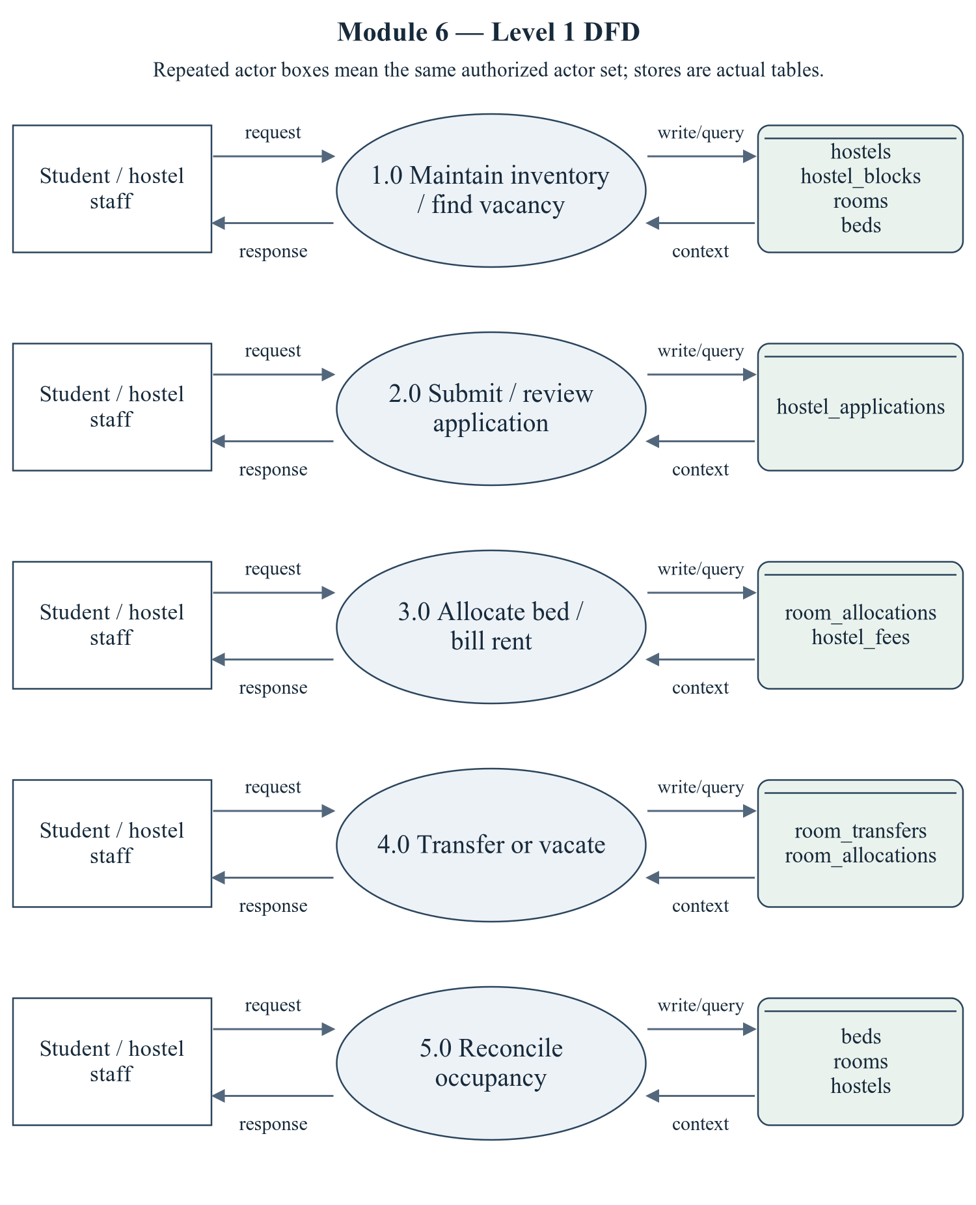
Figure 2.11 Hostel Management — Level 1 DFD
The repeated actor boxes denote the same permitted actor set. Ellipses are module processes; D stores list actual persisted tables. Arrows represent request/response and query/write context, not proof of successful operations.
Editable drawing source: diagrams/05_module_06_dfd_level1.svg, .dot and .mmd. Edit SVG text/shapes in a vector editor, or regenerate from DOT/Mermaid; retain FK IDs and source names. These figures were created from static source, not captured from a running ERP.
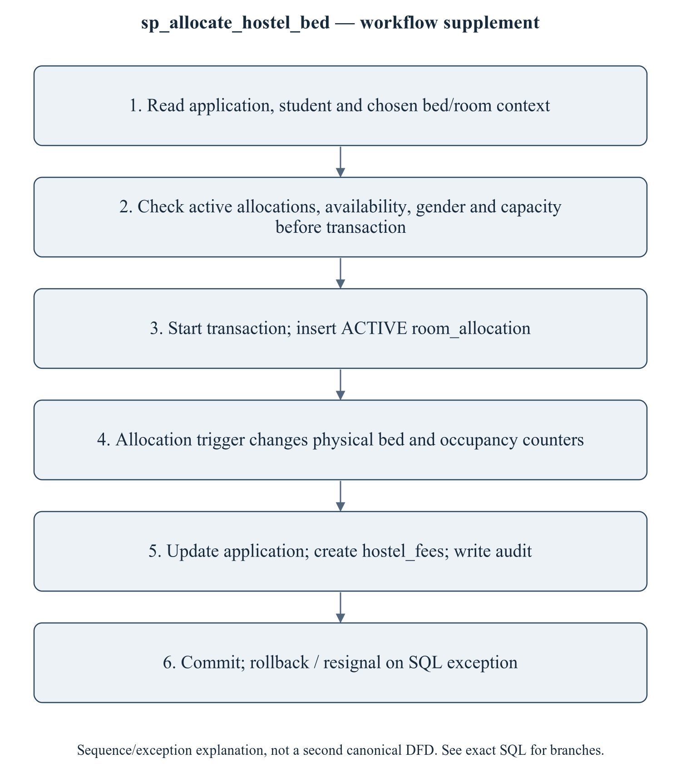
Figure 2.12 sp_allocate_hostel_bed — workflow supplement
This sequence refines the critical procedure for explanation; it is explicitly a control/transaction workflow supplement, not a mislabeled canonical Level 2 DFD. The Level 1 DFD provides the formal module data-flow view. Do not claim that capacity checks are serializable: checks precede the transaction. An active-bed/year UNIQUE constraint is narrower than all-time physical-bed exclusivity. Cross-hostel transfer needs an explicit policy and coordinated FK/counter updates.
Editable drawing source: diagrams/06_module_06_procedure_workflow.svg, .dot and .mmd. Edit SVG text/shapes in a vector editor, or regenerate from DOT/Mermaid; retain FK IDs and source names. These figures were created from static source, not captured from a running ERP.

2.6.2.1 Sub-System Processes, Data Stores (Tables), and External Data Movement
Table 2.16 Hostel Management — processes and real stores
Process | Actual stores | External movement / integration
1.0 Maintain inventory / find vacancy | hostels, hostel_blocks, rooms, beds | Authorized actor request/response; shared master/FK data are internal context, not invented external systems.
2.0 Submit / review application | hostel_applications | Authorized actor request/response; shared master/FK data are internal context, not invented external systems.
3.0 Allocate bed / bill rent | room_allocations, hostel_fees | Authorized actor request/response; shared master/FK data are internal context, not invented external systems.
4.0 Transfer or vacate | room_transfers, room_allocations | Authorized actor request/response; shared master/FK data are internal context, not invented external systems.
5.0 Reconcile occupancy | beds, rooms, hostels | Authorized actor request/response; shared master/FK data are internal context, not invented external systems.

2.6.3 Sub-Schema & Relational Data Dictionary
Relational notation below lists actual attributes. The full dictionary supplies types/nullability/defaults/constraints; PK/FK notation does not invent undeclared relationships.
hostels( hostel_id, hostel_code, name, hostel_type, warden_faculty_id, address, contact_no, total_rooms, total_beds, occupied_beds, rent_per_bed, status, created_at). PK={hostel_id}; FK IDs={FK099}.
hostel_blocks( block_id, hostel_id, block_code, name, floors, status). PK={block_id}; FK IDs={FK100}.
rooms( room_id, hostel_id, block_id, room_number, floor, room_type, capacity, occupied_count, rent_per_bed, status). PK={room_id}; FK IDs={FK101,FK102}.
beds( bed_id, room_id, bed_code, status, remarks). PK={bed_id}; FK IDs={FK103}.
hostel_applications( application_id, application_no, student_id, hostel_id, academic_year_id, room_type_pref, applied_on, status, reviewed_by, reviewed_on, remarks). PK={application_id}; FK IDs={FK104,FK105,FK106,FK107}.
room_allocations( allocation_id, student_id, bed_id, room_id, hostel_id, academic_year_id, allocated_on, allocated_by, vacated_on, rent_amount, status, remarks, active_bed_year). PK={allocation_id}; FK IDs={FK108,FK109,FK110,FK111,FK112,FK113}.
room_transfers( transfer_id, student_id, from_bed_id, to_bed_id, reason, transferred_on, approved_by). PK={transfer_id}; FK IDs={FK114,FK115,FK116,FK117}.
hostel_fees( hostel_fee_id, allocation_id, student_id, academic_year_id, amount, paid_amount, due_date, status, created_at). PK={hostel_fee_id}; FK IDs={FK118,FK119,FK120}.
The complete column/constraint dictionary for these exact relations is in 1.6; it is not copied a second time here. The module report repeats its own complete dictionary for independent use. class_sessions remains a joint G2/G3 contract.
Table 2.17 Shared / cross-module key contracts (not duplicated ownership)
Parent table / key | Module relationship | Declared action / FK ID
academic_years, PK academic_year_id | hostel_applications.academic_year_id → academic_year_id; room_allocations.academic_year_id → academic_year_id; hostel_fees.academic_year_id → academic_year_id | FK106: ON DELETE CASCADE; FK112: ON DELETE CASCADE; FK120: ON DELETE CASCADE
faculty, PK faculty_id | hostels.warden_faculty_id → faculty_id | FK099: ON DELETE SET NULL
students, PK student_id | hostel_applications.student_id → student_id; room_allocations.student_id → student_id; room_transfers.student_id → student_id; hostel_fees.student_id → student_id | FK104: ON DELETE CASCADE; FK108: ON DELETE CASCADE; FK114: ON DELETE CASCADE; FK119: ON DELETE CASCADE
users, PK user_id | hostel_applications.reviewed_by → user_id; room_allocations.allocated_by → user_id; room_transfers.approved_by → user_id | FK107: ON DELETE SET NULL; FK113: ON DELETE SET NULL; FK117: ON DELETE SET NULL

The table dictionaries in this module cover its persisted schema in full. External parents above retain their original ownership; their complete 677-column enterprise dictionary is supplied in the master report and inventory workbook. Shared contracts are repeated here so this module can be read independently without pretending to own another module's tables.

2.6.4 Advanced SQL Implementation

2.6.4.1 Stored Procedures (SQL Code & Execution Proofs)

sp_allocate_hostel_bed
Purpose / expected behavior: Check application/student/bed suitability, create an active allocation and hostel-fee record, update application and audit. Several checks precede START TRANSACTION and do not establish concurrency safety.
Source: database/05_procedures.sql:780–869. Definition found in the pinned snapshot; live existence and execution are unverified. Exact source comments may be stale; only inventoried definitions establish object names.
IN p_application_id: INT UNSIGNED
IN p_bed_id: INT UNSIGNED
IN p_allocated_by: INT UNSIGNED
OUT p_allocation_id: INT UNSIGNED
OUT p_message: VARCHAR(255)
Outputs: p_allocation_id INT UNSIGNED, p_message VARCHAR(255)
Read/write dependencies: audit_logs, beds, hostel_applications, hostel_fees, room_allocations, rooms, students, v_active, v_app_state, v_bed_state, v_hostel, v_rent, v_room, v_student, v_year
Routine calls: sp_push_notification
Transaction boundary: Explicit START TRANSACTION / COMMIT and SQLEXCEPTION handling in the definition.
Invocation template (not executed): bind every @ input to a mutually consistent synthetic fixture selected from the declared tables and run only on an authorized disposable schema. Numeric literals below are planned test inputs, not observed results. Internal COMMIT means wrapping a CALL in an outer ROLLBACK is not a safe fixture-cleanup strategy.
CALL sp_allocate_hostel_bed(@p_application_id, @p_bed_id, @p_allocated_by, @p_allocation_id, @p_message);
SELECT @p_allocation_id AS p_allocation_id, @p_message AS p_message;

Actual result: [[TO BE PROVIDED: run this test and record the actual result]]
Status: [[TO BE PROVIDED: run this test and record the actual result]]
Required evidence: [[TO BE PROVIDED: execute sp_allocate_hostel_bed or its triggering DML using the corresponding module test case; owner must attach sanitized inputs, OUT/SELECT/error output, before/after effects and timestamp]]
Exact SQL definition (unchanged from source):
CREATE PROCEDURE `sp_allocate_hostel_bed`(
IN p_application_id INT UNSIGNED,
IN p_bed_id INT UNSIGNED,
IN p_allocated_by INT UNSIGNED,
OUT p_allocation_id INT UNSIGNED,
OUT p_message VARCHAR(255)
)
BEGIN
DECLARE v_student INT UNSIGNED;
DECLARE v_hostel SMALLINT UNSIGNED;
DECLARE v_room INT UNSIGNED;
DECLARE v_year SMALLINT UNSIGNED;
DECLARE v_bed_state VARCHAR(20);
DECLARE v_active INT DEFAULT 0;
DECLARE v_rent DECIMAL(10,2);
DECLARE v_app_state VARCHAR(20);

DECLARE EXIT HANDLER FOR SQLEXCEPTION
BEGIN
ROLLBACK;
RESIGNAL; -- keep the original error visible to the caller
END;

SELECT `student_id`, `hostel_id`, `academic_year_id`, `status`
INTO v_student, v_hostel, v_year, v_app_state
FROM `hostel_applications` WHERE `application_id` = p_application_id;

IF v_student IS NULL THEN
SIGNAL SQLSTATE '45000' SET MESSAGE_TEXT = 'Hostel application not found.';
END IF;
IF v_app_state NOT IN ('APPLIED', 'WAITLISTED', 'APPROVED') THEN
SIGNAL SQLSTATE '45000'
SET MESSAGE_TEXT = 'This application is no longer active.';
END IF;

SELECT `status`, `room_id` INTO v_bed_state, v_room
FROM `beds` WHERE `bed_id` = p_bed_id;

IF v_bed_state IS NULL THEN
SIGNAL SQLSTATE '45000' SET MESSAGE_TEXT = 'Bed not found.';
END IF;
IF v_bed_state <> 'AVAILABLE' THEN
SIGNAL SQLSTATE '45000' SET MESSAGE_TEXT = 'That bed is not available.';
END IF;

SELECT COUNT(*) INTO v_active
FROM `room_allocations`
WHERE `student_id` = v_student AND `status` = 'ACTIVE';

IF v_active > 0 THEN
SIGNAL SQLSTATE '45000'
SET MESSAGE_TEXT = 'This student already has an active bed allocation.';
END IF;

SELECT `rent_per_bed` INTO v_rent FROM `rooms` WHERE `room_id` = v_room;

START TRANSACTION;

INSERT INTO `room_allocations`
(`student_id`, `bed_id`, `room_id`, `hostel_id`, `academic_year_id`,
`allocated_on`, `allocated_by`, `rent_amount`, `status`)
VALUES
(v_student, p_bed_id, v_room, v_hostel, v_year, CURDATE(), p_allocated_by,
v_rent, 'ACTIVE');

SET p_allocation_id = LAST_INSERT_ID();

INSERT INTO `hostel_fees`
(`allocation_id`, `student_id`, `academic_year_id`, `amount`, `due_date`, `status`)
VALUES
(p_allocation_id, v_student, v_year, v_rent * 6,
DATE_ADD(CURDATE(), INTERVAL 30 DAY), 'PENDING');

UPDATE `hostel_applications`
SET `status` = 'APPROVED', `reviewed_by` = p_allocated_by, `reviewed_on` = NOW()
WHERE `application_id` = p_application_id;

INSERT INTO `audit_logs` (`user_id`, `action`, `entity`, `entity_id`, `description`)
VALUES (p_allocated_by, 'HOSTEL_ALLOCATION', 'room_allocations', p_allocation_id,
CONCAT('Bed ', p_bed_id, ' allocated to student ', v_student));

CALL sp_push_notification(
(SELECT `user_id` FROM `students` WHERE `student_id` = v_student),
'Hostel bed allocated',
CONCAT('Bed ', p_bed_id, ' in room ', v_room, ' has been allocated to you.'),
'HOSTEL_ALLOCATION', 'SUCCESS', 'room_allocations', p_allocation_id, '/student/hostel');

SET p_message = CONCAT('Bed allocated (allocation #', p_allocation_id, ').');
COMMIT;
END$$

sp_vacate_hostel_bed
Purpose / expected behavior: Close an active allocation with vacation date/remarks and audit; update triggers release the bed and adjust counters. Missing/already-vacated paths need execution.
Source: database/05_procedures.sql:876–905. Definition found in the pinned snapshot; live existence and execution are unverified. Exact source comments may be stale; only inventoried definitions establish object names.
IN p_allocation_id: INT UNSIGNED
IN p_done_by: INT UNSIGNED
IN p_reason: VARCHAR(255)
OUT p_message: VARCHAR(255)
Outputs: p_message VARCHAR(255)
Read/write dependencies: audit_logs, room_allocations
Routine calls: No other stored routine call extracted.
Transaction boundary: Explicit START TRANSACTION / COMMIT and SQLEXCEPTION handling in the definition.
Invocation template (not executed): bind every @ input to a mutually consistent synthetic fixture selected from the declared tables and run only on an authorized disposable schema. Numeric literals below are planned test inputs, not observed results. Internal COMMIT means wrapping a CALL in an outer ROLLBACK is not a safe fixture-cleanup strategy.
CALL sp_vacate_hostel_bed(@p_allocation_id, @p_done_by, @p_reason, @p_message);
SELECT @p_message AS p_message;

Actual result: [[TO BE PROVIDED: run this test and record the actual result]]
Status: [[TO BE PROVIDED: run this test and record the actual result]]
Required evidence: [[TO BE PROVIDED: execute sp_vacate_hostel_bed or its triggering DML using the corresponding module test case; owner must attach sanitized inputs, OUT/SELECT/error output, before/after effects and timestamp]]
Exact SQL definition (unchanged from source):
CREATE PROCEDURE `sp_vacate_hostel_bed`(
IN p_allocation_id INT UNSIGNED,
IN p_done_by INT UNSIGNED,
IN p_reason VARCHAR(255),
OUT p_message VARCHAR(255)
)
BEGIN
DECLARE EXIT HANDLER FOR SQLEXCEPTION
BEGIN
ROLLBACK;
RESIGNAL; -- keep the original error visible to the caller
END;

START TRANSACTION;

UPDATE `room_allocations`
SET `status` = 'VACATED', `vacated_on` = CURDATE(), `remarks` = p_reason
WHERE `allocation_id` = p_allocation_id AND `status` = 'ACTIVE';

IF ROW_COUNT() = 0 THEN
SIGNAL SQLSTATE '45000' SET MESSAGE_TEXT = 'No active allocation with that id.';
END IF;

INSERT INTO `audit_logs` (`user_id`, `action`, `entity`, `entity_id`, `description`)
VALUES (p_done_by, 'HOSTEL_ALLOCATION', 'room_allocations', p_allocation_id,
CONCAT('Allocation vacated: ', IFNULL(p_reason, '')));

SET p_message = 'Allocation vacated and the bed is available again.';
COMMIT;
END$$

sp_transfer_room
Purpose / expected behavior: Move an allocation to another bed/room, record room_transfers and audit, and rely on allocation-update triggers for occupancy changes. hostel_id is not changed, so cross-hostel moves need a defined guard/fix.
Source: database/05_procedures.sql:912–975. Definition found in the pinned snapshot; live existence and execution are unverified. Exact source comments may be stale; only inventoried definitions establish object names.
IN p_allocation_id: INT UNSIGNED
IN p_to_bed_id: INT UNSIGNED
IN p_reason: VARCHAR(255)
IN p_approved_by: INT UNSIGNED
OUT p_message: VARCHAR(255)
Outputs: p_message VARCHAR(255)
Read/write dependencies: audit_logs, beds, room_allocations, room_transfers, students, v_from, v_hostel, v_room, v_state, v_student
Routine calls: sp_push_notification
Transaction boundary: Explicit START TRANSACTION / COMMIT and SQLEXCEPTION handling in the definition.
Invocation template (not executed): bind every @ input to a mutually consistent synthetic fixture selected from the declared tables and run only on an authorized disposable schema. Numeric literals below are planned test inputs, not observed results. Internal COMMIT means wrapping a CALL in an outer ROLLBACK is not a safe fixture-cleanup strategy.
CALL sp_transfer_room(@p_allocation_id, @p_to_bed_id, @p_reason, @p_approved_by, @p_message);
SELECT @p_message AS p_message;

Actual result: [[TO BE PROVIDED: run this test and record the actual result]]
Status: [[TO BE PROVIDED: run this test and record the actual result]]
Required evidence: [[TO BE PROVIDED: execute sp_transfer_room or its triggering DML using the corresponding module test case; owner must attach sanitized inputs, OUT/SELECT/error output, before/after effects and timestamp]]
Exact SQL definition (unchanged from source):
CREATE PROCEDURE `sp_transfer_room`(
IN p_allocation_id INT UNSIGNED,
IN p_to_bed_id INT UNSIGNED,
IN p_reason VARCHAR(255),
IN p_approved_by INT UNSIGNED,
OUT p_message VARCHAR(255)
)
BEGIN
DECLARE v_student INT UNSIGNED;
DECLARE v_from INT UNSIGNED;
DECLARE v_state VARCHAR(20);
DECLARE v_room INT UNSIGNED;
DECLARE v_hostel SMALLINT UNSIGNED;

DECLARE EXIT HANDLER FOR SQLEXCEPTION
BEGIN
ROLLBACK;
RESIGNAL; -- keep the original error visible to the caller
END;

SELECT `student_id`, `bed_id`, `hostel_id`
INTO v_student, v_from, v_hostel
FROM `room_allocations` WHERE `allocation_id` = p_allocation_id;

IF v_student IS NULL THEN
SIGNAL SQLSTATE '45000' SET MESSAGE_TEXT = 'Allocation not found.';
END IF;
IF v_from = p_to_bed_id THEN
SIGNAL SQLSTATE '45000' SET MESSAGE_TEXT = 'Student already occupies that bed.';
END IF;

SELECT `status`, `room_id` INTO v_state, v_room
FROM `beds` WHERE `bed_id` = p_to_bed_id;

IF v_state IS NULL THEN
SIGNAL SQLSTATE '45000' SET MESSAGE_TEXT = 'Target bed not found.';
END IF;
IF v_state <> 'AVAILABLE' THEN
SIGNAL SQLSTATE '45000' SET MESSAGE_TEXT = 'Target bed is not available.';
END IF;

START TRANSACTION;

UPDATE `room_allocations`
SET `bed_id` = p_to_bed_id, `room_id` = v_room
WHERE `allocation_id` = p_allocation_id;

INSERT INTO `room_transfers`
(`student_id`, `from_bed_id`, `to_bed_id`, `reason`, `transferred_on`, `approved_by`)
VALUES (v_student, v_from, p_to_bed_id, p_reason, NOW(), p_approved_by);

INSERT INTO `audit_logs` (`user_id`, `action`, `entity`, `entity_id`, `description`)
VALUES (p_approved_by, 'HOSTEL_ALLOCATION', 'room_transfers', p_allocation_id,
CONCAT('Room transfer: bed ', v_from, ' -> ', p_to_bed_id));

CALL sp_push_notification(
(SELECT `user_id` FROM `students` WHERE `student_id` = v_student),
'Room transfer approved',
CONCAT('You have been moved to bed ', p_to_bed_id, '.'),
'HOSTEL_ALLOCATION', 'INFO', 'room_transfers', p_allocation_id, '/student/hostel');

SET p_message = 'Room transfer completed.';
COMMIT;
END$$

2.6.4.2 Database Triggers (SQL Code & Execution Proofs)

trg_allocation_ai
Purpose / expected behavior: For an active inserted allocation, mark the bed occupied, increase room/hostel occupancy and write allocation audit.
Source: database/06_triggers.sql:466–479. Definition found in the pinned snapshot; live existence and execution are unverified. Exact source comments may be stale; only inventoried definitions establish object names.
Event / inputs / output: AFTER INSERT ON `room_allocations` FOR EACH ROW; OLD/NEW are event-appropriate row images; no explicit arguments or scalar return. Side effects are described above.
Read/write dependencies: audit_logs, beds, hostels, room_allocations, rooms
Routine calls: No other stored routine call extracted.
Invocation template (not executed): bind every @ input to a mutually consistent synthetic fixture selected from the declared tables and run only on an authorized disposable schema. Numeric literals below are planned test inputs, not observed results. Internal COMMIT means wrapping a CALL in an outer ROLLBACK is not a safe fixture-cleanup strategy.
CALL sp_allocate_hostel_bed(@p_application_id, @p_bed_id, @p_allocated_by, @p_allocation_id, @p_message);

Actual result: [[TO BE PROVIDED: run this test and record the actual result]]
Status: [[TO BE PROVIDED: run this test and record the actual result]]
Required evidence: [[TO BE PROVIDED: execute trg_allocation_ai or its triggering DML using the corresponding module test case; owner must attach sanitized inputs, OUT/SELECT/error output, before/after effects and timestamp]]
Exact SQL definition (unchanged from source):
CREATE TRIGGER `trg_allocation_ai`
AFTER INSERT ON `room_allocations` FOR EACH ROW
BEGIN
IF NEW.`status` = 'ACTIVE' THEN
UPDATE `beds` SET `status` = 'OCCUPIED' WHERE `bed_id` = NEW.`bed_id`;
UPDATE `rooms` SET `occupied_count` = `occupied_count` + 1 WHERE `room_id` = NEW.`room_id`;
UPDATE `hostels` SET `occupied_beds` = `occupied_beds` + 1 WHERE `hostel_id` = NEW.`hostel_id`;

INSERT INTO `audit_logs` (`user_id`, `action`, `entity`, `entity_id`, `description`)
VALUES (NEW.`allocated_by`, 'HOSTEL_ALLOCATION', 'room_allocations', NEW.`allocation_id`,
CONCAT('TRIGGER: bed ', NEW.`bed_id`, ' occupied, room ',
NEW.`room_id`, ' occupancy incremented'));
END IF;
END$$

trg_allocation_au
Purpose / expected behavior: Handle active/inactive and bed-change transitions, releasing/occupying beds and adjusting relevant room/hostel counters according to the exact branches.
Source: database/06_triggers.sql:483–517. Definition found in the pinned snapshot; live existence and execution are unverified. Exact source comments may be stale; only inventoried definitions establish object names.
Event / inputs / output: AFTER UPDATE ON `room_allocations` FOR EACH ROW; OLD/NEW are event-appropriate row images; no explicit arguments or scalar return. Side effects are described above.
Read/write dependencies: beds, hostels, room_allocations, rooms
Routine calls: No other stored routine call extracted.
Invocation template (not executed): bind every @ input to a mutually consistent synthetic fixture selected from the declared tables and run only on an authorized disposable schema. Numeric literals below are planned test inputs, not observed results. Internal COMMIT means wrapping a CALL in an outer ROLLBACK is not a safe fixture-cleanup strategy.
CALL sp_vacate_hostel_bed(@p_allocation_id, @p_done_by, @p_reason, @p_message);

Actual result: [[TO BE PROVIDED: run this test and record the actual result]]
Status: [[TO BE PROVIDED: run this test and record the actual result]]
Required evidence: [[TO BE PROVIDED: execute trg_allocation_au or its triggering DML using the corresponding module test case; owner must attach sanitized inputs, OUT/SELECT/error output, before/after effects and timestamp]]
Exact SQL definition (unchanged from source):
CREATE TRIGGER `trg_allocation_au`
AFTER UPDATE ON `room_allocations` FOR EACH ROW
BEGIN
-- Bed transfer: free the old bed, occupy the new one.
IF NEW.`bed_id` <> OLD.`bed_id` AND NEW.`status` = 'ACTIVE' THEN
UPDATE `beds` SET `status` = 'AVAILABLE' WHERE `bed_id` = OLD.`bed_id`;
UPDATE `beds` SET `status` = 'OCCUPIED' WHERE `bed_id` = NEW.`bed_id`;

UPDATE `rooms` SET `occupied_count` = GREATEST(0, `occupied_count` - 1)
WHERE `room_id` = OLD.`room_id`;
UPDATE `rooms` SET `occupied_count` = `occupied_count` + 1 WHERE `room_id` = NEW.`room_id`;

IF OLD.`hostel_id` <> NEW.`hostel_id` THEN
UPDATE `hostels` SET `occupied_beds` = GREATEST(0, `occupied_beds` - 1)
WHERE `hostel_id` = OLD.`hostel_id`;
UPDATE `hostels` SET `occupied_beds` = `occupied_beds` + 1 WHERE `hostel_id` = NEW.`hostel_id`;
END IF;
END IF;

-- Vacating: release the bed and decrement every counter.
IF OLD.`status` = 'ACTIVE' AND NEW.`status` IN ('VACATED', 'TRANSFERRED') THEN
UPDATE `beds` SET `status` = 'AVAILABLE' WHERE `bed_id` = NEW.`bed_id`;
UPDATE `rooms` SET `occupied_count` = GREATEST(0, `occupied_count` - 1)
WHERE `room_id` = NEW.`room_id`;
UPDATE `hostels` SET `occupied_beds` = GREATEST(0, `occupied_beds` - 1)
WHERE `hostel_id` = NEW.`hostel_id`;
END IF;

-- Reactivating a vacated allocation (rare, but keeps the counters honest).
IF OLD.`status` IN ('VACATED', 'TRANSFERRED') AND NEW.`status` = 'ACTIVE' THEN
UPDATE `beds` SET `status` = 'OCCUPIED' WHERE `bed_id` = NEW.`bed_id`;
UPDATE `rooms` SET `occupied_count` = `occupied_count` + 1 WHERE `room_id` = NEW.`room_id`;
UPDATE `hostels` SET `occupied_beds` = `occupied_beds` + 1 WHERE `hostel_id` = NEW.`hostel_id`;
END IF;
END$$

trg_allocation_ad
Purpose / expected behavior: If an active allocation is deleted, release bed and decrease room/hostel counters. Cascading FK operations must be tested separately from explicit DELETE trigger behavior.
Source: database/06_triggers.sql:521–531. Definition found in the pinned snapshot; live existence and execution are unverified. Exact source comments may be stale; only inventoried definitions establish object names.
Event / inputs / output: AFTER DELETE ON `room_allocations` FOR EACH ROW; OLD/NEW are event-appropriate row images; no explicit arguments or scalar return. Side effects are described above.
Read/write dependencies: beds, hostels, room_allocations, rooms
Routine calls: No other stored routine call extracted.
Invocation template (not executed): bind every @ input to a mutually consistent synthetic fixture selected from the declared tables and run only on an authorized disposable schema. Numeric literals below are planned test inputs, not observed results. Internal COMMIT means wrapping a CALL in an outer ROLLBACK is not a safe fixture-cleanup strategy.
DELETE FROM room_allocations WHERE allocation_id = @fixture_active_allocation_id;

Actual result: [[TO BE PROVIDED: run this test and record the actual result]]
Status: [[TO BE PROVIDED: run this test and record the actual result]]
Required evidence: [[TO BE PROVIDED: execute trg_allocation_ad or its triggering DML using the corresponding module test case; owner must attach sanitized inputs, OUT/SELECT/error output, before/after effects and timestamp]]
Exact SQL definition (unchanged from source):
CREATE TRIGGER `trg_allocation_ad`
AFTER DELETE ON `room_allocations` FOR EACH ROW
BEGIN
IF OLD.`status` = 'ACTIVE' THEN
UPDATE `beds` SET `status` = 'AVAILABLE' WHERE `bed_id` = OLD.`bed_id`;
UPDATE `rooms` SET `occupied_count` = GREATEST(0, `occupied_count` - 1)
WHERE `room_id` = OLD.`room_id`;
UPDATE `hostels` SET `occupied_beds` = GREATEST(0, `occupied_beds` - 1)
WHERE `hostel_id` = OLD.`hostel_id`;
END IF;
END$$

trg_allocation_bi_duplicate
Purpose / expected behavior: Reject a second ACTIVE allocation for the same student and academic year on INSERT. This is narrower than the allocation procedure all-year check.
Source: database/06_triggers.sql:536–553. Definition found in the pinned snapshot; live existence and execution are unverified. Exact source comments may be stale; only inventoried definitions establish object names.
Event / inputs / output: BEFORE INSERT ON `room_allocations` FOR EACH ROW; OLD/NEW are event-appropriate row images; no explicit arguments or scalar return. Side effects are described above.
Read/write dependencies: room_allocations, v_active
Routine calls: No other stored routine call extracted.
Invocation template (not executed): bind every @ input to a mutually consistent synthetic fixture selected from the declared tables and run only on an authorized disposable schema. Numeric literals below are planned test inputs, not observed results. Internal COMMIT means wrapping a CALL in an outer ROLLBACK is not a safe fixture-cleanup strategy.
CALL sp_allocate_hostel_bed(@p_application_id, @p_bed_id, @p_allocated_by, @p_allocation_id, @p_message);

Actual result: [[TO BE PROVIDED: run this test and record the actual result]]
Status: [[TO BE PROVIDED: run this test and record the actual result]]
Required evidence: [[TO BE PROVIDED: execute trg_allocation_bi_duplicate or its triggering DML using the corresponding module test case; owner must attach sanitized inputs, OUT/SELECT/error output, before/after effects and timestamp]]
Exact SQL definition (unchanged from source):
CREATE TRIGGER `trg_allocation_bi_duplicate`
BEFORE INSERT ON `room_allocations` FOR EACH ROW
BEGIN
DECLARE v_active INT DEFAULT 0;

IF NEW.`status` = 'ACTIVE' THEN
SELECT COUNT(*) INTO v_active
FROM `room_allocations` ra
WHERE ra.`student_id` = NEW.`student_id`
AND ra.`academic_year_id` = NEW.`academic_year_id`
AND ra.`status` = 'ACTIVE';

IF v_active > 0 THEN
SIGNAL SQLSTATE '45000'
SET MESSAGE_TEXT = 'This student already has an active bed allocation for this year.';
END IF;
END IF;
END$$

trg_rooms_bu_capacity
Purpose / expected behavior: Reject an UPDATE in which occupied_count exceeds capacity. It does not create beds or prove counters match the physical inventory.
Source: database/06_triggers.sql:558–573. Definition found in the pinned snapshot; live existence and execution are unverified. Exact source comments may be stale; only inventoried definitions establish object names.
Event / inputs / output: BEFORE UPDATE ON `rooms` FOR EACH ROW; OLD/NEW are event-appropriate row images; no explicit arguments or scalar return. Side effects are described above.
Read/write dependencies: rooms
Routine calls: No other stored routine call extracted.
Invocation template (not executed): bind every @ input to a mutually consistent synthetic fixture selected from the declared tables and run only on an authorized disposable schema. Numeric literals below are planned test inputs, not observed results. Internal COMMIT means wrapping a CALL in an outer ROLLBACK is not a safe fixture-cleanup strategy.
UPDATE rooms SET occupied_count = capacity + 1 WHERE room_id = @fixture_room_id;

Actual result: [[TO BE PROVIDED: run this test and record the actual result]]
Status: [[TO BE PROVIDED: run this test and record the actual result]]
Required evidence: [[TO BE PROVIDED: execute trg_rooms_bu_capacity or its triggering DML using the corresponding module test case; owner must attach sanitized inputs, OUT/SELECT/error output, before/after effects and timestamp]]
Exact SQL definition (unchanged from source):
CREATE TRIGGER `trg_rooms_bu_capacity`
BEFORE UPDATE ON `rooms` FOR EACH ROW
BEGIN
IF NEW.`occupied_count` > NEW.`capacity` THEN
SIGNAL SQLSTATE '45000'
SET MESSAGE_TEXT = 'Room capacity exceeded - there are not enough beds in this room.';
END IF;
IF NEW.`occupied_count` < 0 THEN
SET NEW.`occupied_count` = 0;
END IF;
IF NEW.`occupied_count` >= NEW.`capacity` THEN
SET NEW.`status` = 'FULL';
ELSEIF NEW.`status` = 'FULL' THEN
SET NEW.`status` = 'AVAILABLE';
END IF;
END$$

trg_beds_bu_guard
Purpose / expected behavior: Prevent making an actively allocated bed AVAILABLE under the checked condition. Other bed states and reconciliation paths need testing.
Source: database/06_triggers.sql:578–592. Definition found in the pinned snapshot; live existence and execution are unverified. Exact source comments may be stale; only inventoried definitions establish object names.
Event / inputs / output: BEFORE UPDATE ON `beds` FOR EACH ROW; OLD/NEW are event-appropriate row images; no explicit arguments or scalar return. Side effects are described above.
Read/write dependencies: beds, room_allocations, v_alloc
Routine calls: No other stored routine call extracted.
Invocation template (not executed): bind every @ input to a mutually consistent synthetic fixture selected from the declared tables and run only on an authorized disposable schema. Numeric literals below are planned test inputs, not observed results. Internal COMMIT means wrapping a CALL in an outer ROLLBACK is not a safe fixture-cleanup strategy.
UPDATE beds SET status = 'AVAILABLE' WHERE bed_id = @fixture_actively_allocated_bed_id;

Actual result: [[TO BE PROVIDED: run this test and record the actual result]]
Status: [[TO BE PROVIDED: run this test and record the actual result]]
Required evidence: [[TO BE PROVIDED: execute trg_beds_bu_guard or its triggering DML using the corresponding module test case; owner must attach sanitized inputs, OUT/SELECT/error output, before/after effects and timestamp]]
Exact SQL definition (unchanged from source):
CREATE TRIGGER `trg_beds_bu_guard`
BEFORE UPDATE ON `beds` FOR EACH ROW
BEGIN
DECLARE v_alloc INT DEFAULT 0;

IF OLD.`status` = 'OCCUPIED' AND NEW.`status` = 'AVAILABLE' THEN
SELECT COUNT(*) INTO v_alloc
FROM `room_allocations` ra
WHERE ra.`bed_id` = OLD.`bed_id` AND ra.`status` = 'ACTIVE';
IF v_alloc > 0 THEN
SIGNAL SQLSTATE '45000'
SET MESSAGE_TEXT = 'This bed is currently allocated - vacate the allocation first.';
END IF;
END IF;
END$$

2.6.4.3 User-Defined Functions (UDFs) (SQL Code & Execution Proofs)

fn_hostel_available_beds
Purpose / expected behavior: Count beds marked AVAILABLE through rooms for the hostel. This status count differs from nominal capacity minus stored occupancy and can be affected by reconciliation.
Source: database/07_functions.sql:279–290. Definition found in the pinned snapshot; live existence and execution are unverified. Exact source comments may be stale; only inventoried definitions establish object names.
IN p_hostel_id: SMALLINT UNSIGNED
Output: int scalar return value.
Read/write dependencies: beds, rooms, v_count
Routine calls: No other stored routine call extracted.
Invocation template (not executed): bind every @ input to a mutually consistent synthetic fixture selected from the declared tables and run only on an authorized disposable schema. Numeric literals below are planned test inputs, not observed results. Internal COMMIT means wrapping a CALL in an outer ROLLBACK is not a safe fixture-cleanup strategy.
SELECT fn_hostel_available_beds(@p_hostel_id) AS computed_value;

Actual result: [[TO BE PROVIDED: run this test and record the actual result]]
Status: [[TO BE PROVIDED: run this test and record the actual result]]
Required evidence: [[TO BE PROVIDED: execute fn_hostel_available_beds or its triggering DML using the corresponding module test case; owner must attach sanitized inputs, OUT/SELECT/error output, before/after effects and timestamp]]
Exact SQL definition (unchanged from source):
CREATE FUNCTION `fn_hostel_available_beds`(p_hostel_id SMALLINT UNSIGNED)
RETURNS int
READS SQL DATA
BEGIN
DECLARE v_count INT DEFAULT 0;
SELECT COUNT(*) INTO v_count
FROM `beds` b
JOIN `rooms` r ON r.`room_id` = b.`room_id`
WHERE r.`hostel_id` = p_hostel_id
AND b.`status` = 'AVAILABLE';
RETURN v_count;
END$$

2.6.5 Complex Analytical Queries & Views

v_hostel_occupancy
Purpose / expected behavior: Project hostel capacity/stored occupancy, active residents, rooms and warden. Stored counters require reconciliation evidence; a view is not a measured occupancy result.
Source: database/08_views.sql:239–260. Definition found in the pinned snapshot; live existence and execution are unverified. Exact source comments may be stale; only inventoried definitions establish object names.
Inputs / output: No parameters; SELECT returns columns: hostel_id, hostel_code, hostel_name, hostel_type, total_rooms, total_beds, occupied_beds, available_beds, occupancy_percentage, rooms_configured, rooms_full, rooms_available, active_allocations, rent_per_bed, status, warden_name. WHERE/JOIN predicates are query inputs, not stored view parameters.
Read/write dependencies: faculty, hostels, room_allocations, rooms
Routine calls: No other stored routine call extracted.
Invocation template (not executed): bind every @ input to a mutually consistent synthetic fixture selected from the declared tables and run only on an authorized disposable schema. Numeric literals below are planned test inputs, not observed results. Internal COMMIT means wrapping a CALL in an outer ROLLBACK is not a safe fixture-cleanup strategy.
SELECT * FROM v_hostel_occupancy LIMIT 10;

Actual result: [[TO BE PROVIDED: run this test and record the actual result]]
Status: [[TO BE PROVIDED: run this test and record the actual result]]
Required evidence: [[TO BE PROVIDED: execute v_hostel_occupancy or its triggering DML using the corresponding module test case; owner must attach sanitized inputs, OUT/SELECT/error output, before/after effects and timestamp]]
Exact SQL definition (unchanged from source):
CREATE OR REPLACE VIEW `v_hostel_occupancy` AS
SELECT h.`hostel_id`, h.`hostel_code`, h.`name` AS `hostel_name`, h.`hostel_type`,
h.`total_rooms`, h.`total_beds`, h.`occupied_beds`,
h.`total_beds` - h.`occupied_beds` AS `available_beds`,
ROUND(h.`occupied_beds` * 100.0 / NULLIF(h.`total_beds`,0), 2) AS `occupancy_percentage`,
IFNULL(rc.`rooms_configured`, 0) AS `rooms_configured`,
IFNULL(rc.`rooms_full`, 0) AS `rooms_full`,
IFNULL(rc.`rooms_available`, 0) AS `rooms_available`,
IFNULL(ac.`active_allocations`, 0) AS `active_allocations`,
h.`rent_per_bed`, h.`status`,
CONCAT(wf.`first_name`, ' ', wf.`last_name`) AS `warden_name`
FROM `hostels` h
LEFT JOIN (SELECT `hostel_id`, COUNT(*) AS `rooms_configured`,
SUM(`status` = 'FULL') AS `rooms_full`,
SUM(`status` = 'AVAILABLE') AS `rooms_available`
FROM `rooms` GROUP BY `hostel_id`) rc
ON rc.`hostel_id` = h.`hostel_id`
LEFT JOIN (SELECT `hostel_id`, COUNT(*) AS `active_allocations`
FROM `room_allocations` WHERE `status` = 'ACTIVE'
GROUP BY `hostel_id`) ac
ON ac.`hostel_id` = h.`hostel_id`
LEFT JOIN `faculty` wf ON wf.`faculty_id` = h.`warden_faculty_id`;

v_room_vacancy
Purpose / expected behavior: Project room/block/hostel and bed vacancy data, combining inventory and current states. Distinguish nominal capacity from available physical beds.
Source: database/08_views.sql:265–279. Definition found in the pinned snapshot; live existence and execution are unverified. Exact source comments may be stale; only inventoried definitions establish object names.
Inputs / output: No parameters; SELECT returns columns: room_id, room_number, floor, room_type, capacity, occupied_count, vacant_beds, rent_per_bed, status, hostel_id, hostel_code, hostel_name, hostel_type, block_id, block_code, beds_configured, beds_available. WHERE/JOIN predicates are query inputs, not stored view parameters.
Read/write dependencies: beds, hostel_blocks, hostels, rooms
Routine calls: No other stored routine call extracted.
Invocation template (not executed): bind every @ input to a mutually consistent synthetic fixture selected from the declared tables and run only on an authorized disposable schema. Numeric literals below are planned test inputs, not observed results. Internal COMMIT means wrapping a CALL in an outer ROLLBACK is not a safe fixture-cleanup strategy.
SELECT * FROM v_room_vacancy LIMIT 10;

Actual result: [[TO BE PROVIDED: run this test and record the actual result]]
Status: [[TO BE PROVIDED: run this test and record the actual result]]
Required evidence: [[TO BE PROVIDED: execute v_room_vacancy or its triggering DML using the corresponding module test case; owner must attach sanitized inputs, OUT/SELECT/error output, before/after effects and timestamp]]
Exact SQL definition (unchanged from source):
CREATE OR REPLACE VIEW `v_room_vacancy` AS
SELECT r.`room_id`, r.`room_number`, r.`floor`, r.`room_type`, r.`capacity`,
r.`occupied_count`, (r.`capacity` - r.`occupied_count`) AS `vacant_beds`,
r.`rent_per_bed`, r.`status`,
h.`hostel_id`, h.`hostel_code`, h.`name` AS `hostel_name`, h.`hostel_type`,
b.`block_id`, b.`block_code`,
COUNT(bd.`bed_id`) AS `beds_configured`,
SUM(CASE WHEN bd.`status` = 'AVAILABLE' THEN 1 ELSE 0 END) AS `beds_available`
FROM `rooms` r
JOIN `hostels` h ON h.`hostel_id` = r.`hostel_id`
JOIN `hostel_blocks` b ON b.`block_id` = r.`block_id`
LEFT JOIN `beds` bd ON bd.`room_id` = r.`room_id`
GROUP BY r.`room_id`, r.`room_number`, r.`floor`, r.`room_type`, r.`capacity`,
r.`occupied_count`, r.`rent_per_bed`, r.`status`,
h.`hostel_id`, h.`hostel_code`, h.`name`, h.`hostel_type`, b.`block_id`, b.`block_code`;

Q03 LEFT JOINs active residents while preserving day scholars; Q36 presents room vacancy with running occupancy by hostel. Q14 elsewhere in the SQL collection can fan out room capacities after allocation joins and is flagged rather than presented as verified occupancy. [R08]

Q03 — LEFT JOIN with a status predicate in ON (not WHERE) — residents vs
Source: database/09_queries.sql:95. Purpose is the query projection/aggregation below; no output rows have been generated. Expected column structure follows aliases in the exact statement.
SELECT s.roll_number,
CONCAT(s.first_name, ' ', s.last_name) AS student_name,
CASE WHEN ra.allocation_id IS NULL THEN 'DAY SCHOLAR' ELSE 'RESIDENT' END AS residency,
h.name AS hostel,
h.hostel_code,
r.room_number,
bd.bed_code,
ra.allocated_on
FROM students s
LEFT JOIN room_allocations ra
ON ra.student_id = s.student_id
AND ra.status = 'ACTIVE'
LEFT JOIN hostels h ON h.hostel_id = ra.hostel_id
LEFT JOIN rooms r ON r.room_id = ra.room_id
LEFT JOIN beds bd ON bd.bed_id = ra.bed_id
WHERE s.status = 'ACTIVE'
ORDER BY residency, h.hostel_code, r.room_number
LIMIT 60;

Actual result: [[TO BE PROVIDED: run this test and record the actual result]]
Status: [[TO BE PROVIDED: run this test and record the actual result]]

Q36 — Hostel vacancy board with running occupancy per hostel
Source: database/09_queries.sql:912. Purpose is the query projection/aggregation below; no output rows have been generated. Expected column structure follows aliases in the exact statement.
SELECT h.hostel_code,
b.block_code,
r.room_number,
r.room_type,
r.capacity,
r.occupied_count,
r.capacity - r.occupied_count AS free_beds,
SUM(r.occupied_count) OVER (PARTITION BY h.hostel_id
ORDER BY b.block_code, r.room_number
ROWS BETWEEN UNBOUNDED PRECEDING AND CURRENT ROW) AS running_occupancy,
CASE WHEN r.occupied_count = 0 THEN 'VACANT'
WHEN r.occupied_count >= r.capacity THEN 'FULL'
ELSE 'PARTIAL' END AS room_state,
r.status
FROM rooms r
JOIN hostels h ON h.hostel_id = r.hostel_id
LEFT JOIN hostel_blocks b ON b.block_id = r.block_id
ORDER BY h.hostel_code, b.block_code, r.room_number
LIMIT 80;

Actual result: [[TO BE PROVIDED: run this test and record the actual result]]
Status: [[TO BE PROVIDED: run this test and record the actual result]]

2.6.6 Backend, Frontend, Validation & Transaction Trace
Table 2.18 Hostel Management — exact API route/role register
Method and route | Role gate / handler | Validation and source
GET /api/v1/hostel/hostels | Authenticated; row scope must be inspected  Handler: hostels | No route-local Zod validation; service/DB checks may apply  backend/src/routes/hostel.routes.ts:13
GET /api/v1/hostel/hostels/:id | Authenticated; row scope must be inspected  Handler: hostel | No route-local Zod validation; service/DB checks may apply  backend/src/routes/hostel.routes.ts:14
GET /api/v1/hostel/occupancy | STUDENT, ADMIN, HOSTEL_ADMIN  Handler: occupancy | No route-local Zod validation; service/DB checks may apply  backend/src/routes/hostel.routes.ts:15
GET /api/v1/hostel/stats | ADMIN, HOSTEL_ADMIN  Handler: stats | No route-local Zod validation; service/DB checks may apply  backend/src/routes/hostel.routes.ts:16
GET /api/v1/hostel/rooms | STUDENT, ADMIN, HOSTEL_ADMIN  Handler: rooms | No route-local Zod validation; service/DB checks may apply  backend/src/routes/hostel.routes.ts:18
GET /api/v1/hostel/rooms/vacancy | ADMIN, HOSTEL_ADMIN  Handler: vacancy | No route-local Zod validation; service/DB checks may apply  backend/src/routes/hostel.routes.ts:19
GET /api/v1/hostel/blocks | ADMIN, HOSTEL_ADMIN  Handler: blocks | No route-local Zod validation; service/DB checks may apply  backend/src/routes/hostel.routes.ts:20
GET /api/v1/hostel/beds | ADMIN, HOSTEL_ADMIN  Handler: beds | No route-local Zod validation; service/DB checks may apply  backend/src/routes/hostel.routes.ts:21
POST /api/v1/hostel/rooms | ADMIN, HOSTEL_ADMIN  Handler: createRoom | No route-local Zod validation; service/DB checks may apply  backend/src/routes/hostel.routes.ts:22
GET /api/v1/hostel/applications | STUDENT, ADMIN, HOSTEL_ADMIN  Handler: applications | No route-local Zod validation; service/DB checks may apply  backend/src/routes/hostel.routes.ts:24
POST /api/v1/hostel/applications | STUDENT, ADMIN, HOSTEL_ADMIN  Handler: apply | Zod validate(...) in route  backend/src/routes/hostel.routes.ts:25
PUT /api/v1/hostel/applications/:id/review | ADMIN, HOSTEL_ADMIN  Handler: reviewApplication | Zod validate(...) in route  backend/src/routes/hostel.routes.ts:31
GET /api/v1/hostel/applications/:id/beds | ADMIN, HOSTEL_ADMIN  Handler: suggestedBeds | No route-local Zod validation; service/DB checks may apply  backend/src/routes/hostel.routes.ts:35
GET /api/v1/hostel/allocations | ADMIN, HOSTEL_ADMIN  Handler: allocations | No route-local Zod validation; service/DB checks may apply  backend/src/routes/hostel.routes.ts:37
GET /api/v1/hostel/allocations/me | STUDENT  Handler: myAllocation | No route-local Zod validation; service/DB checks may apply  backend/src/routes/hostel.routes.ts:38
GET /api/v1/hostel/allocations/history/me | STUDENT  Handler: allocationHistory | No route-local Zod validation; service/DB checks may apply  backend/src/routes/hostel.routes.ts:39
GET /api/v1/hostel/allocations/:id | ADMIN, HOSTEL_ADMIN  Handler: allocation | No route-local Zod validation; service/DB checks may apply  backend/src/routes/hostel.routes.ts:40
GET /api/v1/hostel/allocations/student/:id | Authenticated; row scope must be inspected  Handler: allocationHistory | No route-local Zod validation; service/DB checks may apply  backend/src/routes/hostel.routes.ts:41
POST /api/v1/hostel/allocations | ADMIN, HOSTEL_ADMIN  Handler: allocate | Zod validate(...) in route  backend/src/routes/hostel.routes.ts:42
POST /api/v1/hostel/allocations/:id/transfer | ADMIN, HOSTEL_ADMIN  Handler: transfer | Zod validate(...) in route  backend/src/routes/hostel.routes.ts:46
POST /api/v1/hostel/allocations/:id/vacate | ADMIN, HOSTEL_ADMIN  Handler: vacate | Zod validate(...) in route  backend/src/routes/hostel.routes.ts:50
GET /api/v1/hostel/transfers | STUDENT, ADMIN, HOSTEL_ADMIN  Handler: transfers | No route-local Zod validation; service/DB checks may apply  backend/src/routes/hostel.routes.ts:53
GET /api/v1/hostel/fees | STUDENT, ACCOUNTANT, ADMIN, HOSTEL_ADMIN  Handler: hostelFees | No route-local Zod validation; service/DB checks may apply  backend/src/routes/hostel.routes.ts:55

backend/src/controllers/hostel.controller.ts: Exports: hostels, hostel, occupancy, stats, rooms, vacancy, blocks, beds, createRoom, applications, apply, reviewApplication, suggestedBeds, allocations, allocation, myAllocation, allocationHistory, allocate, transfer, vacate, transfers, hostelFees. SQL references: .
backend/src/repositories/hostel.repository.ts: Exports: hostelsRepo, roomsRepo, applicationsRepo, allocationsRepo, hostelFeesRepo. SQL references: academic_years, beds, faculty, hostel_applications, hostel_blocks, hostel_fees, hostels, programs, room_allocations, room_transfers, rooms, students, fn_hostel_available_beds, v_hostel_occupancy, v_room_vacancy.
backend/src/services/hostel.service.ts: Exports: hostels, rooms, applications, allocations, hostelFees. SQL references: beds, hostel_applications, hostels, room_allocations, rooms, students, sp_allocate_hostel_bed, sp_transfer_room, sp_vacate_hostel_bed.
Frontend source pages: frontend/src/pages/hostel/HostelAllocationsPage.tsx; frontend/src/pages/hostel/HostelApplicationsPage.tsx; frontend/src/pages/hostel/HostelDashboardPage.tsx; frontend/src/pages/hostel/HostelRoomsPage.tsx; frontend/src/pages/hostel/MyHostelPage.tsx.
Controller → service → repository separation is present in source. mysql2 query/execute helpers bind values; callProc reads OUT parameters on one acquired connection. Some services write audit/notifications after the database operation on a separate pooled request, so a procedure transaction does not make every service side effect atomic. [R16, R09, R19]
Validation/error contract: route-local Zod schemas operate on request bodies where listed; the report does not infer validation for routes without validate(...). Services raise AppError for selected missing records/invalid inputs; DB FK/UNIQUE/CHECK/SIGNAL errors pass through the shared handler. HTTP statuses and payloads need API execution evidence, not invented response screenshots. [R10]
Exact route validation expressions (TypeScript/Zod, not SQL; no execution claim):
backend/src/routes/hostel.routes.ts:25 — router.post '/applications'
z.object({
hostelId: z.number().int().positive(),
academicYearId: z.number().int().positive(),
roomTypePref: z.enum(['SINGLE', 'DOUBLE', 'TRIPLE', 'SHARED']).optional(),
studentId: z.number().int().positive().optional(),
})

backend/src/routes/hostel.routes.ts:31 — router.put '/applications/:id/review'
z.object({
status: z.enum(['APPROVED', 'REJECTED', 'WAITLISTED']),
remarks: z.string().optional(),
})

backend/src/routes/hostel.routes.ts:42 — router.post '/allocations'
z.object({
applicationId: z.number().int().positive(),
bedId: z.number().int().positive(),
})

backend/src/routes/hostel.routes.ts:46 — router.post '/allocations/:id/transfer'
z.object({
toBedId: z.number().int().positive(),
reason: z.string().min(3),
})

backend/src/routes/hostel.routes.ts:50 — router.post '/allocations/:id/vacate'
z.object({
reason: z.string().min(3),
})

2.7 Faculty, HR and Payroll

2.7.1 Module Scope & Business Rules
Faculty/designation records and directory; leave applications/decisions and balances; payroll generation, components, payslip reads/payment status and workload/payroll analytics. Formulae are educational assumptions, not verified statutory payroll or tax advice. [R17, R02]
Actors: HR and ADMIN for HR/payroll decisions; FACULTY for own leave and payslip views; academics/attendance/exam/hostel modules consume faculty references. Route-by-ID payslip reads need an explicit ownership check.
Motivation: Teaching assignments depend on a single faculty identity, while leave approvals and monthly payroll need auditable records rather than mutable totals. Separating designation, faculty, leave and payslip facts permits cross-module teaching use without duplicating HR masters.
Implemented, static — Faculty validation checks supported date/phone/salary conditions. Leave insert guards validate date order and joining date, not overlapping leave. Approval updates check balance; cancellation can reduce used balance.
Implemented, static — sp_approve_leave determines the academic-year context, updates the leave decision and writes audit/notification. The balance UDF also accounts for pending applications, which can make intended availability semantics different from the used ledger.
Implemented, static — sp_generate_monthly_payroll writes monthly payroll and components, inline PF/tax/loss-of-pay figures and a payroll audit. UNIQUE(faculty_id,pay_month,pay_year) protects one payslip row per period.
Partial / formula mismatch — The procedure hardcodes PF at 12%; fn_calculate_net_salary reads faculty.pf_percent. The procedure does not call the UDF. UNPAID leave days are attributed by the leave start month rather than split across month boundaries.
Partial / analytics and access — The payroll summary labels sums as YTD without year filtering and uses independent MAX(year) / MAX(month). Faculty payslip-by-ID access and cross-role reports require ownership/least-privilege testing.
Unverified — Leave overlap/balance boundaries, paid-payslip immutability, reruns, accounting periods and tax correctness have not been verified live.

2.7.2 Module Data Flow Diagram (Level 1 / Level 2 DFD)
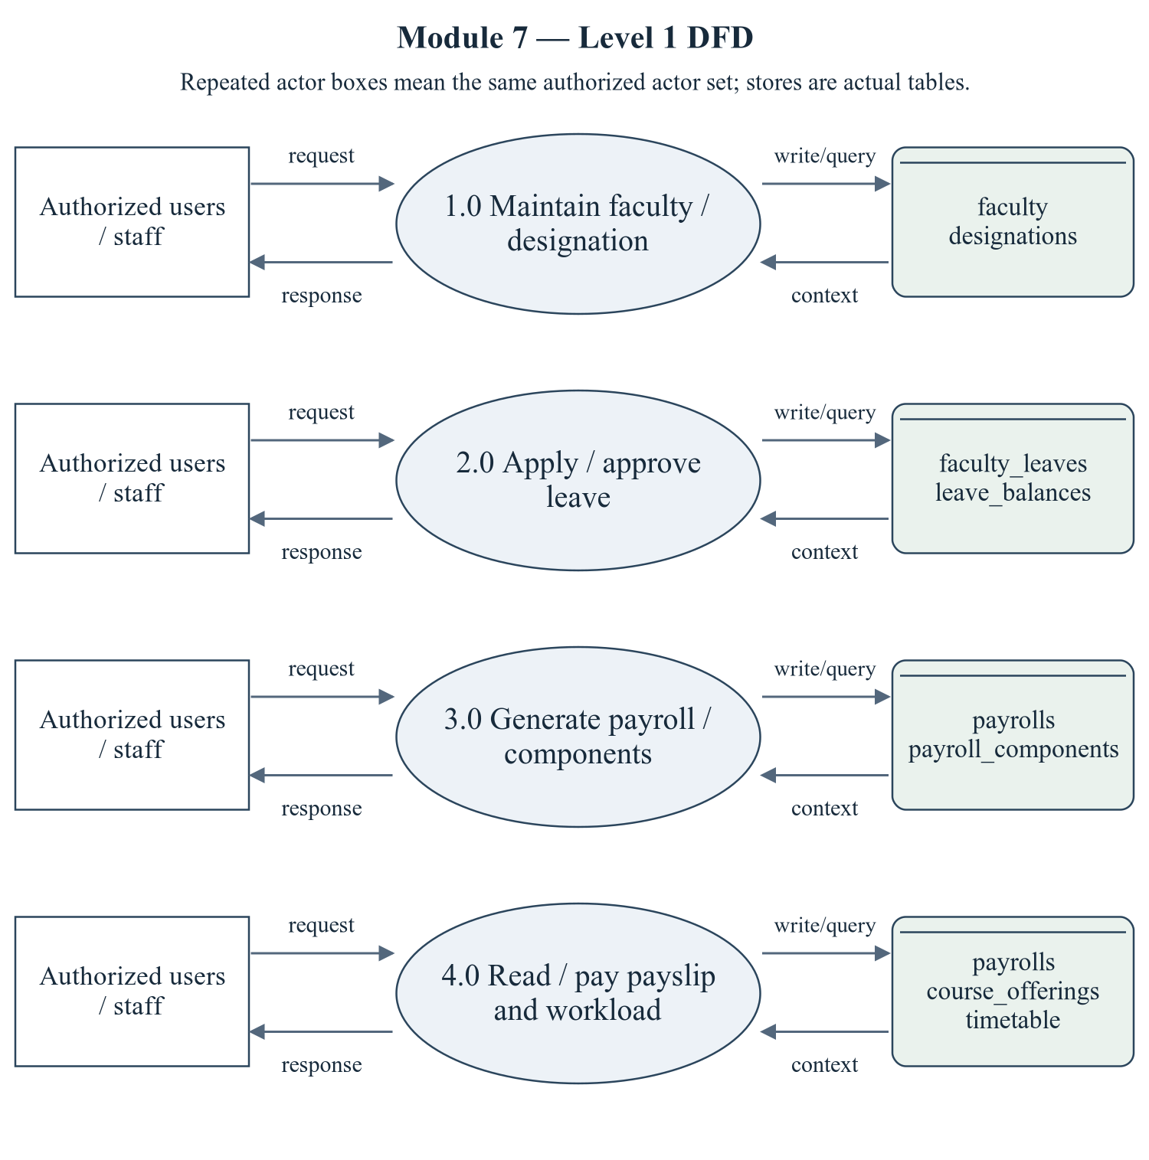
Figure 2.13 Faculty, HR and Payroll — Level 1 DFD
The repeated actor boxes denote the same permitted actor set. Ellipses are module processes; D stores list actual persisted tables. Arrows represent request/response and query/write context, not proof of successful operations.
Editable drawing source: diagrams/05_module_07_dfd_level1.svg, .dot and .mmd. Edit SVG text/shapes in a vector editor, or regenerate from DOT/Mermaid; retain FK IDs and source names. These figures were created from static source, not captured from a running ERP.
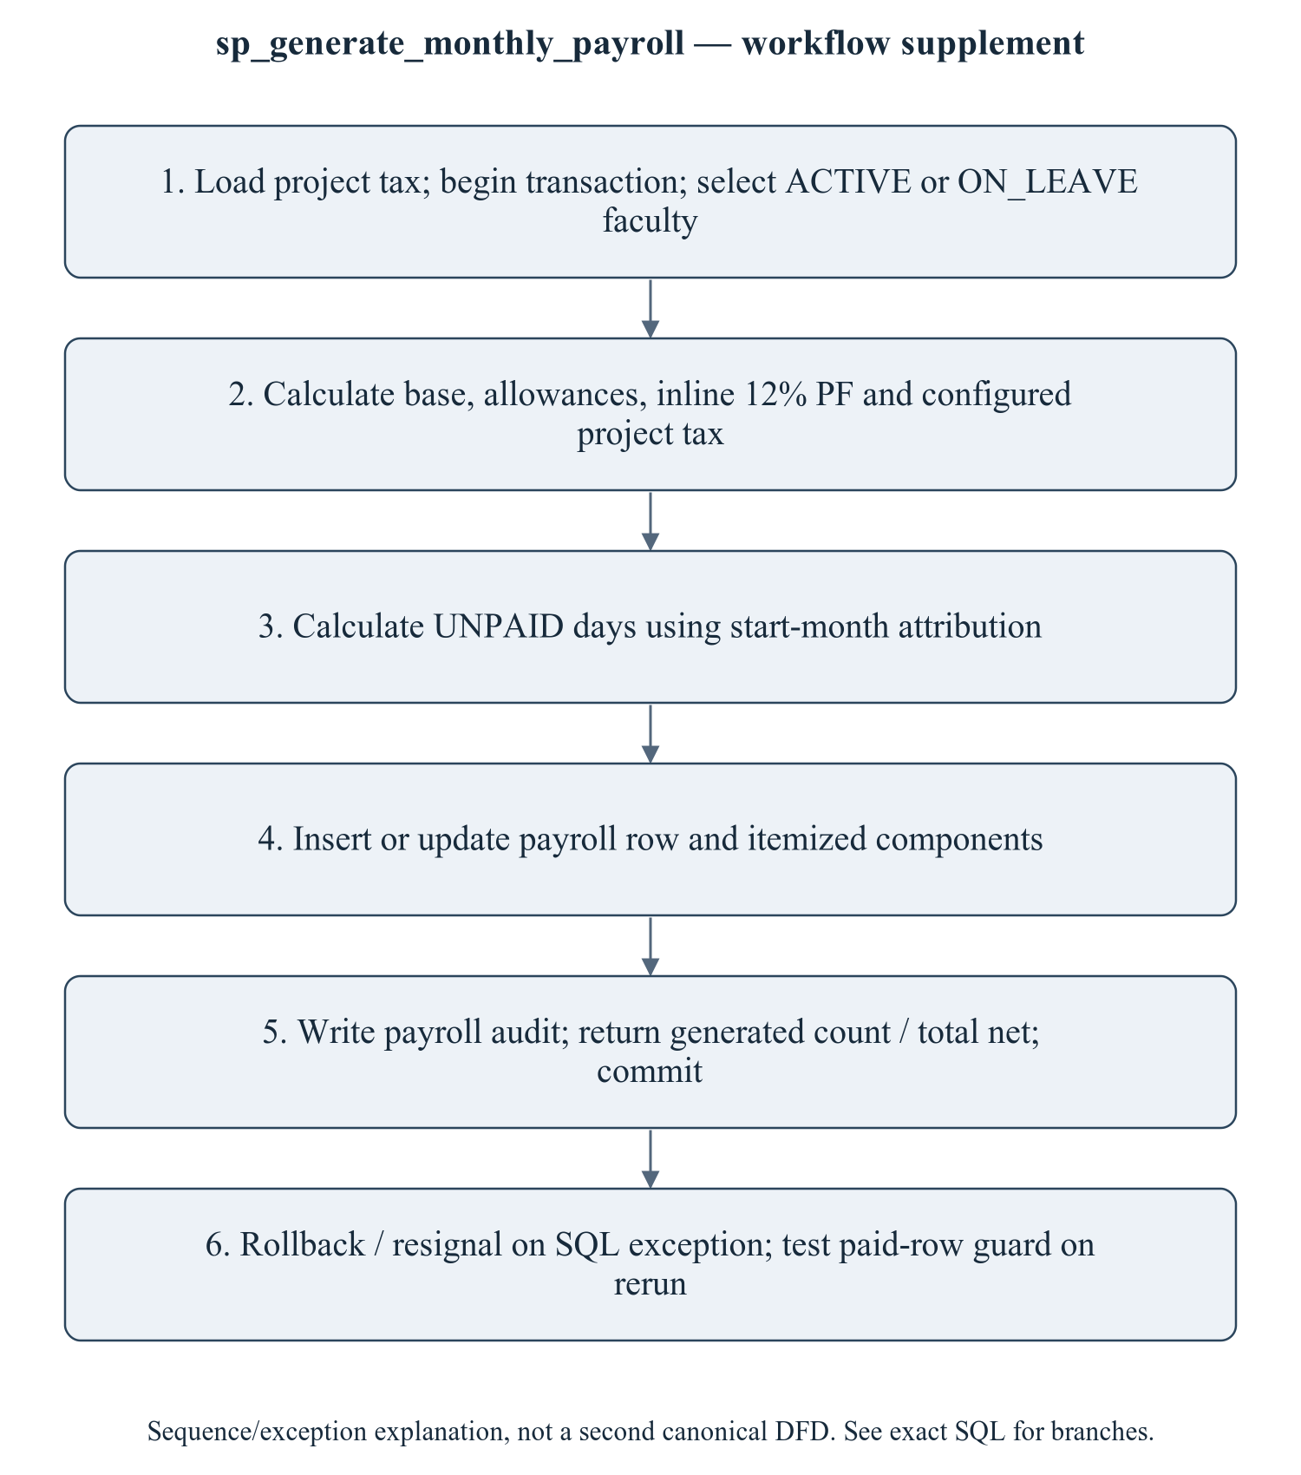
Figure 2.14 sp_generate_monthly_payroll — workflow supplement
This sequence refines the critical procedure for explanation; it is explicitly a control/transaction workflow supplement, not a mislabeled canonical Level 2 DFD. The Level 1 DFD provides the formal module data-flow view. A stored function and a procedure with different PF rules are two implementations, not proof of one centralized formula. Cross-month leave and academic-year balance handling must be approved by the team before the calculations are called correct.
Editable drawing source: diagrams/06_module_07_procedure_workflow.svg, .dot and .mmd. Edit SVG text/shapes in a vector editor, or regenerate from DOT/Mermaid; retain FK IDs and source names. These figures were created from static source, not captured from a running ERP.

2.7.2.1 Sub-System Processes, Data Stores (Tables), and External Data Movement
Table 2.19 Faculty, HR and Payroll — processes and real stores
Process | Actual stores | External movement / integration
1.0 Maintain faculty / designation | faculty, designations | Authorized actor request/response; shared master/FK data are internal context, not invented external systems.
2.0 Apply / approve leave | faculty_leaves, leave_balances | Authorized actor request/response; shared master/FK data are internal context, not invented external systems.
3.0 Generate payroll / components | payrolls, payroll_components | Authorized actor request/response; shared master/FK data are internal context, not invented external systems.
4.0 Read / pay payslip and workload | payrolls, course_offerings, timetable | Authorized actor request/response; shared master/FK data are internal context, not invented external systems.

2.7.3 Sub-Schema & Relational Data Dictionary
Relational notation below lists actual attributes. The full dictionary supplies types/nullability/defaults/constraints; PK/FK notation does not invent undeclared relationships.
designations( designation_id, designation_code, title, grade, min_basic_pay, max_basic_pay, teaching_hours_per_week). PK={designation_id}; FK IDs={}.
faculty( faculty_id, user_id, employee_code, first_name, last_name, email, phone, date_of_birth, gender, designation_id, department_id, joining_date, employment_type, qualification, specialization, experience_years, basic_salary, hra, da, ta, special_allowance, pf_percent, bank_account, status, created_at, updated_at). PK={faculty_id}; FK IDs={FK121,FK122,FK123}.
faculty_leaves( leave_id, faculty_id, leave_type, start_date, end_date, days, reason, applied_on, status, approved_by, approved_on, remarks). PK={leave_id}; FK IDs={FK124,FK125}.
leave_balances( balance_id, faculty_id, academic_year_id, leave_type, allotted, used). PK={balance_id}; FK IDs={FK126,FK127}.
payrolls( payroll_id, faculty_id, pay_month, pay_year, basic, hra, da, ta, special_allowance, gross_salary, pf_deduction, professional_tax, income_tax, lop_days, lop_amount, other_deduction, net_salary, working_days, status, generated_on, paid_on, remarks). PK={payroll_id}; FK IDs={FK128}.
payroll_components( component_id, payroll_id, component_type, name, amount). PK={component_id}; FK IDs={FK129}.
The complete column/constraint dictionary for these exact relations is in 1.6; it is not copied a second time here. The module report repeats its own complete dictionary for independent use. class_sessions remains a joint G2/G3 contract.
Table 2.20 Shared / cross-module key contracts (not duplicated ownership)
Parent table / key | Module relationship | Declared action / FK ID
academic_years, PK academic_year_id | leave_balances.academic_year_id → academic_year_id | FK127: ON DELETE CASCADE
departments, PK department_id | faculty.department_id → department_id | FK123: ON DELETE RESTRICT
users, PK user_id | faculty.user_id → user_id; faculty_leaves.approved_by → user_id | FK121: ON DELETE CASCADE; FK125: ON DELETE SET NULL

The table dictionaries in this module cover its persisted schema in full. External parents above retain their original ownership; their complete 677-column enterprise dictionary is supplied in the master report and inventory workbook. Shared contracts are repeated here so this module can be read independently without pretending to own another module's tables.

2.7.4 Advanced SQL Implementation

2.7.4.1 Stored Procedures (SQL Code & Execution Proofs)

sp_generate_monthly_payroll
Purpose / expected behavior: Generate monthly payroll and components for eligible faculty, inline PF/tax/loss-of-pay calculations and audit. Inline PF is 12%; it does not call the separately defined net-salary UDF.
Source: database/05_procedures.sql:1155–1265. Definition found in the pinned snapshot; live existence and execution are unverified. Exact source comments may be stale; only inventoried definitions establish object names.
IN p_pay_month: TINYINT UNSIGNED
IN p_pay_year: SMALLINT UNSIGNED
IN p_generated_by: INT UNSIGNED
OUT p_generated: INT
OUT p_total_net: DECIMAL(14,2)
OUT p_message: VARCHAR(255)
Outputs: p_generated INT, p_total_net DECIMAL(14,2), p_message VARCHAR(255)
Read/write dependencies: audit_logs, faculty, faculty_leaves, payroll_components, payrolls, system_settings, v_basic, v_count, v_da, v_done, v_faculty, v_gross, v_hra, v_it, v_lop, v_lop_days, v_net, v_pf, v_pt, v_pt_rate, v_sa, v_ta, v_total
Routine calls: No other stored routine call extracted.
Transaction boundary: Explicit START TRANSACTION / COMMIT and SQLEXCEPTION handling in the definition.
Invocation template (not executed): bind every @ input to a mutually consistent synthetic fixture selected from the declared tables and run only on an authorized disposable schema. Numeric literals below are planned test inputs, not observed results. Internal COMMIT means wrapping a CALL in an outer ROLLBACK is not a safe fixture-cleanup strategy.
CALL sp_generate_monthly_payroll(@p_pay_month, @p_pay_year, @p_generated_by, @p_generated, @p_total_net, @p_message);
SELECT @p_generated AS p_generated, @p_total_net AS p_total_net, @p_message AS p_message;

Actual result: [[TO BE PROVIDED: run this test and record the actual result]]
Status: [[TO BE PROVIDED: run this test and record the actual result]]
Required evidence: [[TO BE PROVIDED: execute sp_generate_monthly_payroll or its triggering DML using the corresponding module test case; owner must attach sanitized inputs, OUT/SELECT/error output, before/after effects and timestamp]]
Exact SQL definition (unchanged from source):
CREATE PROCEDURE `sp_generate_monthly_payroll`(
IN p_pay_month TINYINT UNSIGNED,
IN p_pay_year SMALLINT UNSIGNED,
IN p_generated_by INT UNSIGNED,
OUT p_generated INT,
OUT p_total_net DECIMAL(14,2),
OUT p_message VARCHAR(255)
)
BEGIN
DECLARE v_faculty INT UNSIGNED;
DECLARE v_basic, v_hra, v_da, v_ta, v_sa DECIMAL(12,2);
DECLARE v_gross, v_pf, v_pt, v_it, v_lop, v_net DECIMAL(12,2);
DECLARE v_lop_days TINYINT UNSIGNED;
DECLARE v_done TINYINT DEFAULT 0;
DECLARE v_count INT DEFAULT 0;
DECLARE v_total DECIMAL(14,2) DEFAULT 0;
DECLARE v_pt_rate DECIMAL(12,2) DEFAULT 200.00;

DECLARE cur CURSOR FOR
SELECT `faculty_id`, `basic_salary`, `hra`, `da`, `ta`, `special_allowance`
FROM `faculty`
WHERE `status` IN ('ACTIVE', 'ON_LEAVE')
ORDER BY `faculty_id`;

DECLARE CONTINUE HANDLER FOR NOT FOUND SET v_done = 1;

DECLARE EXIT HANDLER FOR SQLEXCEPTION
BEGIN
ROLLBACK;
RESIGNAL; -- keep the original error visible to the caller
END;

SELECT IFNULL(CAST(`setting_value` AS DECIMAL(12,2)), 200.00) INTO v_pt_rate
FROM `system_settings` WHERE `setting_key` = 'PROFESSIONAL_TAX';

START TRANSACTION;
OPEN cur;
pay_loop: LOOP
FETCH cur INTO v_faculty, v_basic, v_hra, v_da, v_ta, v_sa;
IF v_done = 1 THEN LEAVE pay_loop; END IF;

SELECT IFNULL(SUM(`days`), 0) INTO v_lop_days
FROM `faculty_leaves`
WHERE `faculty_id` = v_faculty
AND `status` = 'APPROVED'
AND `leave_type` = 'UNPAID'
AND MONTH(`start_date`) = p_pay_month
AND YEAR(`start_date`) = p_pay_year;

SET v_gross = v_basic + v_hra + v_da + v_ta + v_sa;
SET v_pf = ROUND(v_basic * 0.12, 2);
SET v_pt = v_pt_rate;
SET v_lop = ROUND((v_gross / 30.0) * v_lop_days, 2);
SET v_it = ROUND(GREATEST(0, (v_gross * 12 - 250000) * 0.05 / 12.0), 2);
SET v_net = GREATEST(0, ROUND(v_gross - v_pf - v_pt - v_it - v_lop, 2));

INSERT INTO `payrolls`
(`faculty_id`, `pay_month`, `pay_year`, `basic`, `hra`, `da`, `ta`,
`special_allowance`, `gross_salary`, `pf_deduction`, `professional_tax`,
`income_tax`, `lop_days`, `lop_amount`, `other_deduction`, `net_salary`,
`working_days`, `status`, `generated_on`)
VALUES
(v_faculty, p_pay_month, p_pay_year, v_basic, v_hra, v_da, v_ta, v_sa, v_gross,
v_pf, v_pt, v_it, v_lop_days, v_lop, 0.00, v_net, 30, 'GENERATED', NOW())
ON DUPLICATE KEY UPDATE
`basic` = v_basic, `hra` = v_hra, `da` = v_da, `ta` = v_ta,
`special_allowance` = v_sa, `gross_salary` = v_gross,
`pf_deduction` = v_pf, `professional_tax` = v_pt, `income_tax` = v_it,
`lop_days` = v_lop_days, `lop_amount` = v_lop, `net_salary` = v_net,
`status` = 'GENERATED', `generated_on` = NOW();

DELETE FROM `payroll_components`
WHERE `payroll_id` = (SELECT `payroll_id` FROM `payrolls`
WHERE `faculty_id` = v_faculty
AND `pay_month` = p_pay_month
AND `pay_year` = p_pay_year);

INSERT INTO `payroll_components` (`payroll_id`, `component_type`, `name`, `amount`)
SELECT `payroll_id`, 'EARNING', 'Basic Pay', v_basic FROM `payrolls`
WHERE `faculty_id` = v_faculty AND `pay_month` = p_pay_month AND `pay_year` = p_pay_year;
INSERT INTO `payroll_components` (`payroll_id`, `component_type`, `name`, `amount`)
SELECT `payroll_id`, 'EARNING', 'House Rent Allowance', v_hra FROM `payrolls`
WHERE `faculty_id` = v_faculty AND `pay_month` = p_pay_month AND `pay_year` = p_pay_year;
INSERT INTO `payroll_components` (`payroll_id`, `component_type`, `name`, `amount`)
SELECT `payroll_id`, 'EARNING', 'Dearness Allowance', v_da FROM `payrolls`
WHERE `faculty_id` = v_faculty AND `pay_month` = p_pay_month AND `pay_year` = p_pay_year;
INSERT INTO `payroll_components` (`payroll_id`, `component_type`, `name`, `amount`)
SELECT `payroll_id`, 'EARNING', 'Transport Allowance', v_ta FROM `payrolls`
WHERE `faculty_id` = v_faculty AND `pay_month` = p_pay_month AND `pay_year` = p_pay_year;
INSERT INTO `payroll_components` (`payroll_id`, `component_type`, `name`, `amount`)
SELECT `payroll_id`, 'DEDUCTION', 'Provident Fund', v_pf FROM `payrolls`
WHERE `faculty_id` = v_faculty AND `pay_month` = p_pay_month AND `pay_year` = p_pay_year;
INSERT INTO `payroll_components` (`payroll_id`, `component_type`, `name`, `amount`)
SELECT `payroll_id`, 'DEDUCTION', 'Professional Tax', v_pt FROM `payrolls`
WHERE `faculty_id` = v_faculty AND `pay_month` = p_pay_month AND `pay_year` = p_pay_year;

SET v_count = v_count + 1;
SET v_total = v_total + v_net;
END LOOP;
CLOSE cur;

INSERT INTO `audit_logs` (`user_id`, `action`, `entity`, `entity_id`, `description`)
VALUES (p_generated_by, 'PAYROLL_RUN', 'payrolls', NULL,
CONCAT('Payroll ', p_pay_month, '/', p_pay_year, ' generated for ', v_count,
' faculty, total net ', FORMAT(v_total, 2)));

SET p_generated = v_count;
SET p_total_net = v_total;
SET p_message = CONCAT('Payroll generated for ', v_count, ' faculty members.');
COMMIT;
END$$

sp_approve_leave
Purpose / expected behavior: Approve/reject a leave request with reviewer/remarks and academic-year balance handling, audit and notification. Transition guards act on the UPDATE; pending and used balance semantics need testing.
Source: database/05_procedures.sql:1272–1338. Definition found in the pinned snapshot; live existence and execution are unverified. Exact source comments may be stale; only inventoried definitions establish object names.
IN p_leave_id: INT UNSIGNED
IN p_approve: TINYINT
IN p_approved_by: INT UNSIGNED
IN p_remarks: VARCHAR(255)
OUT p_message: VARCHAR(255)
Outputs: p_message VARCHAR(255)
Read/write dependencies: academic_years, audit_logs, faculty, faculty_leaves, leave_balances, v_days, v_faculty, v_status, v_type, v_year
Routine calls: sp_push_notification
Transaction boundary: Explicit START TRANSACTION / COMMIT and SQLEXCEPTION handling in the definition.
Invocation template (not executed): bind every @ input to a mutually consistent synthetic fixture selected from the declared tables and run only on an authorized disposable schema. Numeric literals below are planned test inputs, not observed results. Internal COMMIT means wrapping a CALL in an outer ROLLBACK is not a safe fixture-cleanup strategy.
CALL sp_approve_leave(@p_leave_id, @p_approve, @p_approved_by, @p_remarks, @p_message);
SELECT @p_message AS p_message;

Actual result: [[TO BE PROVIDED: run this test and record the actual result]]
Status: [[TO BE PROVIDED: run this test and record the actual result]]
Required evidence: [[TO BE PROVIDED: execute sp_approve_leave or its triggering DML using the corresponding module test case; owner must attach sanitized inputs, OUT/SELECT/error output, before/after effects and timestamp]]
Exact SQL definition (unchanged from source):
CREATE PROCEDURE `sp_approve_leave`(
IN p_leave_id INT UNSIGNED,
IN p_approve TINYINT,
IN p_approved_by INT UNSIGNED,
IN p_remarks VARCHAR(255),
OUT p_message VARCHAR(255)
)
BEGIN
DECLARE v_faculty INT UNSIGNED;
DECLARE v_type VARCHAR(20);
DECLARE v_days TINYINT UNSIGNED;
DECLARE v_status VARCHAR(20);
DECLARE v_year SMALLINT UNSIGNED;

DECLARE EXIT HANDLER FOR SQLEXCEPTION
BEGIN
ROLLBACK;
RESIGNAL; -- keep the original error visible to the caller
END;

SELECT `faculty_id`, `leave_type`, `days`, `status`
INTO v_faculty, v_type, v_days, v_status
FROM `faculty_leaves` WHERE `leave_id` = p_leave_id;

IF v_faculty IS NULL THEN
SIGNAL SQLSTATE '45000' SET MESSAGE_TEXT = 'Leave application not found.';
END IF;
IF v_status <> 'PENDING' THEN
SIGNAL SQLSTATE '45000' SET MESSAGE_TEXT = 'This leave has already been decided.';
END IF;

SELECT `academic_year_id` INTO v_year FROM `academic_years` WHERE `is_current` = 1 LIMIT 1;

START TRANSACTION;

IF p_approve = 1 THEN
UPDATE `faculty_leaves`
SET `status` = 'APPROVED', `approved_by` = p_approved_by, `approved_on` = NOW(),
`remarks` = p_remarks
WHERE `leave_id` = p_leave_id;

INSERT INTO `leave_balances` (`faculty_id`, `academic_year_id`, `leave_type`, `allotted`, `used`)
VALUES (v_faculty, v_year, v_type, 0, v_days)
ON DUPLICATE KEY UPDATE `used` = `used` + v_days;

SET p_message = 'Leave approved and the balance has been updated.';
ELSE
UPDATE `faculty_leaves`
SET `status` = 'REJECTED', `approved_by` = p_approved_by, `approved_on` = NOW(),
`remarks` = p_remarks
WHERE `leave_id` = p_leave_id;
SET p_message = 'Leave rejected.';
END IF;

INSERT INTO `audit_logs` (`user_id`, `action`, `entity`, `entity_id`, `description`)
VALUES (p_approved_by, 'LEAVE_ACTION', 'faculty_leaves', p_leave_id, p_message);

CALL sp_push_notification(
(SELECT `user_id` FROM `faculty` WHERE `faculty_id` = v_faculty),
CONCAT('Leave ', IF(p_approve = 1, 'approved', 'rejected')),
CONCAT('Your ', v_type, ' leave for ', v_days, ' day(s) was ',
IF(p_approve = 1, 'approved', 'rejected'), '. ', IFNULL(p_remarks, '')),
'LEAVE_APPROVAL', IF(p_approve = 1, 'SUCCESS', 'WARNING'), 'faculty_leaves', p_leave_id,
'/faculty/leaves');

COMMIT;
END$$

2.7.4.2 Database Triggers (SQL Code & Execution Proofs)

trg_faculty_bi_validate
Purpose / expected behavior: Check faculty birth/joining/contact/salary conditions on INSERT. This is not a comprehensive UPDATE-time salary validation trigger.
Source: database/06_triggers.sql:74–83. Definition found in the pinned snapshot; live existence and execution are unverified. Exact source comments may be stale; only inventoried definitions establish object names.
Event / inputs / output: BEFORE INSERT ON `faculty` FOR EACH ROW; OLD/NEW are event-appropriate row images; no explicit arguments or scalar return. Side effects are described above.
Read/write dependencies: faculty
Routine calls: No other stored routine call extracted.
Invocation template (not executed): bind every @ input to a mutually consistent synthetic fixture selected from the declared tables and run only on an authorized disposable schema. Numeric literals below are planned test inputs, not observed results. Internal COMMIT means wrapping a CALL in an outer ROLLBACK is not a safe fixture-cleanup strategy.
-- Invoke through POST /api/v1/faculty with a complete synthetic faculty payload (M7-01); the repository supplies INSERT faculty.

Actual result: [[TO BE PROVIDED: run this test and record the actual result]]
Status: [[TO BE PROVIDED: run this test and record the actual result]]
Required evidence: [[TO BE PROVIDED: execute trg_faculty_bi_validate or its triggering DML using the corresponding module test case; owner must attach sanitized inputs, OUT/SELECT/error output, before/after effects and timestamp]]
Exact SQL definition (unchanged from source):
CREATE TRIGGER `trg_faculty_bi_validate`
BEFORE INSERT ON `faculty` FOR EACH ROW
BEGIN
IF NEW.`date_of_birth` >= CURDATE() THEN
SIGNAL SQLSTATE '45000' SET MESSAGE_TEXT = 'Faculty date of birth must be in the past.';
END IF;
IF NEW.`joining_date` <= NEW.`date_of_birth` THEN
SIGNAL SQLSTATE '45000' SET MESSAGE_TEXT = 'Joining date must be after the date of birth.';
END IF;
END$$

trg_faculty_leaves_bu_guard
Purpose / expected behavior: Check balance on PENDING→APPROVED and reduce used balance on APPROVED→CANCELLED; validate date order. The procedure, not this trigger, increments used on approval; the balance UDF reserves pending days including the request being approved.
Source: database/06_triggers.sql:599–626. Definition found in the pinned snapshot; live existence and execution are unverified. Exact source comments may be stale; only inventoried definitions establish object names.
Event / inputs / output: BEFORE UPDATE ON `faculty_leaves` FOR EACH ROW; OLD/NEW are event-appropriate row images; no explicit arguments or scalar return. Side effects are described above.
Read/write dependencies: academic_years, faculty_leaves, leave_balances, v_balance, v_year
Routine calls: fn_calculate_faculty_leave_balance
Invocation template (not executed): bind every @ input to a mutually consistent synthetic fixture selected from the declared tables and run only on an authorized disposable schema. Numeric literals below are planned test inputs, not observed results. Internal COMMIT means wrapping a CALL in an outer ROLLBACK is not a safe fixture-cleanup strategy.
CALL sp_approve_leave(@p_leave_id, 1, @p_approved_by, @p_remarks, @p_message);

Actual result: [[TO BE PROVIDED: run this test and record the actual result]]
Status: [[TO BE PROVIDED: run this test and record the actual result]]
Required evidence: [[TO BE PROVIDED: execute trg_faculty_leaves_bu_guard or its triggering DML using the corresponding module test case; owner must attach sanitized inputs, OUT/SELECT/error output, before/after effects and timestamp]]
Exact SQL definition (unchanged from source):
CREATE TRIGGER `trg_faculty_leaves_bu_guard`
BEFORE UPDATE ON `faculty_leaves` FOR EACH ROW
BEGIN
DECLARE v_year SMALLINT UNSIGNED;
DECLARE v_balance DECIMAL(5,2);

IF OLD.`status` = 'PENDING' AND NEW.`status` = 'APPROVED' THEN
SELECT `academic_year_id` INTO v_year FROM `academic_years` WHERE `is_current` = 1 LIMIT 1;
SET v_balance = fn_calculate_faculty_leave_balance(NEW.`faculty_id`, NEW.`leave_type`, v_year);
IF NEW.`leave_type` IN ('CASUAL', 'SICK', 'EARNED') AND v_balance < NEW.`days` THEN
SIGNAL SQLSTATE '45000'
SET MESSAGE_TEXT = 'Leave cannot be approved: remaining balance is insufficient.';
END IF;
END IF;

IF OLD.`status` = 'APPROVED' AND NEW.`status` = 'CANCELLED' THEN
SELECT `academic_year_id` INTO v_year FROM `academic_years` WHERE `is_current` = 1 LIMIT 1;
UPDATE `leave_balances`
SET `used` = GREATEST(0, `used` - OLD.`days`)
WHERE `faculty_id` = OLD.`faculty_id`
AND `leave_type` = OLD.`leave_type`
AND `academic_year_id` = v_year;
END IF;

IF NEW.`end_date` < NEW.`start_date` THEN
SIGNAL SQLSTATE '45000' SET MESSAGE_TEXT = 'Leave end date cannot precede the start date.';
END IF;
END$$

trg_faculty_leaves_bi_guard
Purpose / expected behavior: Reject end_date before start_date and leave starting before faculty joining date. No overlap predicate is implemented in this insert trigger.
Source: database/06_triggers.sql:630–639. Definition found in the pinned snapshot; live existence and execution are unverified. Exact source comments may be stale; only inventoried definitions establish object names.
Event / inputs / output: BEFORE INSERT ON `faculty_leaves` FOR EACH ROW; OLD/NEW are event-appropriate row images; no explicit arguments or scalar return. Side effects are described above.
Read/write dependencies: faculty, faculty_leaves
Routine calls: No other stored routine call extracted.
Invocation template (not executed): bind every @ input to a mutually consistent synthetic fixture selected from the declared tables and run only on an authorized disposable schema. Numeric literals below are planned test inputs, not observed results. Internal COMMIT means wrapping a CALL in an outer ROLLBACK is not a safe fixture-cleanup strategy.
INSERT INTO faculty_leaves (faculty_id, leave_type, start_date, end_date, days, reason) VALUES (@fixture_faculty_id, 'CASUAL', @fixture_start_date, @fixture_end_date, 1, 'Synthetic validation fixture');

Actual result: [[TO BE PROVIDED: run this test and record the actual result]]
Status: [[TO BE PROVIDED: run this test and record the actual result]]
Required evidence: [[TO BE PROVIDED: execute trg_faculty_leaves_bi_guard or its triggering DML using the corresponding module test case; owner must attach sanitized inputs, OUT/SELECT/error output, before/after effects and timestamp]]
Exact SQL definition (unchanged from source):
CREATE TRIGGER `trg_faculty_leaves_bi_guard`
BEFORE INSERT ON `faculty_leaves` FOR EACH ROW
BEGIN
IF NEW.`end_date` < NEW.`start_date` THEN
SIGNAL SQLSTATE '45000' SET MESSAGE_TEXT = 'Leave end date cannot precede the start date.';
END IF;
IF NEW.`start_date` < (SELECT `joining_date` FROM `faculty` WHERE `faculty_id` = NEW.`faculty_id`) THEN
SIGNAL SQLSTATE '45000' SET MESSAGE_TEXT = 'Leave cannot start before the joining date.';
END IF;
END$$

trg_payrolls_bu_guard
Purpose / expected behavior: Reject moving PAID to a state other than PAID or APPROVED and reject negative net salary. It does not reject every amount edit that leaves status PAID/APPROVED; no blanket immutability claim is made.
Source: database/06_triggers.sql:644–654. Definition found in the pinned snapshot; live existence and execution are unverified. Exact source comments may be stale; only inventoried definitions establish object names.
Event / inputs / output: BEFORE UPDATE ON `payrolls` FOR EACH ROW; OLD/NEW are event-appropriate row images; no explicit arguments or scalar return. Side effects are described above.
Read/write dependencies: payrolls
Routine calls: No other stored routine call extracted.
Invocation template (not executed): bind every @ input to a mutually consistent synthetic fixture selected from the declared tables and run only on an authorized disposable schema. Numeric literals below are planned test inputs, not observed results. Internal COMMIT means wrapping a CALL in an outer ROLLBACK is not a safe fixture-cleanup strategy.
UPDATE payrolls SET status = 'DRAFT' WHERE payroll_id = @fixture_paid_payroll_id;

Actual result: [[TO BE PROVIDED: run this test and record the actual result]]
Status: [[TO BE PROVIDED: run this test and record the actual result]]
Required evidence: [[TO BE PROVIDED: execute trg_payrolls_bu_guard or its triggering DML using the corresponding module test case; owner must attach sanitized inputs, OUT/SELECT/error output, before/after effects and timestamp]]
Exact SQL definition (unchanged from source):
CREATE TRIGGER `trg_payrolls_bu_guard`
BEFORE UPDATE ON `payrolls` FOR EACH ROW
BEGIN
IF OLD.`status` = 'PAID' AND NEW.`status` NOT IN ('PAID', 'APPROVED') THEN
SIGNAL SQLSTATE '45000'
SET MESSAGE_TEXT = 'A paid payslip cannot be moved back to draft.';
END IF;
IF NEW.`net_salary` < 0 THEN
SIGNAL SQLSTATE '45000' SET MESSAGE_TEXT = 'Net salary cannot be negative.';
END IF;
END$$

2.7.4.3 User-Defined Functions (UDFs) (SQL Code & Execution Proofs)

fn_calculate_faculty_leave_balance
Purpose / expected behavior: Read the requested faculty/year/type ledger and pending leave contribution to return available balance. Pending reservations and used amounts must not be assumed equivalent.
Source: database/07_functions.sql:226–253. Definition found in the pinned snapshot; live existence and execution are unverified. Exact source comments may be stale; only inventoried definitions establish object names.
IN p_faculty_id: INT UNSIGNED
IN p_leave_type: VARCHAR(20)
IN p_academic_year_id: SMALLINT UNSIGNED
Output: decimal(5,2) scalar return value.
Read/write dependencies: faculty_leaves, leave_balances, v_allotted, v_used
Routine calls: No other stored routine call extracted.
Invocation template (not executed): bind every @ input to a mutually consistent synthetic fixture selected from the declared tables and run only on an authorized disposable schema. Numeric literals below are planned test inputs, not observed results. Internal COMMIT means wrapping a CALL in an outer ROLLBACK is not a safe fixture-cleanup strategy.
SELECT fn_calculate_faculty_leave_balance(@p_faculty_id, @p_leave_type, @p_academic_year_id) AS computed_value;

Actual result: [[TO BE PROVIDED: run this test and record the actual result]]
Status: [[TO BE PROVIDED: run this test and record the actual result]]
Required evidence: [[TO BE PROVIDED: execute fn_calculate_faculty_leave_balance or its triggering DML using the corresponding module test case; owner must attach sanitized inputs, OUT/SELECT/error output, before/after effects and timestamp]]
Exact SQL definition (unchanged from source):
CREATE FUNCTION `fn_calculate_faculty_leave_balance`(
p_faculty_id INT UNSIGNED,
p_leave_type VARCHAR(20),
p_academic_year_id SMALLINT UNSIGNED
) RETURNS decimal(5,2)
READS SQL DATA
BEGIN
DECLARE v_allotted DECIMAL(5,2) DEFAULT 0.00;
DECLARE v_used DECIMAL(5,2) DEFAULT 0.00;

SELECT IFNULL(`allotted`,0) - IFNULL(`used`,0)
INTO v_allotted
FROM `leave_balances`
WHERE `faculty_id` = p_faculty_id
AND `leave_type` = p_leave_type
AND `academic_year_id` = p_academic_year_id
LIMIT 1;

-- Reserve pending applications so the balance cannot be double-spent.
SELECT IFNULL(SUM(`days`),0)
INTO v_used
FROM `faculty_leaves`
WHERE `faculty_id` = p_faculty_id
AND `leave_type` = p_leave_type
AND `status` = 'PENDING';

RETURN v_allotted - v_used;
END$$

fn_calculate_net_salary
Purpose / expected behavior: Compute a project net salary using faculty-specific PF and implemented tax/loss-of-pay rules. It is not called by the monthly payroll procedure and is not a statutory payroll calculator.
Source: database/07_functions.sql:301–342. Definition found in the pinned snapshot; live existence and execution are unverified. Exact source comments may be stale; only inventoried definitions establish object names.
IN p_faculty_id: INT UNSIGNED
IN p_month: TINYINT UNSIGNED
IN p_year: SMALLINT UNSIGNED
Output: decimal(12,2) scalar return value.
Read/write dependencies: faculty, faculty_leaves, system_settings, v_basic, v_da, v_gross, v_hra, v_it, v_lop, v_lop_days, v_net, v_other, v_per_day, v_pf, v_pf_pct, v_pt, v_sa, v_ta
Routine calls: No other stored routine call extracted.
Invocation template (not executed): bind every @ input to a mutually consistent synthetic fixture selected from the declared tables and run only on an authorized disposable schema. Numeric literals below are planned test inputs, not observed results. Internal COMMIT means wrapping a CALL in an outer ROLLBACK is not a safe fixture-cleanup strategy.
SELECT fn_calculate_net_salary(@p_faculty_id, @p_month, @p_year) AS computed_value;

Actual result: [[TO BE PROVIDED: run this test and record the actual result]]
Status: [[TO BE PROVIDED: run this test and record the actual result]]
Required evidence: [[TO BE PROVIDED: execute fn_calculate_net_salary or its triggering DML using the corresponding module test case; owner must attach sanitized inputs, OUT/SELECT/error output, before/after effects and timestamp]]
Exact SQL definition (unchanged from source):
CREATE FUNCTION `fn_calculate_net_salary`(
p_faculty_id INT UNSIGNED,
p_month TINYINT UNSIGNED,
p_year SMALLINT UNSIGNED
) RETURNS decimal(12,2)
READS SQL DATA
BEGIN
DECLARE v_basic, v_hra, v_da, v_ta, v_sa DECIMAL(12,2) DEFAULT 0.00;
DECLARE v_gross, v_pf, v_pt, v_it, v_lop, v_other, v_net DECIMAL(12,2) DEFAULT 0.00;
DECLARE v_pf_pct DECIMAL(5,2) DEFAULT 12.00;
DECLARE v_lop_days TINYINT DEFAULT 0;
DECLARE v_per_day DECIMAL(12,2) DEFAULT 0.00;

SELECT f.`basic_salary`, f.`hra`, f.`da`, f.`ta`, f.`special_allowance`, f.`pf_percent`
INTO v_basic, v_hra, v_da, v_ta, v_sa, v_pf_pct
FROM `faculty` f WHERE f.`faculty_id` = p_faculty_id;

IF v_basic IS NULL THEN RETURN 0.00; END IF;

-- Loss of pay: approved UNPAID leaves that overlap the payroll month.
SELECT IFNULL(SUM(fl.`days`),0) INTO v_lop_days
FROM `faculty_leaves` fl
WHERE fl.`faculty_id` = p_faculty_id
AND fl.`status` = 'APPROVED'
AND fl.`leave_type` IN ('UNPAID')
AND MONTH(fl.`start_date`) = p_month
AND YEAR(fl.`start_date`) = p_year;

SELECT IFNULL(`setting_value`, '200') INTO v_pt
FROM `system_settings` WHERE `setting_key` = 'PROFESSIONAL_TAX';

SET v_gross = v_basic + v_hra + v_da + v_ta + v_sa;
SET v_pf = ROUND(v_basic * (v_pf_pct / 100), 2);
SET v_it = ROUND(GREATEST(0, (v_gross * 12 - 250000) * 0.05 / 12.0), 2);
SET v_per_day= ROUND(v_gross / 30, 2);
SET v_lop = ROUND(v_per_day * v_lop_days, 2);
SET v_other = 0.00;
SET v_net = v_gross - v_pf - v_pt - v_it - v_lop - v_other;

IF v_net < 0 THEN SET v_net = 0.00; END IF;
RETURN ROUND(v_net, 2);
END$$

2.7.5 Complex Analytical Queries & Views

v_faculty_workload
Purpose / expected behavior: Combine faculty designation/department, offerings, enrollment, timetable, class-session and leave workload aggregates. It is consumed by the academic module as a shared view.
Source: database/08_views.sql:177–209. Definition found in the pinned snapshot; live existence and execution are unverified. Exact source comments may be stale; only inventoried definitions establish object names.
Inputs / output: No parameters; SELECT returns columns: faculty_id, employee_code, full_name, email, department_id, department_code, department_name, designation, teaching_hours_per_week, status, offerings_count, students_taught, sessions_taken, timetable_slots, pending_leaves. WHERE/JOIN predicates are query inputs, not stored view parameters.
Read/write dependencies: class_sessions, course_offerings, departments, designations, enrollments, faculty, faculty_leaves, timetable
Routine calls: No other stored routine call extracted.
Invocation template (not executed): bind every @ input to a mutually consistent synthetic fixture selected from the declared tables and run only on an authorized disposable schema. Numeric literals below are planned test inputs, not observed results. Internal COMMIT means wrapping a CALL in an outer ROLLBACK is not a safe fixture-cleanup strategy.
SELECT * FROM v_faculty_workload LIMIT 10;

Actual result: [[TO BE PROVIDED: run this test and record the actual result]]
Status: [[TO BE PROVIDED: run this test and record the actual result]]
Required evidence: [[TO BE PROVIDED: execute v_faculty_workload or its triggering DML using the corresponding module test case; owner must attach sanitized inputs, OUT/SELECT/error output, before/after effects and timestamp]]
Exact SQL definition (unchanged from source):
CREATE OR REPLACE VIEW `v_faculty_workload` AS
SELECT f.`faculty_id`, f.`employee_code`,
CONCAT(f.`first_name`, ' ', f.`last_name`) AS `full_name`,
f.`email`, f.`department_id`, d.`department_code`, d.`name` AS `department_name`,
des.`title` AS `designation`, des.`teaching_hours_per_week`, f.`status`,
IFNULL(oc.`offerings_count`, 0) AS `offerings_count`,
IFNULL(ec.`students_taught`, 0) AS `students_taught`,
IFNULL(sc.`sessions_taken`, 0) AS `sessions_taken`,
IFNULL(tc.`timetable_slots`, 0) AS `timetable_slots`,
IFNULL(lc.`pending_leaves`, 0) AS `pending_leaves`
FROM `faculty` f
JOIN `departments` d ON d.`department_id` = f.`department_id`
JOIN `designations` des ON des.`designation_id` = f.`designation_id`
LEFT JOIN (SELECT `faculty_id`, COUNT(*) AS `offerings_count`
FROM `course_offerings` GROUP BY `faculty_id`) oc
ON oc.`faculty_id` = f.`faculty_id`
LEFT JOIN (SELECT co.`faculty_id`, COUNT(e.`enrollment_id`) AS `students_taught`
FROM `course_offerings` co
LEFT JOIN `enrollments` e ON e.`offering_id` = co.`offering_id`
GROUP BY co.`faculty_id`) ec
ON ec.`faculty_id` = f.`faculty_id`
LEFT JOIN (SELECT co.`faculty_id`, COUNT(cs.`session_id`) AS `sessions_taken`
FROM `course_offerings` co
LEFT JOIN `class_sessions` cs ON cs.`offering_id` = co.`offering_id`
GROUP BY co.`faculty_id`) sc
ON sc.`faculty_id` = f.`faculty_id`
LEFT JOIN (SELECT `faculty_id`, COUNT(*) AS `timetable_slots`
FROM `timetable` WHERE `is_active` = 1 GROUP BY `faculty_id`) tc
ON tc.`faculty_id` = f.`faculty_id`
LEFT JOIN (SELECT `faculty_id`, COUNT(*) AS `pending_leaves`
FROM `faculty_leaves` WHERE `status` = 'PENDING'
GROUP BY `faculty_id`) lc
ON lc.`faculty_id` = f.`faculty_id`;

v_faculty_payroll_summary
Purpose / expected behavior: Join faculty and payroll aggregates/current-year leave context. Labels saying YTD are not supported by a payroll-year filter; independent maxima do not necessarily form one latest period.
Source: database/08_views.sql:214–234. Definition found in the pinned snapshot; live existence and execution are unverified. Exact source comments may be stale; only inventoried definitions establish object names.
Inputs / output: No parameters; SELECT returns columns: faculty_id, employee_code, full_name, email, department_id, department_code, designation, basic_salary, status, payslips_issued, ytd_gross, ytd_net, ytd_pf, ytd_lop, last_pay_year, last_pay_month, casual_leave_balance. WHERE/JOIN predicates are query inputs, not stored view parameters.
Read/write dependencies: academic_years, departments, designations, faculty, payrolls
Routine calls: fn_calculate_faculty_leave_balance
Invocation template (not executed): bind every @ input to a mutually consistent synthetic fixture selected from the declared tables and run only on an authorized disposable schema. Numeric literals below are planned test inputs, not observed results. Internal COMMIT means wrapping a CALL in an outer ROLLBACK is not a safe fixture-cleanup strategy.
SELECT * FROM v_faculty_payroll_summary LIMIT 10;

Actual result: [[TO BE PROVIDED: run this test and record the actual result]]
Status: [[TO BE PROVIDED: run this test and record the actual result]]
Required evidence: [[TO BE PROVIDED: execute v_faculty_payroll_summary or its triggering DML using the corresponding module test case; owner must attach sanitized inputs, OUT/SELECT/error output, before/after effects and timestamp]]
Exact SQL definition (unchanged from source):
CREATE OR REPLACE VIEW `v_faculty_payroll_summary` AS
SELECT f.`faculty_id`, f.`employee_code`,
CONCAT(f.`first_name`, ' ', f.`last_name`) AS `full_name`,
f.`email`, f.`department_id`, d.`department_code`, des.`title` AS `designation`,
f.`basic_salary`, f.`status`,
COUNT(py.`payroll_id`) AS `payslips_issued`,
IFNULL(SUM(py.`gross_salary`),0) AS `ytd_gross`,
IFNULL(SUM(py.`net_salary`),0) AS `ytd_net`,
IFNULL(SUM(py.`pf_deduction`),0) AS `ytd_pf`,
IFNULL(SUM(py.`lop_amount`),0) AS `ytd_lop`,
MAX(py.`pay_year`) AS `last_pay_year`,
MAX(py.`pay_month`) AS `last_pay_month`,
fn_calculate_faculty_leave_balance(f.`faculty_id`, 'CASUAL',
(SELECT ay.`academic_year_id` FROM `academic_years` ay WHERE ay.`is_current` = 1 LIMIT 1)
) AS `casual_leave_balance`
FROM `faculty` f
JOIN `departments` d ON d.`department_id` = f.`department_id`
JOIN `designations` des ON des.`designation_id` = f.`designation_id`
LEFT JOIN `payrolls` py ON py.`faculty_id` = f.`faculty_id`
GROUP BY f.`faculty_id`, f.`employee_code`, f.`first_name`, f.`last_name`, f.`email`,
f.`department_id`, d.`department_code`, des.`title`, f.`basic_salary`, f.`status`;

Q38 uses window SUM partitioned by faculty/pay_year for actual YTD and LAG for monthly change; Q39 compares ledger leave balance with the UDF. These are unexecuted analysis queries; validate academic-year selection, deduction policy and cross-month leave before drawing conclusions. [R08]

Q38 — Payroll register with year-to-date totals per faculty
Source: database/09_queries.sql:963. Purpose is the query projection/aggregation below; no output rows have been generated. Expected column structure follows aliases in the exact statement.
SELECT f.employee_code,
CONCAT(f.first_name, ' ', f.last_name) AS faculty_name,
d.department_code,
py.pay_year,
py.pay_month,
py.gross_salary,
py.net_salary,
SUM(py.net_salary) OVER (PARTITION BY f.faculty_id, py.pay_year
ORDER BY py.pay_month
ROWS BETWEEN UNBOUNDED PRECEDING AND CURRENT ROW) AS ytd_net,
py.net_salary - LAG(py.net_salary) OVER (PARTITION BY f.faculty_id
ORDER BY py.pay_year, py.pay_month) AS month_delta,
py.lop_days,
py.status
FROM payrolls py
JOIN faculty f ON f.faculty_id = py.faculty_id
JOIN departments d ON d.department_id = f.department_id
ORDER BY f.employee_code, py.pay_year DESC, py.pay_month DESC
LIMIT 80;

Actual result: [[TO BE PROVIDED: run this test and record the actual result]]
Status: [[TO BE PROVIDED: run this test and record the actual result]]

Q39 — Leave utilisation vs sanctioned quota (uses the UDF)
Source: database/09_queries.sql:989. Purpose is the query projection/aggregation below; no output rows have been generated. Expected column structure follows aliases in the exact statement.
SELECT f.employee_code,
CONCAT(f.first_name, ' ', f.last_name) AS faculty_name,
lb.leave_type,
lb.allotted,
lb.used,
lb.allotted - lb.used AS remaining_ledger,
fn_calculate_faculty_leave_balance(
f.faculty_id, lb.leave_type,
(SELECT academic_year_id FROM academic_years WHERE is_current = 1 LIMIT 1)
) AS remaining_udf,
ROUND(100.0 * lb.used / NULLIF(lb.allotted, 0), 1) AS utilisation_percentage,
CASE WHEN lb.used >= lb.allotted THEN 'EXHAUSTED'
WHEN lb.used >= 0.8 * lb.allotted THEN 'LOW BALANCE'
ELSE 'HEALTHY' END AS health
FROM leave_balances lb
JOIN faculty f ON f.faculty_id = lb.faculty_id
ORDER BY health DESC, utilisation_percentage DESC
LIMIT 60;

Actual result: [[TO BE PROVIDED: run this test and record the actual result]]
Status: [[TO BE PROVIDED: run this test and record the actual result]]

2.7.6 Backend, Frontend, Validation & Transaction Trace
Table 2.21 Faculty, HR and Payroll — exact API route/role register
Method and route | Role gate / handler | Validation and source
GET /api/v1/faculty | FACULTY, ADMIN, HR  Handler: list | No route-local Zod validation; service/DB checks may apply  backend/src/routes/faculty.routes.ts:70
GET /api/v1/faculty/stats | ADMIN, HR  Handler: stats | No route-local Zod validation; service/DB checks may apply  backend/src/routes/faculty.routes.ts:71
GET /api/v1/faculty/options | ADMIN, HR  Handler: options | No route-local Zod validation; service/DB checks may apply  backend/src/routes/faculty.routes.ts:72
GET /api/v1/faculty/me | FACULTY  Handler: me | No route-local Zod validation; service/DB checks may apply  backend/src/routes/faculty.routes.ts:73
GET /api/v1/faculty/workload | ADMIN, HR  Handler: workload | No route-local Zod validation; service/DB checks may apply  backend/src/routes/faculty.routes.ts:74
GET /api/v1/faculty/me/subjects | FACULTY  Handler: teachingLoad | No route-local Zod validation; service/DB checks may apply  backend/src/routes/faculty.routes.ts:75
GET /api/v1/faculty/me/leave-balances | FACULTY  Handler: balances | No route-local Zod validation; service/DB checks may apply  backend/src/routes/faculty.routes.ts:76
GET /api/v1/faculty/leaves | FACULTY, ADMIN, HR  Handler: leaves | No route-local Zod validation; service/DB checks may apply  backend/src/routes/faculty.routes.ts:79
GET /api/v1/faculty/leaves/types | FACULTY, ADMIN, HR  Handler: leaveTypes | No route-local Zod validation; service/DB checks may apply  backend/src/routes/faculty.routes.ts:80
GET /api/v1/faculty/leaves/:id | FACULTY, ADMIN, HR  Handler: leave | No route-local Zod validation; service/DB checks may apply  backend/src/routes/faculty.routes.ts:81
POST /api/v1/faculty/leaves | FACULTY, ADMIN  Handler: applyLeave | Zod validate(...) in route  backend/src/routes/faculty.routes.ts:82
POST /api/v1/faculty/leaves/:id/review | ADMIN, HR  Handler: reviewLeave | Zod validate(...) in route  backend/src/routes/faculty.routes.ts:90
GET /api/v1/faculty/payroll | FACULTY, ADMIN, HR  Handler: payrolls | No route-local Zod validation; service/DB checks may apply  backend/src/routes/faculty.routes.ts:96
GET /api/v1/faculty/payroll/summary | ADMIN, HR  Handler: payrollSummary | No route-local Zod validation; service/DB checks may apply  backend/src/routes/faculty.routes.ts:97
GET /api/v1/faculty/payroll/months | ADMIN, HR  Handler: payrollMonths | No route-local Zod validation; service/DB checks may apply  backend/src/routes/faculty.routes.ts:98
GET /api/v1/faculty/payroll/:id | FACULTY, ADMIN, HR  Handler: payslip | No route-local Zod validation; service/DB checks may apply  backend/src/routes/faculty.routes.ts:99
POST /api/v1/faculty/payroll/generate | ADMIN, HR  Handler: generatePayroll | Zod validate(...) in route  backend/src/routes/faculty.routes.ts:100
PATCH /api/v1/faculty/payroll/:id/status | ADMIN, HR  Handler: setPayrollStatus | Zod validate(...) in route  backend/src/routes/faculty.routes.ts:104
POST /api/v1/faculty | ADMIN, HR  Handler: create | Zod validate(...) in route  backend/src/routes/faculty.routes.ts:109
GET /api/v1/faculty/:id | ADMIN, HR  Handler: detail | No route-local Zod validation; service/DB checks may apply  backend/src/routes/faculty.routes.ts:110
PUT /api/v1/faculty/:id | ADMIN, HR  Handler: update | Zod validate(...) in route  backend/src/routes/faculty.routes.ts:111
PATCH /api/v1/faculty/:id/account-status | ADMIN, HR  Handler: setAccountStatus | Zod validate(...) in route  backend/src/routes/faculty.routes.ts:112
GET /api/v1/faculty/:id/subjects | FACULTY, ADMIN, HR  Handler: teachingLoad | No route-local Zod validation; service/DB checks may apply  backend/src/routes/faculty.routes.ts:113
GET /api/v1/faculty/:id/leave-balances | ADMIN, HR  Handler: balances | No route-local Zod validation; service/DB checks may apply  backend/src/routes/faculty.routes.ts:114

backend/src/controllers/faculty.controller.ts: Exports: list, options, detail, me, stats, workload, teachingLoad, create, update, setAccountStatus, leaves, leave, balances, leaveTypes, applyLeave, reviewLeave, payrolls, payslip, payrollSummary, payrollMonths, generatePayroll, setPayrollStatus. SQL references: .
backend/src/repositories/faculty.repository.ts: Exports: facultyRepo, leavesRepo, payrollRepo. SQL references: academic_years, course_offerings, departments, designations, faculty, faculty_leaves, leave_balances, payroll_components, payrolls, programs, sections, semesters, subjects, users, fn_calculate_faculty_leave_balance, fn_calculate_net_salary, v_faculty_payroll_summary, v_faculty_workload.
backend/src/services/faculty.service.ts: Exports: faculty, leaves, payroll. SQL references: departments, designations, faculty, sp_approve_leave, sp_generate_monthly_payroll.
Frontend source pages: frontend/src/pages/faculty/FacultyDetailPage.tsx; frontend/src/pages/faculty/FacultyPage.tsx; frontend/src/pages/faculty/LeaveBalancesPage.tsx; frontend/src/pages/faculty/LeavesPage.tsx; frontend/src/pages/faculty/PayrollPage.tsx.
Controller → service → repository separation is present in source. mysql2 query/execute helpers bind values; callProc reads OUT parameters on one acquired connection. Some services write audit/notifications after the database operation on a separate pooled request, so a procedure transaction does not make every service side effect atomic. [R17, R09, R19]
Validation/error contract: route-local Zod schemas operate on request bodies where listed; the report does not infer validation for routes without validate(...). Services raise AppError for selected missing records/invalid inputs; DB FK/UNIQUE/CHECK/SIGNAL errors pass through the shared handler. HTTP statuses and payloads need API execution evidence, not invented response screenshots. [R10]
Exact route validation expressions (TypeScript/Zod, not SQL; no execution claim):
backend/src/routes/faculty.routes.ts:20 —
z.object({ id: z.coerce.number().int().positive() })

backend/src/routes/faculty.routes.ts:82 — router.post '/leaves'
z.object({
facultyId: z.number().int().positive().optional(),
leaveType: z.enum(['CASUAL', 'SICK', 'EARNED', 'MATERNITY', 'PATERNITY', 'UNPAID', 'ON_DUTY']),
startDate: z.string().min(8),
endDate: z.string().min(8),
days: z.number().int().positive(),
reason: z.string().min(5),
})

backend/src/routes/faculty.routes.ts:90 — router.post '/leaves/:id/review'
z.object({
approve: z.boolean(),
remarks: z.string().optional(),
})

backend/src/routes/faculty.routes.ts:100 — router.post '/payroll/generate'
z.object({
month: z.number().int().min(1).max(12),
year: z.number().int().min(2000).max(2100),
})

backend/src/routes/faculty.routes.ts:104 — router.patch '/payroll/:id/status'
z.object({
status: z.enum(['DRAFT', 'GENERATED', 'APPROVED', 'PAID']),
})

backend/src/routes/faculty.routes.ts:109 — router.post '/'
createSchema = z.object({
employeeCode: z.string().trim().min(1).max(20),
firstName: z.string().trim().min(1).max(80),
lastName: z.string().trim().min(1).max(80),
email: z.string().trim().email().max(150).toLowerCase(),
phone: z.preprocess((value) => typeof value === 'string' && value.trim() === '' ? undefined : value,
z.string().trim().min(6).max(20).optional()),
dateOfBirth: dateOnly,
gender: z.enum(['MALE', 'FEMALE', 'OTHER']),
designationId: z.coerce.number().int().positive(),
departmentId: z.coerce.number().int().positive(),
joiningDate: dateOnly,
employmentType: z.enum(['REGULAR', 'CONTRACT', 'VISITING', 'ADJUNCT']).optional(),
qualification: optionalText(),
specialization: optionalText(),
experienceYears: z.coerce.number().int().min(0).max(80).optional(),
basicSalary: z.coerce.number().min(0).optional(),
hra: z.coerce.number().min(0).optional(),
da: z.coerce.number().min(0).optional(),
ta: z.coerce.number().min(0).optional(),
specialAllowance: z.coerce.number().min(0).optional(),
pfPercent: z.coerce.number().min(0).max(25).optional(),
bankAccount: optionalText(30),
password: z.string().min(10).max(72).optional(),
})

backend/src/routes/faculty.routes.ts:111 — router.put '/:id'
patchSchema = z.object({
firstName: z.string().trim().min(1).max(80).optional(),
lastName: z.string().trim().min(1).max(80).optional(),
email: z.string().trim().email().max(150).toLowerCase().optional(),
phone: z.preprocess((value) => typeof value === 'string' && value.trim() === '' ? undefined : value,
z.string().trim().min(6).max(20).optional()),
designationId: z.coerce.number().int().positive().optional(),
departmentId: z.coerce.number().int().positive().optional(),
employmentType: z.enum(['REGULAR', 'CONTRACT', 'VISITING', 'ADJUNCT']).optional(),
qualification: optionalText(),
specialization: optionalText(),
experienceYears: z.coerce.number().int().min(0).max(80).optional(),
basicSalary: z.coerce.number().min(0).optional(),
hra: z.coerce.number().min(0).optional(),
da: z.coerce.number().min(0).optional(),
ta: z.coerce.number().min(0).optional(),
specialAllowance: z.coerce.number().min(0).optional(),
pfPercent: z.coerce.number().min(0).max(25).optional(),
bankAccount: optionalText(30),
status: status.optional(),
}).refine((body) => Object.keys(body).length > 0, 'Provide at least one field to update')

backend/src/routes/faculty.routes.ts:112 — router.patch '/:id/account-status'
z.object({ active: z.boolean() })

2.8 Shared Services & Cross-Cutting Adjuncts
These are not an eighth core module. Shared roles/users, settings, notifications and audit underpin all seven; the six adjunct tables hold mock attempts/questions/answers, chat, study plans and risk snapshots. Default AI behavior is deterministic LOCAL_ENGINE; OpenAI/Gemini calls and optional Mongo mirroring are source-defined but not verified. Planner priority scores and fixed 75% rules are not the SQL risk model. No external email/payment service is implemented as a verified integration. [R09, R10, R18]

sp_push_notification
Purpose / expected behavior: Insert one in-app notification using supplied user/title/message/type/severity/entity/link. No explicit transaction is started; NULL user_id represents a broadcast row. It is not an email or push-provider integration.
Source: database/05_procedures.sql:46–61. Definition found in the pinned snapshot; live existence and execution are unverified. Exact source comments may be stale; only inventoried definitions establish object names.
IN p_user_id: INT UNSIGNED
IN p_title: VARCHAR(160)
IN p_message: VARCHAR(500)
IN p_type: VARCHAR(30)
IN p_severity: VARCHAR(10)
IN p_entity: VARCHAR(60)
IN p_entity_id: INT UNSIGNED
IN p_link: VARCHAR(255)
Outputs: No OUT parameter; effects occur on the referenced table(s).
Read/write dependencies: notifications
Routine calls: No other stored routine call extracted.
Transaction boundary: No explicit transaction is started in this definition.
Invocation template (not executed): bind every @ input to a mutually consistent synthetic fixture selected from the declared tables and run only on an authorized disposable schema. Numeric literals below are planned test inputs, not observed results. Internal COMMIT means wrapping a CALL in an outer ROLLBACK is not a safe fixture-cleanup strategy.
CALL sp_push_notification(@p_user_id, @p_title, @p_message, @p_type, @p_severity, @p_entity, @p_entity_id, @p_link);

Actual result: [[TO BE PROVIDED: run this test and record the actual result]]
Status: [[TO BE PROVIDED: run this test and record the actual result]]
Required evidence: [[TO BE PROVIDED: execute sp_push_notification or its triggering DML using the corresponding module test case; owner must attach sanitized inputs, OUT/SELECT/error output, before/after effects and timestamp]]
Exact SQL definition (unchanged from source):
CREATE PROCEDURE `sp_push_notification`(
IN p_user_id INT UNSIGNED,
IN p_title VARCHAR(160),
IN p_message VARCHAR(500),
IN p_type VARCHAR(30),
IN p_severity VARCHAR(10),
IN p_entity VARCHAR(60),
IN p_entity_id INT UNSIGNED,
IN p_link VARCHAR(255)
)
BEGIN
INSERT INTO `notifications`
(`user_id`, `title`, `message`, `type`, `severity`, `entity`, `entity_id`, `link`)
VALUES
(p_user_id, p_title, p_message, p_type, p_severity, p_entity, p_entity_id, p_link);
END$$

sp_compute_student_risk
Purpose / expected behavior: Compute and upsert student_risk_scores from the database risk view/aggregates for the requested scope. This weighted SQL risk model is not the local study planner priority-item heuristic.
Source: database/05_procedures.sql:1347–1378. Definition found in the pinned snapshot; live existence and execution are unverified. Exact source comments may be stale; only inventoried definitions establish object names.
OUT p_rows: INT
OUT p_message: VARCHAR(255)
Outputs: p_rows INT, p_message VARCHAR(255)
Read/write dependencies: student_risk_scores, v_student_risk_dashboard
Routine calls: No other stored routine call extracted.
Transaction boundary: Explicit START TRANSACTION / COMMIT and SQLEXCEPTION handling in the definition.
Invocation template (not executed): bind every @ input to a mutually consistent synthetic fixture selected from the declared tables and run only on an authorized disposable schema. Numeric literals below are planned test inputs, not observed results. Internal COMMIT means wrapping a CALL in an outer ROLLBACK is not a safe fixture-cleanup strategy.
CALL sp_compute_student_risk(@p_rows, @p_message);
SELECT @p_rows AS p_rows, @p_message AS p_message;

Actual result: [[TO BE PROVIDED: run this test and record the actual result]]
Status: [[TO BE PROVIDED: run this test and record the actual result]]
Required evidence: [[TO BE PROVIDED: execute sp_compute_student_risk or its triggering DML using the corresponding module test case; owner must attach sanitized inputs, OUT/SELECT/error output, before/after effects and timestamp]]
Exact SQL definition (unchanged from source):
CREATE PROCEDURE `sp_compute_student_risk`(OUT p_rows INT, OUT p_message VARCHAR(255))
BEGIN
DECLARE EXIT HANDLER FOR SQLEXCEPTION
BEGIN
ROLLBACK;
RESIGNAL; -- keep the original error visible to the caller
END;

START TRANSACTION;

INSERT INTO `student_risk_scores`
(`student_id`, `computed_on`, `risk_score`, `risk_level`, `attendance_pct`,
`cgpa`, `pending_fees`, `backlog_count`, `factors`)
SELECT r.`student_id`, CURDATE(), r.`risk_score`, r.`risk_level`, r.`attendance_percentage`,
r.`cgpa`, r.`pending_fees`, r.`backlog_count`,
JSON_OBJECT('attendance', r.`attendance_percentage`, 'cgpa', r.`cgpa`,
'backlogs', r.`backlog_count`, 'pending_fees', r.`pending_fees`)
FROM `v_student_risk_dashboard` r
ON DUPLICATE KEY UPDATE
`risk_score` = r.`risk_score`,
`risk_level` = r.`risk_level`,
`attendance_pct` = r.`attendance_percentage`,
`cgpa` = r.`cgpa`,
`pending_fees` = r.`pending_fees`,
`backlog_count` = r.`backlog_count`,
`factors` = JSON_OBJECT('attendance', r.`attendance_percentage`, 'cgpa', r.`cgpa`,
'backlogs', r.`backlog_count`, 'pending_fees', r.`pending_fees`);

SET p_rows = ROW_COUNT();
SET p_message = CONCAT('Risk scores recomputed for ', p_rows, ' students.');
COMMIT;
END$$

v_department_performance
Purpose / expected behavior: Combine department student/faculty/program counts and result/marks indicators for cross-module analytics.
Source: database/08_views.sql:332–378. Definition found in the pinned snapshot; live existence and execution are unverified. Exact source comments may be stale; only inventoried definitions establish object names.
Inputs / output: No parameters; SELECT returns columns: department_id, department_code, department_name, student_count, faculty_count, program_count, average_cgpa, average_attendance, critical_attendance_students, pass_percentage, students_with_dues, pending_fee_amount. WHERE/JOIN predicates are query inputs, not stored view parameters.
Read/write dependencies: departments, exam_registrations, faculty, marks, programs, results, students, v_student_attendance_overall, v_student_fee_status
Routine calls: No other stored routine call extracted.
Invocation template (not executed): bind every @ input to a mutually consistent synthetic fixture selected from the declared tables and run only on an authorized disposable schema. Numeric literals below are planned test inputs, not observed results. Internal COMMIT means wrapping a CALL in an outer ROLLBACK is not a safe fixture-cleanup strategy.
SELECT * FROM v_department_performance LIMIT 10;

Actual result: [[TO BE PROVIDED: run this test and record the actual result]]
Status: [[TO BE PROVIDED: run this test and record the actual result]]
Required evidence: [[TO BE PROVIDED: execute v_department_performance or its triggering DML using the corresponding module test case; owner must attach sanitized inputs, OUT/SELECT/error output, before/after effects and timestamp]]
Exact SQL definition (unchanged from source):
CREATE OR REPLACE VIEW `v_department_performance` AS
SELECT d.`department_id`, d.`department_code`, d.`name` AS `department_name`,
IFNULL(sc.`student_count`, 0) AS `student_count`,
IFNULL(fc.`faculty_count`, 0) AS `faculty_count`,
IFNULL(pc.`program_count`, 0) AS `program_count`,
ac.`average_cgpa`,
aa.`average_attendance`,
IFNULL(aa.`critical_attendance_students`, 0) AS `critical_attendance_students`,
ap.`pass_percentage`,
IFNULL(fd.`students_with_dues`, 0) AS `students_with_dues`,
IFNULL(fd.`pending_fee_amount`, 0) AS `pending_fee_amount`
FROM `departments` d
LEFT JOIN (SELECT `department_id`, COUNT(*) AS `student_count`
FROM `students` GROUP BY `department_id`) sc
ON sc.`department_id` = d.`department_id`
LEFT JOIN (SELECT `department_id`, COUNT(*) AS `faculty_count`
FROM `faculty` WHERE `status` = 'ACTIVE' GROUP BY `department_id`) fc
ON fc.`department_id` = d.`department_id`
LEFT JOIN (SELECT `department_id`, COUNT(*) AS `program_count`
FROM `programs` GROUP BY `department_id`) pc
ON pc.`department_id` = d.`department_id`
LEFT JOIN (SELECT s.`department_id`, ROUND(AVG(r.`cgpa`), 2) AS `average_cgpa`
FROM `results` r JOIN `students` s ON s.`student_id` = r.`student_id`
GROUP BY s.`department_id`) ac
ON ac.`department_id` = d.`department_id`
LEFT JOIN (SELECT s.`department_id`,
ROUND(AVG(v.`overall_percentage`), 2) AS `average_attendance`,
SUM(v.`attendance_status` = 'CRITICAL') AS `critical_attendance_students`
FROM `v_student_attendance_overall` v
JOIN `students` s ON s.`student_id` = v.`student_id`
GROUP BY s.`department_id`) aa
ON aa.`department_id` = d.`department_id`
LEFT JOIN (SELECT s.`department_id`,
ROUND(SUM(m.`is_pass` = 1) * 100.0 / NULLIF(COUNT(*), 0), 2) AS `pass_percentage`
FROM `marks` m
JOIN `exam_registrations` er ON er.`registration_id` = m.`registration_id`
JOIN `students` s ON s.`student_id` = er.`student_id`
GROUP BY s.`department_id`) ap
ON ap.`department_id` = d.`department_id`
LEFT JOIN (SELECT s.`department_id`,
COUNT(*) AS `students_with_dues`,
ROUND(SUM(f.`total_due`), 2) AS `pending_fee_amount`
FROM `v_student_fee_status` f
JOIN `students` s ON s.`student_id` = f.`student_id`
WHERE f.`total_due` > 0
GROUP BY s.`department_id`) fd
ON fd.`department_id` = d.`department_id`;

v_student_risk_dashboard
Purpose / expected behavior: Compute a weighted cross-module risk score using academic, attendance, fee and mock data. This live-query calculation is distinct from stored student_risk_scores and the local planner heuristic.
Source: database/08_views.sql:427–482. Definition found in the pinned snapshot; live existence and execution are unverified. Exact source comments may be stale; only inventoried definitions establish object names.
Inputs / output: No parameters; SELECT returns columns: student_id, roll_number, full_name, department_id, department_code, program_id, program_code, batch_id, current_semester_no, attendance_percentage, cgpa, backlog_count, pending_fees, risk_score, risk_level. WHERE/JOIN predicates are query inputs, not stored view parameters.
Read/write dependencies: departments, mock_exams, programs, students, v_student_academic_summary, v_student_attendance_overall, v_student_fee_status
Routine calls: No other stored routine call extracted.
Invocation template (not executed): bind every @ input to a mutually consistent synthetic fixture selected from the declared tables and run only on an authorized disposable schema. Numeric literals below are planned test inputs, not observed results. Internal COMMIT means wrapping a CALL in an outer ROLLBACK is not a safe fixture-cleanup strategy.
SELECT * FROM v_student_risk_dashboard LIMIT 10;

Actual result: [[TO BE PROVIDED: run this test and record the actual result]]
Status: [[TO BE PROVIDED: run this test and record the actual result]]
Required evidence: [[TO BE PROVIDED: execute v_student_risk_dashboard or its triggering DML using the corresponding module test case; owner must attach sanitized inputs, OUT/SELECT/error output, before/after effects and timestamp]]
Exact SQL definition (unchanged from source):
CREATE OR REPLACE VIEW `v_student_risk_dashboard` AS
SELECT s.`student_id`, s.`roll_number`,
CONCAT(s.`first_name`, ' ', s.`last_name`) AS `full_name`,
s.`department_id`, d.`department_code`, s.`program_id`, p.`program_code`,
s.`batch_id`, s.`current_semester_no`,
att.`overall_percentage` AS `attendance_percentage`,
acs.`cgpa`, acs.`backlog_count`,
fee.`total_due` AS `pending_fees`,
ROUND(
(CASE WHEN att.`overall_percentage` < 75 THEN 35
WHEN att.`overall_percentage` < 85 THEN 15 ELSE 0 END) +
(CASE WHEN acs.`cgpa` < 5.0 THEN 25 WHEN acs.`cgpa` < 6.5 THEN 10 ELSE 0 END) +
(CASE WHEN acs.`backlog_count` >= 4 THEN 20
WHEN acs.`backlog_count` >= 1 THEN 10 ELSE 0 END) +
(CASE WHEN fee.`total_due` > 50000 THEN 10 WHEN fee.`total_due` > 0 THEN 5 ELSE 0 END) +
(CASE WHEN IFNULL(mk.`avg_mock_percentage`,100) < 40 THEN 10
WHEN IFNULL(mk.`avg_mock_percentage`,100) < 60 THEN 5 ELSE 0 END)
, 2) AS `risk_score`,
CASE
WHEN (CASE WHEN att.`overall_percentage` < 75 THEN 35
WHEN att.`overall_percentage` < 85 THEN 15 ELSE 0 END) +
(CASE WHEN acs.`cgpa` < 5.0 THEN 25 WHEN acs.`cgpa` < 6.5 THEN 10 ELSE 0 END) +
(CASE WHEN acs.`backlog_count` >= 4 THEN 20
WHEN acs.`backlog_count` >= 1 THEN 10 ELSE 0 END) +
(CASE WHEN fee.`total_due` > 50000 THEN 10 WHEN fee.`total_due` > 0 THEN 5 ELSE 0 END) +
(CASE WHEN IFNULL(mk.`avg_mock_percentage`,100) < 40 THEN 10
WHEN IFNULL(mk.`avg_mock_percentage`,100) < 60 THEN 5 ELSE 0 END) >= 65 THEN 'CRITICAL'
WHEN (CASE WHEN att.`overall_percentage` < 75 THEN 35
WHEN att.`overall_percentage` < 85 THEN 15 ELSE 0 END) +
(CASE WHEN acs.`cgpa` < 5.0 THEN 25 WHEN acs.`cgpa` < 6.5 THEN 10 ELSE 0 END) +
(CASE WHEN acs.`backlog_count` >= 4 THEN 20
WHEN acs.`backlog_count` >= 1 THEN 10 ELSE 0 END) +
(CASE WHEN fee.`total_due` > 50000 THEN 10 WHEN fee.`total_due` > 0 THEN 5 ELSE 0 END) +
(CASE WHEN IFNULL(mk.`avg_mock_percentage`,100) < 40 THEN 10
WHEN IFNULL(mk.`avg_mock_percentage`,100) < 60 THEN 5 ELSE 0 END) >= 40 THEN 'HIGH'
WHEN (CASE WHEN att.`overall_percentage` < 75 THEN 35
WHEN att.`overall_percentage` < 85 THEN 15 ELSE 0 END) +
(CASE WHEN acs.`cgpa` < 5.0 THEN 25 WHEN acs.`cgpa` < 6.5 THEN 10 ELSE 0 END) +
(CASE WHEN acs.`backlog_count` >= 4 THEN 20
WHEN acs.`backlog_count` >= 1 THEN 10 ELSE 0 END) +
(CASE WHEN fee.`total_due` > 50000 THEN 10 WHEN fee.`total_due` > 0 THEN 5 ELSE 0 END) +
(CASE WHEN IFNULL(mk.`avg_mock_percentage`,100) < 40 THEN 10
WHEN IFNULL(mk.`avg_mock_percentage`,100) < 60 THEN 5 ELSE 0 END) >= 20 THEN 'MEDIUM'
ELSE 'LOW'
END AS `risk_level`
FROM `students` s
JOIN `departments` d ON d.`department_id` = s.`department_id`
JOIN `programs` p ON p.`program_id` = s.`program_id`
LEFT JOIN `v_student_attendance_overall` att ON att.`student_id` = s.`student_id`
LEFT JOIN `v_student_academic_summary` acs ON acs.`student_id` = s.`student_id`
LEFT JOIN `v_student_fee_status` fee ON fee.`student_id` = s.`student_id`
LEFT JOIN (
SELECT me.`student_id`, ROUND(AVG(me.`percentage`),2) AS `avg_mock_percentage`
FROM `mock_exams` me WHERE me.`status` = 'SUBMITTED' GROUP BY me.`student_id`
) mk ON mk.`student_id` = s.`student_id`
WHERE s.`status` = 'ACTIVE';

Table 2.22 Cross-cutting API routes and policy gates
Method and route | Role gate / handler | Source
POST /api/v1/auth/login | Public; login | backend/src/routes/auth.routes.ts:21
POST /api/v1/auth/refresh | Public; refresh | backend/src/routes/auth.routes.ts:22
POST /api/v1/auth/logout | Authenticated; row scope must be inspected; logout | backend/src/routes/auth.routes.ts:23
GET /api/v1/auth/me | Authenticated; row scope must be inspected; me | backend/src/routes/auth.routes.ts:24
POST /api/v1/auth/change-password | Authenticated; row scope must be inspected; changePassword | backend/src/routes/auth.routes.ts:25
GET /api/v1/auth/roles | ADMIN, HR; roles | backend/src/routes/auth.routes.ts:26
GET /api/v1/notifications | Authenticated; row scope must be inspected; mine | backend/src/routes/notification.routes.ts:12
GET /api/v1/notifications/unread | Authenticated; row scope must be inspected; unread | backend/src/routes/notification.routes.ts:13
PATCH /api/v1/notifications/:id/read | Authenticated; row scope must be inspected; markRead | backend/src/routes/notification.routes.ts:14
POST /api/v1/notifications/read-all | Authenticated; row scope must be inspected; markAllRead | backend/src/routes/notification.routes.ts:15
POST /api/v1/notifications/announce | ADMIN, FACULTY, EXAM_CELL, HOSTEL_ADMIN; announce | backend/src/routes/notification.routes.ts:17
POST /api/v1/notifications/push | ADMIN; push | backend/src/routes/notification.routes.ts:25
GET /api/v1/mock-exams/bank/stats | Authenticated; row scope must be inspected; bankStats | backend/src/routes/mock.routes.ts:14
GET /api/v1/mock-exams/questions | Authenticated; row scope must be inspected; list | backend/src/routes/mock.routes.ts:15
GET /api/v1/mock-exams/questions/:id | Authenticated; row scope must be inspected; question | backend/src/routes/mock.routes.ts:16
GET /api/v1/mock-exams/questions/:id/topics | Authenticated; row scope must be inspected; topics | backend/src/routes/mock.routes.ts:17
POST /api/v1/mock-exams/questions | ADMIN, FACULTY; create | backend/src/routes/mock.routes.ts:18
PUT /api/v1/mock-exams/questions/:id | ADMIN, FACULTY; update | backend/src/routes/mock.routes.ts:19
DELETE /api/v1/mock-exams/questions/:id | ADMIN, FACULTY; remove | backend/src/routes/mock.routes.ts:20
POST /api/v1/mock-exams/attempts | STUDENT; start | backend/src/routes/mock.routes.ts:23
GET /api/v1/mock-exams/attempts/me | STUDENT; mine | backend/src/routes/mock.routes.ts:29
GET /api/v1/mock-exams/attempts/stats/me | STUDENT; stats | backend/src/routes/mock.routes.ts:30
GET /api/v1/mock-exams/attempts/leaderboard | Authenticated; row scope must be inspected; leaderboard | backend/src/routes/mock.routes.ts:31
GET /api/v1/mock-exams/attempts/:id | Authenticated; row scope must be inspected; paper | backend/src/routes/mock.routes.ts:32
POST /api/v1/mock-exams/attempts/:id/answer | STUDENT; answer | backend/src/routes/mock.routes.ts:33
POST /api/v1/mock-exams/attempts/:id/submit | STUDENT; submit | backend/src/routes/mock.routes.ts:37
GET /api/v1/mock-exams/attempts/:id/review | STUDENT; review | backend/src/routes/mock.routes.ts:38
GET /api/v1/ai/engine | Authenticated; row scope must be inspected; engine | backend/src/routes/ai.routes.ts:13
GET /api/v1/ai/history | Authenticated; row scope must be inspected; history | backend/src/routes/ai.routes.ts:15
GET /api/v1/ai/sessions | Authenticated; row scope must be inspected; sessions | backend/src/routes/ai.routes.ts:16
POST /api/v1/ai/chat | Authenticated; row scope must be inspected; chat | backend/src/routes/ai.routes.ts:17
GET /api/v1/ai/study-plan | Authenticated; row scope must be inspected; studyPlan | backend/src/routes/ai.routes.ts:23
GET /api/v1/ai/study-plan/me | Authenticated; row scope must be inspected; latestPlan | backend/src/routes/ai.routes.ts:24
GET /api/v1/ai/study-plan/student/:studentId | ADMIN, FACULTY; plans | backend/src/routes/ai.routes.ts:25
GET /api/v1/ai/at-risk | ADMIN, FACULTY, EXAM_CELL; atRisk | backend/src/routes/ai.routes.ts:27
POST /api/v1/ai/risk/recompute | ADMIN; recomputeRisk | backend/src/routes/ai.routes.ts:28
GET /api/v1/reports | ADMIN, FACULTY, ACCOUNTANT, HOSTEL_ADMIN, EXAM_CELL, HR; catalog | backend/src/routes/report.routes.ts:11
GET /api/v1/reports/kpis | ADMIN, FACULTY, ACCOUNTANT, HOSTEL_ADMIN, EXAM_CELL, HR; kpis | backend/src/routes/report.routes.ts:12
GET /api/v1/reports/:key | ADMIN, FACULTY, ACCOUNTANT, HOSTEL_ADMIN, EXAM_CELL, HR; run | backend/src/routes/report.routes.ts:13
GET /api/v1/reports/:key/csv | ADMIN, FACULTY, ACCOUNTANT, HOSTEL_ADMIN, EXAM_CELL, HR; csv | backend/src/routes/report.routes.ts:14
GET /api/v1/health | Public; health | backend/src/routes/misc.routes.ts:19
GET /api/v1/dashboard | Authenticated; row scope must be inspected; dashboard | backend/src/routes/misc.routes.ts:20
GET /api/v1/search | Authenticated; row scope must be inspected; globalSearchHandler | backend/src/routes/misc.routes.ts:21
GET /api/v1/settings | ADMIN; list | backend/src/routes/misc.routes.ts:23
PUT /api/v1/settings | ADMIN; update | backend/src/routes/misc.routes.ts:24
GET /api/v1/audit | ADMIN, HR, ACCOUNTANT; list | backend/src/routes/misc.routes.ts:29
GET /api/v1/audit/stats | ADMIN, HR, ACCOUNTANT; stats | backend/src/routes/misc.routes.ts:30
GET /api/v1/audit/actions | ADMIN, HR, ACCOUNTANT; actions | backend/src/routes/misc.routes.ts:31
GET /api/v1/audit/entities | ADMIN, HR, ACCOUNTANT; entities | backend/src/routes/misc.routes.ts:32

Table 2.23 Complete analytical query catalog (source, not output)
ID / source line | Actual source title | Execution state
Q01 / 41 | Five-table inner join — the student master record, fully resolved | Unexecuted; see exact SQL sidecar and F26 caveats.
Q02 / 68 | Six-table join — who teaches what to whom, and how many enrolled | Unexecuted; see exact SQL sidecar and F26 caveats.
Q03 / 95 | LEFT JOIN with a status predicate in ON (not WHERE) — residents vs | Unexecuted; see exact SQL sidecar and F26 caveats.
Q04 / 121 | Self join — every department with the name of its HOD | Unexecuted; see exact SQL sidecar and F26 caveats.
Q05 / 137 | Anti-join #1 (LEFT JOIN … IS NULL) — active students who have not | Unexecuted; see exact SQL sidecar and F26 caveats.
Q06 / 160 | Anti-join #2 (NOT EXISTS) — subjects that exist in the curriculum but | Unexecuted; see exact SQL sidecar and F26 caveats.
Q07 / 175 | Fee ledger with aggregated payments — one row per student bill | Unexecuted; see exact SQL sidecar and F26 caveats.
Q08 / 199 | Result sheet join — marks traced back to exam, schedule and subject | Unexecuted; see exact SQL sidecar and F26 caveats.
Q09 / 229 | Department strength with a HAVING filter on the group | Unexecuted; see exact SQL sidecar and F26 caveats.
Q10 / 248 | Subjects where more than 20% of the class failed (exam-cell watchlist) | Unexecuted; see exact SQL sidecar and F26 caveats.
Q11 / 269 | Attendance below the 75% bar — the rule that blocks exam registration | Unexecuted; see exact SQL sidecar and F26 caveats.
Q12 / 292 | Monthly collection by payment mode, only months that actually collected | Unexecuted; see exact SQL sidecar and F26 caveats.
Q13 / 307 | Faculty teaching load — sessions actually delivered, per month | Unexecuted; see exact SQL sidecar and F26 caveats.
Q14 / 329 | Hostel occupancy, only hostels past the half-way mark | Unexecuted; see exact SQL sidecar and F26 caveats.
Q15 / 351 | Data-quality check — possible duplicate students (same name + DOB) | Unexecuted; see exact SQL sidecar and F26 caveats.
Q16 / 370 | Scalar subquery in WHERE — students above the institute average | Unexecuted; see exact SQL sidecar and F26 caveats.
Q17 / 388 | Correlated subquery — each student's most recent successful payment | Unexecuted; see exact SQL sidecar and F26 caveats.
Q18 / 421 | IN subquery — students who sat the current end-semester examination | Unexecuted; see exact SQL sidecar and F26 caveats.
Q19 / 442 | Derived table (FROM subquery) — top fee defaulters with ageing | Unexecuted; see exact SQL sidecar and F26 caveats.
Q20 / 476 | Correlated EXISTS — students carrying at least one backlog | Unexecuted; see exact SQL sidecar and F26 caveats.
Q21 / 499 | Two CTEs joined together — the "at-risk" list (academics + money) | Unexecuted; see exact SQL sidecar and F26 caveats.
Q22 / 543 | CTE + aggregation — department performance league table | Unexecuted; see exact SQL sidecar and F26 caveats.
Q23 / 570 | Recursive CTE — a 30-day calendar LEFT JOINed to collections so that | Unexecuted; see exact SQL sidecar and F26 caveats.
Q24 / 591 | Recursive CTE — semester ladder for a program (1 → total_semesters) | Unexecuted; see exact SQL sidecar and F26 caveats.
Q25 / 619 | CTE + window function — rank students inside their department and | Unexecuted; see exact SQL sidecar and F26 caveats.
Q26 / 657 | ROW_NUMBER — the latest class session of every offering | Unexecuted; see exact SQL sidecar and F26 caveats.
Q27 / 681 | RANK — institute toppers by CGPA (ties share the rank, gaps follow) | Unexecuted; see exact SQL sidecar and F26 caveats.
Q28 / 704 | DENSE_RANK + filtered window frame — top 3 scorers per subject | Unexecuted; see exact SQL sidecar and F26 caveats.
Q29 / 728 | LAG / LEAD — month-on-month fee collection growth | Unexecuted; see exact SQL sidecar and F26 caveats.
Q30 / 751 | Running total — cumulative collection through the year | Unexecuted; see exact SQL sidecar and F26 caveats.
Q31 / 771 | Deviation from the subject average (who is below their class) | Unexecuted; see exact SQL sidecar and F26 caveats.
Q32 / 794 | NTILE — split the class into attendance quartiles for mentoring groups | Unexecuted; see exact SQL sidecar and F26 caveats.
Q33 / 813 | FIRST_VALUE / LAST_VALUE — subject toppers without a self join | Unexecuted; see exact SQL sidecar and F26 caveats.
Q34 / 841 | ROW_NUMBER for "second highest" — the viva classic, done properly | Unexecuted; see exact SQL sidecar and F26 caveats.
Q35 / 867 | Exam eligibility — the rule enforced by | Unexecuted; see exact SQL sidecar and F26 caveats.
Q36 / 912 | Hostel vacancy board with running occupancy per hostel | Unexecuted; see exact SQL sidecar and F26 caveats.
Q37 / 938 | Fee ageing buckets (0-30 / 31-90 / 91-180 / 180+) per program | Unexecuted; see exact SQL sidecar and F26 caveats.
Q38 / 963 | Payroll register with year-to-date totals per faculty | Unexecuted; see exact SQL sidecar and F26 caveats.
Q39 / 989 | Leave utilisation vs sanctioned quota (uses the UDF) | Unexecuted; see exact SQL sidecar and F26 caveats.
Q40 / 1013 | Timetable clash detection — the query behind the conflict API | Unexecuted; see exact SQL sidecar and F26 caveats.
Q41 / 1076 | Attendance trend per student — month over month with LAG | Unexecuted; see exact SQL sidecar and F26 caveats.
Q42 / 1104 | Never-attended students — a three-way anti-join (attendance, exams, fees) | Unexecuted; see exact SQL sidecar and F26 caveats.
Q43 / 1119 | Admission funnel — applications by status and category | Unexecuted; see exact SQL sidecar and F26 caveats.
Q44 / 1139 | Cross-module 360° snapshot of one student (parameterised) | Unexecuted; see exact SQL sidecar and F26 caveats.
Q45 / 1161 | Institute KPI card (the numbers on the dashboard) — single-row roll-up | Unexecuted; see exact SQL sidecar and F26 caveats.

A historical repository implementation log reports object counts 61/20/13/17/28, but it is third-party supplied terminal history, not an independently repeated DB validation. It does not establish row-level correctness, rule-suite success or execution of all 45 examples. Six existing Group2 screenshots are explicitly generated with API interception and synthetic fixtures while API/DB were absent. They are not reproduced as live evidence. [R25, R26]

CHAPTER 3: SYSTEM INTEGRATION, TESTING & CONCLUSION

3.1 Cross-Module Foreign Key Alignment & Master Script Execution
Static alignment check compared every declared child/parent column type, including UNSIGNED. All 138 FK targets and referenced columns exist in the inspected definitions; no type mismatch was found. This is not proof that constraints exist/enforce on a live installation or that current rows contain no orphans. The workbook records each FK ID, name, columns, actions and multiplicities. All 61 table/677 column counts reconcile across master, module ownership and inventory.
Dependency-aware TS runner order is 01_schema → 02_tables → 03_constraints → 07_functions → 08_views → 04_seed → 05_procedures → 06_triggers. 03 adds the circular faculty references after tables exist; 06 ends with data/counter reconciliation. Seed loading temporarily disables FK/UNIQUE checks, so post-load orphan/constraint checks remain essential. A Memory temporary enrollment staging table is not a 62nd persistent table. [R20, R24]
Compose is a separate unverified path: numeric initialization differs from the runner and uses MariaDB11.8, not a tested MySQL installation. The upgrade email UNIQUE already exists in fresh DDL; do not blindly reapply it. The admission-credentials migration replaces the procedure for existing installs; the current fresh 05 definition already contains the new signature. Confirm target database and backups before destructive reset/seed scripts.
-- Read-only verification query to run after authorized installation (not executed):
SELECT TABLE_NAME FROM information_schema.TABLES
WHERE TABLE_SCHEMA = DATABASE() AND TABLE_TYPE = 'BASE TABLE';
SELECT ROUTINE_TYPE, COUNT(*) AS definitions
FROM information_schema.ROUTINES WHERE ROUTINE_SCHEMA = DATABASE()
GROUP BY ROUTINE_TYPE;
SELECT COUNT(*) AS view_count FROM information_schema.VIEWS
WHERE TABLE_SCHEMA = DATABASE();
SELECT COUNT(*) AS trigger_count FROM information_schema.TRIGGERS
WHERE TRIGGER_SCHEMA = DATABASE();

3.2 Constraint, Edge-Case & Transaction Validation Testing
Only EXEC-01..EXEC-05 below were executed in this audit. All other cases have the exact requested unresolved Actual result and Status marker. Synthetic counts, percentages and marks in Expected/Input cells are planned oracle fixtures, not captured ERP records.
Run mutating tests only on a disposable authorized database/API. Select mutually compatible fixture IDs through joins (student → enrollment → offering → session/exam/bill/allocation), never assume seed IDs equal 1 or reuse real student records. Capture server/version/sql_mode/timezone, SQL/request, actor role, before/after rows, OUT values, error/status and cleanup. Do not publish passwords, hashes, bearer/refresh tokens, connection strings, real email/phone/bank records or environment values.
Procedures with internal COMMIT/ROLLBACK cannot safely be isolated merely by an outer transaction; use dedicated fixtures/schema rebuild/restore. For concurrency use two independent connections and retain ordering. For every negative case verify unchanged related rows as well as the error. Fix the stale admission signature and make the SQL harness expose/assert FAIL rows before treating db:test exit status as evidence. [R20, R21, R22, D04]
Table 3.1 M1-01 — Approve one valid application
Test field | Required record
Test ID / module | M1-01 / Student and Admission Management
Objective | Approve one valid application
Preconditions | Disposable DB; reviewable application; active matching program/year batch; reviewer user; fresh email; API-created temporary hash.
Input / action | Call current seven-parameter sp_approve_admission for approval; record OUT values and related row counts.
Expected result | Exactly one linked account/student/guardian and APPROVED application, audit/notification; no plaintext secret in evidence.
Actual result | [[TO BE PROVIDED: run this test and record the actual result]]
Status | [[TO BE PROVIDED: run this test and record the actual result]]
Evidence | [[TO BE PROVIDED: attach sanitized SQL/API transcript or screenshot for M1-01; module/test owner should capture fixture identifiers, command/request, before/after/error and execution timestamp from an authorized disposable environment]]

Table 3.2 M1-02 — Reject and repeat review
Test field | Required record
Test ID / module | M1-02 / Student and Admission Management
Objective | Reject and repeat review
Preconditions | Two separate reviewable fixtures; first rejection committed.
Input / action | Reject with p_approve=0, then attempt a second decision on the same application.
Expected result | Initial rejection creates no student; subsequent review signals already reviewed with no duplicate identity.
Actual result | [[TO BE PROVIDED: run this test and record the actual result]]
Status | [[TO BE PROVIDED: run this test and record the actual result]]
Evidence | [[TO BE PROVIDED: attach sanitized SQL/API transcript or screenshot for M1-02; module/test owner should capture fixture identifiers, command/request, before/after/error and execution timestamp from an authorized disposable environment]]

Table 3.3 M1-03 — Negative date and phone
Test field | Required record
Test ID / module | M1-03 / Student and Admission Management
Objective | Negative date and phone
Preconditions | Valid synthetic applicant/student fixtures; transactions for direct DML.
Input / action | Supply date_of_birth=CURDATE() and a phone outside accepted length through API and direct INSERT/UPDATE.
Expected result | API schema or trigger rejects according to its actual predicates; no partial application/student.
Actual result | [[TO BE PROVIDED: run this test and record the actual result]]
Status | [[TO BE PROVIDED: run this test and record the actual result]]
Evidence | [[TO BE PROVIDED: attach sanitized SQL/API transcript or screenshot for M1-03; module/test owner should capture fixture identifiers, command/request, before/after/error and execution timestamp from an authorized disposable environment]]

Table 3.4 M1-04 — Email/batch/rollback edges
Test field | Required record
Test ID / module | M1-04 / Student and Admission Management
Objective | Email/batch/rollback edges
Preconditions | One existing email and one application whose program/year has no active batch.
Input / action | Attempt approval against each fixture, capture users/students/guardians before/after.
Expected result | Duplicate email or missing batch aborts conversion; no orphan account; original application remains reviewable.
Actual result | [[TO BE PROVIDED: run this test and record the actual result]]
Status | [[TO BE PROVIDED: run this test and record the actual result]]
Evidence | [[TO BE PROVIDED: attach sanitized SQL/API transcript or screenshot for M1-04; module/test owner should capture fixture identifiers, command/request, before/after/error and execution timestamp from an authorized disposable environment]]

Table 3.5 M1-05 — Public tracking and own profile scope
Test field | Required record
Test ID / module | M1-05 / Student and Admission Management
Objective | Public tracking and own profile scope
Preconditions | Two synthetic applicants/students, no real records.
Input / action | Track using valid/invalid application identifiers; request another student profile with a student token.
Expected result | Record actual public fields and access response; desired privacy policy must be approved, and unauthorized profile data must not be returned.
Actual result | [[TO BE PROVIDED: run this test and record the actual result]]
Status | [[TO BE PROVIDED: run this test and record the actual result]]
Evidence | [[TO BE PROVIDED: attach sanitized SQL/API transcript or screenshot for M1-05; module/test owner should capture fixture identifiers, command/request, before/after/error and execution timestamp from an authorized disposable environment]]

Table 3.6 M1-06 — First-login direct API bypass
Test field | Required record
Test ID / module | M1-06 / Student and Admission Management
Objective | First-login direct API bypass
Preconditions | Newly approved student is_first_login=1; authenticated token.
Input / action | Call protected non-password API before password change, then change password and repeat.
Expected result | Policy target: only allowed first-login operations before change; current server gap is expected to be exposed, not marked as a passing implementation.
Actual result | [[TO BE PROVIDED: run this test and record the actual result]]
Status | [[TO BE PROVIDED: run this test and record the actual result]]
Evidence | [[TO BE PROVIDED: attach sanitized SQL/API transcript or screenshot for M1-06; module/test owner should capture fixture identifiers, command/request, before/after/error and execution timestamp from an authorized disposable environment]]

Table 3.7 M1-07 — Concurrent approval and status history
Test field | Required record
Test ID / module | M1-07 / Student and Admission Management
Objective | Concurrent approval and status history
Preconditions | Same pending application plus two DB sessions; separate valid student for status update.
Input / action | Race two approvals; then change ACTIVE to SUSPENDED and inspect history/account behavior.
Expected result | At most one identity conversion; status history records actual transition; do not assume account deactivation without evidence.
Actual result | [[TO BE PROVIDED: run this test and record the actual result]]
Status | [[TO BE PROVIDED: run this test and record the actual result]]
Evidence | [[TO BE PROVIDED: attach sanitized SQL/API transcript or screenshot for M1-07; module/test owner should capture fixture identifiers, command/request, before/after/error and execution timestamp from an authorized disposable environment]]

Table 3.8 M2-01 — Single enrollment and duplicate
Test field | Required record
Test ID / module | M2-01 / Academic and Course Management
Objective | Single enrollment and duplicate
Preconditions | Eligible ACTIVE student, non-CANCELLED offering with capacity, no existing enrollment.
Input / action | Insert one enrollment, repeat identical student/offering insertion; inspect counter after each.
Expected result | First accepted; second rejected by UNIQUE/guard; counter changes once.
Actual result | [[TO BE PROVIDED: run this test and record the actual result]]
Status | [[TO BE PROVIDED: run this test and record the actual result]]
Evidence | [[TO BE PROVIDED: attach sanitized SQL/API transcript or screenshot for M2-01; module/test owner should capture fixture identifiers, command/request, before/after/error and execution timestamp from an authorized disposable environment]]

Table 3.9 M2-02 — Capacity and student status boundaries
Test field | Required record
Test ID / module | M2-02 / Academic and Course Management
Objective | Capacity and student status boundaries
Preconditions | Offerings at capacity and one slot below; fixtures ACTIVE, SUSPENDED and an ineligible state.
Input / action | Try each state/capacity combination, including an offering not OPEN but not CANCELLED.
Expected result | Record actual guard behavior: ACTIVE/SUSPENDED allowed subject to other checks; CANCELLED/capacity/ineligible state rejected.
Actual result | [[TO BE PROVIDED: run this test and record the actual result]]
Status | [[TO BE PROVIDED: run this test and record the actual result]]
Evidence | [[TO BE PROVIDED: attach sanitized SQL/API transcript or screenshot for M2-02; module/test owner should capture fixture identifiers, command/request, before/after/error and execution timestamp from an authorized disposable environment]]

Table 3.10 M2-03 — Bulk cohort idempotency / cleanup
Test field | Required record
Test ID / module | M2-03 / Academic and Course Management
Objective | Bulk cohort idempotency / cleanup
Preconditions | Cohort students, mixed existing enrollment and free slots; current procedure loaded.
Input / action | Call sp_bulk_enroll_students twice; inject one failing candidate on a fresh fixture.
Expected result | Record OUT counts; second call creates no duplicate rows or reports a capacity rejection; failure rolls back transactional data. Record whether a temporary table remains on a reused connection because no explicit exception-path DROP is present.
Actual result | [[TO BE PROVIDED: run this test and record the actual result]]
Status | [[TO BE PROVIDED: run this test and record the actual result]]
Evidence | [[TO BE PROVIDED: attach sanitized SQL/API transcript or screenshot for M2-03; module/test owner should capture fixture identifiers, command/request, before/after/error and execution timestamp from an authorized disposable environment]]

Table 3.11 M2-04 — Drop/delete counter semantics
Test field | Required record
Test ID / module | M2-04 / Academic and Course Management
Objective | Drop/delete counter semantics
Preconditions | Two enrollments with known enrolled_count.
Input / action | Change one status to DROPPED; explicitly DELETE another; compare row count, active count and stored counter.
Expected result | Observe current all-row counter contract; UPDATE and DELETE effects differ; reconcile with approved policy.
Actual result | [[TO BE PROVIDED: run this test and record the actual result]]
Status | [[TO BE PROVIDED: run this test and record the actual result]]
Evidence | [[TO BE PROVIDED: attach sanitized SQL/API transcript or screenshot for M2-04; module/test owner should capture fixture identifiers, command/request, before/after/error and execution timestamp from an authorized disposable environment]]

Table 3.12 M2-05 — Timetable overlap and endpoints
Test field | Required record
Test ID / module | M2-05 / Academic and Course Management
Objective | Timetable overlap and endpoints
Preconditions | Valid offering/faculty/section/room; one timetable row and disposable transactions.
Input / action | Insert overlapping faculty, section and room times, then adjacent end/start times and a break-crossing slot.
Expected result | Conflicting/break cases reject under trigger; adjacent times follow exact < and > interval conditions; record all boundaries.
Actual result | [[TO BE PROVIDED: run this test and record the actual result]]
Status | [[TO BE PROVIDED: run this test and record the actual result]]
Evidence | [[TO BE PROVIDED: attach sanitized SQL/API transcript or screenshot for M2-05; module/test owner should capture fixture identifiers, command/request, before/after/error and execution timestamp from an authorized disposable environment]]

Table 3.13 M2-06 — Calendar and cross-faculty assignment
Test field | Required record
Test ID / module | M2-06 / Academic and Course Management
Objective | Calendar and cross-faculty assignment
Preconditions | Authorized staff and unauthorized student/faculty fixtures.
Input / action | Create/delete a calendar event and assign faculty-subject mapping; call same endpoints with disallowed role.
Expected result | Permitted writes succeed; disallowed role returns authorization error without row changes.
Actual result | [[TO BE PROVIDED: run this test and record the actual result]]
Status | [[TO BE PROVIDED: run this test and record the actual result]]
Evidence | [[TO BE PROVIDED: attach sanitized SQL/API transcript or screenshot for M2-06; module/test owner should capture fixture identifiers, command/request, before/after/error and execution timestamp from an authorized disposable environment]]

Table 3.14 M2-07 — Concurrent enrollment / direct UPDATE
Test field | Required record
Test ID / module | M2-07 / Academic and Course Management
Objective | Concurrent enrollment / direct UPDATE
Preconditions | One remaining slot and two eligible students in two connections.
Input / action | Race inserts; also move an existing enrollment/timetable row via direct UPDATE.
Expected result | Acceptance target: no oversubscription and consistent counts; any precheck/update guard gap is recorded as an actual finding.
Actual result | [[TO BE PROVIDED: run this test and record the actual result]]
Status | [[TO BE PROVIDED: run this test and record the actual result]]
Evidence | [[TO BE PROVIDED: attach sanitized SQL/API transcript or screenshot for M2-07; module/test owner should capture fixture identifiers, command/request, before/after/error and execution timestamp from an authorized disposable environment]]

Table 3.15 M3-01 — Session roster and valid individual mark
Test field | Required record
Test ID / module | M3-01 / Attendance Management
Objective | Session roster and valid individual mark
Preconditions | Class session tied to an offering/semester and enrolled synthetic student.
Input / action | Create session through allowed role; fetch roster; mark PRESENT once.
Expected result | One session/student attendance row with correct context/marker; roster matches intended enrollment policy.
Actual result | [[TO BE PROVIDED: run this test and record the actual result]]
Status | [[TO BE PROVIDED: run this test and record the actual result]]
Evidence | [[TO BE PROVIDED: attach sanitized SQL/API transcript or screenshot for M3-01; module/test owner should capture fixture identifiers, command/request, before/after/error and execution timestamp from an authorized disposable environment]]

Table 3.16 M3-02 — Bulk upsert and invalid-row rollback
Test field | Required record
Test ID / module | M3-02 / Attendance Management
Objective | Bulk upsert and invalid-row rollback
Preconditions | Valid session; two eligible students; one non-enrolled/invalid-status fixture.
Input / action | Submit API studentIds array with common PRESENT, then a separate common LATE call; resubmit changed status. Call the CSV procedure with a non-enrolled ID, duplicate IDs and an empty token on separate fixtures.
Expected result | Valid rows upsert without duplicate keys; failing DML rolls back the call. Record p_marked token-count behavior and early empty-token termination instead of assuming distinct-row count.
Actual result | [[TO BE PROVIDED: run this test and record the actual result]]
Status | [[TO BE PROVIDED: run this test and record the actual result]]
Evidence | [[TO BE PROVIDED: attach sanitized SQL/API transcript or screenshot for M3-02; module/test owner should capture fixture identifiers, command/request, before/after/error and execution timestamp from an authorized disposable environment]]

Table 3.17 M3-03 — Session / enrollment consistency negative
Test field | Required record
Test ID / module | M3-03 / Attendance Management
Objective | Session / enrollment consistency negative
Preconditions | Valid session plus unrelated offering, semester and non-enrolled student.
Input / action | Direct INSERT mismatched context or non-enrolled student; separately test the upsert UPDATE branch.
Expected result | Insert guard rejects mismatches; update behavior is recorded rather than assumed equally protected.
Actual result | [[TO BE PROVIDED: run this test and record the actual result]]
Status | [[TO BE PROVIDED: run this test and record the actual result]]
Evidence | [[TO BE PROVIDED: attach sanitized SQL/API transcript or screenshot for M3-03; module/test owner should capture fixture identifiers, command/request, before/after/error and execution timestamp from an authorized disposable environment]]

Table 3.18 M3-04 — EXCUSED and zero-denominator oracle
Test field | Required record
Test ID / module | M3-04 / Attendance Management
Objective | EXCUSED and zero-denominator oracle
Preconditions | Synthetic register: PRESENT=1,LATE=1,ABSENT=1,EXCUSED=1; separate zero-record student.
Input / action | Call both attendance UDFs and query summary/overall/monthly views.
Expected result | UDF result 66.67 for the four-row fixture and 100 for zero counted rows; record and explain differing view formulas, not a fabricated common result.
Actual result | [[TO BE PROVIDED: run this test and record the actual result]]
Status | [[TO BE PROVIDED: run this test and record the actual result]]
Evidence | [[TO BE PROVIDED: attach sanitized SQL/API transcript or screenshot for M3-04; module/test owner should capture fixture identifiers, command/request, before/after/error and execution timestamp from an authorized disposable environment]]

Table 3.19 M3-05 — Session-date versus marked-date month
Test field | Required record
Test ID / module | M3-05 / Attendance Management
Objective | Session-date versus marked-date month
Preconditions | A session in one month marked in the following month.
Input / action | Insert valid marks and query v_monthly_attendance versus join to class_sessions.session_date.
Expected result | Current view groups by marked_at month; desired institutional month basis requires approval.
Actual result | [[TO BE PROVIDED: run this test and record the actual result]]
Status | [[TO BE PROVIDED: run this test and record the actual result]]
Evidence | [[TO BE PROVIDED: attach sanitized SQL/API transcript or screenshot for M3-05; module/test owner should capture fixture identifiers, command/request, before/after/error and execution timestamp from an authorized disposable environment]]

Table 3.20 M3-06 — Role and teaching ownership
Test field | Required record
Test ID / module | M3-06 / Attendance Management
Objective | Role and teaching ownership
Preconditions | Two faculty users assigned to distinct offerings plus STUDENT.
Input / action | Try marking another faculty session and marking as STUDENT.
Expected result | Student role denied; policy target is other-faculty denial unless administrative override. Missing ownership guard must be recorded if observed.
Actual result | [[TO BE PROVIDED: run this test and record the actual result]]
Status | [[TO BE PROVIDED: run this test and record the actual result]]
Evidence | [[TO BE PROVIDED: attach sanitized SQL/API transcript or screenshot for M3-06; module/test owner should capture fixture identifiers, command/request, before/after/error and execution timestamp from an authorized disposable environment]]

Table 3.21 M3-07 — Threshold warning and exam integration
Test field | Required record
Test ID / module | M3-07 / Attendance Management
Objective | Threshold warning and exam integration
Preconditions | Attendance just below/equal/above thresholds; exam minimum differs from global setting.
Input / action | Run low-attendance report/warning and attempt registrations for each threshold fixture.
Expected result | Record notifications and distinguish procedure threshold, insert-trigger threshold and reporting policy.
Actual result | [[TO BE PROVIDED: run this test and record the actual result]]
Status | [[TO BE PROVIDED: run this test and record the actual result]]
Evidence | [[TO BE PROVIDED: attach sanitized SQL/API transcript or screenshot for M3-07; module/test owner should capture fixture identifiers, command/request, before/after/error and execution timestamp from an authorized disposable environment]]

Table 3.22 M4-01 — Registration threshold / exemption
Test field | Required record
Test ID / module | M4-01 / Examination and Results
Objective | Registration threshold / exemption
Preconditions | Enrolled student fixtures below/equal/above exam minimum; global setting explicitly recorded.
Input / action | Call registration procedure at each boundary. Separately test exemption-granted direct INSERT or the existing-row exemption endpoint, including missing reason/authorizer.
Expected result | Procedure accepts eligible attendance and returns REJECTED below its minimum; it has no exemption input. Separate valid exempt-row insertion follows trigger/CHECK rules; missing exemption metadata rejects. Updating a rejected procedure outcome requires a pre-existing row, which the low-attendance branch does not create.
Actual result | [[TO BE PROVIDED: run this test and record the actual result]]
Status | [[TO BE PROVIDED: run this test and record the actual result]]
Evidence | [[TO BE PROVIDED: attach sanitized SQL/API transcript or screenshot for M4-01; module/test owner should capture fixture identifiers, command/request, before/after/error and execution timestamp from an authorized disposable environment]]

Table 3.23 M4-02 — Positive dues eligibility gap
Test field | Required record
Test ID / module | M4-02 / Examination and Results
Objective | Positive dues eligibility gap
Preconditions | Student meets attendance and enrollment rules but has positive outstanding student_fees.
Input / action | Call sp_register_student_for_exam and query v_exam_eligibility.
Expected result | Current code does not impose dues-based rejection. Record actual behavior and do not mark an institutional dues-gate requirement implemented.
Actual result | [[TO BE PROVIDED: run this test and record the actual result]]
Status | [[TO BE PROVIDED: run this test and record the actual result]]
Evidence | [[TO BE PROVIDED: attach sanitized SQL/API transcript or screenshot for M4-02; module/test owner should capture fixture identifiers, command/request, before/after/error and execution timestamp from an authorized disposable environment]]

Table 3.24 M4-03 — Marks positive/negative/absent
Test field | Required record
Test ID / module | M4-03 / Examination and Results
Objective | Marks positive/negative/absent
Preconditions | Valid registration/schedule, known max_marks and grade bands; clean marks fixture.
Input / action | Enter 82/100, then values below 0/above max, absent flag and a changed mark; inspect derived values and audits.
Expected result | 82% maps to the defined AB/9 band for the supplied seed policy; invalid range rejected; absent behavior/audit must match exact SQL.
Actual result | [[TO BE PROVIDED: run this test and record the actual result]]
Status | [[TO BE PROVIDED: run this test and record the actual result]]
Evidence | [[TO BE PROVIDED: attach sanitized SQL/API transcript or screenshot for M4-03; module/test owner should capture fixture identifiers, command/request, before/after/error and execution timestamp from an authorized disposable environment]]

Table 3.25 M4-04 — SGPA / CGPA repeat-attempt oracle
Test field | Required record
Test ID / module | M4-04 / Examination and Results
Objective | SGPA / CGPA repeat-attempt oracle
Preconditions | Independent fixture with mixed exam types, failed and repeated attempts and known credits.
Input / action | Process semester results, call SGPA/CGPA/backlog/earned-credit UDFs; compare hand calculations under both source and proposed policy.
Expected result | Record source formula exactly; reveal no-ENDSEM/pass filter and best-versus-latest differences; do not assume institutional formula agreement.
Actual result | [[TO BE PROVIDED: run this test and record the actual result]]
Status | [[TO BE PROVIDED: run this test and record the actual result]]
Evidence | [[TO BE PROVIDED: attach sanitized SQL/API transcript or screenshot for M4-04; module/test owner should capture fixture identifiers, command/request, before/after/error and execution timestamp from an authorized disposable environment]]

Table 3.26 M4-05 — Publication and hall-ticket scope
Test field | Required record
Test ID / module | M4-05 / Examination and Results
Objective | Publication and hall-ticket scope
Preconditions | Computed but unpublished exam/results and two synthetic students.
Input / action | Read results/hall tickets before and after publishing; try cross-student identifiers and missing schedules.
Expected result | Approved visibility policy enforced; publication updates correct exam and notifications; capture any current read-scope/publication gap.
Actual result | [[TO BE PROVIDED: run this test and record the actual result]]
Status | [[TO BE PROVIDED: run this test and record the actual result]]
Evidence | [[TO BE PROVIDED: attach sanitized SQL/API transcript or screenshot for M4-05; module/test owner should capture fixture identifiers, command/request, before/after/error and execution timestamp from an authorized disposable environment]]

Table 3.27 M4-06 — Rank/failure optional filter regression
Test field | Required record
Test ID / module | M4-06 / Examination and Results
Objective | Rank/failure optional filter regression
Preconditions | Loaded views and data in two semesters; staff token.
Input / action | Call ranking and subject-failure routes without semester filter and with semesterId.
Expected result | No SQL unknown-column errors is the acceptance target; static absent-column finding is expected to need repair.
Actual result | [[TO BE PROVIDED: run this test and record the actual result]]
Status | [[TO BE PROVIDED: run this test and record the actual result]]
Evidence | [[TO BE PROVIDED: attach sanitized SQL/API transcript or screenshot for M4-06; module/test owner should capture fixture identifiers, command/request, before/after/error and execution timestamp from an authorized disposable environment]]

Table 3.28 M4-07 — Mock timer / answer disclosure / atomicity
Test field | Required record
Test ID / module | M4-07 / Examination and Results
Objective | Mock timer / answer disclosure / atomicity
Preconditions | Synthetic bank, student-owned attempt and second student; no personal records.
Input / action | Start/answer/submit/review; try question-list/by-ID answer reads before submission, another attempt paper and expiry boundary.
Expected result | No pre-submission answer/other-attempt disclosure is the policy target; grading matches selected answers; forced failure leaves no partial attempt/result.
Actual result | [[TO BE PROVIDED: run this test and record the actual result]]
Status | [[TO BE PROVIDED: run this test and record the actual result]]
Evidence | [[TO BE PROVIDED: attach sanitized SQL/API transcript or screenshot for M4-07; module/test owner should capture fixture identifiers, command/request, before/after/error and execution timestamp from an authorized disposable environment]]

Table 3.29 M5-01 — Generate bills and repeat
Test field | Required record
Test ID / module | M5-01 / Fees and Payments
Objective | Generate bills and repeat
Preconditions | Fee structures for selected program/semester/category, scholarship fixtures and eligible students.
Input / action | Call sp_generate_semester_fees twice; inspect UNIQUE tuple and assessed components.
Expected result | No duplicate semester bills; capture generic-category structure selection and the unfiltered scholarship join, rather than assuming sanctioned/category-specific behavior.
Actual result | [[TO BE PROVIDED: run this test and record the actual result]]
Status | [[TO BE PROVIDED: run this test and record the actual result]]
Evidence | [[TO BE PROVIDED: attach sanitized SQL/API transcript or screenshot for M5-01; module/test owner should capture fixture identifiers, command/request, before/after/error and execution timestamp from an authorized disposable environment]]

Table 3.30 M5-02 — Partial/full payment and ledger
Test field | Required record
Test ID / module | M5-02 / Fees and Payments
Objective | Partial/full payment and ledger
Preconditions | One bill with independently known due and clean payment history.
Input / action | Pay a positive part then exact remainder; read receipt, student_fees and ordered transactions.
Expected result | Bill paid_amount/due/status and CREDIT ledger entries agree; receipts are unique and match actual payment IDs.
Actual result | [[TO BE PROVIDED: run this test and record the actual result]]
Status | [[TO BE PROVIDED: run this test and record the actual result]]
Evidence | [[TO BE PROVIDED: attach sanitized SQL/API transcript or screenshot for M5-02; module/test owner should capture fixture identifiers, command/request, before/after/error and execution timestamp from an authorized disposable environment]]

Table 3.31 M5-03 — Nonpositive and excess payment
Test field | Required record
Test ID / module | M5-03 / Fees and Payments
Objective | Nonpositive and excess payment
Preconditions | Fresh bill with due D>0.
Input / action | Attempt amount 0, negative and D+1 using API and procedure.
Expected result | Reject invalid/excess amounts without payment, ledger or audit side effects, subject to actual error handling.
Actual result | [[TO BE PROVIDED: run this test and record the actual result]]
Status | [[TO BE PROVIDED: run this test and record the actual result]]
Evidence | [[TO BE PROVIDED: attach sanitized SQL/API transcript or screenshot for M5-03; module/test owner should capture fixture identifiers, command/request, before/after/error and execution timestamp from an authorized disposable environment]]

Table 3.32 M5-04 — Concurrent payments / repeated request
Test field | Required record
Test ID / module | M5-04 / Fees and Payments
Objective | Concurrent payments / repeated request
Preconditions | One bill with due D and two DB sessions/requests, isolated DB.
Input / action | Simultaneously pay amounts whose sum exceeds D; repeat one identical request.
Expected result | Acceptance target: no overpayment, duplicate receipt or repeated posting; current precheck/idempotency gaps must be captured.
Actual result | [[TO BE PROVIDED: run this test and record the actual result]]
Status | [[TO BE PROVIDED: run this test and record the actual result]]
Evidence | [[TO BE PROVIDED: attach sanitized SQL/API transcript or screenshot for M5-04; module/test owner should capture fixture identifiers, command/request, before/after/error and execution timestamp from an authorized disposable environment]]

Table 3.33 M5-05 — Refund full/partial/repeated
Test field | Required record
Test ID / module | M5-05 / Fees and Payments
Objective | Refund full/partial/repeated
Preconditions | Three separate successful payments and untouched refunds tables for the fixtures.
Input / action | Request full amount, smaller amount and repeated/cumulative refunds; inject failure between refund insert and status update.
Expected result | Acceptance target: atomic amount-exact reversal, cumulative cap and idempotency; current whole-payment reversal is a known static mismatch, not a passing result.
Actual result | [[TO BE PROVIDED: run this test and record the actual result]]
Status | [[TO BE PROVIDED: run this test and record the actual result]]
Evidence | [[TO BE PROVIDED: attach sanitized SQL/API transcript or screenshot for M5-05; module/test owner should capture fixture identifiers, command/request, before/after/error and execution timestamp from an authorized disposable environment]]

Table 3.34 M5-06 — Late fee grace/rate and rerun
Test field | Required record
Test ID / module | M5-06 / Fees and Payments
Objective | Late fee grace/rate and rerun
Preconditions | Bills before due, within grace and after grace; known template daily rate; no cap is implemented.
Input / action | Call fee UDF, apply late fees twice and inspect fine/due/audit.
Expected result | Values follow the exact uncapped days × daily-rate function and repeated calls do not compound unexpectedly.
Actual result | [[TO BE PROVIDED: run this test and record the actual result]]
Status | [[TO BE PROVIDED: run this test and record the actual result]]
Evidence | [[TO BE PROVIDED: attach sanitized SQL/API transcript or screenshot for M5-06; module/test owner should capture fixture identifiers, command/request, before/after/error and execution timestamp from an authorized disposable environment]]

Table 3.35 M5-07 — Student scope / scholarship / fine accounting
Test field | Required record
Test ID / module | M5-07 / Fees and Payments
Objective | Student scope / scholarship / fine accounting
Preconditions | Two synthetic students, staff and student tokens; bill/fine/scholarship fixture IDs.
Input / action | Read own/other bills/payments/receipts; award scholarship and impose/waive fine; compare ledger and notification alias.
Expected result | Unauthorized data denied; assessed amounts/notifications match source; separately record whether adjustments actually update ledger/bills.
Actual result | [[TO BE PROVIDED: run this test and record the actual result]]
Status | [[TO BE PROVIDED: run this test and record the actual result]]
Evidence | [[TO BE PROVIDED: attach sanitized SQL/API transcript or screenshot for M5-07; module/test owner should capture fixture identifiers, command/request, before/after/error and execution timestamp from an authorized disposable environment]]

Table 3.36 M6-01 — Valid application and allocation
Test field | Required record
Test ID / module | M6-01 / Hostel Management
Objective | Valid application and allocation
Preconditions | Matching student gender/year/hostel application, AVAILABLE bed/room with capacity, administrator actor.
Input / action | Call sp_allocate_hostel_bed; read application, allocation, hostel_fee, bed, room and hostel.
Expected result | One active allocation and fee row; application state, occupancy and audit agree.
Actual result | [[TO BE PROVIDED: run this test and record the actual result]]
Status | [[TO BE PROVIDED: run this test and record the actual result]]
Evidence | [[TO BE PROVIDED: attach sanitized SQL/API transcript or screenshot for M6-01; module/test owner should capture fixture identifiers, command/request, before/after/error and execution timestamp from an authorized disposable environment]]

Table 3.37 M6-02 — Duplicate student/bed/year boundaries
Test field | Required record
Test ID / module | M6-02 / Hostel Management
Objective | Duplicate student/bed/year boundaries
Preconditions | One active allocation; second bed same year and same physical bed different year fixtures.
Input / action | Attempt duplicate allocation via procedure and direct INSERT for each year combination.
Expected result | Record procedure all-year versus trigger student/year and generated bed/year uniqueness; no claimed all-time exclusivity without evidence.
Actual result | [[TO BE PROVIDED: run this test and record the actual result]]
Status | [[TO BE PROVIDED: run this test and record the actual result]]
Evidence | [[TO BE PROVIDED: attach sanitized SQL/API transcript or screenshot for M6-02; module/test owner should capture fixture identifiers, command/request, before/after/error and execution timestamp from an authorized disposable environment]]

Table 3.38 M6-03 — Wrong hierarchy/gender/capacity
Test field | Required record
Test ID / module | M6-03 / Hostel Management
Objective | Wrong hierarchy/gender/capacity
Preconditions | Application for hostel A; bed in B; full room and unsuitable student fixture.
Input / action | Try each incompatible allocation on separate disposable fixtures.
Expected result | Policy target: all incompatibilities rejected atomically; record current missing application/bed-hostel equality guard if observed.
Actual result | [[TO BE PROVIDED: run this test and record the actual result]]
Status | [[TO BE PROVIDED: run this test and record the actual result]]
Evidence | [[TO BE PROVIDED: attach sanitized SQL/API transcript or screenshot for M6-03; module/test owner should capture fixture identifiers, command/request, before/after/error and execution timestamp from an authorized disposable environment]]

Table 3.39 M6-04 — Vacate and delete counter lifecycle
Test field | Required record
Test ID / module | M6-04 / Hostel Management
Objective | Vacate and delete counter lifecycle
Preconditions | Two separate active allocations with baseline counters.
Input / action | Vacate once and repeat; explicitly delete another active allocation; inspect bed and counters.
Expected result | One release per state transition; no negative/double-decrement; return errors/outcome for repeated vacation.
Actual result | [[TO BE PROVIDED: run this test and record the actual result]]
Status | [[TO BE PROVIDED: run this test and record the actual result]]
Evidence | [[TO BE PROVIDED: attach sanitized SQL/API transcript or screenshot for M6-04; module/test owner should capture fixture identifiers, command/request, before/after/error and execution timestamp from an authorized disposable environment]]

Table 3.40 M6-05 — Transfer within/cross hostel
Test field | Required record
Test ID / module | M6-05 / Hostel Management
Objective | Transfer within/cross hostel
Preconditions | Source active allocation, free target same hostel and free target other hostel.
Input / action | Transfer within hostel then attempt cross-hostel transfer on a fresh fixture.
Expected result | Correct bed/room/history and counters; cross-hostel must be rejected or update entire hierarchy under approved policy. Current unchanged hostel_id is flagged.
Actual result | [[TO BE PROVIDED: run this test and record the actual result]]
Status | [[TO BE PROVIDED: run this test and record the actual result]]
Evidence | [[TO BE PROVIDED: attach sanitized SQL/API transcript or screenshot for M6-05; module/test owner should capture fixture identifiers, command/request, before/after/error and execution timestamp from an authorized disposable environment]]

Table 3.41 M6-06 — Student-ID tampering / history privacy
Test field | Required record
Test ID / module | M6-06 / Hostel Management
Objective | Student-ID tampering / history privacy
Preconditions | Two students with separate applications/allocations and student tokens.
Input / action | Submit application body with other studentId; request another student transfer history.
Expected result | Policy target: ignore/reject unauthorized target IDs; no other-student information or application creation.
Actual result | [[TO BE PROVIDED: run this test and record the actual result]]
Status | [[TO BE PROVIDED: run this test and record the actual result]]
Evidence | [[TO BE PROVIDED: attach sanitized SQL/API transcript or screenshot for M6-06; module/test owner should capture fixture identifiers, command/request, before/after/error and execution timestamp from an authorized disposable environment]]

Table 3.42 M6-07 — Concurrency and maintenance reconciliation
Test field | Required record
Test ID / module | M6-07 / Hostel Management
Objective | Concurrency and maintenance reconciliation
Preconditions | One free bed, two competing valid applications; reserved/maintenance bed fixture and two academic years.
Input / action | Race allocations; run reconciliation only on a disposable copy; compare all states and counters.
Expected result | One valid occupation; no duplicate active physical use under agreed policy; reserved/maintenance status and year semantics must be preserved.
Actual result | [[TO BE PROVIDED: run this test and record the actual result]]
Status | [[TO BE PROVIDED: run this test and record the actual result]]
Evidence | [[TO BE PROVIDED: attach sanitized SQL/API transcript or screenshot for M6-07; module/test owner should capture fixture identifiers, command/request, before/after/error and execution timestamp from an authorized disposable environment]]

Table 3.43 M7-01 — Faculty create and validation
Test field | Required record
Test ID / module | M7-01 / Faculty, HR and Payroll
Objective | Faculty create and validation
Preconditions | Authorized HR user; valid designation/department; synthetic faculty data and fresh employee code/email.
Input / action | Create faculty; try future DOB, impossible joining date and invalid phone/salary on separate fixtures.
Expected result | Valid row accepted; invalid data rejected under actual API/insert-trigger checks; no plaintext credentials in evidence.
Actual result | [[TO BE PROVIDED: run this test and record the actual result]]
Status | [[TO BE PROVIDED: run this test and record the actual result]]
Evidence | [[TO BE PROVIDED: attach sanitized SQL/API transcript or screenshot for M7-01; module/test owner should capture fixture identifiers, command/request, before/after/error and execution timestamp from an authorized disposable environment]]

Table 3.44 M7-02 — Leave overlap/date/balance
Test field | Required record
Test ID / module | M7-02 / Faculty, HR and Payroll
Objective | Leave overlap/date/balance
Preconditions | Faculty joining date and known academic-year/type ledger; pending/approved fixtures.
Input / action | Apply before joining, overlapping dates, exact balance and one day above; approve/reject through procedure.
Expected result | Date-order/joining violations reject; overlap rejection is a policy target with no observed implementation. Record pending-reservation/balance behavior and a valid transition ledger/audit.
Actual result | [[TO BE PROVIDED: run this test and record the actual result]]
Status | [[TO BE PROVIDED: run this test and record the actual result]]
Evidence | [[TO BE PROVIDED: attach sanitized SQL/API transcript or screenshot for M7-02; module/test owner should capture fixture identifiers, command/request, before/after/error and execution timestamp from an authorized disposable environment]]

Table 3.45 M7-03 — Pending and transition idempotency
Test field | Required record
Test ID / module | M7-03 / Faculty, HR and Payroll
Objective | Pending and transition idempotency
Preconditions | Known allotted/used ledger and one pending leave.
Input / action | Read balance UDF before/after approval; repeat approval and attempt reverse decisions.
Expected result | Record whether the pending request is reserved by the UDF and compared again on approval; distinguish used-ledger increments from reserved days. Test repeated transitions and current academic-year selection.
Actual result | [[TO BE PROVIDED: run this test and record the actual result]]
Status | [[TO BE PROVIDED: run this test and record the actual result]]
Evidence | [[TO BE PROVIDED: attach sanitized SQL/API transcript or screenshot for M7-03; module/test owner should capture fixture identifiers, command/request, before/after/error and execution timestamp from an authorized disposable environment]]

Table 3.46 M7-04 — Monthly payroll and components
Test field | Required record
Test ID / module | M7-04 / Faculty, HR and Payroll
Objective | Monthly payroll and components
Preconditions | Faculty base/allowances/pf_percent and configured project tax; known unpaid days.
Input / action | Generate period, read itemized components and independently compute all amounts; rerun before payment.
Expected result | One faculty/period row under the exact inline formula; full component reconciliation is an acceptance target, not current completeness. Source components omit special allowance, income-tax and LOP entries.
Actual result | [[TO BE PROVIDED: run this test and record the actual result]]
Status | [[TO BE PROVIDED: run this test and record the actual result]]
Evidence | [[TO BE PROVIDED: attach sanitized SQL/API transcript or screenshot for M7-04; module/test owner should capture fixture identifiers, command/request, before/after/error and execution timestamp from an authorized disposable environment]]

Table 3.47 M7-05 — Variable PF / cross-month unpaid leave
Test field | Required record
Test ID / module | M7-05 / Faculty, HR and Payroll
Objective | Variable PF / cross-month unpaid leave
Preconditions | Faculty pf_percent different from 12 and unpaid leave spanning two months.
Input / action | Compare procedure payslips and fn_calculate_net_salary for both months.
Expected result | Reveal source formula and start-month differences; approved policy oracle is needed before acceptance.
Actual result | [[TO BE PROVIDED: run this test and record the actual result]]
Status | [[TO BE PROVIDED: run this test and record the actual result]]
Evidence | [[TO BE PROVIDED: attach sanitized SQL/API transcript or screenshot for M7-05; module/test owner should capture fixture identifiers, command/request, before/after/error and execution timestamp from an authorized disposable environment]]

Table 3.48 M7-06 — Paid-row guard and payslip privacy
Test field | Required record
Test ID / module | M7-06 / Faculty, HR and Payroll
Objective | Paid-row guard and payslip privacy
Preconditions | PAID payslip owned by faculty A, second faculty B and HR tokens.
Input / action | Try changing/rerunning paid row; read A payroll by ID using B token.
Expected result | Paid changes rejected per trigger; unauthorized payslip denied is the target; record any current role-only gap.
Actual result | [[TO BE PROVIDED: run this test and record the actual result]]
Status | [[TO BE PROVIDED: run this test and record the actual result]]
Evidence | [[TO BE PROVIDED: attach sanitized SQL/API transcript or screenshot for M7-06; module/test owner should capture fixture identifiers, command/request, before/after/error and execution timestamp from an authorized disposable environment]]

Table 3.49 M7-07 — YTD/latest-period and cross-role reports
Test field | Required record
Test ID / module | M7-07 / Faculty, HR and Payroll
Objective | YTD/latest-period and cross-role reports
Preconditions | December prior-year and January current-year payroll plus staff report roles.
Input / action | Query v_faculty_payroll_summary and payroll_register with year/month; try unrelated report roles.
Expected result | True YTD/latest period and least-privilege access are acceptance targets; record existing all-year/MAX-pair and report-key scope discrepancies.
Actual result | [[TO BE PROVIDED: run this test and record the actual result]]
Status | [[TO BE PROVIDED: run this test and record the actual result]]
Evidence | [[TO BE PROVIDED: attach sanitized SQL/API transcript or screenshot for M7-07; module/test owner should capture fixture identifiers, command/request, before/after/error and execution timestamp from an authorized disposable environment]]

Table 3.50 INT-01 — Clean dependency-aware installation
Test field | Required record
Test ID / module | INT-01 / Enterprise
Objective | Clean dependency-aware installation
Preconditions | Disposable authorized MySQL instance, recorded exact version/sql_mode/timezone and empty intended schema; no production target.
Input / action | Load 01,02,03,07,08,04,05,06 in that order using approved runner and capture each error/result.
Expected result | 61 tables,20 views,13 functions,17 procedures,28 triggers and all 138 FK definitions loaded; no unsupported server syntax.
Actual result | [[TO BE PROVIDED: run this test and record the actual result]]
Status | [[TO BE PROVIDED: run this test and record the actual result]]
Evidence | [[TO BE PROVIDED: attach sanitized SQL/API transcript or screenshot for INT-01; module/test owner should capture fixture identifiers, command/request, before/after/error and execution timestamp from an authorized disposable environment]]

Table 3.51 INT-02 — FK target/type and orphan tests
Test field | Required record
Test ID / module | INT-02 / Enterprise
Objective | FK target/type and orphan tests
Preconditions | Clean loaded DB and sanitized synthetic valid/invalid foreign IDs.
Input / action | Compare information_schema keys/columns with workbook; try orphan child INSERT and declared DELETE actions inside disposable fixtures.
Expected result | All 138 declared FK targets/types align; RESTRICT/CASCADE/SET NULL behavior matches constraints, not an assumed universal cascade.
Actual result | [[TO BE PROVIDED: run this test and record the actual result]]
Status | [[TO BE PROVIDED: run this test and record the actual result]]
Evidence | [[TO BE PROVIDED: attach sanitized SQL/API transcript or screenshot for INT-02; module/test owner should capture fixture identifiers, command/request, before/after/error and execution timestamp from an authorized disposable environment]]

Table 3.52 INT-03 — Constraint boundary matrix
Test field | Required record
Test ID / module | INT-03 / Enterprise
Objective | Constraint boundary matrix
Preconditions | Known tables/constraints and synthetic rows, including NULL options.
Input / action | Test PK/UNIQUE duplicates, nullable UNIQUE tuples, every CHECK boundary, enum invalid value and generated-column write attempt.
Expected result | Enforcement matches server version/SQL mode; NULL-accepting CHECK/UNIQUE behavior is explicitly recorded.
Actual result | [[TO BE PROVIDED: run this test and record the actual result]]
Status | [[TO BE PROVIDED: run this test and record the actual result]]
Evidence | [[TO BE PROVIDED: attach sanitized SQL/API transcript or screenshot for INT-03; module/test owner should capture fixture identifiers, command/request, before/after/error and execution timestamp from an authorized disposable environment]]

Table 3.53 INT-04 — Transaction failure injection
Test field | Required record
Test ID / module | INT-04 / Enterprise
Objective | Transaction failure injection
Preconditions | Disposable DB with before-state dumps and trigger/procedure call permissions.
Input / action | Induce a FK/trigger error after an earlier write in admission, marking, payment, allocation and payroll flows.
Expected result | No partial transaction side effects for atomic procedures; separately expose non-atomic refund/mock/service paths.
Actual result | [[TO BE PROVIDED: run this test and record the actual result]]
Status | [[TO BE PROVIDED: run this test and record the actual result]]
Evidence | [[TO BE PROVIDED: attach sanitized SQL/API transcript or screenshot for INT-04; module/test owner should capture fixture identifiers, command/request, before/after/error and execution timestamp from an authorized disposable environment]]

Table 3.54 INT-05 — Authentication and token lifecycle
Test field | Required record
Test ID / module | INT-05 / Enterprise
Objective | Authentication and token lifecycle
Preconditions | Synthetic accounts for all seven role codes, configured test secrets held outside report.
Input / action | Try failed login lockout, inactive account, changed role, expired access/refresh, refresh rotation, logout then refresh.
Expected result | Record five-failure/15-minute lock behavior, live account checks and revocation; frontend logout ordering/refresh limitations must not be hidden.
Actual result | [[TO BE PROVIDED: run this test and record the actual result]]
Status | [[TO BE PROVIDED: run this test and record the actual result]]
Evidence | [[TO BE PROVIDED: attach sanitized SQL/API transcript or screenshot for INT-05; module/test owner should capture fixture identifiers, command/request, before/after/error and execution timestamp from an authorized disposable environment]]

Table 3.55 INT-06 — Reports/search/notifications privacy
Test field | Required record
Test ID / module | INT-06 / Enterprise
Objective | Reports/search/notifications privacy
Preconditions | Synthetic records only; one token per role and two students.
Input / action | Exercise report-key catalog/CSV, global search and NULL-user broadcast read state.
Expected result | No salary/finance/admission/contact over-disclosure; document whether one user marking a broadcast read affects others.
Actual result | [[TO BE PROVIDED: run this test and record the actual result]]
Status | [[TO BE PROVIDED: run this test and record the actual result]]
Evidence | [[TO BE PROVIDED: attach sanitized SQL/API transcript or screenshot for INT-06; module/test owner should capture fixture identifiers, command/request, before/after/error and execution timestamp from an authorized disposable environment]]

Table 3.56 INT-07 — Application/database TLS paths
Test field | Required record
Test ID / module | INT-07 / Enterprise
Objective | Application/database TLS paths
Preconditions | Authorized disposable TLS-enabled server and CA material stored privately.
Input / action | Test application pool using DB_SSL_CA and SQL runner path separately; then a wrong CA.
Expected result | Correct CA accepted, wrong CA rejected, no secret leakage; runner TLS mismatch is documented/fixed.
Actual result | [[TO BE PROVIDED: run this test and record the actual result]]
Status | [[TO BE PROVIDED: run this test and record the actual result]]
Evidence | [[TO BE PROVIDED: attach sanitized SQL/API transcript or screenshot for INT-07; module/test owner should capture fixture identifiers, command/request, before/after/error and execution timestamp from an authorized disposable environment]]

Table 3.57 INT-08 — Compose / hosting / browser verification
Test field | Required record
Test ID / module | INT-08 / Enterprise
Objective | Compose / hosting / browser verification
Preconditions | Disposable container host or approved staging; configuration and network consent; independent logs.
Input / action | Clean Compose boot; browser navigation and refresh on nested SPA route; health/CORS/API base checks.
Expected result | Record actual startup compatibility/order and route fallback; no deployment/performance claim from README URLs alone.
Actual result | [[TO BE PROVIDED: run this test and record the actual result]]
Status | [[TO BE PROVIDED: run this test and record the actual result]]
Evidence | [[TO BE PROVIDED: attach sanitized SQL/API transcript or screenshot for INT-08; module/test owner should capture fixture identifiers, command/request, before/after/error and execution timestamp from an authorized disposable environment]]

Table 3.58 INT-09 — Performance and recovery evidence
Test field | Required record
Test ID / module | INT-09 / Enterprise
Objective | Performance and recovery evidence
Preconditions | Approved workload scale, synthetic dataset, backup destination and disposable restore target.
Input / action | Run EXPLAIN/latency/error-rate/concurrency tests; backup and restore, compare counts/checksums.
Expected result | Measured values meet team-approved targets and restore integrity; no latency/capacity/availability numbers are invented.
Actual result | [[TO BE PROVIDED: run this test and record the actual result]]
Status | [[TO BE PROVIDED: run this test and record the actual result]]
Evidence | [[TO BE PROVIDED: attach sanitized SQL/API transcript or screenshot for INT-09; module/test owner should capture fixture identifiers, command/request, before/after/error and execution timestamp from an authorized disposable environment]]

Table 3.59 INT-10 — Current DB/API test harness
Test field | Required record
Test ID / module | INT-10 / Enterprise
Objective | Current DB/API test harness
Preconditions | Disposable populated DB/API; corrected admission signature and reviewed smoke expectations.
Input / action | Run DB rule suite with captured SELECT assertion rows and nonzero-on-failure behavior; then smoke/workflow tests with sanitized output.
Expected result | Record each assertion/request, exit code and fixture cleanup; a tool exit code alone is not sufficient business-rule evidence.
Actual result | [[TO BE PROVIDED: run this test and record the actual result]]
Status | [[TO BE PROVIDED: run this test and record the actual result]]
Evidence | [[TO BE PROVIDED: attach sanitized SQL/API transcript or screenshot for INT-10; module/test owner should capture fixture identifiers, command/request, before/after/error and execution timestamp from an authorized disposable environment]]

Table 3.60 EXEC-01 — npm run typecheck in backend
Test field | Required record
Test ID / module | EXEC-01 / Enterprise
Objective | npm run typecheck in backend
Preconditions | Pinned clean repository; npm ci --ignore-scripts --no-audit --no-fund completed; Node 20.20.2, npm 10.8.2, TypeScript 5.9.3. No DB/API required.
Input / action | cwd=backend; npm run typecheck
Expected result | TypeScript compiler exits 0.
Actual result | Exit 0; tsc --noEmit completed.
Execution date / exit | 2026-10-19 / 0
Status | PASS (compiler only)
Evidence | evidence/backend_typecheck.log

Table 3.61 EXEC-02 — npm run build in backend
Test field | Required record
Test ID / module | EXEC-02 / Enterprise
Objective | npm run build in backend
Preconditions | Pinned clean repository; npm ci --ignore-scripts --no-audit --no-fund completed; Node 20.20.2, npm 10.8.2, TypeScript 5.9.3. No DB/API required.
Input / action | cwd=backend; npm run build
Expected result | Production TypeScript compilation exits 0.
Actual result | Exit 0; tsc -p tsconfig.json completed.
Execution date / exit | 2026-10-19 / 0
Status | PASS (build only)
Evidence | evidence/backend_build.log

Table 3.62 EXEC-03 — npm run typecheck in frontend
Test field | Required record
Test ID / module | EXEC-03 / Enterprise
Objective | npm run typecheck in frontend
Preconditions | Pinned clean repository; npm ci --ignore-scripts --no-audit --no-fund completed; Node 20.20.2, npm 10.8.2, TypeScript 5.9.3. No DB/API required.
Input / action | cwd=frontend; npm run typecheck
Expected result | TypeScript compiler exits 0.
Actual result | Exit 0; tsc --noEmit completed.
Execution date / exit | 2026-10-19 / 0
Status | PASS (compiler only)
Evidence | evidence/frontend_typecheck.log

Table 3.63 EXEC-04 — npm run build in frontend
Test field | Required record
Test ID / module | EXEC-04 / Enterprise
Objective | npm run build in frontend
Preconditions | Pinned clean repository; npm ci --ignore-scripts --no-audit --no-fund completed; Node 20.20.2, npm 10.8.2, TypeScript 5.9.3. No DB/API required.
Input / action | cwd=frontend; npm run build
Expected result | Vite production bundling exits 0.
Actual result | Exit 0; production assets generated. Not a browser/E2E test.
Execution date / exit | 2026-10-19 / 0
Status | PASS (build only)
Evidence | evidence/frontend_build.log

Table 3.64 EXEC-05 — npm test in backend
Test field | Required record
Test ID / module | EXEC-05 / Enterprise
Objective | npm test in backend
Preconditions | Pinned clean repository; npm ci --ignore-scripts --no-audit --no-fund completed; Node 20.20.2, npm 10.8.2, TypeScript 5.9.3. No DB/API required.
Input / action | cwd=backend; npm test
Expected result | Discover and execute repository unit tests.
Actual result | Exit 1; No test files found. No business-rule assertions ran.
Execution date / exit | 2026-10-19 / 1
Status | NOT PASSED — NO TEST FILES
Evidence | evidence/backend_vitest.log

3.2.1 Static Findings, Inconsistencies & Prioritized Acceptance Risks
F01 [High] Exam dues gate absent: sp_register_student_for_exam computes dues but does not reject on them; trigger eligibility is attendance/enrollment based. Source: database/05_procedures.sql. Action/proposal: Centralize an approved eligibility policy; test positive-dues registration. Do not claim existing fee blocking.
F02 [High] Attendance policy divergence: Exam procedure uses per-exam minimum; insert trigger uses global setting. UDF, monthly and overall reports differ on EXCUSED/no-data semantics. Source: database/05_procedures.sql; database/06_triggers.sql; database/07_functions.sql; database/08_views.sql. Action/proposal: Agree one denominator, threshold and no-record contract and test boundaries.
F03 [High] Refund amount versus full reversal: Refund service inserts a requested amount, then separately marks the whole payment REFUNDED; trigger reverses the entire original payment. Source: backend/src/services/finance.service.ts; database/06_triggers.sql. Action/proposal: Implement atomic full/partial/cumulative refund accounting and idempotency before acceptance.
F04 [High] Payment concurrency and provisional receipt: Due check precedes transaction and initial receipt uses MAX(payment_id)+1; no observed row lock protects the precheck. Source: database/05_procedures.sql. Action/proposal: Use bill locking and safe receipt/idempotency design; run competing-payment tests.
F05 [High] Hostel target-student authorization: Application body studentId can override current student; history can select a supplied studentId. Source: backend/src/controllers/hostel.controller.ts. Action/proposal: Enforce self-scope server-side for students and test two independent synthetic accounts.
F06 [High] Allocation hierarchy and transfer consistency: No observed application-hostel/selected-bed-hostel equality check; transfer updates room/bed but not hostel_id. Source: database/05_procedures.sql. Action/proposal: Validate the entire hierarchy and define or prohibit cross-hostel moves in one locked transaction.
F07 [High] Faculty session ownership missing: Inspected marking controller/service checks roles but not that the faculty owns the session/offering. Source: backend/src/controllers/attendance.controller.ts; backend/src/services/attendance.service.ts. Action/proposal: Enforce teaching ownership (with explicit administrative override) and run negative access tests.
F08 [High] Mock answer-bank disclosure path: Question list/by-ID reads are authenticate-only; repository projections include correct_option and controller returns them. Paper omits answers, but that alone is insufficient. Source: backend/src/routes/mock.routes.ts; backend/src/repositories/mockexam.repository.ts; backend/src/controllers/mockexam.controller.ts. Action/proposal: Restrict bank answers to staff or use a safe student projection; test API responses before submission.
F09 [High] First-login server enforcement gap: Frontend password-change redirect exists, but authentication middleware does not deny other protected API calls for first-login users. Source: backend/src/middleware/auth.ts; frontend/src/App.tsx. Action/proposal: Add a server-side first-login allowlist for me/change-password/logout and test direct API access.
F10 [Medium] Result-filter columns absent: Optional semester filtering in ranking/subject-wise methods references columns absent from the respective views. Source: backend/src/repositories/exam.repository.ts; database/08_views.sql. Action/proposal: Repair joins/filters or add an intentionally defined view projection; test filters both absent and supplied.
F11 [High] Academic result formula assumptions: SGPA lacks the comment-claimed ENDSEM/pass filter; best-grade backlog/credits and all-result CGPA require institutional repeat-attempt policy. Source: database/07_functions.sql; database/05_procedures.sql. Action/proposal: Obtain the approved grading policy and construct independent oracle fixtures.
F12 [High] Payroll formula duplication: Inline procedure PF=12%; UDF reads faculty.pf_percent. Start-month attribution mishandles cross-month unpaid leave if calendar-day proration is intended. Source: database/05_procedures.sql; database/07_functions.sql. Action/proposal: Agree policy and centralize implementation; test variable PF and cross-month leave.
F13 [Medium] Payroll YTD/latest period view: Payroll sums labeled YTD have no payroll-year filter; independent MAX(year)/MAX(month) can name a nonexistent latest period. Source: database/08_views.sql. Action/proposal: Use a defined year range and an ordered latest-row selection; test December/January fixtures.
F14 [High] Hostel prechecks/reconciliation scope: Allocation prechecks precede transaction; final trigger-file reconciliation has no year scope and can overwrite reserved/maintenance bed states. Source: database/05_procedures.sql; database/06_triggers.sql. Action/proposal: Lock inventory and preserve non-occupancy operational states; test multiple years.
F15 [Medium] Enrollment status/counter contract: Counters count all inserts/deletes, including non-active rows; status updates do not fire those counter triggers. Guard allows SUSPENDED students. Source: database/06_triggers.sql. Action/proposal: Define physical-row versus active-enrollment counters and test drop/re-enroll updates.
F16 [High] Database test drift / verdict capture: SQL admission approval fixture uses an old signature. runFile discards SELECT result sets; SQL assertion failures are not reliably converted to failing process status. Source: tests/db/test_rules.sql; backend/src/scripts/runDbTests.ts; backend/src/scripts/sqlRunner.ts. Action/proposal: Fix current signature, capture assertion rows and fail the runner when any assertion fails.
F17 [Medium] API smoke authorization expectation drift: The student /students expectation must be reconciled with current route authorization before claiming a passing suite. Source: tests/api/smoke.sh; backend/src/routes/student.routes.ts. Action/proposal: Review expected policy, update the test where approved and retain raw HTTP evidence.
F18 [Low] Fee notification alias mismatch: Finance notification code reads fee_code while the repository exposes feeCode. Source: backend/src/services/finance.service.ts; backend/src/repositories/finance.repository.ts. Action/proposal: Align the alias and test the notification text without exposing personal data.
F19 [Medium] AI policy/model claims: Local planner hardcodes 75% and a priority-item heuristic; it is not identical to SQL weighted student risk. Optional provider calls are unverified. Source: backend/src/services/ai.service.ts; database/05_procedures.sql; database/08_views.sql. Action/proposal: Label LOCAL_ENGINE/provider/fallback and distinguish model outputs and policy versions.
F20 [Medium] Container initialization is a different path: Compose mounts numeric SQL files in filename order; the supported TS runner loads functions/views before seeds/procedures/triggers. Compatibility/order cannot be assumed equivalent. Source: docker-compose.yml; backend/src/scripts/sqlRunner.ts. Action/proposal: Verify a clean disposable container boot or replace with an explicit dependency-aware initializer.
F21 [High] Runtime institution/year defaults do not match report context: 03_constraints.sql includes a different long institute name and CURRENT_ACADEMIC_YEAR=2025-26. Report identity/year comes from supplied PICT templates (2026-2027), not this seed setting. Source: database/03_constraints.sql. Action/proposal: Have the team approve/reset institutional settings and active year flags; do not silently rewrite repository evidence.
F22 [Medium] Documentation TLS drift: README says pool TLS/CA settings are absent, but the application pool now reads DB_SSL_CA with certificate validation. The SQL runner does not mirror that option. Source: README.md; backend/src/config/env.ts; backend/src/config/database.ts; backend/src/scripts/sqlRunner.ts. Action/proposal: Treat current code as primary; align documentation and test both connection paths without disclosing CA/credentials.
F23 [High] Cross-role analytical data scope: Every permitted staff report role can choose any catalog key; global search is authenticate-only over students/faculty/payments/admissions. Row/role-specific data minimization is not evident. Source: backend/src/routes/report.routes.ts; backend/src/routes/misc.routes.ts; backend/src/repositories/reports.repository.ts; backend/src/repositories/search.repository.ts. Action/proposal: Agree a report-key and row-scope permission matrix; redact salary/financial/contact fields for unrelated roles.
F24 [High] Payslip-by-ID ownership: Faculty-accessible payroll by-ID reads need a self-owner predicate; role membership alone does not establish ownership of the chosen payroll ID. Source: backend/src/routes/faculty.routes.ts; backend/src/controllers/faculty.controller.ts; backend/src/repositories/faculty.repository.ts. Action/proposal: Enforce payroll.faculty_id=current actor for FACULTY and test another synthetic faculty payslip.
F25 [Medium] Mock multi-statement workflow atomicity: Attempt insertion/question selection and grade/finalize operations are separate repository statements without an observed encompassing transaction. Source: backend/src/repositories/mockexam.repository.ts; backend/src/services/mockexam.service.ts. Action/proposal: Use transactions and idempotent finalization; test failure between stages and mutable question-bank effects.
F26 [Medium] Analytics source-quality exceptions: Q02 compares offering state to ACTIVE, Q44 compares enrollment state to ACTIVE: validate against actual ENUMs. Q14 capacity can fan out; Q23 compares dates directly to timestamps; Q35 claims dues blocking; Q37 includes future dues in 0-30. Q43 comment overclaims CUBE/GROUPING SETS. Source: database/09_queries.sql. Action/proposal: Treat all 45 examples as source artifacts requiring semantic/runtime review; do not report invented outputs or capabilities.
F27 [Medium] Broadcast read-state is shared: A NULL-user notification is a single broadcast row; mark-read updates that shared row, rather than a per-recipient receipt table. Source: backend/src/repositories/notification.repository.ts; database/01_schema.sql. Action/proposal: Define broadcast read semantics; add per-recipient receipt state only as a proposed future design.
F29 [High] Fee generator category/scholarship selection: Generator chooses only category_id IS NULL structure; it prevents any second student/semester bill and applies year-matched scholarship rows without sanction-status filtering or explicit multiple-award aggregation. Source: database/05_procedures.sql. Action/proposal: Define category precedence and sanctioned-award aggregation; test multiple awards, cancelled awards and separate fee structures.
F30 [Medium] Bulk attendance input/count semantics: Procedure parses CSV IDs with one shared status; API serializes an array. Empty token stops the loop and p_marked counts processed tokens including repeats. Source: database/05_procedures.sql; backend/src/services/attendance.service.ts. Action/proposal: Test malformed/duplicate CSV and report token count separately from distinct affected rows.
F31 [Medium] Bulk enrollment cohort and cleanup scope: Students are filtered by program/ACTIVE, not batch or section membership; section filters offerings. Capacity precheck may reject duplicate-only reruns; exception handler does not explicitly drop the Memory temporary table. Source: database/05_procedures.sql. Action/proposal: Define intended cohort filters and staging cleanup; test full capacity and pooled-connection reuse.
F32 [High] Exemption/publication path limitations: Registration procedure has no exemption input and low-attendance rollback creates no row to update. Results processing stamps published_on separately from exam publication; no observed marks procedure/trigger guard blocks published-exam edits despite a service comment. Source: database/05_procedures.sql; database/06_triggers.sql; backend/src/services/exam.service.ts. Action/proposal: Define a complete condonation workflow and result/marks freeze/visibility policy; implement and test explicit server/DB guards.
F33 [High] Leave overlap and payroll detail gaps: No observed leave-overlap guard exists. Approval balance UDF subtracts all pending days including the current request before comparing to its days. Payroll components omit special allowance, income-tax and LOP entries; PAID guard is only a state-transition/negative-net check. Source: database/05_procedures.sql; database/06_triggers.sql; database/07_functions.sql; backend/src/services/faculty.service.ts. Action/proposal: Implement approved overlap/reservation logic, complete payslip components and precise paid-record immutability; run independent oracle tests.
F28 [Medium] Build is not functional validation: Four typecheck/build commands pass. Vitest exits 1 because no test files are found; no live DB/API/E2E or deployment execution was performed. Source: audit/evidence/backend_typecheck.log; audit/evidence/backend_build.log; audit/evidence/frontend_typecheck.log; audit/evidence/frontend_build.log; audit/evidence/backend_vitest.log. Action/proposal: Supply independent, sanitized SQL/API evidence before calling the ERP tested or deployed successfully.
These are static source findings and acceptance risks, not assertions that a live exploit, SQL error or failing business test was observed.

3.2.2 Required Diagrams, Screenshots & Evidence Handover
All source-derived diagrams are included with editable SVG/DOT/Mermaid. New live screenshots remain pending: for each module capture a valid workflow, a rejected validation/authorization case, and the matching routine/trigger/rollback evidence. Every screenshot needs synthetic fixture/test ID, route/query, timestamp and sanitized corroborating API/DB output. See inventories/required_diagrams_and_screenshots.csv and the completion workbook. Existing fixture-backed screenshots are illustrations only, not execution evidence.

3.3 Conclusion & Future Enhancements
The repository implements a substantial seven-module relational ERP structure with advanced SQL and a typed web application. This package verifies the static schema/object inventory and local build/typecheck outcomes, while deliberately withholding live correctness, performance, security, deployment and institutional approval claims. The main integration value is shared identity/academic keys; the main acceptance risks are inconsistent policy calculations, ownership/least-privilege gaps and non-atomic or untested financial/hostel/mock workflows.
Proposed — Student and Admission Management: Enforce first-login password change on the server; make guardian relation applicant supplied; implement private binary document storage and scanning; harden tracking disclosure; add atomic concurrency tests and an approved email workflow.
Proposed — Academic and Course Management: Centralize enrollment status/capacity semantics; add update-time scheduling guards and faculty ownership rules; test staging cleanup and parallel enrollment; reconcile timetable policy with curriculum hours.
Proposed — Attendance Management: Use one percentage/threshold policy, date reports by session date, add session/offering ownership and update-path guards, and define an explicit no-record state rather than silently treating it as perfect attendance.
Proposed — Examination and Results: Centralize eligibility; agree and implement formal repeat-attempt/SGPA rules; repair absent-column filters; protect question-bank answers and attempt ownership; add atomic mock creation/submission and publication-scope tests.
Proposed — Fees and Payments: Lock the target bill during payment, add idempotency and robust receipt generation, define full/partial/cumulative refund policy in one transaction, reconcile ledger balances, and add approved gateway/bank integrations only as future scope.
Proposed — Hostel Management: Bind applications/history to the current student; enforce the full bed-room-hostel/application chain; lock allocation inventory; define academic-year versus physical occupancy semantics; preserve maintenance/reservation states during reconciliation; integrate hostel fees explicitly with finance.
Proposed — Faculty, HR and Payroll: Centralize approved salary policy, split loss-of-pay days by payroll month, define pending-leave reservation semantics, repair YTD/latest-period views, enforce own-payslip access, and add immutable paid-payslip adjustment workflows.
Before submission: resolve MI01–MI19, repair/execute the current SQL/API harness, close or explicitly accept prioritized findings, capture genuine sanitized evidence, confirm PICT settings/year and refresh Word fields/print layout with Times New Roman installed. Certificate wording remains an unsigned template until actual institutional review.

3.4 References
Primary references are commit-pinned repository files; supplied templates govern format. Official documentation explains DBMS/framework semantics, not evidence that this ERP executed successfully. External documentation consulted 2026-10-19.
[T01] Supplied PICT cover, certificate and acknowledgement template.
templates/1_1firstthreepages_report_2026-27.pdf
[T02] Supplied PICT Roman-indexed front-matter template.
templates/1_2romanindexedpages_2026-27.pdf
[T03] Supplied PICT DBMS report structure and formatting instructions.
templates/Dbms Project Template 2026-27.pdf
[R00] Repository snapshot, commit b3b56e06cfa8df6ef3765380d0a14ba75b05dc22.
https://github.com/harshtakalkar037-boop/DBMS-PROJECT/tree/b3b56e06cfa8df6ef3765380d0a14ba75b05dc22
[R01] Shared-master schema.
https://github.com/harshtakalkar037-boop/DBMS-PROJECT/blob/b3b56e06cfa8df6ef3765380d0a14ba75b05dc22/database/01_schema.sql
[R02] Module and adjunct table definitions.
https://github.com/harshtakalkar037-boop/DBMS-PROJECT/blob/b3b56e06cfa8df6ef3765380d0a14ba75b05dc22/database/02_tables.sql
[R03] Deferred constraints, indexes, default settings and grade policy.
https://github.com/harshtakalkar037-boop/DBMS-PROJECT/blob/b3b56e06cfa8df6ef3765380d0a14ba75b05dc22/database/03_constraints.sql
[R04] All 17 stored procedure definitions.
https://github.com/harshtakalkar037-boop/DBMS-PROJECT/blob/b3b56e06cfa8df6ef3765380d0a14ba75b05dc22/database/05_procedures.sql
[R05] All 28 trigger definitions and final occupancy reconciliation.
https://github.com/harshtakalkar037-boop/DBMS-PROJECT/blob/b3b56e06cfa8df6ef3765380d0a14ba75b05dc22/database/06_triggers.sql
[R06] All 13 user-defined function definitions.
https://github.com/harshtakalkar037-boop/DBMS-PROJECT/blob/b3b56e06cfa8df6ef3765380d0a14ba75b05dc22/database/07_functions.sql
[R07] All 20 view definitions.
https://github.com/harshtakalkar037-boop/DBMS-PROJECT/blob/b3b56e06cfa8df6ef3765380d0a14ba75b05dc22/database/08_views.sql
[R08] 45 analytical query examples (not application endpoint SQL).
https://github.com/harshtakalkar037-boop/DBMS-PROJECT/blob/b3b56e06cfa8df6ef3765380d0a14ba75b05dc22/database/09_queries.sql
[R09] API initialization, environment keys and shared DB helpers.
https://github.com/harshtakalkar037-boop/DBMS-PROJECT/blob/b3b56e06cfa8df6ef3765380d0a14ba75b05dc22/backend/src/app.ts
https://github.com/harshtakalkar037-boop/DBMS-PROJECT/blob/b3b56e06cfa8df6ef3765380d0a14ba75b05dc22/backend/src/config/env.ts
https://github.com/harshtakalkar037-boop/DBMS-PROJECT/blob/b3b56e06cfa8df6ef3765380d0a14ba75b05dc22/backend/src/config/database.ts
https://github.com/harshtakalkar037-boop/DBMS-PROJECT/blob/b3b56e06cfa8df6ef3765380d0a14ba75b05dc22/backend/src/config/mongo.ts
[R10] Authentication, RBAC, validation and error handling.
https://github.com/harshtakalkar037-boop/DBMS-PROJECT/blob/b3b56e06cfa8df6ef3765380d0a14ba75b05dc22/backend/src/middleware/auth.ts
https://github.com/harshtakalkar037-boop/DBMS-PROJECT/blob/b3b56e06cfa8df6ef3765380d0a14ba75b05dc22/backend/src/middleware/validate.ts
https://github.com/harshtakalkar037-boop/DBMS-PROJECT/blob/b3b56e06cfa8df6ef3765380d0a14ba75b05dc22/backend/src/middleware/errorHandler.ts
https://github.com/harshtakalkar037-boop/DBMS-PROJECT/blob/b3b56e06cfa8df6ef3765380d0a14ba75b05dc22/backend/src/services/auth.service.ts
https://github.com/harshtakalkar037-boop/DBMS-PROJECT/blob/b3b56e06cfa8df6ef3765380d0a14ba75b05dc22/backend/src/repositories/auth.repository.ts
https://github.com/harshtakalkar037-boop/DBMS-PROJECT/blob/b3b56e06cfa8df6ef3765380d0a14ba75b05dc22/backend/src/routes/auth.routes.ts
[R11] Student and Admission Management implementation chain.
https://github.com/harshtakalkar037-boop/DBMS-PROJECT/blob/b3b56e06cfa8df6ef3765380d0a14ba75b05dc22/backend/src/routes/student.routes.ts
https://github.com/harshtakalkar037-boop/DBMS-PROJECT/blob/b3b56e06cfa8df6ef3765380d0a14ba75b05dc22/backend/src/controllers/student.controller.ts
https://github.com/harshtakalkar037-boop/DBMS-PROJECT/blob/b3b56e06cfa8df6ef3765380d0a14ba75b05dc22/backend/src/services/student.service.ts
https://github.com/harshtakalkar037-boop/DBMS-PROJECT/blob/b3b56e06cfa8df6ef3765380d0a14ba75b05dc22/backend/src/repositories/student.repository.ts
[R12] Academic and Course Management implementation chain.
https://github.com/harshtakalkar037-boop/DBMS-PROJECT/blob/b3b56e06cfa8df6ef3765380d0a14ba75b05dc22/backend/src/routes/academic.routes.ts
https://github.com/harshtakalkar037-boop/DBMS-PROJECT/blob/b3b56e06cfa8df6ef3765380d0a14ba75b05dc22/backend/src/controllers/academic.controller.ts
https://github.com/harshtakalkar037-boop/DBMS-PROJECT/blob/b3b56e06cfa8df6ef3765380d0a14ba75b05dc22/backend/src/services/academic.service.ts
https://github.com/harshtakalkar037-boop/DBMS-PROJECT/blob/b3b56e06cfa8df6ef3765380d0a14ba75b05dc22/backend/src/repositories/academic.repository.ts
[R13] Attendance Management implementation chain.
https://github.com/harshtakalkar037-boop/DBMS-PROJECT/blob/b3b56e06cfa8df6ef3765380d0a14ba75b05dc22/backend/src/routes/attendance.routes.ts
https://github.com/harshtakalkar037-boop/DBMS-PROJECT/blob/b3b56e06cfa8df6ef3765380d0a14ba75b05dc22/backend/src/controllers/attendance.controller.ts
https://github.com/harshtakalkar037-boop/DBMS-PROJECT/blob/b3b56e06cfa8df6ef3765380d0a14ba75b05dc22/backend/src/services/attendance.service.ts
https://github.com/harshtakalkar037-boop/DBMS-PROJECT/blob/b3b56e06cfa8df6ef3765380d0a14ba75b05dc22/backend/src/repositories/attendance.repository.ts
[R14] Examination and Results implementation chain.
https://github.com/harshtakalkar037-boop/DBMS-PROJECT/blob/b3b56e06cfa8df6ef3765380d0a14ba75b05dc22/backend/src/routes/exam.routes.ts
https://github.com/harshtakalkar037-boop/DBMS-PROJECT/blob/b3b56e06cfa8df6ef3765380d0a14ba75b05dc22/backend/src/controllers/exam.controller.ts
https://github.com/harshtakalkar037-boop/DBMS-PROJECT/blob/b3b56e06cfa8df6ef3765380d0a14ba75b05dc22/backend/src/services/exam.service.ts
https://github.com/harshtakalkar037-boop/DBMS-PROJECT/blob/b3b56e06cfa8df6ef3765380d0a14ba75b05dc22/backend/src/repositories/exam.repository.ts
[R15] Fees and Payments implementation chain.
https://github.com/harshtakalkar037-boop/DBMS-PROJECT/blob/b3b56e06cfa8df6ef3765380d0a14ba75b05dc22/backend/src/routes/finance.routes.ts
https://github.com/harshtakalkar037-boop/DBMS-PROJECT/blob/b3b56e06cfa8df6ef3765380d0a14ba75b05dc22/backend/src/controllers/finance.controller.ts
https://github.com/harshtakalkar037-boop/DBMS-PROJECT/blob/b3b56e06cfa8df6ef3765380d0a14ba75b05dc22/backend/src/services/finance.service.ts
https://github.com/harshtakalkar037-boop/DBMS-PROJECT/blob/b3b56e06cfa8df6ef3765380d0a14ba75b05dc22/backend/src/repositories/finance.repository.ts
[R16] Hostel Management implementation chain.
https://github.com/harshtakalkar037-boop/DBMS-PROJECT/blob/b3b56e06cfa8df6ef3765380d0a14ba75b05dc22/backend/src/routes/hostel.routes.ts
https://github.com/harshtakalkar037-boop/DBMS-PROJECT/blob/b3b56e06cfa8df6ef3765380d0a14ba75b05dc22/backend/src/controllers/hostel.controller.ts
https://github.com/harshtakalkar037-boop/DBMS-PROJECT/blob/b3b56e06cfa8df6ef3765380d0a14ba75b05dc22/backend/src/services/hostel.service.ts
https://github.com/harshtakalkar037-boop/DBMS-PROJECT/blob/b3b56e06cfa8df6ef3765380d0a14ba75b05dc22/backend/src/repositories/hostel.repository.ts
[R17] Faculty, HR and Payroll implementation chain.
https://github.com/harshtakalkar037-boop/DBMS-PROJECT/blob/b3b56e06cfa8df6ef3765380d0a14ba75b05dc22/backend/src/routes/faculty.routes.ts
https://github.com/harshtakalkar037-boop/DBMS-PROJECT/blob/b3b56e06cfa8df6ef3765380d0a14ba75b05dc22/backend/src/controllers/faculty.controller.ts
https://github.com/harshtakalkar037-boop/DBMS-PROJECT/blob/b3b56e06cfa8df6ef3765380d0a14ba75b05dc22/backend/src/services/faculty.service.ts
https://github.com/harshtakalkar037-boop/DBMS-PROJECT/blob/b3b56e06cfa8df6ef3765380d0a14ba75b05dc22/backend/src/repositories/faculty.repository.ts
[R18] Cross-cutting AI, risk, mock, dashboard, reports, search, audit, settings and notifications.
https://github.com/harshtakalkar037-boop/DBMS-PROJECT/blob/b3b56e06cfa8df6ef3765380d0a14ba75b05dc22/backend/src/services/ai.service.ts
https://github.com/harshtakalkar037-boop/DBMS-PROJECT/blob/b3b56e06cfa8df6ef3765380d0a14ba75b05dc22/backend/src/services/mockexam.service.ts
https://github.com/harshtakalkar037-boop/DBMS-PROJECT/blob/b3b56e06cfa8df6ef3765380d0a14ba75b05dc22/backend/src/repositories/ai.repository.ts
https://github.com/harshtakalkar037-boop/DBMS-PROJECT/blob/b3b56e06cfa8df6ef3765380d0a14ba75b05dc22/backend/src/repositories/mockexam.repository.ts
https://github.com/harshtakalkar037-boop/DBMS-PROJECT/blob/b3b56e06cfa8df6ef3765380d0a14ba75b05dc22/backend/src/repositories/reports.repository.ts
https://github.com/harshtakalkar037-boop/DBMS-PROJECT/blob/b3b56e06cfa8df6ef3765380d0a14ba75b05dc22/backend/src/repositories/dashboard.repository.ts
https://github.com/harshtakalkar037-boop/DBMS-PROJECT/blob/b3b56e06cfa8df6ef3765380d0a14ba75b05dc22/backend/src/repositories/search.repository.ts
https://github.com/harshtakalkar037-boop/DBMS-PROJECT/blob/b3b56e06cfa8df6ef3765380d0a14ba75b05dc22/backend/src/repositories/notification.repository.ts
https://github.com/harshtakalkar037-boop/DBMS-PROJECT/blob/b3b56e06cfa8df6ef3765380d0a14ba75b05dc22/backend/src/repositories/settings.repository.ts
https://github.com/harshtakalkar037-boop/DBMS-PROJECT/blob/b3b56e06cfa8df6ef3765380d0a14ba75b05dc22/backend/src/repositories/audit.repository.ts
https://github.com/harshtakalkar037-boop/DBMS-PROJECT/blob/b3b56e06cfa8df6ef3765380d0a14ba75b05dc22/backend/src/routes/ai.routes.ts
https://github.com/harshtakalkar037-boop/DBMS-PROJECT/blob/b3b56e06cfa8df6ef3765380d0a14ba75b05dc22/backend/src/routes/mock.routes.ts
https://github.com/harshtakalkar037-boop/DBMS-PROJECT/blob/b3b56e06cfa8df6ef3765380d0a14ba75b05dc22/backend/src/routes/report.routes.ts
https://github.com/harshtakalkar037-boop/DBMS-PROJECT/blob/b3b56e06cfa8df6ef3765380d0a14ba75b05dc22/backend/src/routes/misc.routes.ts
[R19] Frontend routing, HTTP/session client and source pages.
https://github.com/harshtakalkar037-boop/DBMS-PROJECT/blob/b3b56e06cfa8df6ef3765380d0a14ba75b05dc22/frontend/src/App.tsx
https://github.com/harshtakalkar037-boop/DBMS-PROJECT/blob/b3b56e06cfa8df6ef3765380d0a14ba75b05dc22/frontend/src/lib/api.ts
https://github.com/harshtakalkar037-boop/DBMS-PROJECT/blob/b3b56e06cfa8df6ef3765380d0a14ba75b05dc22/frontend/src/lib/auth.tsx
[R20] Dependency-aware DB initialization and verification scripts.
https://github.com/harshtakalkar037-boop/DBMS-PROJECT/blob/b3b56e06cfa8df6ef3765380d0a14ba75b05dc22/backend/src/scripts/sqlRunner.ts
https://github.com/harshtakalkar037-boop/DBMS-PROJECT/blob/b3b56e06cfa8df6ef3765380d0a14ba75b05dc22/backend/src/scripts/resetDb.ts
https://github.com/harshtakalkar037-boop/DBMS-PROJECT/blob/b3b56e06cfa8df6ef3765380d0a14ba75b05dc22/backend/src/scripts/seed.ts
https://github.com/harshtakalkar037-boop/DBMS-PROJECT/blob/b3b56e06cfa8df6ef3765380d0a14ba75b05dc22/backend/src/scripts/verifyDb.ts
https://github.com/harshtakalkar037-boop/DBMS-PROJECT/blob/b3b56e06cfa8df6ef3765380d0a14ba75b05dc22/backend/src/scripts/runDbTests.ts
https://github.com/harshtakalkar037-boop/DBMS-PROJECT/blob/b3b56e06cfa8df6ef3765380d0a14ba75b05dc22/backend/src/scripts/doctor.ts
[R21] SQL business-rule test source (not executed here).
https://github.com/harshtakalkar037-boop/DBMS-PROJECT/blob/b3b56e06cfa8df6ef3765380d0a14ba75b05dc22/tests/db/test_rules.sql
[R22] API smoke/workflow test sources (not executed here).
https://github.com/harshtakalkar037-boop/DBMS-PROJECT/blob/b3b56e06cfa8df6ef3765380d0a14ba75b05dc22/tests/api/smoke.sh
https://github.com/harshtakalkar037-boop/DBMS-PROJECT/blob/b3b56e06cfa8df6ef3765380d0a14ba75b05dc22/tests/api/workflow.py
[R23] Dependency and deployment configuration.
https://github.com/harshtakalkar037-boop/DBMS-PROJECT/blob/b3b56e06cfa8df6ef3765380d0a14ba75b05dc22/backend/package.json
https://github.com/harshtakalkar037-boop/DBMS-PROJECT/blob/b3b56e06cfa8df6ef3765380d0a14ba75b05dc22/frontend/package.json
https://github.com/harshtakalkar037-boop/DBMS-PROJECT/blob/b3b56e06cfa8df6ef3765380d0a14ba75b05dc22/backend/Dockerfile
https://github.com/harshtakalkar037-boop/DBMS-PROJECT/blob/b3b56e06cfa8df6ef3765380d0a14ba75b05dc22/frontend/Dockerfile
https://github.com/harshtakalkar037-boop/DBMS-PROJECT/blob/b3b56e06cfa8df6ef3765380d0a14ba75b05dc22/docker-compose.yml
https://github.com/harshtakalkar037-boop/DBMS-PROJECT/blob/b3b56e06cfa8df6ef3765380d0a14ba75b05dc22/frontend/vite.config.ts
https://github.com/harshtakalkar037-boop/DBMS-PROJECT/blob/b3b56e06cfa8df6ef3765380d0a14ba75b05dc22/frontend/vercel.json
[R24] Seed/load artifacts and upgrades, inspected without republishing row data.
https://github.com/harshtakalkar037-boop/DBMS-PROJECT/blob/b3b56e06cfa8df6ef3765380d0a14ba75b05dc22/database/04_seed.sql
https://github.com/harshtakalkar037-boop/DBMS-PROJECT/blob/b3b56e06cfa8df6ef3765380d0a14ba75b05dc22/database/migrations/2026-10-10_unique_admission_email.sql
https://github.com/harshtakalkar037-boop/DBMS-PROJECT/blob/b3b56e06cfa8df6ef3765380d0a14ba75b05dc22/database/migrations/2026-10-10_approve_admission_credentials.sql
[R25] Secondary repository narrative, not authority over current code.
https://github.com/harshtakalkar037-boop/DBMS-PROJECT/blob/b3b56e06cfa8df6ef3765380d0a14ba75b05dc22/README.md
https://github.com/harshtakalkar037-boop/DBMS-PROJECT/blob/b3b56e06cfa8df6ef3765380d0a14ba75b05dc22/docs/DATA_DICTIONARY.md
https://github.com/harshtakalkar037-boop/DBMS-PROJECT/blob/b3b56e06cfa8df6ef3765380d0a14ba75b05dc22/docs/MODULE_INTEGRATION.md
https://github.com/harshtakalkar037-boop/DBMS-PROJECT/blob/b3b56e06cfa8df6ef3765380d0a14ba75b05dc22/docs/DATABASE_IMPLEMENTATION_LOG.md
https://github.com/harshtakalkar037-boop/DBMS-PROJECT/blob/b3b56e06cfa8df6ef3765380d0a14ba75b05dc22/docs/ER_DIAGRAMS.md
https://github.com/harshtakalkar037-boop/DBMS-PROJECT/blob/b3b56e06cfa8df6ef3765380d0a14ba75b05dc22/docs/PICT_IDENTITY_AND_DATA.md
[R26] Provenance of six existing fixture-backed screenshots.
https://github.com/harshtakalkar037-boop/DBMS-PROJECT/blob/b3b56e06cfa8df6ef3765380d0a14ba75b05dc22/docs/reports/group2/capture_screenshots.cjs
[R27] Checks actually executed for this package on 2026-10-19.
evidence/backend_typecheck.log
evidence/backend_build.log
evidence/frontend_typecheck.log
evidence/frontend_build.log
evidence/backend_vitest.log
[D01] MySQL 8.0 Reference Manual: CHECK constraints.
https://dev.mysql.com/doc/refman/8.0/en/create-table-check-constraints.html
[D02] MySQL 8.0 Reference Manual: trigger syntax and OLD/NEW semantics.
https://dev.mysql.com/doc/refman/8.0/en/trigger-syntax.html
[D03] MySQL 8.0 Reference Manual: CREATE INDEX / UNIQUE behavior.
https://dev.mysql.com/doc/refman/8.0/en/create-index.html
[D04] MySQL 8.0 Reference Manual: START TRANSACTION / COMMIT / ROLLBACK.
https://dev.mysql.com/doc/refman/8.0/en/commit.html
[D05] mysql2 documentation: prepared statements and parameter serialization.
https://sidorares.github.io/node-mysql2/docs/documentation/prepared-statements
[D06] React official documentation: components and state.
https://react.dev/learn
[D07] Express official version 4 API documentation.
https://expressjs.com/en/4x/api/
[D08] TypeScript official compiler CLI documentation.
https://www.typescriptlang.org/docs/handbook/compiler-options.html
[D09] Vite version 5 documentation: production build.
https://v5.vite.dev/guide/build.html

